1. **Find all the topics and tasks which are taught in the month of October:**

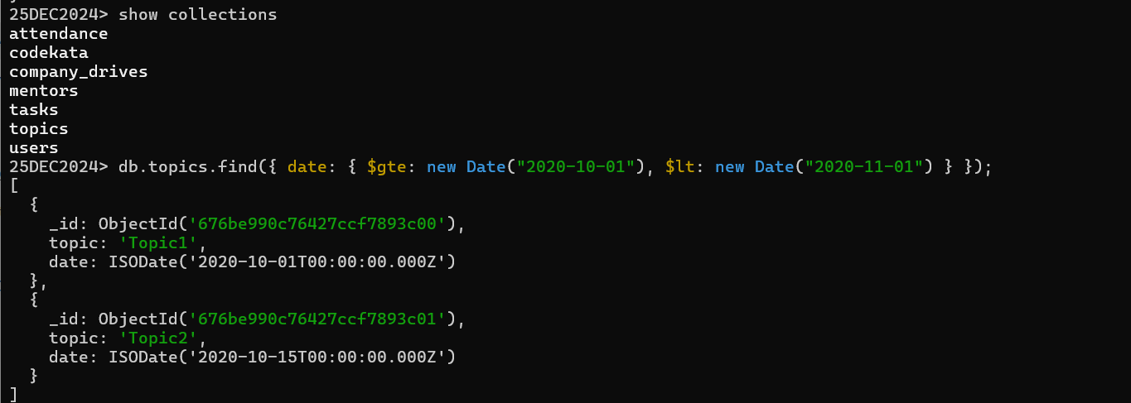

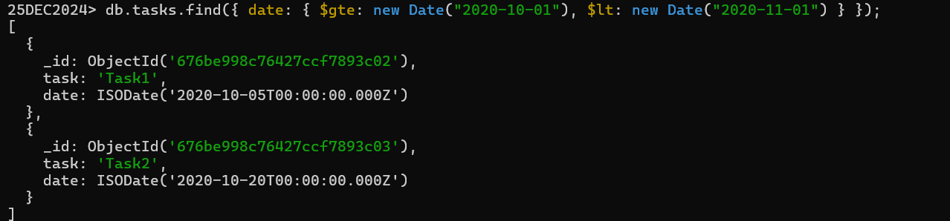**2.** **Find all the company drives which appeared between 15-Oct-2020 and 31-Oct-2020:**

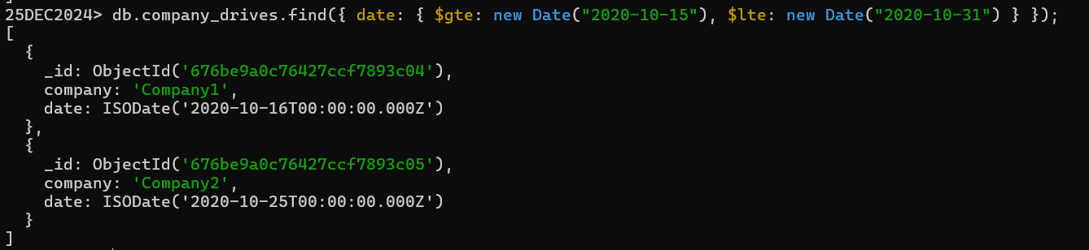

**3.Find all the company drives and students who appeared for the placement:**



**4.** **Find the number of problems solved by the user in Codekata:**

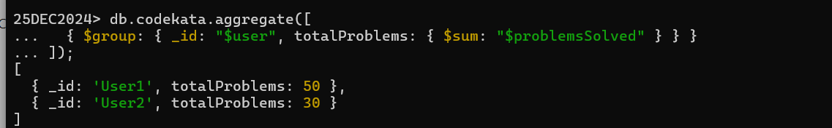

**5.** **Find all the mentors with mentees count more than 15:**

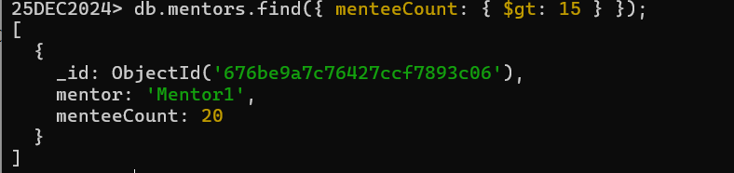

**6.** **Find the number of users who are absent and tasks not submitted between 15-Oct-2020 and 31-Oct-2020:**

