THANMAI B
1NT20IS178

Program to implement CRC error detection

// Include headers
#include<stdio.h>
#include<string.h>
// length of the generator polynomial
#define N strlen(gen_poly)
// data to be transmitted and received
char data[28];
// CRC value
char check_value[28];
// generator polynomial
char gen_poly[10];
// variables
int data_length,i,j;
// function that performs XOR operation
void XOR(){
// if both bits are the same, the output is 0
// if the bits are different the output is 1
for(j = 1;j < N; j++)
check_value[j] = (( check_value[j] == gen_poly[j])?'0':'1');

}
// Function to check for errors on the receiver side
void receiver(){
// get the received data
printf("Enter the received data: ");
scanf("%s", data);
printf("\n-----------------------------\n");
printf("Data received: %s", data);
// Cyclic Redundancy Check
crc();
// Check if the remainder is zero to find the error
for(i=0;(i<N-1) && (check_value[i]!='1');i++);
if(i<N-1)
printf("\nError detected\n\n");
else
printf("\nNo error detected\n\n");
}

void crc(){
// initializing check_value
for(i=0;i<N;i++)
check_value[i]=data[i];
do{
// check if the first bit is 1 and calls XOR function
if(check_value[0]=='1')
XOR();
// Move the bits by 1 position for the next computation
for(j=0;j<N-1;j++)
check_value[j]=check_value[j+1];
// appending a bit from data
check_value[j]=data[i++];
}while(i<=data_length+N-1);
// loop until the data ends
}

int main()
{
// get the data to be transmitted
printf("\nEnter data to be transmitted: ");
scanf("%s",data);
printf("\n Enter the Generating polynomial: ");
// get the generator polynomial
scanf("%s",gen_poly);
// find the length of data
data_length=strlen(data);
// appending n-1 zeros to the data
for(i=data_length;i<data_length+N-1;i++)
data[i]='0';
printf("\n----------------------------------------");
// print the data with padded zeros
printf("\n Data padded with n-1 zeros : %s",data);
printf("\n----------------------------------------");
// Cyclic Redundancy Check
crc();
// print the computed check value
printf("\nCRC or Check value is : %s",check_value);
// Append data with check_value(CRC)
for(i=data_length;i<data_length+N-1;i++)
data[i]=check_value[i-data_length];
printf("\n----------------------------------------");
// printing the final data to be sent
printf("\n Final data to be sent : %s",data);
printf("\n----------------------------------------\n");
// Calling the receiver function to check errors
receiver();
return 0;
}

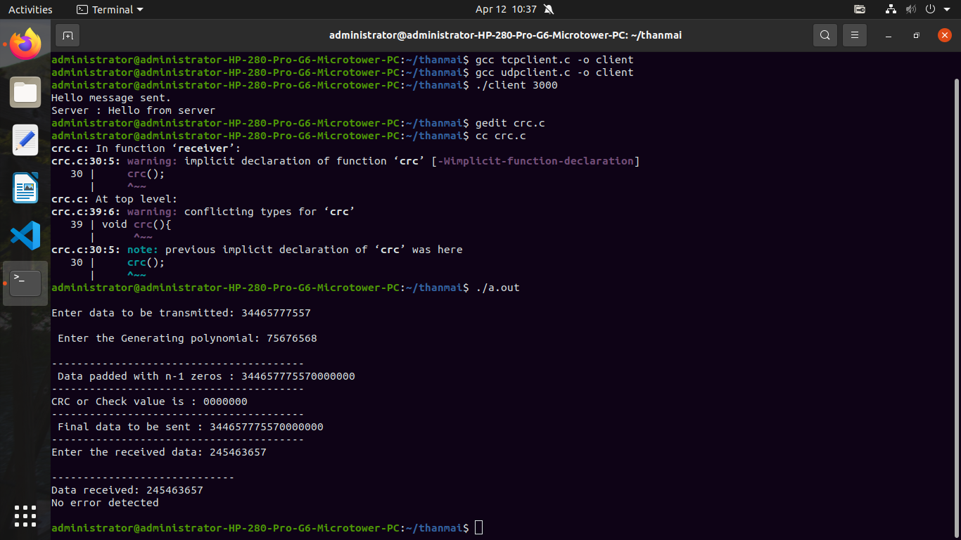
OUTPUT:

