THANMAI B
1NT20IS178

Program to implement client server model using UDP socket programming

SERVER:
// Server side implementation of UDP client-server model
#include <stdio.h>
#include <stdlib.h>
#include <unistd.h>
#include <string.h>
#include <sys/types.h>
#include <sys/socket.h>
#include <arpa/inet.h>
#include <netinet/in.h>

#define PORT 8080
#define MAXLINE 1024

// Driver code
int main() {
int sockfd;
char buffer[MAXLINE];
char *hello = "Hello from server";
struct sockaddr_in servaddr, cliaddr;

// Creating socket file descriptor
if ( (sockfd = socket(AF_INET, SOCK_DGRAM, 0)) < 0 ) {
perror("socket creation failed");
exit(EXIT_FAILURE);
}

memset(&servaddr, 0, sizeof(servaddr));
memset(&cliaddr, 0, sizeof(cliaddr));

// Filling server information
servaddr.sin_family = AF_INET; // IPv4
servaddr.sin_addr.s_addr = INADDR_ANY;
servaddr.sin_port = htons(PORT);

// Bind the socket with the server address
if ( bind(sockfd, (const struct sockaddr *)&servaddr,
sizeof(servaddr)) < 0 )
{
perror("bind failed");
exit(EXIT_FAILURE);
}

int len, n;

len = sizeof(cliaddr); //len is value/result

n = recvfrom(sockfd, (char *)buffer, MAXLINE,
MSG_WAITALL, ( struct sockaddr *) &cliaddr,
&len);
buffer[n] = '\0';
printf("Client : %s\n", buffer);
sendto(sockfd, (const char *)hello, strlen(hello),
MSG_CONFIRM, (const struct sockaddr *) &cliaddr,
len);
printf("Hello message sent.\n");

return 0;
}
CLIENT:
// Client side implementation of UDP client-server model
#include <stdio.h>
#include <stdlib.h>
#include <unistd.h>
#include <string.h>
#include <sys/types.h>
#include <sys/socket.h>
#include <arpa/inet.h>
#include <netinet/in.h>

#define PORT 8080
#define MAXLINE 1024

// Driver code
int main() {
int sockfd;
char buffer[MAXLINE];
char *hello = "Hello from client";
struct sockaddr_in servaddr;

// Creating socket file descriptor
if ( (sockfd = socket(AF_INET, SOCK_DGRAM, 0)) < 0 ) {
perror("socket creation failed");
exit(EXIT_FAILURE);
}

memset(&servaddr, 0, sizeof(servaddr));

// Filling server information
servaddr.sin_family = AF_INET;
servaddr.sin_port = htons(PORT);
servaddr.sin_addr.s_addr = INADDR_ANY;

int n, len;

sendto(sockfd, (const char *)hello, strlen(hello),
MSG_CONFIRM, (const struct sockaddr *) &servaddr,
sizeof(servaddr));
printf("Hello message sent.\n");

n = recvfrom(sockfd, (char *)buffer, MAXLINE,
MSG_WAITALL, (struct sockaddr *) &servaddr,
&len);
buffer[n] = '\0';
printf("Server : %s\n", buffer);

close(sockfd);
return 0;
}
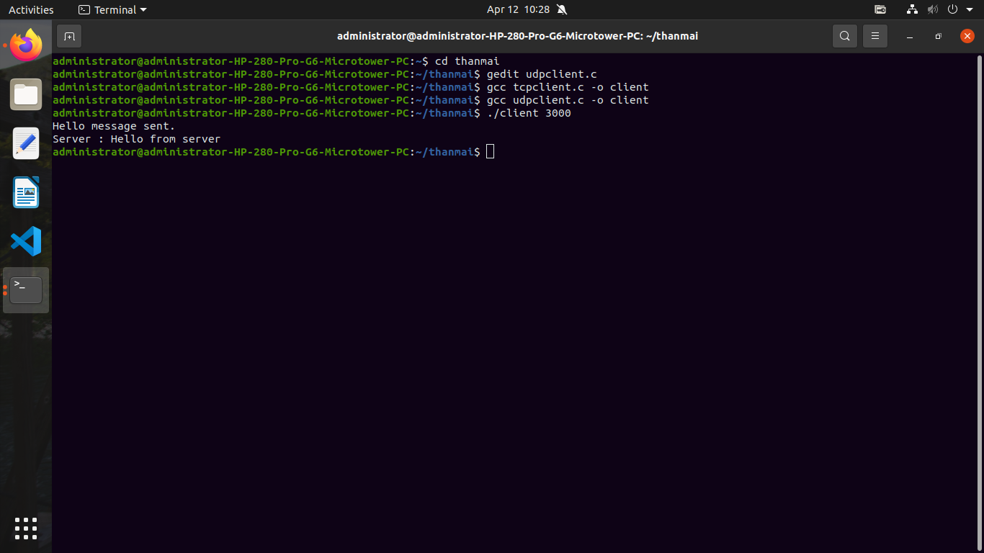
OUTPUT:
