Report By Allure server:

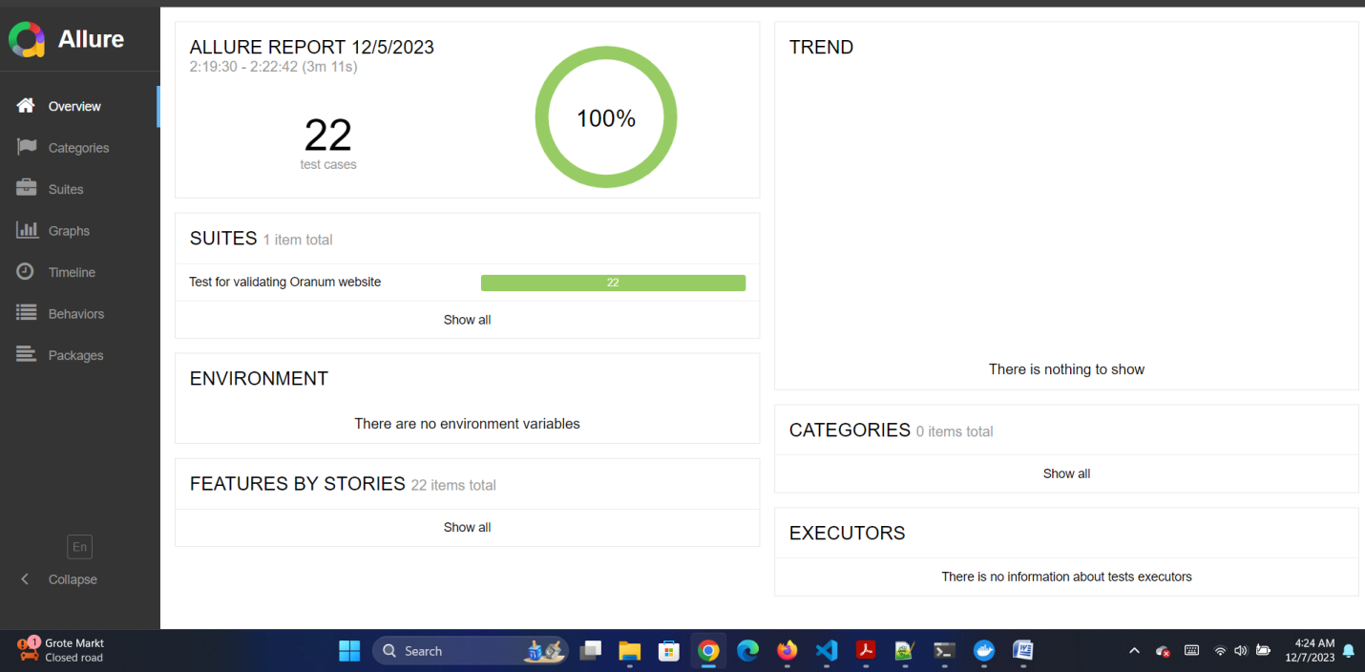

Report from the VS terminal:

