Ramaiah Institute of Technology
(An Autonomous Institute, Affiliated to VTU)
MSR Nagar, MSRIT post, Bangalore-54
A Dissertation Report on
Classification and Prediction using Back Propagation
Submitted by

Katasani Sai Roopa 1MS15CS055
Thanmayee Rachepalli 1MS15CS147
Nivedita Kamat 1MS15CS153
Swathi Ashok Kumar 1MS15CS001

Bachelor of Engineering in Computer Science & Engineering
Under the guidance of

Sowmya B J
Assistant Proffessor
Computer Science & Engineering

DEPARTMENT OF COMPUTER SCIENCE & ENGINEERING
M.S.RAMAIAH INSTITUTE OF TECHNOLOGY
(Autonomous Institute, Affiliated to VTU)
BANGALORE-560054
www.msrit.edu, 20177

INTRODUCTION

Back Propagation is Neural Network learning algorithm. It is a method used in Artificial Neural Networks (ANN) to calculate the error contribution of each neuron after a batch of data (in image recognition, multiple images) is processed. It was started by psychologists and neurologists to develop and test computational analogues of neurons. It was originally introduced in the 1970s, but its importance wasn't fully appreciated until a famous 1986 paper by David Rumelhart, Geoffrey Hinton, and Ronald Williams. That paper describes several neural networks where back Propagation works far faster than earlier approaches to learning, making it possible to use neural nets to solve problems which had previously been insolvable. Today, the backpropagation algorithm is the workhorse of learning in neural networks. It has been used successfully for wide variety of applications, such as speech or voice recognition, image pattern recognition, medical diagnosis, and automatic controls. This paper focuses on the classification and prediction of outputs in a dataset by using back propagation algorithm.
Classification is the problem of identifying to which of a set of categories a new observation belongs, on the basis of a training set of data containing observations whose category membership is known. Random points are assigned to a certain category, and the neural network is trained to find the pattern. When training is complete, it will use what it has learned to accurately classify new points. This is how we can use the neural network model to predict the categories in a similar dataset.
Back Propagation requires a known, desired output for each input value. It is therefore considered to be a supervised learning method. This technique is also sometimes called backward propagation of errors, because the error is calculated at the output and distributed back through the network layers. In Back propagation algorithm the error is back propagated and respectively the weights are adjusted so as to reduce the error. The iteration continues until target value with minimum error is reached. The motivation for back Propagation is to train a multi-layered neural network such that it can learn the appropriate internal representations to allow it to learn any arbitrary mapping of input to output.

DATA SET DESCRIPTION

1. Title: Pima Indians Diabetes Database

2. Sources:
(a) Original owners: National Institute of Diabetes and Digestive and
Kidney Diseases
(b) Donor of database: Vincent Sigillito (vgs@aplcen.apl.jhu.edu)
Research Center, RMI Group Leader
Applied Physics Laboratory
The Johns Hopkins University
Johns Hopkins Road
Laurel, MD 20707
(301) 953-6231
(c) Date received: 9 May 1990

3. Relevant Information:
Several constraints were placed on the selection of these instances from a larger database. In particular, all patients here are females atleast 21 years old of Pima Indian heritage. ADAP is an adaptive learning routine that generates and executes digital analogs of perceptron-like devices. It is a unique algorithm; see the paper for details.

4. Number of Instances: 768

5. Number of Attributes: 8 plus class

6. For Each Attribute: (all numeric-valued)
1. Number of times pregnant
2. Plasma glucose concentration a 2 hours in an oral glucose tolerance test
3. Diastolic blood pressure (mm Hg)
4. Triceps skin fold thickness (mm)
5. 2-Hour serum insulin (mu U/ml)
6. Body mass index (weight in kg/(height in m)^2)
7. Diabetes pedigree function
8. Age (years)
9. Class variable (0 or 1)

7. Missing Attribute Values: Yes

8. Class Distribution: (class value 1 is interpreted as "tested positive for
diabetes")

Class Value Number of instances
0 500
1 268

9. Brief statistical analysis:

Attribute number: Mean: Standard Deviation:
1. 3.8 3.4
2. 120.9 32.0
3. 69.1 19.4
4. 20.5 16.0
5. 79.8 115.2
6. 32.0 7.9
7. 0.5 0.3
8. 33.2 11.8

INFERENCES THAT YOU CAN DRAW CONSIDERING EACH ATTRIBUTE

- Number of times pregnant:
This attribute has the values of the number of times a woman was pregnant. The range of the values of the attribute lies between (0,16). We try to predict whether a women could be diabetic or not based on the number of times she was pregnant.

- Glucose Concentration:
This attribute has the Plasma Glucose Concentration. The range of this attribute lies between (40,200). This in combination with Insulin levels has been used to infer the range of values of both in which a person could or could not be diabetic respectively. Glucose Concentration alone could be used to infer this.

- Diastolic Blood Pressure:
This attribute shows the Diastolic blood pressure (mm Hg). The range of this attribute lies between (30,122). We use Blood Pressure along with BMI to find the range of values of both in which a person could be diabetic.
- Skin Thickness:
This is the thickness of the skin at triceps measured in mm. This along with Insulin levels can be used to find the range of values of both, in which a person would likely be diabetic.

- Insulin level:
This is measured in mu U/ml. The range of these values in which a person is likely to be diabetic or not could be inferred by plotting the values with the outcome.

- BMI (Body Mass Index):
We infer how the BMI of a person effects the outcome. In other words, the correlation between BMI and outcome.

- Age:
We infer how the Age of a person effects the outcome. In other words, the correlation between Age and outcome.

ALGORITHM DESCRIPTION

Backpropogation is an algorithm for supervised learning of artificial neural networks using gradient descent. Given an artificial neural network and an error function, the method calculates the
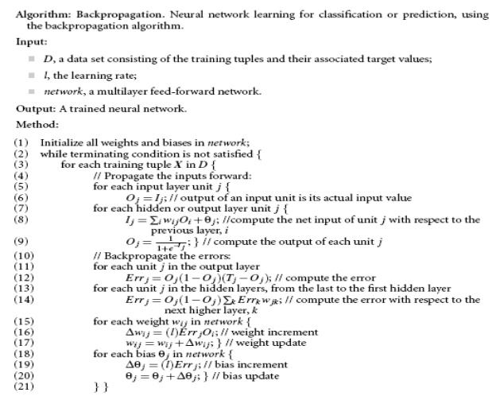

gradient of the error function with respect to the neural network's weights. It is a generalization of the delta rule for perceptrons to multilayer feedforward neural networks.
The "backwards" part of the name stems from the fact that calculation of the gradient proceeds backwards through the network, with the gradient of the final layer of weights being calculated first and the gradient of the first layer of weights being calculated last. Partial computations of the gradient from one layer are reused in the computation of the gradient for the previous layer. This backwards flow of the error information allows for efficient computation of the gradient at each layer versus the naive approach of calculating the gradient of each layer separately.
Backpropagation's popularity has experienced a recent resurgence given the widespread adoption of deep neural networks for image recognition and speech recognition. It is considered an efficient algorithm, and modern implementations take advantage of specialized GPUs to further improve performance.

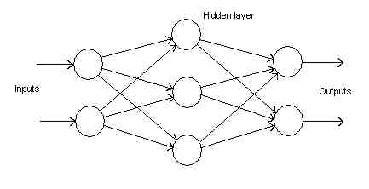

The operations of the Backpropagation neural networks can be divided into two steps:feed forward and Backpropogation. In the feedforward step, an input pattern is applied to the input layer and its effect propagates, layer by layer, through the network until an output is produced. The network's actual output value is then compared to the expected output, and an error signal is computed for each of the output nodes. Since all the hidden nodes have, to some degree, contributed to the errors evident in the output layer, the output error signals are transmitted backwards from the output layer to each node in the hidden layer that immediately contributed to the output layer. This process is then repeated, layer by layer, until each node in the network has received an error signal that describes its relative contribution to the overall error.
Once the error signal for each node has been determined, the errors are then used by the nodes to update the values for each connection weights until the network converges to a state that allows all the training patterns to be encoded. The Backpropagation algorithm looks for the minimum value of the error function in weight space using a technique called the delta rule or gradient descent. The weights that minimize the error function is then considered to be a solution to the learning problem.
The network behaviour is analogous to a human that is shown a set of data and is asked to classify them into predefined classes. Like a human, it will come up with "theories" about how the samples fit into the classes. These are then tested against the correct outputs to see how accurate the guesses of the network are. Radical changes in the latest theory are indicated by large changes in the weights, and small changes may be seen as minor adjustments to the theory.
There are also issues regarding generalizing a neural network. Issues to consider are problems associated with under-training and over-training data. Under-training can occur when the neural network is not complex enough to detect a pattern in a complicated data set. This is usually the result of networks with so few hidden nodes that it cannot accurately represent the solution, therefore under-fitting the data (Figure 1).
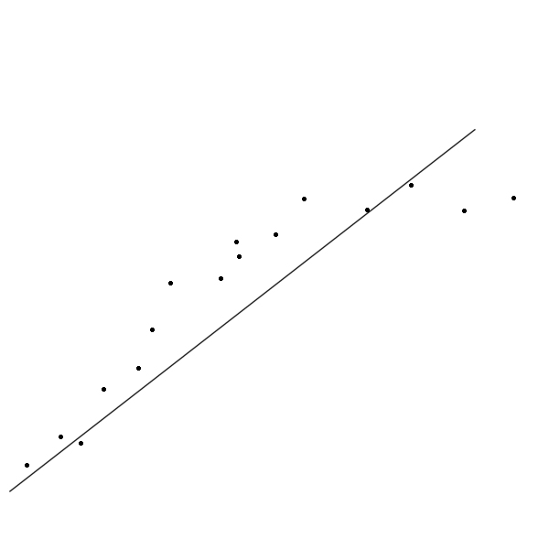
Figure 1Under-fitting data
On the other hand, over-training can result in a network that is too complex, resulting in predictions that are far beyond the range of the training data. Networks with too many hidden nodes will tend to over-fit the solution (Figure 1)
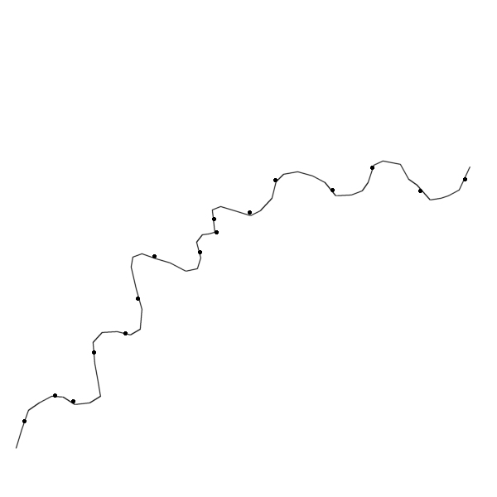
Figure 7Over-fitting data
The aim is to create a neural network with the "right" number of hidden nodes that will lead to a good solution to the problem (Figure 2).
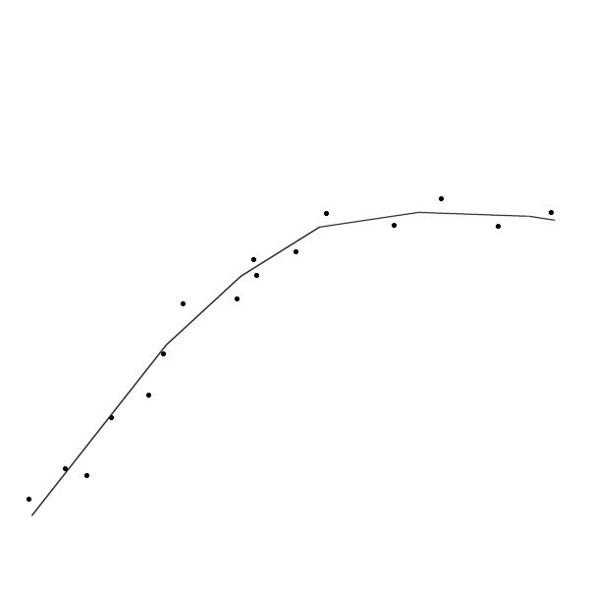
Figure2.Good fit of the data
Algorithm
Feedforward:
When a specified training pattern is fed to the input layer, the weighted sum of the input to the jth node in the hidden layer is given by
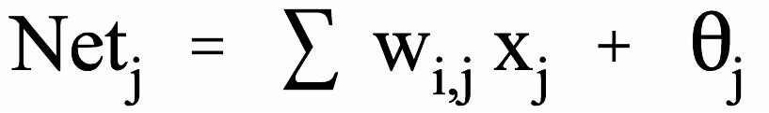 (1)
Equation (1) is used to calculate the aggregate input to the neuron. The 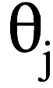 term is the weighted value from a bias node that always has an output value of 1. The bias node is considered a "pseudo input" to each neuron in the hidden layer and the output layer, and is used to overcome the problems associated with situations where the values of an input pattern are zero. If any input pattern has zero values, the neural network could not be trained without a bias node.
To decide whether a neuron should fire, the "Net" term, also known as theaction potential, is passed onto an appropriate activation function. The resulting value from the activation function determines the neuron's output, and becomes the input value for the neurons in the next layer connected to it.
Since one of the requirements for the Backpropagation algorithm is that the activation function is differentiable, a typical activation function used is the Sigmoid equation
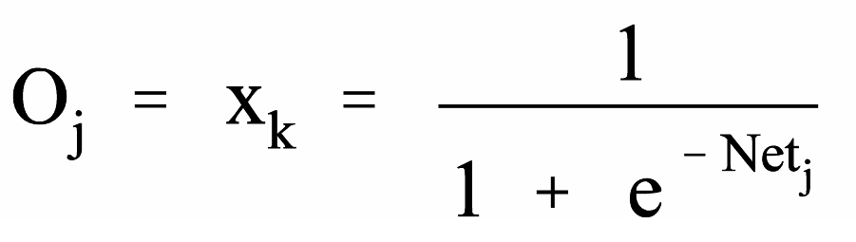 | (2)
It should be noted that many other types of functions can, and are, used:-hyperbolic tan being another popular choice.
Similarly, equations (1) and (2) are used to determine the output value for node k in the output layer.
Error Calculations and Weight Adjustments
Output layer:
If the actual activation value of the output node, k, is Ok, and the expected target output for node k is tk, the difference between the actual output and the expected output is given by:
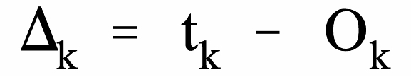 | (3)
The error signal for node k in the output layer can be calculated as
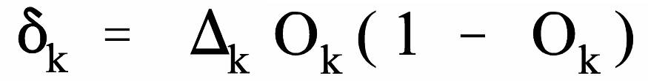 | (4)
where the Ok(1-Ok) term is the derivative of the Sigmoid function.
With the delta rule, the change in the weight connecting input node j and output node k is proportional to the error at node k multiplied by the activation of node j.
The formulas used to modify the weight, wj,k, between the output node, k, and the node, j is:
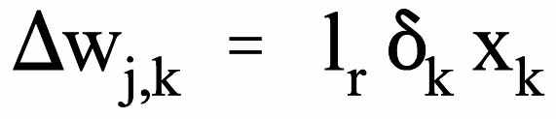  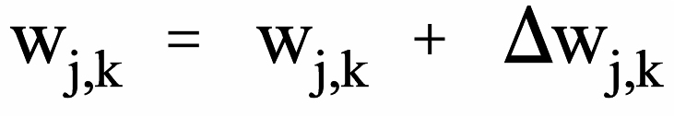 | (5)  (6)
Where 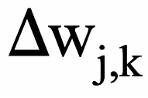 is the change in the weight between nodes j and k, lr is the learning rate. The learning rate is a relatively small constant that indicates the relative change in weights. If the learning rate is too low, the network will learn very slowly, and if the learning rate is too high, the network may oscillate around minimum point , overshooting the lowest point with each weight adjustment, but never actually reaching it. Usually the learning rate is very small, with 0.01 not an uncommon number. Some modifications to the Backpropagation algorithm allows the learning rate to decrease from a large value during the learning process. This has many advantages. Since it is assumed that the network initiates at a state that is distant from the optimal set of weights, training will initially be rapid. As learning progresses, the learning rate decreases as it approaches the optimal point in the minima. Slowing the learning process near the optimal point encourages the network to converge to a solution while reducing the possibility of overshooting. If, however, the learning process initiates close to the optimal point, the system may initially oscillate, but this effect is reduced with time as the learning rate decreases.
It should also be noted that, in equation (5), the xk variable is the input value to the node k, and is the same value as the output from node j.
To improve the process of updating the weights, a modification to equation (5) is made:
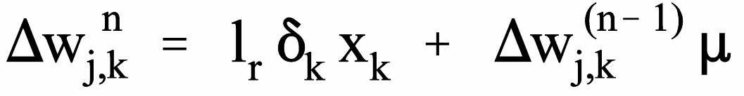 | (7)
Here the weight update during the nth iteration is determined by including a momentum term (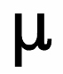), which is multiplied to the (n-1)th iteration of the . The introduction of the momentum term is used to accelerate the learning process by "encouraging" the weight changes to continue in the same direction with larger steps.. Typically, the momentum term has a value between 0 and 1.
Hidden layer:
The error signal for node j in the hidden layer can be calculated as
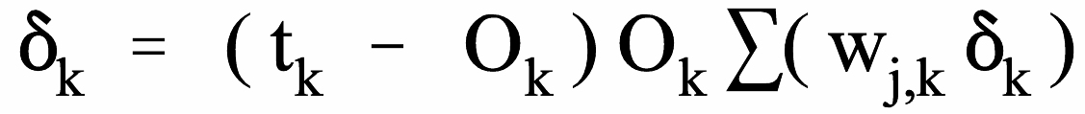 | (8)
where the Sum term adds the weighted error signal for all nodes, k,in the output layer.
As before, the formula to adjust the weight, wi,j, between the input node, i, and the node, j is:
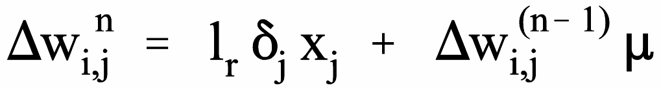  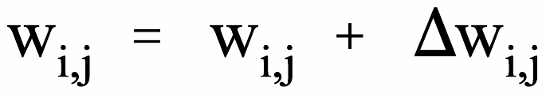 | (9)  (10)
GLOBAL ERROR
Finally, Backpropagation is derived by assuming that it is desirable to minimize the error on the output nodes over all the patterns presented to the neural network. The following equation is used to calculate the error function E, for all patterns
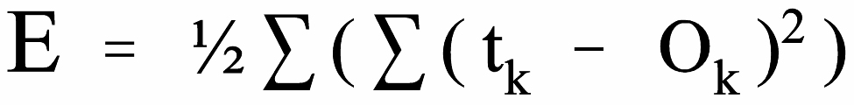 | (11)
Ideally, the error function should have a value of zero when the neural network has been correctly trained. This, however, is numerically unrealistic.

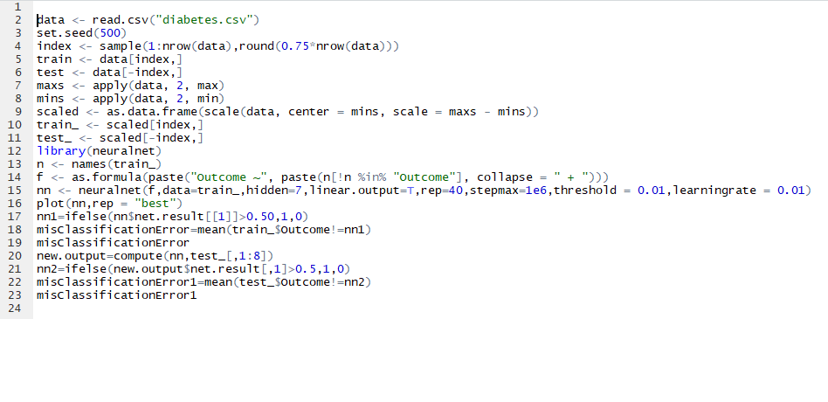
RESULT SNAPSHOT

We divide the dataset into training and test data. We sampled 75% of the original data to use as the training data. The rest is used to test the model. Scale function is used to normalize the data by finding the minimum and maximum values for each attribute in the data set.
We use the Neural Net Package to implement our back propagation algorithm. We store the trained neural net model in a variable called nn. We use this to classify the outcomes for the test data.By doing lots of trail and errors we have set the number of hidden layers to be 1 and the number of hidden nodes to be 7.we set the learning rate and the threshold to be 0.01.And our neural network looked as shown in the figure below.
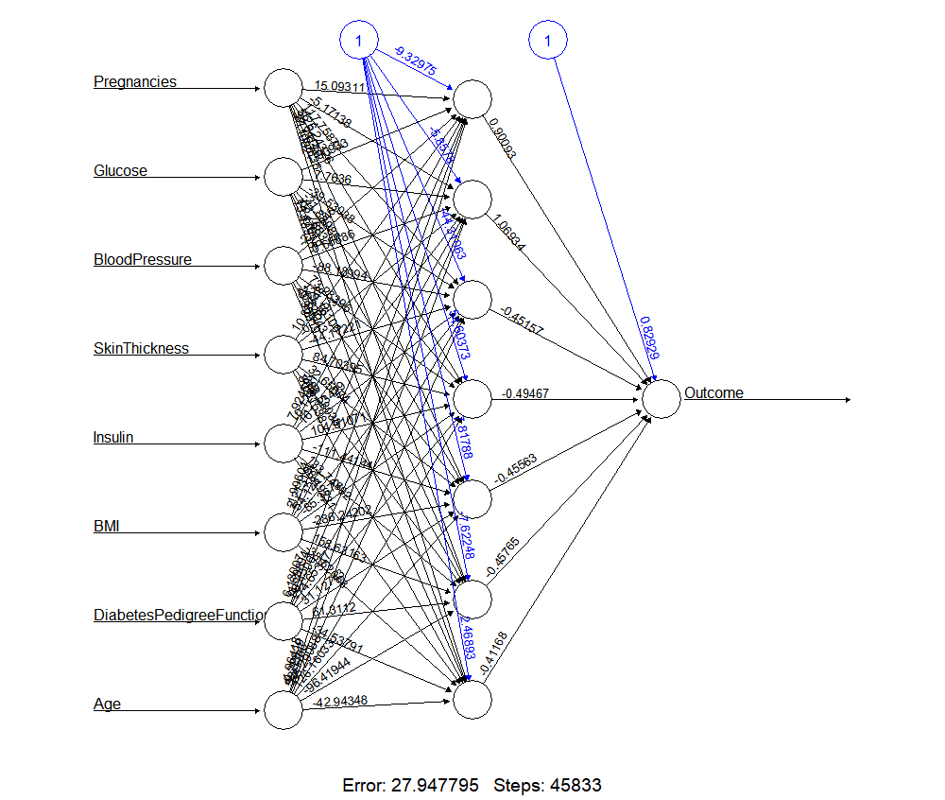
The following are the inferences we got from the algorithm:
We first found the correlation of each attribute with other and used this correlation result as the base to draw inferences.All the diagonal elements are darkly coloured because every attribute is strongly correlated with each other. The darkness of the colour indicates the percentage of the correlation of each attribute with every other i,e by the colour we can estimate the percentage of the correlation.Using this correlation as the base graph we have drawn inferences.The correlation graph is as shown below:

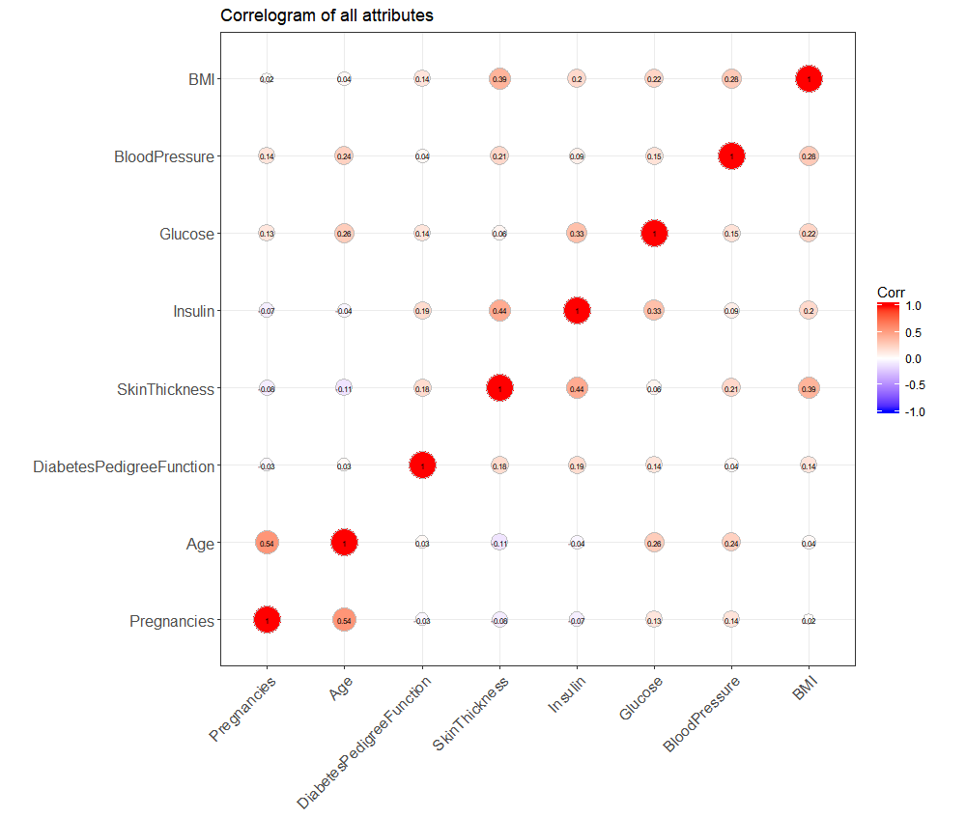

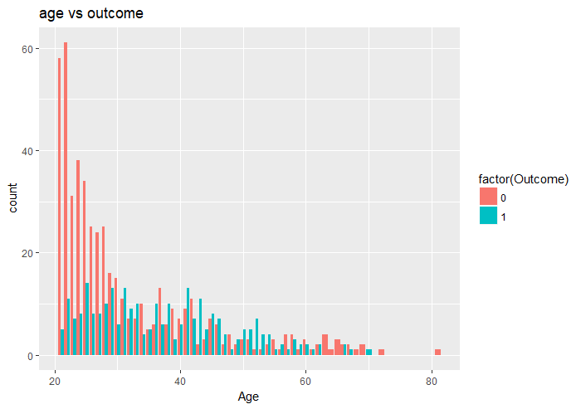

When we plot our age values with outcome its looks as the above shown figure.In the bar graph the red color indicates no diabetes and blue color indicates that a woman has diabetes.We can clearly make out that the percentage of woman whose age is less than 40 are less affected with diabetes. The same is shown as a density graph below, density graph is same as the bar graph but its way easier to understand in a layman perspective.

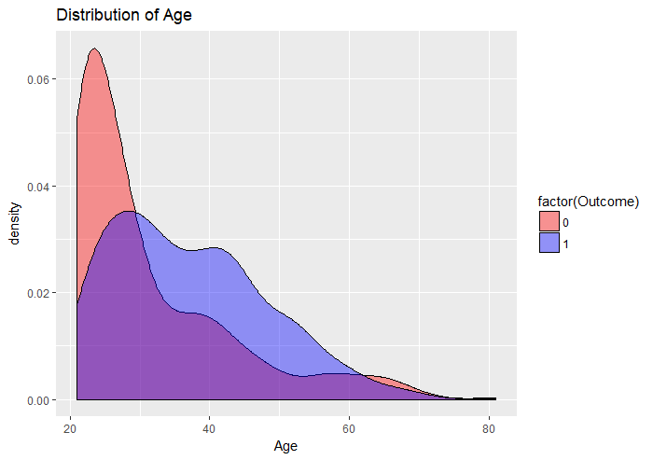

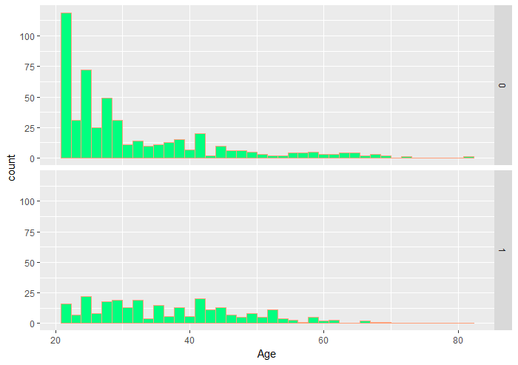

In the below graph we see the density graph of Glucose. From the graph we clearly get to know that a woman who has more than 150 ml of Glucose content is more prone to become diabetic.

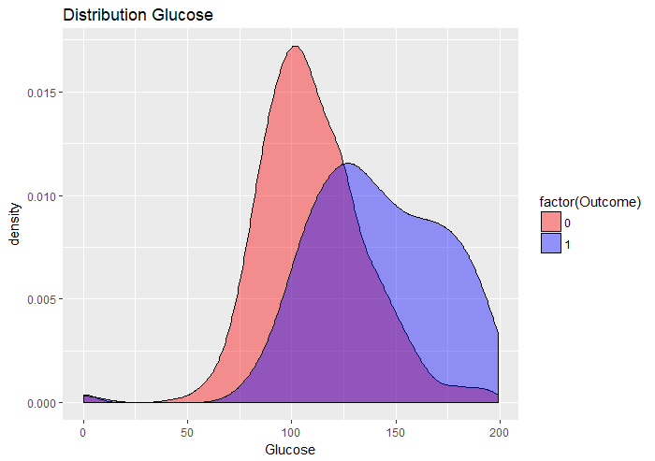

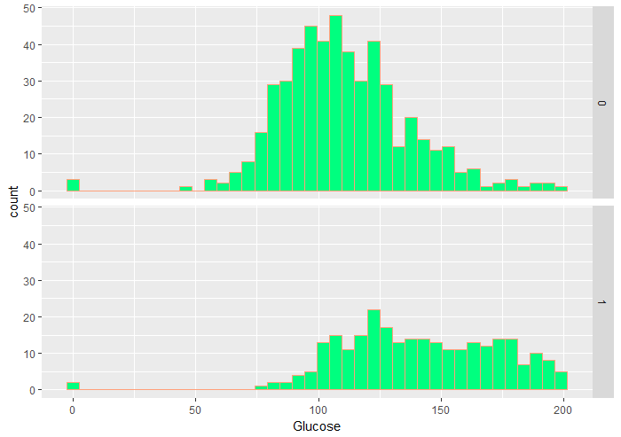

We observe that the density of the people who don't have diabetes is more in the range 80ml and 120ml of glucose levels, whereas, the density of people with diabetes is more in the range 120ml to 200ml of glucose levels. The inference we obtain from this, is that it is more likely that a person has diabetes if their glucose levels are greater than 120ml while maintaining the glucose levels between 80ml and 120ml make it more likely that a person does not have diabetes.

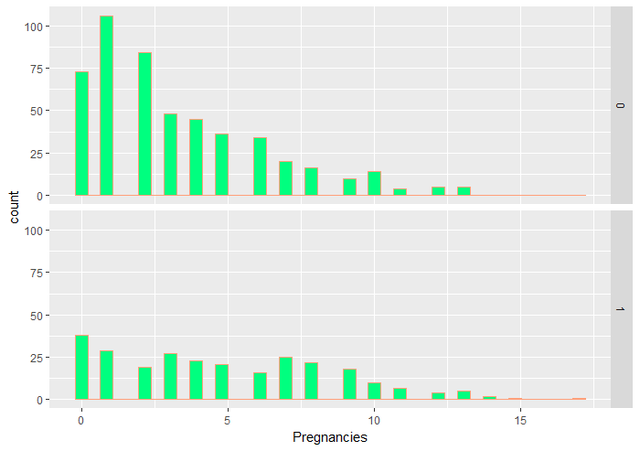
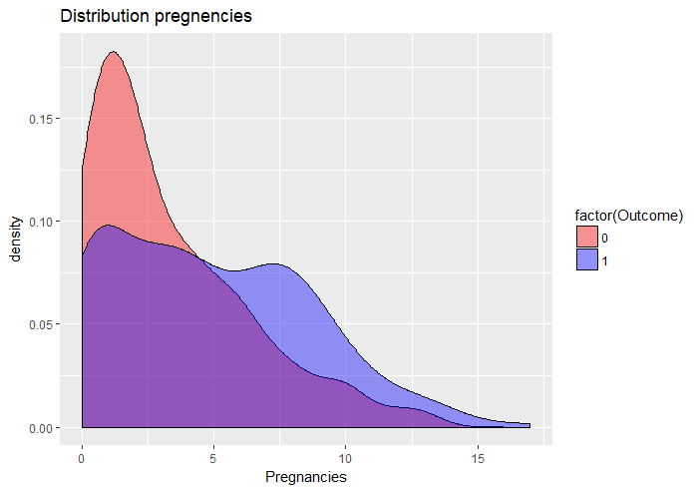
We observe from the above graph, that there is a higher density of females not having diabetes when they had less than 5 pregnancies whereas the chances of having diabetes increases as the number of pregnancies increase. This is reinforced by the double bar graph above.
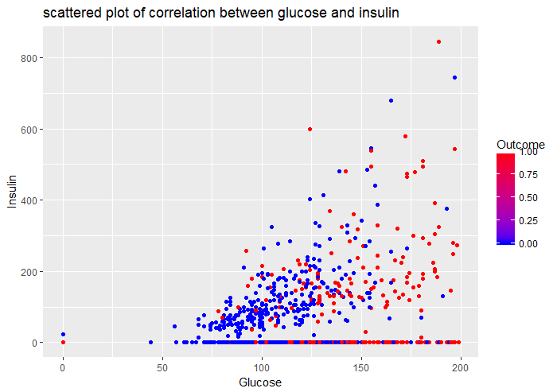
In the above graph, we can see the scattered outcome w.r.t both insulin and glucose levels. The red dots indicate the outcomes which are positive for diabetes and the blue ones show the outcomes which are negative for diabetes. We observe that, most blue dots are concentrated in the area where the Glucose levels are between 75ml and 125ml and the insulin is in between 0 and 100. This is the area where the probability of having diabetes is least. This is the inference we make from the above graph.

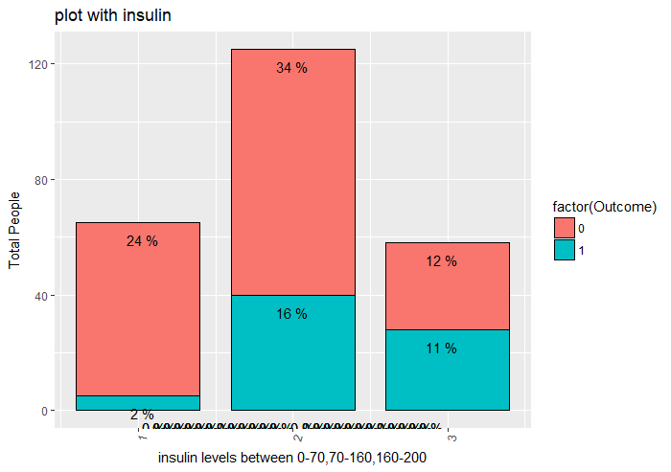
The above graph shows the percentage division of people with diabetes in blue and without diabetes in red. The graph is taken in three intervals of insulin, 0-70, 70-160, 160-200. The inferences we can draw from the above graph is that for people whose insulin levels lie in the range 0-70, the percentage of people with outcome '0' is much greater (24%), than the percentage of people with outcome '1' (2%). This leads us to infer that females who have insulin levels between are more likely to not have diabetes than they are to have it. This proves to be true fro females whose insulin levels lie in the range 70-160 as well. But, when we look at the outcomes of females whose insulin levels lie in the range 160-200, we observe that the percentage of people with diabetes (11%) is almost equal to the percentage of people without diabetes (12%). This helps us conclude that females with insulin levels in the range 160-200 are more likely to be diabetic than the females with insulin levels less than 160.
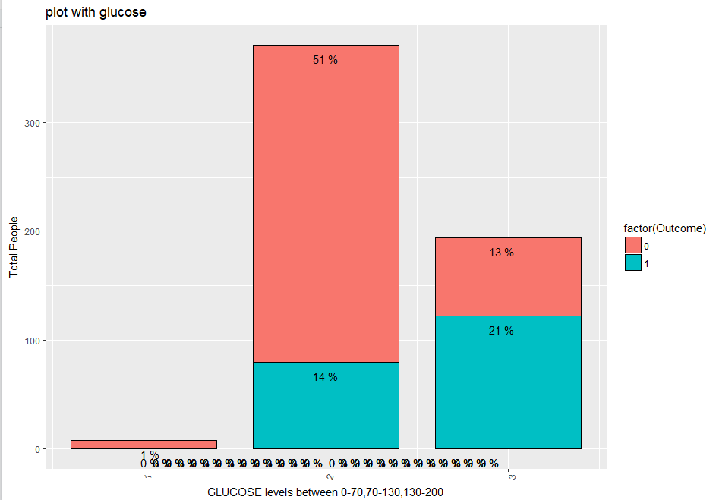
The above graph shows the percentage division of people with diabetes in blue and without diabetes in red. We divided the glucose level into three intervals of glucose, 0-70, 70-130, 130-200. The inferences we can draw from the above graph is that for people whose insulin levels lie in the range 70-130, the percentage of people with outcome '0' is much greater (51%), than the percentage of people with outcome '1' (14%). This leads us to infer that females who have glucose levels between 70-130 are more likely to not have diabetes than they are to have it. This proves to be true fro females whose insulin levels lie in the range 130-200 as well. But, when we look at the outcomes of females whose insulin levels lie in the range 130-200, we observe that the percentage of people with diabetes (21%) is greater than the percentage of people without diabetes (13%). This helps us conclude that females with glucose levels in the range 130-200 are more likely to be diabetic than the females with glucose levels less than 130.

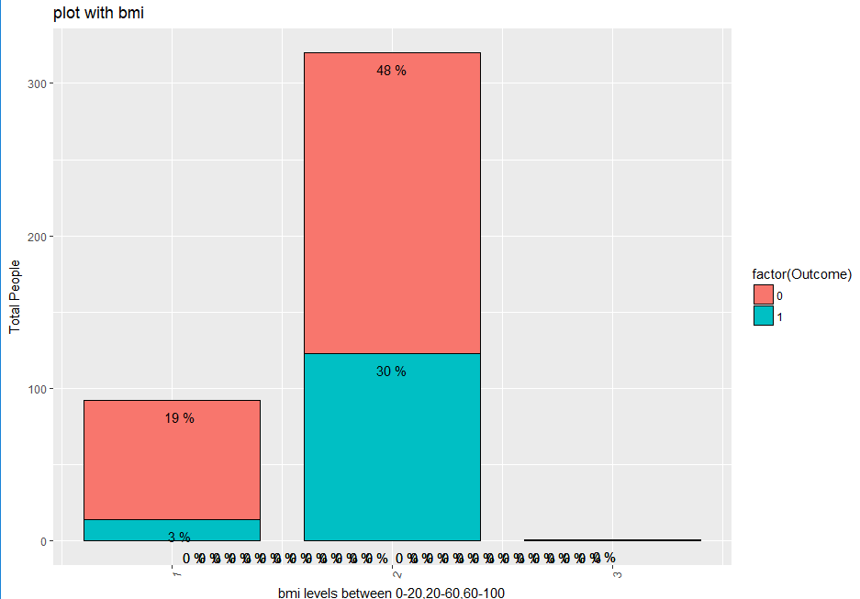
We divided the body mass index(bmi) levels into three intervals of bmi, 0-20, 20-60, 60-100. The inferences we can draw from the above graph is that for people whose bmi levels lie in the range 0-20, the percentage of people with outcome '0' is much greater (19%), than the percentage of people with outcome '1' (3%). This leads us to infer that females who have bmi levels between 0-20 are more likely to not have diabetes than they are to have it. This proves to be true for females whose bmi levels lie in the range 20-60 as well. But, when we look at the outcomes of females whose bmi levels lie in the range 60-100, we observe that the percentage of people in this range are negligible. This helps us conclude that females with bmi levels in the range 20-60 are more likely to be diabetic than the females with bmi levels less than 60.

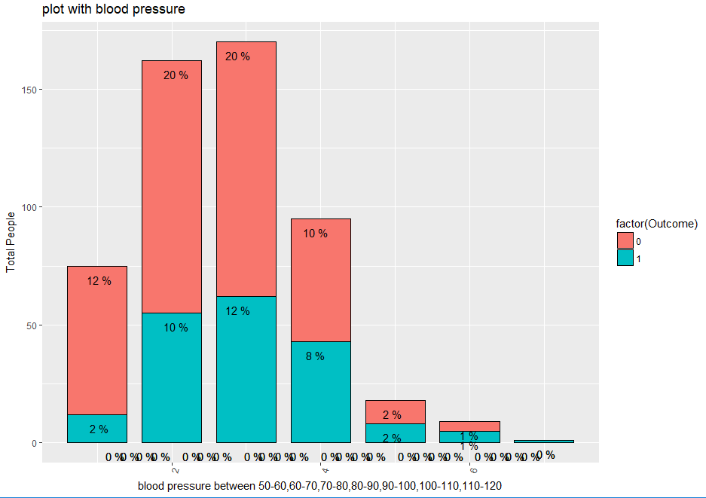
We divided the blood pressure levels into six intervals of blood pressure, 50-60, 60-70, 70-80,80-90,90-100,100-110,110-120. The inferences we can draw from the above graph is that for people whose blood pressure levels lie in the range 50-100, the percentage of people with outcome '0' is much greater , than the percentage of people with outcome '1' . This leads us to infer that females who have bp levels between 50-100 are more likely to not have diabetes than they are to have it.
SOCIAL USE OF BACKPROPOGATION
Back propogation neural network can be used when:
- A large amount of input/output data is available, but you're not sure how to relate it to the output.
- The problem appears to have overwhelming complexity, but there is clearly a solution.
- It is easy to create a number of examples of the correct behaviour.
- The solution to the problem may change over time, within the bounds of the given input and output parameters.
- Outputs can be fuzzy, or non-numeric.

Despite of the rapid development of theories for computational intelligence, application to diabetes diagnosis remains a challenge. This is due to specific problems of data use. These problems arise when statistical models of data are unknown or time-dependent, or when the parameters of the learning system need to be updated incrementally, while only a partial glimpse of incoming data is available. Based on the promising outcomes of studies applying computational algorithms to the problem of diabetes diagnosis, it is clear that a more sophisticated risk score could be developed. This would significantly decrease healthcare costs via early prediction and diagnosis of type 2 diabetes.
Some algorithms work better on the diabetes diagnosis problem than others. It will be important to compare outcomes further to find the most reliable algorithm for clinical application. Neural network methodology has outperformed classical statistical methods in cases where input variables are interrelated. Because clinical measurements are usually derived from multiple interrelated systems, it is evident that neural networks might be more accurate than classical methods in multivariate analysis of clinical data.
Trained models of diabetes risk factors should be incorporated into easy-to-use software solutions such that medical practitioners, who are not experts in artificial intelligence and computational techniques, may apply them easily. For this purpose, graphical user interface-enabled tools need to be developed by which medical practitioners can simply enter health profiles of their patients and receive an instant diabetes prediction with an acceptable degree of confidence. If the ANN-based prediction approach shows improved medical diagnosis, then it may become more widely accepted as a means to assist patient care in more hospitals and clinics.
Though the PID dataset provides a well validated data for predicting diabetes diagnosis, it is possible that models trained on such a dataset may not perform equally well on profiles of patients from other ethnic group. Therefore, it is recommended that models of choice must be trained on a dataset that closely represents patient profiles of medical practitioners within specific geographic regions.

