Intel Grand Challenge

Title: Analysis on road accident

Team Name: Techie pythons

Author’s Name: Thannoli.R

Vidhya Bharathi.K

Swetha.M.S

Date: 10.09.2023

Abstract

This study aims to investigate the relationship between speed, time. We analysed exhaustive dataset of road accidents, considering a variable such as vehicle, speed and the time at which accidents occurred. Our findings reveal a strong correlation between speed, particularly during certain times of the day. We discuss the implications of these findings for road safety measures and highlight the need for targeted interventions to reduce road accidents and save lives.

Introduction

Road accidents are the foremost problem recognized around the world. It impacts society and economy progress of the country. Major key factors of road accidents are due to overspeed, non-compliance with traffic rules, sleepiness, alcohol intake, incautious of human, vehicle and road conditions. This may lead to destroy of livelihoods. The road transportation is a primary mode of transport that plays a major role in day-to- day life. As road transportation increases with rapid increase in road accident. The increment is proportionate to the growth in population, economic development, industrialization in the country. Analysing road accidents is crucial for identifying trends, implementing safety measures and reducing their frequency and severity.

Analysis on road accidents

For analysing the road accidents, datasets used are: Timespan, speed and variables are collected. For precise analysis, the data are cleansed like removing outliers, redundant data’s, correcting errors and then pre-processed. This are done through excel.

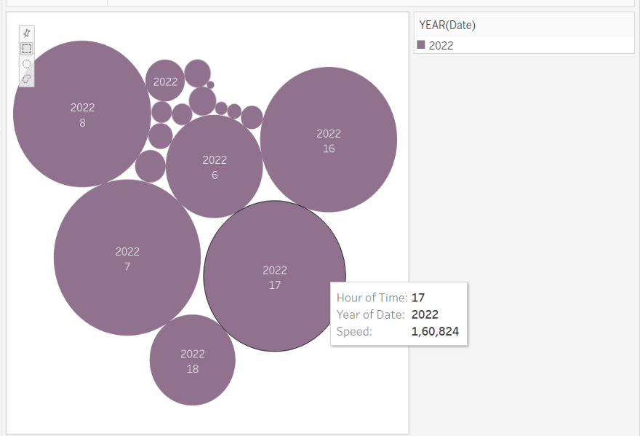

From the above image, we could see the gist of the road accident using bubble chart. This image holds the information that occurred in the year of 2022, when it has been occurred and at which speed the vehicle has been travelled cause the accidents.

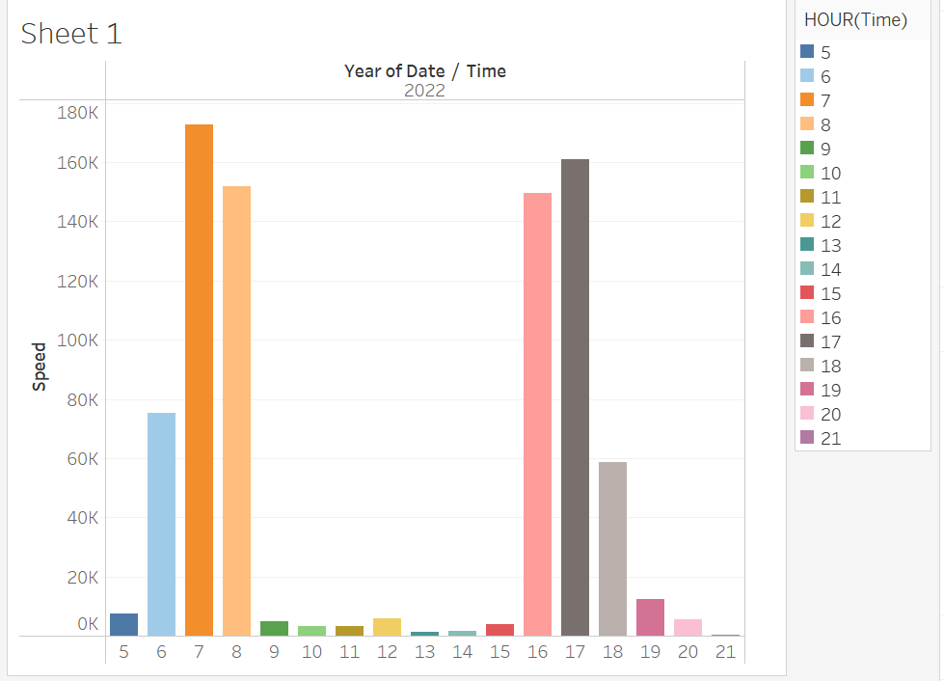

The above image is the actual analysis of the road accident. We have chosen the speed, date and time from the date set. For accurate analysis, Bar chart has been chosen. Here, Y- axis holds Speed and X- axis holds date and time.

Descriptive of the above statistic:

We could see that the most of the accidents occurred in 7-8 in the morning and 4-5 in the evening due to the traffic congestion (This time is peak due to majority of population are travelling for their purpose). As travel period between 10-3 is low, so occurrence of an accident will be less. From the statistic,

Relationship between speed and accident frequency:

We could see that majority of the accidents occurred when the speed crosses 140k. The average accidents recorded when the speed is between 60k-80k and lowest accidents has been recorded between 0k-20k.

Date and time trends:

In the time of 7, it has been recorded the highest distribution of accidents. At the time of 9, it has been recorded the lowest appearance of accidents.

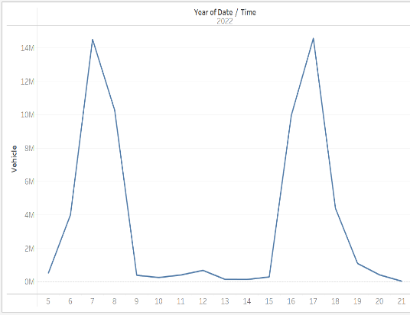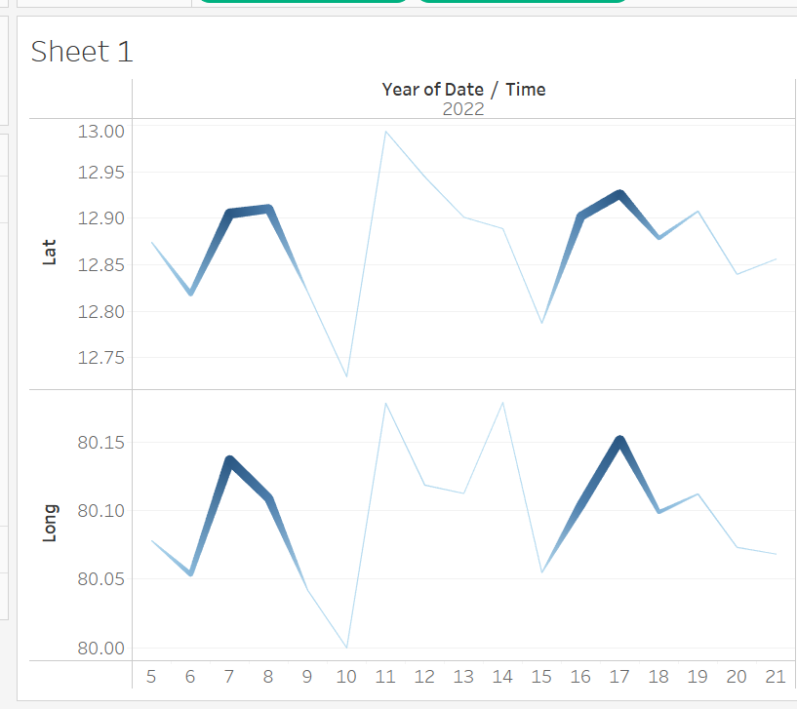vehicle proportionate to road accidents:

Here image 1 describes that as increase in vehicle the number of accidents also increases, we could also see occurrence the leptokurtic between 5-9AM and 2-9PM (as vehicle travelled are at peak at this time) and appearance of platykurtic in between 10AM-1PM (as vehicle travelled are less at this time).

Geographic distribution of road accidents:

From image 2 we can clearly understand existence of road accident with help of longitude and latitude, between 12.99 latitude and between 80.17 longitude majority of accidents has been recorded.

Recommendations:

To avoid road accidents, Drive in the prescribed speed limits on the various roads; it is essential to install speed governor in the vehicles; plan trip to avoid peak hours.

Conclusion

This analysis of road accidents with focused on speed and time has revealed critical insights into the factors contributing to road safety. The data underscores the undeniable correlation between excessive speed and the likelihood of accidents, emphasizing the importance of adhering to speed limits and adopting responsible driving habits. Ultimately, addressing road safety requires a multifaceted approach, including stricter enforcement of speed limits, enhanced driver education, improved road infrastructure, and the integration of advanced technology for monitoring and mitigating risks. By taking proactive measures in these areas, we can work towards reducing road accidents and creating safer environments for all road users.