- HAS-A association
- Aggregation – (has a relationship) – Company has people as Employee, and are loosely coupled, why because, people as Employee can still exist, even after Company die.
- Composition (part-of relationship) – Company has Department, and are tightly coupled,
Why because, Department cannot exist, if Company dies. – Parent life time.
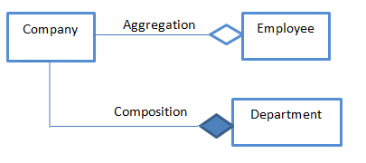
- IS-A association
Inheritance – Employee is a People Type.

