* **HAS-A** association

1. **Aggregation** – (**has a** relationship) – Company has people as Employee, and are loosely coupled, why because, people as Employee can still exist, even after Company die.
2. **Composition** (**part-of** relationship) – Company has Department, and are tightly coupled,

Why because, Department cannot exist, if Company dies. – Parent life time.

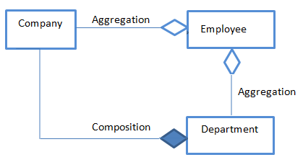

* **IS-A** association

**Inheritance** – Employee is a People Type.