FedTW: Target-Wise Label-Shift Correction for Federated Multi-Target Cloud Workload Forecasting
Thanoon Y. Mohammed  Dept. of Computer Technique Engineering, Northern Technical University, Mosul, Iraq  thanon.younes@ntu.edu.iq | Ahmad F. AL-allaf  Computer Engineering Dept., Technical College for Computer and AI, Northern Technical University, Mosul, Iraq | M. R. Mouhamed  Dept. of Mathematics, Faculty of Science, Helwan University, Cairo, Egypt

Abstract—Federated learning lets cloud sites train a shared workload forecaster without exchanging their utilisation traces, but the sites rarely hold identically distributed jobs. We study federated forecasting of job duration, CPU usage and memory usage on the Alibaba 2017 and CC-IN2P3 2024 production traces under 11 client regimes, giving every method the same number of rounds, local steps and samples. When clients differ in the range of one target, the damage concentrates on that target: under severe duration skew, federated averaging loses 16.0 and 32.0 $R^{2}$ points of duration accuracy relative to IID clients, while CPU and memory are almost unchanged. At a matched budget, the FedProx proximal term does not repair this loss for any coefficient between ${10}^{−3}$ and $10$, which identifies the failure as label shift rather than client drift. We therefore propose FedTW, which re-weights the loss of every output by the ratio of global and local target densities, estimated from one-shot ten-bin histograms. FedTW improves the skewed target in all 12 target-skew cases of both traces (Holm-corrected Wilcoxon $p≤0.027$), by up to 38.3 $R^{2}$ points, matches federated averaging under IID clients, adds no per-round communication and tolerates differentially private histograms.
Index Terms—federated learning, cloud workload forecasting, label distribution skew, importance weighting, FedProx, non-IID data

I. INTRODUCTION
Forecasts of job duration, CPU usage and memory usage drive capacity planning, autoscaling and energy-aware placement in cloud data centres [1], [2]. Recurrent and attention-based models trained on utilisation traces are the current practice [3]–[6], and they assume that the trace is available in one place. When telemetry belongs to several tenants, sites or providers, pooling it is often impossible because the traces expose tenant behaviour and workload composition [7]. Federated learning (FL) exchanges model updates instead of records [8], [9] and is therefore a natural fit for multi-site workload forecasting over communication networks [10].
The clients of a workload federation, however, rarely hold identically distributed data. Sites specialise: one cluster runs short interactive jobs, another long batch jobs, a third memory-heavy analytics. In FL terms this is a skew in the distribution of the prediction targets across clients. Federated averaging (FedAvg) degrades when client distributions differ [11]–[13], and the usual remedy is to limit client drift with the proximal term of FedProx [14]. An earlier analysis of ours reported that a large proximal coefficient recovered duration accuracy under a duration-sorted partition. That conclusion did not separate regularisation from training length, because the proximal runs trained for several times more rounds under early stopping, and the benefit appeared only for the target that defined the partition.
This paper revisits the question under a strictly budget-matched protocol and grades the heterogeneity of each target separately. The evidence points to a simple mechanism: when clients differ in the range of one target, their local objectives are biased estimates of the global objective for that target, so the failure is label shift, and a proximal term, which only slows local learning, cannot remove the bias. We propose FedTW (Federated Target-Wise re-weighting), which corrects the local loss of each target with importance weights computed from coarse, one-shot histograms. The contributions are:
- a budget-matched benchmark on two production traces with 11 client regimes, including Dirichlet target skew graded in severity and applied to each target, with the client divergence quantified for every regime;
- a diagnosis showing that target skew damages mainly the skewed target, in proportion to its divergence, and that FedProx does not repair it at any tested coefficient once budgets are equal;
- FedTW, a target-wise label-shift correction that recovers 92% and 83% of the duration accuracy lost to the most extreme partition, reduces to FedAvg under IID data and composes with adaptive server optimisers;
- a statistical protocol with ten seeds, paired Wilcoxon tests with Holm correction, block-bootstrap intervals and temporal hold-out blocks.

II. RELATED WORK
Workload forecasting. Deep sequence models have replaced statistical forecasters for cloud workloads [1], including LSTM [4], sliding-window multivariate networks [3], attention [5] and convolutional-recurrent hybrids [6]. All assume centrally available training data.
Heterogeneous FL. Under non-IID data, local optima diverge and the averaged model drifts away from the global minimiser [11]–[13]. Client-side corrections modify the local update, for example the proximal term of FedProx [14], the control variates of SCAFFOLD [15] and the normalisation of FedNova [16]; server-side methods change aggregation, for example FedAvgM [17] and FedAdam [18]. Benchmarks show that no method dominates across forms of skew [19], [20].
Personalised FL keeps part of the model local and targets good per-client models rather than one global model [21]; it is complementary to the global forecaster studied here. In edge and multi-site cloud settings, the communication budget is a first-class constraint [10], which favours remedies that do not add per-round traffic.
Label skew. For classification, FedLC calibrates logits with local class priors [22] and FedRS restricts softmax updates [23]; both rely on a discrete label space. Outside FL, importance weighting by the ratio of target and source label densities is the classical correction for label shift [24], [25]. Federated forecasting studies of network traffic and energy load [26]–[28] usually predict one target, tune the proximal coefficient once, and do not control the partition. To our knowledge, no prior work corrects label shift separately for each output of a multi-target federated regressor.

III. SYSTEM MODEL AND METHOD

A. Traces, Task and Leakage-Free Split
Alibaba cluster-trace-v2017 [29] covers one day of a commercial cluster and CC-IN2P3 2024 [30] one year of a scientific computing centre. Terminated jobs with valid timestamps are kept, jobs are sorted by start time and consecutive jobs are mean-pooled in blocks of 10 and 70, giving 191,118 and 343,368 records. Each sample maps the 24 most recent records (duration, CPU, memory) to the three values of the next record. Targets are transformed with $log\left(1+x\right)$ and scaled with the median and inter-quartile range of the training period. The sequence is split chronologically into training (72%), validation (8%) and test (20%) periods before any partitioning, and windows are built inside each period, so no input or target crosses a boundary. Only training windows are distributed to clients; validation windows select checkpoints and tune FedProx, and the test set is used once for reporting.

B. Model and Federated Protocol
The forecaster is an LSTM encoder [31] with 32 units and dropout 0.2, followed by one head per target (16 ReLU units and a linear output), trained with the mean absolute error summed over targets. Twenty clients run $τ=25$ Adam steps [32] per round (learning rate ${10}^{−3}$, batch 32), and the server aggregates weighted by sample counts. Every method trains for $R=60$ rounds without early stopping; the checkpoint with the lowest validation loss (checked every five rounds) is reported, so all methods receive identical rounds, steps, samples and communication. Each configuration is run with ten seeds that change the initialisation, the partition and the mini-batches. Table I lists the configuration. All clients and seeds are stacked into one batched model, so a ten-seed federation trains in about five minutes on four CPU cores.
TABLE I: Experimental configuration (identical for every method).
Item | Setting
Input / output | 24 past records $→$ next (duration, CPU, memory)
Split | 72/8/20% chronological, before partitioning
Windows (Alibaba) | 137,580 / 15,266 / 38,200 train/val/test
Windows (CC-IN2P3) | 247,200 / 27,446 / 68,650 train/val/test
Model | LSTM(32), dropout 0.2, 3 heads (16 ReLU $→$ 1)
Loss / optimiser | MAE; Adam, lr ${10}^{−3}$, batch 32, reset each round
Federation | $K=20$ clients, $R=60$ rounds, $τ=25$ local steps
Selection | lowest validation MAE, checked every 5 rounds
Seeds | 0–9 (0–4 for sweep, ablations and 180 rounds)
FedTW | $Q=10$ quantile bins, clip $c=10$, smoothing 1
Hardware | 4 CPU cores; $≈$5 min per ten-seed run

C. Client Regimes and Measured Heterogeneity
Table II lists the regimes. IID assigns windows uniformly at random; QTY skews client sizes only; TEMP gives each client a contiguous time block; SYS varies the number of local steps and PART samples half of the clients per round. Target skew adapts the Dirichlet protocol of Hsu et al. [17] to regression: the chosen target is split into ten training-quantile bins, and the windows of each bin are spread over clients with proportions drawn from $Dir\left(α\right)$. BAND-dur reproduces the partition of the earlier analysis. Heterogeneity is measured per target by the sample-weighted Jensen–Shannon (JS) divergence [33] between each client’s ten-bin histogram and the global one. Each target-skew regime mainly affects the target it was built from.
TABLE II: Client regimes and Jensen–Shannon divergence (bits) of duration/CPU/memory, mean over ten partition seeds.
Regime | Construction | JS Alibaba | JS CC-IN2P3
IID | uniform random | 0.00/0.00/0.00 | 0.00/0.00/0.00
QTY | sizes $∼$ Dir(0.5) | 0.00/0.00/0.00 | 0.00/0.00/0.00
TEMP | 20 time blocks | 0.02/0.02/0.04 | 0.03/0.03/0.04
SYS | 20/40/100% local steps | 0.00/0.00/0.00 | 0.00/0.00/0.00
PART | 10 of 20 per round | 0.00/0.00/0.00 | 0.00/0.00/0.00
LS-dur-1.0 | dur. bins, Dir(1.0) | 0.13/0.00/0.00 | 0.14/0.00/0.01
LS-dur-0.3 | dur. bins, Dir(0.3) | 0.31/0.01/0.01 | 0.32/0.00/0.02
LS-dur-0.1 | dur. bins, Dir(0.1) | 0.47/0.02/0.02 | 0.48/0.01/0.03
BAND-dur | 80% dur.-sorted bands | 0.42/0.04/0.03 | 0.42/0.01/0.04
LS-cpu-0.1 | CPU bins, Dir(0.1) | 0.02/0.49/0.00 | 0.01/0.49/0.01
LS-mem-0.1 | mem. bins, Dir(0.1) | 0.02/0.00/0.49 | 0.03/0.01/0.48

D. FedTW: Target-Wise Label-Shift Correction
Let client $k$ hold $n_{k}$ training windows $\left(x_{i},y_{i}\right)$ with $y_{i}=\left(y_{i1},y_{i2},y_{i3}\right)$, and let $b_{ij}∈\{1,…,Q\}$ be the quantile bin of target $j$ of sample $i$ ($Q=10$). Each client reports once the counts $n_{kjq}$ of its targets per bin, $3Q$ integers in total. The server forms the global bin distribution and each client its smoothed local one,
pjq=k​nkjqk​nk, πkjq=nkjq+1nk+Q. 1
The weight of sample $i$ on client $k$ for target $j$ is the clipped density ratio, renormalised to mean one on the client,
ωkij=minpjbijπkjbij, c, ωkij=ωkij1nki′​ωki′j, 2
with $c=10$, and local training minimises
Lkθ=1nki​j=13ωkij fjxi;θ−yij. 3
Aggregation is unchanged (FedAvg, or FedAdam for FedTW+FedAdam); Fig. 1 and Algorithm 1 summarise the procedure. The correction rests on the standard label-shift argument [24], [25].
Proposition 1: Suppose client $k$ differs from the federation only in the marginal of target $j$, i.e. $p_{k}\left(x,y_{j}\right)=p\left(x∣y_{j}\right) p_{k}\left(y_{j}\right)$, and that the client and global densities have a constant ratio within each bin. Then, without clipping and smoothing, $E_{p_{k}}\left[ω_{kj} ℓ_{j}\left(θ\right)\right]=E_{p}\left[ℓ_{j}\left(θ\right)\right]$ for every $θ$, so all clients share the global minimiser of the loss of target $j$.
Proof: Let ${\overset{‾}{ℓ}}_{jq}\left(θ\right)=E\left[ℓ_{j}\left(θ\right)∣b_{j}=q\right]$, which is the same on every client because $p\left(x∣y_{j}\right)$ is shared and the density ratio is constant inside the bin. Then Epkωkjℓj=q​πkjqpjqπkjqℓjq=q​pjq ℓjq=Epℓj, and the normalising constant in (2) equals one in expectation. $◼$
Hence the client objectives for target $j$ no longer disagree about the optimum, and the source of drift is removed rather than damped; clipping and smoothing trade a small bias for lower variance when a client has few samples in a bin. The weights are computed per target, so a skew in duration changes only the duration loss; under IID data $π_{kjq}≈p_{jq}$ and FedTW reduces to FedAvg. The one-off histograms can be protected by secure aggregation [34] or by Laplace noise for $ε$-differential privacy [35].

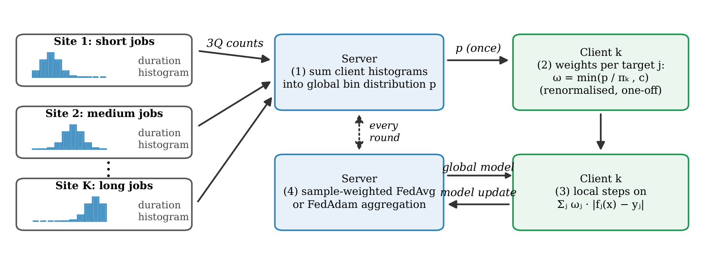
Fig. 1. FedTW workflow. Clients report per-target histograms once; the server returns the global bin distribution; each client computes clipped density-ratio weights once and trains with the weighted loss in every round, while aggregation and the per-round messages are unchanged.

Algorithm 1: FedTW (client weights computed once)
Input: clients $k=1..K$, bins $Q$, clip $c$, rounds $R$, local steps $τ$
each client sends its bin counts $n_{kjq}$ ($3Q$ integers) once
server computes $p_{jq}$ by (1) and broadcasts it
each client computes $ω_{kij}$ by (1)–(2)
for $r=1,…,R$ do
server sends the global model $θ^{r}$ to the clients
each client runs $τ$ Adam steps on $L_{k}$ in (3) from $θ^{r}$
server aggregates the client models (FedAvg or FedAdam)
end for

E. Communication and Computation Cost
The forecaster has 6,243 parameters (4,608 in the LSTM encoder and 545 in each head), so a model update occupies about 25 kB in 32-bit floating point, and a round of FedAvg with 20 clients exchanges about 1 MB in each direction. FedTW leaves this per-round traffic unchanged. Its only additional message is the histogram of $3Q=30$ integers per client, sent once before training, plus one broadcast of the 30 global bin probabilities, which is less than 0.1% of a single round. The weights are computed once on each client with one pass over its local targets, and the weighted loss adds one multiplication per sample and target to local training. FedTW is therefore suited to bandwidth-constrained links between sites and needs no change to the aggregation protocol, unlike methods that transmit control variates every round [15], which double the upload.

F. Baselines and Statistics
We compare FedAvg [8], FedProx [14], FedAvgM [17] (server momentum 0.9) and FedAdam [18] (server learning rate 0.03) with FedTW, FedTW+FedAdam and a centralised model trained with the same number of optimiser steps. FedProx is swept over $μ∈\{{10}^{−3},{10}^{−2},0.1,0.3,1,3,10\}$ on four regimes; the value with the lowest validation loss over these regimes ($μ=0.001$ on both traces) is used everywhere, as is common practice. SCAFFOLD [15] assumes local SGD, and with the adaptive local optimiser used here it fell below 70% IID $R^{2}$ on Alibaba for every scaling tried, so it is not reported. Methods are compared by paired differences over seeds with two-sided Wilcoxon signed-rank tests [36] and Holm correction [37] within stated families. Test-data uncertainty is quantified by a moving-block bootstrap [38] of the test period (200 resamples, blocks of 1,000 windows), and the test period is also split into four consecutive hold-out blocks.

IV. RESULTS

A. Target Skew Damages Mainly the Skewed Target
The centralised model reaches $R^{2}$ = 78.2/77.3/74.1% (duration/CPU/memory) on Alibaba and 55.9/54.2/47.3% on CC-IN2P3, and FedAvg with IID clients matches it (79.5/77.6/74.3% and 56.5/54.4/46.7%). A centralised model trained on as many samples as the whole federation gains up to 7.9 points on CC-IN2P3, so the year-long trace is still improving at this budget; all comparisons below are therefore made at equal budgets.
Table III reports FedAvg in every regime. Quantity skew, temporal silos and partial participation change every target by at most 2.4 points. System heterogeneity costs up to 11.2 duration points on CC-IN2P3, but it lowers all targets together because slow clients contribute fewer steps. Target skew behaves differently. LS-dur-0.1 reduces duration $R^{2}$ by 16.0 (Alibaba) and 32.0 points (CC-IN2P3), and BAND-dur by 22.6 and 46.2 points, while CPU and memory move by less than 4.7 points. Skewing CPU or memory instead lowers that target by 7.9/10.3 and 8.8/20.1 points. Fig. 2 shows that the loss of each target follows its JS divergence (Spearman $ρ=−0.67$, $p<0.001$, $n=66$).

TABLE III: Test $R^{2}$ (%) of FedAvg in every regime, mean of ten seeds; the change relative to IID FedAvg is given in parentheses. The centralised model is trained with the same number of optimiser steps (equal steps) or on as many samples as the federation (equal samples).
 | Alibaba 2017 |  |  | CC-IN2P3 2024
Regime | Duration | CPU | Memory | Duration | CPU | Memory
Central (equal steps) | 78.20 | 77.29 | 74.09 | 55.92 | 54.18 | 47.25
Central (equal samples) | 80.93 | 77.85 | 74.50 | 63.84 | 59.43 | 52.52
IID | 79.46 | 77.58 | 74.32 | 56.49 | 54.35 | 46.75
QTY | 79.46 (0.0) | 77.48 ($−$0.1) | 74.26 ($−$0.1) | 56.36 ($−$0.1) | 54.41 (+0.1) | 46.80 (+0.1)
TEMP | 79.31 ($−$0.2) | 77.49 ($−$0.1) | 74.17 ($−$0.2) | 54.34 ($−$2.1) | 53.44 ($−$0.9) | 44.39 ($−$2.4)
SYS | 76.95 ($−$2.5) | 76.70 ($−$0.9) | 73.46 ($−$0.9) | 45.32 ($−$11.2) | 52.15 ($−$2.2) | 41.75 ($−$5.0)
PART | 79.17 ($−$0.3) | 77.49 ($−$0.1) | 74.23 ($−$0.1) | 56.80 (+0.3) | 54.30 ($−$0.1) | 47.02 (+0.3)
LS-dur-1.0 | 78.03 ($−$1.4) | 77.60 (0.0) | 74.29 (0.0) | 48.78 ($−$7.7) | 54.16 ($−$0.2) | 46.03 ($−$0.7)
LS-dur-0.3 | 74.32 ($−$5.1) | 77.60 (0.0) | 74.28 (0.0) | 39.68 ($−$16.8) | 53.94 ($−$0.4) | 45.10 ($−$1.6)
LS-dur-0.1 | 63.48 ($−$16.0) | 77.07 ($−$0.5) | 74.01 ($−$0.3) | 24.49 ($−$32.0) | 53.01 ($−$1.3) | 43.21 ($−$3.5)
BAND-dur | 56.91 ($−$22.6) | 77.43 ($−$0.2) | 73.97 ($−$0.4) | 10.27 ($−$46.2) | 52.61 ($−$1.7) | 42.07 ($−$4.7)
LS-cpu-0.1 | 77.44 ($−$2.0) | 69.73 ($−$7.9) | 74.02 ($−$0.3) | 51.63 ($−$4.9) | 44.05 ($−$10.3) | 42.60 ($−$4.1)
LS-mem-0.1 | 78.91 ($−$0.5) | 77.50 ($−$0.1) | 65.55 ($−$8.8) | 44.67 ($−$11.8) | 51.97 ($−$2.4) | 26.66 ($−$20.1)

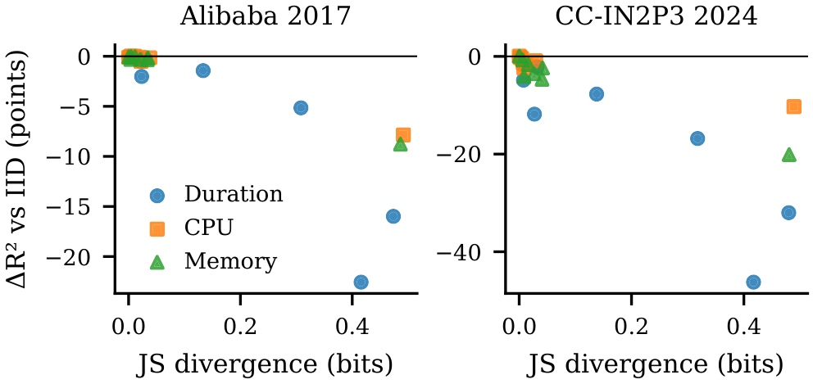
Fig. 2. Change in test $R^{2}$ of FedAvg relative to IID clients versus the JS divergence of the target, for every regime and target (mean of ten seeds).

B. The Proximal Term Does Not Repair Target Skew
Fig. 3 shows the FedProx sweep. With IID clients accuracy falls steadily as $μ$ grows. Under target skew no coefficient restores the skewed target: across the six skewed rows of the sweep, the best coefficient improves on FedAvg by at most 1.5 points, whereas FedTW gains 9.0 to 38.3 points in the same rows. Under BAND-dur, where the earlier analysis reported a large gain at $μ=1$, the proximal term is harmful once budgets are equal, and it stays harmful at three times the budget: after 180 rounds FedAvg reaches 69.2% duration $R^{2}$ on Alibaba and FedProx ($μ=1$) 54.0% (11.5% and 6.6% on CC-IN2P3). The earlier gain thus reflected the longer training of the proximal runs, not the proximal term. The validation-tuned coefficient is the smallest of the grid, which makes FedProx practically equal to FedAvg: none of the 66 trace$×$regime$×$target cells differs significantly after Holm correction. A proximal term on the duration head only does not help either (Table V).

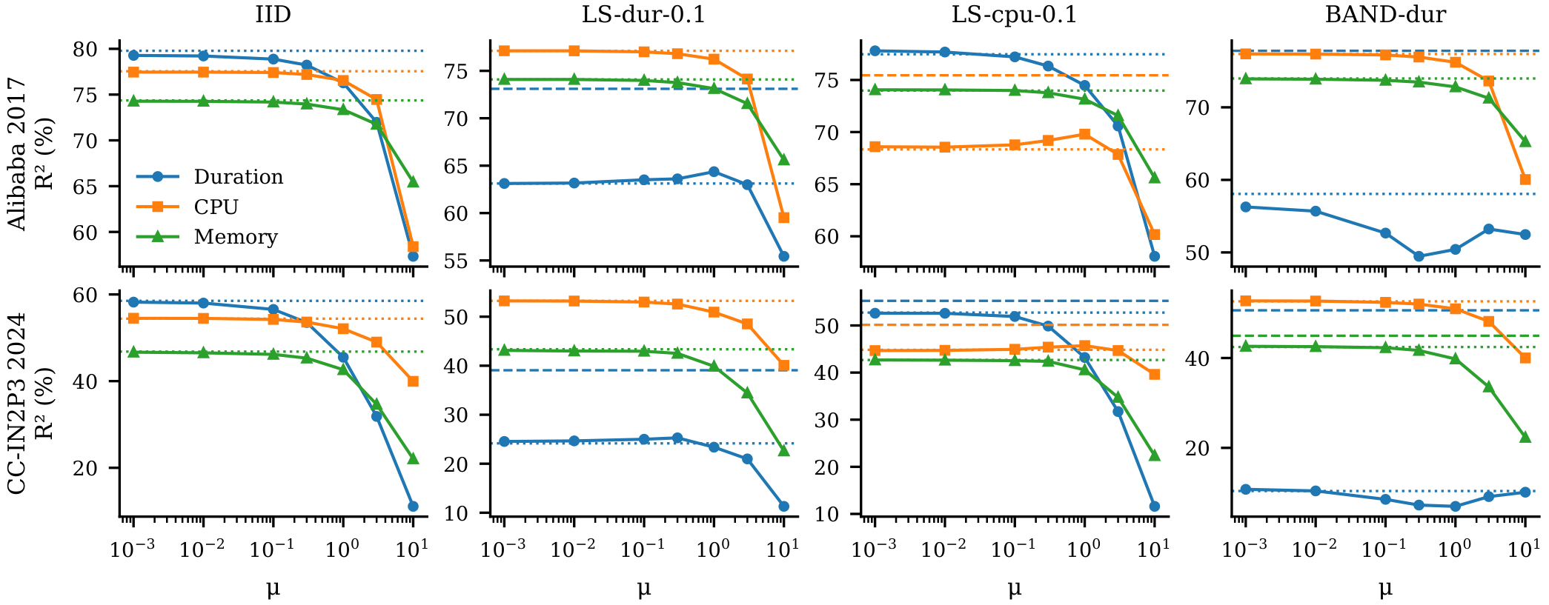
Fig. 3. FedProx sweep at a matched budget (five seeds). Dotted lines: FedAvg on the same seeds; dashed lines: FedTW where it differs from FedAvg by more than two points. No coefficient restores the skewed target, and large coefficients degrade all targets.

TABLE IV: Test $R^{2}$ (%, mean of ten seeds) on the skewed target of each target-skew regime and on duration under IID clients. The best federated method is in bold. $Δ$: FedTW minus FedAvg (paired, 95% CI); $p$: Wilcoxon signed-rank, Holm-corrected over the twelve skewed rows.
Trace | Regime | Target | Central | FedAvg | FedProx | FedAvgM | FedAdam | FedTW | FedTW+FedAdam | $Δ$ FedTW$−$FedAvg [95% CI] | $p$
Ali. | IID | Dur. | 78.20 | 79.46 | 79.44 | 81.31 | 81.59 | 79.45 | 81.60 | – | –
 | LS-dur-1.0 | Dur. | 78.20 | 78.03 | 78.04 | – | 80.79 | 78.80 | 81.64 | +0.77 [+0.26, +1.28] | 0.027
 | LS-dur-0.3 | Dur. | 78.20 | 74.32 | 74.26 | – | 77.59 | 76.42 | 80.29 | +2.11 [+0.34, +3.87] | 0.027
 | LS-dur-0.1 | Dur. | 78.20 | 63.48 | 63.42 | 62.77 | 61.86 | 72.51 | 75.59 | +9.04 [+7.02, +11.05] | 0.023
 | BAND-dur | Dur. | 78.20 | 56.91 | 56.91 | 68.85 | 70.89 | 77.70 | 81.09 | +20.80 [+18.37, +23.23] | 0.023
 | LS-cpu-0.1 | CPU | 77.29 | 69.73 | 69.85 | 68.67 | 71.12 | 75.52 | 75.73 | +5.79 [+2.60, +8.98] | 0.023
 | LS-mem-0.1 | Mem. | 74.09 | 65.55 | 65.60 | – | 65.52 | 72.18 | 72.69 | +6.63 [+4.37, +8.89] | 0.023
IN2P3 | IID | Dur. | 55.92 | 56.49 | 56.52 | 62.05 | 62.63 | 56.50 | 62.78 | – | –
 | LS-dur-1.0 | Dur. | 55.92 | 48.78 | 48.85 | – | 53.78 | 52.22 | 60.07 | +3.44 [+1.34, +5.54] | 0.023
 | LS-dur-0.3 | Dur. | 55.92 | 39.68 | 39.72 | – | 40.90 | 48.72 | 58.78 | +9.04 [+6.50, +11.58] | 0.023
 | LS-dur-0.1 | Dur. | 55.92 | 24.49 | 24.55 | 20.14 | 21.16 | 38.31 | 39.57 | +13.81 [+9.14, +18.49] | 0.023
 | BAND-dur | Dur. | 55.92 | 10.27 | 10.38 | 8.83 | 8.71 | 48.59 | 59.37 | +38.32 [+34.96, +41.68] | 0.023
 | LS-cpu-0.1 | CPU | 54.18 | 44.05 | 44.05 | 41.25 | 41.74 | 50.16 | 50.96 | +6.11 [+4.75, +7.47] | 0.023
 | LS-mem-0.1 | Mem. | 47.25 | 26.66 | 26.77 | – | 24.23 | 39.79 | 42.73 | +13.14 [+10.17, +16.11] | 0.023

C. FedTW Corrects Target Skew Without Side Effects
Table IV compares the methods on the skewed targets and Fig. 4 shows all methods, regimes and targets. FedTW improves the skewed target in all 12 target-skew cases; every seed improves in 10 of them, all remain significant after Holm correction, and the block-bootstrap interval excludes zero in 12 of 12. Relative to FedAvg with IID clients at the same budget, FedTW recovers 92% and 83% of the duration accuracy lost under BAND-dur and 57% and 43% under LS-dur-0.1. Over the 54 remaining cells (other targets and non-skew regimes) the largest decrease relative to FedAvg is 0.38 points and none is significant, while some correlated off-target cells improve by up to 3.7 points. Server-side adaptivity alone does not address target skew (FedAdam is no better than FedAvg under LS-dur-0.1), but it is complementary to FedTW: FedTW+FedAdam improves over FedAdam in 12 of 12 skewed cases after correction and is the most accurate federated method in every skewed row. FedTW is also better than tuned FedProx in 12 of 12 skewed cases.

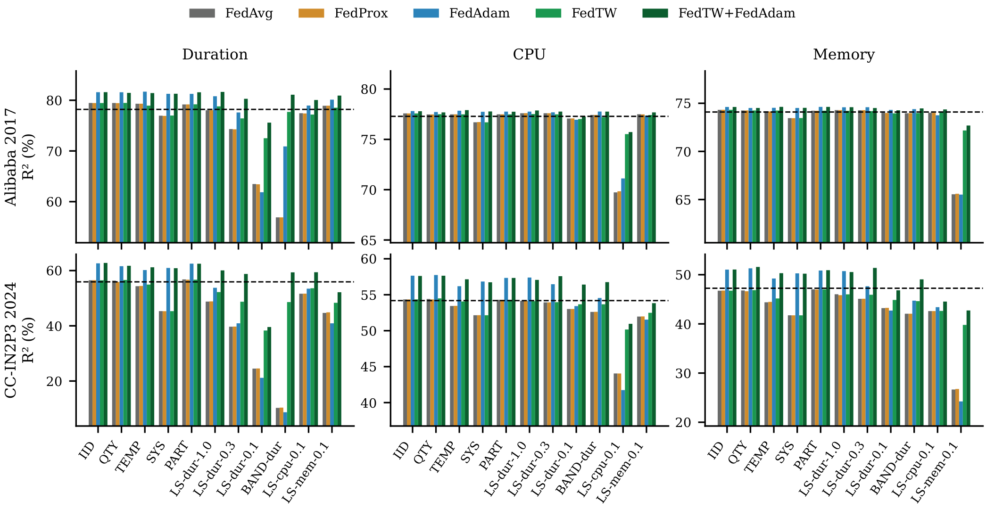
Fig. 4. Test $R^{2}$ of all methods in all regimes (mean of ten seeds); the dashed line marks the centralised model with equal steps. FedTW coincides with FedAvg where there is no target skew and recovers the skewed target where there is.

D. Budget, Robustness and Ablations
Fig. 5 plots duration $R^{2}$ against rounds. Under target skew, FedTW leads FedAvg and FedAdam at every recorded round, so the advantage does not depend on where training stops; with 180 rounds FedTW reaches 77.7% and 47.7% under LS-dur-0.1, against 65.3% and 25.2% for FedAvg. The gain is positive in each of the four temporal test blocks for 12 of the 12 cases. Table V varies the design: five or twenty bins change the result by at most 1.3 points, a tighter clip ($c=3$) performs equally well, and Laplace-noised histograms with $ε=1$ or $0.1$ retain the full gain, because client bins hold hundreds of samples. Adding a proximal term to FedTW lowers accuracy, and communicating five times more often ($τ=5$, 300 rounds) helps FedAvg on Alibaba only and never reaches FedTW. The histogram exchange is 30 integers per client, sent once, and the run time of FedTW does not differ measurably from FedAvg (-2.9%).
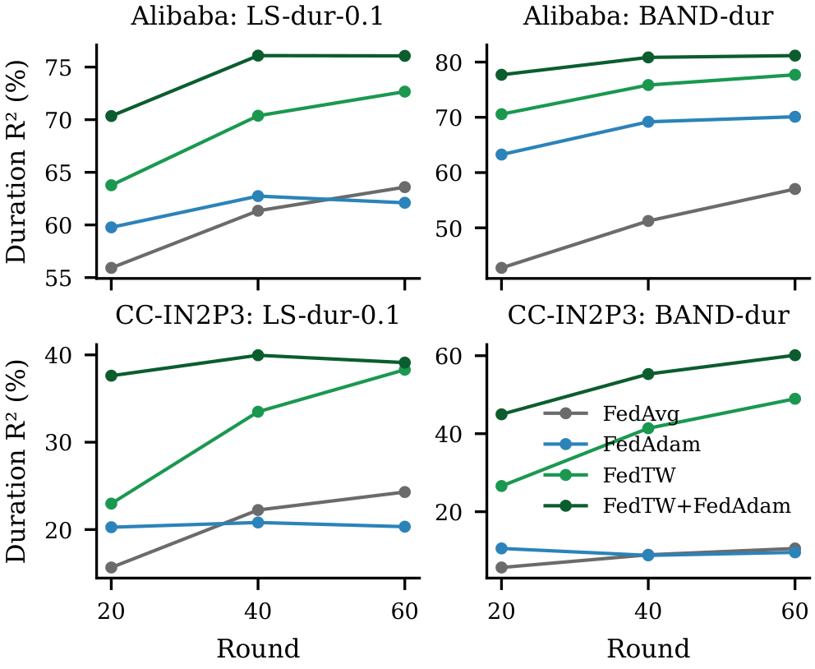
Fig. 5. Duration test $R^{2}$ versus communication round (mean of ten seeds) under severe duration skew and the band partition.
TABLE V: Ablations: test $R^{2}$ (%) of the skewed target, mean of seeds 0–4. Columns: LS-dur-0.1, BAND-dur and LS-cpu-0.1 on Alibaba (A) and CC-IN2P3 (I).
Variant | A-dur | A-band | A-cpu | I-dur | I-band | I-cpu
FedAvg | 63.12 | 58.07 | 68.34 | 24.15 | 10.39 | 44.83
FedTW (Q = 10, c = 10) | 73.11 | 77.80 | 75.45 | 39.07 | 50.62 | 50.14
FedTW, Q = 5 | 72.49 | 78.14 | 75.06 | 39.82 | 49.30 | 50.95
FedTW, Q = 20 | 73.43 | 78.30 | 75.32 | 38.73 | 50.47 | 50.20
FedTW, c = 3 | 73.10 | 78.48 | 75.14 | 40.67 | 51.18 | 50.37
FedTW, DP ε = 1 | 73.05 | 78.44 | 75.38 | 39.02 | 50.57 | 50.17
FedTW, DP ε = 0.1 | 73.37 | 78.44 | 75.40 | 39.08 | 50.48 | 50.16
FedTW + prox. (μ = 1) | 70.44 | 74.60 | 74.16 | 33.72 | 39.15 | 49.00
Prox. on dur. head (μ = 1) | 64.38 | 50.43 | 68.64 | 26.29 | 7.28 | 44.54
FedAvg, τ = 5, 300 rnd. | 70.92 | 72.19 | 71.57 | 23.12 | 12.75 | 45.55

V. DISCUSSION AND LIMITATIONS
When clients differ in the distribution of one target, each minimises a loss that over-represents part of that target’s range, and the client objectives disagree about the optimum itself. A proximal term limits how far clients move, which also slows all other learning; at an equal budget the two effects cancel or the second dominates. Re-weighting removes the disagreement, and because it is computed per output it is target-specific, exactly the property that a single model-wide coefficient lacks. For operators of multi-site clouds, the per-target divergence of the one-shot histograms is a cheap diagnostic that predicts which forecasts will suffer, and FedTW costs nothing where the divergence is small. The regime analysis also shows when FedTW is not needed. Quantity skew, temporal silos, heterogeneous local work and partial participation leave the per-target histograms close to the global ones, so the weights are close to one and FedTW behaves as FedAvg (Fig. 4); the losses in these regimes come from optimisation budget rather than from label shift, and server-side adaptivity such as FedAdam is the appropriate tool there. Combining the two, as in FedTW+FedAdam, covers both sources of error. The design parameters are not critical: the bin count $Q$ trades resolution against the number of samples per bin, and the clip $c$ only matters for clients with nearly empty bins, which is why the ablations change the results by about one point at most.
FedTW also fits the operational constraints of distributed clouds. It needs one message per client before training, works with partial participation and heterogeneous local work (it matched FedAvg in SYS and PART), and can be combined with secure aggregation, since the server only needs the sum of the histograms. When a new site joins, it reports its histogram, the global distribution is updated, and existing sites refresh their weights locally without retraining from scratch.
The study has limitations. The partitions are constructed from two traces rather than observed across independent sites, and real federations may also differ in the input distribution, which FedTW does not correct. The correction assumes label shift; the remaining gap under severe skew on CC-IN2P3 suggests that this holds only approximately. The 60-round budget does not fully converge on CC-IN2P3, although the 180-round check leaves the conclusions unchanged. Finally, the forecaster is a compact LSTM chosen to make ten-seed studies affordable.

VI. CONCLUSION
Under a budget-matched protocol on two production traces and 11 client regimes, target skew damages mainly the forecast of the skewed target, in proportion to the measured divergence, and the FedProx proximal term does not repair it at any coefficient. The failure is label shift, and FedTW, a target-wise importance re-weighting driven by one-shot ten-bin histograms, corrects it: it significantly improves the skewed target in every target-skew case, matches FedAvg under IID clients and composes with adaptive server optimisers. Future work will address joint shifts of inputs and targets and federations of independently operated sites. Code, partitions and per-seed results are released with the paper.

REFERENCES
[1] M. Masdari and A. Khoshnevis, “A survey and classification of the workload forecasting methods in cloud computing,” Cluster Computing, vol. 23, no. 4, pp. 2399–2424, 2020.
[2] J. Kumar and A. K. Singh, “Workload prediction in cloud using artificial neural network and adaptive differential evolution,” Future Gener. Comput. Syst., vol. 81, pp. 41–52, 2018.
[3] M. Xu, C. Song, H. Wu, S. S. Gill, K. Ye, and C. Xu, “esDNN: Deep neural network based multivariate workload prediction in cloud computing environments,” ACM Trans. Internet Technol., vol. 22, no. 3, art. 75, 2022.
[4] D. Janardhanan and E. Barrett, “CPU workload forecasting of machines in data centers using LSTM recurrent neural networks and ARIMA models,” in Proc. ICITST, 2017, pp. 55–60.
[5] J. Bi, H. Ma, H. Yuan, and J. Zhang, “Accurate prediction of workloads and resources with multi-head attention and hybrid LSTM for cloud data centers,” IEEE Trans. Sustain. Comput., vol. 8, no. 3, pp. 375–384, 2023.
[6] J. Dogani, F. Khunjush, M. R. Mahmoudi, and M. Seydali, “Multivariate workload and resource prediction in cloud computing using CNN and GRU by attention mechanism,” J. Supercomput., vol. 79, no. 3, pp. 3437–3470, 2023.
[7] V. Mothukuri, R. M. Parizi, S. Pouriyeh, Y. Huang, A. Dehghantanha, and G. Srivastava, “A survey on security and privacy of federated learning,” Future Gener. Comput. Syst., vol. 115, pp. 619–640, 2021.
[8] B. McMahan, E. Moore, D. Ramage, S. Hampson, and B. Aguera y Arcas, “Communication-efficient learning of deep networks from decentralized data,” in Proc. AISTATS, 2017, pp. 1273–1282.
[9] P. Kairouz et al., “Advances and open problems in federated learning,” Found. Trends Mach. Learn., vol. 14, no. 1–2, pp. 1–210, 2021.
[10] W. Y. B. Lim et al., “Federated learning in mobile edge networks: A comprehensive survey,” IEEE Commun. Surveys Tuts., vol. 22, no. 3, pp. 2031–2063, 2020.
[11] Y. Zhao, M. Li, L. Lai, N. Suda, D. Civin, and V. Chandra, “Federated learning with non-IID data,” arXiv:1806.00582, 2018.
[12] K. Hsieh, A. Phanishayee, O. Mutlu, and P. B. Gibbons, “The non-IID data quagmire of decentralized machine learning,” in Proc. ICML, 2020, pp. 4387–4398.
[13] X. Li, K. Huang, W. Yang, S. Wang, and Z. Zhang, “On the convergence of FedAvg on non-IID data,” in Proc. ICLR, 2020.
[14] T. Li, A. K. Sahu, M. Zaheer, M. Sanjabi, A. Talwalkar, and V. Smith, “Federated optimization in heterogeneous networks,” in Proc. MLSys, 2020, pp. 429–450.
[15] S. P. Karimireddy, S. Kale, M. Mohri, S. Reddi, S. Stich, and A. T. Suresh, “SCAFFOLD: Stochastic controlled averaging for federated learning,” in Proc. ICML, 2020, pp. 5132–5143.
[16] J. Wang, Q. Liu, H. Liang, G. Joshi, and H. V. Poor, “Tackling the objective inconsistency problem in heterogeneous federated optimization,” in Proc. NeurIPS, 2020, pp. 7611–7623.
[17] T.-M. H. Hsu, H. Qi, and M. Brown, “Measuring the effects of non-identical data distribution for federated visual classification,” arXiv:1909.06335, 2019.
[18] S. J. Reddi et al., “Adaptive federated optimization,” in Proc. ICLR, 2021.
[19] Q. Li, Y. Diao, Q. Chen, and B. He, “Federated learning on non-IID data silos: An experimental study,” in Proc. IEEE ICDE, 2022, pp. 965–978.
[20] H. Zhu, J. Xu, S. Liu, and Y. Jin, “Federated learning on non-IID data: A survey,” Neurocomputing, vol. 465, pp. 371–390, 2021.
[21] A. Z. Tan, H. Yu, L. Cui, and Q. Yang, “Towards personalized federated learning,” IEEE Trans. Neural Netw. Learn. Syst., vol. 34, no. 12, pp. 9587–9603, 2023.
[22] J. Zhang et al., “Federated learning with label distribution skew via logits calibration,” in Proc. ICML, 2022, pp. 26311–26329.
[23] X.-C. Li and D.-C. Zhan, “FedRS: Federated learning with restricted softmax for label distribution non-IID data,” in Proc. ACM SIGKDD, 2021, pp. 995–1005.
[24] M. Saerens, P. Latinne, and C. Decaestecker, “Adjusting the outputs of a classifier to new a priori probabilities: A simple procedure,” Neural Comput., vol. 14, no. 1, pp. 21–41, 2002.
[25] Z. Lipton, Y.-X. Wang, and A. Smola, “Detecting and correcting for label shift with black box predictors,” in Proc. ICML, 2018, pp. 3122–3130.
[26] V. Perifanis, N. Pavlidis, R.-A. Koutsiamanis, and P. S. Efraimidis, “Federated learning for 5G base station traffic forecasting,” Comput. Netw., vol. 235, art. 109950, 2023.
[27] C. Briggs, Z. Fan, and P. Andras, “Federated learning for short-term residential load forecasting,” IEEE Open Access J. Power Energy, vol. 9, pp. 573–583, 2022.
[28] M. N. Fekri, K. Grolinger, and S. Mir, “Distributed load forecasting using smart meter data: Federated learning with recurrent neural networks,” Int. J. Electr. Power Energy Syst., vol. 137, art. 107669, 2022.
[29] Alibaba Group, “Alibaba cluster trace program: cluster-trace-v2017,” 2017. [Online]. Available: https://github.com/alibaba/clusterdata
[30] G. Cochard and B. Simon, “CC-IN2P3 2024 workload dataset,” Zenodo, 2026, doi: 10.5281/zenodo.18668107.
[31] S. Hochreiter and J. Schmidhuber, “Long short-term memory,” Neural Comput., vol. 9, no. 8, pp. 1735–1780, 1997.
[32] D. P. Kingma and J. Ba, “Adam: A method for stochastic optimization,” in Proc. ICLR, 2015.
[33] J. Lin, “Divergence measures based on the Shannon entropy,” IEEE Trans. Inf. Theory, vol. 37, no. 1, pp. 145–151, 1991.
[34] K. Bonawitz et al., “Practical secure aggregation for privacy-preserving machine learning,” in Proc. ACM CCS, 2017, pp. 1175–1191.
[35] C. Dwork, F. McSherry, K. Nissim, and A. Smith, “Calibrating noise to sensitivity in private data analysis,” in Proc. TCC, 2006, pp. 265–284.
[36] F. Wilcoxon, “Individual comparisons by ranking methods,” Biometrics Bull., vol. 1, no. 6, pp. 80–83, 1945.
[37] S. Holm, “A simple sequentially rejective multiple test procedure,” Scand. J. Statist., vol. 6, no. 2, pp. 65–70, 1979.
[38] H. R. Künsch, “The jackknife and the bootstrap for general stationary observations,” Ann. Statist., vol. 17, no. 3, pp. 1217–1241, 1989.

