FedTW: target-wise label-shift correction for federated multi-target cloud workload forecasting under heterogeneous clients
Thanoon Y. Mohammed^{1*}, Ahmad F. AL-allaf², M. R. Mouhamed³
¹ Department of Computer Technique Engineering, Northern Technical University, Mosul, Iraq
² Computer Engineering Department, Technical College for Computer and AI, Northern Technical University, Mosul, Iraq
³ Department of Mathematics, Faculty of Science, Helwan University, Cairo, Egypt
Correspondence: thanon.younes@ntu.edu.iq

Abstract
Federated learning allows cloud sites to train a shared workload forecaster without pooling their utilisation traces, but sites rarely hold identically distributed jobs. We study federated forecasting of job duration, CPU usage and memory usage on the Alibaba 2017 and CC-IN2P3 2024 production traces under 11 client regimes, with every method given the same number of rounds, local steps and samples. When clients differ in the range of one target, the damage concentrates on that target: under severe Dirichlet duration skew, federated averaging loses 16.0 and 32.0 R² points of duration accuracy relative to IID clients on the two traces, while CPU and memory are almost unchanged. At a matched budget, the FedProx proximal term does not repair this loss at any coefficient between 0.001 and 10, which indicates that the failure is a label-shift problem rather than client drift. We therefore propose FedTW, a target-wise label-shift correction that re-weights the loss of every output by the ratio of global and local target densities, estimated from one-shot ten-bin histograms. FedTW improves the skewed target in all 12 target-skew cells across both traces (Holm-corrected Wilcoxon p ≤ 0.027), for example by 9.0 and 13.8 R² points for severe duration skew and by 20.8 and 38.3 points for the most extreme partition, and it matches federated averaging under IID data. The correction adds no per-round communication, tolerates differentially private histograms and combines with adaptive server optimisers. Code, partitions and per-seed results are released.
Keywords: Federated learning, Cloud workload forecasting, Label distribution skew, Importance weighting, FedProx, Multi-target regression, Non-IID data

Introduction
Accurate forecasts of job duration, CPU usage and memory usage underpin capacity planning, autoscaling and energy-aware placement in cloud data centres [1, 2]. Recurrent and attention-based forecasters trained on historical utilisation traces now represent the state of practice [3–6]. These models are normally trained on a pooled trace. When the telemetry belongs to several tenants, sites or providers, however, pooling is often impossible: utilisation traces reveal tenant behaviour and workload composition [7], and data-protection regulation restricts their transfer [8]. Federated learning (FL) removes the need to pool data by exchanging model updates instead of records [9, 10], and it is therefore a natural fit for multi-site workload forecasting [11].
The difficulty is that the clients of a workload federation rarely hold identically distributed data. Sites specialise: one cluster runs short interactive jobs, another long batch jobs, a third memory-heavy analytics. In FL terms this is a skew in the distribution of the prediction targets across clients. Federated averaging (FedAvg) is known to degrade when client distributions differ [12–14], and the standard remedy is to limit client drift, most prominently with the proximal term of FedProx [15]. In an earlier version of this study we followed that route and reported that a large proximal coefficient recovered much of the duration accuracy lost under a duration-sorted client partition. Two observations made us revisit that conclusion. First, the proximal configurations trained for several times more communication rounds than FedAvg under early stopping, so the gain could not be separated from the longer training. Second, the benefit appeared only for the target that defined the partition, while one model-wide coefficient harmed the other two targets of the same network.
This paper replaces the fixed-coefficient view with a diagnosis and a remedy. We re-run the study under a strictly budget-matched protocol, in which every method receives the same number of rounds, local steps and samples, and we grade the heterogeneity of each target separately. The evidence points to a simple mechanism. When clients differ in the range of one target, their local objectives are biased estimates of the global objective for that target only; the resulting failure is a label-shift problem rather than an optimisation-drift problem, and a proximal term, which only slows the local model down, does not remove the bias. We therefore propose FedTW (Federated Target-Wise re-weighting), which corrects the local loss of every target with importance weights computed from coarse, one-shot target histograms. FedTW makes the local objective of each target unbiased for the global one under label shift, reduces exactly to FedAvg when clients are identically distributed, adds no per-round communication, and can be combined with any server optimiser.

Contributions
The paper makes four contributions.
(i) A budget-matched benchmark for federated multi-target workload forecasting on two production traces, Alibaba 2017 [16] and CC-IN2P3 2024 [17], covering 11 client regimes, including Dirichlet target skew graded in severity and applied to each target in turn, with the resulting client divergence quantified for every regime.
(ii) A diagnosis showing that the damage caused by target skew concentrates on the skewed target, grows with the measured divergence, and is not repaired by proximal regularisation at any tested coefficient once training budgets are equal; the gains attributed to FedProx in our earlier analysis are explained by longer training.
(iii) FedTW, a target-wise label-shift correction for multi-output regression that recovers 92% and 83% of the duration accuracy lost to the most severe partition of the two traces while matching FedAvg under IID data, together with ablations on histogram resolution, weight clipping and differentially private histograms.
(iv) A statistical protocol with ten seeds per configuration, paired Wilcoxon tests with Holm correction, moving-block bootstrap intervals that capture test-data uncertainty, and four temporal hold-out blocks, released with code, partitions and per-seed results.
The rest of the paper is organised as follows. The next section reviews related work. The Methods section describes the data, the forecasting model, the client regimes, the baselines and FedTW. The Results section reports the heterogeneity diagnosis, the proximal sweep, the comparison of methods and the robustness analyses. The Discussion section interprets the findings and states the limitations, and the last section concludes.

Related work

Cloud workload forecasting
Workload forecasting in clouds has progressed from statistical models to deep sequence models [1]. Janardhanan and Barrett compared LSTM and ARIMA models for machine-level CPU forecasting [4]; Kumar and Singh combined neural networks with adaptive differential evolution [2]; and Xu et al. cast multivariate resource usage as a sliding-window supervised problem [3]. Later work added attention [5], convolutional-recurrent hybrids [6], correlation-aware collaborative LSTMs across servers [18] and integrated host-load models [19, 20]. All of these methods assume that the training trace is available in one place. The present study keeps a compact recurrent forecaster and concentrates on what changes when the trace is split across clients that cannot share it.

Federated optimisation under heterogeneity
FedAvg [9] performs several local steps on each client before averaging the models. When client distributions differ, the local optima move apart and the averaged model drifts away from the minimiser of the global objective [12–14, 21]. Two families of remedies address this drift. Client-side corrections modify the local update: FedProx adds a proximal penalty that keeps local models near the global model [15], SCAFFOLD corrects local gradients with control variates [22], FedNova normalises heterogeneous numbers of local steps [23], and FedDyn uses a dynamic regulariser [24]. Server-side methods instead change aggregation, for example FedAvgM with server momentum [25] and the adaptive FedAdam optimiser [26]. Large benchmarks show that no single method dominates across label, feature and quantity skew [27], and surveys emphasise that the appropriate remedy depends on the form of heterogeneity [28–30]. Personalised FL, which keeps part of the model local [31, 32], targets a different goal: good per-client models rather than a single global model.

Label distribution skew
For classification, label distribution skew has specific remedies. FedLC calibrates logits with the local class prior [33], and FedRS restricts the softmax updates of missing classes [34]. Both rely on a discrete label space and a softmax output, and neither applies directly to continuous targets. Outside FL, importance weighting by the ratio of target and source label densities is the classical correction for label shift [35–37], and label-density re-weighting has been used for imbalanced regression [38]. We are not aware of work that applies this correction per output of a multi-target federated regressor, where each output can be skewed independently.

Federated time-series forecasting
Federated forecasting has been studied for base-station traffic [39], residential and smart-meter load [40, 41] and smart grids [42]. These studies consistently report that sophisticated aggregators rarely beat FedAvg on time series and that the proximal coefficient is tuned once per study or data set; one reports an optimum near 0.5 [42]. They usually forecast one target and rarely control the heterogeneity of the client partition. The present work differs in three respects: it grades target skew for each output of a multi-target forecaster, it compares methods under identical training budgets, and it proposes a correction aimed at the mechanism that the diagnosis identifies.

Methods

Workload traces and preprocessing
Two production traces with different structure and time scale are used. Alibaba cluster-trace-v2017 [16] records one day of a commercial cluster; terminated batch instances with valid timestamps are kept, and duration is the difference between end and start time. The CC-IN2P3 2024 trace [17] covers one year of a scientific computing centre; records affected by the documented collection fault are removed, duration is computed from the timestamps, mean CPU utilisation is CPU time divided by duration, and the maximum resident set size is used for memory. Jobs are sorted by start time, and consecutive jobs are mean-pooled into blocks of 10 (Alibaba) and 70 (CC-IN2P3) to suppress per-job noise, which yields 191,118 and 343,368 records. Every target is log-transformed with log(1 + x) and standardised with the median and inter-quartile range of the training period only.

Forecasting task and leakage-free split
Each sample maps a window of the 24 most recent records (duration, CPU and memory) to the three values of the next record. The record sequence is divided chronologically into training (first 72%), validation (next 8%) and test (last 20%) periods before any client partitioning, and windows are built inside each period, so no input or target crosses a period boundary. This gives 137,580/15,266/38,200 training, validation and test windows for Alibaba and 247,200/27,446/68,650 for CC-IN2P3. Only training windows are distributed to clients. Validation windows are used for checkpoint selection and for the single tuning decision of FedProx; because the validation loss is a sample-weighted mean, it equals the loss that clients holding the validation windows would report to the server. Test windows are used once, for the selected checkpoint and, as a secondary report, for the final-round model. All methods, regimes and seeds share the same test set, which is also the test set of the centralised reference.

Forecasting model
The forecaster is a single-layer LSTM encoder [43] with 32 units, followed by dropout (0.2) and one head per target. Each head is a 16-unit ReLU layer and a linear output, so the encoder is shared while each target has its own parameters. The model is trained with the mean absolute error summed over the three standardised targets, and every client uses Adam [44] with learning rate 10⁻³ and batch size 32; the optimiser state is reset at every round. The same architecture, loss and optimiser are used for the centralised reference, which trains on the pooled training windows for the same number of optimiser steps per round.

Federated protocol and training budget
Twenty clients participate in every round unless a regime specifies otherwise. Each round consists of τ = 25 local steps per client, after which the server aggregates the models weighted by client sample counts. Training runs for R = 60 rounds for every method; there is no early stopping, and the checkpoint with the lowest validation loss, evaluated every five rounds, is reported. Every method therefore receives the same number of rounds, local steps, samples and communication, which removes the confound between regularisation and training length. Test accuracy is also recorded every twenty rounds to compare methods as a function of the budget. Initial weights are identical across clients and methods for a given seed, and each configuration is run with ten seeds (0–9) that change the initialisation, the client partition and the sampling of mini-batches. The implementation stacks the parameters of all clients and seeds into one batched model in PyTorch [45], which makes a complete ten-seed federation run in a few minutes on four CPU cores.

Client regimes and measured heterogeneity
Table 1 defines the 11 client regimes. IID assigns windows to clients uniformly at random, which gives a genuinely identically distributed reference; the chronological-chunk reference of the earlier version is retained as the temporal regime TEMP. QTY draws client sizes from a Dirichlet distribution (α = 0.5) while keeping every client's content IID. Target (label) skew follows the Dirichlet protocol of Hsu et al. [25] adapted to regression: the chosen target is discretised into ten quantile bins of the training period, and the windows of each bin are spread over clients with proportions drawn from Dirichlet(α). Smaller α means stronger skew; we use α ∈ {1.0, 0.3, 0.1} for duration and α = 0.1 for CPU and memory. BAND-dur reproduces the partition of the earlier version: 80% of the windows are sorted by duration into 20 contiguous bands, one per client, and the remaining 20% are spread uniformly. SYS gives each client 20%, 40% or 100% of the local steps, and PART samples half of the clients in every round.
Heterogeneity is quantified per target by the sample-weighted Jensen–Shannon divergence [46] between each client's histogram of that target over the ten bins and the global histogram (in bits, between 0 and 1). The values in Table 1 show that each target-skew regime affects mainly the target it was built from, which lets us attribute accuracy changes to the heterogeneity of a specific output.
Table 1 Client regimes and measured heterogeneity. JS is the sample-weighted Jensen–Shannon divergence (bits) between each client's target histogram (ten training-quantile bins) and the global histogram, averaged over ten partition seeds.
Regime | Construction of the 20 clients | Heterogeneity modelled | JS dur. (Ali) | JS CPU (Ali) | JS mem. (Ali) | JS dur. (IN2P3) | JS CPU (IN2P3) | JS mem. (IN2P3)
IID | Uniform random assignment of windows | Reference, no heterogeneity | 0.000 | 0.000 | 0.000 | 0.000 | 0.000 | 0.000
QTY | Random content, client sizes ~ Dirichlet(0.5) | Quantity skew | 0.000 | 0.000 | 0.000 | 0.000 | 0.000 | 0.000
TEMP | 20 consecutive time blocks of the training period | Temporal silos | 0.020 | 0.020 | 0.035 | 0.032 | 0.029 | 0.042
SYS | IID data; 20%, 40% or 100% of local steps | System heterogeneity | 0.000 | 0.000 | 0.000 | 0.000 | 0.000 | 0.000
PART | IID data; 10 of 20 clients per round | Partial participation | 0.000 | 0.000 | 0.000 | 0.000 | 0.000 | 0.000
LS-dur-1.0 | Duration bins spread by Dirichlet(1.0) | Mild duration skew | 0.133 | 0.004 | 0.004 | 0.138 | 0.002 | 0.006
LS-dur-0.3 | Duration bins spread by Dirichlet(0.3) | Moderate duration skew | 0.308 | 0.011 | 0.011 | 0.318 | 0.004 | 0.016
LS-dur-0.1 | Duration bins spread by Dirichlet(0.1) | Severe duration skew | 0.474 | 0.022 | 0.021 | 0.480 | 0.007 | 0.026
BAND-dur | 80% sorted into 20 duration bands, 20% uniform | Extreme duration skew (earlier S4) | 0.416 | 0.038 | 0.033 | 0.417 | 0.012 | 0.041
LS-cpu-0.1 | CPU bins spread by Dirichlet(0.1) | Severe CPU skew | 0.023 | 0.491 | 0.004 | 0.008 | 0.489 | 0.008
LS-mem-0.1 | Memory bins spread by Dirichlet(0.1) | Severe memory skew | 0.023 | 0.004 | 0.486 | 0.027 | 0.008 | 0.481

Baselines
We compare FedTW with FedAvg [9], FedProx [15], FedAvgM [25] and FedAdam [26], and with the centralised model. FedProx is swept over μ ∈ {0.001, 0.01, 0.1, 0.3, 1, 3, 10} on four regimes (IID, LS-dur-0.1, LS-cpu-0.1 and BAND-dur) with five seeds. The coefficient with the lowest mean validation loss over these regimes (μ = 0.001 on both traces, the smallest value of the grid) is then used in all regimes, which mirrors the common practice of tuning μ once per data set. FedAvgM uses server momentum 0.9 with server learning rate 1, and FedAdam uses server learning rate 0.03, β₁ = 0.9, β₂ = 0.99 and ε = 10⁻³; both settings were chosen on the IID validation loss of Alibaba. To test whether a target-specific proximal term would suffice, an ablation applies μ = 1 to the duration head only. We also evaluated SCAFFOLD [22]. Its control variates assume plain local SGD and scale with the inverse learning rate, and with the adaptive local optimiser used here they degraded the IID accuracy of Alibaba to below 70% R² for every scaling we tried. Because this reflects an incompatibility of settings rather than a property of the method, SCAFFOLD is not reported further. Classification-specific label-skew methods [33, 34] do not apply to continuous targets.

FedTW: target-wise label-shift correction
Let client k hold n_{k} training windows (x_{i}, y_{i}) with targets y_{i} = (y_{i1}, y_{i2}, y_{i3}), and let b_{ij} ∈ {1, …, Q} be the training-period quantile bin of target j for sample i (Q = 10). Before training, each client reports the counts n_{kjq} of its training targets in every bin of every target, 3Q integers in total. The server adds them to form the global bin distribution
p_{jq} = Σ_{k} n_{kjq} / Σ_{k} n_{k} , (1)
and each client forms its own smoothed distribution
π_{kjq} = (n_{kjq} + 1) / (n_{k} + Q) . (2)
The FedTW weight of sample i on client k for target j is the clipped density ratio, renormalised to mean one on the client:
ω̃_{kij} = min( p_{j,bᵢⱼ} / π_{kj,bᵢⱼ} , c ), ω_{kij} = ω̃_{kij} / ( (1/n_{k}) Σ_{i′} ω̃_{ki′j} ) , (3)
with clipping constant c = 10. Local training then minimises the target-wise weighted loss
L_{k}(θ) = (1/n_{k}) Σ_{i} Σ_{j} ω_{kij} | f_{j}(x_{i}; θ) − y_{ij} | , (4)
and the server aggregates exactly as in FedAvg (or FedAdam, for FedTW+FedAdam).
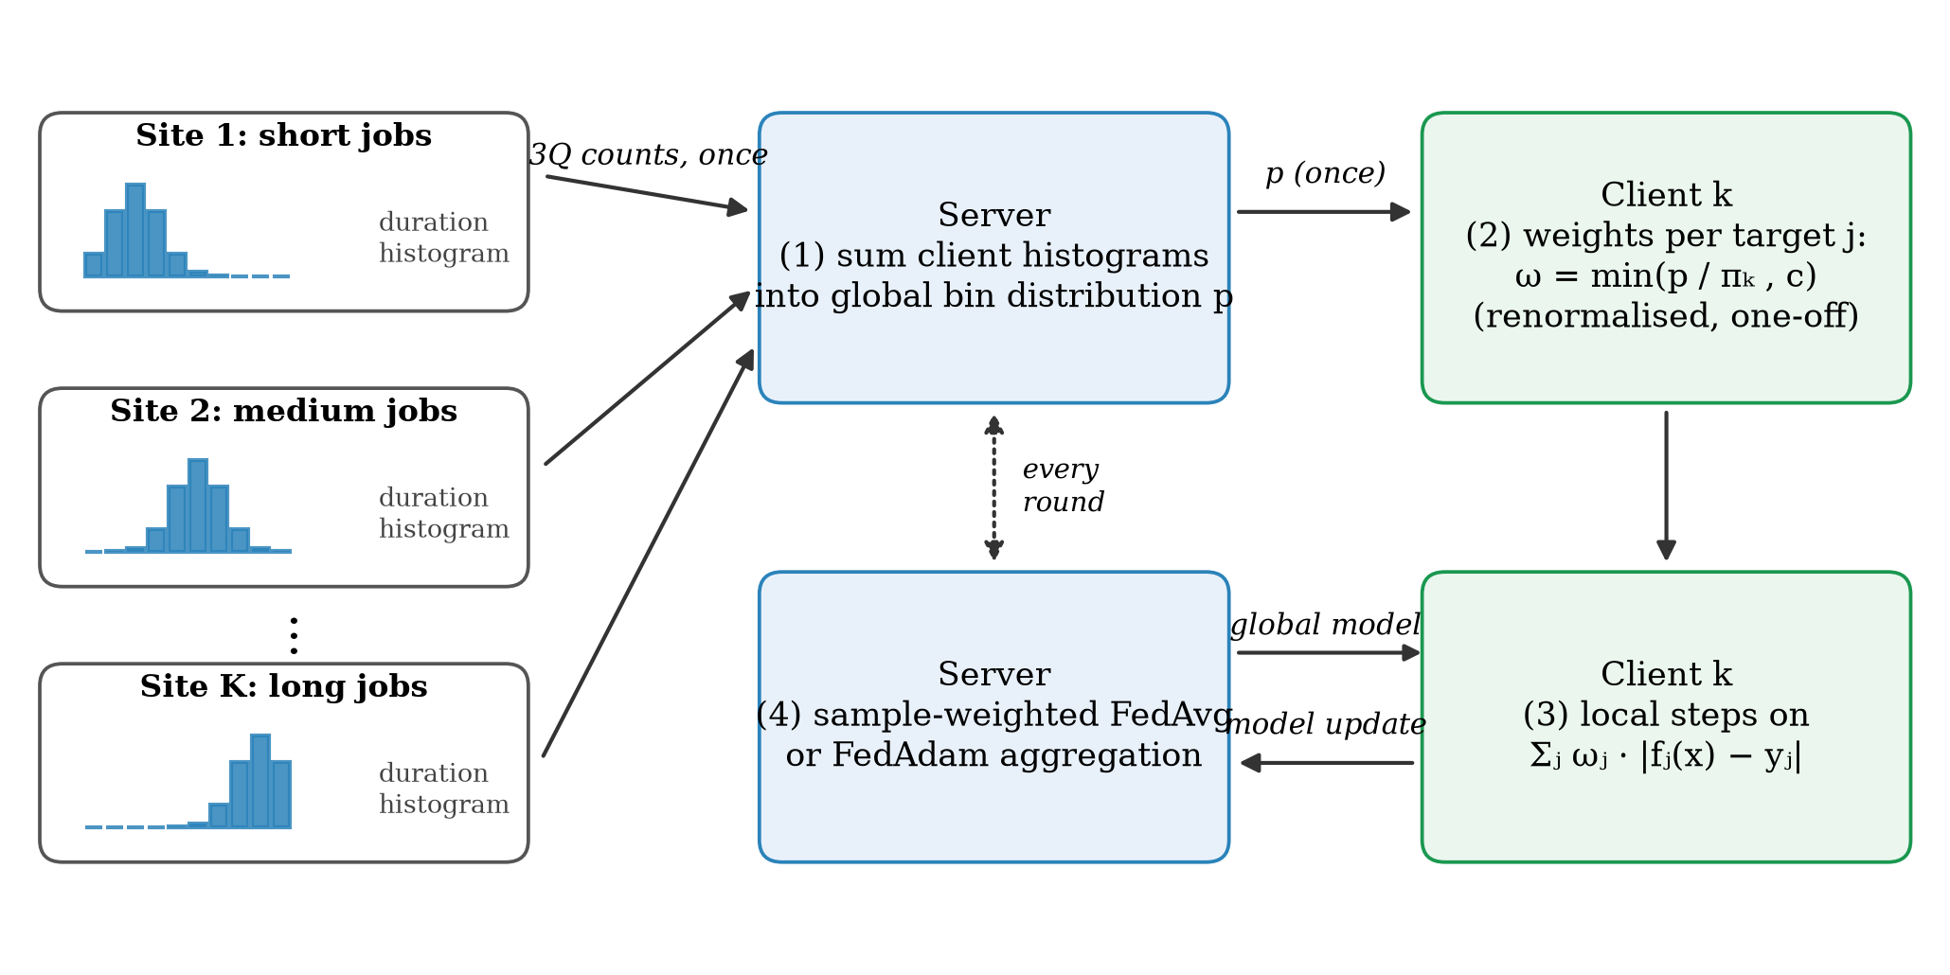
Fig. 1 FedTW workflow. Each client reports its target histograms once; the server returns the global bin distribution; each client computes clipped per-target density-ratio weights once and then trains with the weighted loss in every round, while aggregation is unchanged.

The motivation is the standard label-shift argument [36, 37]. If client k differs from the federation only in the marginal distribution of target j, that is p_{k}(x, y_{j}) = p(x | y_{j}) p_{k}(y_{j}), then E_{pₖ}[ω_{j} ℓ_{j}] = E_{p}[ℓ_{j}] for the loss ℓ_{j} of target j, up to discretisation and clipping. Each client's objective for target j is then an unbiased estimate of the global objective, so the objectives of the clients no longer disagree about where the optimum of that target lies, and the source of drift is removed rather than damped. Three properties follow directly from the construction. Weights are computed independently for each target, so a skew in duration changes only the duration loss, and a client that is skewed in several targets is corrected in each. Under IID data π_{kjq} ≈ p_{jq} in Eq. (2) and all weights are close to one, so FedTW reduces to FedAvg. The only communication is the one-off histogram of 3Q counts per client, which can be protected with secure aggregation [47] or with Laplace noise for ε-differential privacy [48]; we evaluate the latter with ε ∈ {1, 0.1}.

Statistical analysis
For each trace, regime and target we report the mean test R² (in the original units) over ten seeds with a 95% t-interval, together with SMAPE. Methods are compared by paired differences over seeds. Significance is assessed with the two-sided Wilcoxon signed-rank test [49, 50] and adjusted with the Holm procedure [51] within each family of contrasts; the family is the set of all trace × regime × target cells of one pair of methods and is stated with each table. Because seeds capture only optimisation randomness, we also quantify test-data uncertainty with a moving-block bootstrap [52] of the test period (200 resamples, blocks of 1,000 consecutive windows, identical resamples for all methods), which yields an interval for the seed-averaged difference between two methods. Finally, the test period is divided into four consecutive blocks that serve as temporal hold-outs [53], and the sign of each contrast is checked in every block. All per-seed values are provided in the supplementary files.

Results

Reference accuracy
The centralised model reaches a test R² of 78.20%, 77.29% and 74.09% for duration, CPU and memory on Alibaba and 55.92%, 54.18% and 47.25% on CC-IN2P3. Training it on as many samples as the whole federation processes raises these values by up to 7.9 points (CC-IN2P3 duration), which shows that the CC-IN2P3 models are still improving at this budget. For that reason every comparison below is made between methods that receive exactly the same budget, and a three-fold budget is examined separately. Under IID clients, FedAvg matches the centralised model on both traces (79.46/77.58/74.32% on Alibaba and 56.49/54.35/46.75% on CC-IN2P3), and the adaptive server optimiser FedAdam is higher still (81.59% and 62.63% for duration). These IID values are the baseline against which the effect of heterogeneity is measured below.

Target skew damages mainly the skewed target
Table 2 reports FedAvg in every regime. Quantity skew, temporal silos and partial participation change the accuracy of every target by at most 2.4 R² points on either trace. System heterogeneity costs more, up to 11.2 duration points on CC-IN2P3, but it lowers all three targets together and for a simple reason: clients that perform fewer local steps contribute less optimisation within the fixed budget. Target skew behaves differently. Severe duration skew (LS-dur-0.1) reduces duration R² by 16.0 points on Alibaba and 32.0 points on CC-IN2P3, and the band partition of the earlier study (BAND-dur) by 22.6 and 46.2 points, while CPU and memory move by less than 4.7 points in the same regimes. When CPU or memory is skewed instead, that target suffers most: LS-cpu-0.1 lowers CPU R² by 7.9 and 10.3 points and LS-mem-0.1 lowers memory R² by 8.8 and 20.1 points. On CC-IN2P3 part of the damage spills over to duration (4.9 and 11.8 points), presumably through the shared encoder, whereas on Alibaba the spill-over stays below 2.0 points. The loss grows as the Dirichlet concentration decreases from α = 1.0 to α = 0.1, in line with the measured divergence. Figure 2 relates the loss of every target in every regime to the Jensen–Shannon divergence of that target (Spearman ρ = −0.67, p < 0.001, n = 66). Heterogeneity therefore acts on individual outputs of the shared network, and its effect is predicted by how differently the clients see the distribution of each output.
Table 2 Test R² (%) of FedAvg in every regime (mean ± s.d. over ten seeds; change relative to IID FedAvg in parentheses). The skewed target of each target-skew regime is in bold.
Trace | Regime | Duration | CPU | Memory
Alibaba | Centralised (equal steps) | 78.20 ± 1.16 | 77.29 ± 0.19 | 74.09 ± 0.17
Alibaba | Centralised (equal samples) | 80.93 ± 0.78 | 77.85 ± 0.20 | 74.50 ± 0.21
Alibaba | IID | 79.46 ± 0.53 | 77.58 ± 0.10 | 74.32 ± 0.09
Alibaba | QTY | 79.46 ± 0.67 (0.0) | 77.48 ± 0.13 (−0.1) | 74.26 ± 0.08 (−0.1)
Alibaba | TEMP | 79.31 ± 0.71 (−0.2) | 77.49 ± 0.14 (−0.1) | 74.17 ± 0.07 (−0.2)
Alibaba | SYS | 76.95 ± 1.39 (−2.5) | 76.70 ± 0.37 (−0.9) | 73.46 ± 0.32 (−0.9)
Alibaba | PART | 79.17 ± 0.79 (−0.3) | 77.49 ± 0.12 (−0.1) | 74.23 ± 0.15 (−0.1)
Alibaba | LS-dur-1.0 | 78.03 ± 0.82 (−1.4) | 77.60 ± 0.11 (0.0) | 74.29 ± 0.06 (0.0)
Alibaba | LS-dur-0.3 | 74.32 ± 2.84 (−5.1) | 77.60 ± 0.12 (0.0) | 74.28 ± 0.05 (0.0)
Alibaba | LS-dur-0.1 | 63.48 ± 5.87 (−16.0) | 77.07 ± 0.31 (−0.5) | 74.01 ± 0.18 (−0.3)
Alibaba | BAND-dur | 56.91 ± 3.69 (−22.6) | 77.43 ± 0.17 (−0.2) | 73.97 ± 0.13 (−0.4)
Alibaba | LS-cpu-0.1 | 77.44 ± 0.87 (−2.0) | 69.73 ± 5.10 (−7.9) | 74.02 ± 0.17 (−0.3)
Alibaba | LS-mem-0.1 | 78.91 ± 0.81 (−0.5) | 77.50 ± 0.14 (−0.1) | 65.55 ± 2.95 (−8.8)
CC-IN2P3 | Centralised (equal steps) | 55.92 ± 6.81 | 54.18 ± 0.60 | 47.25 ± 1.92
CC-IN2P3 | Centralised (equal samples) | 63.84 ± 5.17 | 59.43 ± 0.69 | 52.52 ± 1.28
CC-IN2P3 | IID | 56.49 ± 2.61 | 54.35 ± 0.43 | 46.75 ± 1.06
CC-IN2P3 | QTY | 56.36 ± 3.73 (−0.1) | 54.41 ± 0.69 (+0.1) | 46.80 ± 1.48 (+0.1)
CC-IN2P3 | TEMP | 54.34 ± 2.71 (−2.1) | 53.44 ± 0.45 (−0.9) | 44.39 ± 1.03 (−2.4)
CC-IN2P3 | SYS | 45.32 ± 3.47 (−11.2) | 52.15 ± 0.66 (−2.2) | 41.75 ± 2.09 (−5.0)
CC-IN2P3 | PART | 56.80 ± 2.74 (+0.3) | 54.30 ± 0.52 (−0.1) | 47.02 ± 1.07 (+0.3)
CC-IN2P3 | LS-dur-1.0 | 48.78 ± 3.85 (−7.7) | 54.16 ± 0.49 (−0.2) | 46.03 ± 1.14 (−0.7)
CC-IN2P3 | LS-dur-0.3 | 39.68 ± 5.84 (−16.8) | 53.94 ± 0.57 (−0.4) | 45.10 ± 1.36 (−1.6)
CC-IN2P3 | LS-dur-0.1 | 24.49 ± 9.35 (−32.0) | 53.01 ± 0.71 (−1.3) | 43.21 ± 1.15 (−3.5)
CC-IN2P3 | BAND-dur | 10.27 ± 2.09 (−46.2) | 52.61 ± 0.46 (−1.7) | 42.07 ± 1.20 (−4.7)
CC-IN2P3 | LS-cpu-0.1 | 51.63 ± 3.22 (−4.9) | 44.05 ± 2.34 (−10.3) | 42.60 ± 1.23 (−4.1)
CC-IN2P3 | LS-mem-0.1 | 44.67 ± 3.76 (−11.8) | 51.97 ± 0.80 (−2.4) | 26.66 ± 3.98 (−20.1)

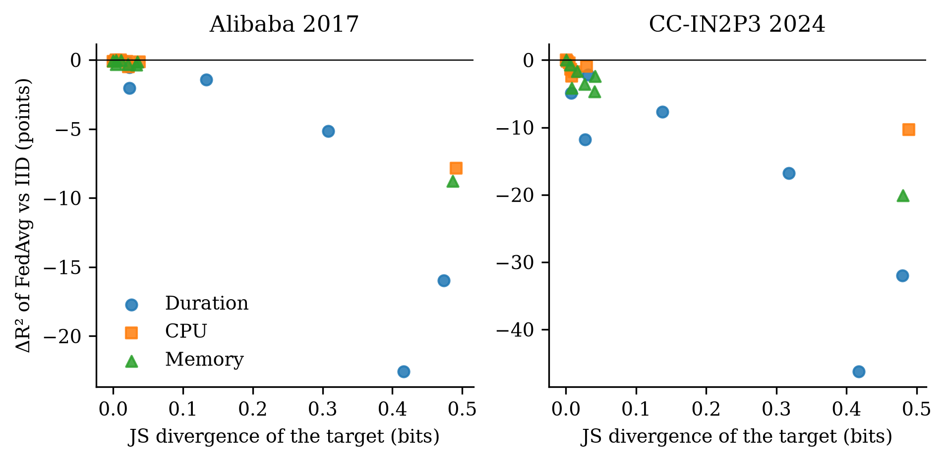
Fig. 2 Change in test R² of FedAvg relative to IID clients against the Jensen–Shannon divergence of the corresponding target, for every regime and target on both traces. Each point is the mean over ten seeds.

The proximal term does not repair target skew at a matched budget
Table 3 and Fig. 3 report the FedProx sweep. Under IID clients, accuracy declines steadily as μ grows, and for μ ≥ 3 all three targets degrade sharply on both traces. Under target skew, no coefficient restores the skewed target: across the six skew-regime rows of the sweep, the best coefficient improves the skewed target over FedAvg by at most 1.5 R² points. The best duration R² under LS-dur-0.1 is 64.37% on Alibaba (μ = 1.0) and 25.29% on CC-IN2P3 (μ = 0.3), against 63.12% and 24.15% for FedAvg on the same seeds; FedTW reaches 72.51% and 38.31%. The band partition, where the earlier study reported a large gain at μ = 1, shows the same picture once rounds are equal: the best proximal setting reaches 56.28% and 10.77% duration R², compared with 58.07% and 10.39% for FedAvg. Restricting the penalty to the duration head does not help either (Table 6). With three times as many rounds, FedAvg itself improves under BAND-dur on Alibaba (69.22% duration R²), whereas FedProx with μ = 1 reaches only 54.03%; on CC-IN2P3 the two reach 11.54% and 6.58%. Whether the budget is 60 or 180 rounds, the proximal term does not help once both methods receive the same budget. The improvement reported in our earlier analysis therefore reflects the longer training that early stopping granted to the proximal runs, not the proximal term itself. When μ is tuned once per trace on validation data, as is common practice, the criterion selects the smallest coefficient of the grid (μ = 0.001 on both traces), and the tuned FedProx becomes practically indistinguishable from FedAvg: none of the 66 trace × regime × target cells differs significantly after Holm correction, and its mean is lower in 32 of them.
Table 3 FedProx coefficient sweep at a matched budget (test R², %, mean over five seeds). FedAvg uses the same five seeds; FedTW is shown for reference (ten seeds). The best coefficient of each row is in bold.
Trace | Regime | Target | FedAvg | μ=0.001 | μ=0.01 | μ=0.1 | μ=0.3 | μ=1 | μ=3 | μ=10 | FedTW
Alibaba | IID | Duration | 79.78 | 79.28 | 79.22 | 78.88 | 78.23 | 76.28 | 71.98 | 57.34 | 79.45
Alibaba | IID | CPU | 77.55 | 77.45 | 77.45 | 77.41 | 77.20 | 76.54 | 74.46 | 58.40 | 77.58
Alibaba | IID | Memory | 74.36 | 74.28 | 74.27 | 74.19 | 73.97 | 73.35 | 71.75 | 65.44 | 74.32
Alibaba | LS-dur-0.1 | Duration | 63.12 | 63.12 | 63.17 | 63.51 | 63.61 | 64.37 | 62.99 | 55.44 | 72.51
Alibaba | LS-dur-0.1 | CPU | 77.11 | 77.12 | 77.11 | 77.01 | 76.81 | 76.24 | 74.14 | 59.52 | 77.02
Alibaba | LS-dur-0.1 | Memory | 74.10 | 74.10 | 74.09 | 73.99 | 73.76 | 73.13 | 71.54 | 65.60 | 73.95
Alibaba | LS-cpu-0.1 | Duration | 77.46 | 77.80 | 77.68 | 77.22 | 76.34 | 74.48 | 70.58 | 58.08 | 77.18
Alibaba | LS-cpu-0.1 | CPU | 68.34 | 68.59 | 68.55 | 68.78 | 69.20 | 69.80 | 67.85 | 60.17 | 75.52
Alibaba | LS-cpu-0.1 | Memory | 73.98 | 74.06 | 74.04 | 73.99 | 73.77 | 73.15 | 71.58 | 65.60 | 74.07
Alibaba | BAND-dur | Duration | 58.07 | 56.28 | 55.69 | 52.67 | 49.47 | 50.42 | 53.23 | 52.47 | 77.70
Alibaba | BAND-dur | CPU | 77.35 | 77.37 | 77.34 | 77.23 | 76.94 | 76.22 | 73.63 | 60.05 | 77.20
Alibaba | BAND-dur | Memory | 73.98 | 73.93 | 73.88 | 73.73 | 73.48 | 72.82 | 71.26 | 65.27 | 73.98
CC-IN2P3 | IID | Duration | 58.52 | 58.23 | 58.01 | 56.54 | 53.52 | 45.50 | 31.86 | 11.11 | 56.50
CC-IN2P3 | IID | CPU | 54.41 | 54.50 | 54.47 | 54.24 | 53.62 | 52.09 | 49.00 | 39.95 | 54.35
CC-IN2P3 | IID | Memory | 46.81 | 46.68 | 46.53 | 46.17 | 45.31 | 42.63 | 34.64 | 22.06 | 46.76
CC-IN2P3 | LS-dur-0.1 | Duration | 24.15 | 24.55 | 24.67 | 25.00 | 25.29 | 23.38 | 20.99 | 11.31 | 38.31
CC-IN2P3 | LS-dur-0.1 | CPU | 53.24 | 53.23 | 53.20 | 52.99 | 52.57 | 50.94 | 48.52 | 40.08 | 53.67
CC-IN2P3 | LS-dur-0.1 | Memory | 43.35 | 43.13 | 43.01 | 42.96 | 42.52 | 39.89 | 34.43 | 22.61 | 44.87
CC-IN2P3 | LS-cpu-0.1 | Duration | 52.74 | 52.61 | 52.59 | 51.92 | 49.88 | 43.21 | 31.73 | 11.60 | 53.61
CC-IN2P3 | LS-cpu-0.1 | CPU | 44.83 | 44.68 | 44.72 | 44.94 | 45.40 | 45.73 | 44.68 | 39.63 | 50.16
CC-IN2P3 | LS-cpu-0.1 | Memory | 42.68 | 42.68 | 42.64 | 42.54 | 42.39 | 40.59 | 34.74 | 22.37 | 42.64
CC-IN2P3 | BAND-dur | Duration | 10.39 | 10.77 | 10.42 | 8.54 | 7.27 | 6.98 | 9.16 | 10.13 | 48.59
CC-IN2P3 | BAND-dur | CPU | 52.62 | 52.73 | 52.69 | 52.40 | 52.01 | 50.96 | 48.16 | 40.02 | 53.67
CC-IN2P3 | BAND-dur | Memory | 42.46 | 42.61 | 42.54 | 42.30 | 41.70 | 39.80 | 33.56 | 22.33 | 44.63

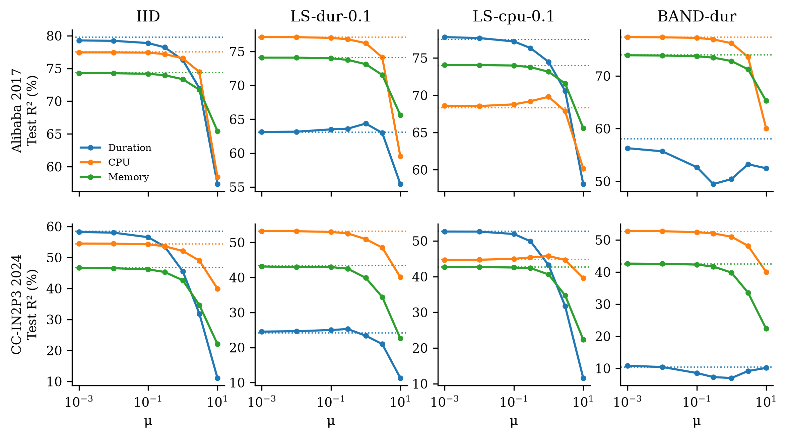
Fig. 3 FedProx coefficient sweep at a matched budget (five seeds). Dotted lines show FedAvg on the same seeds. No coefficient restores the skewed target, and large coefficients degrade all targets.

FedTW corrects target skew without harming other cells
Table 4 compares all methods and Fig. 4 shows them per regime and target. FedTW improves the skewed target in every target-skew regime of both traces. Table 5 gives the paired contrasts with FedAvg: all 12 differences are positive, every seed improves in 10 of them, and all remain significant after Holm correction. The block-bootstrap intervals, which reflect uncertainty in the test data rather than in the optimisation, exclude zero in 12 of the 12 cells. Measured against FedAvg with IID clients at the same budget, FedTW recovers 92% (Alibaba) and 83% (CC-IN2P3) of the duration accuracy lost under the band partition, and 57% and 43% under LS-dur-0.1. The gain is largest where the divergence is largest and shrinks for mild skew (α = 1.0), where FedAvg loses little to begin with.
FedTW also leaves unaffected what it should not affect. Across the 54 remaining cells (other targets of the skewed regimes and all targets of the non-skew regimes), the largest decrease relative to FedAvg is 0.38 R² points and no cell is significantly worse after Holm correction. Several off-target cells improve, by up to 3.7 points on CC-IN2P3, because skewing one target also shifts the correlated targets slightly (Table 1) and FedTW corrects those shifts as well. Under IID clients the two methods are indistinguishable, as the construction predicts. The correction is complementary to server-side optimisation: FedTW+FedAdam improves over FedAdam on the skewed target in 12 of 12 cells after correction and is the most accurate federated method in every skewed row of Table 4. FedAdam on its own does not address target skew; under LS-dur-0.1 it is no better than FedAvg on duration (61.86% versus 63.48% on Alibaba and 21.16% versus 24.49% on CC-IN2P3). FedTW is better than tuned FedProx on the skewed target in 12 of 12 cells after correction.
Table 4 Comparison of methods at a matched budget (test R², %, mean over ten seeds). Rows show the skewed target of each target-skew regime, all three targets under IID, and duration for the remaining regimes; the complete table with all targets and intervals is in Additional file 1. The best federated method of each row is in bold.
Trace | Regime | Target | Central | FedAvg | FedProx | FedAvgM | FedAdam | FedTW | FedTW+FedAdam
Alibaba | IID | Duration | 78.20 | 79.46 | 79.44 | 81.31 | 81.59 | 79.45 | 81.60
Alibaba | IID | CPU | 77.29 | 77.58 | 77.58 | 77.48 | 77.81 | 77.58 | 77.80
Alibaba | IID | Memory | 74.09 | 74.32 | 74.32 | 74.50 | 74.62 | 74.32 | 74.62
Alibaba | QTY | Duration | 78.20 | 79.46 | 79.43 | – | 81.58 | 79.47 | 81.45
Alibaba | TEMP | Duration | 78.20 | 79.31 | 79.32 | – | 81.70 | 78.94 | 81.42
Alibaba | SYS | Duration | 78.20 | 76.95 | 76.92 | – | 81.27 | 76.99 | 81.29
Alibaba | PART | Duration | 78.20 | 79.17 | 79.18 | – | 81.26 | 79.20 | 81.57
Alibaba | LS-dur-1.0 | Duration | 78.20 | 78.03 | 78.04 | – | 80.79 | 78.80 | 81.64
Alibaba | LS-dur-0.3 | Duration | 78.20 | 74.32 | 74.26 | – | 77.59 | 76.42 | 80.29
Alibaba | LS-dur-0.1 | Duration | 78.20 | 63.48 | 63.42 | 62.77 | 61.86 | 72.51 | 75.59
Alibaba | BAND-dur | Duration | 78.20 | 56.91 | 56.91 | 68.85 | 70.89 | 77.70 | 81.09
Alibaba | LS-cpu-0.1 | CPU | 77.29 | 69.73 | 69.85 | 68.67 | 71.12 | 75.52 | 75.73
Alibaba | LS-mem-0.1 | Memory | 74.09 | 65.55 | 65.60 | – | 65.52 | 72.18 | 72.69
CC-IN2P3 | IID | Duration | 55.92 | 56.49 | 56.52 | 62.05 | 62.63 | 56.50 | 62.78
CC-IN2P3 | IID | CPU | 54.18 | 54.35 | 54.35 | 58.40 | 57.65 | 54.35 | 57.61
CC-IN2P3 | IID | Memory | 47.25 | 46.75 | 46.78 | 51.35 | 51.04 | 46.76 | 51.06
CC-IN2P3 | QTY | Duration | 55.92 | 56.36 | 55.85 | – | 61.60 | 56.61 | 61.74
CC-IN2P3 | TEMP | Duration | 55.92 | 54.34 | 54.44 | – | 60.19 | 54.94 | 61.19
CC-IN2P3 | SYS | Duration | 55.92 | 45.32 | 45.30 | – | 60.96 | 45.31 | 60.87
CC-IN2P3 | PART | Duration | 55.92 | 56.80 | 56.70 | – | 62.52 | 56.71 | 62.49
CC-IN2P3 | LS-dur-1.0 | Duration | 55.92 | 48.78 | 48.85 | – | 53.78 | 52.22 | 60.07
CC-IN2P3 | LS-dur-0.3 | Duration | 55.92 | 39.68 | 39.72 | – | 40.90 | 48.72 | 58.78
CC-IN2P3 | LS-dur-0.1 | Duration | 55.92 | 24.49 | 24.55 | 20.14 | 21.16 | 38.31 | 39.57
CC-IN2P3 | BAND-dur | Duration | 55.92 | 10.27 | 10.38 | 8.83 | 8.71 | 48.59 | 59.37
CC-IN2P3 | LS-cpu-0.1 | CPU | 54.18 | 44.05 | 44.05 | 41.25 | 41.74 | 50.16 | 50.96
CC-IN2P3 | LS-mem-0.1 | Memory | 47.25 | 26.66 | 26.77 | – | 24.23 | 39.79 | 42.73
FedAvgM was evaluated on IID, LS-dur-0.1, LS-cpu-0.1 and BAND-dur only (– elsewhere). Central: centralised model with the same number of optimiser steps.

Table 5 FedTW versus FedAvg on the skewed target (paired by seed, n = 10). Δ is the mean paired difference in R² points with a 95% t-interval; the bootstrap interval reflects test-data uncertainty (moving-block bootstrap of the test period); p is the two-sided Wilcoxon signed-rank p-value after Holm correction over the twelve rows of this table.
Trace | Regime | Target | FedAvg | FedTW | Δ [95% CI] | Bootstrap 95% CI | Seeds improved | p (Holm)
Alibaba | LS-dur-1.0 | Duration | 78.03 | 78.80 | +0.77 [+0.26, +1.28] | [+0.42, +1.03] | 8/10 | 0.027
Alibaba | LS-dur-0.3 | Duration | 74.32 | 76.42 | +2.11 [+0.34, +3.87] | [+1.46, +2.62] | 8/10 | 0.027
Alibaba | LS-dur-0.1 | Duration | 63.48 | 72.51 | +9.04 [+7.02, +11.05] | [+7.32, +10.49] | 10/10 | 0.023
Alibaba | BAND-dur | Duration | 56.91 | 77.70 | +20.80 [+18.37, +23.23] | [+17.35, +23.84] | 10/10 | 0.023
Alibaba | LS-cpu-0.1 | CPU | 69.73 | 75.52 | +5.79 [+2.60, +8.98] | [+4.73, +6.61] | 10/10 | 0.023
Alibaba | LS-mem-0.1 | Memory | 65.55 | 72.18 | +6.63 [+4.37, +8.89] | [+5.89, +7.56] | 10/10 | 0.023
CC-IN2P3 | LS-dur-1.0 | Duration | 48.78 | 52.22 | +3.44 [+1.34, +5.54] | [+2.49, +3.83] | 10/10 | 0.023
CC-IN2P3 | LS-dur-0.3 | Duration | 39.68 | 48.72 | +9.04 [+6.50, +11.58] | [+7.32, +9.72] | 10/10 | 0.023
CC-IN2P3 | LS-dur-0.1 | Duration | 24.49 | 38.31 | +13.81 [+9.14, +18.49] | [+12.23, +14.89] | 10/10 | 0.023
CC-IN2P3 | BAND-dur | Duration | 10.27 | 48.59 | +38.32 [+34.96, +41.68] | [+34.67, +41.39] | 10/10 | 0.023
CC-IN2P3 | LS-cpu-0.1 | CPU | 44.05 | 50.16 | +6.11 [+4.75, +7.47] | [+6.12, +7.14] | 10/10 | 0.023
CC-IN2P3 | LS-mem-0.1 | Memory | 26.66 | 39.79 | +13.14 [+10.17, +16.11] | [+11.28, +14.63] | 10/10 | 0.023

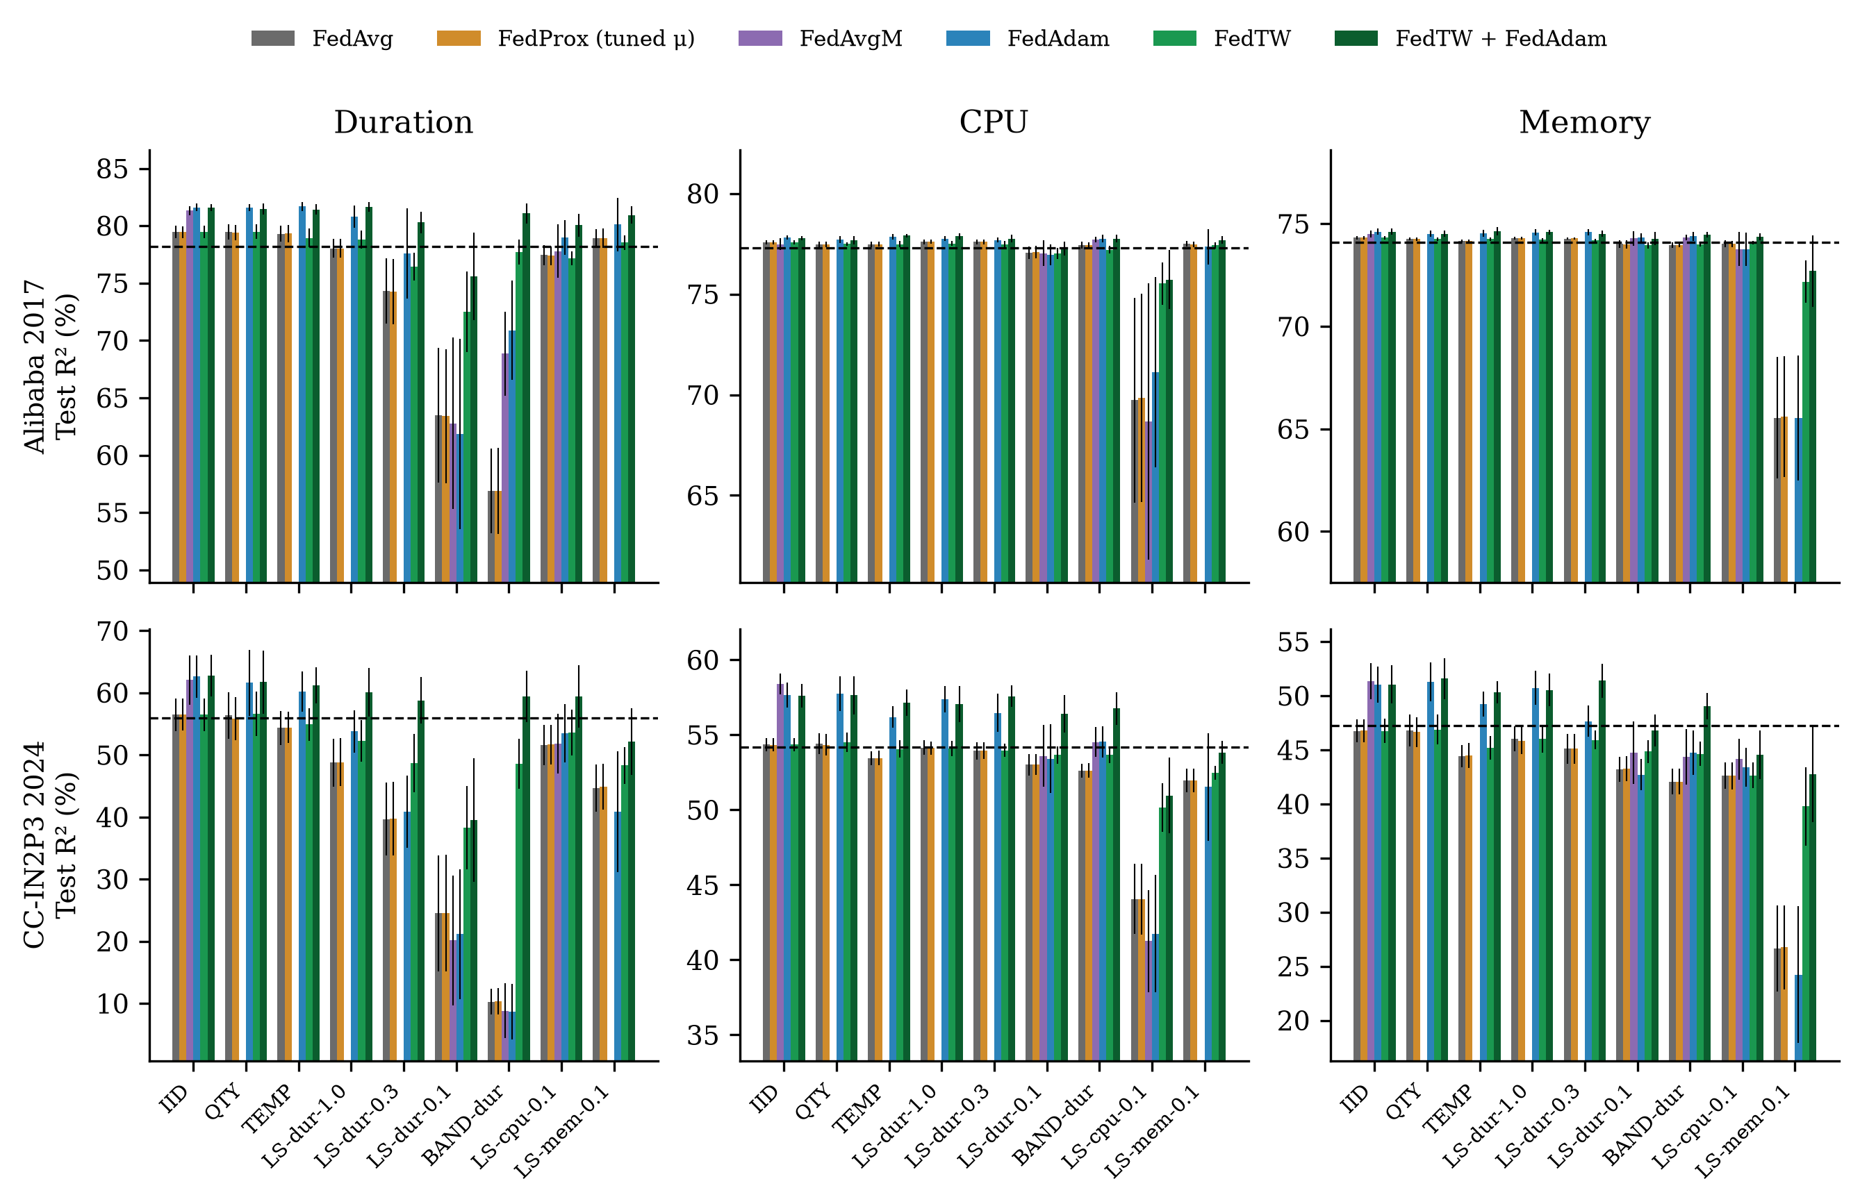
Fig. 4 Test R² of every method across regimes (mean ± s.d. over ten seeds); the dashed line marks the centralised model.

Accuracy as a function of the training budget
Figure 5 plots test R² of duration against the number of communication rounds. Under target skew, FedTW is ahead of FedAvg, FedProx and FedAdam at every recorded round, so the advantage does not depend on where training is stopped; under IID clients its curve coincides with that of FedAvg. The comparison at three times the budget confirms this: after 180 rounds FedTW reaches 77.67% and 47.74% duration R² under LS-dur-0.1, whereas FedAvg reaches 65.34% and 25.25%. Reducing client drift by communicating five times more often (τ = 5 with 300 rounds) helps FedAvg on Alibaba but not on CC-IN2P3, and in no case reaches FedTW, which uses one fifth of that communication (Table 6).
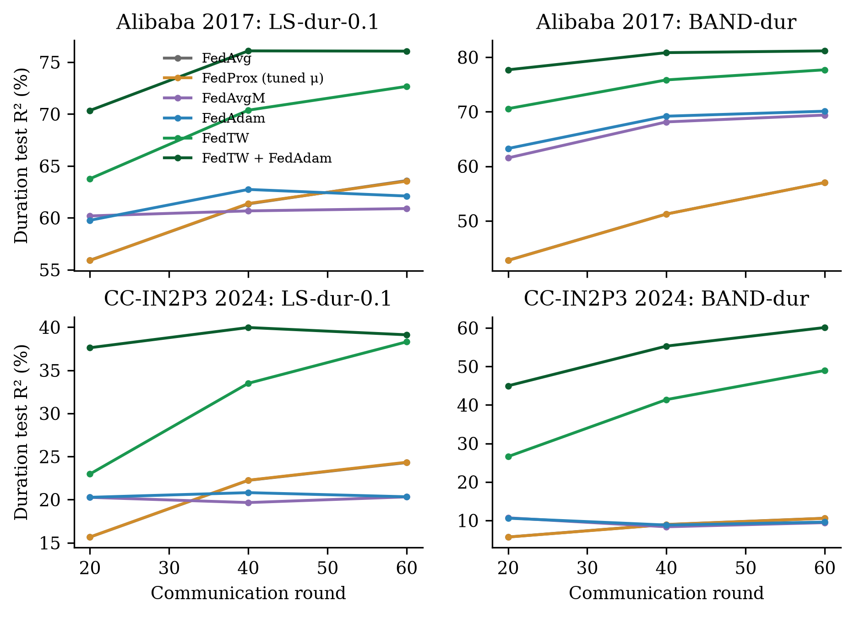
Fig. 5 Duration test R² against communication round (mean over ten seeds) under severe duration skew and the band partition. All methods receive the same number of local steps per round.

Robustness and ablations
The FedTW gain on the skewed target is positive in each of the four consecutive test blocks for 12 of the 12 cells, so it does not come from one period of the test trace. Table 6 varies the design of FedTW. Five or twenty bins instead of ten change the skewed-target R² by at most 1.3 points. A tighter clip (c = 3) performs equally well, so the result is not sensitive to the clipping constant. Adding Laplace noise to the reported histograms for ε-differential privacy with ε = 1 leaves the result essentially unchanged, and so does ε = 0.1 (101% of the improvement is retained on average), because the client histograms hold hundreds to thousands of samples per bin and Laplace noise of scale 1/ε is small in comparison. Adding a proximal term (μ = 1) to FedTW lowers the skewed-target accuracy in every column, which again indicates that the residual gap to the IID reference is not caused by drift. The histogram exchange is 3Q = 30 integers per client, sent once, and the weights are computed once before training; the wall-clock time of FedTW runs does not differ measurably from that of FedAvg (mean difference -2.9%).
Table 6 Ablations and alternative remedies (test R² of the skewed target, %, mean over seeds 0–4).
Variant | Ali LS-dur-0.1 | Ali BAND-dur | Ali LS-cpu-0.1 | IN2P3 LS-dur-0.1 | IN2P3 BAND-dur | IN2P3 LS-cpu-0.1
FedAvg | 63.12 | 58.07 | 68.34 | 24.15 | 10.39 | 44.83
FedTW (Q = 10, c = 10) | 73.11 | 77.80 | 75.45 | 39.07 | 50.62 | 50.14
FedTW, Q = 5 | 72.49 | 78.14 | 75.06 | 39.82 | 49.30 | 50.95
FedTW, Q = 20 | 73.43 | 78.30 | 75.32 | 38.73 | 50.47 | 50.20
FedTW, c = 3 | 73.10 | 78.48 | 75.14 | 40.67 | 51.18 | 50.37
FedTW, DP histograms ε = 1 | 73.05 | 78.44 | 75.38 | 39.02 | 50.57 | 50.17
FedTW, DP histograms ε = 0.1 | 73.37 | 78.44 | 75.40 | 39.08 | 50.48 | 50.16
FedTW + proximal term (μ = 1) | 70.44 | 74.60 | 74.16 | 33.72 | 39.15 | 49.00
Proximal term on duration head only (μ = 1) | 64.38 | 50.43 | 68.64 | 26.29 | 7.28 | 44.54
FedAvg, τ = 5 and 300 rounds (5× communication) | 70.92 | 72.19 | 71.57 | 23.12 | 12.75 | 45.55

Discussion

Why the proximal term fails and the correction works
The results support a simple reading. When clients differ in the distribution of one target, each client minimises a loss that over-represents part of that target's range. Averaging such models does not recover the global minimiser, because the client objectives disagree about the optimum itself, not merely about how far to step towards it. A proximal term limits how far a client moves from the global model, which reduces the damage of disagreement but also slows the learning of everything else; at an equal budget the two effects cancel or the second dominates. Re-weighting removes the disagreement: after weighting, each client's loss for the skewed target estimates the global loss, so local steps point towards the same optimum. Because the weights are computed for each output separately, the correction is automatically target-specific, which is exactly the property that a single model-wide coefficient lacks. The earlier recommendation to tune μ per regime and per target is thus replaced by a mechanism that needs no tuning across regimes: the histograms reveal the regime, and the weights reduce to one when there is no skew.

Practical implications for workload federations
Target-range skew is the natural form of heterogeneity in a federation of cloud sites, since sites specialise in interactive, batch or analytics jobs. The diagnosis gives operators a cheap test: the per-target divergence of client histograms, computable from the same one-shot exchange that FedTW uses, predicts which forecasts will suffer (Fig. 2). Where the divergence is small, plain FedAvg or FedAdam suffices and FedTW costs nothing; where it is large, FedTW recovers most of the lost accuracy. Because it only changes the client loss, FedTW can be added to existing federated pipelines and server optimisers without changing the communication protocol.

Limitations
Several limitations qualify these conclusions. First, the client partitions are constructed from two traces rather than observed across real independent sites; the band and Dirichlet constructions are standard and cover a range of severities, but real federations may combine target skew with differences in the input distribution, which FedTW does not correct. Second, the correction assumes label shift, that is, that the conditional distribution of the inputs given a target is shared across clients; the residual gap to the centralised model under the most severe skew, especially on CC-IN2P3, suggests that this assumption holds only approximately. Third, the weights rely on coarse histograms and on clipping; very small clients with empty bins receive noisy weights, which the smoothing and clipping only partly control. Fourth, a fixed budget of 60 rounds does not fully converge on CC-IN2P3; the three-fold budget leaves the conclusions unchanged, but absolute accuracies there would rise with longer training. Fifth, the forecaster is a compact LSTM, chosen so that ten-seed studies over many regimes remain affordable; larger architectures may respond differently in magnitude, although the mechanism does not depend on the architecture. Finally, SCAFFOLD and other drift-correcting methods designed for local SGD were not evaluated in their native setting, and classification-specific label-skew methods do not apply to continuous targets.

Conclusions
This study revisited the use of FedProx for federated multi-target cloud workload forecasting under a budget-matched protocol. On two production traces and 11 client regimes, heterogeneity in the range of one target damages mainly the forecast of that target, in proportion to the measured client divergence, and the proximal term does not repair the damage at any coefficient once training budgets are equal. The failure is a label-shift problem, and FedTW, a target-wise importance re-weighting driven by one-shot ten-bin histograms, corrects it: it significantly improves the skewed target in every target-skew regime, recovers 92% and 83% of the loss under the most extreme partition, matches FedAvg under IID clients and composes with adaptive server optimisers. Future work will extend the correction to joint shifts of inputs and targets, evaluate it on federations of independently operated sites, and combine it with personalised output heads for sites whose workloads differ beyond the range of their targets.

Abbreviations
FL: federated learning; FedAvg: federated averaging; FedProx: federated proximal optimisation; FedAvgM: FedAvg with server momentum; FedAdam: federated Adam; FedTW: federated target-wise re-weighting; IID: independent and identically distributed; JS: Jensen–Shannon; LSTM: long short-term memory; MAE: mean absolute error; SMAPE: symmetric mean absolute percentage error; R²: coefficient of determination.

Declarations

Availability of data and materials
The Alibaba cluster-trace-v2017 [16] and the CC-IN2P3 2024 workload dataset [17] are publicly available. The preprocessing scripts, the batched federated-learning implementation, the scenario and FedTW code, the configuration of every run, the client partitions (generated deterministically from the published seeds), the per-seed and per-round results, and the scripts that produce every table and figure are available in the project repository and are provided as Additional file 1.

Competing interests
The authors declare that they have no competing interests.

Funding
This research received no external funding.

Authors' contributions
TYM: conceptualisation, methodology, software, formal analysis, investigation, data curation, visualisation, writing – original draft. AFA: supervision, methodology, validation, writing – review and editing. MRM: validation, formal analysis, writing – review and editing. All authors read and approved the final manuscript.

Acknowledgements
The authors thank Alibaba Group and the CC-IN2P3 computing centre for making their production workload traces publicly available.

References
1. Masdari M, Khoshnevis A. A survey and classification of the workload forecasting methods in cloud computing. Cluster Comput. 2020;23(4):2399–2424. https://doi.org/10.1007/s10586-019-03010-3
2. Kumar J, Singh AK. Workload prediction in cloud using artificial neural network and adaptive differential evolution. Future Gener Comput Syst. 2018;81:41–52. https://doi.org/10.1016/j.future.2017.10.047
3. Xu M, Song C, Wu H, Gill SS, Ye K, Xu C. esDNN: deep neural network based multivariate workload prediction in cloud computing environments. ACM Trans Internet Technol. 2022;22(3):75. https://doi.org/10.1145/3524114
4. Janardhanan D, Barrett E. CPU workload forecasting of machines in data centers using LSTM recurrent neural networks and ARIMA models. In: Proc. 12th Int. Conf. Internet Technology and Secured Transactions (ICITST). 2017. p. 55–60. https://doi.org/10.23919/ICITST.2017.8356346
5. Bi J, Ma H, Yuan H, Zhang J. Accurate prediction of workloads and resources with multi-head attention and hybrid LSTM for cloud data centers. IEEE Trans Sustain Comput. 2023;8(3):375–384. https://doi.org/10.1109/TSUSC.2023.3259522
6. Dogani J, Khunjush F, Mahmoudi MR, Seydali M. Multivariate workload and resource prediction in cloud computing using CNN and GRU by attention mechanism. J Supercomput. 2023;79(3):3437–3470. https://doi.org/10.1007/s11227-022-04782-z
7. Mothukuri V, Parizi RM, Pouriyeh S, Huang Y, Dehghantanha A, Srivastava G. A survey on security and privacy of federated learning. Future Gener Comput Syst. 2021;115:619–640. https://doi.org/10.1016/j.future.2020.10.007
8. European Parliament and Council of the European Union. Regulation (EU) 2016/679 (General Data Protection Regulation). Off J Eur Union. 2016;L119:1–88.
9. McMahan B, Moore E, Ramage D, Hampson S, Aguera y Arcas B. Communication-efficient learning of deep networks from decentralized data. In: Proc. 20th Int. Conf. Artificial Intelligence and Statistics (AISTATS). PMLR 54; 2017. p. 1273–1282.
10. Kairouz P, McMahan HB, Avent B, et al. Advances and open problems in federated learning. Found Trends Mach Learn. 2021;14(1–2):1–210. https://doi.org/10.1561/2200000083
11. Lim WYB, Luong NC, Hoang DT, Jiao Y, Liang Y-C, Yang Q, Niyato D, Miao C. Federated learning in mobile edge networks: a comprehensive survey. IEEE Commun Surv Tutor. 2020;22(3):2031–2063. https://doi.org/10.1109/COMST.2020.2986024
12. Zhao Y, Li M, Lai L, Suda N, Civin D, Chandra V. Federated learning with non-IID data. arXiv:1806.00582. 2018.
13. Hsieh K, Phanishayee A, Mutlu O, Gibbons PB. The non-IID data quagmire of decentralized machine learning. In: Proc. 37th Int. Conf. Machine Learning (ICML). PMLR 119; 2020. p. 4387–4398.
14. Li X, Huang K, Yang W, Wang S, Zhang Z. On the convergence of FedAvg on non-IID data. In: Proc. Int. Conf. Learning Representations (ICLR). 2020.
15. Li T, Sahu AK, Zaheer M, Sanjabi M, Talwalkar A, Smith V. Federated optimization in heterogeneous networks. In: Proc. Machine Learning and Systems (MLSys). 2020;2:429–450.
16. Alibaba Group. Alibaba cluster trace program: cluster-trace-v2017. 2017. https://github.com/alibaba/clusterdata. Accessed 27 Sep 2026.
17. Cochard G, Simon B. CC-IN2P3 2024 workload dataset. Zenodo. 2026. https://doi.org/10.5281/zenodo.18668107
18. Han X, Pan L, Liu S. CFL-LSTM: collaborative cloud server load prediction using multi-dimensional time series correlation analysis and LSTM. Big Data Min Anal. 2026;9(5):1173–1196. https://doi.org/10.26599/BDMA.2025.9020097
19. Patel E, Kushwaha DS. An integrated deep learning prediction approach for efficient modelling of host load patterns in cloud computing. J Grid Comput. 2023;21(1):5. https://doi.org/10.1007/s10723-022-09639-6
20. Jeong B, Baek S, Park S, Jeon J, Jeong Y-S. Stable and efficient resource management using deep neural network on cloud computing. Neurocomputing. 2023;521:99–112. https://doi.org/10.1016/j.neucom.2022.11.089
21. Woodworth BE, Patel KK, Srebro N. Minibatch vs local SGD for heterogeneous distributed learning. In: Advances in Neural Information Processing Systems (NeurIPS). 2020;33:6281–6292.
22. Karimireddy SP, Kale S, Mohri M, Reddi S, Stich S, Suresh AT. SCAFFOLD: stochastic controlled averaging for federated learning. In: Proc. 37th Int. Conf. Machine Learning (ICML). PMLR 119; 2020. p. 5132–5143.
23. Wang J, Liu Q, Liang H, Joshi G, Poor HV. Tackling the objective inconsistency problem in heterogeneous federated optimization. In: Advances in Neural Information Processing Systems (NeurIPS). 2020;33:7611–7623.
24. Acar DAE, Zhao Y, Matas R, Mattina M, Whatmough P, Saligrama V. Federated learning based on dynamic regularization. In: Proc. Int. Conf. Learning Representations (ICLR). 2021.
25. Hsu T-MH, Qi H, Brown M. Measuring the effects of non-identical data distribution for federated visual classification. arXiv:1909.06335. 2019.
26. Reddi SJ, Charles Z, Zaheer M, Garrett Z, Rush K, Konečný J, Kumar S, McMahan HB. Adaptive federated optimization. In: Proc. Int. Conf. Learning Representations (ICLR). 2021.
27. Li Q, Diao Y, Chen Q, He B. Federated learning on non-IID data silos: an experimental study. In: Proc. IEEE 38th Int. Conf. Data Engineering (ICDE). 2022. p. 965–978. https://doi.org/10.1109/ICDE53745.2022.00077
28. Zhu H, Xu J, Liu S, Jin Y. Federated learning on non-IID data: a survey. Neurocomputing. 2021;465:371–390. https://doi.org/10.1016/j.neucom.2021.07.098
29. Ye M, Fang X, Du B, Yuen PC, Tao D. Heterogeneous federated learning: state-of-the-art and research challenges. ACM Comput Surv. 2023;56(3):79. https://doi.org/10.1145/3625558
30. Wang J, Charles Z, Xu Z, Joshi G, McMahan HB, et al. A field guide to federated optimization. arXiv:2107.06917. 2021.
31. Tan AZ, Yu H, Cui L, Yang Q. Towards personalized federated learning. IEEE Trans Neural Netw Learn Syst. 2023;34(12):9587–9603. https://doi.org/10.1109/TNNLS.2022.3160699
32. Collins L, Hassani H, Mokhtari A, Shakkottai S. Exploiting shared representations for personalized federated learning. In: Proc. 38th Int. Conf. Machine Learning (ICML). PMLR 139; 2021. p. 2089–2099.
33. Zhang J, Li Z, Li B, Xu J, Wu S, Ding S, Wu C. Federated learning with label distribution skew via logits calibration. In: Proc. 39th Int. Conf. Machine Learning (ICML). PMLR 162; 2022. p. 26311–26329.
34. Li X-C, Zhan D-C. FedRS: federated learning with restricted softmax for label distribution non-IID data. In: Proc. 27th ACM SIGKDD Conf. Knowledge Discovery and Data Mining (KDD). 2021. p. 995–1005. https://doi.org/10.1145/3447548.3467254
35. Shimodaira H. Improving predictive inference under covariate shift by weighting the log-likelihood function. J Stat Plan Inference. 2000;90(2):227–244. https://doi.org/10.1016/S0378-3758(00)00115-4
36. Saerens M, Latinne P, Decaestecker C. Adjusting the outputs of a classifier to new a priori probabilities: a simple procedure. Neural Comput. 2002;14(1):21–41. https://doi.org/10.1162/089976602753284446
37. Lipton Z, Wang Y-X, Smola A. Detecting and correcting for label shift with black box predictors. In: Proc. 35th Int. Conf. Machine Learning (ICML). PMLR 80; 2018. p. 3122–3130.
38. Yang Y, Zha K, Chen Y, Wang H, Katabi D. Delving into deep imbalanced regression. In: Proc. 38th Int. Conf. Machine Learning (ICML). PMLR 139; 2021. p. 11842–11851.
39. Perifanis V, Pavlidis N, Koutsiamanis R-A, Efraimidis PS. Federated learning for 5G base station traffic forecasting. Comput Netw. 2023;235:109950. https://doi.org/10.1016/j.comnet.2023.109950
40. Briggs C, Fan Z, Andras P. Federated learning for short-term residential load forecasting. IEEE Open Access J Power Energy. 2022;9:573–583. https://doi.org/10.1109/OAJPE.2022.3206220
41. Fekri MN, Grolinger K, Mir S. Distributed load forecasting using smart meter data: federated learning with recurrent neural networks. Int J Electr Power Energy Syst. 2022;137:107669. https://doi.org/10.1016/j.ijepes.2021.107669
42. Tibermacine A, et al. Privacy-preserving load forecasting in smart grids using federated learning: a comparative analysis of aggregation strategies. Front Energy Res. 2025. https://doi.org/10.3389/fenrg.2026.1854654
43. Hochreiter S, Schmidhuber J. Long short-term memory. Neural Comput. 1997;9(8):1735–1780. https://doi.org/10.1162/neco.1997.9.8.1735
44. Kingma DP, Ba J. Adam: a method for stochastic optimization. In: Proc. Int. Conf. Learning Representations (ICLR). 2015.
45. Paszke A, Gross S, Massa F, et al. PyTorch: an imperative style, high-performance deep learning library. In: Advances in Neural Information Processing Systems (NeurIPS). 2019;32:8024–8035.
46. Lin J. Divergence measures based on the Shannon entropy. IEEE Trans Inf Theory. 1991;37(1):145–151. https://doi.org/10.1109/18.61115
47. Bonawitz K, Ivanov V, Kreuter B, Marcedone A, McMahan HB, Patel S, Ramage D, Segal A, Seth K. Practical secure aggregation for privacy-preserving machine learning. In: Proc. ACM SIGSAC Conf. Computer and Communications Security (CCS). 2017. p. 1175–1191. https://doi.org/10.1145/3133956.3133982
48. Dwork C, McSherry F, Nissim K, Smith A. Calibrating noise to sensitivity in private data analysis. In: Theory of Cryptography Conference (TCC). LNCS 3876; 2006. p. 265–284. https://doi.org/10.1007/11681878_14
49. Wilcoxon F. Individual comparisons by ranking methods. Biom Bull. 1945;1(6):80–83. https://doi.org/10.2307/3001968
50. Demšar J. Statistical comparisons of classifiers over multiple data sets. J Mach Learn Res. 2006;7:1–30.
51. Holm S. A simple sequentially rejective multiple test procedure. Scand J Stat. 1979;6(2):65–70.
52. Künsch HR. The jackknife and the bootstrap for general stationary observations. Ann Stat. 1989;17(3):1217–1241. https://doi.org/10.1214/aos/1176347265
53. Bergmeir C, Benítez JM. On the use of cross-validation for time series predictor evaluation. Inf Sci. 2012;191:192–213. https://doi.org/10.1016/j.ins.2011.12.028

