**ΑΠΟΤΕΛΕΣΜΑΤΑ ΜΕΤΡΗΣΕΩΝ (LOGS)**

**QUESTDB**

**1st USE CASE : 7776000 rows , 7.5 GB**

**(du -hs ~/.questdb/db)**

1. Παραγωγή Δεδομένων (4 ημερών)

./tsbs_generate_data --use-case="devops" --seed=666 --scale=20 \

--timestamp-start="2016-01-01T00:00:00Z" \

--timestamp-end="2016-01-06T00:00:00Z" \

--log-interval="10s" --format="questdb" \

| gzip > /tmp/questdb-data.gz

b) Loading Data

**Με 8 workers**

cat /tmp/questdb-data.gz | gunzip | ./tsbs_load_questdb \

--workers=1

Results :

time,per. metric/s,metric total,overall metric/s,per. row/s,row total,overall row/s

1703846609,1593286.11,1.593516E+07,1593286.11,141979.51,1.420000E+06,141979.51

1703846619,796811.96,2.390332E+07,1195076.75,70999.64,2.130000E+06,106492.05

1703846629,1043656.31,3.433932E+07,1144607.60,93005.02,3.060000E+06,101996.76

1703846639,751936.31,4.185878E+07,1046441.17,66999.14,3.730000E+06,93247.48

1703846649,527434.96,4.713314E+07,942642.01,46999.91,4.200000E+06,83998.15

1703846659,662100.13,5.375442E+07,895884.25,58997.52,4.790000E+06,79831.31

1703846669,695741.62,6.071188E+07,867292.91,61999.61,5.410000E+06,77283.96

1703846679,785571.71,6.856734E+07,857078.26,70002.29,6.110000E+06,76373.80

1703846689,650886.18,7.507626E+07,834168.17,57999.48,6.690000E+06,74332.22

1703846699,774354.68,8.282000E+07,828186.76,68998.28,7.380000E+06,73798.82

1703846709,291790.36,8.573768E+07,779427.56,26001.99,7.640000E+06,69454.02

Summary:

loaded 87264000 metrics in 113.191sec with 8 workers (mean rate 770944.98 metrics/sec)

loaded 7776000 rows in 113.191sec with 8 workers (mean rate 68698.07 rows/sec)

**Με 4 workers:**

cat /tmp/questdb-data.gz | gunzip | ./tsbs_load_questdb \

--workers=4

time,per. metric/s,metric total,overall metric/s,per. row/s,row total,overall row/s

1703847016,2412449.79,2.412748E+07,2412449.79,214973.43,2.150000E+06,214973.43

1703847026,1705739.71,4.118516E+07,2059113.66,151997.48,3.670000E+06,183487.14

1703847036,1514970.28,5.633516E+07,1877738.64,134997.35,5.020000E+06,167324.42

1703847046,1559842.35,7.193440E+07,1798264.62,138992.72,6.410000E+06,160241.50

Summary:

loaded 87264000 metrics in 48.561sec with 4 workers (mean rate 1797004.62 metrics/sec)

loaded 7776000 rows in 48.561sec with 4 workers (mean rate 160129.12 rows/sec)

**Με 2 workers :**

time,per. metric/s,metric total,overall metric/s,per. row/s,row total,overall row/s

1703847212,2109458.82,2.109748E+07,2109458.82,187974.23,1.880000E+06,187974.23

1703847222,1930332.30,4.040000E+07,2019903.56,172007.16,3.600000E+06,179991.41

1703847232,2233201.96,6.273188E+07,2091000.47,199001.24,5.590000E+06,186327.79

1703847242,1986352.15,8.259516E+07,2064839.21,177002.15,7.360000E+06,183996.45

Summary:

loaded 87264000 metrics in 42.620sec with 2 workers (mean rate 2047472.34 metrics/sec)

loaded 7776000 rows in 42.620sec with 2 workers (mean rate 182448.03 rows/sec)

**With 1 Worker:**

time,per. metric/s,metric total,overall metric/s,per. row/s,row total,overall row/s

1703847336,1054737.90,1.054878E+07,1054737.90,93987.52,9.400000E+05,93987.52

1703847346,1021249.97,2.076062E+07,1037995.59,91005.88,1.850000E+06,92496.84

1703847356,1593445.09,3.669626E+07,1223150.42,141989.40,3.270000E+06,108994.81

1703847366,1402924.95,5.072442E+07,1268089.83,125009.71,4.520000E+06,112998.16

1703847376,807918.46,5.880442E+07,1176049.33,71992.73,5.240000E+06,104796.52

1703847386,1425211.12,7.305626E+07,1217574.48,127002.42,6.510000E+06,108497.34

Summary:

loaded 87264000 metrics in 68.511sec with 1 workers (mean rate 1273724.52 metrics/sec)

loaded 7776000 rows in 68.511sec with 1 workers (mean rate 113500.20 rows/sec)

**2nd USE CASE : 48211200 rows , 12 GB**

α) Παραγωγή Δεδομένων (1 μήνα)

./tsbs_generate_data --use-case="devops" --seed=666 --scale=20 \

--timestamp-start="2016-01-01T00:00:00Z" \

--timestamp-end="2016-02-01T00:00:00Z" \

--log-interval="10s" --format="questdb" \

| gzip > /tmp/questdb-data.gz

β) loading

cat /tmp/questdb-data.gz | gunzip | ./tsbs_load_questdb --workers=1

**Με 1 worker :**

time,per. metric/s,metric total,overall metric/s,per. row/s,row total,overall row/s

1703855314,1447590.85,4.696500E+08,1423178.42,128991.52,4.185000E+07,126817.88

1703855324,1683344.82,4.864831E+08,1430830.22,150002.75,4.335000E+07,127499.77

1703855334,987619.59,4.963588E+08,1418167.77,88004.95,4.423000E+07,126371.41

1703855344,1391486.32,5.102744E+08,1417426.58,123993.08,4.547000E+07,126305.34

1703855354,1649609.46,5.267706E+08,1423701.82,146999.06,4.694000E+07,126864.64

Summary:

loaded 541036800 metrics in 379.011sec with 1 workers (mean rate 1427494.76 metrics/sec)

loaded 48211200 rows in 379.011sec with 1 workers (mean rate 127202.50 rows/sec)

**Με 2 workers:**

time,per. metric/s,metric total,overall metric/s,per. row/s,row total,overall row/s

1703856378,1500898.85,4.418188E+08,1840752.33,133740.06,3.937000E+07,164027.48

1703856388,1675308.73,4.585394E+08,1834147.46,149289.68,4.086000E+07,163439.11

1703856398,1436483.91,4.729044E+08,1818852.56,127998.03,4.214000E+07,162075.98

1703856408,2064824.24,4.935531E+08,1827962.78,183995.74,4.398000E+07,162887.84

1703856418,1738311.14,5.109475E+08,1824758.96,154899.94,4.553000E+07,162602.38

1703856428,1448611.09,5.254244E+08,1811796.64,129081.72,4.682000E+07,161447.23

Summary:

loaded 541036800 metrics in 297.020sec with 2 workers (mean rate 1821550.89 metrics/sec)

loaded 48211200 rows in 297.020sec with 2 workers (mean rate 162316.42 rows/sec)

**Με 4 workers:**

time,per. metric/s,metric total,overall metric/s,per. row/s,row total,overall row/s

1703941976,1054949.19,4.607844E+08,959964.90,94002.07,4.106000E+07,85541.43

1703941986,1357854.45,4.743631E+08,968085.17,120998.44,4.227000E+07,86265.05

1703941996,1088589.60,4.852488E+08,970495.20,97002.28,4.324000E+07,86479.79

1703942006,1167093.71,4.969200E+08,974350.15,103997.48,4.428000E+07,86823.28

1703942016,1447683.65,5.113963E+08,983452.34,129005.14,4.557000E+07,87634.44

1703942026,852900.03,5.199252E+08,980989.12,76000.89,4.633000E+07,87414.94

1703942036,1638539.66,5.363100E+08,993165.56,146004.96,4.779000E+07,88499.90

Summary:

loaded 541036800 metrics in 545.713sec with 4 workers (mean rate 991431.73 metrics/sec)

loaded 48211200 rows in 545.713sec with 4 workers (mean rate 88345.40 rows/sec)

**Με 8 workers:**

time,per. metric/s,metric total,overall metric/s,per. row/s,row total,overall row/s

1703944192,482482.48,4.400226E+08,898003.36,42997.01,3.921000E+07,80020.23

1703944202,1122260.59,4.512445E+08,902488.21,100006.47,4.021000E+07,80419.93

1703944212,1436500.54,4.656093E+08,912958.88,128001.83,4.149000E+07,81352.89

1703944222,1324223.53,4.788519E+08,920868.00,117997.11,4.267000E+07,82057.60

1703944232,942593.46,4.882781E+08,921277.93,83997.46,4.351000E+07,82094.21

1703944242,1369262.20,5.019700E+08,929573.50,122006.25,4.473000E+07,82833.28

1703944252,1582272.72,5.177925E+08,941440.57,141002.20,4.614000E+07,83890.88

1703944262,1054895.84,5.283419E+08,943466.64,93996.24,4.708000E+07,84071.34

Summary:

loaded 541036800 metrics in 568.500sec with 8 workers (mean rate 951691.81 metrics/sec)

loaded 48211200 rows in 568.500sec with 8 workers (mean rate 84804.22 rows/sec)

**3rd USE CASE :93312000 rows , 18 GB (93.4% of 29.39GB)**

α) Παραγωγή Δεδομένων (2 μηνών)

./tsbs_generate_data --use-case="devops" --seed=666 --scale=20 \

--timestamp-start="2016-01-01T00:00:00Z" \

--timestamp-end="2016-03-01T00:00:00Z" \

--log-interval="10s" --format="questdb" \

| gzip > /tmp/questdbBIG-data.gz

β) loading

cat /tmp/questdbBIG-data.gz | gunzip | ./tsbs_load_questdb \ --workers=1

**Με 1 worker:**

time,per. metric/s,metric total,overall metric/s,per. row/s,row total,overall row/s

1703959039,2165768.59,9.260575E+08,1815795.20,192990.96,8.252000E+07,161803.58

1703959049,1447654.86,9.405344E+08,1808715.40,128996.51,8.381000E+07,161172.66

1703959059,1840531.27,9.589388E+08,1809315.67,164008.49,8.545000E+07,161226.17

1703959069,1716890.97,9.761088E+08,1807604.00,152990.28,8.698000E+07,161073.64

1703959079,1133455.93,9.874431E+08,1795347.01,101001.78,8.799000E+07,159981.45

1703959089,1941528.34,1.006857E+09,1797957.26,173008.41,8.972000E+07,160214.06

1703959099,1458900.98,1.021446E+09,1792009.00,130002.05,9.102000E+07,159684.03

1703959109,2053614.96,1.041983E+09,1796519.60,182993.49,9.285000E+07,160085.93

Summary:

loaded 1047168000 metrics in 584.836sec with 1 workers (mean rate 1790532.47 metrics/sec)

loaded 93312000 rows in 584.836sec with 1 workers (mean rate 159552.40 rows/sec)

**Με 2 workers:**

time,per. metric/s,metric total,overall metric/s,per. row/s,row total,overall row/s

1703958181,2008906.93,9.617444E+08,1814606.81,179007.92,8.570000E+07,161697.64

1703958191,1829235.54,9.800363E+08,1814877.70,163004.59,8.733000E+07,161721.84

1703958201,1548655.88,9.955231E+08,1810037.22,137997.14,8.871000E+07,161290.48

1703958211,1728088.39,1.012805E+09,1808573.76,153989.88,9.025000E+07,161160.10

1703958221,1728389.32,1.030087E+09,1807167.14,154014.02,9.179000E+07,161034.74

1703958231,1268119.11,1.042769E+09,1797873.15,112999.03,9.292000E+07,160206.54

Summary:

loaded 1047168000 metrics in 584.748sec with 2 workers (mean rate 1790803.34 metrics/sec)

loaded 93312000 rows in 584.748sec with 2 workers (mean rate 159576.54 rows/sec)

**Με 4 workers:**

time,per. metric/s,metric total,overall metric/s,per. row/s,row total,overall row/s

1703960037,1200666.75,9.418806E+08,1177349.42,106994.36,8.393000E+07,104912.38

1703960047,1167200.79,9.535519E+08,1177224.14,104006.66,8.497000E+07,104901.20

1703960057,1582316.18,9.693752E+08,1182164.32,140998.95,8.638000E+07,105341.42

1703960067,1884733.60,9.882288E+08,1190631.80,167944.00,8.806000E+07,106095.91

1703960077,1313388.59,1.001359E+09,1192092.75,117034.63,8.923000E+07,106226.10

1703960087,1155865.20,1.012917E+09,1191666.54,102999.57,9.026000E+07,106188.14

1703960097,179578.74,1.014713E+09,1179898.92,16001.13,9.042000E+07,105139.53

1703960107,302968.82,1.017743E+09,1169818.24,26997.22,9.069000E+07,104241.25

1703960117,11202.16,1.017855E+09,1156652.35,1000.01,9.070000E+07,103068.07

1703960127,392792.63,1.021783E+09,1148069.55,34999.52,9.105000E+07,102303.25

1703960137,168316.27,1.023466E+09,1137183.69,15000.38,9.120000E+07,101333.24

1703960147,403995.54,1.027506E+09,1129126.60,35999.60,9.156000E+07,100615.28

1703960157,1324322.96,1.040749E+09,1131248.18,118006.32,9.274000E+07,100804.30

Summary:

loaded 1047168000 metrics in 923.906sec with 4 workers (mean rate 1133414.28 metrics/sec)

loaded 93312000 rows in 923.906sec with 4 workers (mean rate 100997.31 rows/sec)

**CRATE**

**1st USE CASE :**

**7776000 rows ,**

**Master: 523 MB**

**Worker1: 491 MB**

**Worker2: 503 MB**

**Total: 1517 MB = 1.4814453125 GB**

**(du -hs /var/lib/crate)**

1. Παραγωγή Δεδομένων (4 ημερών)

./tsbs_generate_data --use-case="devops" --seed=666 --scale=20 \

--timestamp-start="2016-01-01T00:00:00Z" \

--timestamp-end="2016-01-06T00:00:00Z" \

--log-interval="10s" --format="cratedb" \

| gzip > /tmp/cratedb-data.gz

b) Loading Data (**με** και **χωρίς** ενεργοποιημένους hash-workers)

**(Με hash workers τα πράματα πάνε καλύτερα όταν έχουμε λίγους workers π.χ.2-3. Για 6 workers και πάνω, με hash workers, η επίδοση γίνεται χειρότερη)**

**Με 1 worker**

cat /tmp/cratedb-data.gz | gunzip | ./tsbs_load_cratedb \

--workers=1

Results :

time,per. metric/s,metric total,overall metric/s,per. row/s,row total,overall row/s

1704110090,101000.80,7.743314E+07,87992.20,9000.07,6.900000E+06,7840.91

1704110100,112198.34,7.855516E+07,88264.19,9999.67,7.000000E+06,7865.17

1704110110,100995.10,7.956516E+07,88405.65,8999.56,7.090000E+06,7877.77

1704110120,123487.95,8.080000E+07,88791.16,11000.35,7.200000E+06,7912.08

1704110130,123443.29,8.203442E+07,89167.81,11000.12,7.310000E+06,7945.65

1704110140,112183.22,8.315626E+07,89415.29,9999.93,7.410000E+06,7967.74

1704110150,100947.42,8.416626E+07,89538.03,8995.31,7.500000E+06,7978.67

1704110160,134755.75,8.551314E+07,90013.77,12006.04,7.620000E+06,8021.05

1704110170,112207.56,8.663516E+07,90244.94,10000.50,7.720000E+06,8041.67

Summary:

loaded 87264000 metrics in 965.635sec with 1 workers (mean rate 90369.58 metrics/sec)

loaded 7776000 rows in 965.635sec with 1 workers (mean rate 8052.74 rows/sec)

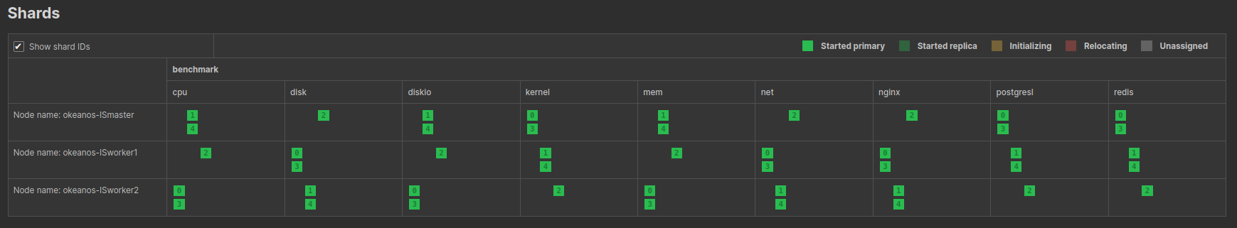

**Με έναν worker και hash-workers=true**

[λείπει αλλά μάλλον δεν κάνει διαφορά]

**Με** **2 workers**: (Master : 1.5GB, Worker1 : 1.4GB, Worker2: 1.5GB => 4.4GB)

time,per. metric/s,metric total,overall metric/s,per. row/s,row total,overall row/s

1704114162,44869.71,7.844314E+07,90164.41,3999.80,6.990000E+06,8034.47

1704114172,22434.63,7.866748E+07,89394.78,2000.06,7.010000E+06,7965.90

1704114182,112212.36,7.978956E+07,89651.14,10000.39,7.110000E+06,7988.76

1704114192,78561.58,8.057516E+07,89527.93,7000.14,7.180000E+06,7977.78

1704114202,67362.90,8.124878E+07,89284.36,6000.08,7.240000E+06,7956.04

1704114212,89739.12,8.214626E+07,89289.30,7999.21,7.320000E+06,7956.51

1704114222,112262.15,8.326878E+07,89536.30,10000.90,7.420000E+06,7978.49

1704114232,67304.92,8.394188E+07,89299.78,5999.55,7.480000E+06,7957.44

1704114242,112263.93,8.506442E+07,89541.49,10000.88,7.580000E+06,7978.95

1704114252,112172.52,8.618626E+07,89777.25,9998.98,7.680000E+06,7999.99

1704114262,89824.35,8.708442E+07,89777.74,8000.74,7.760000E+06,8000.00

Summary:

loaded 87264000 metrics in 970.552sec with 2 workers (mean rate 89911.70 metrics/sec)

loaded 7776000 rows in 970.552sec with 2 workers (mean rate 8011.93 rows/sec)

**Με 2 workers και hash-workers=true:**

1704117360,168210.47,7.642314E+07,117572.93,14990.77,6.810000E+06,10476.82

1704117370,157157.68,7.799442E+07,118172.58,14002.64,6.950000E+06,10530.23

1704117380,123487.61,7.922878E+07,118251.88,11004.60,7.060000E+06,10537.31

1704117390,145863.71,8.068748E+07,118657.95,12999.44,7.190000E+06,10573.52

1704117400,157139.18,8.225878E+07,119215.62,14000.82,7.330000E+06,10623.19

1704117410,123423.05,8.349314E+07,119275.73,10998.85,7.440000E+06,10628.55

1704117420,101001.52,8.450314E+07,119018.35,9000.14,7.530000E+06,10605.62

1704117430,78562.74,8.528878E+07,118456.46,6999.89,7.600000E+06,10555.54

1704117440,89757.30,8.618626E+07,118063.36,8000.83,7.680000E+06,10520.55

Summary:

loaded 87264000 metrics in 737.879sec with 2 workers (mean rate 118263.33 metrics/sec)

loaded 7776000 rows in 737.879sec with 2 workers (mean rate 10538.32 rows/sec)

**Με 3 workers:** (Master:526 MB, Worker1: 533 MB, Worker2:481 MB)

time,per. metric/s,metric total,overall metric/s,per. row/s,row total,overall row/s

1704114982,89739.23,6.901626E+07,150035.01,7999.22,6.150000E+06,13369.53

1704114992,258031.45,7.159748E+07,152333.59,22991.93,6.380000E+06,13574.34

1704115002,224521.25,7.384188E+07,153836.95,20007.24,6.580000E+06,13708.31

1704115012,258143.57,7.642314E+07,155965.51,23001.57,6.810000E+06,13897.95

1704115022,201994.03,7.844314E+07,156886.11,17999.47,6.990000E+06,13979.98

1704115032,235674.07,8.080000E+07,158431.05,20998.94,7.200000E+06,14117.62

1704115042,168315.23,8.248314E+07,158621.12,15000.11,7.350000E+06,14134.59

1704115052,112212.40,8.360516E+07,157745.57,10000.93,7.450000E+06,14056.60

1704115062,168250.23,8.528810E+07,157940.15,14996.10,7.600000E+06,14074.00

1704115072,168412.67,8.697188E+07,158130.52,15003.09,7.750000E+06,14090.89

Summary:

loaded 87264000 metrics in 550.566sec with 3 workers (mean rate 158498.66 metrics/sec)

loaded 7776000 rows in 550.566sec with 3 workers (mean rate 14123.64 rows/sec)

**Με hash-workers=true και 3 workers:**

time,per. metric/s,metric total,overall metric/s,per. row/s,row total,overall row/s

1704116329,213201.02,7.406626E+07,172247.04,19001.52,6.600000E+06,15348.83

1704116339,213232.48,7.619878E+07,173178.61,18998.26,6.790000E+06,15431.78

1704116349,157138.14,7.777000E+07,172822.20,14001.44,6.930000E+06,15400.00

1704116359,145870.65,7.922878E+07,172236.26,12999.34,7.060000E+06,15347.81

1704116369,67313.26,7.990188E+07,170003.97,6000.29,7.120000E+06,15148.93

1704116379,134676.94,8.124878E+07,169267.92,11998.84,7.240000E+06,15083.30

1704116389,190767.21,8.315626E+07,169706.64,17001.71,7.410000E+06,15122.45

1704116399,212973.70,8.528878E+07,170573.09,18975.20,7.600000E+06,15199.60

1704116409,168529.07,8.697188E+07,170533.06,15019.52,7.750000E+06,15196.07

Summary:

loaded 87264000 metrics in 510.593sec with 3 workers (mean rate 170907.00 metrics/sec)

loaded 7776000 rows in 510.593sec with 3 workers (mean rate 15229.34 rows/sec)

**Με 6 workers:** (Master: 546 MB, Worker1: 532 MB, Worker2: 476 MB)

1704117970,213234.72,7.294442E+07,208412.06,18998.28,6.500000E+06,18571.38

1704117980,258097.37,7.552516E+07,209792.08,23002.08,6.730000E+06,18694.44

1704117990,157108.72,7.709626E+07,208368.19,13999.89,6.870000E+06,18567.56

1704118000,280564.17,7.990188E+07,210268.07,25000.19,7.120000E+06,18736.84

1704118010,258100.83,8.248314E+07,211494.67,22997.76,7.350000E+06,18846.10

1704118020,235700.84,8.484000E+07,212099.79,21001.32,7.560000E+06,18899.98

1704118030,157065.33,8.641062E+07,210757.51,14000.30,7.700000E+06,18780.48

1704118040,33684.74,8.674748E+07,206541.34,2999.89,7.730000E+06,18404.74

Summary:

loaded 87264000 metrics in 424.264sec with 6 workers (mean rate 205683.26 metrics/sec)

loaded 7776000 rows in 424.264sec with 6 workers (mean rate 18328.21 rows/sec)

**Με 6 workers και hash-workers=true:**

1704119159,235691.39,7.182188E+07,189004.93,21001.73,6.400000E+06,16842.10

1704119169,291805.31,7.474000E+07,191640.89,25999.40,6.660000E+06,17076.91

1704119179,145881.36,7.619878E+07,190496.93,13000.30,6.790000E+06,16975.00

1704119189,112176.22,7.732062E+07,188586.54,9999.31,6.890000E+06,16804.85

1704119199,33684.81,7.765748E+07,184898.29,2999.89,6.920000E+06,16476.15

1704119209,269194.55,8.035062E+07,186859.51,23989.36,7.160000E+06,16650.95

1704119219,123521.07,8.158516E+07,185420.78,11005.98,7.270000E+06,16522.72

1704119229,56108.82,8.214626E+07,182547.12,4999.89,7.320000E+06,16266.66

1704119239,56122.28,8.270748E+07,179798.77,5000.03,7.370000E+06,16021.73

1704119249,202003.43,8.472748E+07,180271.20,18000.31,7.550000E+06,16063.83

Summary:

loaded 87264000 metrics in 477.103sec with 6 workers (mean rate 182904.03 metrics/sec)

loaded 7776000 rows in 477.103sec with 6 workers (mean rate 16298.38 rows/sec)

**Με 9 workers (1.5-1.4-1.5):**

1704119680,123258.19,6.744516E+07,217553.50,10982.55,6.010000E+06,19386.07

1704119690,303507.90,7.047546E+07,220235.34,27042.58,6.280000E+06,19624.96

1704119700,224301.49,7.272000E+07,220358.64,19986.41,6.480000E+06,19635.92

1704119710,247053.07,7.518878E+07,221143.21,22015.60,6.700000E+06,19705.86

1704119720,179568.04,7.698442E+07,219955.38,16000.36,6.860000E+06,19599.99

1704119730,44868.16,7.743314E+07,215091.44,3999.66,6.900000E+06,19166.61

1704119740,44875.75,7.788188E+07,210491.20,4000.16,6.940000E+06,18756.72

1704119750,314249.83,8.102442E+07,213221.72,27999.63,7.220000E+06,18999.96

1704119760,291747.04,8.394188E+07,215235.18,26000.09,7.480000E+06,19179.45

1704119770,157137.09,8.551314E+07,213782.83,14000.99,7.620000E+06,19050.00

Summary:

loaded 87264000 metrics in 404.239sec with 9 workers (mean rate 215872.16 metrics/sec)

loaded 7776000 rows in 404.239sec with 9 workers (mean rate 19236.13 rows/sec)

**Με 9 workers και hash-workers=true: (1.5-1.4-1.5)**

time,per. metric/s,metric total,overall metric/s,per. row/s,row total,overall row/s

1704133705,145915.08,7.193442E+07,171272.10,12999.03,6.410000E+06,15261.88

1704133715,157070.89,7.350516E+07,170941.84,13999.72,6.550000E+06,15232.52

1704133725,101002.65,7.451516E+07,169352.35,9000.24,6.640000E+06,15090.88

1704133735,157121.00,7.608626E+07,169080.57,14000.98,6.780000E+06,15066.67

1704133745,145872.80,7.754516E+07,168575.99,12998.47,6.910000E+06,15021.70

1704133755,123487.31,7.878000E+07,167616.68,11000.29,7.020000E+06,14936.14

1704133765,168329.48,8.046314E+07,167631.53,15001.38,7.170000E+06,14937.50

1704133775,168311.76,8.214626E+07,167645.42,14999.98,7.320000E+06,14938.77

1704133785,258017.36,8.472748E+07,169453.57,22990.68,7.550000E+06,15099.88

1704133795,213335.22,8.686000E+07,170313.66,19007.41,7.740000E+06,15176.46

Summary:

loaded 87264000 metrics in 510.475sec with 9 workers (mean rate 170946.56 metrics/sec)

loaded 7776000 rows in 510.475sec with 9 workers (mean rate 15232.86 rows/sec)

**Με 12 workers:**

time,per. metric/s,metric total,overall metric/s,per. row/s,row total,overall row/s

1704134253,190748.86,6.138516E+07,245539.91,17000.08,5.470000E+06,21879.94

1704134263,258128.21,6.396626E+07,246024.04,23001.62,5.700000E+06,21923.07

1704134273,403974.26,6.800626E+07,251874.41,35997.71,6.060000E+06,22444.39

1704134283,392807.31,7.193442E+07,256907.82,34999.23,6.410000E+06,22892.78

1704134293,246855.54,7.440314E+07,256561.17,21998.53,6.630000E+06,22861.95

1704134303,258152.40,7.698442E+07,256614.21,23002.17,6.860000E+06,22866.62

1704134313,359068.58,8.057516E+07,259919.23,31999.52,7.180000E+06,23161.23

1704134323,246922.52,8.304442E+07,259513.08,21999.69,7.400000E+06,23124.93

1704134333,336692.10,8.641130E+07,261851.80,30000.37,7.700000E+06,23333.28

Summary:

loaded 87264000 metrics in 332.702sec with 12 workers (mean rate 262288.52 metrics/sec)

loaded 7776000 rows in 332.702sec with 12 workers (mean rate 23372.24 rows/sec)

**Με 15 workers:**

time,per. metric/s,metric total,overall metric/s,per. row/s,row total,overall row/s

1704134810,179518.08,6.441516E+07,230054.09,16000.19,5.740000E+06,20500.00

1704134820,168353.56,6.609878E+07,227926.38,14999.25,5.890000E+06,20310.31

1704134830,381547.23,6.991442E+07,233047.29,33998.51,6.230000E+06,20766.60

1704134840,213191.95,7.204626E+07,232406.82,19000.71,6.420000E+06,20709.64

1704134850,246877.54,7.451516E+07,232859.05,21998.89,6.640000E+06,20749.93

1704134860,269391.32,7.720878E+07,233965.97,24002.61,6.880000E+06,20848.48

1704134870,235637.69,7.956516E+07,234015.14,20999.97,7.090000E+06,20852.94

1704134880,325465.97,8.282000E+07,236628.16,28998.39,7.380000E+06,21085.68

1704134890,224454.65,8.506442E+07,236290.02,20001.13,7.580000E+06,21055.55

Summary:

loaded 87264000 metrics in 368.987sec with 15 workers (mean rate 236496.02 metrics/sec)

loaded 7776000 rows in 368.987sec with 15 workers (mean rate 21073.90 rows/sec)

**Με 18 workers:**

time,per. metric/s,metric total,overall metric/s,per. row/s,row total,overall row/s

1704135473,201997.27,6.464000E+07,165743.50,17999.76,5.760000E+06,14769.22

1704135483,201992.48,6.666000E+07,166649.76,17999.33,5.940000E+06,14849.98

1704135493,347781.05,7.013878E+07,171068.79,30991.36,6.250000E+06,15243.78

1704135503,325537.14,7.339314E+07,174745.47,29009.01,6.540000E+06,15571.42

1704135513,246861.97,7.586188E+07,176422.67,21998.93,6.760000E+06,15720.90

1704135523,202009.92,7.788188E+07,177004.17,18000.88,6.940000E+06,15772.72

1704135533,280583.18,8.068772E+07,179305.93,24999.93,7.190000E+06,15977.77

1704135543,246857.59,8.315626E+07,180774.43,22000.32,7.410000E+06,16108.69

1704135553,224436.61,8.540062E+07,181703.41,20000.05,7.610000E+06,16191.49

Summary:

loaded 87264000 metrics in 478.382sec with 18 workers (mean rate 182414.92 metrics/sec)

loaded 7776000 rows in 478.382sec with 18 workers (mean rate 16254.79 rows/sec)

**Data Ingestion using different configs**

1. Data Ingestion with 12 workers in the small dataset, using 3, 6 and 9 shards without partitioning

**with 3 shards (no partitioning):**

Summary:

loaded 87264000 metrics in 236.840sec with 12 workers (mean rate 368451.92 metrics/sec)

loaded 7776000 rows in 236.840sec with 12 workers (mean rate 32832.35 rows/sec)

**with 6 shards (no partitioning):**

Summary:

loaded 87264000 metrics in 402.921sec with 12 workers (mean rate 216578.69 metrics/sec)

loaded 7776000 rows in 402.921sec with 12 workers (mean rate 19299.09 rows/sec)

**with 9 shards (no partitioning):**

Summary:

loaded 87264000 metrics in 541.612sec with 12 workers (mean rate 161119.16 metrics/sec)

loaded 7776000 rows in 541.612sec with 12 workers (mean rate 14357.15 rows/sec)

1. Data Ingestion with 12 workers in the small dataset, using 3, 6 and 9 shards with partitioning

**with 3 shards (with partitioning):**

Summary:

loaded 87264000 metrics in 321.227sec with 12 workers (mean rate 271658.33 metrics/sec)

loaded 7776000 rows in 321.227sec with 12 workers (mean rate 24207.18 rows/sec)

**with 6 shards (with partitioning):**

Summary:

loaded 87264000 metrics in 536.118sec with 12 workers (mean rate 162770.01 metrics/sec)

loaded 7776000 rows in 536.118sec with 12 workers (mean rate 14504.26 rows/sec)

**with 9 shards (with partitioning):**

Summary:

loaded 87264000 metrics in 472.506sec with 12 workers (mean rate 184683.25 metrics/sec)

loaded 7776000 rows in 472.506sec with 12 workers (mean rate 16456.92 rows/sec)

**Με 12 shards (with partitioning):**

Summary:

loaded 87264000 metrics in 759.149sec with 12 workers (mean rate 114949.78 metrics/sec)

loaded 7776000 rows in 759.149sec with 12 workers (mean rate 10243.05 rows/sec)

**2nd USE CASE : 48211200 rows ,**

**Master: 2.9 GB  
Worker1: 3.2 GB**

**Worker2: 3.1 GB**

**Total: 9.2 GB**

α) Παραγωγή Δεδομένων (1 μήνα)

./tsbs_generate_data --use-case="devops" --seed=666 --scale=20 \

--timestamp-start="2016-01-01T00:00:00Z" \

--timestamp-end="2016-02-01T00:00:00Z" \

--log-interval="10s" --format="cratedb" \

| gzip > /tmp/cratedb-data.gz

β) loading

cat /tmp/cratedb-data.gz | gunzip | ./tsbs_load_cratedb \ --workers=1

**Με 1 worker :**

1704208823,67318.65,5.409106E+08,87810.16,6000.41,4.820000E+07,7824.68

1704208833,78556.86,5.416963E+08,87795.17,6999.36,4.827000E+07,7823.34

1704208843,101009.19,5.427063E+08,87816.55,9000.82,4.836000E+07,7825.24

1704208853,78554.75,5.434919E+08,87801.58,6999.35,4.843000E+07,7823.91

1704208863,112263.17,5.446144E+08,87841.03,10000.82,4.853000E+07,7827.42

1704208873,112177.80,5.457363E+08,87880.22,9999.45,4.863000E+07,7830.92

1704208883,89821.84,5.466344E+08,87883.35,8000.52,4.871000E+07,7831.19

1704208893,78554.65,5.474200E+08,87868.37,6999.70,4.878000E+07,7829.85

Summary:

loaded 548308800 metrics in 6239.490sec with 1 workers (mean rate 87877.18 metrics/sec)

loaded 48859200 rows in 6239.490sec with 1 workers (mean rate 7830.64 rows/sec)

**Με 2 workers με hash-workers=true:**

time,per. metric/s,metric total,overall metric/s,per. row/s,row total,overall row/s

1704225784,179544.48,5.419206E+08,132175.74,15999.86,4.829000E+07,11778.05

1704225794,179558.66,5.437163E+08,132291.03,15999.52,4.845000E+07,11788.32

1704225804,157121.27,5.452875E+08,132351.30,13999.94,4.859000E+07,11793.69

1704225814,202008.91,5.473075E+08,132519.96,18000.79,4.877000E+07,11808.72

Summary:

loaded 548308800 metrics in 4135.596sec with 2 workers (mean rate 132582.77 metrics/sec)

loaded 48859200 rows in 4135.596sec with 2 workers (mean rate 11814.31 rows/sec)

**Με 3 workers:**

time,per. metric/s,metric total,overall metric/s,per. row/s,row total,overall row/s

1704277872,145883.70,5.296888E+08,161490.46,13000.51,4.720000E+07,14390.24

1704277882,123437.99,5.309231E+08,161374.81,11000.18,4.731000E+07,14379.94

1704277892,213123.70,5.330552E+08,161531.68,18993.02,4.750000E+07,14393.92

1704277902,224551.59,5.353000E+08,161722.01,20006.02,4.770000E+07,14410.87

1704277912,190743.35,5.372075E+08,161809.43,16999.59,4.787000E+07,14418.67

1704277922,179570.61,5.390031E+08,161862.76,16000.41,4.803000E+07,14423.42

1704277932,157127.49,5.405744E+08,161848.59,13999.95,4.817000E+07,14422.15

1704277942,202004.35,5.425944E+08,161968.45,18000.39,4.835000E+07,14432.83

1704277952,190757.86,5.445019E+08,162054.13,17001.06,4.852000E+07,14440.48

1704277962,258120.67,5.470831E+08,162339.20,22999.53,4.875000E+07,14465.87

Summary:

loaded 548308800 metrics in 3375.921sec with 3 workers (mean rate 162417.54 metrics/sec)

loaded 48859200 rows in 3375.921sec with 3 workers (mean rate 14472.85 rows/sec)

**Με 6 workers (no hash workers):**

time,per. metric/s,metric total,overall metric/s,per. row/s,row total,overall row/s

1704281135,179567.71,5.278931E+08,256258.69,16000.15,4.704000E+07,22834.94

1704281145,224454.39,5.301375E+08,256105.06,20001.82,4.724000E+07,22821.26

1704281155,168280.60,5.318206E+08,255682.74,14997.02,4.739000E+07,22783.63

1704281165,246983.58,5.342900E+08,255641.13,22004.06,4.761000E+07,22779.90

1704281175,190731.41,5.361975E+08,255332.01,16998.52,4.778000E+07,22752.37

1704281185,336710.50,5.395644E+08,255717.67,30001.47,4.808000E+07,22786.72

1704281195,100994.55,5.405744E+08,254987.83,8999.87,4.817000E+07,22721.69

1704281205,22440.86,5.407988E+08,253896.10,2000.08,4.819000E+07,22624.41

1704281215,56121.50,5.413600E+08,252971.92,4999.96,4.824000E+07,22542.05

1704281225,258045.71,5.439406E+08,252995.52,22998.55,4.847000E+07,22544.18

1704281235,303013.57,5.469706E+08,253227.07,27001.21,4.874000E+07,22564.81

Summary:

loaded 548308800 metrics in 2165.518sec with 6 workers (mean rate 253199.78 metrics/sec)

loaded 48859200 rows in 2165.518sec with 6 workers (mean rate 22562.36 rows/sec)

**Με 9 workers (no hash):**

time,per. metric/s,metric total,overall metric/s,per. row/s,row total,overall row/s

1704289097,291979.89,5.153244E+08,297875.31,26014.60,4.592000E+07,26543.35

1704289107,381497.55,5.191400E+08,298355.97,33994.61,4.626000E+07,26586.18

1704289117,314239.92,5.222819E+08,298446.72,28004.63,4.654000E+07,26594.28

1704289127,336702.38,5.256488E+08,298664.07,30001.10,4.684000E+07,26613.64

1704289137,325415.41,5.289031E+08,298815.22,28998.17,4.713000E+07,26627.11

1704289147,314209.41,5.320452E+08,298901.70,28000.66,4.741000E+07,26634.82

1704289157,381549.56,5.358606E+08,299363.42,34000.32,4.775000E+07,26675.97

1704289167,392827.62,5.397888E+08,299882.65,35001.04,4.810000E+07,26722.22

1704289177,347870.22,5.432675E+08,300147.77,31000.02,4.841000E+07,26745.86

1704289187,392767.81,5.471952E+08,300656.67,34999.98,4.876000E+07,26791.21

Summary:

loaded 548308800 metrics in 1821.856sec with 9 workers (mean rate 300961.58 metrics/sec)

loaded 48859200 rows in 1821.856sec with 9 workers (mean rate 26818.36 rows/sec)

**Με 12 workers (no hash):**

time,per. metric/s,metric total,overall metric/s,per. row/s,row total,overall row/s

1704291617,325411.10,5.312596E+08,329974.66,28997.42,4.734000E+07,29403.71

1704291627,370203.33,5.349631E+08,330223.09,32986.22,4.767000E+07,29425.83

1704291637,314365.95,5.381052E+08,330125.86,28014.61,4.795000E+07,29417.18

1704291647,302949.11,5.411352E+08,329960.12,26995.47,4.822000E+07,29402.41

1704291657,246961.10,5.436044E+08,329457.17,22003.13,4.844000E+07,29357.57

1704291667,145865.06,5.450631E+08,328351.14,12999.38,4.857000E+07,29259.02

1704291677,291758.33,5.479806E+08,328132.03,26000.92,4.883000E+07,29239.51

Summary:

loaded 548308800 metrics in 1670.846sec with 12 workers (mean rate 328162.37 metrics/sec)

loaded 48859200 rows in 1670.846sec with 12 workers (mean rate 29242.19 rows/sec)

**Με 15 workers:**

time,per. metric/s,metric total,overall metric/s,per. row/s,row total,overall row/s

1704294898,482578.20,5.184662E+08,286445.42,43001.44,4.620000E+07,25524.86

1704294908,359089.59,5.220575E+08,286844.60,31996.93,4.652000E+07,25560.42

1704294918,426265.37,5.263218E+08,287606.77,37984.80,4.690000E+07,25628.34

1704294928,437876.64,5.306988E+08,288423.11,39016.27,4.729000E+07,25701.07

1704294938,460180.17,5.353002E+08,289351.45,41003.22,4.770000E+07,25783.78

1704294948,134662.21,5.366469E+08,288519.73,11999.13,4.782000E+07,25709.67

1704294958,89754.46,5.375444E+08,287456.89,8000.58,4.790000E+07,25614.97

1704294968,190733.61,5.394519E+08,286942.37,16998.90,4.807000E+07,25569.14

1704294978,336693.22,5.428188E+08,287205.60,30000.29,4.837000E+07,25592.58

1704294988,381431.50,5.466337E+08,287701.61,33994.43,4.871000E+07,25636.81

Summary:

loaded 548308800 metrics in 1901.616sec with 15 workers (mean rate 288338.35 metrics/sec)

loaded 48859200 rows in 1901.616sec with 15 workers (mean rate 25693.52 rows/sec)

**Με 18 workers (no hash):**

time,per. metric/s,metric total,overall metric/s,per. row/s,row total,overall row/s

1704311406,392778.56,5.156613E+08,277237.10,34996.66,4.595000E+07,24704.29

1704311416,471350.24,5.203744E+08,278275.05,42003.41,4.637000E+07,24796.79

1704311426,325374.86,5.236281E+08,278525.58,29000.61,4.666000E+07,24819.15

1704311436,347938.85,5.271075E+08,278892.84,31000.08,4.697000E+07,24851.85

1704311446,336542.97,5.304744E+08,279196.40,29986.54,4.727000E+07,24878.89

1704311456,460310.35,5.350755E+08,280144.21,41018.39,4.768000E+07,24963.35

1704311466,415221.28,5.392277E+08,280847.74,36999.94,4.805000E+07,25026.04

1704311476,460076.03,5.438288E+08,281776.45,40996.97,4.846000E+07,25108.80

Summary:

loaded 548308800 metrics in 1939.765sec with 18 workers (mean rate 282667.69 metrics/sec)

loaded 48859200 rows in 1939.765sec with 18 workers (mean rate 25188.21 rows/sec)

**3rd USE CASE : 93312000 rows ,**

**Master: 5.8 GB  
Worker1: 5.8 GB**

**Worker2: 6.1 GB**

**Total: 17.7 GB**

α) Παραγωγή Δεδομένων (2 μήνες)

./tsbs_generate_data --use-case="devops" --seed=666 --scale=20 \

--timestamp-start="2016-01-01T00:00:00Z" \

--timestamp-end="2016-03-01T00:00:00Z" \

--log-interval="10s" --format="cratedb" \

| gzip > /tmp/cratedbBIG-data.gz

β) loading

cat /tmp/cratedbBIG-data.gz | gunzip | ./tsbs_load_cratedb \

--workers=1

**Με 1 worker :**

Summary:

loaded 1047168000 metrics in 12779.027sec with 1 workers (mean rate 81944.27 metrics/sec)

loaded 93312000 rows in 12779.027sec with 1 workers (mean rate 7301.96 rows/sec)

**Με 2 workers (with hash) :**

Summary:

loaded 1047168000 metrics in 8181.817sec with 2 workers (mean rate 127987.22 metrics/sec)

loaded 93312000 rows in 8181.817sec with 2 workers (mean rate 11404.80 rows/sec)

**Με 3 workers (with hash) :**

Summary:

loaded 1047168000 metrics in 7851.830sec with 3 workers (mean rate 133366.11 metrics/sec)

loaded 93312000 rows in 7851.830sec with 3 workers (mean rate 11884.11 rows/sec)

**Με 6 workers (no hash):**

Summary:

loaded 1047168000 metrics in 4993.996sec with 6 workers (mean rate 209685.39 metrics/sec)

loaded 93312000 rows in 4993.996sec with 6 workers (mean rate 18684.84 rows/sec)

**Με 9 workers (no hash):**

Summary:

loaded 1047168000 metrics in 5753.729sec with 9 workers (mean rate 181998.16 metrics/sec)

loaded 93312000 rows in 5753.729sec with 9 workers (mean rate 16217.66 rows/sec)

**Με 12 workers (no hash):**

Summary:

loaded 1047168000 metrics in 3726.396sec with 12 workers (mean rate 281013.61 metrics/sec)

loaded 93312000 rows in 3726.396sec with 12 workers (mean rate 25040.82 rows/sec)

**Με 15 workers (no hash):**

Summary:

loaded 1047168000 metrics in 3599.233sec with 15 workers (mean rate 290942.00 metrics/sec)

loaded 93312000 rows in 3599.233sec with 15 workers (mean rate 25925.52 rows/sec)

**Με 18 workers (no hash):**

Summary:

loaded 1047168000 metrics in 3008.071sec with 18 workers (mean rate 348119.43 metrics/sec)

loaded 93312000 rows in 3008.071sec with 18 workers (mean rate 31020.54 rows/sec)

**Με 12 workers (3 shards no partitioning):**

Summary:

loaded 1047168000 metrics in 3574.853sec with 12 workers (mean rate 292926.20 metrics/sec)

loaded 93312000 rows in 3574.853sec with 12 workers (mean rate 26102.33 rows/sec)

**Με 12 workers (6 shards no partitioning):**

Summary:

loaded 1047168000 metrics in 4974.955sec with 12 workers (mean rate 210487.92 metrics/sec)

loaded 93312000 rows in 4974.955sec with 12 workers (mean rate 18756.35 rows/sec)

**Με 12 workers (9 shards no partitioning):**

Summary:

loaded 1047168000 metrics in 5547.786sec with 12 workers (mean rate 188754.23 metrics/sec)

loaded 93312000 rows in 5547.786sec with 12 workers (mean rate 16819.68 rows/sec)

**Με 12 workers (3 shards with partitioning by month):**

Summary:

loaded 1047168000 metrics in 4311.059sec with 12 workers (mean rate 242902.72 metrics/sec)

loaded 93312000 rows in 4311.059sec with 12 workers (mean rate 21644.80 rows/sec)

**Με 12 workers (6 shards with partitioning by month):**

Summary:

loaded 1047168000 metrics in 5295.657sec with 12 workers (mean rate 197740.90 metrics/sec)

loaded 93312000 rows in 5295.657sec with 12 workers (mean rate 17620.48 rows/sec)

**Με 12 workers (9 shards with partitioning by month):**

Summary:

loaded 1047168000 metrics in 7869.495sec with 12 workers (mean rate 133066.74 metrics/sec)

loaded 93312000 rows in 7869.495sec with 12 workers (mean rate 11857.43 rows/sec)

**RUNNING QUERIES**

**B. CRATE DB**

*1st config : 6 shards, no partitioning*

*1000 Queries, type:single-groupby-1-1-1*

1. **Generate queries :**

./tsbs_generate_queries --use-case="devops" --seed=666 --scale=20 \

--timestamp-start="2016-01-01T00:00:00Z" \

--timestamp-end="2016-01-03T10:00:01Z" \

--queries=1000 --query-type="single-groupby-1-1-1" --format="cratedb" \

| gzip > /tmp/cratedb-queries-single-groupby-1-1-1.gz

1. **Run queries (example for 1 worker):**

cat /tmp/cratedb-queries-single-groupby-1-1-1.gz | \

gunzip | ./tsbs_run_queries_cratedb --workers=1 \

--hdr-latencies="/tmp/HDRlaten_Workers1_Queries1000_TypeOfQuer1.out" --memprofile="/tmp/mem_profile_Workers1_Queries1000_TypeOfQuer1.pprof"

***and with --prewarm-queries*** :

cat /tmp/cratedb-queries-single-groupby-1-1-1.gz | \

gunzip | ./tsbs_run_queries_cratedb --workers=1 \

--hdr-latencies="/tmp/HDRlaten_Workers1_Queries1000_TypeOfQuer1.out" --memprofile="/tmp/mem_profile_Workers1_Queries1000_TypeOfQuer1.pprof" --prewarm-queries=True

**With 1 worker (no prewarm):**

After 1000 queries with 1 workers:

Interval query rate: 36.13 queries/sec Overall query rate: 24.53 queries/sec

CrateDB 1 cpu metric(s), random 1 hosts, random 1h0m0s by 1m:

min: 0.94ms, med: 1.72ms, mean: 2.01ms, max: 63.52ms, stddev: 2.32ms, sum: 2.0sec, count: 1000

all queries :

min: 0.94ms, med: 1.72ms, mean: 2.01ms, max: 63.52ms, stddev: 2.32ms, sum: 2.0sec, count: 1000

Run complete after 1000 queries with 1 workers (Overall query rate 24.52 queries/sec):

CrateDB 1 cpu metric(s), random 1 hosts, random 1h0m0s by 1m:

min: 0.94ms, med: 1.72ms, mean: 2.01ms, max: 63.52ms, stddev: 2.32ms, sum: 2.0sec, count: 1000

all queries :

min: 0.94ms, med: 1.72ms, mean: 2.01ms, max: 63.52ms, stddev: 2.32ms, sum: 2.0sec, count: 1000

Saving High Dynamic Range (HDR) Histogram of Response Latencies to /tmp/HDRlaten_Workers1_Queries1000_TypeOfQuer1.out

wall clock time: 40.805456sec

**With 1 worker (with prewarm):**

After 1000 queries with 1 workers:

Interval query rate: 33.45 queries/sec Overall query rate: 38.46 queries/sec

CrateDB 1 cpu metric(s), random 1 hosts, random 1h0m0s by 1m:

min: 0.01ms, med: 0.51ms, mean: 0.48ms, max: 8.04ms, stddev: 0.50ms, sum: 1.0sec, count: 1999

all queries :

min: 0.01ms, med: 0.51ms, mean: 0.48ms, max: 8.04ms, stddev: 0.50ms, sum: 1.0sec, count: 1999

cold queries :

min: 0.50ms, med: 0.90ms, mean: 0.93ms, max: 8.04ms, stddev: 0.31ms, sum: 0.9sec, count: 1000

warm queries :

min: 0.01ms, med: 0.03ms, mean: 0.03ms, max: 0.83ms, stddev: 0.03ms, sum: 0.0sec, count: 999

After 1000 queries with 1 workers:

Interval query rate: 148.04 queries/sec Overall query rate: 38.47 queries/sec

CrateDB 1 cpu metric(s), random 1 hosts, random 1h0m0s by 1m:

min: 0.01ms, med: 0.50ms, mean: 0.48ms, max: 8.04ms, stddev: 0.50ms, sum: 1.0sec, count: 2000

all queries :

min: 0.01ms, med: 0.50ms, mean: 0.48ms, max: 8.04ms, stddev: 0.50ms, sum: 1.0sec, count: 2000

cold queries :

min: 0.50ms, med: 0.90ms, mean: 0.93ms, max: 8.04ms, stddev: 0.31ms, sum: 0.9sec, count: 1000

warm queries :

min: 0.01ms, med: 0.03ms, mean: 0.03ms, max: 0.83ms, stddev: 0.03ms, sum: 0.0sec, count: 1000

Run complete after 1000 queries with 1 workers (Overall query rate 38.47 queries/sec):

CrateDB 1 cpu metric(s), random 1 hosts, random 1h0m0s by 1m:

min: 0.01ms, med: 0.50ms, mean: 0.48ms, max: 8.04ms, stddev: 0.50ms, sum: 1.0sec, count: 2000

all queries :

min: 0.01ms, med: 0.50ms, mean: 0.48ms, max: 8.04ms, stddev: 0.50ms, sum: 1.0sec, count: 2000

cold queries :

min: 0.50ms, med: 0.90ms, mean: 0.93ms, max: 8.04ms, stddev: 0.31ms, sum: 0.9sec, count: 1000

warm queries :

min: 0.01ms, med: 0.03ms, mean: 0.03ms, max: 0.83ms, stddev: 0.03ms, sum: 0.0sec, count: 1000

wall clock time: 51.995489sec

*2nd config : 6 shards, no partitioning*

*10000 Queries, type:single-groupby-1-1-1*

1. **Generate queries :**

./tsbs_generate_queries --use-case="devops" --seed=666 --scale=20 \

--timestamp-start="2016-01-01T00:00:00Z" \

--timestamp-end="2016-01-03T10:00:01Z" \

--queries=10000 --query-type="single-groupby-1-1-1" --format="cratedb" \

| gzip > /tmp/cratedb-queries-single-groupby-1-1-1.gz

1. **Run queries (example for 1 worker):**

cat /tmp/cratedb-queries-single-groupby-1-1-1.gz | \

gunzip | ./tsbs_run_queries_cratedb --workers=1 \

--hdr-latencies="/tmp/HDRlaten_Workers1_Queries10000_TypeOfQuer1.out" --memprofile="/tmp/mem_profile_Workers1_Queries10000_TypeOfQuer1.pprof"

**With 1 worker (no prewarm):**

After 10000 queries with 1 workers:

Interval query rate: 39.02 queries/sec Overall query rate: 35.54 queries/sec

CrateDB 1 cpu metric(s), random 1 hosts, random 1h0m0s by 1m:

min: 0.52ms, med: 1.00ms, mean: 1.05ms, max: 14.39ms, stddev: 0.41ms, sum: 10.5sec, count: 10000

all queries :

min: 0.52ms, med: 1.00ms, mean: 1.05ms, max: 14.39ms, stddev: 0.41ms, sum: 10.5sec, count: 10000

Run complete after 10000 queries with 1 workers (Overall query rate 35.54 queries/sec):

CrateDB 1 cpu metric(s), random 1 hosts, random 1h0m0s by 1m:

min: 0.52ms, med: 1.00ms, mean: 1.05ms, max: 14.39ms, stddev: 0.41ms, sum: 10.5sec, count: 10000

all queries :

min: 0.52ms, med: 1.00ms, mean: 1.05ms, max: 14.39ms, stddev: 0.41ms, sum: 10.5sec, count: 10000

Saving High Dynamic Range (HDR) Histogram of Response Latencies to /tmp/HDRlaten_Workers1_Queries10000_TypeOfQuer1.out

wall clock time: 281.400702sec

**(για τη δεκαπλάσια δουλειά, όχι δεκαπλάσιο χρόνο!)**

**With 1 worker (with prewarm):**

After 10000 queries with 1 workers:

Interval query rate: 36.90 queries/sec Overall query rate: 38.64 queries/sec

CrateDB 1 cpu metric(s), random 1 hosts, random 1h0m0s by 1m:

min: 0.01ms, med: 0.54ms, mean: 0.50ms, max: 23.70ms, stddev: 0.53ms, sum: 10.1sec, count: 19999

all queries :

min: 0.01ms, med: 0.54ms, mean: 0.50ms, max: 23.70ms, stddev: 0.53ms, sum: 10.1sec, count: 19999

cold queries :

min: 0.52ms, med: 0.96ms, mean: 0.98ms, max: 23.70ms, stddev: 0.33ms, sum: 9.8sec, count: 10000

warm queries :

min: 0.01ms, med: 0.03ms, mean: 0.03ms, max: 1.87ms, stddev: 0.03ms, sum: 0.3sec, count: 9999

After 10000 queries with 1 workers:

Interval query rate: 97.14 queries/sec Overall query rate: 38.64 queries/sec

CrateDB 1 cpu metric(s), random 1 hosts, random 1h0m0s by 1m:

min: 0.01ms, med: 0.54ms, mean: 0.50ms, max: 23.70ms, stddev: 0.53ms, sum: 10.1sec, count: 20000

all queries :

min: 0.01ms, med: 0.54ms, mean: 0.50ms, max: 23.70ms, stddev: 0.53ms, sum: 10.1sec, count: 20000

cold queries :

min: 0.52ms, med: 0.96ms, mean: 0.98ms, max: 23.70ms, stddev: 0.33ms, sum: 9.8sec, count: 10000

warm queries :

min: 0.01ms, med: 0.03ms, mean: 0.03ms, max: 1.87ms, stddev: 0.03ms, sum: 0.3sec, count: 10000

Run complete after 10000 queries with 1 workers (Overall query rate 38.64 queries/sec):

CrateDB 1 cpu metric(s), random 1 hosts, random 1h0m0s by 1m:

min: 0.01ms, med: 0.54ms, mean: 0.50ms, max: 23.70ms, stddev: 0.53ms, sum: 10.1sec, count: 20000

all queries :

min: 0.01ms, med: 0.54ms, mean: 0.50ms, max: 23.70ms, stddev: 0.53ms, sum: 10.1sec, count: 20000

cold queries :

min: 0.52ms, med: 0.96ms, mean: 0.98ms, max: 23.70ms, stddev: 0.33ms, sum: 9.8sec, count: 10000

warm queries :

min: 0.01ms, med: 0.03ms, mean: 0.03ms, max: 1.87ms, stddev: 0.03ms, sum: 0.3sec, count: 10000

wall clock time: 517.594888sec

*3rd config : 6 shards, no partitioning*

*100000 Queries, type:single-groupby-1-1-1*

1. **Generate queries :**

./tsbs_generate_queries --use-case="devops" --seed=666 --scale=20 \

--timestamp-start="2016-01-01T00:00:00Z" \

--timestamp-end="2016-01-03T10:00:01Z" \

--queries=100000 --query-type="single-groupby-1-1-1" --format="cratedb" \

| gzip > /tmp/cratedb-queries-single-groupby-1-1-1.gz

1. **Run queries (example for 1 worker):**

cat /tmp/cratedb3-queries-single-groupby-1-1-1.gz | gunzip | ./tsbs_run_queries_cratedb --workers=1 --hdr-latencies="/tmp/HDRlaten_Workers1_Queries100000_TypeOfQuer1.out" --memprofile="/tmp/mem_profile_Workers1_Queries100000_TypeOfQuer1.pprof"

**With 1 worker (no prewarm):**

After 100000 queries with 1 workers:

Interval query rate: 29.26 queries/sec Overall query rate: 34.20 queries/sec

CrateDB 1 cpu metric(s), random 1 hosts, random 1h0m0s by 1m:

min: 0.44ms, med: 0.86ms, mean: 0.82ms, max: 80.73ms, stddev: 0.54ms, sum: 82.4sec, count: 100000

all queries :

min: 0.44ms, med: 0.86ms, mean: 0.82ms, max: 80.73ms, stddev: 0.54ms, sum: 82.4sec, count: 100000

Run complete after 100000 queries with 1 workers (Overall query rate 34.20 queries/sec):

CrateDB 1 cpu metric(s), random 1 hosts, random 1h0m0s by 1m:

min: 0.44ms, med: 0.86ms, mean: 0.82ms, max: 80.73ms, stddev: 0.54ms, sum: 82.4sec, count: 100000

all queries :

min: 0.44ms, med: 0.86ms, mean: 0.82ms, max: 80.73ms, stddev: 0.54ms, sum: 82.4sec, count: 100000

Saving High Dynamic Range (HDR) Histogram of Response Latencies to /tmp/HDRlaten_Workers1_Queries100000_TypeOfQuer1.out

wall clock time: 2923.777616sec

**With 1 worker (with prewarm):**

After 100000 queries with 1 workers:

Interval query rate: 37.06 queries/sec Overall query rate: 33.39 queries/sec

CrateDB 1 cpu metric(s), random 1 hosts, random 1h0m0s by 1m:

min: 0.01ms, med: 0.52ms, mean: 0.44ms, max: 16.77ms, stddev: 0.45ms, sum: 89.1sec, count: 199999

all queries :

min: 0.01ms, med: 0.52ms, mean: 0.44ms, max: 16.77ms, stddev: 0.45ms, sum: 89.1sec, count: 199999

cold queries :

min: 0.47ms, med: 0.89ms, mean: 0.87ms, max: 16.77ms, stddev: 0.20ms, sum: 86.7sec, count: 100000

warm queries :

min: 0.01ms, med: 0.02ms, mean: 0.02ms, max: 9.86ms, stddev: 0.04ms, sum: 2.4sec, count: 99999

After 100000 queries with 1 workers:

Interval query rate: 131.05 queries/sec Overall query rate: 33.39 queries/sec

CrateDB 1 cpu metric(s), random 1 hosts, random 1h0m0s by 1m:

min: 0.01ms, med: 0.52ms, mean: 0.44ms, max: 16.77ms, stddev: 0.45ms, sum: 89.1sec, count: 200000

all queries :

min: 0.01ms, med: 0.52ms, mean: 0.44ms, max: 16.77ms, stddev: 0.45ms, sum: 89.1sec, count: 200000

cold queries :

min: 0.47ms, med: 0.89ms, mean: 0.87ms, max: 16.77ms, stddev: 0.20ms, sum: 86.7sec, count: 100000

warm queries :

min: 0.01ms, med: 0.02ms, mean: 0.02ms, max: 9.86ms, stddev: 0.04ms, sum: 2.4sec, count: 100000

Run complete after 100000 queries with 1 workers (Overall query rate 33.39 queries/sec):

CrateDB 1 cpu metric(s), random 1 hosts, random 1h0m0s by 1m:

min: 0.01ms, med: 0.52ms, mean: 0.44ms, max: 16.77ms, stddev: 0.45ms, sum: 89.1sec, count: 200000

all queries :

min: 0.01ms, med: 0.52ms, mean: 0.44ms, max: 16.77ms, stddev: 0.45ms, sum: 89.1sec, count: 200000

cold queries :

min: 0.47ms, med: 0.89ms, mean: 0.87ms, max: 16.77ms, stddev: 0.20ms, sum: 86.7sec, count: 100000

warm queries :

min: 0.01ms, med: 0.02ms, mean: 0.02ms, max: 9.86ms, stddev: 0.04ms, sum: 2.4sec, count: 100000

Saving High Dynamic Range (HDR) Histogram of Response Latencies to /tmp/HDRlaten_Workers1_Queries100000_TypeOfQuer1.out

wall clock time: 5988.983800sec

FIRST TYPE OF QUERY

*1st config : 6 shards, no partitioning*

*1000 Queries, type:single-groupby-1-1-1*

1. **Generate queries :**

./tsbs_generate_queries --use-case="devops" --seed=666 --scale=20 \

--timestamp-start="2016-01-01T00:00:00Z" \

--timestamp-end="2016-03-01T00:00:01Z" \

--queries=1000 --query-type="single-groupby-1-1-1" --format="cratedb" \

| gzip > /tmp/cratedb-queries-single-groupby-1-1-1.gz

1. **Run queries (example for 1 worker):**

cat /tmp/cratedb-queries-single-groupby-1-1-1.gz | \

gunzip | ./tsbs_run_queries_cratedb --workers=1 \

--hdr-latencies="/tmp/HDRlaten_Workers1_Queries1000_TypeOfQuer1_correct.out" --memprofile="/tmp/mem_profile_Workers1_Queries1000_TypeOfQuer1_correct.pprof"

***and with --prewarm-queries*** :

cat /tmp/cratedb-queries-single-groupby-1-1-1.gz | \

gunzip | ./tsbs_run_queries_cratedb --workers=1 \

--hdr-latencies="/tmp/HDRlaten_Workers1_Queries1000_TypeOfQuer1.out" --memprofile="/tmp/mem_profile_Workers1_Queries1000_TypeOfQuer1.pprof" --prewarm-queries=True

**With 1 worker (no prewarm):**

After 1000 queries with 1 workers:

Interval query rate: 29.05 queries/sec Overall query rate: 23.63 queries/sec

CrateDB 1 cpu metric(s), random 1 hosts, random 1h0m0s by 1m:

min: 0.64ms, med: 1.28ms, mean: 1.31ms, max: 13.52ms, stddev: 0.65ms, sum: 1.3sec, count: 1000

all queries :

min: 0.64ms, med: 1.28ms, mean: 1.31ms, max: 13.52ms, stddev: 0.65ms, sum: 1.3sec, count: 1000

Run complete after 1000 queries with 1 workers (Overall query rate 23.63 queries/sec):

CrateDB 1 cpu metric(s), random 1 hosts, random 1h0m0s by 1m:

min: 0.64ms, med: 1.28ms, mean: 1.31ms, max: 13.52ms, stddev: 0.65ms, sum: 1.3sec, count: 1000

all queries :

min: 0.64ms, med: 1.28ms, mean: 1.31ms, max: 13.52ms, stddev: 0.65ms, sum: 1.3sec, count: 1000

Saving High Dynamic Range (HDR) Histogram of Response Latencies to /tmp/HDRlaten_Workers1_Queries1000_TypeOfQuer1_correct.out

wall clock time: 42.323606sec

**With 1 worker (with prewarm):**

After 1000 queries with 1 workers:

Interval query rate: 29.05 queries/sec Overall query rate: 23.63 queries/sec

CrateDB 1 cpu metric(s), random 1 hosts, random 1h0m0s by 1m:

min: 0.64ms, med: 1.28ms, mean: 1.31ms, max: 13.52ms, stddev: 0.65ms, sum: 1.3sec, count: 1000

all queries :

min: 0.64ms, med: 1.28ms, mean: 1.31ms, max: 13.52ms, stddev: 0.65ms, sum: 1.3sec, count: 1000

Run complete after 1000 queries with 1 workers (Overall query rate 23.63 queries/sec):

CrateDB 1 cpu metric(s), random 1 hosts, random 1h0m0s by 1m:

min: 0.64ms, med: 1.28ms, mean: 1.31ms, max: 13.52ms, stddev: 0.65ms, sum: 1.3sec, count: 1000

all queries :

min: 0.64ms, med: 1.28ms, mean: 1.31ms, max: 13.52ms, stddev: 0.65ms, sum: 1.3sec, count: 1000

Saving High Dynamic Range (HDR) Histogram of Response Latencies to /tmp/HDRlaten_Workers1_Queries1000_TypeOfQuer1_correct.out

wall clock time: 42.323606sec

user@okeanos-ISworker1:~/go/src/github.com/timescale/tsbs/bin$ cat

*2nd config : 6 shards, no partitioning*

*10000 Queries, type:single-groupby-1-1-1*

1. **Generate queries :**

./tsbs_generate_queries --use-case="devops" --seed=666 --scale=20 \

--timestamp-start="2016-01-01T00:00:00Z" \

--timestamp-end="2016-03-01T00:00:01Z" \

--queries=10000 --query-type="single-groupby-1-1-1" --format="cratedb" \

| gzip > /tmp/cratedb-queries-single-groupby-1-1-1_10000.gz

1. **Run queries (example for 1 worker):**

cat /tmp/cratedb-queries-single-groupby-1-1-1_10000.gz | \

gunzip | ./tsbs_run_queries_cratedb --workers=1 \

--hdr-latencies="/tmp/HDRlaten_Workers1_Queries10000_TypeOfQuer1_correct.out" --memprofile="/tmp/mem_profile_Workers1_Queries10000_TypeOfQuer1_correct.pprof"

--prewarm-queries=True

**With 1 worker (no prewarm):**

After 10000 queries with 1 workers:

Interval query rate: 51.31 queries/sec Overall query rate: 50.39 queries/sec

CrateDB 1 cpu metric(s), random 1 hosts, random 1h0m0s by 1m:

min: 0.43ms, med: 0.67ms, mean: 0.71ms, max: 7.13ms, stddev: 0.19ms, sum: 7.1sec, count: 10000

all queries :

min: 0.43ms, med: 0.67ms, mean: 0.71ms, max: 7.13ms, stddev: 0.19ms, sum: 7.1sec, count: 10000

Run complete after 10000 queries with 1 workers (Overall query rate 50.39 queries/sec):

CrateDB 1 cpu metric(s), random 1 hosts, random 1h0m0s by 1m:

min: 0.43ms, med: 0.67ms, mean: 0.71ms, max: 7.13ms, stddev: 0.19ms, sum: 7.1sec, count: 10000

all queries :

min: 0.43ms, med: 0.67ms, mean: 0.71ms, max: 7.13ms, stddev: 0.19ms, sum: 7.1sec, count: 10000

Saving High Dynamic Range (HDR) Histogram of Response Latencies to /tmp/HDRlaten_Workers1_Queries10000_TypeOfQuer1_correct.out

wall clock time: 198.451839sec

**With 1 worker (with prewarm):**

cat /tmp/cratedb-queries-single-groupby-1-1-1_10000.gz | \

gunzip | ./tsbs_run_queries_cratedb --workers=1 \

--hdr-latencies="/tmp/HDRlaten_Workers1_Queries10000_TypeOfQuer1_correct.out" --memprofile="/tmp/mem_profile_Workers1_Queries10000_TypeOfQuer1_correct.pprof" --prewarm-queries=True

After 10000 queries with 1 workers:

Interval query rate: 51.68 queries/sec Overall query rate: 51.36 queries/sec

CrateDB 1 cpu metric(s), random 1 hosts, random 1h0m0s by 1m:

min: 0.01ms, med: 0.43ms, mean: 0.46ms, max: 5.74ms, stddev: 0.45ms, sum: 9.2sec, count: 19999

all queries :

min: 0.01ms, med: 0.43ms, mean: 0.46ms, max: 5.74ms, stddev: 0.45ms, sum: 9.2sec, count: 19999

cold queries :

min: 0.43ms, med: 0.91ms, mean: 0.90ms, max: 5.74ms, stddev: 0.14ms, sum: 9.0sec, count: 10000

warm queries :

min: 0.01ms, med: 0.02ms, mean: 0.02ms, max: 0.79ms, stddev: 0.01ms, sum: 0.2sec, count: 9999

After 10000 queries with 1 workers:

Interval query rate: 16.97 queries/sec Overall query rate: 51.35 queries/sec

CrateDB 1 cpu metric(s), random 1 hosts, random 1h0m0s by 1m:

min: 0.01ms, med: 0.43ms, mean: 0.46ms, max: 5.74ms, stddev: 0.45ms, sum: 9.2sec, count: 20000

all queries :

min: 0.01ms, med: 0.43ms, mean: 0.46ms, max: 5.74ms, stddev: 0.45ms, sum: 9.2sec, count: 20000

cold queries :

min: 0.43ms, med: 0.91ms, mean: 0.90ms, max: 5.74ms, stddev: 0.14ms, sum: 9.0sec, count: 10000

warm queries :

min: 0.01ms, med: 0.02ms, mean: 0.02ms, max: 0.79ms, stddev: 0.01ms, sum: 0.2sec, count: 10000

Run complete after 10000 queries with 1 workers (Overall query rate 51.35 queries/sec):

CrateDB 1 cpu metric(s), random 1 hosts, random 1h0m0s by 1m:

min: 0.01ms, med: 0.43ms, mean: 0.46ms, max: 5.74ms, stddev: 0.45ms, sum: 9.2sec, count: 20000

all queries :

min: 0.01ms, med: 0.43ms, mean: 0.46ms, max: 5.74ms, stddev: 0.45ms, sum: 9.2sec, count: 20000

cold queries :

min: 0.43ms, med: 0.91ms, mean: 0.90ms, max: 5.74ms, stddev: 0.14ms, sum: 9.0sec, count: 10000

warm queries :

min: 0.01ms, med: 0.02ms, mean: 0.02ms, max: 0.79ms, stddev: 0.01ms, sum: 0.2sec, count: 10000

Saving High Dynamic Range (HDR) Histogram of Response Latencies to /tmp/HDRlaten_Workers1_Queries10000_TypeOfQuer1_correct.out

wall clock time: 389.468769sec

*3rd config : 6 shards, no partitioning*

*100000 Queries, type:single-groupby-1-1-1*

**10. Generate queries :**

./tsbs_generate_queries --use-case="devops" --seed=666 --scale=20 \

--timestamp-start="2016-01-01T00:00:00Z" \

--timestamp-end="2016-03-01T00:00:01Z" \

--queries=100000 --query-type="single-groupby-1-1-1" --format="cratedb" \

| gzip > /tmp/cratedb-queries-single-groupby-1-1-1.gz

1. **Run queries (example for 1 worker):**

cat /tmp/cratedb-queries-single-groupby-1-1-1.gz | \

gunzip | ./tsbs_run_queries_cratedb --workers=1 \

--hdr-latencies="/tmp/HDRlaten_Workers1_Queries100000_TypeOfQuer1_correct.out" --memprofile="/tmp/mem_profile_Workers1_Queries100000_TypeOfQuer1_correct.pprof" --prewarm-queries=True

**With 1 worker (no prewarm):**

After 100000 queries with 1 workers:

Interval query rate: 55.30 queries/sec Overall query rate: 50.25 queries/sec

CrateDB 1 cpu metric(s), random 1 hosts, random 1h0m0s by 1m:

min: 0.44ms, med: 0.84ms, mean: 0.85ms, max: 14.39ms, stddev: 0.22ms, sum: 84.6sec, count: 100000

all queries :

min: 0.44ms, med: 0.84ms, mean: 0.85ms, max: 14.39ms, stddev: 0.22ms, sum: 84.6sec, count: 100000

Run complete after 100000 queries with 1 workers (Overall query rate 50.25 queries/sec):

CrateDB 1 cpu metric(s), random 1 hosts, random 1h0m0s by 1m:

min: 0.44ms, med: 0.84ms, mean: 0.85ms, max: 14.39ms, stddev: 0.22ms, sum: 84.6sec, count: 100000

all queries :

min: 0.44ms, med: 0.84ms, mean: 0.85ms, max: 14.39ms, stddev: 0.22ms, sum: 84.6sec, count: 100000

Saving High Dynamic Range (HDR) Histogram of Response Latencies to /tmp/HDRlaten_Workers1_Queries100000_TypeOfQuer1_correct.out

wall clock time: 1990.254914sec

**With 1 worker (with prewarm):**

After 100000 queries with 1 workers:

Interval query rate: 46.57 queries/sec Overall query rate: 51.12 queries/sec

CrateDB 1 cpu metric(s), random 1 hosts, random 1h0m0s by 1m:

min: 0.01ms, med: 0.53ms, mean: 0.47ms, max: 19.37ms, stddev: 0.48ms, sum: 94.2sec, count: 199999

all queries :

min: 0.01ms, med: 0.53ms, mean: 0.47ms, max: 19.37ms, stddev: 0.48ms, sum: 94.2sec, count: 199999

cold queries :

min: 0.49ms, med: 0.92ms, mean: 0.92ms, max: 19.37ms, stddev: 0.24ms, sum: 92.0sec, count: 100000

warm queries :

min: 0.01ms, med: 0.02ms, mean: 0.02ms, max: 1.07ms, stddev: 0.01ms, sum: 2.3sec, count: 99999

After 100000 queries with 1 workers:

Interval query rate: 14.61 queries/sec Overall query rate: 51.12 queries/sec

CrateDB 1 cpu metric(s), random 1 hosts, random 1h0m0s by 1m:

min: 0.01ms, med: 0.53ms, mean: 0.47ms, max: 19.37ms, stddev: 0.48ms, sum: 94.2sec, count: 200000

all queries :

min: 0.01ms, med: 0.53ms, mean: 0.47ms, max: 19.37ms, stddev: 0.48ms, sum: 94.2sec, count: 200000

cold queries :

min: 0.49ms, med: 0.92ms, mean: 0.92ms, max: 19.37ms, stddev: 0.24ms, sum: 92.0sec, count: 100000

warm queries :

min: 0.01ms, med: 0.02ms, mean: 0.02ms, max: 1.07ms, stddev: 0.01ms, sum: 2.3sec, count: 100000

Run complete after 100000 queries with 1 workers (Overall query rate 51.12 queries/sec):

CrateDB 1 cpu metric(s), random 1 hosts, random 1h0m0s by 1m:

min: 0.01ms, med: 0.53ms, mean: 0.47ms, max: 19.37ms, stddev: 0.48ms, sum: 94.2sec, count: 200000

all queries :

min: 0.01ms, med: 0.53ms, mean: 0.47ms, max: 19.37ms, stddev: 0.48ms, sum: 94.2sec, count: 200000

cold queries :

min: 0.49ms, med: 0.92ms, mean: 0.92ms, max: 19.37ms, stddev: 0.24ms, sum: 92.0sec, count: 100000

warm queries :

min: 0.01ms, med: 0.02ms, mean: 0.02ms, max: 1.07ms, stddev: 0.01ms, sum: 2.3sec, count: 100000

Saving High Dynamic Range (HDR) Histogram of Response Latencies to /tmp/HDRlaten_Workers1_Queries100000_TypeOfQuer1_correct.out

wall clock time: 3912.661072sec

**(SECOND QUERY)**

*1st config : 6 shards, no partitioning*

*100000 Queries, type:*single-groupby-5-1-12

1. **Generate queries :**

./tsbs_generate_queries --use-case="devops" --seed=666 --scale=20 \

--timestamp-start="2016-01-01T00:00:00Z" \

--timestamp-end="2016-03-01T00:00:01Z" \

--queries=100000 --query-type="single-groupby-5-1-12" --format="cratedb" \

| gzip > /tmp/cratedb-queries-single-groupby-5-1-12_100000.gz

1. **Run queries (example for 1 worker):**

cat /tmp/cratedb-queries-single-groupby-5-1-12_100000.gz | \

gunzip | ./tsbs_run_queries_cratedb --workers=1 \

--hdr-latencies="/tmp/HDRlaten_Workers1_Queries100000_TypeOfQuer2.out" --memprofile="/tmp/mem_profile_Workers1_Queries100000_TypeOfQuer2.pprof" --prewarm-queries=True

**1 worker (no prewarm):**

After 100000 queries with 1 workers:

Interval query rate: 44.95 queries/sec Overall query rate: 40.00 queries/sec

CrateDB 5 cpu metric(s), random 1 hosts, random 12h0m0s by 1m:

min: 0.58ms, med: 1.00ms, mean: 1.00ms, max: 18.15ms, stddev: 0.22ms, sum: 100.4sec, count: 100000

all queries :

min: 0.58ms, med: 1.00ms, mean: 1.00ms, max: 18.15ms, stddev: 0.22ms, sum: 100.4sec, count: 100000

Run complete after 100000 queries with 1 workers (Overall query rate 40.00 queries/sec):

CrateDB 5 cpu metric(s), random 1 hosts, random 12h0m0s by 1m:

min: 0.58ms, med: 1.00ms, mean: 1.00ms, max: 18.15ms, stddev: 0.22ms, sum: 100.4sec, count: 100000

all queries :

min: 0.58ms, med: 1.00ms, mean: 1.00ms, max: 18.15ms, stddev: 0.22ms, sum: 100.4sec, count: 100000

Saving High Dynamic Range (HDR) Histogram of Response Latencies to /tmp/HDRlaten_Workers1_Queries100000_TypeOfQuer2.out

wall clock time: 2500.027847sec

**1 worker (with prewarm):**

After 100000 queries with 1 workers:

Interval query rate: 41.02 queries/sec Overall query rate: 40.45 queries/sec

CrateDB 5 cpu metric(s), random 1 hosts, random 12h0m0s by 1m:

min: 0.01ms, med: 0.60ms, mean: 0.53ms, max: 22.55ms, stddev: 0.55ms, sum: 106.6sec, count: 199999

all queries :

min: 0.01ms, med: 0.60ms, mean: 0.53ms, max: 22.55ms, stddev: 0.55ms, sum: 106.6sec, count: 199999

cold queries :

min: 0.52ms, med: 1.03ms, mean: 1.04ms, max: 22.55ms, stddev: 0.32ms, sum: 103.9sec, count: 100000

warm queries :

min: 0.01ms, med: 0.03ms, mean: 0.03ms, max: 1.90ms, stddev: 0.02ms, sum: 2.7sec, count: 99999

After 100000 queries with 1 workers:

Interval query rate: 50.02 queries/sec Overall query rate: 40.45 queries/sec

CrateDB 5 cpu metric(s), random 1 hosts, random 12h0m0s by 1m:

min: 0.01ms, med: 0.59ms, mean: 0.53ms, max: 22.55ms, stddev: 0.55ms, sum: 106.6sec, count: 200000

all queries :

min: 0.01ms, med: 0.59ms, mean: 0.53ms, max: 22.55ms, stddev: 0.55ms, sum: 106.6sec, count: 200000

cold queries :

min: 0.52ms, med: 1.03ms, mean: 1.04ms, max: 22.55ms, stddev: 0.32ms, sum: 103.9sec, count: 100000

warm queries :

min: 0.01ms, med: 0.03ms, mean: 0.03ms, max: 1.90ms, stddev: 0.02ms, sum: 2.7sec, count: 100000

Run complete after 100000 queries with 1 workers (Overall query rate 40.45 queries/sec):

CrateDB 5 cpu metric(s), random 1 hosts, random 12h0m0s by 1m:

min: 0.01ms, med: 0.59ms, mean: 0.53ms, max: 22.55ms, stddev: 0.55ms, sum: 106.6sec, count: 200000

all queries :

min: 0.01ms, med: 0.59ms, mean: 0.53ms, max: 22.55ms, stddev: 0.55ms, sum: 106.6sec, count: 200000

cold queries :

min: 0.52ms, med: 1.03ms, mean: 1.04ms, max: 22.55ms, stddev: 0.32ms, sum: 103.9sec, count: 100000

warm queries :

min: 0.01ms, med: 0.03ms, mean: 0.03ms, max: 1.90ms, stddev: 0.02ms, sum: 2.7sec, count: 100000

Saving High Dynamic Range (HDR) Histogram of Response Latencies to /tmp/HDRlaten_Workers1_Queries100000_TypeOfQuer2.out

wall clock time: 4944.838584sec

*2nd config : 6 shards, no partitioning*

*10000 Queries, type:*single-groupby-5-1-12

1. **Generate queries :**

./tsbs_generate_queries --use-case="devops" --seed=666 --scale=20 \

--timestamp-start="2016-01-01T00:00:00Z" \

--timestamp-end="2016-03-01T00:00:01Z" \

--queries=10000 --query-type="single-groupby-5-1-12" --format="cratedb" \

| gzip > /tmp/cratedb-queries-single-groupby-5-1-12_10000.gz

1. **Run queries (example for 1 worker):**

cat /tmp/cratedb-queries-single-groupby-5-1-12_10000.gz | \

gunzip | ./tsbs_run_queries_cratedb --workers=1 \

--hdr-latencies="/tmp/HDRlaten_Workers1_Queries10000_TypeOfQuer2.out" --memprofile="/tmp/mem_profile_Workers1_Queries10000_TypeOfQuer2.pprof" --prewarm-queries=True

**1 worker (without prewarm):**

After 10000 queries with 1 workers:

Interval query rate: 41.15 queries/sec Overall query rate: 41.36 queries/sec

CrateDB 5 cpu metric(s), random 1 hosts, random 12h0m0s by 1m:

min: 0.60ms, med: 0.89ms, mean: 0.93ms, max: 12.82ms, stddev: 0.25ms, sum: 9.3sec, count: 10000

all queries :

min: 0.60ms, med: 0.89ms, mean: 0.93ms, max: 12.82ms, stddev: 0.25ms, sum: 9.3sec, count: 10000

Run complete after 10000 queries with 1 workers (Overall query rate 41.36 queries/sec):

CrateDB 5 cpu metric(s), random 1 hosts, random 12h0m0s by 1m:

min: 0.60ms, med: 0.89ms, mean: 0.93ms, max: 12.82ms, stddev: 0.25ms, sum: 9.3sec, count: 10000

all queries :

min: 0.60ms, med: 0.89ms, mean: 0.93ms, max: 12.82ms, stddev: 0.25ms, sum: 9.3sec, count: 10000

Saving High Dynamic Range (HDR) Histogram of Response Latencies to /tmp/HDRlaten_Workers1_Queries10000_TypeOfQuer2.out

wall clock time: 241.800340sec

**1 worker (with prewarm):**

After 10000 queries with 1 workers:

Interval query rate: 40.38 queries/sec Overall query rate: 39.87 queries/sec

CrateDB 5 cpu metric(s), random 1 hosts, random 12h0m0s by 1m:

min: 0.01ms, med: 0.62ms, mean: 0.54ms, max: 13.19ms, stddev: 0.57ms, sum: 10.9sec, count: 19999

all queries :

min: 0.01ms, med: 0.62ms, mean: 0.54ms, max: 13.19ms, stddev: 0.57ms, sum: 10.9sec, count: 19999

cold queries :

min: 0.61ms, med: 1.03ms, mean: 1.06ms, max: 13.19ms, stddev: 0.34ms, sum: 10.6sec, count: 10000

warm queries :

min: 0.01ms, med: 0.03ms, mean: 0.03ms, max: 0.68ms, stddev: 0.01ms, sum: 0.3sec, count: 9999

After 10000 queries with 1 workers:

Interval query rate: 32.14 queries/sec Overall query rate: 39.87 queries/sec

CrateDB 5 cpu metric(s), random 1 hosts, random 12h0m0s by 1m:

min: 0.01ms, med: 0.61ms, mean: 0.54ms, max: 13.19ms, stddev: 0.57ms, sum: 10.9sec, count: 20000

all queries :

min: 0.01ms, med: 0.61ms, mean: 0.54ms, max: 13.19ms, stddev: 0.57ms, sum: 10.9sec, count: 20000

cold queries :

min: 0.61ms, med: 1.03ms, mean: 1.06ms, max: 13.19ms, stddev: 0.34ms, sum: 10.6sec, count: 10000

warm queries :

min: 0.01ms, med: 0.03ms, mean: 0.03ms, max: 0.68ms, stddev: 0.01ms, sum: 0.3sec, count: 10000

Run complete after 10000 queries with 1 workers (Overall query rate 39.87 queries/sec):

CrateDB 5 cpu metric(s), random 1 hosts, random 12h0m0s by 1m:

min: 0.01ms, med: 0.61ms, mean: 0.54ms, max: 13.19ms, stddev: 0.57ms, sum: 10.9sec, count: 20000

all queries :

min: 0.01ms, med: 0.61ms, mean: 0.54ms, max: 13.19ms, stddev: 0.57ms, sum: 10.9sec, count: 20000

cold queries :

min: 0.61ms, med: 1.03ms, mean: 1.06ms, max: 13.19ms, stddev: 0.34ms, sum: 10.6sec, count: 10000

warm queries :

min: 0.01ms, med: 0.03ms, mean: 0.03ms, max: 0.68ms, stddev: 0.01ms, sum: 0.3sec, count: 10000

Saving High Dynamic Range (HDR) Histogram of Response Latencies to /tmp/HDRlaten_Workers1_Queries10000_TypeOfQuer2.out

wall clock time: 501.683543sec

*3rd config : 6 shards, no partitioning*

*1000 Queries, type:*single-groupby-5-1-12

1. **Generate queries :**

./tsbs_generate_queries --use-case="devops" --seed=666 --scale=20 \

--timestamp-start="2016-01-01T00:00:00Z" \

--timestamp-end="2016-03-01T00:00:01Z" \

--queries=1000 --query-type="single-groupby-5-1-12" --format="cratedb" \

| gzip > /tmp/cratedb-queries-single-groupby-5-1-12_1000.gz

1. **Run queries (example for 1 worker):**

cat /tmp/cratedb-queries-single-groupby-5-1-12_1000.gz | \

gunzip | ./tsbs_run_queries_cratedb --workers=1 \

--hdr-latencies="/tmp/HDRlaten_Workers1_Queries1000_TypeOfQuer2.out" --memprofile="/tmp/mem_profile_Workers1_Queries1000_TypeOfQuer2.pprof" --prewarm-queries=True

**1 worker (without prewarm):**

After 1000 queries with 1 workers:

Interval query rate: 38.19 queries/sec Overall query rate: 39.27 queries/sec

CrateDB 5 cpu metric(s), random 1 hosts, random 12h0m0s by 1m:

min: 0.59ms, med: 0.85ms, mean: 0.88ms, max: 2.62ms, stddev: 0.19ms, sum: 0.9sec, count: 1000

all queries :

min: 0.59ms, med: 0.85ms, mean: 0.88ms, max: 2.62ms, stddev: 0.19ms, sum: 0.9sec, count: 1000

Run complete after 1000 queries with 1 workers (Overall query rate 39.26 queries/sec):

CrateDB 5 cpu metric(s), random 1 hosts, random 12h0m0s by 1m:

min: 0.59ms, med: 0.85ms, mean: 0.88ms, max: 2.62ms, stddev: 0.19ms, sum: 0.9sec, count: 1000

all queries :

min: 0.59ms, med: 0.85ms, mean: 0.88ms, max: 2.62ms, stddev: 0.19ms, sum: 0.9sec, count: 1000

Saving High Dynamic Range (HDR) Histogram of Response Latencies to /tmp/HDRlaten_Workers1_Queries1000_TypeOfQuer2.out

wall clock time: 25.471941sec

**1 worker (with prewarm):**

After 1000 queries with 1 workers:

Interval query rate: 39.44 queries/sec Overall query rate: 41.72 queries/sec

CrateDB 5 cpu metric(s), random 1 hosts, random 12h0m0s by 1m:

min: 0.01ms, med: 0.59ms, mean: 0.50ms, max: 1.58ms, stddev: 0.49ms, sum: 1.0sec, count: 1999

all queries :

min: 0.01ms, med: 0.59ms, mean: 0.50ms, max: 1.58ms, stddev: 0.49ms, sum: 1.0sec, count: 1999

cold queries :

min: 0.59ms, med: 0.96ms, mean: 0.97ms, max: 1.58ms, stddev: 0.17ms, sum: 1.0sec, count: 1000

warm queries :

min: 0.01ms, med: 0.02ms, mean: 0.02ms, max: 0.09ms, stddev: 0.01ms, sum: 0.0sec, count: 999

After 1000 queries with 1 workers:

Interval query rate: 38.63 queries/sec Overall query rate: 41.72 queries/sec

CrateDB 5 cpu metric(s), random 1 hosts, random 12h0m0s by 1m:

min: 0.01ms, med: 0.09ms, mean: 0.50ms, max: 1.58ms, stddev: 0.49ms, sum: 1.0sec, count: 2000

all queries :

min: 0.01ms, med: 0.09ms, mean: 0.50ms, max: 1.58ms, stddev: 0.49ms, sum: 1.0sec, count: 2000

cold queries :

min: 0.59ms, med: 0.96ms, mean: 0.97ms, max: 1.58ms, stddev: 0.17ms, sum: 1.0sec, count: 1000

warm queries :

min: 0.01ms, med: 0.02ms, mean: 0.02ms, max: 0.09ms, stddev: 0.01ms, sum: 0.0sec, count: 1000

Run complete after 1000 queries with 1 workers (Overall query rate 41.72 queries/sec):

CrateDB 5 cpu metric(s), random 1 hosts, random 12h0m0s by 1m:

min: 0.01ms, med: 0.09ms, mean: 0.50ms, max: 1.58ms, stddev: 0.49ms, sum: 1.0sec, count: 2000

all queries :

min: 0.01ms, med: 0.09ms, mean: 0.50ms, max: 1.58ms, stddev: 0.49ms, sum: 1.0sec, count: 2000

cold queries :

min: 0.59ms, med: 0.96ms, mean: 0.97ms, max: 1.58ms, stddev: 0.17ms, sum: 1.0sec, count: 1000

warm queries :

min: 0.01ms, med: 0.02ms, mean: 0.02ms, max: 0.09ms, stddev: 0.01ms, sum: 0.0sec, count: 1000

Saving High Dynamic Range (HDR) Histogram of Response Latencies to /tmp/HDRlaten_Workers1_Queries1000_TypeOfQuer2.out

wall clock time: 47.942706sec

**(THIRD QUERY)**

*1st config : 6 shards, no partitioning*

*1000 Queries, type:double-groupby-5*

1. **Generate queries :**

./tsbs_generate_queries --use-case="devops" --seed=666 --scale=20 \

--timestamp-start="2016-01-01T00:00:00Z" \

--timestamp-end="2016-03-01T00:00:01Z" \

--queries=1000 --query-type="*double-groupby-5*" --format="cratedb" \

| gzip > /tmp/cratedb-queries-*double-groupby-5*_1000.gz

1. **Run queries (example for 1 worker):**

cat /tmp/cratedb-queries-*double-groupby-5*_1000.gz | \

gunzip | ./tsbs_run_queries_cratedb --workers=1 \

--hdr-latencies="/tmp/HDRlaten_Workers1_Queries1000_TypeOfQuer3.out" --memprofile="/tmp/mem_profile_Workers1_Queries1000_TypeOfQuer3.pprof" --prewarm-queries=True

**1 worker (without prewarm):**

After 1000 queries with 1 workers:

Interval query rate: 20.18 queries/sec Overall query rate: 18.47 queries/sec

CrateDB mean of 5 metrics, all hosts, random 12h0m0s by 1h:

min: 0.57ms, med: 0.93ms, mean: 0.95ms, max: 2.92ms, stddev: 0.18ms, sum: 0.9sec, count: 1000

all queries :

min: 0.57ms, med: 0.93ms, mean: 0.95ms, max: 2.92ms, stddev: 0.18ms, sum: 0.9sec, count: 1000

Run complete after 1000 queries with 1 workers (Overall query rate 18.47 queries/sec):

CrateDB mean of 5 metrics, all hosts, random 12h0m0s by 1h:

min: 0.57ms, med: 0.93ms, mean: 0.95ms, max: 2.92ms, stddev: 0.18ms, sum: 0.9sec, count: 1000

all queries :

min: 0.57ms, med: 0.93ms, mean: 0.95ms, max: 2.92ms, stddev: 0.18ms, sum: 0.9sec, count: 1000

Saving High Dynamic Range (HDR) Histogram of Response Latencies to /tmp/HDRlaten_Workers1_Queries1000_TypeOfQuer3.out

wall clock time: 54.143586sec

**1 worker (with prewarm):**

After 1000 queries with 1 workers:

Interval query rate: 19.21 queries/sec Overall query rate: 18.27 queries/sec

CrateDB mean of 5 metrics, all hosts, random 12h0m0s by 1h:

min: 0.01ms, med: 0.66ms, mean: 0.53ms, max: 1.88ms, stddev: 0.52ms, sum: 1.1sec, count: 1999

all queries :

min: 0.01ms, med: 0.66ms, mean: 0.53ms, max: 1.88ms, stddev: 0.52ms, sum: 1.1sec, count: 1999

cold queries :

min: 0.66ms, med: 1.03ms, mean: 1.04ms, max: 1.88ms, stddev: 0.16ms, sum: 1.0sec, count: 1000

warm queries :

min: 0.01ms, med: 0.02ms, mean: 0.03ms, max: 0.09ms, stddev: 0.01ms, sum: 0.0sec, count: 999

After 1000 queries with 1 workers:

Interval query rate: 21.91 queries/sec Overall query rate: 18.27 queries/sec

CrateDB mean of 5 metrics, all hosts, random 12h0m0s by 1h:

min: 0.01ms, med: 0.09ms, mean: 0.53ms, max: 1.88ms, stddev: 0.52ms, sum: 1.1sec, count: 2000

all queries :

min: 0.01ms, med: 0.09ms, mean: 0.53ms, max: 1.88ms, stddev: 0.52ms, sum: 1.1sec, count: 2000

cold queries :

min: 0.66ms, med: 1.03ms, mean: 1.04ms, max: 1.88ms, stddev: 0.16ms, sum: 1.0sec, count: 1000

warm queries :

min: 0.01ms, med: 0.02ms, mean: 0.03ms, max: 0.09ms, stddev: 0.01ms, sum: 0.0sec, count: 1000

Run complete after 1000 queries with 1 workers (Overall query rate 18.27 queries/sec):

CrateDB mean of 5 metrics, all hosts, random 12h0m0s by 1h:

min: 0.01ms, med: 0.09ms, mean: 0.53ms, max: 1.88ms, stddev: 0.52ms, sum: 1.1sec, count: 2000

all queries :

min: 0.01ms, med: 0.09ms, mean: 0.53ms, max: 1.88ms, stddev: 0.52ms, sum: 1.1sec, count: 2000

cold queries :

min: 0.66ms, med: 1.03ms, mean: 1.04ms, max: 1.88ms, stddev: 0.16ms, sum: 1.0sec, count: 1000

warm queries :

min: 0.01ms, med: 0.02ms, mean: 0.03ms, max: 0.09ms, stddev: 0.01ms, sum: 0.0sec, count: 1000

Saving High Dynamic Range (HDR) Histogram of Response Latencies to /tmp/HDRlaten_Workers1_Queries1000_TypeOfQuer3.out

wall clock time: 109.483415sec

*2nd config : 6 shards, no partitioning*

*10000 Queries, type:double-groupby-5*

1. **Generate queries :**

./tsbs_generate_queries --use-case="devops" --seed=666 --scale=20 \

--timestamp-start="2016-01-01T00:00:00Z" \

--timestamp-end="2016-03-01T00:00:01Z" \

--queries=10000 --query-type="*double-groupby-5*" --format="cratedb" \

| gzip > /tmp/cratedb-queries-*double-groupby-5*_10000.gz

1. **Run queries (example for 1 worker):**

cat /tmp/cratedb-queries-*double-groupby-5*_10000.gz | \

gunzip | ./tsbs_run_queries_cratedb --workers=1 \

--hdr-latencies="/tmp/HDRlaten_Workers1_Queries10000_TypeOfQuer3.out" --memprofile="/tmp/mem_profile_Workers1_Queries10000_TypeOfQuer3.pprof" --prewarm-queries=True

**1 worker (without prewarm):**

After 10000 queries with 1 workers:

Interval query rate: 17.51 queries/sec Overall query rate: 18.51 queries/sec

CrateDB mean of 5 metrics, all hosts, random 12h0m0s by 1h:

min: 0.57ms, med: 1.03ms, mean: 1.04ms, max: 3.62ms, stddev: 0.18ms, sum: 10.4sec, count: 10000

all queries :

min: 0.57ms, med: 1.03ms, mean: 1.04ms, max: 3.62ms, stddev: 0.18ms, sum: 10.4sec, count: 10000

Run complete after 10000 queries with 1 workers (Overall query rate 18.51 queries/sec):

CrateDB mean of 5 metrics, all hosts, random 12h0m0s by 1h:

min: 0.57ms, med: 1.03ms, mean: 1.04ms, max: 3.62ms, stddev: 0.18ms, sum: 10.4sec, count: 10000

all queries :

min: 0.57ms, med: 1.03ms, mean: 1.04ms, max: 3.62ms, stddev: 0.18ms, sum: 10.4sec, count: 10000

Saving High Dynamic Range (HDR) Histogram of Response Latencies to /tmp/HDRlaten_Workers1_Queries10000_TypeOfQuer3.out

wall clock time: 540.275706sec

**1 worker (with prewarm):**

After 10000 queries with 1 workers:

Interval query rate: 17.14 queries/sec Overall query rate: 19.05 queries/sec

CrateDB mean of 5 metrics, all hosts, random 12h0m0s by 1h:

min: 0.01ms, med: 0.65ms, mean: 0.59ms, max: 8.63ms, stddev: 0.58ms, sum: 11.8sec, count: 19999

all queries :

min: 0.01ms, med: 0.65ms, mean: 0.59ms, max: 8.63ms, stddev: 0.58ms, sum: 11.8sec, count: 19999

cold queries :

min: 0.62ms, med: 1.14ms, mean: 1.15ms, max: 8.63ms, stddev: 0.19ms, sum: 11.5sec, count: 10000

warm queries :

min: 0.01ms, med: 0.03ms, mean: 0.03ms, max: 1.79ms, stddev: 0.02ms, sum: 0.3sec, count: 9999

After 10000 queries with 1 workers:

Interval query rate: 14.76 queries/sec Overall query rate: 19.05 queries/sec

CrateDB mean of 5 metrics, all hosts, random 12h0m0s by 1h:

min: 0.01ms, med: 0.62ms, mean: 0.59ms, max: 8.63ms, stddev: 0.58ms, sum: 11.8sec, count: 20000

all queries :

min: 0.01ms, med: 0.62ms, mean: 0.59ms, max: 8.63ms, stddev: 0.58ms, sum: 11.8sec, count: 20000

cold queries :

min: 0.62ms, med: 1.14ms, mean: 1.15ms, max: 8.63ms, stddev: 0.19ms, sum: 11.5sec, count: 10000

warm queries :

min: 0.01ms, med: 0.03ms, mean: 0.03ms, max: 1.79ms, stddev: 0.02ms, sum: 0.3sec, count: 10000

Run complete after 10000 queries with 1 workers (Overall query rate 19.05 queries/sec):

CrateDB mean of 5 metrics, all hosts, random 12h0m0s by 1h:

min: 0.01ms, med: 0.62ms, mean: 0.59ms, max: 8.63ms, stddev: 0.58ms, sum: 11.8sec, count: 20000

all queries :

min: 0.01ms, med: 0.62ms, mean: 0.59ms, max: 8.63ms, stddev: 0.58ms, sum: 11.8sec, count: 20000

cold queries :

min: 0.62ms, med: 1.14ms, mean: 1.15ms, max: 8.63ms, stddev: 0.19ms, sum: 11.5sec, count: 10000

warm queries :

min: 0.01ms, med: 0.03ms, mean: 0.03ms, max: 1.79ms, stddev: 0.02ms, sum: 0.3sec, count: 10000

Saving High Dynamic Range (HDR) Histogram of Response Latencies to /tmp/HDRlaten_Workers1_Queries10000_TypeOfQuer3.out

wall clock time: 1050.096071sec

*3rd config : 6 shards, no partitioning*

*100000 Queries, type:double-groupby-5*

1. **Generate queries :**

./tsbs_generate_queries --use-case="devops" --seed=666 --scale=20 \

--timestamp-start="2016-01-01T00:00:00Z" \

--timestamp-end="2016-03-01T00:00:01Z" \

--queries=100000 --query-type="*double-groupby-5*" --format="cratedb" \

| gzip > /tmp/cratedb-queries-*double-groupby-5*_100000.gz

1. **Run queries (example for 1 worker):**

cat /tmp/cratedb-queries-*double-groupby-5*_100000.gz | \

gunzip | ./tsbs_run_queries_cratedb --workers=1 \

--hdr-latencies="/tmp/HDRlaten_Workers1_Queries100000_TypeOfQuer3.out" --memprofile="/tmp/mem_profile_Workers1_Queries100000_TypeOfQuer3.pprof" --prewarm-queries=True

**1 worker (without prewarm):**

After 100000 queries with 1 workers:

Interval query rate: 18.29 queries/sec Overall query rate: 18.76 queries/sec

CrateDB mean of 5 metrics, all hosts, random 12h0m0s by 1h:

min: 0.62ms, med: 1.12ms, mean: 1.15ms, max: 18.04ms, stddev: 0.27ms, sum: 114.7sec, count: 100000

all queries :

min: 0.62ms, med: 1.12ms, mean: 1.15ms, max: 18.04ms, stddev: 0.27ms, sum: 114.7sec, count: 100000

Run complete after 100000 queries with 1 workers (Overall query rate 18.76 queries/sec):

CrateDB mean of 5 metrics, all hosts, random 12h0m0s by 1h:

min: 0.62ms, med: 1.12ms, mean: 1.15ms, max: 18.04ms, stddev: 0.27ms, sum: 114.7sec, count: 100000

all queries :

min: 0.62ms, med: 1.12ms, mean: 1.15ms, max: 18.04ms, stddev: 0.27ms, sum: 114.7sec, count: 100000

Saving High Dynamic Range (HDR) Histogram of Response Latencies to /tmp/HDRlaten_Workers1_Queries100000_TypeOfQuer3.out

wall clock time: 5329.807008sec

**RUNNING (100) QUERIES WITH DIFFERENT CONFIGS**

**CRATEDB**

1. **3 shards - no partitioning**
2. **single group by**

**generate :**

./tsbs_generate_queries --use-case="devops" --seed=666 --scale=20 --timestamp-start="2016-01-01T00:00:00Z" --timestamp-end="2016-03-01T00:00:01Z" --queries=100 --query-type="single-groupby-1-1-1" --format="cratedb" | gzip > /tmp/cratedb100-queries-single-groupby-1-1-1.gz

**run :**

cat /tmp/cratedb100-queries-single-groupby-1-1-1.gz | \

> gunzip | ./tsbs_run_queries_cratedb --workers=...

**results :**

**i. 1 worker**

After 100 queries with 1 workers:

Interval query rate: 9.88 queries/sec Overall query rate: 9.88 queries/sec

CrateDB 1 cpu metric(s), random 1 hosts, random 1h0m0s by 1m:

min: 15.00ms, med: 60.22ms, mean: 101.12ms, max: 1805.89ms, stddev: 198.86ms, sum: 10.1sec, count: 100

all queries :

min: 15.00ms, med: 60.22ms, mean: 101.12ms, max: 1805.89ms, stddev: 198.86ms, sum: 10.1sec, count: 100

Run complete after 100 queries with 1 workers (Overall query rate 9.85 queries/sec):

CrateDB 1 cpu metric(s), random 1 hosts, random 1h0m0s by 1m:

min: 15.00ms, med: 60.22ms, mean: 101.12ms, max: 1805.89ms, stddev: 198.86ms, sum: 10.1sec, count: 100

all queries :

min: 15.00ms, med: 60.22ms, mean: 101.12ms, max: 1805.89ms, stddev: 198.86ms, sum: 10.1sec, count: 100

wall clock time: 10.194117sec

**with prewarming :**

After 100 queries with 1 workers:

Interval query rate: 38.36 queries/sec Overall query rate: 38.36 queries/sec

CrateDB 1 cpu metric(s), random 1 hosts, random 1h0m0s by 1m:

min: 5.18ms, med: 18.57ms, mean: 26.03ms, max: 67.30ms, stddev: 17.86ms, sum: 5.2sec, count: 199

all queries :

min: 5.18ms, med: 18.57ms, mean: 26.03ms, max: 67.30ms, stddev: 17.86ms, sum: 5.2sec, count: 199

cold queries :

min: 6.51ms, med: 17.88ms, mean: 26.07ms, max: 63.00ms, stddev: 17.62ms, sum: 2.6sec, count: 100

warm queries :

min: 5.18ms, med: 19.22ms, mean: 25.99ms, max: 67.30ms, stddev: 18.09ms, sum: 2.6sec, count: 99

After 100 queries with 1 workers:

Interval query rate: 39.15 queries/sec Overall query rate: 38.36 queries/sec

CrateDB 1 cpu metric(s), random 1 hosts, random 1h0m0s by 1m:

min: 5.18ms, med: 18.57ms, mean: 26.01ms, max: 67.30ms, stddev: 17.81ms, sum: 5.2sec, count: 200

all queries :

min: 5.18ms, med: 18.57ms, mean: 26.01ms, max: 67.30ms, stddev: 17.81ms, sum: 5.2sec, count: 200

cold queries :

min: 6.51ms, med: 17.88ms, mean: 26.07ms, max: 63.00ms, stddev: 17.62ms, sum: 2.6sec, count: 100

warm queries :

min: 5.18ms, med: 19.22ms, mean: 25.95ms, max: 67.30ms, stddev: 18.01ms, sum: 2.6sec, count: 100

Run complete after 100 queries with 1 workers (Overall query rate 38.17 queries/sec):

CrateDB 1 cpu metric(s), random 1 hosts, random 1h0m0s by 1m:

min: 5.18ms, med: 18.57ms, mean: 26.01ms, max: 67.30ms, stddev: 17.81ms, sum: 5.2sec, count: 200

all queries :

min: 5.18ms, med: 18.57ms, mean: 26.01ms, max: 67.30ms, stddev: 17.81ms, sum: 5.2sec, count: 200

cold queries :

min: 6.51ms, med: 17.88ms, mean: 26.07ms, max: 63.00ms, stddev: 17.62ms, sum: 2.6sec, count: 100

warm queries :

min: 5.18ms, med: 19.22ms, mean: 25.95ms, max: 67.30ms, stddev: 18.01ms, sum: 2.6sec, count: 100

wall clock time: 5.267848sec

**ii. 2 workers**

After 100 queries with 2 workers:

Interval query rate: 39.64 queries/sec Overall query rate: 39.64 queries/sec

CrateDB 1 cpu metric(s), random 1 hosts, random 1h0m0s by 1m:

min: 12.44ms, med: 58.67ms, mean: 50.31ms, max: 87.85ms, stddev: 20.21ms, sum: 5.0sec, count: 100

all queries :

min: 12.44ms, med: 58.67ms, mean: 50.31ms, max: 87.85ms, stddev: 20.21ms, sum: 5.0sec, count: 100

Run complete after 100 queries with 2 workers (Overall query rate 39.38 queries/sec):

CrateDB 1 cpu metric(s), random 1 hosts, random 1h0m0s by 1m:

min: 12.44ms, med: 58.67ms, mean: 50.31ms, max: 87.85ms, stddev: 20.21ms, sum: 5.0sec, count: 100

all queries :

min: 12.44ms, med: 58.67ms, mean: 50.31ms, max: 87.85ms, stddev: 20.21ms, sum: 5.0sec, count: 100

wall clock time: 2.556798sec

**with prewarming:**

After 100 queries with 2 workers:

Interval query rate: 50.47 queries/sec Overall query rate: 50.47 queries/sec

CrateDB 1 cpu metric(s), random 1 hosts, random 1h0m0s by 1m:

min: 5.46ms, med: 37.71ms, mean: 39.52ms, max: 84.62ms, stddev: 22.64ms, sum: 7.8sec, count: 198

all queries :

min: 5.46ms, med: 37.71ms, mean: 39.52ms, max: 84.62ms, stddev: 22.64ms, sum: 7.8sec, count: 198

cold queries :

min: 6.91ms, med: 55.26ms, mean: 42.89ms, max: 84.62ms, stddev: 23.08ms, sum: 4.3sec, count: 100

warm queries :

min: 5.46ms, med: 27.32ms, mean: 36.08ms, max: 79.46ms, stddev: 21.66ms, sum: 3.5sec, count: 98

After 100 queries with 2 workers:

Interval query rate: 33.30 queries/sec Overall query rate: 50.34 queries/sec

CrateDB 1 cpu metric(s), random 1 hosts, random 1h0m0s by 1m:

min: 5.46ms, med: 37.71ms, mean: 39.49ms, max: 84.62ms, stddev: 22.59ms, sum: 7.9sec, count: 199

all queries :

min: 5.46ms, med: 37.71ms, mean: 39.49ms, max: 84.62ms, stddev: 22.59ms, sum: 7.9sec, count: 199

cold queries :

min: 6.91ms, med: 55.26ms, mean: 42.89ms, max: 84.62ms, stddev: 23.08ms, sum: 4.3sec, count: 100

warm queries :

min: 5.46ms, med: 27.70ms, mean: 36.05ms, max: 79.46ms, stddev: 21.55ms, sum: 3.6sec, count: 99

After 100 queries with 2 workers:

Interval query rate: 33.55 queries/sec Overall query rate: 50.22 queries/sec

CrateDB 1 cpu metric(s), random 1 hosts, random 1h0m0s by 1m:

min: 5.46ms, med: 37.71ms, mean: 39.57ms, max: 84.62ms, stddev: 22.56ms, sum: 7.9sec, count: 200

all queries :

min: 5.46ms, med: 37.71ms, mean: 39.57ms, max: 84.62ms, stddev: 22.56ms, sum: 7.9sec, count: 200

cold queries :

min: 6.91ms, med: 55.26ms, mean: 42.89ms, max: 84.62ms, stddev: 23.08ms, sum: 4.3sec, count: 100

warm queries :

min: 5.46ms, med: 27.70ms, mean: 36.24ms, max: 79.46ms, stddev: 21.53ms, sum: 3.6sec, count: 100

Run complete after 100 queries with 2 workers (Overall query rate 49.84 queries/sec):

CrateDB 1 cpu metric(s), random 1 hosts, random 1h0m0s by 1m:

min: 5.46ms, med: 37.71ms, mean: 39.57ms, max: 84.62ms, stddev: 22.56ms, sum: 7.9sec, count: 200

all queries :

min: 5.46ms, med: 37.71ms, mean: 39.57ms, max: 84.62ms, stddev: 22.56ms, sum: 7.9sec, count: 200

cold queries :

min: 6.91ms, med: 55.26ms, mean: 42.89ms, max: 84.62ms, stddev: 23.08ms, sum: 4.3sec, count: 100

warm queries :

min: 5.46ms, med: 27.70ms, mean: 36.24ms, max: 79.46ms, stddev: 21.53ms, sum: 3.6sec, count: 100

wall clock time: 4.043965sec

**iii. 3 workers**

After 100 queries with 3 workers:

Interval query rate: 58.07 queries/sec Overall query rate: 58.07 queries/sec

CrateDB 1 cpu metric(s), random 1 hosts, random 1h0m0s by 1m:

min: 8.65ms, med: 58.14ms, mean: 50.71ms, max: 94.47ms, stddev: 21.43ms, sum: 5.1sec, count: 100

all queries :

min: 8.65ms, med: 58.14ms, mean: 50.71ms, max: 94.47ms, stddev: 21.43ms, sum: 5.1sec, count: 100

Run complete after 100 queries with 3 workers (Overall query rate 57.53 queries/sec):

CrateDB 1 cpu metric(s), random 1 hosts, random 1h0m0s by 1m:

min: 8.65ms, med: 58.14ms, mean: 50.71ms, max: 94.47ms, stddev: 21.43ms, sum: 5.1sec, count: 100

all queries :

min: 8.65ms, med: 58.14ms, mean: 50.71ms, max: 94.47ms, stddev: 21.43ms, sum: 5.1sec, count: 100

wall clock time: 1.755497sec

**with prewarming:**

After 100 queries with 3 workers:

Interval query rate: 77.51 queries/sec Overall query rate: 77.51 queries/sec

CrateDB 1 cpu metric(s), random 1 hosts, random 1h0m0s by 1m:

min: 4.97ms, med: 31.38ms, mean: 38.40ms, max: 116.48ms, stddev: 23.69ms, sum: 7.6sec, count: 197

all queries :

min: 4.97ms, med: 31.38ms, mean: 38.40ms, max: 116.48ms, stddev: 23.69ms, sum: 7.6sec, count: 197

cold queries :

min: 5.74ms, med: 30.09ms, mean: 36.44ms, max: 114.61ms, stddev: 23.34ms, sum: 3.6sec, count: 100

warm queries :

min: 4.97ms, med: 50.83ms, mean: 40.43ms, max: 116.48ms, stddev: 23.88ms, sum: 3.9sec, count: 97

After 100 queries with 3 workers:

Interval query rate: 28.56 queries/sec Overall query rate: 76.84 queries/sec

CrateDB 1 cpu metric(s), random 1 hosts, random 1h0m0s by 1m:

min: 4.97ms, med: 31.38ms, mean: 38.50ms, max: 116.48ms, stddev: 23.67ms, sum: 7.6sec, count: 198

all queries :

min: 4.97ms, med: 31.38ms, mean: 38.50ms, max: 116.48ms, stddev: 23.67ms, sum: 7.6sec, count: 198

cold queries :

min: 5.74ms, med: 30.09ms, mean: 36.44ms, max: 114.61ms, stddev: 23.34ms, sum: 3.6sec, count: 100

warm queries :

min: 4.97ms, med: 50.83ms, mean: 40.60ms, max: 116.48ms, stddev: 23.82ms, sum: 4.0sec, count: 98

After 100 queries with 3 workers:

Interval query rate: 29.43 queries/sec Overall query rate: 76.23 queries/sec

CrateDB 1 cpu metric(s), random 1 hosts, random 1h0m0s by 1m:

min: 4.97ms, med: 31.38ms, mean: 38.40ms, max: 116.48ms, stddev: 23.65ms, sum: 7.6sec, count: 199

all queries :

min: 4.97ms, med: 31.38ms, mean: 38.40ms, max: 116.48ms, stddev: 23.65ms, sum: 7.6sec, count: 199

cold queries :

min: 5.74ms, med: 30.09ms, mean: 36.44ms, max: 114.61ms, stddev: 23.34ms, sum: 3.6sec, count: 100

warm queries :

min: 4.97ms, med: 50.83ms, mean: 40.39ms, max: 116.48ms, stddev: 23.79ms, sum: 4.0sec, count: 99

After 100 queries with 3 workers:

Interval query rate: 30.20 queries/sec Overall query rate: 75.65 queries/sec

CrateDB 1 cpu metric(s), random 1 hosts, random 1h0m0s by 1m:

min: 4.97ms, med: 31.38ms, mean: 38.53ms, max: 116.48ms, stddev: 23.66ms, sum: 7.7sec, count: 200

all queries :

min: 4.97ms, med: 31.38ms, mean: 38.53ms, max: 116.48ms, stddev: 23.66ms, sum: 7.7sec, count: 200

cold queries :

min: 5.74ms, med: 30.09ms, mean: 36.44ms, max: 114.61ms, stddev: 23.34ms, sum: 3.6sec, count: 100

warm queries :

min: 4.97ms, med: 50.83ms, mean: 40.63ms, max: 116.48ms, stddev: 23.80ms, sum: 4.1sec, count: 100

Run complete after 100 queries with 3 workers (Overall query rate 74.69 queries/sec):

CrateDB 1 cpu metric(s), random 1 hosts, random 1h0m0s by 1m:

min: 4.97ms, med: 31.38ms, mean: 38.53ms, max: 116.48ms, stddev: 23.66ms, sum: 7.7sec, count: 200

all queries :

min: 4.97ms, med: 31.38ms, mean: 38.53ms, max: 116.48ms, stddev: 23.66ms, sum: 7.7sec, count: 200

cold queries :

min: 5.74ms, med: 30.09ms, mean: 36.44ms, max: 114.61ms, stddev: 23.34ms, sum: 3.6sec, count: 100

warm queries :

min: 4.97ms, med: 50.83ms, mean: 40.63ms, max: 116.48ms, stddev: 23.80ms, sum: 4.1sec, count: 100

wall clock time: 2.714150sec

**iv. 6 workers**

After 100 queries with 6 workers:

Interval query rate: 102.62 queries/sec Overall query rate: 102.62 queries/sec

CrateDB 1 cpu metric(s), random 1 hosts, random 1h0m0s by 1m:

min: 11.91ms, med: 61.09ms, mean: 57.45ms, max: 88.28ms, stddev: 19.67ms, sum: 5.7sec, count: 100

all queries :

min: 11.91ms, med: 61.09ms, mean: 57.45ms, max: 88.28ms, stddev: 19.67ms, sum: 5.7sec, count: 100

Run complete after 100 queries with 6 workers (Overall query rate 100.86 queries/sec):

CrateDB 1 cpu metric(s), random 1 hosts, random 1h0m0s by 1m:

min: 11.91ms, med: 61.09ms, mean: 57.45ms, max: 88.28ms, stddev: 19.67ms, sum: 5.7sec, count: 100

all queries :

min: 11.91ms, med: 61.09ms, mean: 57.45ms, max: 88.28ms, stddev: 19.67ms, sum: 5.7sec, count: 100

wall clock time: 1.008695sec

**with prewarming:**

After 100 queries with 6 workers:

Interval query rate: 140.09 queries/sec Overall query rate: 140.09 queries/sec

CrateDB 1 cpu metric(s), random 1 hosts, random 1h0m0s by 1m:

min: 5.94ms, med: 54.73ms, mean: 41.73ms, max: 83.47ms, stddev: 21.53ms, sum: 8.3sec, count: 198

all queries :

min: 5.94ms, med: 54.73ms, mean: 41.73ms, max: 83.47ms, stddev: 21.53ms, sum: 8.3sec, count: 198

cold queries :

min: 6.16ms, med: 55.17ms, mean: 42.51ms, max: 81.62ms, stddev: 21.76ms, sum: 4.3sec, count: 100

warm queries :

min: 5.94ms, med: 54.53ms, mean: 40.93ms, max: 83.47ms, stddev: 21.27ms, sum: 4.0sec, count: 98

After 100 queries with 6 workers:

Interval query rate: 32.52 queries/sec Overall query rate: 137.80 queries/sec

CrateDB 1 cpu metric(s), random 1 hosts, random 1h0m0s by 1m:

min: 5.94ms, med: 54.74ms, mean: 41.80ms, max: 83.47ms, stddev: 21.50ms, sum: 8.3sec, count: 199

all queries :

min: 5.94ms, med: 54.74ms, mean: 41.80ms, max: 83.47ms, stddev: 21.50ms, sum: 8.3sec, count: 199

cold queries :

min: 6.16ms, med: 55.17ms, mean: 42.51ms, max: 81.62ms, stddev: 21.76ms, sum: 4.3sec, count: 100

warm queries :

min: 5.94ms, med: 54.58ms, mean: 41.08ms, max: 83.47ms, stddev: 21.21ms, sum: 4.1sec, count: 99

After 100 queries with 6 workers:

Interval query rate: 32.54 queries/sec Overall query rate: 135.60 queries/sec

CrateDB 1 cpu metric(s), random 1 hosts, random 1h0m0s by 1m:

min: 5.94ms, med: 54.73ms, mean: 41.68ms, max: 83.47ms, stddev: 21.51ms, sum: 8.3sec, count: 200

all queries :

min: 5.94ms, med: 54.73ms, mean: 41.68ms, max: 83.47ms, stddev: 21.51ms, sum: 8.3sec, count: 200

cold queries :

min: 6.16ms, med: 55.17ms, mean: 42.51ms, max: 81.62ms, stddev: 21.76ms, sum: 4.3sec, count: 100

warm queries :

min: 5.94ms, med: 54.53ms, mean: 40.85ms, max: 83.47ms, stddev: 21.23ms, sum: 4.1sec, count: 100

Run complete after 100 queries with 6 workers (Overall query rate 132.85 queries/sec):

CrateDB 1 cpu metric(s), random 1 hosts, random 1h0m0s by 1m:

min: 5.94ms, med: 54.73ms, mean: 41.68ms, max: 83.47ms, stddev: 21.51ms, sum: 8.3sec, count: 200

all queries :

min: 5.94ms, med: 54.73ms, mean: 41.68ms, max: 83.47ms, stddev: 21.51ms, sum: 8.3sec, count: 200

cold queries :

min: 6.16ms, med: 55.17ms, mean: 42.51ms, max: 81.62ms, stddev: 21.76ms, sum: 4.3sec, count: 100

warm queries :

min: 5.94ms, med: 54.53ms, mean: 40.85ms, max: 83.47ms, stddev: 21.23ms, sum: 4.1sec, count: 100

wall clock time: 1.539254sec

**v. 9 workers**

After 100 queries with 9 workers:

Interval query rate: 124.22 queries/sec Overall query rate: 124.22 queries/sec

CrateDB 1 cpu metric(s), random 1 hosts, random 1h0m0s by 1m:

min: 14.81ms, med: 72.55ms, mean: 69.99ms, max: 108.55ms, stddev: 18.53ms, sum: 7.0sec, count: 100

all queries :

min: 14.81ms, med: 72.55ms, mean: 69.99ms, max: 108.55ms, stddev: 18.53ms, sum: 7.0sec, count: 100

Run complete after 100 queries with 9 workers (Overall query rate 121.53 queries/sec):

CrateDB 1 cpu metric(s), random 1 hosts, random 1h0m0s by 1m:

min: 14.81ms, med: 72.55ms, mean: 69.99ms, max: 108.55ms, stddev: 18.53ms, sum: 7.0sec, count: 100

all queries :

min: 14.81ms, med: 72.55ms, mean: 69.99ms, max: 108.55ms, stddev: 18.53ms, sum: 7.0sec, count: 100

wall clock time: 0.843673sec

**with prewarming:**

After 100 queries with 9 workers:

Interval query rate: 165.35 queries/sec Overall query rate: 165.35 queries/sec

CrateDB 1 cpu metric(s), random 1 hosts, random 1h0m0s by 1m:

min: 7.96ms, med: 56.77ms, mean: 53.11ms, max: 146.10ms, stddev: 22.41ms, sum: 10.4sec, count: 196

all queries :

min: 7.96ms, med: 56.77ms, mean: 53.11ms, max: 146.10ms, stddev: 22.41ms, sum: 10.4sec, count: 196

cold queries :

min: 7.96ms, med: 57.50ms, mean: 55.10ms, max: 146.10ms, stddev: 24.58ms, sum: 5.5sec, count: 100

warm queries :

min: 8.18ms, med: 56.20ms, mean: 51.04ms, max: 87.08ms, stddev: 19.69ms, sum: 4.9sec, count: 96

After 100 queries with 9 workers:

Interval query rate: 26.99 queries/sec Overall query rate: 161.16 queries/sec

CrateDB 1 cpu metric(s), random 1 hosts, random 1h0m0s by 1m:

min: 7.96ms, med: 56.85ms, mean: 53.28ms, max: 146.10ms, stddev: 22.48ms, sum: 10.5sec, count: 197

all queries :

min: 7.96ms, med: 56.85ms, mean: 53.28ms, max: 146.10ms, stddev: 22.48ms, sum: 10.5sec, count: 197

cold queries :

min: 7.96ms, med: 57.50ms, mean: 55.10ms, max: 146.10ms, stddev: 24.58ms, sum: 5.5sec, count: 100

warm queries :

min: 8.18ms, med: 56.26ms, mean: 51.41ms, max: 87.08ms, stddev: 19.92ms, sum: 5.0sec, count: 97

After 100 queries with 9 workers:

Interval query rate: 27.21 queries/sec Overall query rate: 157.25 queries/sec

CrateDB 1 cpu metric(s), random 1 hosts, random 1h0m0s by 1m:

min: 7.96ms, med: 56.85ms, mean: 53.31ms, max: 146.10ms, stddev: 22.43ms, sum: 10.6sec, count: 198

all queries :

min: 7.96ms, med: 56.85ms, mean: 53.31ms, max: 146.10ms, stddev: 22.43ms, sum: 10.6sec, count: 198

cold queries :

min: 7.96ms, med: 57.50ms, mean: 55.10ms, max: 146.10ms, stddev: 24.58ms, sum: 5.5sec, count: 100

warm queries :

min: 8.18ms, med: 56.26ms, mean: 51.48ms, max: 87.08ms, stddev: 19.83ms, sum: 5.0sec, count: 98

After 100 queries with 9 workers:

Interval query rate: 27.61 queries/sec Overall query rate: 153.63 queries/sec

CrateDB 1 cpu metric(s), random 1 hosts, random 1h0m0s by 1m:

min: 7.96ms, med: 56.85ms, mean: 53.33ms, max: 146.10ms, stddev: 22.37ms, sum: 10.6sec, count: 199

all queries :

min: 7.96ms, med: 56.85ms, mean: 53.33ms, max: 146.10ms, stddev: 22.37ms, sum: 10.6sec, count: 199

cold queries :

min: 7.96ms, med: 57.50ms, mean: 55.10ms, max: 146.10ms, stddev: 24.58ms, sum: 5.5sec, count: 100

warm queries :

min: 8.18ms, med: 56.32ms, mean: 51.53ms, max: 87.08ms, stddev: 19.73ms, sum: 5.1sec, count: 99

After 100 queries with 9 workers:

Interval query rate: 27.09 queries/sec Overall query rate: 150.12 queries/sec

CrateDB 1 cpu metric(s), random 1 hosts, random 1h0m0s by 1m:

min: 7.96ms, med: 56.85ms, mean: 53.35ms, max: 146.10ms, stddev: 22.32ms, sum: 10.7sec, count: 200

all queries :

min: 7.96ms, med: 56.85ms, mean: 53.35ms, max: 146.10ms, stddev: 22.32ms, sum: 10.7sec, count: 200

cold queries :

min: 7.96ms, med: 57.50ms, mean: 55.10ms, max: 146.10ms, stddev: 24.58ms, sum: 5.5sec, count: 100

warm queries :

min: 8.18ms, med: 56.32ms, mean: 51.61ms, max: 87.08ms, stddev: 19.65ms, sum: 5.2sec, count: 100

Run complete after 100 queries with 9 workers (Overall query rate 146.00 queries/sec):

CrateDB 1 cpu metric(s), random 1 hosts, random 1h0m0s by 1m:

min: 7.96ms, med: 56.85ms, mean: 53.35ms, max: 146.10ms, stddev: 22.32ms, sum: 10.7sec, count: 200

all queries :

min: 7.96ms, med: 56.85ms, mean: 53.35ms, max: 146.10ms, stddev: 22.32ms, sum: 10.7sec, count: 200

cold queries :

min: 7.96ms, med: 57.50ms, mean: 55.10ms, max: 146.10ms, stddev: 24.58ms, sum: 5.5sec, count: 100

warm queries :

min: 8.18ms, med: 56.32ms, mean: 51.61ms, max: 87.08ms, stddev: 19.65ms, sum: 5.2sec, count: 100

wall clock time: 1.408301sec

**v. 12 workers**

After 100 queries with 12 workers:

Interval query rate: 143.27 queries/sec Overall query rate: 143.27 queries/sec

CrateDB 1 cpu metric(s), random 1 hosts, random 1h0m0s by 1m:

min: 11.63ms, med: 76.32ms, mean: 79.51ms, max: 160.95ms, stddev: 23.37ms, sum: 8.0sec, count: 100

all queries :

min: 11.63ms, med: 76.32ms, mean: 79.51ms, max: 160.95ms, stddev: 23.37ms, sum: 8.0sec, count: 100

Run complete after 100 queries with 12 workers (Overall query rate 139.35 queries/sec):

CrateDB 1 cpu metric(s), random 1 hosts, random 1h0m0s by 1m:

min: 11.63ms, med: 76.32ms, mean: 79.51ms, max: 160.95ms, stddev: 23.37ms, sum: 8.0sec, count: 100

all queries :

min: 11.63ms, med: 76.32ms, mean: 79.51ms, max: 160.95ms, stddev: 23.37ms, sum: 8.0sec, count: 100

wall clock time: 0.737986sec

**with prewarming:**

After 100 queries with 12 workers:

Interval query rate: 168.24 queries/sec Overall query rate: 168.24 queries/sec

CrateDB 1 cpu metric(s), random 1 hosts, random 1h0m0s by 1m:

min: 6.21ms, med: 68.66ms, mean: 69.81ms, max: 188.52ms, stddev: 26.71ms, sum: 13.7sec, count: 196

all queries :

min: 6.21ms, med: 68.66ms, mean: 69.81ms, max: 188.52ms, stddev: 26.71ms, sum: 13.7sec, count: 196

cold queries :

min: 6.21ms, med: 69.86ms, mean: 72.75ms, max: 159.88ms, stddev: 26.60ms, sum: 7.3sec, count: 100

warm queries :

min: 18.72ms, med: 67.41ms, mean: 66.74ms, max: 188.52ms, stddev: 26.49ms, sum: 6.4sec, count: 96

After 100 queries with 12 workers:

Interval query rate: 24.23 queries/sec Overall query rate: 163.32 queries/sec

CrateDB 1 cpu metric(s), random 1 hosts, random 1h0m0s by 1m:

min: 6.21ms, med: 68.66ms, mean: 69.73ms, max: 188.52ms, stddev: 26.67ms, sum: 13.7sec, count: 197

all queries :

min: 6.21ms, med: 68.66ms, mean: 69.73ms, max: 188.52ms, stddev: 26.67ms, sum: 13.7sec, count: 197

cold queries :

min: 6.21ms, med: 69.86ms, mean: 72.75ms, max: 159.88ms, stddev: 26.60ms, sum: 7.3sec, count: 100

warm queries :

min: 18.72ms, med: 67.41ms, mean: 66.61ms, max: 188.52ms, stddev: 26.38ms, sum: 6.5sec, count: 97

After 100 queries with 12 workers:

Interval query rate: 24.66 queries/sec Overall query rate: 158.81 queries/sec

CrateDB 1 cpu metric(s), random 1 hosts, random 1h0m0s by 1m:

min: 6.21ms, med: 68.34ms, mean: 69.67ms, max: 188.52ms, stddev: 26.62ms, sum: 13.8sec, count: 198

all queries :

min: 6.21ms, med: 68.34ms, mean: 69.67ms, max: 188.52ms, stddev: 26.62ms, sum: 13.8sec, count: 198

cold queries :

min: 6.21ms, med: 69.86ms, mean: 72.75ms, max: 159.88ms, stddev: 26.60ms, sum: 7.3sec, count: 100

warm queries :

min: 18.72ms, med: 67.33ms, mean: 66.52ms, max: 188.52ms, stddev: 26.26ms, sum: 6.5sec, count: 98

After 100 queries with 12 workers:

Interval query rate: 24.69 queries/sec Overall query rate: 154.59 queries/sec

CrateDB 1 cpu metric(s), random 1 hosts, random 1h0m0s by 1m:

min: 6.21ms, med: 68.34ms, mean: 69.60ms, max: 188.52ms, stddev: 26.57ms, sum: 13.9sec, count: 199

all queries :

min: 6.21ms, med: 68.34ms, mean: 69.60ms, max: 188.52ms, stddev: 26.57ms, sum: 13.9sec, count: 199

cold queries :

min: 6.21ms, med: 69.86ms, mean: 72.75ms, max: 159.88ms, stddev: 26.60ms, sum: 7.3sec, count: 100

warm queries :

min: 18.72ms, med: 67.33ms, mean: 66.42ms, max: 188.52ms, stddev: 26.15ms, sum: 6.6sec, count: 99

After 100 queries with 12 workers:

Interval query rate: 24.71 queries/sec Overall query rate: 150.63 queries/sec

CrateDB 1 cpu metric(s), random 1 hosts, random 1h0m0s by 1m:

min: 6.21ms, med: 68.29ms, mean: 69.55ms, max: 188.52ms, stddev: 26.51ms, sum: 13.9sec, count: 200

all queries :

min: 6.21ms, med: 68.29ms, mean: 69.55ms, max: 188.52ms, stddev: 26.51ms, sum: 13.9sec, count: 200

cold queries :

min: 6.21ms, med: 69.86ms, mean: 72.75ms, max: 159.88ms, stddev: 26.60ms, sum: 7.3sec, count: 100

warm queries :

min: 18.72ms, med: 65.89ms, mean: 66.35ms, max: 188.52ms, stddev: 26.02ms, sum: 6.6sec, count: 100

Run complete after 100 queries with 12 workers (Overall query rate 146.07 queries/sec):

CrateDB 1 cpu metric(s), random 1 hosts, random 1h0m0s by 1m:

min: 6.21ms, med: 68.29ms, mean: 69.55ms, max: 188.52ms, stddev: 26.51ms, sum: 13.9sec, count: 200

all queries :

min: 6.21ms, med: 68.29ms, mean: 69.55ms, max: 188.52ms, stddev: 26.51ms, sum: 13.9sec, count: 200

cold queries :

min: 6.21ms, med: 69.86ms, mean: 72.75ms, max: 159.88ms, stddev: 26.60ms, sum: 7.3sec, count: 100

warm queries :

min: 18.72ms, med: 65.89ms, mean: 66.35ms, max: 188.52ms, stddev: 26.02ms, sum: 6.6sec, count: 100

wall clock time: 1.413853sec

**vi. 18 workers**

After 100 queries with 18 workers:

Interval query rate: 148.72 queries/sec Overall query rate: 148.72 queries/sec

CrateDB 1 cpu metric(s), random 1 hosts, random 1h0m0s by 1m:

min: 52.03ms, med: 106.90ms, mean: 112.93ms, max: 279.41ms, stddev: 39.90ms, sum: 11.3sec, count: 100

all queries :

min: 52.03ms, med: 106.90ms, mean: 112.93ms, max: 279.41ms, stddev: 39.90ms, sum: 11.3sec, count: 100

Run complete after 100 queries with 18 workers (Overall query rate 143.29 queries/sec):

CrateDB 1 cpu metric(s), random 1 hosts, random 1h0m0s by 1m:

min: 52.03ms, med: 106.90ms, mean: 112.93ms, max: 279.41ms, stddev: 39.90ms, sum: 11.3sec, count: 100

all queries :

min: 52.03ms, med: 106.90ms, mean: 112.93ms, max: 279.41ms, stddev: 39.90ms, sum: 11.3sec, count: 100

wall clock time: 0.724204sec

**with prewarming:**

After 100 queries with 18 workers:

Interval query rate: 201.86 queries/sec Overall query rate: 201.86 queries/sec

CrateDB 1 cpu metric(s), random 1 hosts, random 1h0m0s by 1m:

min: 29.49ms, med: 80.02ms, mean: 84.87ms, max: 225.40ms, stddev: 29.35ms, sum: 16.6sec, count: 196

all queries :

min: 29.49ms, med: 80.02ms, mean: 84.87ms, max: 225.40ms, stddev: 29.35ms, sum: 16.6sec, count: 196

cold queries :

min: 29.61ms, med: 82.76ms, mean: 88.11ms, max: 225.40ms, stddev: 33.09ms, sum: 8.8sec, count: 100

warm queries :

min: 29.49ms, med: 77.15ms, mean: 81.50ms, max: 147.78ms, stddev: 24.42ms, sum: 7.8sec, count: 96

After 100 queries with 18 workers:

Interval query rate: 22.21 queries/sec Overall query rate: 193.90 queries/sec

CrateDB 1 cpu metric(s), random 1 hosts, random 1h0m0s by 1m:

min: 29.49ms, med: 80.02ms, mean: 84.81ms, max: 225.40ms, stddev: 29.29ms, sum: 16.7sec, count: 197

all queries :

min: 29.49ms, med: 80.02ms, mean: 84.81ms, max: 225.40ms, stddev: 29.29ms, sum: 16.7sec, count: 197

cold queries :

min: 29.61ms, med: 82.76ms, mean: 88.11ms, max: 225.40ms, stddev: 33.09ms, sum: 8.8sec, count: 100

warm queries :

min: 29.49ms, med: 77.15ms, mean: 81.39ms, max: 147.78ms, stddev: 24.32ms, sum: 7.9sec, count: 97

After 100 queries with 18 workers:

Interval query rate: 22.20 queries/sec Overall query rate: 186.61 queries/sec

CrateDB 1 cpu metric(s), random 1 hosts, random 1h0m0s by 1m:

min: 29.49ms, med: 79.80ms, mean: 84.66ms, max: 225.40ms, stddev: 29.29ms, sum: 16.8sec, count: 198

all queries :

min: 29.49ms, med: 79.80ms, mean: 84.66ms, max: 225.40ms, stddev: 29.29ms, sum: 16.8sec, count: 198

cold queries :

min: 29.61ms, med: 82.76ms, mean: 88.11ms, max: 225.40ms, stddev: 33.09ms, sum: 8.8sec, count: 100

warm queries :

min: 29.49ms, med: 76.49ms, mean: 81.13ms, max: 147.78ms, stddev: 24.33ms, sum: 8.0sec, count: 98

After 100 queries with 18 workers:

Interval query rate: 22.24 queries/sec Overall query rate: 179.93 queries/sec

CrateDB 1 cpu metric(s), random 1 hosts, random 1h0m0s by 1m:

min: 29.49ms, med: 79.80ms, mean: 84.52ms, max: 225.40ms, stddev: 29.29ms, sum: 16.8sec, count: 199

all queries :

min: 29.49ms, med: 79.80ms, mean: 84.52ms, max: 225.40ms, stddev: 29.29ms, sum: 16.8sec, count: 199

cold queries :

min: 29.61ms, med: 82.76ms, mean: 88.11ms, max: 225.40ms, stddev: 33.09ms, sum: 8.8sec, count: 100

warm queries :

min: 29.49ms, med: 76.49ms, mean: 80.88ms, max: 147.78ms, stddev: 24.33ms, sum: 8.0sec, count: 99

After 100 queries with 18 workers:

Interval query rate: 22.56 queries/sec Overall query rate: 173.87 queries/sec

CrateDB 1 cpu metric(s), random 1 hosts, random 1h0m0s by 1m:

min: 29.49ms, med: 79.52ms, mean: 84.38ms, max: 225.40ms, stddev: 29.28ms, sum: 16.9sec, count: 200

all queries :

min: 29.49ms, med: 79.52ms, mean: 84.38ms, max: 225.40ms, stddev: 29.28ms, sum: 16.9sec, count: 200

cold queries :

min: 29.61ms, med: 82.76ms, mean: 88.11ms, max: 225.40ms, stddev: 33.09ms, sum: 8.8sec, count: 100

warm queries :

min: 29.49ms, med: 75.26ms, mean: 80.64ms, max: 147.78ms, stddev: 24.33ms, sum: 8.1sec, count: 100

Run complete after 100 queries with 18 workers (Overall query rate 167.46 queries/sec):

CrateDB 1 cpu metric(s), random 1 hosts, random 1h0m0s by 1m:

min: 29.49ms, med: 79.52ms, mean: 84.38ms, max: 225.40ms, stddev: 29.28ms, sum: 16.9sec, count: 200

all queries :

min: 29.49ms, med: 79.52ms, mean: 84.38ms, max: 225.40ms, stddev: 29.28ms, sum: 16.9sec, count: 200

cold queries :

min: 29.61ms, med: 82.76ms, mean: 88.11ms, max: 225.40ms, stddev: 33.09ms, sum: 8.8sec, count: 100

warm queries :

min: 29.49ms, med: 75.26ms, mean: 80.64ms, max: 147.78ms, stddev: 24.33ms, sum: 8.1sec, count: 100

wall clock time: 1.240740sec

1. **single-groupby-5-1-12**

**results :**

**i. 1 worker**

After 100 queries with 1 workers:

Interval query rate: 31.79 queries/sec Overall query rate: 31.79 queries/sec

CrateDB 5 cpu metric(s), random 1 hosts, random 12h0m0s by 1m:

min: 11.57ms, med: 24.11ms, mean: 31.18ms, max: 69.56ms, stddev: 15.54ms, sum: 3.1sec, count: 100

all queries :

min: 11.57ms, med: 24.11ms, mean: 31.18ms, max: 69.56ms, stddev: 15.54ms, sum: 3.1sec, count: 100

Run complete after 100 queries with 1 workers (Overall query rate 31.65 queries/sec):

CrateDB 5 cpu metric(s), random 1 hosts, random 12h0m0s by 1m:

min: 11.57ms, med: 24.11ms, mean: 31.18ms, max: 69.56ms, stddev: 15.54ms, sum: 3.1sec, count: 100

all queries :

min: 11.57ms, med: 24.11ms, mean: 31.18ms, max: 69.56ms, stddev: 15.54ms, sum: 3.1sec, count: 100

wall clock time: 3.174876sec

**with prewarming :**

After 100 queries with 1 workers:

Interval query rate: 18.69 queries/sec Overall query rate: 18.69 queries/sec

CrateDB 5 cpu metric(s), random 1 hosts, random 12h0m0s by 1m:

min: 11.18ms, med: 30.11ms, mean: 53.28ms, max: 1271.49ms, stddev: 111.43ms, sum: 10.6sec, count: 199

all queries :

min: 11.18ms, med: 30.11ms, mean: 53.28ms, max: 1271.49ms, stddev: 111.43ms, sum: 10.6sec, count: 199

cold queries :

min: 12.13ms, med: 35.98ms, mean: 72.87ms, max: 1271.49ms, stddev: 153.81ms, sum: 7.3sec, count: 100

warm queries :

min: 11.18ms, med: 27.68ms, mean: 33.48ms, max: 68.87ms, stddev: 16.91ms, sum: 3.3sec, count: 99

After 100 queries with 1 workers:

Interval query rate: 18.34 queries/sec Overall query rate: 18.68 queries/sec

CrateDB 5 cpu metric(s), random 1 hosts, random 12h0m0s by 1m:

min: 11.18ms, med: 30.11ms, mean: 53.20ms, max: 1271.49ms, stddev: 111.16ms, sum: 10.6sec, count: 200

all queries :

min: 11.18ms, med: 30.11ms, mean: 53.20ms, max: 1271.49ms, stddev: 111.16ms, sum: 10.6sec, count: 200

cold queries :

min: 12.13ms, med: 35.98ms, mean: 72.87ms, max: 1271.49ms, stddev: 153.81ms, sum: 7.3sec, count: 100

warm queries :

min: 11.18ms, med: 27.68ms, mean: 33.52ms, max: 68.87ms, stddev: 16.82ms, sum: 3.4sec, count: 100

Run complete after 100 queries with 1 workers (Overall query rate 18.59 queries/sec):

CrateDB 5 cpu metric(s), random 1 hosts, random 12h0m0s by 1m:

min: 11.18ms, med: 30.11ms, mean: 53.20ms, max: 1271.49ms, stddev: 111.16ms, sum: 10.6sec, count: 200

all queries :

min: 11.18ms, med: 30.11ms, mean: 53.20ms, max: 1271.49ms, stddev: 111.16ms, sum: 10.6sec, count: 200

cold queries :

min: 12.13ms, med: 35.98ms, mean: 72.87ms, max: 1271.49ms, stddev: 153.81ms, sum: 7.3sec, count: 100

warm queries :

min: 11.18ms, med: 27.68ms, mean: 33.52ms, max: 68.87ms, stddev: 16.82ms, sum: 3.4sec, count: 100

wall clock time: 10.809659sec

**ii. 2 workers**

After 100 queries with 2 workers:

Interval query rate: 49.75 queries/sec Overall query rate: 49.75 queries/sec

CrateDB 5 cpu metric(s), random 1 hosts, random 12h0m0s by 1m:

min: 10.87ms, med: 32.02ms, mean: 39.87ms, max: 84.11ms, stddev: 20.74ms, sum: 4.0sec, count: 100

all queries :

min: 10.87ms, med: 32.02ms, mean: 39.87ms, max: 84.11ms, stddev: 20.74ms, sum: 4.0sec, count: 100

Run complete after 100 queries with 2 workers (Overall query rate 49.37 queries/sec):

CrateDB 5 cpu metric(s), random 1 hosts, random 12h0m0s by 1m:

min: 10.87ms, med: 32.02ms, mean: 39.87ms, max: 84.11ms, stddev: 20.74ms, sum: 4.0sec, count: 100

all queries :

min: 10.87ms, med: 32.02ms, mean: 39.87ms, max: 84.11ms, stddev: 20.74ms, sum: 4.0sec, count: 100

wall clock time: 2.041470sec

**with prewarming:**

After 100 queries with 2 workers:

Interval query rate: 50.45 queries/sec Overall query rate: 50.45 queries/sec

CrateDB 5 cpu metric(s), random 1 hosts, random 12h0m0s by 1m:

min: 10.91ms, med: 30.63ms, mean: 39.30ms, max: 83.80ms, stddev: 20.45ms, sum: 7.8sec, count: 199

all queries :

min: 10.91ms, med: 30.63ms, mean: 39.30ms, max: 83.80ms, stddev: 20.45ms, sum: 7.8sec, count: 199

cold queries :

min: 12.34ms, med: 30.70ms, mean: 39.53ms, max: 82.43ms, stddev: 20.26ms, sum: 4.0sec, count: 100

warm queries :

min: 10.91ms, med: 29.85ms, mean: 39.07ms, max: 83.80ms, stddev: 20.64ms, sum: 3.9sec, count: 99

After 100 queries with 2 workers:

Interval query rate: 29.99 queries/sec Overall query rate: 50.27 queries/sec

CrateDB 5 cpu metric(s), random 1 hosts, random 12h0m0s by 1m:

min: 10.91ms, med: 30.63ms, mean: 39.27ms, max: 83.80ms, stddev: 20.40ms, sum: 7.9sec, count: 200

all queries :

min: 10.91ms, med: 30.63ms, mean: 39.27ms, max: 83.80ms, stddev: 20.40ms, sum: 7.9sec, count: 200

cold queries :

min: 12.34ms, med: 30.70ms, mean: 39.53ms, max: 82.43ms, stddev: 20.26ms, sum: 4.0sec, count: 100

warm queries :

min: 10.91ms, med: 29.85ms, mean: 39.01ms, max: 83.80ms, stddev: 20.54ms, sum: 3.9sec, count: 100

Run complete after 100 queries with 2 workers (Overall query rate 49.90 queries/sec):

CrateDB 5 cpu metric(s), random 1 hosts, random 12h0m0s by 1m:

min: 10.91ms, med: 30.63ms, mean: 39.27ms, max: 83.80ms, stddev: 20.40ms, sum: 7.9sec, count: 200

all queries :

min: 10.91ms, med: 30.63ms, mean: 39.27ms, max: 83.80ms, stddev: 20.40ms, sum: 7.9sec, count: 200

cold queries :

min: 12.34ms, med: 30.70ms, mean: 39.53ms, max: 82.43ms, stddev: 20.26ms, sum: 4.0sec, count: 100

warm queries :

min: 10.91ms, med: 29.85ms, mean: 39.01ms, max: 83.80ms, stddev: 20.54ms, sum: 3.9sec, count: 100

wall clock time: 4.039916sec

**iii. 3 workers**

After 100 queries with 3 workers:

Interval query rate: 73.89 queries/sec Overall query rate: 73.89 queries/sec

CrateDB 5 cpu metric(s), random 1 hosts, random 12h0m0s by 1m:

min: 11.22ms, med: 30.53ms, mean: 39.66ms, max: 87.98ms, stddev: 20.18ms, sum: 4.0sec, count: 100

all queries :

min: 11.22ms, med: 30.53ms, mean: 39.66ms, max: 87.98ms, stddev: 20.18ms, sum: 4.0sec, count: 100

Run complete after 100 queries with 3 workers (Overall query rate 73.05 queries/sec):

CrateDB 5 cpu metric(s), random 1 hosts, random 12h0m0s by 1m:

min: 11.22ms, med: 30.53ms, mean: 39.66ms, max: 87.98ms, stddev: 20.18ms, sum: 4.0sec, count: 100

all queries :

min: 11.22ms, med: 30.53ms, mean: 39.66ms, max: 87.98ms, stddev: 20.18ms, sum: 4.0sec, count: 100

wall clock time: 1.385312sec

**with prewarming:**

After 100 queries with 3 workers:

Interval query rate: 71.52 queries/sec Overall query rate: 71.52 queries/sec

CrateDB 5 cpu metric(s), random 1 hosts, random 12h0m0s by 1m:

min: 10.02ms, med: 33.52ms, mean: 41.61ms, max: 112.38ms, stddev: 22.32ms, sum: 8.2sec, count: 198

all queries :

min: 10.02ms, med: 33.52ms, mean: 41.61ms, max: 112.38ms, stddev: 22.32ms, sum: 8.2sec, count: 198

cold queries :

min: 10.82ms, med: 32.61ms, mean: 40.51ms, max: 112.38ms, stddev: 22.15ms, sum: 4.1sec, count: 100

warm queries :

min: 10.02ms, med: 35.61ms, mean: 42.73ms, max: 88.76ms, stddev: 22.44ms, sum: 4.2sec, count: 98

After 100 queries with 3 workers:

Interval query rate: 26.20 queries/sec Overall query rate: 70.90 queries/sec

CrateDB 5 cpu metric(s), random 1 hosts, random 12h0m0s by 1m:

min: 10.02ms, med: 33.72ms, mean: 41.63ms, max: 112.38ms, stddev: 22.27ms, sum: 8.3sec, count: 199

all queries :

min: 10.02ms, med: 33.72ms, mean: 41.63ms, max: 112.38ms, stddev: 22.27ms, sum: 8.3sec, count: 199

cold queries :

min: 10.82ms, med: 32.61ms, mean: 40.51ms, max: 112.38ms, stddev: 22.15ms, sum: 4.1sec, count: 100

warm queries :

min: 10.02ms, med: 37.27ms, mean: 42.76ms, max: 88.76ms, stddev: 22.33ms, sum: 4.2sec, count: 99

After 100 queries with 3 workers:

Interval query rate: 28.64 queries/sec Overall query rate: 70.38 queries/sec

CrateDB 5 cpu metric(s), random 1 hosts, random 12h0m0s by 1m:

min: 10.02ms, med: 33.72ms, mean: 41.73ms, max: 112.38ms, stddev: 22.26ms, sum: 8.3sec, count: 200

all queries :

min: 10.02ms, med: 33.72ms, mean: 41.73ms, max: 112.38ms, stddev: 22.26ms, sum: 8.3sec, count: 200

cold queries :

min: 10.82ms, med: 32.61ms, mean: 40.51ms, max: 112.38ms, stddev: 22.15ms, sum: 4.1sec, count: 100

warm queries :

min: 10.02ms, med: 37.27ms, mean: 42.95ms, max: 88.76ms, stddev: 22.30ms, sum: 4.3sec, count: 100

Run complete after 100 queries with 3 workers (Overall query rate 69.58 queries/sec):

CrateDB 5 cpu metric(s), random 1 hosts, random 12h0m0s by 1m:

min: 10.02ms, med: 33.72ms, mean: 41.73ms, max: 112.38ms, stddev: 22.26ms, sum: 8.3sec, count: 200

all queries :

min: 10.02ms, med: 33.72ms, mean: 41.73ms, max: 112.38ms, stddev: 22.26ms, sum: 8.3sec, count: 200

cold queries :

min: 10.82ms, med: 32.61ms, mean: 40.51ms, max: 112.38ms, stddev: 22.15ms, sum: 4.1sec, count: 100

warm queries :

min: 10.02ms, med: 37.27ms, mean: 42.95ms, max: 88.76ms, stddev: 22.30ms, sum: 4.3sec, count: 100

wall clock time: 2.908649sec

**iv. 6 workers**

After 100 queries with 6 workers:

Interval query rate: 105.22 queries/sec Overall query rate: 105.22 queries/sec

CrateDB 5 cpu metric(s), random 1 hosts, random 12h0m0s by 1m:

min: 13.65ms, med: 61.71ms, mean: 54.83ms, max: 96.95ms, stddev: 21.36ms, sum: 5.5sec, count: 100

all queries :

min: 13.65ms, med: 61.71ms, mean: 54.83ms, max: 96.95ms, stddev: 21.36ms, sum: 5.5sec, count: 100

Run complete after 100 queries with 6 workers (Overall query rate 103.38 queries/sec):

CrateDB 5 cpu metric(s), random 1 hosts, random 12h0m0s by 1m:

min: 13.65ms, med: 61.71ms, mean: 54.83ms, max: 96.95ms, stddev: 21.36ms, sum: 5.5sec, count: 100

all queries :

min: 13.65ms, med: 61.71ms, mean: 54.83ms, max: 96.95ms, stddev: 21.36ms, sum: 5.5sec, count: 100

wall clock time: 0.986490sec

**with prewarming:**

After 100 queries with 6 workers:

Interval query rate: 118.76 queries/sec Overall query rate: 118.76 queries/sec

CrateDB 5 cpu metric(s), random 1 hosts, random 12h0m0s by 1m:

min: 9.72ms, med: 59.05ms, mean: 49.72ms, max: 97.75ms, stddev: 20.32ms, sum: 9.9sec, count: 199

all queries :

min: 9.72ms, med: 59.05ms, mean: 49.72ms, max: 97.75ms, stddev: 20.32ms, sum: 9.9sec, count: 199

cold queries :

min: 15.02ms, med: 45.59ms, mean: 46.07ms, max: 97.75ms, stddev: 19.86ms, sum: 4.6sec, count: 100

warm queries :

min: 9.72ms, med: 61.39ms, mean: 53.40ms, max: 89.64ms, stddev: 20.12ms, sum: 5.3sec, count: 99

After 100 queries with 6 workers:

Interval query rate: 15.98 queries/sec Overall query rate: 115.06 queries/sec

CrateDB 5 cpu metric(s), random 1 hosts, random 12h0m0s by 1m:

min: 9.72ms, med: 59.05ms, mean: 49.78ms, max: 97.75ms, stddev: 20.29ms, sum: 10.0sec, count: 200

all queries :

min: 9.72ms, med: 59.05ms, mean: 49.78ms, max: 97.75ms, stddev: 20.29ms, sum: 10.0sec, count: 200

cold queries :

min: 15.02ms, med: 45.59ms, mean: 46.07ms, max: 97.75ms, stddev: 19.86ms, sum: 4.6sec, count: 100

warm queries :

min: 9.72ms, med: 61.39ms, mean: 53.49ms, max: 89.64ms, stddev: 20.04ms, sum: 5.3sec, count: 100

Run complete after 100 queries with 6 workers (Overall query rate 112.92 queries/sec):

CrateDB 5 cpu metric(s), random 1 hosts, random 12h0m0s by 1m:

min: 9.72ms, med: 59.05ms, mean: 49.78ms, max: 97.75ms, stddev: 20.29ms, sum: 10.0sec, count: 200

all queries :

min: 9.72ms, med: 59.05ms, mean: 49.78ms, max: 97.75ms, stddev: 20.29ms, sum: 10.0sec, count: 200

cold queries :

min: 15.02ms, med: 45.59ms, mean: 46.07ms, max: 97.75ms, stddev: 19.86ms, sum: 4.6sec, count: 100

warm queries :

min: 9.72ms, med: 61.39ms, mean: 53.49ms, max: 89.64ms, stddev: 20.04ms, sum: 5.3sec, count: 100

wall clock time: 1.805514sec

**v. 9 workers**

After 100 queries with 9 workers:

Interval query rate: 134.56 queries/sec Overall query rate: 134.56 queries/sec

CrateDB 5 cpu metric(s), random 1 hosts, random 12h0m0s by 1m:

min: 16.58ms, med: 63.45ms, mean: 63.88ms, max: 142.74ms, stddev: 24.22ms, sum: 6.4sec, count: 100

all queries :

min: 16.58ms, med: 63.45ms, mean: 63.88ms, max: 142.74ms, stddev: 24.22ms, sum: 6.4sec, count: 100

Run complete after 100 queries with 9 workers (Overall query rate 131.05 queries/sec):

CrateDB 5 cpu metric(s), random 1 hosts, random 12h0m0s by 1m:

min: 16.58ms, med: 63.45ms, mean: 63.88ms, max: 142.74ms, stddev: 24.22ms, sum: 6.4sec, count: 100

all queries :

min: 16.58ms, med: 63.45ms, mean: 63.88ms, max: 142.74ms, stddev: 24.22ms, sum: 6.4sec, count: 100

wall clock time: 0.783181sec

**with prewarming:**

After 100 queries with 9 workers:

Interval query rate: 142.71 queries/sec Overall query rate: 142.71 queries/sec

CrateDB 5 cpu metric(s), random 1 hosts, random 12h0m0s by 1m:

min: 14.17ms, med: 64.61ms, mean: 60.52ms, max: 146.59ms, stddev: 22.45ms, sum: 11.7sec, count: 194

all queries :

min: 14.17ms, med: 64.61ms, mean: 60.52ms, max: 146.59ms, stddev: 22.45ms, sum: 11.7sec, count: 194

cold queries :

min: 17.66ms, med: 65.50ms, mean: 62.83ms, max: 146.59ms, stddev: 23.91ms, sum: 6.3sec, count: 100

warm queries :

min: 14.17ms, med: 63.52ms, mean: 58.06ms, max: 111.83ms, stddev: 20.51ms, sum: 5.5sec, count: 94

After 100 queries with 9 workers:

Interval query rate: 25.96 queries/sec Overall query rate: 139.49 queries/sec

CrateDB 5 cpu metric(s), random 1 hosts, random 12h0m0s by 1m:

min: 14.17ms, med: 64.70ms, mean: 60.70ms, max: 146.59ms, stddev: 22.54ms, sum: 11.8sec, count: 195

all queries :

min: 14.17ms, med: 64.70ms, mean: 60.70ms, max: 146.59ms, stddev: 22.54ms, sum: 11.8sec, count: 195

cold queries :

min: 17.66ms, med: 65.50ms, mean: 62.83ms, max: 146.59ms, stddev: 23.91ms, sum: 6.3sec, count: 100

warm queries :

min: 14.17ms, med: 63.55ms, mean: 58.46ms, max: 111.83ms, stddev: 20.76ms, sum: 5.6sec, count: 95

After 100 queries with 9 workers:

Interval query rate: 25.81 queries/sec Overall query rate: 136.42 queries/sec

CrateDB 5 cpu metric(s), random 1 hosts, random 12h0m0s by 1m:

min: 14.17ms, med: 64.70ms, mean: 60.75ms, max: 146.59ms, stddev: 22.49ms, sum: 11.9sec, count: 196

all queries :

min: 14.17ms, med: 64.70ms, mean: 60.75ms, max: 146.59ms, stddev: 22.49ms, sum: 11.9sec, count: 196

cold queries :

min: 17.66ms, med: 65.50ms, mean: 62.83ms, max: 146.59ms, stddev: 23.91ms, sum: 6.3sec, count: 100

warm queries :

min: 14.17ms, med: 63.55ms, mean: 58.58ms, max: 111.83ms, stddev: 20.69ms, sum: 5.6sec, count: 96

After 100 queries with 9 workers:

Interval query rate: 26.45 queries/sec Overall query rate: 133.60 queries/sec

CrateDB 5 cpu metric(s), random 1 hosts, random 12h0m0s by 1m:

min: 14.17ms, med: 64.87ms, mean: 60.81ms, max: 146.59ms, stddev: 22.45ms, sum: 12.0sec, count: 197

all queries :

min: 14.17ms, med: 64.87ms, mean: 60.81ms, max: 146.59ms, stddev: 22.45ms, sum: 12.0sec, count: 197

cold queries :

min: 17.66ms, med: 65.50ms, mean: 62.83ms, max: 146.59ms, stddev: 23.91ms, sum: 6.3sec, count: 100

warm queries :

min: 14.17ms, med: 63.66ms, mean: 58.72ms, max: 111.83ms, stddev: 20.62ms, sum: 5.7sec, count: 97

After 100 queries with 9 workers:

Interval query rate: 26.71 queries/sec Overall query rate: 130.96 queries/sec

CrateDB 5 cpu metric(s), random 1 hosts, random 12h0m0s by 1m:

min: 14.17ms, med: 64.87ms, mean: 60.87ms, max: 146.59ms, stddev: 22.40ms, sum: 12.1sec, count: 198

all queries :

min: 14.17ms, med: 64.87ms, mean: 60.87ms, max: 146.59ms, stddev: 22.40ms, sum: 12.1sec, count: 198

cold queries :

min: 17.66ms, med: 65.50ms, mean: 62.83ms, max: 146.59ms, stddev: 23.91ms, sum: 6.3sec, count: 100

warm queries :

min: 14.17ms, med: 63.66ms, mean: 58.86ms, max: 111.83ms, stddev: 20.57ms, sum: 5.8sec, count: 98

After 100 queries with 9 workers:

Interval query rate: 26.37 queries/sec Overall query rate: 128.40 queries/sec

CrateDB 5 cpu metric(s), random 1 hosts, random 12h0m0s by 1m:

min: 14.17ms, med: 64.87ms, mean: 60.88ms, max: 146.59ms, stddev: 22.35ms, sum: 12.1sec, count: 199

all queries :

min: 14.17ms, med: 64.87ms, mean: 60.88ms, max: 146.59ms, stddev: 22.35ms, sum: 12.1sec, count: 199

cold queries :

min: 17.66ms, med: 65.50ms, mean: 62.83ms, max: 146.59ms, stddev: 23.91ms, sum: 6.3sec, count: 100

warm queries :

min: 14.17ms, med: 63.92ms, mean: 58.91ms, max: 111.83ms, stddev: 20.47ms, sum: 5.8sec, count: 99

After 100 queries with 9 workers:

Interval query rate: 26.21 queries/sec Overall query rate: 125.94 queries/sec

CrateDB 5 cpu metric(s), random 1 hosts, random 12h0m0s by 1m:

min: 14.17ms, med: 64.87ms, mean: 60.91ms, max: 146.59ms, stddev: 22.30ms, sum: 12.2sec, count: 200

all queries :

min: 14.17ms, med: 64.87ms, mean: 60.91ms, max: 146.59ms, stddev: 22.30ms, sum: 12.2sec, count: 200

cold queries :

min: 17.66ms, med: 65.50ms, mean: 62.83ms, max: 146.59ms, stddev: 23.91ms, sum: 6.3sec, count: 100

warm queries :

min: 14.17ms, med: 63.92ms, mean: 58.99ms, max: 111.83ms, stddev: 20.38ms, sum: 5.9sec, count: 100

Run complete after 100 queries with 9 workers (Overall query rate 122.99 queries/sec):

CrateDB 5 cpu metric(s), random 1 hosts, random 12h0m0s by 1m:

min: 14.17ms, med: 64.87ms, mean: 60.91ms, max: 146.59ms, stddev: 22.30ms, sum: 12.2sec, count: 200

all queries :

min: 14.17ms, med: 64.87ms, mean: 60.91ms, max: 146.59ms, stddev: 22.30ms, sum: 12.2sec, count: 200

cold queries :

min: 17.66ms, med: 65.50ms, mean: 62.83ms, max: 146.59ms, stddev: 23.91ms, sum: 6.3sec, count: 100

warm queries :

min: 14.17ms, med: 63.92ms, mean: 58.99ms, max: 111.83ms, stddev: 20.38ms, sum: 5.9sec, count: 100

wall clock time: 1.667272sec

**v. 12 workers**

After 100 queries with 12 workers:

Interval query rate: 150.10 queries/sec Overall query rate: 150.10 queries/sec

CrateDB 5 cpu metric(s), random 1 hosts, random 12h0m0s by 1m:

min: 25.30ms, med: 70.28ms, mean: 75.28ms, max: 201.08ms, stddev: 28.85ms, sum: 7.5sec, count: 100

all queries :

min: 25.30ms, med: 70.28ms, mean: 75.28ms, max: 201.08ms, stddev: 28.85ms, sum: 7.5sec, count: 100

Run complete after 100 queries with 12 workers (Overall query rate 145.29 queries/sec):

CrateDB 5 cpu metric(s), random 1 hosts, random 12h0m0s by 1m:

min: 25.30ms, med: 70.28ms, mean: 75.28ms, max: 201.08ms, stddev: 28.85ms, sum: 7.5sec, count: 100

all queries :

min: 25.30ms, med: 70.28ms, mean: 75.28ms, max: 201.08ms, stddev: 28.85ms, sum: 7.5sec, count: 100

wall clock time: 0.711152sec

**with prewarming:**

After 100 queries with 12 workers:

Interval query rate: 147.21 queries/sec Overall query rate: 147.21 queries/sec

CrateDB 5 cpu metric(s), random 1 hosts, random 12h0m0s by 1m:

min: 19.59ms, med: 78.81ms, mean: 78.77ms, max: 188.31ms, stddev: 25.73ms, sum: 15.4sec, count: 196

all queries :

min: 19.59ms, med: 78.81ms, mean: 78.77ms, max: 188.31ms, stddev: 25.73ms, sum: 15.4sec, count: 196

cold queries :

min: 23.97ms, med: 79.23ms, mean: 81.42ms, max: 188.31ms, stddev: 26.45ms, sum: 8.1sec, count: 100

warm queries :

min: 19.59ms, med: 77.28ms, mean: 76.00ms, max: 153.74ms, stddev: 24.67ms, sum: 7.3sec, count: 96

After 100 queries with 12 workers:

Interval query rate: 22.95 queries/sec Overall query rate: 143.27 queries/sec

CrateDB 5 cpu metric(s), random 1 hosts, random 12h0m0s by 1m:

min: 19.59ms, med: 78.84ms, mean: 78.83ms, max: 188.31ms, stddev: 25.68ms, sum: 15.5sec, count: 197

all queries :

min: 19.59ms, med: 78.84ms, mean: 78.83ms, max: 188.31ms, stddev: 25.68ms, sum: 15.5sec, count: 197

cold queries :

min: 23.97ms, med: 79.23ms, mean: 81.42ms, max: 188.31ms, stddev: 26.45ms, sum: 8.1sec, count: 100

warm queries :

min: 19.59ms, med: 77.74ms, mean: 76.16ms, max: 153.74ms, stddev: 24.59ms, sum: 7.4sec, count: 97

After 100 queries with 12 workers:

Interval query rate: 23.92 queries/sec Overall query rate: 139.75 queries/sec

CrateDB 5 cpu metric(s), random 1 hosts, random 12h0m0s by 1m:

min: 19.59ms, med: 78.81ms, mean: 78.65ms, max: 188.31ms, stddev: 25.75ms, sum: 15.6sec, count: 198

all queries :

min: 19.59ms, med: 78.81ms, mean: 78.65ms, max: 188.31ms, stddev: 25.75ms, sum: 15.6sec, count: 198

cold queries :

min: 23.97ms, med: 79.23ms, mean: 81.42ms, max: 188.31ms, stddev: 26.45ms, sum: 8.1sec, count: 100

warm queries :

min: 19.59ms, med: 77.28ms, mean: 75.82ms, max: 153.74ms, stddev: 24.69ms, sum: 7.4sec, count: 98

After 100 queries with 12 workers:

Interval query rate: 23.92 queries/sec Overall query rate: 136.43 queries/sec

CrateDB 5 cpu metric(s), random 1 hosts, random 12h0m0s by 1m:

min: 19.59ms, med: 78.84ms, mean: 78.66ms, max: 188.31ms, stddev: 25.68ms, sum: 15.7sec, count: 199

all queries :

min: 19.59ms, med: 78.84ms, mean: 78.66ms, max: 188.31ms, stddev: 25.68ms, sum: 15.7sec, count: 199

cold queries :

min: 23.97ms, med: 79.23ms, mean: 81.42ms, max: 188.31ms, stddev: 26.45ms, sum: 8.1sec, count: 100

warm queries :

min: 19.59ms, med: 77.74ms, mean: 75.86ms, max: 153.74ms, stddev: 24.57ms, sum: 7.5sec, count: 99

After 100 queries with 12 workers:

Interval query rate: 23.92 queries/sec Overall query rate: 133.30 queries/sec

CrateDB 5 cpu metric(s), random 1 hosts, random 12h0m0s by 1m:

min: 19.59ms, med: 78.81ms, mean: 78.61ms, max: 188.31ms, stddev: 25.62ms, sum: 15.7sec, count: 200

all queries :

min: 19.59ms, med: 78.81ms, mean: 78.61ms, max: 188.31ms, stddev: 25.62ms, sum: 15.7sec, count: 200

cold queries :

min: 23.97ms, med: 79.23ms, mean: 81.42ms, max: 188.31ms, stddev: 26.45ms, sum: 8.1sec, count: 100

warm queries :

min: 19.59ms, med: 77.28ms, mean: 75.80ms, max: 153.74ms, stddev: 24.45ms, sum: 7.6sec, count: 100

Run complete after 100 queries with 12 workers (Overall query rate 129.67 queries/sec):

CrateDB 5 cpu metric(s), random 1 hosts, random 12h0m0s by 1m:

min: 19.59ms, med: 78.81ms, mean: 78.61ms, max: 188.31ms, stddev: 25.62ms, sum: 15.7sec, count: 200

all queries :

min: 19.59ms, med: 78.81ms, mean: 78.61ms, max: 188.31ms, stddev: 25.62ms, sum: 15.7sec, count: 200

cold queries :

min: 23.97ms, med: 79.23ms, mean: 81.42ms, max: 188.31ms, stddev: 26.45ms, sum: 8.1sec, count: 100

warm queries :

min: 19.59ms, med: 77.28ms, mean: 75.80ms, max: 153.74ms, stddev: 24.45ms, sum: 7.6sec, count: 100

wall clock time: 1.586161sec

**vi. 18 workers**

After 100 queries with 18 workers:

Interval query rate: 183.34 queries/sec Overall query rate: 183.34 queries/sec

CrateDB 5 cpu metric(s), random 1 hosts, random 12h0m0s by 1m:

min: 32.81ms, med: 83.12ms, mean: 93.16ms, max: 226.74ms, stddev: 36.63ms, sum: 9.3sec, count: 100

all queries :

min: 32.81ms, med: 83.12ms, mean: 93.16ms, max: 226.74ms, stddev: 36.63ms, sum: 9.3sec, count: 100

Run complete after 100 queries with 18 workers (Overall query rate 175.91 queries/sec):

CrateDB 5 cpu metric(s), random 1 hosts, random 12h0m0s by 1m:

min: 32.81ms, med: 83.12ms, mean: 93.16ms, max: 226.74ms, stddev: 36.63ms, sum: 9.3sec, count: 100

all queries :

min: 32.81ms, med: 83.12ms, mean: 93.16ms, max: 226.74ms, stddev: 36.63ms, sum: 9.3sec, count: 100

wall clock time: 0.592694sec

**with prewarming:**

After 100 queries with 18 workers:

Interval query rate: 149.68 queries/sec Overall query rate: 149.68 queries/sec

CrateDB 5 cpu metric(s), random 1 hosts, random 12h0m0s by 1m:

min: 54.48ms, med: 110.27ms, mean: 115.43ms, max: 279.82ms, stddev: 39.06ms, sum: 22.0sec, count: 191

all queries :

min: 54.48ms, med: 110.27ms, mean: 115.43ms, max: 279.82ms, stddev: 39.06ms, sum: 22.0sec, count: 191

cold queries :

min: 58.09ms, med: 111.54ms, mean: 119.06ms, max: 252.20ms, stddev: 42.01ms, sum: 11.9sec, count: 100

warm queries :

min: 54.48ms, med: 108.88ms, mean: 111.45ms, max: 279.82ms, stddev: 35.11ms, sum: 10.1sec, count: 91

After 100 queries with 18 workers:

Interval query rate: 19.08 queries/sec Overall query rate: 144.52 queries/sec

CrateDB 5 cpu metric(s), random 1 hosts, random 12h0m0s by 1m:

min: 54.48ms, med: 110.19ms, mean: 115.28ms, max: 279.82ms, stddev: 39.02ms, sum: 22.1sec, count: 192

all queries :

min: 54.48ms, med: 110.19ms, mean: 115.28ms, max: 279.82ms, stddev: 39.02ms, sum: 22.1sec, count: 192

cold queries :

min: 58.09ms, med: 111.54ms, mean: 119.06ms, max: 252.20ms, stddev: 42.01ms, sum: 11.9sec, count: 100

warm queries :

min: 54.48ms, med: 105.94ms, mean: 111.16ms, max: 279.82ms, stddev: 35.02ms, sum: 10.2sec, count: 92

After 100 queries with 18 workers:

Interval query rate: 19.73 queries/sec Overall query rate: 139.94 queries/sec

CrateDB 5 cpu metric(s), random 1 hosts, random 12h0m0s by 1m:

min: 54.48ms, med: 110.19ms, mean: 115.09ms, max: 279.82ms, stddev: 39.00ms, sum: 22.2sec, count: 193

all queries :

min: 54.48ms, med: 110.19ms, mean: 115.09ms, max: 279.82ms, stddev: 39.00ms, sum: 22.2sec, count: 193

cold queries :

min: 58.09ms, med: 111.54ms, mean: 119.06ms, max: 252.20ms, stddev: 42.01ms, sum: 11.9sec, count: 100

warm queries :

min: 54.48ms, med: 105.94ms, mean: 110.82ms, max: 279.82ms, stddev: 34.99ms, sum: 10.3sec, count: 93

After 100 queries with 18 workers:

Interval query rate: 19.99 queries/sec Overall query rate: 135.74 queries/sec

CrateDB 5 cpu metric(s), random 1 hosts, random 12h0m0s by 1m:

min: 54.48ms, med: 110.19ms, mean: 115.18ms, max: 279.82ms, stddev: 38.92ms, sum: 22.3sec, count: 194

all queries :

min: 54.48ms, med: 110.19ms, mean: 115.18ms, max: 279.82ms, stddev: 38.92ms, sum: 22.3sec, count: 194

cold queries :

min: 58.09ms, med: 111.54ms, mean: 119.06ms, max: 252.20ms, stddev: 42.01ms, sum: 11.9sec, count: 100

warm queries :

min: 54.48ms, med: 105.94ms, mean: 111.04ms, max: 279.82ms, stddev: 34.87ms, sum: 10.4sec, count: 94

After 100 queries with 18 workers:

Interval query rate: 19.77 queries/sec Overall query rate: 131.77 queries/sec

CrateDB 5 cpu metric(s), random 1 hosts, random 12h0m0s by 1m:

min: 54.48ms, med: 110.19ms, mean: 114.90ms, max: 279.82ms, stddev: 39.01ms, sum: 22.4sec, count: 195

all queries :

min: 54.48ms, med: 110.19ms, mean: 114.90ms, max: 279.82ms, stddev: 39.01ms, sum: 22.4sec, count: 195

cold queries :

min: 58.09ms, med: 111.54ms, mean: 119.06ms, max: 252.20ms, stddev: 42.01ms, sum: 11.9sec, count: 100

warm queries :

min: 54.48ms, med: 105.94ms, mean: 110.52ms, max: 279.82ms, stddev: 35.05ms, sum: 10.5sec, count: 95

After 100 queries with 18 workers:

Interval query rate: 19.65 queries/sec Overall query rate: 128.05 queries/sec

CrateDB 5 cpu metric(s), random 1 hosts, random 12h0m0s by 1m:

min: 54.48ms, med: 109.35ms, mean: 114.70ms, max: 279.82ms, stddev: 39.02ms, sum: 22.5sec, count: 196

all queries :

min: 54.48ms, med: 109.35ms, mean: 114.70ms, max: 279.82ms, stddev: 39.02ms, sum: 22.5sec, count: 196

cold queries :

min: 58.09ms, med: 111.54ms, mean: 119.06ms, max: 252.20ms, stddev: 42.01ms, sum: 11.9sec, count: 100

warm queries :

min: 54.48ms, med: 105.74ms, mean: 110.15ms, max: 279.82ms, stddev: 35.06ms, sum: 10.6sec, count: 96

After 100 queries with 18 workers:

Interval query rate: 19.87 queries/sec Overall query rate: 124.60 queries/sec

CrateDB 5 cpu metric(s), random 1 hosts, random 12h0m0s by 1m:

min: 54.48ms, med: 109.35ms, mean: 114.49ms, max: 279.82ms, stddev: 39.02ms, sum: 22.6sec, count: 197

all queries :

min: 54.48ms, med: 109.35ms, mean: 114.49ms, max: 279.82ms, stddev: 39.02ms, sum: 22.6sec, count: 197

cold queries :

min: 58.09ms, med: 111.54ms, mean: 119.06ms, max: 252.20ms, stddev: 42.01ms, sum: 11.9sec, count: 100

warm queries :

min: 54.48ms, med: 105.74ms, mean: 109.78ms, max: 279.82ms, stddev: 35.06ms, sum: 10.6sec, count: 97

After 100 queries with 18 workers:

Interval query rate: 19.89 queries/sec Overall query rate: 121.38 queries/sec

CrateDB 5 cpu metric(s), random 1 hosts, random 12h0m0s by 1m:

min: 54.48ms, med: 108.94ms, mean: 114.23ms, max: 279.82ms, stddev: 39.10ms, sum: 22.6sec, count: 198

all queries :

min: 54.48ms, med: 108.94ms, mean: 114.23ms, max: 279.82ms, stddev: 39.10ms, sum: 22.6sec, count: 198

cold queries :

min: 58.09ms, med: 111.54ms, mean: 119.06ms, max: 252.20ms, stddev: 42.01ms, sum: 11.9sec, count: 100

warm queries :

min: 54.48ms, med: 105.47ms, mean: 109.29ms, max: 279.82ms, stddev: 35.21ms, sum: 10.7sec, count: 98

After 100 queries with 18 workers:

Interval query rate: 20.11 queries/sec Overall query rate: 118.38 queries/sec

CrateDB 5 cpu metric(s), random 1 hosts, random 12h0m0s by 1m:

min: 25.39ms, med: 108.94ms, mean: 113.78ms, max: 279.82ms, stddev: 39.50ms, sum: 22.6sec, count: 199

all queries :

min: 25.39ms, med: 108.94ms, mean: 113.78ms, max: 279.82ms, stddev: 39.50ms, sum: 22.6sec, count: 199

cold queries :

min: 58.09ms, med: 111.54ms, mean: 119.06ms, max: 252.20ms, stddev: 42.01ms, sum: 11.9sec, count: 100

warm queries :

min: 25.39ms, med: 105.47ms, mean: 108.45ms, max: 279.82ms, stddev: 36.02ms, sum: 10.7sec, count: 99

After 100 queries with 18 workers:

Interval query rate: 20.39 queries/sec Overall query rate: 115.60 queries/sec

CrateDB 5 cpu metric(s), random 1 hosts, random 12h0m0s by 1m:

min: 25.39ms, med: 108.88ms, mean: 113.42ms, max: 279.82ms, stddev: 39.73ms, sum: 22.7sec, count: 200

all queries :

min: 25.39ms, med: 108.88ms, mean: 113.42ms, max: 279.82ms, stddev: 39.73ms, sum: 22.7sec, count: 200

cold queries :

min: 58.09ms, med: 111.54ms, mean: 119.06ms, max: 252.20ms, stddev: 42.01ms, sum: 11.9sec, count: 100

warm queries :

min: 25.39ms, med: 101.30ms, mean: 107.78ms, max: 279.82ms, stddev: 36.44ms, sum: 10.8sec, count: 100

Run complete after 100 queries with 18 workers (Overall query rate 112.45 queries/sec):

CrateDB 5 cpu metric(s), random 1 hosts, random 12h0m0s by 1m:

min: 25.39ms, med: 108.88ms, mean: 113.42ms, max: 279.82ms, stddev: 39.73ms, sum: 22.7sec, count: 200

all queries :

min: 25.39ms, med: 108.88ms, mean: 113.42ms, max: 279.82ms, stddev: 39.73ms, sum: 22.7sec, count: 200

cold queries :

min: 58.09ms, med: 111.54ms, mean: 119.06ms, max: 252.20ms, stddev: 42.01ms, sum: 11.9sec, count: 100

warm queries :

min: 25.39ms, med: 101.30ms, mean: 107.78ms, max: 279.82ms, stddev: 36.44ms, sum: 10.8sec, count: 100

wall clock time: 1.831235sec

—--------------------------------------------------------------

1. **double-groupby-5**

**results :**

**i. 1 worker**

After 100 queries with 1 workers:

Interval query rate: 13.82 queries/sec Overall query rate: 13.82 queries/sec

CrateDB mean of 5 metrics, all hosts, random 12h0m0s by 1h:

min: 33.74ms, med: 66.25ms, mean: 72.24ms, max: 255.96ms, stddev: 30.71ms, sum: 7.2sec, count: 100

all queries :

min: 33.74ms, med: 66.25ms, mean: 72.24ms, max: 255.96ms, stddev: 30.71ms, sum: 7.2sec, count: 100

Run complete after 100 queries with 1 workers (Overall query rate 13.77 queries/sec):

CrateDB mean of 5 metrics, all hosts, random 12h0m0s by 1h:

min: 33.74ms, med: 66.25ms, mean: 72.24ms, max: 255.96ms, stddev: 30.71ms, sum: 7.2sec, count: 100

all queries :

min: 33.74ms, med: 66.25ms, mean: 72.24ms, max: 255.96ms, stddev: 30.71ms, sum: 7.2sec, count: 100

wall clock time: 7.287153sec

**ii. 2 workers**

After 100 queries with 2 workers:

Interval query rate: 28.32 queries/sec Overall query rate: 28.32 queries/sec

CrateDB mean of 5 metrics, all hosts, random 12h0m0s by 1h:

min: 35.81ms, med: 66.68ms, mean: 70.35ms, max: 132.71ms, stddev: 19.44ms, sum: 7.0sec, count: 100

all queries :

min: 35.81ms, med: 66.68ms, mean: 70.35ms, max: 132.71ms, stddev: 19.44ms, sum: 7.0sec, count: 100

Run complete after 100 queries with 2 workers (Overall query rate 28.16 queries/sec):

CrateDB mean of 5 metrics, all hosts, random 12h0m0s by 1h:

min: 35.81ms, med: 66.68ms, mean: 70.35ms, max: 132.71ms, stddev: 19.44ms, sum: 7.0sec, count: 100

all queries :

min: 35.81ms, med: 66.68ms, mean: 70.35ms, max: 132.71ms, stddev: 19.44ms, sum: 7.0sec, count: 100

wall clock time: 3.573264sec

**iii. 3 workers**

After 100 queries with 3 workers:

Interval query rate: 37.39 queries/sec Overall query rate: 37.39 queries/sec

CrateDB mean of 5 metrics, all hosts, random 12h0m0s by 1h:

min: 39.96ms, med: 74.94ms, mean: 78.72ms, max: 168.94ms, stddev: 23.99ms, sum: 7.9sec, count: 100

all queries :

min: 39.96ms, med: 74.94ms, mean: 78.72ms, max: 168.94ms, stddev: 23.99ms, sum: 7.9sec, count: 100

Run complete after 100 queries with 3 workers (Overall query rate 37.09 queries/sec):

CrateDB mean of 5 metrics, all hosts, random 12h0m0s by 1h:

min: 39.96ms, med: 74.94ms, mean: 78.72ms, max: 168.94ms, stddev: 23.99ms, sum: 7.9sec, count: 100

all queries :

min: 39.96ms, med: 74.94ms, mean: 78.72ms, max: 168.94ms, stddev: 23.99ms, sum: 7.9sec, count: 100

wall clock time: 2.721302sec

**iv. 6 workers**

After 100 queries with 6 workers:

Interval query rate: 54.88 queries/sec Overall query rate: 54.88 queries/sec

CrateDB mean of 5 metrics, all hosts, random 12h0m0s by 1h:

min: 42.92ms, med: 99.22ms, mean: 105.89ms, max: 223.97ms, stddev: 39.67ms, sum: 10.6sec, count: 100

all queries :

min: 42.92ms, med: 99.22ms, mean: 105.89ms, max: 223.97ms, stddev: 39.67ms, sum: 10.6sec, count: 100

Run complete after 100 queries with 6 workers (Overall query rate 54.18 queries/sec):

CrateDB mean of 5 metrics, all hosts, random 12h0m0s by 1h:

min: 42.92ms, med: 99.22ms, mean: 105.89ms, max: 223.97ms, stddev: 39.67ms, sum: 10.6sec, count: 100

all queries :

min: 42.92ms, med: 99.22ms, mean: 105.89ms, max: 223.97ms, stddev: 39.67ms, sum: 10.6sec, count: 100

wall clock time: 1.874617sec

**v. 9 workers**

After 100 queries with 9 workers:

Interval query rate: 61.04 queries/sec Overall query rate: 61.04 queries/sec

CrateDB mean of 5 metrics, all hosts, random 12h0m0s by 1h:

min: 61.66ms, med: 137.94ms, mean: 144.36ms, max: 267.07ms, stddev: 47.61ms, sum: 14.4sec, count: 100

all queries :

min: 61.66ms, med: 137.94ms, mean: 144.36ms, max: 267.07ms, stddev: 47.61ms, sum: 14.4sec, count: 100

Run complete after 100 queries with 9 workers (Overall query rate 60.08 queries/sec):

CrateDB mean of 5 metrics, all hosts, random 12h0m0s by 1h:

min: 61.66ms, med: 137.94ms, mean: 144.36ms, max: 267.07ms, stddev: 47.61ms, sum: 14.4sec, count: 100

all queries :

min: 61.66ms, med: 137.94ms, mean: 144.36ms, max: 267.07ms, stddev: 47.61ms, sum: 14.4sec, count: 100

wall clock time: 1.691722sec

**v. 12 workers**

After 100 queries with 12 workers:

Interval query rate: 59.83 queries/sec Overall query rate: 59.83 queries/sec

CrateDB mean of 5 metrics, all hosts, random 12h0m0s by 1h:

min: 87.39ms, med: 177.34ms, mean: 190.07ms, max: 359.55ms, stddev: 58.33ms, sum: 19.0sec, count: 100

all queries :

min: 87.39ms, med: 177.34ms, mean: 190.07ms, max: 359.55ms, stddev: 58.33ms, sum: 19.0sec, count: 100

Run complete after 100 queries with 12 workers (Overall query rate 58.83 queries/sec):

CrateDB mean of 5 metrics, all hosts, random 12h0m0s by 1h:

min: 87.39ms, med: 177.34ms, mean: 190.07ms, max: 359.55ms, stddev: 58.33ms, sum: 19.0sec, count: 100

all queries :

min: 87.39ms, med: 177.34ms, mean: 190.07ms, max: 359.55ms, stddev: 58.33ms, sum: 19.0sec, count: 100

wall clock time: 1.728250sec

**vi. 18 workers**

After 100 queries with 18 workers:

Interval query rate: 59.71 queries/sec Overall query rate: 59.71 queries/sec

CrateDB mean of 5 metrics, all hosts, random 12h0m0s by 1h:

min: 102.18ms, med: 285.04ms, mean: 281.64ms, max: 465.25ms, stddev: 56.41ms, sum: 28.2sec, count: 100

all queries :

min: 102.18ms, med: 285.04ms, mean: 281.64ms, max: 465.25ms, stddev: 56.41ms, sum: 28.2sec, count: 100

Run complete after 100 queries with 18 workers (Overall query rate 58.65 queries/sec):

CrateDB mean of 5 metrics, all hosts, random 12h0m0s by 1h:

min: 102.18ms, med: 285.04ms, mean: 281.64ms, max: 465.25ms, stddev: 56.41ms, sum: 28.2sec, count: 100

all queries :

min: 102.18ms, med: 285.04ms, mean: 281.64ms, max: 465.25ms, stddev: 56.41ms, sum: 28.2sec, count: 100

wall clock time: 1.736020sec

—-------------------------------------------------------------------------

1. **double-groupby-5**

**results :**

**i. 1 worker**

After 100 queries with 1 workers:

Interval query rate: 14.42 queries/sec Overall query rate: 14.42 queries/sec

CrateDB mean of 5 metrics, all hosts, random 12h0m0s by 1h:

min: 33.83ms, med: 63.78ms, mean: 69.14ms, max: 248.08ms, stddev: 27.70ms, sum: 6.9sec, count: 100

all queries :

min: 33.83ms, med: 63.78ms, mean: 69.14ms, max: 248.08ms, stddev: 27.70ms, sum: 6.9sec, count: 100

Run complete after 100 queries with 1 workers (Overall query rate 14.37 queries/sec):

CrateDB mean of 5 metrics, all hosts, random 12h0m0s by 1h:

min: 33.83ms, med: 63.78ms, mean: 69.14ms, max: 248.08ms, stddev: 27.70ms, sum: 6.9sec, count: 100

all queries :

min: 33.83ms, med: 63.78ms, mean: 69.14ms, max: 248.08ms, stddev: 27.70ms, sum: 6.9sec, count: 100

wall clock time: 6.985042sec

**ii. 2 workers**

After 100 queries with 2 workers:

Interval query rate: 26.40 queries/sec Overall query rate: 26.40 queries/sec

CrateDB mean of 5 metrics, all hosts, random 12h0m0s by 1h:

min: 28.86ms, med: 70.34ms, mean: 75.25ms, max: 152.65ms, stddev: 25.30ms, sum: 7.5sec, count: 100

all queries :

min: 28.86ms, med: 70.34ms, mean: 75.25ms, max: 152.65ms, stddev: 25.30ms, sum: 7.5sec, count: 100

Run complete after 100 queries with 2 workers (Overall query rate 26.26 queries/sec):

CrateDB mean of 5 metrics, all hosts, random 12h0m0s by 1h:

min: 28.86ms, med: 70.34ms, mean: 75.25ms, max: 152.65ms, stddev: 25.30ms, sum: 7.5sec, count: 100

all queries :

min: 28.86ms, med: 70.34ms, mean: 75.25ms, max: 152.65ms, stddev: 25.30ms, sum: 7.5sec, count: 100

wall clock time: 3.829767sec

**iii. 3 workers**

After 100 queries with 3 workers:

Interval query rate: 35.94 queries/sec Overall query rate: 35.94 queries/sec

CrateDB mean of 5 metrics, all hosts, random 12h0m0s by 1h:

min: 38.45ms, med: 75.41ms, mean: 82.65ms, max: 212.14ms, stddev: 30.82ms, sum: 8.3sec, count: 100

all queries :

min: 38.45ms, med: 75.41ms, mean: 82.65ms, max: 212.14ms, stddev: 30.82ms, sum: 8.3sec, count: 100

Run complete after 100 queries with 3 workers (Overall query rate 35.65 queries/sec):

CrateDB mean of 5 metrics, all hosts, random 12h0m0s by 1h:

min: 38.45ms, med: 75.41ms, mean: 82.65ms, max: 212.14ms, stddev: 30.82ms, sum: 8.3sec, count: 100

all queries :

min: 38.45ms, med: 75.41ms, mean: 82.65ms, max: 212.14ms, stddev: 30.82ms, sum: 8.3sec, count: 100

wall clock time: 2.828642sec

**iv. 6 workers**

After 100 queries with 6 workers:

Interval query rate: 44.57 queries/sec Overall query rate: 44.57 queries/sec

CrateDB mean of 5 metrics, all hosts, random 12h0m0s by 1h:

min: 45.66ms, med: 128.62ms, mean: 133.23ms, max: 339.89ms, stddev: 54.31ms, sum: 13.3sec, count: 100

all queries :

min: 45.66ms, med: 128.62ms, mean: 133.23ms, max: 339.89ms, stddev: 54.31ms, sum: 13.3sec, count: 100

Run complete after 100 queries with 6 workers (Overall query rate 44.03 queries/sec):

CrateDB mean of 5 metrics, all hosts, random 12h0m0s by 1h:

min: 45.66ms, med: 128.62ms, mean: 133.23ms, max: 339.89ms, stddev: 54.31ms, sum: 13.3sec, count: 100

all queries :

min: 45.66ms, med: 128.62ms, mean: 133.23ms, max: 339.89ms, stddev: 54.31ms, sum: 13.3sec, count: 100

wall clock time: 2.299675sec

**v. 9 workers**

After 100 queries with 9 workers:

Interval query rate: 58.36 queries/sec Overall query rate: 58.36 queries/sec

CrateDB mean of 5 metrics, all hosts, random 12h0m0s by 1h:

min: 43.28ms, med: 146.11ms, mean: 148.90ms, max: 309.74ms, stddev: 51.09ms, sum: 14.9sec, count: 100

all queries :

min: 43.28ms, med: 146.11ms, mean: 148.90ms, max: 309.74ms, stddev: 51.09ms, sum: 14.9sec, count: 100

Run complete after 100 queries with 9 workers (Overall query rate 57.46 queries/sec):

CrateDB mean of 5 metrics, all hosts, random 12h0m0s by 1h:

min: 43.28ms, med: 146.11ms, mean: 148.90ms, max: 309.74ms, stddev: 51.09ms, sum: 14.9sec, count: 100

all queries :

min: 43.28ms, med: 146.11ms, mean: 148.90ms, max: 309.74ms, stddev: 51.09ms, sum: 14.9sec, count: 100

wall clock time: 1.767515sec

**v. 12 workers**

After 100 queries with 12 workers:

Interval query rate: 60.78 queries/sec Overall query rate: 60.78 queries/sec

CrateDB mean of 5 metrics, all hosts, random 12h0m0s by 1h:

min: 82.02ms, med: 181.13ms, mean: 190.43ms, max: 376.78ms, stddev: 56.60ms, sum: 19.0sec, count: 100

all queries :

min: 82.02ms, med: 181.13ms, mean: 190.43ms, max: 376.78ms, stddev: 56.60ms, sum: 19.0sec, count: 100

Run complete after 100 queries with 12 workers (Overall query rate 59.75 queries/sec):

CrateDB mean of 5 metrics, all hosts, random 12h0m0s by 1h:

min: 82.02ms, med: 181.13ms, mean: 190.43ms, max: 376.78ms, stddev: 56.60ms, sum: 19.0sec, count: 100

all queries :

min: 82.02ms, med: 181.13ms, mean: 190.43ms, max: 376.78ms, stddev: 56.60ms, sum: 19.0sec, count: 100

wall clock time: 1.702490sec

**vi. 18 workers**

After 100 queries with 18 workers:

Interval query rate: 60.73 queries/sec Overall query rate: 60.73 queries/sec

CrateDB mean of 5 metrics, all hosts, random 12h0m0s by 1h:

min: 160.36ms, med: 262.25ms, mean: 277.09ms, max: 459.90ms, stddev: 62.81ms, sum: 27.7sec, count: 100

all queries :

min: 160.36ms, med: 262.25ms, mean: 277.09ms, max: 459.90ms, stddev: 62.81ms, sum: 27.7sec, count: 100

Run complete after 100 queries with 18 workers (Overall query rate 59.58 queries/sec):

CrateDB mean of 5 metrics, all hosts, random 12h0m0s by 1h:

min: 160.36ms, med: 262.25ms, mean: 277.09ms, max: 459.90ms, stddev: 62.81ms, sum: 27.7sec, count: 100

all queries :

min: 160.36ms, med: 262.25ms, mean: 277.09ms, max: 459.90ms, stddev: 62.81ms, sum: 27.7sec, count: 100

wall clock time: 1.710856sec

—-----------------------------------------------------------------------------------------------------

1. **groupby-orderby-limit**

**results :**

**i. 1 worker**

After 100 queries with 1 workers:

Interval query rate: 1.23 queries/sec Overall query rate: 1.23 queries/sec

CrateDB max cpu over last 5 min-intervals (random end):

min: 16.66ms, med: 902.01ms, mean: 814.75ms, max: 1702.08ms, stddev: 486.12ms, sum: 81.5sec, count: 100

all queries :

min: 16.66ms, med: 902.01ms, mean: 814.75ms, max: 1702.08ms, stddev: 486.12ms, sum: 81.5sec, count: 100

Run complete after 100 queries with 1 workers (Overall query rate 1.23 queries/sec):

CrateDB max cpu over last 5 min-intervals (random end):

min: 16.66ms, med: 902.01ms, mean: 814.75ms, max: 1702.08ms, stddev: 486.12ms, sum: 81.5sec, count: 100

all queries :

min: 16.66ms, med: 902.01ms, mean: 814.75ms, max: 1702.08ms, stddev: 486.12ms, sum: 81.5sec, count: 100

wall clock time: 81.553257sec

**ii. 2 workers**

After 100 queries with 2 workers:

Interval query rate: 2.46 queries/sec Overall query rate: 2.46 queries/sec

CrateDB max cpu over last 5 min-intervals (random end):

min: 34.40ms, med: 896.06ms, mean: 810.76ms, max: 1771.84ms, stddev: 478.83ms, sum: 81.1sec, count: 100

all queries :

min: 34.40ms, med: 896.06ms, mean: 810.76ms, max: 1771.84ms, stddev: 478.83ms, sum: 81.1sec, count: 100

Run complete after 100 queries with 2 workers (Overall query rate 2.46 queries/sec):

CrateDB max cpu over last 5 min-intervals (random end):

min: 34.40ms, med: 896.06ms, mean: 810.76ms, max: 1771.84ms, stddev: 478.83ms, sum: 81.1sec, count: 100

all queries :

min: 34.40ms, med: 896.06ms, mean: 810.76ms, max: 1771.84ms, stddev: 478.83ms, sum: 81.1sec, count: 100

wall clock time: 40.762934sec

**iii. 3 workers**

After 100 queries with 3 workers:

Interval query rate: 3.47 queries/sec Overall query rate: 3.47 queries/sec

CrateDB max cpu over last 5 min-intervals (random end):

min: 56.37ms, med: 891.23ms, mean: 852.68ms, max: 2332.03ms, stddev: 521.92ms, sum: 85.3sec, count: 100

all queries :

min: 56.37ms, med: 891.23ms, mean: 852.68ms, max: 2332.03ms, stddev: 521.92ms, sum: 85.3sec, count: 100

Run complete after 100 queries with 3 workers (Overall query rate 3.46 queries/sec):

CrateDB max cpu over last 5 min-intervals (random end):

min: 56.37ms, med: 891.23ms, mean: 852.68ms, max: 2332.03ms, stddev: 521.92ms, sum: 85.3sec, count: 100

all queries :

min: 56.37ms, med: 891.23ms, mean: 852.68ms, max: 2332.03ms, stddev: 521.92ms, sum: 85.3sec, count: 100

wall clock time: 28.936597sec

**iv. 6 workers**

After 100 queries with 6 workers:

Interval query rate: 4.70 queries/sec Overall query rate: 4.70 queries/sec

CrateDB max cpu over last 5 min-intervals (random end):

min: 52.13ms, med: 1364.54ms, mean: 1239.42ms, max: 2725.76ms, stddev: 711.59ms, sum: 123.9sec, count: 100

all queries :

min: 52.13ms, med: 1364.54ms, mean: 1239.42ms, max: 2725.76ms, stddev: 711.59ms, sum: 123.9sec, count: 100

Run complete after 100 queries with 6 workers (Overall query rate 4.70 queries/sec):

CrateDB max cpu over last 5 min-intervals (random end):

min: 52.13ms, med: 1364.54ms, mean: 1239.42ms, max: 2725.76ms, stddev: 711.59ms, sum: 123.9sec, count: 100

all queries :

min: 52.13ms, med: 1364.54ms, mean: 1239.42ms, max: 2725.76ms, stddev: 711.59ms, sum: 123.9sec, count: 100

wall clock time: 21.339991sec

:

**v. 9 workers**

After 100 queries with 9 workers:

Interval query rate: 4.53 queries/sec Overall query rate: 4.53 queries/sec

CrateDB max cpu over last 5 min-intervals (random end):

min: 109.72ms, med: 2039.62ms, mean: 1930.36ms, max: 4061.18ms, stddev: 999.00ms, sum: 193.0sec, count: 100

all queries :

min: 109.72ms, med: 2039.62ms, mean: 1930.36ms, max: 4061.18ms, stddev: 999.00ms, sum: 193.0sec, count: 100

Run complete after 100 queries with 9 workers (Overall query rate 4.52 queries/sec):

CrateDB max cpu over last 5 min-intervals (random end):

min: 109.72ms, med: 2039.62ms, mean: 1930.36ms, max: 4061.18ms, stddev: 999.00ms, sum: 193.0sec, count: 100

all queries :

min: 109.72ms, med: 2039.62ms, mean: 1930.36ms, max: 4061.18ms, stddev: 999.00ms, sum: 193.0sec, count: 100

wall clock time: 22.184915sec

**v. 12 workers**

After 100 queries with 12 workers:

Interval query rate: 4.14 queries/sec Overall query rate: 4.14 queries/sec

CrateDB max cpu over last 5 min-intervals (random end):

min: 912.99ms, med: 2657.92ms, mean: 2784.21ms, max: 4861.95ms, stddev: 972.68ms, sum: 278.4sec, count: 100

all queries :

min: 912.99ms, med: 2657.92ms, mean: 2784.21ms, max: 4861.95ms, stddev: 972.68ms, sum: 278.4sec, count: 100

Run complete after 100 queries with 12 workers (Overall query rate 4.13 queries/sec):

CrateDB max cpu over last 5 min-intervals (random end):

min: 912.99ms, med: 2657.92ms, mean: 2784.21ms, max: 4861.95ms, stddev: 972.68ms, sum: 278.4sec, count: 100

all queries :

min: 912.99ms, med: 2657.92ms, mean: 2784.21ms, max: 4861.95ms, stddev: 972.68ms, sum: 278.4sec, count: 100

wall clock time: 24.250585sec

**vi. 18 workers**

After 100 queries with 18 workers:

Interval query rate: 4.44 queries/sec Overall query rate: 4.44 queries/sec

CrateDB max cpu over last 5 min-intervals (random end):

min: 1663.30ms, med: 3713.41ms, mean: 3751.29ms, max: 6263.30ms, stddev: 1024.47ms, sum: 375.1sec, count: 100

all queries :

min: 1663.30ms, med: 3713.41ms, mean: 3751.29ms, max: 6263.30ms, stddev: 1024.47ms, sum: 375.1sec, count: 100

Run complete after 100 queries with 18 workers (Overall query rate 4.43 queries/sec):

CrateDB max cpu over last 5 min-intervals (random end):

min: 1663.30ms, med: 3713.41ms, mean: 3751.29ms, max: 6263.30ms, stddev: 1024.47ms, sum: 375.1sec, count: 100

all queries :

min: 1663.30ms, med: 3713.41ms, mean: 3751.29ms, max: 6263.30ms, stddev: 1024.47ms, sum: 375.1sec, count: 100

wall clock time: 22.624710sec

1. **6 shards - no partitioning**
2. **single group by:**

cat /tmp/cratedb100-queries-single-groupby-1-1-1.gz | gunzip | ./tsbs_run_queries_cratedb --workers=12

**i. 1 worker:**

After 100 queries with 1 workers:

Interval query rate: 15.80 queries/sec Overall query rate: 15.80 queries/sec

CrateDB 1 cpu metric(s), random 1 hosts, random 1h0m0s by 1m:

min: 6.59ms, med: 54.33ms, mean: 63.26ms, max: 1028.70ms, stddev: 114.30ms, sum: 6.3sec, count: 100

all queries :

min: 6.59ms, med: 54.33ms, mean: 63.26ms, max: 1028.70ms, stddev: 114.30ms, sum: 6.3sec, count: 100

Run complete after 100 queries with 1 workers (Overall query rate 15.71 queries/sec):

CrateDB 1 cpu metric(s), random 1 hosts, random 1h0m0s by 1m:

min: 6.59ms, med: 54.33ms, mean: 63.26ms, max: 1028.70ms, stddev: 114.30ms, sum: 6.3sec, count: 100

all queries :

min: 6.59ms, med: 54.33ms, mean: 63.26ms, max: 1028.70ms, stddev: 114.30ms, sum: 6.3sec, count: 100

wall clock time: 6.407055sec

**ii. 2 workers:**

After 100 queries with 2 workers:

Interval query rate: 67.30 queries/sec Overall query rate: 67.30 queries/sec

CrateDB 1 cpu metric(s), random 1 hosts, random 1h0m0s by 1m:

min: 4.83ms, med: 14.64ms, mean: 29.51ms, max: 87.68ms, stddev: 23.17ms, sum: 3.0sec, count: 100

all queries :

min: 4.83ms, med: 14.64ms, mean: 29.51ms, max: 87.68ms, stddev: 23.17ms, sum: 3.0sec, count: 100

Run complete after 100 queries with 2 workers (Overall query rate 66.68 queries/sec):

CrateDB 1 cpu metric(s), random 1 hosts, random 1h0m0s by 1m:

min: 4.83ms, med: 14.64ms, mean: 29.51ms, max: 87.68ms, stddev: 23.17ms, sum: 3.0sec, count: 100

all queries :

min: 4.83ms, med: 14.64ms, mean: 29.51ms, max: 87.68ms, stddev: 23.17ms, sum: 3.0sec, count: 100

wall clock time: 1.515223sec

**iii. 3 workers:**

After 100 queries with 3 workers:

Interval query rate: 103.94 queries/sec Overall query rate: 103.94 queries/sec

CrateDB 1 cpu metric(s), random 1 hosts, random 1h0m0s by 1m:

min: 5.97ms, med: 12.29ms, mean: 28.63ms, max: 64.15ms, stddev: 22.79ms, sum: 2.9sec, count: 100

all queries :

min: 5.97ms, med: 12.29ms, mean: 28.63ms, max: 64.15ms, stddev: 22.79ms, sum: 2.9sec, count: 100

Run complete after 100 queries with 3 workers (Overall query rate 102.10 queries/sec):

CrateDB 1 cpu metric(s), random 1 hosts, random 1h0m0s by 1m:

min: 5.97ms, med: 12.29ms, mean: 28.63ms, max: 64.15ms, stddev: 22.79ms, sum: 2.9sec, count: 100

all queries :

min: 5.97ms, med: 12.29ms, mean: 28.63ms, max: 64.15ms, stddev: 22.79ms, sum: 2.9sec, count: 100

wall clock time: 0.994926sec

**iv. 6 workers:**

After 100 queries with 6 workers:

Interval query rate: 136.61 queries/sec Overall query rate: 136.61 queries/sec

CrateDB 1 cpu metric(s), random 1 hosts, random 1h0m0s by 1m:

min: 7.28ms, med: 55.34ms, mean: 43.20ms, max: 93.03ms, stddev: 22.07ms, sum: 4.3sec, count: 100

all queries :

min: 7.28ms, med: 55.34ms, mean: 43.20ms, max: 93.03ms, stddev: 22.07ms, sum: 4.3sec, count: 100

Run complete after 100 queries with 6 workers (Overall query rate 133.19 queries/sec):

CrateDB 1 cpu metric(s), random 1 hosts, random 1h0m0s by 1m:

min: 7.28ms, med: 55.34ms, mean: 43.20ms, max: 93.03ms, stddev: 22.07ms, sum: 4.3sec, count: 100

all queries :

min: 7.28ms, med: 55.34ms, mean: 43.20ms, max: 93.03ms, stddev: 22.07ms, sum: 4.3sec, count: 100

wall clock time: 0.769797sec

**v. 9 workers:**

After 100 queries with 9 workers:

Interval query rate: 157.45 queries/sec Overall query rate: 157.45 queries/sec

CrateDB 1 cpu metric(s), random 1 hosts, random 1h0m0s by 1m:

min: 8.45ms, med: 55.15ms, mean: 55.48ms, max: 157.34ms, stddev: 32.65ms, sum: 5.5sec, count: 100

all queries :

min: 8.45ms, med: 55.15ms, mean: 55.48ms, max: 157.34ms, stddev: 32.65ms, sum: 5.5sec, count: 100

Run complete after 100 queries with 9 workers (Overall query rate 150.58 queries/sec):

CrateDB 1 cpu metric(s), random 1 hosts, random 1h0m0s by 1m:

min: 8.45ms, med: 55.15ms, mean: 55.48ms, max: 157.34ms, stddev: 32.65ms, sum: 5.5sec, count: 100

all queries :

min: 8.45ms, med: 55.15ms, mean: 55.48ms, max: 157.34ms, stddev: 32.65ms, sum: 5.5sec, count: 100

wall clock time: 0.690829sec

**vi. 12 workers:**

After 100 queries with 12 workers:

Interval query rate: 209.76 queries/sec Overall query rate: 209.76 queries/sec

CrateDB 1 cpu metric(s), random 1 hosts, random 1h0m0s by 1m:

min: 7.33ms, med: 57.51ms, mean: 54.20ms, max: 123.25ms, stddev: 25.89ms, sum: 5.4sec, count: 100

all queries :

min: 7.33ms, med: 57.51ms, mean: 54.20ms, max: 123.25ms, stddev: 25.89ms, sum: 5.4sec, count: 100

Run complete after 100 queries with 12 workers (Overall query rate 201.10 queries/sec):

CrateDB 1 cpu metric(s), random 1 hosts, random 1h0m0s by 1m:

min: 7.33ms, med: 57.51ms, mean: 54.20ms, max: 123.25ms, stddev: 25.89ms, sum: 5.4sec, count: 100

all queries :

min: 7.33ms, med: 57.51ms, mean: 54.20ms, max: 123.25ms, stddev: 25.89ms, sum: 5.4sec, count: 100

wall clock time: 0.518739sec

**vii. 18 workers:**

After 100 queries with 18 workers:

Interval query rate: 286.35 queries/sec Overall query rate: 286.35 queries/sec

CrateDB 1 cpu metric(s), random 1 hosts, random 1h0m0s by 1m:

min: 9.36ms, med: 59.88ms, mean: 55.99ms, max: 113.68ms, stddev: 25.67ms, sum: 5.6sec, count: 100

all queries :

min: 9.36ms, med: 59.88ms, mean: 55.99ms, max: 113.68ms, stddev: 25.67ms, sum: 5.6sec, count: 100

Run complete after 100 queries with 18 workers (Overall query rate 272.26 queries/sec):

CrateDB 1 cpu metric(s), random 1 hosts, random 1h0m0s by 1m:

min: 9.36ms, med: 59.88ms, mean: 55.99ms, max: 113.68ms, stddev: 25.67ms, sum: 5.6sec, count: 100

all queries :

min: 9.36ms, med: 59.88ms, mean: 55.99ms, max: 113.68ms, stddev: 25.67ms, sum: 5.6sec, count: 100

wall clock time: 0.386601sec

1. **single-groupby-5-1-12**

cat /tmp/cratedb100-queries-single-groupby-5-1-12.gz | gunzip | ./tsbs_run_queries_cratedb --workers=1

**i. 1 worker:**

After 100 queries with 1 workers:

Interval query rate: 6.47 queries/sec Overall query rate: 6.47 queries/sec

CrateDB 5 cpu metric(s), random 1 hosts, random 12h0m0s by 1m:

min: 22.74ms, med: 69.72ms, mean: 154.11ms, max: 1681.54ms, stddev: 237.12ms, sum: 15.4sec, count: 100

all queries :

min: 22.74ms, med: 69.72ms, mean: 154.11ms, max: 1681.54ms, stddev: 237.12ms, sum: 15.4sec, count: 100

Run complete after 100 queries with 1 workers (Overall query rate 6.45 queries/sec):

CrateDB 5 cpu metric(s), random 1 hosts, random 12h0m0s by 1m:

min: 22.74ms, med: 69.72ms, mean: 154.11ms, max: 1681.54ms, stddev: 237.12ms, sum: 15.4sec, count: 100

all queries :

min: 22.74ms, med: 69.72ms, mean: 154.11ms, max: 1681.54ms, stddev: 237.12ms, sum: 15.4sec, count: 100

wall clock time: 15.540847sec

**ii. 2 workers:**

After 100 queries with 2 workers:

Interval query rate: 40.65 queries/sec Overall query rate: 40.65 queries/sec

CrateDB 5 cpu metric(s), random 1 hosts, random 12h0m0s by 1m:

min: 18.77ms, med: 41.01ms, mean: 46.43ms, max: 79.16ms, stddev: 19.59ms, sum: 4.6sec, count: 100

all queries :

min: 18.77ms, med: 41.01ms, mean: 46.43ms, max: 79.16ms, stddev: 19.59ms, sum: 4.6sec, count: 100

Run complete after 100 queries with 2 workers (Overall query rate 40.36 queries/sec):

CrateDB 5 cpu metric(s), random 1 hosts, random 12h0m0s by 1m:

min: 18.77ms, med: 41.01ms, mean: 46.43ms, max: 79.16ms, stddev: 19.59ms, sum: 4.6sec, count: 100

all queries :

min: 18.77ms, med: 41.01ms, mean: 46.43ms, max: 79.16ms, stddev: 19.59ms, sum: 4.6sec, count: 100

wall clock time: 2.495498sec

**iii. 3 workers:**

After 100 queries with 3 workers:

Interval query rate: 49.57 queries/sec Overall query rate: 49.57 queries/sec

CrateDB 5 cpu metric(s), random 1 hosts, random 12h0m0s by 1m:

min: 24.60ms, med: 66.53ms, mean: 59.69ms, max: 92.88ms, stddev: 17.93ms, sum: 6.0sec, count: 100

all queries :

min: 24.60ms, med: 66.53ms, mean: 59.69ms, max: 92.88ms, stddev: 17.93ms, sum: 6.0sec, count: 100

Run complete after 100 queries with 3 workers (Overall query rate 48.97 queries/sec):

CrateDB 5 cpu metric(s), random 1 hosts, random 12h0m0s by 1m:

min: 24.60ms, med: 66.53ms, mean: 59.69ms, max: 92.88ms, stddev: 17.93ms, sum: 6.0sec, count: 100

all queries :

min: 24.60ms, med: 66.53ms, mean: 59.69ms, max: 92.88ms, stddev: 17.93ms, sum: 6.0sec, count: 100

wall clock time: 2.065762sec

**iv. 6 workers:**

After 100 queries with 6 workers:

Interval query rate: 84.66 queries/sec Overall query rate: 84.66 queries/sec

CrateDB 5 cpu metric(s), random 1 hosts, random 12h0m0s by 1m:

min: 21.74ms, med: 69.92ms, mean: 68.80ms, max: 149.63ms, stddev: 27.32ms, sum: 6.9sec, count: 100

all queries :

min: 21.74ms, med: 69.92ms, mean: 68.80ms, max: 149.63ms, stddev: 27.32ms, sum: 6.9sec, count: 100

Run complete after 100 queries with 6 workers (Overall query rate 82.98 queries/sec):

CrateDB 5 cpu metric(s), random 1 hosts, random 12h0m0s by 1m:

min: 21.74ms, med: 69.92ms, mean: 68.80ms, max: 149.63ms, stddev: 27.32ms, sum: 6.9sec, count: 100

all queries :

min: 21.74ms, med: 69.92ms, mean: 68.80ms, max: 149.63ms, stddev: 27.32ms, sum: 6.9sec, count: 100

wall clock time: 1.229728sec

**v. 9 workers:**

After 100 queries with 9 workers:

Interval query rate: 120.02 queries/sec Overall query rate: 120.02 queries/sec

CrateDB 5 cpu metric(s), random 1 hosts, random 12h0m0s by 1m:

min: 29.03ms, med: 71.89ms, mean: 71.38ms, max: 145.27ms, stddev: 25.00ms, sum: 7.1sec, count: 100

all queries :

min: 29.03ms, med: 71.89ms, mean: 71.38ms, max: 145.27ms, stddev: 25.00ms, sum: 7.1sec, count: 100

Run complete after 100 queries with 9 workers (Overall query rate 117.11 queries/sec):

CrateDB 5 cpu metric(s), random 1 hosts, random 12h0m0s by 1m:

min: 29.03ms, med: 71.89ms, mean: 71.38ms, max: 145.27ms, stddev: 25.00ms, sum: 7.1sec, count: 100

all queries :

min: 29.03ms, med: 71.89ms, mean: 71.38ms, max: 145.27ms, stddev: 25.00ms, sum: 7.1sec, count: 100

wall clock time: 0.875718sec

**vi. 12 workers:**

After 100 queries with 12 workers:

Interval query rate: 133.84 queries/sec Overall query rate: 133.84 queries/sec

CrateDB 5 cpu metric(s), random 1 hosts, random 12h0m0s by 1m:

min: 36.53ms, med: 81.67ms, mean: 85.21ms, max: 193.27ms, stddev: 28.26ms, sum: 8.5sec, count: 100

all queries :

min: 36.53ms, med: 81.67ms, mean: 85.21ms, max: 193.27ms, stddev: 28.26ms, sum: 8.5sec, count: 100

Run complete after 100 queries with 12 workers (Overall query rate 129.99 queries/sec):

CrateDB 5 cpu metric(s), random 1 hosts, random 12h0m0s by 1m:

min: 36.53ms, med: 81.67ms, mean: 85.21ms, max: 193.27ms, stddev: 28.26ms, sum: 8.5sec, count: 100

all queries :

min: 36.53ms, med: 81.67ms, mean: 85.21ms, max: 193.27ms, stddev: 28.26ms, sum: 8.5sec, count: 100

wall clock time: 0.793054sec

**vii. 18 workers:**

After 100 queries with 18 workers:

Interval query rate: 122.04 queries/sec Overall query rate: 122.04 queries/sec

CrateDB 5 cpu metric(s), random 1 hosts, random 12h0m0s by 1m:

min: 29.01ms, med: 123.92ms, mean: 138.85ms, max: 376.43ms, stddev: 62.73ms, sum: 13.9sec, count: 100

all queries :

min: 29.01ms, med: 123.92ms, mean: 138.85ms, max: 376.43ms, stddev: 62.73ms, sum: 13.9sec, count: 100

Run complete after 100 queries with 18 workers (Overall query rate 117.75 queries/sec):

CrateDB 5 cpu metric(s), random 1 hosts, random 12h0m0s by 1m:

min: 29.01ms, med: 123.92ms, mean: 138.85ms, max: 376.43ms, stddev: 62.73ms, sum: 13.9sec, count: 100

all queries :

min: 29.01ms, med: 123.92ms, mean: 138.85ms, max: 376.43ms, stddev: 62.73ms, sum: 13.9sec, count: 100

wall clock time: 0.879757sec

1. **double-groupby-5**

**results :**

**i. 1 worker**

After 100 queries with 1 workers:

Interval query rate: 18.48 queries/sec Overall query rate: 18.48 queries/sec

CrateDB mean of 5 metrics, all hosts, random 12h0m0s by 1h:

min: 21.84ms, med: 41.62ms, mean: 53.95ms, max: 280.64ms, stddev: 42.95ms, sum: 5.4sec, count: 100

all queries :

min: 21.84ms, med: 41.62ms, mean: 53.95ms, max: 280.64ms, stddev: 42.95ms, sum: 5.4sec, count: 100

Run complete after 100 queries with 1 workers (Overall query rate 18.39 queries/sec):

CrateDB mean of 5 metrics, all hosts, random 12h0m0s by 1h:

min: 21.84ms, med: 41.62ms, mean: 53.95ms, max: 280.64ms, stddev: 42.95ms, sum: 5.4sec, count: 100

all queries :

min: 21.84ms, med: 41.62ms, mean: 53.95ms, max: 280.64ms, stddev: 42.95ms, sum: 5.4sec, count: 100

wall clock time: 5.463884sec

**ii. 2 workers**

After 100 queries with 2 workers:

Interval query rate: 38.47 queries/sec Overall query rate: 38.47 queries/sec

CrateDB mean of 5 metrics, all hosts, random 12h0m0s by 1h:

min: 27.85ms, med: 46.05ms, mean: 51.53ms, max: 108.81ms, stddev: 16.09ms, sum: 5.2sec, count: 100

all queries :

min: 27.85ms, med: 46.05ms, mean: 51.53ms, max: 108.81ms, stddev: 16.09ms, sum: 5.2sec, count: 100

Run complete after 100 queries with 2 workers (Overall query rate 38.18 queries/sec):

CrateDB mean of 5 metrics, all hosts, random 12h0m0s by 1h:

min: 27.85ms, med: 46.05ms, mean: 51.53ms, max: 108.81ms, stddev: 16.09ms, sum: 5.2sec, count: 100

all queries :

min: 27.85ms, med: 46.05ms, mean: 51.53ms, max: 108.81ms, stddev: 16.09ms, sum: 5.2sec, count: 100

wall clock time: 2.641376sec

**iii. 3 workers**

After 100 queries with 3 workers:

Interval query rate: 52.60 queries/sec Overall query rate: 52.60 queries/sec

CrateDB mean of 5 metrics, all hosts, random 12h0m0s by 1h:

min: 31.36ms, med: 51.64ms, mean: 56.58ms, max: 133.29ms, stddev: 17.92ms, sum: 5.7sec, count: 100

all queries :

min: 31.36ms, med: 51.64ms, mean: 56.58ms, max: 133.29ms, stddev: 17.92ms, sum: 5.7sec, count: 100

Run complete after 100 queries with 3 workers (Overall query rate 51.86 queries/sec):

CrateDB mean of 5 metrics, all hosts, random 12h0m0s by 1h:

min: 31.36ms, med: 51.64ms, mean: 56.58ms, max: 133.29ms, stddev: 17.92ms, sum: 5.7sec, count: 100

all queries :

min: 31.36ms, med: 51.64ms, mean: 56.58ms, max: 133.29ms, stddev: 17.92ms, sum: 5.7sec, count: 100

wall clock time: 1.954193sec

**iv. 6 workers**

After 100 queries with 6 workers:

Interval query rate: 56.55 queries/sec Overall query rate: 56.55 queries/sec

CrateDB mean of 5 metrics, all hosts, random 12h0m0s by 1h:

min: 40.96ms, med: 95.11ms, mean: 103.61ms, max: 202.09ms, stddev: 31.31ms, sum: 10.4sec, count: 100

all queries :

min: 40.96ms, med: 95.11ms, mean: 103.61ms, max: 202.09ms, stddev: 31.31ms, sum: 10.4sec, count: 100

Run complete after 100 queries with 6 workers (Overall query rate 55.82 queries/sec):

CrateDB mean of 5 metrics, all hosts, random 12h0m0s by 1h:

min: 40.96ms, med: 95.11ms, mean: 103.61ms, max: 202.09ms, stddev: 31.31ms, sum: 10.4sec, count: 100

all queries :

min: 40.96ms, med: 95.11ms, mean: 103.61ms, max: 202.09ms, stddev: 31.31ms, sum: 10.4sec, count: 100

wall clock time: 1.816267sec

**v. 9 workers**

After 100 queries with 9 workers:

Interval query rate: 68.82 queries/sec Overall query rate: 68.82 queries/sec

CrateDB mean of 5 metrics, all hosts, random 12h0m0s by 1h:

min: 52.59ms, med: 120.74ms, mean: 124.97ms, max: 293.87ms, stddev: 45.02ms, sum: 12.5sec, count: 100

all queries :

min: 52.59ms, med: 120.74ms, mean: 124.97ms, max: 293.87ms, stddev: 45.02ms, sum: 12.5sec, count: 100

Run complete after 100 queries with 9 workers (Overall query rate 67.20 queries/sec):

CrateDB mean of 5 metrics, all hosts, random 12h0m0s by 1h:

min: 52.59ms, med: 120.74ms, mean: 124.97ms, max: 293.87ms, stddev: 45.02ms, sum: 12.5sec, count: 100

all queries :

min: 52.59ms, med: 120.74ms, mean: 124.97ms, max: 293.87ms, stddev: 45.02ms, sum: 12.5sec, count: 100

wall clock time: 1.519109sec

**v. 12 workers**

After 100 queries with 12 workers:

Interval query rate: 65.69 queries/sec Overall query rate: 65.69 queries/sec

CrateDB mean of 5 metrics, all hosts, random 12h0m0s by 1h:

min: 56.31ms, med: 165.29ms, mean: 176.56ms, max: 351.02ms, stddev: 54.34ms, sum: 17.7sec, count: 100

all queries :

min: 56.31ms, med: 165.29ms, mean: 176.56ms, max: 351.02ms, stddev: 54.34ms, sum: 17.7sec, count: 100

Run complete after 100 queries with 12 workers (Overall query rate 64.39 queries/sec):

CrateDB mean of 5 metrics, all hosts, random 12h0m0s by 1h:

min: 56.31ms, med: 165.29ms, mean: 176.56ms, max: 351.02ms, stddev: 54.34ms, sum: 17.7sec, count: 100

all queries :

min: 56.31ms, med: 165.29ms, mean: 176.56ms, max: 351.02ms, stddev: 54.34ms, sum: 17.7sec, count: 100

wall clock time: 1.584815sec

**vi. 18 workers**

After 100 queries with 18 workers:

Interval query rate: 68.71 queries/sec Overall query rate: 68.71 queries/sec

CrateDB mean of 5 metrics, all hosts, random 12h0m0s by 1h:

min: 140.94ms, med: 249.76ms, mean: 246.33ms, max: 367.13ms, stddev: 50.04ms, sum: 24.6sec, count: 100

all queries :

min: 140.94ms, med: 249.76ms, mean: 246.33ms, max: 367.13ms, stddev: 50.04ms, sum: 24.6sec, count: 100

Run complete after 100 queries with 18 workers (Overall query rate 67.21 queries/sec):

CrateDB mean of 5 metrics, all hosts, random 12h0m0s by 1h:

min: 140.94ms, med: 249.76ms, mean: 246.33ms, max: 367.13ms, stddev: 50.04ms, sum: 24.6sec, count: 100

all queries :

min: 140.94ms, med: 249.76ms, mean: 246.33ms, max: 367.13ms, stddev: 50.04ms, sum: 24.6sec, count: 100

wall clock time: 1.522363sec

—-----------------------------------------------------------------------------------------------------

1. **groupby-orderby-limit**

**results :**

**i. 1 worker**

After 100 queries with 1 workers:

Interval query rate: 1.66 queries/sec Overall query rate: 1.66 queries/sec

CrateDB max cpu over last 5 min-intervals (random end):

min: 16.25ms, med: 665.92ms, mean: 603.59ms, max: 1239.68ms, stddev: 354.58ms, sum: 60.4sec, count: 100

all queries :

min: 16.25ms, med: 665.92ms, mean: 603.59ms, max: 1239.68ms, stddev: 354.58ms, sum: 60.4sec, count: 100

Run complete after 100 queries with 1 workers (Overall query rate 1.66 queries/sec):

CrateDB max cpu over last 5 min-intervals (random end):

min: 16.25ms, med: 665.92ms, mean: 603.59ms, max: 1239.68ms, stddev: 354.58ms, sum: 60.4sec, count: 100

all queries :

min: 16.25ms, med: 665.92ms, mean: 603.59ms, max: 1239.68ms, stddev: 354.58ms, sum: 60.4sec, count: 100

wall clock time: 60.443546sec

**ii. 2 workers**

After 100 queries with 2 workers:

Interval query rate: 3.34 queries/sec Overall query rate: 3.34 queries/sec

CrateDB max cpu over last 5 min-intervals (random end):

min: 26.24ms, med: 611.68ms, mean: 597.02ms, max: 1288.06ms, stddev: 347.19ms, sum: 59.7sec, count: 100

all queries :

min: 26.24ms, med: 611.68ms, mean: 597.02ms, max: 1288.06ms, stddev: 347.19ms, sum: 59.7sec, count: 100

Run complete after 100 queries with 2 workers (Overall query rate 3.33 queries/sec):

CrateDB max cpu over last 5 min-intervals (random end):

min: 26.24ms, med: 611.68ms, mean: 597.02ms, max: 1288.06ms, stddev: 347.19ms, sum: 59.7sec, count: 100

all queries :

min: 26.24ms, med: 611.68ms, mean: 597.02ms, max: 1288.06ms, stddev: 347.19ms, sum: 59.7sec, count: 100

wall clock time: 30.041271sec

**iii. 3 workers**

After 100 queries with 3 workers:

Interval query rate: 3.83 queries/sec Overall query rate: 3.83 queries/sec

CrateDB max cpu over last 5 min-intervals (random end):

min: 38.00ms, med: 773.98ms, mean: 780.51ms, max: 1993.21ms, stddev: 445.09ms, sum: 78.1sec, count: 100

all queries :

min: 38.00ms, med: 773.98ms, mean: 780.51ms, max: 1993.21ms, stddev: 445.09ms, sum: 78.1sec, count: 100

Run complete after 100 queries with 3 workers (Overall query rate 3.82 queries/sec):

CrateDB max cpu over last 5 min-intervals (random end):

min: 38.00ms, med: 773.98ms, mean: 780.51ms, max: 1993.21ms, stddev: 445.09ms, sum: 78.1sec, count: 100

all queries :

min: 38.00ms, med: 773.98ms, mean: 780.51ms, max: 1993.21ms, stddev: 445.09ms, sum: 78.1sec, count: 100

wall clock time: 26.217216sec

**iv. 6 workers**

After 100 queries with 6 workers:

Interval query rate: 3.94 queries/sec Overall query rate: 3.94 queries/sec

CrateDB max cpu over last 5 min-intervals (random end):

min: 65.62ms, med: 1647.55ms, mean: 1492.71ms, max: 3358.21ms, stddev: 820.71ms, sum: 149.3sec, count: 100

all queries :

min: 65.62ms, med: 1647.55ms, mean: 1492.71ms, max: 3358.21ms, stddev: 820.71ms, sum: 149.3sec, count: 100

Run complete after 100 queries with 6 workers (Overall query rate 3.93 queries/sec):

CrateDB max cpu over last 5 min-intervals (random end):

min: 65.62ms, med: 1647.55ms, mean: 1492.71ms, max: 3358.21ms, stddev: 820.71ms, sum: 149.3sec, count: 100

all queries :

min: 65.62ms, med: 1647.55ms, mean: 1492.71ms, max: 3358.21ms, stddev: 820.71ms, sum: 149.3sec, count: 100

wall clock time: 25.511171sec

**v. 9 workers**

After 100 queries with 9 workers:

Interval query rate: 4.12 queries/sec Overall query rate: 4.12 queries/sec

CrateDB max cpu over last 5 min-intervals (random end):

min: 423.70ms, med: 2118.14ms, mean: 2116.18ms, max: 4623.87ms, stddev: 1003.48ms, sum: 211.6sec, count: 100

all queries :

min: 423.70ms, med: 2118.14ms, mean: 2116.18ms, max: 4623.87ms, stddev: 1003.48ms, sum: 211.6sec, count: 100

Run complete after 100 queries with 9 workers (Overall query rate 4.11 queries/sec):

CrateDB max cpu over last 5 min-intervals (random end):

min: 423.70ms, med: 2118.14ms, mean: 2116.18ms, max: 4623.87ms, stddev: 1003.48ms, sum: 211.6sec, count: 100

all queries :

min: 423.70ms, med: 2118.14ms, mean: 2116.18ms, max: 4623.87ms, stddev: 1003.48ms, sum: 211.6sec, count: 100

wall clock time: 24.364660sec

**v. 12 workers**

After 100 queries with 12 workers:

Interval query rate: 4.03 queries/sec Overall query rate: 4.03 queries/sec

CrateDB max cpu over last 5 min-intervals (random end):

min: 735.90ms, med: 2835.97ms, mean: 2818.71ms, max: 4909.31ms, stddev: 953.00ms, sum: 281.9sec, count: 100

all queries :

min: 735.90ms, med: 2835.97ms, mean: 2818.71ms, max: 4909.31ms, stddev: 953.00ms, sum: 281.9sec, count: 100

Run complete after 100 queries with 12 workers (Overall query rate 4.02 queries/sec):

CrateDB max cpu over last 5 min-intervals (random end):

min: 735.90ms, med: 2835.97ms, mean: 2818.71ms, max: 4909.31ms, stddev: 953.00ms, sum: 281.9sec, count: 100

all queries :

min: 735.90ms, med: 2835.97ms, mean: 2818.71ms, max: 4909.31ms, stddev: 953.00ms, sum: 281.9sec, count: 100

wall clock time: 24.926618sec

**vi. 18 workers**

After 100 queries with 18 workers:

Interval query rate: 3.78 queries/sec Overall query rate: 3.78 queries/sec

CrateDB max cpu over last 5 min-intervals (random end):

min: 1715.84ms, med: 4435.97ms, mean: 4464.70ms, max: 8001.28ms, stddev: 1269.23ms, sum: 446.5sec, count: 100

all queries :

min: 1715.84ms, med: 4435.97ms, mean: 4464.70ms, max: 8001.28ms, stddev: 1269.23ms, sum: 446.5sec, count: 100

Run complete after 100 queries with 18 workers (Overall query rate 3.77 queries/sec):

CrateDB max cpu over last 5 min-intervals (random end):

min: 1715.84ms, med: 4435.97ms, mean: 4464.70ms, max: 8001.28ms, stddev: 1269.23ms, sum: 446.5sec, count: 100

all queries :

min: 1715.84ms, med: 4435.97ms, mean: 4464.70ms, max: 8001.28ms, stddev: 1269.23ms, sum: 446.5sec, count: 100

wall clock time: 26.598713sec

1. **9 shards - no partitioning**

./tsbs_generate_queries --use-case="devops" --seed=666 --scale=20 --timestamp-start="2016-01-01T00:00:00Z" --timestamp-end="2016-03-01T00:00:01Z" --queries=100 --query-type="double-groupby-5" --format="cratedb" | gzip > /tmp/cratedb100-queries-double-groupby-5.gz

1. **single group by:**

cat /tmp/cratedb100-queries-single-groupby-1-1-1.gz | gunzip | ./tsbs_run_queries_cratedb --workers=1

**i. results :**

**i. 1 worker**

After 100 queries with 1 workers:

Interval query rate: 8.09 queries/sec Overall query rate: 8.09 queries/sec

CrateDB 1 cpu metric(s), random 1 hosts, random 1h0m0s by 1m:

min: 16.27ms, med: 65.78ms, mean: 123.51ms, max: 1287.55ms, stddev: 187.53ms, sum: 12.4sec, count: 100

all queries :

min: 16.27ms, med: 65.78ms, mean: 123.51ms, max: 1287.55ms, stddev: 187.53ms, sum: 12.4sec, count: 100

Run complete after 100 queries with 1 workers (Overall query rate 8.07 queries/sec):

CrateDB 1 cpu metric(s), random 1 hosts, random 1h0m0s by 1m:

min: 16.27ms, med: 65.78ms, mean: 123.51ms, max: 1287.55ms, stddev: 187.53ms, sum: 12.4sec, count: 100

all queries :

min: 16.27ms, med: 65.78ms, mean: 123.51ms, max: 1287.55ms, stddev: 187.53ms, sum: 12.4sec, count: 100

wall clock time: 12.437197sec

**ii. 2 workers**

After 100 queries with 2 workers:

Interval query rate: 35.30 queries/sec Overall query rate: 35.30 queries/sec

CrateDB 1 cpu metric(s), random 1 hosts, random 1h0m0s by 1m:

min: 9.93ms, med: 60.85ms, mean: 56.58ms, max: 88.65ms, stddev: 18.72ms, sum: 5.7sec, count: 100

all queries :

min: 9.93ms, med: 60.85ms, mean: 56.58ms, max: 88.65ms, stddev: 18.72ms, sum: 5.7sec, count: 100

Run complete after 100 queries with 2 workers (Overall query rate 35.07 queries/sec):

CrateDB 1 cpu metric(s), random 1 hosts, random 1h0m0s by 1m:

min: 9.93ms, med: 60.85ms, mean: 56.58ms, max: 88.65ms, stddev: 18.72ms, sum: 5.7sec, count: 100

all queries :

min: 9.93ms, med: 60.85ms, mean: 56.58ms, max: 88.65ms, stddev: 18.72ms, sum: 5.7sec, count: 100

wall clock time: 2.870670sec

**iii. 3 workers**

After 100 queries with 3 workers:

Interval query rate: 56.36 queries/sec Overall query rate: 56.36 queries/sec

CrateDB 1 cpu metric(s), random 1 hosts, random 1h0m0s by 1m:

min: 9.85ms, med: 59.59ms, mean: 52.43ms, max: 102.38ms, stddev: 20.96ms, sum: 5.2sec, count: 100

all queries :

min: 9.85ms, med: 59.59ms, mean: 52.43ms, max: 102.38ms, stddev: 20.96ms, sum: 5.2sec, count: 100

Run complete after 100 queries with 3 workers (Overall query rate 55.76 queries/sec):

CrateDB 1 cpu metric(s), random 1 hosts, random 1h0m0s by 1m:

min: 9.85ms, med: 59.59ms, mean: 52.43ms, max: 102.38ms, stddev: 20.96ms, sum: 5.2sec, count: 100

all queries :

min: 9.85ms, med: 59.59ms, mean: 52.43ms, max: 102.38ms, stddev: 20.96ms, sum: 5.2sec, count: 100

wall clock time: 1.813718sec

**iv. 6 workers**

After 100 queries with 6 workers:

Interval query rate: 101.99 queries/sec Overall query rate: 101.99 queries/sec

CrateDB 1 cpu metric(s), random 1 hosts, random 1h0m0s by 1m:

min: 9.98ms, med: 60.53ms, mean: 57.35ms, max: 143.06ms, stddev: 25.34ms, sum: 5.7sec, count: 100

all queries :

min: 9.98ms, med: 60.53ms, mean: 57.35ms, max: 143.06ms, stddev: 25.34ms, sum: 5.7sec, count: 100

Run complete after 100 queries with 6 workers (Overall query rate 99.79 queries/sec):

CrateDB 1 cpu metric(s), random 1 hosts, random 1h0m0s by 1m:

min: 9.98ms, med: 60.53ms, mean: 57.35ms, max: 143.06ms, stddev: 25.34ms, sum: 5.7sec, count: 100

all queries :

min: 9.98ms, med: 60.53ms, mean: 57.35ms, max: 143.06ms, stddev: 25.34ms, sum: 5.7sec, count: 100

wall clock time: 1.024499sec

**v. 9 workers**

After 100 queries with 9 workers:

Interval query rate: 135.77 queries/sec Overall query rate: 135.77 queries/sec

CrateDB 1 cpu metric(s), random 1 hosts, random 1h0m0s by 1m:

min: 9.01ms, med: 63.55ms, mean: 63.54ms, max: 102.78ms, stddev: 18.77ms, sum: 6.4sec, count: 100

all queries :

min: 9.01ms, med: 63.55ms, mean: 63.54ms, max: 102.78ms, stddev: 18.77ms, sum: 6.4sec, count: 100

Run complete after 100 queries with 9 workers (Overall query rate 132.37 queries/sec):

CrateDB 1 cpu metric(s), random 1 hosts, random 1h0m0s by 1m:

min: 9.01ms, med: 63.55ms, mean: 63.54ms, max: 102.78ms, stddev: 18.77ms, sum: 6.4sec, count: 100

all queries :

min: 9.01ms, med: 63.55ms, mean: 63.54ms, max: 102.78ms, stddev: 18.77ms, sum: 6.4sec, count: 100

wall clock time: 0.775983sec

**vi. 12 workers**

After 100 queries with 12 workers:

Interval query rate: 147.87 queries/sec Overall query rate: 147.87 queries/sec

CrateDB 1 cpu metric(s), random 1 hosts, random 1h0m0s by 1m:

min: 28.86ms, med: 75.38ms, mean: 78.38ms, max: 155.01ms, stddev: 20.02ms, sum: 7.8sec, count: 100

all queries :

min: 28.86ms, med: 75.38ms, mean: 78.38ms, max: 155.01ms, stddev: 20.02ms, sum: 7.8sec, count: 100

Run complete after 100 queries with 12 workers (Overall query rate 142.97 queries/sec):

CrateDB 1 cpu metric(s), random 1 hosts, random 1h0m0s by 1m:

min: 28.86ms, med: 75.38ms, mean: 78.38ms, max: 155.01ms, stddev: 20.02ms, sum: 7.8sec, count: 100

all queries :

min: 28.86ms, med: 75.38ms, mean: 78.38ms, max: 155.01ms, stddev: 20.02ms, sum: 7.8sec, count: 100

wall clock time: 0.722525sec

**vii. 15 workers**

After 100 queries with 15 workers:

Interval query rate: 178.02 queries/sec Overall query rate: 178.02 queries/sec

CrateDB 1 cpu metric(s), random 1 hosts, random 1h0m0s by 1m:

min: 17.57ms, med: 68.25ms, mean: 80.45ms, max: 253.18ms, stddev: 37.00ms, sum: 8.0sec, count: 100

all queries :

min: 17.57ms, med: 68.25ms, mean: 80.45ms, max: 253.18ms, stddev: 37.00ms, sum: 8.0sec, count: 100

Run complete after 100 queries with 15 workers (Overall query rate 170.27 queries/sec):

CrateDB 1 cpu metric(s), random 1 hosts, random 1h0m0s by 1m:

min: 17.57ms, med: 68.25ms, mean: 80.45ms, max: 253.18ms, stddev: 37.00ms, sum: 8.0sec, count: 100

all queries :

min: 17.57ms, med: 68.25ms, mean: 80.45ms, max: 253.18ms, stddev: 37.00ms, sum: 8.0sec, count: 100

wall clock time: 0.614022sec

**vii. 18 workers**

After 100 queries with 18 workers:

Interval query rate: 187.89 queries/sec Overall query rate: 187.89 queries/sec

CrateDB 1 cpu metric(s), random 1 hosts, random 1h0m0s by 1m:

min: 47.46ms, med: 84.21ms, mean: 89.18ms, max: 162.81ms, stddev: 26.35ms, sum: 8.9sec, count: 100

all queries :

min: 47.46ms, med: 84.21ms, mean: 89.18ms, max: 162.81ms, stddev: 26.35ms, sum: 8.9sec, count: 100

Run complete after 100 queries with 18 workers (Overall query rate 179.72 queries/sec):

CrateDB 1 cpu metric(s), random 1 hosts, random 1h0m0s by 1m:

min: 47.46ms, med: 84.21ms, mean: 89.18ms, max: 162.81ms, stddev: 26.35ms, sum: 8.9sec, count: 100

all queries :

min: 47.46ms, med: 84.21ms, mean: 89.18ms, max: 162.81ms, stddev: 26.35ms, sum: 8.9sec, count: 100

wall clock time: 0.582579sec

1. **single-groupby-5-1-12:**

cat /tmp/cratedb100-queries-single-groupby-5-1-12.gz | gunzip | ./tsbs_run_queries_cratedb --workers=1

**i. results :**

**i. 1 worker**

After 100 queries with 1 workers:

Interval query rate: 19.05 queries/sec Overall query rate: 19.05 queries/sec

CrateDB 5 cpu metric(s), random 1 hosts, random 12h0m0s by 1m:

min: 16.75ms, med: 27.60ms, mean: 52.21ms, max: 1130.75ms, stddev: 114.10ms, sum: 5.2sec, count: 100

all queries :

min: 16.75ms, med: 27.60ms, mean: 52.21ms, max: 1130.75ms, stddev: 114.10ms, sum: 5.2sec, count: 100

Run complete after 100 queries with 1 workers (Overall query rate 18.93 queries/sec):

CrateDB 5 cpu metric(s), random 1 hosts, random 12h0m0s by 1m:

min: 16.75ms, med: 27.60ms, mean: 52.21ms, max: 1130.75ms, stddev: 114.10ms, sum: 5.2sec, count: 100

all queries :

min: 16.75ms, med: 27.60ms, mean: 52.21ms, max: 1130.75ms, stddev: 114.10ms, sum: 5.2sec, count: 100

wall clock time: 5.316694sec

**ii. 2 workers**

After 100 queries with 2 workers:

Interval query rate: 38.16 queries/sec Overall query rate: 38.16 queries/sec

CrateDB 5 cpu metric(s), random 1 hosts, random 12h0m0s by 1m:

min: 19.53ms, med: 50.28ms, mean: 51.73ms, max: 104.99ms, stddev: 22.52ms, sum: 5.2sec, count: 100

all queries :

min: 19.53ms, med: 50.28ms, mean: 51.73ms, max: 104.99ms, stddev: 22.52ms, sum: 5.2sec, count: 100

Run complete after 100 queries with 2 workers (Overall query rate 37.80 queries/sec):

CrateDB 5 cpu metric(s), random 1 hosts, random 12h0m0s by 1m:

min: 19.53ms, med: 50.28ms, mean: 51.73ms, max: 104.99ms, stddev: 22.52ms, sum: 5.2sec, count: 100

all queries :

min: 19.53ms, med: 50.28ms, mean: 51.73ms, max: 104.99ms, stddev: 22.52ms, sum: 5.2sec, count: 100

wall clock time: 2.668849sec

**iii. 3 workers**

After 100 queries with 3 workers:

Interval query rate: 59.89 queries/sec Overall query rate: 59.89 queries/sec

CrateDB 5 cpu metric(s), random 1 hosts, random 12h0m0s by 1m:

min: 20.60ms, med: 39.35ms, mean: 48.41ms, max: 127.20ms, stddev: 22.11ms, sum: 4.8sec, count: 100

all queries :

min: 20.60ms, med: 39.35ms, mean: 48.41ms, max: 127.20ms, stddev: 22.11ms, sum: 4.8sec, count: 100

Run complete after 100 queries with 3 workers (Overall query rate 58.90 queries/sec):

CrateDB 5 cpu metric(s), random 1 hosts, random 12h0m0s by 1m:

min: 20.60ms, med: 39.35ms, mean: 48.41ms, max: 127.20ms, stddev: 22.11ms, sum: 4.8sec, count: 100

all queries :

min: 20.60ms, med: 39.35ms, mean: 48.41ms, max: 127.20ms, stddev: 22.11ms, sum: 4.8sec, count: 100

wall clock time: 1.724016sec

**iv. 6 workers**

After 100 queries with 6 workers:

Interval query rate: 84.71 queries/sec Overall query rate: 84.71 queries/sec

CrateDB 5 cpu metric(s), random 1 hosts, random 12h0m0s by 1m:

min: 28.89ms, med: 70.37ms, mean: 68.66ms, max: 132.53ms, stddev: 19.65ms, sum: 6.9sec, count: 100

all queries :

min: 28.89ms, med: 70.37ms, mean: 68.66ms, max: 132.53ms, stddev: 19.65ms, sum: 6.9sec, count: 100

Run complete after 100 queries with 6 workers (Overall query rate 83.27 queries/sec):

CrateDB 5 cpu metric(s), random 1 hosts, random 12h0m0s by 1m:

min: 28.89ms, med: 70.37ms, mean: 68.66ms, max: 132.53ms, stddev: 19.65ms, sum: 6.9sec, count: 100

all queries :

min: 28.89ms, med: 70.37ms, mean: 68.66ms, max: 132.53ms, stddev: 19.65ms, sum: 6.9sec, count: 100

wall clock time: 1.221494sec

**v. 9 workers**

After 100 queries with 9 workers:

Interval query rate: 95.87 queries/sec Overall query rate: 95.87 queries/sec

CrateDB 5 cpu metric(s), random 1 hosts, random 12h0m0s by 1m:

min: 30.64ms, med: 87.91ms, mean: 91.94ms, max: 167.74ms, stddev: 30.67ms, sum: 9.2sec, count: 100

all queries :

min: 30.64ms, med: 87.91ms, mean: 91.94ms, max: 167.74ms, stddev: 30.67ms, sum: 9.2sec, count: 100

Run complete after 100 queries with 9 workers (Overall query rate 93.59 queries/sec):

CrateDB 5 cpu metric(s), random 1 hosts, random 12h0m0s by 1m:

min: 30.64ms, med: 87.91ms, mean: 91.94ms, max: 167.74ms, stddev: 30.67ms, sum: 9.2sec, count: 100

all queries :

min: 30.64ms, med: 87.91ms, mean: 91.94ms, max: 167.74ms, stddev: 30.67ms, sum: 9.2sec, count: 100

wall clock time: 1.093566sec

**vi. 12 workers**

After 100 queries with 12 workers:

Interval query rate: 102.78 queries/sec Overall query rate: 102.78 queries/sec

CrateDB 5 cpu metric(s), random 1 hosts, random 12h0m0s by 1m:

min: 37.16ms, med: 97.74ms, mean: 111.45ms, max: 277.89ms, stddev: 45.93ms, sum: 11.1sec, count: 100

all queries :

min: 37.16ms, med: 97.74ms, mean: 111.45ms, max: 277.89ms, stddev: 45.93ms, sum: 11.1sec, count: 100

Run complete after 100 queries with 12 workers (Overall query rate 99.95 queries/sec):

CrateDB 5 cpu metric(s), random 1 hosts, random 12h0m0s by 1m:

min: 37.16ms, med: 97.74ms, mean: 111.45ms, max: 277.89ms, stddev: 45.93ms, sum: 11.1sec, count: 100

all queries :

min: 37.16ms, med: 97.74ms, mean: 111.45ms, max: 277.89ms, stddev: 45.93ms, sum: 11.1sec, count: 100

wall clock time: 1.029463sec

**vii. 15 workers**

After 100 queries with 15 workers:

Interval query rate: 103.01 queries/sec Overall query rate: 103.01 queries/sec

CrateDB 5 cpu metric(s), random 1 hosts, random 12h0m0s by 1m:

min: 67.49ms, med: 125.73ms, mean: 139.71ms, max: 359.42ms, stddev: 50.68ms, sum: 14.0sec, count: 100

all queries :

min: 67.49ms, med: 125.73ms, mean: 139.71ms, max: 359.42ms, stddev: 50.68ms, sum: 14.0sec, count: 100

Run complete after 100 queries with 15 workers (Overall query rate 99.76 queries/sec):

CrateDB 5 cpu metric(s), random 1 hosts, random 12h0m0s by 1m:

min: 67.49ms, med: 125.73ms, mean: 139.71ms, max: 359.42ms, stddev: 50.68ms, sum: 14.0sec, count: 100

all queries :

min: 67.49ms, med: 125.73ms, mean: 139.71ms, max: 359.42ms, stddev: 50.68ms, sum: 14.0sec, count: 100

wall clock time: 1.034558sec

**vii. 18 workers**

After 100 queries with 18 workers:

Interval query rate: 113.88 queries/sec Overall query rate: 113.88 queries/sec

CrateDB 5 cpu metric(s), random 1 hosts, random 12h0m0s by 1m:

min: 62.29ms, med: 132.94ms, mean: 148.29ms, max: 325.47ms, stddev: 63.89ms, sum: 14.8sec, count: 100

all queries :

min: 62.29ms, med: 132.94ms, mean: 148.29ms, max: 325.47ms, stddev: 63.89ms, sum: 14.8sec, count: 100

Run complete after 100 queries with 18 workers (Overall query rate 109.95 queries/sec):

CrateDB 5 cpu metric(s), random 1 hosts, random 12h0m0s by 1m:

min: 62.29ms, med: 132.94ms, mean: 148.29ms, max: 325.47ms, stddev: 63.89ms, sum: 14.8sec, count: 100

all queries :

min: 62.29ms, med: 132.94ms, mean: 148.29ms, max: 325.47ms, stddev: 63.89ms, sum: 14.8sec, count: 100

wall clock time: 0.941425sec

1. **double-groupby-5:**

./tsbs_generate_queries --use-case="devops" --seed=666 --scale=20 --timestamp-start="2016-01-01T00:00:00Z" --timestamp-end="2016-03-01T00:00:01Z" --queries=100 --query-type="single-groupby-1-1-1" --format="cratedb" | gzip > /tmp/cratedb100-queries-single-groupby-1-1-1.gz

cat /tmp/cratedb100-queries-double-groupby-5.gz | gunzip | ./tsbs_run_queries_cratedb --workers=9

**i. results :**

**i. 1 worker**

After 100 queries with 1 workers:

Interval query rate: 21.65 queries/sec Overall query rate: 21.65 queries/sec

CrateDB mean of 5 metrics, all hosts, random 12h0m0s by 1h:

min: 17.81ms, med: 39.43ms, mean: 46.03ms, max: 141.11ms, stddev: 24.10ms, sum: 4.6sec, count: 100

all queries :

min: 17.81ms, med: 39.43ms, mean: 46.03ms, max: 141.11ms, stddev: 24.10ms, sum: 4.6sec, count: 100

Run complete after 100 queries with 1 workers (Overall query rate 21.52 queries/sec):

CrateDB mean of 5 metrics, all hosts, random 12h0m0s by 1h:

min: 17.81ms, med: 39.43ms, mean: 46.03ms, max: 141.11ms, stddev: 24.10ms, sum: 4.6sec, count: 100

all queries :

min: 17.81ms, med: 39.43ms, mean: 46.03ms, max: 141.11ms, stddev: 24.10ms, sum: 4.6sec, count: 100

wall clock time: 4.671323sec

**ii. 2 workers**

After 100 queries with 2 workers:

Interval query rate: 35.70 queries/sec Overall query rate: 35.70 queries/sec

CrateDB mean of 5 metrics, all hosts, random 12h0m0s by 1h:

min: 27.39ms, med: 51.05ms, mean: 55.61ms, max: 110.94ms, stddev: 17.63ms, sum: 5.6sec, count: 100

all queries :

min: 27.39ms, med: 51.05ms, mean: 55.61ms, max: 110.94ms, stddev: 17.63ms, sum: 5.6sec, count: 100

Run complete after 100 queries with 2 workers (Overall query rate 35.41 queries/sec):

CrateDB mean of 5 metrics, all hosts, random 12h0m0s by 1h:

min: 27.39ms, med: 51.05ms, mean: 55.61ms, max: 110.94ms, stddev: 17.63ms, sum: 5.6sec, count: 100

all queries :

min: 27.39ms, med: 51.05ms, mean: 55.61ms, max: 110.94ms, stddev: 17.63ms, sum: 5.6sec, count: 100

wall clock time: 2.846925sec

**iii. 3 workers**

After 100 queries with 3 workers:

Interval query rate: 47.38 queries/sec Overall query rate: 47.38 queries/sec

CrateDB mean of 5 metrics, all hosts, random 12h0m0s by 1h:

min: 31.64ms, med: 58.32ms, mean: 62.62ms, max: 144.94ms, stddev: 19.24ms, sum: 6.3sec, count: 100

all queries :

min: 31.64ms, med: 58.32ms, mean: 62.62ms, max: 144.94ms, stddev: 19.24ms, sum: 6.3sec, count: 100

Run complete after 100 queries with 3 workers (Overall query rate 46.87 queries/sec):

CrateDB mean of 5 metrics, all hosts, random 12h0m0s by 1h:

min: 31.64ms, med: 58.32ms, mean: 62.62ms, max: 144.94ms, stddev: 19.24ms, sum: 6.3sec, count: 100

all queries :

min: 31.64ms, med: 58.32ms, mean: 62.62ms, max: 144.94ms, stddev: 19.24ms, sum: 6.3sec, count: 100

wall clock time: 2.158482sec

**iv. 6 workers**

After 100 queries with 6 workers:

Interval query rate: 47.53 queries/sec Overall query rate: 47.53 queries/sec

CrateDB mean of 5 metrics, all hosts, random 12h0m0s by 1h:

min: 61.18ms, med: 113.62ms, mean: 123.41ms, max: 309.45ms, stddev: 43.81ms, sum: 12.3sec, count: 100

all queries :

min: 61.18ms, med: 113.62ms, mean: 123.41ms, max: 309.45ms, stddev: 43.81ms, sum: 12.3sec, count: 100

Run complete after 100 queries with 6 workers (Overall query rate 46.88 queries/sec):

CrateDB mean of 5 metrics, all hosts, random 12h0m0s by 1h:

min: 61.18ms, med: 113.62ms, mean: 123.41ms, max: 309.45ms, stddev: 43.81ms, sum: 12.3sec, count: 100

all queries :

min: 61.18ms, med: 113.62ms, mean: 123.41ms, max: 309.45ms, stddev: 43.81ms, sum: 12.3sec, count: 100

wall clock time: 2.163549sec

**v. 9 workers**

After 100 queries with 9 workers:

Interval query rate: 50.51 queries/sec Overall query rate: 50.51 queries/sec

CrateDB mean of 5 metrics, all hosts, random 12h0m0s by 1h:

min: 43.49ms, med: 169.18ms, mean: 175.07ms, max: 374.30ms, stddev: 63.86ms, sum: 17.5sec, count: 100

all queries :

min: 43.49ms, med: 169.18ms, mean: 175.07ms, max: 374.30ms, stddev: 63.86ms, sum: 17.5sec, count: 100

Run complete after 100 queries with 9 workers (Overall query rate 49.67 queries/sec):

CrateDB mean of 5 metrics, all hosts, random 12h0m0s by 1h:

min: 43.49ms, med: 169.18ms, mean: 175.07ms, max: 374.30ms, stddev: 63.86ms, sum: 17.5sec, count: 100

all queries :

min: 43.49ms, med: 169.18ms, mean: 175.07ms, max: 374.30ms, stddev: 63.86ms, sum: 17.5sec, count: 100

wall clock time: 2.044930sec

**vi. 12 workers**

After 100 queries with 12 workers:

Interval query rate: 54.46 queries/sec Overall query rate: 54.46 queries/sec

CrateDB mean of 5 metrics, all hosts, random 12h0m0s by 1h:

min: 87.83ms, med: 201.87ms, mean: 210.72ms, max: 569.31ms, stddev: 73.92ms, sum: 21.1sec, count: 100

all queries :

min: 87.83ms, med: 201.87ms, mean: 210.72ms, max: 569.31ms, stddev: 73.92ms, sum: 21.1sec, count: 100

Run complete after 100 queries with 12 workers (Overall query rate 53.39 queries/sec):

CrateDB mean of 5 metrics, all hosts, random 12h0m0s by 1h:

min: 87.83ms, med: 201.87ms, mean: 210.72ms, max: 569.31ms, stddev: 73.92ms, sum: 21.1sec, count: 100

all queries :

min: 87.83ms, med: 201.87ms, mean: 210.72ms, max: 569.31ms, stddev: 73.92ms, sum: 21.1sec, count: 100

wall clock time: 1.908482sec

**vii. 15 workers**

After 100 queries with 15 workers:

Interval query rate: 49.80 queries/sec Overall query rate: 49.80 queries/sec

CrateDB mean of 5 metrics, all hosts, random 12h0m0s by 1h:

min: 105.30ms, med: 275.30ms, mean: 286.99ms, max: 486.24ms, stddev: 83.48ms, sum: 28.7sec, count: 100

all queries :

min: 105.30ms, med: 275.30ms, mean: 286.99ms, max: 486.24ms, stddev: 83.48ms, sum: 28.7sec, count: 100

Run complete after 100 queries with 15 workers (Overall query rate 48.79 queries/sec):

CrateDB mean of 5 metrics, all hosts, random 12h0m0s by 1h:

min: 105.30ms, med: 275.30ms, mean: 286.99ms, max: 486.24ms, stddev: 83.48ms, sum: 28.7sec, count: 100

all queries :

min: 105.30ms, med: 275.30ms, mean: 286.99ms, max: 486.24ms, stddev: 83.48ms, sum: 28.7sec, count: 100

wall clock time: 2.086626sec

**vii. 18 workers**

After 100 queries with 18 workers:

Interval query rate: 54.19 queries/sec Overall query rate: 54.19 queries/sec

CrateDB mean of 5 metrics, all hosts, random 12h0m0s by 1h:

min: 136.80ms, med: 307.09ms, mean: 311.74ms, max: 595.81ms, stddev: 68.54ms, sum: 31.2sec, count: 100

all queries :

min: 136.80ms, med: 307.09ms, mean: 311.74ms, max: 595.81ms, stddev: 68.54ms, sum: 31.2sec, count: 100

Run complete after 100 queries with 18 workers (Overall query rate 53.14 queries/sec):

CrateDB mean of 5 metrics, all hosts, random 12h0m0s by 1h:

min: 136.80ms, med: 307.09ms, mean: 311.74ms, max: 595.81ms, stddev: 68.54ms, sum: 31.2sec, count: 100

all queries :

min: 136.80ms, med: 307.09ms, mean: 311.74ms, max: 595.81ms, stddev: 68.54ms, sum: 31.2sec, count: 100

wall clock time: 1.919227sec

1. **groupby-orderby-limit**

./tsbs_generate_queries --use-case="devops" --seed=666 --scale=20 --timestamp-start="2016-01-01T00:00:00Z" --timestamp-end="2016-03-01T00:00:01Z" --queries=100 --query-type="groupby-orderby-limit" --format="cratedb" | gzip > /tmp/cratedb100-queries-groupby-orderby-limit.gz

cat /tmp/cratedb100-queries-groupby-orderby-limit.gz | gunzip | ./tsbs_run_queries_cratedb --workers=1

**i. results :**

**i. 1 worker**

After 100 queries with 1 workers:

Interval query rate: 1.73 queries/sec Overall query rate: 1.73 queries/sec

CrateDB max cpu over last 5 min-intervals (random end):

min: 15.09ms, med: 636.80ms, mean: 578.63ms, max: 1184.13ms, stddev: 331.06ms, sum: 57.9sec, count: 100

all queries :

min: 15.09ms, med: 636.80ms, mean: 578.63ms, max: 1184.13ms, stddev: 331.06ms, sum: 57.9sec, count: 100

Run complete after 100 queries with 1 workers (Overall query rate 1.73 queries/sec):

CrateDB max cpu over last 5 min-intervals (random end):

min: 15.09ms, med: 636.80ms, mean: 578.63ms, max: 1184.13ms, stddev: 331.06ms, sum: 57.9sec, count: 100

all queries :

min: 15.09ms, med: 636.80ms, mean: 578.63ms, max: 1184.13ms, stddev: 331.06ms, sum: 57.9sec, count: 100

wall clock time: 57.947300sec

**ii. 2 workers**

After 100 queries with 2 workers:

Interval query rate: 2.85 queries/sec Overall query rate: 2.85 queries/sec

CrateDB max cpu over last 5 min-intervals (random end):

min: 24.59ms, med: 735.74ms, mean: 701.06ms, max: 1735.30ms, stddev: 378.75ms, sum: 70.1sec, count: 100

all queries :

min: 24.59ms, med: 735.74ms, mean: 701.06ms, max: 1735.30ms, stddev: 378.75ms, sum: 70.1sec, count: 100

Run complete after 100 queries with 2 workers (Overall query rate 2.84 queries/sec):

CrateDB max cpu over last 5 min-intervals (random end):

min: 24.59ms, med: 735.74ms, mean: 701.06ms, max: 1735.30ms, stddev: 378.75ms, sum: 70.1sec, count: 100

all queries :

min: 24.59ms, med: 735.74ms, mean: 701.06ms, max: 1735.30ms, stddev: 378.75ms, sum: 70.1sec, count: 100

wall clock time: 35.210268sec

**iii. 3 workers**

After 100 queries with 3 workers:

Interval query rate: 3.22 queries/sec Overall query rate: 3.22 queries/sec

CrateDB max cpu over last 5 min-intervals (random end):

min: 12.97ms, med: 864.61ms, mean: 920.05ms, max: 2678.40ms, stddev: 594.37ms, sum: 92.0sec, count: 100

all queries :

min: 12.97ms, med: 864.61ms, mean: 920.05ms, max: 2678.40ms, stddev: 594.37ms, sum: 92.0sec, count: 100

Run complete after 100 queries with 3 workers (Overall query rate 3.22 queries/sec):

CrateDB max cpu over last 5 min-intervals (random end):

min: 12.97ms, med: 864.61ms, mean: 920.05ms, max: 2678.40ms, stddev: 594.37ms, sum: 92.0sec, count: 100

all queries :

min: 12.97ms, med: 864.61ms, mean: 920.05ms, max: 2678.40ms, stddev: 594.37ms, sum: 92.0sec, count: 100

wall clock time: 31.127724sec

**iv. 6 workers**

After 100 queries with 6 workers:

Interval query rate: 3.38 queries/sec Overall query rate: 3.38 queries/sec

CrateDB max cpu over last 5 min-intervals (random end):

min: 47.96ms, med: 1829.69ms, mean: 1756.73ms, max: 4197.63ms, stddev: 1005.18ms, sum: 175.7sec, count: 100

all queries :

min: 47.96ms, med: 1829.69ms, mean: 1756.73ms, max: 4197.63ms, stddev: 1005.18ms, sum: 175.7sec, count: 100

Run complete after 100 queries with 6 workers (Overall query rate 3.38 queries/sec):

CrateDB max cpu over last 5 min-intervals (random end):

min: 47.96ms, med: 1829.69ms, mean: 1756.73ms, max: 4197.63ms, stddev: 1005.18ms, sum: 175.7sec, count: 100

all queries :

min: 47.96ms, med: 1829.69ms, mean: 1756.73ms, max: 4197.63ms, stddev: 1005.18ms, sum: 175.7sec, count: 100

wall clock time: 29.673120sec

**v. 9 workers**

After 100 queries with 9 workers:

Interval query rate: 3.40 queries/sec Overall query rate: 3.40 queries/sec

CrateDB max cpu over last 5 min-intervals (random end):

min: 370.45ms, med: 2412.54ms, mean: 2539.54ms, max: 5789.69ms, stddev: 1203.55ms, sum: 254.0sec, count: 100

all queries :

min: 370.45ms, med: 2412.54ms, mean: 2539.54ms, max: 5789.69ms, stddev: 1203.55ms, sum: 254.0sec, count: 100

Run complete after 100 queries with 9 workers (Overall query rate 3.40 queries/sec):

CrateDB max cpu over last 5 min-intervals (random end):

min: 370.45ms, med: 2412.54ms, mean: 2539.54ms, max: 5789.69ms, stddev: 1203.55ms, sum: 254.0sec, count: 100

all queries :

min: 370.45ms, med: 2412.54ms, mean: 2539.54ms, max: 5789.69ms, stddev: 1203.55ms, sum: 254.0sec, count: 100

wall clock time: 29.486127sec

**vi. 12 workers**

After 100 queries with 12 workers:

Interval query rate: 3.35 queries/sec Overall query rate: 3.35 queries/sec

CrateDB max cpu over last 5 min-intervals (random end):

min: 660.58ms, med: 3461.50ms, mean: 3422.35ms, max: 6661.63ms, stddev: 1203.62ms, sum: 342.2sec, count: 100

all queries :

min: 660.58ms, med: 3461.50ms, mean: 3422.35ms, max: 6661.63ms, stddev: 1203.62ms, sum: 342.2sec, count: 100

Run complete after 100 queries with 12 workers (Overall query rate 3.34 queries/sec):

CrateDB max cpu over last 5 min-intervals (random end):

min: 660.58ms, med: 3461.50ms, mean: 3422.35ms, max: 6661.63ms, stddev: 1203.62ms, sum: 342.2sec, count: 100

all queries :

min: 660.58ms, med: 3461.50ms, mean: 3422.35ms, max: 6661.63ms, stddev: 1203.62ms, sum: 342.2sec, count: 100

wall clock time: 30.004220sec

**vii. 15 workers**

After 100 queries with 15 workers:

Interval query rate: 3.33 queries/sec Overall query rate: 3.33 queries/sec

CrateDB max cpu over last 5 min-intervals (random end):

min: 1829.31ms, med: 4252.16ms, mean: 4173.08ms, max: 6788.10ms, stddev: 1336.58ms, sum: 417.3sec, count: 100

all queries :

min: 1829.31ms, med: 4252.16ms, mean: 4173.08ms, max: 6788.10ms, stddev: 1336.58ms, sum: 417.3sec, count: 100

Run complete after 100 queries with 15 workers (Overall query rate 3.32 queries/sec):

CrateDB max cpu over last 5 min-intervals (random end):

min: 1829.31ms, med: 4252.16ms, mean: 4173.08ms, max: 6788.10ms, stddev: 1336.58ms, sum: 417.3sec, count: 100

all queries :

min: 1829.31ms, med: 4252.16ms, mean: 4173.08ms, max: 6788.10ms, stddev: 1336.58ms, sum: 417.3sec, count: 100

wall clock time: 30.184406sec

**vii. 18 workers**

After 100 queries with 18 workers:

Interval query rate: 3.03 queries/sec Overall query rate: 3.03 queries/sec

CrateDB max cpu over last 5 min-intervals (random end):

min: 1401.15ms, med: 5522.18ms, mean: 5467.89ms, max: 8252.16ms, stddev: 1369.44ms, sum: 546.8sec, count: 100

all queries :

min: 1401.15ms, med: 5522.18ms, mean: 5467.89ms, max: 8252.16ms, stddev: 1369.44ms, sum: 546.8sec, count: 100

Run complete after 100 queries with 18 workers (Overall query rate 3.03 queries/sec):

CrateDB max cpu over last 5 min-intervals (random end):

min: 1401.15ms, med: 5522.18ms, mean: 5467.89ms, max: 8252.16ms, stddev: 1369.44ms, sum: 546.8sec, count: 100

all queries :

min: 1401.15ms, med: 5522.18ms, mean: 5467.89ms, max: 8252.16ms, stddev: 1369.44ms, sum: 546.8sec, count: 100

wall clock time: 33.092657sec

1. **3 shards - with partitioning by month**

./tsbs_generate_queries --use-case="devops" --seed=666 --scale=20 --timestamp-start="2016-01-01T00:00:00Z" --timestamp-end="2016-03-01T00:00:01Z" --queries=100 --query-type="single-groupby-1-1-1" --format="cratedb" | gzip > /tmp/cratedb100-queries-single-groupby-1-1-1.gz

1. **single group by:**

cat /tmp/cratedb100-queries-single-groupby-1-1-1.gz | gunzip | ./tsbs_run_queries_cratedb --workers=1

**i. results :**

**i. 1 worker**

After 100 queries with 1 workers:

Interval query rate: 15.45 queries/sec Overall query rate: 15.45 queries/sec

CrateDB 1 cpu metric(s), random 1 hosts, random 1h0m0s by 1m:

min: 14.40ms, med: 61.83ms, mean: 64.56ms, max: 477.73ms, stddev: 51.33ms, sum: 6.5sec, count: 100

all queries :

min: 14.40ms, med: 61.83ms, mean: 64.56ms, max: 477.73ms, stddev: 51.33ms, sum: 6.5sec, count: 100

Run complete after 100 queries with 1 workers (Overall query rate 15.37 queries/sec):

CrateDB 1 cpu metric(s), random 1 hosts, random 1h0m0s by 1m:

min: 14.40ms, med: 61.83ms, mean: 64.56ms, max: 477.73ms, stddev: 51.33ms, sum: 6.5sec, count: 100

all queries :

min: 14.40ms, med: 61.83ms, mean: 64.56ms, max: 477.73ms, stddev: 51.33ms, sum: 6.5sec, count: 100

wall clock time: 6.540014sec

**ii. 2 workers**

After 100 queries with 2 workers:

Interval query rate: 46.38 queries/sec Overall query rate: 46.38 queries/sec

CrateDB 1 cpu metric(s), random 1 hosts, random 1h0m0s by 1m:

min: 10.64ms, med: 58.10ms, mean: 42.97ms, max: 111.25ms, stddev: 24.33ms, sum: 4.3sec, count: 100

all queries :

min: 10.64ms, med: 58.10ms, mean: 42.97ms, max: 111.25ms, stddev: 24.33ms, sum: 4.3sec, count: 100

Run complete after 100 queries with 2 workers (Overall query rate 45.95 queries/sec):

CrateDB 1 cpu metric(s), random 1 hosts, random 1h0m0s by 1m:

min: 10.64ms, med: 58.10ms, mean: 42.97ms, max: 111.25ms, stddev: 24.33ms, sum: 4.3sec, count: 100

all queries :

min: 10.64ms, med: 58.10ms, mean: 42.97ms, max: 111.25ms, stddev: 24.33ms, sum: 4.3sec, count: 100

wall clock time: 2.197740sec

**iii. 3 workers**

After 100 queries with 3 workers:

Interval query rate: 65.36 queries/sec Overall query rate: 65.36 queries/sec

CrateDB 1 cpu metric(s), random 1 hosts, random 1h0m0s by 1m:

min: 8.23ms, med: 57.97ms, mean: 45.36ms, max: 109.73ms, stddev: 25.17ms, sum: 4.5sec, count: 100

all queries :

min: 8.23ms, med: 57.97ms, mean: 45.36ms, max: 109.73ms, stddev: 25.17ms, sum: 4.5sec, count: 100

Run complete after 100 queries with 3 workers (Overall query rate 64.53 queries/sec):

CrateDB 1 cpu metric(s), random 1 hosts, random 1h0m0s by 1m:

min: 8.23ms, med: 57.97ms, mean: 45.36ms, max: 109.73ms, stddev: 25.17ms, sum: 4.5sec, count: 100

all queries :

min: 8.23ms, med: 57.97ms, mean: 45.36ms, max: 109.73ms, stddev: 25.17ms, sum: 4.5sec, count: 100

wall clock time: 1.569944sec

**iv. 6 workers**

After 100 queries with 6 workers:

Interval query rate: 110.03 queries/sec Overall query rate: 110.03 queries/sec

CrateDB 1 cpu metric(s), random 1 hosts, random 1h0m0s by 1m:

min: 9.01ms, med: 59.36ms, mean: 53.41ms, max: 102.88ms, stddev: 20.65ms, sum: 5.3sec, count: 100

all queries :

min: 9.01ms, med: 59.36ms, mean: 53.41ms, max: 102.88ms, stddev: 20.65ms, sum: 5.3sec, count: 100

Run complete after 100 queries with 6 workers (Overall query rate 107.80 queries/sec):

CrateDB 1 cpu metric(s), random 1 hosts, random 1h0m0s by 1m:

min: 9.01ms, med: 59.36ms, mean: 53.41ms, max: 102.88ms, stddev: 20.65ms, sum: 5.3sec, count: 100

all queries :

min: 9.01ms, med: 59.36ms, mean: 53.41ms, max: 102.88ms, stddev: 20.65ms, sum: 5.3sec, count: 100

wall clock time: 0.947694sec

**v. 9 workers**

After 100 queries with 9 workers:

Interval query rate: 133.28 queries/sec Overall query rate: 133.28 queries/sec

CrateDB 1 cpu metric(s), random 1 hosts, random 1h0m0s by 1m:

min: 11.89ms, med: 64.17ms, mean: 65.08ms, max: 122.32ms, stddev: 17.76ms, sum: 6.5sec, count: 100

all queries :

min: 11.89ms, med: 64.17ms, mean: 65.08ms, max: 122.32ms, stddev: 17.76ms, sum: 6.5sec, count: 100

Run complete after 100 queries with 9 workers (Overall query rate 129.74 queries/sec):

CrateDB 1 cpu metric(s), random 1 hosts, random 1h0m0s by 1m:

min: 11.89ms, med: 64.17ms, mean: 65.08ms, max: 122.32ms, stddev: 17.76ms, sum: 6.5sec, count: 100

all queries :

min: 11.89ms, med: 64.17ms, mean: 65.08ms, max: 122.32ms, stddev: 17.76ms, sum: 6.5sec, count: 100

wall clock time: 0.792417sec

**vi. 12 workers**

After 100 queries with 12 workers:

Interval query rate: 163.10 queries/sec Overall query rate: 163.10 queries/sec

CrateDB 1 cpu metric(s), random 1 hosts, random 1h0m0s by 1m:

min: 8.28ms, med: 67.10ms, mean: 69.93ms, max: 149.85ms, stddev: 23.26ms, sum: 7.0sec, count: 100

all queries :

min: 8.28ms, med: 67.10ms, mean: 69.93ms, max: 149.85ms, stddev: 23.26ms, sum: 7.0sec, count: 100

Run complete after 100 queries with 12 workers (Overall query rate 157.14 queries/sec):

CrateDB 1 cpu metric(s), random 1 hosts, random 1h0m0s by 1m:

min: 8.28ms, med: 67.10ms, mean: 69.93ms, max: 149.85ms, stddev: 23.26ms, sum: 7.0sec, count: 100

all queries :

min: 8.28ms, med: 67.10ms, mean: 69.93ms, max: 149.85ms, stddev: 23.26ms, sum: 7.0sec, count: 100

wall clock time: 0.658399sec

**vii. 15 workers**

After 100 queries with 15 workers:

Interval query rate: 160.41 queries/sec Overall query rate: 160.41 queries/sec

CrateDB 1 cpu metric(s), random 1 hosts, random 1h0m0s by 1m:

min: 19.34ms, med: 73.80ms, mean: 87.73ms, max: 227.57ms, stddev: 44.38ms, sum: 8.8sec, count: 100

all queries :

min: 19.34ms, med: 73.80ms, mean: 87.73ms, max: 227.57ms, stddev: 44.38ms, sum: 8.8sec, count: 100

Run complete after 100 queries with 15 workers (Overall query rate 153.00 queries/sec):

CrateDB 1 cpu metric(s), random 1 hosts, random 1h0m0s by 1m:

min: 19.34ms, med: 73.80ms, mean: 87.73ms, max: 227.57ms, stddev: 44.38ms, sum: 8.8sec, count: 100

all queries :

min: 19.34ms, med: 73.80ms, mean: 87.73ms, max: 227.57ms, stddev: 44.38ms, sum: 8.8sec, count: 100

wall clock time: 0.681370sec

**vii. 18 workers**

After 100 queries with 18 workers:

Interval query rate: 210.73 queries/sec Overall query rate: 210.73 queries/sec

CrateDB 1 cpu metric(s), random 1 hosts, random 1h0m0s by 1m:

min: 21.12ms, med: 74.88ms, mean: 78.79ms, max: 153.88ms, stddev: 25.82ms, sum: 7.9sec, count: 100

all queries :

min: 21.12ms, med: 74.88ms, mean: 78.79ms, max: 153.88ms, stddev: 25.82ms, sum: 7.9sec, count: 100

Run complete after 100 queries with 18 workers (Overall query rate 201.13 queries/sec):

CrateDB 1 cpu metric(s), random 1 hosts, random 1h0m0s by 1m:

min: 21.12ms, med: 74.88ms, mean: 78.79ms, max: 153.88ms, stddev: 25.82ms, sum: 7.9sec, count: 100

all queries :

min: 21.12ms, med: 74.88ms, mean: 78.79ms, max: 153.88ms, stddev: 25.82ms, sum: 7.9sec, count: 100

wall clock time: 0.520425sec

1. **single-groupby-5-1-12:**

./tsbs_generate_queries --use-case="devops" --seed=666 --scale=20 --timestamp-start="2016-01-01T00:00:00Z" --timestamp-end="2016-03-01T00:00:01Z" --queries=100 --query-type="single-groupby-5-1-12" --format="cratedb" | gzip > /tmp/cratedb100-queries-single-groupby-5-1-12.gz

cat /tmp/cratedb100-queries-single-groupby-5-1-12.gz | gunzip | ./tsbs_run_queries_cratedb --workers=1

**i. results :**

**i. 1 worker**

After 100 queries with 1 workers:

Interval query rate: 25.49 queries/sec Overall query rate: 25.49 queries/sec

CrateDB 5 cpu metric(s), random 1 hosts, random 12h0m0s by 1m:

min: 16.00ms, med: 26.90ms, mean: 38.92ms, max: 337.06ms, stddev: 35.99ms, sum: 3.9sec, count: 100

all queries :

min: 16.00ms, med: 26.90ms, mean: 38.92ms, max: 337.06ms, stddev: 35.99ms, sum: 3.9sec, count: 100

Run complete after 100 queries with 1 workers (Overall query rate 25.32 queries/sec):

CrateDB 5 cpu metric(s), random 1 hosts, random 12h0m0s by 1m:

min: 16.00ms, med: 26.90ms, mean: 38.92ms, max: 337.06ms, stddev: 35.99ms, sum: 3.9sec, count: 100

all queries :

min: 16.00ms, med: 26.90ms, mean: 38.92ms, max: 337.06ms, stddev: 35.99ms, sum: 3.9sec, count: 100

wall clock time: 3.975275sec

**ii. 2 workers**

After 100 queries with 2 workers:

Interval query rate: 59.14 queries/sec Overall query rate: 59.14 queries/sec

CrateDB 5 cpu metric(s), random 1 hosts, random 12h0m0s by 1m:

min: 15.80ms, med: 23.23ms, mean: 33.03ms, max: 85.50ms, stddev: 19.11ms, sum: 3.3sec, count: 100

all queries :

min: 15.80ms, med: 23.23ms, mean: 33.03ms, max: 85.50ms, stddev: 19.11ms, sum: 3.3sec, count: 100

Run complete after 100 queries with 2 workers (Overall query rate 58.44 queries/sec):

CrateDB 5 cpu metric(s), random 1 hosts, random 12h0m0s by 1m:

min: 15.80ms, med: 23.23ms, mean: 33.03ms, max: 85.50ms, stddev: 19.11ms, sum: 3.3sec, count: 100

all queries :

min: 15.80ms, med: 23.23ms, mean: 33.03ms, max: 85.50ms, stddev: 19.11ms, sum: 3.3sec, count: 100

wall clock time: 1.729978sec

**iii. 3 workers**

After 100 queries with 3 workers:

Interval query rate: 59.17 queries/sec Overall query rate: 59.17 queries/sec

CrateDB 5 cpu metric(s), random 1 hosts, random 12h0m0s by 1m:

min: 15.84ms, med: 42.82ms, mean: 49.73ms, max: 105.14ms, stddev: 24.84ms, sum: 5.0sec, count: 100

all queries :

min: 15.84ms, med: 42.82ms, mean: 49.73ms, max: 105.14ms, stddev: 24.84ms, sum: 5.0sec, count: 100

Run complete after 100 queries with 3 workers (Overall query rate 58.51 queries/sec):

CrateDB 5 cpu metric(s), random 1 hosts, random 12h0m0s by 1m:

min: 15.84ms, med: 42.82ms, mean: 49.73ms, max: 105.14ms, stddev: 24.84ms, sum: 5.0sec, count: 100

all queries :

min: 15.84ms, med: 42.82ms, mean: 49.73ms, max: 105.14ms, stddev: 24.84ms, sum: 5.0sec, count: 100

wall clock time: 1.730193sec

**iv. 6 workers**

After 100 queries with 6 workers:

Interval query rate: 85.12 queries/sec Overall query rate: 85.12 queries/sec

CrateDB 5 cpu metric(s), random 1 hosts, random 12h0m0s by 1m:

min: 18.20ms, med: 71.83ms, mean: 68.88ms, max: 128.29ms, stddev: 25.51ms, sum: 6.9sec, count: 100

all queries :

min: 18.20ms, med: 71.83ms, mean: 68.88ms, max: 128.29ms, stddev: 25.51ms, sum: 6.9sec, count: 100

Run complete after 100 queries with 6 workers (Overall query rate 83.71 queries/sec):

CrateDB 5 cpu metric(s), random 1 hosts, random 12h0m0s by 1m:

min: 18.20ms, med: 71.83ms, mean: 68.88ms, max: 128.29ms, stddev: 25.51ms, sum: 6.9sec, count: 100

all queries :

min: 18.20ms, med: 71.83ms, mean: 68.88ms, max: 128.29ms, stddev: 25.51ms, sum: 6.9sec, count: 100

wall clock time: 1.215824sec

**v. 9 workers**

After 100 queries with 9 workers:

Interval query rate: 122.71 queries/sec Overall query rate: 122.71 queries/sec

CrateDB 5 cpu metric(s), random 1 hosts, random 12h0m0s by 1m:

min: 15.57ms, med: 72.23ms, mean: 70.19ms, max: 148.04ms, stddev: 28.60ms, sum: 7.0sec, count: 100

all queries :

min: 15.57ms, med: 72.23ms, mean: 70.19ms, max: 148.04ms, stddev: 28.60ms, sum: 7.0sec, count: 100

Run complete after 100 queries with 9 workers (Overall query rate 119.25 queries/sec):

CrateDB 5 cpu metric(s), random 1 hosts, random 12h0m0s by 1m:

min: 15.57ms, med: 72.23ms, mean: 70.19ms, max: 148.04ms, stddev: 28.60ms, sum: 7.0sec, count: 100

all queries :

min: 15.57ms, med: 72.23ms, mean: 70.19ms, max: 148.04ms, stddev: 28.60ms, sum: 7.0sec, count: 100

wall clock time: 0.862111sec

**vi. 12 workers**

After 100 queries with 12 workers:

Interval query rate: 159.75 queries/sec Overall query rate: 159.75 queries/sec

CrateDB 5 cpu metric(s), random 1 hosts, random 12h0m0s by 1m:

min: 20.16ms, med: 69.62ms, mean: 69.84ms, max: 141.14ms, stddev: 27.26ms, sum: 7.0sec, count: 100

all queries :

min: 20.16ms, med: 69.62ms, mean: 69.84ms, max: 141.14ms, stddev: 27.26ms, sum: 7.0sec, count: 100

Run complete after 100 queries with 12 workers (Overall query rate 154.08 queries/sec):

CrateDB 5 cpu metric(s), random 1 hosts, random 12h0m0s by 1m:

min: 20.16ms, med: 69.62ms, mean: 69.84ms, max: 141.14ms, stddev: 27.26ms, sum: 7.0sec, count: 100

all queries :

min: 20.16ms, med: 69.62ms, mean: 69.84ms, max: 141.14ms, stddev: 27.26ms, sum: 7.0sec, count: 100

wall clock time: 0.672275sec

**vii. 15 workers**

After 100 queries with 15 workers:

Interval query rate: 156.87 queries/sec Overall query rate: 156.87 queries/sec

CrateDB 5 cpu metric(s), random 1 hosts, random 12h0m0s by 1m:

min: 30.00ms, med: 86.48ms, mean: 89.75ms, max: 194.06ms, stddev: 33.58ms, sum: 9.0sec, count: 100

all queries :

min: 30.00ms, med: 86.48ms, mean: 89.75ms, max: 194.06ms, stddev: 33.58ms, sum: 9.0sec, count: 100

Run complete after 100 queries with 15 workers (Overall query rate 150.89 queries/sec):

CrateDB 5 cpu metric(s), random 1 hosts, random 12h0m0s by 1m:

min: 30.00ms, med: 86.48ms, mean: 89.75ms, max: 194.06ms, stddev: 33.58ms, sum: 9.0sec, count: 100

all queries :

min: 30.00ms, med: 86.48ms, mean: 89.75ms, max: 194.06ms, stddev: 33.58ms, sum: 9.0sec, count: 100

wall clock time: 0.689028sec

**vii. 18 workers**

After 100 queries with 18 workers:

Interval query rate: 186.52 queries/sec Overall query rate: 186.52 queries/sec

CrateDB 5 cpu metric(s), random 1 hosts, random 12h0m0s by 1m:

min: 30.20ms, med: 87.67ms, mean: 90.32ms, max: 152.28ms, stddev: 29.59ms, sum: 9.0sec, count: 100

all queries :

min: 30.20ms, med: 87.67ms, mean: 90.32ms, max: 152.28ms, stddev: 29.59ms, sum: 9.0sec, count: 100

Run complete after 100 queries with 18 workers (Overall query rate 178.59 queries/sec):

CrateDB 5 cpu metric(s), random 1 hosts, random 12h0m0s by 1m:

min: 30.20ms, med: 87.67ms, mean: 90.32ms, max: 152.28ms, stddev: 29.59ms, sum: 9.0sec, count: 100

all queries :

min: 30.20ms, med: 87.67ms, mean: 90.32ms, max: 152.28ms, stddev: 29.59ms, sum: 9.0sec, count: 100

wall clock time: 0.585536sec

1. **double-groupby-5:**

./tsbs_generate_queries --use-case="devops" --seed=666 --scale=20 --timestamp-start="2016-01-01T00:00:00Z" --timestamp-end="2016-03-01T00:00:01Z" --queries=100 --query-type="double-groupby-5" --format="cratedb" | gzip > /tmp/cratedb100-queries-double-groupby-5.gz

cat /tmp/cratedb100-queries-double-groupby-5.gz | gunzip | ./tsbs_run_queries_cratedb --workers=1

**i. results :**

**i. 1 worker**

After 100 queries with 1 workers:

Interval query rate: 16.39 queries/sec Overall query rate: 16.39 queries/sec

CrateDB mean of 5 metrics, all hosts, random 12h0m0s by 1h:

min: 37.14ms, med: 54.28ms, mean: 60.85ms, max: 237.87ms, stddev: 24.34ms, sum: 6.1sec, count: 100

all queries :

min: 37.14ms, med: 54.28ms, mean: 60.85ms, max: 237.87ms, stddev: 24.34ms, sum: 6.1sec, count: 100

Run complete after 100 queries with 1 workers (Overall query rate 16.28 queries/sec):

CrateDB mean of 5 metrics, all hosts, random 12h0m0s by 1h:

min: 37.14ms, med: 54.28ms, mean: 60.85ms, max: 237.87ms, stddev: 24.34ms, sum: 6.1sec, count: 100

all queries :

min: 37.14ms, med: 54.28ms, mean: 60.85ms, max: 237.87ms, stddev: 24.34ms, sum: 6.1sec, count: 100

wall clock time: 6.178239sec

**ii. 2 workers**

After 100 queries with 2 workers:

Interval query rate: 33.95 queries/sec Overall query rate: 33.95 queries/sec

CrateDB mean of 5 metrics, all hosts, random 12h0m0s by 1h:

min: 38.18ms, med: 55.76ms, mean: 58.42ms, max: 86.52ms, stddev: 12.82ms, sum: 5.8sec, count: 100

all queries :

min: 38.18ms, med: 55.76ms, mean: 58.42ms, max: 86.52ms, stddev: 12.82ms, sum: 5.8sec, count: 100

Run complete after 100 queries with 2 workers (Overall query rate 33.69 queries/sec):

CrateDB mean of 5 metrics, all hosts, random 12h0m0s by 1h:

min: 38.18ms, med: 55.76ms, mean: 58.42ms, max: 86.52ms, stddev: 12.82ms, sum: 5.8sec, count: 100

all queries :

min: 38.18ms, med: 55.76ms, mean: 58.42ms, max: 86.52ms, stddev: 12.82ms, sum: 5.8sec, count: 100

wall clock time: 2.988951sec

**iii. 3 workers**

After 100 queries with 3 workers:

Interval query rate: 45.10 queries/sec Overall query rate: 45.10 queries/sec

CrateDB mean of 5 metrics, all hosts, random 12h0m0s by 1h:

min: 32.64ms, med: 59.77ms, mean: 65.85ms, max: 133.65ms, stddev: 21.39ms, sum: 6.6sec, count: 100

all queries :

min: 32.64ms, med: 59.77ms, mean: 65.85ms, max: 133.65ms, stddev: 21.39ms, sum: 6.6sec, count: 100

Run complete after 100 queries with 3 workers (Overall query rate 44.65 queries/sec):

CrateDB mean of 5 metrics, all hosts, random 12h0m0s by 1h:

min: 32.64ms, med: 59.77ms, mean: 65.85ms, max: 133.65ms, stddev: 21.39ms, sum: 6.6sec, count: 100

all queries :

min: 32.64ms, med: 59.77ms, mean: 65.85ms, max: 133.65ms, stddev: 21.39ms, sum: 6.6sec, count: 100

wall clock time: 2.263564sec

**iv. 6 workers**

After 100 queries with 6 workers:

Interval query rate: 71.31 queries/sec Overall query rate: 71.31 queries/sec

CrateDB mean of 5 metrics, all hosts, random 12h0m0s by 1h:

min: 32.02ms, med: 77.12ms, mean: 79.72ms, max: 149.81ms, stddev: 21.74ms, sum: 8.0sec, count: 100

all queries :

min: 32.02ms, med: 77.12ms, mean: 79.72ms, max: 149.81ms, stddev: 21.74ms, sum: 8.0sec, count: 100

Run complete after 100 queries with 6 workers (Overall query rate 70.15 queries/sec):

CrateDB mean of 5 metrics, all hosts, random 12h0m0s by 1h:

min: 32.02ms, med: 77.12ms, mean: 79.72ms, max: 149.81ms, stddev: 21.74ms, sum: 8.0sec, count: 100

all queries :

min: 32.02ms, med: 77.12ms, mean: 79.72ms, max: 149.81ms, stddev: 21.74ms, sum: 8.0sec, count: 100

wall clock time: 1.452361sec

**v. 9 workers**

After 100 queries with 9 workers:

Interval query rate: 77.59 queries/sec Overall query rate: 77.59 queries/sec

CrateDB mean of 5 metrics, all hosts, random 12h0m0s by 1h:

min: 43.41ms, med: 98.56ms, mean: 112.89ms, max: 229.42ms, stddev: 42.99ms, sum: 11.3sec, count: 100

all queries :

min: 43.41ms, med: 98.56ms, mean: 112.89ms, max: 229.42ms, stddev: 42.99ms, sum: 11.3sec, count: 100

Run complete after 100 queries with 9 workers (Overall query rate 76.15 queries/sec):

CrateDB mean of 5 metrics, all hosts, random 12h0m0s by 1h:

min: 43.41ms, med: 98.56ms, mean: 112.89ms, max: 229.42ms, stddev: 42.99ms, sum: 11.3sec, count: 100

all queries :

min: 43.41ms, med: 98.56ms, mean: 112.89ms, max: 229.42ms, stddev: 42.99ms, sum: 11.3sec, count: 100

wall clock time: 1.337532sec

**vi. 12 workers**

After 100 queries with 12 workers:

Interval query rate: 69.71 queries/sec Overall query rate: 69.71 queries/sec

CrateDB mean of 5 metrics, all hosts, random 12h0m0s by 1h:

min: 71.26ms, med: 157.72ms, mean: 166.29ms, max: 356.77ms, stddev: 58.73ms, sum: 16.6sec, count: 100

all queries :

min: 71.26ms, med: 157.72ms, mean: 166.29ms, max: 356.77ms, stddev: 58.73ms, sum: 16.6sec, count: 100

Run complete after 100 queries with 12 workers (Overall query rate 68.07 queries/sec):

CrateDB mean of 5 metrics, all hosts, random 12h0m0s by 1h:

min: 71.26ms, med: 157.72ms, mean: 166.29ms, max: 356.77ms, stddev: 58.73ms, sum: 16.6sec, count: 100

all queries :

min: 71.26ms, med: 157.72ms, mean: 166.29ms, max: 356.77ms, stddev: 58.73ms, sum: 16.6sec, count: 100

wall clock time: 1.502149sec

**vii. 15 workers**

After 100 queries with 15 workers:

Interval query rate: 73.43 queries/sec Overall query rate: 73.43 queries/sec

CrateDB mean of 5 metrics, all hosts, random 12h0m0s by 1h:

min: 83.87ms, med: 189.86ms, mean: 197.02ms, max: 361.41ms, stddev: 59.28ms, sum: 19.7sec, count: 100

all queries :

min: 83.87ms, med: 189.86ms, mean: 197.02ms, max: 361.41ms, stddev: 59.28ms, sum: 19.7sec, count: 100

Run complete after 100 queries with 15 workers (Overall query rate 71.76 queries/sec):

CrateDB mean of 5 metrics, all hosts, random 12h0m0s by 1h:

min: 83.87ms, med: 189.86ms, mean: 197.02ms, max: 361.41ms, stddev: 59.28ms, sum: 19.7sec, count: 100

all queries :

min: 83.87ms, med: 189.86ms, mean: 197.02ms, max: 361.41ms, stddev: 59.28ms, sum: 19.7sec, count: 100

wall clock time: 1.425857sec

**vii. 18 workers**

After 100 queries with 18 workers:

Interval query rate: 78.20 queries/sec Overall query rate: 78.20 queries/sec

CrateDB mean of 5 metrics, all hosts, random 12h0m0s by 1h:

min: 136.15ms, med: 203.90ms, mean: 219.32ms, max: 483.87ms, stddev: 69.10ms, sum: 21.9sec, count: 100

all queries :

min: 136.15ms, med: 203.90ms, mean: 219.32ms, max: 483.87ms, stddev: 69.10ms, sum: 21.9sec, count: 100

Run complete after 100 queries with 18 workers (Overall query rate 76.11 queries/sec):

CrateDB mean of 5 metrics, all hosts, random 12h0m0s by 1h:

min: 136.15ms, med: 203.90ms, mean: 219.32ms, max: 483.87ms, stddev: 69.10ms, sum: 21.9sec, count: 100

all queries :

min: 136.15ms, med: 203.90ms, mean: 219.32ms, max: 483.87ms, stddev: 69.10ms, sum: 21.9sec, count: 100

wall clock time: 1.349326sec

1. **groupby-orderby-limit:**

./tsbs_generate_queries --use-case="devops" --seed=666 --scale=20 --timestamp-start="2016-01-01T00:00:00Z" --timestamp-end="2016-03-01T00:00:01Z" --queries=100 --query-type="groupby-orderby-limit" --format="cratedb" | gzip > /tmp/cratedb100-queries-groupby-orderby-limit.gz

cat /tmp/cratedb100-queries-groupby-orderby-limit.gz | gunzip | ./tsbs_run_queries_cratedb --workers=1

**i. results :**

**i. 1 worker**

After 100 queries with 1 workers:

Interval query rate: 1.55 queries/sec Overall query rate: 1.55 queries/sec

CrateDB max cpu over last 5 min-intervals (random end):

min: 31.19ms, med: 798.78ms, mean: 644.72ms, max: 1213.63ms, stddev: 320.70ms, sum: 64.5sec, count: 100

all queries :

min: 31.19ms, med: 798.78ms, mean: 644.72ms, max: 1213.63ms, stddev: 320.70ms, sum: 64.5sec, count: 100

Run complete after 100 queries with 1 workers (Overall query rate 1.55 queries/sec):

CrateDB max cpu over last 5 min-intervals (random end):

min: 31.19ms, med: 798.78ms, mean: 644.72ms, max: 1213.63ms, stddev: 320.70ms, sum: 64.5sec, count: 100

all queries :

min: 31.19ms, med: 798.78ms, mean: 644.72ms, max: 1213.63ms, stddev: 320.70ms, sum: 64.5sec, count: 100

wall clock time: 64.559110sec

**ii. 2 workers**

After 100 queries with 2 workers:

Interval query rate: 3.09 queries/sec Overall query rate: 3.09 queries/sec

CrateDB max cpu over last 5 min-intervals (random end):

min: 16.43ms, med: 764.16ms, mean: 641.51ms, max: 1135.04ms, stddev: 322.73ms, sum: 64.2sec, count: 100

all queries :

min: 16.43ms, med: 764.16ms, mean: 641.51ms, max: 1135.04ms, stddev: 322.73ms, sum: 64.2sec, count: 100

Run complete after 100 queries with 2 workers (Overall query rate 3.09 queries/sec):

CrateDB max cpu over last 5 min-intervals (random end):

min: 16.43ms, med: 764.16ms, mean: 641.51ms, max: 1135.04ms, stddev: 322.73ms, sum: 64.2sec, count: 100

all queries :

min: 16.43ms, med: 764.16ms, mean: 641.51ms, max: 1135.04ms, stddev: 322.73ms, sum: 64.2sec, count: 100

wall clock time: 32.400413sec

**iii. 3 workers**

After 100 queries with 3 workers:

Interval query rate: 4.20 queries/sec Overall query rate: 4.20 queries/sec

CrateDB max cpu over last 5 min-intervals (random end):

min: 39.74ms, med: 819.93ms, mean: 710.80ms, max: 1635.58ms, stddev: 368.62ms, sum: 71.1sec, count: 100

all queries :

min: 39.74ms, med: 819.93ms, mean: 710.80ms, max: 1635.58ms, stddev: 368.62ms, sum: 71.1sec, count: 100

Run complete after 100 queries with 3 workers (Overall query rate 4.19 queries/sec):

CrateDB max cpu over last 5 min-intervals (random end):

min: 39.74ms, med: 819.93ms, mean: 710.80ms, max: 1635.58ms, stddev: 368.62ms, sum: 71.1sec, count: 100

all queries :

min: 39.74ms, med: 819.93ms, mean: 710.80ms, max: 1635.58ms, stddev: 368.62ms, sum: 71.1sec, count: 100

wall clock time: 23.906172sec

**iv. 6 workers**

After 100 queries with 6 workers:

Interval query rate: 4.81 queries/sec Overall query rate: 4.81 queries/sec

CrateDB max cpu over last 5 min-intervals (random end):

min: 63.72ms, med: 1275.13ms, mean: 1218.85ms, max: 2805.63ms, stddev: 720.40ms, sum: 121.9sec, count: 100

all queries :

min: 63.72ms, med: 1275.13ms, mean: 1218.85ms, max: 2805.63ms, stddev: 720.40ms, sum: 121.9sec, count: 100

Run complete after 100 queries with 6 workers (Overall query rate 4.80 queries/sec):

CrateDB max cpu over last 5 min-intervals (random end):

min: 63.72ms, med: 1275.13ms, mean: 1218.85ms, max: 2805.63ms, stddev: 720.40ms, sum: 121.9sec, count: 100

all queries :

min: 63.72ms, med: 1275.13ms, mean: 1218.85ms, max: 2805.63ms, stddev: 720.40ms, sum: 121.9sec, count: 100

wall clock time: 20.898219sec

**v. 9 workers**

After 100 queries with 9 workers:

Interval query rate: 4.93 queries/sec Overall query rate: 4.93 queries/sec

CrateDB max cpu over last 5 min-intervals (random end):

min: 241.24ms, med: 1941.82ms, mean: 1753.09ms, max: 3629.05ms, stddev: 873.71ms, sum: 175.3sec, count: 100

all queries :

min: 241.24ms, med: 1941.82ms, mean: 1753.09ms, max: 3629.05ms, stddev: 873.71ms, sum: 175.3sec, count: 100

Run complete after 100 queries with 9 workers (Overall query rate 4.92 queries/sec):

CrateDB max cpu over last 5 min-intervals (random end):

min: 241.24ms, med: 1941.82ms, mean: 1753.09ms, max: 3629.05ms, stddev: 873.71ms, sum: 175.3sec, count: 100

all queries :

min: 241.24ms, med: 1941.82ms, mean: 1753.09ms, max: 3629.05ms, stddev: 873.71ms, sum: 175.3sec, count: 100

wall clock time: 20.381243sec

**vi. 12 workers**

After 100 queries with 12 workers:

Interval query rate: 4.80 queries/sec Overall query rate: 4.80 queries/sec

CrateDB max cpu over last 5 min-intervals (random end):

min: 589.98ms, med: 2348.93ms, mean: 2383.44ms, max: 4298.49ms, stddev: 867.22ms, sum: 238.3sec, count: 100

all queries :

min: 589.98ms, med: 2348.93ms, mean: 2383.44ms, max: 4298.49ms, stddev: 867.22ms, sum: 238.3sec, count: 100

Run complete after 100 queries with 12 workers (Overall query rate 4.78 queries/sec):

CrateDB max cpu over last 5 min-intervals (random end):

min: 589.98ms, med: 2348.93ms, mean: 2383.44ms, max: 4298.49ms, stddev: 867.22ms, sum: 238.3sec, count: 100

all queries :

min: 589.98ms, med: 2348.93ms, mean: 2383.44ms, max: 4298.49ms, stddev: 867.22ms, sum: 238.3sec, count: 100

wall clock time: 20.968311sec

**vii. 15 workers**

After 100 queries with 15 workers:

Interval query rate: 4.64 queries/sec Overall query rate: 4.64 queries/sec

CrateDB max cpu over last 5 min-intervals (random end):

min: 648.42ms, med: 2942.08ms, mean: 3022.89ms, max: 4644.86ms, stddev: 920.28ms, sum: 302.3sec, count: 100

all queries :

min: 648.42ms, med: 2942.08ms, mean: 3022.89ms, max: 4644.86ms, stddev: 920.28ms, sum: 302.3sec, count: 100

Run complete after 100 queries with 15 workers (Overall query rate 4.63 queries/sec):

CrateDB max cpu over last 5 min-intervals (random end):

min: 648.42ms, med: 2942.08ms, mean: 3022.89ms, max: 4644.86ms, stddev: 920.28ms, sum: 302.3sec, count: 100

all queries :

min: 648.42ms, med: 2942.08ms, mean: 3022.89ms, max: 4644.86ms, stddev: 920.28ms, sum: 302.3sec, count: 100

wall clock time: 21.661249sec

**vii. 18 workers**

After 100 queries with 18 workers:

Interval query rate: 4.86 queries/sec Overall query rate: 4.86 queries/sec

CrateDB max cpu over last 5 min-intervals (random end):

min: 1161.60ms, med: 3437.18ms, mean: 3396.17ms, max: 5439.23ms, stddev: 927.70ms, sum: 339.6sec, count: 100

all queries :

min: 1161.60ms, med: 3437.18ms, mean: 3396.17ms, max: 5439.23ms, stddev: 927.70ms, sum: 339.6sec, count: 100

Run complete after 100 queries with 18 workers (Overall query rate 4.84 queries/sec):

CrateDB max cpu over last 5 min-intervals (random end):

min: 1161.60ms, med: 3437.18ms, mean: 3396.17ms, max: 5439.23ms, stddev: 927.70ms, sum: 339.6sec, count: 100

all queries :

min: 1161.60ms, med: 3437.18ms, mean: 3396.17ms, max: 5439.23ms, stddev: 927.70ms, sum: 339.6sec, count: 100

wall clock time: 20.701217sec

1. **6 shards - with partitioning by month**

./tsbs_generate_queries --use-case="devops" --seed=666 --scale=20 --timestamp-start="2016-01-01T00:00:00Z" --timestamp-end="2016-03-01T00:00:01Z" --queries=100 --query-type="single-groupby-1-1-1" --format="cratedb" | gzip > /tmp/cratedb100-queries-single-groupby-1-1-1.gz

1. **single group by:**

cat /tmp/cratedb100-queries-single-groupby-1-1-1.gz | gunzip | ./tsbs_run_queries_cratedb --workers=1

**i. results :**

**i. 1 worker**

After 100 queries with 1 workers:

Interval query rate: 25.32 queries/sec Overall query rate: 25.32 queries/sec

CrateDB 1 cpu metric(s), random 1 hosts, random 1h0m0s by 1m:

min: 8.13ms, med: 24.85ms, mean: 39.42ms, max: 230.07ms, stddev: 39.85ms, sum: 3.9sec, count: 100

all queries :

min: 8.13ms, med: 24.85ms, mean: 39.42ms, max: 230.07ms, stddev: 39.85ms, sum: 3.9sec, count: 100

Run complete after 100 queries with 1 workers (Overall query rate 25.17 queries/sec):

CrateDB 1 cpu metric(s), random 1 hosts, random 1h0m0s by 1m:

min: 8.13ms, med: 24.85ms, mean: 39.42ms, max: 230.07ms, stddev: 39.85ms, sum: 3.9sec, count: 100

all queries :

min: 8.13ms, med: 24.85ms, mean: 39.42ms, max: 230.07ms, stddev: 39.85ms, sum: 3.9sec, count: 100

wall clock time: 3.998547sec

**ii. 2 workers**

After 100 queries with 2 workers:

Interval query rate: 63.52 queries/sec Overall query rate: 63.52 queries/sec

CrateDB 1 cpu metric(s), random 1 hosts, random 1h0m0s by 1m:

min: 7.50ms, med: 19.03ms, mean: 31.32ms, max: 114.39ms, stddev: 23.79ms, sum: 3.1sec, count: 100

all queries :

min: 7.50ms, med: 19.03ms, mean: 31.32ms, max: 114.39ms, stddev: 23.79ms, sum: 3.1sec, count: 100

Run complete after 100 queries with 2 workers (Overall query rate 62.75 queries/sec):

CrateDB 1 cpu metric(s), random 1 hosts, random 1h0m0s by 1m:

min: 7.50ms, med: 19.03ms, mean: 31.32ms, max: 114.39ms, stddev: 23.79ms, sum: 3.1sec, count: 100

all queries :

min: 7.50ms, med: 19.03ms, mean: 31.32ms, max: 114.39ms, stddev: 23.79ms, sum: 3.1sec, count: 100

wall clock time: 1.613501sec

**iii. 3 workers**

After 100 queries with 3 workers:

Interval query rate: 88.64 queries/sec Overall query rate: 88.64 queries/sec

CrateDB 1 cpu metric(s), random 1 hosts, random 1h0m0s by 1m:

min: 5.41ms, med: 18.46ms, mean: 32.75ms, max: 95.66ms, stddev: 25.36ms, sum: 3.3sec, count: 100

all queries :

min: 5.41ms, med: 18.46ms, mean: 32.75ms, max: 95.66ms, stddev: 25.36ms, sum: 3.3sec, count: 100

Run complete after 100 queries with 3 workers (Overall query rate 86.76 queries/sec):

CrateDB 1 cpu metric(s), random 1 hosts, random 1h0m0s by 1m:

min: 5.41ms, med: 18.46ms, mean: 32.75ms, max: 95.66ms, stddev: 25.36ms, sum: 3.3sec, count: 100

all queries :

min: 5.41ms, med: 18.46ms, mean: 32.75ms, max: 95.66ms, stddev: 25.36ms, sum: 3.3sec, count: 100

wall clock time: 1.176372sec

**iv. 6 workers**

After 100 queries with 6 workers:

Interval query rate: 151.92 queries/sec Overall query rate: 151.92 queries/sec

CrateDB 1 cpu metric(s), random 1 hosts, random 1h0m0s by 1m:

min: 7.11ms, med: 26.38ms, mean: 37.33ms, max: 83.22ms, stddev: 23.91ms, sum: 3.7sec, count: 100

all queries :

min: 7.11ms, med: 26.38ms, mean: 37.33ms, max: 83.22ms, stddev: 23.91ms, sum: 3.7sec, count: 100

Run complete after 100 queries with 6 workers (Overall query rate 148.09 queries/sec):

CrateDB 1 cpu metric(s), random 1 hosts, random 1h0m0s by 1m:

min: 7.11ms, med: 26.38ms, mean: 37.33ms, max: 83.22ms, stddev: 23.91ms, sum: 3.7sec, count: 100

all queries :

min: 7.11ms, med: 26.38ms, mean: 37.33ms, max: 83.22ms, stddev: 23.91ms, sum: 3.7sec, count: 100

wall clock time: 0.695937sec

**v. 9 workers**

After 100 queries with 9 workers:

Interval query rate: 163.06 queries/sec Overall query rate: 163.06 queries/sec

CrateDB 1 cpu metric(s), random 1 hosts, random 1h0m0s by 1m:

min: 7.20ms, med: 57.90ms, mean: 51.55ms, max: 125.58ms, stddev: 26.97ms, sum: 5.2sec, count: 100

all queries :

min: 7.20ms, med: 57.90ms, mean: 51.55ms, max: 125.58ms, stddev: 26.97ms, sum: 5.2sec, count: 100

Run complete after 100 queries with 9 workers (Overall query rate 154.84 queries/sec):

CrateDB 1 cpu metric(s), random 1 hosts, random 1h0m0s by 1m:

min: 7.20ms, med: 57.90ms, mean: 51.55ms, max: 125.58ms, stddev: 26.97ms, sum: 5.2sec, count: 100

all queries :

min: 7.20ms, med: 57.90ms, mean: 51.55ms, max: 125.58ms, stddev: 26.97ms, sum: 5.2sec, count: 100

wall clock time: 0.675636sec

**vi. 12 workers**

After 100 queries with 12 workers:

Interval query rate: 215.19 queries/sec Overall query rate: 215.19 queries/sec

CrateDB 1 cpu metric(s), random 1 hosts, random 1h0m0s by 1m:

min: 8.39ms, med: 59.58ms, mean: 53.99ms, max: 119.53ms, stddev: 24.22ms, sum: 5.4sec, count: 100

all queries :

min: 8.39ms, med: 59.58ms, mean: 53.99ms, max: 119.53ms, stddev: 24.22ms, sum: 5.4sec, count: 100

Run complete after 100 queries with 12 workers (Overall query rate 206.27 queries/sec):

CrateDB 1 cpu metric(s), random 1 hosts, random 1h0m0s by 1m:

min: 8.39ms, med: 59.58ms, mean: 53.99ms, max: 119.53ms, stddev: 24.22ms, sum: 5.4sec, count: 100

all queries :

min: 8.39ms, med: 59.58ms, mean: 53.99ms, max: 119.53ms, stddev: 24.22ms, sum: 5.4sec, count: 100

wall clock time: 0.505948sec

**vii. 15 workers**

After 100 queries with 15 workers:

Interval query rate: 196.17 queries/sec Overall query rate: 196.17 queries/sec

CrateDB 1 cpu metric(s), random 1 hosts, random 1h0m0s by 1m:

min: 17.08ms, med: 67.03ms, mean: 67.56ms, max: 170.41ms, stddev: 25.03ms, sum: 6.8sec, count: 100

all queries :

min: 17.08ms, med: 67.03ms, mean: 67.56ms, max: 170.41ms, stddev: 25.03ms, sum: 6.8sec, count: 100

Run complete after 100 queries with 15 workers (Overall query rate 186.05 queries/sec):

CrateDB 1 cpu metric(s), random 1 hosts, random 1h0m0s by 1m:

min: 17.08ms, med: 67.03ms, mean: 67.56ms, max: 170.41ms, stddev: 25.03ms, sum: 6.8sec, count: 100

all queries :

min: 17.08ms, med: 67.03ms, mean: 67.56ms, max: 170.41ms, stddev: 25.03ms, sum: 6.8sec, count: 100

wall clock time: 0.563558sec

**vii. 18 workers**

After 100 queries with 18 workers:

Interval query rate: 222.43 queries/sec Overall query rate: 222.43 queries/sec

CrateDB 1 cpu metric(s), random 1 hosts, random 1h0m0s by 1m:

min: 22.06ms, med: 70.53ms, mean: 74.81ms, max: 212.90ms, stddev: 28.58ms, sum: 7.5sec, count: 100

all queries :

min: 22.06ms, med: 70.53ms, mean: 74.81ms, max: 212.90ms, stddev: 28.58ms, sum: 7.5sec, count: 100

Run complete after 100 queries with 18 workers (Overall query rate 208.68 queries/sec):

CrateDB 1 cpu metric(s), random 1 hosts, random 1h0m0s by 1m:

min: 22.06ms, med: 70.53ms, mean: 74.81ms, max: 212.90ms, stddev: 28.58ms, sum: 7.5sec, count: 100

all queries :

min: 22.06ms, med: 70.53ms, mean: 74.81ms, max: 212.90ms, stddev: 28.58ms, sum: 7.5sec, count: 100

wall clock time: 0.508355sec

1. **single-groupby-5-1-12:**

cat /tmp/cratedb100-queries-single-groupby-5-1-12.gz | gunzip | ./tsbs_run_queries_cratedb --workers=1

**i. results :**

**i. 1 worker**

After 100 queries with 1 workers:

Interval query rate: 36.66 queries/sec Overall query rate: 36.66 queries/sec

CrateDB 5 cpu metric(s), random 1 hosts, random 12h0m0s by 1m:

min: 12.94ms, med: 20.62ms, mean: 27.02ms, max: 102.83ms, stddev: 16.11ms, sum: 2.7sec, count: 100

all queries :

min: 12.94ms, med: 20.62ms, mean: 27.02ms, max: 102.83ms, stddev: 16.11ms, sum: 2.7sec, count: 100

Run complete after 100 queries with 1 workers (Overall query rate 36.42 queries/sec):

CrateDB 5 cpu metric(s), random 1 hosts, random 12h0m0s by 1m:

min: 12.94ms, med: 20.62ms, mean: 27.02ms, max: 102.83ms, stddev: 16.11ms, sum: 2.7sec, count: 100

all queries :

min: 12.94ms, med: 20.62ms, mean: 27.02ms, max: 102.83ms, stddev: 16.11ms, sum: 2.7sec, count: 100

wall clock time: 2.764596sec

**ii. 2 workers**

After 100 queries with 2 workers:

Interval query rate: 70.06 queries/sec Overall query rate: 70.06 queries/sec

CrateDB 5 cpu metric(s), random 1 hosts, random 12h0m0s by 1m:

min: 13.33ms, med: 20.51ms, mean: 28.13ms, max: 87.25ms, stddev: 17.63ms, sum: 2.8sec, count: 100

all queries :

min: 13.33ms, med: 20.51ms, mean: 28.13ms, max: 87.25ms, stddev: 17.63ms, sum: 2.8sec, count: 100

Run complete after 100 queries with 2 workers (Overall query rate 69.25 queries/sec):

CrateDB 5 cpu metric(s), random 1 hosts, random 12h0m0s by 1m:

min: 13.33ms, med: 20.51ms, mean: 28.13ms, max: 87.25ms, stddev: 17.63ms, sum: 2.8sec, count: 100

all queries :

min: 13.33ms, med: 20.51ms, mean: 28.13ms, max: 87.25ms, stddev: 17.63ms, sum: 2.8sec, count: 100

wall clock time: 1.461741sec

**iii. 3 workers**

After 100 queries with 3 workers:

Interval query rate: 85.71 queries/sec Overall query rate: 85.71 queries/sec

CrateDB 5 cpu metric(s), random 1 hosts, random 12h0m0s by 1m:

min: 11.02ms, med: 24.05ms, mean: 34.61ms, max: 127.42ms, stddev: 22.19ms, sum: 3.5sec, count: 100

all queries :

min: 11.02ms, med: 24.05ms, mean: 34.61ms, max: 127.42ms, stddev: 22.19ms, sum: 3.5sec, count: 100

Run complete after 100 queries with 3 workers (Overall query rate 84.32 queries/sec):

CrateDB 5 cpu metric(s), random 1 hosts, random 12h0m0s by 1m:

min: 11.02ms, med: 24.05ms, mean: 34.61ms, max: 127.42ms, stddev: 22.19ms, sum: 3.5sec, count: 100

all queries :

min: 11.02ms, med: 24.05ms, mean: 34.61ms, max: 127.42ms, stddev: 22.19ms, sum: 3.5sec, count: 100

wall clock time: 1.206429sec

**iv. 6 workers**

After 100 queries with 6 workers:

Interval query rate: 128.90 queries/sec Overall query rate: 128.90 queries/sec

CrateDB 5 cpu metric(s), random 1 hosts, random 12h0m0s by 1m:

min: 12.61ms, med: 34.80ms, mean: 45.23ms, max: 95.16ms, stddev: 23.90ms, sum: 4.5sec, count: 100

all queries :

min: 12.61ms, med: 34.80ms, mean: 45.23ms, max: 95.16ms, stddev: 23.90ms, sum: 4.5sec, count: 100

Run complete after 100 queries with 6 workers (Overall query rate 125.90 queries/sec):

CrateDB 5 cpu metric(s), random 1 hosts, random 12h0m0s by 1m:

min: 12.61ms, med: 34.80ms, mean: 45.23ms, max: 95.16ms, stddev: 23.90ms, sum: 4.5sec, count: 100

all queries :

min: 12.61ms, med: 34.80ms, mean: 45.23ms, max: 95.16ms, stddev: 23.90ms, sum: 4.5sec, count: 100

wall clock time: 0.814434sec

**v. 9 workers**

After 100 queries with 9 workers:

Interval query rate: 137.62 queries/sec Overall query rate: 137.62 queries/sec

CrateDB 5 cpu metric(s), random 1 hosts, random 12h0m0s by 1m:

min: 20.77ms, med: 63.10ms, mean: 62.45ms, max: 139.96ms, stddev: 27.40ms, sum: 6.2sec, count: 100

all queries :

min: 20.77ms, med: 63.10ms, mean: 62.45ms, max: 139.96ms, stddev: 27.40ms, sum: 6.2sec, count: 100

Run complete after 100 queries with 9 workers (Overall query rate 133.98 queries/sec):

CrateDB 5 cpu metric(s), random 1 hosts, random 12h0m0s by 1m:

min: 20.77ms, med: 63.10ms, mean: 62.45ms, max: 139.96ms, stddev: 27.40ms, sum: 6.2sec, count: 100

all queries :

min: 20.77ms, med: 63.10ms, mean: 62.45ms, max: 139.96ms, stddev: 27.40ms, sum: 6.2sec, count: 100

wall clock time: 0.767095sec

**vi. 12 workers**

After 100 queries with 12 workers:

Interval query rate: 148.53 queries/sec Overall query rate: 148.53 queries/sec

CrateDB 5 cpu metric(s), random 1 hosts, random 12h0m0s by 1m:

min: 17.22ms, med: 78.22ms, mean: 77.28ms, max: 155.41ms, stddev: 24.22ms, sum: 7.7sec, count: 100

all queries :

min: 17.22ms, med: 78.22ms, mean: 77.28ms, max: 155.41ms, stddev: 24.22ms, sum: 7.7sec, count: 100

Run complete after 100 queries with 12 workers (Overall query rate 143.64 queries/sec):

CrateDB 5 cpu metric(s), random 1 hosts, random 12h0m0s by 1m:

min: 17.22ms, med: 78.22ms, mean: 77.28ms, max: 155.41ms, stddev: 24.22ms, sum: 7.7sec, count: 100

all queries :

min: 17.22ms, med: 78.22ms, mean: 77.28ms, max: 155.41ms, stddev: 24.22ms, sum: 7.7sec, count: 100

wall clock time: 0.720049sec

**vii. 15 workers**

After 100 queries with 15 workers:

Interval query rate: 158.90 queries/sec Overall query rate: 158.90 queries/sec

CrateDB 5 cpu metric(s), random 1 hosts, random 12h0m0s by 1m:

min: 30.47ms, med: 89.86ms, mean: 89.86ms, max: 167.20ms, stddev: 26.65ms, sum: 9.0sec, count: 100

all queries :

min: 30.47ms, med: 89.86ms, mean: 89.86ms, max: 167.20ms, stddev: 26.65ms, sum: 9.0sec, count: 100

Run complete after 100 queries with 15 workers (Overall query rate 153.08 queries/sec):

CrateDB 5 cpu metric(s), random 1 hosts, random 12h0m0s by 1m:

min: 30.47ms, med: 89.86ms, mean: 89.86ms, max: 167.20ms, stddev: 26.65ms, sum: 9.0sec, count: 100

all queries :

min: 30.47ms, med: 89.86ms, mean: 89.86ms, max: 167.20ms, stddev: 26.65ms, sum: 9.0sec, count: 100

wall clock time: 0.678399sec

**vii. 18 workers**

After 100 queries with 18 workers:

Interval query rate: 139.32 queries/sec Overall query rate: 139.32 queries/sec

CrateDB 5 cpu metric(s), random 1 hosts, random 12h0m0s by 1m:

min: 64.61ms, med: 109.83ms, mean: 121.39ms, max: 339.28ms, stddev: 47.53ms, sum: 12.1sec, count: 100

all queries :

min: 64.61ms, med: 109.83ms, mean: 121.39ms, max: 339.28ms, stddev: 47.53ms, sum: 12.1sec, count: 100

Run complete after 100 queries with 18 workers (Overall query rate 133.79 queries/sec):

CrateDB 5 cpu metric(s), random 1 hosts, random 12h0m0s by 1m:

min: 64.61ms, med: 109.83ms, mean: 121.39ms, max: 339.28ms, stddev: 47.53ms, sum: 12.1sec, count: 100

all queries :

min: 64.61ms, med: 109.83ms, mean: 121.39ms, max: 339.28ms, stddev: 47.53ms, sum: 12.1sec, count: 100

wall clock time: 0.778462sec

1. **double-groupby-5:**

cat /tmp/cratedb100-queries-double-groupby-5.gz | gunzip | ./tsbs_run_queries_cratedb --workers=1

**i. results :**

**i. 1 worker**

After 100 queries with 1 workers:

Interval query rate: 22.10 queries/sec Overall query rate: 22.10 queries/sec

CrateDB mean of 5 metrics, all hosts, random 12h0m0s by 1h:

min: 22.67ms, med: 38.98ms, mean: 45.13ms, max: 149.78ms, stddev: 20.43ms, sum: 4.5sec, count: 100

all queries :

min: 22.67ms, med: 38.98ms, mean: 45.13ms, max: 149.78ms, stddev: 20.43ms, sum: 4.5sec, count: 100

Run complete after 100 queries with 1 workers (Overall query rate 21.99 queries/sec):

CrateDB mean of 5 metrics, all hosts, random 12h0m0s by 1h:

min: 22.67ms, med: 38.98ms, mean: 45.13ms, max: 149.78ms, stddev: 20.43ms, sum: 4.5sec, count: 100

all queries :

min: 22.67ms, med: 38.98ms, mean: 45.13ms, max: 149.78ms, stddev: 20.43ms, sum: 4.5sec, count: 100

wall clock time: 4.568984sec

**ii. 2 workers**

After 100 queries with 2 workers:

Interval query rate: 39.08 queries/sec Overall query rate: 39.08 queries/sec

CrateDB mean of 5 metrics, all hosts, random 12h0m0s by 1h:

min: 23.09ms, med: 46.99ms, mean: 51.01ms, max: 104.82ms, stddev: 17.58ms, sum: 5.1sec, count: 100

all queries :

min: 23.09ms, med: 46.99ms, mean: 51.01ms, max: 104.82ms, stddev: 17.58ms, sum: 5.1sec, count: 100

Run complete after 100 queries with 2 workers (Overall query rate 38.79 queries/sec):

CrateDB mean of 5 metrics, all hosts, random 12h0m0s by 1h:

min: 23.09ms, med: 46.99ms, mean: 51.01ms, max: 104.82ms, stddev: 17.58ms, sum: 5.1sec, count: 100

all queries :

min: 23.09ms, med: 46.99ms, mean: 51.01ms, max: 104.82ms, stddev: 17.58ms, sum: 5.1sec, count: 100

wall clock time: 2.599109sec

**iii. 3 workers**

After 100 queries with 3 workers:

Interval query rate: 44.78 queries/sec Overall query rate: 44.78 queries/sec

CrateDB mean of 5 metrics, all hosts, random 12h0m0s by 1h:

min: 32.81ms, med: 61.05ms, mean: 66.11ms, max: 129.61ms, stddev: 21.71ms, sum: 6.6sec, count: 100

all queries :

min: 32.81ms, med: 61.05ms, mean: 66.11ms, max: 129.61ms, stddev: 21.71ms, sum: 6.6sec, count: 100

Run complete after 100 queries with 3 workers (Overall query rate 44.03 queries/sec):

CrateDB mean of 5 metrics, all hosts, random 12h0m0s by 1h:

min: 32.81ms, med: 61.05ms, mean: 66.11ms, max: 129.61ms, stddev: 21.71ms, sum: 6.6sec, count: 100

all queries :

min: 32.81ms, med: 61.05ms, mean: 66.11ms, max: 129.61ms, stddev: 21.71ms, sum: 6.6sec, count: 100

wall clock time: 2.303251sec

**iv. 6 workers**

After 100 queries with 6 workers:

Interval query rate: 56.31 queries/sec Overall query rate: 56.31 queries/sec

CrateDB mean of 5 metrics, all hosts, random 12h0m0s by 1h:

min: 40.95ms, med: 104.65ms, mean: 104.14ms, max: 190.10ms, stddev: 28.82ms, sum: 10.4sec, count: 100

all queries :

min: 40.95ms, med: 104.65ms, mean: 104.14ms, max: 190.10ms, stddev: 28.82ms, sum: 10.4sec, count: 100

Run complete after 100 queries with 6 workers (Overall query rate 55.49 queries/sec):

CrateDB mean of 5 metrics, all hosts, random 12h0m0s by 1h:

min: 40.95ms, med: 104.65ms, mean: 104.14ms, max: 190.10ms, stddev: 28.82ms, sum: 10.4sec, count: 100

all queries :

min: 40.95ms, med: 104.65ms, mean: 104.14ms, max: 190.10ms, stddev: 28.82ms, sum: 10.4sec, count: 100

wall clock time: 1.829152sec

**v. 9 workers**

After 100 queries with 9 workers:

Interval query rate: 58.80 queries/sec Overall query rate: 58.80 queries/sec

CrateDB mean of 5 metrics, all hosts, random 12h0m0s by 1h:

min: 69.52ms, med: 127.74ms, mean: 149.39ms, max: 401.01ms, stddev: 63.26ms, sum: 14.9sec, count: 100

all queries :

min: 69.52ms, med: 127.74ms, mean: 149.39ms, max: 401.01ms, stddev: 63.26ms, sum: 14.9sec, count: 100

Run complete after 100 queries with 9 workers (Overall query rate 57.72 queries/sec):

CrateDB mean of 5 metrics, all hosts, random 12h0m0s by 1h:

min: 69.52ms, med: 127.74ms, mean: 149.39ms, max: 401.01ms, stddev: 63.26ms, sum: 14.9sec, count: 100

all queries :

min: 69.52ms, med: 127.74ms, mean: 149.39ms, max: 401.01ms, stddev: 63.26ms, sum: 14.9sec, count: 100

wall clock time: 1.765206sec

**vi. 12 workers**

After 100 queries with 12 workers:

Interval query rate: 55.02 queries/sec Overall query rate: 55.02 queries/sec

CrateDB mean of 5 metrics, all hosts, random 12h0m0s by 1h:

min: 86.74ms, med: 201.47ms, mean: 208.13ms, max: 437.97ms, stddev: 67.92ms, sum: 20.8sec, count: 100

all queries :

min: 86.74ms, med: 201.47ms, mean: 208.13ms, max: 437.97ms, stddev: 67.92ms, sum: 20.8sec, count: 100

Run complete after 100 queries with 12 workers (Overall query rate 53.93 queries/sec):

CrateDB mean of 5 metrics, all hosts, random 12h0m0s by 1h:

min: 86.74ms, med: 201.47ms, mean: 208.13ms, max: 437.97ms, stddev: 67.92ms, sum: 20.8sec, count: 100

all queries :

min: 86.74ms, med: 201.47ms, mean: 208.13ms, max: 437.97ms, stddev: 67.92ms, sum: 20.8sec, count: 100

wall clock time: 1.887320sec

**vii. 15 workers**

After 100 queries with 15 workers:

Interval query rate: 51.27 queries/sec Overall query rate: 51.27 queries/sec

CrateDB mean of 5 metrics, all hosts, random 12h0m0s by 1h:

min: 125.40ms, med: 276.43ms, mean: 279.38ms, max: 465.92ms, stddev: 64.34ms, sum: 27.9sec, count: 100

all queries :

min: 125.40ms, med: 276.43ms, mean: 279.38ms, max: 465.92ms, stddev: 64.34ms, sum: 27.9sec, count: 100

Run complete after 100 queries with 15 workers (Overall query rate 50.46 queries/sec):

CrateDB mean of 5 metrics, all hosts, random 12h0m0s by 1h:

min: 125.40ms, med: 276.43ms, mean: 279.38ms, max: 465.92ms, stddev: 64.34ms, sum: 27.9sec, count: 100

all queries :

min: 125.40ms, med: 276.43ms, mean: 279.38ms, max: 465.92ms, stddev: 64.34ms, sum: 27.9sec, count: 100

wall clock time: 2.014313sec

**vii. 18 workers**

After 100 queries with 18 workers:

Interval query rate: 52.45 queries/sec Overall query rate: 52.45 queries/sec

CrateDB mean of 5 metrics, all hosts, random 12h0m0s by 1h:

min: 154.12ms, med: 300.25ms, mean: 302.90ms, max: 499.39ms, stddev: 66.03ms, sum: 30.3sec, count: 100

all queries :

min: 154.12ms, med: 300.25ms, mean: 302.90ms, max: 499.39ms, stddev: 66.03ms, sum: 30.3sec, count: 100

Run complete after 100 queries with 18 workers (Overall query rate 51.44 queries/sec):

CrateDB mean of 5 metrics, all hosts, random 12h0m0s by 1h:

min: 154.12ms, med: 300.25ms, mean: 302.90ms, max: 499.39ms, stddev: 66.03ms, sum: 30.3sec, count: 100

all queries :

min: 154.12ms, med: 300.25ms, mean: 302.90ms, max: 499.39ms, stddev: 66.03ms, sum: 30.3sec, count: 100

wall clock time: 1.979858sec

1. **groupby-orderby-limit:**

cat /tmp/cratedb100-queries-groupby-orderby-limit.gz | gunzip | ./tsbs_run_queries_cratedb --workers=1

**i. results :**

**i. 1 worker**

After 100 queries with 1 workers:

Interval query rate: 2.01 queries/sec Overall query rate: 2.01 queries/sec

CrateDB max cpu over last 5 min-intervals (random end):

min: 12.93ms, med: 584.89ms, mean: 497.77ms, max: 991.01ms, stddev: 256.47ms, sum: 49.8sec, count: 100

all queries :

min: 12.93ms, med: 584.89ms, mean: 497.77ms, max: 991.01ms, stddev: 256.47ms, sum: 49.8sec, count: 100

Run complete after 100 queries with 1 workers (Overall query rate 2.01 queries/sec):

CrateDB max cpu over last 5 min-intervals (random end):

min: 12.93ms, med: 584.89ms, mean: 497.77ms, max: 991.01ms, stddev: 256.47ms, sum: 49.8sec, count: 100

all queries :

min: 12.93ms, med: 584.89ms, mean: 497.77ms, max: 991.01ms, stddev: 256.47ms, sum: 49.8sec, count: 100

wall clock time: 49.857915sec

**ii. 2 workers**

After 100 queries with 2 workers:

Interval query rate: 3.36 queries/sec Overall query rate: 3.36 queries/sec

CrateDB max cpu over last 5 min-intervals (random end):

min: 10.85ms, med: 647.01ms, mean: 591.51ms, max: 1929.47ms, stddev: 349.45ms, sum: 59.2sec, count: 100

all queries :

min: 10.85ms, med: 647.01ms, mean: 591.51ms, max: 1929.47ms, stddev: 349.45ms, sum: 59.2sec, count: 100

Run complete after 100 queries with 2 workers (Overall query rate 3.36 queries/sec):

CrateDB max cpu over last 5 min-intervals (random end):

min: 10.85ms, med: 647.01ms, mean: 591.51ms, max: 1929.47ms, stddev: 349.45ms, sum: 59.2sec, count: 100

all queries :

min: 10.85ms, med: 647.01ms, mean: 591.51ms, max: 1929.47ms, stddev: 349.45ms, sum: 59.2sec, count: 100

wall clock time: 29.838040sec

**iii. 3 workers**

After 100 queries with 3 workers:

Interval query rate: 3.74 queries/sec Overall query rate: 3.74 queries/sec

CrateDB max cpu over last 5 min-intervals (random end):

min: 37.00ms, med: 768.03ms, mean: 796.84ms, max: 2284.29ms, stddev: 538.21ms, sum: 79.7sec, count: 100

all queries :

min: 37.00ms, med: 768.03ms, mean: 796.84ms, max: 2284.29ms, stddev: 538.21ms, sum: 79.7sec, count: 100

Run complete after 100 queries with 3 workers (Overall query rate 3.74 queries/sec):

CrateDB max cpu over last 5 min-intervals (random end):

min: 37.00ms, med: 768.03ms, mean: 796.84ms, max: 2284.29ms, stddev: 538.21ms, sum: 79.7sec, count: 100

all queries :

min: 37.00ms, med: 768.03ms, mean: 796.84ms, max: 2284.29ms, stddev: 538.21ms, sum: 79.7sec, count: 100

wall clock time: 26.810825sec

**iv. 6 workers**

After 100 queries with 6 workers:

Interval query rate: 4.14 queries/sec Overall query rate: 4.14 queries/sec

CrateDB max cpu over last 5 min-intervals (random end):

min: 64.26ms, med: 1591.42ms, mean: 1419.85ms, max: 3253.25ms, stddev: 830.38ms, sum: 142.0sec, count: 100

all queries :

min: 64.26ms, med: 1591.42ms, mean: 1419.85ms, max: 3253.25ms, stddev: 830.38ms, sum: 142.0sec, count: 100

Run complete after 100 queries with 6 workers (Overall query rate 4.13 queries/sec):

CrateDB max cpu over last 5 min-intervals (random end):

min: 64.26ms, med: 1591.42ms, mean: 1419.85ms, max: 3253.25ms, stddev: 830.38ms, sum: 142.0sec, count: 100

all queries :

min: 64.26ms, med: 1591.42ms, mean: 1419.85ms, max: 3253.25ms, stddev: 830.38ms, sum: 142.0sec, count: 100

wall clock time: 24.257449sec

**v. 9 workers**

After 100 queries with 9 workers:

Interval query rate: 4.03 queries/sec Overall query rate: 4.03 queries/sec

CrateDB max cpu over last 5 min-intervals (random end):

min: 227.70ms, med: 2312.70ms, mean: 2177.31ms, max: 4240.64ms, stddev: 1027.75ms, sum: 217.7sec, count: 100

all queries :

min: 227.70ms, med: 2312.70ms, mean: 2177.31ms, max: 4240.64ms, stddev: 1027.75ms, sum: 217.7sec, count: 100

Run complete after 100 queries with 9 workers (Overall query rate 4.02 queries/sec):

CrateDB max cpu over last 5 min-intervals (random end):

min: 227.70ms, med: 2312.70ms, mean: 2177.31ms, max: 4240.64ms, stddev: 1027.75ms, sum: 217.7sec, count: 100

all queries :

min: 227.70ms, med: 2312.70ms, mean: 2177.31ms, max: 4240.64ms, stddev: 1027.75ms, sum: 217.7sec, count: 100

wall clock time: 24.929366sec

**vi. 12 workers**

After 100 queries with 12 workers:

Interval query rate: 4.20 queries/sec Overall query rate: 4.20 queries/sec

CrateDB max cpu over last 5 min-intervals (random end):

min: 848.61ms, med: 2721.02ms, mean: 2752.65ms, max: 5318.91ms, stddev: 1044.28ms, sum: 275.3sec, count: 100

all queries :

min: 848.61ms, med: 2721.02ms, mean: 2752.65ms, max: 5318.91ms, stddev: 1044.28ms, sum: 275.3sec, count: 100

Run complete after 100 queries with 12 workers (Overall query rate 4.19 queries/sec):

CrateDB max cpu over last 5 min-intervals (random end):

min: 848.61ms, med: 2721.02ms, mean: 2752.65ms, max: 5318.91ms, stddev: 1044.28ms, sum: 275.3sec, count: 100

all queries :

min: 848.61ms, med: 2721.02ms, mean: 2752.65ms, max: 5318.91ms, stddev: 1044.28ms, sum: 275.3sec, count: 100

wall clock time: 23.935084sec

**vii. 15 workers**

After 100 queries with 15 workers:

Interval query rate: 3.80 queries/sec Overall query rate: 3.80 queries/sec

CrateDB max cpu over last 5 min-intervals (random end):

min: 1045.34ms, med: 3630.97ms, mean: 3682.39ms, max: 6248.70ms, stddev: 1158.71ms, sum: 368.2sec, count: 100

all queries :

min: 1045.34ms, med: 3630.97ms, mean: 3682.39ms, max: 6248.70ms, stddev: 1158.71ms, sum: 368.2sec, count: 100

Run complete after 100 queries with 15 workers (Overall query rate 3.79 queries/sec):

CrateDB max cpu over last 5 min-intervals (random end):

min: 1045.34ms, med: 3630.97ms, mean: 3682.39ms, max: 6248.70ms, stddev: 1158.71ms, sum: 368.2sec, count: 100

all queries :

min: 1045.34ms, med: 3630.97ms, mean: 3682.39ms, max: 6248.70ms, stddev: 1158.71ms, sum: 368.2sec, count: 100

wall clock time: 26.466857sec

**vii. 18 workers**

After 100 queries with 18 workers:

Interval query rate: 3.91 queries/sec Overall query rate: 3.91 queries/sec

CrateDB max cpu over last 5 min-intervals (random end):

min: 1983.68ms, med: 4520.96ms, mean: 4311.58ms, max: 7493.38ms, stddev: 1147.44ms, sum: 431.2sec, count: 100

all queries :

min: 1983.68ms, med: 4520.96ms, mean: 4311.58ms, max: 7493.38ms, stddev: 1147.44ms, sum: 431.2sec, count: 100

Run complete after 100 queries with 18 workers (Overall query rate 3.90 queries/sec):

CrateDB max cpu over last 5 min-intervals (random end):

min: 1983.68ms, med: 4520.96ms, mean: 4311.58ms, max: 7493.38ms, stddev: 1147.44ms, sum: 431.2sec, count: 100

all queries :

min: 1983.68ms, med: 4520.96ms, mean: 4311.58ms, max: 7493.38ms, stddev: 1147.44ms, sum: 431.2sec, count: 100

wall clock time: 25.684143sec

1. **9 shards - with partitioning by month**

./tsbs_generate_queries --use-case="devops" --seed=666 --scale=20 --timestamp-start="2016-01-01T00:00:00Z" --timestamp-end="2016-03-01T00:00:01Z" --queries=100 --query-type="double-groupby-5" --format="cratedb" | gzip > /tmp/cratedb100-queries-double-groupby-5.gz

1. **single group by:**

cat /tmp/cratedb100-queries-single-groupby-1-1-1.gz | gunzip | ./tsbs_run_queries_cratedb --workers=1

**i. results :**

**i. 1 worker**

After 100 queries with 1 workers:

Interval query rate: 6.00 queries/sec Overall query rate: 6.00 queries/sec

CrateDB 1 cpu metric(s), random 1 hosts, random 1h0m0s by 1m:

min: 18.29ms, med: 69.58ms, mean: 165.88ms, max: 2380.80ms, stddev: 311.45ms, sum: 16.6sec, count: 100

all queries :

min: 18.29ms, med: 69.58ms, mean: 165.88ms, max: 2380.80ms, stddev: 311.45ms, sum: 16.6sec, count: 100

Run complete after 100 queries with 1 workers (Overall query rate 5.98 queries/sec):

CrateDB 1 cpu metric(s), random 1 hosts, random 1h0m0s by 1m:

min: 18.29ms, med: 69.58ms, mean: 165.88ms, max: 2380.80ms, stddev: 311.45ms, sum: 16.6sec, count: 100

all queries :

min: 18.29ms, med: 69.58ms, mean: 165.88ms, max: 2380.80ms, stddev: 311.45ms, sum: 16.6sec, count: 100

wall clock time: 16.762174sec

**ii. 2 workers**

After 100 queries with 2 workers:

Interval query rate: 34.91 queries/sec Overall query rate: 34.91 queries/sec

CrateDB 1 cpu metric(s), random 1 hosts, random 1h0m0s by 1m:

min: 19.03ms, med: 63.30ms, mean: 57.18ms, max: 104.42ms, stddev: 20.54ms, sum: 5.7sec, count: 100

all queries :

min: 19.03ms, med: 63.30ms, mean: 57.18ms, max: 104.42ms, stddev: 20.54ms, sum: 5.7sec, count: 100

Run complete after 100 queries with 2 workers (Overall query rate 34.67 queries/sec):

CrateDB 1 cpu metric(s), random 1 hosts, random 1h0m0s by 1m:

min: 19.03ms, med: 63.30ms, mean: 57.18ms, max: 104.42ms, stddev: 20.54ms, sum: 5.7sec, count: 100

all queries :

min: 19.03ms, med: 63.30ms, mean: 57.18ms, max: 104.42ms, stddev: 20.54ms, sum: 5.7sec, count: 100

wall clock time: 2.905667sec

**iii. 3 workers**

After 100 queries with 3 workers:

Interval query rate: 79.12 queries/sec Overall query rate: 79.12 queries/sec

CrateDB 1 cpu metric(s), random 1 hosts, random 1h0m0s by 1m:

min: 9.22ms, med: 25.53ms, mean: 37.00ms, max: 77.52ms, stddev: 22.54ms, sum: 3.7sec, count: 100

all queries :

min: 9.22ms, med: 25.53ms, mean: 37.00ms, max: 77.52ms, stddev: 22.54ms, sum: 3.7sec, count: 100

Run complete after 100 queries with 3 workers (Overall query rate 78.14 queries/sec):

CrateDB 1 cpu metric(s), random 1 hosts, random 1h0m0s by 1m:

min: 9.22ms, med: 25.53ms, mean: 37.00ms, max: 77.52ms, stddev: 22.54ms, sum: 3.7sec, count: 100

all queries :

min: 9.22ms, med: 25.53ms, mean: 37.00ms, max: 77.52ms, stddev: 22.54ms, sum: 3.7sec, count: 100

wall clock time: 1.296606sec

**iv. 6 workers**

After 100 queries with 6 workers:

Interval query rate: 119.95 queries/sec Overall query rate: 119.95 queries/sec

CrateDB 1 cpu metric(s), random 1 hosts, random 1h0m0s by 1m:

min: 13.71ms, med: 56.00ms, mean: 48.66ms, max: 94.02ms, stddev: 21.10ms, sum: 4.9sec, count: 100

all queries :

min: 13.71ms, med: 56.00ms, mean: 48.66ms, max: 94.02ms, stddev: 21.10ms, sum: 4.9sec, count: 100

Run complete after 100 queries with 6 workers (Overall query rate 117.63 queries/sec):

CrateDB 1 cpu metric(s), random 1 hosts, random 1h0m0s by 1m:

min: 13.71ms, med: 56.00ms, mean: 48.66ms, max: 94.02ms, stddev: 21.10ms, sum: 4.9sec, count: 100

all queries :

min: 13.71ms, med: 56.00ms, mean: 48.66ms, max: 94.02ms, stddev: 21.10ms, sum: 4.9sec, count: 100

wall clock time: 0.867957sec

**v. 9 workers**

After 100 queries with 9 workers:

Interval query rate: 111.28 queries/sec Overall query rate: 111.28 queries/sec

CrateDB 1 cpu metric(s), random 1 hosts, random 1h0m0s by 1m:

min: 19.64ms, med: 73.53ms, mean: 78.32ms, max: 187.92ms, stddev: 30.73ms, sum: 7.8sec, count: 100

all queries :

min: 19.64ms, med: 73.53ms, mean: 78.32ms, max: 187.92ms, stddev: 30.73ms, sum: 7.8sec, count: 100

Run complete after 100 queries with 9 workers (Overall query rate 108.43 queries/sec):

CrateDB 1 cpu metric(s), random 1 hosts, random 1h0m0s by 1m:

min: 19.64ms, med: 73.53ms, mean: 78.32ms, max: 187.92ms, stddev: 30.73ms, sum: 7.8sec, count: 100

all queries :

min: 19.64ms, med: 73.53ms, mean: 78.32ms, max: 187.92ms, stddev: 30.73ms, sum: 7.8sec, count: 100

wall clock time: 0.946879sec

**vi. 12 workers**

After 100 queries with 12 workers:

Interval query rate: 137.91 queries/sec Overall query rate: 137.91 queries/sec

CrateDB 1 cpu metric(s), random 1 hosts, random 1h0m0s by 1m:

min: 23.80ms, med: 79.54ms, mean: 84.36ms, max: 185.01ms, stddev: 24.97ms, sum: 8.4sec, count: 100

all queries :

min: 23.80ms, med: 79.54ms, mean: 84.36ms, max: 185.01ms, stddev: 24.97ms, sum: 8.4sec, count: 100

Run complete after 100 queries with 12 workers (Overall query rate 133.94 queries/sec):

CrateDB 1 cpu metric(s), random 1 hosts, random 1h0m0s by 1m:

min: 23.80ms, med: 79.54ms, mean: 84.36ms, max: 185.01ms, stddev: 24.97ms, sum: 8.4sec, count: 100

all queries :

min: 23.80ms, med: 79.54ms, mean: 84.36ms, max: 185.01ms, stddev: 24.97ms, sum: 8.4sec, count: 100

wall clock time: 0.770649sec

**vii. 15 workers**

After 100 queries with 15 workers:

Interval query rate: 123.70 queries/sec Overall query rate: 123.70 queries/sec

CrateDB 1 cpu metric(s), random 1 hosts, random 1h0m0s by 1m:

min: 46.24ms, med: 105.89ms, mean: 113.21ms, max: 274.01ms, stddev: 40.71ms, sum: 11.3sec, count: 100

all queries :

min: 46.24ms, med: 105.89ms, mean: 113.21ms, max: 274.01ms, stddev: 40.71ms, sum: 11.3sec, count: 100

Run complete after 100 queries with 15 workers (Overall query rate 119.52 queries/sec):

CrateDB 1 cpu metric(s), random 1 hosts, random 1h0m0s by 1m:

min: 46.24ms, med: 105.89ms, mean: 113.21ms, max: 274.01ms, stddev: 40.71ms, sum: 11.3sec, count: 100

all queries :

min: 46.24ms, med: 105.89ms, mean: 113.21ms, max: 274.01ms, stddev: 40.71ms, sum: 11.3sec, count: 100

wall clock time: 0.865518sec

**vii. 18 workers**

After 100 queries with 18 workers:

Interval query rate: 130.88 queries/sec Overall query rate: 130.88 queries/sec

CrateDB 1 cpu metric(s), random 1 hosts, random 1h0m0s by 1m:

min: 52.36ms, med: 122.72ms, mean: 126.88ms, max: 261.22ms, stddev: 37.01ms, sum: 12.7sec, count: 100

all queries :

min: 52.36ms, med: 122.72ms, mean: 126.88ms, max: 261.22ms, stddev: 37.01ms, sum: 12.7sec, count: 100

Run complete after 100 queries with 18 workers (Overall query rate 126.20 queries/sec):

CrateDB 1 cpu metric(s), random 1 hosts, random 1h0m0s by 1m:

min: 52.36ms, med: 122.72ms, mean: 126.88ms, max: 261.22ms, stddev: 37.01ms, sum: 12.7sec, count: 100

all queries :

min: 52.36ms, med: 122.72ms, mean: 126.88ms, max: 261.22ms, stddev: 37.01ms, sum: 12.7sec, count: 100

wall clock time: 0.820612sec

1. **single-groupby-5-1-12:**

cat /tmp/cratedb100-queries-single-groupby-5-1-12.gz | gunzip | ./tsbs_run_queries_cratedb --workers=1

**i. results :**

**i. 1 worker**

After 100 queries with 1 workers:

Interval query rate: 19.07 queries/sec Overall query rate: 19.07 queries/sec

CrateDB 5 cpu metric(s), random 1 hosts, random 12h0m0s by 1m:

min: 16.84ms, med: 27.31ms, mean: 52.15ms, max: 686.78ms, stddev: 84.27ms, sum: 5.2sec, count: 100

all queries :

min: 16.84ms, med: 27.31ms, mean: 52.15ms, max: 686.78ms, stddev: 84.27ms, sum: 5.2sec, count: 100

Run complete after 100 queries with 1 workers (Overall query rate 18.96 queries/sec):

CrateDB 5 cpu metric(s), random 1 hosts, random 12h0m0s by 1m:

min: 16.84ms, med: 27.31ms, mean: 52.15ms, max: 686.78ms, stddev: 84.27ms, sum: 5.2sec, count: 100

all queries :

min: 16.84ms, med: 27.31ms, mean: 52.15ms, max: 686.78ms, stddev: 84.27ms, sum: 5.2sec, count: 100

wall clock time: 5.305354sec

**ii. 2 workers**

After 100 queries with 2 workers:

Interval query rate: 51.62 queries/sec Overall query rate: 51.62 queries/sec

CrateDB 5 cpu metric(s), random 1 hosts, random 12h0m0s by 1m:

min: 16.61ms, med: 27.97ms, mean: 38.11ms, max: 82.82ms, stddev: 19.53ms, sum: 3.8sec, count: 100

all queries :

min: 16.61ms, med: 27.97ms, mean: 38.11ms, max: 82.82ms, stddev: 19.53ms, sum: 3.8sec, count: 100

Run complete after 100 queries with 2 workers (Overall query rate 51.20 queries/sec):

CrateDB 5 cpu metric(s), random 1 hosts, random 12h0m0s by 1m:

min: 16.61ms, med: 27.97ms, mean: 38.11ms, max: 82.82ms, stddev: 19.53ms, sum: 3.8sec, count: 100

all queries :

min: 16.61ms, med: 27.97ms, mean: 38.11ms, max: 82.82ms, stddev: 19.53ms, sum: 3.8sec, count: 100

wall clock time: 1.970279sec

**iii. 3 workers**

After 100 queries with 3 workers:

Interval query rate: 71.37 queries/sec Overall query rate: 71.37 queries/sec

CrateDB 5 cpu metric(s), random 1 hosts, random 12h0m0s by 1m:

min: 14.43ms, med: 31.23ms, mean: 41.44ms, max: 107.22ms, stddev: 22.53ms, sum: 4.1sec, count: 100

all queries :

min: 14.43ms, med: 31.23ms, mean: 41.44ms, max: 107.22ms, stddev: 22.53ms, sum: 4.1sec, count: 100

Run complete after 100 queries with 3 workers (Overall query rate 70.42 queries/sec):

CrateDB 5 cpu metric(s), random 1 hosts, random 12h0m0s by 1m:

min: 14.43ms, med: 31.23ms, mean: 41.44ms, max: 107.22ms, stddev: 22.53ms, sum: 4.1sec, count: 100

all queries :

min: 14.43ms, med: 31.23ms, mean: 41.44ms, max: 107.22ms, stddev: 22.53ms, sum: 4.1sec, count: 100

wall clock time: 1.439675sec

**iv. 6 workers**

After 100 queries with 6 workers:

Interval query rate: 109.82 queries/sec Overall query rate: 109.82 queries/sec

CrateDB 5 cpu metric(s), random 1 hosts, random 12h0m0s by 1m:

min: 19.16ms, med: 51.33ms, mean: 52.60ms, max: 90.78ms, stddev: 20.69ms, sum: 5.3sec, count: 100

all queries :

min: 19.16ms, med: 51.33ms, mean: 52.60ms, max: 90.78ms, stddev: 20.69ms, sum: 5.3sec, count: 100

Run complete after 100 queries with 6 workers (Overall query rate 107.72 queries/sec):

CrateDB 5 cpu metric(s), random 1 hosts, random 12h0m0s by 1m:

min: 19.16ms, med: 51.33ms, mean: 52.60ms, max: 90.78ms, stddev: 20.69ms, sum: 5.3sec, count: 100

all queries :

min: 19.16ms, med: 51.33ms, mean: 52.60ms, max: 90.78ms, stddev: 20.69ms, sum: 5.3sec, count: 100

wall clock time: 0.947471sec

**v. 9 workers**

After 100 queries with 9 workers:

Interval query rate: 115.33 queries/sec Overall query rate: 115.33 queries/sec

CrateDB 5 cpu metric(s), random 1 hosts, random 12h0m0s by 1m:

min: 30.32ms, med: 73.95ms, mean: 73.62ms, max: 130.47ms, stddev: 24.02ms, sum: 7.4sec, count: 100

all queries :

min: 30.32ms, med: 73.95ms, mean: 73.62ms, max: 130.47ms, stddev: 24.02ms, sum: 7.4sec, count: 100

Run complete after 100 queries with 9 workers (Overall query rate 112.36 queries/sec):

CrateDB 5 cpu metric(s), random 1 hosts, random 12h0m0s by 1m:

min: 30.32ms, med: 73.95ms, mean: 73.62ms, max: 130.47ms, stddev: 24.02ms, sum: 7.4sec, count: 100

all queries :

min: 30.32ms, med: 73.95ms, mean: 73.62ms, max: 130.47ms, stddev: 24.02ms, sum: 7.4sec, count: 100

wall clock time: 0.914148sec

**vi. 12 workers**

After 100 queries with 12 workers:

Interval query rate: 126.32 queries/sec Overall query rate: 126.32 queries/sec

CrateDB 5 cpu metric(s), random 1 hosts, random 12h0m0s by 1m:

min: 38.82ms, med: 89.74ms, mean: 92.19ms, max: 187.26ms, stddev: 33.27ms, sum: 9.2sec, count: 100

all queries :

min: 38.82ms, med: 89.74ms, mean: 92.19ms, max: 187.26ms, stddev: 33.27ms, sum: 9.2sec, count: 100

Run complete after 100 queries with 12 workers (Overall query rate 122.48 queries/sec):

CrateDB 5 cpu metric(s), random 1 hosts, random 12h0m0s by 1m:

min: 38.82ms, med: 89.74ms, mean: 92.19ms, max: 187.26ms, stddev: 33.27ms, sum: 9.2sec, count: 100

all queries :

min: 38.82ms, med: 89.74ms, mean: 92.19ms, max: 187.26ms, stddev: 33.27ms, sum: 9.2sec, count: 100

wall clock time: 0.844976sec

**vii. 15 workers**

After 100 queries with 15 workers:

Interval query rate: 134.76 queries/sec Overall query rate: 134.76 queries/sec

CrateDB 5 cpu metric(s), random 1 hosts, random 12h0m0s by 1m:

min: 53.85ms, med: 103.23ms, mean: 107.01ms, max: 228.81ms, stddev: 33.65ms, sum: 10.7sec, count: 100

all queries :

min: 53.85ms, med: 103.23ms, mean: 107.01ms, max: 228.81ms, stddev: 33.65ms, sum: 10.7sec, count: 100

Run complete after 100 queries with 15 workers (Overall query rate 130.03 queries/sec):

CrateDB 5 cpu metric(s), random 1 hosts, random 12h0m0s by 1m:

min: 53.85ms, med: 103.23ms, mean: 107.01ms, max: 228.81ms, stddev: 33.65ms, sum: 10.7sec, count: 100

all queries :

min: 53.85ms, med: 103.23ms, mean: 107.01ms, max: 228.81ms, stddev: 33.65ms, sum: 10.7sec, count: 100

wall clock time: 0.797601sec

**vii. 18 workers**

After 100 queries with 18 workers:

Interval query rate: 110.17 queries/sec Overall query rate: 110.17 queries/sec

CrateDB 5 cpu metric(s), random 1 hosts, random 12h0m0s by 1m:

min: 52.23ms, med: 142.42ms, mean: 154.68ms, max: 362.62ms, stddev: 61.31ms, sum: 15.5sec, count: 100

all queries :

min: 52.23ms, med: 142.42ms, mean: 154.68ms, max: 362.62ms, stddev: 61.31ms, sum: 15.5sec, count: 100

Run complete after 100 queries with 18 workers (Overall query rate 106.41 queries/sec):

CrateDB 5 cpu metric(s), random 1 hosts, random 12h0m0s by 1m:

min: 52.23ms, med: 142.42ms, mean: 154.68ms, max: 362.62ms, stddev: 61.31ms, sum: 15.5sec, count: 100

all queries :

min: 52.23ms, med: 142.42ms, mean: 154.68ms, max: 362.62ms, stddev: 61.31ms, sum: 15.5sec, count: 100

wall clock time: 0.976282sec

1. **double-groupby-5:**

cat /tmp/cratedb100-queries-double-groupby-5.gz | gunzip | ./tsbs_run_queries_cratedb --workers=9

**i. results :**

**i. 1 worker**

After 100 queries with 1 workers:

Interval query rate: 22.82 queries/sec Overall query rate: 22.82 queries/sec

CrateDB mean of 5 metrics, all hosts, random 12h0m0s by 1h:

min: 19.58ms, med: 35.23ms, mean: 43.67ms, max: 179.43ms, stddev: 26.52ms, sum: 4.4sec, count: 100

all queries :

min: 19.58ms, med: 35.23ms, mean: 43.67ms, max: 179.43ms, stddev: 26.52ms, sum: 4.4sec, count: 100

Run complete after 100 queries with 1 workers (Overall query rate 22.68 queries/sec):

CrateDB mean of 5 metrics, all hosts, random 12h0m0s by 1h:

min: 19.58ms, med: 35.23ms, mean: 43.67ms, max: 179.43ms, stddev: 26.52ms, sum: 4.4sec, count: 100

all queries :

min: 19.58ms, med: 35.23ms, mean: 43.67ms, max: 179.43ms, stddev: 26.52ms, sum: 4.4sec, count: 100

wall clock time: 4.432126sec

**ii. 2 workers**

After 100 queries with 2 workers:

Interval query rate: 41.79 queries/sec Overall query rate: 41.79 queries/sec

CrateDB mean of 5 metrics, all hosts, random 12h0m0s by 1h:

min: 21.14ms, med: 44.59ms, mean: 47.70ms, max: 116.05ms, stddev: 15.32ms, sum: 4.8sec, count: 100

all queries :

min: 21.14ms, med: 44.59ms, mean: 47.70ms, max: 116.05ms, stddev: 15.32ms, sum: 4.8sec, count: 100

Run complete after 100 queries with 2 workers (Overall query rate 41.45 queries/sec):

CrateDB mean of 5 metrics, all hosts, random 12h0m0s by 1h:

min: 21.14ms, med: 44.59ms, mean: 47.70ms, max: 116.05ms, stddev: 15.32ms, sum: 4.8sec, count: 100

all queries :

min: 21.14ms, med: 44.59ms, mean: 47.70ms, max: 116.05ms, stddev: 15.32ms, sum: 4.8sec, count: 100

wall clock time: 2.433455sec

**iii. 3 workers**

After 100 queries with 3 workers:

Interval query rate: 50.52 queries/sec Overall query rate: 50.52 queries/sec

CrateDB mean of 5 metrics, all hosts, random 12h0m0s by 1h:

min: 24.20ms, med: 53.49ms, mean: 58.92ms, max: 123.11ms, stddev: 18.79ms, sum: 5.9sec, count: 100

all queries :

min: 24.20ms, med: 53.49ms, mean: 58.92ms, max: 123.11ms, stddev: 18.79ms, sum: 5.9sec, count: 100

Run complete after 100 queries with 3 workers (Overall query rate 49.99 queries/sec):

CrateDB mean of 5 metrics, all hosts, random 12h0m0s by 1h:

min: 24.20ms, med: 53.49ms, mean: 58.92ms, max: 123.11ms, stddev: 18.79ms, sum: 5.9sec, count: 100

all queries :

min: 24.20ms, med: 53.49ms, mean: 58.92ms, max: 123.11ms, stddev: 18.79ms, sum: 5.9sec, count: 100

wall clock time: 2.022441sec

**iv. 6 workers**

After 100 queries with 6 workers:

Interval query rate: 53.13 queries/sec Overall query rate: 53.13 queries/sec

CrateDB mean of 5 metrics, all hosts, random 12h0m0s by 1h:

min: 53.85ms, med: 108.12ms, mean: 111.15ms, max: 204.01ms, stddev: 33.13ms, sum: 11.1sec, count: 100

all queries :

min: 53.85ms, med: 108.12ms, mean: 111.15ms, max: 204.01ms, stddev: 33.13ms, sum: 11.1sec, count: 100

Run complete after 100 queries with 6 workers (Overall query rate 52.33 queries/sec):

CrateDB mean of 5 metrics, all hosts, random 12h0m0s by 1h:

min: 53.85ms, med: 108.12ms, mean: 111.15ms, max: 204.01ms, stddev: 33.13ms, sum: 11.1sec, count: 100

all queries :

min: 53.85ms, med: 108.12ms, mean: 111.15ms, max: 204.01ms, stddev: 33.13ms, sum: 11.1sec, count: 100

wall clock time: 1.938266sec

**v. 9 workers**

After 100 queries with 9 workers:

Interval query rate: 57.02 queries/sec Overall query rate: 57.02 queries/sec

CrateDB mean of 5 metrics, all hosts, random 12h0m0s by 1h:

min: 61.61ms, med: 143.73ms, mean: 154.60ms, max: 369.42ms, stddev: 57.53ms, sum: 15.5sec, count: 100

all queries :

min: 61.61ms, med: 143.73ms, mean: 154.60ms, max: 369.42ms, stddev: 57.53ms, sum: 15.5sec, count: 100

Run complete after 100 queries with 9 workers (Overall query rate 55.80 queries/sec):

CrateDB mean of 5 metrics, all hosts, random 12h0m0s by 1h:

min: 61.61ms, med: 143.73ms, mean: 154.60ms, max: 369.42ms, stddev: 57.53ms, sum: 15.5sec, count: 100

all queries :

min: 61.61ms, med: 143.73ms, mean: 154.60ms, max: 369.42ms, stddev: 57.53ms, sum: 15.5sec, count: 100

wall clock time: 1.825586sec

**vi. 12 workers**

After 100 queries with 12 workers:

Interval query rate: 59.65 queries/sec Overall query rate: 59.65 queries/sec

CrateDB mean of 5 metrics, all hosts, random 12h0m0s by 1h:

min: 76.28ms, med: 187.74ms, mean: 193.85ms, max: 372.14ms, stddev: 59.54ms, sum: 19.4sec, count: 100

all queries :

min: 76.28ms, med: 187.74ms, mean: 193.85ms, max: 372.14ms, stddev: 59.54ms, sum: 19.4sec, count: 100

Run complete after 100 queries with 12 workers (Overall query rate 58.66 queries/sec):

CrateDB mean of 5 metrics, all hosts, random 12h0m0s by 1h:

min: 76.28ms, med: 187.74ms, mean: 193.85ms, max: 372.14ms, stddev: 59.54ms, sum: 19.4sec, count: 100

all queries :

min: 76.28ms, med: 187.74ms, mean: 193.85ms, max: 372.14ms, stddev: 59.54ms, sum: 19.4sec, count: 100

wall clock time: 1.732422sec

**vii. 15 workers**

After 100 queries with 15 workers:

Interval query rate: 57.15 queries/sec Overall query rate: 57.15 queries/sec

CrateDB mean of 5 metrics, all hosts, random 12h0m0s by 1h:

min: 146.75ms, med: 242.74ms, mean: 248.97ms, max: 460.48ms, stddev: 55.63ms, sum: 24.9sec, count: 100

all queries :

min: 146.75ms, med: 242.74ms, mean: 248.97ms, max: 460.48ms, stddev: 55.63ms, sum: 24.9sec, count: 100

Run complete after 100 queries with 15 workers (Overall query rate 55.95 queries/sec):

CrateDB mean of 5 metrics, all hosts, random 12h0m0s by 1h:

min: 146.75ms, med: 242.74ms, mean: 248.97ms, max: 460.48ms, stddev: 55.63ms, sum: 24.9sec, count: 100

all queries :

min: 146.75ms, med: 242.74ms, mean: 248.97ms, max: 460.48ms, stddev: 55.63ms, sum: 24.9sec, count: 100

wall clock time: 1.822735sec

**vii. 18 workers**

After 100 queries with 18 workers:

Interval query rate: 57.26 queries/sec Overall query rate: 57.26 queries/sec

CrateDB mean of 5 metrics, all hosts, random 12h0m0s by 1h:

min: 166.85ms, med: 289.31ms, mean: 299.17ms, max: 545.63ms, stddev: 80.80ms, sum: 29.9sec, count: 100

all queries :

min: 166.85ms, med: 289.31ms, mean: 299.17ms, max: 545.63ms, stddev: 80.80ms, sum: 29.9sec, count: 100

Run complete after 100 queries with 18 workers (Overall query rate 56.09 queries/sec):

CrateDB mean of 5 metrics, all hosts, random 12h0m0s by 1h:

min: 166.85ms, med: 289.31ms, mean: 299.17ms, max: 545.63ms, stddev: 80.80ms, sum: 29.9sec, count: 100

all queries :

min: 166.85ms, med: 289.31ms, mean: 299.17ms, max: 545.63ms, stddev: 80.80ms, sum: 29.9sec, count: 100

wall clock time: 1.819807sec

1. **groupby-orderby-limit:**

cat /tmp/cratedb100-queries-groupby-orderby-limit.gz | gunzip | ./tsbs_run_queries_cratedb --workers=1

**i. results :**

**i. 1 worker**

After 100 queries with 1 workers:

Interval query rate: 1.99 queries/sec Overall query rate: 1.99 queries/sec

CrateDB max cpu over last 5 min-intervals (random end):

min: 18.54ms, med: 551.46ms, mean: 502.85ms, max: 1054.46ms, stddev: 286.99ms, sum: 50.3sec, count: 100

all queries :

min: 18.54ms, med: 551.46ms, mean: 502.85ms, max: 1054.46ms, stddev: 286.99ms, sum: 50.3sec, count: 100

Run complete after 100 queries with 1 workers (Overall query rate 1.99 queries/sec):

CrateDB max cpu over last 5 min-intervals (random end):

min: 18.54ms, med: 551.46ms, mean: 502.85ms, max: 1054.46ms, stddev: 286.99ms, sum: 50.3sec, count: 100

all queries :

min: 18.54ms, med: 551.46ms, mean: 502.85ms, max: 1054.46ms, stddev: 286.99ms, sum: 50.3sec, count: 100

wall clock time: 50.367430sec

**ii. 2 workers**

After 100 queries with 2 workers:

Interval query rate: 3.27 queries/sec Overall query rate: 3.27 queries/sec

CrateDB max cpu over last 5 min-intervals (random end):

min: 46.87ms, med: 657.57ms, mean: 611.67ms, max: 1351.93ms, stddev: 342.38ms, sum: 61.2sec, count: 100

all queries :

min: 46.87ms, med: 657.57ms, mean: 611.67ms, max: 1351.93ms, stddev: 342.38ms, sum: 61.2sec, count: 100

Run complete after 100 queries with 2 workers (Overall query rate 3.26 queries/sec):

CrateDB max cpu over last 5 min-intervals (random end):

min: 46.87ms, med: 657.57ms, mean: 611.67ms, max: 1351.93ms, stddev: 342.38ms, sum: 61.2sec, count: 100

all queries :

min: 46.87ms, med: 657.57ms, mean: 611.67ms, max: 1351.93ms, stddev: 342.38ms, sum: 61.2sec, count: 100

wall clock time: 30.671458sec

**iii. 3 workers**

After 100 queries with 3 workers:

Interval query rate: 3.65 queries/sec Overall query rate: 3.65 queries/sec

CrateDB max cpu over last 5 min-intervals (random end):

min: 30.94ms, med: 819.01ms, mean: 818.44ms, max: 2216.06ms, stddev: 511.73ms, sum: 81.8sec, count: 100

all queries :

min: 30.94ms, med: 819.01ms, mean: 818.44ms, max: 2216.06ms, stddev: 511.73ms, sum: 81.8sec, count: 100

Run complete after 100 queries with 3 workers (Overall query rate 3.64 queries/sec):

CrateDB max cpu over last 5 min-intervals (random end):

min: 30.94ms, med: 819.01ms, mean: 818.44ms, max: 2216.06ms, stddev: 511.73ms, sum: 81.8sec, count: 100

all queries :

min: 30.94ms, med: 819.01ms, mean: 818.44ms, max: 2216.06ms, stddev: 511.73ms, sum: 81.8sec, count: 100

wall clock time: 27.521744sec

**iv. 6 workers**

After 100 queries with 6 workers:

Interval query rate: 4.09 queries/sec Overall query rate: 4.09 queries/sec

CrateDB max cpu over last 5 min-intervals (random end):

min: 45.90ms, med: 1514.30ms, mean: 1430.05ms, max: 3282.82ms, stddev: 849.49ms, sum: 143.0sec, count: 100

all queries :

min: 45.90ms, med: 1514.30ms, mean: 1430.05ms, max: 3282.82ms, stddev: 849.49ms, sum: 143.0sec, count: 100

Run complete after 100 queries with 6 workers (Overall query rate 4.08 queries/sec):

CrateDB max cpu over last 5 min-intervals (random end):

min: 45.90ms, med: 1514.30ms, mean: 1430.05ms, max: 3282.82ms, stddev: 849.49ms, sum: 143.0sec, count: 100

all queries :

min: 45.90ms, med: 1514.30ms, mean: 1430.05ms, max: 3282.82ms, stddev: 849.49ms, sum: 143.0sec, count: 100

wall clock time: 24.574917sec

**v. 9 workers**

After 100 queries with 9 workers:

Interval query rate: 4.01 queries/sec Overall query rate: 4.01 queries/sec

CrateDB max cpu over last 5 min-intervals (random end):

min: 137.93ms, med: 2057.47ms, mean: 2181.34ms, max: 4954.62ms, stddev: 1079.00ms, sum: 218.1sec, count: 100

all queries :

min: 137.93ms, med: 2057.47ms, mean: 2181.34ms, max: 4954.62ms, stddev: 1079.00ms, sum: 218.1sec, count: 100

Run complete after 100 queries with 9 workers (Overall query rate 4.00 queries/sec):

CrateDB max cpu over last 5 min-intervals (random end):

min: 137.93ms, med: 2057.47ms, mean: 2181.34ms, max: 4954.62ms, stddev: 1079.00ms, sum: 218.1sec, count: 100

all queries :

min: 137.93ms, med: 2057.47ms, mean: 2181.34ms, max: 4954.62ms, stddev: 1079.00ms, sum: 218.1sec, count: 100

wall clock time: 25.032900sec

**vi. 12 workers**

After 100 queries with 12 workers:

Interval query rate: 3.86 queries/sec Overall query rate: 3.86 queries/sec

CrateDB max cpu over last 5 min-intervals (random end):

min: 973.28ms, med: 2942.21ms, mean: 2938.72ms, max: 5527.81ms, stddev: 1070.00ms, sum: 293.9sec, count: 100

all queries :

min: 973.28ms, med: 2942.21ms, mean: 2938.72ms, max: 5527.81ms, stddev: 1070.00ms, sum: 293.9sec, count: 100

Run complete after 100 queries with 12 workers (Overall query rate 3.85 queries/sec):

CrateDB max cpu over last 5 min-intervals (random end):

min: 973.28ms, med: 2942.21ms, mean: 2938.72ms, max: 5527.81ms, stddev: 1070.00ms, sum: 293.9sec, count: 100

all queries :

min: 973.28ms, med: 2942.21ms, mean: 2938.72ms, max: 5527.81ms, stddev: 1070.00ms, sum: 293.9sec, count: 100

wall clock time: 26.033989sec

**vii. 15 workers**

After 100 queries with 15 workers:

Interval query rate: 3.29 queries/sec Overall query rate: 3.29 queries/sec

CrateDB max cpu over last 5 min-intervals (random end):

min: 1321.02ms, med: 4198.14ms, mean: 4285.48ms, max: 6655.23ms, stddev: 1411.45ms, sum: 428.5sec, count: 100

all queries :

min: 1321.02ms, med: 4198.14ms, mean: 4285.48ms, max: 6655.23ms, stddev: 1411.45ms, sum: 428.5sec, count: 100

Run complete after 100 queries with 15 workers (Overall query rate 3.29 queries/sec):

CrateDB max cpu over last 5 min-intervals (random end):

min: 1321.02ms, med: 4198.14ms, mean: 4285.48ms, max: 6655.23ms, stddev: 1411.45ms, sum: 428.5sec, count: 100

all queries :

min: 1321.02ms, med: 4198.14ms, mean: 4285.48ms, max: 6655.23ms, stddev: 1411.45ms, sum: 428.5sec, count: 100

wall clock time: 30.470572sec

**vii. 18 workers**

After 100 queries with 18 workers:

Interval query rate: 3.27 queries/sec Overall query rate: 3.27 queries/sec

CrateDB max cpu over last 5 min-intervals (random end):

min: 2133.63ms, med: 5115.65ms, mean: 5091.32ms, max: 7926.78ms, stddev: 1335.02ms, sum: 509.1sec, count: 100

all queries :

min: 2133.63ms, med: 5115.65ms, mean: 5091.32ms, max: 7926.78ms, stddev: 1335.02ms, sum: 509.1sec, count: 100

Run complete after 100 queries with 18 workers (Overall query rate 3.27 queries/sec):

CrateDB max cpu over last 5 min-intervals (random end):

min: 2133.63ms, med: 5115.65ms, mean: 5091.32ms, max: 7926.78ms, stddev: 1335.02ms, sum: 509.1sec, count: 100

all queries :

min: 2133.63ms, med: 5115.65ms, mean: 5091.32ms, max: 7926.78ms, stddev: 1335.02ms, sum: 509.1sec, count: 100

wall clock time: 30.661767sec

**QUESTDB**

./tsbs_generate_queries --use-case="devops" --seed=666 --scale=20 --timestamp-start="2016-01-01T00:00:00Z" --timestamp-end="2016-03-01T00:00:01Z" --queries=100 --query-type="groupby-orderby-limit" --format="questdb" | gzip > /tmp/questdb100-queries-groupby-orderby-limit.gz

cat /tmp/questdb100-queries-groupby-orderby-limit.gz | gunzip | ./tsbs_run_queries_questdb --workers=1

1. **single group by:**
2. **1 worker**

Added index to hostname column of cpu table

After 100 queries with 1 workers:

Interval query rate: 23.20 queries/sec Overall query rate: 23.20 queries/sec

QuestDB 1 cpu metric(s), random 1 hosts, random 1h0m0s by 1m:

min: 1.96ms, med: 16.29ms, mean: 43.08ms, max: 2078.53ms, stddev: 208.17ms, sum: 4.3sec, count: 100

all queries :

min: 1.96ms, med: 16.29ms, mean: 43.08ms, max: 2078.53ms, stddev: 208.17ms, sum: 4.3sec, count: 100

Run complete after 100 queries with 1 workers (Overall query rate 23.01 queries/sec):

QuestDB 1 cpu metric(s), random 1 hosts, random 1h0m0s by 1m:

min: 1.96ms, med: 16.29ms, mean: 43.08ms, max: 2078.53ms, stddev: 208.17ms, sum: 4.3sec, count: 100

all queries :

min: 1.96ms, med: 16.29ms, mean: 43.08ms, max: 2078.53ms, stddev: 208.17ms, sum: 4.3sec, count: 100

wall clock time: 4.382325sec

1. **2 workers**

Added index to hostname column of cpu table

After 100 queries with 2 workers:

Interval query rate: 25.30 queries/sec Overall query rate: 25.30 queries/sec

QuestDB 1 cpu metric(s), random 1 hosts, random 1h0m0s by 1m:

min: 2.02ms, med: 22.41ms, mean: 77.90ms, max: 2026.24ms, stddev: 223.63ms, sum: 7.8sec, count: 100

all queries :

min: 2.02ms, med: 22.41ms, mean: 77.90ms, max: 2026.24ms, stddev: 223.63ms, sum: 7.8sec, count: 100

Run complete after 100 queries with 2 workers (Overall query rate 25.07 queries/sec):

QuestDB 1 cpu metric(s), random 1 hosts, random 1h0m0s by 1m:

min: 2.02ms, med: 22.41ms, mean: 77.90ms, max: 2026.24ms, stddev: 223.63ms, sum: 7.8sec, count: 100

all queries :

min: 2.02ms, med: 22.41ms, mean: 77.90ms, max: 2026.24ms, stddev: 223.63ms, sum: 7.8sec, count: 100

wall clock time: 4.027031sec

1. **3 workers**

Added index to hostname column of cpu table

After 100 queries with 3 workers:

Interval query rate: 51.26 queries/sec Overall query rate: 51.26 queries/sec

QuestDB 1 cpu metric(s), random 1 hosts, random 1h0m0s by 1m:

min: 1.70ms, med: 18.64ms, mean: 55.58ms, max: 724.64ms, stddev: 125.97ms, sum: 5.6sec, count: 100

all queries :

min: 1.70ms, med: 18.64ms, mean: 55.58ms, max: 724.64ms, stddev: 125.97ms, sum: 5.6sec, count: 100

Run complete after 100 queries with 3 workers (Overall query rate 50.46 queries/sec):

QuestDB 1 cpu metric(s), random 1 hosts, random 1h0m0s by 1m:

min: 1.70ms, med: 18.64ms, mean: 55.58ms, max: 724.64ms, stddev: 125.97ms, sum: 5.6sec, count: 100

all queries :

min: 1.70ms, med: 18.64ms, mean: 55.58ms, max: 724.64ms, stddev: 125.97ms, sum: 5.6sec, count: 100

wall clock time: 2.011891sec

1. **4 workers**

Added index to hostname column of cpu table

After 100 queries with 4 workers:

Interval query rate: 55.81 queries/sec Overall query rate: 55.81 queries/sec

QuestDB 1 cpu metric(s), random 1 hosts, random 1h0m0s by 1m:

min: 2.22ms, med: 22.98ms, mean: 69.80ms, max: 595.01ms, stddev: 113.40ms, sum: 7.0sec, count: 100

all queries :

min: 2.22ms, med: 22.98ms, mean: 69.80ms, max: 595.01ms, stddev: 113.40ms, sum: 7.0sec, count: 100

Run complete after 100 queries with 4 workers (Overall query rate 54.61 queries/sec):

QuestDB 1 cpu metric(s), random 1 hosts, random 1h0m0s by 1m:

min: 2.22ms, med: 22.98ms, mean: 69.80ms, max: 595.01ms, stddev: 113.40ms, sum: 7.0sec, count: 100

all queries :

min: 2.22ms, med: 22.98ms, mean: 69.80ms, max: 595.01ms, stddev: 113.40ms, sum: 7.0sec, count: 100

wall clock time: 1.864303sec

1. **6 workers**

Added index to hostname column of cpu table

After 100 queries with 6 workers:

Interval query rate: 115.57 queries/sec Overall query rate: 115.57 queries/sec

QuestDB 1 cpu metric(s), random 1 hosts, random 1h0m0s by 1m:

min: 3.11ms, med: 34.16ms, mean: 51.48ms, max: 229.39ms, stddev: 52.63ms, sum: 5.1sec, count: 100

all queries :

min: 3.11ms, med: 34.16ms, mean: 51.48ms, max: 229.39ms, stddev: 52.63ms, sum: 5.1sec, count: 100

Run complete after 100 queries with 6 workers (Overall query rate 110.92 queries/sec):

QuestDB 1 cpu metric(s), random 1 hosts, random 1h0m0s by 1m:

min: 3.11ms, med: 34.16ms, mean: 51.48ms, max: 229.39ms, stddev: 52.63ms, sum: 5.1sec, count: 100

all queries :

min: 3.11ms, med: 34.16ms, mean: 51.48ms, max: 229.39ms, stddev: 52.63ms, sum: 5.1sec, count: 100

wall clock time: 0.938455sec

1. **8 workers**

Added index to hostname column of cpu table

After 100 queries with 8 workers:

Interval query rate: 57.67 queries/sec Overall query rate: 57.67 queries/sec

QuestDB 1 cpu metric(s), random 1 hosts, random 1h0m0s by 1m:

min: 2.28ms, med: 80.46ms, mean: 130.91ms, max: 569.41ms, stddev: 117.37ms, sum: 13.1sec, count: 100

all queries :

min: 2.28ms, med: 80.46ms, mean: 130.91ms, max: 569.41ms, stddev: 117.37ms, sum: 13.1sec, count: 100

Run complete after 100 queries with 8 workers (Overall query rate 56.39 queries/sec):

QuestDB 1 cpu metric(s), random 1 hosts, random 1h0m0s by 1m:

min: 2.28ms, med: 80.46ms, mean: 130.91ms, max: 569.41ms, stddev: 117.37ms, sum: 13.1sec, count: 100

all queries :

min: 2.28ms, med: 80.46ms, mean: 130.91ms, max: 569.41ms, stddev: 117.37ms, sum: 13.1sec, count: 100

wall clock time: 1.809211sec

1. **single-groupby-5-1-12:**
2. **1 worker**

Added index to hostname column of cpu table

After 100 queries with 1 workers:

Interval query rate: 19.43 queries/sec Overall query rate: 19.43 queries/sec

QuestDB 5 cpu metric(s), random 1 hosts, random 12h0m0s by 1m:

min: 4.84ms, med: 28.08ms, mean: 51.42ms, max: 510.46ms, stddev: 87.49ms, sum: 5.1sec, count: 100

all queries :

min: 4.84ms, med: 28.08ms, mean: 51.42ms, max: 510.46ms, stddev: 87.49ms, sum: 5.1sec, count: 100

Run complete after 100 queries with 1 workers (Overall query rate 19.30 queries/sec):

QuestDB 5 cpu metric(s), random 1 hosts, random 12h0m0s by 1m:

min: 4.84ms, med: 28.08ms, mean: 51.42ms, max: 510.46ms, stddev: 87.49ms, sum: 5.1sec, count: 100

all queries :

min: 4.84ms, med: 28.08ms, mean: 51.42ms, max: 510.46ms, stddev: 87.49ms, sum: 5.1sec, count: 100

wall clock time: 5.211743sec

1. **2 workers**

Added index to hostname column of cpu table

After 100 queries with 2 workers:

Interval query rate: 29.08 queries/sec Overall query rate: 29.08 queries/sec

QuestDB 5 cpu metric(s), random 1 hosts, random 12h0m0s by 1m:

min: 4.30ms, med: 27.68ms, mean: 68.28ms, max: 595.62ms, stddev: 97.76ms, sum: 6.8sec, count: 100

all queries :

min: 4.30ms, med: 27.68ms, mean: 68.28ms, max: 595.62ms, stddev: 97.76ms, sum: 6.8sec, count: 100

Run complete after 100 queries with 2 workers (Overall query rate 28.81 queries/sec):

QuestDB 5 cpu metric(s), random 1 hosts, random 12h0m0s by 1m:

min: 4.30ms, med: 27.68ms, mean: 68.28ms, max: 595.62ms, stddev: 97.76ms, sum: 6.8sec, count: 100

all queries :

min: 4.30ms, med: 27.68ms, mean: 68.28ms, max: 595.62ms, stddev: 97.76ms, sum: 6.8sec, count: 100

wall clock time: 3.504430sec

1. **3 workers**

Added index to hostname column of cpu table

After 100 queries with 3 workers:

Interval query rate: 50.69 queries/sec Overall query rate: 50.69 queries/sec

QuestDB 5 cpu metric(s), random 1 hosts, random 12h0m0s by 1m:

min: 4.12ms, med: 25.48ms, mean: 58.93ms, max: 439.84ms, stddev: 89.01ms, sum: 5.9sec, count: 100

all queries :

min: 4.12ms, med: 25.48ms, mean: 58.93ms, max: 439.84ms, stddev: 89.01ms, sum: 5.9sec, count: 100

Run complete after 100 queries with 3 workers (Overall query rate 49.55 queries/sec):

QuestDB 5 cpu metric(s), random 1 hosts, random 12h0m0s by 1m:

min: 4.12ms, med: 25.48ms, mean: 58.93ms, max: 439.84ms, stddev: 89.01ms, sum: 5.9sec, count: 100

all queries :

min: 4.12ms, med: 25.48ms, mean: 58.93ms, max: 439.84ms, stddev: 89.01ms, sum: 5.9sec, count: 100

wall clock time: 2.057146sec

1. **4 workers**

Added index to hostname column of cpu table

After 100 queries with 4 workers:

Interval query rate: 45.05 queries/sec Overall query rate: 45.05 queries/sec

QuestDB 5 cpu metric(s), random 1 hosts, random 12h0m0s by 1m:

min: 4.73ms, med: 35.43ms, mean: 78.56ms, max: 847.77ms, stddev: 133.71ms, sum: 7.9sec, count: 100

all queries :

min: 4.73ms, med: 35.43ms, mean: 78.56ms, max: 847.77ms, stddev: 133.71ms, sum: 7.9sec, count: 100

Run complete after 100 queries with 4 workers (Overall query rate 44.31 queries/sec):

QuestDB 5 cpu metric(s), random 1 hosts, random 12h0m0s by 1m:

min: 4.73ms, med: 35.43ms, mean: 78.56ms, max: 847.77ms, stddev: 133.71ms, sum: 7.9sec, count: 100

all queries :

min: 4.73ms, med: 35.43ms, mean: 78.56ms, max: 847.77ms, stddev: 133.71ms, sum: 7.9sec, count: 100

wall clock time: 2.289144sec

1. **6 workers**

Added index to hostname column of cpu table

After 100 queries with 6 workers:

Interval query rate: 48.17 queries/sec Overall query rate: 48.17 queries/sec

QuestDB 5 cpu metric(s), random 1 hosts, random 12h0m0s by 1m:

min: 5.04ms, med: 70.32ms, mean: 119.18ms, max: 1079.42ms, stddev: 146.18ms, sum: 11.9sec, count: 100

all queries :

min: 5.04ms, med: 70.32ms, mean: 119.18ms, max: 1079.42ms, stddev: 146.18ms, sum: 11.9sec, count: 100

Run complete after 100 queries with 6 workers (Overall query rate 47.03 queries/sec):

QuestDB 5 cpu metric(s), random 1 hosts, random 12h0m0s by 1m:

min: 5.04ms, med: 70.32ms, mean: 119.18ms, max: 1079.42ms, stddev: 146.18ms, sum: 11.9sec, count: 100

all queries :

min: 5.04ms, med: 70.32ms, mean: 119.18ms, max: 1079.42ms, stddev: 146.18ms, sum: 11.9sec, count: 100

wall clock time: 2.166097sec

1. **8 workers**

Added index to hostname column of cpu table

After 100 queries with 8 workers:

Interval query rate: 73.11 queries/sec Overall query rate: 73.11 queries/sec

QuestDB 5 cpu metric(s), random 1 hosts, random 12h0m0s by 1m:

min: 4.34ms, med: 78.70ms, mean: 106.99ms, max: 470.27ms, stddev: 92.81ms, sum: 10.7sec, count: 100

all queries :

min: 4.34ms, med: 78.70ms, mean: 106.99ms, max: 470.27ms, stddev: 92.81ms, sum: 10.7sec, count: 100

Run complete after 100 queries with 8 workers (Overall query rate 71.49 queries/sec):

QuestDB 5 cpu metric(s), random 1 hosts, random 12h0m0s by 1m:

min: 4.34ms, med: 78.70ms, mean: 106.99ms, max: 470.27ms, stddev: 92.81ms, sum: 10.7sec, count: 100

all queries :

min: 4.34ms, med: 78.70ms, mean: 106.99ms, max: 470.27ms, stddev: 92.81ms, sum: 10.7sec, count: 100

wall clock time: 1.427898sec

1. **double-groupby-5:**
2. **1 worker**

Added index to hostname column of cpu table

After 100 queries with 1 workers:

Interval query rate: 14.02 queries/sec Overall query rate: 14.02 queries/sec

QuestDB mean of 5 metrics, all hosts, random 12h0m0s by 1h:

min: 15.75ms, med: 23.47ms, mean: 71.28ms, max: 1418.62ms, stddev: 159.14ms, sum: 7.1sec, count: 100

all queries :

min: 15.75ms, med: 23.47ms, mean: 71.28ms, max: 1418.62ms, stddev: 159.14ms, sum: 7.1sec, count: 100

Run complete after 100 queries with 1 workers (Overall query rate 13.94 queries/sec):

QuestDB mean of 5 metrics, all hosts, random 12h0m0s by 1h:

min: 15.75ms, med: 23.47ms, mean: 71.28ms, max: 1418.62ms, stddev: 159.14ms, sum: 7.1sec, count: 100

all queries :

min: 15.75ms, med: 23.47ms, mean: 71.28ms, max: 1418.62ms, stddev: 159.14ms, sum: 7.1sec, count: 100

wall clock time: 7.218459sec

1. **2 workers**

After 100 queries with 2 workers:

Interval query rate: 55.26 queries/sec Overall query rate: 55.26 queries/sec

QuestDB mean of 5 metrics, all hosts, random 12h0m0s by 1h:

min: 14.64ms, med: 25.23ms, mean: 36.07ms, max: 331.12ms, stddev: 38.38ms, sum: 3.6sec, count: 100

all queries :

min: 14.64ms, med: 25.23ms, mean: 36.07ms, max: 331.12ms, stddev: 38.38ms, sum: 3.6sec, count: 100

Run complete after 100 queries with 2 workers (Overall query rate 54.26 queries/sec):

QuestDB mean of 5 metrics, all hosts, random 12h0m0s by 1h:

min: 14.64ms, med: 25.23ms, mean: 36.07ms, max: 331.12ms, stddev: 38.38ms, sum: 3.6sec, count: 100

all queries :

min: 14.64ms, med: 25.23ms, mean: 36.07ms, max: 331.12ms, stddev: 38.38ms, sum: 3.6sec, count: 100

wall clock time: 1.898865sec

1. **3 workers**

Added index to hostname column of cpu table

After 100 queries with 3 workers:

Interval query rate: 46.42 queries/sec Overall query rate: 46.42 queries/sec

QuestDB mean of 5 metrics, all hosts, random 12h0m0s by 1h:

min: 15.18ms, med: 24.73ms, mean: 61.28ms, max: 412.65ms, stddev: 83.06ms, sum: 6.1sec, count: 100

all queries :

min: 15.18ms, med: 24.73ms, mean: 61.28ms, max: 412.65ms, stddev: 83.06ms, sum: 6.1sec, count: 100

Run complete after 100 queries with 3 workers (Overall query rate 45.89 queries/sec):

QuestDB mean of 5 metrics, all hosts, random 12h0m0s by 1h:

min: 15.18ms, med: 24.73ms, mean: 61.28ms, max: 412.65ms, stddev: 83.06ms, sum: 6.1sec, count: 100

all queries :

min: 15.18ms, med: 24.73ms, mean: 61.28ms, max: 412.65ms, stddev: 83.06ms, sum: 6.1sec, count: 100

wall clock time: 2.203418sec

1. **4 workers**

Added index to hostname column of cpu table

After 100 queries with 4 workers:

Interval query rate: 33.89 queries/sec Overall query rate: 33.89 queries/sec

QuestDB mean of 5 metrics, all hosts, random 12h0m0s by 1h:

min: 15.27ms, med: 43.05ms, mean: 117.50ms, max: 1121.86ms, stddev: 185.77ms, sum: 11.8sec, count: 100

all queries :

min: 15.27ms, med: 43.05ms, mean: 117.50ms, max: 1121.86ms, stddev: 185.77ms, sum: 11.8sec, count: 100

Run complete after 100 queries with 4 workers (Overall query rate 33.30 queries/sec):

QuestDB mean of 5 metrics, all hosts, random 12h0m0s by 1h:

min: 15.27ms, med: 43.05ms, mean: 117.50ms, max: 1121.86ms, stddev: 185.77ms, sum: 11.8sec, count: 100

all queries :

min: 15.27ms, med: 43.05ms, mean: 117.50ms, max: 1121.86ms, stddev: 185.77ms, sum: 11.8sec, count: 100

wall clock time: 3.080267sec

1. **6 workers**

Added index to hostname column of cpu table

After 100 queries with 6 workers:

Interval query rate: 47.66 queries/sec Overall query rate: 47.66 queries/sec

QuestDB mean of 5 metrics, all hosts, random 12h0m0s by 1h:

min: 15.12ms, med: 66.59ms, mean: 123.51ms, max: 710.27ms, stddev: 140.60ms, sum: 12.4sec, count: 100

all queries :

min: 15.12ms, med: 66.59ms, mean: 123.51ms, max: 710.27ms, stddev: 140.60ms, sum: 12.4sec, count: 100

Run complete after 100 queries with 6 workers (Overall query rate 46.72 queries/sec):

QuestDB mean of 5 metrics, all hosts, random 12h0m0s by 1h:

min: 15.12ms, med: 66.59ms, mean: 123.51ms, max: 710.27ms, stddev: 140.60ms, sum: 12.4sec, count: 100

all queries :

min: 15.12ms, med: 66.59ms, mean: 123.51ms, max: 710.27ms, stddev: 140.60ms, sum: 12.4sec, count: 100

wall clock time: 2.175202sec

1. **8 workers**

Added index to hostname column of cpu table

After 100 queries with 8 workers:

Interval query rate: 28.43 queries/sec Overall query rate: 28.43 queries/sec

QuestDB mean of 5 metrics, all hosts, random 12h0m0s by 1h:

min: 17.61ms, med: 162.54ms, mean: 249.74ms, max: 1065.15ms, stddev: 242.34ms, sum: 25.0sec, count: 100

all queries :

min: 17.61ms, med: 162.54ms, mean: 249.74ms, max: 1065.15ms, stddev: 242.34ms, sum: 25.0sec, count: 100

Run complete after 100 queries with 8 workers (Overall query rate 28.13 queries/sec):

QuestDB mean of 5 metrics, all hosts, random 12h0m0s by 1h:

min: 17.61ms, med: 162.54ms, mean: 249.74ms, max: 1065.15ms, stddev: 242.34ms, sum: 25.0sec, count: 100

all queries :

min: 17.61ms, med: 162.54ms, mean: 249.74ms, max: 1065.15ms, stddev: 242.34ms, sum: 25.0sec, count: 100

wall clock time: 3.592781sec

1. **groupby-orderby-limit:**
2. **1 worker**

Added index to hostname column of cpu table

After 100 queries with 1 workers:

Interval query rate: 401.82 queries/sec Overall query rate: 401.82 queries/sec

QuestDB max cpu over last 5 min-intervals (random end):

min: 1.66ms, med: 1.94ms, mean: 2.48ms, max: 23.65ms, stddev: 2.43ms, sum: 0.2sec, count: 100

all queries :

min: 1.66ms, med: 1.94ms, mean: 2.48ms, max: 23.65ms, stddev: 2.43ms, sum: 0.2sec, count: 100

Run complete after 100 queries with 1 workers (Overall query rate 390.99 queries/sec):

QuestDB max cpu over last 5 min-intervals (random end):

min: 1.66ms, med: 1.94ms, mean: 2.48ms, max: 23.65ms, stddev: 2.43ms, sum: 0.2sec, count: 100

all queries :

min: 1.66ms, med: 1.94ms, mean: 2.48ms, max: 23.65ms, stddev: 2.43ms, sum: 0.2sec, count: 100

wall clock time: 0.269615sec

1. **2 workers**

After 100 queries with 2 workers:

Interval query rate: 442.73 queries/sec Overall query rate: 442.73 queries/sec

QuestDB max cpu over last 5 min-intervals (random end):

min: 1.64ms, med: 2.76ms, mean: 4.57ms, max: 27.07ms, stddev: 4.39ms, sum: 0.5sec, count: 100

all queries :

min: 1.64ms, med: 2.76ms, mean: 4.57ms, max: 27.07ms, stddev: 4.39ms, sum: 0.5sec, count: 100

Run complete after 100 queries with 2 workers (Overall query rate 428.70 queries/sec):

QuestDB max cpu over last 5 min-intervals (random end):

min: 1.64ms, med: 2.76ms, mean: 4.57ms, max: 27.07ms, stddev: 4.39ms, sum: 0.5sec, count: 100

all queries :

min: 1.64ms, med: 2.76ms, mean: 4.57ms, max: 27.07ms, stddev: 4.39ms, sum: 0.5sec, count: 100

wall clock time: 0.247867sec

1. **3 workers**

Added index to hostname column of cpu table

After 100 queries with 3 workers:

Interval query rate: 316.46 queries/sec Overall query rate: 316.46 queries/sec

QuestDB max cpu over last 5 min-intervals (random end):

min: 1.45ms, med: 2.91ms, mean: 9.28ms, max: 189.86ms, stddev: 29.93ms, sum: 0.9sec, count: 100

all queries :

min: 1.45ms, med: 2.91ms, mean: 9.28ms, max: 189.86ms, stddev: 29.93ms, sum: 0.9sec, count: 100

Run complete after 100 queries with 3 workers (Overall query rate 297.79 queries/sec):

QuestDB max cpu over last 5 min-intervals (random end):

min: 1.45ms, med: 2.91ms, mean: 9.28ms, max: 189.86ms, stddev: 29.93ms, sum: 0.9sec, count: 100

all queries :

min: 1.45ms, med: 2.91ms, mean: 9.28ms, max: 189.86ms, stddev: 29.93ms, sum: 0.9sec, count: 100

wall clock time: 0.359764sec

1. **4 workers**

Added index to hostname column of cpu table

After 100 queries with 4 workers:

Interval query rate: 284.07 queries/sec Overall query rate: 284.07 queries/sec

QuestDB max cpu over last 5 min-intervals (random end):

min: 1.88ms, med: 4.40ms, mean: 13.93ms, max: 176.43ms, stddev: 31.49ms, sum: 1.4sec, count: 100

all queries :

min: 1.88ms, med: 4.40ms, mean: 13.93ms, max: 176.43ms, stddev: 31.49ms, sum: 1.4sec, count: 100

Run complete after 100 queries with 4 workers (Overall query rate 260.03 queries/sec):

QuestDB max cpu over last 5 min-intervals (random end):

min: 1.88ms, med: 4.40ms, mean: 13.93ms, max: 176.43ms, stddev: 31.49ms, sum: 1.4sec, count: 100

all queries :

min: 1.88ms, med: 4.40ms, mean: 13.93ms, max: 176.43ms, stddev: 31.49ms, sum: 1.4sec, count: 100

wall clock time: 0.424171sec

1. **6 workers**

Added index to hostname column of cpu table

After 100 queries with 6 workers:

Interval query rate: 278.90 queries/sec Overall query rate: 278.90 queries/sec

QuestDB max cpu over last 5 min-intervals (random end):

min: 1.62ms, med: 8.68ms, mean: 21.32ms, max: 238.25ms, stddev: 41.92ms, sum: 2.1sec, count: 100

all queries :

min: 1.62ms, med: 8.68ms, mean: 21.32ms, max: 238.25ms, stddev: 41.92ms, sum: 2.1sec, count: 100

Run complete after 100 queries with 6 workers (Overall query rate 256.75 queries/sec):

QuestDB max cpu over last 5 min-intervals (random end):

min: 1.62ms, med: 8.68ms, mean: 21.32ms, max: 238.25ms, stddev: 41.92ms, sum: 2.1sec, count: 100

all queries :

min: 1.62ms, med: 8.68ms, mean: 21.32ms, max: 238.25ms, stddev: 41.92ms, sum: 2.1sec, count: 100

wall clock time: 0.433728sec

1. **8 workers**

Added index to hostname column of cpu table

After 100 queries with 8 workers:

Interval query rate: 324.75 queries/sec Overall query rate: 324.75 queries/sec

QuestDB max cpu over last 5 min-intervals (random end):

min: 1.68ms, med: 4.91ms, mean: 23.58ms, max: 205.53ms, stddev: 45.89ms, sum: 2.4sec, count: 100

all queries :

min: 1.68ms, med: 4.91ms, mean: 23.58ms, max: 205.53ms, stddev: 45.89ms, sum: 2.4sec, count: 100

Run complete after 100 queries with 8 workers (Overall query rate 299.28 queries/sec):

QuestDB max cpu over last 5 min-intervals (random end):

min: 1.68ms, med: 4.91ms, mean: 23.58ms, max: 205.53ms, stddev: 45.89ms, sum: 2.4sec, count: 100

all queries :

min: 1.68ms, med: 4.91ms, mean: 23.58ms, max: 205.53ms, stddev: 45.89ms, sum: 2.4sec, count: 100

wall clock time: 0.374068sec

**Single/Custom Queries**

**QUESTDB**

**(χωρίς partition)**

**QUERY:**

**SELECT * FROM nginx LIMIT 100000**

**Execute: 54.27msNetwork: 44.73msTotal: 99ms**

**Count: 10.23μsCompile: 5.79ms**

**QUERY:**

**SELECT c.usage_user usage_user, d.used_percent**

**FROM cpu as c**

**ASOF JOIN disk as d;**

**Execute: 549.85msNetwork: 33.15msTotal: 583ms**

**Count: 31.53μsCompile: 38.24ms**

**(για λόγους σύγκρισης το πιο περιφραστικό query χωρίς το asof join)**

**Execute: 1.46sNetwork: 34.23msTotal: 1.5s**

**Count: 46.41msCompile: 15.83ms**

**QUERY:**

SELECT hostname, *timestamp*, usage_user

FROM cpu

WHERE *timestamp* in '2016-02'

**Total: 412ms**

**QUERY:**

SELECT hostname, *timestamp*, usage_user

FROM cpu

WHERE *timestamp*<'2016-02-15T00:00:00.000000Z' and *timestamp*>='2016-01-15T00:00:00.000000Z'

**Execute: 370.31msNetwork: 48.69msTotal: 419ms**

**Count: 300.84msCompile: 32.46ms**

**QUERY SCENARIO 1:**

* **Επίλεξε τους hosts που για κάποιο χρονικό διάστημα είχαν σχεδόν σταθερό memory usage (η μέγιστη τιμή ήταν το πολύ 10% πάνω απ την ελάχιστη). Από αυτούς, βρες για την ίδια χρονική διάρκεια το πλήθος των συνολικών πακέτων που παρέλαβαν και κατάταξέ τους κατά φθίνουσα σειρά μέγιστης χρήσης της memory**
* **SELECT first.hostname, total_packets_recv FROM**
* **(**
* **SELECT hostname, maximum,minimum FROM**
* **(**
* **select hostname, max(used_percent) as maximum, min(used_percent) as minimum, max(os) as OS from mem**
* **WHERE timestamp>='2016-01-01T00:00:00.000000Z' AND timestamp<='2016-02-27T00:00:00.000000Z'**
* **GROUP BY hostname**
* **)**
* **WHERE maximum<=1.1*minimum**
* **) as first**
* **JOIN**
* **(**
* **SELECT hostname, sum(packets_recv) as total_packets_recv FROM net WHERE timestamp>='2016-01-01T00:00:00.000000Z' AND timestamp<='2016-02-27T00:00:00.000000Z'**
* **GROUP BY hostname**
* **) as second**
* **ON first.hostname=second.hostname**
* **ORDER BY first.maximum DESC**

Total: 6s

**QUERY SCENARIO 2:**

**Βρες τους hosts που κάποια (ή κάποιες) χρονική στιγμή πέτυχαν memory used_percent τουλάχιστον 10πλάσιο του (μη μηδενικού) cpu usage_user και για την ίδια χρονική στιγμή υπολόγισε πόσα context switches είχε κάνει.**

**SELECT first.hostname, first.timestamp, first.usage_user,second.used_percent ,k.context_switches FROM**

**(**

**SELECT hostname,usage_user, timestamp FROM cpu WHERE usage_user>0 LIMIT 10000**

**) as first**

**JOIN**

**(**

**SELECT hostname,used_percent,timestamp FROM mem**

**) as second**

**ON first.hostname=second.hostname AND first.timestamp=second.timestamp AND second.used_percent>=10*first.usage_user**

**INNER JOIN kernel as k ON second.hostname=k.hostname AND k.timestamp=second.timestamp**

**Execute: 7.5sNetwork: 31.75msTotal: 7.54s**

**Count: 555.19msCompile: 6.18ms**

WHERE ranking<4;

**Query 7**

SELECT hostname, requests

FROM nginx

WHERE *timestamp*='2016-01-18T17:42:00.000000Z';

**Execute: 92.77msNetwork: 28.23msTotal: 121ms**

**(πιθανώς βοηθάει το partition by day, ξέρει σε ποια μέρα να ψάξει ακριβώς, ενώ με μήνα θα ήξερε απλώς ποιον μήνα να ψάξει)**

**Query 8**

SELECT hostname, max(used_percent) as maxUsedPer

FROM disk

GROUP BY hostname;

**Total: 2512ms**

**Query 9 Window Function**

SELECT a.hostname, a.used_percent,*timestamp*,a.ranking FROM (SELECT hostname as hostname, used_percent,*timestamp*,ROW_NUMBER() OVER (PARTITION BY hostname ORDER BY used_percent DESC) AS ranking FROM mem)AS a WHERE a.ranking<4 ORDER BY a.hostname,ranking ASC

**Execute: 49sNetwork: 33.86msTotal: 49.04s**

**(2η: Execute: 48.03sNetwork: 104.55msTotal: 48.14s**

**)**

**QUEST DB (WITH PARTITION)**

**QUERY:**

**SELECT * FROM nginx LIMIT 100000**

**Execute: 58.74msNetwork: 52.26msTotal: 111ms**

**QUERY:**

**SELECT c.usage_user usage_user, d.used_percent**

**FROM cpu as c**

**ASOF JOIN disk as d;**

**Execute: 76.21msNetwork: 24.79msTotal: 101ms**

**QUERY:**

SELECT hostname, *timestamp*, usage_user

FROM cpu

WHERE *timestamp* in '2016-02'

**Execute: 62.49msNetwork: 59.51msTotal: 122ms**

**QUERY:**

SELECT hostname, *timestamp*, usage_user

FROM cpu

WHERE *timestamp*<'2016-02-15T00:00:00.000000Z' and *timestamp*>='2016-01-15T00:00:00.000000Z'

**Total: 300ms**

**(μέτρια συνεισφορά του partition)**

**QUERY SCENARIO 1:**

* **Επίλεξε τους hosts που για κάποιο χρονικό διάστημα είχαν σχεδόν σταθερό memory usage (η μέγιστη τιμή ήταν το πολύ 10% πάνω απ την ελάχιστη). Από αυτούς, βρες για την ίδια χρονική διάρκεια το πλήθος των συνολικών πακέτων που παρέλαβαν και κατάταξέ τους κατά φθίνουσα σειρά μέγιστης χρήσης της memory**
* **SELECT first.hostname, total_packets_recv FROM**
* **(**
* **SELECT hostname, maximum,minimum FROM**
* **(**
* **select hostname, max(used_percent) as maximum, min(used_percent) as minimum, max(os) as OS from mem**
* **WHERE timestamp>='2016-01-01T00:00:00.000000Z' AND timestamp<='2016-02-27T00:00:00.000000Z'**
* **GROUP BY hostname**
* **)**
* **WHERE maximum<=1.1*minimum**
* **) as first**
* **JOIN**
* **(**
* **SELECT hostname, sum(packets_recv) as total_packets_recv FROM net WHERE timestamp>='2016-01-01T00:00:00.000000Z' AND timestamp<='2016-02-27T00:00:00.000000Z'**
* **GROUP BY hostname**
* **) as second**
* **ON first.hostname=second.hostname**
* **ORDER BY first.maximum DESC**

Execute: 1.77sNetwork: 103.36msTotal: 1.87s

**QUERY SCENARIO 2:**

**Βρες τους hosts που κάποια (ή κάποιες) χρονική στιγμή πέτυχαν memory used_percent τουλάχιστον 10πλάσιο του (μη μηδενικού) cpu usage_user και για την ίδια χρονική στιγμή υπολόγισε πόσα context switches είχε κάνει.**

**SELECT first.hostname, first.timestamp, first.usage_user,second.used_percent ,k.context_switches FROM**

**(**

**SELECT hostname,usage_user, timestamp FROM cpu WHERE usage_user>0 LIMIT 10000**

**) as first**

**JOIN**

**(**

**SELECT hostname,used_percent,timestamp FROM mem**

**) as second**

**ON first.hostname=second.hostname AND first.timestamp=second.timestamp AND second.used_percent>=10*first.usage_user**

**INNER JOIN kernel as k ON second.hostname=k.hostname AND k.timestamp=second.timestamp**

**Execute: 7.67sNetwork: 52.2msTotal: 7.73s**

**Query 7**

SELECT hostname, requests

FROM nginx

WHERE *timestamp*='2016-01-18T17:42:00.000000Z';

**Execute: 1.35sNetwork: 33.65msTotal: 1.39s**

**Query 8**

SELECT hostname, max(used_percent) as maxUsedPer

FROM disk

GROUP BY hostname;

**Execute: 2.78sNetwork: 39.26msTotal: 2.82s**

**Query 9 Window Function**

SELECT a.hostname, a.used_percent,*timestamp*,a.ranking FROM (SELECT hostname as hostname, used_percent,*timestamp*,ROW_NUMBER() OVER (PARTITION BY hostname ORDER BY used_percent DESC) AS ranking FROM mem)AS a WHERE a.ranking<4 ORDER BY a.hostname,ranking ASC

**Execute: 47.83sNetwork: 40.82msTotal: 47.87s**

**CRATEDB:**

**QUERY:**

**SELECT * FROM benchmark.nginx LIMIT 100000**

**3 SHARDS + NO PARTITION: 3.271 seconds**

**6 SHARDS + NO PARTITION: 5.925 seconds**

**9 SHARDS + NO PARTITION: 3.773 seconds**

**3 SHARDS + WITH PARTITION: 5.266 seconds**

**6 SHARDS + WITH PARTITION: 3.258 seconds**

**9 SHARDS + WITH PARTITION: 2.985 seconds**

**QUERY:**

**SELECT c.usage_user usage_user, a.used_percent**

**FROM (SELECT * FROM benchmark.cpu LIMIT 10000) as c**

**JOIN (**

**SELECT**

**ts,**

**tags['hostname'],**

**used_percent**

**FROM**

**(SELECT * FROM benchmark.disk LIMIT 10000) as d**

**) a**

**ON c.ts >= a.ts and c.tags['hostname']=a.tags['hostname']**

**ORDER BY c.ts, a.ts DESC;**

**3 SHARDS + NO PARTITION: 9.009 seconds**

**6 SHARDS + NO PARTITION: 18.392 seconds**

**9 SHARDS + NO PARTITION: 21.387 seconds**

**3 SHARDS + WITH PARTITION:9.258 seconds**

**6 SHARDS + WITH PARTITION: 41.221 seconds**

**9 SHARDS + WITH PARTITION: 29.187 seconds**

**QUERY:**

SELECT tags['hostname'], ts, usage_user

FROM benchmark.cpu

WHERE ts<'2016-03-01T00:00:00.000000Z' and ts>='2016-02-01T00:00:00.000000Z' limit 100000;

**3 SHARDS + NO PARTITION: 3.631 seconds**

**6 SHARDS + NO PARTITION: 3.880 seconds**

**9 SHARDS + NO PARTITION: 3.442 seconds**

**3 SHARDS + WITH PARTITION:1.934 seconds (το partition φαίνεται να βοηθάει εδώ)**

**6 SHARDS + WITH PARTITION: 1.356 seconds**

**9 SHARDS + WITH PARTITION: 1.143 seconds**

**QUERY:**

SELECT tags['hostname'], ts, usage_user

FROM benchmark.cpu

WHERE ts<'2016-02-15T00:00:00.000000Z' and ts>='2016-01-15T00:00:00.000000Z' limit 100000;

**3 SHARDS + NO PARTITION: 3.021 seconds**

**6 SHARDS + NO PARTITION: 3.204 seconds**

**9 SHARDS + NO PARTITION: 3.967 seconds**

**3 SHARDS + WITH PARTITION:3.956 seconds (εδω αναμενομενα δεν βοηθαει το partition)**

**6 SHARDS + WITH PARTITION:3.412 seconds**

**9 SHARDS + WITH PARTITION:3.509 seconds**

**QUERY SCENARIO 1:**

* **Επίλεξε τους hosts που για κάποιο χρονικό διάστημα είχαν σχεδόν σταθερό memory usage (η μέγιστη τιμή ήταν το πολύ 10% πάνω απ την ελάχιστη). Από αυτούς, βρες για την ίδια χρονική διάρκεια το πλήθος των συνολικών πακέτων που παρέλαβαν και κατάταξέ τους κατά φθίνουσα σειρά μέγιστης χρήσης της memory**
* **SELECT one.tags['hostname'], total_packets_recv FROM**
* **(**
* **SELECT tags['hostname'], maximum,minimum FROM**
* **(**
* **select tags['hostname'], max(used_percent) as maximum, min(used_percent) as minimum, max(tags['os']) as OS from benchmark.mem**
* **WHERE ts>='2016-01-01T00:00:00.000000Z' AND ts<='2016-02-27T00:00:00.000000Z'**
* **GROUP BY tags['hostname']**
* **) as nam**
* **WHERE maximum<=1.1*minimum**
* **) as one**
* **JOIN**
* **(**
* **SELECT tags['hostname'], sum(packets_recv) as total_packets_recv FROM benchmark.net WHERE ts>='2016-01-01T00:00:00.000000Z' AND ts<='2016-02-27T00:00:00.000000Z'**
* **GROUP BY tags['hostname']**
* **) as two**
* **ON one.tags['hostname']=two.tags['hostname']**
* **ORDER BY one.maximum DESC LIMIT 100000;**

**3 SHARDS + NO PARTITION: 4.006 seconds**

**6 SHARDS + NO PARTITION: 3.139 seconds**

**9 SHARDS + NO PARTITION: 1η μέτρηση=2.123 seconds**

**2η μέτρηση=1.429 seconds**

**3 SHARDS + WITH PARTITION: 3.708 seconds**

**6 SHARDS + WITH PARTITION: 3.024 seconds**

**9 SHARDS + WITH PARTITION: 1.859 seconds**

**(2η μέτρηση : 1.474 seconds)**

**QUERY SCENARIO 2:**

**Βρες τους hosts που κάποια (ή κάποιες) χρονική στιγμή πέτυχαν memory user_percent τουλάχιστον 10πλάσιο του (μη μηδενικού) cpu usage_user και για την ίδια χρονική στιγμή υπολόγισε πόσα context switches είχε κάνει.**

**SELECT one.tags['hostname'], one.ts, one.usage_user,two.used_percent ,k.context_switches FROM**

**(**

**SELECT tags['hostname'],usage_user, ts FROM benchmark.cpu WHERE usage_user>0 LIMIT 10000**

**) as one**

**JOIN**

**(**

**SELECT tags['hostname'],used_percent,ts FROM benchmark.mem LIMIT 10000**

**) as two**

**ON one.tags['hostname']=two.tags['hostname'] AND one.ts=two.ts AND two.used_percent>=10*one.usage_user**

**INNER JOIN benchmark.kernel as k ON two.tags['hostname']=k.tags['hostname'] AND k.ts=two.ts**

**3 SHARDS + NO PARTITION:23.010 seconds**

**6 SHARDS + NO PARTITION: 24.419 seconds**

**9 SHARDS + NO PARTITION: 24.907 seconds**

**(επόμενες μετρήσεις γύρω στα 22sec)**

**3 SHARDS + WITH PARTITION: 24.109 seconds**

**6 SHARDS + WITH PARTITION: 36.960 seconds**

**9 SHARDS + WITH PARTITION: 22.253 seconds**

**Query 9 : Window Function**

**Εύρεση για κάθε host των τριων μεγαλύτερων memory usages που επέτυχαν, των χρονικών στιγμών στις οποίες τις πέτυχαν και ένα ranking**

SELECT a.hostname, a.used_percent,ts,a.ranking FROM (SELECT tags['hostname'] as hostname, used_percent,ts,ROW_NUMBER() OVER (PARTITION BY tags['hostname'] ORDER BY used_percent DESC) AS ranking FROM benchmark.mem)As a WHERE a.ranking<4 ORDER BY a.hostname,ranking ASC

**3 SHARDS + NO PARTITION: 23.693 seconds**

**6 SHARDS + NO PARTITION: 26.688 seconds**

**(2η μέτρηση: 21.559 seconds ,3η μέτρηση: 24.258 seconds, 4η:22.242 seconds)**

**9 SHARDS + NO PARTITION: 24.385 seconds**

**(2η:25.557 seconds)**

**3 SHARDS + WITH PARTITION: 22.997 seconds**

**(2η: 26.561 seconds, 3η: 26.613 seconds)**

**6 SHARDS + WITH PARTITION: 28.177 seconds**

**(2η:24.581 seconds, 3η:21.567 seconds, 4η:22.990 seconds)**

**9 SHARDS + WITH PARTITION: 24.686 seconds**

**(2η:24.176 seconds)**

**Query 7**

SELECT tags['hostname'], requests

FROM benchmark.nginx

WHERE ts='2016-01-18T17:42:00.000000Z'

**3 SHARDS + NO PARTITION: 0.533 seconds**

**6 SHARDS + NO PARTITION: 0.380 seconds**

**9 SHARDS + NO PARTITION: 0.262 seconds**

**3 SHARDS + WITH PARTITION: 0.107 seconds**

**6 SHARDS + WITH PARTITION: 0.444 seconds**

**9 SHARDS + WITH PARTITION:0.688 seconds**

**Query 8**

SELECT tags['hostname'], max(used_percent) as maxUsedPer

FROM benchmark.disk

GROUP BY tags['hostname'];

**3 SHARDS + NO PARTITION: 2.969 seconds**

**6 SHARDS + NO PARTITION: 2.079 seconds**

**(2η : 1.195 seconds, 3η: 1.359 seconds)**

**9 SHARDS + NO PARTITION: 1.230 seconds**

**(2η: 0.979 seconds)**

**3 SHARDS + WITH PARTITION: 1.661 seconds**

**(2η:1.045 seconds, 3η:1.070 seconds)**

**6 SHARDS + WITH PARTITION: 1.498 seconds**

**(2η:0.721 seconds, 3η:0.708 seconds)**

**9 SHARDS + WITH PARTITION:1.742 seconds**

**(2η:1.047 seconds, 3η:0.958 seconds)**

**CLUSTER LOAD / CPU LOAD:**

**CRATEDB:**

**Big dataset**

Κατά το φόρτωμα με 3 shards χωρις partitioning (πολύ φορτωμένο)

οι κομβοι ταλαντώνονταν περί του 3.5-4-4.5 όταν σταθεροποιηθηκε το συστημα.:

περιεργο οτι ο μαστερ ειχε περισσοτερες διακυμανσεις απο τους υπολοιπους

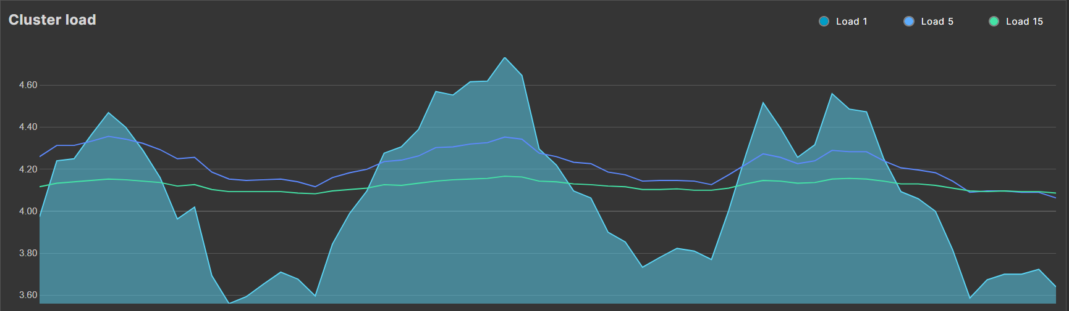

το περισσοτερο usage cpu (όχι υψηλό) - ι συχνα λιγοτερο μεχρι και 6-7%

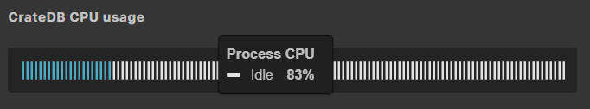

το heap usage έφτανε μέγιστα στο 2.85-3GB / 4GB (υψηλό) (ελάχιστα 1.20GB και ταλαντωνόταν πάνω κάτω)

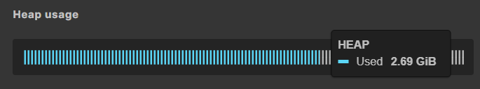

Προφανώς και το disk usage έφτανε πολύ υψηλά.

ΣΥΜΠΕΡΑΣΜΑ: Φορτώσαμε αρκετά το σύστημα

Loading 9 shards/no partitioning

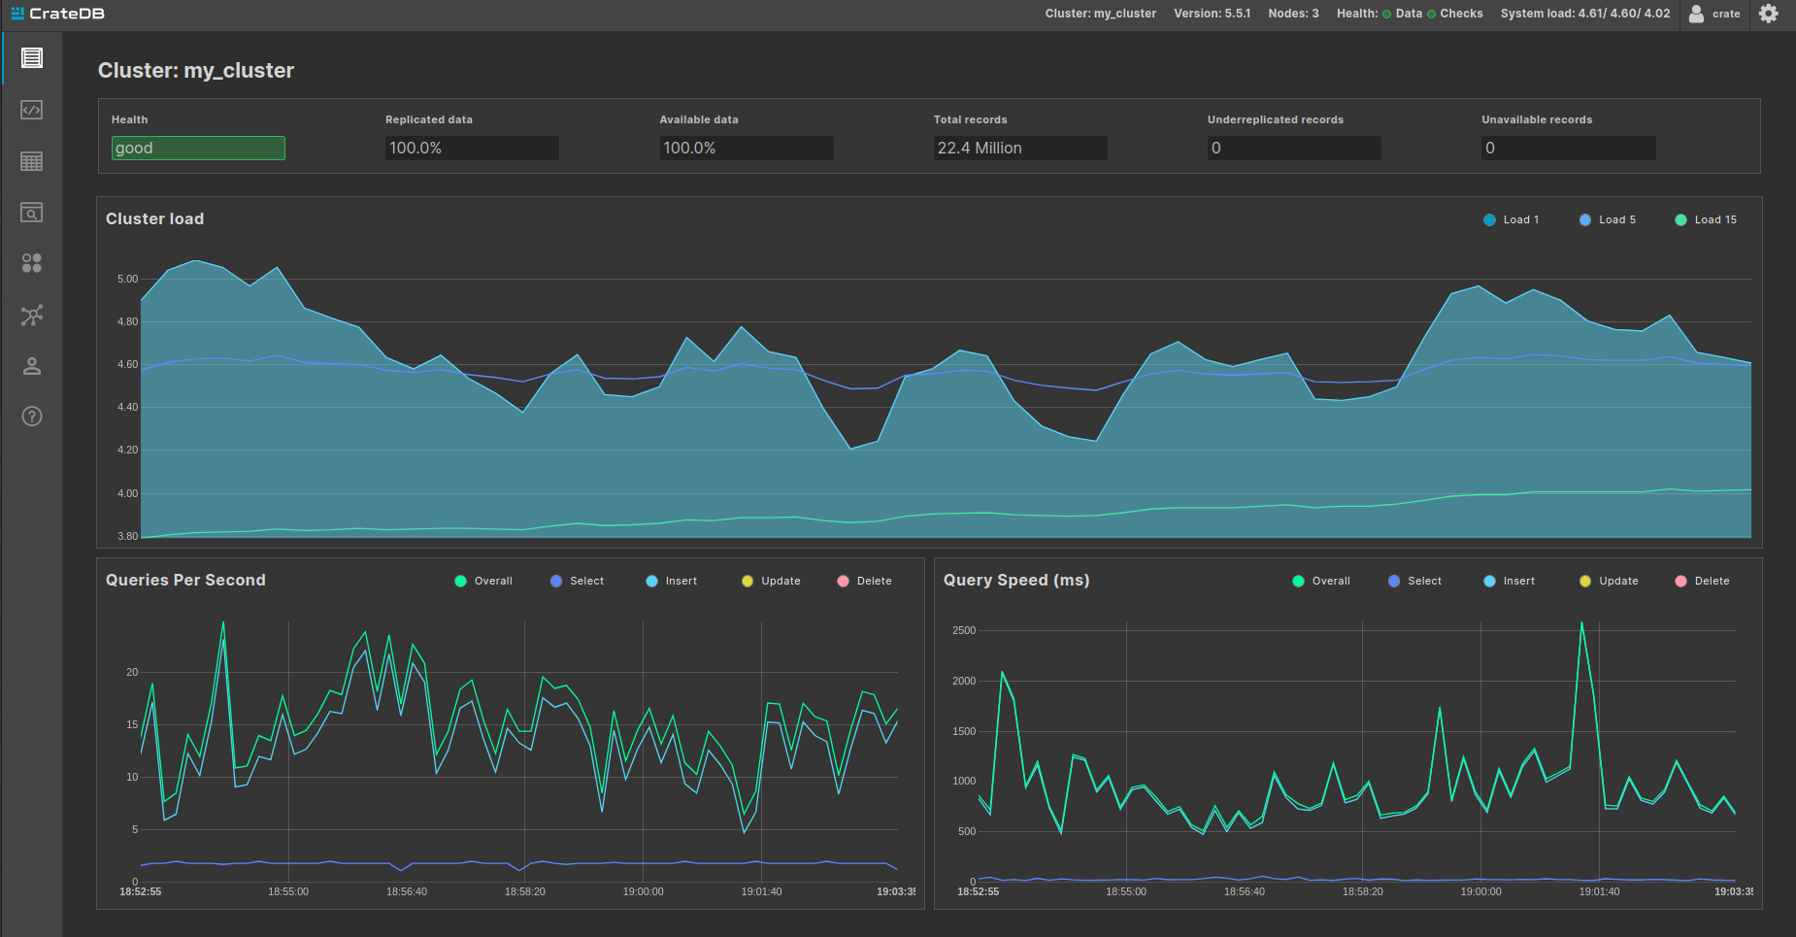

BATCH QUERIES (best and worst cases):

single-groupby-1-1-1:

6 shards with partitioning:

For 12 workers: (μικροτερος φορτος στη cpu στα αλλα δυο nodes)

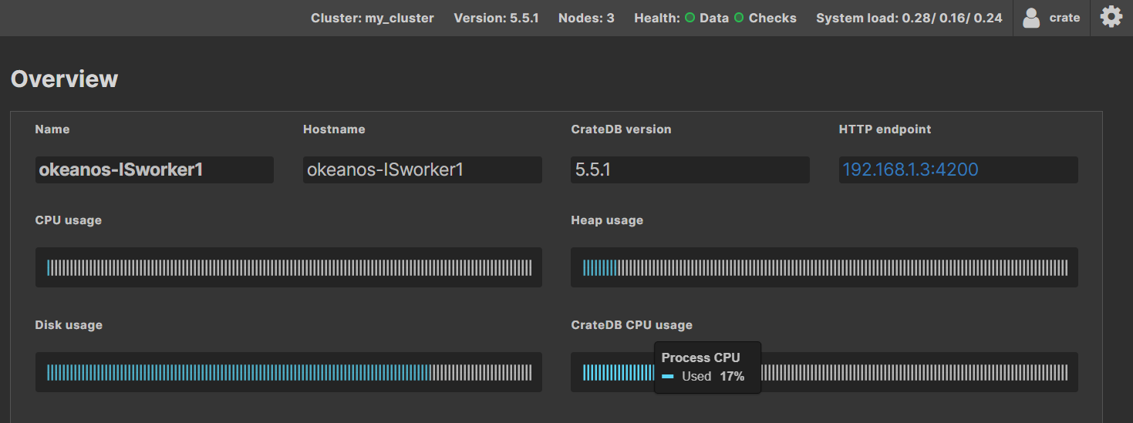

9 shards without partitioning:

For 1 worker

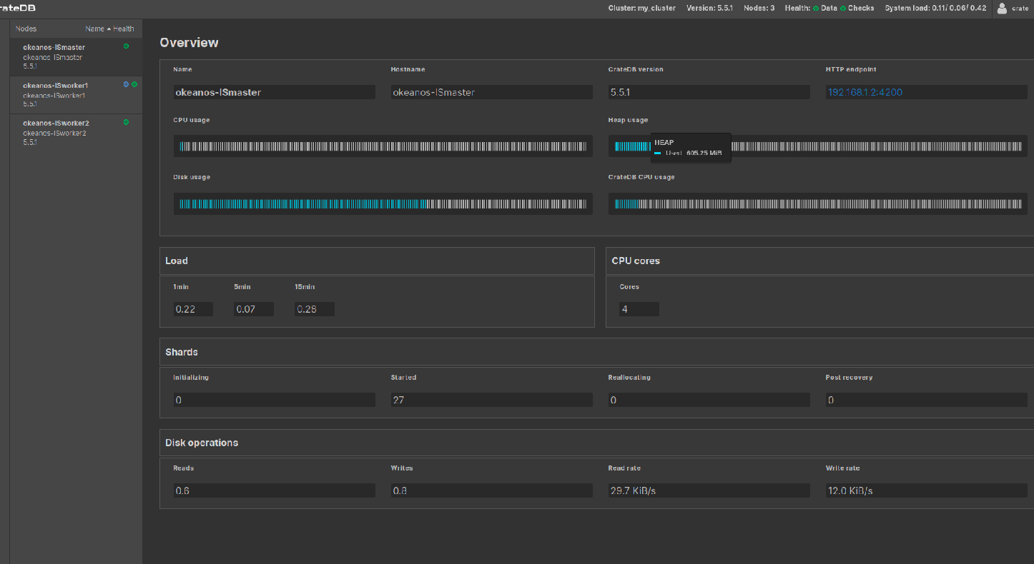

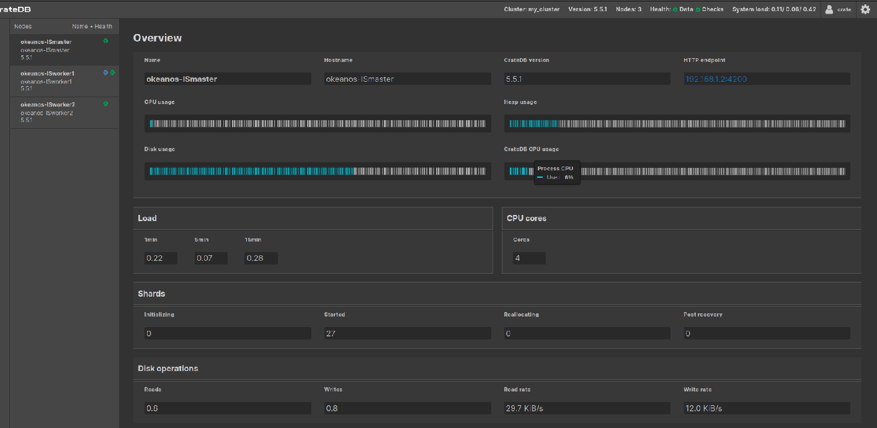

single-groupby-5-1-12:

6 shards with partitioning:

For 15 workers: (περιπου ιδιο για worker2 και λίγο περισσότερο και πιο μικρο για master)

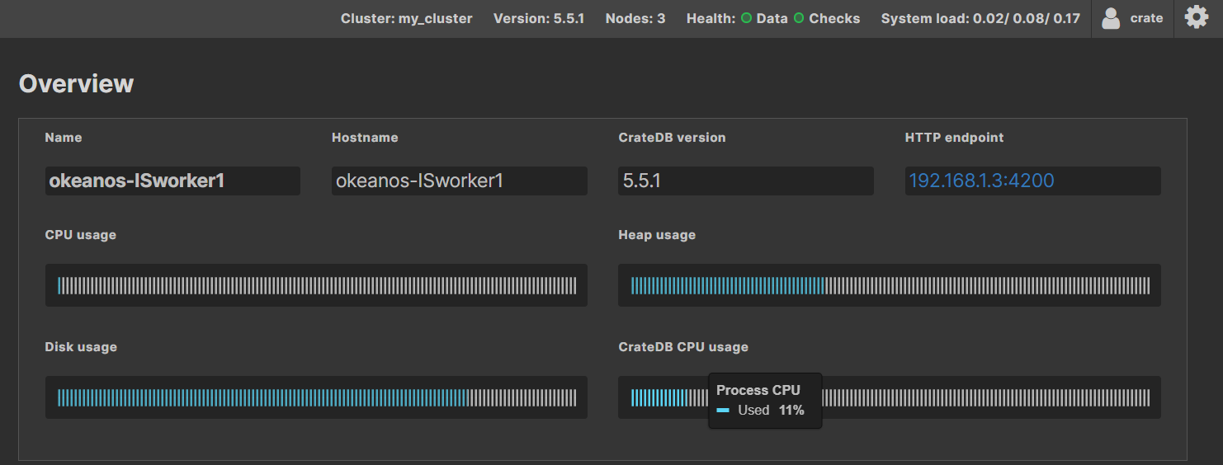

6 shards without partitioning:

For 1 worker:

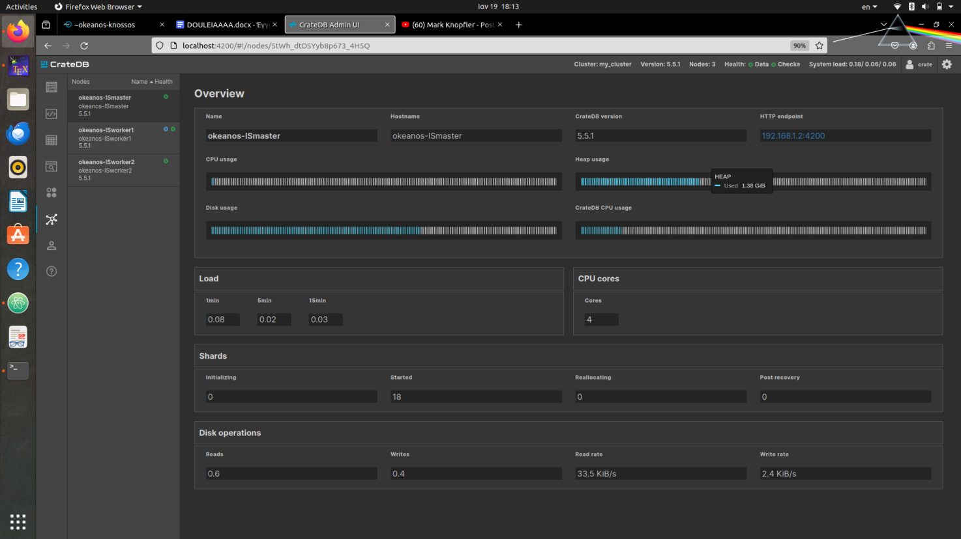

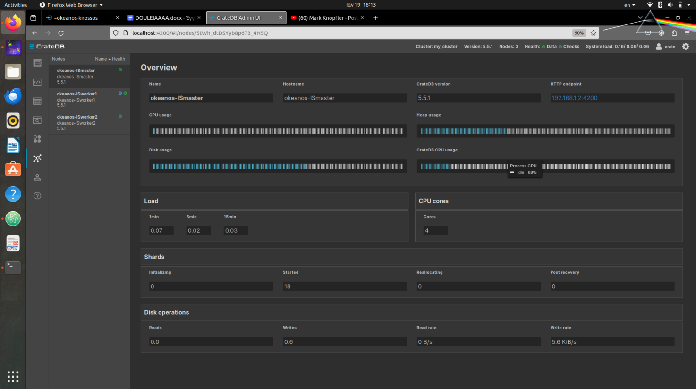

double-groupby-5:

Μεχρι 3 workers:

9 shards with partitioning:

For 3 workers:

Master (και παρόμοια worker1 αλλά head 725 MiB):

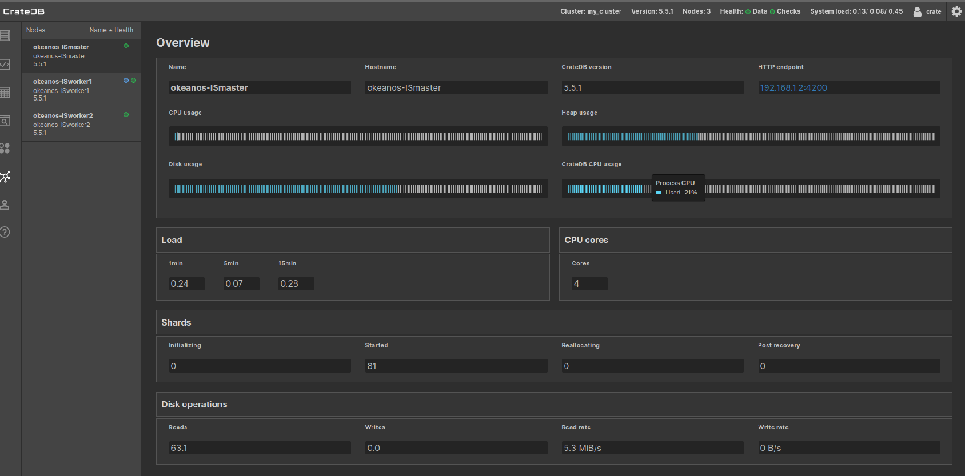

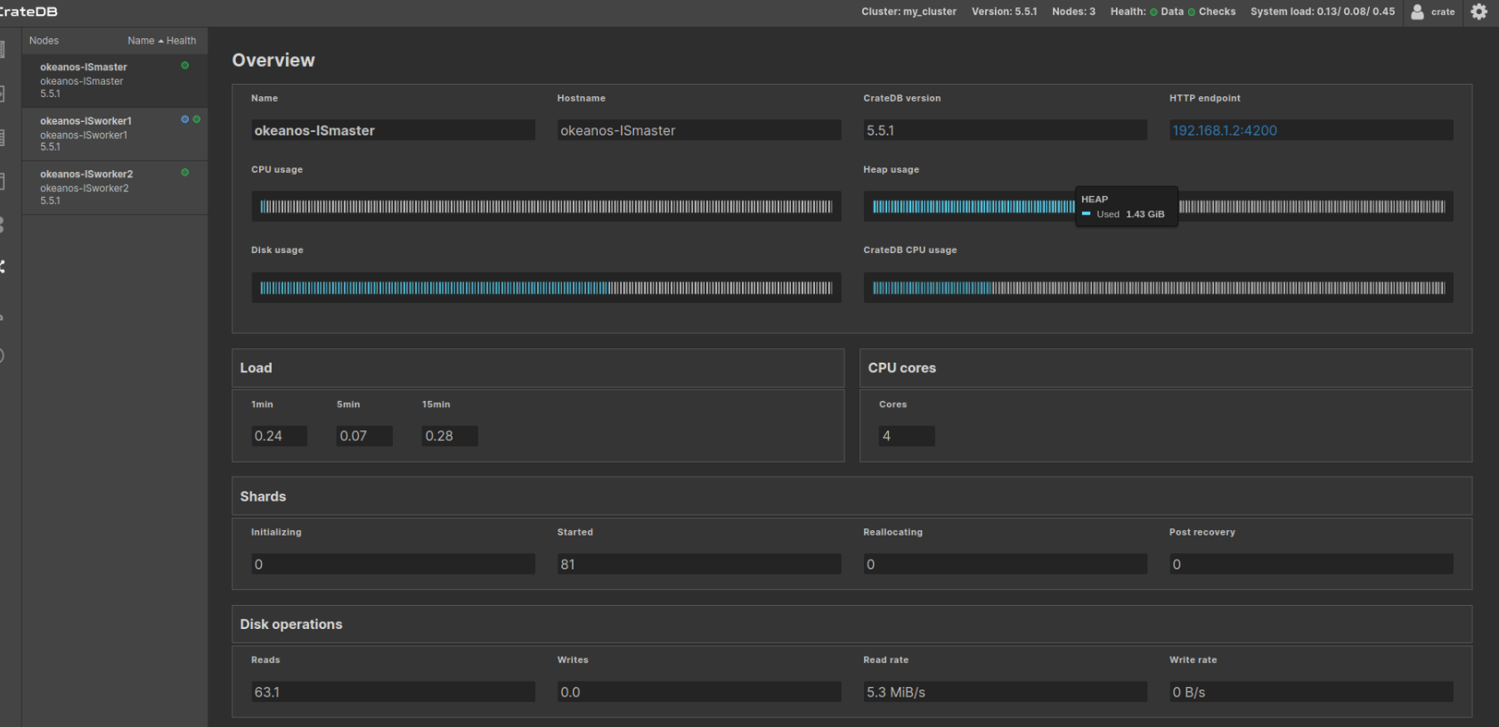

Worker2:

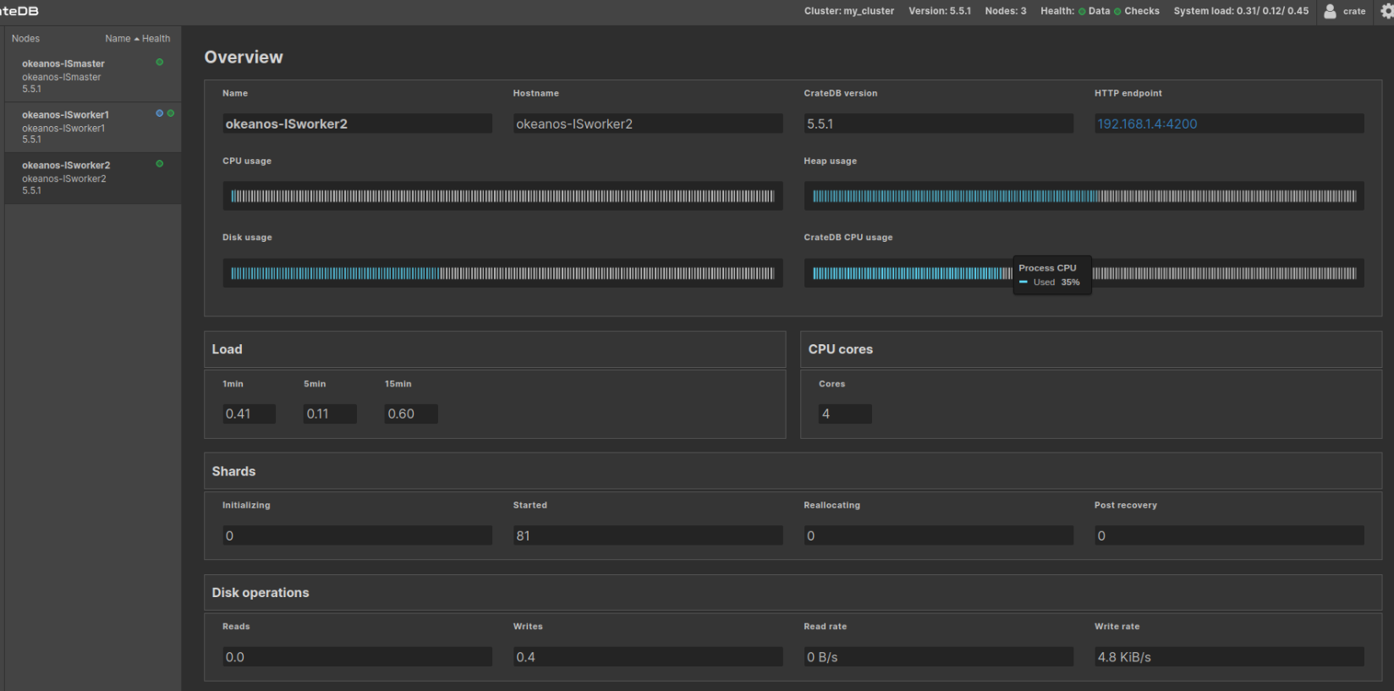

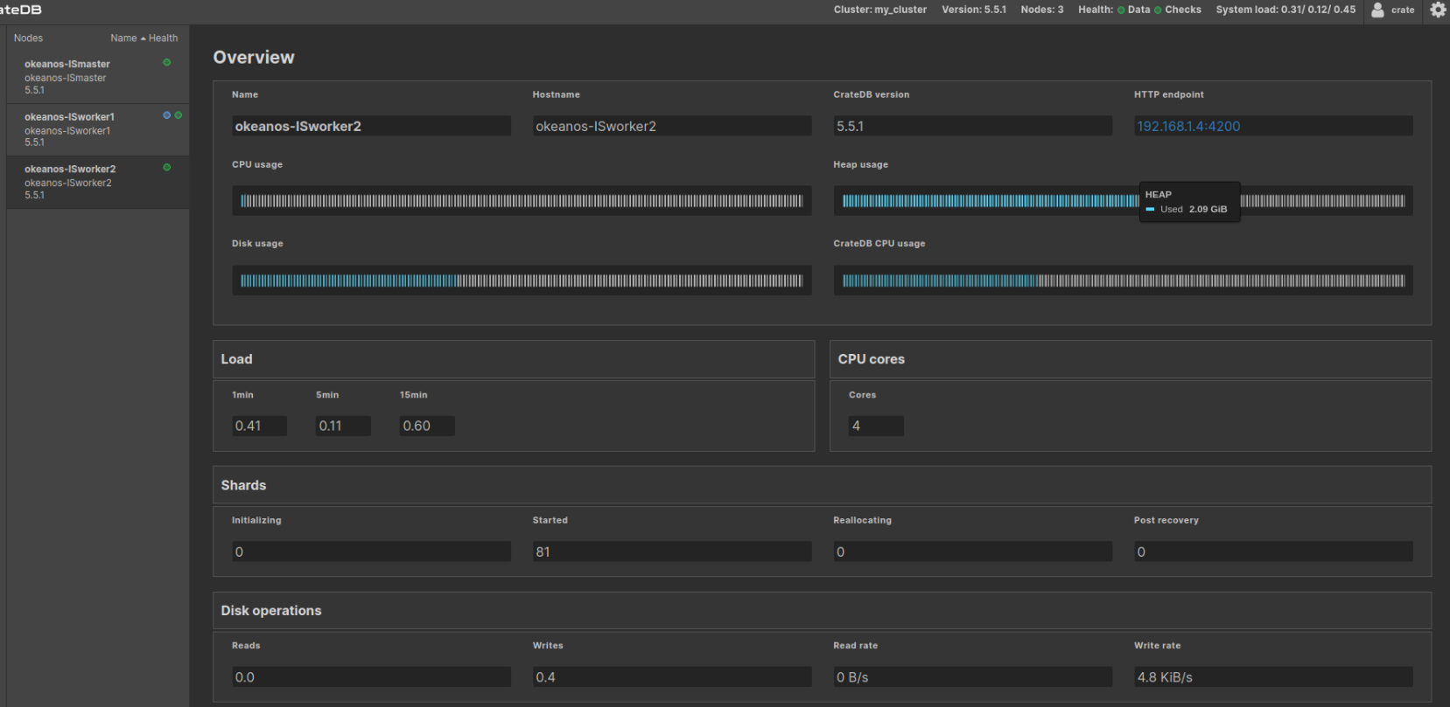

3 shards without partitioning:

For 1 worker:

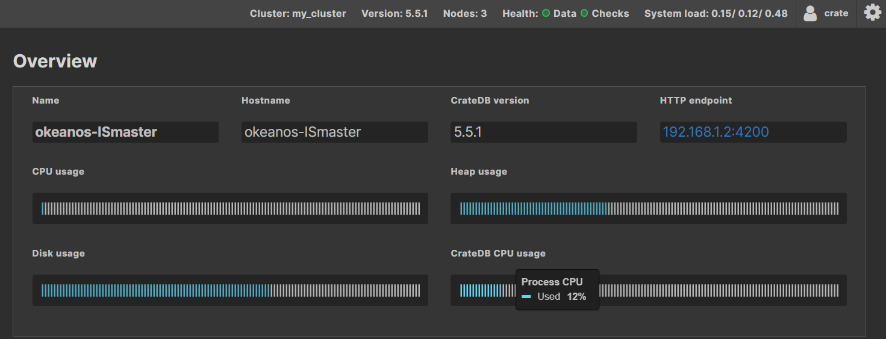

Μετά:

3 shards with partitioning:

For 9 workers: (o master λιγοτερο απο ολους)

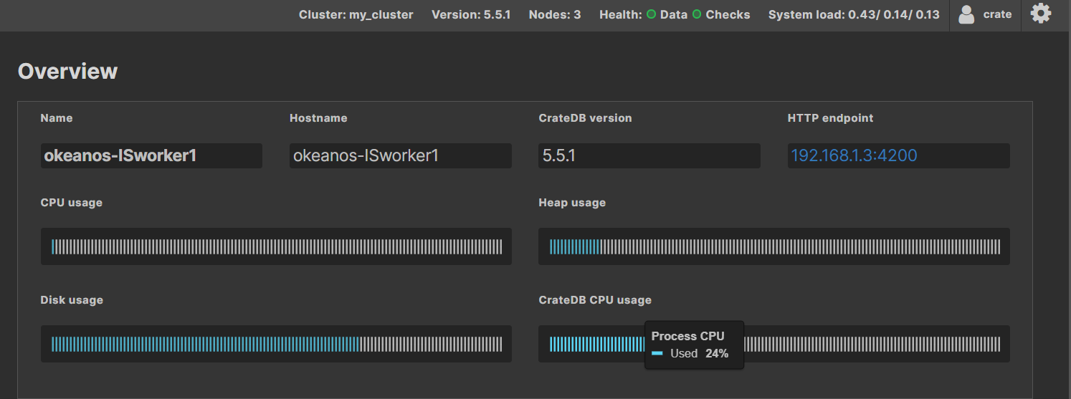

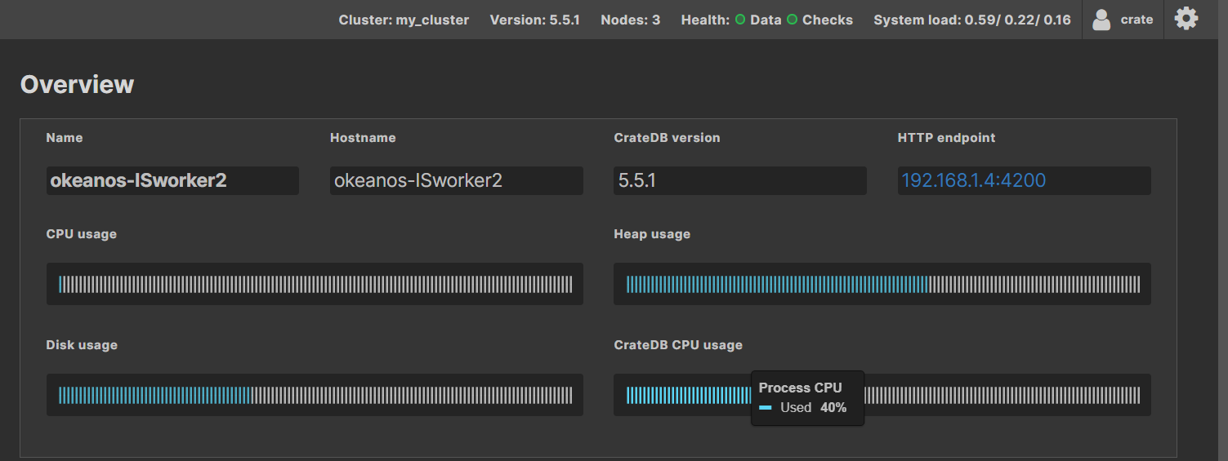

9 shards without partitioning:

For 6 workers:

Master & worker1

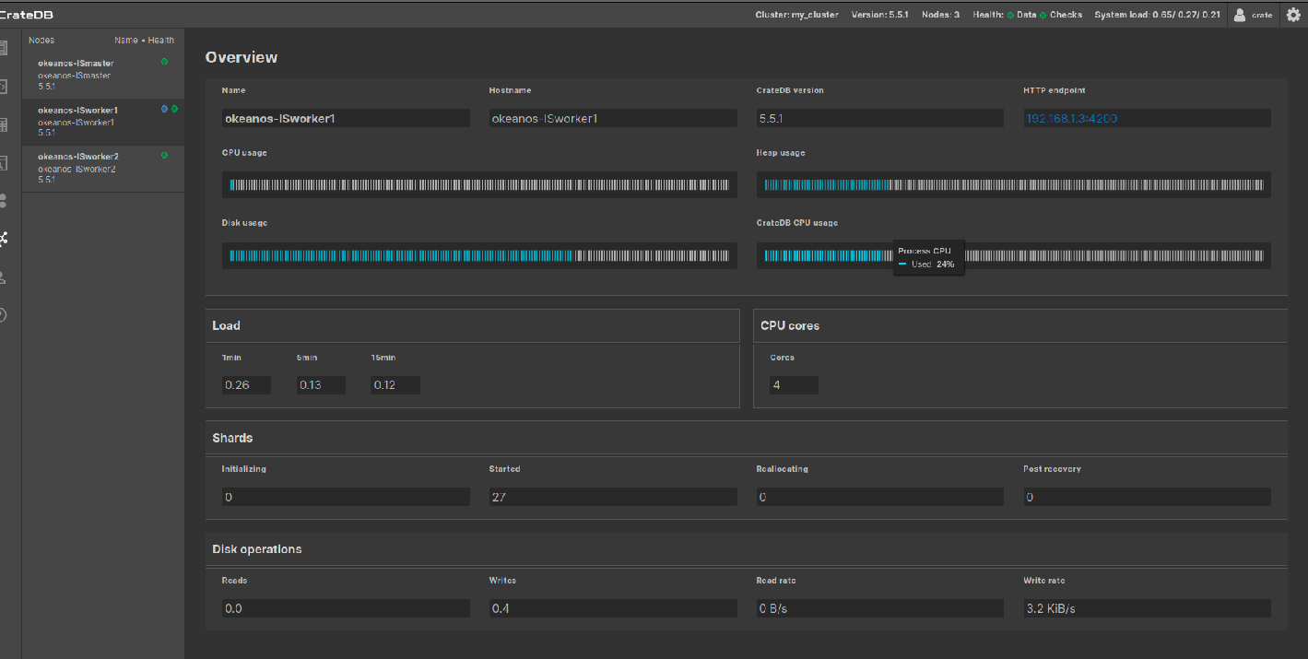

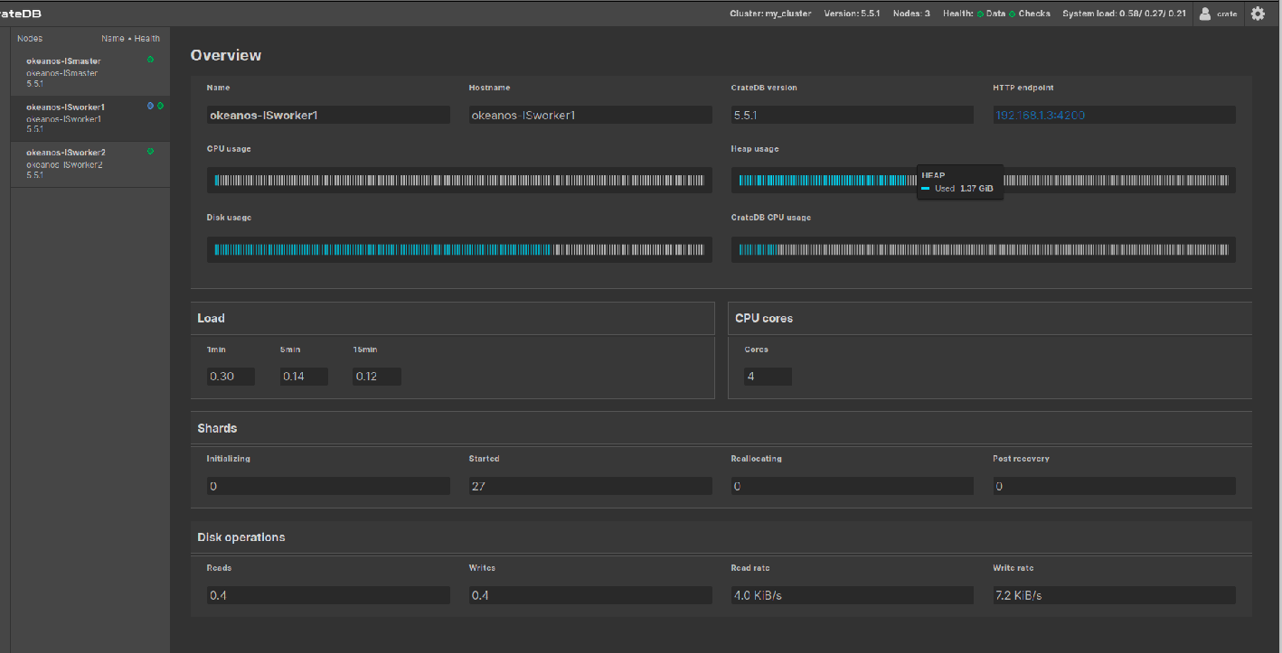

worker2

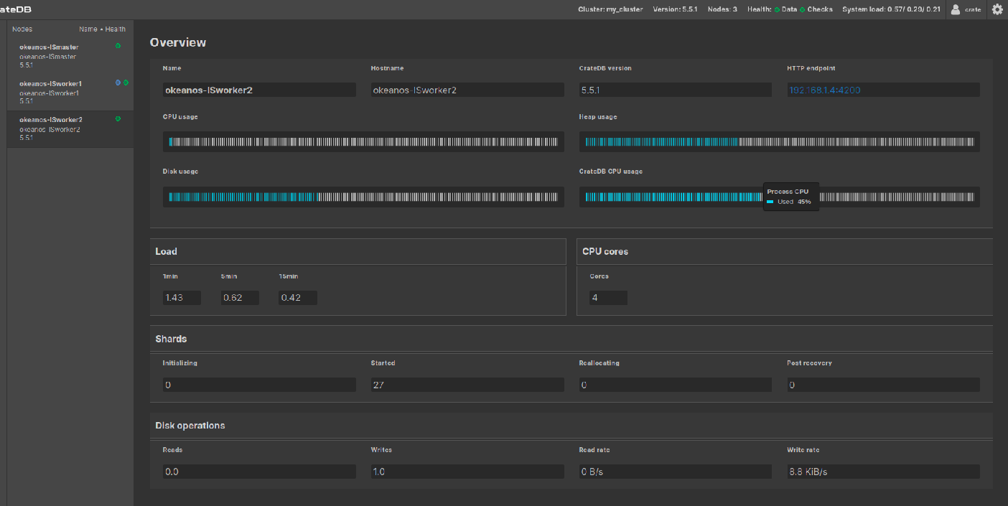

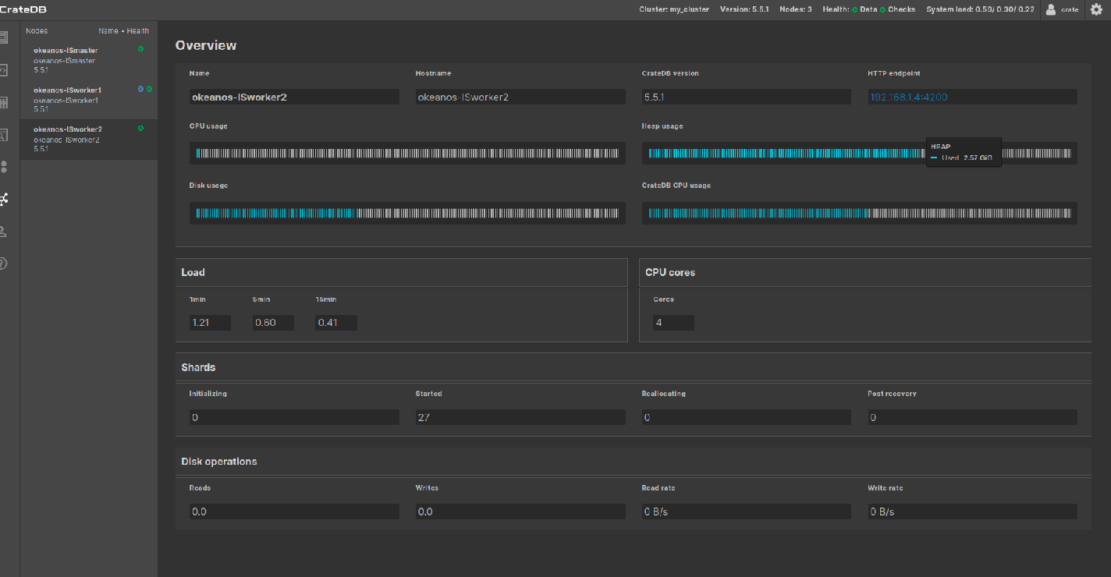

groupby-orderby-limit:

Μεχρι 2 workers:

9 shards with partitioning:

For 2 workers:

Master : μεταξύ 32% και 47% cpu usage

Worker1: 42% με 45%

Worker2: 100%

Στο δεύτερο τρέξιμο, ο worker2 επίσης ήταν στο 100, οι άλλοι δύο έφτασαν κάποιες φορές και τα περίπου 50-55% αλλά πάντοτε πολύ κάτω του worker2 που ήταν μόνιμα στο 100%. Ενδεικτικά

Master:

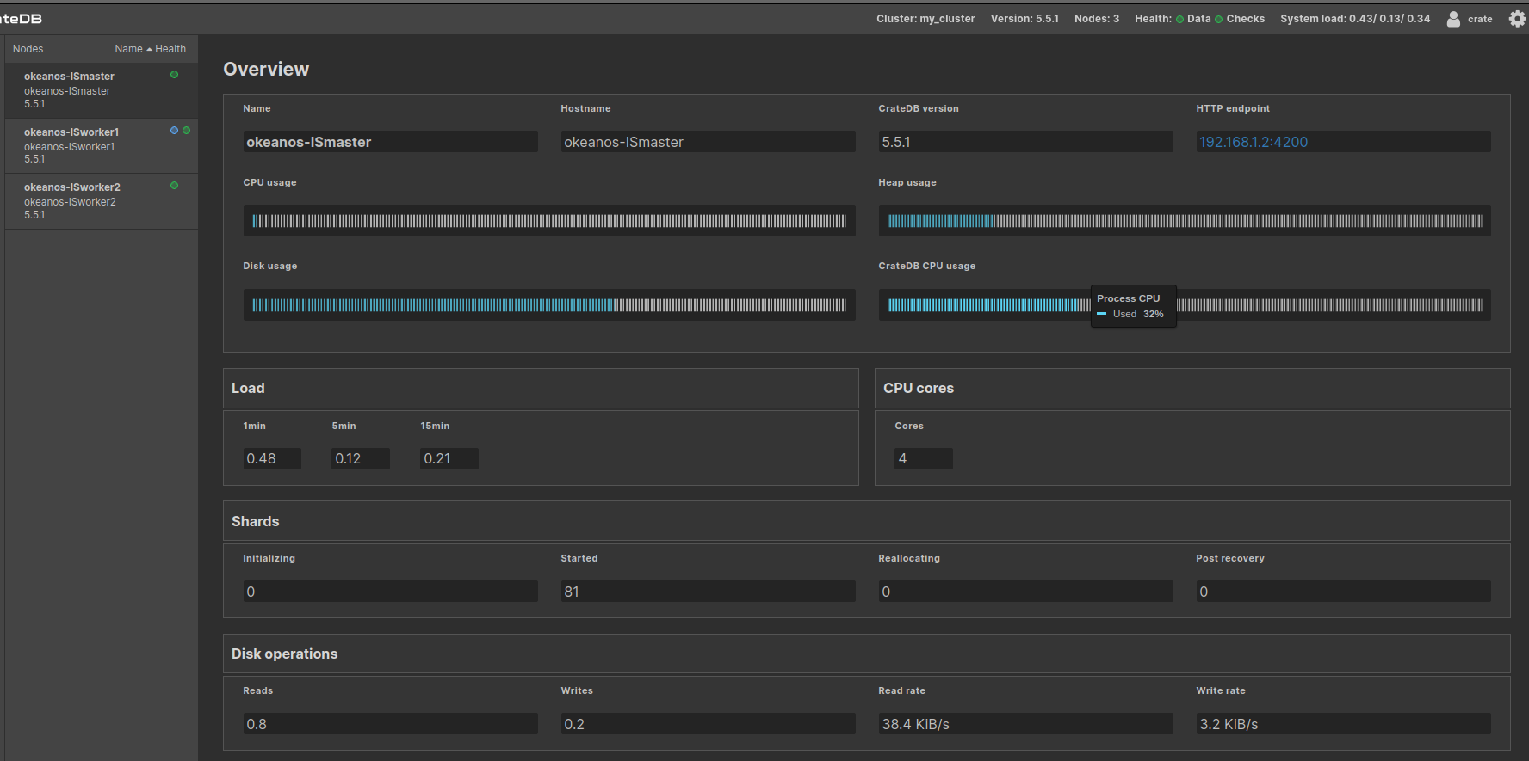

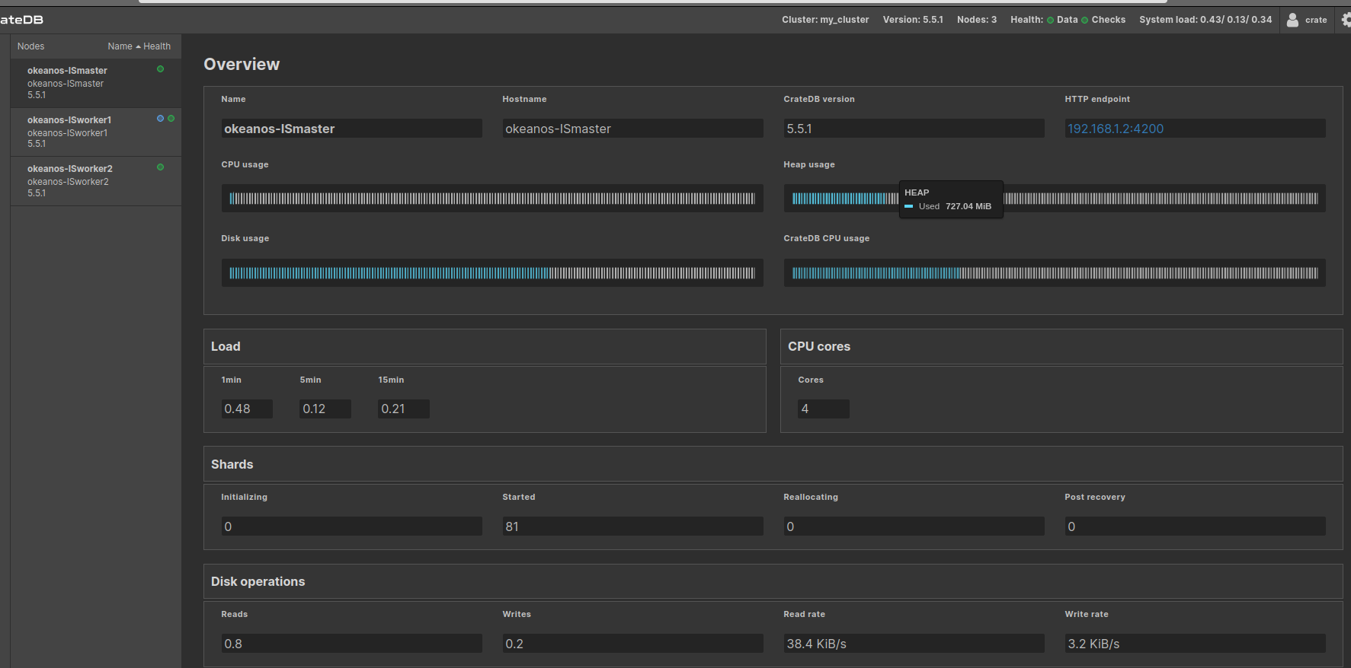

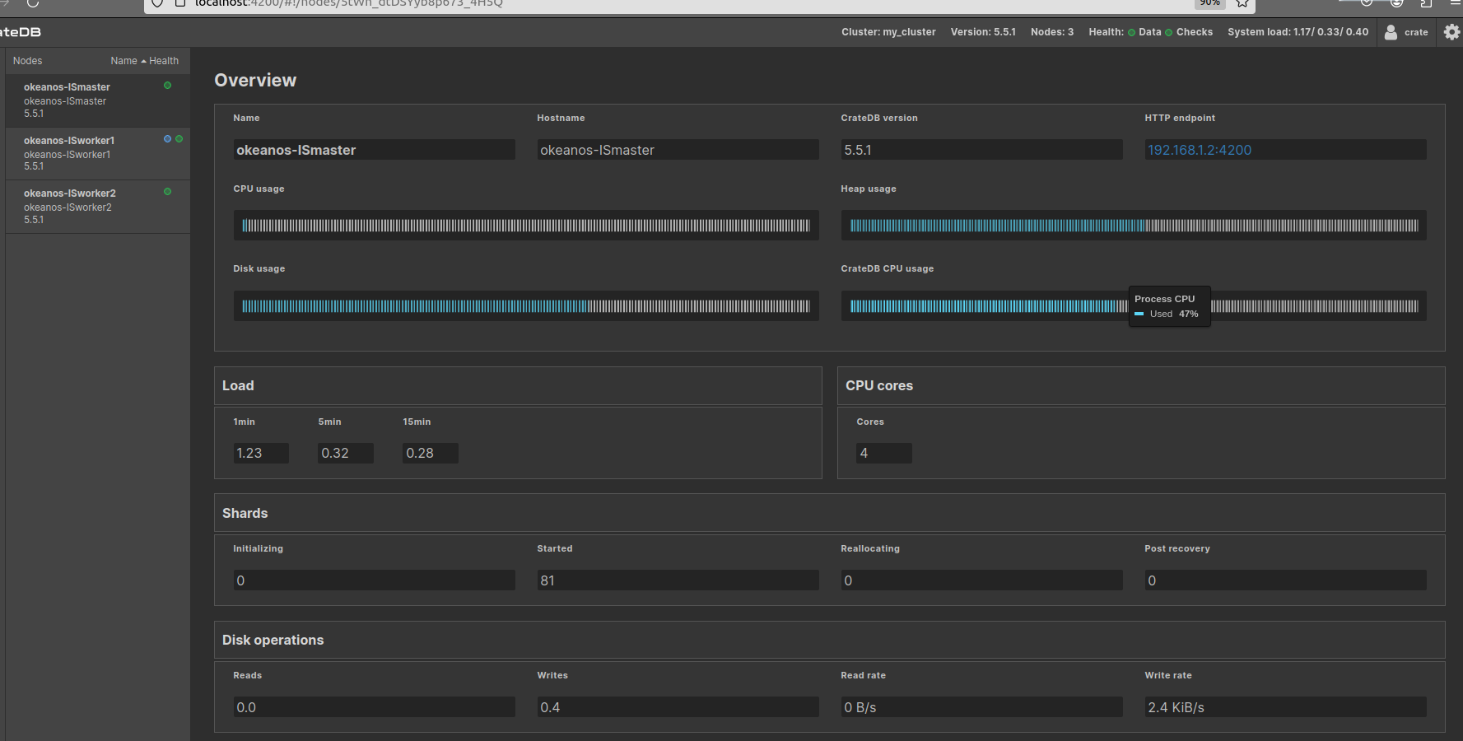

worker1:



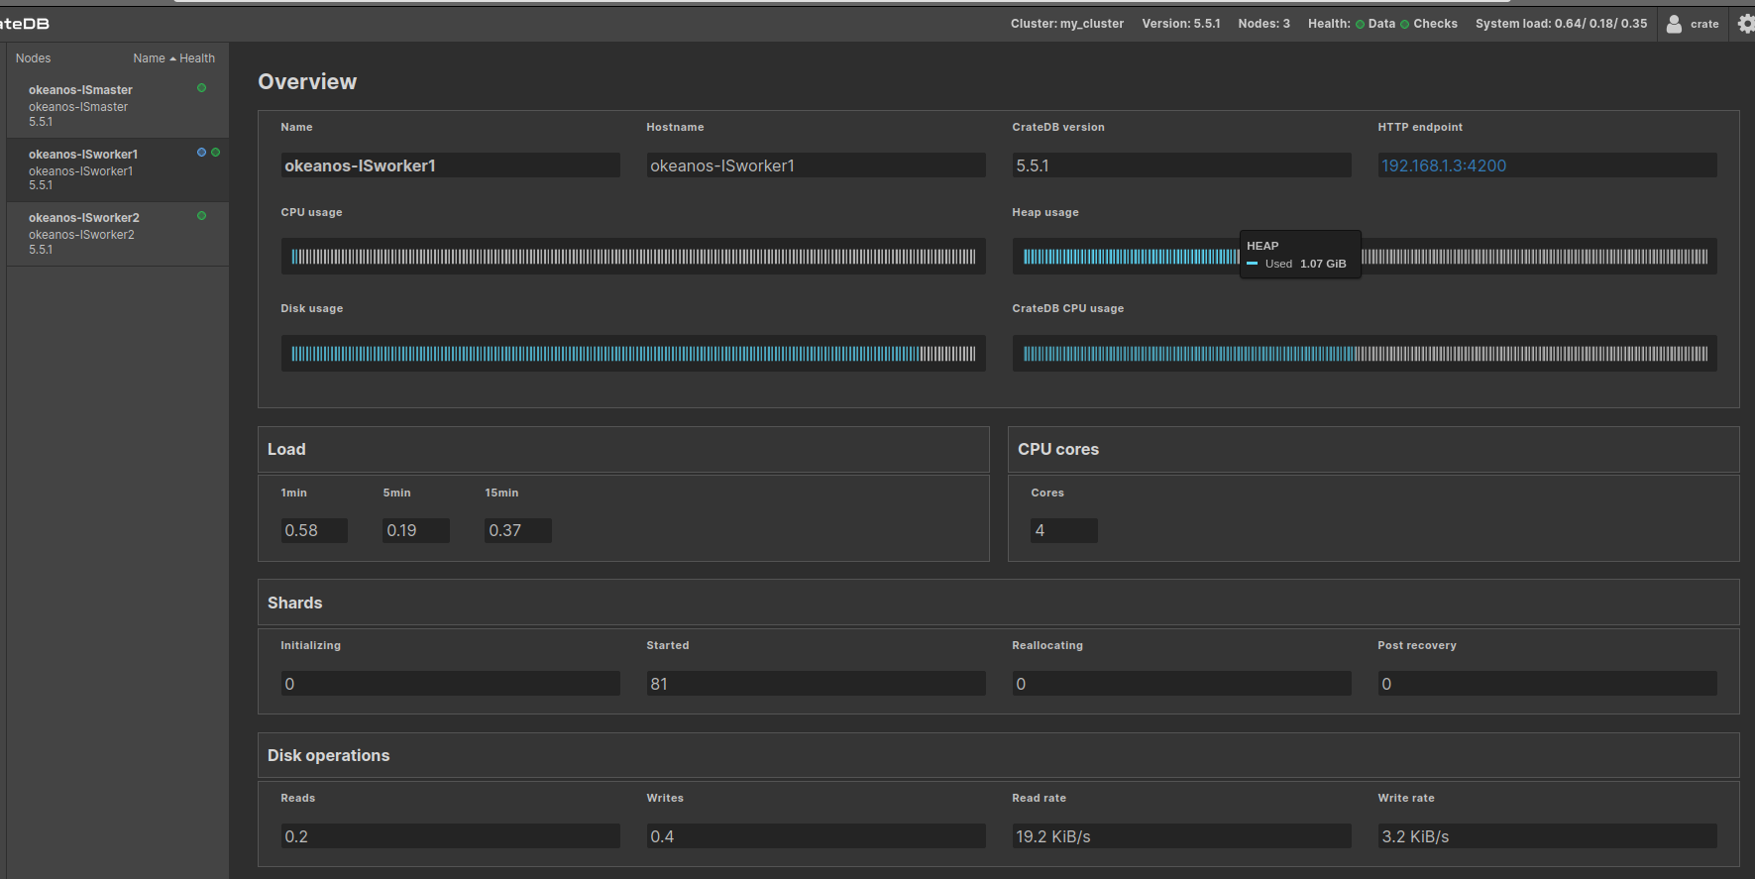

worker2:

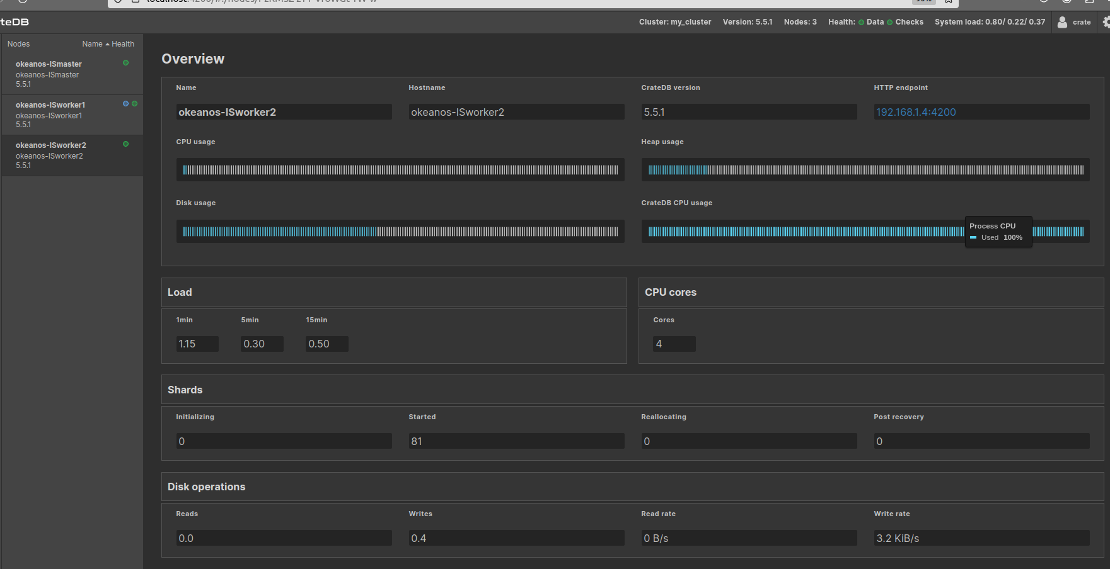

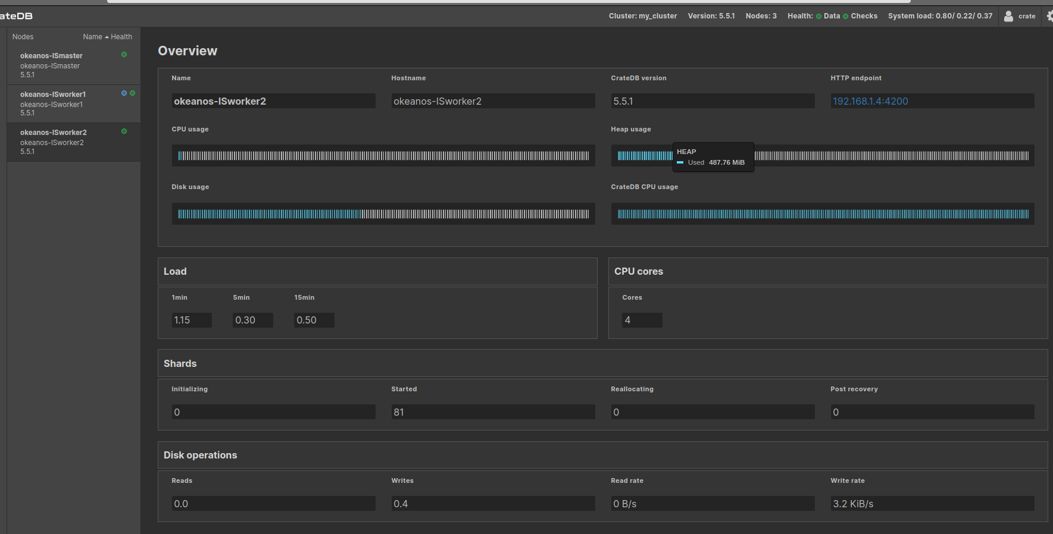

3 shards without partitioning:

For 1 worker:

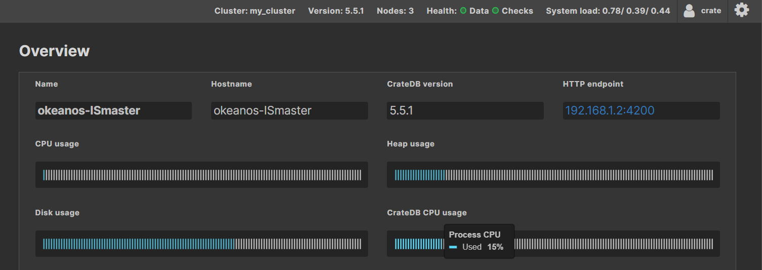

Μετά:

3 shards with partitioning:

For 9 workers: (o master πιο κατω)

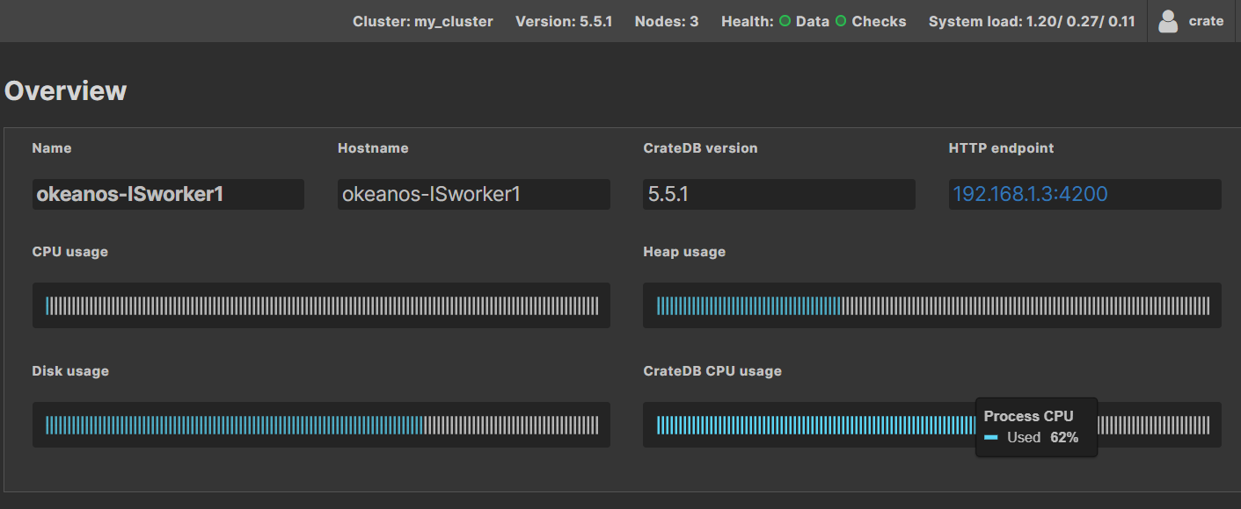

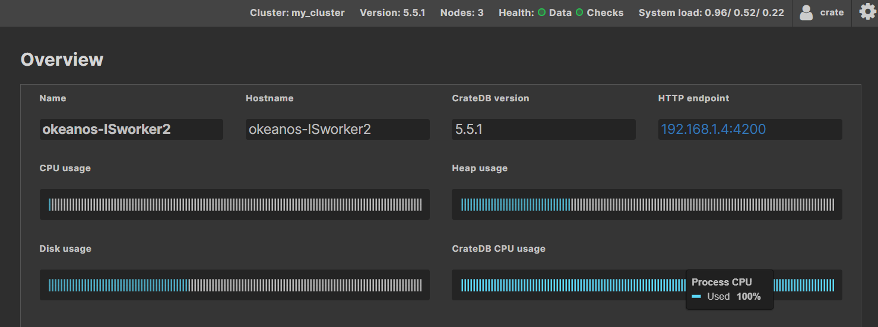

αυξημενο system load και υψηλη χρηση της cpu για αυτο το set queries

9 shards without partitioning:

For 18 workers

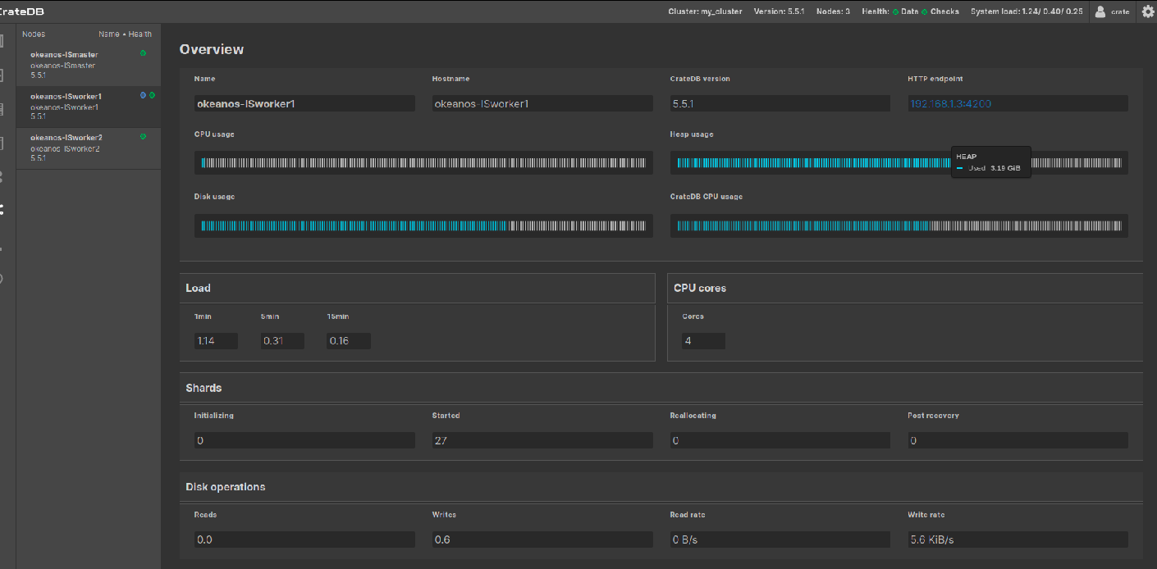

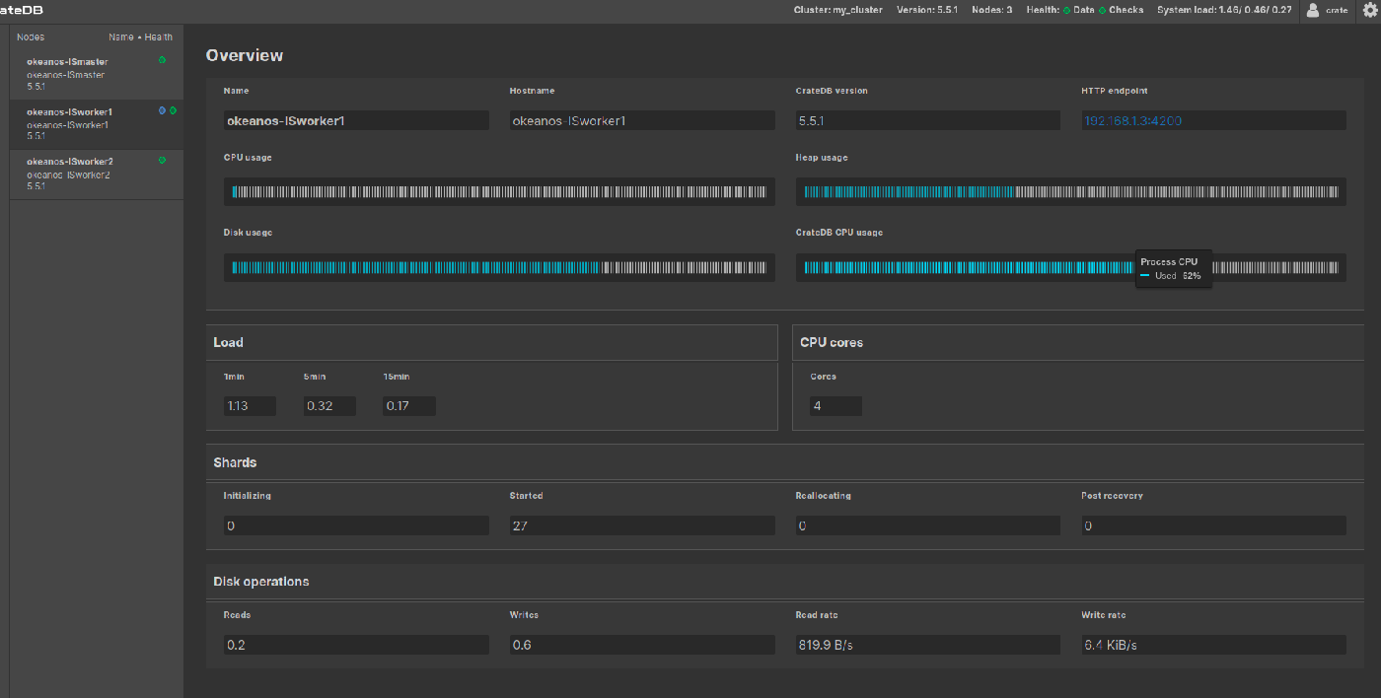

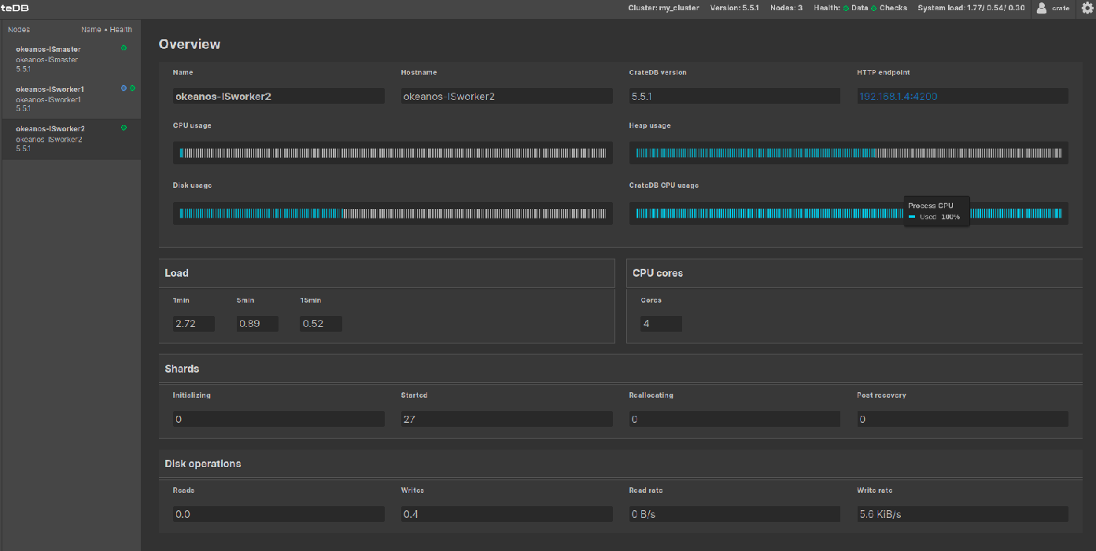

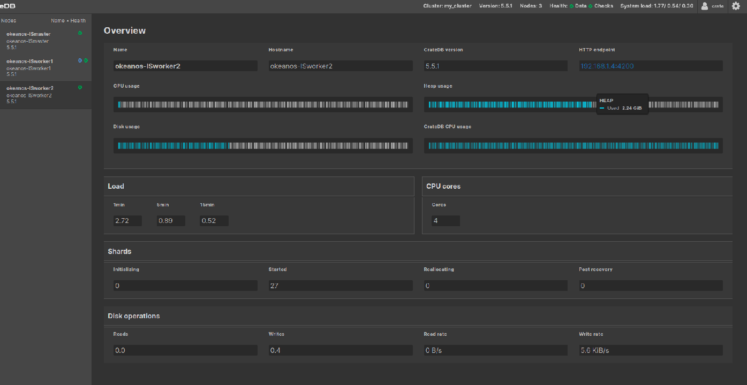

Γενικώς το cpu usage κυμαινόταν σε όλους τους κόμβους σε τιμές άνω του 50% φθάνοντας μερικές φορές και τιμές πολύ κοντά στο 100%. Παρόμοια συμπεριφορά για όλους τους κόμβους. Το system load επίσης σημαντικό.

