Lemnos (Greek: Λήμνος; Ancient Greek: Λῆμνος) is a Greek island in the northern part of the Aegean Sea. Administratively the island forms a separate municipality within the Lemnos regional unit, which is part of the North Aegean region. The principal town of the island and seat of the municipality is Myrina. At 477.583 square kilometers (184.396 sq. mi), it is the 8th-largest island of Greece.

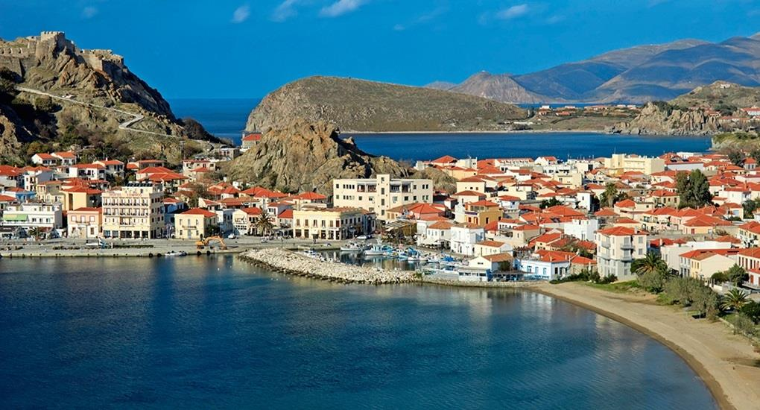

**Beaches**

* Thanos
  + Distance: 50
  + Orientation: South
  + Description: Cosmopolitan, With Facilities, Sandy, Shallow Waters

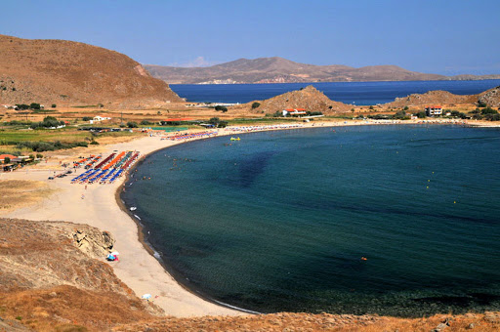

* Agios Ioannis
  + Distance: 16.4
  + Orientation: North
  + Description: With Facilities, Sandy, Shallow Waters

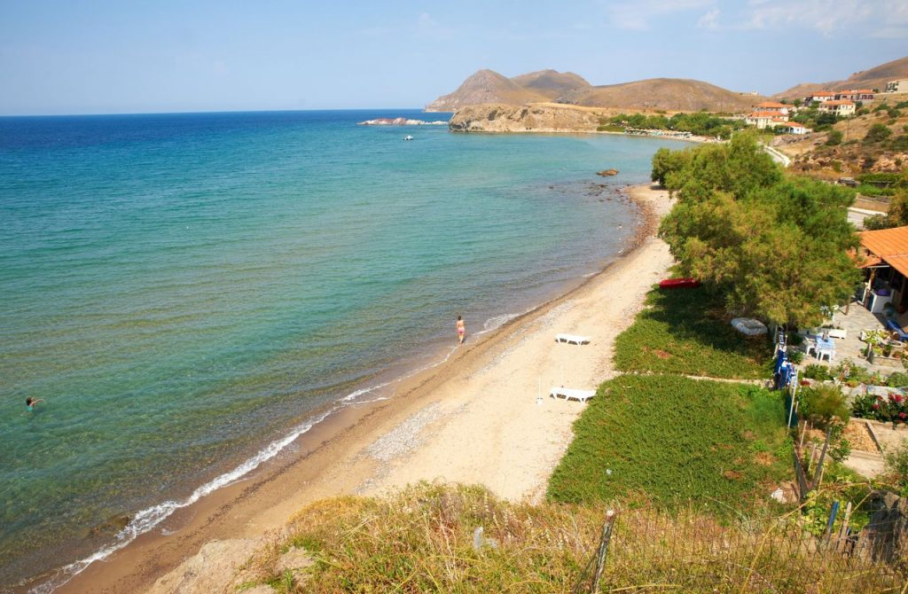

* Mikro Fanaraki
  + Distance: 33.8
  + Orientation: South
  + Description: Small, Scenic, Snorkeling, With Facilities, Sandy, Shallow Waters

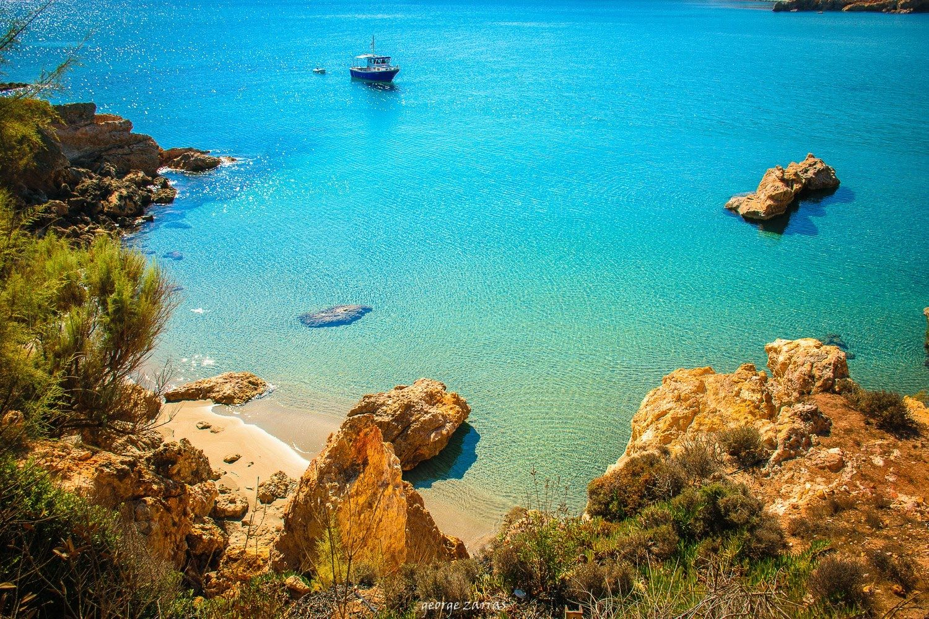

* Plati
  + Distance: 4.8
  + Orientation: West
  + Description: With Facilities, Sandy, Shallow Waters

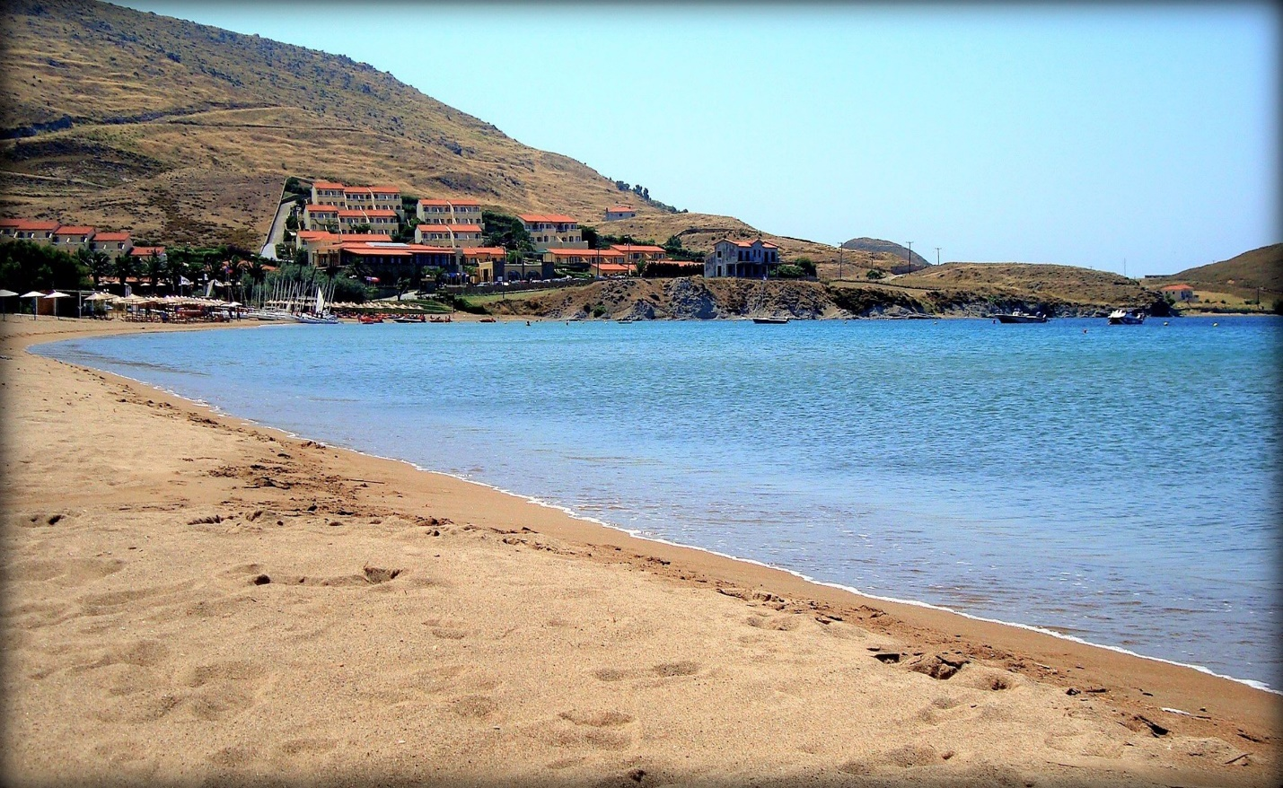

* Keros
  + Distance: 6.3
  + Orientation: East
  + Description: With Facilities, Sandy, Shallow Waters, Water Sports

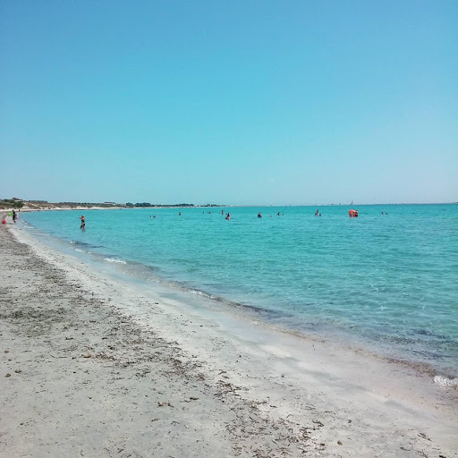

* Evgati
  + Distance: 5.1
  + Orientation: South
  + Description: With Facilities, Sandy, Shallow Waters

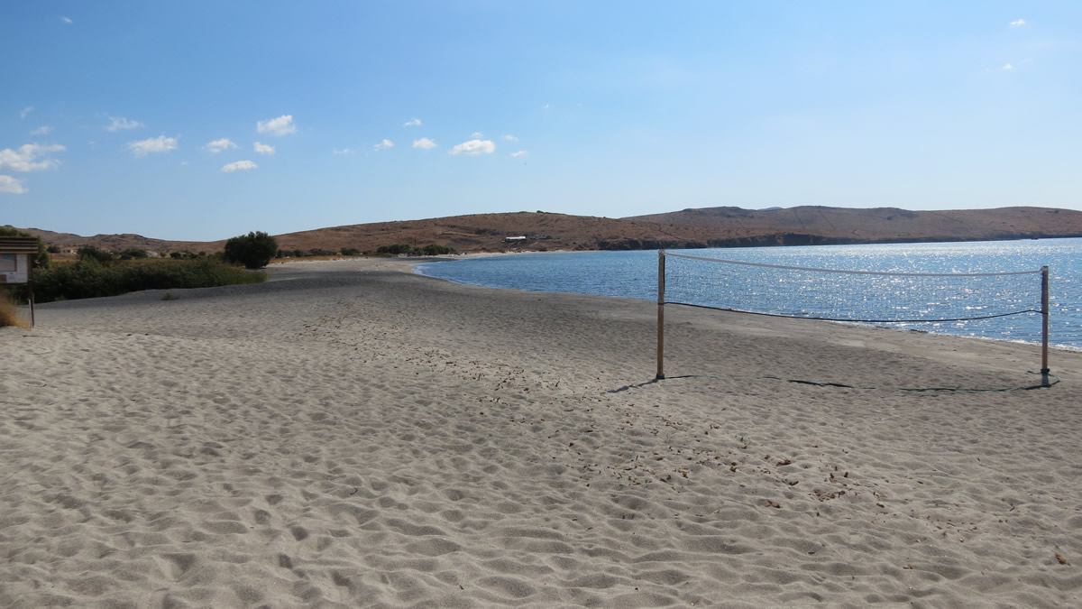

* Megalo Fanaraki
  + Distance: 34
  + Orientation: West
  + Description: Cosmopolitan, With Facilities, Sandy

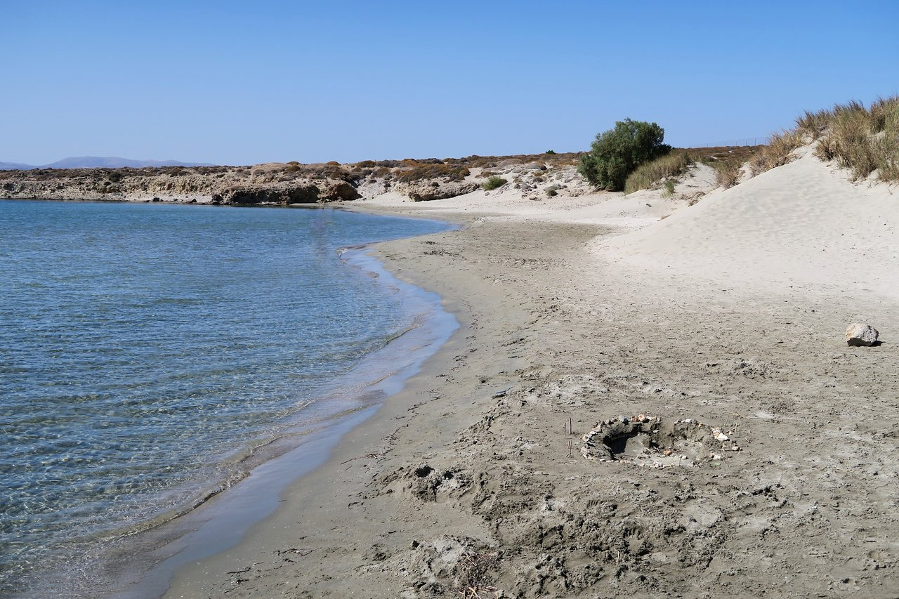

* Chavouli
  + Distance: 34.2
  + Orientation: West
  + Description: With Facilities, Sandy, Shallow Waters

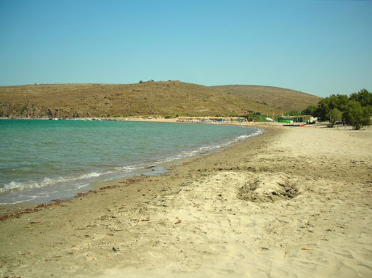

* Gomati
  + Distance: 23.9
  + Orientation: North
  + Description: With Facilities, Sandy, Shallow Waters

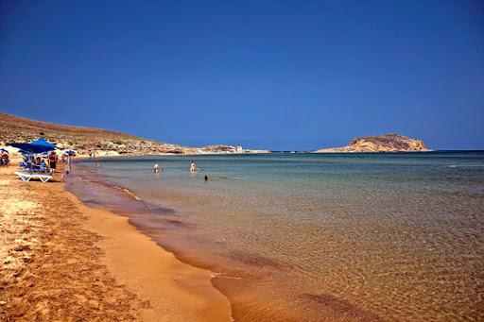

* Shallow Waters
  + Distance: 7.1
  + Orientation: West
  + Description: Cosmopolitan, With Facilities, Sandy, Shallow Waters, Water Sports

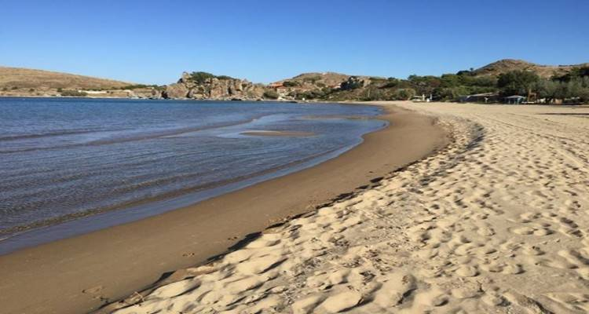

* Lychna
  + Distance: 24.9
  + Orientation: South
  + Description: Sandy, Ήσυχη, Shallow Waters

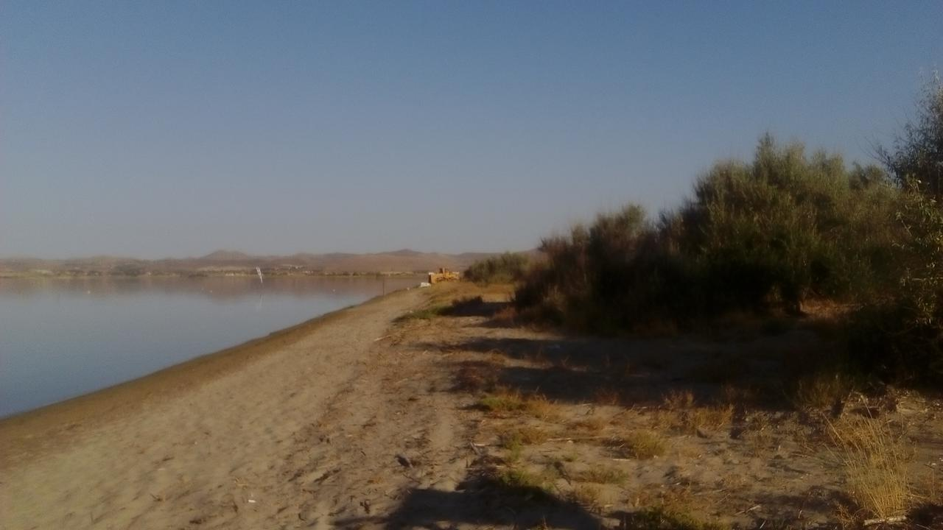

* Zematas
  + Distance: 44.2
  + Orientation: North
  + Description: Cosmopolitan, With Facilities, Sandy, Shallow Waters, Water Sports

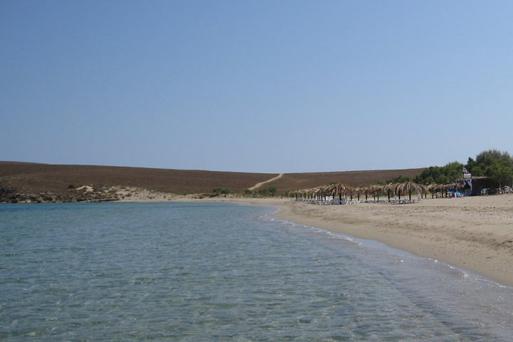

* Kokkinovrachos
  + Distance: 37
  + Orientation: East
  + Description: With Facilities, Sandy, Shallow Waters

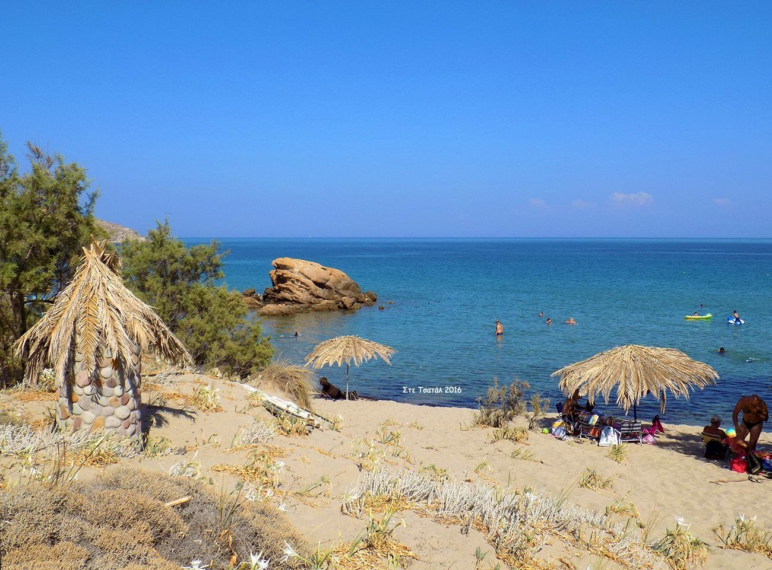

* Parthenomytos
  + Distance: 38.1
  + Orientation: East
  + Description: Ανοργάνωτη, Sandy, Shallow Waters, Ήσυχη, Βραβευμένη

