Middleware Architecture
(SCS2314)
SwiftTrack Middleware Integration Platform

- Introduction to the Solution
Modern logistics platforms rely on multiple heterogeneous systems to process customer orders, optimize delivery routes, and manage warehouse operations. These systems are typically developed using different technologies and communication protocols, creating integration challenges such as tight coupling, latency, reliability concerns, and lack of visibility into order processing states.
This project presents SwiftTrack Middleware, an event-driven integration platform that acts as an intermediary between a client-facing application and three external enterprise systems:
- Customer Management System (CMS) — SOAP-based service responsible for customer validation and order registration.
- Route Optimization System (ROS) — REST-based service responsible for determining optimal delivery routes.
- Warehouse Management System (WMS) — TCP-based service responsible for inventory allocation and dispatch operations.
The primary objective of SwiftTrack Middleware is to:
- Provide a unified interface for order submission
- Orchestrate interactions with heterogeneous backend systems
- Ensure reliable message delivery through asynchronous communication
- Support fault tolerance using retry and dead-letter mechanisms
- Offer real-time order tracking and notification capabilities
The solution adopts a microservices-inspired architecture leveraging an API Gateway, asynchronous message broker, orchestration worker, persistent storage, and protocol-specific adapters.

- Architecture of the Solution
2.1 Conceptual Architecture
The conceptual architecture illustrates the logical interaction between system actors and middleware components without focusing on deployment or technology details.
The major conceptual components include:
- Client Application (Web UI)
- API Gateway
- Message Broker
- Orchestration Worker
- Database
- External Enterprise Systems (CMS, ROS, WMS)
The conceptual flow is as follows:
- The client submits an order via the API Gateway.
- The API Gateway persists the order and publishes an event to the message broker.
- The orchestration worker consumes the event and executes the processing pipeline.
- The worker sequentially interacts with CMS, ROS, and WMS.
- Order state changes are persisted and propagated to the client through real-time notifications.
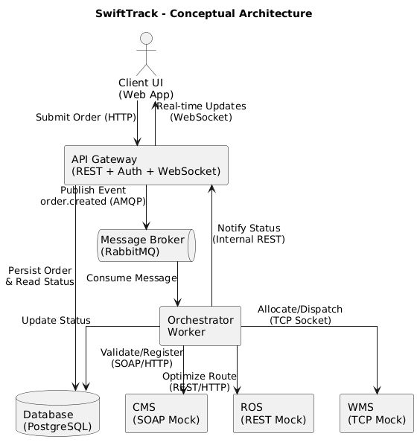
2.2 Implementation Architecture
The implementation architecture describes the physical realization of the conceptual model using containerized services.
The deployed services include:
- UI Service — React-based client interface
- API Gateway Service (FastAPI) — Handles authentication, order submission, WebSocket notifications, and internal coordination endpoints
- Worker Service — RabbitMQ consumer responsible for orchestration logic and external system integration
- RabbitMQ Broker — Facilitates asynchronous communication and decoupling
- PostgreSQL Database — Stores order state and user information
- CMS Mock Service — SOAP-over-HTTP simulation
- ROS Mock Service — REST simulation
- WMS Mock Service — TCP socket server simulation
The system is deployed using Docker Compose, enabling isolated execution environments and simplified service orchestration.

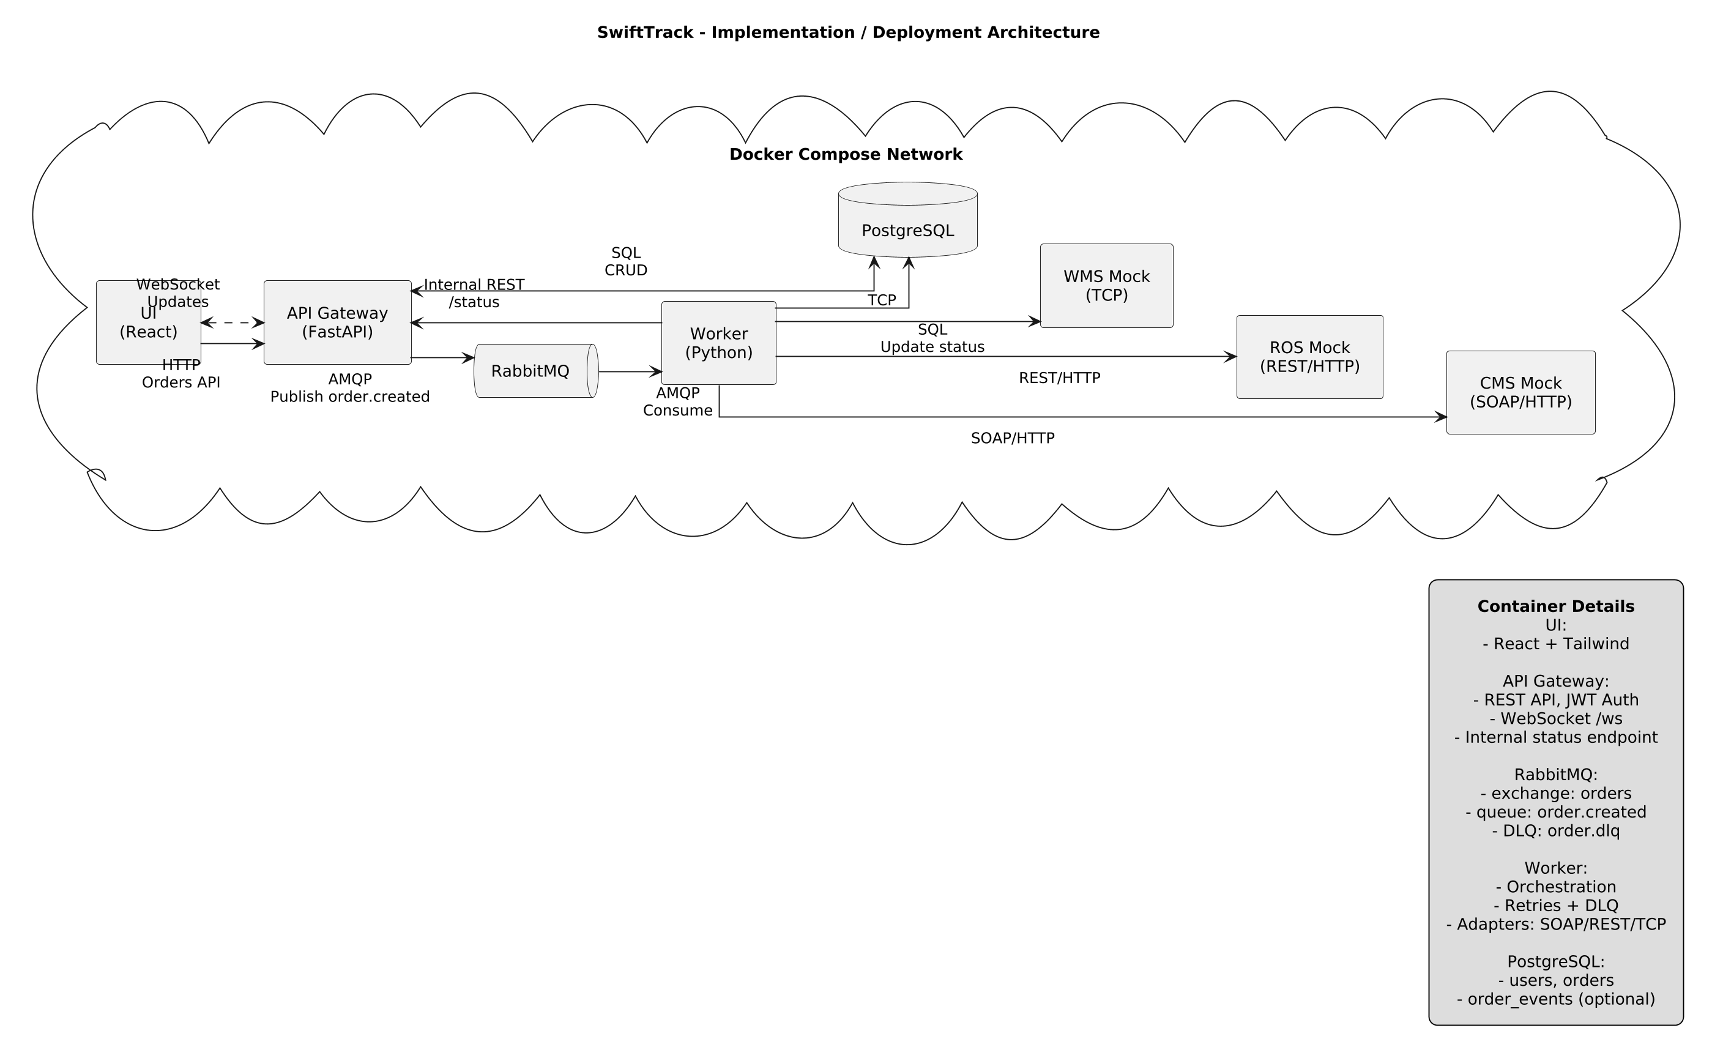

2.3 Alternative Architecture 1 — Synchronous Service Orchestration

In this architecture, the API Gateway directly invokes CMS, ROS, and WMS sequentially within a single request lifecycle.
Advantages
- Simplified architecture
- Reduced infrastructure requirements
- Easier debugging due to linear flow
Limitations
- High coupling between services
- Poor scalability under peak load
- Increased latency for client responses
- Lack of reliability guarantees during failures

  - Alternative Architecture 2 — Choreography-Based Event Architecture

In this model, each integration adapter acts as an independent consumer and producer of domain events.
CMS → publishes event → ROS → publishes event → WMS
Advantages
- High decoupling
- Improved scalability
- Independent service evolution
Limitations
- Distributed business logic
- Increased debugging complexity
- Event contract management overhead

2.5 Final Architecture Selection Rationale
The final solution adopts an Event-Driven Orchestration Architecture combining:
- Centralized workflow control
- Asynchronous messaging
- Clear state management
- Improved reliability through retry and DLQ
This architecture provides an optimal trade-off between complexity, reliability, and implementation feasibility for the project scope.

- Architectural and Integration Patterns
3.1 Architectural Patterns

API Gateway Pattern
Provides a unified entry point for clients, encapsulating authentication, routing, and aggregation logic.
Event-Driven Architecture
Orders are propagated as events through the broker, enabling asynchronous processing and system decoupling.
Orchestration Pattern
The worker coordinates the processing sequence across heterogeneous systems, maintaining workflow state.
Microservices Pattern
Each component is independently deployable and functionally cohesive.

3.2 Integration Patterns

Message Broker Pattern
RabbitMQ ensures asynchronous communication and system decoupling.
Adapter Pattern
Protocol-specific adapters encapsulate SOAP, REST, and TCP interactions.
Retry Pattern
Transient failures trigger controlled retry attempts.
Dead Letter Queue Pattern
Messages exceeding retry thresholds are redirected for manual inspection.
Idempotency Pattern
Prevents duplicate processing during retries.
Outbox Pattern (Design Consideration)
Ensures transactional consistency between database persistence and message publication.

4. Prototype Implementation
The prototype demonstrates the fundamental order orchestration workflow using mocked external services.
4.1 Order Submission Flow
- Client authenticates and submits order
- API Gateway validates request and persists order
- Event published to RabbitMQ
- Worker consumes event
- CMS validation invoked
- ROS routing invoked
- WMS dispatch invoked
- Final status recorded

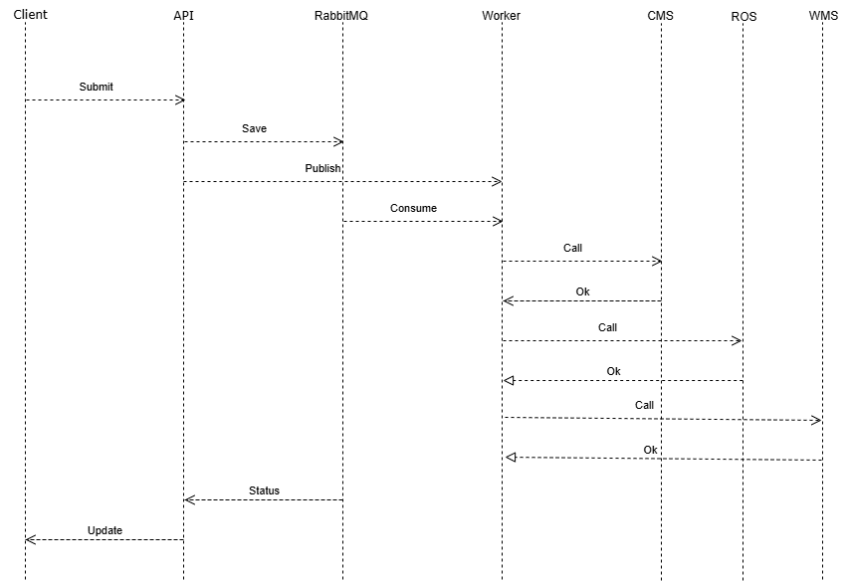

4.2 Real-Time Tracking Mechanism
Real-time updates are delivered using WebSocket connections maintained between the client and API Gateway.
The mechanism includes:
- Persistent client connections
- Event-triggered status updates
- Internal worker-to-gateway notification endpoints
- Broadcast to subscribed clients

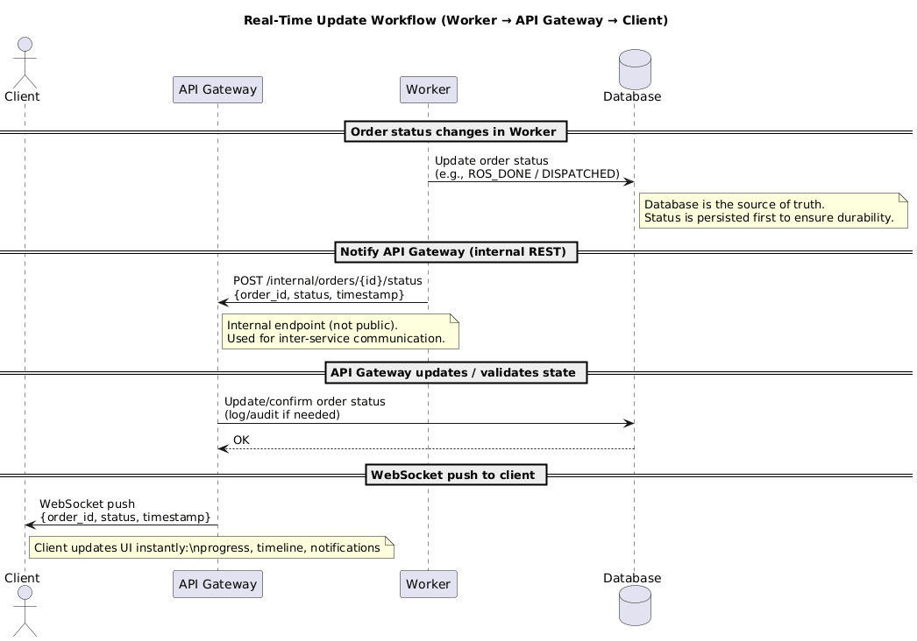

4.3 Prototype Scope
Fully implemented:
- Order submission
- Event publication
- Sequential orchestration
- Mock system integration
- Status persistence
- Basic WebSocket updates
Minimally implemented:
- Notification UI sophistication
- Advanced failure visualization
- Production-grade observability

5. Information Security Considerations
5.1 Authentication and Authorization
- JWT-based authentication
- Client-level data isolation
- Protected API endpoints

5.2 Data Protection
- Password hashing
- Secure credential storage
- Avoidance of plaintext secrets

5.3 Transport Security
- HTTPS and WSS recommended for production
- Internal network isolation via Docker

5.4 Input Validation
- Schema validation using request models
- SQL injection prevention through parameterized queries

5.5 Secret Management
- Environment variable usage
- Source control exclusion of secrets

5.6 Messaging Security
- Broker credential configuration
- Queue access restrictions

5.7 Logging and Auditing
- Operational logging
- Event traceability
- Sensitive data redaction
5.8 Availability and Resilience
- Retry strategies
- DLQ handling
- External call timeouts
- Circuit breaker as future enhancement

