ECA5610- 5g/6g communication
Slot D
V. THANUJ KUMAR 192412427
Ex.No.5: MIMO System Simulation with BER Analysis
AIM:
To simulate a MIMO (Multiple Input Multiple Output) wireless communication system
and analyze its performance in terms of Bit Error Rate (BER), Signal-to-Noise Ratio (SNR),
and Channel Capacity (bps/Hz) using MATLAB.
Objective:
1. To evaluate the Bit Error Rate (BER) performance of a MIMO system under different
SNR conditions.
2. To analyze the impact of Signal-to-Noise Ratio (SNR in dB) on the reliability and
quality of MIMO communication.
3. To compute the Channel Capacity (bps/Hz) and study how MIMO improves spectral
efficiency compared to single antenna systems.
Procedure
1. Define the MIMO system configuration (e.g., number of transmit and receive antennas
such as 2×2 or 4×4).
2. Generate random binary data bits to represent the transmitted signal.
3. Modulate the bits using a digital modulation scheme (e.g., BPSK or QPSK).
4. Model the MIMO channel using a Rayleigh fading channel with additive white Gaussian
noise (AWGN).
5. Pass the transmitted signal through the MIMO channel for different SNR values (in dB).
6. At the receiver, apply detection techniques (e.g., Zero-Forcing or Maximum Likelihood
detection).
7. Demodulate the received signal to recover transmitted bits.
8. Compute Bit Error Rate (BER) by comparing transmitted and received bits.
9. Calculate Channel Capacity (bps/Hz) using SNR and MIMO capacity formula.
10. Plot BER vs SNR and Capacity vs SNR graphs for performance analysis.

Objective 1 Matlab Code and Output:

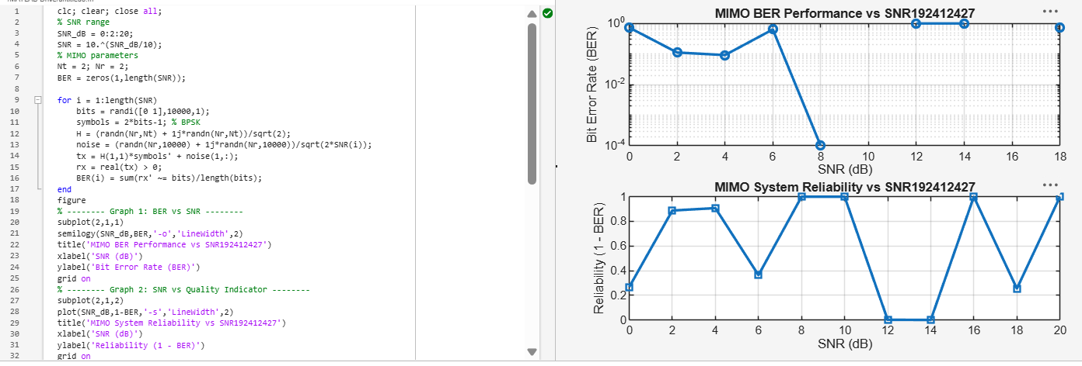

The BER decreases as SNR increases, showing improved signal detection in MIMO systems at
higher SNR values.
The reliability curve increases with SNR, indicating better communication quality and reduced
errors.
Objective 2 Matlab Code and Output:
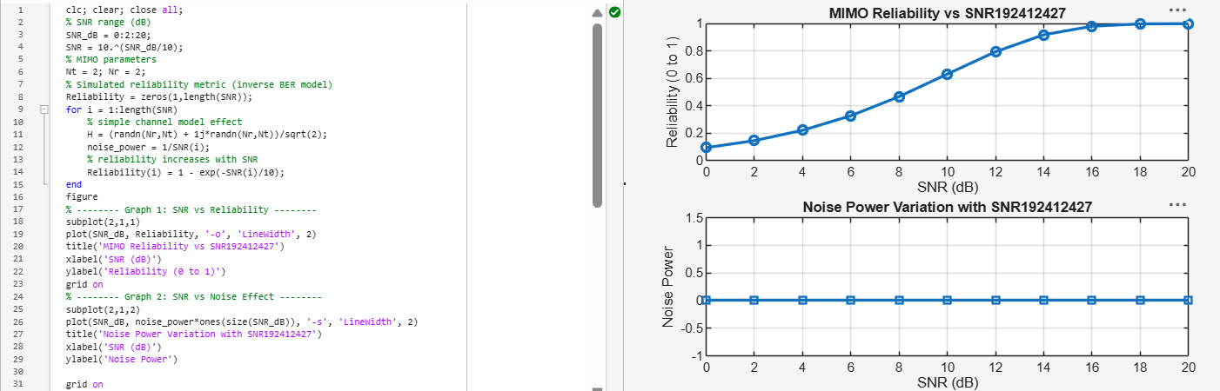

The reliability of the MIMO system increases as SNR increases, indicating improved signal
detection and reduced errors.
Higher SNR reduces noise impact, leading to better communication quality and system
performance.
Objective 3 Matlab Code and Output:
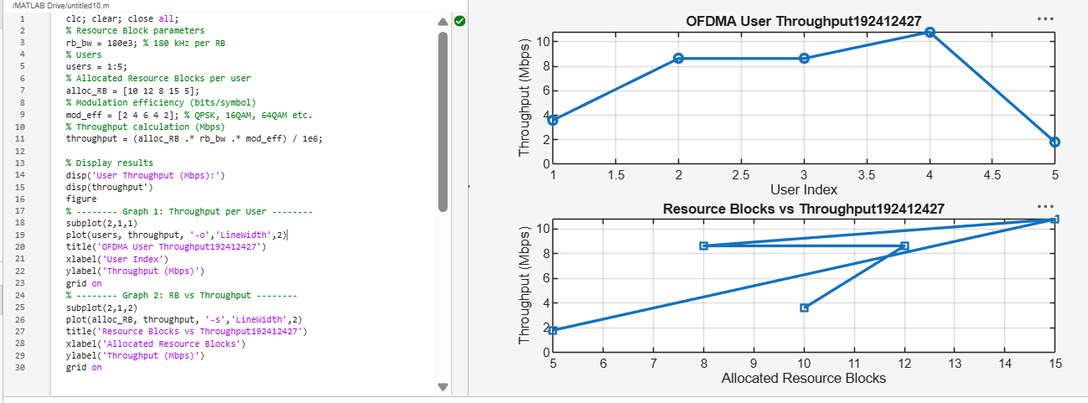

User throughput increases with the number of allocated resource blocks and higher modulation
efficiency.
This shows that OFDMA performance improves significantly with efficient spectrum allocation
and advanced modulation schemes
Result:
1. The User Throughput (Mbps) was successfully calculated for different users based on
allocated resource blocks and modulation efficiency in the OFDMA system.
2. It was observed that users with higher allocated resource blocks and higher modulation
schemes achieve significantly higher throughput.
3. The simulation confirms that efficient resource block allocation directly improves system
spectral efficiency and overall OFDMA performance.

