ECA5610- 5g/6g communication
Slot D
V THANUJ KUMAR 192412427

Ex.No:1: Simulation of FDMA in MATLAB
Aim: To simulate a Frequency Division Multiple Access (FDMA) system using MATLAB
and analyze its communication performance in terms of channel bandwidth, data rate, and
signal-to-noise ratio (SNR).
Objective 1:
To simulate an FDMA system by allocating individual frequency channels to multiple users
and determine the channel bandwidth assigned to each user.
Output Parameter: Channel Bandwidth (kHz)
Objective 2:
To calculate the data rate achieved by each user in the FDMA system based on the allocated
channel bandwidth.
Output Parameter: Data Rate (kbps)
Objective 3:
To evaluate the communication quality of the FDMA system by calculating the Signal-to-
Noise Ratio (SNR) for different users.
Output Parameter: Signal-to-Noise Ratio (SNR) (dB)
Procedure
1. Open MATLAB and create a new script file.
2. Define the total available bandwidth, number of FDMA users, carrier frequencies, signal
power, and noise power.
3. Allocate a unique frequency channel to each user and calculate the channel bandwidth.
4. Compute the data rate for each user based on the allocated bandwidth and modulation
scheme.
5. Calculate the Signal-to-Noise Ratio (SNR) using the signal and noise power values.
6. Plot the transmitted signals of all FDMA users using different carrier frequencies.
7. Display the calculated channel bandwidth, data rate, and SNR in the MATLAB
Command Window.
8. Analyze the results to verify independent channel allocation and evaluate the overall
performance of the FDMA system.
Objective 1 MATLAB Code& output
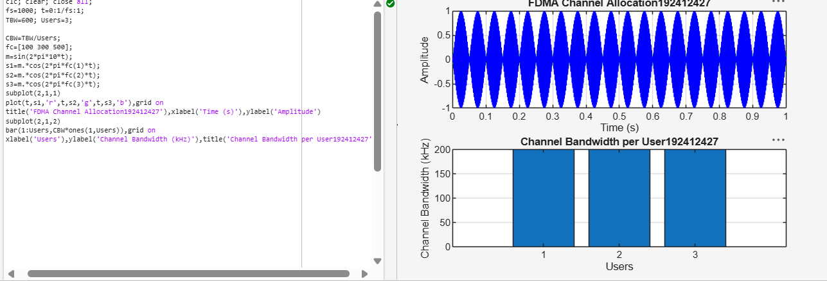
utput Graph 1: FDMA Channel Allocation

• Displays three users transmitting on different carrier frequencies (100 kHz, 300 kHz,
and 500 kHz).
• Demonstrates that each user occupies a separate frequency channel.
Output Graph 2: Channel Bandwidth Allocation
• Shows a bar graph of the bandwidth allocated to each user.
• Each user is assigned 200 kHz, confirming equal FDMA channel allocation.
Objective 2: Matlab Code and Output
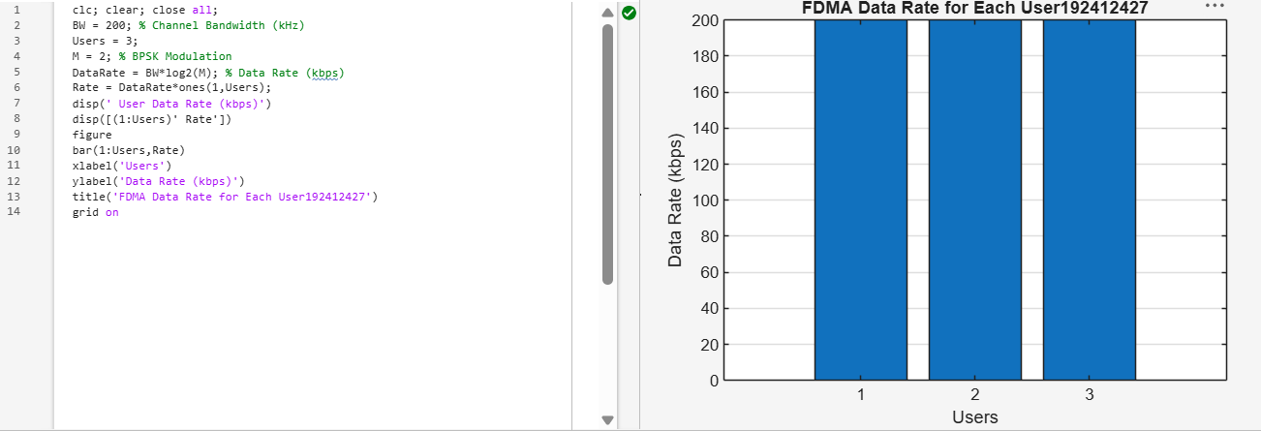
The graph shows that all FDMA users achieve an equal data rate of 200 kbps due to equal channel
bandwidth allocation. This confirms fair and interference-free data transmission among users.
Objective 3: Matlab Code and Output
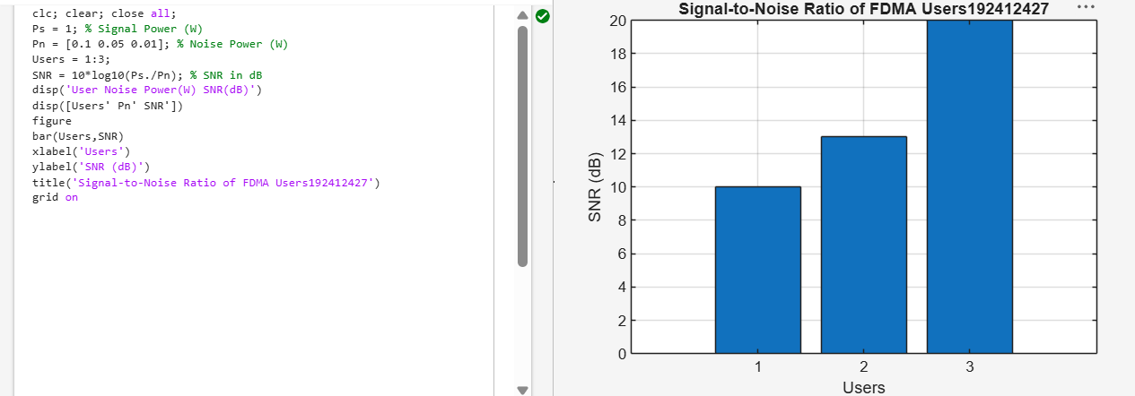
The graph shows that the SNR increases as the noise power decreases for different FDMA
users. A higher SNR indicates better communication quality and more reliable signal
transmission.
Result:
1. The FDMA system was successfully simulated by allocating separate frequency channels
to three users, and the channel bandwidth assigned to each user was determined.
2. The data rate achieved by each user was successfully calculated based on the allocated
channel bandwidth, demonstrating equal transmission capacity for all users.
3. The Signal-to-Noise Ratio (SNR) for different users was successfully evaluated,
showing that higher SNR values provide better communication quality and reliable data

