Predicting the chances of occurrence of Cardio Vascular Disease (CVD) in people using Classification Techniques within fifty years of age

D.KARTHICK
BIGDATA ANALYTICS
SRM UNIVERSITY
Chennai,india
Karthick_dhana@srmuniv.edu.in
B.PRIYADHARSHINI
INFORMATION TECHNOLOGY
SRM UNIVERSITY
Chennai,india
priyadharshini.b@ktr.srmuniv.ac.in

Abstract— The changing lifestyle, food habits and other bad habits like smoking, drinking has lead people to heart attack at young age. This paper aims in predicting the likelihood of cardiac disease in people based on the attributes such as the age, sex, cp, trestbps, chol, fbs, restecg, thalac, exang, oldpeak, slope, ca, thal. The data of existing patients within fifty years of age has to be collected and trained. Classification algorithms like Naive Bayes algorithms is applied to develop a model. This model will form a basis for predicting the chances of occurrence of CVD. If a person’s data are given the classifier will predict if he is liable to CVD or not. The output is a binary classification which will give 1 or 0; 1 being the chances to occur and 0 being the chances not to occur.
Keywords—component; CVD,MAFIA,CART,OOB,Ntree

Introduction
Heart and blood vessel disease were also called heart disease which includes numerous problems, many of which are related to a process called atherosclerosis. Atherosclerosis is termed as a condition that develops when a substance called plaque builds up in the walls of arteries. It narrows the arteries, making it harder for blood to flow through. If a blood clot forms, it will stop the blood flow. It can cause a heart attack or stroke.
Normally stroke happens most probably when the blood flow towards the heart being blocked by a blood clot. In this case if this clot gets cuts off and if the blood flow stops completely, then the part of the heart muscle being supplied by that artery will die. In most of the cases people will survive in during first heart attack and return to their old state to enjoy many more years of productive activity. But getting a heart attack determines that you have to do some changes. Heart specialists will analyze you for medications and lifestyle changes of how badly the heart organ got damaged and in what degree of heart disease caused the occurrence for attack.[1]

Related work

Maximal Frequent Item Set Algorithm
In this paper they implemented association rules that has two separate phases. In the first phase, they found the set of frequent item sets in the database. In the second step, they used the frequent item sets to generate interesting patterns, and various forms of interestingness have been proposed. In practice, the first phase is the most time-consuming.[3]

CART ALGORITHM:
Here the author had used CART algorithm or Classification and Regression Tree on WEKA tool and it is used in data mining for classifying the variables of dataset .Regression tree which is determined in which the variable is not interrupted and tree is won to make the final decision. Finally CART algorithm was applied on the dataset of Heart Disease of Male persons in their research for the prediction of the Class which is based on the selected attributes of a dataset which involves age, chest pain, rest blood pressure, rest electrograph, blood sugar, maximum heart rate, exercise angina and disease.[11]

C4.5 Algorithm
In this paper they used C4.5 algorithm which is a program that contributes a set of labeled data and produces a decision tree as output also this follows-on decision tree is then verified against unseen labeled test data to enumerate its generalization. They generated taxonomy rules using decision trees from a set of given data. Finally using C4.5 algorithm they built a decision trees from a set of training data similar to the ID3algorithm, using the concept of information entropy.[13]

K-Means Clusterring Algorithm
In this model the use of K-means helps in grouping the data in accord with their individual values into k distinct collections. And then Data were categorized into the identical cluster that has alike feature values. The positive number representing the number of collections, needs to be delivered in advance. The preprocessed heart illness data is grouped using the K-means algorithm with the K values.[13]

Proposed Work
It is clear that a number of algorithm are there to analyze heart disease. But previous models does not predict the chances of getting heart disease within fifty years of age.
So we need a Cardio Vascular Disease affected patient’s data set within fifty years of age, which will be helpful for predicting the heart disease, Also it will be a precautionary measure for avoiding the earlier occurrence of heart disease.
It is also clear that there is no model for predicting the occurrence of CVD within fifty years of age.

Proposed system design

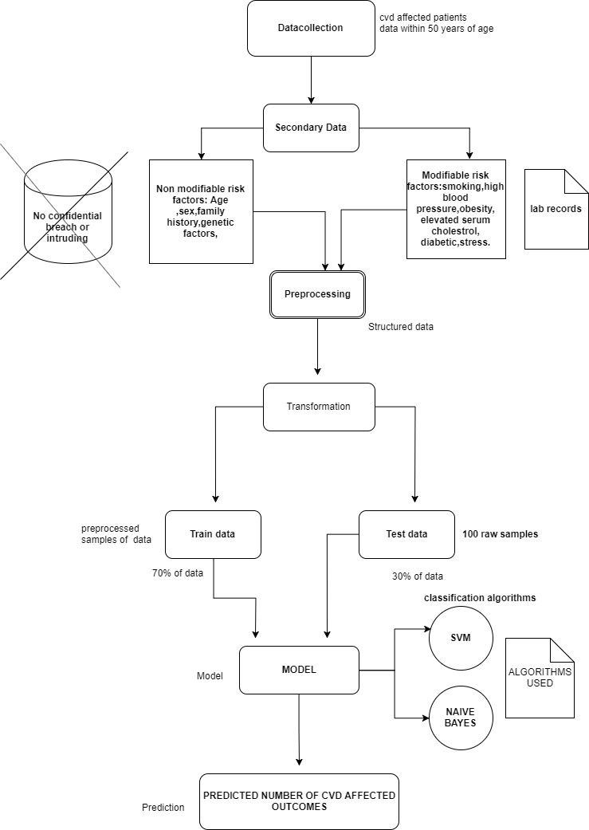

Proposed Project Flow Diagram

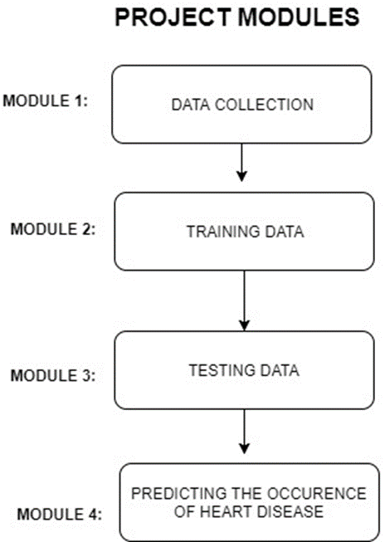

Hardware and Software requirements
Software:

1. Software – R studio

Hardware:

1. RAM : 4GB
2. Processor : core i3 3110-M @2.4ghz
3. Storage : 100gb

Algorithms used:

1. Naive Bayes
2. PCA(Principle Component Analysis)
3. Random Forest

Abbreviations:

1.CVD : Cardio vascular Disease
2.MAFIA : Maximum Frequent Item Sets Algorithm
3.CART : Classification and Regression Trees
4.OOB : Out Of Bag Error
5.Ntree : No of trees

Attributes Description
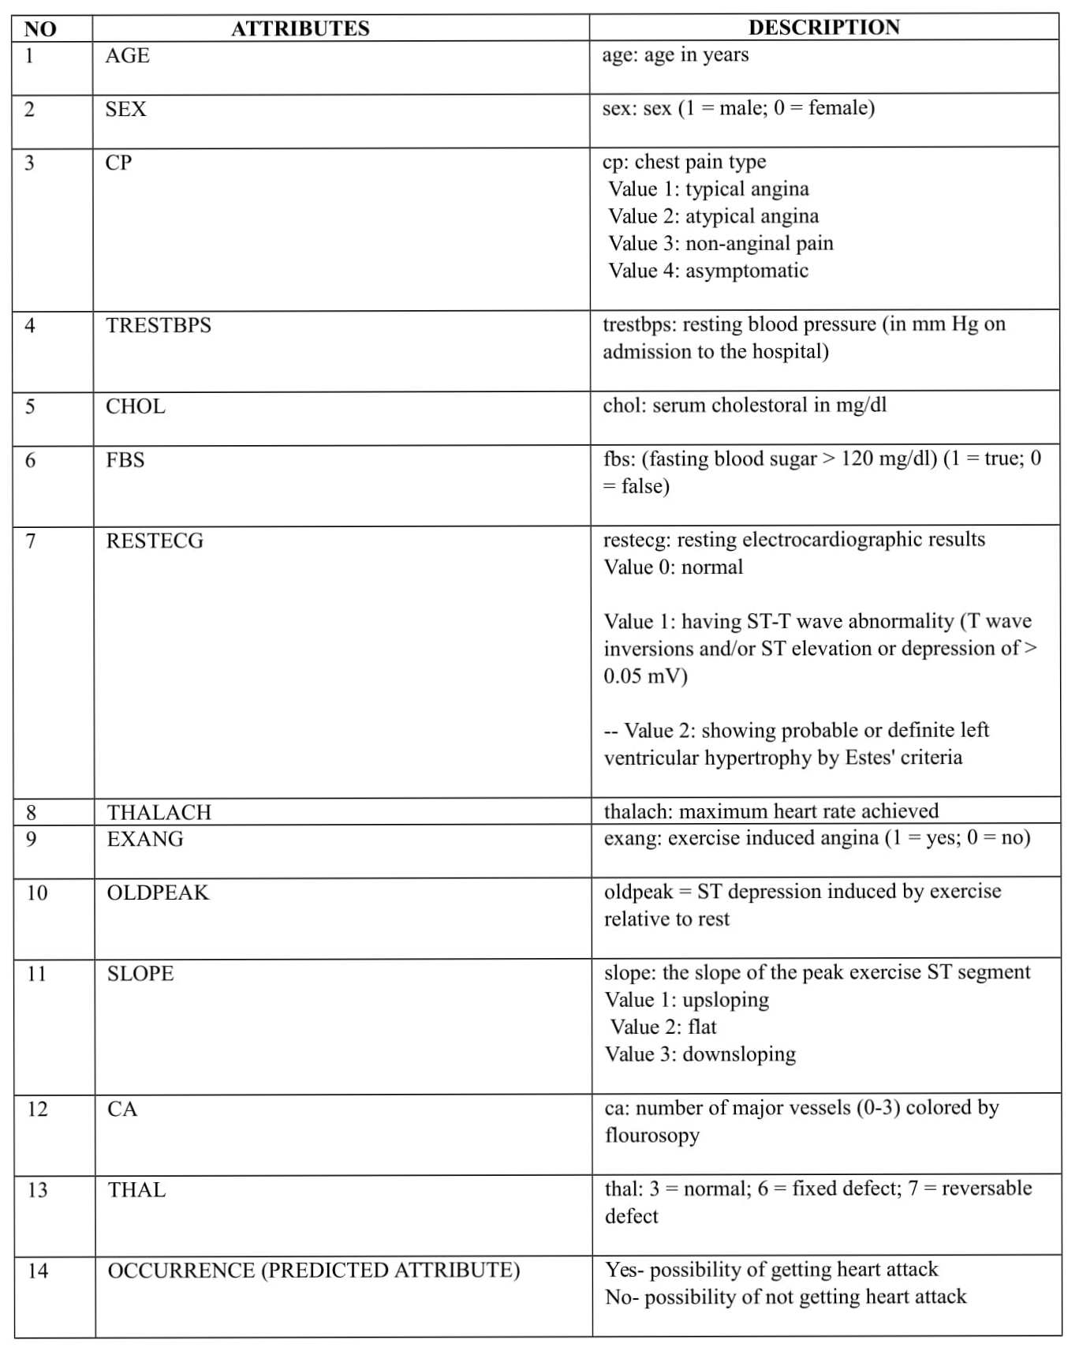

Principal component analysis
Here in this paper we use principle component analysis which is a method of extracting important variables (in form of components) from a large set of variables available in a data set. It extracts low dimensional set of features from a high dimensional data set with a motive to capture as much information as possible. With the help of fewer variables, visualization also becomes much more meaningful. It is more useful in dealing with three or higher dimensional data.
In our paper we applied this concept on CVD medical data of about 13 attributes in R studio platform to find the most prominent symptom for getting a heart disease.
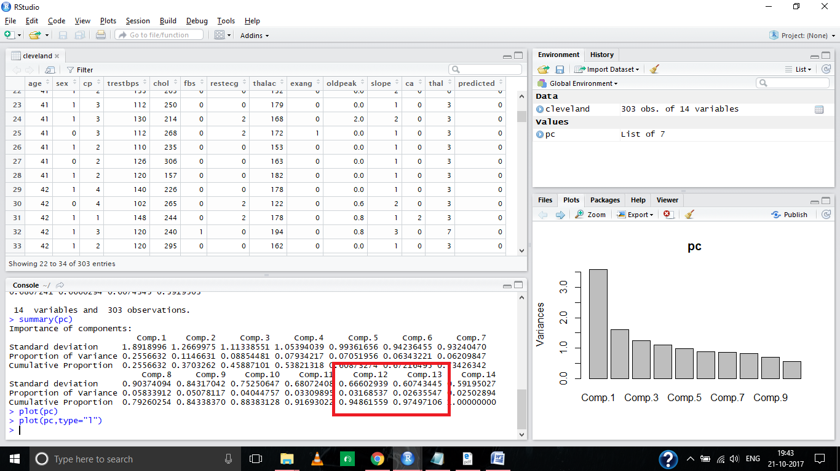
Figure 4.1
In the above figure 4.1 component thirteen (comp.12,comp.13) which corresponds to a cumulative proportion of about 97% which forms the principal component and also it determines that Ca, thal value which forms the main symptom for getting heart disease.
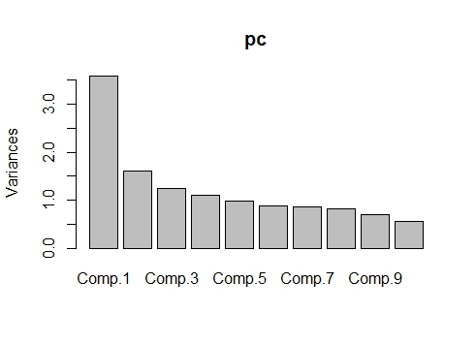
Figure 4.2

In the above figure 4.2 The transformation is defined in such a way that the first principal component(Comp.1) has the largest possible variance (that is, accounts for as much of the variability in the data as possible), and each succeeding component in turn has the highest variance possible under the constraint that it is orthogonal to the preceding components.

Random Forest
Random forest which is similar to bootstrapping algorithm with Decision tree (CART) model [11] .We have 303 observation in the complete dataset with 14 variables. Using Random forest we tried to build multiple CART model with different sample and different initial variables. For instance, it will take a random sample of 100 observation and 5 randomly chosen initial number of variables to build a CART model. It will repeat the process 14 times and then it will make a final prediction on each observation. The Final prediction forms the function of each prediction. This final prediction is defined by simply the mean of each predictions.

In our paper we had computed the variable importance using the Random Forest by training our data by using appropriate Mtry and Ntree values by reducing the OOB error rate.

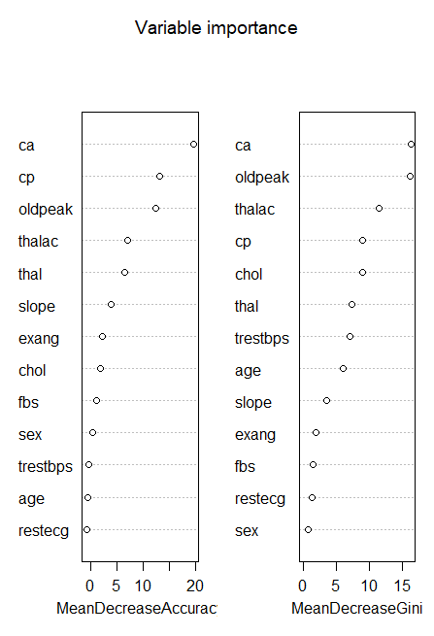
Figure 5.1

From the above (figure 5.1) ca variable contributes more and has maximum importance for accuracy for predicting the heart disease. Also CP, thalac, oldpeak, and thal value has more contributions.

Result analysis
Naive bayes classifier: A classifier is a process of mapping from a (discrete or continuous) feature space X to a discrete set of labels Y. Here we are dealing about learning classifiers, and learning classifiers are divided into supervised and unsupervised learning classifiers. The applications of classifiers are wide ranging. They find use in medicine, finance, mobile phones, computer vision (face recognition, target tracking), voice recognition, data mining and uncountable other areas.
The best example for a classifier which accepts a person's details, such as age, home address, marital status, and medical history which classifies a person with respect to the conditions.
So with the help of Naive Bayes classifier in this paper we trained the existing cleveland dataset from the UCI repository using thirteen medical attributes, and we found out which attribute contributes more for getting heart disease.

Data Source : http://archive.ics.uci.edu/ml/datasets/heart+Disease

Envisaged Research
The proposed research work entitled “Predicting the chances of occurrence of Cardio Vascular Disease (CVD) in people using classification techniques within 50 years of age” would envisage the following:
ü Model to predict CVD within fifty years of age.
ü It will be an earlier precautionary measure to prevent heart disease.

Acknowledgment
I, Karthick.D ,convey my profound gratitude to my guide
Mrs. B.Priyadharshini, Assistant Professor(Sr.G), SRM University, for her guidance and encouragement given to me in carrying out this project work.
I shall be ever grateful to her for her valuable and constant feedbacks throughout the course of this paper. I would also like to put forth my earnest thanks to our department for providing us the proper resources and the freedom to pursue this project in an efficient manner.

Conclusion
Motivated by the world-wide increasing mortality of heart
disease patients each year and the availability of huge amounts of data, researchers are using data mining techniques in the diagnosis of heart disease. Although applying data mining techniques to help health care professionals in the diagnosis of heart disease is having some success, the use of data mining techniques which is used to identify a appropriate treatment for CVD patients in which they had received less attention. so in applying our data mining techniques while selecting the suitable treatment for CVD disease patients our paper predicts the prominent symptom for getting heart disease. Finally our model is trained with Naive bayes algorithm using a binary classification which will give 1 or 0. One being the chances of getting heart attack and zero being the chance of not getting heart attack.

References

- Mai Shouman, Tim Turner and Rob Stocker, Using Data Mining Techniques In Heart Disease Diagnosis And Treatment, Japan-Egypt Conference on Electronics, Communications and Computers, 2012
- T.John Peterand K. Somasundaram, An Empirical Study On Prediction Of Heart Disease Using Classification Data Mining Techniques, ISBN: 978-81-909042-2-3, 2012
- Hnin Wint Khaing, Data Mining based Fragmentation and Prediction of Medical Data, ISBN: 978-1-61284-840-2, 2011
- S Satapathy and S Chattopadhya, Mining Important Predictors Of Heart Attack, International Conference On Advances In Recent Technologies In Communication And Computing 2011
- S. el Rafaie, Abdel-Badeeh M. Salem and K. Revett, On the Use of SPECT Imaging Datasets for Automated Classification of Ventricular Heart Disease, The 8th International Conference on INFOrmatics and Systems (INFOS2012)
- S.Vijayarani, M.Divya, An Efficient Algorithm for Generating Classification Rules, ISSN : 0976-8491 (Online) | ISSN : 2229-4333 (Print), IJCST Vol. 2, Issue 4, 2011
- Geetika, A Survey of Classification Methods and its Applications, International Journal of Computer Applications (0975 – 8887) Volume 53– No.17, September 2012
- G.Subbalakshmi, K. Ramesh, M. Chinna Rao , Decision Support in Heart Disease Prediction System using Naive Bayes, ISSN : 0976-5166 Vol. 2 No. 2 Apr-May 2011.
- Bala Sundar V, T Devi, N Saravanan, Development of a Data Clustering Algorithm for Predicting Heart, International Journal of Computer Applications (0975 – 888) Volume 48– No.7, June 2012
- Shadab Adam Pattekari and Asma Parveen, Prediction System For Heart Disease Using Naive Bayes, International Journal of Advanced Computer and Mathematical Sciences ISSN 2230-9624. Vol 3, Issue 3, 2012,pp290.
- An Approach for Classification using Simple CART Algorithm in Weka, 2017 11 th International Conference on Intelligent Systems and Control (ISCO).
- The Effect of Sample Age and Prediction Resolution on Myocardial Infarction Risk Prediction, IEEE JOURNAL OF BIOMEDICAL AND HEALTH INFORMATICS, VOL. 19, NO. 3, MAY 2015.
- Predicting the Analysis of Heart Disease Symptoms Using Medicinal Data Mining Methods International Journal on Advanced Computer Theory and Engineering (IJACTE) ISSN (Print) : 2319 – 2526, Volume-2, Issue-2, 2013 .

