This is a project on mongodb using Node.js

Author: Thanuja D

Email: thanujadayananda05@gmail.com

The project contains a form created using ejs, along with basic css (views folder),

and connection to database in app.js

the form has insertion to name, course, age , email

**screenshots-**

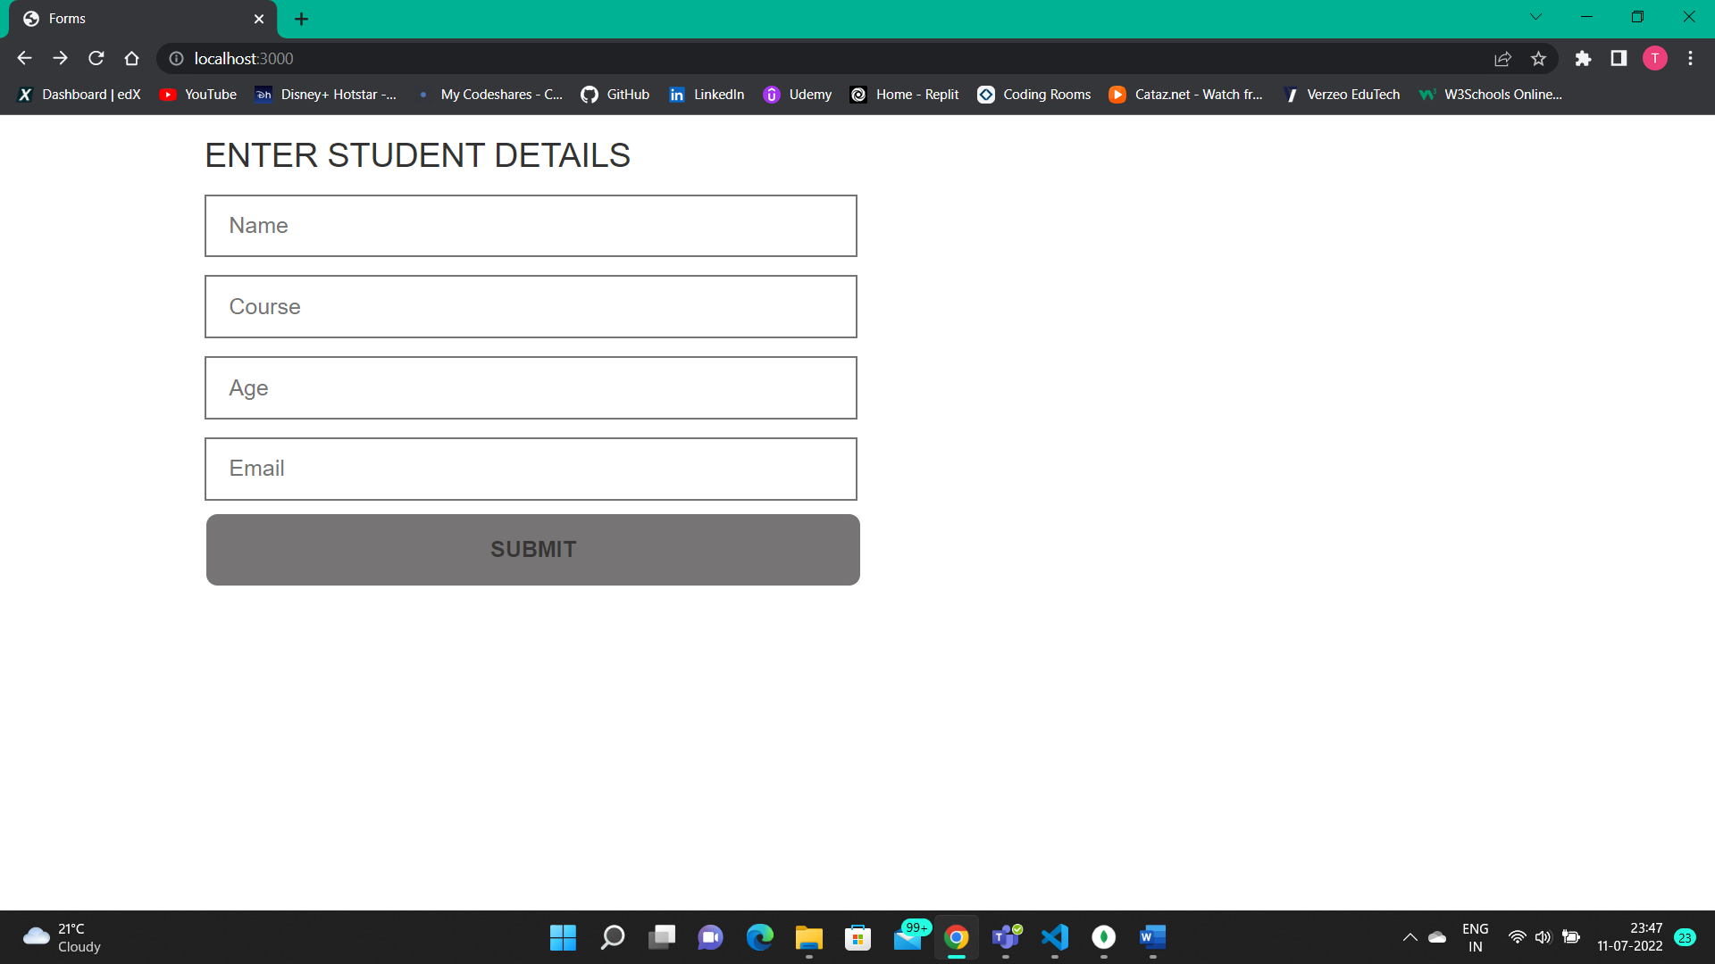

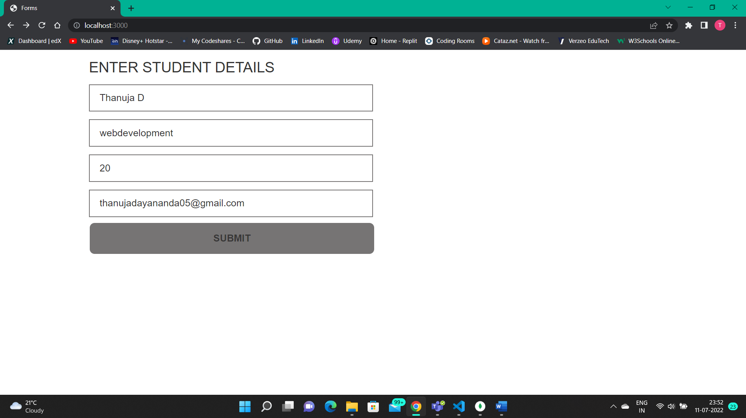**Input data-**

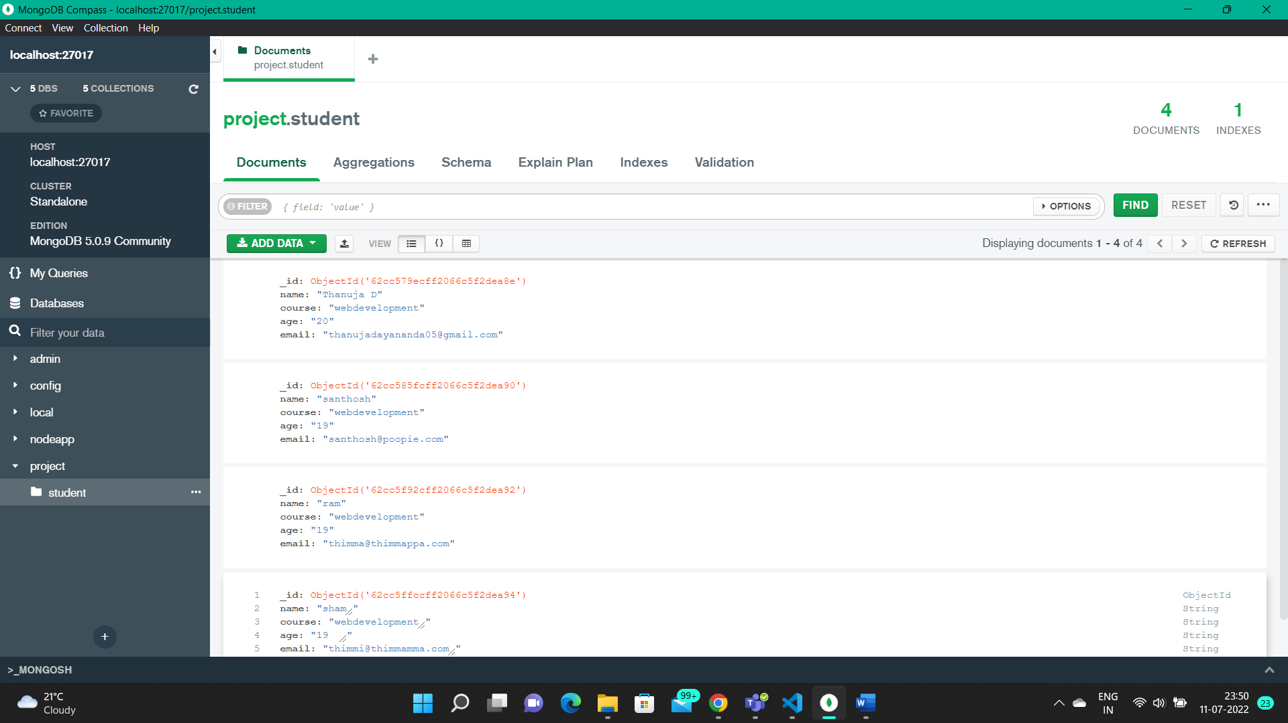**Stored value in database(** after input**)**