THIS IS A STUDENT PORTAL DEVELOPED USING NODEJS, MYSQL, HTML, CSS, BOOTSTRAP

THE WEBPAGE CONSISTS OF FUNCTIONS SUCH AS

1. A MAIN ADMIN WINDOW
2. LOGIN PAGE
3. REGISTERATION PAGE
4. AND PERSONAL DASHBOARD

WORKING VIDEO LINK:

https://drive.google.com/file/d/1CHQwFeKE7iye68JZGBBkT85RCuS3GuDX/view?usp=sharing

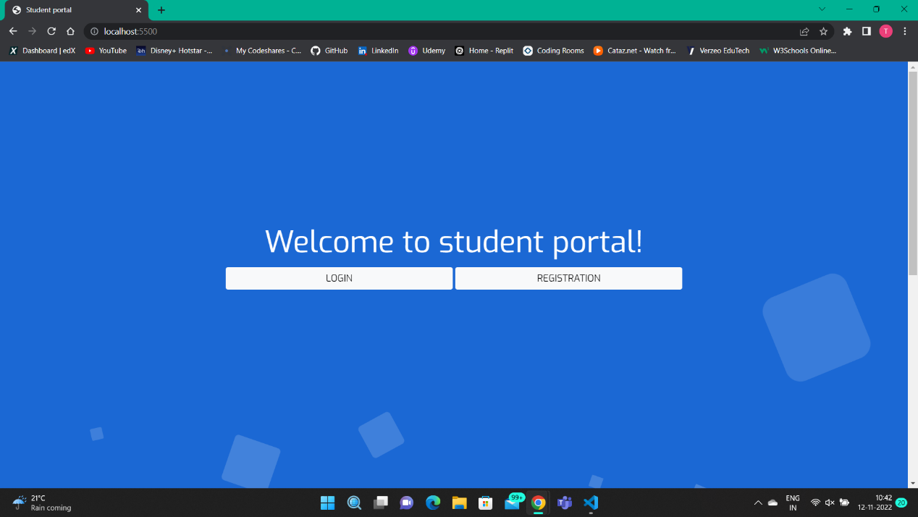SNAPSHOTS-

