AI-BASED ELECTRICITY DEMAND INTELLIGENCE SYSTEM FOR SRI LANKA
COMMON INTEGRATED SOLUTION REPORT
Project ID: R26-IT010
Team member | Student ID | Individual component
Thanujan T | IT22545176 | Behaviour Intelligence
Janahan R | IT22069740 | Adaptive Forecasting and Prediction
Madushani R.P | IT22273062 | Explainable AI for Electricity Demand Forecasting
Dewmini D.M.D.P | IT22630216 | Scenario Analysis and Decision Support for Electricity Demand Forecasting

Report submitted in partial fulfilment of the requirements for the
Bachelor of Science (Hons) in Information Technology
Specialising in Information Technology
Department of Information Technology
Sri Lanka Institute of Information Technology
Sri Lanka
October 2026

DECLARATION AND SUPERVISOR CERTIFICATION
Candidate declaration. We declare that this common report is our own work and does not incorporate, without acknowledgement, material previously submitted for a degree or diploma at any university or institute of higher learning. To the best of our knowledge, it contains no material previously published or written by another person except where acknowledgement is made in the text. We grant the Sri Lanka Institute of Information Technology the non-exclusive right to reproduce and distribute this report, in whole or in part, in print, electronic, or other media, while retaining the right to use the content in future work.
Student name | Student ID | Signature | Date
Thanujan T | IT22545176
Janahan R | IT22069740
Madushani R.P | IT22273062
Dewmini D.M.D.P | IT22630216

Supervisor certification. The above candidates carried out this research project under my supervision.
Role and name | Signature | Date
Supervisor: Dr. Nathali Silva

ABSTRACT
Electricity planners in Sri Lanka receive demand figures and forecasts but little help in judging what kind of day each day is, why a model predicts what it does, how demand would respond to unusual conditions, and how certain a forecast is. This report presents the AI-Based Electricity Demand Intelligence System (Project R26-IT010), a decision-support system built by four undergraduates as four connected components: behaviour intelligence (daily-profile clustering, anomaly and peak detection, behaviour labels), adaptive forecasting (hybrid deep-learning forecasts with calibrated intervals), explainable AI (SHAP and LIME explanations of an XGBoost model) and scenario analysis (what-if simulation with risk levels and recommendations).
Following Design Science Research, each component was built and evaluated on 15-minute demand data for January 2020 to May 2025 and delivered through its own FastAPI service and React dashboard. A launcher starts all four, and the behaviour dashboard acts as the shell that embeds the other applications and links each abnormal day to its LIME explanation. Each component met its technical objectives: for example, the behaviour service passed 24 of 24 API checks and reproduced its results exactly, the forecasting service produced 95% intervals with 96.3-97.1% test coverage, and the scenario service exposed and mitigated impossible predictions outside the training range.
The integrated evaluation also shows limits. Integration exists at the user-interface level but not the data level; the components use different data files of undocumented or synthetic origin, different evaluation protocols and different forecasting models, so their results are not comparable; and no stakeholder validation was carried out. The project demonstrates a coherent architecture and reusable methods. Real utility data, a shared data contract and service-to-service integration are needed before operational use.
Keywords: Electricity demand intelligence, Decision support, Demand forecasting, Explainable AI, Sri Lanka

ACKNOWLEDGEMENTS
We sincerely thank our research supervisor, Dr. Nathali Silva, for her guidance, expert advice and constructive feedback throughout this project.
We are grateful to the lecturers and staff of the Department of Information Technology and the Faculty of Computing at the Sri Lanka Institute of Information Technology for the knowledge, facilities and technical support that made the work possible, and to the panel members who reviewed our progress and whose comments strengthened the model comparisons and the justification of the features.
We thank one another for the cooperation that allowed four components, developed in parallel, to be demonstrated as one system, and our families and friends for their encouragement and support. This project was self-funded and received no external sponsorship.

TABLE OF CONTENTS
DECLARATION AND SUPERVISOR CERTIFICATION i
ABSTRACT ii
ACKNOWLEDGEMENTS iii
TABLE OF CONTENTS iv
LIST OF FIGURES vi
LIST OF TABLES vii
LIST OF ABBREVIATIONS viii
LIST OF APPENDICES x
1 INTRODUCTION AND PROJECT CONTEXT 1
1.1 Background and Context 1
1.2 Stakeholders and User Needs 2
1.3 Alignment with the Sustainable Development Goals 3
1.4 Purpose and Scope of the Common Report 3
2 OVERALL PROBLEM DEFINITION AND FOUR SUBPROBLEMS 4
2.1 Overall Problem Definition 4
2.2 Root Causes and Overall Research Gap 4
2.3 Subproblem and Component Mapping 5
2.4 Overall Aim and Group Objectives 6
2.5 Scope, Assumptions and Constraints 6
3 OVERALL SOLUTION STRUCTURE 8
3.1 Integrated Solution Overview 8
3.2 High-Level Architecture 8
3.3 Component 1 Summary: Behaviour Intelligence 10
3.4 Component 2 Summary: Adaptive Forecasting and Prediction 11
3.5 Component 3 Summary: Explainable AI 12
3.6 Component 4 Summary: Scenario Analysis and Decision Support 13
3.7 End-to-End User and Data Flow 13
4 COMPONENT INTEGRATION AND COHESIVE OPERATION 15
4.1 Integration Strategy 15
4.2 Interfaces, Data Contracts and Shared Models 17
4.3 Shared Non-Functional Requirements 20
4.4 Integrated Workflow and Exception Handling 20
4.5 Team Contribution and Dependency Matrix 21
5 INTEGRATED IMPLEMENTATION AND PROJECT EXECUTION 23
5.1 Common Technology Stack and Infrastructure 23
5.2 Development and Integration Process 23
5.3 Deployment and Operational Configuration 24
5.4 Evidence of Team Execution 25
6 INTEGRATED TESTING, EVALUATION AND VALIDATION 26
6.1 Evaluation Framework and Success Criteria 26
6.2 Integration and End-to-End Testing 27
6.3 Overall Results 27
6.3.1 What the results show together 28
6.3.2 Cross-component consistency 28
6.4 Stakeholder and User Validation 30
6.5 Achievement of Common Objectives 30
6.6 Integrated Limitations and Threats 31
7 COMMERCIALISATION, SUSTAINABILITY AND RESPONSIBLE INNOVATION 32
7.1 Value Proposition and Beneficiaries 32
7.2 Market Alternatives and Differentiation 32
7.3 Business Model and Feasibility 32
7.4 Adoption, Intellectual Property and Compliance 33
7.5 Sustainable Development Goal Contribution 34
8 CONCLUSION AND FUTURE DIRECTIONS 35
8.1 Overall Conclusion 35
8.2 Principal Integrated Contribution 35
8.3 Future Directions 36
REFERENCES 37
APPENDICES 38
Appendix A Integrated Interface Specification 38
A.1 Behaviour intelligence service (port 8001) 38
A.2 Scenario analysis service (port 8002) 39
A.3 Explainable AI and adaptive forecasting services 39
A.4 Cross-component link 39
Appendix B Team Contribution Declaration 40

LIST OF FIGURES
Figure 3.1: High-level architecture of the integrated system as implemented 9
Figure 3.2: End-to-end user journeys through the integrated system 14
Figure 4.1: Data files used by the four components 18

LIST OF TABLES
Table 1.1: Components of the integrated solution 2
Table 1.2: Stakeholders, needs and the components that address them 2
Table 1.3: Sustainable Development Goal alignment 3
Table 2.1: Subproblems, components and intended dependencies 5
Table 2.2: Group objectives, responsible components and evidence 6
Table 3.1: Summary of Component 1, behaviour intelligence 10
Table 3.2: Summary of Component 2, adaptive forecasting and prediction 11
Table 3.3: Summary of Component 3, explainable AI 12
Table 3.4: Summary of Component 4, scenario analysis and decision support 13
Table 4.1: Intended and implemented integration 16
Table 4.2: Service interfaces 17
Table 4.3: Datasets used by the four components 18
Table 4.4: Shared non-functional requirements and their status 20
Table 4.5: Failure paths, recovery and fallbacks 21
Table 4.6: Team contribution matrix 22
Table 5.1: Common technology stack 23
Table 5.2: Services and ports started by the launcher 24
Table 5.3: Evidence of team execution 25
Table 6.1: Group evaluation framework 26
Table 6.2: Testing carried out on the complete solution 27
Table 6.3: Headline results of the four components 28
Table 6.4: Evaluation protocols of the four components 29
Table 6.5: Achievement of the group objectives 30
Table 6.6: Integrated limitations and threats to validity 31
Table 7.1: Planned budgets of the four components (LKR) 33
Table A.1: Endpoints of the behaviour intelligence service 38
Table A.2: Endpoints of the scenario analysis service 39
Table A.3: Interfaces of the XAI and forecasting services 39
Table A.4: Behaviour-to-XAI deep link 39
Table A.5: Individual and shared contributions 40
Table A.6: Confirmation of the contribution record 40

LIST OF ABBREVIATIONS
Abbreviation | Meaning
AI | Artificial Intelligence
API | Application Programming Interface
B2G | Business-to-Government
CEB | Ceylon Electricity Board
CI | Continuous Integration
CNN | Convolutional Neural Network
CORS | Cross-Origin Resource Sharing
CSV | Comma-Separated Values
EQ | Evaluation Question
G | Group objective
GDP | Gross Domestic Product
HTTP | Hypertext Transfer Protocol
IQR | Interquartile Range
JSON | JavaScript Object Notation
LECO | Lanka Electricity Company
LIME | Local Interpretable Model-agnostic Explanations
LKR | Sri Lankan Rupee
LSTM | Long Short-Term Memory
MAE | Mean Absolute Error
MAPE | Mean Absolute Percentage Error
MC | Monte Carlo
R² | Coefficient of determination
REST | Representational State Transfer
RMSE | Root Mean Squared Error
SCADA | Supervisory Control and Data Acquisition
SDG | Sustainable Development Goal
SHAP | SHapley Additive exPlanations
SLIIT | Sri Lanka Institute of Information Technology
SP | Subproblem
SSL | Secure Sockets Layer
TLS | Transport Layer Security
TPE | Tree-structured Parzen Estimator
UI | User Interface
XAI | Explainable Artificial Intelligence

LIST OF APPENDICES
Appendix | Description | Page
Appendix A | Integrated Interface Specification | 38
Appendix B | Team Contribution Declaration | 40

1 INTRODUCTION AND PROJECT CONTEXT

1.1 Background and Context
Electricity cannot be stored cheaply at grid scale, so generation must follow demand almost instantly. Global demand is rising as industry grows and transport and other end uses are electrified [1]. In Sri Lanka the Ceylon Electricity Board (CEB) runs a national grid whose demand varies with the hour, the day of the week, the season, public holidays and weather. Annual demand has been reported to grow by roughly 5-6% a year [2], and the 2022 energy crisis, which involved scheduled power cuts of up to 13 hours a day, showed how costly poorly anticipated demand can be [3].
Research and tools for electricity planning have concentrated on forecasting: how much demand there will be. A planner who must act on a forecast asks further questions. What kind of day is this, and is it behaving normally? Why does the model predict this value? What would happen if the weather or the price changed? How sure is the forecast? Answers to these questions are usually found in separate tools, if at all.
The research project AI-Based Electricity Demand Intelligence System for Sri Lanka (Project ID R26-IT010) responds by combining four services in one decision-support system. Each service was built by one member of a team of four undergraduates and is delivered through its own FastAPI backend and React dashboard. Table 1.1 summarises the four components, the question each answers and its owner.
Table 1.1: Components of the integrated solution
Component | Planner question answered | Owner
1. Behaviour intelligence | What kind of day is each day, and which days are abnormal? | Thanujan T (IT22545176)
2. Adaptive forecasting and prediction | What will demand be in the next 15 minutes, and how uncertain is that forecast? | Janahan R (IT22069740)
3. Explainable AI (XAI) | Why does the model predict this value, and do the drivers change over time? | Madushani R.P (IT22273062)
4. Scenario analysis and decision support | What happens to demand if conditions change, and what should be done? | Dewmini D.M.D.P (IT22630216)

Source: Project proposal [4] and the four individual theses [5], [6], [7], [8].

1.2 Stakeholders and User Needs
The project proposal [4] identified energy planners and analysts, utility companies such as CEB and the Lanka Electricity Company (LECO), and industrial and commercial consumers as the stakeholders. The individual theses add system-control and load-dispatch engineers at CEB, sector regulators and ministries responsible for energy planning, renewable-energy developers, and researchers [5], [7], [8]. Table 1.2 lists the stakeholder groups and the needs that the system is designed to meet.
Table 1.2: Stakeholders, needs and the components that address them
Stakeholder group | Type | Need | Components
Energy planners and analysts | Primary | Understand demand behaviour, test what-if situations and justify decisions | 1, 3, 4
CEB / LECO operators and load-dispatch engineers | Primary | Reliable short-term forecasts with a range; early warning of peak and abnormal days | 1, 2
Regulators and energy ministries | Secondary | Evidence about demand behaviour and risk as renewable generation grows | 1, 4
Industrial and commercial consumers | Secondary | Information on how consumption interacts with the grid | 1, 2
Researchers and renewable-energy developers | Tertiary | Reusable methods and findings | All

These needs come from the proposal and from the literature reviewed in the individual theses. They were not confirmed through stakeholder engagement. The proposal planned expert reviews and user evaluations with CEB planners and operators, but none was carried out (Section 6.4), so the needs are design assumptions rather than validated requirements.

1.3 Alignment with the Sustainable Development Goals
All four components align with the same three United Nations Sustainable Development Goals [9]. Table 1.3 states the intended contribution and the evidence.
Table 1.3: Sustainable Development Goal alignment
Goal | Intended contribution | Evidence of impact
SDG 7: Affordable and clean energy | Better forecasts, behaviour insight, explanations and scenario tests support reliable and efficient supply and reserve planning, including variable renewables | None measured; contribution is plausible but unproven
SDG 9: Industry, innovation and infrastructure | Applies interpretable and probabilistic machine learning to critical energy infrastructure | Demonstrated as a working prototype
SDG 13: Climate action | More accurate planning can reduce unnecessary over-generation and so emissions | Not measured

The report makes no claim of measured impact on any goal. The effect on emissions or supply reliability would need a pilot with a utility and real data.

1.4 Purpose and Scope of the Common Report
This common report presents the integrated problem and the integrated solution: how the four components fit together, how they were integrated, how the complete system was evaluated, and what value it offers. It does not repeat the component-level research. The detailed methods, experiments and evidence for each component are in the four individual theses [5], [6], [7], [8], to which the report points throughout. Where the individual theses disagree or leave a gap that matters for the whole system, the report says so, because an honest account of the integrated system is more useful than a uniform one.

2 OVERALL PROBLEM DEFINITION AND FOUR SUBPROBLEMS

2.1 Overall Problem Definition
Electricity planners in Sri Lanka lack an integrated, trustworthy way to understand, anticipate and interrogate demand. They receive demand figures and forecasts but little help in judging what kind of day each day is, why a model predicts what it does, how demand would respond to conditions that have not yet occurred, and how certain a forecast is. The consequence is decisions made on single numbers, with limited ability to prepare for peaks, abnormal days or extreme conditions.
The common research problem is therefore: how can electricity demand data be turned into a coherent decision-support system that describes demand behaviour, forecasts demand with an indication of uncertainty, explains model predictions, and lets planners test scenarios, so that planners can make informed and risk-aware decisions?

2.2 Root Causes and Overall Research Gap
The proposal and the four literature reviews point to the following causes [4], [5], [6], [7], [8]:
- Forecast-only tools. Studies and tools concentrate on forecast accuracy and give point values judged by MAE and RMSE, with no behavioural context, no explanation and no statement of uncertainty [10]. Accuracy is typically reported as mean absolute error (MAE) and root mean squared error (RMSE).
- Limited model families and static models. Published Sri Lankan studies rely largely on LSTM, MLP and gradient-boosting models and rarely compare hybrid or attention-based designs or describe how a model in use is chosen or replaced [6].
- Opaque predictions. Accurate models are black boxes, which reduces the trust of planners who must justify decisions [7].
- Untested behaviour under unusual inputs. Models are chosen by test-set error, and their behaviour when scenario inputs leave the training range is rarely examined [8].
- Fragmented systems. Behaviour analysis, forecasting, explanation and scenario testing are normally built as separate tools rather than one connected system [5].

The overarching gap is the absence of one system that links these functions for Sri Lankan planners and is built around a documented, verified body of demand data. Closing the gap needs more than one model, because the four questions in Table 1.1 are different in kind and require different methods.

2.3 Subproblem and Component Mapping
The common problem was divided into four subproblems that do not overlap in method but depend on one another in use. Table 2.1 shows the mapping and the intended dependencies.
Table 2.1: Subproblems, components and intended dependencies
Subproblem | Component and owner | Intended dependencies
SP1: Describe demand behaviour and detect abnormal and peak days | Behaviour intelligence (Thanujan T) | Flags days for explanation by SP3; could give context to SP2 and SP4
SP2: Forecast short-term demand with calibrated uncertainty | Adaptive forecasting (Janahan R) | Could supply forecasts and intervals to SP3 and SP4
SP3: Explain predictions globally and locally and link explanations to anomalies | Explainable AI (Madushani R.P) | Takes anomalous dates from SP1; explains a forecasting model
SP4: Test what-if scenarios and convert results into risk and advice | Scenario analysis (Dewmini D.M.D.P) | Uses a forecasting model; could use SP2 intervals and SP3 explanations

All four are needed. Without SP1 the planner cannot tell what kind of day is under discussion; without SP2 there is no forward-looking number or range; without SP3 neither the forecast nor the flagged anomaly can be trusted or justified; and without SP4 the planner cannot prepare for conditions that have not occurred. The progress-review panel noted that the scenario and explanation components might overlap. They are distinct: the XAI component studies a model on observed data, while the scenario component studies it on hypothetical data [8].
Section 4.1 distinguishes the dependencies that were intended from those that were implemented. At the time of writing, only one cross-component link operates at run time (behaviour to XAI).

2.4 Overall Aim and Group Objectives
Aim. To develop an integrated decision-support system that helps Sri Lankan energy planners understand, forecast, explain and test scenarios of electricity demand, and to evaluate it honestly on the data available.
Table 2.2: Group objectives, responsible components and evidence
No. | Group objective | Components | Evidence used
G1 | Describe daily demand behaviour and detect abnormal and peak days with readable labels | 1 | Clustering and detector comparison; label statistics; API checks [5]
G2 | Forecast short-term demand through a systematic model comparison, with calibrated uncertainty | 2 | Aligned test metrics; paired comparison; interval coverage [6]
G3 | Explain predictions globally (SHapley Additive exPlanations, SHAP) and locally (Local Interpretable Model-agnostic Explanations, LIME) and connect explanations to anomalies | 3 | Model metrics; SHAP by year; LIME fidelity; link test [7]
G4 | Let planners test what-if scenarios and convert results into risk levels and recommendations | 4 | Scenario results; extrapolation and validity tests [8]
G5 | Deliver the four capabilities as one cohesive system on shared data through APIs and a dashboard | All | Launcher, shell, deep link, data lineage (Chapters 4 and 6)
G6 | Validate the complete system with stakeholders and on real utility data | All | Stakeholder and data validation (Section 6.4)

2.5 Scope, Assumptions and Constraints
In scope: four components, each with a backend and dashboard; offline model development in notebooks; integration at the user-interface level through a launcher, a dashboard shell and a deep link; and evaluation on the project's 15-minute demand data from January 2020 to May 2025.
Out of scope: deployment on a live utility system; real-time streaming of meter data; analysis of individual consumers; causal analysis of demand; and a formal user study.
Assumptions: the data files used are reasonable stand-ins for Sri Lankan demand; results describe how models behave, not how demand is caused in the real world; and fixed scenario sizes are illustrative planning questions.
Constraints and dependencies: CEB data were not obtained, so the components ran on files of undocumented or synthetic origin (Section 4.2); the project was carried out by a team of four within the 2026 project schedule; and the four components were developed largely in parallel, which shaped the integration choices described in Chapter 4.

3 OVERALL SOLUTION STRUCTURE

3.1 Integrated Solution Overview
The solution is one decision-support system with four cooperating services, designed to answer the four questions of Table 1.1 from one dashboard. Its central value is that a planner can move from "this day was unusual" to "this is what the model responded to", from "demand will be X" to "demand will be X, give or take Y", and from "what if it is hotter?" to "this much extra demand, at this risk level, with this advice". The end-to-end outcome is a set of linked applications, started together and reached from a single shell, backed by documented methods and an explicit statement of their limits.

3.2 High-Level Architecture
Figure 3.1 shows the architecture as implemented. Planners use a web browser to reach four React frontends. The behaviour dashboard also acts as the shell of the system: its sidebar opens the three other applications in embedded views. Each frontend talks to its own FastAPI backend, and each backend reads and writes its own files (data, trained models and saved results). A team launcher, start-all.py, starts all four backends and frontends on fixed ports. The only cross-component link that operates at run time is a deep link from the behaviour dashboard to the XAI page for a selected date [5].
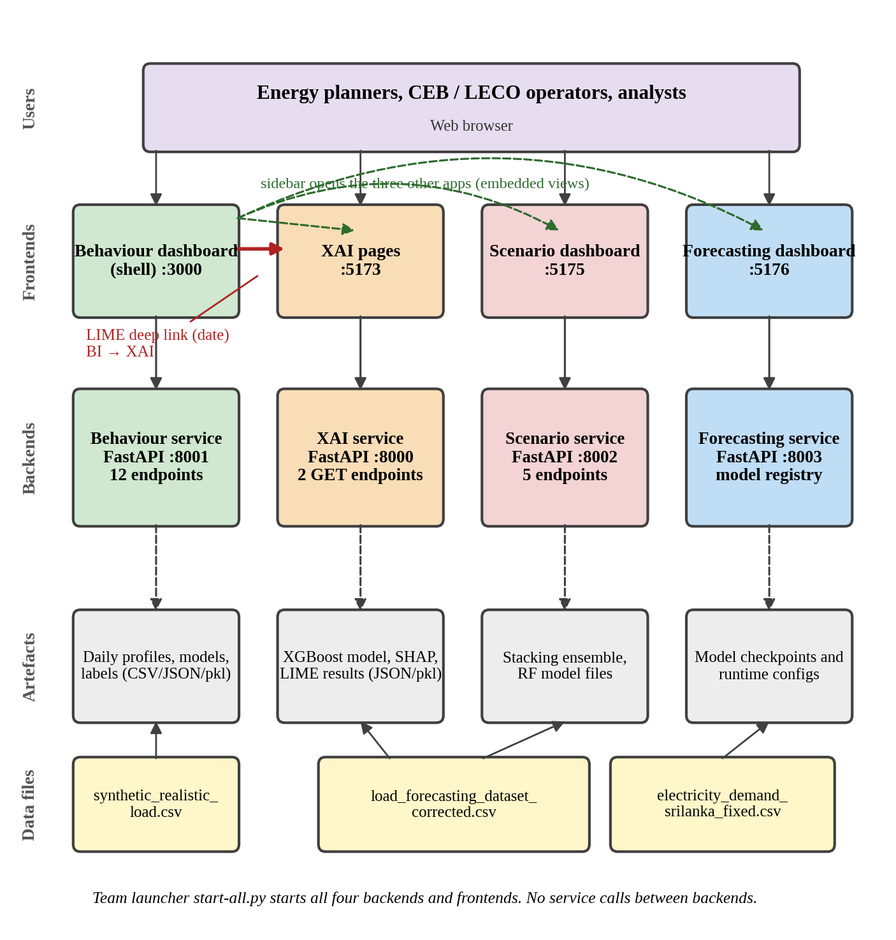
Figure 3.1: High-level architecture of the integrated system as implemented
Source: Author's drawing from the team launcher and the individual theses [5], [6], [7], [8].
The implemented architecture is simpler than the one drawn in the proposal [4], which showed a single API gateway with authentication and rate limiting, a shared time-series database, an application database and a model store. The implemented system has no gateway, no database and no shared model store: results, models and caches are files, and each service is a separate application. This was a pragmatic choice for a research prototype, and its consequences for integration are discussed in Chapter 4.

3.3 Component 1 Summary: Behaviour Intelligence
Table 3.1: Summary of Component 1, behaviour intelligence
Item | Summary
Owner | Thanujan T (IT22545176)
Subproblem | What kind of day is each day, which days are abnormal, and why?
Input | 15-minute load series (synthetic_realistic_load.csv, 189,793 readings, January 2020 to May 2025), converted into 1,977 daily 96-point profiles
Core method | Cleaning and resampling; four clustering algorithms ranked by mean rank over three validity indices (K-Means with k = 2 selected); four anomaly detectors ranked by bootstrap stability (Isolation Forest selected); a three-condition peak rule; ordered rules for four behaviour labels with risk and reason; frequency-based prediction of the label of a future date
Output | Per-day cluster, anomaly score, peak flag, label, risk level and written reason; 12 REST endpoints; a dashboard with model-comparison pages; a CSV report
Contribution | Day-level behavioural intelligence, and the dashboard shell and launcher that integrate the other three applications

Detail is in [5].

3.4 Component 2 Summary: Adaptive Forecasting and Prediction
Table 3.2: Summary of Component 2, adaptive forecasting and prediction
Item | Summary
Owner | Janahan R (IT22069740)
Subproblem | What will demand be in the next 15 minutes, and how uncertain is the forecast?
Input | electricity_demand_srilanka_fixed.csv (189,888 rows, January 2020 to May 2025); a 96-step window of 20 weather, temporal, calendar and lag features
Core method | Five deep-learning architectures (CNN, LSTM, Transformer, CNN-LSTM, CNN-Transformer) evaluated as seven variants, including two Monte Carlo (MC) Dropout variants; chronological 80/10/10 split with training-only scaling; 100-pass MC inference; validation-residual calibration of 95% intervals; a model registry with an explicit default
Output | A 15-minute-ahead forecast, a 95% interval for the MC variants and the variant used, through a FastAPI service and dashboard
Contribution | Short-term forecasting with uncertainty; a switchable model registry (not automatic selection or online learning)

Detail is in [6].

3.5 Component 3 Summary: Explainable AI
Table 3.3: Summary of Component 3, explainable AI
Item | Summary
Owner | Madushani R.P (IT22273062)
Subproblem | Why does the model predict this value, and do the drivers of demand change over time?
Input | load_forecasting_dataset_corrected.csv (189,888 rows; 188,607 after interquartile range (IQR) cleaning of demand; 12 features), with a chronological 80/20 split (150,885 training and 37,722 test rows)
Core method | Linear Regression, Random Forest and XGBoost compared; XGBoost tuned with Optuna (50 trials of the Tree-structured Parzen Estimator, TPE, on a validation subset) and chosen for exact SHAP values; SHAP computed for each year from 2020 to 2025; LIME applied to 15 instances from four demand bands
Output | Temporal-drift and anomaly-diagnosis results served by two GET endpoints to two dashboard pages; a date link received from the behaviour dashboard
Contribution | Global and local explanations of an XGBoost demand model, connected to anomaly detection

Detail is in [7].

3.6 Component 4 Summary: Scenario Analysis and Decision Support
Table 3.4: Summary of Component 4, scenario analysis and decision support
Item | Summary
Owner | Dewmini D.M.D.P (IT22630216)
Subproblem | What happens to demand if conditions change, and what should the planner do?
Input | load_forecasting_dataset_corrected.csv (189,888 rows, 12 features), mean imputation, training-only IQR cleaning (factor 3.0), a random 80/20 split (151,910 training and 37,978 test rows)
Core method | Linear Regression, Random Forest and Gradient Boosting compared; a stacking ensemble with out-of-fold predictions and an Optuna-tuned Ridge meta learner; a computed deployment rule; a scenario engine (heat wave, cold spell, price shock, economic boom and custom); Low, Medium and High risk with recommendations; a 0 kW floor
Output | Five FastAPI endpoints and a four-tab React dashboard (Overview, Predict, Scenarios, Performance)
Contribution | What-if analysis converted into risk levels and advice, with tests of model behaviour on out-of-range inputs

Detail is in [8].

3.7 End-to-End User and Data Flow
Figure 3.2 shows how a planner uses the system. There are three journeys. In journey A the planner opens the behaviour dashboard, reads the label, risk and reason for a day and, for an abnormal day, follows the LIME button to the XAI page for that date. In journey B the planner picks a scenario in the scenario dashboard and receives the change in demand, a risk level and a recommendation. In journey C the planner opens the forecasting dashboard and receives a forecast and, for the MC variants, a 95% interval.
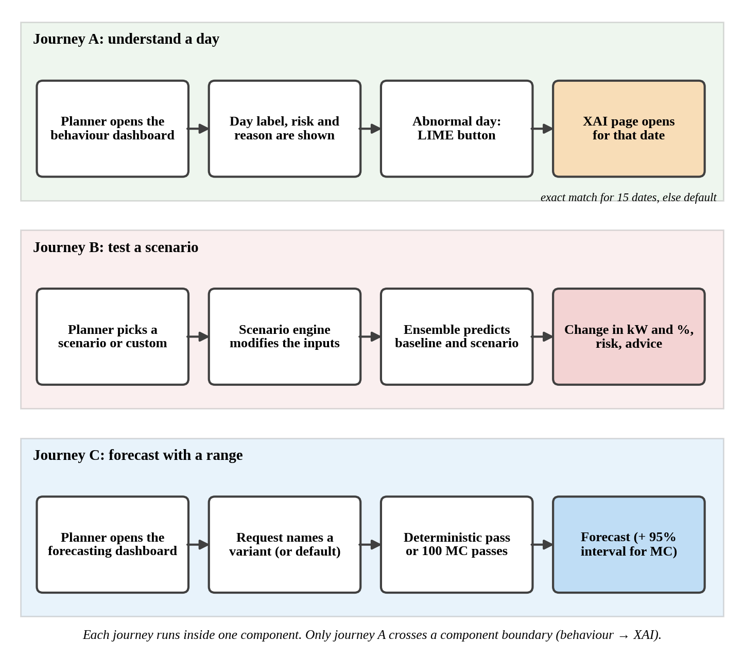
Figure 3.2: End-to-end user journeys through the integrated system
Source: Author's drawing from the individual theses [5], [6], [7], [8].
Data moves inside each component only: raw file to preprocessing, to model, to saved artefact, to API, to dashboard. The date is the only item that crosses a component boundary, in the deep link from journey A. In particular, forecasts, intervals, explanations and behaviour labels are not yet passed from one service to another through the APIs (Section 4.1).

4 COMPONENT INTEGRATION AND COHESIVE OPERATION

4.1 Integration Strategy
The four components were developed largely in parallel, each in its own folder of the team repository, with a FastAPI backend and a React frontend. Given that, the team chose to integrate first at the user-interface (UI) level. A launcher (start-all.py) starts every backend and frontend on a fixed port, the behaviour dashboard serves as a shell that opens the other applications in embedded views, and a deep link carries a date from the behaviour dashboard to the XAI page. Backends accept requests from the dashboard's origin through cross-origin resource sharing (CORS) settings. Each component can also be run alone (start-all.py --only <key>), which kept integration risk low: a failure in one application does not stop the others [5].
The proposal envisaged a deeper, data-level integration. Table 4.1 compares what was intended with what was implemented. The comparison is deliberately explicit, because it is the most important fact about the integrated system.
Table 4.1: Intended and implemented integration
Integration item | Intended in the proposal or theses | Status
Single launcher and fixed ports | Start the whole system together | Implemented
Dashboard shell embedding the other applications | One entry point for planners | Implemented (behaviour dashboard)
Behaviour dashboard to XAI deep link | Move from an abnormal day to its explanation | Implemented; exact match only for 15 explained dates, otherwise a default instance is shown
Shared data file and data contract | All four services on the same data | Not achieved: three different files are used (Section 4.2)
Service-to-service API calls | Components consume one another's outputs | Not implemented
Behaviour labels as context for forecasting | Labels passed to the forecasting services | Not implemented
One forecasting model feeding XAI and scenarios | XAI explains and scenarios use the forecasting model | Not implemented: XAI and scenario each trained their own model
Forecast intervals in scenario results | Each scenario result given a range | Not implemented (future work)
Central API gateway with transport layer security (TLS) and token authentication | Secure single entry point | Not implemented
Shared database and model store | Time-series DB, application DB and model store | Not implemented; files are used

Source: Proposal [4]; integration sections of [5], [7], [8].
Integration risks were managed by keeping components independent, by using the same frameworks (FastAPI, React, JSON) so that the applications look and behave alike, and by making the shell tolerant of a missing application: if a teammate application is not running, the shell shows its owner and start commands instead of an error [5].

4.2 Interfaces, Data Contracts and Shared Models
Table 4.2 summarises the interfaces. Appendix A gives the endpoint lists. All services return JSON. The behaviour service wraps its responses in a uniform envelope (success, message, data), and its automatic documentation is available at /docs.
Table 4.2: Service interfaces
Component | Backend / frontend ports | Interface | Persistence
Behaviour intelligence | 8001 / 3000 | 12 endpoints (5 POST pipeline stages, 7 GET), JSON envelope, CSV export | CSV, JSON and pickle files
Adaptive forecasting | 8003 / 5176 | Forecast and interval for a named variant or the default; model registry | Model checkpoints and runtime configuration files
Explainable AI | 8000 / 5173 | 2 GET endpoints (SHAP temporal drift, LIME anomaly diagnosis) | Pre-computed JSON and a pickled model
Scenario analysis | 8002 / 5175 | 5 endpoints: model information, predict, scenarios, scenario test, health | Saved model files

Source: Team launcher as reported in [5]; interface sections of [5], [6], [7], [8].
Shared identifiers and links. The only identifier shared across components is the calendar date. The behaviour dashboard opens the XAI route /anomaly-diagnosis with the parameters source=bi and date. The XAI page recognises the source, shows a banner and links back to the dashboard.
Shared data. The theses say that the components share one dataset [7], [8], but the files they use differ (Figure 4.1 and Table 4.3). This is the most significant integration finding of the project. The behaviour component moved to a different file in August 2026 after diagnosing that the earlier file had no temporal structure: adjacent 15-minute loads were almost uncorrelated (mean correlation 0.003 against 0.62 on the new file), irradiance was non-zero at midnight, and temperature was identical at every hour [5]. The XAI backend still reads the earlier file, from the behaviour component's data folder, so a LIME explanation opened from an abnormal day describes a different load series for that date [5].
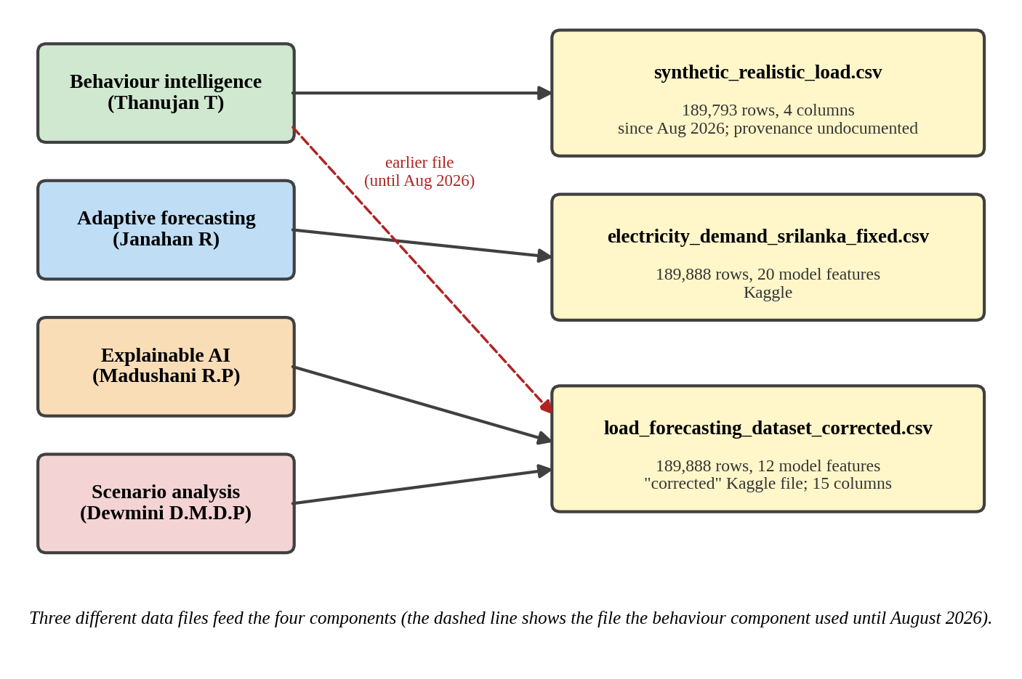
Figure 4.1: Data files used by the four components
Source: Author's drawing from [5], [6], [7], [8].
Table 4.3: Datasets used by the four components
Component | File | Rows | Inputs used | Provenance recorded
Behaviour intelligence | synthetic_realistic_load.csv | 189,793 | Timestamp and load only | Not documented; name and statistics suggest generated data
Adaptive forecasting | electricity_demand_srilanka_fixed.csv | 189,888 | 20 features (weather, time, calendar, lags) | Kaggle; original publisher not documented
Explainable AI | load_forecasting_dataset_corrected.csv | 189,888 (188,607 after cleaning) | 12 features (weather, economic, time) | Corrected version of a Kaggle dataset; origin to be confirmed
Scenario analysis | load_forecasting_dataset_corrected.csv | 189,888 | 12 features (weather, economic, time) | As above; supervisor asked that the dataset be verified

Models. No model is shared. Each of the three components with a supervised model trained its own: the forecasting component uses deep-learning variants, the XAI component an XGBoost model, and the scenario component a stacking ensemble; the behaviour component uses unsupervised models (K-Means, Isolation Forest) [5], [6], [7], [8]. The XAI service therefore explains a model that is not the one the forecasting service serves, and the scenario service simulates with a third model.
Versions and validation. No interface versioning exists. The behaviour service validates missing parameters (Hypertext Transfer Protocol, HTTP, status 422) but does not validate the format of a date at the route, and it reports failures with HTTP 200 and success = false, a weakness recorded in [5]. The scenario service applies a 0 kW floor to every prediction. The forecasting registry never substitutes a different variant silently [6].

4.3 Shared Non-Functional Requirements
Table 4.4: Shared non-functional requirements and their status
Attribute | Requirement | Status
Performance | Interactive response for a planning tool | Behaviour service: read endpoints 70-160 ms (median); pipeline 5-9 s [5]. MC forecasting needs about 100 passes per request; no benchmark. XAI and scenario response times not measured.
Usability | Readable by non-technical planners | Dashboards and plain-language labels, reasons and recommendations; no usability test
Security | Authenticated, encrypted access | Not met: no TLS or authentication; local use only; CORS limits origins
Privacy | No personal data | Met: aggregated demand and weather data only
Reliability | Reproducible, predictable results | Behaviour pipeline reproduced exactly; seeds fixed (42) in other components; scenario floor prevents negative demand
Maintainability | Separable components | Met by separate applications; duplicated preprocessing and training code across components
Scalability | Handle larger data and more users | Limited: single process, file-based; behaviour dashboard returns all 1,977 days in one 524 kB response
Accessibility | Usable by people with disabilities | Not evaluated
Standards | Representational State Transfer (REST) with JSON, IEEE referencing, data-protection law | Followed; compliance with data-protection law relevant only to a real deployment

4.4 Integrated Workflow and Exception Handling
In normal operation the launcher starts the four services. The planner enters through the behaviour dashboard, reads day-level intelligence, and uses the sidebar to open the forecasting, XAI or scenario applications, or the LIME button to open the XAI explanation of an abnormal day. Table 4.5 lists the main failure paths and how each is handled.
Table 4.5: Failure paths, recovery and fallbacks
Situation | Behaviour | Assessment
A teammate application is not running | The shell shows the owner and the start commands | Good: graceful, informative
The abnormal date is not one of the 15 explained instances | The XAI page opens and shows a default instance, with the requested date in a banner | Acceptable but may mislead if the banner is overlooked
The XAI link comes from a predicted abnormal day (source=bi-predict) | The XAI code expects a matched-dates field the behaviour service does not send | Gap
Scenario inputs leave the training range | The ensemble can predict negative demand; the API sets values below 0 kW to 0 | Safeguard added; extrapolation error remains
A forecasting variant is unavailable | The registry returns no silent substitute | Good: predictable
An invalid date string is sent to the behaviour service | Returns HTTP 200 with success = false and a raw message | Weak: should be an error status with a sanitised message
The anomaly stage runs without a saved scaler | Fails with an unhelpful error | Weak

4.5 Team Contribution and Dependency Matrix
Table 4.6 maps each student to research, development, integration and evidence. The full agreed record is in Appendix B.
Table 4.6: Team contribution matrix
Member | Research tasks | Development tasks | Integration work | Test evidence
Thanujan T (1) | Clustering and anomaly-detector comparison; label design | Pipeline, 12-endpoint API, React dashboard | Dashboard shell, launcher, LIME deep links | 24/24 API checks; exact reproduction; back-test
Janahan R (2) | Seven-variant comparison; MC Dropout; interval calibration | FastAPI model registry, dashboard integration | Forecasting app on port 8003, opened from the shell | Aligned-test metrics; paired comparison; coverage
Madushani R.P (3) | Model comparison; Optuna tuning; SHAP by year; LIME | 2 endpoints, 2 dashboard pages | Page that receives the date link | Test metrics; local fidelity (R²)
Dewmini D.M.D.P (4) | Model comparison; stacking; deployment rule; extrapolation tests | 5 endpoints, four-tab dashboard, risk logic | Shared backend conventions | Scenario, extrapolation and validity tables

Shared outputs are the repository, the launcher and the shell (behaviour component), the proposal, and this report. The dependencies are those in Table 2.1; as Table 4.1 shows, most remain intended rather than implemented.

5 INTEGRATED IMPLEMENTATION AND PROJECT EXECUTION

5.1 Common Technology Stack and Infrastructure
Table 5.1: Common technology stack
Layer | Technology | Reason
Language | Python (3.12 for the behaviour backend) | Standard for data analysis and machine learning
Backend | FastAPI with Uvicorn | Fast REST APIs with automatic documentation; the same framework in all four services
Frontend | React (Vite, Recharts, axios, Tailwind in the proposal) | Component-based dashboards with charts
Machine learning | scikit-learn (behaviour, XAI baselines, scenario); XGBoost, SHAP, LIME (XAI); TensorFlow / Keras (forecasting); Optuna (XAI, scenario) | Each library fits the method of its component
Persistence | CSV, JSON and pickle files; model checkpoints | Simple, inspectable artefacts for a prototype; no database
Source control | Git and GitHub; one folder and branch per component | Avoids integration conflicts
Orchestration | Launcher start-all.py | One command starts all services

The proposal budgeted cloud computing, hosting, a domain and Secure Sockets Layer (SSL) certificate, and storage (Section 7.3). The implemented system runs on developer machines; a hosted environment was not used in the material reviewed.

5.2 Development and Integration Process
Development followed Design Science Research [11]: each component was built as an artefact and evaluated. Work proceeded in notebooks that prepare data, compare models and save results, followed by an API that serves the saved artefacts and a dashboard that presents them. The team used a shared repository with a folder per component and a branch per component, and a launcher to run them together. Two progress reviews are referred to in the individual theses; the first panel asked for a model comparison, justification of each feature and a clearer distinction between the scenario and XAI components, and these requests were acted on in the scenario thesis [8].
Verification was manual. The behaviour component used purpose-written scripts and the FastAPI test client, and the repository contains no automated unit tests [5]. No continuous-integration pipeline is evidenced in the material reviewed. Detailed sprint planning, review and release practices are therefore not claimed here.

5.3 Deployment and Operational Configuration
The integrated system is run locally. Table 5.2 lists how each service is started. The whole system starts with py -3.12 start-all.py from the repository root, and a single component with start-all.py --only <key>. The Python 3.12 interpreter must be named explicitly on the behaviour developer's machine because the default interpreter lacks the required packages [5].
Table 5.2: Services and ports started by the launcher
Key | Component | Backend port | Frontend port
bi | Behaviour intelligence (shell) | 8001 | 3000
xai | Explainable AI | 8000 | 5173
forecast | Scenario analysis (Demand forecasting application) | 8002 | 5175
nn | Adaptive forecasting | 8003 | 5176

Source: start-all.py, as reported in [5].
The system has no container build, no hosted deployment, no transport security or authentication, and no automated monitoring, backup or restore. Recovery means re-running the notebooks or pipelines (the behaviour pipeline takes about 5 to 9 seconds) and restoring the saved artefacts from the Git repository. A production deployment would need containers, a gateway with TLS and token authentication, a database, monitoring and scheduled backup.

5.4 Evidence of Team Execution
Team execution is evidenced by the project plan, the shared repository, the progress reviews and the four individual theses. Table 5.3 summarises what each source shows.
Table 5.3: Evidence of team execution
Source | What it shows | Summary
Project plan (work breakdown structure and Gantt chart) | Planned work and schedule | Nine work packages: research and requirements, system design, dataset preparation, model development, backend development, frontend development, system integration, testing and evaluation, and documentation and final submission. Semester 1 (January to June 2026) covered research through model development; Semester 2 (July to December 2026) covered development through delivery [4].
Shared repository | How the work was organised | One team repository with a folder and a branch per component, as planned in the proposal; a shared launcher and the dashboard shell kept in the behaviour component; the same frameworks (FastAPI and React) in all four services [4], [5].
Progress reviews | External feedback and the team's response | The first progress-review panel asked for a model comparison, a justification of each input feature and a clearer distinction between the scenario and XAI components; these requests were acted on in the scenario thesis [8].
Dated milestones | Timeline of the work | Proposal submitted and certified by the supervisor in March 2026 [4]; the behaviour component replaced its dataset in August 2026 after diagnosing that the earlier file had no temporal structure [5]; individual theses and this report completed in October 2026.
Individual theses | Individual accountability | Each member's thesis documents their own research, development and evidence [5], [6], [7], [8]; the agreed contributions are recorded in Appendix B.

6 INTEGRATED TESTING, EVALUATION AND VALIDATION

6.1 Evaluation Framework and Success Criteria
Table 6.1 states the group-level evaluation questions, the criteria that would count as success, and the evidence used. Component-level criteria and baselines are defined in the individual theses.
Table 6.1: Group evaluation framework
Question | Success criterion | Evidence and method
EQ1: Does each component deliver its function? | Each objective G1-G4 met on its own data against its baselines | Component experiments [5], [6], [7], [8]
EQ2: Do the components operate together end to end? | Linked journeys run from the shell without manual intervention | Launcher and shell run; deep-link test; integration notes
EQ3: Are the results valid and comparable across components? | Same data, comparable protocols, no leakage | Comparison of data files and protocols (Section 6.3)
EQ4: Do stakeholders find the system useful and usable? | Positive evaluation by planners or operators | Expert review or usability study (not done)

6.2 Integration and End-to-End Testing
Table 6.2: Testing carried out on the complete solution
Test type | What was done | Outcome
Interface | Behaviour service: 24 checks with FastAPI's test client covering all routes, validation, CORS and error cases | 24 passed, 0 failed [5]
System | Launcher starts all four applications; shell opens each one | Demonstrated [5]; no recorded test log
End to end | Abnormal day on the behaviour dashboard opens the XAI page for the same date | Works; exact match only for 15 dates; three gaps recorded [5], [7]
Regression and reproducibility | Behaviour pipeline re-run and compared day by day; run under scikit-learn 1.5.1 and 1.6.1 | 0 mismatches; identical results [5]
Security | None; no authentication or TLS | Not tested
Performance | Behaviour endpoints timed (20 calls each) | Medians 70-160 ms; other components not measured [5]
Usability and user acceptance | None | Not tested
Automated cross-component tests | None exist | Gap

The end-to-end test showed three integration gaps: the XAI service explains the earlier data file rather than the series the behaviour component now analyses; the XAI code expects a source=bi-predict link and a list of matched dates that the behaviour service does not send; and no component calls another's API, so behaviour labels are not passed to the forecasting services [5]. Integration is therefore demonstrated at the user-interface level but not at the data level.

6.3 Overall Results
Table 6.3 synthesises the headline result of each component. The metrics are mean absolute error (MAE), root mean squared error (RMSE), mean absolute percentage error (MAPE) and the coefficient of determination (R²). The values are not directly comparable, because the components use different data, tasks and protocols (Table 6.4 and Section 6.3.2); they show that each component works on its own terms.
Table 6.3: Headline results of the four components
Component | Data and protocol | Methods compared | Headline result
1. Behaviour | 189,793 readings; 1,977 daily profiles; unsupervised, evaluated in sample | Four clusterers; four anomaly detectors | K-Means k = 2 (Silhouette 0.4729, Davies-Bouldin 0.8373), matching weekday/weekend on 99.14% of days; Isolation Forest flagged 60 days (mean Jaccard 0.7769); labels: 1,279 normal, 281 peak, 396 holiday/low, 21 abnormal; future-label accuracy 78.85% vs 62.36% baseline [5]
2. Forecasting | 189,888 rows; chronological 80/10/10; 18,817 aligned test rows | Seven variants (five architectures) | CNN-Transformer with MC Dropout MAE 20.46 kW, RMSE 29.23 kW, MAPE 0.97%, R² 0.9745, statistically tied with the CNN-LSTM (20.52 kW, p = 0.90); 95% intervals: 96.3-97.1% test coverage after calibration [6]
3. XAI | 189,888 rows (188,607 after cleaning); chronological 80/20 | Linear Regression, Random Forest, XGBoost | Tuned XGBoost test RMSE 2.02 kW, MAE 1.05 kW, R² 0.9999; temperature mean |SHAP| about 154-160 kW in every year against 0.2-0.3 kW for other features; LIME local R² about 0.60 (low, high, peak) and 0.04 (medium) [7]
4. Scenario | 189,888 rows; random 80/20 | Linear Regression, Random Forest, Gradient Boosting, stacking ensemble | All R² ≥ 0.9999; ensemble puts 99.9% of its trust on the linear learner; heat wave +53.0%, cold spell −66.2% (510.9 kW, below the 606.9 kW dataset minimum); price and gross domestic product (GDP) scenarios ≈ 0; negative predictions removed by a 0 kW floor [8]

6.3.1 What the results show together
Each component achieved its technical objective. The behaviour component separates weekday and weekend regimes, isolates a stable set of abnormal days and labels every day with a reason. The forecasting component identifies two statistically tied best variants, shows that raw MC Dropout intervals under-cover and calibrates them. The XAI component shows that temperature dominates the demand model in every year, with small drift. The scenario component shows that temperature drives the heat-wave and cold-spell scenarios and that a model with an almost perfect test score can still produce impossible values outside its training range.

6.3.2 Cross-component consistency
Three cross-component observations qualify these results.
The data differ. As Table 4.3 shows, the components do not run on the same file. The XAI and scenario results rest on a file that the behaviour component judged to have no temporal structure, and in which temperature alone explains demand almost completely (R² of 0.9999 or higher with simple models, temperature importance 1.0000 in the scenario thesis). The behaviour thesis calls its replacement file synthetic. The conclusion that demand depends almost entirely on temperature should therefore be read as a property of these files, not of Sri Lankan demand.
The protocols differ. Table 6.4 compares them. The scenario component used a random shuffled split, which the thesis itself notes can inflate test scores on time-series data; the others used chronological splits or unsupervised in-sample evaluation. Scores should not be ranked across components.
Table 6.4: Evaluation protocols of the four components
Component | Split / evaluation | Leakage control | Seed
Behaviour | In-sample (unsupervised); temporal hold-out for the label prediction back-test | Models and thresholds fitted and assessed on the same days | Fixed
Forecasting | Chronological 80/10/10 | Training-only scaling; calibration on validation residuals | 42 (single seed)
XAI | Chronological 80/20; tuning on a validation subset | Test set untouched by Optuna | 42
Scenario | Random shuffled 80/20 | Out-of-fold predictions for the ensemble; shuffled split may leak neighbouring readings | 42

The forecasting component lacks a simple baseline. On their file the XAI and scenario components found that Linear Regression reaches R² of 0.9999 or higher. The forecasting component did not include a linear or tree baseline, and its best deep model reaches R² of 0.9745 on a different file. Whether the deep-learning variants offer any advantage over a simple model on the forecasting file was therefore not tested, and the benefit of deep learning over simple baselines is not established at team level.

6.4 Stakeholder and User Validation
No stakeholder or user validation of the complete solution was carried out. The proposal planned an expert review of the behaviour labels with CEB operators and planners, and a user evaluation of the explanations with planners; neither was completed, and the scenario thesis states that no formal user study was done. The forecasting component recorded no stakeholder evidence, and no demonstration or feedback session with users was held.
The only external feedback documented is academic. The project was supervised by Dr. Nathali Silva, who certified the proposal in March 2026, and a progress-review panel commented on the work. The panel asked for a systematic model comparison, a justification of each input feature and a clearer distinction between the scenario and XAI components, and the team responded in the scenario thesis (Section 5.4) [8]. These reviews improved the technical rigour of the components but are not a substitute for evaluation by the intended users. The usefulness of the system to planners and operators is therefore a design claim and not a measured result, and a structured evaluation with them is the first item of future work (Section 8.3).

6.5 Achievement of Common Objectives
Table 6.5: Achievement of the group objectives
No. | Status | Justification
G1 | Achieved on the data used | All labelling and detection functions delivered and reproduced; results describe a synthetic series
G2 | Achieved with caveats | Seven variants compared and calibrated intervals delivered; no simple baseline; single seed
G3 | Achieved with caveats | SHAP by year and LIME delivered and linked; LIME covers only 15 instances and has low fidelity for medium demand; explains XGBoost only
G4 | Achieved with caveats | Four scenarios plus custom, risk levels and recommendations; extrapolation risk found and mitigated with a floor; thresholds not validated
G5 | Partly achieved | Launcher, shell and one deep link work; no shared data, models or service calls
G6 | Not achieved | No stakeholder validation; no real utility data

6.6 Integrated Limitations and Threats
Table 6.6: Integrated limitations and threats to validity
Limitation or threat | Effect | Mitigation or future work
Different data files of undocumented or synthetic origin; the earlier file judged to have no temporal structure | Findings describe the files, not Sri Lankan demand; cross-component explanations may describe a different series | Obtain and document real utility data; adopt one data file and a data contract
Non-comparable protocols; one random split | Scores cannot be compared; some may be inflated | Common chronological protocol and shared baselines
Three separate supervised models; none shared | XAI explains a model that is not served; scenarios use a third | One shared forecasting model, or explain and simulate the served model
No simple baseline in the forecasting component | Advantage of deep learning not established | Add linear and tree baselines on the same file
UI-level integration only | Labels, intervals and explanations are not combined in results | Service-to-service APIs and a gateway
No stakeholder validation and no CEB data | Usefulness untested | Expert review and pilot with a utility
No security, monitoring or automated tests | Not suitable for operational use | Gateway with TLS and tokens, continuous integration (CI) and monitoring
File-based, single-process services | Limited scalability | Database, pagination, caching
SHAP and LIME describe the model, not causes; scenario sizes are fixed examples; some label rules have defects (for example 69 low-demand weekend days labelled peak) | Risk of over-interpretation | State limits with every output; refine rules

7 COMMERCIALISATION, SUSTAINABILITY AND RESPONSIBLE INNOVATION

7.1 Value Proposition and Beneficiaries
The proposition is a single decision-support system that answers four planner questions: what kind of day this is, what demand will be and how sure the forecast is, why the model says so, and what would happen if conditions changed. It moves planners from isolated numbers to interpretable, risk-aware information. The primary beneficiaries are energy planners, analysts and system-control engineers at utilities such as CEB; secondary beneficiaries are regulators, ministries and large consumers; society benefits indirectly if better planning improves reliability and reduces waste [4], [5], [7], [8]. The value described is potential value: it rests on stakeholder needs that were assumed rather than confirmed (Section 1.2) and on components that were evaluated on files of unverified origin.

7.2 Market Alternatives and Differentiation
The primary market is national utilities and grid operators, beginning with Sri Lanka and extending to other developing countries; secondary markets are regulators, industrial zones, renewable-energy developers and smart-city planners. The scenario thesis notes that commercial and open-source energy-management tools, such as EnergyHub and OpenEnergyMonitor, mainly offer dashboards of historical trends, peak alerts and simple predictions [8]. The claimed differentiation of the integrated product is that behaviour analysis, probabilistic forecasting, explanation and scenario testing are offered together, are built around local factors such as Poya days and tropical weather, and report uncertainty and limits explicitly. No formal market study or customer interviews have been carried out, so these claims are hypotheses for a pilot to test.

7.3 Business Model and Feasibility
The individual proposals describe a business-to-government (B2G) annual software subscription for national utilities, business-to-business licensing for private energy companies and industrial users, and one-off consultancy and integration fees for connecting the system to supervisory control and data acquisition (SCADA), smart-meter or analytics platforms, with discounted pilots for provincial utilities. Pricing is intended to be value-based. The behaviour component's proposal gave indicative figures of LKR 250,000 to 450,000 per institution per year for licences and LKR 0.5 to 2 million per engagement for integration [5]; these have not been tested with any customer.
Costs fall into development, data and operation. Table 7.1 lists the budgets planned for each component in Sri Lankan rupees (LKR). The total is an upper bound, because each plan includes its own computing equipment and some shared items (hosting, domain and storage) that a single deployment would share. The scenario figure is a draft estimate in that thesis and is to be replaced with the proposal budget.
Table 7.1: Planned budgets of the four components (LKR)
Component | Planned budget | Source
Behaviour intelligence | 373,400 | Project proposal [5]
Adaptive forecasting | 311,700 | Project proposal [6]
Explainable AI | 291,000 | Project proposal [7]
Scenario analysis | 372,000 | Draft estimate [8]
Total of the four plans | 1,348,100 | Sum; not de-duplicated

Technical feasibility is shown by the working prototypes: the models are light enough to run on a laptop, the behaviour pipeline runs in seconds, and the MC Dropout forecasting variants cost about 100 forward passes per request. Operational feasibility is not shown, because the system was not deployed, integrated with utility systems or exposed to users.

7.4 Adoption, Intellectual Property and Compliance
Adoption barriers. The main barriers are the absence of validation on real utility data, the lack of stakeholder evidence, the missing security features, integration with existing control and analytics systems, and the need for planners to trust model outputs, which the explanation and uncertainty components are designed to help with but have not been shown to achieve.
Intellectual property. The proposals mention protecting the model structures, the explanation and scenario logic and the source code. Because the algorithms and libraries used (scikit-learn, XGBoost, SHAP, LIME, Optuna, TensorFlow, FastAPI and React) are public or open source, the protectable value lies in the integrated pipeline, the behaviour-label taxonomy and rules, the scenario and risk logic, the dashboards and any locally calibrated models. Ownership under SLIIT policy and any dataset licence terms should be confirmed before any commercial use.
Data protection, ethics and safety. The data are aggregated and contain no personal information. A commercial deployment should respect applicable data-protection law, for example Sri Lanka's Personal Data Protection Act, No. 9 of 2022 [12], contractual limits on the use of utility data and the requirements of the sector regulator. Outputs must be presented with their limits: explanations describe model behaviour and not cause; scenario results are illustrations and not probabilities; intervals are empirical and approximate; and behaviour labels are rules, not validated classifications. The system is advisory and must not be used to control the grid.

7.5 Sustainable Development Goal Contribution
Reliable, well-planned supply contributes to SDG 7, the use of interpretable and probabilistic machine learning on energy infrastructure to SDG 9, and the avoidance of unnecessary over-generation to SDG 13 [9]. These contributions are plausible but unmeasured. Possible negative effects include over-reliance on models trained on unverified or synthetic data, which could lead to poor planning decisions, and the energy and cost of computation, notably the repeated stochastic passes of the MC Dropout variants. To sustain any benefit, the system would need real-data validation, monitoring of forecast error and coverage, retraining as demand behaviour changes, and a pilot with a utility that measures operational outcomes.

8 CONCLUSION AND FUTURE DIRECTIONS

8.1 Overall Conclusion
The common problem was how to give Sri Lankan planners one coherent system that describes demand behaviour, forecasts demand with an indication of uncertainty, explains model predictions and lets them test scenarios. The project answers this at the level of a working prototype. Four components were built, each evaluated against its own baselines, and each delivered through an API and dashboard. They are started together, reached from a single shell, and linked where it matters most for an operator: an abnormal day on the behaviour dashboard opens the explanation page for that date.
The integrated evidence is, however, weaker than the component results suggest. The components do not share data, models or service calls; the data files they use are of undocumented or synthetic origin, and one of them was judged by a teammate to have no temporal structure; their evaluation protocols are not comparable; and no stakeholder validation took place. The project has therefore demonstrated a coherent architecture and a set of methods, not a validated decision-support product. In particular, the finding that demand depends almost entirely on temperature should be read as a property of the files used and not of Sri Lankan demand.

8.2 Principal Integrated Contribution
Beyond the four components, the team has produced a reusable integration pattern (separate FastAPI and React applications, a launcher and a shell with deep links) that let four parallel pieces of work be demonstrated together; a set of methods that address problems common to decision-support models, namely multi-index selection of unsupervised models, calibration of dropout-based intervals, testing of models on scenario inputs, and stability-based selection of anomaly detectors; and an honest record of what did not work, notably that data provenance must be verified before modelling and that integration should be designed at the data level early. The discovery by one member that the shared file had no temporal structure is itself a valuable result for the whole team.

8.3 Future Directions
The following work is prioritised by its effect on the strength of the evidence.
- Obtain and document real utility data (for example from CEB), adopt one verified data file and write a data contract that all components follow.
- Validate with stakeholders: expert review of behaviour labels, a usability study of the dashboards with planners and operators, and a pilot with a utility.
- Adopt a common evaluation protocol: chronological splits, shared simple baselines (linear and tree models) and repeated seeds, so that results become comparable.
- Integrate at the data level: service-to-service APIs so that behaviour labels inform forecasting, forecast intervals appear in scenario results, and the XAI service explains the model that is actually served.
- Harden the system: a gateway with TLS and token authentication, a database, pagination and caching, automated tests, continuous integration and monitoring.
- Extend the methods: explanation of the deep-learning models, adaptive and heteroscedastic intervals, drift detection and retraining, scenario and cost assessment, and calendar features in the behaviour labels.

REFERENCES
[1] International Energy Agency (IEA), "Electricity 2024: Analysis and forecast to 2026," IEA, Paris, France, 2024.
[2] Ceylon Electricity Board, "Annual Report 2022," Ceylon Electricity Board, Colombo, Sri Lanka, 2022.
[3] Ceylon Electricity Board, "CEB Care portal." [Online]. Available: https://cebcare.ceb.lk/gensum/details. [Accessed: Mar. 10, 2026].
[4] Janahan R., "AI-Based Electricity Demand Intelligence System for Sri Lanka," Project Proposal Report, Project ID R26-IT010, Sri Lanka Institute of Information Technology, Mar. 2026.
[5] Thanujan T, "Behaviour Intelligence component of the AI-Based Electricity Demand Intelligence System for Sri Lanka," Individual thesis (IT22545176), B.Sc. (Hons) in Information Technology, Sri Lanka Institute of Information Technology, Oct. 2026.
[6] Janahan R., "Adaptive Forecasting and Prediction component of the AI-Based Electricity Demand Intelligence System for Sri Lanka," Individual thesis (IT22069740), B.Sc. (Hons) in Information Technology, Sri Lanka Institute of Information Technology, Oct. 2026.
[7] Madushani R. P., "Explainable AI for Electricity Demand Forecasting," Individual thesis (IT22273062), B.Sc. (Hons) in Information Technology, Sri Lanka Institute of Information Technology, Oct. 2026.
[8] Dewmini D. M. D. P., "Scenario Analysis and Decision Support for Electricity Demand Forecasting," Individual thesis (IT22630216), B.Sc. (Hons) in Information Technology, Sri Lanka Institute of Information Technology, Oct. 2026.
[9] United Nations General Assembly, "Transforming our world: The 2030 Agenda for Sustainable Development," Resolution A/RES/70/1, 2015.
[10] T. Hong and S. Fan, "Probabilistic electric load forecasting: A tutorial review," International Journal of Forecasting, vol. 32, no. 3, pp. 914-938, 2016.
[11] A. R. Hevner, S. T. March, J. Park, and S. Ram, "Design science in information systems research," MIS Quarterly, vol. 28, no. 1, pp. 75-105, 2004.
[12] Parliament of the Democratic Socialist Republic of Sri Lanka, "Personal Data Protection Act, No. 9 of 2022," Colombo, Sri Lanka, 2022.
Note: these entries were assembled from the project documents and from well-known sources. Each must be checked against the original publication before submission.

APPENDICES

Appendix A Integrated Interface Specification
This appendix records the interfaces of the four services as documented in the individual theses.

A.1 Behaviour intelligence service (port 8001)
Table A.1: Endpoints of the behaviour intelligence service
Method | Path | Purpose
GET | /health | Liveness check
POST | /api/generate-daily-profiles | Clean raw data and build daily profiles
POST | /api/run-clustering | Fit scaler, K-Means and DBSCAN; save models and metrics
POST | /api/run-anomaly-detection | Fit Isolation Forest and compute z-scores
POST | /api/detect-peak-days | Apply the peak rule
POST | /api/generate-behavior-labels | Apply the labelling rules
GET | /api/dashboard-summary | Counts, distributions, recent abnormal days and all days
GET | /api/get-day-profile?date= | 96 points, label, risk and reason for one day
GET | /api/predict-future-behavior?date= | Likely label, confidence and distribution for a date
GET | /api/model-comparison | Clustering comparison (cached)
GET | /api/anomaly-comparison | Anomaly-detector comparison (cached)
GET | /api/download-report?label= | CSV report, optionally filtered by label

Source: [5]. Responses use the envelope {"success", "message", "data"} except the CSV download.

A.2 Scenario analysis service (port 8002)
Table A.2: Endpoints of the scenario analysis service
Path | Purpose
/api/model-info | Information about the deployed model
/api/predict | Single demand prediction (floored at 0 kW)
/api/scenarios | The four pre-computed scenarios
/api/scenario-test | Custom scenario test
/api/health | Health check

Source: [8].

A.3 Explainable AI and adaptive forecasting services
Table A.3: Interfaces of the XAI and forecasting services
Service | Interface as documented
XAI (port 8000) | Two GET endpoints: one returns the SHAP temporal-drift results and one returns the LIME anomaly-diagnosis results. Both return JSON served from pre-computed files (temporal_drift.json and anomaly_diagnosis.json) and are consumed by the two dashboard pages.
Adaptive forecasting (port 8003) | A FastAPI service with a model registry of seven stable variant IDs (cnn, lstm, transformer, cnn_lstm_b, cnn_transformer_b, cnn_lstm_mc, cnn_transformer_mc). A request names a variant or uses the default (cnn_lstm_b) and receives the forecast, the lower and upper bounds for the MC variants, and the variant used. Unavailable variants are never replaced silently.

Source: [7], [6]. Route names are defined in each backend's source code.

A.4 Cross-component link
Table A.4: Behaviour-to-XAI deep link
Item | Specification
Route opened | /anomaly-diagnosis on the XAI frontend (port 5173)
Parameters | source=bi and date (calendar date); source=bi-predict is expected by the XAI code but is not sent
Behaviour of the target page | Shows a Behaviour Intelligence banner and the date; shows the matching explanation if the date is one of the 15 explained instances, otherwise the default instance; links back to the dashboard

Source: [5], [7].

Appendix B Team Contribution Declaration
Table A.5 records the individual and shared contributions drawn from the individual theses. All four members are asked to confirm it in Table A.6.
Table A.5: Individual and shared contributions
Member | Individual contribution | Shared contribution
Thanujan T (IT22545176) | Data pipeline, clustering, anomaly and peak detection, labelling, model comparisons, future-behaviour prediction, 12-endpoint API, dashboard, evaluation | Dashboard shell, launcher start-all.py, deep links, repository
Janahan R (IT22069740) | Data pipeline for forecasting, five trained architectures and seven variants, MC Dropout, interval calibration, model registry, FastAPI service and dashboard integration, evaluation | Project proposal; this report
Madushani R.P (IT22273062) | Data preparation, model comparison, Optuna tuning, yearly SHAP, LIME on 15 instances, two endpoints and dashboard pages | Page receiving the deep link
Dewmini D.M.D.P (IT22630216) | Data preparation, model comparison, stacking ensemble, deployment rule, scenario engine, risk and recommendations, five endpoints, dashboard, extrapolation tests | Shared backend conventions

Table A.6: Confirmation of the contribution record
Member | Signature | Date
Thanujan T
Janahan R
Madushani R.P
Dewmini D.M.D.P

