Cardiff Metropolitan University
ICBT Campus
CIS6003 Advanced Programming
Individual Written Report (WRIT1)
Sunrise Dental Clinic
A three-tier distributed appointment and patient management system
Thanujaya Hasaranga Perera
Registration number: st20374257
Repository: github.com/Thanujaya448/sunrise-dental-clinic
Word count (body): approximately 4,390
Submission date: ____________________

Contents

To populate this table in Word: right-click it and choose Update Field, then Update entire table.

1. Introduction
Sunrise Dental Clinic manages appointments, patient records and billing on paper. The brief lists six functions the clinic believes it needs, but it also lists four problems the clinic is actually suffering: double bookings, lost patient records, long waiting times, and billing errors. These four failures, not the six functions, were treated as the real specification for this system.
The distinction matters, because each failure implies a requirement the six functions never mention. Double bookings can only occur if an appointment occupies a period of time rather than an instant, which means every treatment must carry a duration and the system needs a defined, enforced rule for what counts as a clash. Lost patient records imply that a patient must be a persistent entity referenced by each appointment, not a set of fields copied into every booking. Long waiting times suggest that refusing an unavailable slot is only half a solution — the system should offer an alternative. Billing errors point to prices that live in maintained data rather than in code.
This report describes a three-tier distributed appointment and patient management system built to address those failures: a browser client and a Java Swing client sharing one REST API, a Spring Boot business tier, and a MySQL 8 data tier in which several business rules are enforced by triggers and a stored procedure. It sets out the assumptions made, the modelling decisions taken, the design patterns applied and the alternatives rejected, the testing strategy and its evidence, and an honest evaluation of what the system does not yet do.

2. Assumptions and derived requirements
The brief states that "you may make assumptions" and explicitly invites them regarding access permissions. Thirteen were made. Each is recorded in the project's requirements register and traced to a line in the brief, one of the four stated failures, or a marking criterion; the significant ones are set out below.
Roles (ASM-01, ASM-02). The brief says only "authorised staff". Three roles were assumed — Receptionist, Dentist and Administrator — because a shared account destroys accountability, and an audit trail that cannot name a person is of no use when a booking is disputed. Crucially, the role determines which menu items appear, but authorisation is enforced in the business tier: hiding a button is not a security control, and the system is tested for this (§6).
Patient persistence (ASM-03). The brief requires new patients to be registered, which is only meaningful if returning patients are looked up. Patient is therefore a first-class entity with a generated number; an appointment references it. Copying patient details into each appointment would recreate the lost-records failure the clinic already has.
Treatment durations (ASM-07). This is the brief's largest omission. Without a duration per treatment, "double booking" can only mean two appointments at the identical minute, which is not the problem the clinic described. Each treatment type therefore carries a standard duration, and an appointment's end time is derived from it rather than entered by the receptionist.
The clash rule (ASM-08). Two appointments clash when their time ranges, each widened by a ten-minute turnaround buffer, intersect for the same dentist on the same date. Cancelled and no-show appointments release the slot.
Discounts (ASM-12). Four categories were assumed — none, senior citizen 10%, returning patient 5%, staff and family 15% — with the most generous applying and no stacking. This was a deliberate choice: it gives the Strategy pattern genuine work to do rather than a token single implementation.
Scope (ASM-13). Tax is not modelled, and the notification feature logs the message it would send rather than dispatching it. Both are stated here as scoping decisions rather than left as unexplained gaps.

3. Requirements modelling and UML
Six diagrams were produced: a use case diagram, a domain class diagram, a design class diagram with a pattern-focused companion, and three sequence diagrams. All are written in PlantUML and the .puml sources are committed alongside the rendered images, so the diagrams are versioned, diffable and reviewable in a pull request like any other artefact. A binary drawing exported from a graphics tool cannot be diffed, and in practice stops being updated.

3.1 Use case diagram
Twenty-one use cases across four actors. Receptionist, Dentist and Administrator inherit from an abstract Staff User, so behaviour every signed-in user shares — signing in, viewing help, exiting safely — is written once rather than three times. A Notification Gateway appears as a secondary actor because notification is a system the clinic depends on rather than a person using it.
<<include>> marks behaviour the base case always performs — booking always records an audit entry — while <<extend>> marks optional behaviour guarded by a condition: Suggest Alternative Slot extends Book Appointment only when the requested slot is unavailable. The arrows point in opposite directions, a common error, so the diagram carries a legend stating both.
One modelling decision is worth defending. Authentication is a precondition of every use case, not an <<include>> on each. Drawing twenty-one include arrows to Log In would be technically defensible and practically useless — it would add no information and obscure the relationships that do. It is recorded in each use case specification instead.

3.2 Domain class diagram
The domain model is an analysis model: it describes the clinic's problem domain, not the Java classes that implement it. This distinction is deliberate and follows Larman (2004). DentistSchedule appears here because a dentist's working day is a real concept the clinic reasons about, but it has no corresponding class in the code, where the same behaviour is a private helper in AppointmentService. That is not an inconsistency; a domain model that mirrored the implementation one-for-one would have added nothing the design class diagram does not already show.
Multiplicity is stated on every association. Two are load-bearing and were chosen rather than defaulted:
Composition between Bill and BillLine (filled diamond). A bill line has no meaning apart from its bill and cannot be moved to another one. The model is enforced in the schema — bill_line's foreign key is ON DELETE CASCADE, so deleting a bill removes its lines by definition rather than by convention.
Aggregation between DentistSchedule and Appointment (hollow diamond). A schedule groups appointments, but an appointment exists independently of it and survives being removed from one. The schema reflects this too: appointment's foreign key to patient is ON DELETE RESTRICT, because deleting a patient must never silently destroy their appointment history.
Recording the UML relationship and its SQL consequence together is what stops the model being decorative.

3.3 Design class diagram and sequence diagrams
The design class diagram shows the three physical tiers and the pattern participants in each. It was redrawn from the implemented system partway through the project. The first version had been drawn as design intent and the code then diverged from it — it named four controllers, three repositories, a mapper and a report factory that were never built. Leaving it would have meant submitting a diagram of a system that does not exist. The revised version, and the three sequence diagrams revised with it, name only classes present in the repository, and §5.5 explains each divergence as a decision rather than an omission.
The three sequence diagrams cover logging in, booking against a clash, and generating a bill. Each marks the HTTP boundary explicitly, and each shows the failure paths beside the success path — the value of the booking diagram is precisely that it shows what happens when the trigger rejects the insert.
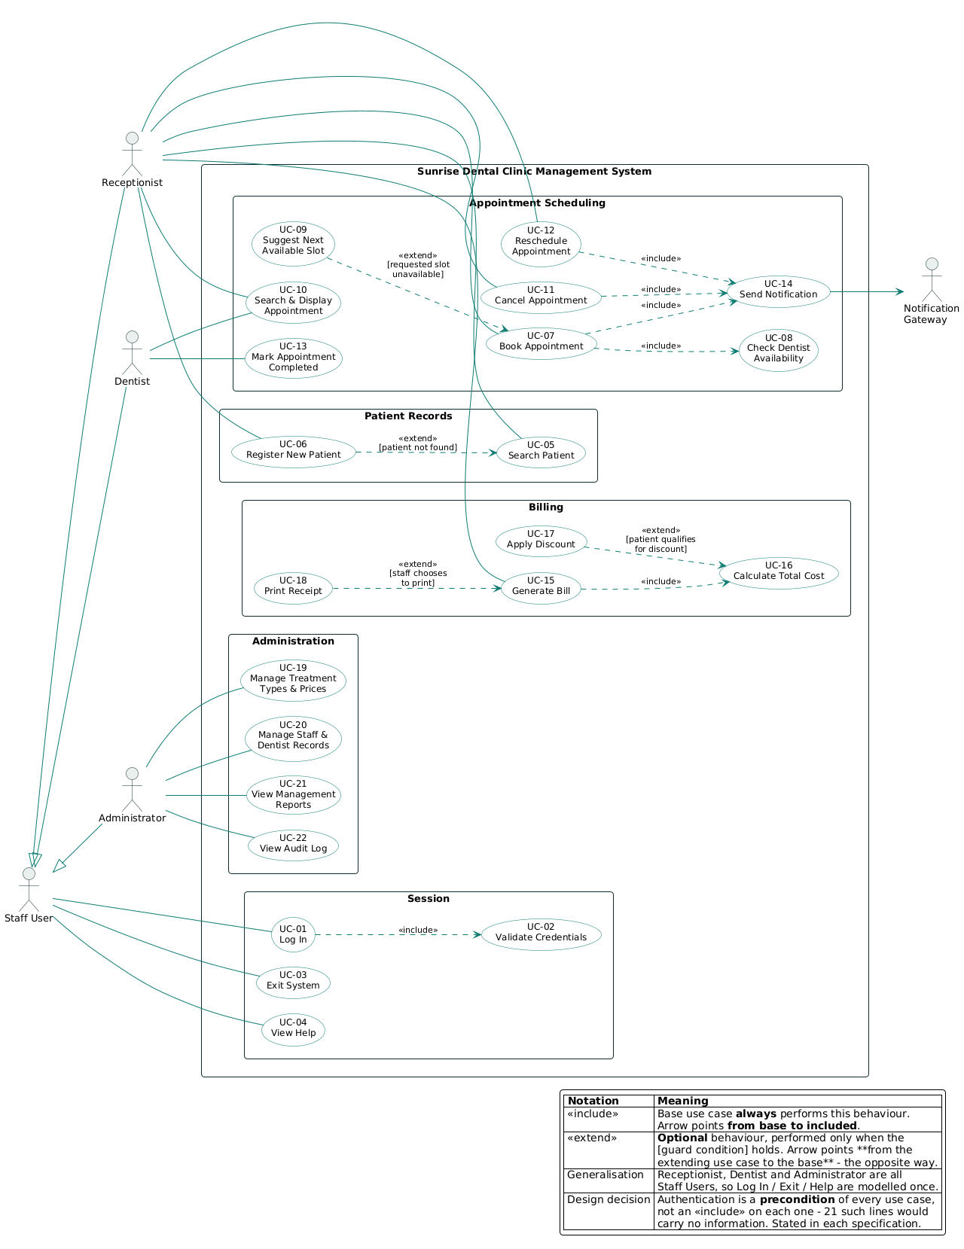
Figure 1: Use case diagram — 21 use cases, four actors, actor generalisation, five <<include>> and four <<extend>> relationships.
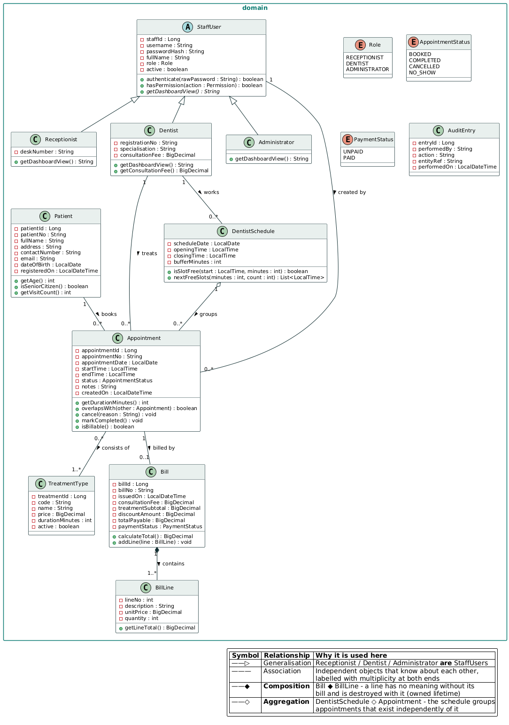
Figure 2: Domain class diagram — the analysis model. Composition Bill ◆ BillLine, aggregation DentistSchedule ◇ Appointment, multiplicity on every association.
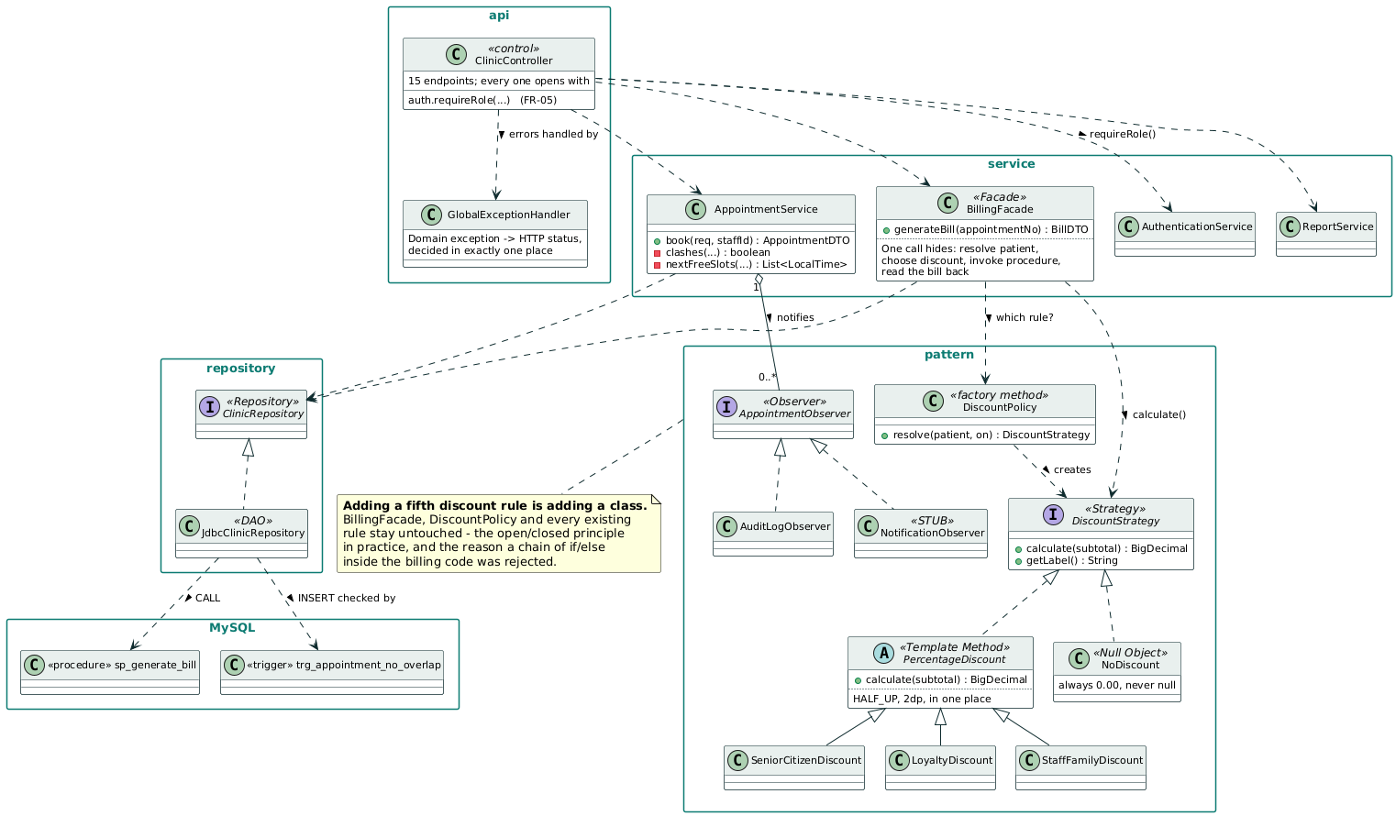
Figure 3: Design class diagram (business tier) — the collaborations that carry a pattern. Every class shown exists in the repository. The full three-tier diagram is at Appendix C.

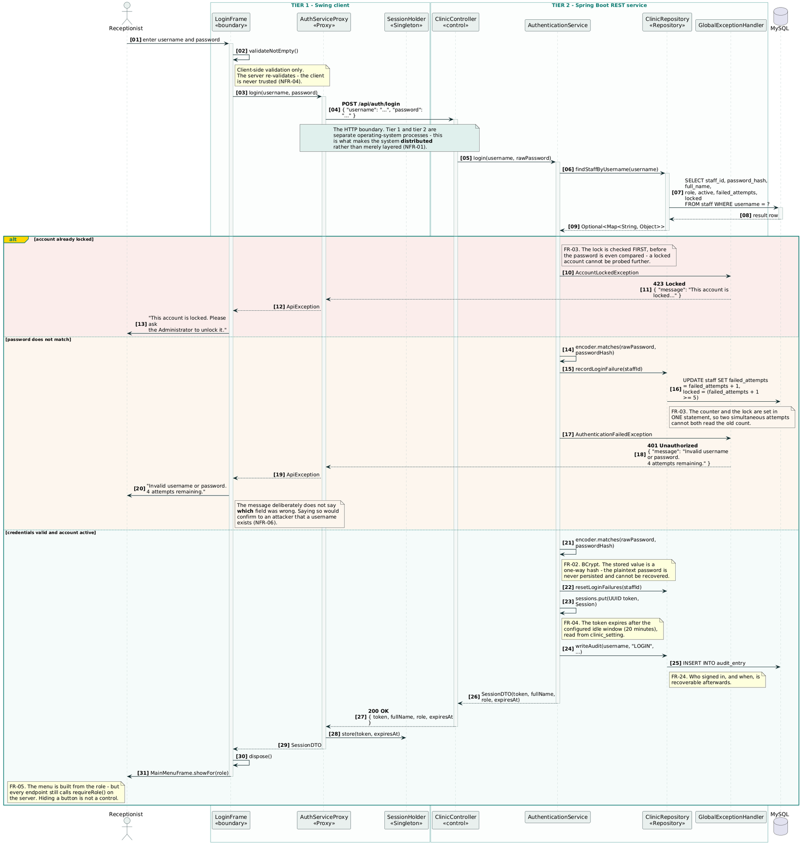
Figure 4: Sequence: UC-01 Log In. Shows the HTTP boundary, BCrypt comparison, lockout branch and audit write.

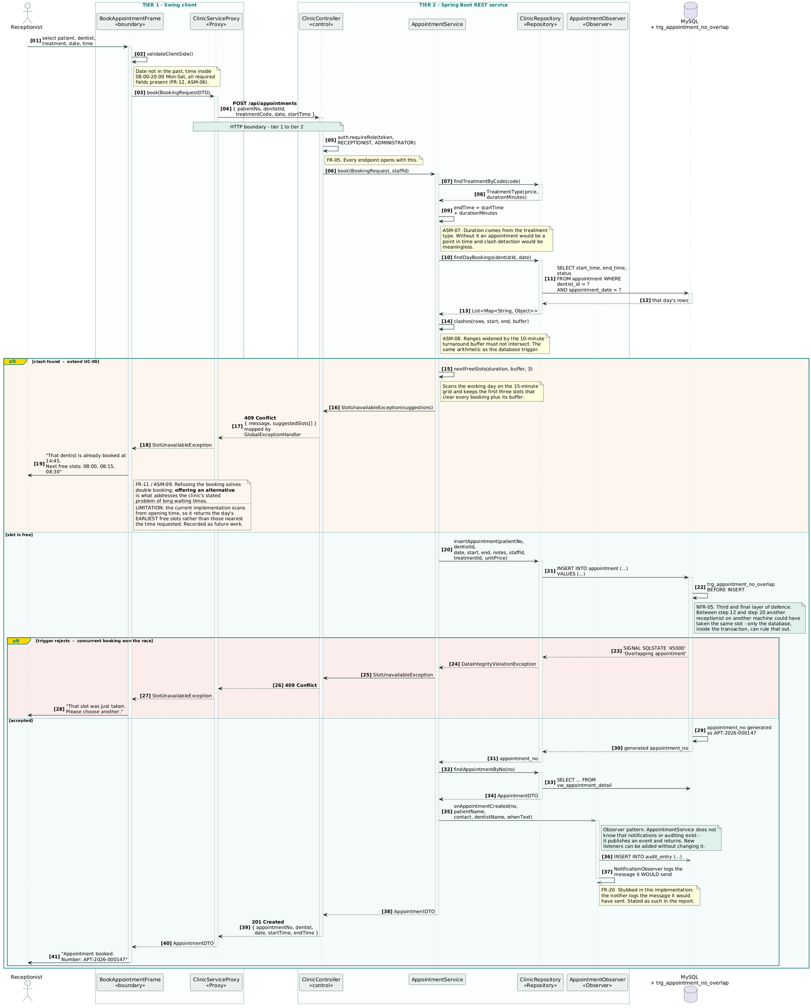
Figure 5: Sequence: UC-07 Book Appointment. Three layers of clash defence, ending with the database trigger inside the transaction.

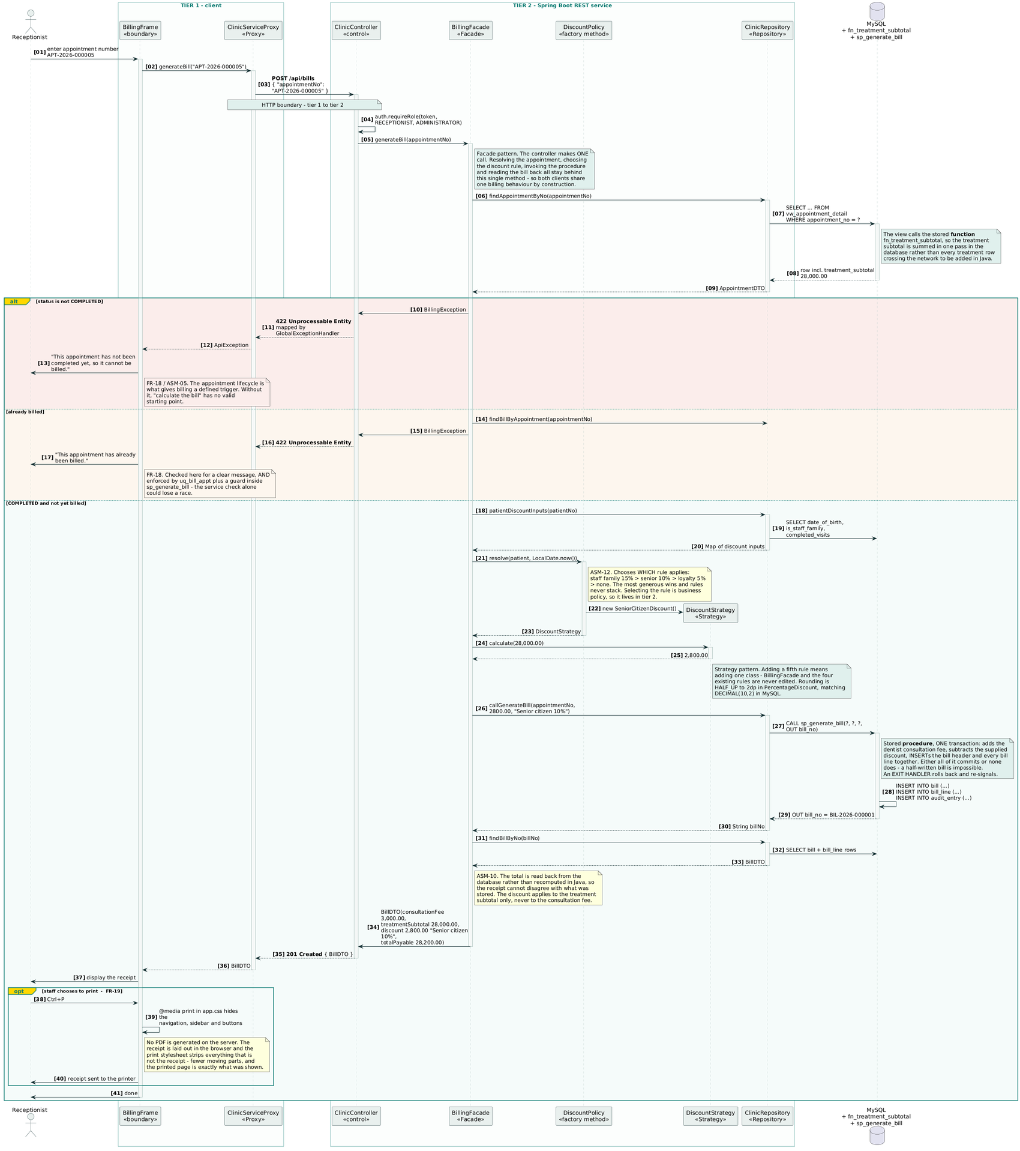
Figure 6: Sequence: UC-14 Generate Bill. Facade, discount Strategy selection, and the stored procedure writing header and lines in one transaction.

4. Three-tier distributed architecture
The system runs as three separate operating-system processes: a client, a Spring Boot REST service on port 8080, and MySQL 8 on port 3306. The distinction that matters is between layers and tiers. Packaging code into presentation, business and data layers inside one executable is a logical separation that a careless import can undo. Putting an HTTP boundary between them makes the separation physical: the client cannot reach a repository or a SQL statement even if a developer wanted it to, because those classes are not in its process (Fowler, 2002).

4.1 How the separation was proved rather than asserted
Any project can draw three boxes and claim its tiers are separated. Two pieces of evidence in this build make the claim testable.
Two independent clients share one API. A browser client served from the service's own static/ directory, and a Java Swing desktop client, both call the same fifteen endpoints. Neither holds a business rule. Had a rule leaked into the browser — the clash arithmetic, the discount percentages, the billing total — the Swing client could not exist without duplicating it, and the two would drift apart at the first change. The second client was built partly as a deliberate check on this.
The whole business tier runs with no database. The 69 service-layer tests in §6 execute AuthenticationService, AppointmentService and BillingFacade against a hand-written in-memory repository, with no MySQL, no JDBC driver and no Spring context. If a business rule had been written into a SQL string rather than into Java, those tests could not run at all. A green suite is therefore direct evidence of the boundary, not just of correctness.

4.2 Where each rule lives, and one deliberate duplication
Validation is duplicated intentionally. The client checks required fields and opening hours so the receptionist gets an immediate response; the service re-checks everything because the client is never trusted (NFR-04). The service is authoritative, and 18-forbidden.png demonstrates the point — a dentist's own session receives HTTP 403 from a report endpoint even though the tab was never displayed. Hiding a control is not a control.
The clash rule is duplicated more contentiously. AppointmentService checks for a clash and trg_appointment_no_overlap enforces it inside the transaction. The duplication was accepted after weighing two objections. Against it: the rule now exists in two languages and could diverge, and business logic in the data tier is widely discouraged because it is harder to test and version. For it: between the service's check and its INSERT, another receptionist on another machine can commit the same slot, and no amount of application code can close that window — only a constraint inside the transaction can (NFR-05). The compromise was to make the divergence risk visible rather than theoretical: the same arithmetic is asserted in Java by AppointmentOverlapTest and against a real MySQL server by the CI pipeline on every push, so if the two ever disagree, the build fails.

4.3 What the architecture costs
Every operation now pays a network round trip, the system cannot run offline, and deployment means three components rather than one. Sessions are held in a ConcurrentHashMap, so they are lost on restart and would not survive running a second instance — a limitation §8 returns to. For a single clinic these costs are acceptable; Fowler's (2002) advice not to distribute objects unless the distribution is genuinely needed is the reason the boundary is one coarse hop per user action rather than a chatty remote interface.
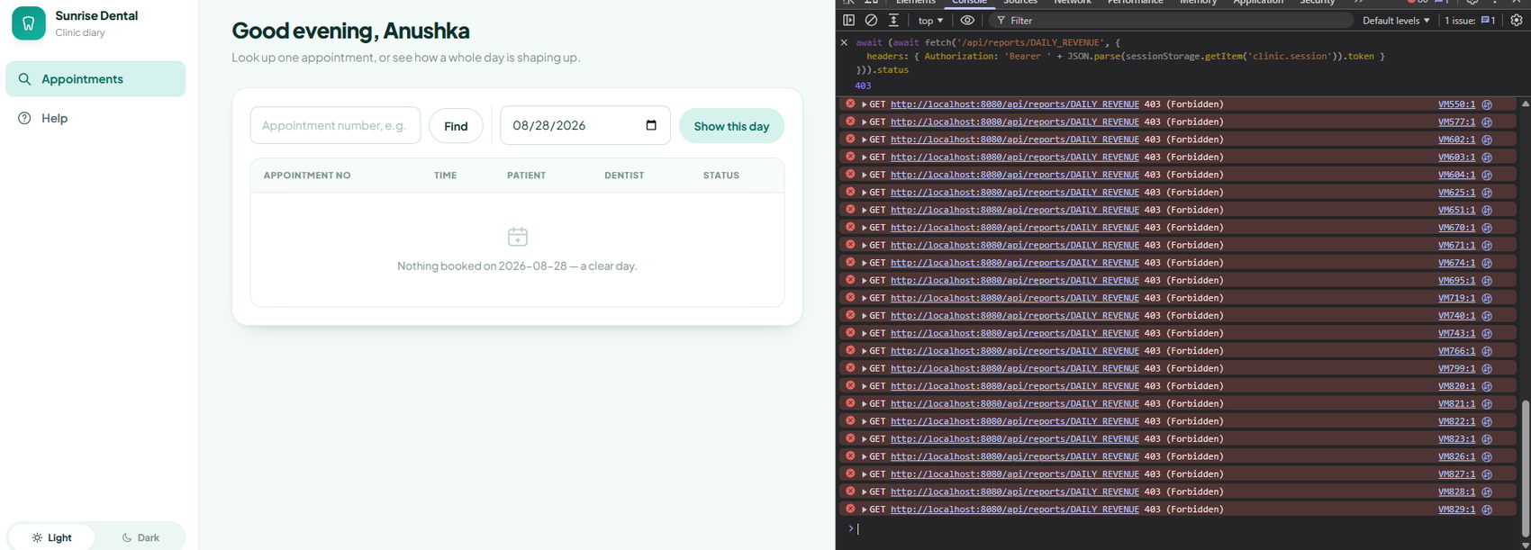
Figure 7: Server-side authorisation. A dentist’s own session receives HTTP 403 from a report endpoint, proving the control is enforced in the business tier and not by hiding the tab.

5. Design patterns applied and evaluated
Patterns were selected because a specific force in this system called for one, not to satisfy a checklist. Gamma et al. (1994) warn in their own introduction that applying a pattern where the problem does not exist adds indirection without benefit, and the last part of this section records two patterns considered and deliberately rejected on exactly that ground.

5.1 Strategy and Null Object — the discount rules (behavioural)
The clinic applies four discount categories: none, senior citizen 10%, returning patient 5%, and staff and family 15% (ASM-12). Each is encapsulated behind a DiscountStrategy interface with a single calculate method, and DiscountPolicy.resolve() selects the one that applies.
The alternative rejected was the obvious one: a chain of if/else if inside BillingFacade. It is shorter and needs no interface. It was rejected because the discount rules vary independently of how a bill is assembled, and under the if/else design every new rule means editing a method that is already tested and working — placing the rules that currently pass at risk each time one is added. With Strategy, adding a fifth rule is adding a class; the facade, the policy and the four existing rules are untouched. This is the open/closed principle in a form that can be demonstrated rather than asserted, and the eighteen tests in DiscountStrategyTest prove each rule in isolation, which an if/else chain would not permit.
Null Object completes it. The "no discount applies" case is itself a strategy returning 0.00, rather than resolve() returning null. Fowler (2002) describes this as Special Case: the absent value is represented by an object that behaves correctly, so no caller has to test for it. BillingFacade therefore contains no null check, and no future caller can forget one.
What it cost. Six classes where a dozen lines would have worked, and a reader must follow one more indirection to see the arithmetic. For four rules in a clinic system that is a fair exchange; for a single fixed rule it would be over-engineering, and the pattern would not have been used.
An abstract PercentageDiscount sits between the interface and the three percentage rules, applying BigDecimal rounding HALF_UP to two decimal places in one place. This is Template Method: the invariant part of the algorithm — multiply, round, match DECIMAL(10,2) in MySQL — is fixed in the superclass and only the rate and label vary. Without it, three subclasses would each round independently and could silently drift apart, producing bills that fail to reconcile with the stored totals by a cent.

5.2 Observer — appointment events (behavioural)
When an appointment is booked, two things must happen besides the booking: the patient should be notified, and the event must reach the audit trail (FR-20, FR-24). AppointmentService publishes to a list of AppointmentObserver implementations injected by Spring and knows nothing about either.
The alternative rejected was calling the notifier and the audit writer directly from book(). That couples the clinic's most important business method to two concerns that are not booking, and each new listener would edit it again. Under Observer, a third listener is a new @Component; book() does not change. The tests demonstrate the decoupling directly: AppointmentService is constructed with a RecordingObserver in one test and with an empty list in another, and booking succeeds in both.
What it cost. The flow is harder to trace in a debugger, because nothing in book() names who will be called. That is the standard trade-off of indirection, and it is real.
An honesty note. NotificationObserver logs the message it would send. No SMS or email is dispatched. The pattern is fully implemented and the integration is not, and the report says so rather than implying otherwise.

5.3 Facade — billing (structural)
Generating a bill means resolving the appointment, checking it is completed and not already billed, building a Patient from its discount inputs, selecting a strategy, invoking a stored procedure, and reading the bill back. BillingFacade.generateBill(appointmentNo) is the only method the controller calls.
The alternative rejected was letting the controller orchestrate those steps. It would work, but the sequence would then be duplicated in the browser client and the Swing client — and the moment a rule changed, one of them would be missed. Because the facade holds it, both clients share one billing behaviour by construction.

5.4 Proxy, Singleton, Repository and Adapter
Proxy (structural) appears in both clients. ClinicServiceProxy and the browser's request() expose the service as though it were local, hiding the HTTP call, the Authorization header and the mapping of status codes to meaning, so client code reads as method calls.
Singleton (creational) holds the session in each client — SessionHolder in Swing, one module-level Session object in JavaScript. Singleton is justifiably criticised as global state that complicates testing (Martin, 2017), and that criticism applies here. It was accepted only because the scope is a single client process holding a single signed-in user, and the alternative — threading the token through every constructor — would obscure the design for no practical gain. It is not used anywhere in the business tier.
Repository and DAO separate the service layer from SQL. The measurable benefit is in §6: the whole service layer runs in tests against an in-memory implementation with no MySQL, no JDBC driver and no Spring context. One interface was used rather than five, which keeps the wiring visible at twelve tables; Fowler (2002) would split it per aggregate as the system grew.
Adapter / DTO (structural). The Dtos records are the API contract and deliberately do not mirror the tables — no client ever learns a primary key or a column name, so the schema can change without breaking tier 1.

5.5 Patterns considered and rejected
Two are worth recording. Factory Method with Template Method for reports was in the original design: a ReportFactory producing AbstractReport subclasses. The implemented system instead maps a fixed ReportType enum to a view name. This was chosen because four read-only queries do not justify four classes of hierarchy, and because the enum makes SQL injection structurally impossible — a caller cannot supply a view name that is not already a constant. The pattern would have added machinery and removed a security property.
An ORM (JPA/Hibernate) was rejected for the data tier. The clinic's rules live partly in a trigger and a stored procedure; an ORM's caching and generated SQL work against database-side logic. Spring JDBC keeps the interaction explicit, at the cost of hand-written row mapping.

6. Testing
The suite contains 99 automated tests, all passing, run by Maven and re-run by GitHub Actions on every push. The full test plan, derived test data and traceability matrix are in docs/test-plan.md; this section explains the decisions behind them.

6.1 Testing at the level that can prove the thing
Each tier is tested by the technique that can prove it, and nothing is proved twice. Pure rules are tested with no collaborators; the business tier with the repository replaced by a test double; the rules living in MySQL against a real MySQL 8 server, because the point of a trigger is that it holds inside the transaction, which no Java test can demonstrate; the presentation tier manually, with recorded evidence.

6.2 Test-driven development
Two features were written test-first, and the red and green steps are separate commits so the sequence is visible in the Git history rather than merely claimed: bb1ac3d → 94d7a0b for the clash rule, and ffa86d5 → 8b73b14 for the discount strategies. Checking out a red commit and running mvn test reproduces the failure; the green commit that follows makes the same tests pass without altering them.
TDD changed the design, which is its actual value rather than the tests it leaves behind (Beck, 2003). Writing AppointmentOverlapTest first forced the clash rule out of the service and onto Appointment.overlapsWith(), where it could be exercised without a database. Writing DiscountStrategyTest first made the four rules separate classes, because testing a branch of an if/else chain in isolation is not possible.

6.3 Deriving the test data
Test data was derived from the specification by two standard techniques rather than invented (Myers et al., 2011).
Equivalence partitioning divides each input into classes the system should treat identically and takes one value from each; testing 09:00 and 09:15 proves nothing new, because they fall in the same class. The partitions for the booking request and for credentials are tabulated in the test plan.
Boundary value analysis then tested each edge at the value itself and at the adjacent value on each side, because every failure the clinic reported happens at an edge. Opening at 08:00 is accepted and 07:45 refused; a thirty-minute treatment may start at 19:30 but not 19:45; a patient aged 65 receives the senior discount and one aged 64 does not; a fifth visit earns loyalty and a fourth does not. Against an existing 10:00–11:30 booking with a ten-minute buffer, 09:30 is refused and the adjacent slot 09:15 is accepted.

6.4 A hand-written test double rather than a mocking framework
spring-boot-starter-test supplies Mockito, so mocks were available. InMemoryClinicRepository was written by hand instead.
A mock verifies that a method was called; the double holds state, so a test asserts on the consequence — the appointment now exists, the status really changed, the audit trail records it. Fowler (2007) frames this as behaviour versus state verification: the former couples a test to how the code is written, so refactoring breaks tests that should not care; the latter couples only to what the code achieves. Meszaros (2007) adds that a readable fake documents the contract, which fifteen when(...).thenReturn(...) lines do not.
The double deliberately does not re-implement the overlap trigger or sp_generate_bill. Re-implementing them in Java would only test the copy. Those rules are proved against a real server instead.

6.5 What the testing actually found
Six defects are recorded in the test plan. Two are worth naming here because they were found by testing rather than by review.
A boundary case was originally written at 09:35, which is not on the fifteen-minute grid, so it failed validation before ever reaching the clash rule — the test passed while testing nothing it claimed to. It now uses 09:30 and 09:15, the adjacent legal slots.
More significantly, tokenExpires set the session window to zero minutes, stamping the expiry at exactly "now". Whether the subsequent check saw that as past depended on the platform clock's resolution: it passed consistently on Linux and in CI, and failed intermittently on Windows. The fix sets a window that has already elapsed, removing the race. A Thread.sleep was rejected because it would hide the race behind a delay and slow every future run. A test whose result depends on clock granularity is worse than no test, because it teaches a team to ignore red builds.

6.6 Coverage, read honestly
Line coverage is 47.5% overall and branch coverage 73.8%. The headline figure is the least interesting number available, because coverage measures what was executed, not what was proved. Two things matter more: branch coverage where the decisions are — service at 91.3%, pattern at 94.4% — and where the uncovered code sits. It sits in repository (5%) and api (0%), which is correct: one is SQL, proved against real MySQL instead; the other delegates rather than decides, so covering it would test Spring's request mapping. Raising the headline honestly would mean @WebMvcTest slice tests, recorded in §8 as future work rather than added as padding.
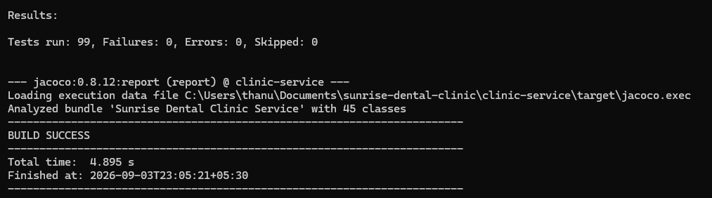
Figure 8: The full suite: 99 tests run, 0 failures, 0 errors.
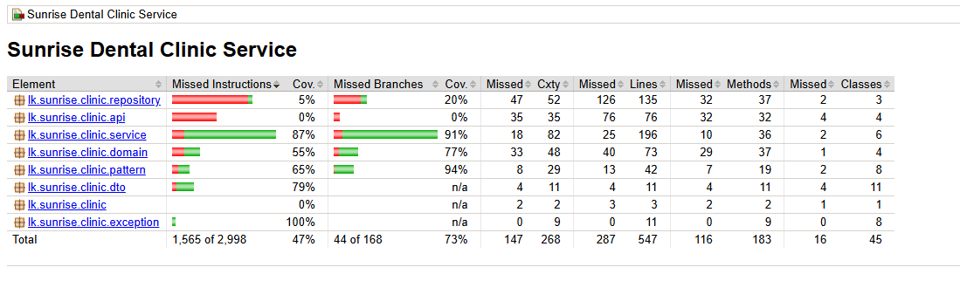
Figure 9: JaCoCo coverage by package. The first Cov. column is instruction coverage; the line and branch figures quoted in §6.6 are taken from jacoco.csv.

7. Version control, continuous integration and deployment
The repository is at github.com/Thanujaya448/sunrise-dental-clinic.

7.1 Branching and history
Work was done on short-lived feature/ branches, each merged into main through a pull request rather than committed directly. The history is written to be readable: commit messages state what changed and why, and the two test-driven cycles appear as separate red and green commits so the sequence can be verified rather than taken on trust (§6.2).

7.2 Continuous integration
.github/workflows/ci.yml runs on every push and every pull request. It has three jobs, one per tier, and a failure in any of them blocks the merge.
`unit-tests` builds on JDK 17, runs the 99 tests with JaCoCo, and uploads the JUnit reports, the coverage report and the packaged jar as artefacts. A per-package coverage table is written to the run summary, so a reviewer sees the figures without downloading anything.
`database-rules` is the job worth examining. GitHub starts a real MySQL 8 container, builds the schema from the five SQL scripts, runs the fourteen-row health check and fails if any row reads FAIL. It then asserts the business rules directly: a clashing appointment must be rejected, a booking inside the ten-minute buffer must be rejected, a legal booking must be accepted, sp_generate_bill must produce a total of 28,200.00, and a second bill for the same appointment must be refused. Two of those steps pass only when MySQL returns an error — the shell logic inverts the exit status, so a silent acceptance fails the build.
This is the single strongest piece of evidence in the submission. A machine that had never seen the database built it from scratch and confirmed that the trigger enforces the clinic's core rule. It also proves the scripts are complete and run in order, which no local test can, because a local database accumulates state.
`desktop-client` compiles and packages the Swing client, so the second client cannot silently break against the shared API contract.
The pipeline earned its place immediately. The flaky session-expiry test described in §6.5 was green on Linux and in CI and red on Windows; running the same commit in more than one environment is what exposed it (Humble and Farley, 2010).

7.3 Deployment
mvn verify produces an executable jar containing an embedded Tomcat, released on GitHub under tag v1.0. It runs with:
java -jar clinic-service-0.1.0-SNAPSHOT.jar --spring.datasource.password=...

The database password is supplied at runtime rather than committed. The repository's application.properties carries a placeholder, and the CI job uses a throwaway credential for its disposable container. A committed production password cannot be un-committed from a public history.
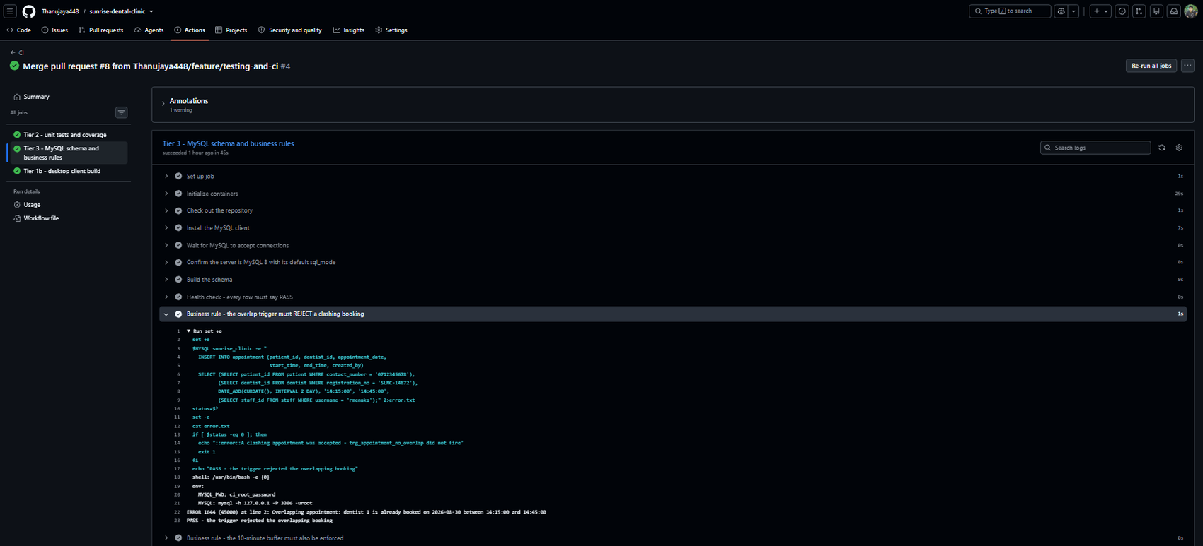
Figure 10: The database-rules CI job. A machine that had never seen the database built the schema from scratch and confirmed trg_appointment_no_overlap rejected a clashing booking. Note that the MySQL error is the pass condition.

8. Critical evaluation, limitations and future work
All four failures the clinic described are addressed: double bookings are prevented at three points, the last inside the database transaction; patient records persist and are referenced rather than copied; a refused booking offers alternatives; and the bill total is computed once, in one transaction, and read back rather than recalculated. What follows is what the system does not do.
A promise the system cannot keep. After five failed sign-ins an account locks and the message says to ask the Administrator to unlock it. There is no unlock function — no endpoint, no screen. resetLoginFailures clears the counter on a successful sign-in but never clears the lock, so the only route back is a manual UPDATE. This was found while testing and is the most serious defect remaining: a system that tells a user to do something impossible is worse than one that simply refuses. It is a repository method, a role-guarded endpoint and a button.
Sessions do not survive anything. Held in a ConcurrentHashMap, they are lost on restart and a second instance would not recognise the first's tokens. Acceptable for one clinic on one server; Redis or a signed JWT if it were not.
Suggested slots are the wrong ones. nextFreeSlots scans from opening time and returns the day's earliest free slots, so a receptionist asking for 14:45 is offered 08:00. It satisfies FR-11 literally and misses its intent, which was to reduce waiting. Ranking candidates by distance from the requested time would fix it.
Two features are stubs, and are labelled as such. NotificationObserver logs the message it would send; nothing is dispatched. No tax is modelled.
Testing has a shaped gap. Controllers sit at 0% coverage and the repository at 5%; defensible, but @WebMvcTest slice tests would close it honestly. The sub-two-second search requirement was verified against seeded data only, not at 10,000 records.
What I would do differently. The design class diagram was drawn as intent and then left to drift while the code changed, and it named five classes that were never built. Regenerating diagrams from the implementation at each merge, rather than once at the end, would have caught that in a pull request instead of a week before submission.

References
(Harvard. Not counted towards the 4,000 words.)
Beck, K. (2003) Test-Driven Development: By Example. Boston, MA: Addison-Wesley.
Codd, E.F. (1970) 'A relational model of data for large shared data banks', Communications of the ACM, 13(6), pp. 377–387.
Date, C.J. (2003) An Introduction to Database Systems. 8th edn. Boston, MA: Addison-Wesley.
Fowler, M. (2002) Patterns of Enterprise Application Architecture. Boston, MA: Addison-Wesley.
Fowler, M. (2003) UML Distilled: A Brief Guide to the Standard Object Modeling Language. 3rd edn. Boston, MA: Addison-Wesley.
Fowler, M. (2007) Mocks Aren't Stubs. Available at: https://martinfowler.com/articles/mocksArentStubs.html (Accessed: 3 September 2026).
Gamma, E., Helm, R., Johnson, R. and Vlissides, J. (1994) Design Patterns: Elements of Reusable Object-Oriented Software. Reading, MA: Addison-Wesley.
Humble, J. and Farley, D. (2010) Continuous Delivery: Reliable Software Releases through Build, Test, and Deployment Automation. Boston, MA: Addison-Wesley.
Larman, C. (2004) Applying UML and Patterns: An Introduction to Object-Oriented Analysis and Design and Iterative Development. 3rd edn. Upper Saddle River, NJ: Prentice Hall.
Martin, R.C. (2017) Clean Architecture: A Craftsman's Guide to Software Structure and Design. Boston, MA: Prentice Hall.
Meszaros, G. (2007) xUnit Test Patterns: Refactoring Test Code. Upper Saddle River, NJ: Addison-Wesley.
Myers, G.J., Sandler, C. and Badgett, T. (2011) The Art of Software Testing. 3rd edn. Hoboken, NJ: Wiley.
Oracle (2024) MySQL 8.0 Reference Manual. Available at: https://dev.mysql.com/doc/refman/8.0/en/ (Accessed: 3 September 2026).
VMware (2024) Spring Framework Reference Documentation. Available at: https://docs.spring.io/spring-framework/reference/ (Accessed: 3 September 2026).

Appendix A — Test plan and traceability matrix
The complete test plan, derived test data, traceability matrix, data-tier test cases and manual test cases are maintained as docs/test-plan.md in the repository and reproduced below.

A.1. Testing strategy
Testing follows the shape of the architecture. Each tier is proved by the technique that can actually prove it, and nothing is proved twice.
Level | What it covers | Technique | Where it lives
Unit — domain | Rules that are pure arithmetic or pure logic: the clash rule, the discount rules | JUnit 5, no collaborators at all | domain/AppointmentOverlapTest, pattern/DiscountStrategyTest
Unit — service | Tier 2 business logic: validation, scheduling, authorisation, discount selection | JUnit 5 with a hand-written test double replacing the repository | service/*Test
Integration — data tier | Rules enforced by the database: the overlap trigger, sp_generate_bill | SQL scripts run against a real MySQL 8 server | db/06_verify.sql, db/08_healthcheck.sql, and the database-rules job in CI
Manual — presentation | The browser and desktop clients end to end | Scripted manual test cases with recorded evidence | Section 7 of this document

A.1.1 Why a hand-written test double rather than Mockito
spring-boot-starter-test brings Mockito, so a mock was available. A hand-written InMemoryClinicRepository was chosen instead:
- A mock verifies that a method was called. The double holds state, so a test asserts on the consequence — the appointment now exists, the status really changed, the audit trail records it. Behaviour verification couples a test to how the service is written; state verification couples it only to what it achieves, so these tests survive refactoring.
- Fifteen when(...).thenReturn(...) lines do not document a contract. One readable class does.
- The double is itself the proof that the tiers are separated. The entire service layer runs in it with no MySQL, no JDBC driver and no Spring context. If a single business rule had leaked into a SQL string, these tests could not exist.

A.1.2 What the service tests deliberately do NOT do
The double does not re-implement the overlap trigger or sp_generate_bill. Those are data-tier rules; re-implementing them in Java would only test the copy. They are proved against a real MySQL 8 server instead — see section 6.
BillingFacadeTest therefore asserts that the facade selects the right Strategy and passes the right discount amount to the procedure. The arithmetic that turns that amount into a bill total is asserted in SQL.

A.1.3 Test-driven development
Two features were written test-first, and the red and green steps are separate commits so the sequence is visible in the Git history rather than merely claimed:
Cycle | Feature | Red commit — test written first, fails | Green commit — implementation, test passes
1 | Appointment.overlapsWith() — the clash rule (FR-10, ASM-08) | bb1ac3d test(domain): failing tests for appointment clash rule | 94d7a0b feat(domain): implement clash rule with turnaround buffer — 12 tests pass
2 | DiscountStrategy family — the discount rules (FR-17, ASM-12) | ffa86d5 test(pattern): failing tests for discount strategies | 8b73b14 feat(pattern): implement discount strategies with BigDecimal rounding — 18 tests pass

Checking out the red commit and running mvn test reproduces the failure; the green commit that follows it makes the same tests pass without altering them. That sequence in the history is the evidence — the tests were not written after the code to fit it.

A.2. How test data was derived
Test data is derived from the specification, not invented. Two techniques were applied to every rule that takes a value.

A.2.1 Equivalence partitioning
Each input is divided into classes that the system should treat identically; one value is taken from each class. Testing 09:00 and 09:15 proves nothing new, because they are in the same class.
Input | Partitions | Representative values
Booking request completeness | complete · missing patient · missing dentist · missing treatment · missing date/time | one case each
Patient number | exists · does not exist | PAT-2026-000001 · PAT-2026-999999
Treatment code | active · unknown | SCA · ZZZ
Appointment day | open day · closed day (Sunday) · past date | next Monday · next Sunday · yesterday
Requested slot | free · overlapping · inside buffer · adjacent, clear | see 2.2
Appointment status when billing | COMPLETED · BOOKED · CANCELLED · already billed | one case each
Patient discount category | none · senior · loyalty · staff family · several at once | age 40 / 65 / 4 visits / staff flag / all three
Credentials | correct · wrong password · unknown user · locked · deactivated · blank | one case each

A.2.2 Boundary value analysis
Every defect the clinic reported happens at an edge, never in the middle of a range. Each boundary is tested at the value itself and at the adjacent value on each side.
Rule | Boundary | Just below | On the boundary | Just above
Opening time 08:00 | 08:00 | 07:45 → refused | 08:00 → accepted | 08:15 → accepted
Closing time 20:00 (30-min treatment) | 19:30 start | 19:15 → accepted | 19:30 → accepted (ends 20:00) | 19:45 → refused
Slot grain 15 min | multiples of 15 | 08:05, 08:10, 08:20 → refused | 08:00, 08:15, 08:30, 08:45 → accepted | —
Turnaround buffer 10 min, existing 10:00–11:30 | 09:15–09:45 → accepted (widens to 09:55) | — | 09:30–10:00 → refused (widens to 10:10) | 11:45 → accepted
Senior citizen age 65 | 64 → no discount | 65 → 10% | 66 → 10%
Loyalty, 5th visit | 3 previous → none | 4 previous → 5% | 5 previous → 5%
Login attempts, max 5 | 1st failure → "4 attempts remaining" | — | —
Session, 20 min idle | live token → accepted | 0-minute window → expired | —

A.2.3 Rounding
Money is BigDecimal with RoundingMode.HALF_UP to two decimal places, matching DECIMAL(10,2) in MySQL, and is asserted at a value that actually rounds — a subtotal chosen so that the percentage does not divide exactly. double is never used for money anywhere in the system.

A.3. Automated test plan — tier 2 and the domain
Every row below is one automated test. Run them with:
cd clinic-service
mvn -B verify

Measured result: 99 tests run, 0 failures, 0 errors, JaCoCo report produced and the service JAR packaged. Screenshot the Maven output and the JaCoCo summary page into docs/evidence/.

A.3.1 Authentication — AuthenticationServiceTest (20 tests)
Test ID | Requirement | Test method | Input / condition | Expected outcome
UT-AUTH-01 | FR-01 | SignIn.signsInSuccessfully | reception1 + correct password | Token issued; role RECEPTIONIST; expiry in the future
UT-AUTH-02 | FR-02 | SignIn.storedValueIsAHashNotThePassword | Stored credential inspected | Value starts $2, is 60 chars, never contains the password
UT-AUTH-03 | FR-24 | SignIn.writesAuditEntry | Successful sign-in | A LOGIN row is written to the audit trail
UT-AUTH-04 | FR-03 | SignIn.resetsFailureCounter | Successful sign-in after failures | Failure counter reset for that staff ID
UT-AUTH-05 | NFR-04 | SignIn.refusesBlankInput | "", " ", null | ValidationException before the database is touched
UT-AUTH-06 | FR-03 | Refusal.wrongPasswordIsCounted | Correct user, wrong password | AuthenticationFailedException; failure recorded once
UT-AUTH-07 | NFR-06 | Refusal.doesNotRevealWhichFieldWasWrong | Unknown username | Message is exactly the generic "Invalid username or password" — no user enumeration
UT-AUTH-08 | FR-03 | Refusal.countsDownRemainingAttempts | 1st failure of 5 allowed | Message contains "4 attempts remaining"
UT-AUTH-09 | FR-03 | Refusal.lockedAccountIsRefusedDistinctly | Locked account, correct password | AccountLockedException, message names the lock
UT-AUTH-10 | FR-05 | Refusal.deactivatedAccountIsRefused | Inactive account | Generic authentication failure
UT-AUTH-11 | FR-04 | Sessions.tokenResolvesToSession | Fresh token | Resolves to the correct username and staff ID
UT-AUTH-12 | FR-04 | Sessions.rejectsMissingAndUnknownTokens | null, blank, forged UUID | SessionExpiredException in all three cases
UT-AUTH-13 | FR-04 | Sessions.tokenExpires | SESSION_MINUTES = -1, i.e. a window that has already elapsed | SessionExpiredException, message says "expired"
UT-AUTH-14 | FR-04 | Sessions.logoutInvalidatesToken | Sign out, then reuse the token | Refused; LOGOUT written to the audit trail
UT-AUTH-15 | FR-26 | Sessions.logoutWithoutTokenDoesNotThrow | logout(null) | Returns quietly — a safe exit never crashes
UT-AUTH-16 | FR-04 | Sessions.tokensAreUnique | Two different sign-ins | Two different tokens
UT-AUTH-17 | FR-05 | RoleChecks.allowsPermittedRole | Receptionist, receptionist-or-admin action | Allowed
UT-AUTH-18 | FR-05 | RoleChecks.refusesWrongRole | Dentist, receptionist-only action | ForbiddenException
UT-AUTH-19 | FR-05 | RoleChecks.refusesWithoutAnyToken | No token; forged token | SessionExpiredException — hiding a button in the client is not a control
UT-AUTH-20 | FR-05 | RoleChecks.allowsAdministrator | Administrator, admin-only action | Allowed, role returned

A.3.2 Appointments — AppointmentServiceTest (34 tests)
Test ID | Requirement | Test method | Input / condition | Expected outcome
UT-APPT-01 | FR-09, FR-08 | HappyPath.booksSuccessfully | Valid request, free slot | Appointment stored, status BOOKED, number APT-YYYY-NNNNNN
UT-APPT-02 | FR-09, ASM-07 | HappyPath.derivesEndTimeFromTreatmentDuration | 30-min scaling; 90-min root canal | Ends 08:30 and 15:30 respectively — duration comes from the treatment, not the user
UT-APPT-03 | FR-20 | HappyPath.publishesToObservers | Valid booking | Observer notified exactly once, with the patient's name
UT-APPT-04 | FR-20 | HappyPath.worksWithNoObservers | No observers registered | Booking still succeeds — listeners are optional
UT-APPT-05 | NFR-04 | Validation.rejectsMissingPatient | Blank patient number | ValidationException
UT-APPT-06 | NFR-04 | Validation.rejectsMissingDentist | null dentist | ValidationException
UT-APPT-07 | NFR-04 | Validation.rejectsMissingTreatment | null treatment code | ValidationException
UT-APPT-08 | NFR-04 | Validation.rejectsMissingDateOrTime | Missing date; missing time | ValidationException in both cases
UT-APPT-09 | FR-07 | Validation.rejectsUnknownPatient | PAT-2026-999999 | NotFoundException — a 404, not a 400
UT-APPT-10 | FR-21 | Validation.rejectsUnknownTreatmentCode | Code ZZZ | NotFoundException
UT-APPT-11 | FR-12 | OpeningHours.openingBoundary | 08:00; 07:45 | Accepted; refused
UT-APPT-12 | FR-12 | OpeningHours.closingBoundary | 19:30; 19:45 (30-min treatment) | Accepted; refused
UT-APPT-13 | FR-12, ASM-06 | OpeningHours.rejectsClosedDay | Next Sunday | ValidationException naming the closed day
UT-APPT-14 | FR-12 | OpeningHours.rejectsPastDate | Yesterday | ValidationException
UT-APPT-15…21 | FR-12, ASM-06 | OpeningHours.enforcesSlotGranularity (7 parameterised cases) | 08:00 / 08:15 / 08:30 / 08:45 accepted; 08:05 / 08:10 / 08:20 refused | Only multiples of 15 minutes are accepted
UT-APPT-22 | FR-10 | ClashDetection.refusesOverlap | 10:30 against an existing 10:00–11:30 | SlotUnavailableException
UT-APPT-23 | FR-11, ASM-09 | ClashDetection.offersAlternatives | Same clash | Exception carries at most 3 free slots, none inside the busy period plus buffer
UT-APPT-24 | FR-10, ASM-08 | ClashDetection.bufferBeforeExistingAppointment | 09:30 (widens to 10:10); 09:15 (widens to 09:55) | Refused; accepted
UT-APPT-25 | FR-10, ASM-08 | ClashDetection.bufferAfterExistingAppointment | 11:45 after an 11:30 end | Accepted — clears the 10-minute turnaround
UT-APPT-26 | FR-10 | ClashDetection.differentDentistDoesNotClash | Same time, Dr. Fernando | Accepted — the rule is per dentist
UT-APPT-27 | FR-10 | ClashDetection.differentDayDoesNotClash | Same time, next day | Accepted
UT-APPT-28 | NFR-05 | ClashDetection.secondIdenticalBookingIsRefused | Same slot booked twice in a row | Second attempt refused — the first booking occupies the slot
UT-APPT-29 | FR-15 | StatusTransitions.cancelsWithReason | Cancel a booked appointment with a reason | Status CANCELLED; observers notified
UT-APPT-30 | FR-15, FR-24 | StatusTransitions.refusesCancellationWithoutReason | Blank reason | ValidationException; appointment left untouched
UT-APPT-31 | FR-15 | StatusTransitions.refusesDoubleCancellation | Cancel twice | Second attempt refused
UT-APPT-32 | FR-16, ASM-05 | StatusTransitions.refusesCompletingACancelledAppointment | Complete a cancelled appointment | ValidationException
UT-APPT-33 | FR-16 | StatusTransitions.completesBookedAppointment | Complete a booked appointment | Status COMPLETED — the precondition for billing
UT-APPT-34 | FR-13 | StatusTransitions.unknownAppointmentNumberIsNotFound | APT-2026-999999 | NotFoundException

A.3.3 Billing — BillingFacadeTest (15 tests)
Test ID | Requirement | Test method | Input / condition | Expected outcome
UT-BILL-01 | FR-17 | Preconditions.unknownAppointment | Unknown appointment number | NotFoundException
UT-BILL-02 | FR-18, ASM-05 | Preconditions.refusesBookedAppointment | Status BOOKED | BillingException naming the precondition
UT-BILL-03 | FR-18, ASM-05 | Preconditions.refusesCancelledAppointment | Status CANCELLED | BillingException
UT-BILL-04 | FR-18 | Preconditions.refusesSecondBill | Bill the same appointment twice | Second attempt refused, message says "already"
UT-BILL-05 | ASM-12 | DiscountSelection.ordinaryPatientGetsNoDiscount | Age 40, no flags, 0 visits | Amount 0.00, label "No discount" — the Null Object, never null
UT-BILL-06 | ASM-12 | DiscountSelection.seniorGetsTenPercent | Age exactly 65, subtotal 10,000 | 1000.00, label contains "Senior"
UT-BILL-07 | ASM-12 | DiscountSelection.sixtyFourIsNotSenior | Age 64 | 0.00 — the boundary is exact
UT-BILL-08 | ASM-12 | DiscountSelection.fifthVisitEarnsLoyalty | 4 previous visits | 500.00, label "Returning patient 5%"
UT-BILL-09 | ASM-12 | DiscountSelection.fourthVisitEarnsNothing | 3 previous visits | 0.00
UT-BILL-10 | ASM-12 | DiscountSelection.staffFamilyGetsFifteenPercent | Staff family flag | 1500.00
UT-BILL-11 | ASM-12 | DiscountSelection.mostGenerousRuleWins | Senior and loyal and staff family | 1500.00 only — rules do not stack
UT-BILL-12 | FR-17, FR-19 | BillContents.returnsStoredBill | Bill a completed appointment | Bill read back from the data tier; number BIL-YYYY-NNNNNN; status UNPAID
UT-BILL-13 | FR-19 | BillContents.unknownBillNumber | Unknown bill number | NotFoundException
UT-BILL-14 | NFR-04 | DatabaseRuleSurfaced.translatesDataAccessException | Stored procedure signals SQLSTATE 45000 | The procedure's own business message reaches the user, not a stack trace
UT-BILL-15 | NFR-04 | DatabaseRuleSurfaced.handlesMessagelessFailure | Failure with no message | Falls back to "The bill could not be generated"

A.3.4 Domain rules — AppointmentOverlapTest (12 tests) and DiscountStrategyTest (18 tests)
Both were written test-first (section 1.3) and run with no collaborators at all — not even a test double.
Test ID | Requirement | Coverage
UT-DOM-01…04 | FR-10, ASM-08 | Overlapping ranges: identical times, contains, starts inside, ends inside
UT-DOM-05…08 | ASM-08 | Buffer: clears exactly, inside the buffer, clears before, zero buffer
UT-DOM-09…12 | FR-10 | Different key: other dentist, other day, cancelled frees the slot, later the same day
UT-PAT-01…07 | ASM-12 | Discount arithmetic: senior, loyalty, staff, none, rounding, zero subtotal, null subtotal
UT-PAT-08…13 | ASM-12 | Boundaries: age 64 / 65 / 66; 3 / 4 / 5 previous visits (parameterised)
UT-PAT-14…18 | ASM-12 | Precedence: staff beats senior, senior beats loyalty, all three, none, null patient

A.4. Traceability matrix
Every requirement in the register traces forward to a use case, a class and the tests that prove it. Blank test cells are requirements proved by manual test or by the data tier, not by JUnit — stated rather than hidden.
Req | Description | Use case | Class(es) under test | Tests
FR-01 | Staff log in | UC-01 | AuthenticationService | UT-AUTH-01
FR-02 | Passwords stored hashed | UC-01 | AuthenticationService (BCrypt) | UT-AUTH-02, DB-08
FR-03 | Lock out after 5 failures | UC-01 | AuthenticationService | UT-AUTH-04, 06, 08, 09
FR-04 | Session with idle timeout | UC-02 | AuthenticationService | UT-AUTH-11…16
FR-05 | Role-restricted functions | UC-03 | AuthenticationService, ClinicController | UT-AUTH-10, 17…20
FR-06 | Register a new patient | UC-05 | JdbcClinicRepository, patient table | DB-01, MAN-03
FR-07 | Look up an existing patient | UC-06 | AppointmentService | UT-APPT-09, MAN-04
FR-08 | Generated appointment number | UC-07 | trg_appointment_number | UT-APPT-01, DB-04
FR-09 | Book an appointment | UC-07 | AppointmentService | UT-APPT-01, 02
FR-10 | Reject a dentist overlap | UC-07 | Appointment, AppointmentService, trg_appointment_no_overlap | UT-DOM-01…12, UT-APPT-22, 24…27, DB-02
FR-11 | Suggest the next 3 free slots | UC-07 | AppointmentService.nextFreeSlots | UT-APPT-23
FR-12 | Reject out-of-hours and past dates | UC-07 | AppointmentService | UT-APPT-11…21
FR-13 | Search by appointment number | UC-10 | AppointmentService, vw_appointment_detail | UT-APPT-34, MAN-05
FR-14 | Display full appointment detail | UC-10 | vw_appointment_detail | MAN-05
FR-15 | Cancel / reschedule | UC-11 | AppointmentService, trg_appointment_overlap_upd | UT-APPT-29…31
FR-16 | Mark completed / no-show | UC-13 | AppointmentService | UT-APPT-32, 33
FR-17 | Calculate a bill | UC-14 | BillingFacade, sp_generate_bill | UT-BILL-01, 12, DB-05
FR-18 | Bill only completed appointments | UC-14 | BillingFacade, sp_generate_bill | UT-BILL-02…04, DB-06
FR-19 | Print a receipt | UC-15 | app.css @media print, BillingFrame | UT-BILL-12, 13, MAN-07
FR-20 | Appointment notifications | UC-08 | NotificationObserver (stub — logs what it would send) | UT-APPT-03, 04
FR-21 | Maintain treatments and prices | UC-16 | TreatmentTypeRepository, treatment_type | UT-APPT-10, MAN-08
FR-22 | Maintain staff and dentists | UC-17 | staff, dentist tables | DB-01, MAN-09
FR-23 | Management reports | UC-18 | ReportService, 5 views | DB-01, MAN-06
FR-24 | Audit log | UC-19 | AuditLogObserver, audit_entry | UT-AUTH-03, 14, UT-APPT-30
FR-25 | Help screen | UC-20 | Help panel / HelpFrame | MAN-10
FR-26 | Safe exit | UC-21 | AuthenticationService.logout | UT-AUTH-15, MAN-11
NFR-01 | Three physical tiers | — | Browser / Swing → Spring Boot :8080 → MySQL :3306 | The whole service suite runs with no database at all — see 1.1
NFR-02 | Patterns from all three families, evaluated | — | pattern/ package | UT-BILL-05…11, UT-APPT-03, 04, UT-PAT-01…18
NFR-03 | 3NF schema with referential integrity | — | 01_schema.sql | DB-01
NFR-04 | Client and server validation, server authoritative | — | AppointmentService, GlobalExceptionHandler | UT-APPT-05…08, UT-BILL-14, 15, UT-AUTH-05
NFR-05 | Concurrent bookings cannot both succeed | — | Service check and trg_appointment_no_overlap | UT-APPT-28, DB-02, DB-03
NFR-06 | Role-restricted patient data, no PII in logs | — | AuthenticationService, AuditLogObserver | UT-AUTH-07, 19
NFR-07 | Automated tests on every push | — | .github/workflows/ci.yml | The CI run for this commit
NFR-08 | Search under 2 s at 10,000 records | — | Indexes in 01_schema.sql | MAN-12
NFR-09 | Operable by non-technical staff | — | Browser UI | MAN-13

A.5. Coverage
JaCoCo runs on every build and every CI push.
cd clinic-service
mvn -B verify

Report: clinic-service/target/site/jacoco/index.html. In CI it is also uploaded as the jacoco-coverage-report artifact, and a per-package summary is printed to the workflow run's summary page.
How to read these figures honestly. Coverage measures what was executed, not what was proved. A single test that calls every method and asserts nothing scores 100%. So the headline 47.5% is the least interesting number on this page, and quoting it alone — in either direction — would misrepresent the suite.
Two things matter more:
- Branch coverage on the packages that hold decisions. A branch is an if, a boundary, a rule that can go either way. service is at 91.3% and pattern at 94.4% — nearly every decision the clinic's rules can make is exercised by a test.
- Where the uncovered lines are. They are concentrated in exactly the places that should be uncovered by unit tests.

Measured run, mvn -B verify. Note on which metric is quoted: the table below reports line coverage, taken from jacoco.csv. The first Cov. column on JaCoCo's own HTML page is instruction coverage, which is a slightly different number for the same code — pattern, for example, is 65% by instruction and 69% by line. Both are given here so the figures in this document and the figures in the screenshot can be reconciled.
Package | Line cov. | Instruction cov. | Branch cov. | Reading
lk.sunrise.clinic.service | 87.2% | 87% | 91.3% | The business logic. This is the figure that matters, and it is the highest in the project.
lk.sunrise.clinic.pattern | 69.0% | 65% | 94.4% | Every discount decision is covered. The uncovered lines are NotificationObserver and AuditLogObserver bodies — logging, not logic.
lk.sunrise.clinic.exception | 100% | 100% | n/a | Every domain exception is thrown by a test — no dead exception types.
lk.sunrise.clinic.domain | 45.2% | 55% | 77.3% | Appointment.overlapsWith() is fully covered; the shortfall is unused accessors on Patient and TreatmentType. Line coverage penalises getters; branch coverage shows the rule itself is proved.
lk.sunrise.clinic.dto | 63.6% | 79% | n/a | Java records — generated accessors.
lk.sunrise.clinic.repository | 6.7% | 5% | 20.0% | Deliberately low. This layer is SQL. Executing it in a unit test would prove only that JDBC works; it is proved instead against a real MySQL 8 server in section 6.
lk.sunrise.clinic.api | 0.0% | 0% | 0.0% | Deliberately zero. Controllers delegate and do not decide. Covering them would test Spring's request mapping, not the clinic's rules; they are proved by the manual end-to-end tests in section 7.
Overall | 47.5% | 47% | 73.8% | Dominated by the two layers that are intentionally untested here.

Stating the gap and defending it is worth more than raising the headline figure by adding tests that assert nothing. If the number needed to rise, the honest way would be @WebMvcTest slice tests over the controllers — noted in the report as future work rather than added as padding.

A.6. Data-tier tests
These prove the rules that live in MySQL. They cannot be proved in Java, because the point of them is that they hold inside the transaction.
Run locally:
mysql -u root -p < db/08_healthcheck.sql
mysql -u root -p --force < db/06_verify.sql

--force is required for 06_verify.sql: several checks are supposed to error, and that error is the pass condition. In CI the same assertions run as explicit shell steps in the database-rules job, which fails the build if a rejection does not happen.
Test ID | Requirement | What is done | Expected outcome
DB-01 | NFR-03, FR-06, FR-22, FR-23 | 08_healthcheck.sql | 14 rows, every one PASS: 12 tables, 5 views, 4 triggers, 2 routines, 9 foreign keys, seed data present
DB-02 | FR-10, NFR-05 | Insert 14:15–14:45 against an existing 14:00–14:30 | SQLSTATE 45000 — rejected by trg_appointment_no_overlap
DB-03 | ASM-08, NFR-05 | Insert 14:35–15:05 — no overlap, but inside the 10-minute buffer | SQLSTATE 45000 — rejected
DB-04 | FR-08, FR-09 | Insert 14:45–15:15 — clears the buffer | Accepted; appointment_no generated as APT-YYYY-NNNNNN
DB-05 | FR-17, ASM-10, ASM-12 | CALL sp_generate_bill for the senior citizen: 3,000 fee + 28,000 treatments − 2,800 discount | total_payable = 28200.00, bill lines written in the same transaction
DB-06 | FR-18 | Call sp_generate_bill again for the same appointment | Rejected — an appointment may be billed once only
DB-07 | ASM-05 | Call sp_generate_bill for a BOOKED appointment | Rejected — only completed appointments are billable
DB-08 | FR-02 | Inspect staff.password_hash | All 5 rows are BCrypt hashes ($2…), no plain text anywhere

A.7. Manual test cases — presentation tier
Automated tests cannot prove that a receptionist can use the screen. These are run by hand against the running system, and the evidence is a screenshot of your own system taken at the moment of the test.
Test ID | Requirement | Steps | Expected result
MAN-01 | FR-01, NFR-09 | Open http://localhost:8080, sign in as a receptionist | Dashboard opens showing only the receptionist's tabs
MAN-02 | FR-05 | Sign in as a dentist | Billing and admin tabs are absent; calling the endpoint directly still returns 403
MAN-03 | FR-06 | Register a new patient | PAT-YYYY-NNNNNN issued and shown
MAN-04 | FR-07 | Search for that patient by name | Found; details displayed
MAN-05 | FR-13, FR-14 | Search an appointment by number | Patient, dentist, treatments, times and status all shown
MAN-06 | FR-23 | Open each of the five reports | Each returns rows and is readable
MAN-07 | FR-19 | Generate a bill, then print (Ctrl+P) | Print preview shows only the receipt — navigation and buttons are stripped
MAN-08 | FR-21 | Change a treatment price as Administrator | New price applies to the next booking; existing appointments keep their snapshot price
MAN-09 | FR-22 | Add a dentist as Administrator | Appears in the booking screen's dentist list
MAN-10 | FR-25 | Open Help | Explains each function in plain language
MAN-11 | FR-26 | Sign out, then press Back | Returns to the sign-in screen; the session cannot be resumed
MAN-12 | NFR-08 | Search with the seeded data | Result returns in well under 2 seconds
MAN-13 | NFR-09, FR-11 | Attempt a clashing booking | The refusal names the conflict and offers three alternative times
MAN-14 | — | Toggle light / dark / system appearance | All screens remain legible; the choice survives a page reload

A.8. Defects found and fixed during testing
Recording the defects testing actually caught is stronger evidence that the tests do something than any coverage figure.
# | Found by | Defect | Fix
1 | 05_views.sql on MySQL 8 | Three views failed ONLY_FULL_GROUP_BY, which MySQL 8 enables by default and MariaDB does not | Every non-aggregated column added to GROUP BY; all scripts re-run under MySQL 8's exact default sql_mode
2 | 01_schema.sql on MySQL 8 | last_value became a reserved word in MySQL 8 (window functions) | Renamed to last_issued; all 72 identifiers checked against the MySQL 8 reserved-word list
3 | Browser rendering | The sign-in screen rendered on top of the whole application: .login-shell { display: grid } overrode the hidden attribute | [hidden] { display: none !important; } — caught only by opening the page, never by reading the code
4 | Browser rendering, dark mode | Toast messages were unreadable: background: var(--ink) inverts to near-white behind white text | Dedicated --toast-bg / --toast-fg tokens defined per theme
5 | AppointmentServiceTest | The buffer boundary case was first written at 09:35, which is not on the 15-minute grain, so it failed validation before ever reaching the clash rule — the test was not testing what it claimed | Boundary moved to the adjacent legal slots, 09:30 (refused) and 09:15 (accepted)
6 | AuthenticationServiceTest on Windows | A flaky test. tokenExpires set the session window to zero minutes, stamping the expiry at exactly "now". Whether the subsequent check saw that as past depended on the platform clock's resolution: it passed consistently on Linux, but on Windows, where LocalDateTime.now() can return the same value on two consecutive calls, it failed intermittently. The suite was green on one operating system and red on another for the same commit | The window is now set to a value that has already elapsed (-1), so the token is stamped a minute in the past and the race cannot occur. A Thread.sleep was rejected: it would have hidden the race behind a delay rather than removing it, and slow tests are the first thing a team stops running

Appendix B — Evidence from the running system
Every screenshot below was captured from the system running on the author’s own machine against a local MySQL 8 server. Where a feature is a stub this is stated in the caption.
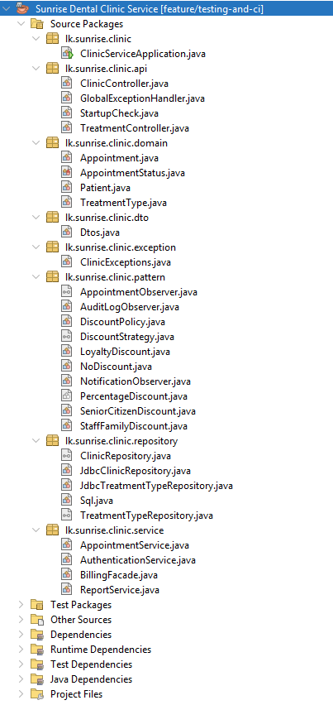
Figure 11: Project structure in Apache NetBeans: two Maven projects, with the business tier split into api, service, pattern, repository, domain, dto and exception packages.
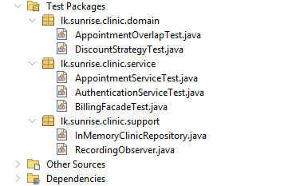
Figure 12: The test packages: five test classes plus the hand-written test doubles in the support package.
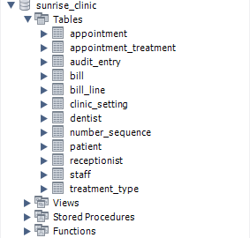
Figure 13: The sunrise_clinic schema in MySQL Workbench — 12 tables in third normal form.
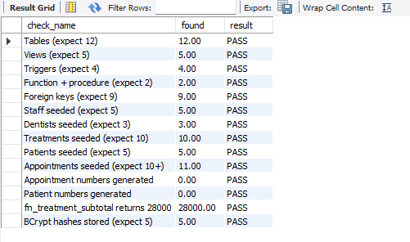
Figure 14: db/08_healthcheck.sql — all 14 checks return PASS: 12 tables, 5 views, 4 triggers, 2 routines, 9 foreign keys and the seeded reference data.
Figure 15: The buffer rule enforced by trg_appointment_no_overlap. The MySQL error is the expected result: a booking 10 minutes after an existing appointment ends is refused inside the transaction.
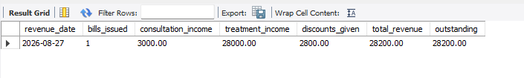
Figure 16: vw_daily_revenue after sp_generate_bill: consultation 3,000 + treatments 28,000 − discount 2,800 = 28,200.00.
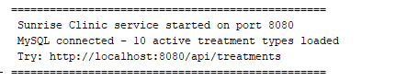
Figure 17: The business tier starting and connecting to MySQL.
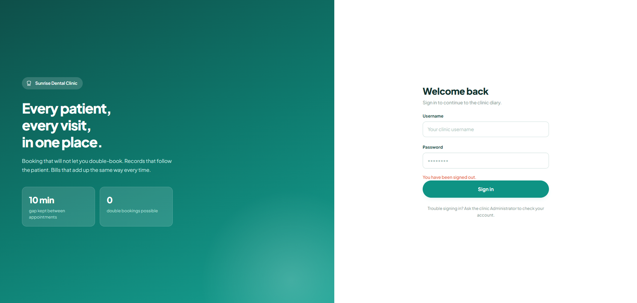
Figure 18: The sign-in screen. No credentials are displayed on the page.
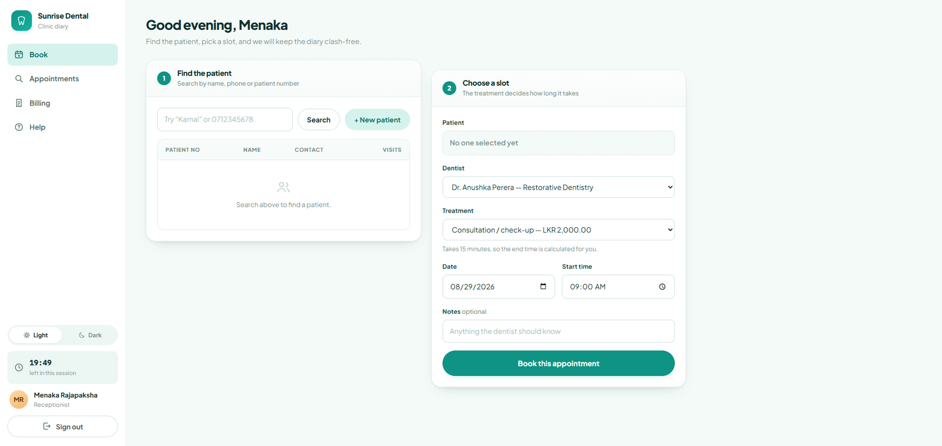
Figure 19: The receptionist’s view after signing in.
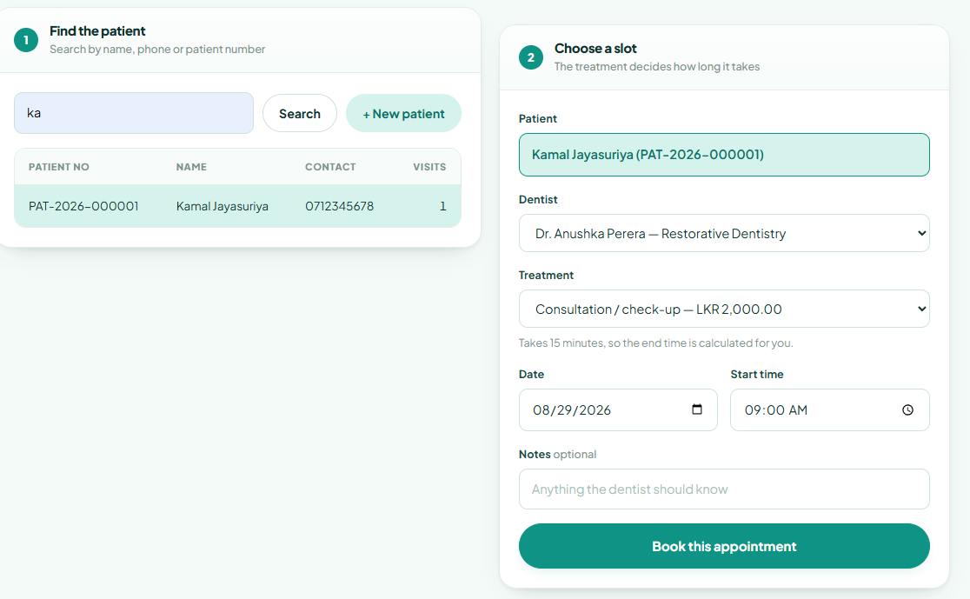
Figure 20: The booking form. The end time is derived from the treatment’s duration and is not entered by the user.
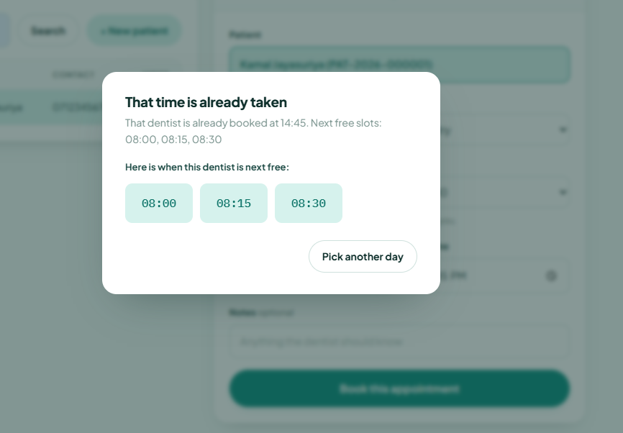
Figure 21: FR-10 and FR-11 together: the clash is refused with a reason, and three alternative times are offered. Refusing solves double booking; offering an alternative addresses the waiting-time failure.
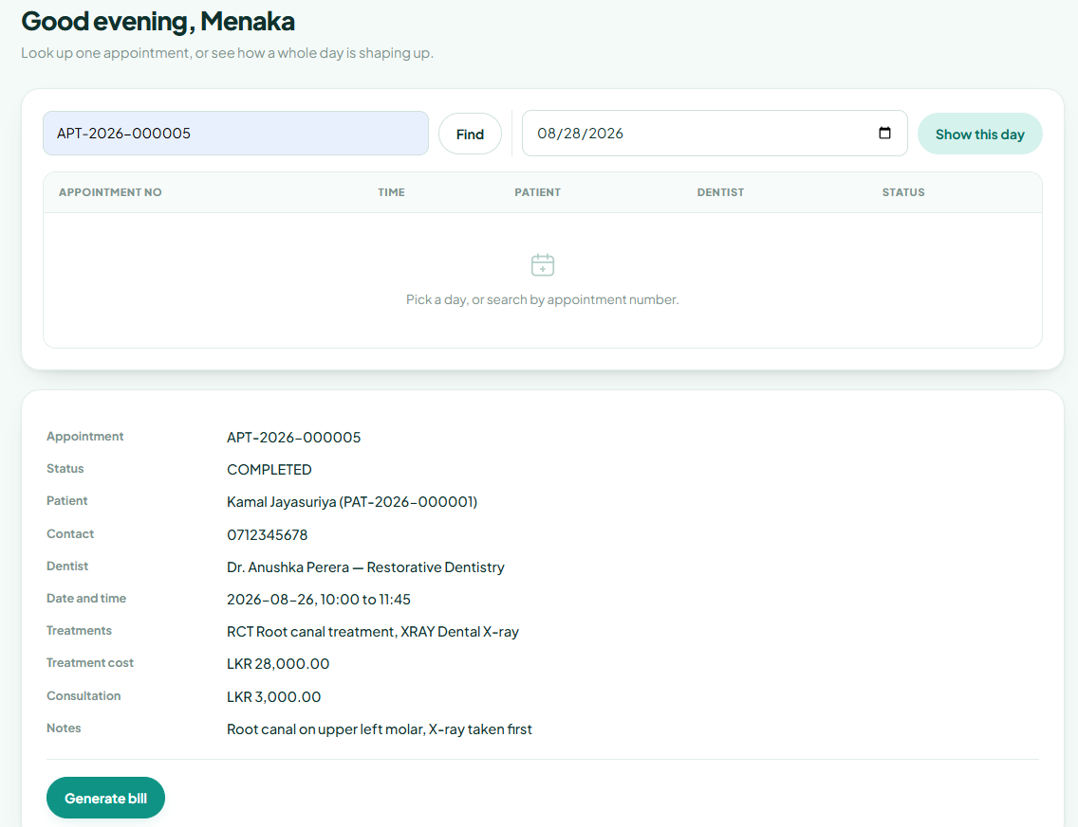
Figure 22: UC-10 Search and display appointment.
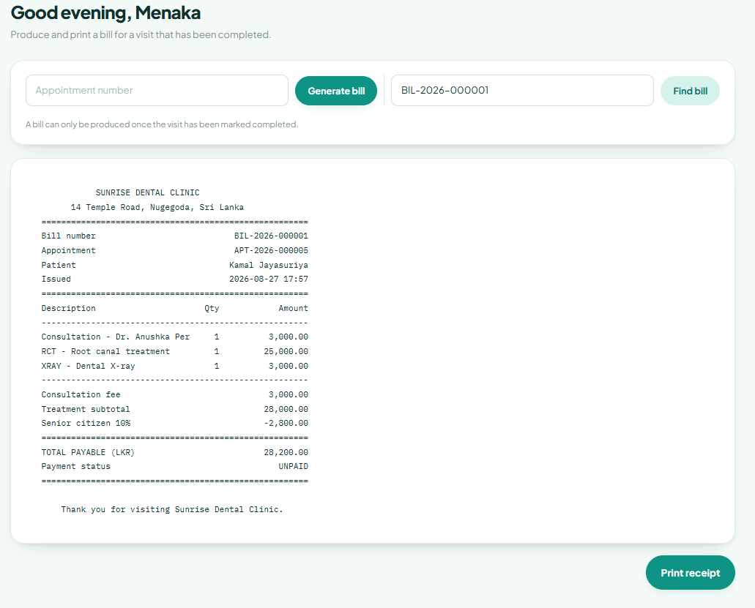
Figure 23: A generated bill showing the discount line selected by the Strategy pattern.
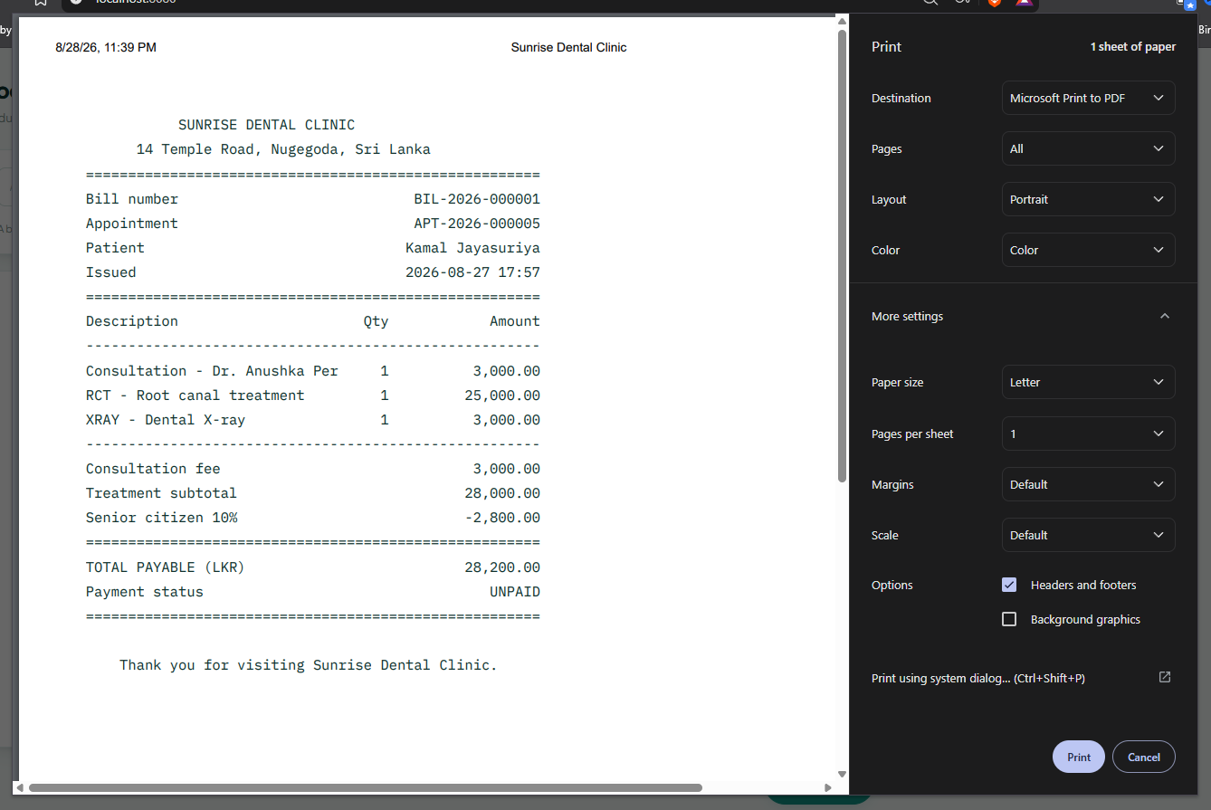
Figure 24: FR-19. The print stylesheet strips navigation and controls, leaving only the receipt, and the arithmetic on the page matches the stored total.
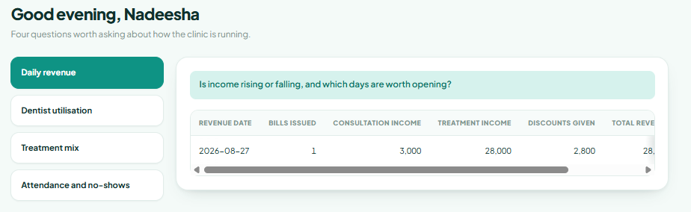
Figure 25: One of the five management report views.
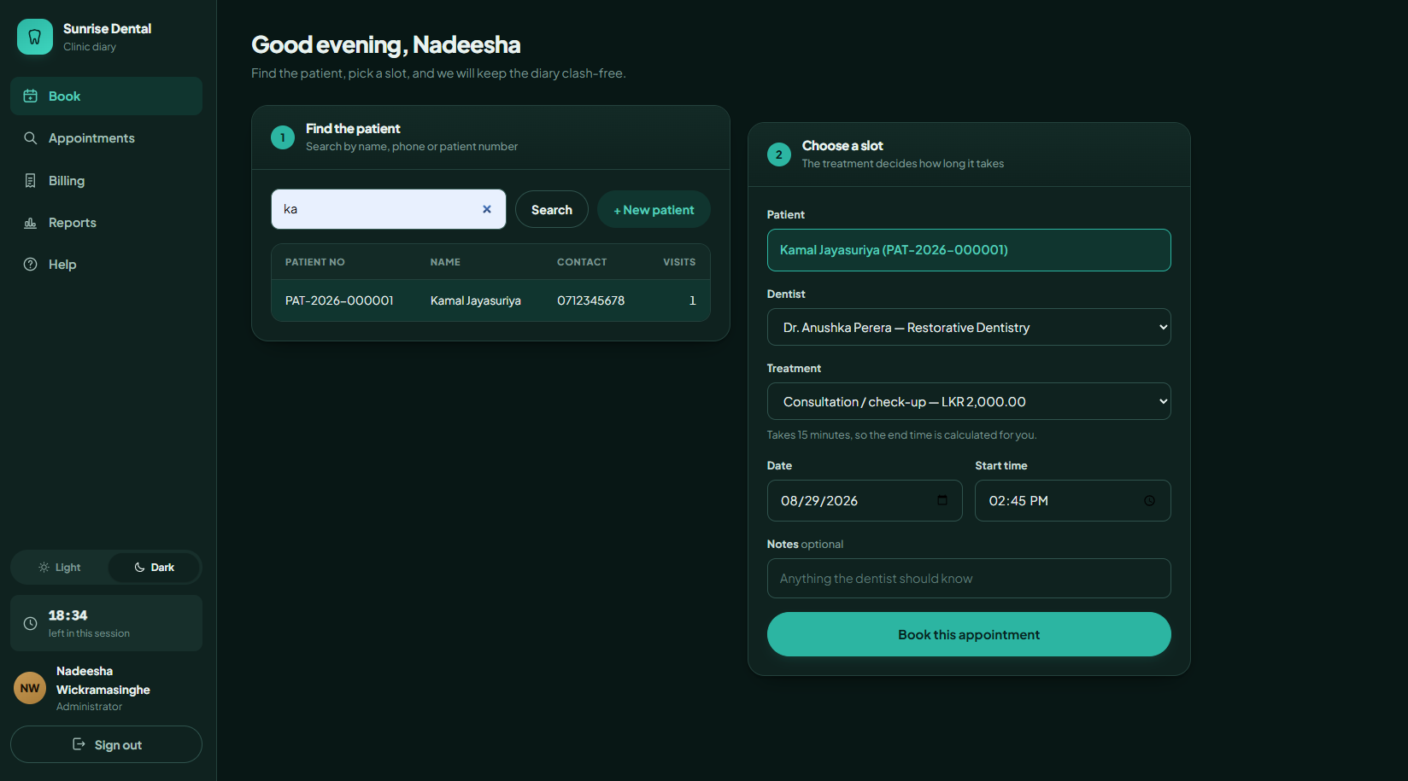
Figure 26: Three-state theming: light, dark, and following the operating system.
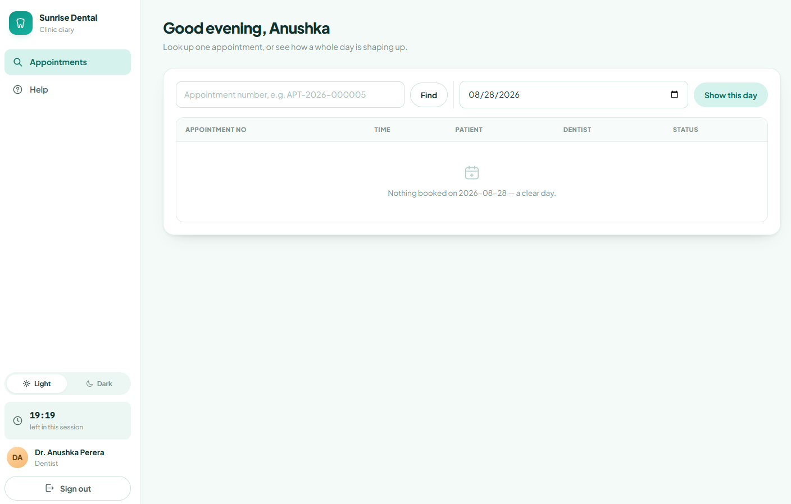
Figure 27: The same system signed in as a dentist — fewer functions are offered.
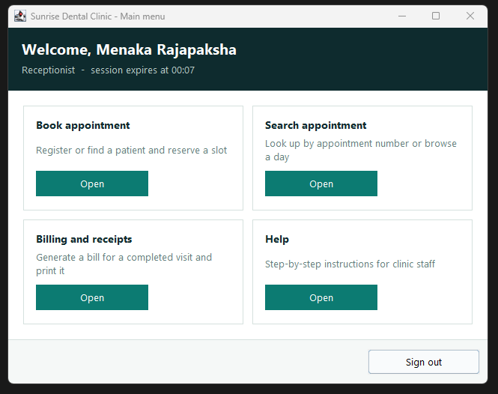
Figure 28: The Java Swing desktop client, a second independent client over the same REST API. It is a demonstration of tier separation rather than a finished product.
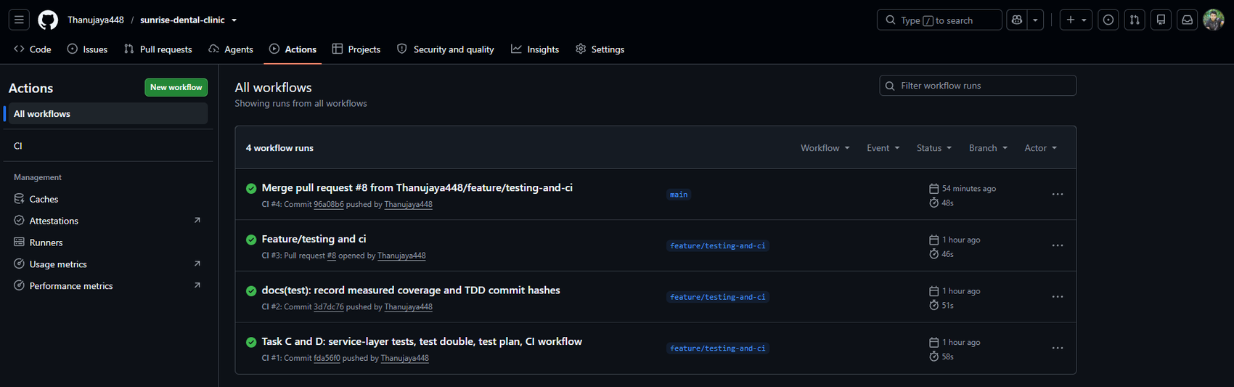
Figure 29: GitHub Actions: every run green, on both the feature branch and main.
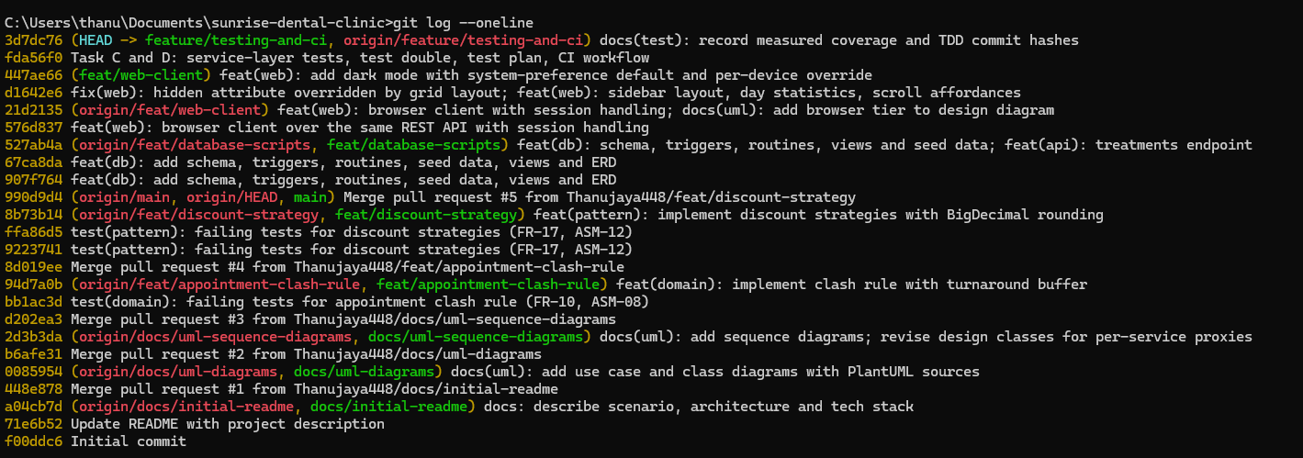
Figure 30: The commit history showing the two test-first cycles as separate red and green commits.
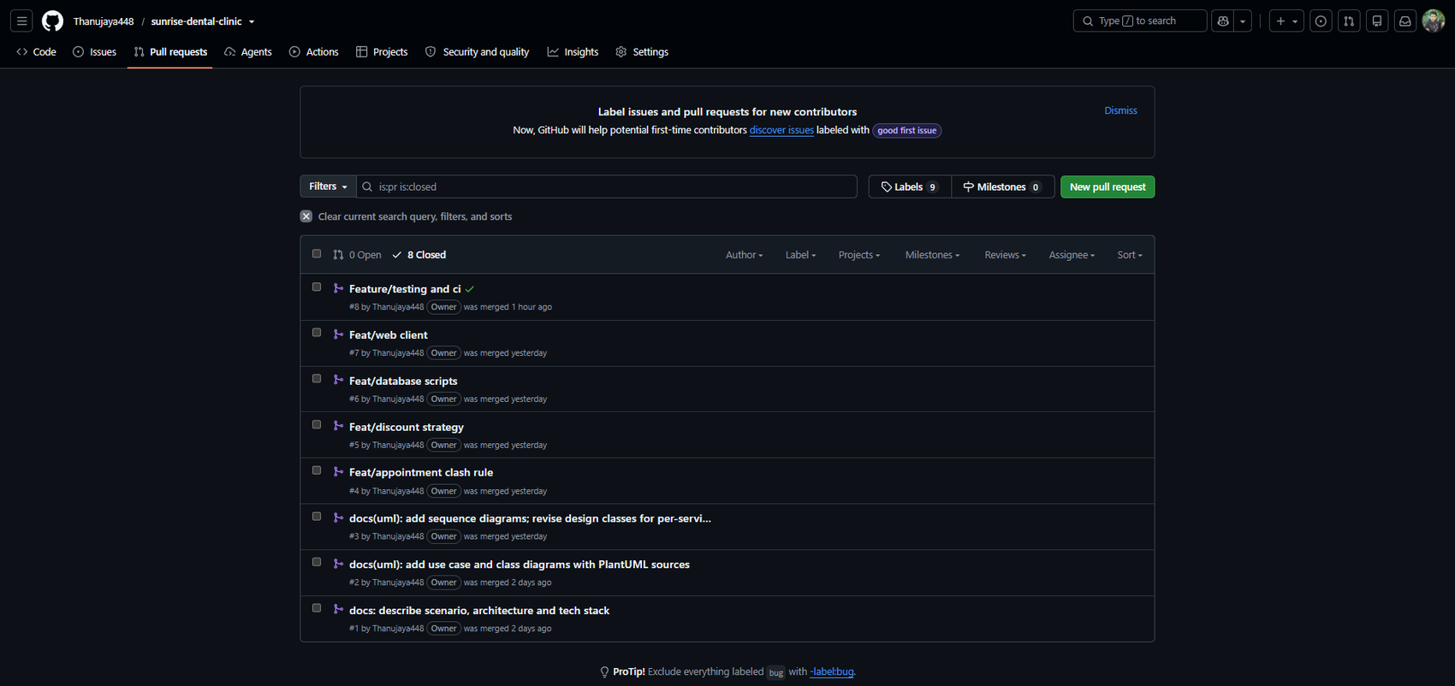
Figure 31: Merged pull requests — no work was committed directly to main.
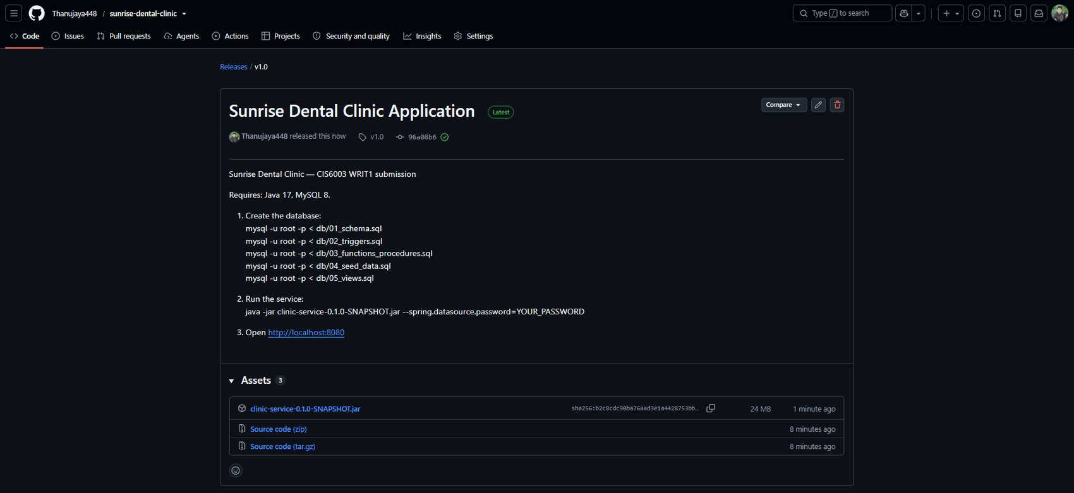
Figure 32: The tagged v1.0 release with the executable jar attached.

Appendix C — Full design class diagram
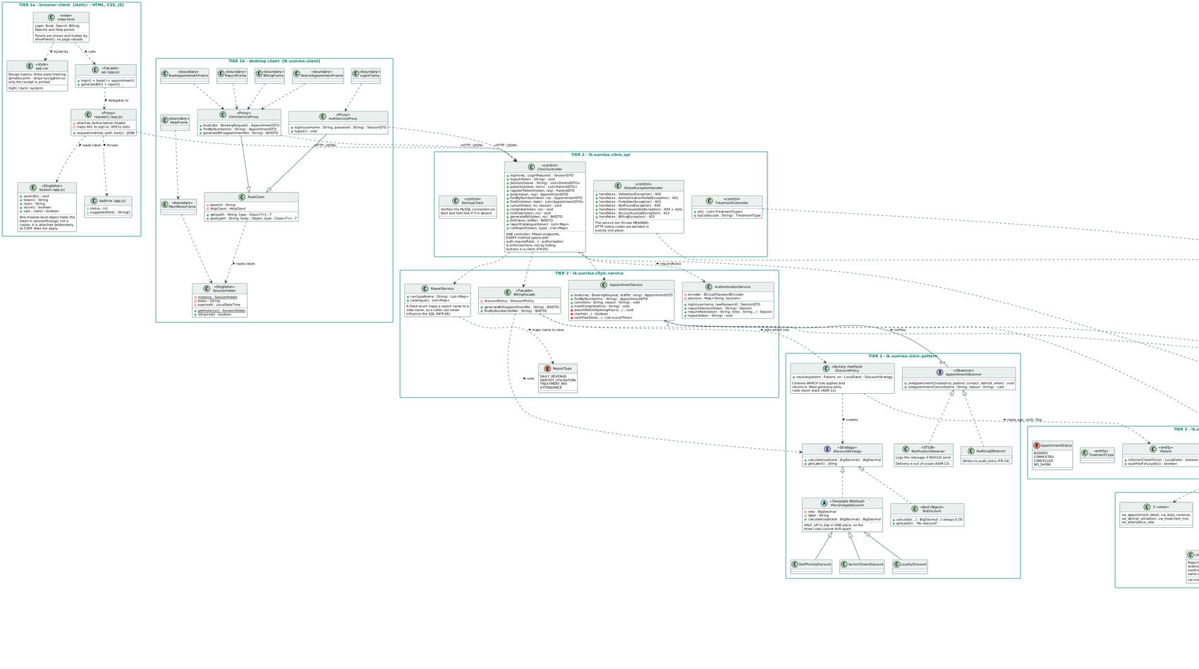
Figure 33: The complete three-tier design class diagram, generated from the implemented system. Two clients, one API, and the business rules that live in MySQL.

