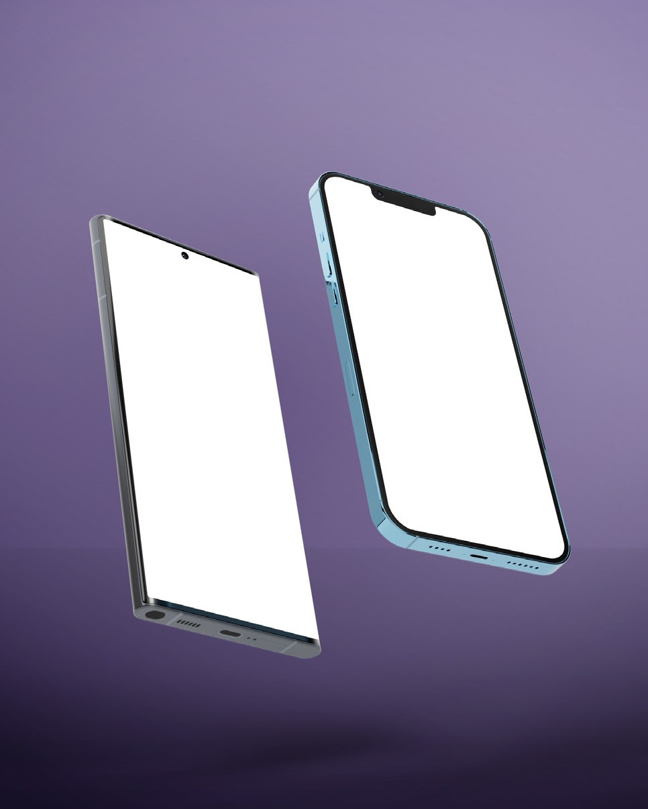APP FEATURES

# Super Simple. Super Quick.

OUR APP

# #1 UAE - B2B

**Marketplace Solution**

Lorem ipsum dolor sit amet, consectetuer adipiscing elit, sed diam nonummy nibh euismod tincidunt ut laoreet dolore magna aliquam erat volutpat. Ut wisi enim ad minim veniam, quis nostrud exerci tation ullamcorper suscipit lobortis nisl ut aliquip ex ea commodo consequat. Duis autem vel eum iriure dolor in

Download Now

Lorem ipsum dolor sit amet, consectetuer adipiscing elit, sed diam nonummy nibh euismod tincidunt ut laoreet dolore magna aliquam erat volutpat. Ut wisi enim ad minim veniam.

## Easy and Efﬁcient Ordering

Lorem ipsum dolor sit amet

## Lowest Price Range

Lorem ipsum dolor sit amet

## Customers Service 24/7/365

Lorem ipsum dolor sit amet

## User - Friendly

Lorem ipsum dolor sit amet

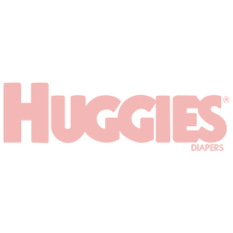

Home Services About Us FAQ Contact Us Download App

REGISTER TO BECOME CUSTOMER

**#1 UAE - B2B**

**Marketplace Solution**

Download Now



ABOUT US

**Lorem ipsum dolor consectetuer**

Maxbrands International is a specialist distributor of branded excess inventory and fast-moving consumer goods both throughout the Middle East and worldwide. Our close and

long-lasting relationships with leading manufacturers and brand owners across the globe enables source and supply products at competitive prices

**#1 UAE - B2B**

**Marketplace Solution**

**Partner Companies**

**Menu**

**Say Hello**

Download App

Services About Us FAQ

Contact Us

[inf](mailto:info@maxbrandsintl.com)[o@maxbrandsintl.com](mailto:o@maxbrandsintl.com)

+971 4 220 2635

Saeed Khalfan Hamad Khalfan

Al sowaidi building , Ofﬁce no MO4 Behind Gold Land building Deira, Dubai

Copyright© 2022. All Rights Reserved.

**Facebook Instagram Linkedin**

Discover More

**Lorem ipsum dolor**

TESTIMONIALS

# Our Customer Reviews



### Lorem ipsum dolor sit amet, consectetuer adipiscing elit, sed diam nonummy nibh euismod tincidunt ut laoreet dolore magna aliquam erat volutpa consectetuer adipiscing elit,

sed diam Ut wisi enim ad minim veniam.

### Jennifer Lee

Business Owner