FID score after 30 epochs for the below architecture is 588.533. (evaluated ovre 100 samples)

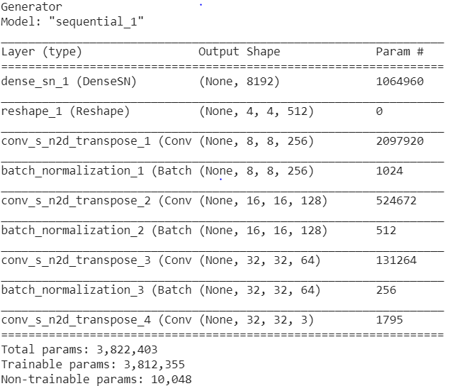 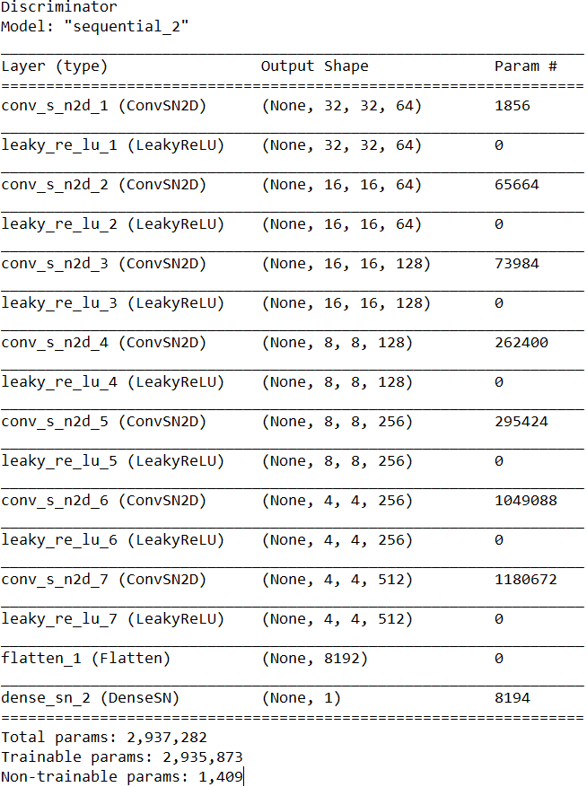

FID score after 30 epochs for the below architecture with attention is 601.323 . (evaluated over 100 samples)

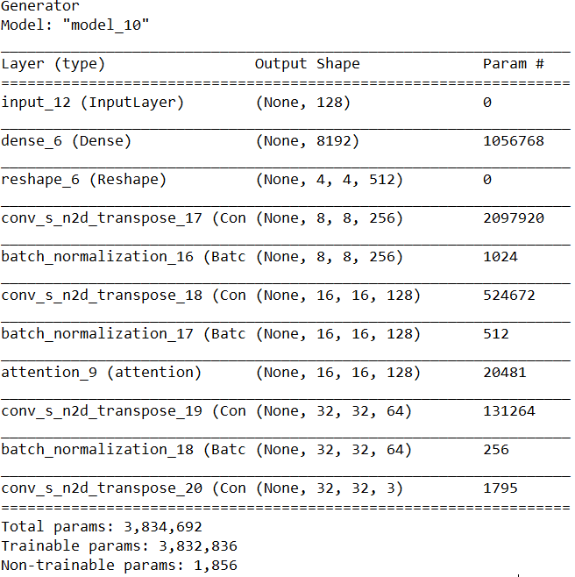 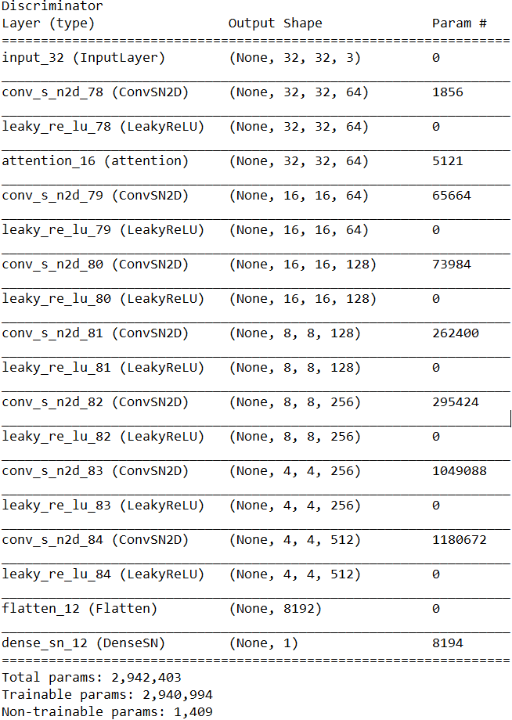

FID score for the below architecture is 590.03. (evaluated over 100 samples)

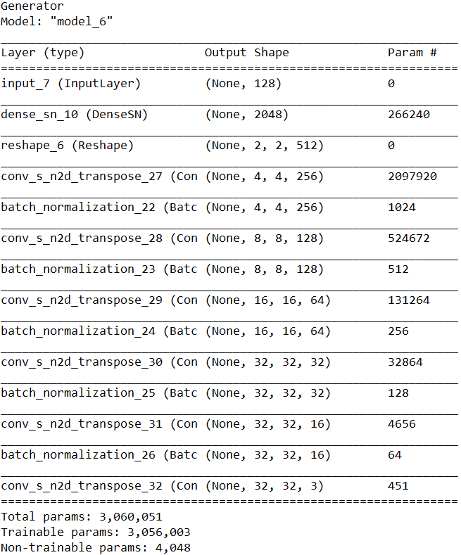 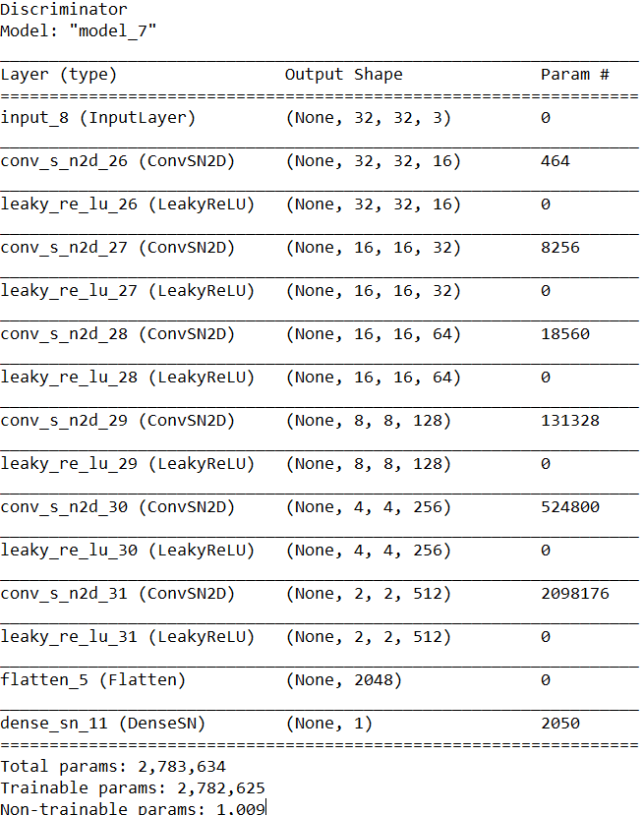

For the below architecture with attention, FID score is 599. (evaluated over 100 samples)

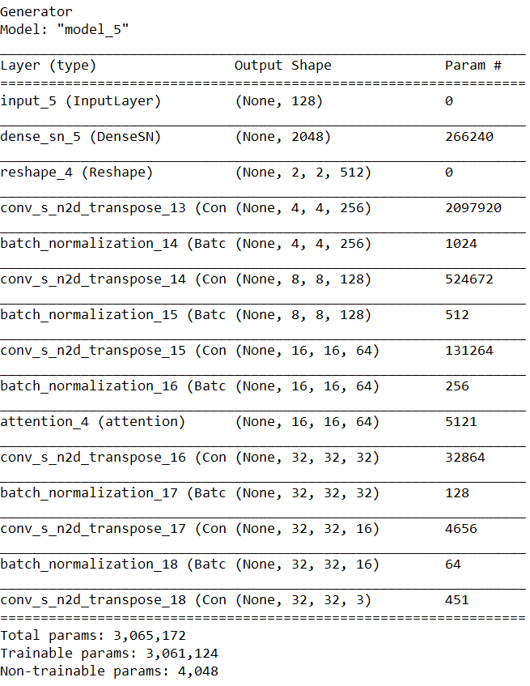 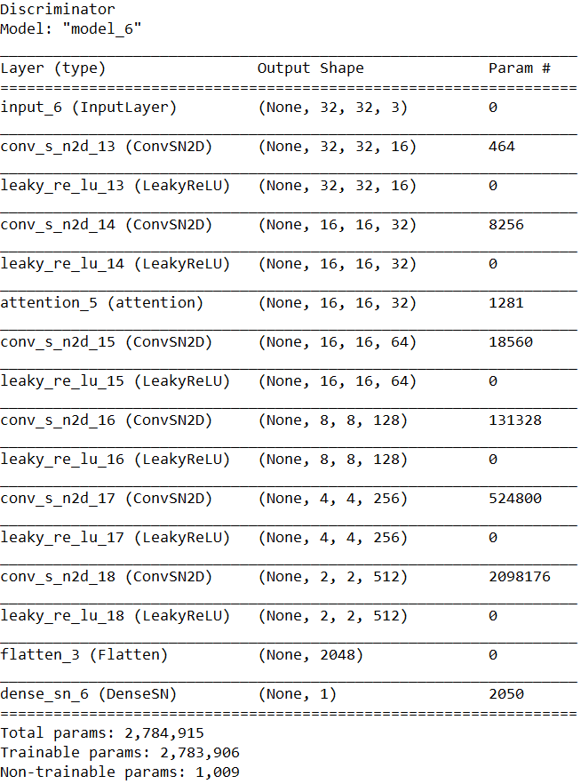

For the below architecture, the fid score is 606.050. (evaluated over 100 samples)

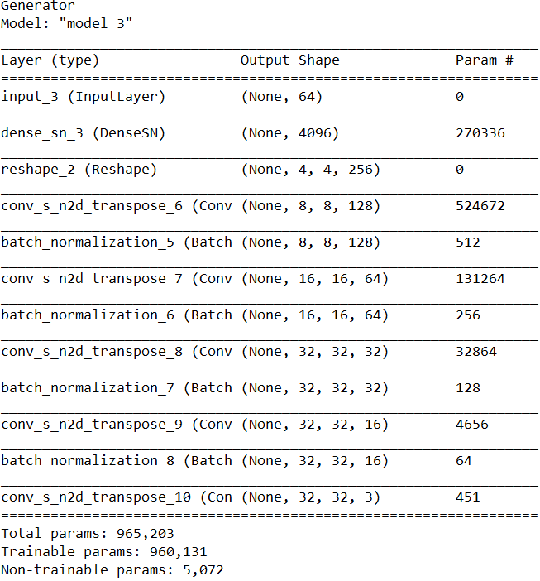 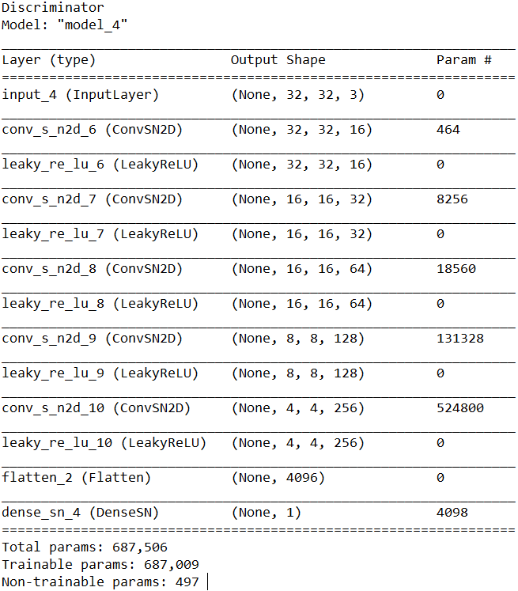

For the below architecture with attention, FID score is 150.36. (evaluated over 500 samples)

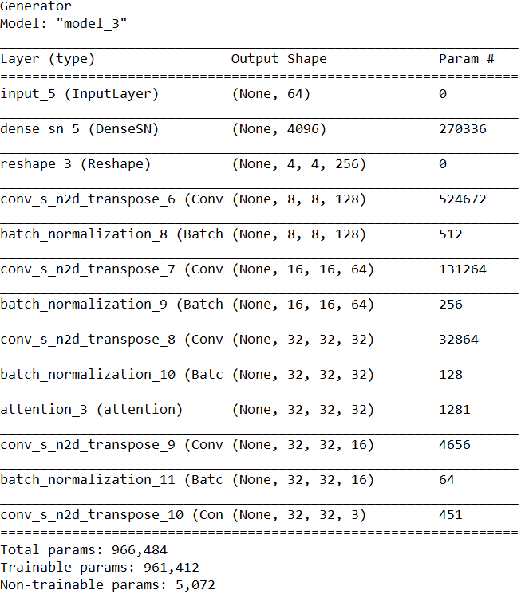 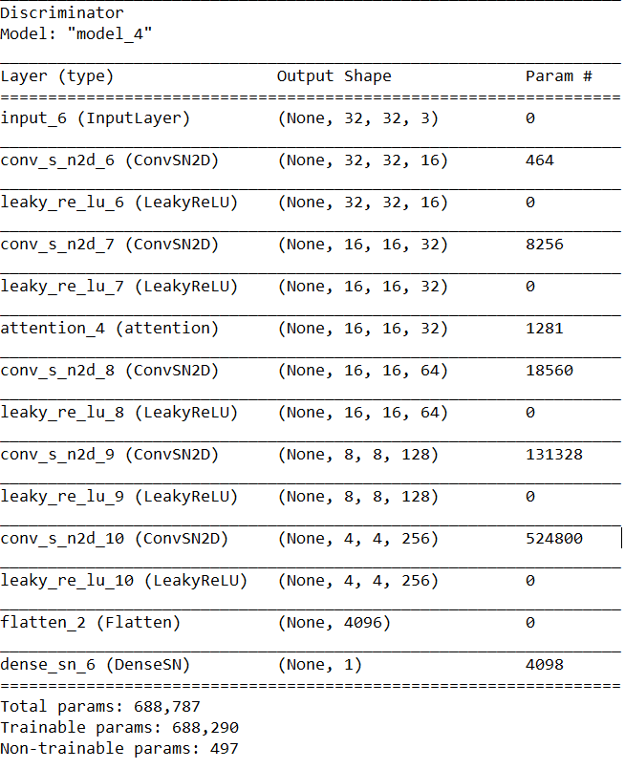

For the below architecture, the FID score is 309.76. (evaluated over 500 samples).

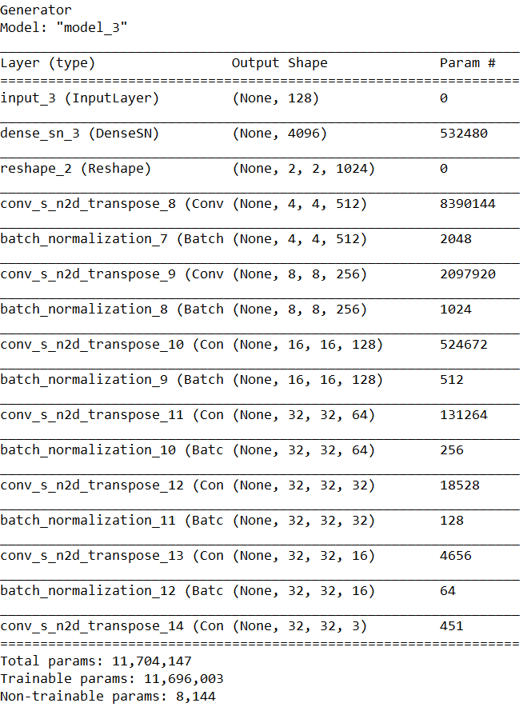 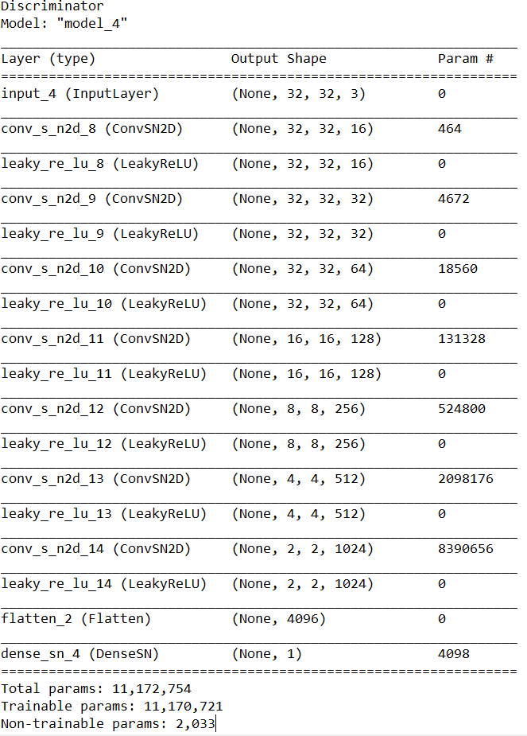

For the below architecture involving attention, FID score is 230.69. (evaluated over 500 samples)

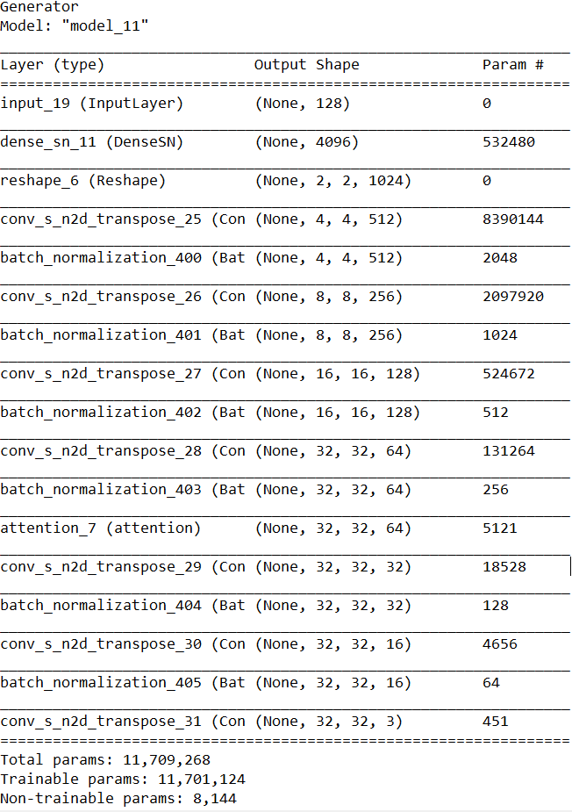 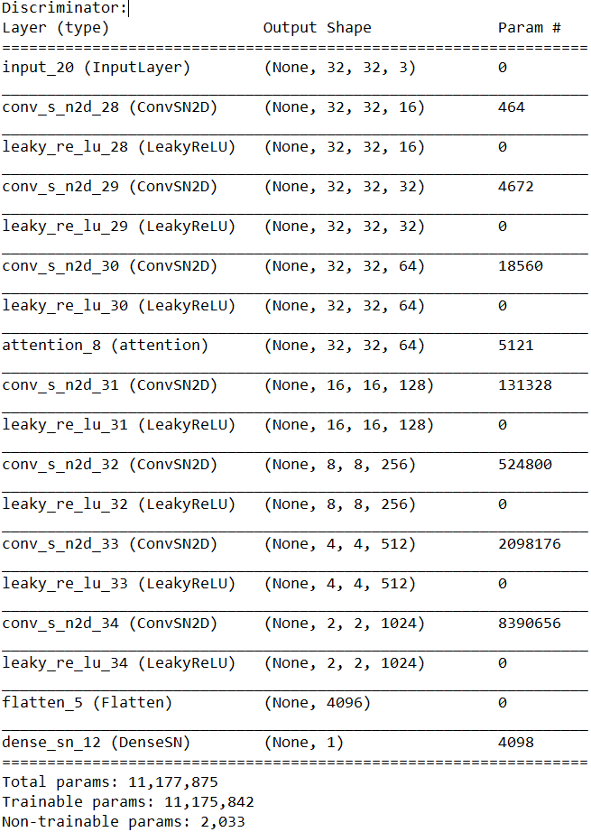

For the below architecture, FID score is 139.25. (evaluated over 500 samples)

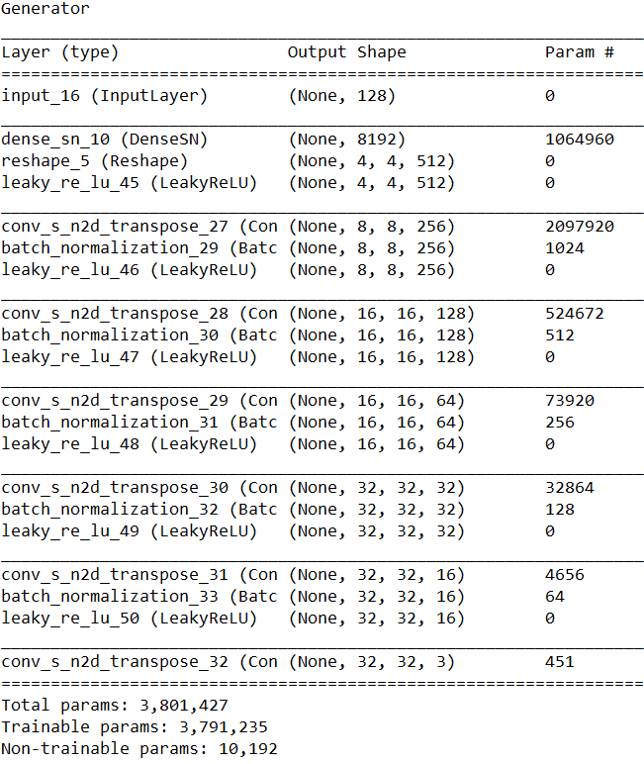 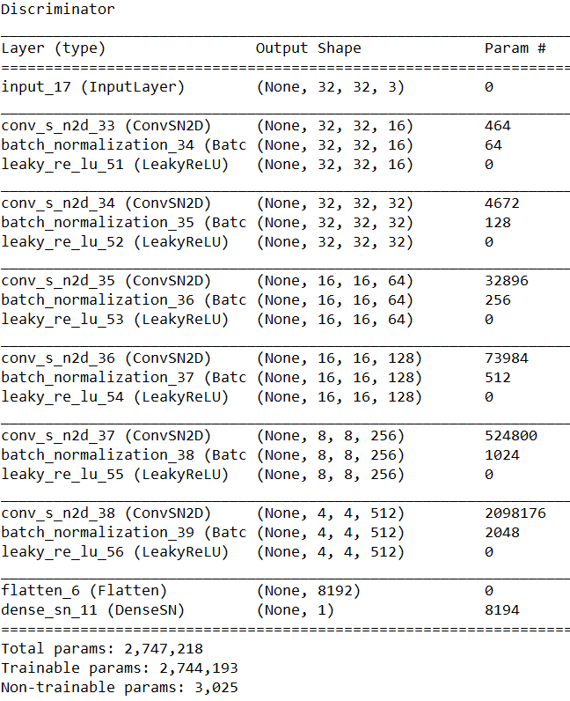

For the below architecture with attention, FID score is 151.39. (evaluated over 500 samples)

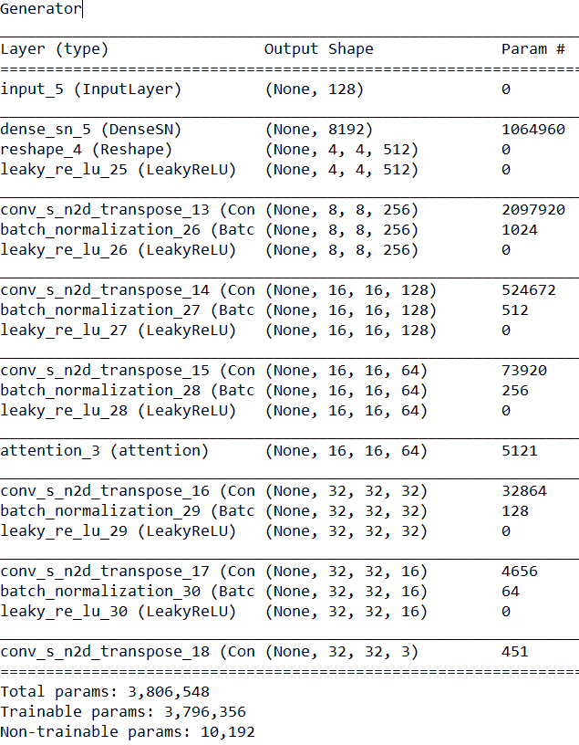 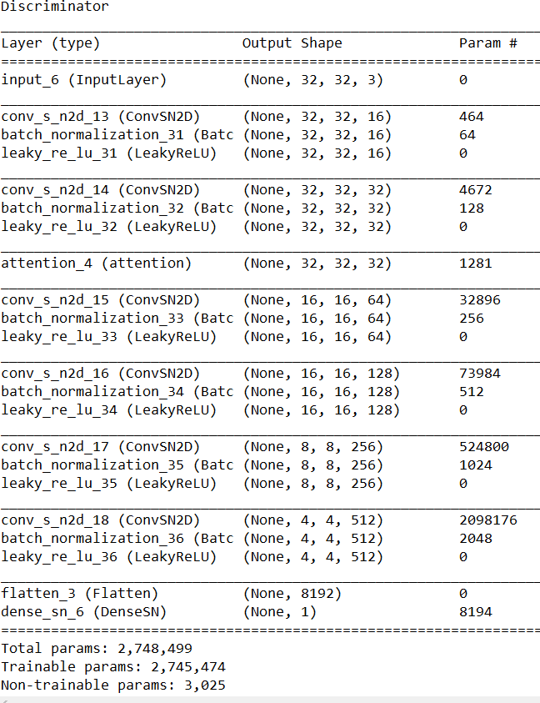

FID score for the below architecture is 135.87.(evaluated over 500 samples)

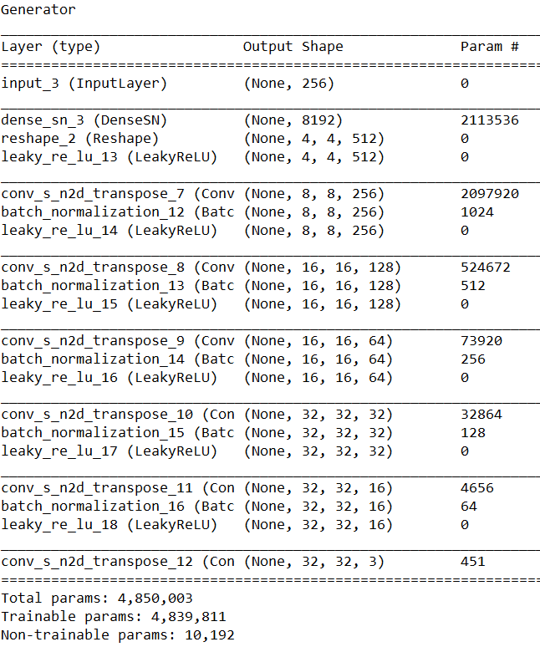 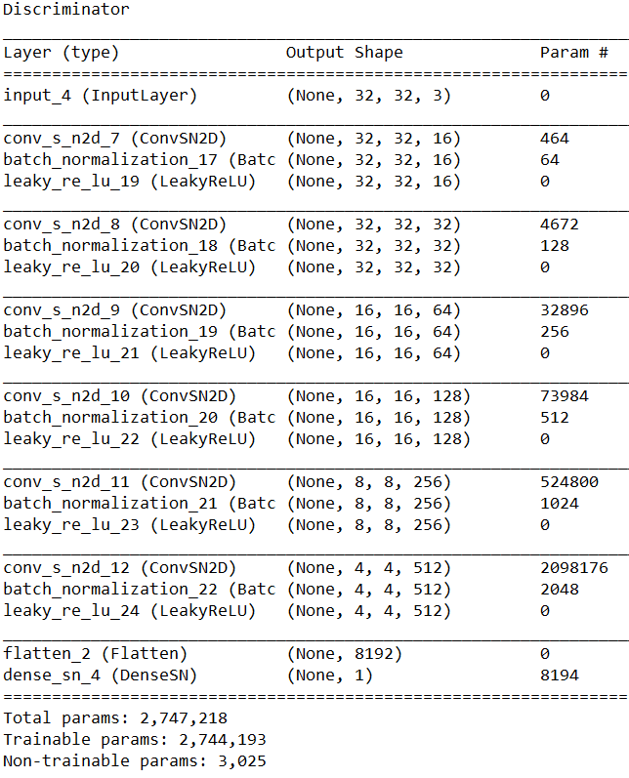

For the below architecture with attention, FID score is 139.98. (evaluated over 500 samples)

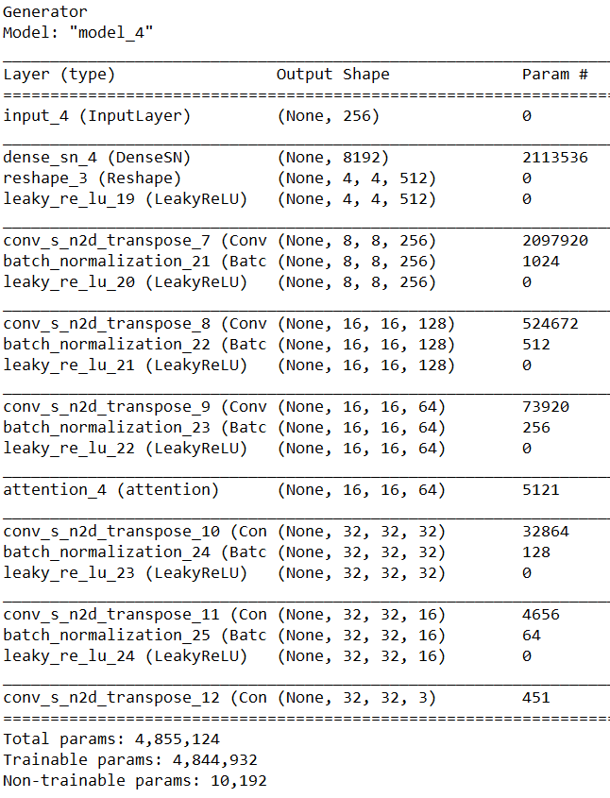 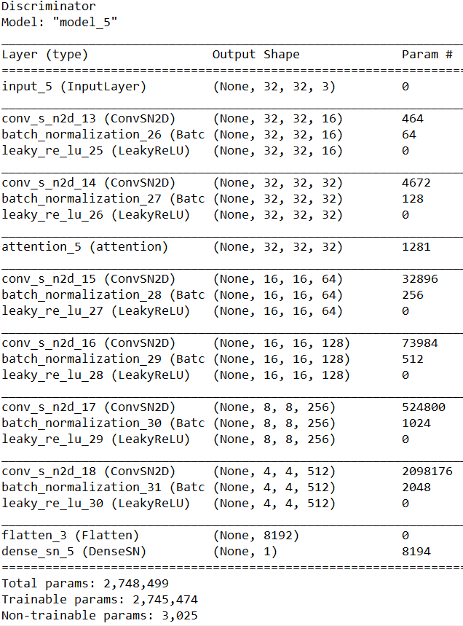

For the below architecture, FID score is 142.87. (evaluated over 500 samples)

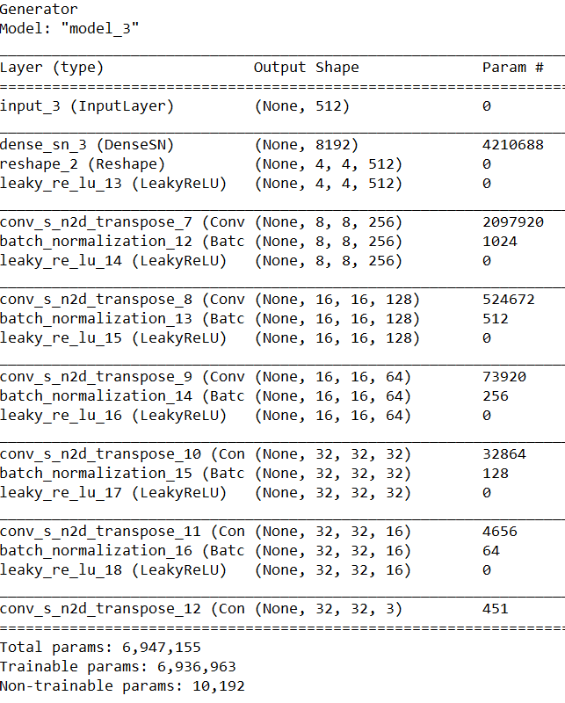 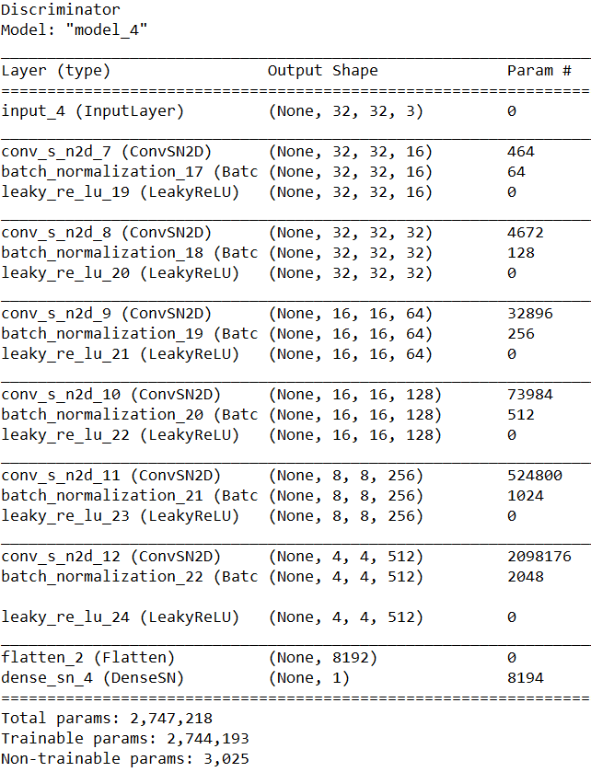

For the below architecture with attention, FID score is 144.49. (evaluated over 500 samples)

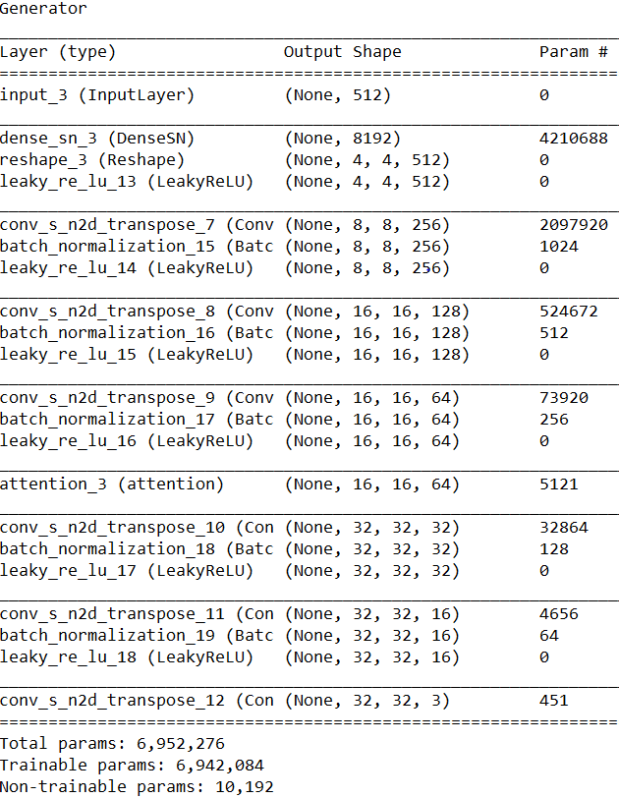 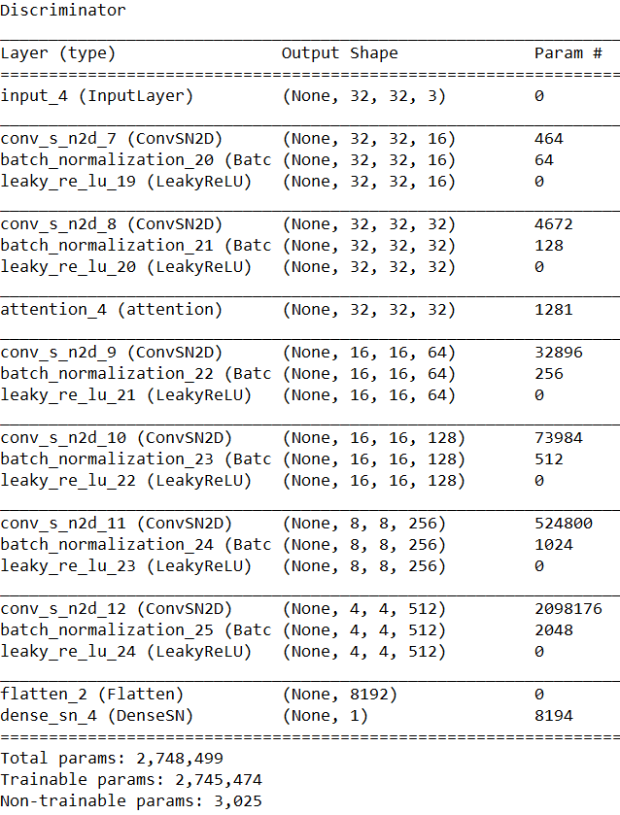

FID score for the below architecture is 310.75. (evaluated over 500 samples)

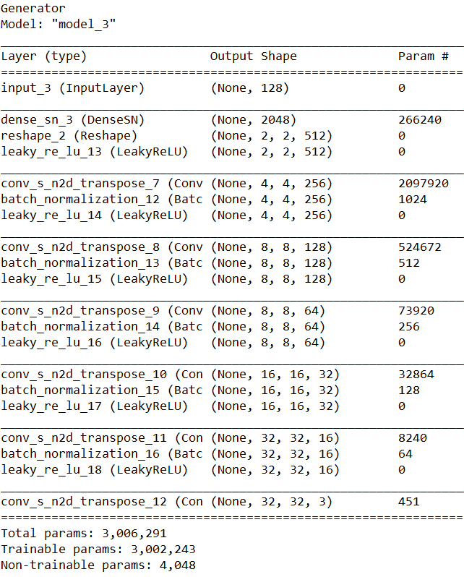 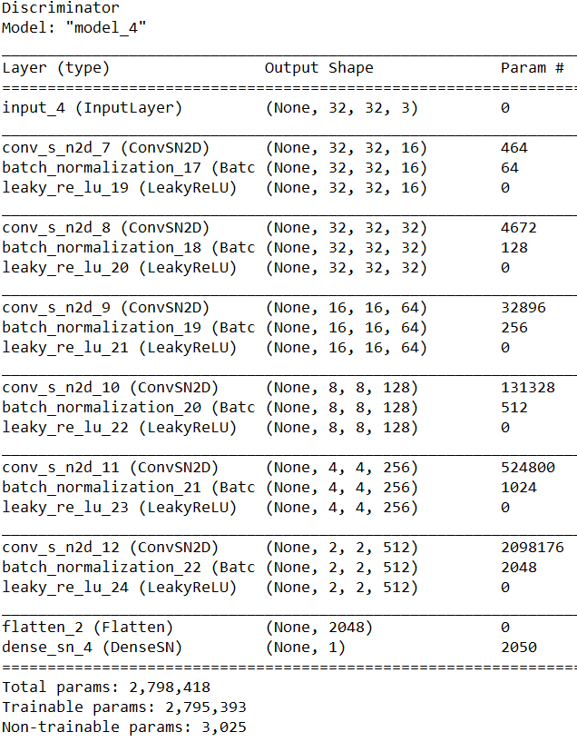

For the below architecture with attention, FID score is 432.36. (evaluated over 500 samples)(20 epochs only here )

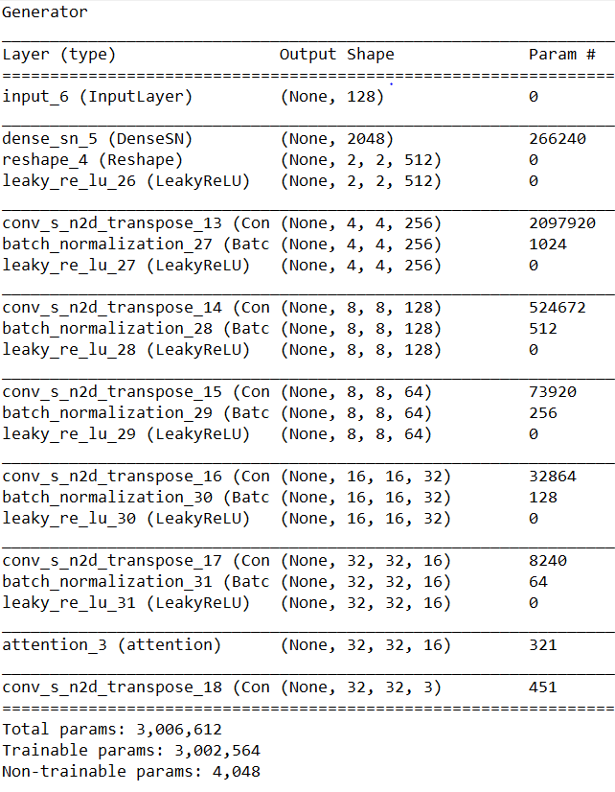 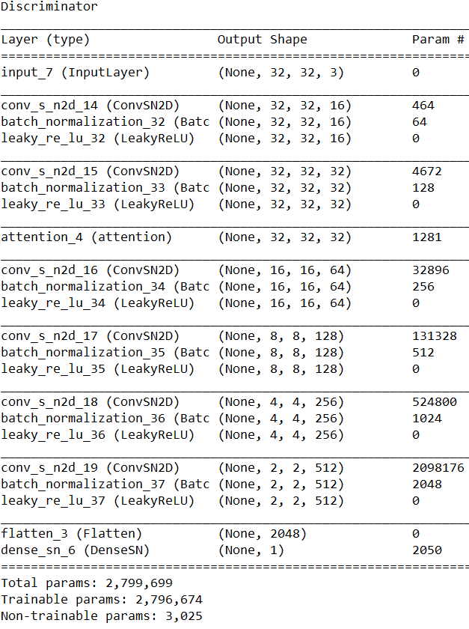

Till here, all the architectures were run for 30 epochs.

FID score for the below implementation is 174.83. (over 500 samples with 30 epochs)

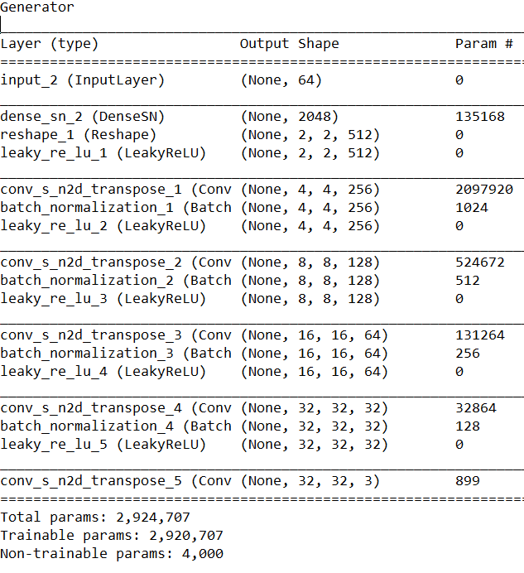 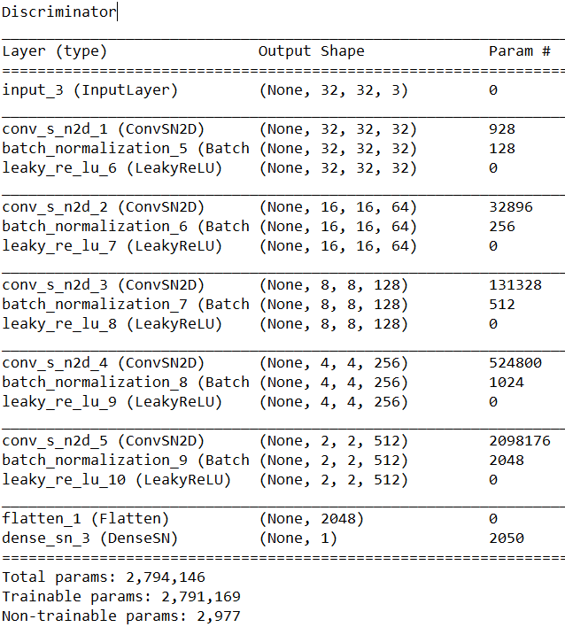

FID score for the below implementation with attention is 392.4.(over 500 samples with 20 epochs)

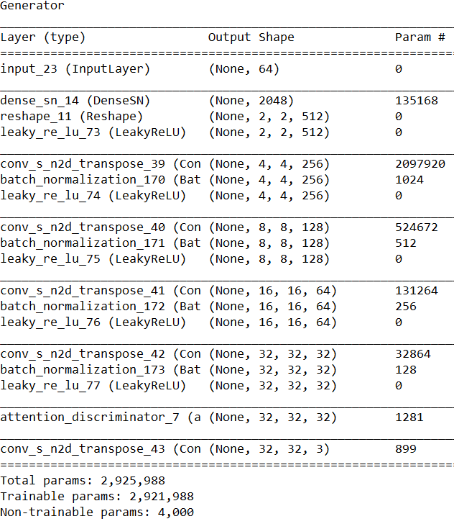 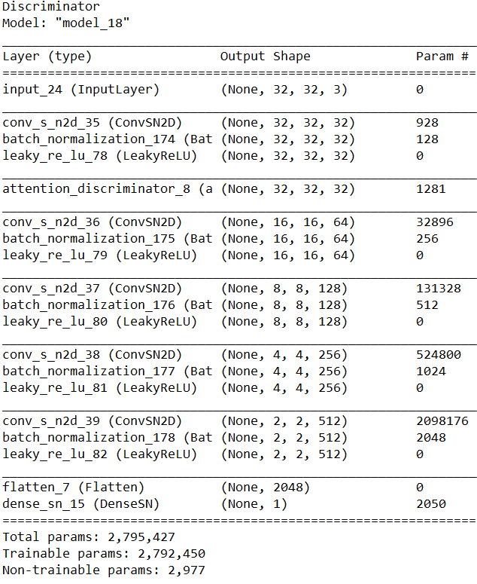

FID score for the below implementation is 224.97. (over 500 samples with 30 epochs)

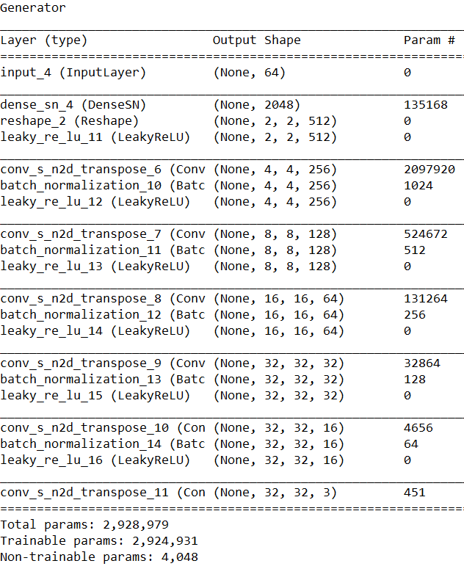 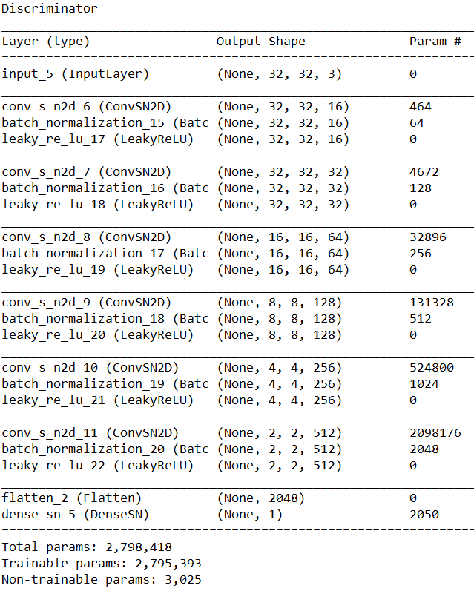

FID score for the below implementation with attention is 205.96.(over 500 samples with 20 epochs

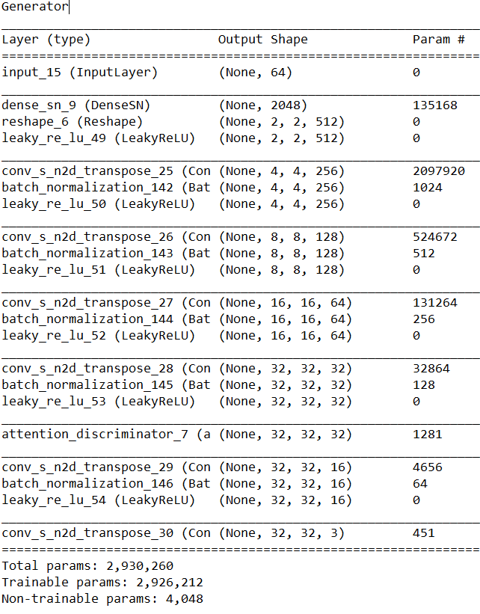 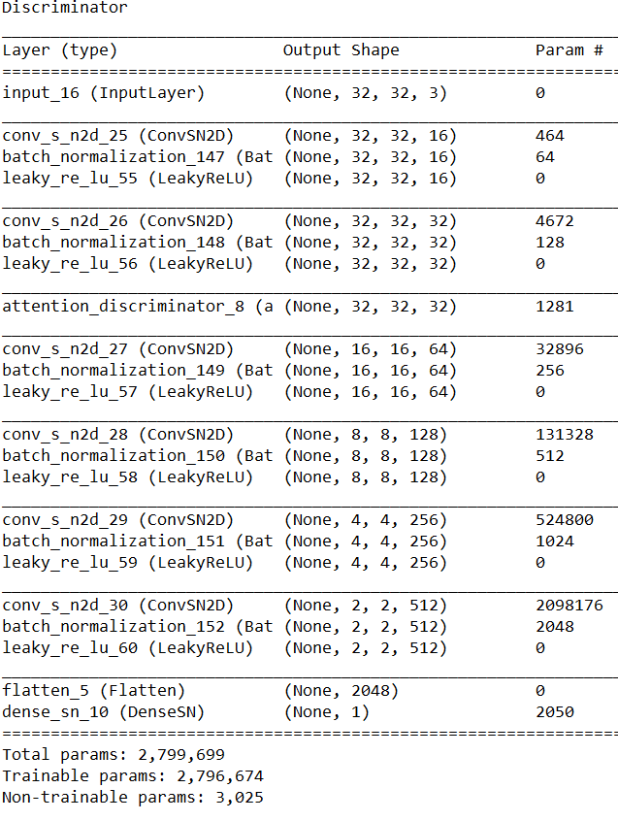

FID score for below architecture is 182.85.(over 500 samples with 30 epochs)

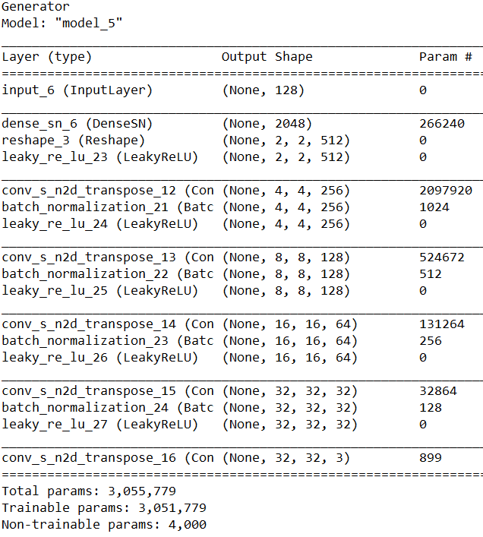 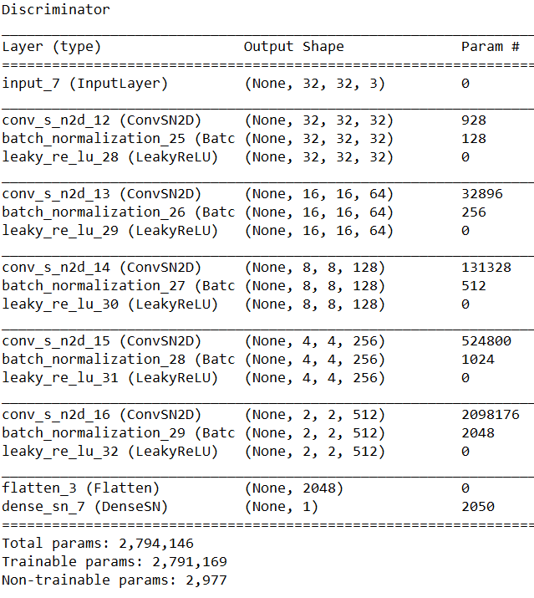

FID score for the below architecture with attention is 588.21. ( over 500 samples with 20 epochs)

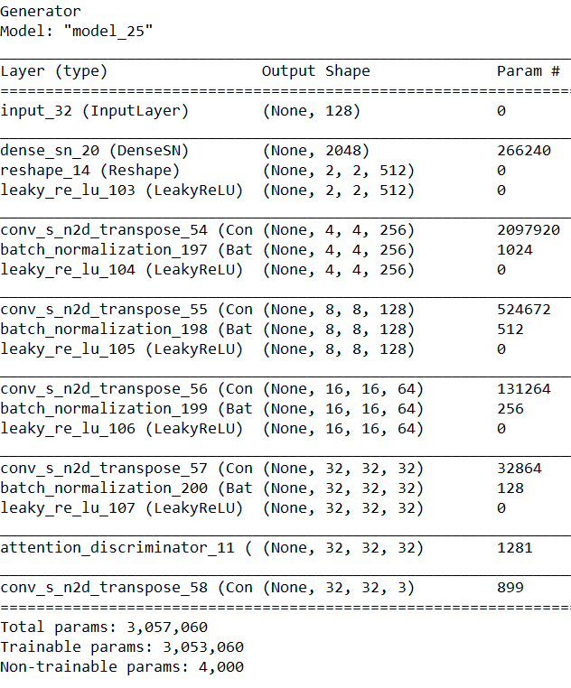 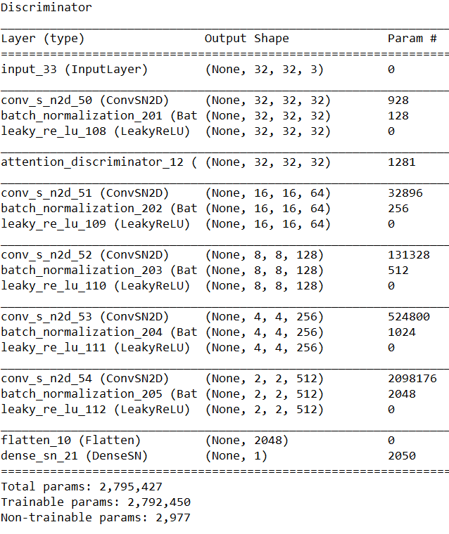

FID score for below architecture is 144.34.(over 500 samples with 30 epochs)

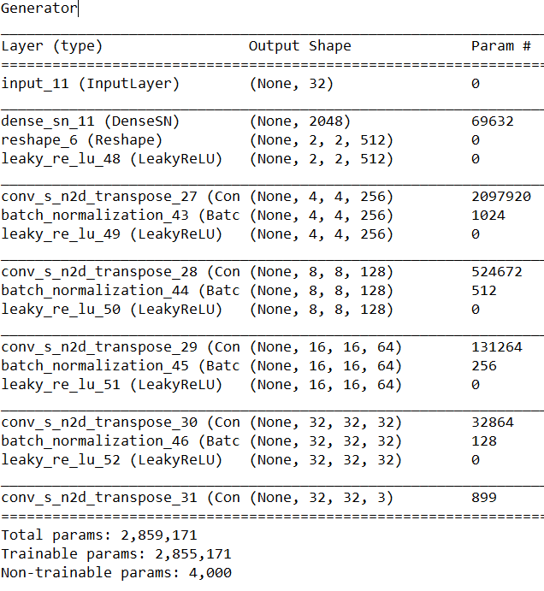 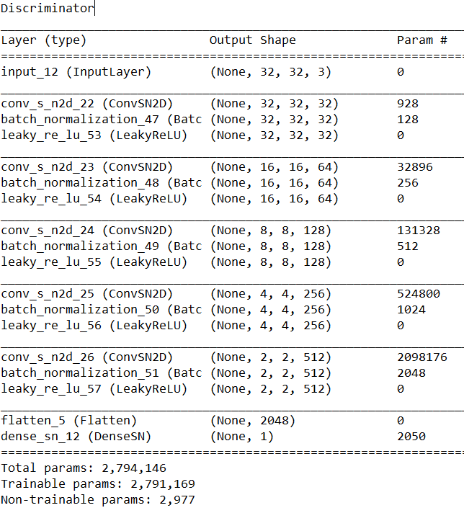

FID score for the below architecture with attention is 1024.68. ( over 500 samples with 20 epochs)

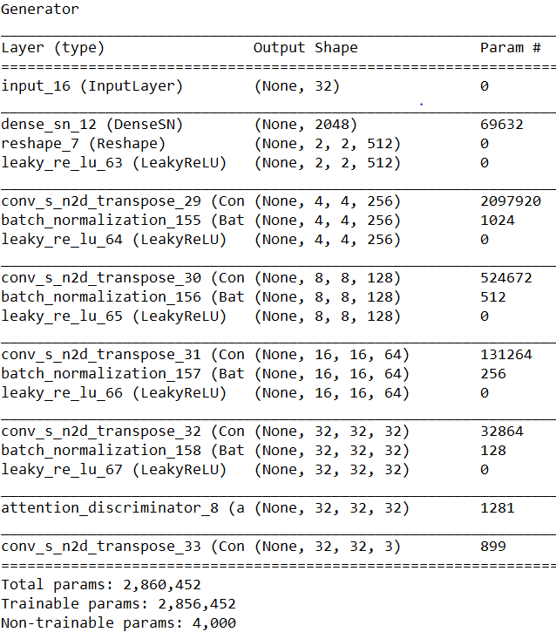 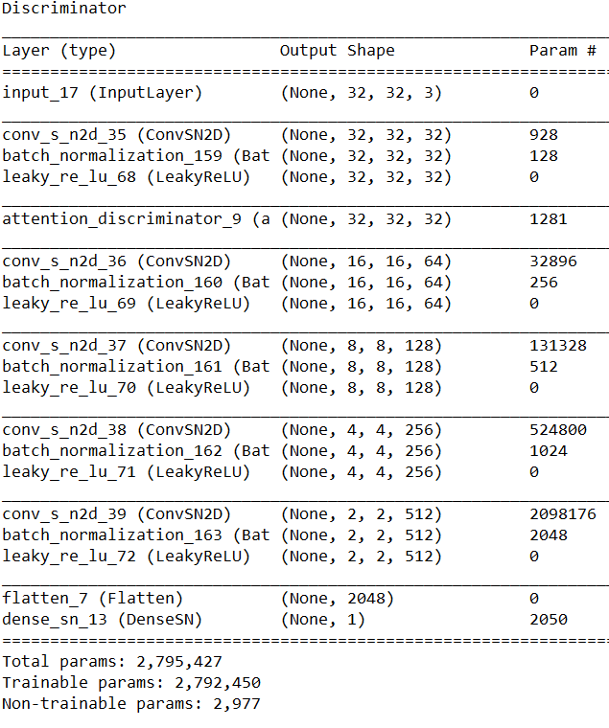

FID score for below architecture is 201.36.(over 500 samples with 30 epochs)

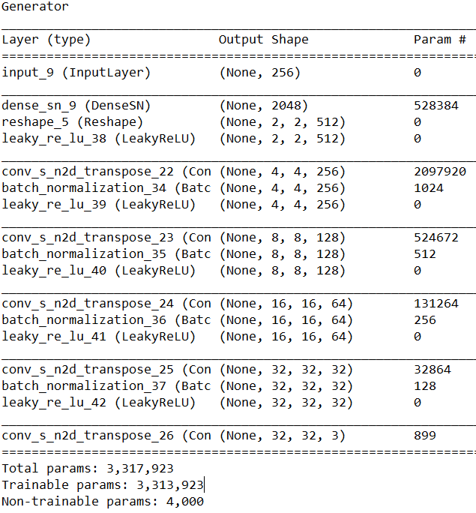 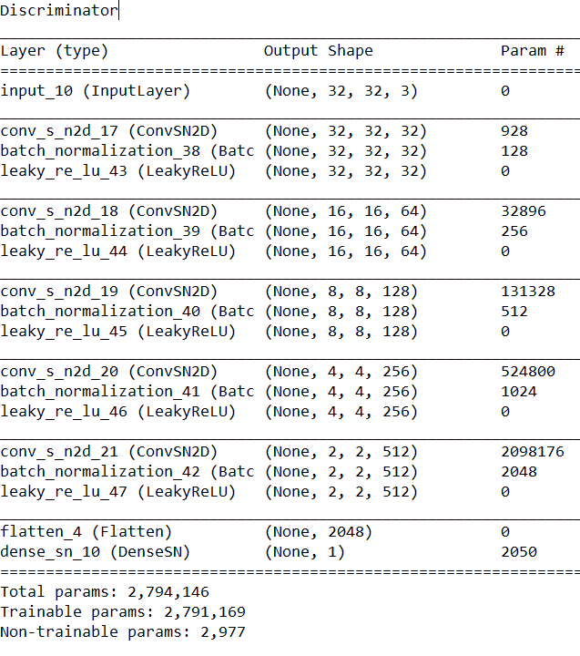

FID score for the below architecture with attention is 417.82. ( over 500 samples with 20 epochs)

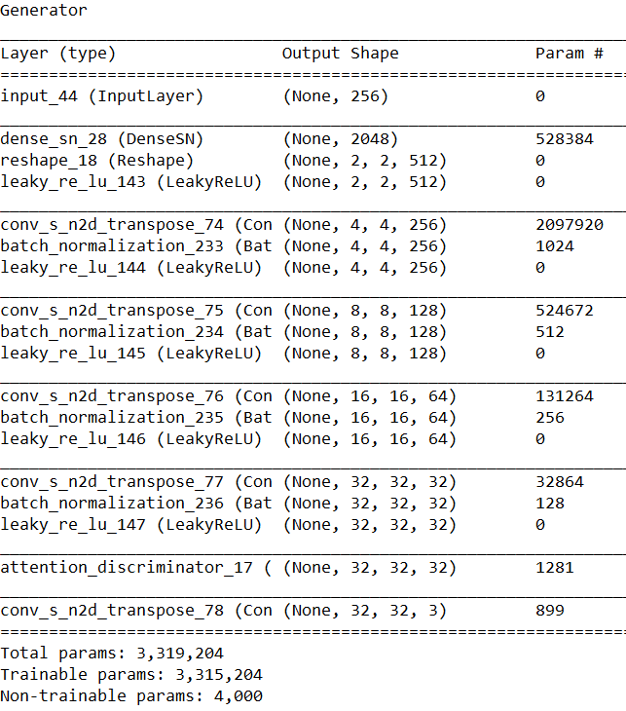 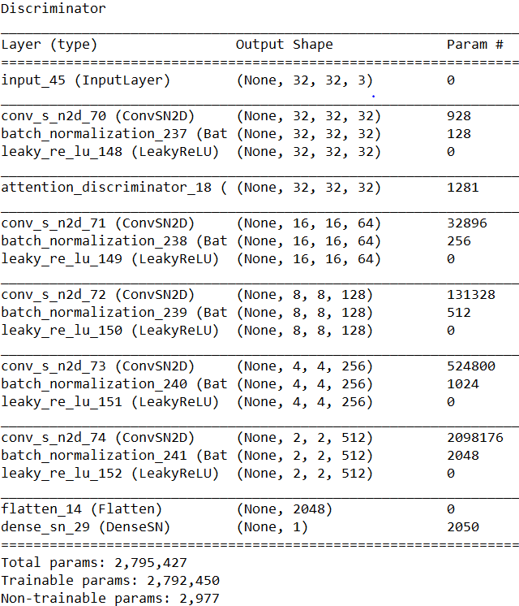

FID score for below architecture is 194.53.(over 500 samples with 30 epochs)

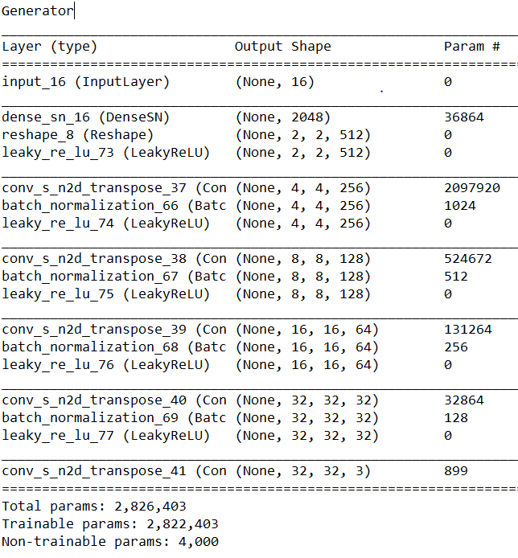 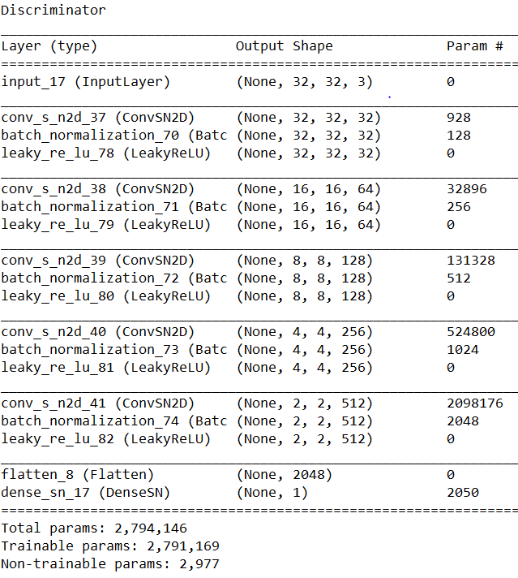

FID score for the below architecture with attention is 316.02. ( over 500 samples with 20 epochs)

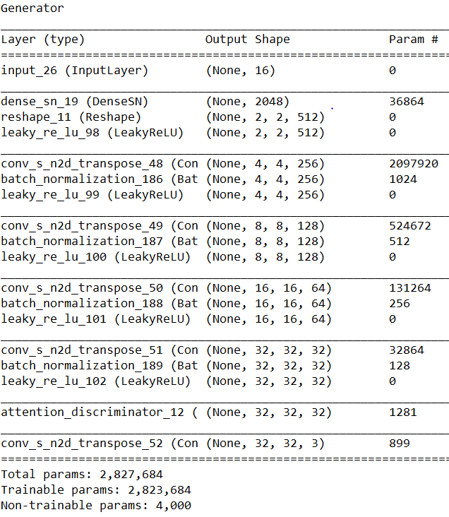 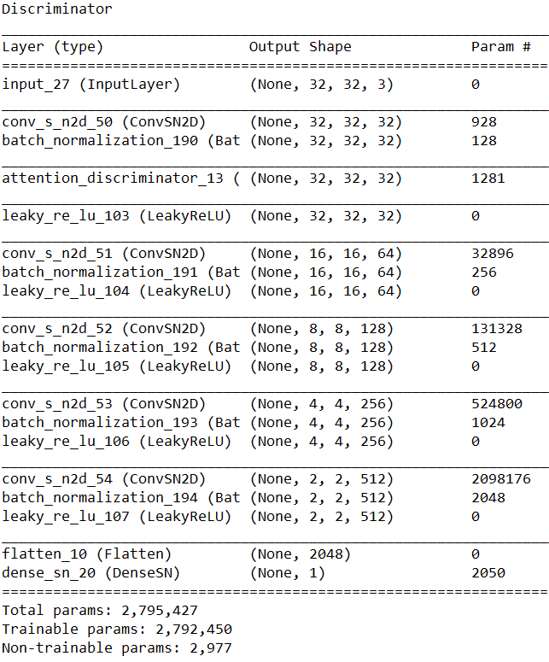

FID score for below architecture is 189.62.(over 500 samples with 30 epochs)

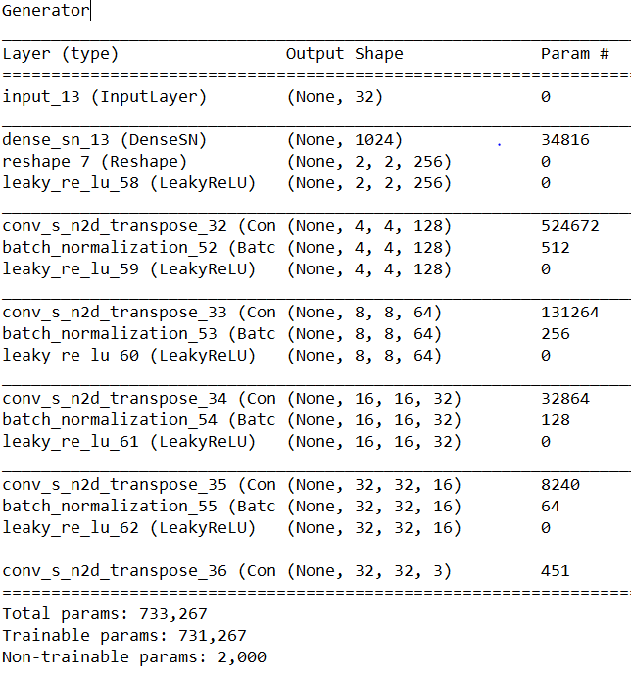 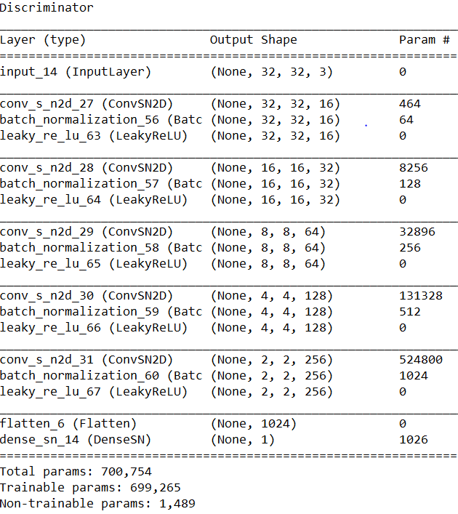

FID score for the below architecture with attention is 225.6. ( over 500 samples with 20 epochs)

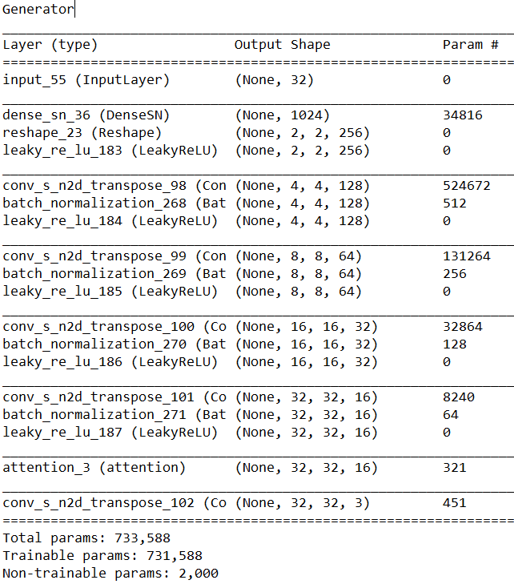 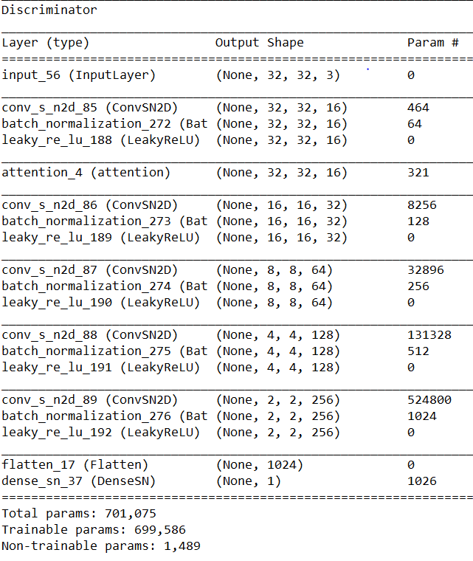

FID score for below architecture is 104.08.(over 500 samples with 30 epochs)

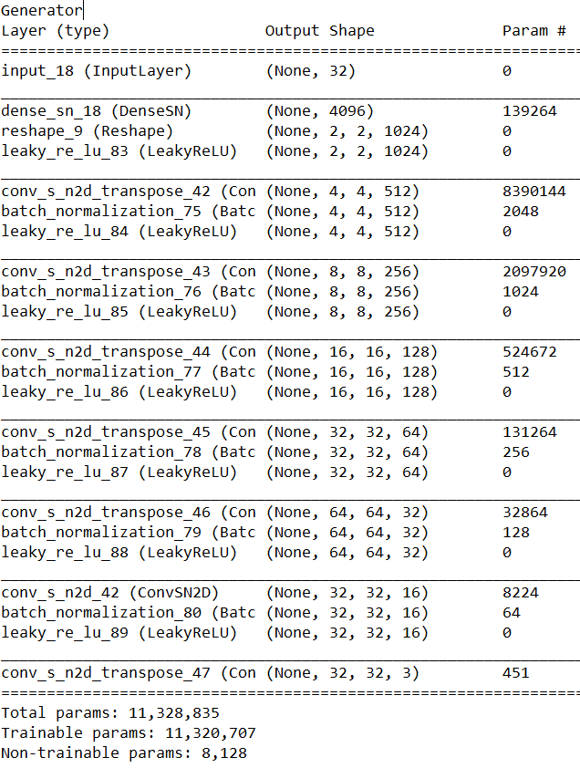 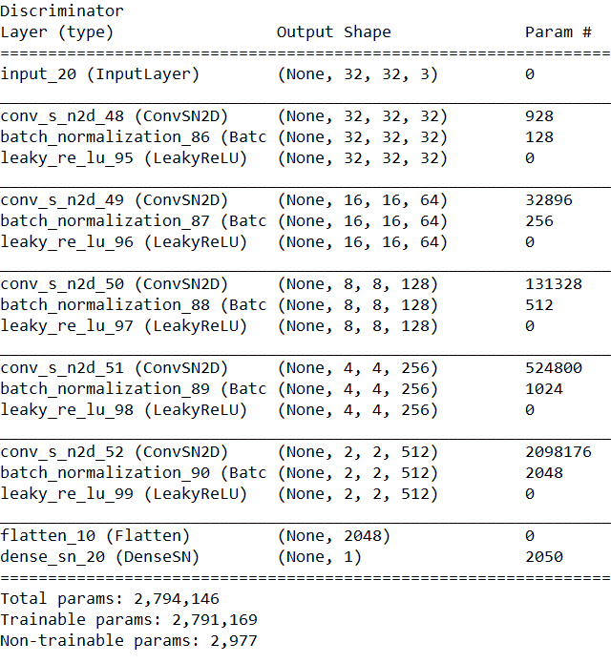

FID score for the below architecture with attention is 136.45. ( over 500 samples with 20 epochs)

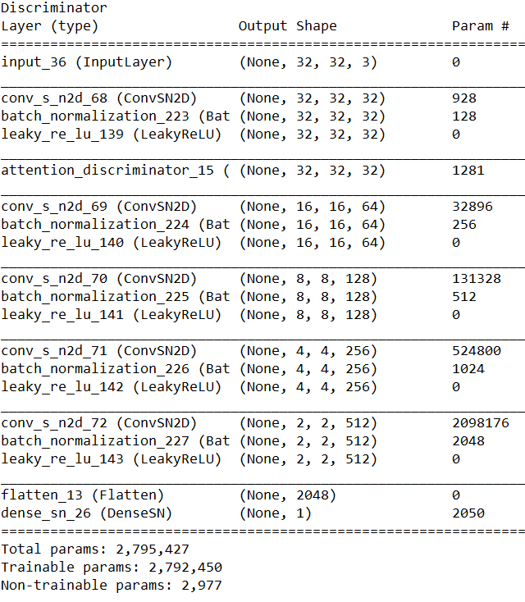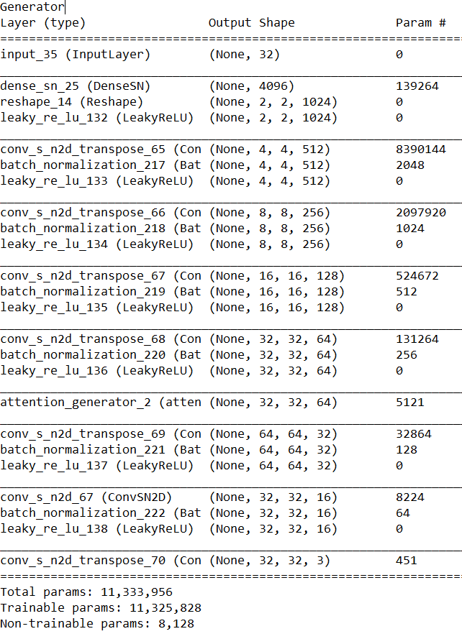

FID score for below architecture is 152.57.(over 500 samples with 30 epochs)

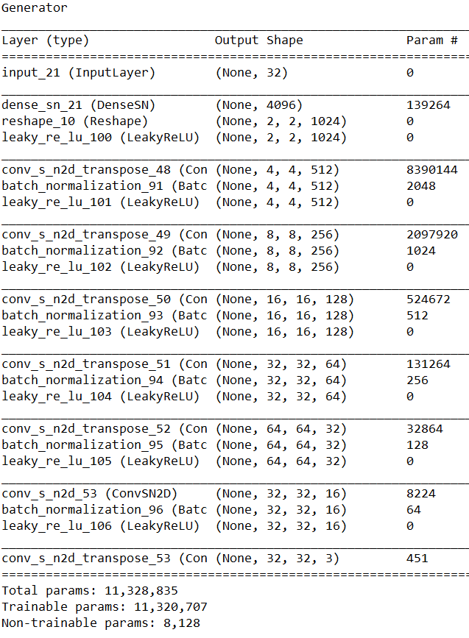 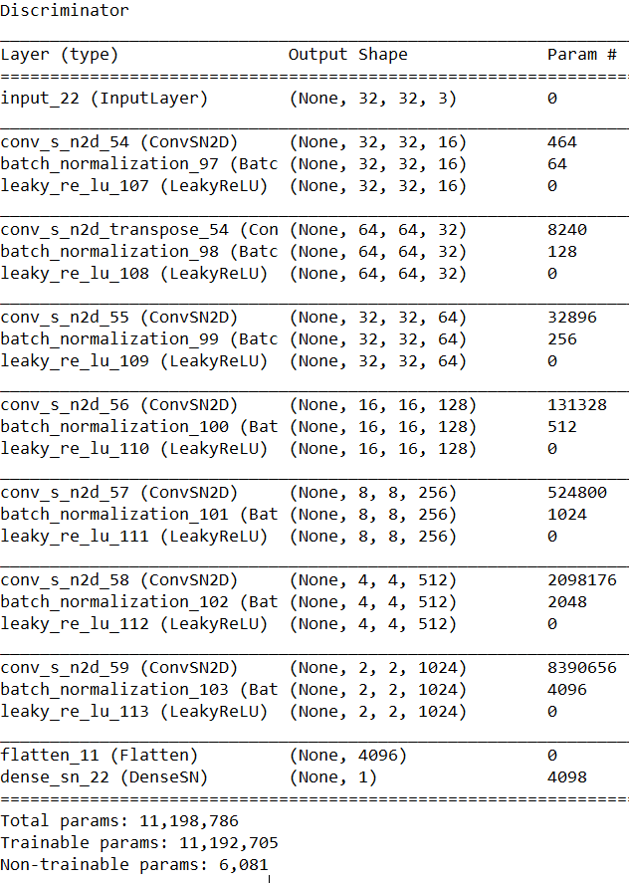

FID score for the below architecture with attention is 168.64. ( over 500 samples with 20 epochs)

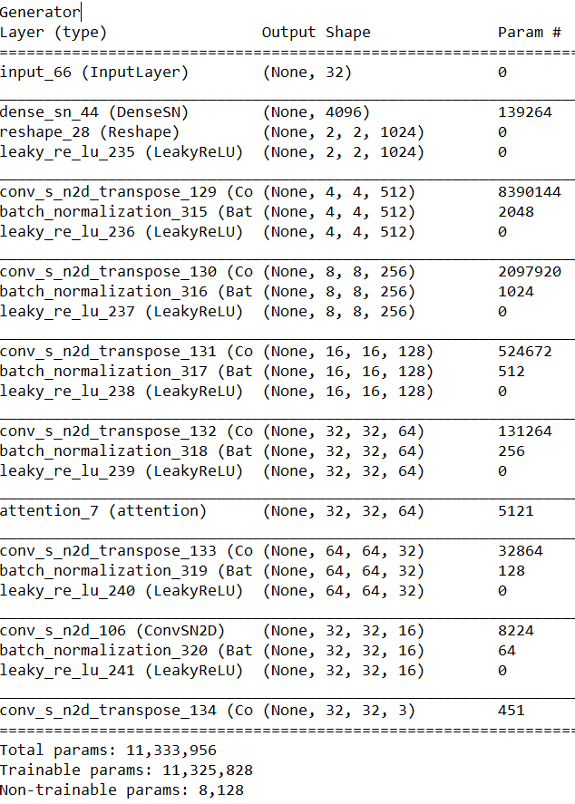 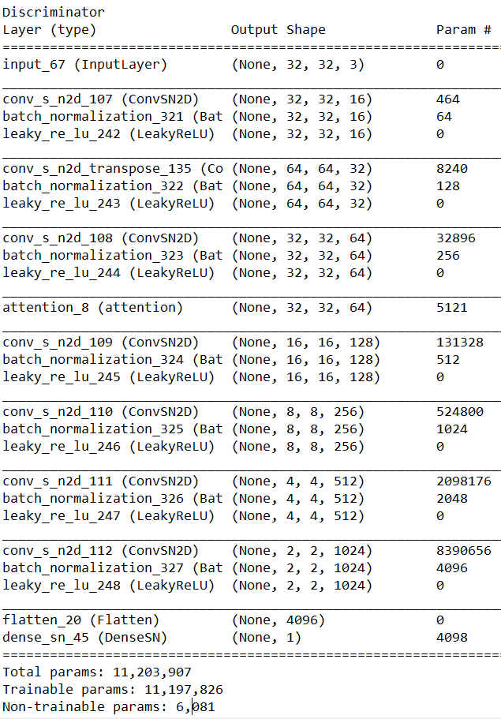

## FINAL MODELS:

FID score for below architecture is 97.8.(over 500 samples with 30 epochs)

Note: Ratio in TTUR is 5 here and batch size is changed to 32.

 

FID score for the below architecture with attention is 105.36. ( over 500 samples with 20 epochs)

Note: Ratio in TTUR is 5 here and batch size is changed to 32.

