
CONTRIVER®, Bengaluru
Department of Programming and Development

INTERNSHIP TRAINING REPORT
Submitted in partial fulfilment of the requirements for the certification of

90 days internship training program SUBMITTED BY

THANUSH
(4RA22IS056)

Under the Guidance of

Mr. SANJAY B
Sr. Production Head and Chief Executive Officer, Contriver.

Department of Programming and Development
M/S CONTRIVER®

402 B, Basement floor, Mysore Rd, Opp. Gopalan Arcade Mall, Rajarajeshwari Nagar, Bengaluru 560039, Karnataka, India
2025 - 2026

CONTRIVER®

402 B, Mysore Rd, Rajarajeshwari Nagar, Bengaluru 560039.
Department of Department of Programming and Development

TRAINING CERTIFICATE

This is to certify that Sri THANUSH (4RA22IS056). Bona-fide student of Rajeev Institute of Technology in partial fulfillment for the award of “Training Certificate” in Department of Programming and Development of the CONTRIVER, Bengaluru during the year 2025- 2026. It is certified that he/she has undergone internship during the time period from 06/09/2025 to 06/12/2025 of all working days corrections/suggestions indicated for internal validation have been incorporated in the report deposited to the guide and trainer. The training report has been approved as it satisfies the organizational requirements in respect of Internship training prescribed for the said qualification.

Shri. ATHREY S KATTI Mr. MOHAMMED SALMAN H Shri. SANJAY B

Bachelor of mechanical engineering.
Trainer of PD&D
DCV, B.E.
Sr. Design Engineer, Chief
DMT, B.E.
Sr. Production Head and Chief

Guide Operating Officer Executive Officer

ACKNOWLEDGEMENT
It is our privilege to express gratitude to all those inspired us and guided to complete the internship-training program. This work has remained incomplete without the direct and indirect help of many people who have guided us in the success of this internship. We are grateful to them.

Date:
Place: Bengaluru
- THANUSH

RESUME

THANUSH

Bachelor of Engineering, ISE
CONTACT INFORMATION
ADDRESS:
S/O R Umashankar,
Hemavathi-nagara, Behind Subramanya temple, Rochira Nilaya, Hassan, Karnataka - 573201
EMAIL ID: thanushhassan31@gmail.com
CONTACT NO: 9110699850
OBJECTIVE
Aspiring Software Engineer with a solid foundation in programming, data structures, data science, data analytics and algorithms, proficient in Python, Power-BI, SQL and Tableau. Seeking opportunities to apply technical expertise in real-world projects while contributing to innovative, high-impact solutions. Passionate about continuous learning, analytical problem-solving, and delivering value through clean, efficient code. Eager to collaborate with dynamic teams and play a meaningful role in driving organizational growth and success.
ACADEMIC INFORMATION
EDUCATION QUALIFICATIONS:

COURSE/EXAM | INSTITUTION | YEAR OF PASSING | MARKS OBTAINED IN %
10th STANDARD |  | 2020 | 87.2
PUC/12th |  | 2022 | 70
B.E IN | Rajeev Institute of | On-Going | 7.4 CGPA
Information | Technology, Hassan.
SCIENCE AND | Karnataka
ENGINEERING | VTU Affiliated

INTERNSHIP:

COMPANY NAME | CONTRIVER, Rajarajeshwari Nagar, Bengaluru-560039
INTERNSHIP NAME | Machine Learning and Generative AI
PROJECT DETAILS

Fake news detection using Machine Learning:
The spread of misinformation across social media, news outlets, and online platforms has become increasingly unpredictable due to varying sources, user biases, and manipulative content strategies. Traditional systems rely on keyword filters, manual fact-checking, and static dashboards that only display past flagged articles without predicting future risks or offering proactive guidance. These systems lack intelligent detection, ignore important factors like linguistic patterns, sentiment, and source credibility, and leave users to make decisions based on guesswork, often resulting in higher misinformation exposure and reduced trust in media.
Proposed Solution
The project introduces an AI-driven Fake News Detection System that uses machine learning and natural language processing (NLP) to classify news articles and social media posts as reliable or misleading. The system provides smart recommendations such as highlighting suspicious claims, ranking sources by credibility, and suggesting verified alternatives.

PERSONAL STRENGTH

- Network Security, Cybersecurity, and Ethical Hacking: Passionate about exploring network security, ethical hacking techniques, and securing digital infrastructures.
- Gaming and Travel: enhances strategic thinking and problem-solving skills; Travelling – fosters adaptability and cultural awareness.

DECLARATION

I hereby declare that all the information’s are correct and true to the best of my knowledge and belief.

DATE: Yours Sincerely,
Place: Bengaluru (THANUSH)

TAKEAWAY TOPICS FROM TRAINING

- PYTHON
  - INTRODUCTION TO PYTHON
  - PYTHON BASICS
  - DATA STRUCTURES
  - OBJECTED-ORIENTED PROGRAMMING(OOP)
  - FILE HANDLING
  - FILE READING
  - LIBRARIES

MACHINE LEARNING
  - INTRODUCTION TO MEACHING LEARNING
  - DATA PREPROCESSING
  - SUPERVISED LEARNING
  - UNSUPERVISED LEARNING

WEB DEVELOPMENT
  - HTML, CSS, JAVA SCRIPTS

PYTHON

INTRODUCTION TO PYTHON
Python is a high-level, interpreted, and general-purpose programming language known for its simplicity, readability, and wide range of applications. It is widely used in areas such as web development, data science, artificial intelligence, automation, and software development. Python’s clear syntax closely resembles natural language, making it easy to learn and suitable for both beginners and professionals. Its open-source nature and strong community support have contributed to the availability of extensive documentation, tools, and frameworks that accelerate development and problem-solving.

PYTHON BASICS
Python Basics include fundamental concepts such as variables, data types, operators, expressions, and control flow statements like conditional statements (if, else, elseif) and loops (for, while). These basics form the foundation of Python programming by enabling users to write logical, structured, and efficient programs. Understanding functions, input/output operations, and error handling is also essential, as they help in modularizing code, improving reusability, and managing runtime exceptions effectively.

DATA STRUCTURES
Data Structures in Python provide efficient ways to store, organize, and manipulate data. Built- in data structures such as lists, tuples, sets, and dictionaries are commonly used to handle collections of data. Lists allow ordered and mutable data storage, tuples store immutable sequences, sets manage unique elements, and dictionaries store data in key–value pairs. These data structures enhance performance, simplify complex operations, and play a crucial role in data processing and algorithm implementation.

OBJECT-ORIENTED PROGRAMMING(OOP)
Object-Oriented Programming (OOP) in Python focuses on organizing code using objects and classes, promoting modularity, reusability, and scalability. Key OOP concepts such as classes, objects, inheritance, polymorphism, encapsulation, and abstraction help structure large and complex applications efficiently. By modeling real-world entities as objects, Python OOP improves code maintainability and makes programs easier to understand, extend, and debug.

FILE HANDLING
File Handling in Python allows programs to interact with external files for storing and retrieving data. Python provides built-in functions and methods to create, open, write, append, and close files in various formats such as text and binary files. File handling is essential for data persistence, logging, and managing large datasets outside the program’s memory. Proper file handling techniques ensure data integrity and efficient resource management.
FILE READING

File Reading is a key aspect of file handling that enables programs to access and process data stored in files. Python supports multiple file reading methods, such as reading entire files, reading line by line, or reading specific portions of data. This functionality is especially useful in applications that involve data analysis, report generation, and configuration management, allowing programs to dynamically load and process external data.
LIBRARIES

Libraries in Python extend its core functionality by providing pre-built modules and packages for specific tasks. Popular libraries such as NumPy, Pandas, Matplotlib, TensorFlow, and Scikit- learn support numerical computation, data analysis, visualization, machine learning, and artificial intelligence. By using libraries, developers can reduce development time, improve efficiency, and implement complex features without writing code from scratch, making Python a powerful and versatile programming language for modern applications.

MACHINE LEARNING

INTRODUCTION TO MACHINE LEARNING
Machine Learning is a subset of artificial intelligence that enables computer systems to learn from data and improve their performance without being explicitly programmed. It focuses on developing algorithms and models that can identify patterns, make predictions, and support decision-making based on historical data. Machine learning is widely used in applications such as recommendation systems, image and speech recognition, predictive analytics, and automation, making it a core technology in modern intelligent systems.

DATA PREPROCESSING
Data Preprocessing is a crucial step in machine learning that involves preparing raw data for analysis and model training. Real-world data is often incomplete, noisy, or inconsistent, so preprocessing techniques such as data cleaning, handling missing values, removing duplicates, normalization, standardization, and feature encoding are applied. Effective data preprocessing improves data quality, enhances model accuracy, and ensures reliable and meaningful learning outcomes.

SUPERVISED LEARNING
Supervised Learning is a machine learning approach where models are trained using labeled data, meaning that each input is associated with a known output. The algorithm learns the relationship between input features and target values to make accurate predictions on new, unseen data. Common supervised learning tasks include classification and regression, with widely used algorithms such as linear regression, decision trees, support vector machines, and random forests. This approach is extensively used in applications like fraud detection, spam filtering, and demand forecasting.

UNSUPERVISED LEARNING
Unsupervised Learning involves training models on unlabeled data, where no predefined output is provided. The goal is to discover hidden patterns, structures, or relationships within the data. Techniques such as clustering, dimensionality reduction, and association rule mining are commonly used in unsupervised learning. Algorithms like k-means clustering and principal component analysis (PCA) help in grouping similar data points and reducing complexity, making this approach valuable for exploratory data analysis, customer segmentation, and anomaly detection.

WEB DEVELOPMENT
Web Development is the process of creating and maintaining websites and web applications that run on the internet. It involves designing the structure, appearance, and functionality of web pages to ensure an effective and user-friendly experience. Core web technologies such as HTML, CSS, and JavaScript work together to build responsive, interactive, and visually appealing websites that can be accessed across different devices and platforms.

HTML

HTML (Hyper-Text Markup Language) is the foundational language used to create the structure and content of web pages. It defines elements such as headings, paragraphs, images, links, forms, and tables using a system of tags. HTML provides the basic skeleton of a website,

enabling browsers to interpret and display content correctly. A well-structured HTML document improves accessibility, search engine optimization (SEO), and overall website organization.

CSS
CSS (Cascading Style Sheets) is used to control the presentation and layout of web pages. It defines styles such as colors, fonts, spacing, alignment, and responsiveness, allowing developers to enhance the visual appeal of a website. CSS separates content from design, making web pages easier to maintain and modify. Advanced CSS features such as flexbox, grid, and media queries enable responsive designs that adapt to different screen sizes and devices.

JAVA SCRIPTS
JavaScript is a scripting language that adds interactivity and dynamic behavior to web pages. It allows developers to create features such as form validation, animations, dynamic content updates, and interactive user interfaces. JavaScript runs in the browser and interacts with HTML and CSS to enhance user engagement. With the support of modern frameworks and libraries, JavaScript plays a critical role in developing interactive and feature-rich web applications.

TAKE AWAY TOPICS FROM GUEST LECTURER (2-3)

- INTRODUCTION TO WORDPRESS
- WORDPRESS INSTALLATION AND SETUP
- WORDPRESS DASHBOARD
- WORDPRESS THEMES
- WORDPRESS PLUGINS

Introduction to WordPress
WordPress is a popular open-source content management system (CMS) used to create and manage websites and blogs with ease. It is built using PHP and MySQL and is widely adopted due to its flexibility, user-friendly interface, and strong community support. WordPress allows

users to build a wide range of websites, including personal blogs, business websites, portfolios, and e-commerce platforms, without requiring advanced programming knowledge. Its extensible architecture and vast ecosystem of themes and plugins make it a powerful tool for modern web development.

WordPress Installation and Setup
WordPress installation involves setting up the software on a web server or local environment. This process typically includes selecting a hosting provider, creating a database, and configuring essential settings such as site title, admin credentials, and permalinks. WordPress can be installed manually or through one-click installers provided by many hosting services. Proper setup ensures website security, performance optimization, and smooth functionality. Initial configuration also includes selecting a language, setting time zones, and installing essential plugins to enhance site performance and security.

WordPress Dashboard
The WordPress dashboard is the central control panel used to manage all aspects of a website. It provides access to features such as creating and editing posts and pages, managing media files, moderating comments, and configuring site settings. The dashboard interface is designed to be intuitive, allowing users to navigate easily through menus like Appearance, Plugins, Users, and Settings. It also displays important updates, notifications, and site statistics, enabling administrators to monitor and maintain the website efficiently.

WordPress Themes
WordPress themes define the visual appearance and layout of a website. They control elements such as design, typography, color schemes, and page structure. Themes can be customized to match specific branding requirements and user preferences. WordPress offers thousands of free and premium themes that support responsive design and modern web standards. Customizing themes allow users to enhance user experience while maintaining consistency across the website. Themes can also be extended or modified using custom CSS and template files.

WordPress Plugins
WordPress plugins add functionality and features to a website without altering core files. They enable users to integrate tools such as contact forms, search engine optimization (SEO), security enhancements, performance optimization, and e-commerce capabilities. Plugins make WordPress highly flexible and scalable by allowing websites to grow and adapt to changing

requirements. With thousands of plugins available in the WordPress repository, users can easily
extend their website’s capabilities while maintaining stability and performance.

FEEDBACK/OPINOIN OF THE INTERSHIP

Innovative topics/Methods:
The internship introduced several innovative topics and modern technological methods that align well with current industry trends. The integration of Python programming, machine learning concepts, and web development tools provided exposure to practical, real-world problem solving rather than purely theoretical learning. The use of data-driven approaches, predictive models, and optimization techniques demonstrated how emerging technologies can be applied to solve complex engineering problems effectively.
Additionally, the internship emphasized hands-on learning through project-based methodologies. Instead of traditional lecture-based teaching, the focus was on implementation, experimentation, and analysis. This approach encouraged critical thinking, improved problem- solving skills, and helped in understanding how theoretical concepts are translated into functional systems. The exposure to modern frameworks, libraries, and development environments further enhanced technical competence.
Overall, the innovative teaching methods and topic selection helped bridge the gap between academic learning and industrial applications. The structured workflow, real-time examples, and practical assignments significantly improved conceptual clarity and technical confidence.

Industrial significance of the topics:
The topics covered during the internship have strong industrial relevance and are widely used in various domains such as energy management, data analytics, automation, and web-based systems. Machine learning techniques such as prediction and optimization are increasingly important in industries that rely on data-driven decision-making. Python’s role as a primary programming language in industry further strengthens the practical value of the internship.
Web development and content management tools like WordPress introduced during the internship is essential for building user interfaces, dashboards, and online platforms. These skills are directly applicable in software companies, startups, and enterprises that require

scalable and user-friendly digital solutions. The combination of backend logic and frontend visualization mirrors real-world development practices.
By aligning the training with industry requirements, the internship enhanced employability skills and prepared participants for professional environments. The exposure to industrial tools, workflows, and problem-solving techniques makes the knowledge gained highly applicable in real-time industrial projects.

Syllabus/Concepts that can be included/recommended in engineering curriculum (Academics):
The internship highlighted several concepts that should be incorporated into the engineering curriculum to improve industry readiness. Topics such as Python programming, data preprocessing, machine learning fundamentals, and web application development should be introduced at earlier stages of academic learning. This would help students develop strong practical foundations alongside theoretical knowledge.
Incorporating project-based learning and real-world case studies into the syllabus can significantly enhance understanding and engagement. Concepts like supervised and unsupervised learning, data visualization, API integration, and basic deployment practices are highly relevant and should be included as core or elective subjects. Exposure to tools such as Git, cloud platforms, and modern frameworks would further strengthen academic outcomes. Updating the curriculum to reflect current technological advancements will help bridge the gap between academics and industry. Internships like this demonstrate the importance of skill- oriented education and continuous curriculum modernization.

Area of improvements/Drawbacks in the internship program:
While the internship was highly informative, there are a few areas where improvements can be made. One drawback was the limited duration for covering complex topics such as machine learning and system optimization. Extending the internship duration or providing advanced sessions could allow deeper exploration and better understanding of these concepts.
Additionally, more industry-level case studies and live project demonstrations could further enhance practical exposure. Regular assessments, structured milestones, and personalized

feedback would help track individual progress more effectively. Some participants may also benefit from additional support sessions to clarify advanced concepts.
Addressing these areas of improvement would make the internship more comprehensive and impactful. Enhancing interaction, mentoring, and real-world exposure can further elevate the overall learning experience.

Opinion of the internship:
Overall, the internship was a valuable and enriching learning experience. It provided a strong balance between theoretical concepts and practical implementation, enabling a clear understanding of modern technologies and their applications. The structured learning approach, combined with hands-on projects, significantly improved technical skills and professional confidence.
The internship also helped in developing problem-solving abilities, analytical thinking, and teamwork skills. Exposure to industry-relevant tools and workflows prepared participants for real-world challenges and future career opportunities. The guidance and support provided during the program contributed positively to the learning environment.
In conclusion, the internship successfully met its objectives and added significant value to academic and professional development. It is highly recommended for students seeking practical exposure, skill enhancement, and industry-oriented learning experiences.

CONTENTS

LIST OF FIGURES ..............................................................................................
LIST OF TABLES ................................................................................................
CHAPTER 1
INTRODUCTION 1-3
  - OVERVIEW 1
  - EXISTING SYSTEM 1
  - PROPOSED SYSTEM 1-2
  - ORGANIZATION OF THE REPORT 3
CHAPTER 2
LITERATURE SURVEY 4-6
  - INTRODUCTION 4
  - EXISTING TECHNIQUES/RELATED WORK 4-5
  - COMPARATIVE ANALYSIS 5
  - RESEARCH GAPS/ PROBLEM IDENTIFICATION 5-6
  - EXPECTED CONTRIBUTION 6
  - SUMMARY/CONCLUSION 6
  - REFERENCE 6
CHAPTER 3
SYSTEM REQUIREMENT SPECIFICATION 7-12
  - OBJECTIVE 7
  - FUNCTIONAL REQUIREMENTS 7-9
    - USE CASE DIAGRAM 8-9
  - NON-FUNCTIONAL REQUIREMENTS 9-11
  - SYSTEM REQUIREMENTS 12
CHAPTER 4
SYSTEM ANALYSIS AND DESIGN 13-23
  - HIGH LEVEL DESIGN 13-16
    - System Architecture 13
    - Data Flow Diagram 14-16
  - DATA FLOW DIAGRAM 17-23

IMPLEMENTATION 24-27
    - CLIENT-SERVER ARCHITECTURE 24
      - Frontend Dashboard 24
      - Backend Server 25
    - DATA UPLOAD AND API HANDLING 25
    - AI-BASED PRICE PREDICTION 26
    - AI NEWS GENERATION CODE 26
    - FRONTEND IMPLEMENTATION 27
CHAPTER 6

TESTING 28-31
  - TESTING METHODOLOGY 28
  - UNIT TESTING 28-29
  - FUNCTIONAL TESTING 29
  - INTEGRATION TESTING 29
  - VALIDATION OF AI-BASED PREDICTION 30
  - ERROR HANDLING AND BOUNDARY TESTING 30
  - PERFORMANCE TESTING 30
  - TEST CASE SUMMARY 31
  - SUMMARY 31

CHAPTER 7

RESULT AND DISCUSSION 32-36
SNAPSHOTS
  - PYTHON IMPORT STATEMENTS 32
  - API KEYS USED IN THE APPLICATION 32
  - FETCHING THE DATA 34
  - LOADING THE CHARTS 34
  - EXECUTE DETAILS 35
  - EXECUTE DETAILS 35
  - NEWS DRIVEN AND TEXT GENERATED 36

CONCLUSION 37

FUTURE ENHANCEMENT 37

BIBLIOGRAPHY 38

APPENDIX 39-40

LIST OF FIGURES
Figure 3.1 Use Case Diagram 8
Figure 4.1 Data Flow Block Diagram 13
Figure 4.1.1 System architecture ………………………………………………………………. 16
Figure 4.3 AI-powered stock market prediction 18
Figure 4.4 Map reduce module 20
Figure 4.5 Evaluation module 22
Figure 7.1 Python import statements 32
Figure 7.2 API keys used in the applications 32
Figure 7.3 Fetching the data 33
Figure 7.4 Loading the charts 34
Figure 7.5 Execute details 35
Figure 7.6 Execute details 35
Figure 7.7 News driven and text generated 36

Chapter 1

  - Overview

INTRODUCTION

The stock market is a complex and dynamic system influenced by various factors such as historical price movements, market trends, and news events. With the growth of AI and ML, it has become possible to analyze large volumes of financial data efficiently. This project focuses on developing an AI-Powered Stock Market Simulator that combines historical stock data with news-driven insights to simulate market behavior. The system uses ml techniques for price prediction, sentiment analysis of news, and text generation to provide meaningful insights. An interactive web interface is developed using Streamlit to visualize historical prices, predicted trends, and generated summaries, making the system useful for educational and analytical purposes.

Existing System

In the existing system, stock market analysis is mainly performed using traditional tools such as spreadsheets, basic charting platforms, and standalone financial websites. These systems primarily rely on historical price data and technical indicators without considering the impact of real-time news and market sentiment. Prediction methods are either manual or based on simple statistical models, which limits accuracy and adaptability. Additionally, most existing platforms do not provide integrated text-based explanations or insights, making it difficult for beginners to understand market behavior. The lack of interactivity, automation, and AI-based analysis reduces the effectiveness of traditional stock market simulation systems.

Disadvantages of Existing System

Existing systems mainly depend on historical stock price data and do not consider the impact of real-time news and market sentiment. Traditional prediction methods are often manual or based on simple statistical models, resulting in low prediction accuracy. Lack of integration between stock data analysis and news-based insights limits a complete understanding of market behavior. Limited interactivity and visualization features reduce user engagement and learning effectiveness.

Proposed System

The proposed system introduces an AI-Powered Stock Market Simulator with News-Driven Text Generation
to overcome the limitations of existing methods. It integrates multiple data sources such as Yahoo Finance, Alpha

Vantage, and News API to collect stock prices and financial news. Machine learning algorithms are used to predict future stock prices based on historical data, while news sentiment analysis helps capture the effect of market- related events. The system also generates simple textual summaries to explain market trends and predictions. An interactive Streamlit-based web interface allows users to select stock symbols, time periods, and prediction parameters easily. This proposed system provides a more intelligent, interactive, and educational approach to stock market simulation. The goal of this system is twofold. Firstly, a framework for creating Hadoop clusters with different processing capabilities is designed. Secondly, in the consideration of utilizing the created virtual clusters and to share the spare resources, a new scheduler is offered to support jobs with performance.

Advantages of Proposed System
- Integrates historical stock data with real-time news information for more realistic market simulation.
- Uses machine learning techniques to predict future stock prices, improving analysis accuracy.
- News-driven sentiment analysis helps understand the impact of market events on stock prices.
- Generates automatic text-based insights, making stock trends easier to understand for beginners.
- Provides interactive and user-friendly visualizations through a web-based interface.
- Supports multiple data sources, increasing reliability and flexibility of the system.
- Serves as an effective educational tool for learning AI, machine learning, and stock market concepts.

Organization of the report

Chapter 1
Chapter 1 describes the overview, the existing system and the proposed system.

Chapter 2
Chapter 2 contains the literature survey and the background study of AI-Powered Stock Market Simulation with News-Driven and Text Generation

Chapter 3
Chapter 3 summarizes the Functional, Non-Functional and System requirements of the project.

Chapter 4
Chapter 4 signifies the system design and analysis with highlights of the system architecture, low level design and high-level design.

Chapter 5
Chapter 5 includes the implementation part of the project along with the pseudo code.

Chapter 6
Chapter 6 includes the various testing approaches performed.

Chapter 2

Introduction

LITERATURE SURVEY

Simulating stock market behavior using AI requires integrating financial forecasting models with natural language generation systems that respond to real-world news. This survey explores traditional and AI-based market prediction methods, sentiment analysis, generative text models, and hybrid frameworks that combine financial data with news-driven simulation Background / Theoretical Framework
- Stock market simulation: Modelling price movements, volatility, and investor behavior using historical and synthetic data.
- Financial forecasting: Time-series models (ARIMA, GARCH), machine learning (SVM, RF), and deep learning (LSTM, Transformer) for predicting stock prices.
- Sentiment analysis: NLP techniques to extract market sentiment from news, tweets, and financial reports.
- Reinforcement learning: Agents trained to simulate trading strategies and market reactions based on evolving news and price data.

Existing Techniques / Related Work

Traditional Financial Models
      - ARIMA and GARCH models are widely used for volatility and price prediction.
      - These models offer interpretability but struggle with nonlinear patterns and external factors like news sentiment.

Machine learning for Market Prediction
      - Random Forest, SVM, and XG Boost have shown strong performance on structured financial datasets.
      - Feature engineering (e.g., technical indicators, macroeconomic variables) is critical for accuracy.

Deep learning for Price Forecasting
      - LSTM and Transformer models capture temporal dependencies and complex patterns in stock data.
      - Hybrid models (CNN-LSTM, Transformer-GRU) improve accuracy for short-term and intraday predictions.

Sentiment Analysis from News
      - Lexicon-based and supervised learning approaches extract sentiment from financial news and social media.

      - BERT and Fin BERT models fine-tuned on financial corpora outperform traditional sentiment classifiers using News API.

Text Generation for Financial Narratives
      - GPT-2, GPT-3, and T5 models generate realistic financial commentary and simulate news impact.
      - Few-shot and fine-tuned models can produce scenario-based narratives aligned with market movements.

Comparative Analysis (summary)

Approach | Strengths | Weaknesses | Typical use
ARIMA / GARCH | Interpretable, good for volatility | or with non-linearities | Baseline forecasting
Random Forest / XG Boost | Good with structured  features, robust | Needs feature engineer | Short term prediction with tabular/structured data
TM / Transformer | Captures temporal patterns,  high accuracy | Compute-intensive, Data-  hungry | Intraday and multi-day  forecasting
RT / Fin BERT  (Sentiment) | Context-aware sentiment  extraction | Requires domain specific  fine tuning | News sentiment analysis
T / T5 (Text  Generation) | Coherent, realistic text  generation | May hallucinate facts, lacks  grounding | Simulated news generation
(DQN, PPO) | Learns adaptive strategies | Sample inefficiency, complex tuning | ding simulation
Table 2.3.1: Comparative Analysis

Research Gaps / Problem Identification Trading simulation
- Lack of integration: Few systems combine price forecasting, sentiment analysis, and text generation into a unified simulator.
- Realism in simulation: Generated news often lacks grounding in actual market dynamics, reducing realism.
- Explainability: Deep models used for forecasting and generation are black-boxes, limiting trust in simulation outcomes.
- Adaptivity: Simulators often fail to adapt to sudden market shifts or novel news events.
- Evaluation metrics: Standardized metrics for evaluating realism and impact of generated news on simulated markets are lacking.

- Hyperparameter tuning and scaling: Hybrid approaches (e.g., PSO-LSTM) show promise but need systematic evaluation on diverse, realistic datasets for generalization.

How these gaps inform the proposed project (expected contributions)
- Develop a hybrid simulator combining LSTM/Transformer-based forecasting with Fin BERT driven sentiment analysis and GPT-based news generation.
- Use reinforcement learning to simulate trading behavior in response to generated news and predicted prices.
- Implement explainability modules (e.g., feature importance, sentiment scores) to justify simulation outcomes.
- Evaluate using both financial metrics (RMSE, Sharpe ratio) and NLP metrics (BLEU, ROUGE, coherence).

Summary / Conclusion
The literature shows a progression from statistical models to deep learning and generative AI in financial simulation. However, integration across forecasting, sentiment analysis, and text generation remains limited. A unified AI-powered simulator that models market behavior and generates realistic news narratives can fill this gap and offer a powerful tool for education, strategy testing, and financial storytelling.

Reference (Suggested Key Papers for Citations)
- Zhang, Y., et al. (2020). "Stock market prediction via LSTM and attention mechanisms."
- Araci, D. (2019). Fin BERT: Financial sentiment analysis with pre-trained language models.
- Liu, Y., et al. (2021). "Text generation for financial narratives using GPT-2." • Yang, Y., et al. (2022).
"Reinforcement learning for stock trading: A survey."
- Chen, H., et al. (2018). "Financial news impact on stock market prediction using deep learning."

Chapter 3

SYSTEM REQUIREMENT SPECIFICATION

This SRS outlines an AI system that ingests financial news, performs text recognition and NLP, and generates actionable stock movement predictions and sentiment signals. It captures objectives, scope, functional and non- functional requirements, and core use cases for development and validation.

Objective

Purpose: Define clear requirements for an AI system that predicts short-term stock movements by analysing news articles, press releases, social media finance posts, and filings through text recognition and NLP. Outcome: Deliver sentiment scores, event classifications, and predictive signals to support traders, analysts, and automated strategies.
Stakeholders: Product managers, data scientists/ML engineers, backend/frontend engineers, DevOps/ML Ops, compliance officers, and end users (retail/pro institutional).

Scope and assumptions
- In scope: News ingestion and OCR, entity recognition (tickers/companies), sentiment analysis, event detection, predictive modelling, signal delivery via API/dashboard, and back-testing.
- Out of scope: Long-horizon macro forecasting, portfolio construction, brokerage execution, and proprietary market data redistribution.
- Assumptions: Availability of licensed news feeds, historical market data, ticker mapping, and compliance review for content usage.

Functional Requirements

- News ingestion: Aggregate structured/unstructured sources (RSS, web feeds, licensed APIs, PDFs, images) with time-stamped metadata.

- Text recognition (OCR): Extract text from images/scanned PDFs; support multilingual content and noisy layouts.

- De-duplication: Identify and collapse duplicate or near-duplicate articles; maintain canonical record.
- Ticker/company resolution: Map entities to listed tickers with confidence scores; handle subsidiaries and mergers.

Use Case Diagrams

A use case diagram in the Unified Modeling Language (UML) is a behavioral diagram defined by and created using the use-case analysis. It captures the essential requirements of a new system or software change.

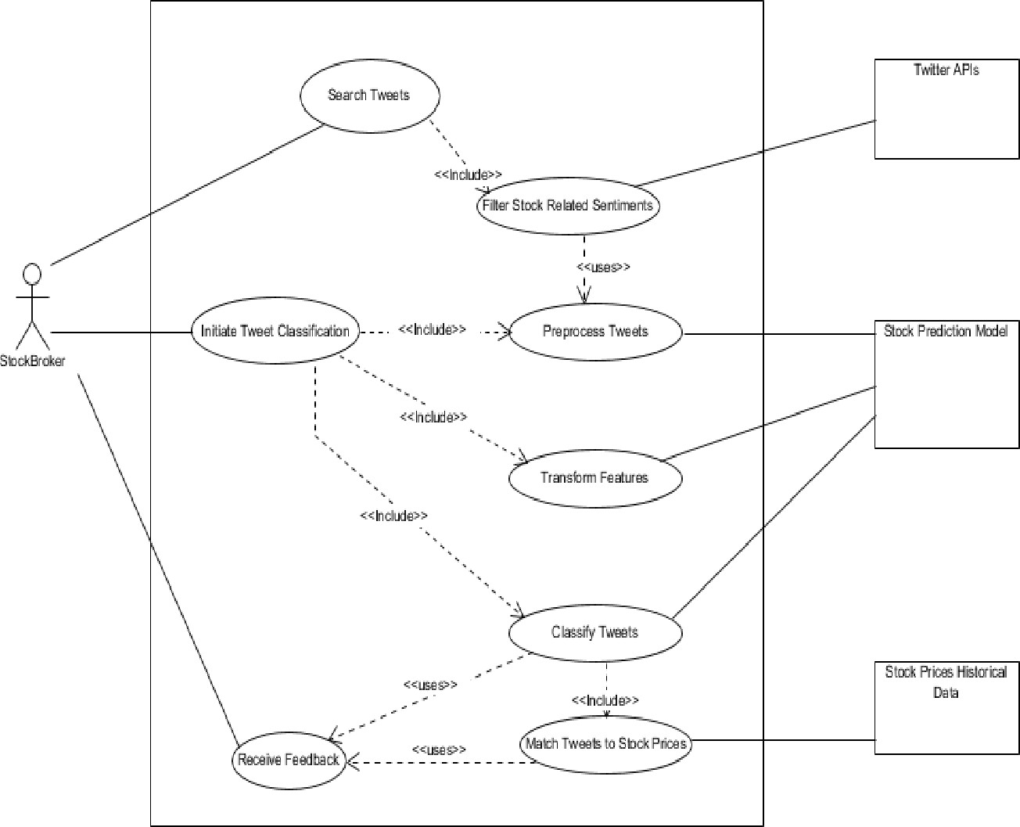

Figure 3.1: Use Case Diagram of AI-Powered stock market prediction

The foremost purpose is to provide a graphical representation of the functionality of the AI-powered stock prediction system in terms of actors, their goals (specified as use cases), and any dependencies between those use cases. Each use case illustrates how the system interacts with end users or external systems to achieve specific financial analysis and prediction goals.

Use cases:
A use case elaborates a sequence of actions that delivers measurable value to an actor, such as
predicting stock movement based on news sentiment. Use cases are drawn as horizontal ellipses and may include:

- Ingest Financial News
- Perform OCR/Text Recognition
- Extract Entities and Map Tickers
- Analyze Sentiment and Classify Events
- Generate Stock Movement Predictions
- Deliver Alerts and API Responses
- Audit and Compliance Review

Actors:
Actors represent entities interacting with the system. They are drawn as stick figures and include:

- Trader/Investor: Uses predictions and alerts to make decisions.
- Data Scientist: Trains and monitors models.
- News Provider/API: Supplies raw news content.
- Compliance Officer: Reviews audit logs and content licensing
- External System/API Client: Integrates predictions into trading platforms or dashboards.

Associations:
Associations are solid lines connecting actors to use cases, indicating interaction. For example:
- A Trader is associated with Receive Prediction Alerts.
- A News Provider is associated with Ingest Financial News.
- A Data Scientist is associated with Train Models and Audit Model Performance.

System boundary boxes:

To define the scope of the AI system, a rectangle can be drawn around the use cases. This boundary box distinguishes internal system functionality (e.g., NLP, prediction engine) from external actors and systems. Anything outside the box—such as external trading platforms or raw news sources—is not within the system’s scope.

Non-Functional Requirements

A non-functional requirement specifies the criteria that may be used to judge the operation of a system rather than

the specific behavior. If differs from the functional requirement where it specifies the specific behavior or functions. On the other hand, non-functional requirement defines how the system is supposed to be. They are expressed in the form “system shall be <requirement>”.

Performance
Performance requirements specify how fast and efficiently the system should operate under given condition.
- Latency: The system must process incoming news and generate predictions within 5–10 seconds depending on source type.
- Throughput: It should handle 100,000+ articles per day and predictions for 5,000+ tickers.
- Scalability: Must scale horizontally to handle spikes (e.g., earnings season).

Security
Security requirements ensure that the system protects data, prevents unauthorized access, and complies with regulations.
- Encryption: All data must be encrypted at rest and in transit.
- Access Control: Role-based authentication for traders, data scientists, and compliance officers.
- Audit Logging: Immutable logs for predictions, inputs, and model versions.
- Compliance: Adherence to GDPR, SEBI, SEC, or other financial data regulations.

Reliability & Availability
Reliability and availability requirements define how dependable and accessible the system must be.
- Uptime: Maintain 99.9% availability for APIs and dashboards.
- Fault Tolerance: Automatic retries and failover mechanisms for ingestion pipelines.
- Disaster Recovery: Recovery Point Objective ≤ 15 minutes; Recovery Time Objective ≤ 1 hour.
- Resilience: Graceful degradation during outages (fallback predictions).

Maintainability

Maintainability requirements describe how easily the system can be updated, fixed, or extended.

- Modularity: Microservices architecture with clear contracts.

- Versioning: Maintain model registry with reproducibility.

- Testing: Automated unit, integration, and regression tests.

- CI/CD: Continuous integration and deployment pipelines with rollback.

4 5.Observability

Observability requirements ensure the system can be monitored, diagnosed, and improved.

- Monitoring: Real-time metrics for ingestion, OCR accuracy, sentiment calibration, and prediction hit rates.

- Alerting: Automated alerts for failures, drift, or latency anomalies.

- Explainability: Provide interpretable outputs (e.g., sentiment drivers, event tags).

Usability

Usability requirements define how user-friendly and accessible the system should be.

- Dashboard UX: Intuitive interface with filters (sector, ticker, sentiment).

- Accessibility: Support multiple languages and screen-reader compatibility.

- Customization: Configurable alerts and prediction horizons.

- Integration: Easy API integration with trading platforms and BI tools.

System Requirements

Hardware requirements

Processor : Intel Core i5 or higher (multi-core)
Storage : 1 TB SSD for fast data access
RAM : Minimum 8 GB (16 GB recommended)
GPU : NVIDIA RTX 3060 or higher for model training and inference.
Network : High-speed internet (≥100 Mbps) for real-time news ingestion.

Software requirements

Operating System : Ubuntu 20.04 LTS or later Programming Lang : Python 3.9+
: TensorFlow or Py-Torch, spa-Cy, NLTK, (Hugging-Face) Frameworks

OCR Engine : Tesseract OCR or Google Vision API Database : PostgreSQL or MongoDB
Message Queue : Apache Kafka or RabbitMQ IDE : VS Code, Jupyter Notebook Deployment Tools : Docker, Kubernetes Monitoring Tools : Prometheus, Grafana Version Control : Git with GitHub or GitLab

Chapter 4

SYSTEM ANALYSIS AND DESIGN

The process of designing, developing, and refining intelligent systems for financial prediction is guided by the Systems Development Life Cycle (SDLC). This structured methodology ensures that each phase—from requirement gathering to deployment—is planned, monitored, and optimized for performance and reliability. In the context of AI-powered stock market prediction, SDLC helps define how news-driven data is ingested, processed, and transformed into actionable insights through machine learning and natural language processing.

High Level Design

High-Level Design provides a blueprint of the system architecture and its major components. It outlines how modules interact, what data flows between them, and how external systems (e.g., news APIs, trading platforms) integrate with the core prediction engine.

System Architecture
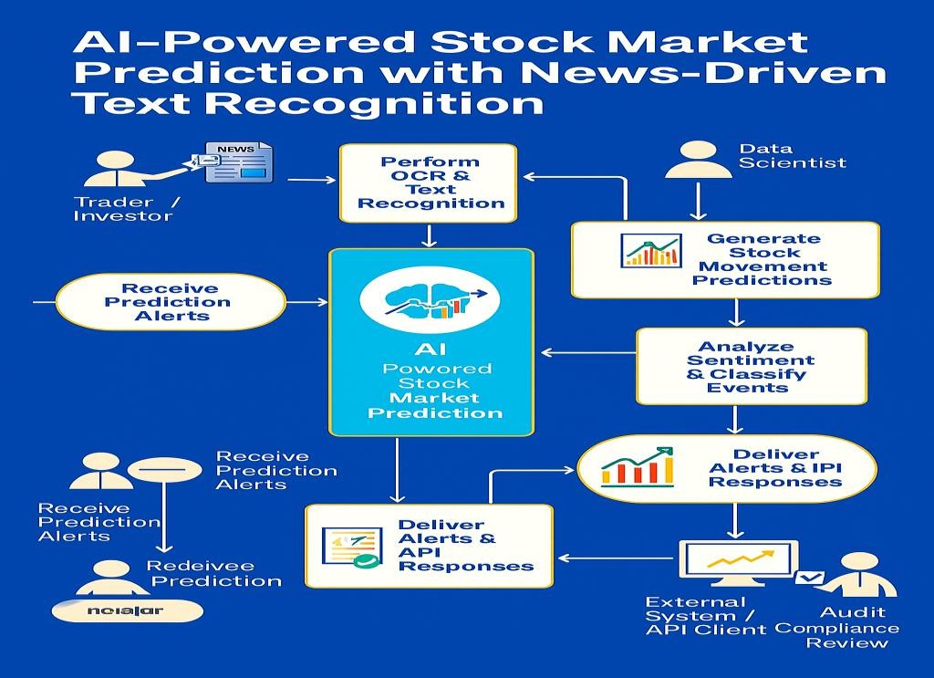

This architecture is designed for real-time ingestion of financial news, text recognition/NLP, feature engineering, short-horizon prediction, and delivery of signals to end users and external systems. It emphasizes modularity, scalability, auditability, and low-latency processing.

Architecture overview
      - Core layers: Data acquisition, processing (OCR/NLP), feature store, prediction services, delivery interfaces, governance/observability.
      - Processing modes: Stream for real-time signals; batch for re-scoring, backtesting, and model retraining.
      - Scalability: Horizontally scalable microservices with stateless APIs, distributed storage, and message-based decoupling.

Layered components

Data acquisition layer
      - Connectors: RSS/news APIs, filings, social finance posts, PDFs/images.
      - Metadata normalizer: Extract: source, timestamp, language, author, URL, license.
      - Queue/stream: Buffer: events; decouple: producers from downstream consumers

Text recognition and NLP layer
      - OCR service: Detect: document type/language; extract: text with confidence and layout segments.
      - NLP pipeline: Tokenize, NER, coreference: map companies and tickers; sentiment/event: earnings, guidance changes, M&A, litigation, regulatory actions; relevance: score per ticker/sector.
      - Content summarizer (optional): Generate: concise summaries for dashboards and alerts.

Feature store and market data layer
      - Feature assembler: Join: news-derived features with historical price/volume, volatility, sector indices, calendar (earnings dates).
      - Temporal aligner: Sync: publish time, event time, market trading windows; dedupe: near-duplicates.
      - Feature store: Persist: versioned features; serve: consistent reads to training/inference.

Data Flow Diagram

A data flow diagram (DFD) is a graphical approach that interprets the information flow and the transformation that is practiced while data moves from input to output. The DFDs may be used to symbolize a system or software at any level of abstraction. It depicts what data flows rather than how they are processed. Therefore, it does not depend on software, hardware and data structure of file organization.
- Recognize: Non-text media pass through OCR; text cleaned and segmented.
- Understand: NLP extracts entities/tickers, classifies events, and scores sentiment/relevance.
- Assemble: News features join market data; aligned to trading windows and deduped.
- Predict: Online service generates signals; batch re-scoring refines later horizons.
- Deliver: Signals flow to APIs, dashboards, and alerts with explanations and audit references.
- Monitor: Metrics and logs captured; compliance checks and bias audits run periodically.

Deployment and scaling
- Microservices: Separate: ingestion, OCR/NLP, feature store, inference, delivery; communicate: via queues/streams and APIs.
- Storage: Hot: cache for recent features; warm: relational/NoSQL for features/predictions; cold: object storage for archives.
- Autoscaling: Scale: ingestion and inference on news spikes (earnings season); prioritize: high-impact events.
- Resilience: Retries: transient failures; circuit breakers: protect downstream; dead-letter queues: capture bad events.

Model lifecycle
- Training: Datasets: labelled event/sentiment and market outcomes; validation: rolling windows and cross- market robustness.
- Versioning: Registry: models, features, data slices; A/B: shadow tests before promotion.
- Drift management: Monitor: performance and feature distributions; retrain: adaptive schedules; rollback: on degradation.

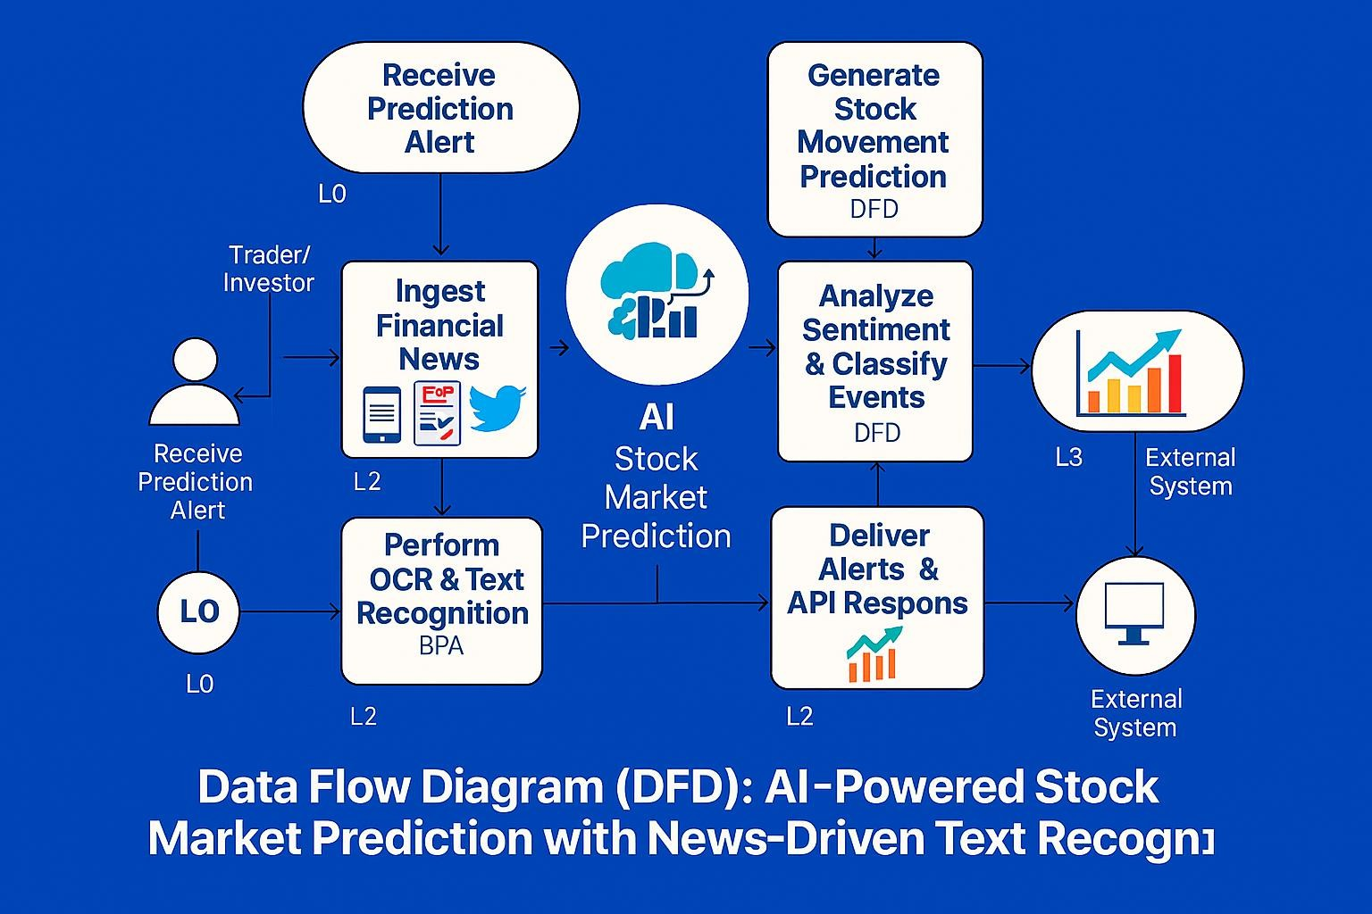

Figure 4.2: Data Flow Diagram

Data Flow Diagram (DFD)

External Entities

- News Sources: APIs, RSS feeds, social media, PDFs, filings.

- Trader/Investor: Consumes predictions and alerts.

- Data Scientist: Trains and monitors models.

- Compliance Officer: Reviews audit logs and licensing.

- External Systems: Trading platforms or BI dashboards integrating predictions

Processes

- News Ingestion

  - Collects raw financial news and metadata.

  - Normalizes formats and queues for processing.

OCR & Text Recognition

  - Converts scanned documents/images into machine-readable text.

  - Cleans and structures extracted text.

NLP Processing

  - Performs sentiment analysis (positive/neutral/negative).

  - Classifies events (earnings, M&A, litigation, regulatory).

  - Maps entities to tickers/sectors.

AI-Powered stock market prediction with news driven text generation Job Scheduling Module

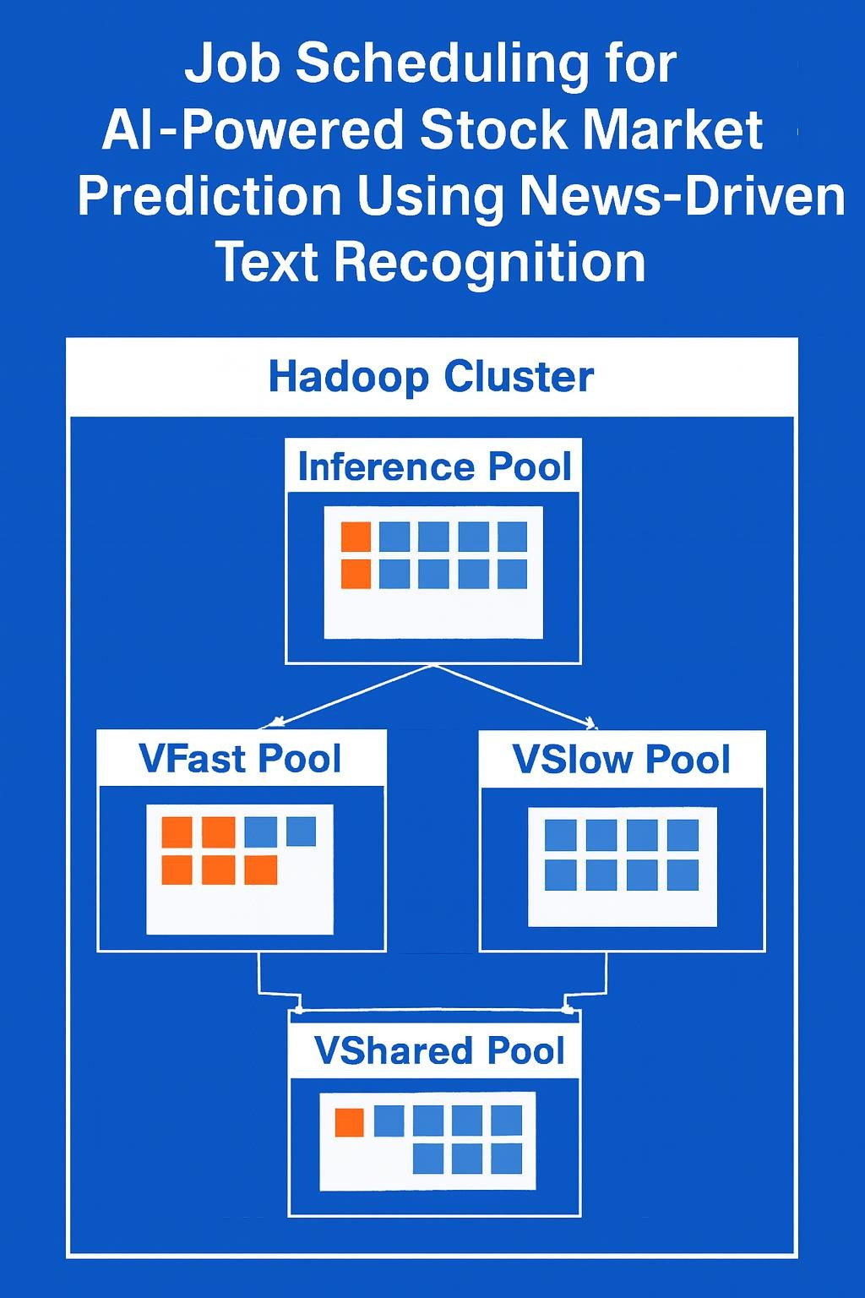

Figure 4.3: AI-Powered stock market prediction with news driven text generation Job Scheduling Model
It shows:
- Three nodes (Node1, Node2, Node3) processing financial news data.
- V-Fast Pool for high-priority tasks like real-time sentiment analysis.
- V-Slow Pool for batch tasks like historical back-testing.
- V-Shared Pool combining both types of tasks.
- Arrows indicating how tasks are dynamically scheduled across nodes.

Inference-Pool-Nodes(Node1,Node2,Node3):
Each node handles a mix of tasks like:
  - OCR (orange squares): converting scanned news to text
  - NER/Sentiment Analysis (blue squares): extracting entities and scoring tone

V-Fast-Pool:
Prioritizes real-time tasks such as:
  - Breaking news sentiment scoring
  - Immediate prediction generation
- V-Slow-Pool:
Handles batch tasks like:
  - Historical back-testing
  - Model retraining
  - Bias audits
- V-Shared-Pool:
Combines both task types for flexible resource allocation

This layout helps explain how your system dynamically schedules workloads across nodes based on urgency and resource type — ideal for presentations, SRS documentation, or architecture reviews.

MapReduce Module
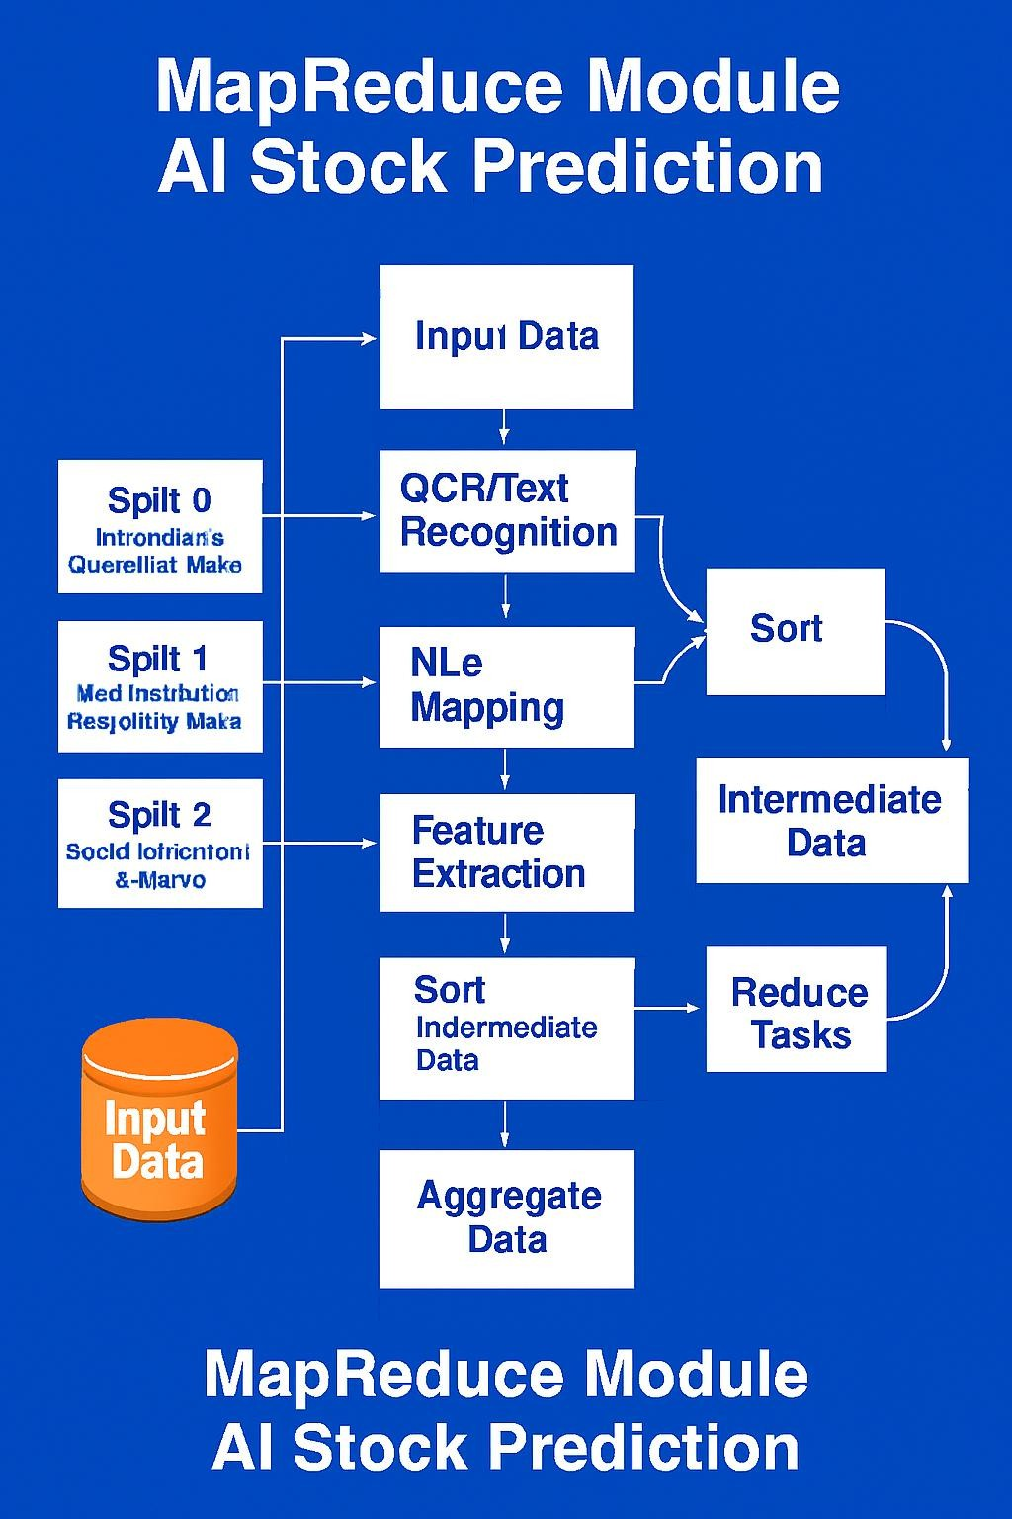
Figure 4.4: MapReduce Module

What it shows:
      - Input Data: News articles, social media posts, PDFs, and filings.

Splits:
  - Split 0: Earnings & guidance news
  - Split 1: M&A, litigation, regulatory updates
  - Split 2: Social sentiment & macroeconomic commentary

Map Phase:
  - OCR/Text Recognition
  - NLP Mapping (entities, sentiment, events)
  - Feature Extraction (ticker-level vectors)

Sort & Intermediate Data:
  - Sorted by ticker, timestamp, sentiment, event type
  - Aggregated into intermediate feature sets

Reduce Phase:
  - Shuffling and grouping by ticker/time window
  - Aggregation and prediction generation

Output:
      - Final predictions stored in HDFS replicas or feature store
      - Delivered via APIs and dashboards

Evaluation Module

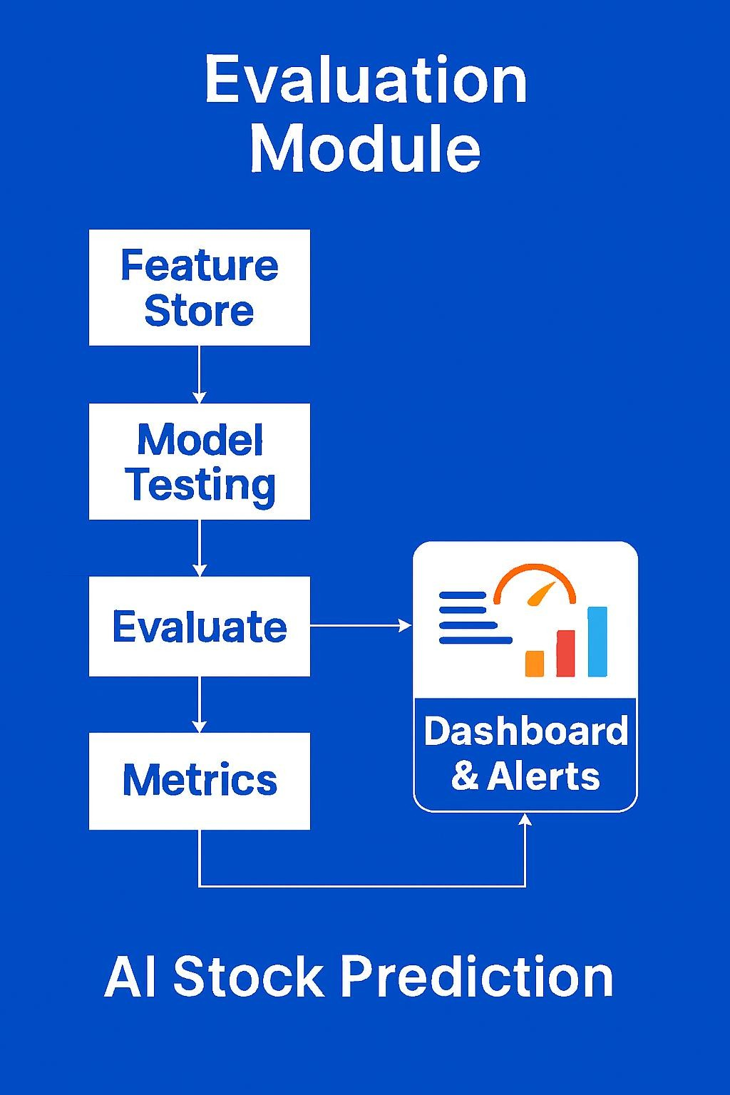
Figure 4.5: Evaluation Module

Evaluation Pipeline
- Feature Store
- Stores processed features: sentiment scores, event tags, ticker mappings, historical price/volume.
- Model Testing
- Runs trained models (e.g., LSTM, XG-Boost) on unseen data.
- Applies rolling windows and cross-validation.
- Evaluate
- Compares predictions against actual market movements.
- Flags false positives, missed signals, and drift.
- Metrics
- Tracks accuracy, precision, recall, hit rate, and expected return band performance.
- Sector-wise and event-type breakdowns.
- Dashboard & Alerts
- Visualizes evaluation results.
- Sends alerts for model degradation or bias detection.

Chapter 5

IMPLEMENTATION
The implementation phase of the AI-Powered Stock Market Simulator with News-Driven Text Generation focuses on converting the proposed system design into a fully functional application. This chapter explains how the frontend dashboard, backend processing logic, machine learning model, and news-based text generation are implemented and integrated. The system is developed using Python and Streamlit, along with external APIs and visualization libraries, to provide an interactive and educational stock market simulation platform.

CLIENT–SERVER ARCHITECTURE
The system follows a client–server architecture model. In this architecture, the user interface acts as the client, while the backend processing logic handles data acquisition, machine learning computation, and result generation. Streamlit serves as both the frontend interface and the backend execution layer, simplifying deployment and integration.
The client layer collects user inputs such as stock symbol, data source, prediction duration, and market sentiment. These inputs are sent to the backend logic, which processes historical stock data, trains the machine learning model, applies sentiment adjustments, and returns predictions and insights to the frontend for visualization.

FRONTEND DASHBOARD
The frontend dashboard is implemented using the Streamlit framework, which provides an interactive and responsive web interface. The dashboard allows users to interact with the system through various UI components such as text inputs, dropdown menus, sliders, and buttons.
The main functionalities of the frontend dashboard include:
  - Selecting stock data sources such as Yahoo Finance, Alpha Vantage, or CSV upload

  - Entering stock ticker symbols and selecting historical data periods

  - Configuring prediction duration and market sentiment

  - Viewing historical stock prices using candlestick charts

  - Visualizing predicted future prices using line charts

  - Displaying AI-generated market commentary and live financial news

The frontend dynamically updates all visualizations and outputs based on user input, ensuring real- time interaction and ease of use.

BACKEND SERVER (PYTHON / ML LOGIC)
The backend server logic is implemented in Python within the Streamlit application. It is responsible for handling data retrieval, preprocessing, machine learning execution, and result generation.
The backend performs the following tasks:
  - Fetching historical stock price data from Yahoo Finance and Alpha Vantage APIs

  - Handling CSV file uploads and validating dataset structure

  - Cleaning and preprocessing financial data

  - Creating time-based features for machine learning

  - Training a Linear Regression model for price prediction

  - Generating future price forecasts

  - Adjusting predictions based on selected market sentiment

The backend ensures that all computations are performed efficiently and that only validated data is passed to the visualization layer.

DATA UPLOAD AND API HANDLING
The system supports multiple methods for acquiring stock market data to improve flexibility and reliability. Users can choose between live API-based data or offline datasets.
The supported data handling mechanisms include:
  - Yahoo Finance API for quick access to historical stock prices

  - Alpha Vantage API for daily time-series stock data

  - CSV File Upload for custom or offline datasets

All incoming datasets are standardized into a common format consisting of date, open, high, low, and close prices. API keys are securely managed using a configuration file to prevent exposure of sensitive information. Error checks are performed to handle invalid symbols, missing data, or API rate limits.

AI-BASED PRICE PREDICTION
The core intelligence of the system is implemented using a machine learning model based on Linear Regression. The model predicts future stock prices by learning patterns from historical closing prices.

The AI-based price prediction process includes:
  - Sorting historical data chronologically

  - Generating a numerical time index as a feature

  - Training the regression model using historical closing prices

  - Predicting stock prices for a user-defined future duration

To simulate real-world market the predicted prices are adjusted using user-selected news sentiment. Positive sentiment increases predicted prices, while negative sentiment decreases them. This approach demonstrates how qualitative market factors can influence quantitative predictions.

AI NEWS GENERATOR CODE
def generate_market_summary (sentiment, days, articles):
headlines = ", ". join ([a['title'] for a in articles [:3]]) if articles else "recent market developments" if sentiment == "Very Positive":
tone = "strong bullish momentum driven by optimistic news" elif sentiment == "Positive":
tone = "steady upward movement supported by positive signals" elif sentiment == "Negative":
tone = "mild downward pressure due to unfavorable headlines" elif sentiment == "Very Negative":
tone = "sharp bearish sentiment caused by negative indicators" else:
tone = "sideways movement as markets digest mixed news" return (
f"D Market Outlook:\n"
f"Over the next {days} days, the stock is expected to show {tone}. "
f"This outlook considers historical price trends and live news such as: {headlines}. " f"This is an educational simulation, not financial advice."

)
st.subheader (" AI-Generated Market Commentary") st.write(generate_market_summary (news_sentiment, future_days, news_articles))

FRONTEND IMPLEMENTATION
The frontend implementation integrates interactive charts, news display, and AI-generated commentary into a single unified dashboard. Visualization plays a crucial role in helping users understand historical trends and future predictions.
The following visual components are implemented:
  - Candlestick charts for historical stock price analysis using Plotly.

  - Line charts for predicted future prices

  - News panels displaying live financial headlines

  - Text sections showing AI-generated market summaries

The frontend also includes a data preview section that allows users to inspect recent rows of the dataset, ensuring transparency and educational value. All components are synchronized to update automatically whenever user inputs change.

Chapter 6

TESTING
Testing is a critical phase in the development of the AI-Powered Stock Market Simulator with News-Driven Text Generation. This chapter describes the testing strategies used to ensure that the system functions correctly, produces reliable outputs, and meets the intended objectives. Various testing techniques such as functional testing, integration testing, validation testing, and performance testing are applied to verify the correctness and stability of the application.

TESTING METHODOLOGY

The testing process follows a systematic methodology to validate each module of the system individually as well as the complete integrated application. Both manual and automated testing approaches are adopted to ensure accuracy and robustness.
The major testing stages include:

  - Unit testing of individual modules

  - Functional testing of system features

  - Integration testing between frontend and backend components

  - Validation testing of machine learning predictions

  - Error handling and boundary testing

Each test is performed using valid, invalid, and boundary input values to observe system behaviour.

UNIT TESTING

Unit testing is carried out to verify the functionality of individual components of the system. Each module is tested independently to ensure it performs its intended task without errors.
The following components are unit tested:
  - Stock data loading modules (Yahoo Finance, Alpha Vantage, CSV upload)

  - Data preprocessing and validation logic

  - Machine learning regression model training

  - News fetching and parsing module

  - AI-based text generation logic

Unit testing helps identify issues at an early stage and ensures that each component produces correct output before integration.

FUNCTIONAL TESTING
Functional testing is performed to verify that the system meets all specified functional requirements. The focus of this testing is to ensure that each feature of the application behaves as expected from the user’s perspective.
The following functionalities are tested:
  - Selection of different stock data sources

  - Input of valid and invalid stock symbols

  - Prediction duration selection using sliders

  - Market sentiment selection and its effect on predictions

  - Display of historical candlestick charts

  - Generation of future price predictions

  - Display of AI-generated market commentary

All functions are tested using multiple test cases to confirm consistent and accurate results.

INTEGRATION TESTING
Integration testing verifies the interaction between different modules of the system. This ensures that data flows correctly from the frontend to the backend and back to the frontend without errors.
The following integrations are tested:
  - Interaction between frontend input controls and backend data processing

  - Integration of machine learning predictions with visualization components

  - Integration of news data with AI-based text generation

  - Synchronization of user inputs with dynamic chart updates

Successful integration testing confirms that the system components work together seamlessly as a complete application.

VALIDATION OF AI-BASED PREDICTION
Validation testing is performed to evaluate the reliability of the machine learning model used for stock price prediction. The model output is checked for logical consistency and trend alignment rather than real-world trading accuracy, as the system is intended for educational purposes.
The validation process includes:
  - Comparing predicted prices with recent historical trends

  - Observing prediction behaviour under different sentiment inputs

  - Ensuring predictions do not generate unrealistic values

This testing confirms that the AI-based simulation behaves in a realistic and controlled manner.

ERROR HANDLING AND BOUNDARY TESTING
Error handling and boundary testing are conducted to ensure the system can handle unexpected or invalid inputs gracefully. The application is tested with:
  - Invalid stock symbols

  - Empty or corrupted CSV files

  - Insufficient historical data

  - API failure or rate limit scenarios

Appropriate warning and error messages are displayed to guide users, preventing system crashes and improving user experience.

PERFORMANCE TESTING
Performance testing evaluates the responsiveness and efficiency of the application. The system is tested under normal and moderate data loads to observe response time and stability.
Key performance factors tested include:
  - Time taken to load stock data from APIs

  - Time required to train the machine learning model

  - Speed of chart rendering and UI updates. Caching mechanisms are verified to ensure reduced API calls and improved performance.

TEST CASE SUMMARY

Test Case ID | Description | Input | Expected Output | Result
TC01 | Load stock data | Valid stock symbol | Data loaded successfully | Pass
TC02 | Invalid symbol | Invalid stock symbol | Error message displayed | Pass
TC03 | CSV upload | Valid CSV file | Data processed correctly | Pass
TC04 | Prediction | Future days selected | Price predicted | Pass
TC05 | Sentiment impact | Positive sentiment | Increased prediction | Pass
TC06 | News fetch | API available | News displayed | Pass
Table 6.1: Test Cases

SUMMARY
This chapter presented the testing strategies and results for the AI-Powered Stock Market Simulator. Through comprehensive testing of individual modules, integrated components, AI-based predictions, and system performance, the application is verified to be stable, reliable, and suitable for educational use. The successful completion of testing confirms that the system meets its functional requirements and is ready for deployment and demonstration.

Chapter 7

7.1 Snapshots

RESULTS AND DISCUSSION

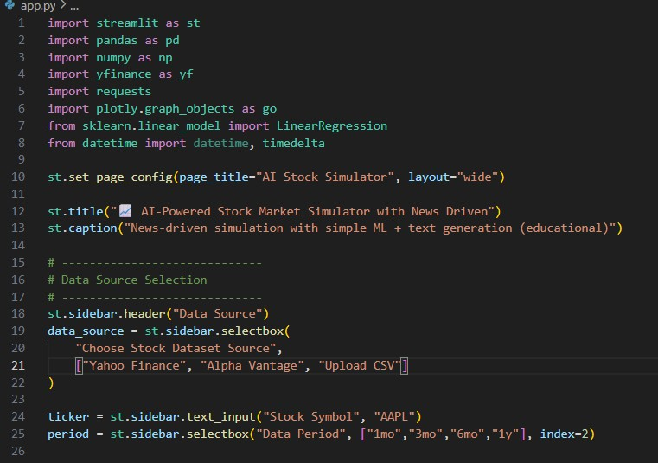

Figure 7.1: Python import statements
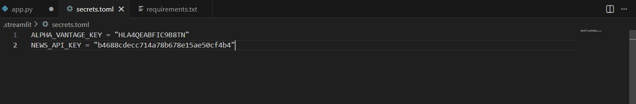
Figure 7.2: API keys used in the application
The Figure 7.1 depicts the initial setup of a Python-based Streamlit application. It includes import statements for data processing, machine learning, visualization, and API handling libraries. The code also configures the web app layout and defines the main title and sidebar inputs for selecting stock data sources. And in Figure 7.2 shows the file is used to securely store API keys required for accessing external services such as Alpha Vantage and News APIs.

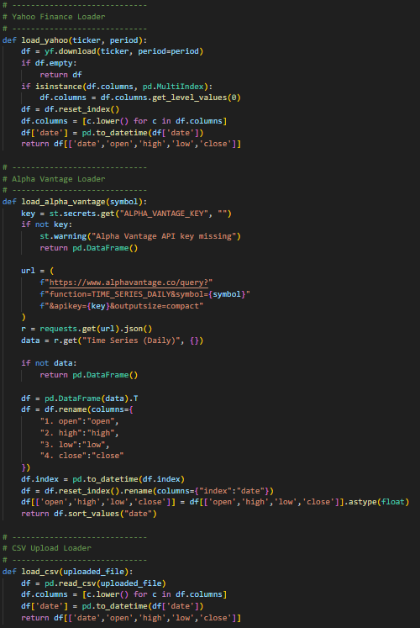

Figure 7.3: Fetching the data
Figure 7.3 shows the module is responsible for loading stock market data from multiple sources such as ‘Yahoo Finance’, ‘Alpha Vantage’, and CSV files. It processes and standardizes the data into a common format for further analysis

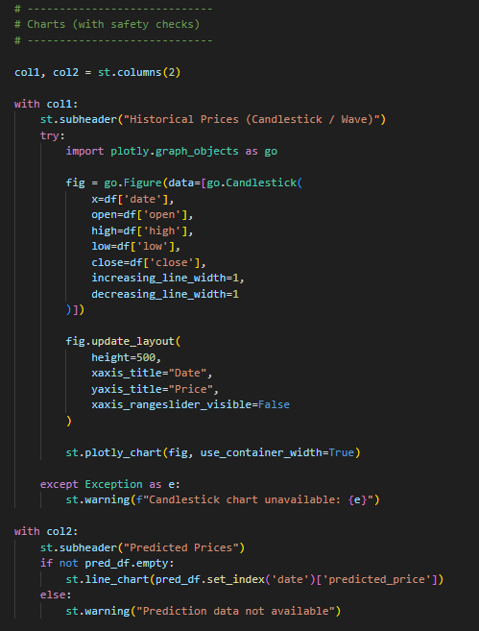

Figure 7.4: Loading the charts
Figure 7.4 shows the module visualizes historical stock prices using a candlestick or wave-style chart for better market trend analysis. It also displays predicted stock prices using a line chart, ensuring safe error handling when data is unavailable

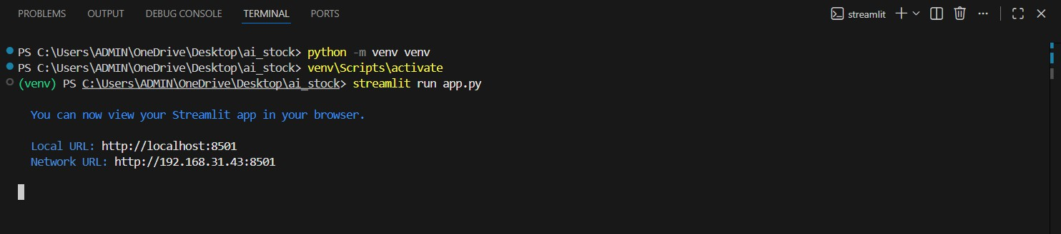

Figure 7.5: Execute details

Figure 7.5 shows the steps for the creation and activation of a Python virtual environment followed by successful execution of the Streamlit application. The application runs locally and provides a web interface accessible through the generated URL. It connects with localhost:8501 which ends up opening the website in Microsoft Edge or Google Chrome.
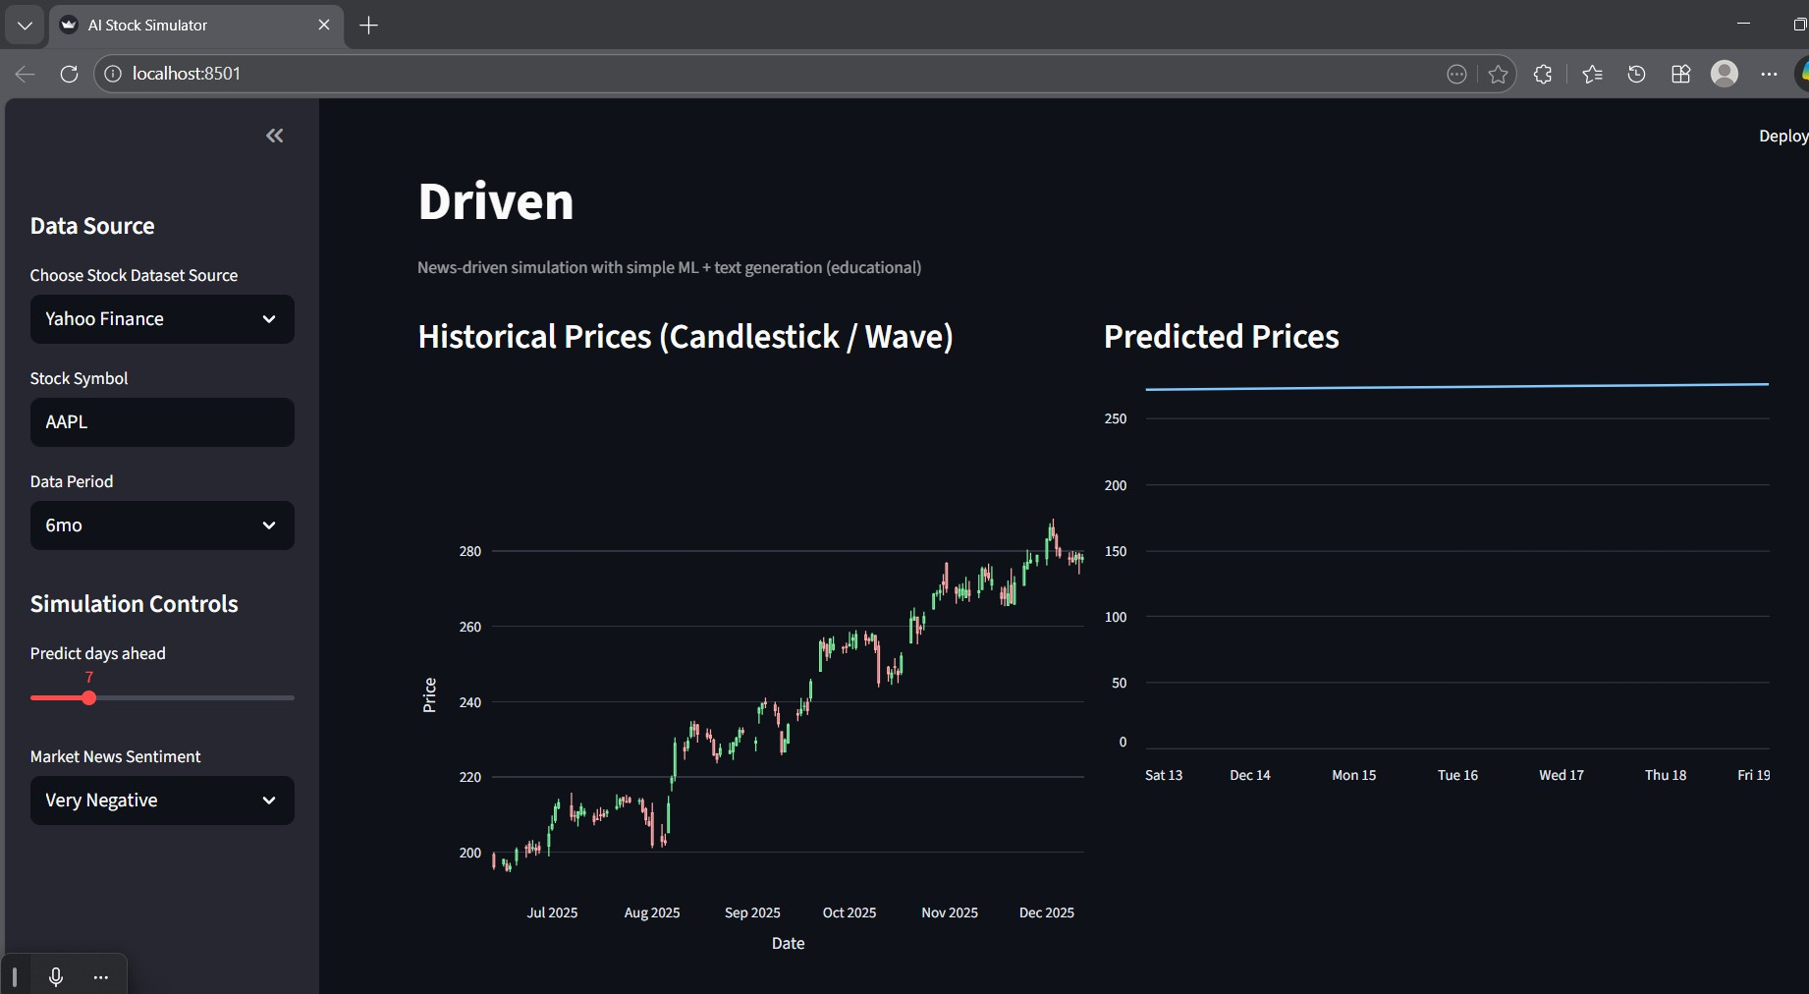

Figure 7.6: Execution details

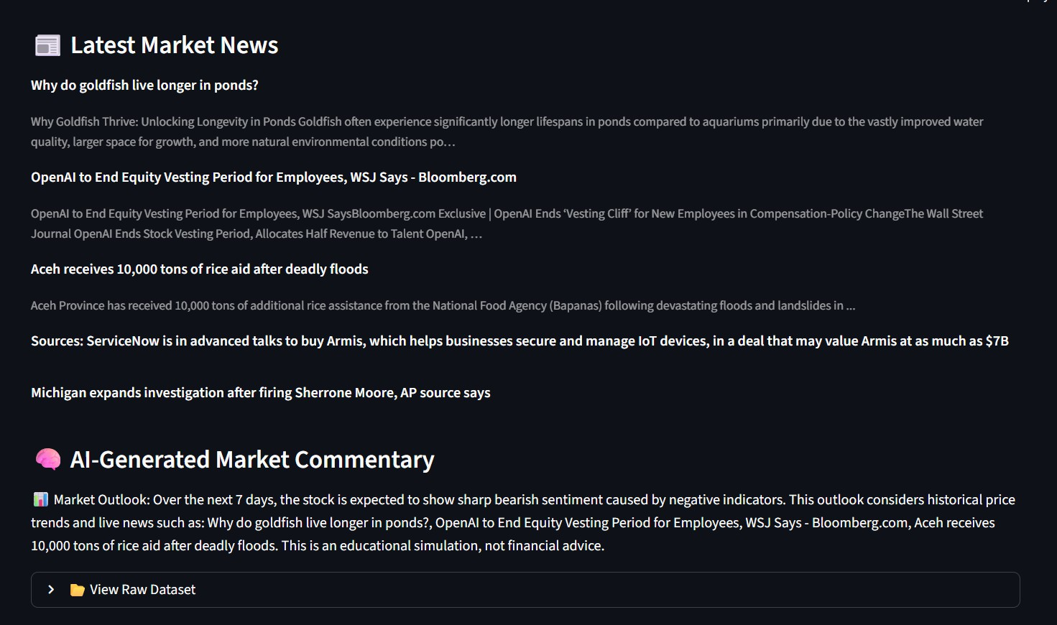
Figure 7.7: News Driven and Text Generated
This output screen displays the AI-Powered Stock Market Simulator interface, showing historical stock prices using a candlestick chart and predicted future prices based on selected parameters. Users can interactively choose the data source, stock symbol, time period, and market sentiment to analyze stock behavior. And another figure depicts the news generated by the AI by calling the News API.

CONCLUSION

The AI-Powered Stock Market Simulator with News-Driven Text Generation is designed to demonstrate the practical application of machine learning, data analysis, and web-based visualization in the financial domain. The system integrates multiple data sources such as Yahoo Finance, Alpha Vantage, and news APIs to collect historical stock prices and market-related information. By combining numerical stock data with news sentiment, the simulator provides a more realistic and informative view of market behavior.
The application successfully visualizes historical stock prices using candlestick charts, allowing users to understand market trends and price movements clearly. In addition, a basic machine learning model is used to predict future stock prices for a selected number of days. The inclusion of user-controlled parameters such as stock symbol, time period, prediction horizon, and market sentiment makes the system interactive and flexible. The use of Streamlit enables a simple and user- friendly interface, making the application accessible even to users with limited technical knowledge.
Overall, this project serves as an effective educational tool rather than a real-time trading system. It helps students and beginners understand how stock data, machine learning models, and news sentiment can influence market predictions. The project also provides a strong foundation for further enhancements, such as advanced prediction models, real-time sentiment analysis, and improved forecasting accuracy. Thus, the system successfully meets its objective of simulating stock market behavior using AI techniques in a simple and understandable manner.

FUTURE ENHANCEMENT
In the future, the AI-Powered Stock Market Simulator can be improved by using advanced machine learning models to increase prediction accuracy. Real-time news sentiment analysis can be added to automatically analyze market news instead of using predefined values. Additional features such as technical indicators, portfolio analysis, and cloud deployment can further enhance the system and make it more useful for learning and analysis purposes.

BIBLIOGRAPHY
- Aurélien Géron, Hands-On Machine Learning with Scikit-Learn, Keras, and TensorFlow, 3rd Edition,
O’Reilly Media, 2024.
- Marcos López de Prado, Advances in Financial Machine Learning, Updated Edition, Wiley, 2024.
- Python Software Foundation, Python 3 Documentation, 2024–2025, available online.
- Scikit-learn Developers, Scikit-learn: Machine Learning in Python, Official Documentation, 2024, available online.
- Streamlit Inc., Streamlit Documentation: Building Data Apps, 2024–2025, available online.
- Yahoo Finance, Stock Market Historical and Real-Time Data, 2024–2025, available online.
- Alpha Vantage, Financial Market Data APIs Documentation, 2024–2025, available online.
- NewsAPI.org, News API Documentation for Sentiment Analysis, 2024–2025, available online.
- Ian Goodfellow, Yoshua Bengio, and Aaron Courville, Deep Learning, MIT Press, 2016.
- OpenAI, Generative AI and Text Generation Documentation, 2024–2025, available online.
- Google Developers, Machine Learning and AI Resources, 2024, available online.
- Google Developers, Machine Learning and Artificial Intelligence Guides, 2024–2025, available online.
- Microsoft Learn, Machine Learning with Python and Azure AI, 2024, available online.
- Investopedia, Stock Market Concepts and Financial Analysis Tutorials, 2024–2025, available online.
- Towards Data Science, Articles on Stock Market Prediction and AI, 2024–2025, available online.
- Kaggle, Financial Datasets and Machine Learning Notebooks, 2024–2025, available online.
- Yahoo Finance – https://finance.yahoo.com
- Alpha Vantage API – https://www.alphavantage.co
- News API – https://newsapi.org

APPENDIX A

Streamlit
Streamlit is an open-source Python framework used to develop interactive and user-friendly web applications for data science and machine learning projects. In this project, Streamlit is used to create the front-end interface of the AI-Powered Stock Market Simulator, allowing users to select stock symbols, data sources, time periods, and prediction parameters. It enables real-time visualization of historical stock prices and predicted results using charts and graphs, making the application easy to use without requiring advanced web development skills.

Python Libraries
Python libraries are reusable packages that provide built-in functions and tools to simplify complex programming tasks. In this project, Pandas and NumPy are used for handling, cleaning, and processing large volumes of stock market data efficiently. Scikit-learn is utilized to implement machine learning algorithms for predicting future stock prices based on historical data. Visualization libraries such as Matplotlib and Plotly are used to represent stock trends and prediction results in graphical form. Together, these libraries support data analysis, model development, and visualization, making the system reliable and easy to implement (like Pandas, NumPy, Requests, Plotly, Scikit-learn etc).

Yahoo Finance
yfinance is a Python library used to download historical and real-time stock market data from Yahoo Finance in a simple and efficient manner. In this project, yfinance is used to fetch stock price details such as open, high, low, close, and volume for selected companies over a specified time period. It helps in collecting reliable financial data required for analysis, visualization, and machine learning- based stock price prediction in the AI-Powered Stock Market Simulator.

API calls (News API and Alpha Vantage API)

News API and Alpha Vantage API are external data services used to obtain financial news and stock market information. In this project, News API is used to collect news articles related to companies and market trends, which helps in understanding market sentiment. Alpha Vantage API is used to fetch stock market data such as historical prices and financial indicators. Together, these APIs enhance the system by combining numerical stock data with news-based insights for better stock.

Modules Used for AI-Powered Stock Market Simulation with News-Driven and Text Generation
- Stock Data Collection Module
- News Data Collection Module
- Data Preprocessing Module
- Machine Learning Prediction Module
- News-Driven Sentiment Analysis Module
- Text Generation Module
- Visualization Module
- User Input and Control Module
- API Configuration and Security Module
- Web Application Integration Module (Streamlit Frontend Layer)

