GIT:
Great question Thanusha 👩‍💻 — Git is asked in almost every DevOps / AWS / Cloud interview, especially since you're preparing seriously for career growth.
I’ll explain Git from interview perspective — meaning:
- What interviewer expects
- How you should answer
- Common follow-up questions

🔹 1. What is Git?
Git is a distributed version control system used to track changes in source code.
✅ Interview Answer (Best Format)
Git is a distributed version control system that helps track code changes, maintain version history, support collaboration, and manage branching and merging efficiently. Each developer has a full copy of the repository locally.

🔹 2. Centralized vs Distributed VCS
🔹 Centralized (Example: SVN)
- One central server
- Developers depend on server
🔹 Distributed (Git)
- Every developer has full repo
- Can work offline
- Faster
👉 Interview may ask:
Why Git is better than SVN?
- Offline work
- Faster commits
- Easy branching
- No single point of failure

🔹 3. Git Architecture (Very Important Question)
🔹 Three Main Areas in Git
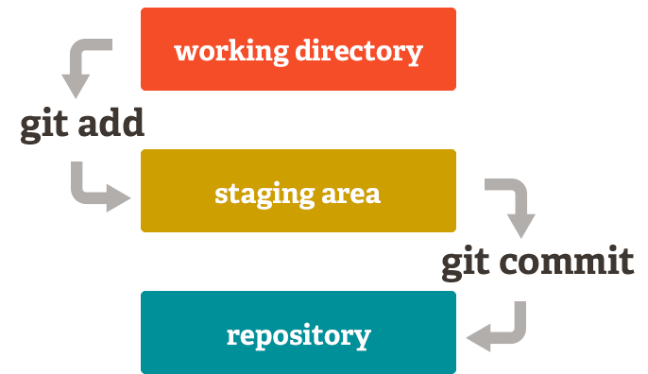
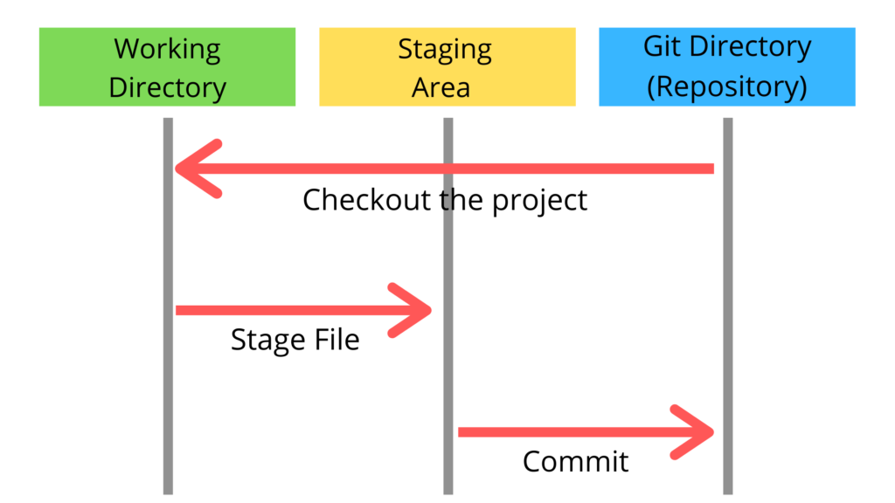
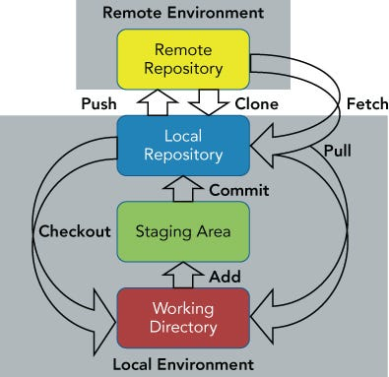

1️⃣ Working Directory
Where you write/modify code.
2️⃣ Staging Area (Index)
Intermediate area before commit.
3️⃣ Local Repository
Where commits are stored.

🔹 Flow:
Working Directory → git add → Staging Area → git commit → Local Repo → git push → Remote Repo
👉 Interviewer may ask:
- What happens internally when you run git add?
- What is staging area?
- Can we commit without staging? (No)

🔹 4. Important Git Commands (Must Know)
Command | Purpose
git init | Initialize repo
git clone | Copy remote repo
git status | Check changes
git add | Add to staging
git commit | Save snapshot
git push | Upload to remote
git pull | Fetch + merge
git fetch | Download changes only
git branch | Create branch
git checkout | Switch branch
git merge | Merge branches
git rebase | Reapply commits
git stash | Temporarily save changes

🔹 5. Branching Concept (Very Frequently Asked)
🔹 What is Branch?
A branch is an independent line of development.
Default branch:
- main (earlier master)

🔹 Branching Strategy (Interview Gold Question 🔥)
🔹 Git Flow
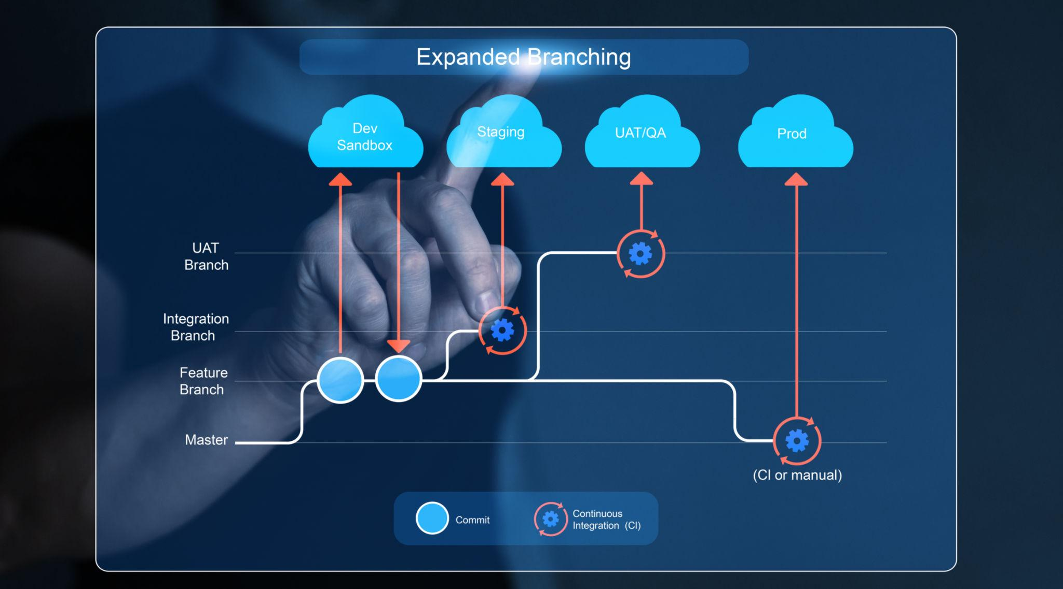
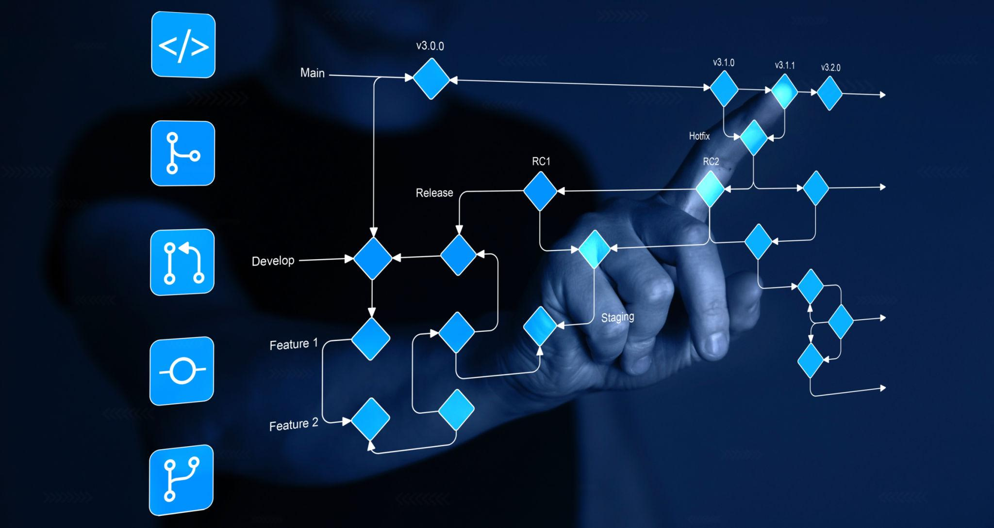
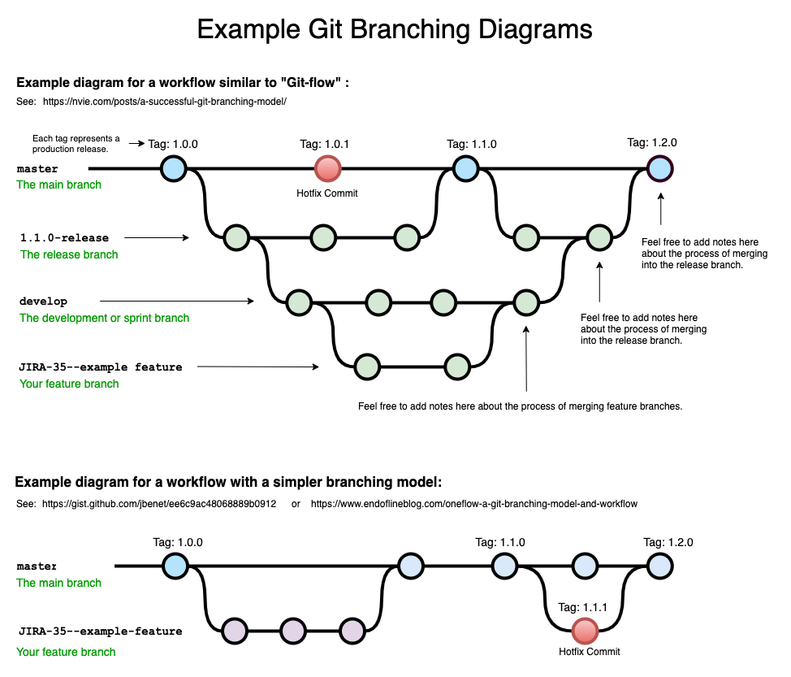
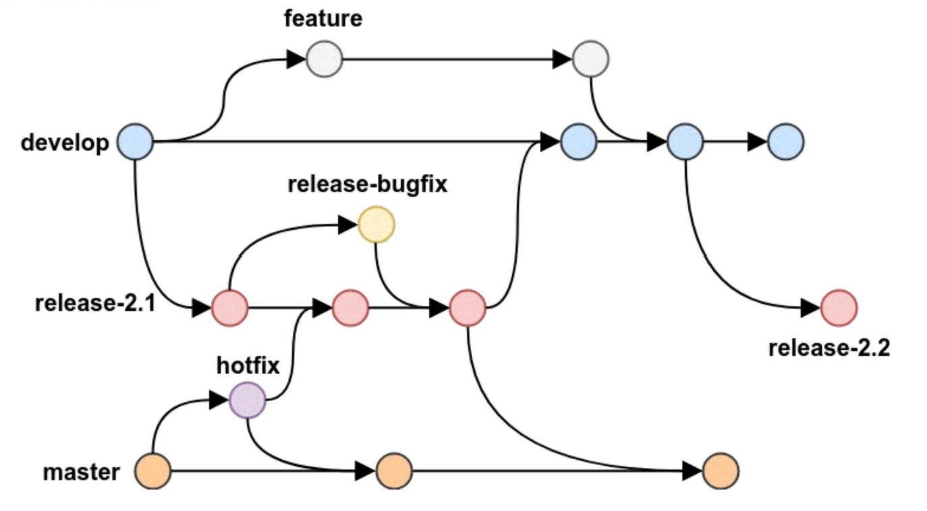
- main → production
- develop → integration
- feature branches
- release branch
- hotfix branch

🔹 In DevOps interview, say this:
We follow feature branching. Developers create feature branches from develop, raise PR, get code reviewed, then merge. Production code stays in main branch.
💡 Since you're moving toward DevOps roles, they love hearing about:
- PR reviews
- CI/CD integration
- Protected branches

🔹 6. Merge vs Rebase (Very Important)
Merge | Rebase
Keeps history | Rewrites history
Creates merge commit | Linear history
Safe | Risky if not careful
👉 Interview Question:
When do you use rebase?
Answer:
Rebase is used to maintain a clean linear history before merging to main branch.

🔹 7. What is Merge Conflict?
When same file lines modified in different branches.
How to resolve:
- Open conflicted file
- Edit manually
- git add
- git commit

🔹 8. Git Internals (Advanced – Good for 3+ Years Experience)
Since you have 3.2 years experience, they may go deeper.
🔹 What is a commit?
A commit is a snapshot with:
- Commit ID (SHA-1 hash)
- Author
- Timestamp
- Parent commit reference
🔹 What is HEAD?
Pointer to current branch.
🔹 What is Detached HEAD?
When HEAD points to commit instead of branch.

🔹 9. Git in DevOps Perspective
They may ask:
🔹 How Git integrates with CI/CD?
Answer:
When code is pushed to remote repository, CI pipeline triggers automatically (e.g., Jenkins/GitHub Actions), runs build, test, and deployment process.
Example tools:
- GitHub
- GitLab
- Bitbucket
- Jenkins

🔹 10. Common Tricky Interview Questions
❓ Difference between git pull and git fetch
- fetch → only downloads
- pull → fetch + merge
❓ How to undo last commit?
- git reset --soft HEAD~1
- git revert <commit-id>
❓ Difference between reset and revert?
- reset → rewrites history
- revert → safe, creates new commit

🔹 11. Real Scenario Question (DevOps)
Interviewer:
You pushed wrong code to main branch. What will you do?
Answer:
- If not shared → git reset
- If already pushed → git revert
🔥 This answer shows maturity.

🔹 12. Best Way to Answer in Interview
Instead of just definitions, explain with real scenario:
In my project, we use feature branching. Once development is completed, we create pull request, get approval, then merge into develop branch. Jenkins pipeline triggers automatically for testing and deployment.
That’s strong answer 💪

🔹 Final Tip for You Thanusha
For AWS / DevOps interviews, focus on:
- Git + CI/CD
- Branching strategy
- Merge conflicts
- Rebase concept
- Rollback strategy

