DESIGN AND ANALYSIS OF ALGORITHMS
Laboratory Record
Experiments: Aim, Algorithm, Program and Output

Experiment 1: Selection Sort (O(n²))
Aim
To implement the Selection Sort algorithm to sort a given set of elements in ascending order and analyze its time complexity.
Algorithm
1. Start.
2. Read the number of elements n and store them in array a.
3. Repeat for i = 0 to n - 2:
4. a. Set min = i.
5. b. Repeat for j = i + 1 to n - 1: if a[j] < a[min], set min = j.
6. c. Swap the values of a[i] and a[min].
7. Print the sorted array.
8. Stop.
Program
#include <stdio.h>

int main() {
int n, i, j, min, temp;
printf("Enter number of elements: ");
scanf("%d", &n);
int a[n];
printf("Enter elements:\n");
for(i = 0; i < n; i++)
scanf("%d", &a[i]);

for(i = 0; i < n - 1; i++) {
min = i;
for(j = i + 1; j < n; j++) {
if(a[j] < a[min])
min = j;
}
temp = a[i];
a[i] = a[min];
a[min] = temp;
}

printf("Sorted array:\n");
for(i = 0; i < n; i++)
printf("%d ", a[i]);
return 0;
}
Output
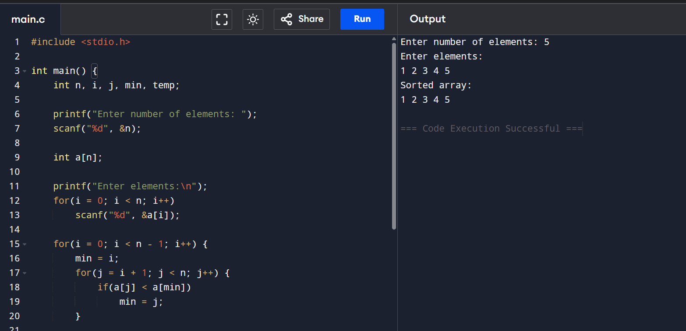

Experiment 2: Bubble Sort (O(n²))
Aim
To implement the Bubble Sort algorithm to sort a given set of elements in ascending order and analyze its time complexity.
Algorithm
1. Start.
2. Read the number of elements n and store them in array a.
3. Repeat for i = 0 to n - 2:
4. Repeat for j = 0 to n - i - 2: if a[j] > a[j + 1], swap a[j] and a[j + 1].
5. Print the sorted array.
6. Stop.
Program
#include <stdio.h>

int main() {
int n, i, j, temp;
printf("Enter number of elements: ");
scanf("%d", &n);
int a[n];
printf("Enter elements:\n");
for(i = 0; i < n; i++)
scanf("%d", &a[i]);

for(i = 0; i < n - 1; i++) {
for(j = 0; j < n - i - 1; j++) {
if(a[j] > a[j + 1]) {
temp = a[j];
a[j] = a[j + 1];
a[j + 1] = temp;
}
}
}

printf("Sorted array:\n");
for(i = 0; i < n; i++)
printf("%d ", a[i]);
return 0;
}
Output
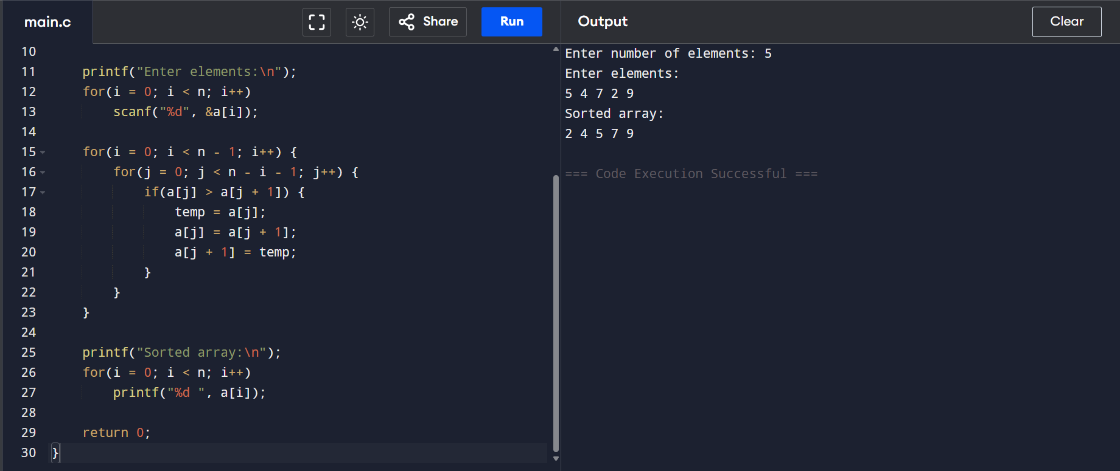

Experiment 3: String Matching (Naive Method) (O(nm))
Aim
To implement the Naive String Matching algorithm to find all occurrences of a pattern within a given text.
Algorithm
1. Start.
2. Read the text string and the pattern string.
3. Let n = length of text and m = length of pattern.
4. Repeat for i = 0 to n - m:
5. Repeat for j = 0 to m - 1: if text[i + j] ≠ pattern[j], break.
6. If j == m, report a match found at position i.
7. If no match was found, report that the pattern is not found.
8. Stop.
Program
#include <stdio.h>
#include <string.h>

int main() {
char text[100], pattern[100];
int i, j, found = 0;
printf("Enter text: ");
scanf("%s", text);
printf("Enter pattern: ");
scanf("%s", pattern);

int n = strlen(text);
int m = strlen(pattern);

for(i = 0; i <= n - m; i++) {
for(j = 0; j < m; j++) {
if(text[i + j] != pattern[j])
break;
}
if(j == m) {
printf("Pattern found at position %d\n", i);
found = 1;
}
}
if(!found)
printf("Pattern not found\n");
return 0;
}
Output
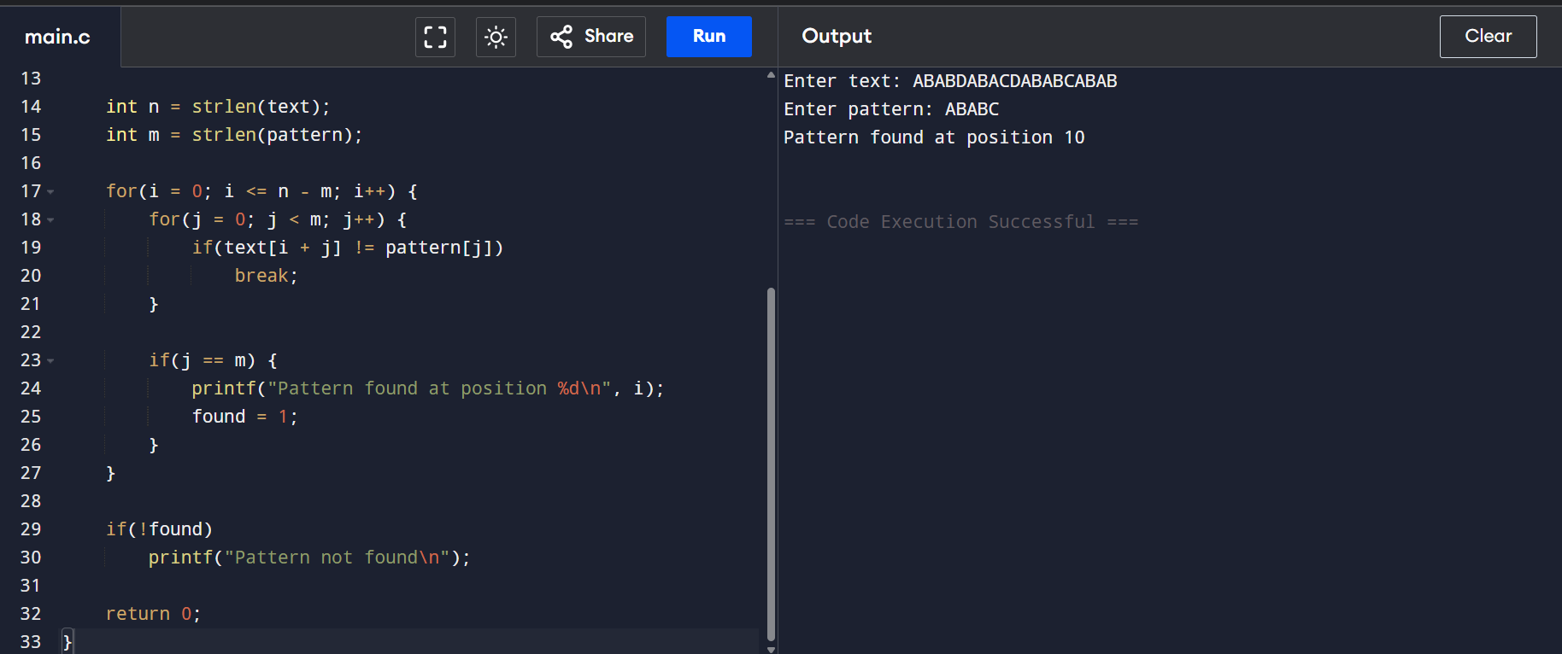

Experiment 4: Brute Force Closest Pair (O(n²))
Aim
To find the minimum distance between any two points among a given set of n points using the Brute Force method.
Algorithm
1. Start.
2. Read the number of points n and their coordinates (x, y).
3. Initialize minDist to a very large value.
4. Repeat for i = 0 to n - 1:
5. Repeat for j = i + 1 to n - 1: compute distance d between point i and point j; if d < minDist, set minDist = d.
6. Print the minimum distance.
7. Stop.
Program
#include <stdio.h>
#include <math.h>

int main() {
int n, i, j;
printf("Enter number of points: ");
scanf("%d", &n);
float x[n], y[n];
printf("Enter coordinates:\n");
for(i = 0; i < n; i++)
scanf("%f %f", &x[i], &y[i]);

float minDist = 1000000;
for(i = 0; i < n; i++) {
for(j = i + 1; j < n; j++) {
float d = sqrt((x[i]-x[j])*(x[i]-x[j]) +
(y[i]-y[j])*(y[i]-y[j]));
if(d < minDist)
minDist = d;
}
}
printf("Minimum Distance = %.2f\n", minDist);
return 0;
}
Output
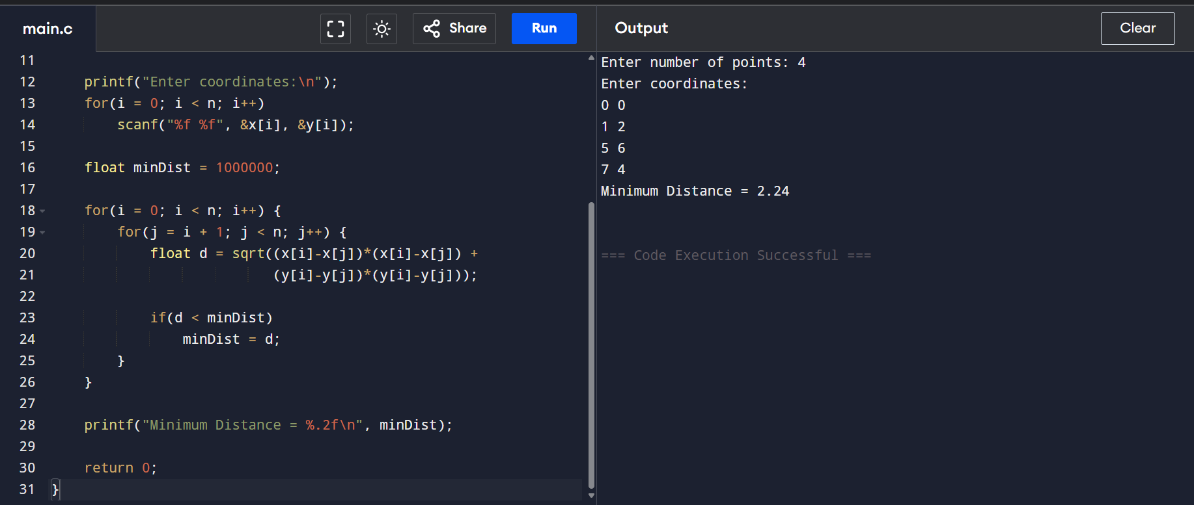

Experiment 5: Convex Hull (Brute Force) (O(n³))
Aim
To find the edges of the convex hull for a given set of points using the Brute Force method.
Algorithm
1. Start.
2. Read the number of points n and their coordinates (x, y).
3. Repeat for every pair of points (i, j):
4. Repeat for every other point k: compute the cross product value using points i, j, k; count how many points lie on the positive and negative side.
5. If all points lie on one side (pos == 0 or neg == 0), the line joining i and j is a hull edge — print it.
6. Stop.
Program
#include <stdio.h>

struct Point {
int x, y;
};

int main() {
int n, i, j, k;
printf("Enter number of points: ");
scanf("%d", &n);
struct Point p[n];
printf("Enter coordinates:\n");
for(i = 0; i < n; i++)
scanf("%d %d", &p[i].x, &p[i].y);

printf("Convex Hull Edges:\n");
for(i = 0; i < n; i++) {
for(j = i + 1; j < n; j++) {
int pos = 0, neg = 0;
for(k = 0; k < n; k++) {
int val = (p[j].x - p[i].x) * (p[k].y - p[i].y)
- (p[j].y - p[i].y) * (p[k].x - p[i].x);
if(val > 0) pos++;
else if(val < 0) neg++;
}
if(pos == 0 || neg == 0)
printf("(%d,%d) -> (%d,%d)\n",
p[i].x, p[i].y, p[j].x, p[j].y);
}
}
return 0;
}
Output
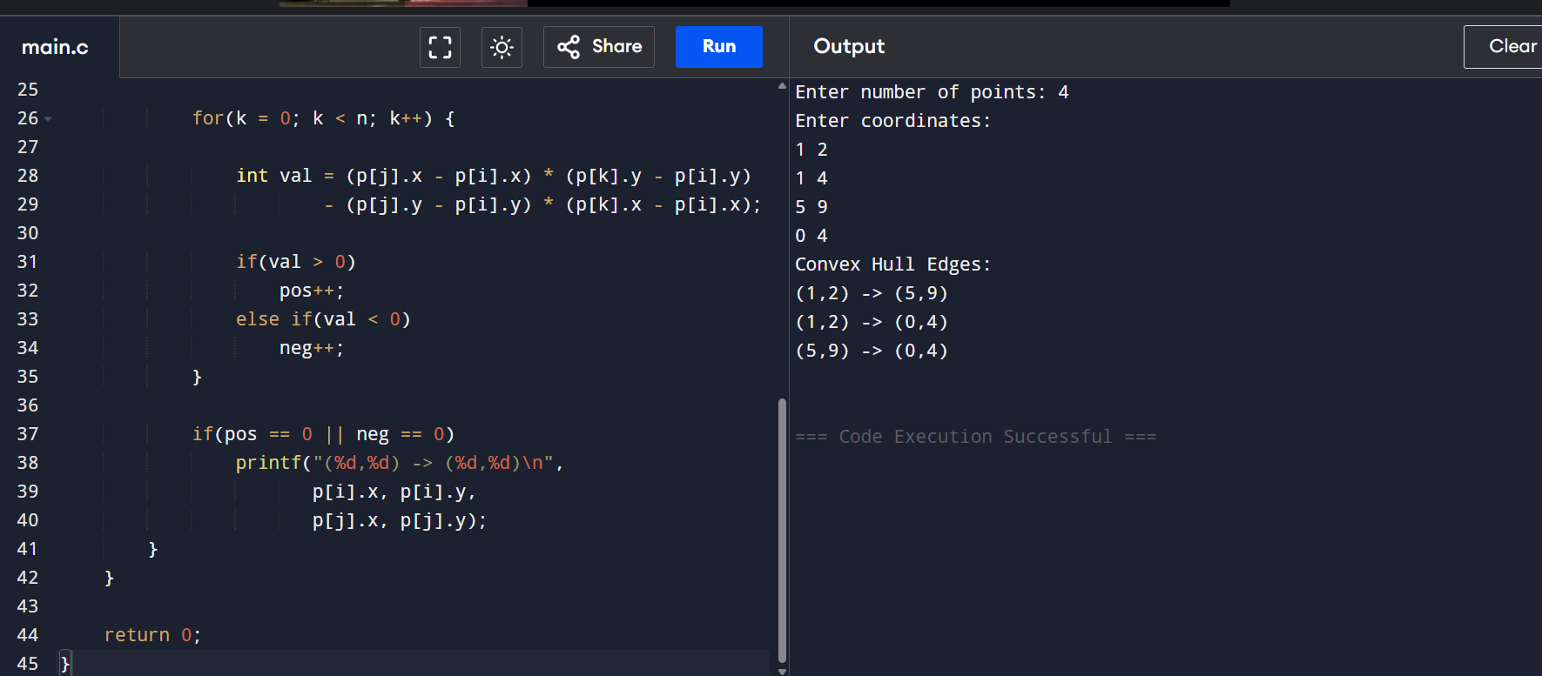

Experiment 6: Divide and Conquer (Maximum & Minimum) (O(n))
Aim
To find the maximum and minimum elements of a given array using the Divide and Conquer approach.
Algorithm
1. Start.
2. Read the number of elements n and store them in array a.
3. Call maxMin(a, low, high):
4. a. If low == high, set max = min = a[low].
5. b. Else if high == low + 1, compare a[low] and a[high] and set max, min accordingly.
6. c. Else, find mid = (low + high) / 2; recursively call maxMin(a, low, mid) and maxMin(a, mid + 1, high); combine the results to get the overall max and min.
7. Print the maximum and minimum values.
8. Stop.
Program
#include <stdio.h>

int max, min;

void maxMin(int a[], int low, int high) {
int mid;
if(low == high) {
max = min = a[low];
}
else if(high == low + 1) {
if(a[low] > a[high]) {
max = a[low]; min = a[high];
} else {
max = a[high]; min = a[low];
}
}
else {
int max1, min1;
mid = (low + high) / 2;
maxMin(a, low, mid);
max1 = max; min1 = min;
maxMin(a, mid + 1, high);
if(max < max1) max = max1;
if(min > min1) min = min1;
}
}

int main() {
int n, i;
printf("Enter number of elements: ");
scanf("%d", &n);
int a[n];
printf("Enter elements:\n");
for(i = 0; i < n; i++)
scanf("%d", &a[i]);

maxMin(a, 0, n - 1);
printf("Maximum = %d\n", max);
printf("Minimum = %d\n", min);
return 0;
}
Output
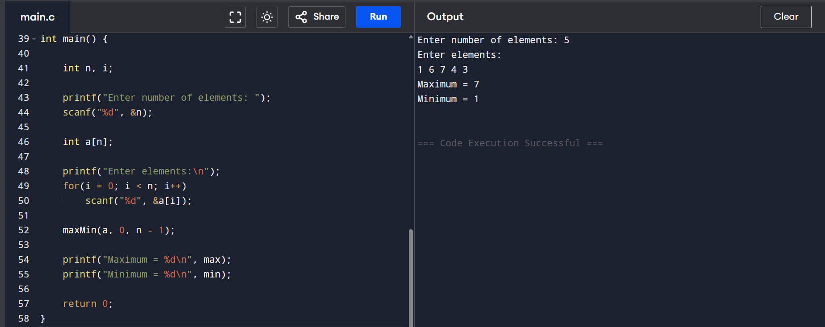

Experiment 7: Merge Sort (O(n log n))
Aim
To implement the Merge Sort algorithm to sort a given set of elements in ascending order using the Divide and Conquer approach.
Algorithm
1. Start.
2. Read the number of elements n and store them in array a.
3. Call mergeSort(a, l, r):
4. a. If l < r, find mid = (l + r) / 2.
5. b. Recursively call mergeSort(a, l, mid) and mergeSort(a, mid + 1, r).
6. c. Call merge(a, l, mid, r) to merge the two sorted halves.
7. In merge(): compare elements of both halves and copy them into a temporary array in sorted order, then copy back into the original array.
8. Print the sorted array.
9. Stop.
Program
#include <stdio.h>

void merge(int a[], int l, int m, int r) {
int i = l, j = m + 1, k = 0;
int temp[100];
while(i <= m && j <= r) {
if(a[i] <= a[j])
temp[k++] = a[i++];
else
temp[k++] = a[j++];
}
while(i <= m) temp[k++] = a[i++];
while(j <= r) temp[k++] = a[j++];
for(i = l, k = 0; i <= r; i++, k++)
a[i] = temp[k];
}

void mergeSort(int a[], int l, int r) {
if(l < r) {
int m = (l + r) / 2;
mergeSort(a, l, m);
mergeSort(a, m + 1, r);
merge(a, l, m, r);
}
}

int main() {
int n, i;
printf("Enter number of elements: ");
scanf("%d", &n);
int a[n];
printf("Enter elements:\n");
for(i = 0; i < n; i++)
scanf("%d", &a[i]);

mergeSort(a, 0, n - 1);
printf("Sorted array:\n");
for(i = 0; i < n; i++)
printf("%d ", a[i]);
return 0;
}
Output
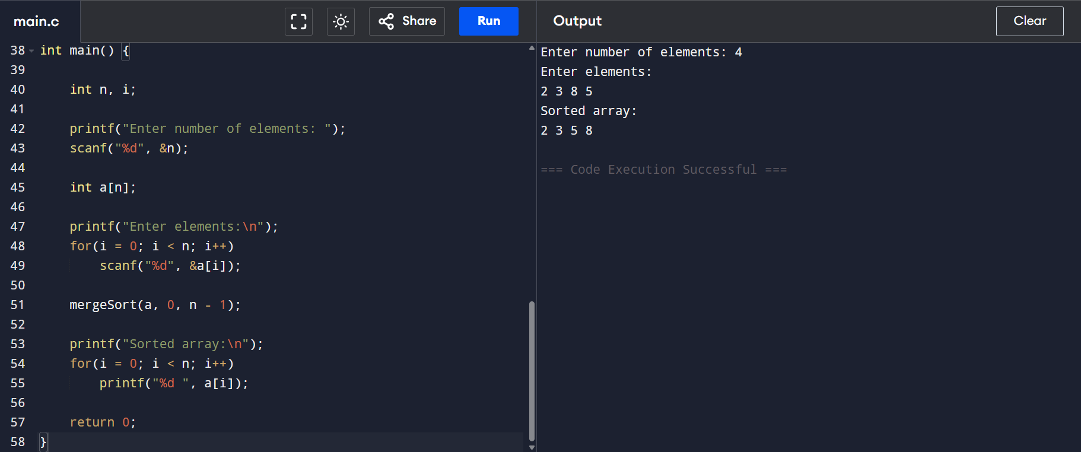

Experiment 8: Binary Search (O(log n))
Aim
To implement the Binary Search algorithm to search for a given key in a sorted array of elements.
Algorithm
1. Start.
2. Read the number of elements n and store the sorted elements in array a.
3. Read the key element to be searched.
4. Set low = 0 and high = n - 1.
5. Repeat while low ≤ high:
6. a. Find mid = (low + high) / 2.
7. b. If a[mid] == key, print the position and stop.
8. c. Else if a[mid] < key, set low = mid + 1.
9. d. Else, set high = mid - 1.
10. If the key was not found, print "Element not found".
11. Stop.
Program
#include <stdio.h>

int main() {
int n, i, key;
printf("Enter number of elements: ");
scanf("%d", &n);
int a[n];
printf("Enter sorted elements:\n");
for(i = 0; i < n; i++)
scanf("%d", &a[i]);
printf("Enter element to search: ");
scanf("%d", &key);

int low = 0;
int high = n - 1;
while(low <= high) {
int mid = (low + high) / 2;
if(a[mid] == key) {
printf("Element found at position %d\n", mid);
return 0;
}
else if(a[mid] < key)
low = mid + 1;
else
high = mid - 1;
}
printf("Element not found\n");
return 0;
}
Output
