AttnGAN: Fine-Grained Text to Image Generation

In this paper author employing Attention based Generative Adversarial Network to predict images from text. Spatial attention model is a deep learning layer which focus on specific parts of input by assigning different weights to different parts of the input, so while prediction algorithm will predict accurate class by choosing highest weight class. We are adding spatial attention layer to GAN model to enhance image prediction quality from text. This algorithm will use generator and discriminator where generator will generate new images from learned parameters and then discriminator will penalize generator based on generated image quality. So to reduce penalty generator will use attention layer to generate image as per given text features.

In propose paper author has utilized BIRD dataset to train model but this dataset is not available on net in accurate format as TEXT annotation it contains single word showing in below screen

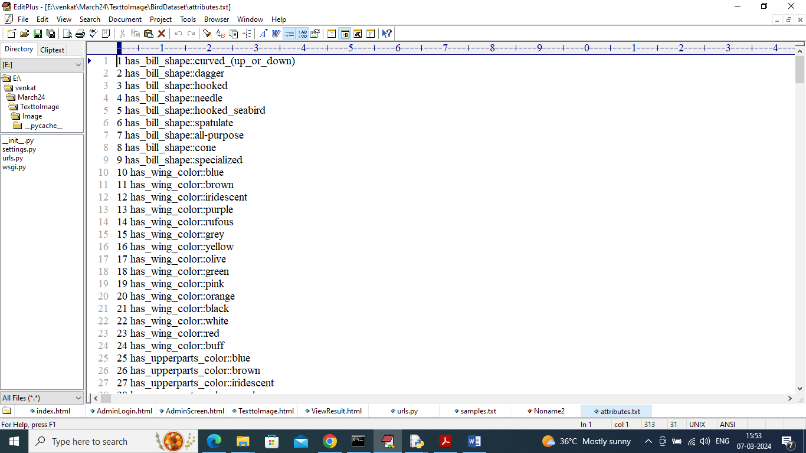

In above bird data annotation we have some simple words without any propose sentence so we have used FLICKER dataset which contains proper images and text annotations like below screen

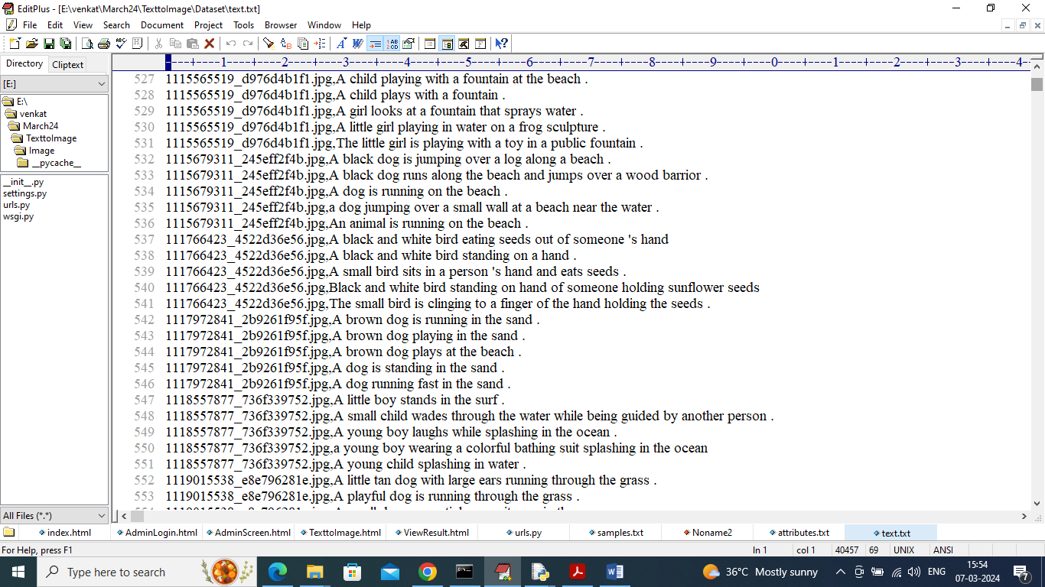

In above screen in Flicker dataset we can see image name and its text in proper sentence format so we have use above dataset to train model.

To implement this project we have used PYTHON web frame work which consists of following modules

1. Login: using this module user can login to system using username and password as admin and admin
2. Train Model: using this module user can train and load spatial attention GAN model
3. Text to Image: using this module user can input some text and then application will generate image

SCREEN SHOTS

To run project double click on run.bat file to get below screen

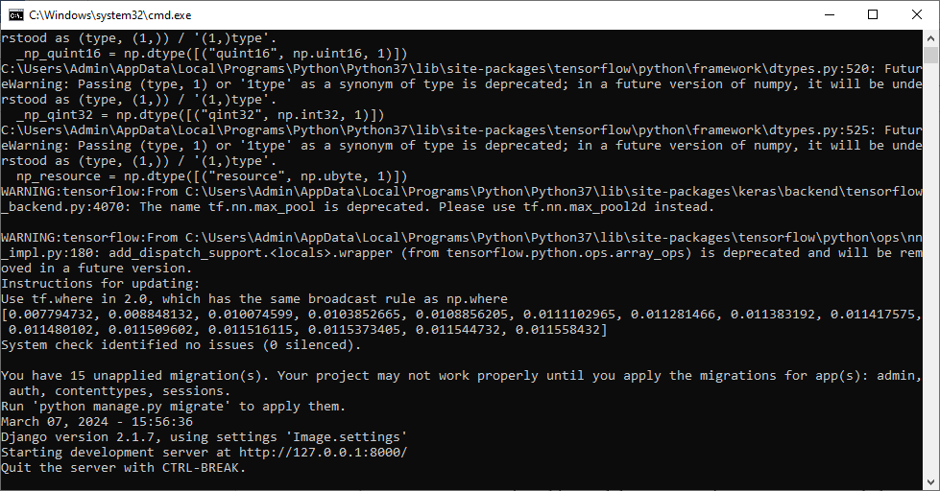

In above screen python server started and now open browser and enter URL as <http://127.0.0.1:5000/index.html> and press enter key to get below page

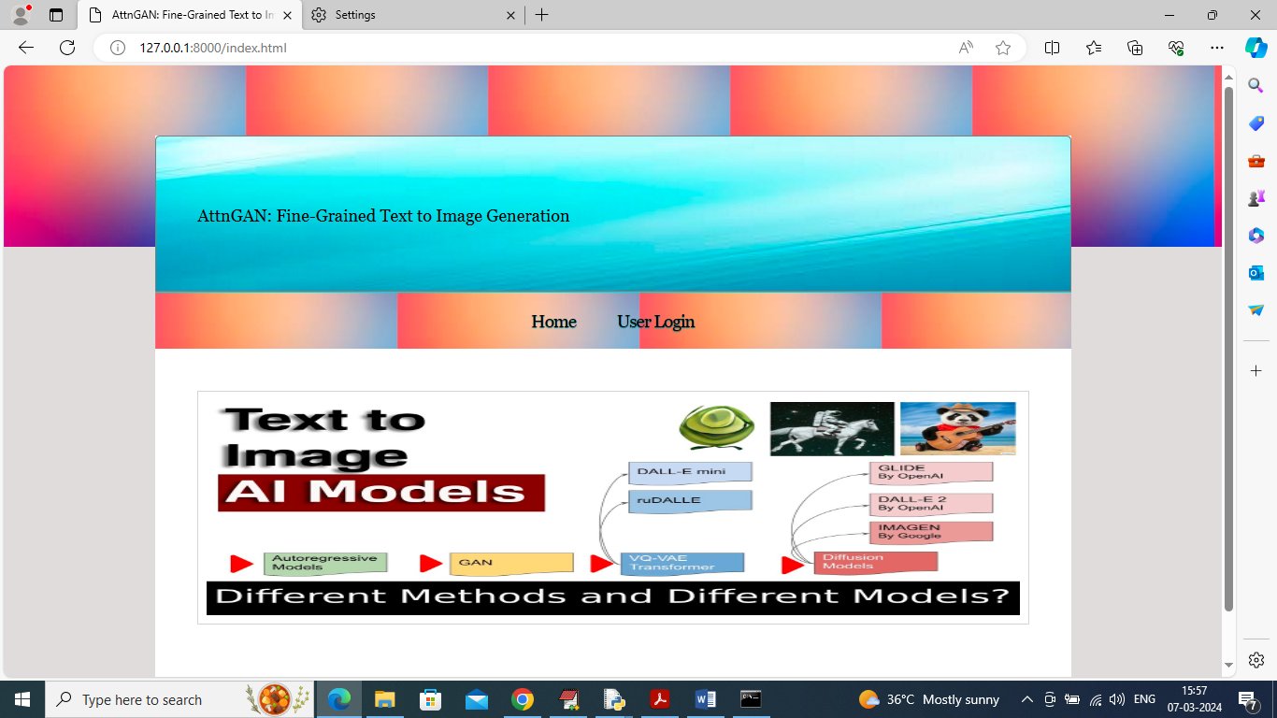

In above screen click on ‘User Login’ link to get below page

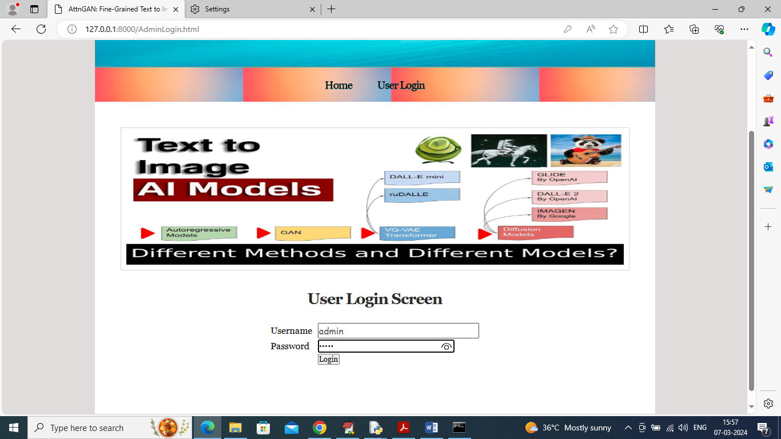

In above screen user is login and after login will get below page

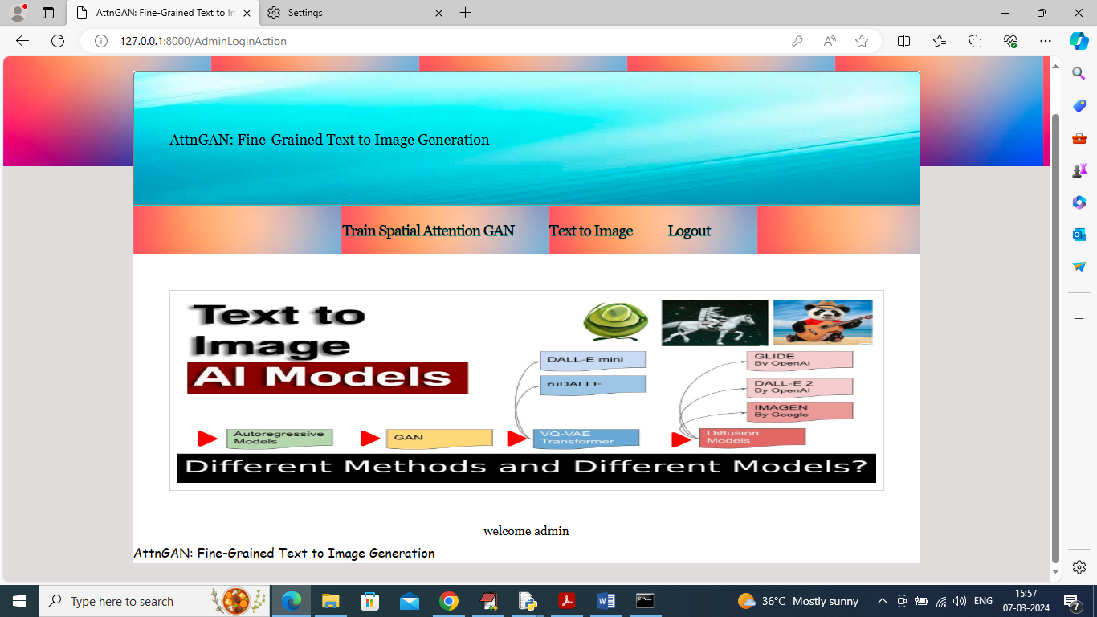

In above screen click on ‘Train Spatial Attention GAN’ link to train model and get below page

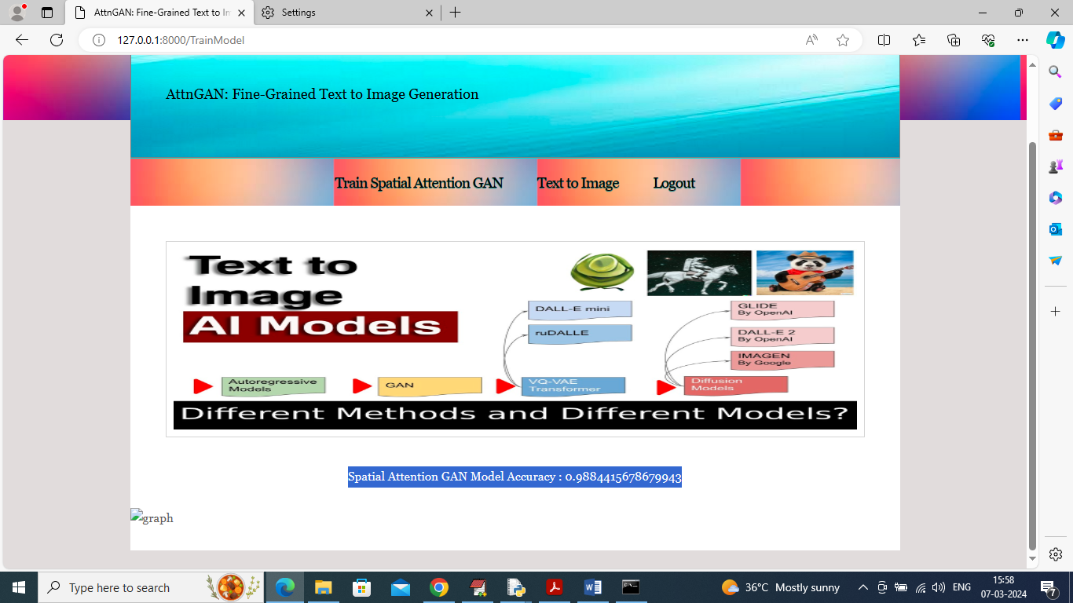

In above screen in blue colour text can see model training completed with an accuracy off 98% and now click on ‘Text to Image’ link to get below page

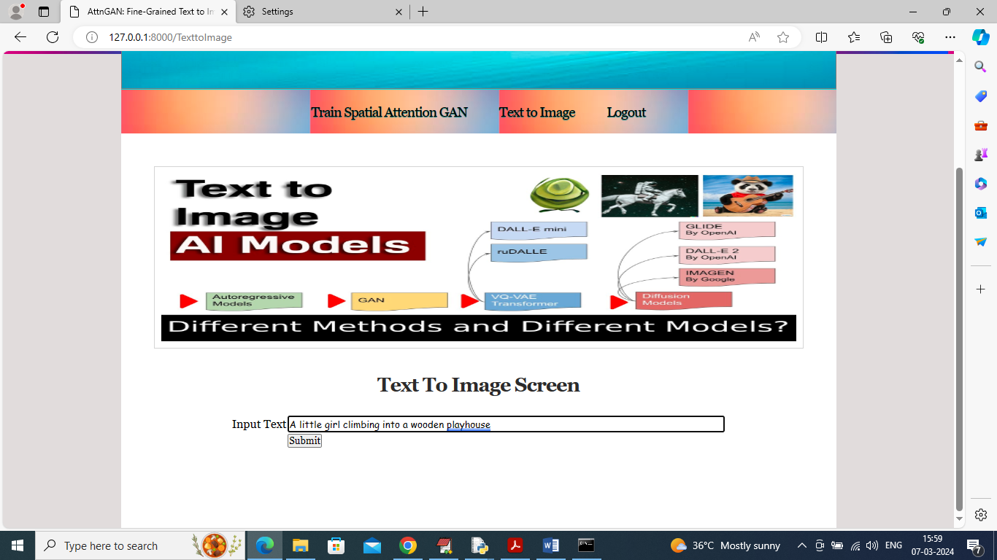

In above screen enter some text and then click on ‘Submit’ button to get below text

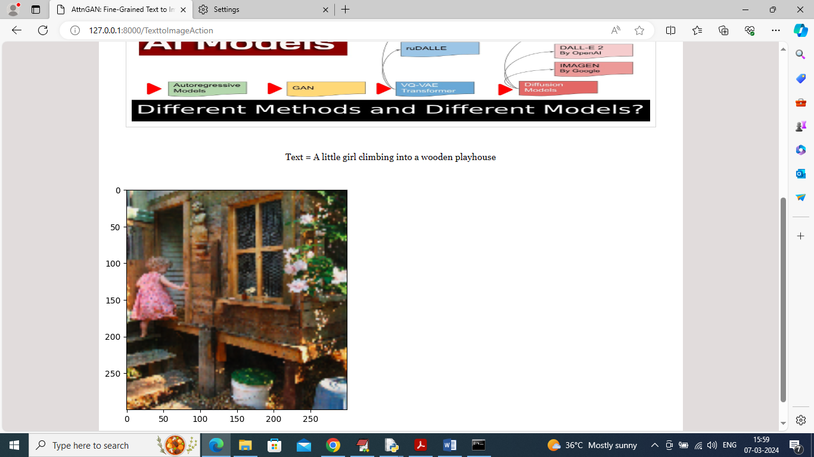

In above screen given text as ‘A little girl climbing into a wooden playhouse’ and then similar generated from given text. If model is unaware of any text then will get blur image and below is another example

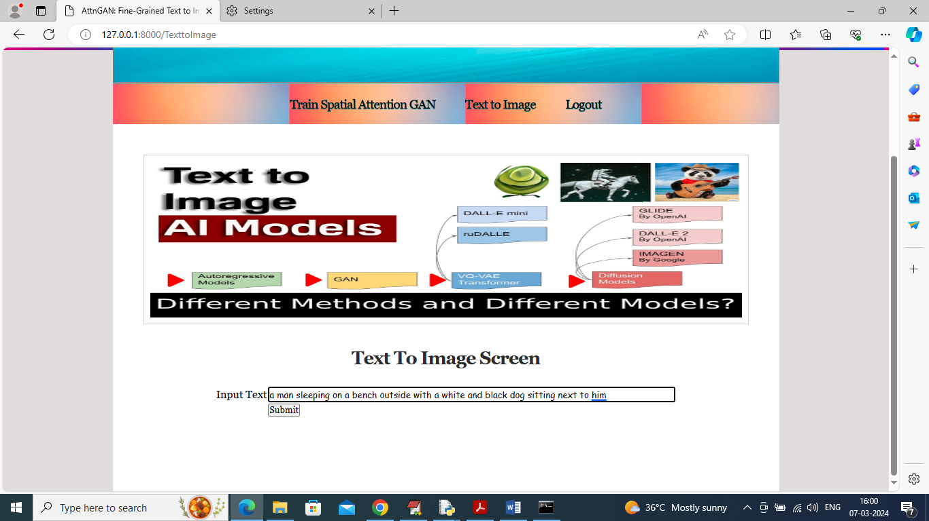

In above screen given other text and below is the output

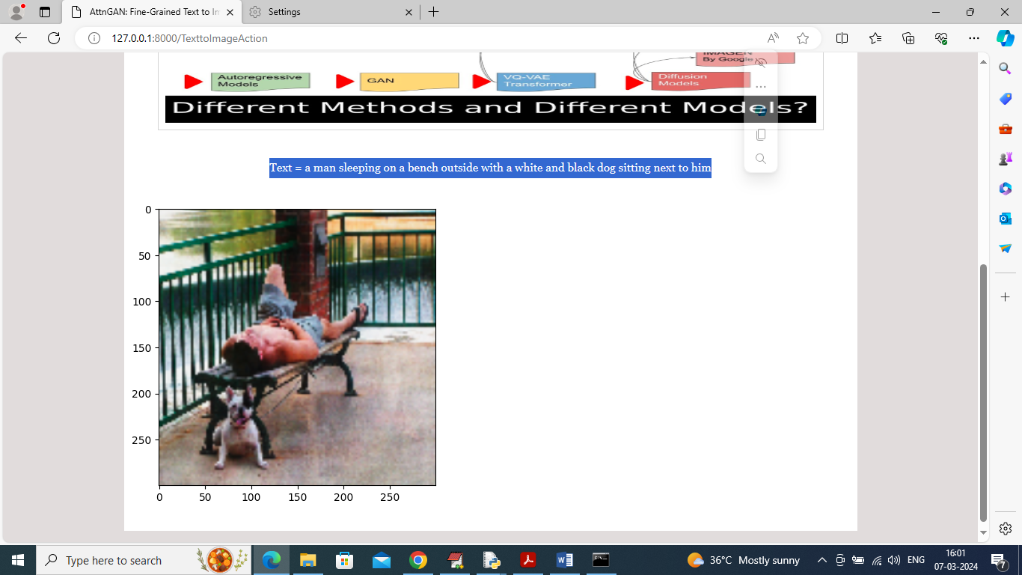

In above screen in blue colour text can see the given text and then can see generated image and similarly you can give text to get output.

If you want you can take input text from Samples.txt which is available inside code folder