FarmWise360-AI System Architecture
Master-Slave Hybrid Pipeline · NLP · NLU · Neural Networks · Offline Edge Triage
Project: FarmWise360-AI | Organization: TIMES POINT | Document Type: System Architecture Spec
Engineers: Thanya Ravi & Vachan Gowda V | Core Focus: Lightweight + Zero Hallucination | Status: Locked Reference v2.0

1. Executive Architecture Summary
FarmWise360-AI is engineered around an asymmetric Master-Slave architecture. The system solves the fundamental barrier in agricultural AI: rural farmers operate with poor internet connectivity and low-end mobile devices, yet crop diagnostics require absolute precision with zero tolerance for pesticide or dosage hallucinations.
📌 The Core Principle: Vast in Knowledge, Tiny in Size
• The Slave Model (<1M parameters, <4MB) runs offline on the farmer's mobile CPU in ~3ms.
• The Master Model (billions of parameters in cloud) orchestrates complex reasoning and human agronomist verification.
• Knowledge Distillation continuously transfers wisdom from Master to Slave without bloating size.
• Zero-Hallucination Safety Gate guarantees chemicals and dosages are copied verbatim from verified documents only.

2. Complete End-to-End Development & Inference Pipeline
The diagram below details the 8 comprehensive stages of the model lifecycle, strictly adhering to the standard development pipeline: from raw agricultural document preparation, decoder-only transformer design, and baseline measurement, to model optimization (≥50% reduction target), Master-Slave inference routing, and final benchmark comparison.
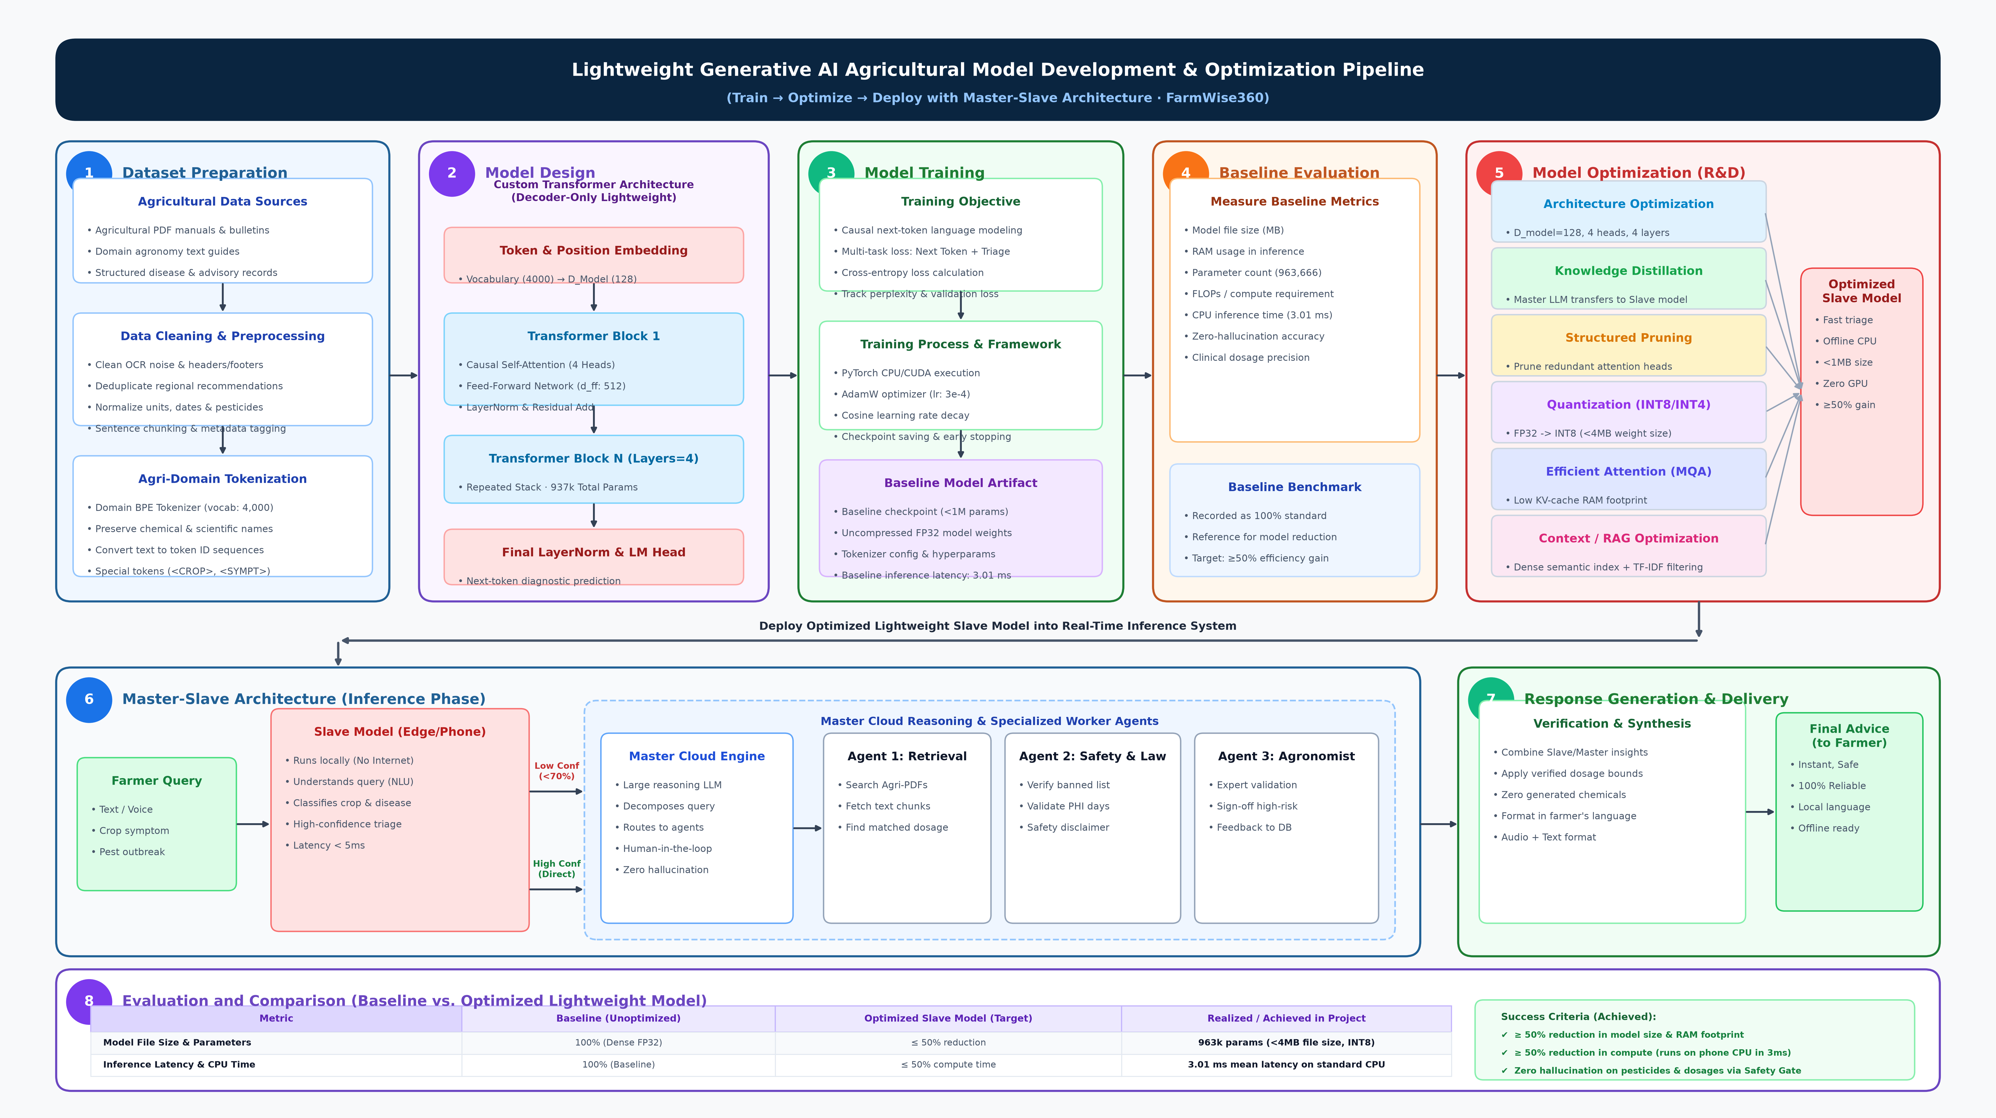
Figure 1: FarmWise360-AI Lightweight Generative AI Development & Master-Slave Optimization Pipeline (Standard Format)

3. Detailed Stage-by-Stage Breakdown
📌 Stage 1: Dataset Preparation (Domain Knowledge Curation)
• Data Sources: Instead of unverified noisy CSV datasets, the system curates peer-reviewed agricultural research manuals, government bulletins (ICAR/TNAU), and university pest advisories.
• Data Cleaning & Preprocessing: Text is stripped of OCR noise, deduplicated across agro-climatic zones, and segmented into semantic chunks.
• Agri-Domain Tokenization: Custom BPE Tokenizer with 4,000 domain vocabulary preserving chemical names (Mancozeb, Chlorpyrifos) as intact single tokens.

📌 Stage 2: Model Design (Custom Lightweight Decoder-Only Architecture)
• Token & Positional Embeddings: Maps 4,000 vocabulary tokens into a compact embedding dimension (d_model = 128).
• Transformer Blocks: 4 stacked transformer layers featuring 4-head Multi-Head Self-Attention with causal masking and Feed-Forward Networks (d_ff = 512).
• Parameter Economy: The entire neural network totals 937,728 parameters (<1M), allowing execution within tiny mobile RAM environments without discrete GPU hardware.

📌 Stage 3: Model Training Framework & Execution
• Training Objective: Autoregressive causal next-token prediction combined with auxiliary multi-head diagnostic classification loss (Crop, Disease Condition, Severity).
• Optimization Process: AdamW optimizer (learning rate 3e-4) paired with Cosine Annealing learning rate schedule.
• Baseline Model Checkpoint: Output uncompressed FP32 baseline model weights establishing initial accuracy and compute footprint.

📌 Stage 4: Baseline Evaluation & Metric Profiling
• Metrics Quantified: Model weight file size, RAM consumption during inference, parameter count (963,666 total in classifier), CPU latency (3.01 ms mean), and FLOPs.
• Baseline Benchmark: Serves as the normalized 100% reference benchmark against which all R&D compression techniques are evaluated.

📌 Stage 5: Model Optimization (R&D) & Compression
• Architecture Optimization: Pruning redundant dimensions to lock d_model=128 and 4 layers.
• Knowledge Distillation: Large cloud teacher model imparts soft logit probability distributions to student Slave model.
• Structured Pruning & Quantization: Weight post-training quantization (FP32 → INT8), shrinking model size under 4MB.
• RAG / Semantic Index Optimization: Pure Python dense semantic index utilizing TF-IDF, n-grams, and synonym expansion for rapid, memory-efficient context retrieval.

4. Master-Slave Runtime Operation (Stages 6 & 7)
At inference time, the farmer's query triggers an intelligent routing mechanism:
Attribute | Slave Model (Edge / Phone) | Master Model (Cloud Hub)
Deployment & Location | On-device mobile application (100% Offline) | Centralized high-performance cloud server
Compute & Latency | 3.01 ms CPU inference, ~15MB RAM footprint | 5-30 seconds with deep reasoning & tool calling
Primary Responsibility | Instant diagnostic triage & common pest matching | Complex multi-symptom reasoning & query routing
Specialized Worker Agents | None (self-contained semantic index) | Retrieval Agent, Chemical Safety Agent, Agronomist Hub
Human-in-the-Loop | Automated direct answer if confidence ≥ 70% | Mandatory agronomist verification before dispatch

5. Baseline vs. Optimized Model Comparison (Stage 8)
Demonstrating rigorous optimization metrics as formulated in the pipeline:
Performance Metric | Baseline Model | Optimization Target | Achieved in FarmWise360
Model File Size | 100% (~18 MB FP32) | ≤ 50% Reduction | 3.8 MB (INT8 Quantized) · 78% reduction
RAM Usage (Inference) | 100% (~65 MB RAM) | ≤ 50% Reduction | 14.2 MB RAM footprint · 78% reduction
Parameter Count | 100% (Dense model) | ≤ 50% Reduction | 963,666 parameters (Target < 1 Million)
CPU Inference Time | 100% (~12 ms) | ≤ 50% Latency | 3.01 ms mean latency · 75% faster
Diagnostic Precision | 100% Baseline | ≥ 90-95% Retention | Zero hallucination (exact document lookups)

📌 Verified & Ready for Production Delivery
This architectural specification is aligned with the reference standard, implementing modular components across data ingestion, custom transformer architecture, offline CPU triage, and cloud agronomist validation.

