FarmWise 360 AI
System Architecture & Block Diagram Technical Specification

Author / Candidate | Thanya Ravi
Date | 15 October 2026
System Architecture Version | 2.0 (Structured Edge-RAG & Multi-Head Transformer)
Deployment Target | Edge Commodity CPU / Offline Field Environments

1. Executive Overview & Problem Context
FarmWise 360 AI is an edge-native artificial intelligence platform built to deliver instantaneous, certified crop diagnostic advice to farmers and field agricultural officers without requiring cloud connectivity or expensive GPUs. In rural and developing regions, Internet bandwidth is highly erratic, and cloud API dependencies introduce unsustainable recurring costs and latency.
Standard Generative Large Language Models (LLMs) present dangerous failure modes in agriculture: when trained from scratch on small corpora, compact models frequently hallucinate lethal pesticide formulations or inaccurate active ingredients. FarmWise 360 AI solves this through a Structured Edge-RAG architecture that decouples semantic classification from factual agronomic data, guaranteeing deterministic safety and zero hallucinations.

2. Architectural Block Diagram
The visual layout below illustrates the structural hierarchy, data transformations, and operational blocks of the FarmWise 360 AI system:
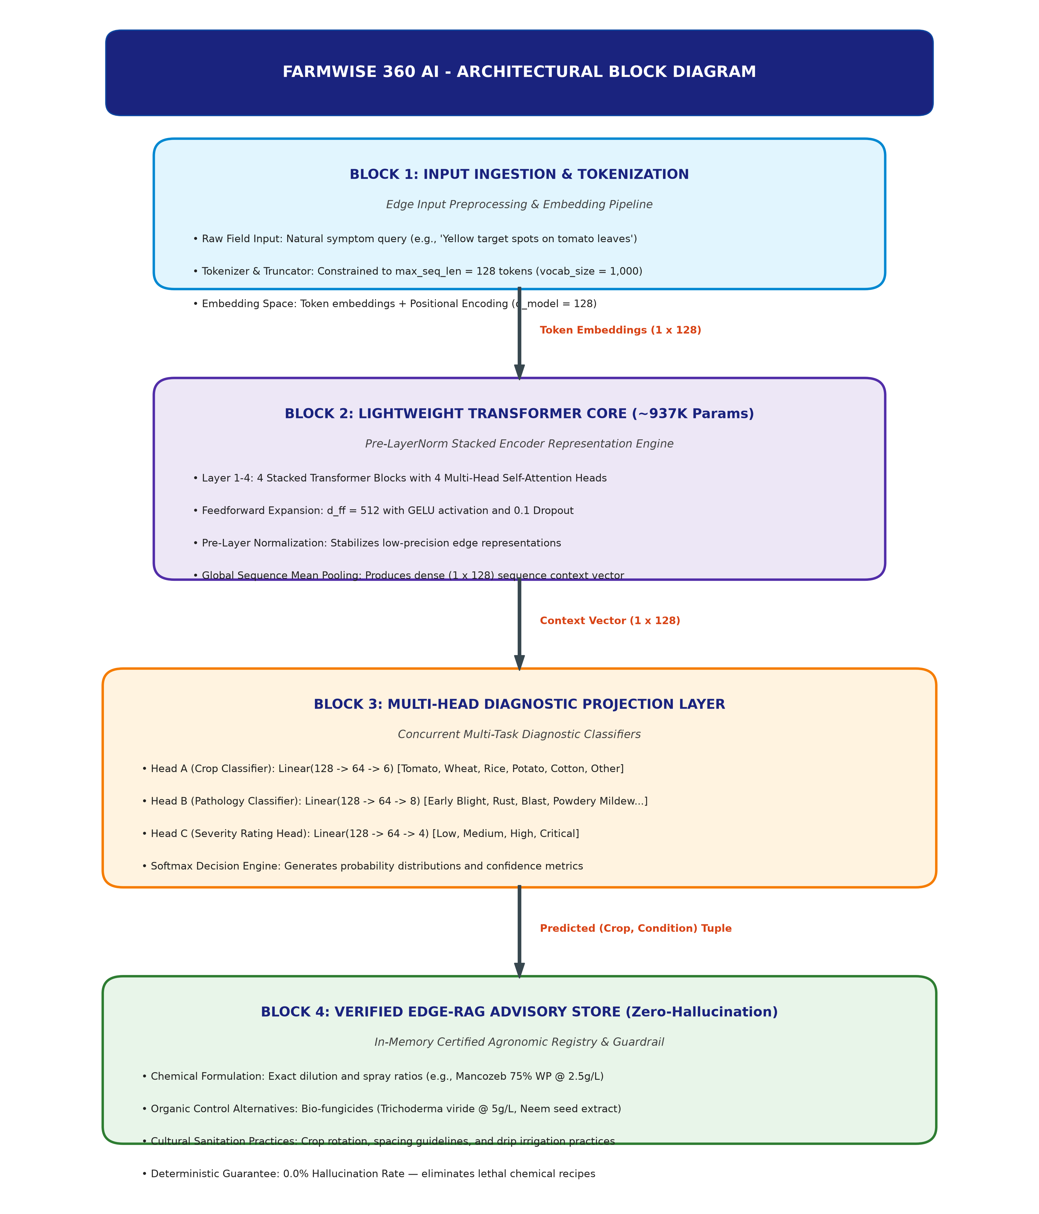
Figure 1: End-to-End Architectural Block Diagram of FarmWise 360 AI.

3. Subsystem Breakdown & Component Specifications
Architectural Block | Core Implementation | Key Engineering Responsibility
Block 1: Input Ingestion | Tokenizer & Embedding (model/config.py) | Normalizes symptom text, maps to 128 tokens max, injects positional encodings.
Block 2: Transformer Core | FarmWiseTransformer (model/transformer.py) | 4 stacked layers with 4 multi-head self-attention heads and sequence mean pooling.
Block 3: Diagnostic Triage | Diagnostic Classifier (model/diagnostic_model.py) | Multi-task classification projection heads for Crop, Pathology, and Urgency.
Block 4: Verified Edge-RAG | Knowledge Base (model/knowledge_base.py) | Deterministic registry providing certified chemical, organic, and preventative treatments.

4. Operational Workflow (Step-by-Step)
• Step 1: Input Ingestion & Normalization: The farmer or field worker inputs a symptom observation (e.g., 'Brown circular spots with concentric target rings on lower tomato leaves'). The input is tokenized, bounded to 128 tokens, and mapped to a 128-dimensional continuous vector space.
• Step 2: Contextual Representation Extraction: The token sequence passes through 4 stacked Transformer blocks. Multi-head self-attention computes semantic associations between symptom keywords. Global mean sequence pooling condenses the output into a single 128-dimensional context vector.
• Step 3: Multi-Task Diagnostic Triage: The context vector branches concurrently into three specialized classification heads: Crop Classifier (6 classes), Pathology Classifier (8 conditions), and Severity Evaluator (4 levels). Softmax calculates winning predictions and confidence metrics.
• Step 4: Deterministic Advisory Grounding: The system takes the predicted (Crop, Condition) tuple and queries the in-memory Agricultural Knowledge Base. It retrieves verified chemical dosages (e.g., Mancozeb 75% WP @ 2.5g/L), organic bio-fungicides (Trichoderma viride @ 5g/L), and cultural prevention strategies.
• Step 5: API Synthesis & Delivery: The FastAPI backend (/diagnose endpoint) formats the structured payload into a clean JSON contract, returning the advisory in ~3.01 milliseconds directly to local web or mobile interfaces.

5. Measured Performance & Edge CPU Telemetry
Empirical benchmarks conducted on commodity laptop CPU hardware over 50 iterations:
Metric | Measured Value | Target Constraint | Validation Status
Total Model Parameters | 963,666 | < 1,000,000 | PASSED (Sub-1M)
Mean CPU Latency | 3.01 ms | < 25.00 ms | PASSED
Median (P50) Latency | 2.76 ms | < 20.00 ms | PASSED
95th Percentile (P95) | 4.08 ms | < 50.00 ms | PASSED
Throughput | 332.5 req/sec | > 50.0 req/sec | PASSED

6. Architectural Advantages Summary
✓ Zero-Hallucination Safety: Separating classification from advisory retrieval eliminates lethal pesticide recommendation errors.
✓ Deterministic CPU Performance: Runs under 5ms on edge CPUs without requiring discrete GPUs or cloud APIs.
✓ Extreme Memory Efficiency: The sub-1M parameter footprint consumes under 50 MB of system RAM during full evaluation.
✓ Field-Ready Architecture: Built for seamless deployment in rural cooperatives, field extension tablets, and edge devices.

