# 1 Show film name ONLY which has screening

SELECT film.name

FROM film

JOIN screening

ON film.id = screening.film_id

GROUP BY film.name;

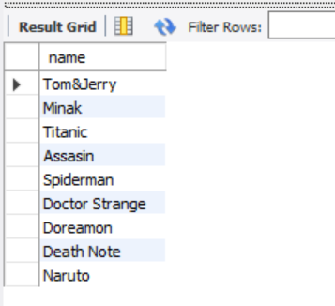

# 2 Show Room name with all sear row and seat column of 'Room 2'

SELECT

room.name,

seat.row, seat.number

FROM room

JOIN seat

ON room.id = seat.room_id

WHERE room.name = 'Room 2';

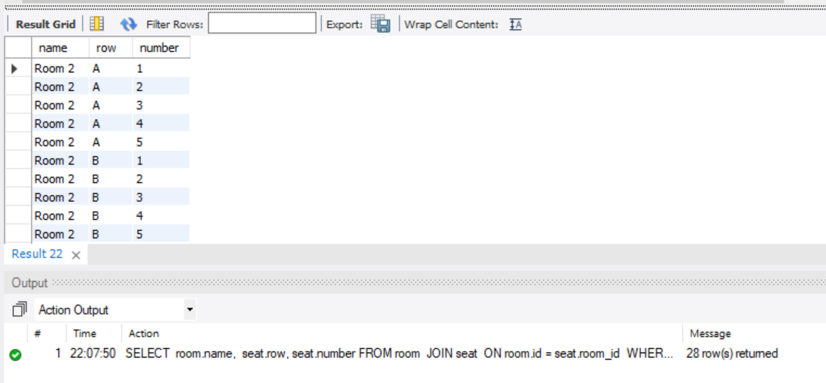

# 3 Show all Screening information including film name, room name, time of fil 'Tom & Jerry'

SELECT

screening.id, screening.film_id, screening.room_id,

room.name,

film.name

FROM screening

JOIN film

ON screening.film_id = film.id

JOIN room

ON screening.room_id = room.id

WHERE film.name = 'Tom&Jerry';

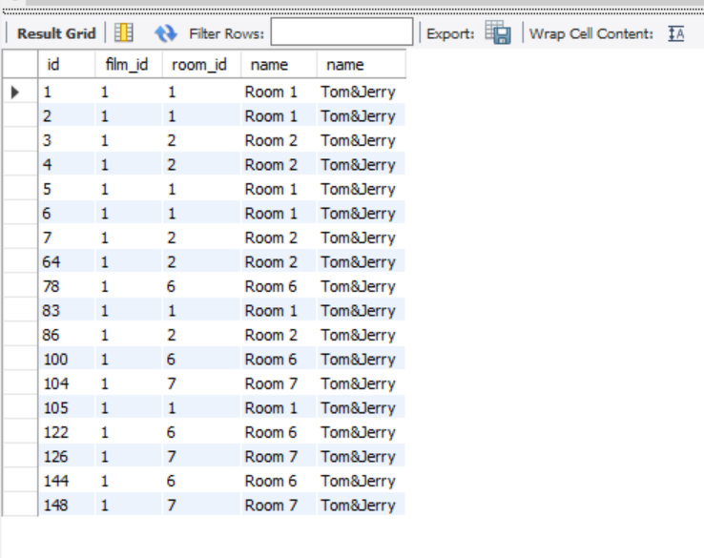

# 4 Show what seat that customer "Dung Nguyen ' booked

SELECT

customer.first_name, customer.last_name, seat.number, seat.row

FROM customer

JOIN booking

ON booking.customer_id = customer.id

JOIN reserved_seat

ON reserved_seat.booking_id = booking.id

JOIN seat

ON seat.id = reserved_seat.seat_id

WHERE customer.first_name = 'Dung' AND customer.last_name = 'Nguyen';

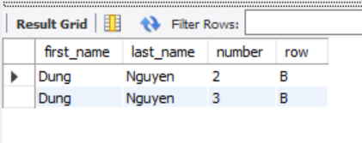

# 5 How many film that showed in 24/5/2022

SELECT

COUNT(DISTINCT(film_id)) AS NumberOfFilms

FROM screening

WHERE DATE(start_time) = '2022-05-24';

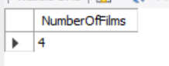

# 6 What is the maximum length and minimum length of all film

SELECT

MAX(length_min) AS MaxLength,

MIN(length_min) AS MinLength

FROM film;

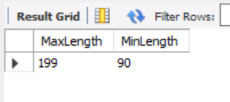

# 7 How many seat in Room 7

SELECT COUNT(seat.id) AS SeatsInRoom7

FROM seat

JOIN room

ON seat.room_id = room.id

WHERE room.name = 'Room 7';

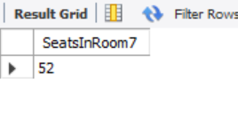

# 8 Total seat are booked of film "Tome&Jerry"

SELECT COUNT(reserved_seat.seat_id) AS SeatBookedTomJerry

FROM reserved_seat

JOIN booking

ON reserved_seat.booking_id = booking.id

JOIN screening

ON screening.id = booking.screening_id

JOIN film

ON film.id = screening.film_id

WHERE film.name = 'Tom&Jerry'

