BÀI TẬP TUẦN 8
Bài tập: ngày 09/03/2026
Lớp: 12_ĐH_CNTT4
Tên sinh viên: Trần Thị Thanh Thảo
Mã số sinh viên: 1250080179
Bài tập 1:
Tạo bảng
CREATE TABLE HangSX (
MaHangSX VARCHAR2(10) CONSTRAINT pk_hangsx PRIMARY KEY,
TenHang VARCHAR2(30) NOT NULL,
DiaChi VARCHAR2(50),
SoDT VARCHAR2(15),

Email VARCHAR2(50)
);
CREATE TABLE SanPham (
MaSP VARCHAR2(10) CONSTRAINT pk_sanpham PRIMARY KEY,
MaHangSX VARCHAR2(10) REFERENCES HangSX(MaHangSX),
TenSP VARCHAR2(50) NOT NULL,
SoLuong NUMBER(10),
MauSac VARCHAR2(20),
GiaBan NUMBER(15,2),
DonViTinh VARCHAR2(15),
MoTa CLOB
);
CREATE TABLE NhanVien (
MaNV VARCHAR2(10) CONSTRAINT pk_nhanvien PRIMARY KEY,
TenNV VARCHAR2(50) NOT NULL,
GioiTinh VARCHAR2(10),
DiaChi VARCHAR2(100),
SoDT VARCHAR2(15),
Email VARCHAR2(50),
TenPhong VARCHAR2(30)
);
CREATE TABLE PNhap (
SoHDN VARCHAR2(10) CONSTRAINT pk_pnhap PRIMARY KEY,
NgayNhap DATE,
MaNV VARCHAR2(10) REFERENCES NhanVien(MaNV)
);
CREATE TABLE Nhap (
SoHDN VARCHAR2(10) REFERENCES PNhap(SoHDN),
MaSP VARCHAR2(10) REFERENCES SanPham(MaSP),
SoLuongN NUMBER(10),
DonGiaN NUMBER(15,2),
CONSTRAINT pk_nhap PRIMARY KEY (SoHDN, MaSP)
);
CREATE TABLE PXuat (
SoHDX VARCHAR2(10) CONSTRAINT pk_pxuat PRIMARY KEY,
NgayXuat DATE,
MaNV VARCHAR2(10) REFERENCES NhanVien(MaNV)
);
CREATE TABLE Xuat (
SoHDX VARCHAR2(10) REFERENCES PXuat(SoHDX),
MaSP VARCHAR2(10) REFERENCES SanPham(MaSP),
SoLuongX NUMBER(10),
CONSTRAINT pk_xuat PRIMARY KEY (SoHDX, MaSP)
);
Kết quả:
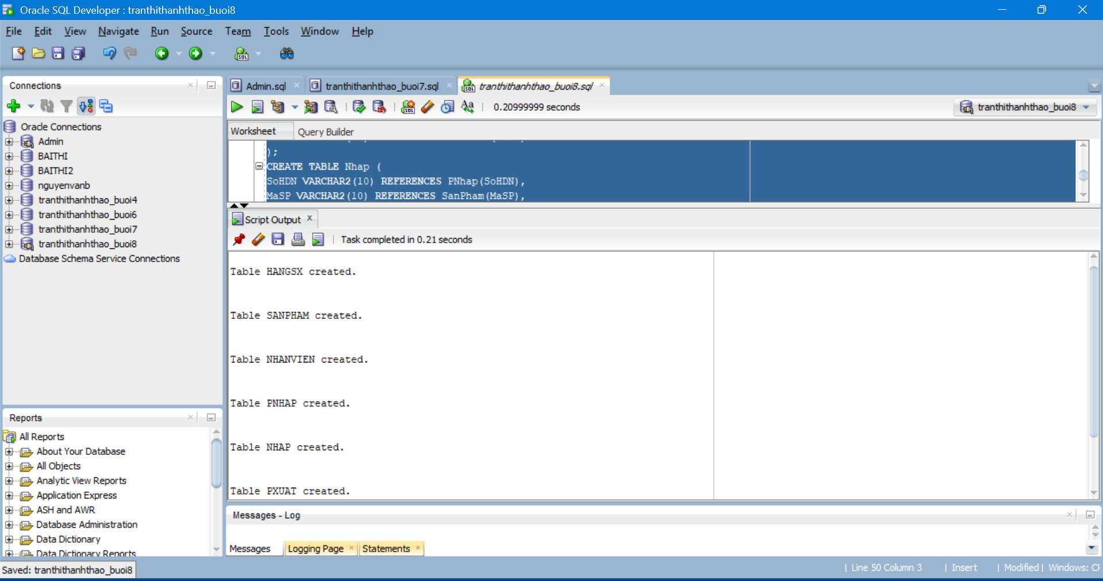
Câu a: Thủ tục sp_NhapHangSX
CREATE OR REPLACE PROCEDURE sp_NhapHangSX(
p_MaHangSX VARCHAR2,
p_TenHang VARCHAR2,
p_DiaChi VARCHAR2,
p_SoDT VARCHAR2,
p_Email VARCHAR2
)
AS
v_count NUMBER := 0;
BEGIN
SELECT COUNT(*) INTO v_count
FROM HangSX
WHERE TenHang = p_TenHang;
IF v_count > 0 THEN
DBMS_OUTPUT.PUT_LINE('Ten hang da ton tai');
ELSE
INSERT INTO HangSX
VALUES(p_MaHangSX,p_TenHang,p_DiaChi,p_SoDT,p_Email);
END IF;
END;
Kết quả: 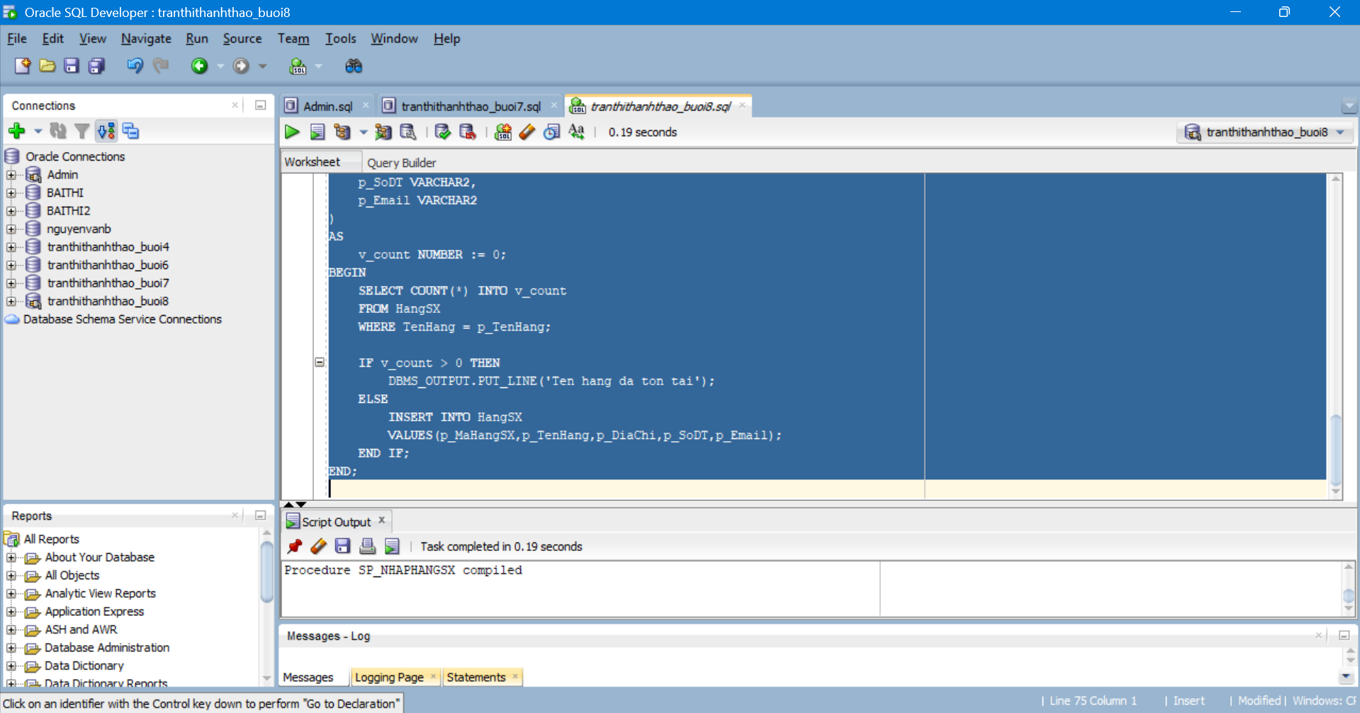
Kiểm tra:
---kiểm tra
BEGIN
sp_NhapHangSX('HSX06','LG','Hàn Quốc','0906666666','lg@gmail.com');
END;
SELECT * FROM HangSX WHERE TenHang='LG';
Kết quả:
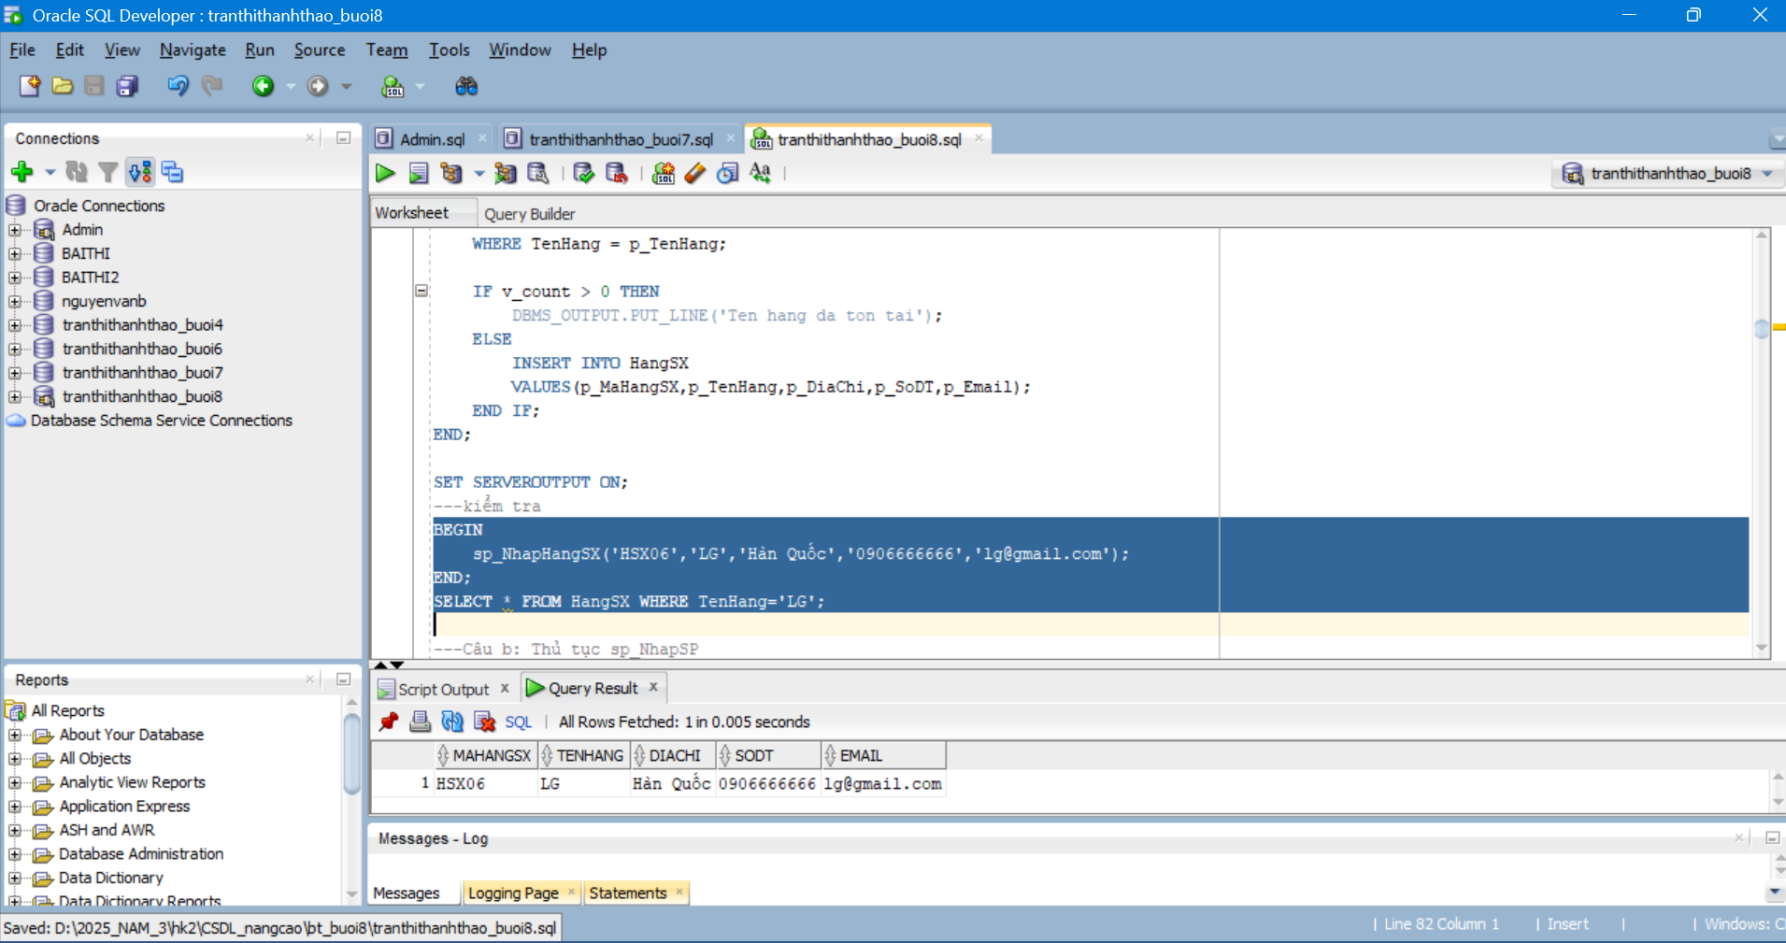
Câu b: Thủ tục sp_NhapSP
CREATE OR REPLACE PROCEDURE sp_NhapSP(
p_MaSP VARCHAR2,
p_TenHang VARCHAR2,
p_TenSP VARCHAR2,
p_SoLuong NUMBER,
p_MauSac VARCHAR2,
p_GiaBan NUMBER,
p_DonViTinh VARCHAR2,
p_MoTa VARCHAR2
)
AS
v_mahang VARCHAR2(10);
v_count NUMBER;
BEGIN
SELECT MaHangSX INTO v_mahang
FROM HangSX
WHERE TenHang = p_TenHang;
SELECT COUNT(*) INTO v_count
FROM SanPham
WHERE MaSP = p_MaSP;
IF v_count > 0 THEN
UPDATE SanPham
SET TenSP=p_TenSP,
SoLuong=p_SoLuong,
MauSac=p_MauSac,
GiaBan=p_GiaBan,
DonViTinh=p_DonViTinh,
MoTa=p_MoTa
WHERE MaSP=p_MaSP;
ELSE
INSERT INTO SanPham
VALUES(p_MaSP,v_mahang,p_TenSP,p_SoLuong,p_MauSac,p_GiaBan,p_DonViTinh,p_MoTa);
END IF;
EXCEPTION
WHEN NO_DATA_FOUND THEN
DBMS_OUTPUT.PUT_LINE('Ten hang khong ton tai');
END;
Kết quả: 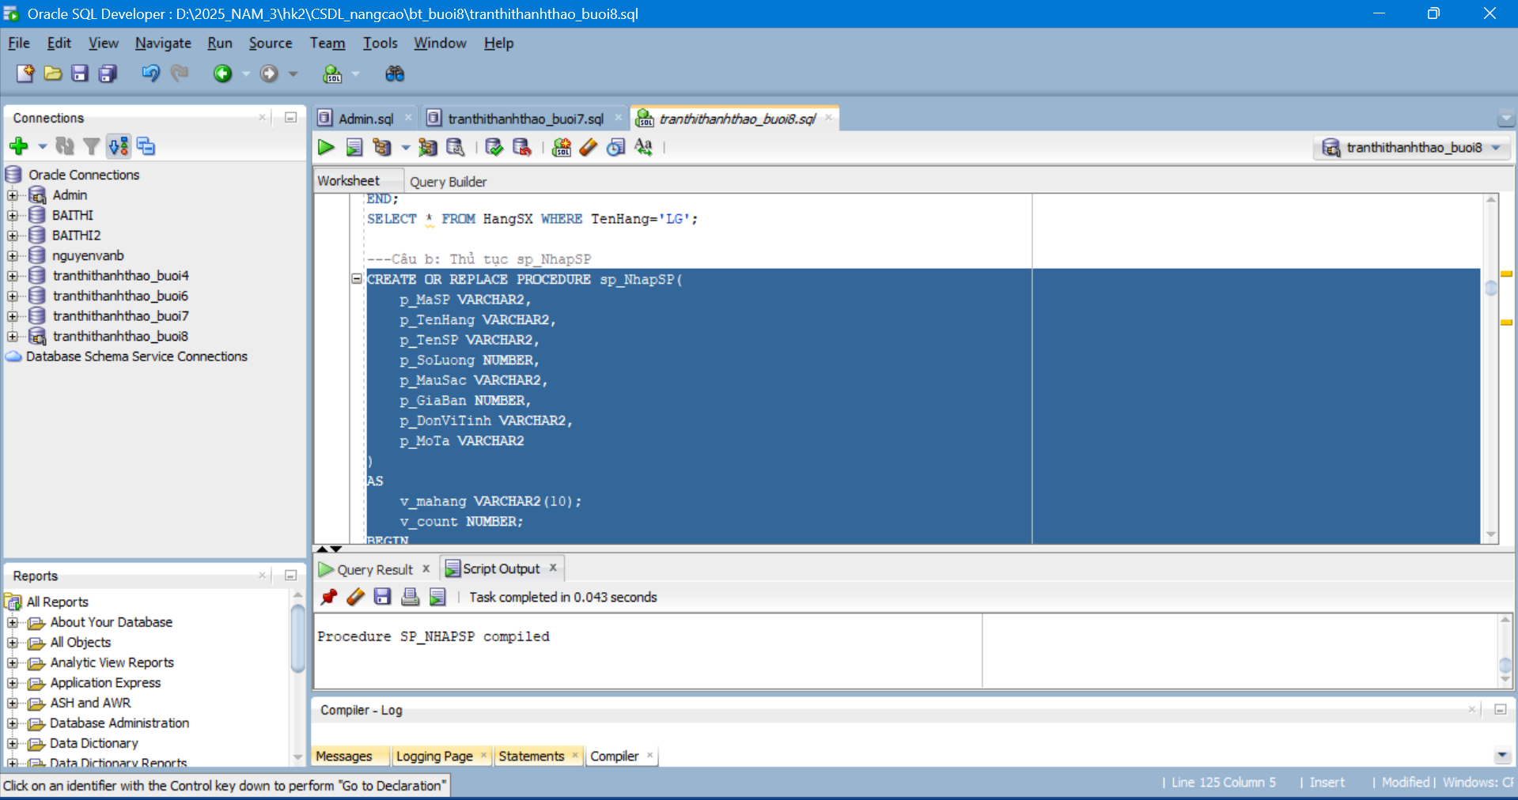
Câu c: Thủ tục sp_xoaHangSX
CREATE OR REPLACE PROCEDURE sp_xoaHangSX(
p_TenHang VARCHAR2
)
AS
v_mahang VARCHAR2(10);
BEGIN
SELECT MaHangSX INTO v_mahang
FROM HangSX
WHERE TenHang=p_TenHang;
DELETE FROM SanPham
WHERE MaHangSX=v_mahang;

DELETE FROM HangSX
WHERE MaHangSX=v_mahang;
EXCEPTION
WHEN NO_DATA_FOUND THEN
DBMS_OUTPUT.PUT_LINE('Ten hang khong ton tai');
END;
Kết quả:
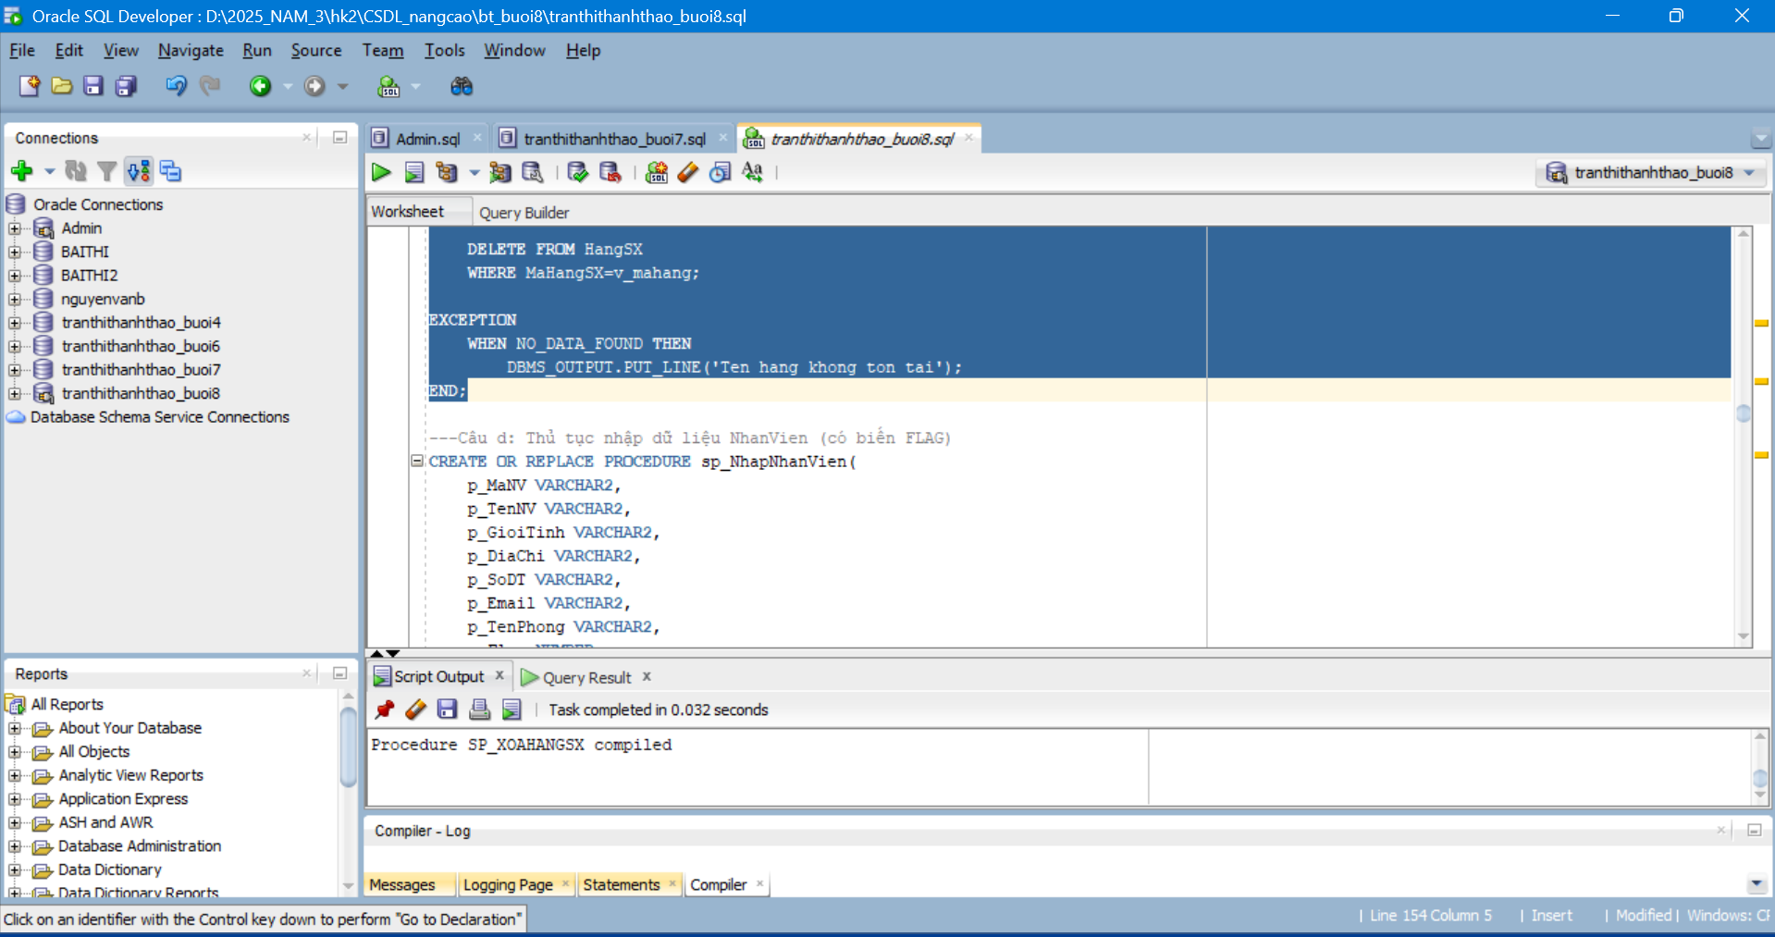
Câu d: Thủ tục nhập dữ liệu NhanVien (có biến FLAG)
---Câu d: Thủ tục nhập dữ liệu NhanVien (có biến FLAG)
CREATE OR REPLACE PROCEDURE sp_NhapNhanVien(
p_MaNV VARCHAR2,
p_TenNV VARCHAR2,
p_GioiTinh VARCHAR2,
p_DiaChi VARCHAR2,
p_SoDT VARCHAR2,
p_Email VARCHAR2,
p_TenPhong VARCHAR2,
p_Flag NUMBER
)
AS
BEGIN
IF p_Flag = 0 THEN
UPDATE NhanVien
SET TenNV=p_TenNV,
GioiTinh=p_GioiTinh,
DiaChi=p_DiaChi,
SoDT=p_SoDT,
Email=p_Email,
TenPhong=p_TenPhong
WHERE MaNV=p_MaNV;
ELSE
INSERT INTO NhanVien
VALUES(p_MaNV,p_TenNV,p_GioiTinh,p_DiaChi,p_SoDT,p_Email,p_TenPhong);
END IF;
END;
Kết quả:
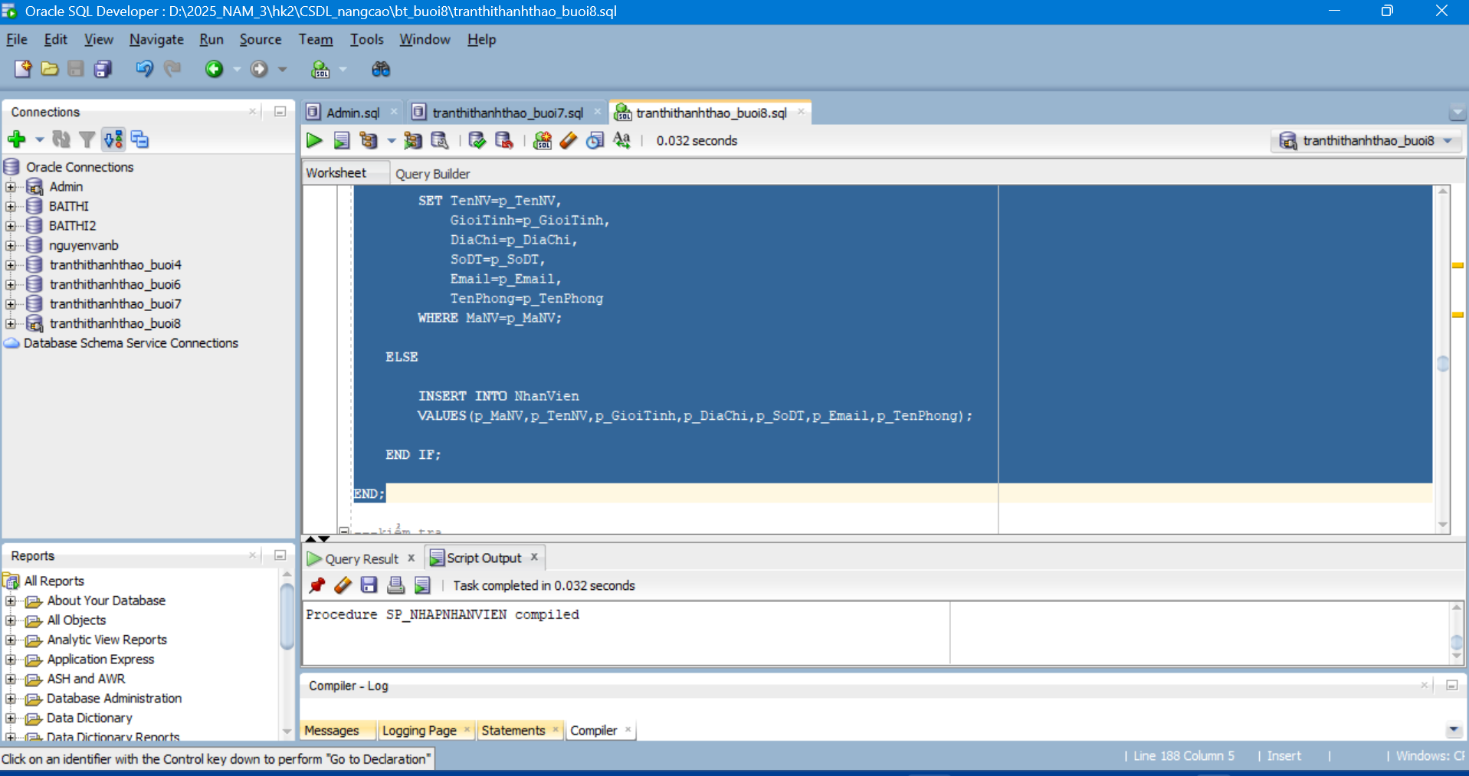
Kiểm tra:
BEGIN
sp_NhapNhanVien('NV06','Phan Văn G','Nam','Huế','0966666666','g@gmail.com','Kho',1);
END;
SELECT * FROM NhanVien WHERE MaNV='NV06';
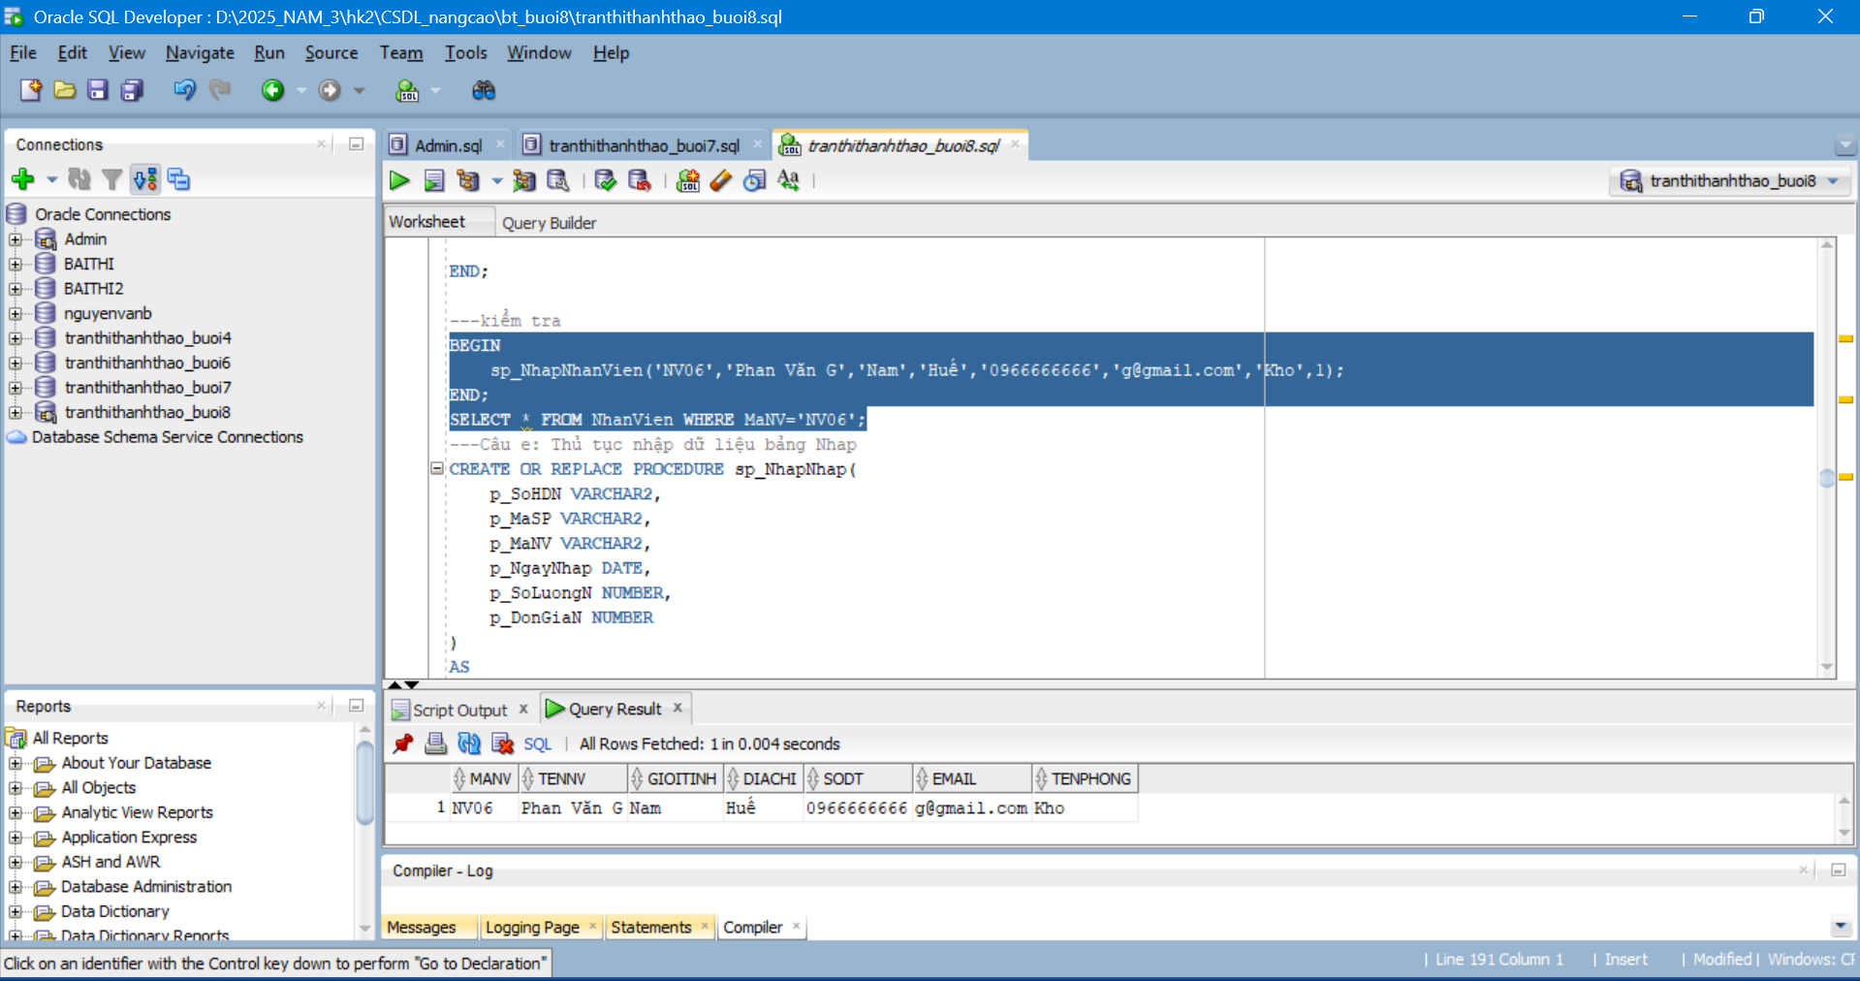
Câu e: Thủ tục nhập dữ liệu bảng Nhap
---Câu e: Thủ tục nhập dữ liệu bảng Nhap
CREATE OR REPLACE PROCEDURE sp_NhapNhap(
p_SoHDN VARCHAR2,
p_MaSP VARCHAR2,
p_MaNV VARCHAR2,
p_NgayNhap DATE,
p_SoLuongN NUMBER,
p_DonGiaN NUMBER
)
AS
v_count NUMBER;
BEGIN
SELECT COUNT(*) INTO v_count FROM SanPham WHERE MaSP=p_MaSP;
IF v_count=0 THEN
DBMS_OUTPUT.PUT_LINE('MaSP khong ton tai');
RETURN;
END IF;
SELECT COUNT(*) INTO v_count FROM NhanVien WHERE MaNV=p_MaNV;
IF v_count=0 THEN
DBMS_OUTPUT.PUT_LINE('MaNV khong ton tai');
RETURN;
END IF;
SELECT COUNT(*) INTO v_count FROM PNhap WHERE SoHDN=p_SoHDN;
IF v_count>0 THEN
UPDATE Nhap
SET SoLuongN=p_SoLuongN,
DonGiaN=p_DonGiaN
WHERE SoHDN=p_SoHDN AND MaSP=p_MaSP;
ELSE
INSERT INTO PNhap VALUES(p_SoHDN,p_NgayNhap,p_MaNV);
INSERT INTO Nhap
VALUES(p_SoHDN,p_MaSP,p_SoLuongN,p_DonGiaN);
END IF;
END;
Kết quả:
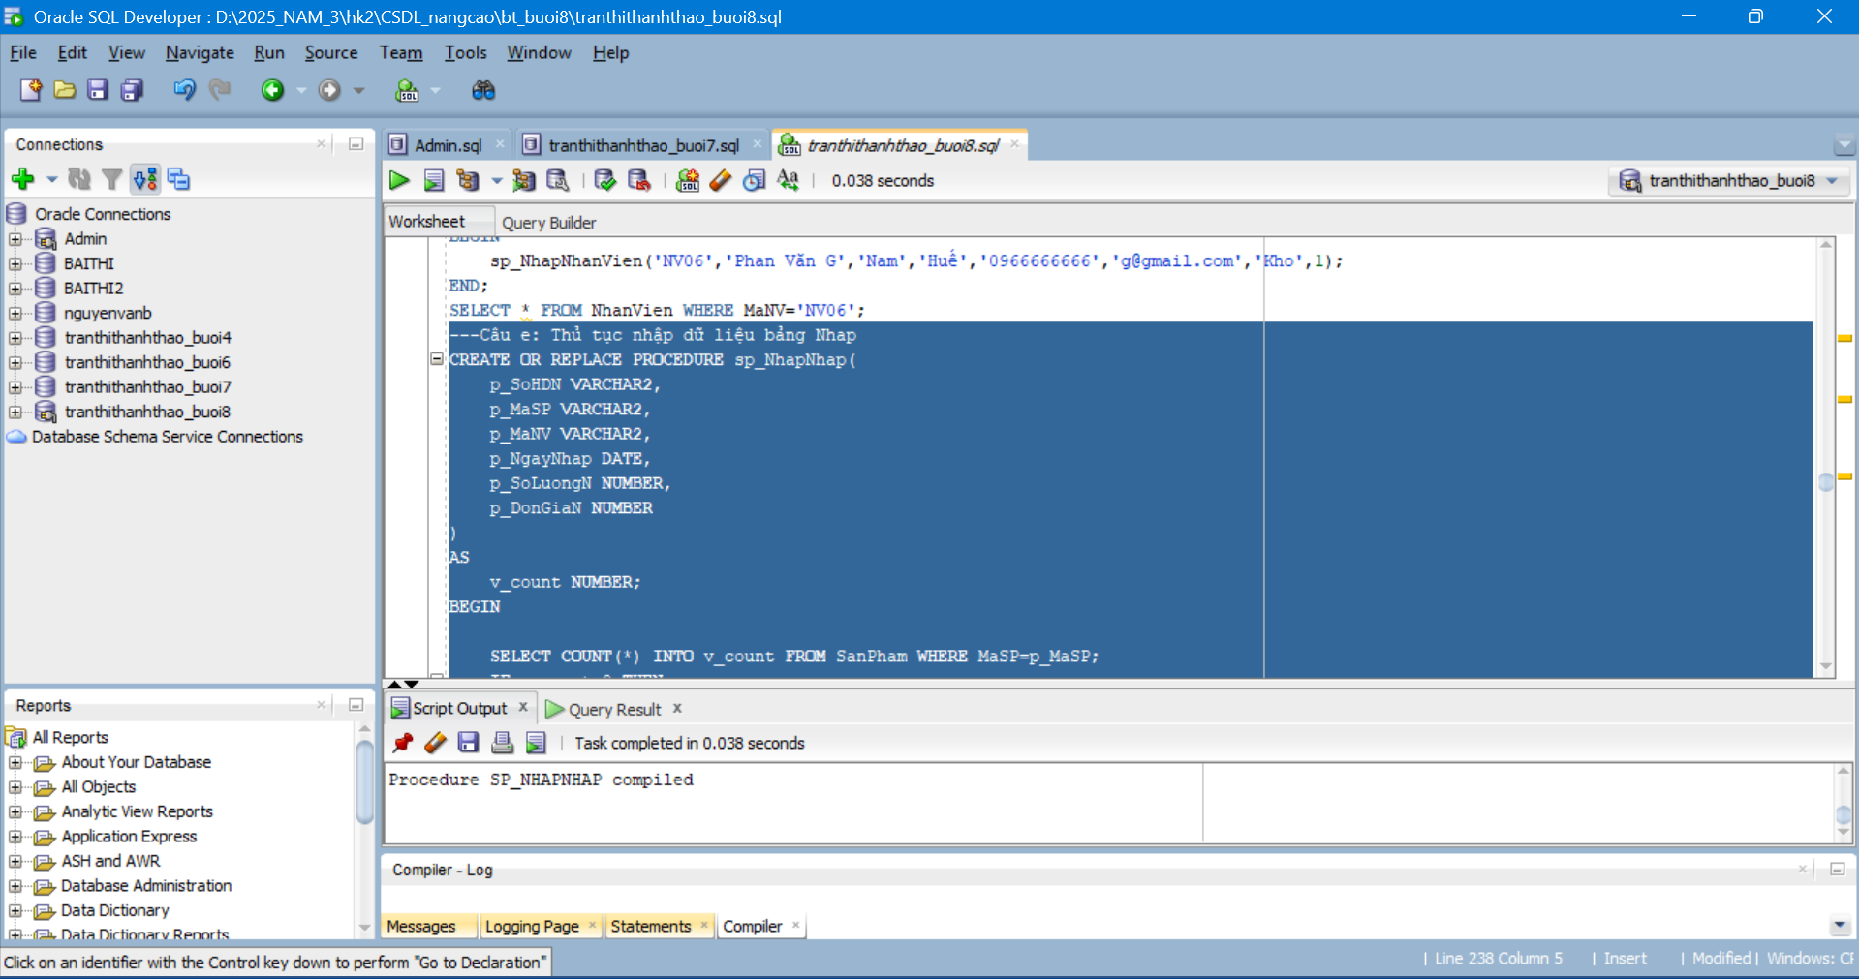
Câu f: Thủ tục nhập dữ liệu bảng Xuat
---Câu f: Thủ tục nhập dữ liệu bảng Xuat
CREATE OR REPLACE PROCEDURE sp_NhapXuat(
p_SoHDX VARCHAR2,
p_MaSP VARCHAR2,
p_MaNV VARCHAR2,
p_NgayXuat DATE,
p_SoLuongX NUMBER
)
AS
v_count NUMBER;
v_soluong NUMBER;
BEGIN
SELECT COUNT(*) INTO v_count FROM SanPham WHERE MaSP=p_MaSP;
IF v_count=0 THEN
DBMS_OUTPUT.PUT_LINE('MaSP khong ton tai');
RETURN;
END IF;
SELECT COUNT(*) INTO v_count FROM NhanVien WHERE MaNV=p_MaNV;
IF v_count=0 THEN
DBMS_OUTPUT.PUT_LINE('MaNV khong ton tai');
RETURN;
END IF;
SELECT SoLuong INTO v_soluong
FROM SanPham
WHERE MaSP=p_MaSP;
IF p_SoLuongX > v_soluong THEN
DBMS_OUTPUT.PUT_LINE('Khong du hang');
RETURN;
END IF;
SELECT COUNT(*) INTO v_count FROM PXuat WHERE SoHDX=p_SoHDX;
IF v_count>0 THEN
UPDATE Xuat
SET SoLuongX=p_SoLuongX
WHERE SoHDX=p_SoHDX AND MaSP=p_MaSP;
ELSE
INSERT INTO PXuat VALUES(p_SoHDX,p_NgayXuat,p_MaNV);
INSERT INTO Xuat VALUES(p_SoHDX,p_MaSP,p_SoLuongX);
END IF;
END;
Kết quả:
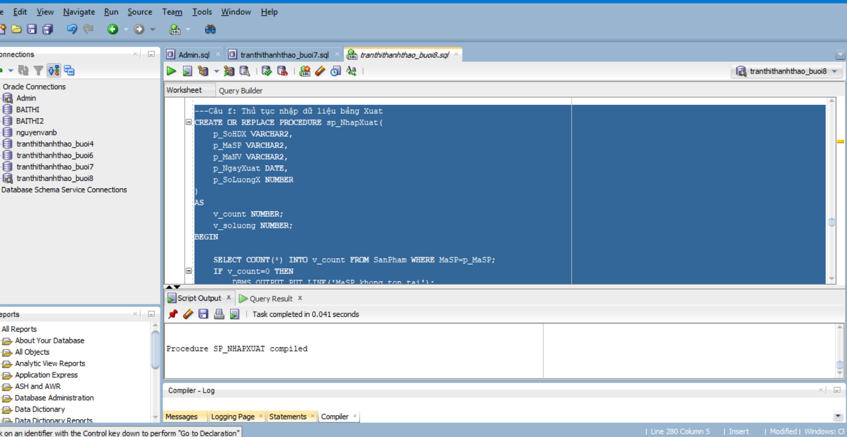
Câu g: Thủ tục xóa NhanVien
---Câu g: Thủ tục xóa NhanVien
CREATE OR REPLACE PROCEDURE sp_XoaNhanVien(
p_MaNV VARCHAR2
)
AS
v_count NUMBER;
BEGIN

SELECT COUNT(*) INTO v_count
FROM NhanVien
WHERE MaNV=p_MaNV;

IF v_count=0 THEN
DBMS_OUTPUT.PUT_LINE('Nhan vien khong ton tai');
RETURN;
END IF;

DELETE FROM Nhap
WHERE SoHDN IN (SELECT SoHDN FROM PNhap WHERE MaNV=p_MaNV);

DELETE FROM PNhap WHERE MaNV=p_MaNV;

DELETE FROM Xuat
WHERE SoHDX IN (SELECT SoHDX FROM PXuat WHERE MaNV=p_MaNV);

DELETE FROM PXuat WHERE MaNV=p_MaNV;

DELETE FROM NhanVien WHERE MaNV=p_MaNV;

END;
Kết quả: 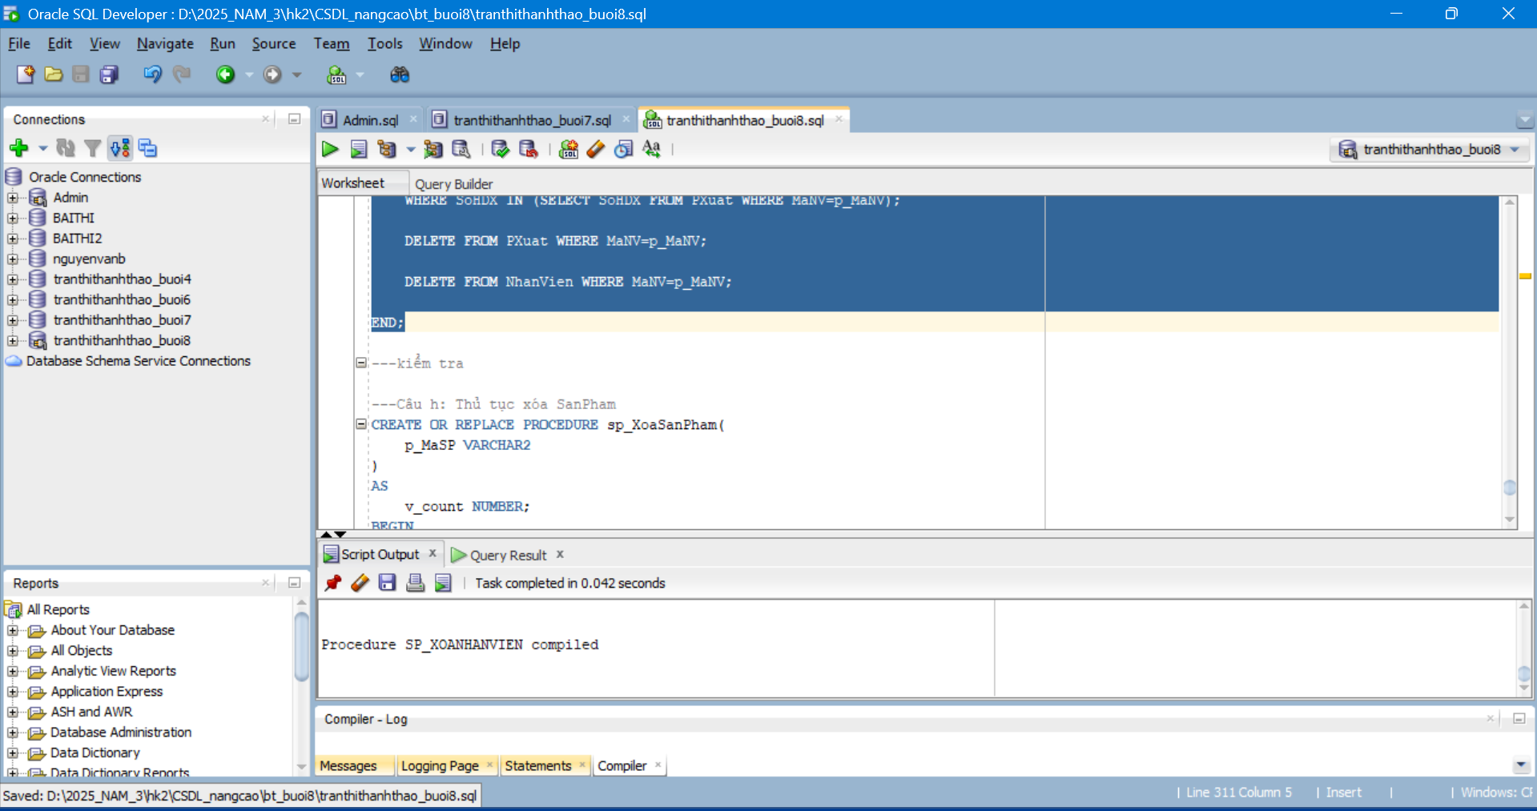
Câu h: Thủ tục xóa SanPham
---Câu h: Thủ tục xóa SanPham
CREATE OR REPLACE PROCEDURE sp_XoaSanPham(
p_MaSP VARCHAR2
)
AS
v_count NUMBER;
BEGIN
SELECT COUNT(*) INTO v_count
FROM SanPham
WHERE MaSP=p_MaSP;

IF v_count=0 THEN
DBMS_OUTPUT.PUT_LINE('San pham khong ton tai');
RETURN;
END IF;
DELETE FROM Nhap WHERE MaSP=p_MaSP;
DELETE FROM Xuat WHERE MaSP=p_MaSP;
DELETE FROM SanPham WHERE MaSP=p_MaSP;
END;
Kết quả: 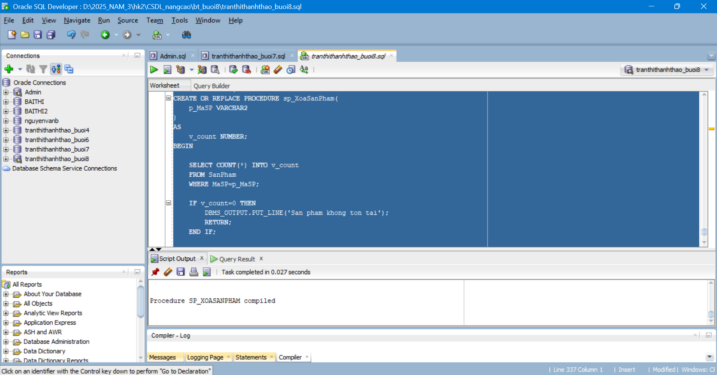
Bài tập 2
a. Thủ tục sp_ThemNhanVien (có OUT)
CREATE OR REPLACE PROCEDURE sp_ThemNhanVien(
MaNV VARCHAR2,
TenNV VARCHAR2,
GioiTinh VARCHAR2,
DiaChi VARCHAR2,
SoDT VARCHAR2,
Email VARCHAR2,
TenPhong VARCHAR2,
Flag NUMBER,
KQ OUT NUMBER
)
AS
v_count NUMBER;
BEGIN
SELECT COUNT(*) INTO v_count
FROM NhanVien
WHERE MaNV = sp_ThemNhanVien.MaNV;
IF v_count = 0 AND Flag = 1 THEN
KQ := 1;
ELSIF Flag = 0 THEN
INSERT INTO NhanVien
VALUES(MaNV,TenNV,GioiTinh,DiaChi,SoDT,Email,TenPhong);
KQ := 0;
ELSE
UPDATE NhanVien
SET TenNV = TenNV,
GioiTinh = GioiTinh,
DiaChi = DiaChi,
SoDT = SoDT,
Email = Email,
TenPhong = TenPhong
WHERE MaNV = MaNV;
KQ := 0;
END IF;
END;

Kết quả: 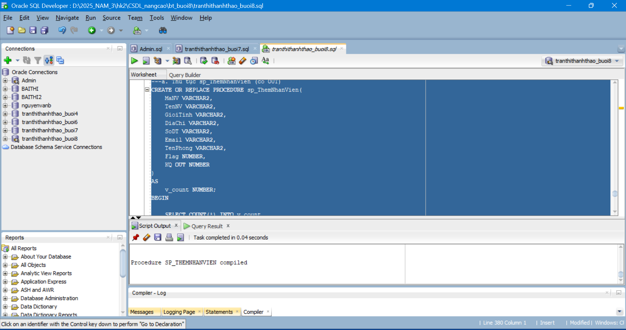
b. Thủ tục sp_ThemMoiSP (có OUT)
---b. Thủ tục sp_ThemMoiSP (có OUT)
CREATE OR REPLACE PROCEDURE sp_ThemMoiSP(
MaSP VARCHAR2,
TenHang VARCHAR2,
TenSP VARCHAR2,
SoLuong NUMBER,
MauSac VARCHAR2,
GiaBan NUMBER,
DonViTinh VARCHAR2,
MoTa VARCHAR2,
Flag NUMBER,
KQ OUT NUMBER
)
AS
v_count NUMBER;
v_mahang VARCHAR2(10);
BEGIN
IF TenHang IS NULL THEN
KQ := 1;
ELSIF SoLuong < 0 THEN
KQ := 2;
ELSE
SELECT MaHangSX INTO v_mahang
FROM HangSX
WHERE TenHang = TenHang;
SELECT COUNT(*) INTO v_count
FROM SanPham
WHERE MaSP = MaSP;
IF v_count > 0 THEN
UPDATE SanPham
SET MaHangSX = v_mahang,
TenSP = TenSP,
SoLuong = SoLuong,
MauSac = MauSac,
GiaBan = GiaBan,
DonViTinh = DonViTinh,
MoTa = MoTa
WHERE MaSP = MaSP;
ELSE
INSERT INTO SanPham
VALUES(MaSP,v_mahang,TenSP,SoLuong,MauSac,GiaBan,DonViTinh,MoTa);
END IF;
KQ := 0;
END IF;
END;
Kết quả: 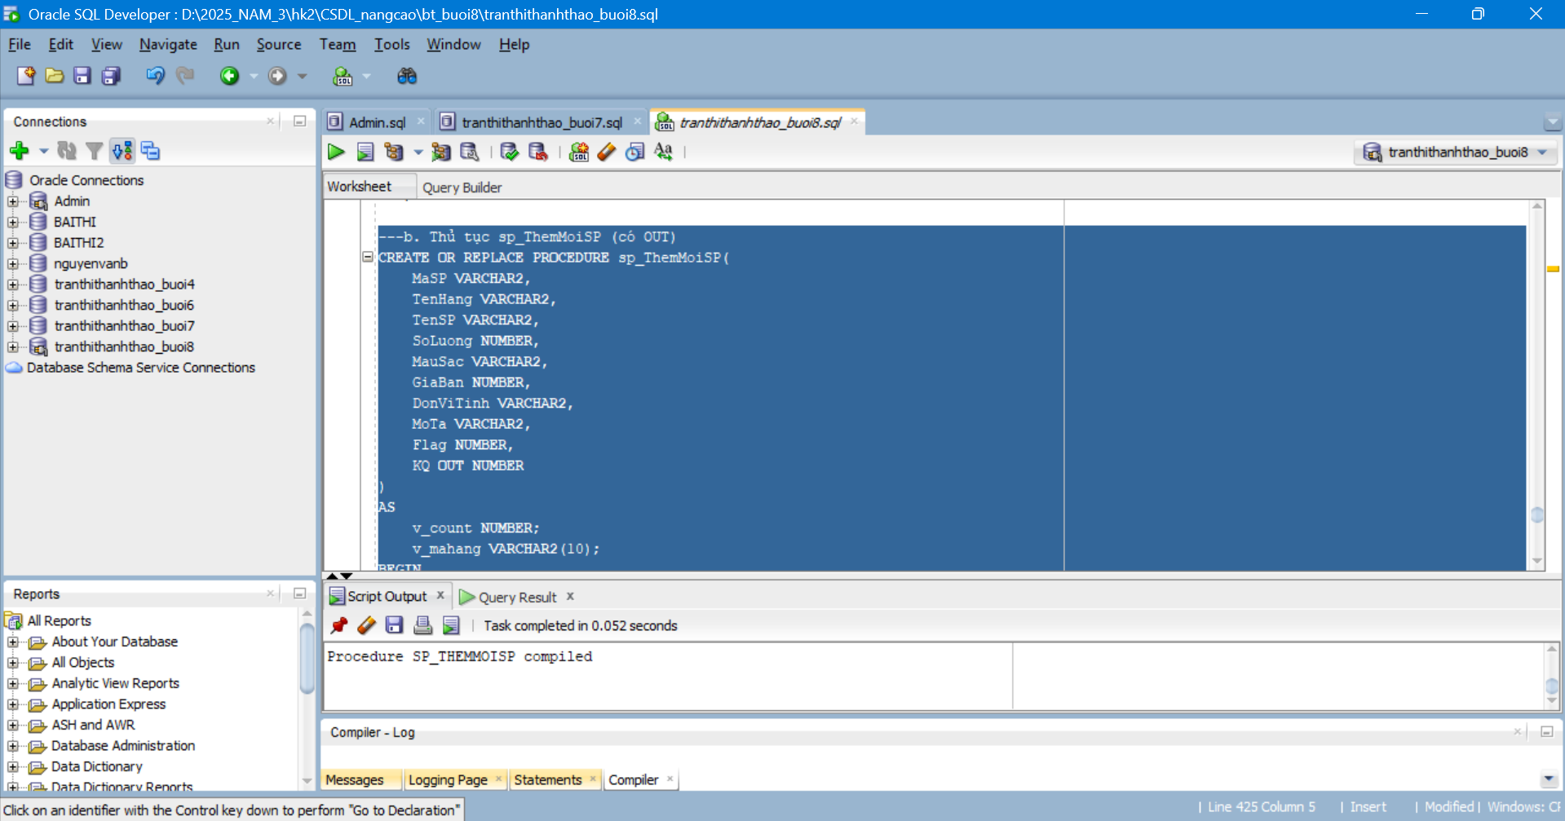
c. Thủ tục xóa NhanVien (có OUT)
---c. Thủ tục xóa NhanVien (có OUT)
CREATE OR REPLACE PROCEDURE xoaSanPham(
MaSP VARCHAR2,
KQ OUT NUMBER
)
AS
v_count NUMBER;
BEGIN
SELECT COUNT(*) INTO v_count
FROM SanPham
WHERE MaSP = xoaSanPham.MaSP;
IF v_count = 0 THEN
KQ := 1;
ELSE
DELETE FROM SanPham
WHERE MaSP = MaSP;
KQ := 0;
END IF;
END;
Kết quả:
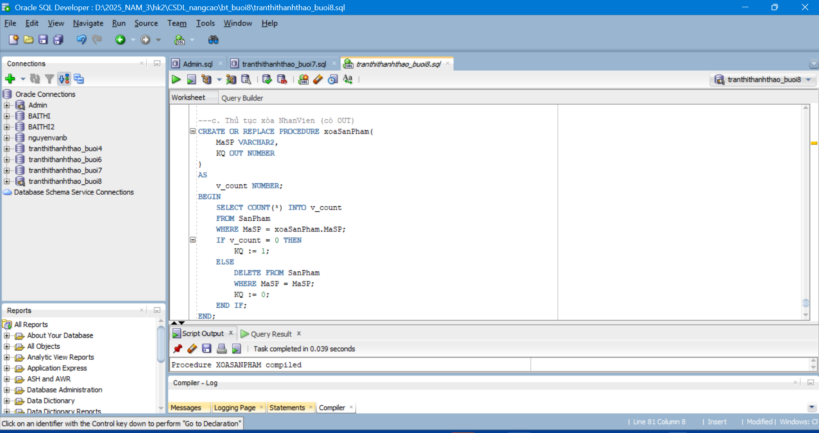
d. Thủ tục xóa SanPham (có OUT)
---d. Thủ tục xóa SanPham (có OUT)
CREATE OR REPLACE PROCEDURE sp_NhapHangSX(
MaHangSX VARCHAR2,
TenHang VARCHAR2,
DiaChi VARCHAR2,
SoDT VARCHAR2,
Email VARCHAR2,
KQ OUT NUMBER
)
AS
v_count NUMBER;
BEGIN
SELECT COUNT(*) INTO v_count
FROM HangSX
WHERE TenHang = sp_NhapHangSX.TenHang;
IF v_count > 0 THEN
KQ := 1;
ELSE
INSERT INTO HangSX
VALUES(MaHangSX,TenHang,DiaChi,SoDT,Email);
KQ := 0;
END IF;
END;
Kết quả: 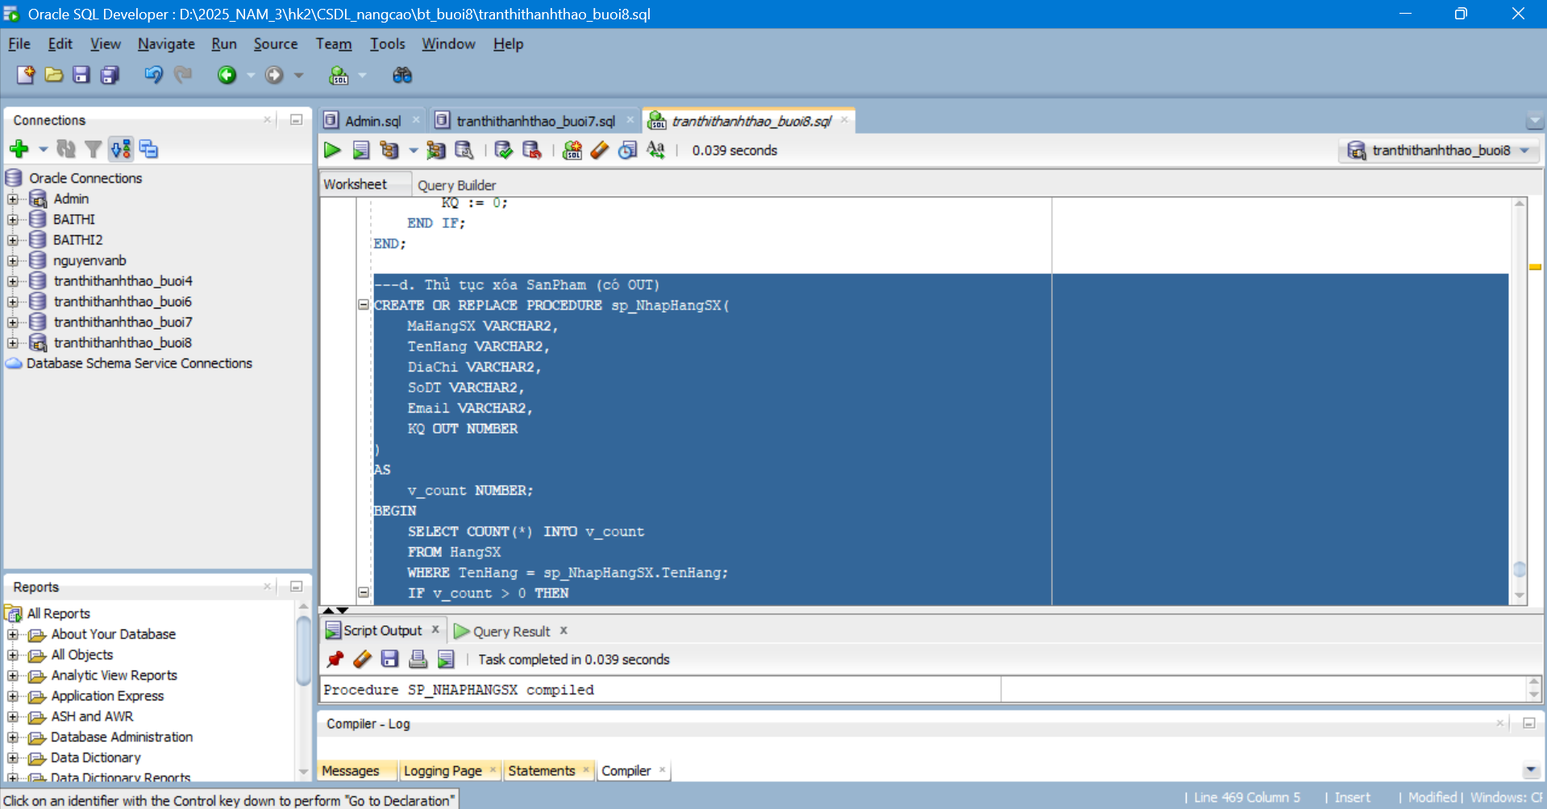
e. Thủ tục sp_NhapHangSX (có OUT)
---e. Thủ tục sp_NhapHangSX (có OUT)
CREATE OR REPLACE PROCEDURE sp_NhapHangSX(
MaHangSX VARCHAR2,
TenHang VARCHAR2,
DiaChi VARCHAR2,
SoDT VARCHAR2,
Email VARCHAR2,
KQ OUT NUMBER
)
AS
v_count NUMBER;
BEGIN
SELECT COUNT(*) INTO v_count
FROM HangSX
WHERE TenHang = sp_NhapHangSX.TenHang;
IF v_count > 0 THEN
KQ := 1;
ELSE
INSERT INTO HangSX
VALUES(MaHangSX,TenHang,DiaChi,SoDT,Email);
KQ := 0;
END IF;
END;
Kết quả: 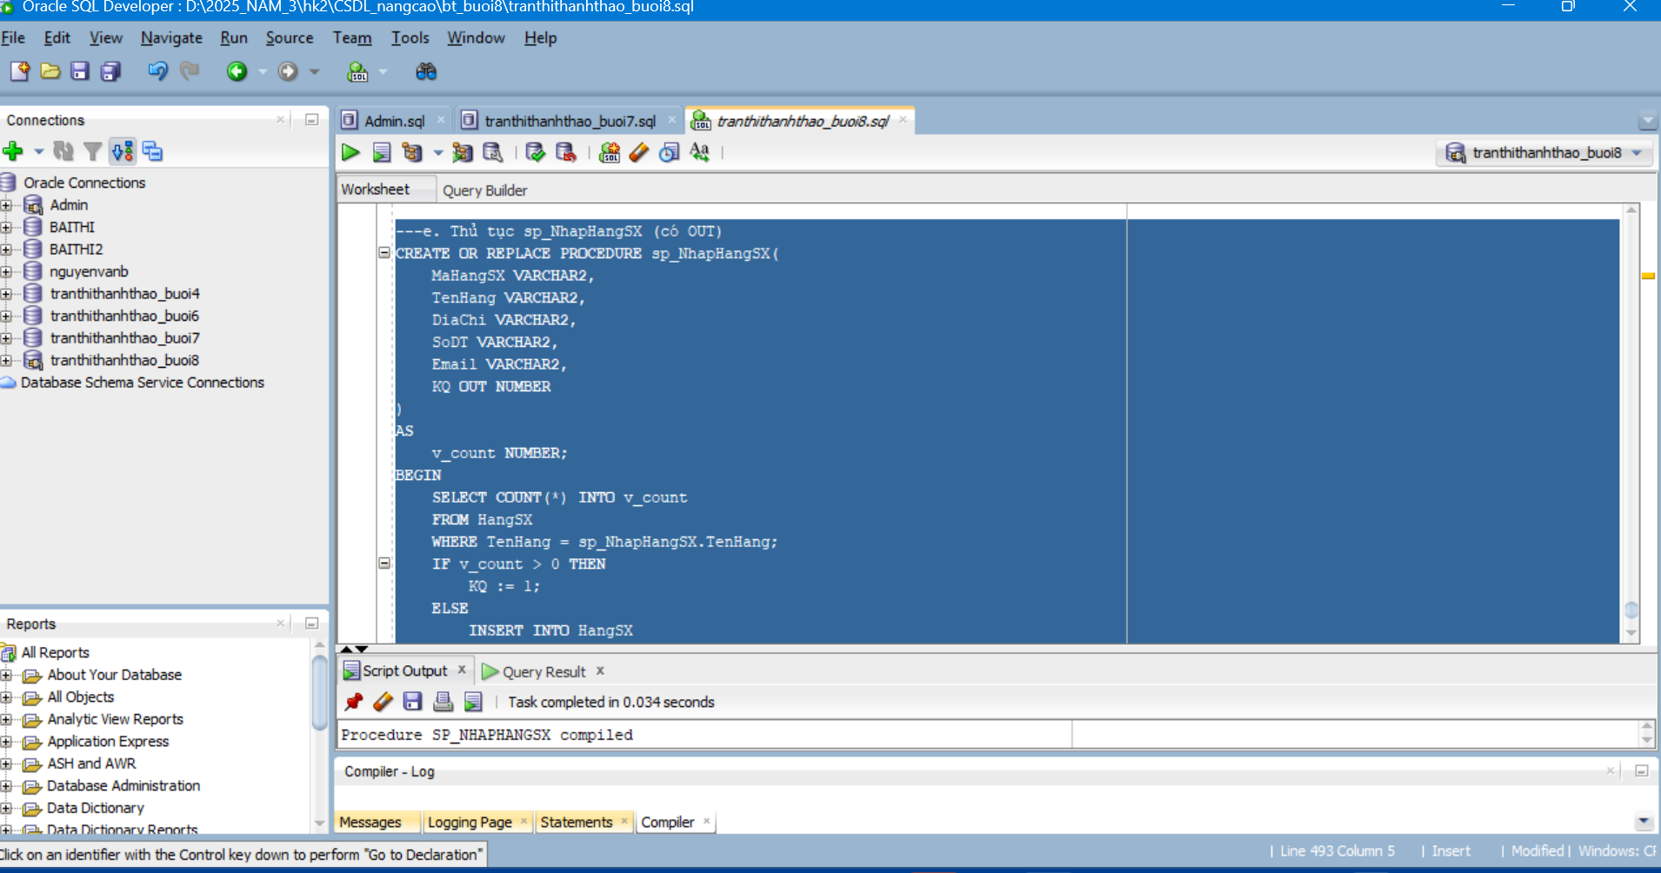
f. Thủ tục nhập bảng Nhap (có OUT)
---f. Thủ tục nhập bảng Nhap (có OUT)
CREATE OR REPLACE PROCEDURE sp_Nhap(
p_SoHDN VARCHAR2,
p_MaSP VARCHAR2,
p_MaNV VARCHAR2,
p_NgayNhap DATE,
p_SoLuongN NUMBER,
p_DonGiaN NUMBER,
KQ OUT NUMBER
)
AS
v_sp NUMBER;
v_nv NUMBER;
v_hd NUMBER;
v_ct NUMBER;
BEGIN
SELECT COUNT(*) INTO v_sp
FROM SanPham
WHERE MaSP = p_MaSP;
IF v_sp = 0 THEN
KQ := 1;
RETURN;
END IF;
SELECT COUNT(*) INTO v_nv
FROM NhanVien
WHERE MaNV = p_MaNV;
IF v_nv = 0 THEN
KQ := 2;
RETURN;
END IF;
SELECT COUNT(*) INTO v_hd
FROM PNhap
WHERE SoHDN = p_SoHDN;
IF v_hd = 0 THEN
INSERT INTO PNhap
VALUES(p_SoHDN,p_NgayNhap,p_MaNV);
END IF;
SELECT COUNT(*) INTO v_ct
FROM Nhap
WHERE SoHDN = p_SoHDN AND MaSP = p_MaSP;
IF v_ct > 0 THEN
UPDATE Nhap
SET SoLuongN = p_SoLuongN,
DonGiaN = p_DonGiaN
WHERE SoHDN = p_SoHDN
AND MaSP = p_MaSP;
ELSE
INSERT INTO Nhap
VALUES(p_SoHDN,p_MaSP,p_SoLuongN,p_DonGiaN);
END IF;
KQ := 0;
END;
Kết quả:
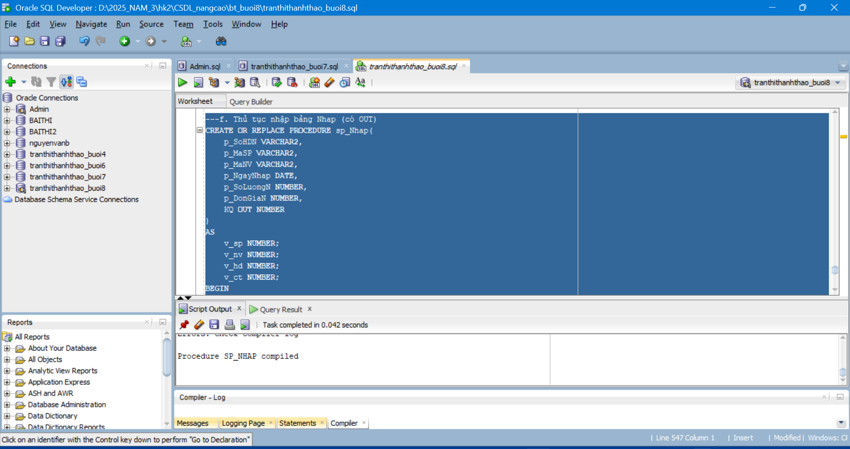
g. Thủ tục nhập bảng Xuat (có OUT)
---g. Thủ tục nhập bảng Xuat (có OUT)
CREATE OR REPLACE PROCEDURE sp_Xuat(
p_SoHDX VARCHAR2,
p_MaSP VARCHAR2,
p_MaNV VARCHAR2,
p_NgayXuat DATE,
p_SoLuongX NUMBER,
KQ OUT NUMBER
)
AS
v_sp NUMBER;
v_nv NUMBER;
v_hd NUMBER;
v_ct NUMBER;
v_sl NUMBER;
BEGIN
SELECT COUNT(*) INTO v_sp
FROM SanPham
WHERE MaSP = p_MaSP;
IF v_sp = 0 THEN
KQ := 1;
RETURN;
END IF;
SELECT COUNT(*) INTO v_nv
FROM NhanVien
WHERE MaNV = p_MaNV;
IF v_nv = 0 THEN
KQ := 2;
RETURN;
END IF;
SELECT SoLuong INTO v_sl
FROM SanPham
WHERE MaSP = p_MaSP;
IF p_SoLuongX > v_sl THEN
KQ := 3;
RETURN;
END IF;
SELECT COUNT(*) INTO v_hd
FROM PXuat
WHERE SoHDX = p_SoHDX;
IF v_hd = 0 THEN
INSERT INTO PXuat
VALUES(p_SoHDX,p_NgayXuat,p_MaNV);
END IF;
SELECT COUNT(*) INTO v_ct
FROM Xuat
WHERE SoHDX = p_SoHDX AND MaSP = p_MaSP;
IF v_ct > 0 THEN
UPDATE Xuat
SET SoLuongX = p_SoLuongX
WHERE SoHDX = p_SoHDX
AND MaSP = p_MaSP;
ELSE
INSERT INTO Xuat
VALUES(p_SoHDX,p_MaSP,p_SoLuongX);
END IF;
UPDATE SanPham
SET SoLuong = SoLuong - p_SoLuongX
WHERE MaSP = p_MaSP;
KQ := 0;
END;
Kết quả:
