TRƯỜNG ĐẠI HỌC TÀI NGUYÊN VÀ MÔI TRƯỜNG
THÀNH PHỐ HỒ CHÍ MINH
KHOA CÔNG NGHỆ THÔNG TIN


CƠ SỞ DỮ LIỆU NÂNG CAO
THỰC HÀNH BUỔI 5

Sinh viên thực hiện: Trần Thị Thanh Thảo (1250080179)
Lớp: 12_ĐH_CNTT4
Khoá: 2023 – 2027
Giảng viên hướng dẫn : Ths.Phạm Trọng Huynh

TP. Hồ Chí Minh, 04 tháng 05 năm 2026
TRƯỜNG ĐẠI HỌC TÀI NGUYÊN VÀ MÔI TRƯỜNG
THÀNH PHỐ HỒ CHÍ MINH
KHOA CÔNG NGHỆ THÔNG TIN


CƠ SỞ DỮ LIỆU NÂNG CAO
THỰC HÀNH BUỔI 5

Sinh viên thực hiện: Trần Thị Thanh Thảo (1250080179)
Lớp: 12_ĐH_CNTT4
Khoá: 2023 – 2027
Giảng viên hướng dẫn : Ths.Phạm Trọng Huynh

TP. Hồ Chí Minh, 04 tháng 05 năm 2026

MỤC LỤC
PHẦN 1: CÁC BÀI TẬP THỰC HÀNH 1
1. Lab 5 1
1.1. Bài tập 1 1
1.1.1. Đề bài 1
1.1.2. Code và kết quả 2
1.1.2.1 View - Trigger - Stored Procedure - Bài Tập Nâng Cao 2
BÀI 1 – VIEW NÂNG CAO 2
BÀI 2 - STORED PROCEDURE NÂNG CAO 25
BÀI 3 – TRIGGER NÂNG CAO 61
BÀI 4 - TỔNG HỢP 81
PHẦN 2: NHẬN XÉT 100

PHẦN 1: CÁC BÀI TẬP THỰC HÀNH

1. Lab 5

1.1. Bài tập 1

1.1.1. Đề bài
BÀI 1 – VIEW NÂNG CAO
Câu 1.1: View kiểm tra sinh viên học vượt (chưa hoàn thành môn tiên quyết)
Câu 1.2: View phân tích hiệu suất giảng dạy với RANK/DENSE_RANK và tỉ lệ đạt
Câu 1.3: View thống kê đăng ký theo tháng với tổng tích lũy SUM() OVER
Câu 1.4: View INSTEAD OF - Cho phép INSERT vào view 4 bảng
Câu 1.5: View phân tích phân vị với PERCENTILE_CONT và STDDEV
Câu 1.6: View PIVOT - Điểm sinh viên chuyển thành cột theo lớp
Câu 1.7: View kiểm tra toàn vẹn dữ liệu bằng UNION ALL
BÀI 2 – STORED PROCEDURE NÂNG CAO
Câu 2.1: Thủ tục trả về SYS_REFCURSOR + thủ tục in kết quả
Câu 2.2: Exception tùy chỉnh với PRAGMA EXCEPTION_INIT
Câu 2.3: Thủ tục đệ quy tính học phí cộng dồn tiên quyết
Câu 2.4: Package pkg_student_mgmt - SPEC và BODY đầy đủ
Câu 2.5: BULK COLLECT và FORALL xử lý hàng loạt
Câu 2.6: Thủ tục báo cáo môn học với định dạng bảng ASCII
Câu 2.7: Hàm convert_to_gpa_40 và thủ tục print_gpa_report
Câu 2.8: Thủ tục ghi log với PRAGMA AUTONOMOUS_TRANSACTION
BÀI 3 - TRIGGER NÂNG CAO
Câu 3.1: Compound Trigger giải quyết Mutating Table
Câu 3.2: INSTEAD OF UPDATE Trigger trên view 4 bảng
Câu 3.3: DDL Trigger ghi nhật ký mọi thay đổi cấu trúc
Câu 3.4: Trigger chuỗi - Cascade khi xóa sinh viên
Câu 3.5: Trigger với WHEN - Tự động cấp chứng chỉ khi đạt điểm
BÀI 4 - TỔNG HỢP
Câu 4.1: Hệ thống đăng ký học hoàn chỉnh - Package + View + Trigger
Câu 4.2: Tối ưu hóa: EXPLAIN PLAN và BULK COLLECT Refactor

1.1.2. Code và kết quả

1.1.2.1 View - Trigger - Stored Procedure - Bài Tập Nâng Cao

BÀI 1 – VIEW NÂNG CAO
Câu 1.1: View kiểm tra sinh viên học vượt (chưa hoàn thành môn tiên quyết)
CREATE OR REPLACE VIEW vw_prerequisite_check AS
SELECT
s.studentid,
s.firstname
|| ' '
|| s.lastname AS ho_ten,
co.description AS ten_mon,
co.courseno,
tq.description AS ten_mon_tq,
tq.courseno AS courseno_tq
FROM
enrollment e
JOIN student s ON e.studentid = s.studentid
JOIN class cl ON e.classid = cl.classid
JOIN course co ON cl.courseno = co.courseno
JOIN course tq ON co.prerequisite = tq.courseno
WHERE
co.prerequisite IS NOT NULL
AND NOT EXISTS (
SELECT
1
FROM
enrollment e2
JOIN class cl2 ON e2.classid = cl2.classid
WHERE
e2.studentid = s.studentid
AND cl2.courseno = co.prerequisite
AND e2.finalgrade IS NOT NULL
);

-- Dem truong hop hoc vuot theo tung mon:
SELECT
ten_mon,
courseno,
COUNT(*) AS so_sv_hoc_vuot
FROM
vw_prerequisite_check
GROUP BY
ten_mon,
courseno
ORDER BY
so_sv_hoc_vuot DESC;
Kết quả:
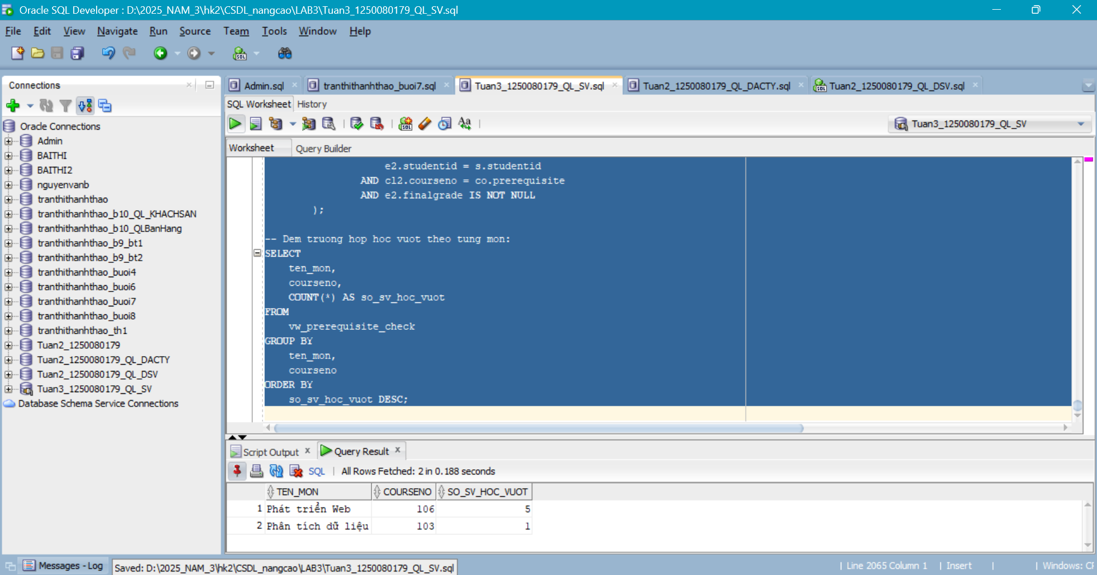
Câu 1.2: View phân tích hiệu suất giảng dạy với RANK/DENSE_RANK và tỉ lệ đạt
CREATE OR REPLACE VIEW vw_instructor_performance AS
SELECT
instructorid,
ho_ten,
so_lop,
tong_sv,
sv_co_diem,
diem_tb,
diem_max,
diem_min,
round(sv_dat * 100 / nullif(sv_co_diem, 0),
1) AS ty_le_dat_pct,
DENSE_RANK()
OVER(
ORDER BY
diem_tb DESC NULLS LAST
) AS hang_diem_tb,
RANK()
OVER(
ORDER BY
tong_sv DESC
) AS hang_so_sv
FROM
(
SELECT
i.instructorid,
i.firstname
|| ' '
|| i.lastname AS ho_ten,
COUNT(DISTINCT cl.classid) AS so_lop,
COUNT(e.studentid) AS tong_sv,
COUNT(e.finalgrade) AS sv_co_diem,
round(
avg(e.finalgrade),
2
) AS diem_tb,
MAX(e.finalgrade) AS diem_max,
MIN(e.finalgrade) AS diem_min,
SUM(
CASE
WHEN e.finalgrade >= 50 THEN
1
ELSE
0
END
) AS sv_dat
FROM
instructor i
LEFT JOIN class cl ON i.instructorid = cl.instructorid
LEFT JOIN enrollment e ON cl.classid = e.classid
GROUP BY
i.instructorid,
i.firstname,
i.lastname
);

-- Top 3 giao vien ty le SV dat cao nhat:
SELECT
ho_ten,
ty_le_dat_pct,
sv_co_diem,
diem_tb
FROM
vw_instructor_performance
WHERE
hang_diem_tb <= 3
ORDER BY
hang_diem_tb;
Kết quả:
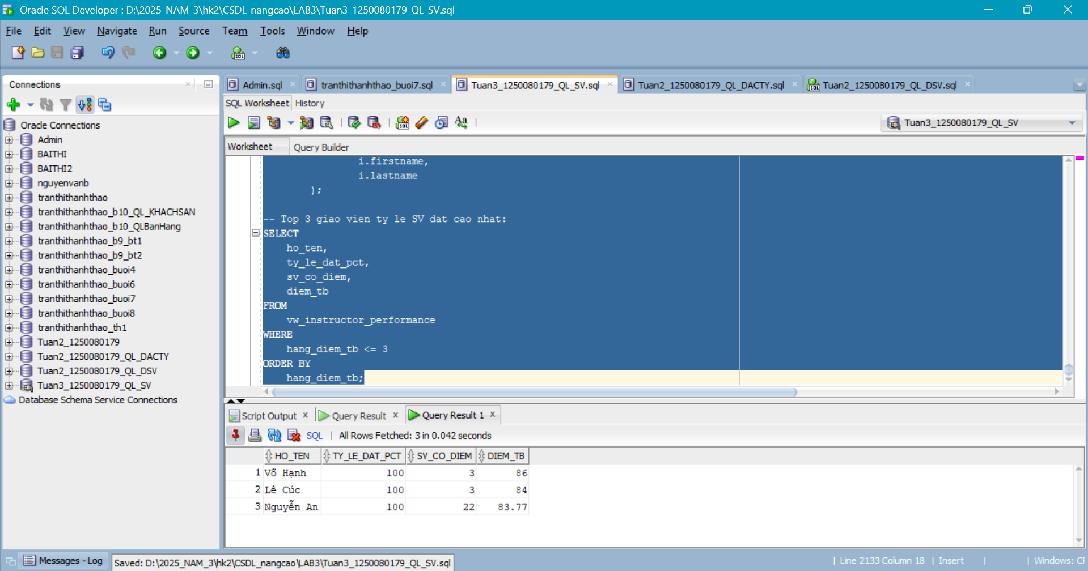
Câu 1.3: View thống kê đăng ký theo tháng với tổng tích lũy SUM() OVER
CREATE OR REPLACE VIEW vw_monthly_enrollment_stats AS
SELECT
nam,
thang,
so_dang_ky,
so_sv_moi,
so_mon,
diem_tb_thang,
SUM(so_dang_ky)
OVER(
ORDER BY
nam, thang
ROWS BETWEEN UNBOUNDED PRECEDING AND CURRENT ROW
) AS luy_ke_dang_ky
FROM
(
SELECT
to_char(e.enrolldate, 'YYYY') AS nam,
to_char(e.enrolldate, 'MM') AS thang,
COUNT(*) AS so_dang_ky,
COUNT(DISTINCT e.studentid) AS so_sv_moi,
COUNT(DISTINCT cl.courseno) AS so_mon,
round(
avg(e.finalgrade),
2
) AS diem_tb_thang
FROM
enrollment e
JOIN class cl ON e.classid = cl.classid
GROUP BY
to_char(e.enrolldate, 'YYYY'),
to_char(e.enrolldate, 'MM')
)
ORDER BY
nam DESC,
thang ASC;

SELECT
*
FROM
vw_monthly_enrollment_stats;
Kết quả: 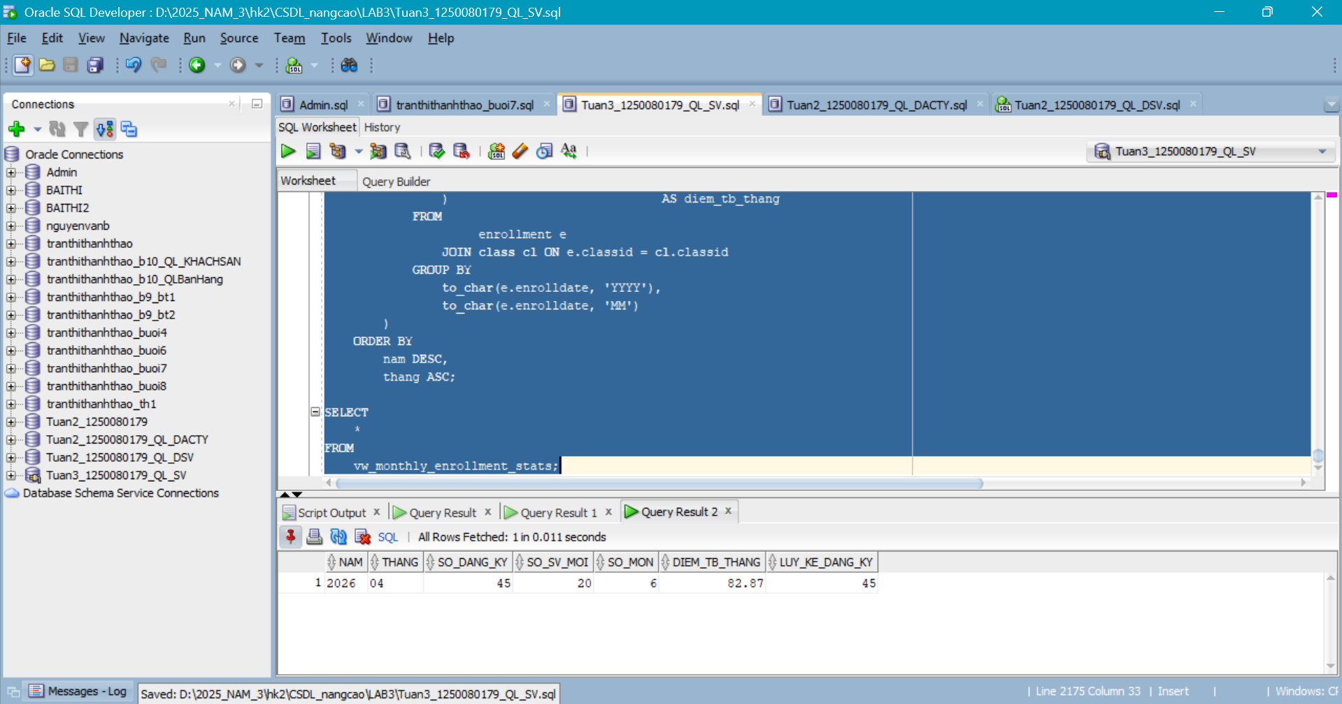
Câu 1.4: View INSTEAD OF - Cho phép INSERT vào view 4 bảng
--Bước 1 - Tạo view:
CREATE OR REPLACE VIEW vw_enrollment_full AS
SELECT
e.studentid,
e.classid,
e.enrolldate,
e.finalgrade,
s.firstname
|| ' '
|| s.lastname AS ten_sv,
co.description AS ten_mon,
i.firstname
|| ' '
|| i.lastname AS ten_gv
FROM
enrollment e
JOIN student s ON e.studentid = s.studentid
JOIN class cl ON e.classid = cl.classid
JOIN course co ON cl.courseno = co.courseno
JOIN instructor i ON cl.instructorid = i.instructorid;
--Bước 2 - INSTEAD OF INSERT trigger:
CREATE OR REPLACE TRIGGER trg_iot_enrollment_full INSTEAD OF
INSERT ON vw_enrollment_full
FOR EACH ROW
DECLARE
v_sv_check NUMBER;
v_cl_check NUMBER;
v_capacity NUMBER;
v_enrolled NUMBER;
BEGIN
SELECT
COUNT(*)
INTO v_sv_check
FROM
student
WHERE
studentid = :new.studentid;

IF v_sv_check = 0 THEN
raise_application_error(-20050, 'Sinh vien khong ton tai!');
RETURN;
END IF;
SELECT
COUNT(*)
INTO v_cl_check
FROM
class
WHERE
classid = :new.classid;

IF v_cl_check = 0 THEN
raise_application_error(-20051, 'Lop hoc khong ton tai!');
RETURN;
END IF;
SELECT
capacity
INTO v_capacity
FROM
class
WHERE
classid = :new.classid;

SELECT
COUNT(*)
INTO v_enrolled
FROM
enrollment
WHERE
classid = :new.classid;

IF v_enrolled >= v_capacity THEN
raise_application_error(-20052, 'Lop da day!');
RETURN;
END IF;

INSERT INTO enrollment (
studentid,
classid,
enrolldate,
createdby,
createddate,
modifiedby,
modifieddate
) VALUES ( :new.studentid,
:new.classid,
nvl(:new.enrolldate,
sysdate),
user,
sysdate,
user,
sysdate );

dbms_output.put_line('[OK] Da dang ky: SV '
|| :new.studentid
|| ' -> Lop
'
|| :new.classid);

END trg_iot_enrollment_full;
/
-- Kiem tra INSERT qua view:
INSERT INTO vw_enrollment_full (
studentid,
classid
) VALUES ( 3004,
1008 );
COMMIT;
Kết quả:
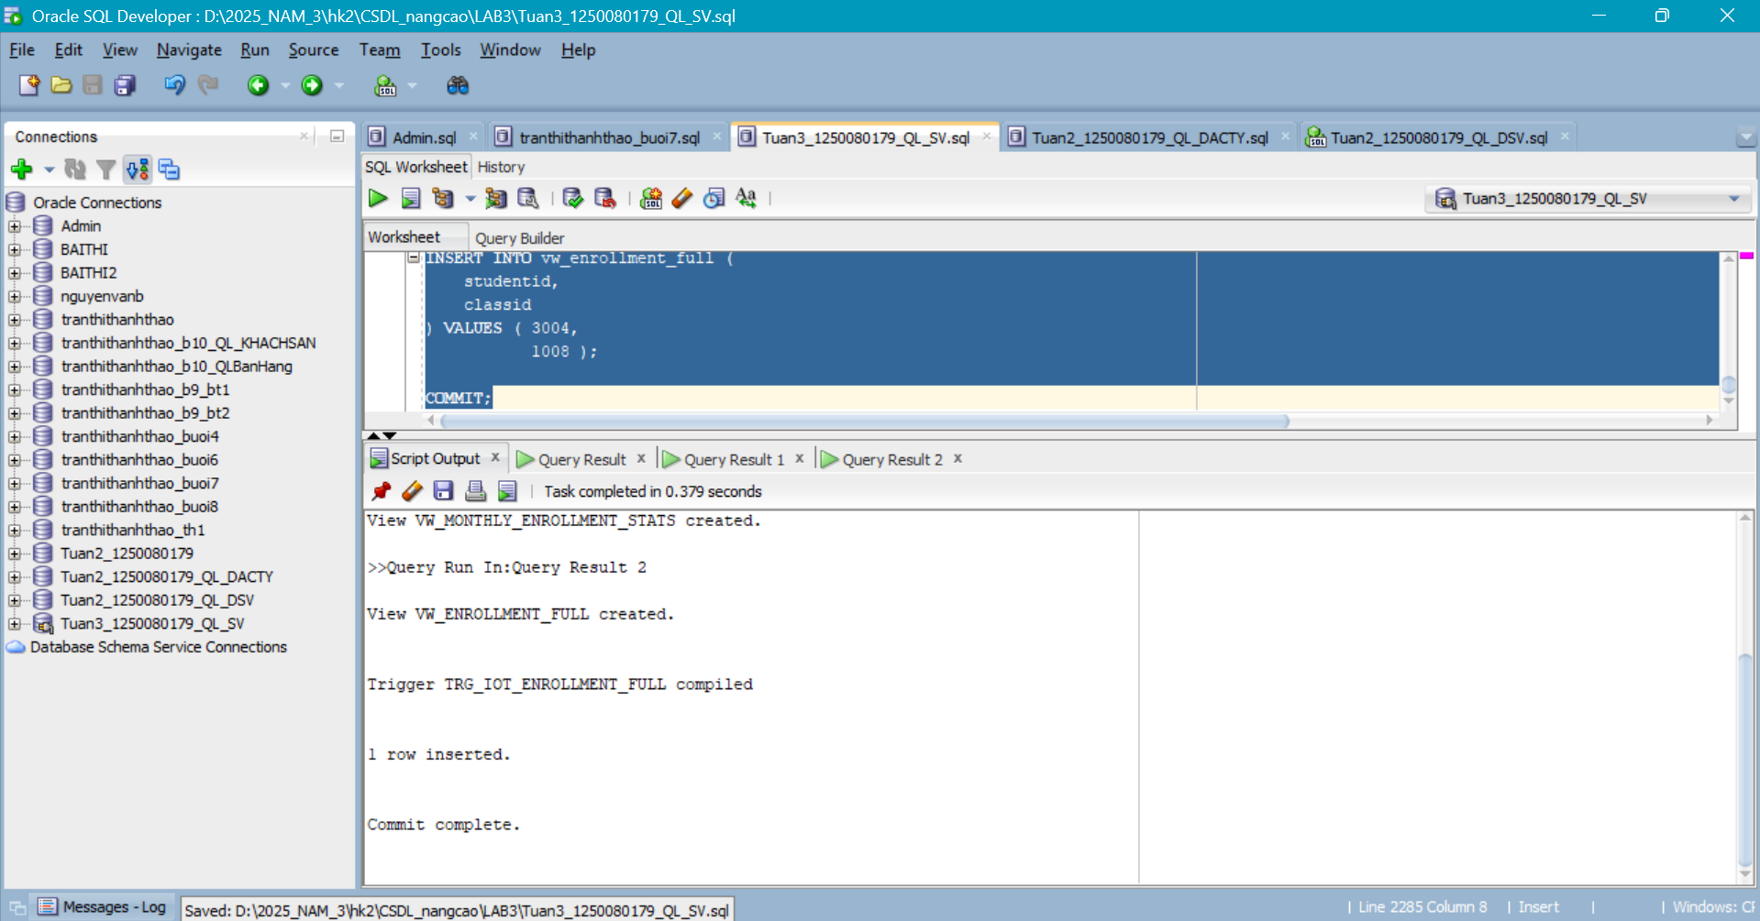
Câu 1.5: View phân tích phân vị với PERCENTILE_CONT và STDDEV
CREATE OR REPLACE VIEW vw_grade_distribution AS
SELECT
classid,
courseno,
description,
sv_a,
sv_b,
sv_c,
sv_d,
sv_f,
sv_chua_co,
p25,
p50_median,
p75,
round(std_dev, 2) AS do_lech_chuan,
round(std_dev / nullif(diem_tb, 0) * 100,
2) AS he_so_bt
FROM
(
SELECT
cl.classid,
cl.courseno,
co.description,
SUM(
CASE
WHEN e.finalgrade >= 90 THEN
1
ELSE
0
END
) AS sv_a,
SUM(
CASE
WHEN e.finalgrade >= 80
AND e.finalgrade < 90 THEN
1
ELSE
0
END
) AS sv_b,
SUM(
CASE
WHEN e.finalgrade >= 70
AND e.finalgrade < 80 THEN
1
ELSE
0
END
) AS sv_c,
SUM(
CASE
WHEN e.finalgrade >= 50
AND e.finalgrade < 70 THEN
1
ELSE
0
END
) AS sv_d,
SUM(
CASE
WHEN e.finalgrade < 50
AND e.finalgrade IS NOT NULL THEN
1
ELSE
0
END
) AS sv_f,
SUM(
CASE
WHEN e.finalgrade IS NULL THEN
1
ELSE
0
END
) AS sv_chua_co,
PERCENTILE_CONT(0.25) WITHIN GROUP(
ORDER BY
e.finalgrade
) AS p25,
PERCENTILE_CONT(0.50) WITHIN GROUP(
ORDER BY
e.finalgrade
) AS p50_median,
PERCENTILE_CONT(0.75) WITHIN GROUP(
ORDER BY
e.finalgrade
) AS p75,
STDDEV(e.finalgrade) AS std_dev,
AVG(e.finalgrade) AS diem_tb
FROM
class cl
JOIN course co ON cl.courseno = co.courseno
LEFT JOIN enrollment e ON cl.classid = e.classid
GROUP BY
cl.classid,
cl.courseno,
co.description
HAVING
COUNT(e.finalgrade) >= 2
);

SELECT
*
FROM
vw_grade_distribution
ORDER BY
classid;
Kết quả:
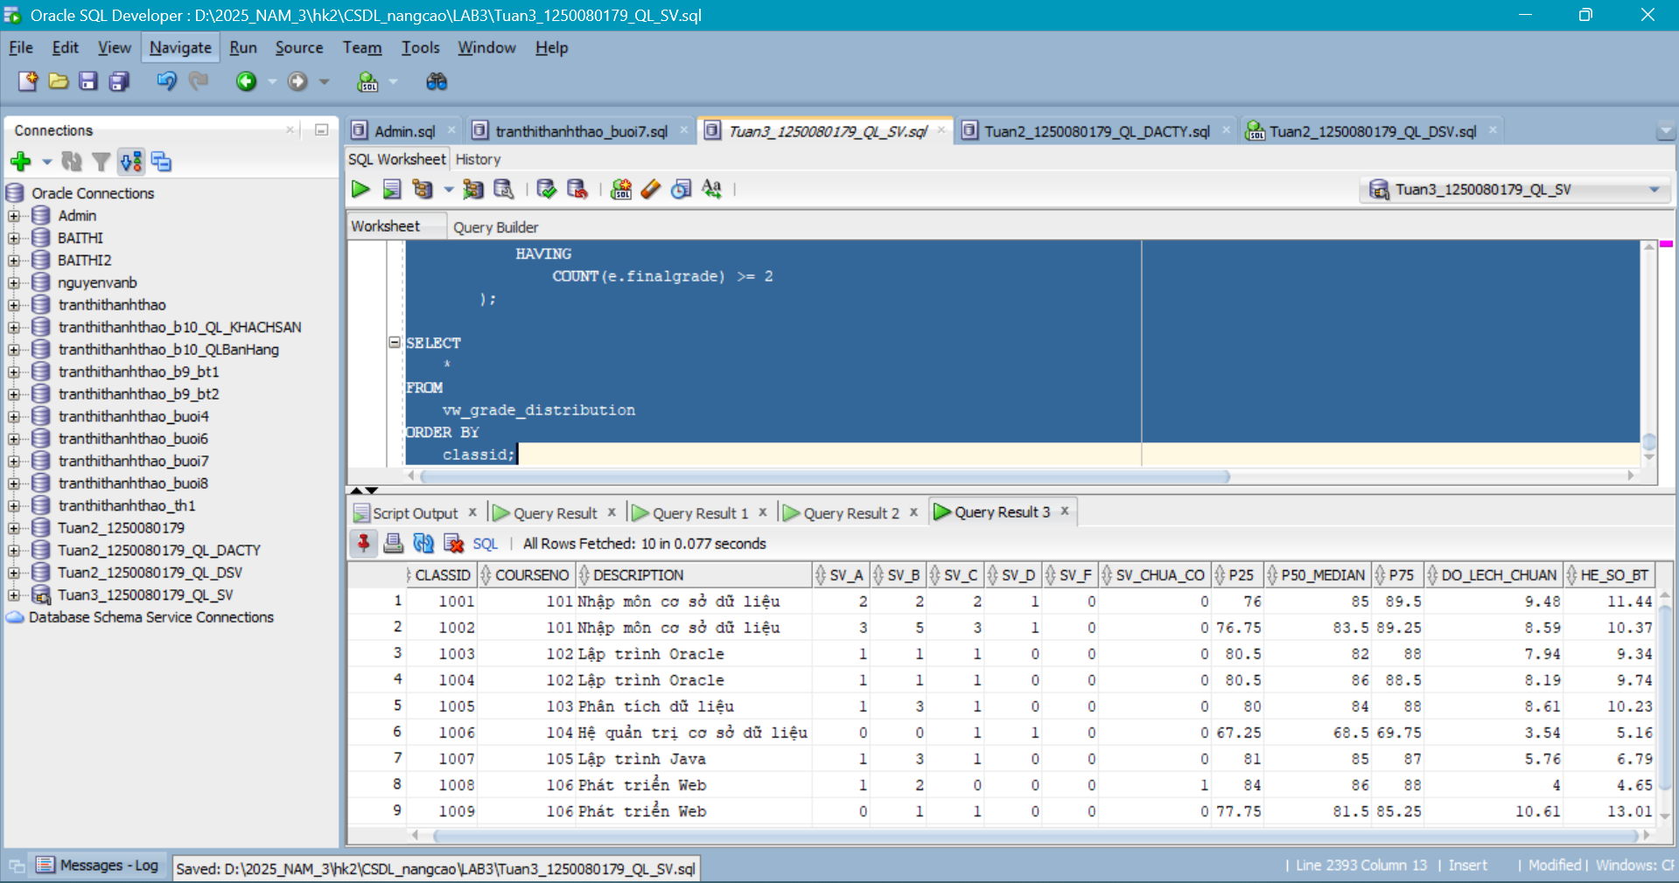

Câu 1.6: View PIVOT - Điểm sinh viên chuyển thành cột theo lớp
CREATE OR REPLACE VIEW vw_student_grade_pivot AS
SELECT
studentid,
ho_ten,
MAX(
CASE
WHEN classid = 1 THEN
finalgrade
END
) AS diem_lop_1,
MAX(
CASE
WHEN classid = 2 THEN
finalgrade
END
) AS diem_lop_2,
MAX(
CASE
WHEN classid = 3 THEN
finalgrade
END
) AS diem_lop_3,
MAX(
CASE
WHEN classid = 4 THEN
finalgrade
END
) AS diem_lop_4,
round(
avg(finalgrade),
2
) AS diem_tb_chung,
COUNT(classid) AS tong_lop
FROM
(
SELECT
e.studentid,
s.firstname
|| ' '
|| s.lastname AS ho_ten,
e.classid,
e.finalgrade
FROM
enrollment e
JOIN student s ON e.studentid = s.studentid
)
GROUP BY
studentid,
ho_ten
ORDER BY
studentid;

SELECT
*
FROM
vw_student_grade_pivot;
-- Cach 2: Dung menh de PIVOT (Oracle 11g+)
SELECT
*
FROM
(
SELECT
e.studentid,
e.classid,
e.finalgrade
FROM
enrollment e
) PIVOT (
MAX(finalgrade)
FOR classid
IN ( 1 AS diem_lop_1, 2 AS diem_lop_2, 3 AS diem_lop_3, 4 AS diem_lop_4 )
);
Kết quả:
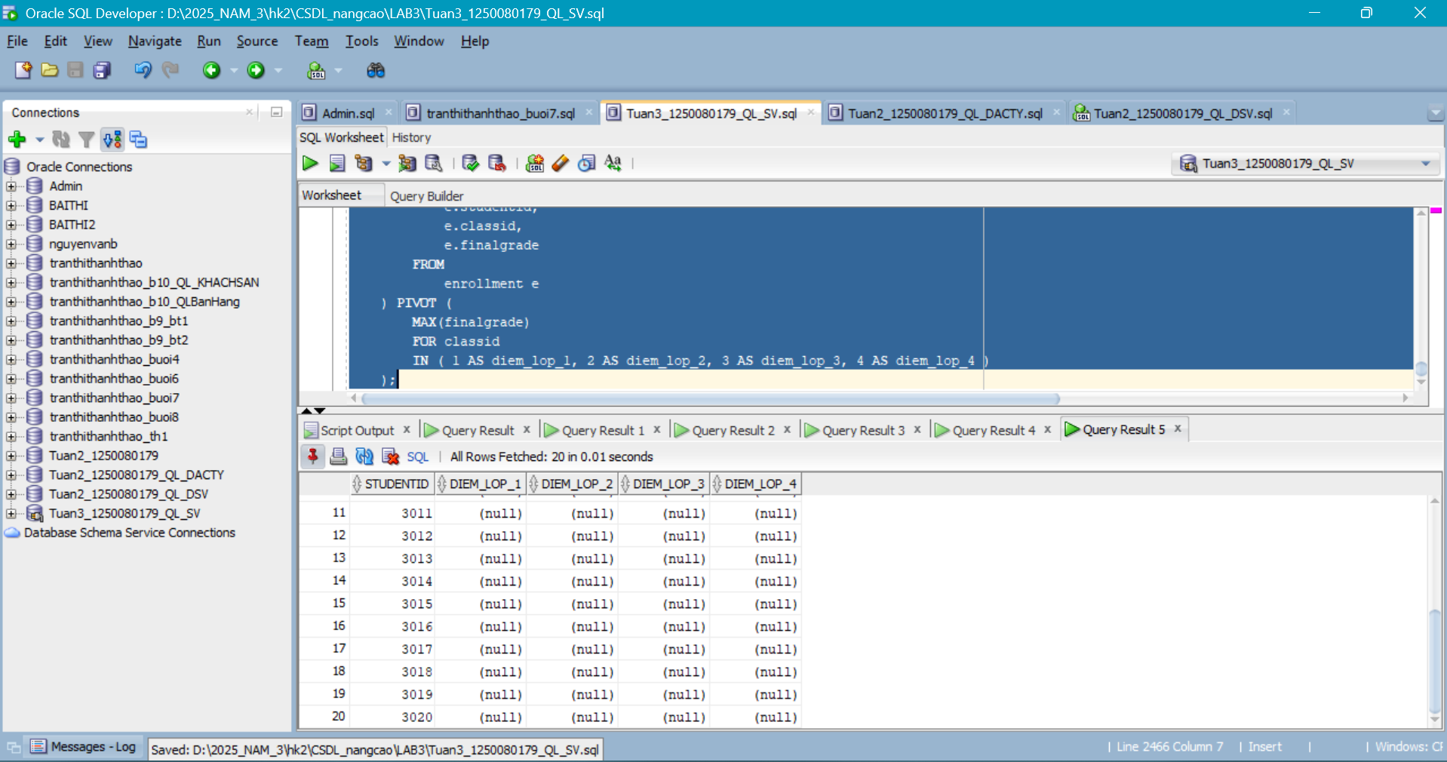
Câu 1.7: View kiểm tra toàn vẹn dữ liệu bằng UNION ALL
CREATE OR REPLACE VIEW vw_data_integrity_check AS
-- Loi 1: SV trong ENROLLMENT khong ton tai trong STUDENT
SELECT
'LOI_1: SV_KHONG_TON_TAI' AS loai_van_de,
to_char(e.studentid) AS ma_tham_chieu,
'StudentID '
|| e.studentid
|| ' co trong ENROLLMENT nhung khong co
trong STUDENT' AS mo_ta
FROM
enrollment e
WHERE
NOT EXISTS (
SELECT
1
FROM
student s
WHERE
s.studentid = e.studentid
)
UNION ALL

-- Loi 2: Lop trong CLASS thieu giao vien
SELECT
'LOI_2: LOP_THIEU_GIAO_VIEN',
to_char(cl.classid),
'ClassID '
|| cl.classid
|| ' khong co InstructorID hop le'
FROM
class cl
WHERE
NOT EXISTS (
SELECT
1
FROM
instructor i
WHERE
i.instructorid = cl.instructorid
)
UNION ALL

-- Loi 3: Diem trong GRADE khong khop voi ENROLLMENT
SELECT
'LOI_3: DIEM_KHONG_KHOP',
to_char(g.studentid)
|| '/'
|| to_char(g.classid),
'GRADE.grade='
|| g.grade
|| ' khac
ENROLLMENT.finalgrade='
|| e.finalgrade
FROM
grade g
JOIN enrollment e ON g.studentid = e.studentid
AND g.classid = e.classid
WHERE
g.grade != nvl(e.finalgrade, -999)
UNION ALL

-- Loi 4: SV dang ky qua 3 lop
SELECT
'LOI_4: DANG_KY_QUA_3_LOP',
to_char(studentid),
'StudentID '
|| studentid
|| ' dang ky '
|| COUNT(*)
|| ' lop (toi da 3)'
FROM
enrollment
GROUP BY
studentid
HAVING
COUNT(*) > 3;

SELECT
*
FROM
vw_data_integrity_check;
Kết quả:
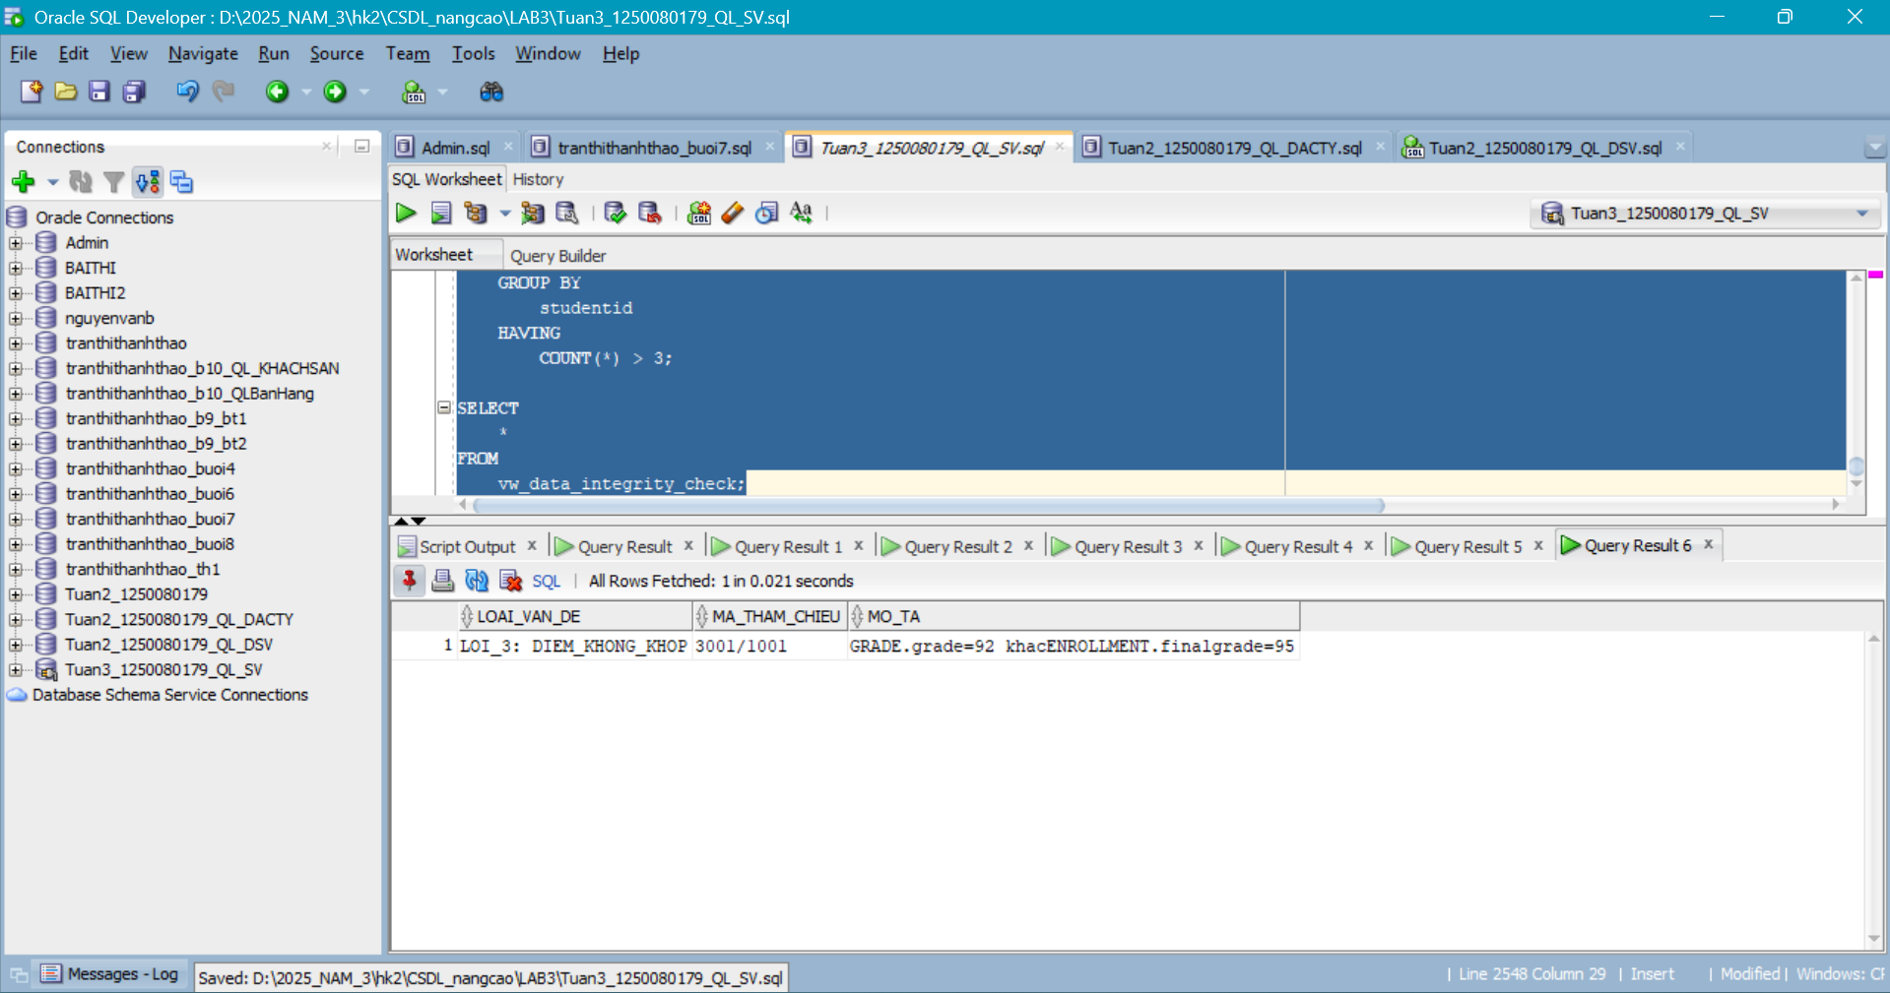

BÀI 2 - STORED PROCEDURE NÂNG CAO
Câu 2.1: Thủ tục trả về SYS_REFCURSOR + thủ tục in kết quả
--Thủ tục trả về cursor:
CREATE OR REPLACE PROCEDURE get_students_by_class (
p_classid IN NUMBER,
p_result OUT SYS_REFCURSOR
) IS
v_check NUMBER;
BEGIN
SELECT
COUNT(*)
INTO v_check
FROM
class
WHERE
classid = p_classid;

IF v_check = 0 THEN
p_result := NULL;
dbms_output.put_line('Lop '
|| p_classid
|| ' khong ton tai!');
RETURN;
END IF;

OPEN p_result FOR SELECT
s.studentid,
s.firstname
|| ' '
|| s.lastname AS ho_ten,
e.finalgrade,
CASE
WHEN e.finalgrade >= 90 THEN
'A'
WHEN e.finalgrade >= 80 THEN
'B'
WHEN e.finalgrade >= 70 THEN
'C'
WHEN e.finalgrade >= 50 THEN
'D'
WHEN e.finalgrade IS NULL THEN
'Chua co'
ELSE
'F'
END AS xep_loai,
RANK()
OVER(
ORDER BY
e.finalgrade DESC NULLS LAST
) AS thu_hang
FROM
enrollment e
JOIN student s ON e.studentid = s.studentid
WHERE
e.classid = p_classid
ORDER BY
thu_hang;

END get_students_by_class;
/
--Thủ tục in kết quả:
CREATE OR REPLACE PROCEDURE print_class_result (
p_classid IN NUMBER
) IS

v_cur SYS_REFCURSOR;
v_sid NUMBER;
v_ten VARCHAR2(50);
v_diem NUMBER;
v_xep VARCHAR2(10);
v_hang NUMBER;
BEGIN
get_students_by_class(p_classid, v_cur);
IF v_cur IS NULL THEN
RETURN;
END IF;
dbms_output.put_line('=== KET QUA LOP '
|| p_classid
|| ' ===');
dbms_output.put_line(rpad('Hang', 5)
|| rpad('Ho
Ten', 22)
|| lpad('Diem', 6)
|| ' Xep loai');

dbms_output.put_line(rpad('-', 45, '-'));
LOOP
FETCH v_cur INTO
v_sid,
v_ten,
v_diem,
v_xep,
v_hang;
EXIT WHEN v_cur%notfound;
dbms_output.put_line(lpad(v_hang, 4)
|| ' '
|| rpad(v_ten, 22)
|| lpad(
nvl(
to_char(v_diem),
'--'
),
6
)
|| ' '
|| v_xep);

END LOOP;

CLOSE v_cur;
END print_class_result;
/

BEGIN
print_class_result(1);
END;
/
Kết quả:
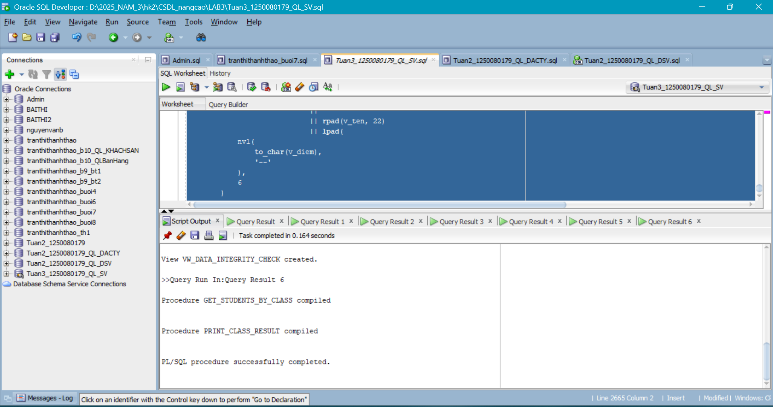
Câu 2.2: Exception tùy chỉnh với PRAGMA EXCEPTION_INIT
CREATE OR REPLACE PROCEDURE validate_enrollment (
p_studentid IN NUMBER,
p_classid IN NUMBER
) IS

ex_sv_not_found EXCEPTION;
PRAGMA exception_init ( ex_sv_not_found, -20101 );
ex_class_not_found EXCEPTION;
PRAGMA exception_init ( ex_class_not_found, -20102 );
ex_class_full EXCEPTION;
PRAGMA exception_init ( ex_class_full, -20103 );
ex_already_enrolled EXCEPTION;
PRAGMA exception_init ( ex_already_enrolled, -20104 );
v_check NUMBER;
v_cap NUMBER;
v_enr NUMBER;
BEGIN
SELECT
COUNT(*)
INTO v_check
FROM
student
WHERE
studentid = p_studentid;

IF v_check = 0 THEN
raise_application_error(-20101, 'Sinh vien '
|| p_studentid
|| ' khong
ton tai!');
END IF;

SELECT
COUNT(*)
INTO v_check
FROM
class
WHERE
classid = p_classid;

IF v_check = 0 THEN
raise_application_error(-20102, 'Lop hoc '
|| p_classid
|| ' khong ton
tai!');
END IF;

SELECT
capacity
INTO v_cap
FROM
class
WHERE
classid = p_classid;

SELECT
COUNT(*)
INTO v_enr
FROM
enrollment
WHERE
classid = p_classid;

IF v_enr >= v_cap THEN
raise_application_error(-20103, 'Lop '
|| p_classid
|| ' da day
('
|| v_enr
|| '/'
|| v_cap
|| ')!');
END IF;

SELECT
COUNT(*)
INTO v_check
FROM
enrollment
WHERE
studentid = p_studentid
AND classid = p_classid;

IF v_check > 0 THEN
raise_application_error(-20104, 'SV '
|| p_studentid
|| ' da dang ky lop
nay roi!');
END IF;

dbms_output.put_line('[OK] Tat ca dieu kien deu thoa man!');
EXCEPTION
WHEN ex_sv_not_found THEN
dbms_output.put_line('[KHONG TON TAI]
' || sqlerrm);
WHEN ex_class_not_found THEN
dbms_output.put_line('[LOP SAI]
' || sqlerrm);
WHEN ex_class_full THEN
dbms_output.put_line('[DAY LOP]
' || sqlerrm);
WHEN ex_already_enrolled THEN
dbms_output.put_line('[TRUNG LAP]
' || sqlerrm);
WHEN OTHERS THEN
dbms_output.put_line('[LOI KHAC] ' || sqlerrm);
END validate_enrollment;
/
Kết quả:
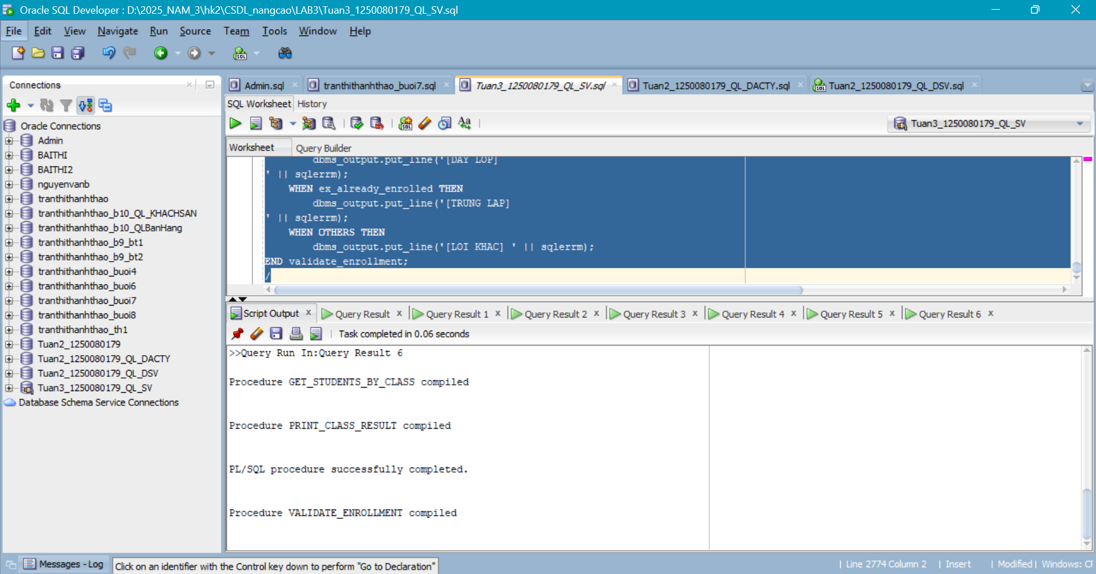

Câu 2.3: Thủ tục đệ quy tính học phí cộng dồn tiên quyết
CREATE OR REPLACE PROCEDURE calc_total_prerequisite_cost (
p_courseno IN NUMBER,
p_total OUT NUMBER,
p_depth IN NUMBER DEFAULT 0
) IS

v_cost NUMBER;
v_prereq NUMBER;
v_desc VARCHAR2(50);
v_sub_total NUMBER := 0;
v_indent VARCHAR2(40);
BEGIN
IF p_depth >= 10 THEN
dbms_output.put_line('CANH BAO: Dat gioi han do sau (10)!');
p_total := 0;
RETURN;
END IF;

BEGIN
SELECT
cost,
prerequisite,
description
INTO
v_cost,
v_prereq,
v_desc
FROM
course
WHERE
courseno = p_courseno;

EXCEPTION
WHEN no_data_found THEN
p_total := 0;
RETURN;
END;

v_indent := lpad(' ', p_depth * 4);
IF v_prereq IS NOT NULL THEN
calc_total_prerequisite_cost(v_prereq, v_sub_total, p_depth + 1);
END IF;

p_total := nvl(v_cost, 0) + v_sub_total;
dbms_output.put_line(v_indent
|| 'Cap '
|| p_depth
|| ': '
|| p_courseno
|| ' - '
|| v_desc
|| ' (phi: '
|| nvl(v_cost, 0)
|| ')');

END calc_total_prerequisite_cost;
/

-- Kiem tra:
DECLARE
v_total NUMBER;
BEGIN
calc_total_prerequisite_cost(30, v_total);
dbms_output.put_line('Tong hoc phi can thiet: ' || v_total);
END;
/
Kết quả:
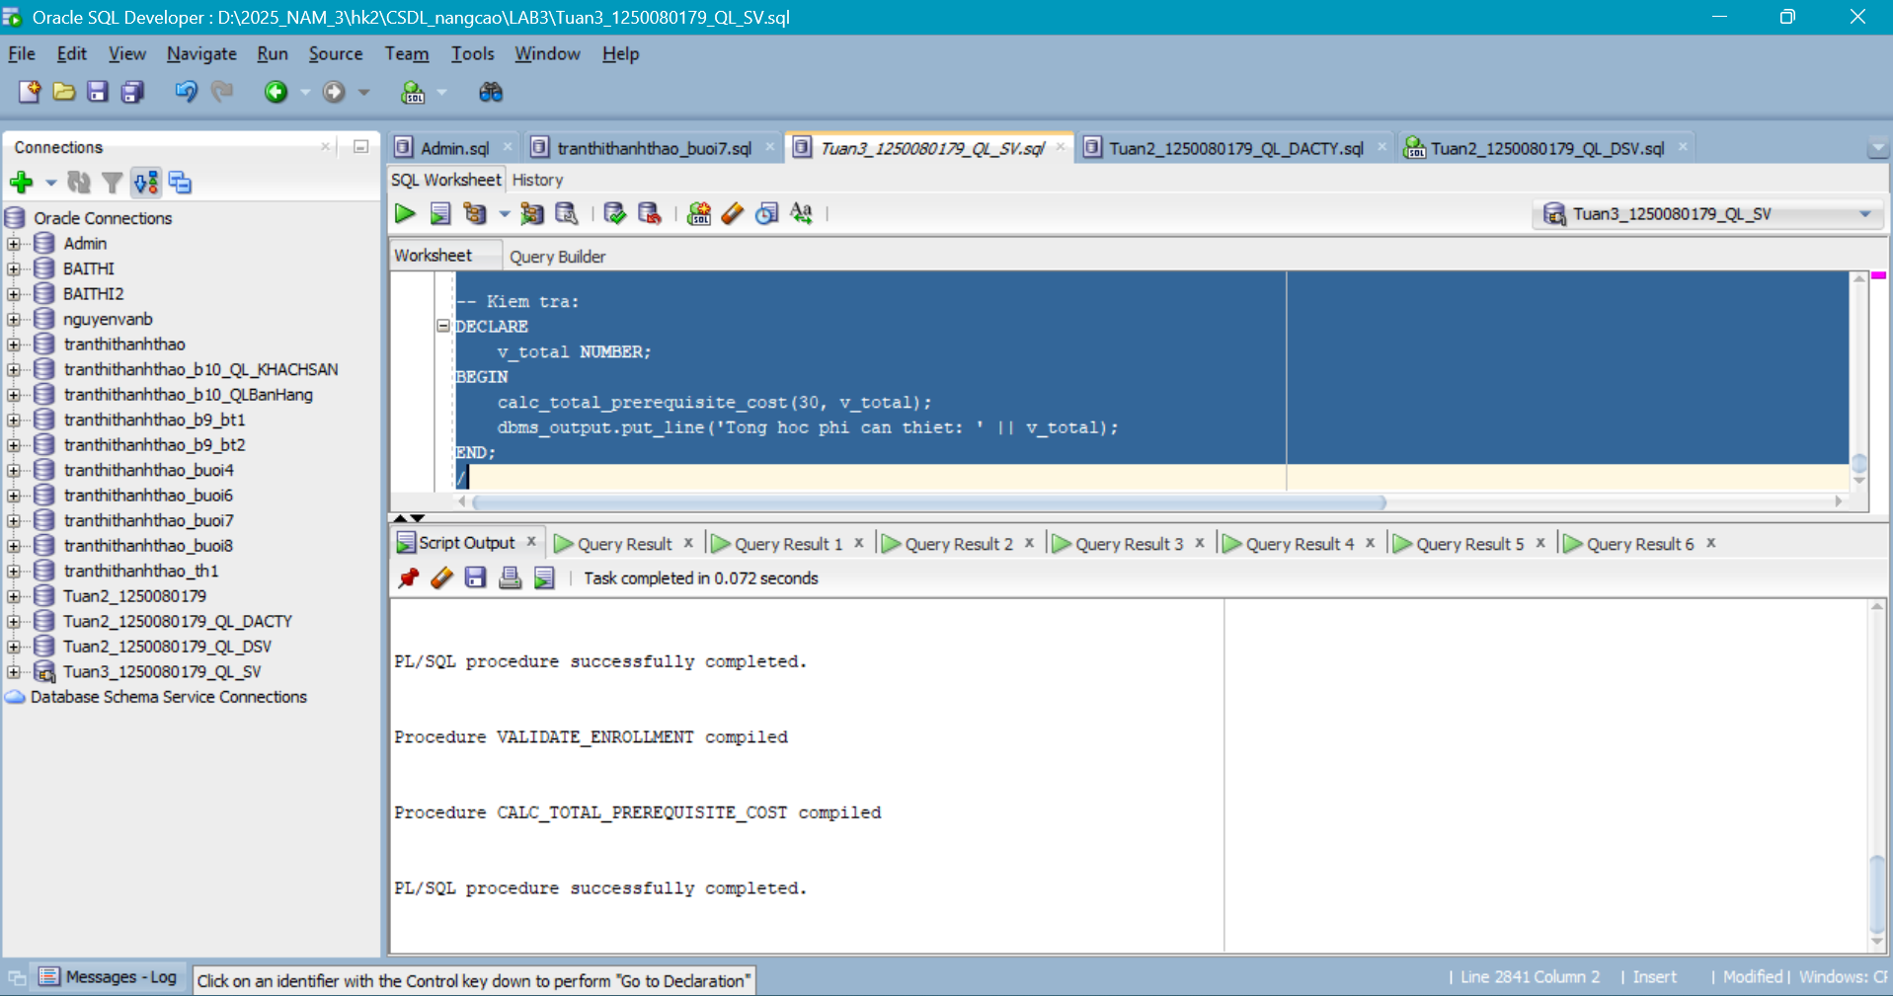
Câu 2.4: Package pkg_student_mgmt - SPEC và BODY đầy đủ
--Package SPEC:
CREATE OR REPLACE PACKAGE pkg_student_mgmt AS
c_max_classes CONSTANT NUMBER := 3;
PROCEDURE enroll (
p_sid NUMBER,
p_cid NUMBER
);

PROCEDURE withdraw (
p_sid NUMBER,
p_cid NUMBER
);

FUNCTION get_student_gpa (
p_sid NUMBER
) RETURN NUMBER;

PROCEDURE print_transcript (
p_sid NUMBER
);

FUNCTION count_enrolled (
p_sid NUMBER
) RETURN NUMBER;

END pkg_student_mgmt;
/
--Package BODY:
CREATE OR REPLACE PACKAGE BODY pkg_student_mgmt AS
-- Bien noi bo: dem so lan goi
g_call_count NUMBER := 0;
FUNCTION count_enrolled(p_sid NUMBER) RETURN NUMBER IS
v_cnt NUMBER;
BEGIN
SELECT COUNT(*) INTO v_cnt FROM enrollment WHERE studentid=p_sid;
RETURN v_cnt;
END; PROCEDURE enroll (
p_sid NUMBER,
p_cid NUMBER
) IS
v_check NUMBER;
v_cap NUMBER;
v_enr NUMBER;
BEGIN
g_call_count := g_call_count + 1;
SELECT
COUNT(*)
INTO v_check
FROM
student
WHERE
studentid = p_sid;

IF v_check = 0 THEN
dbms_output.put_line('[LOI] SV khong ton tai');
RETURN;
END IF;
SELECT
COUNT(*)
INTO v_check
FROM
class
WHERE
classid = p_cid;

IF v_check = 0 THEN
dbms_output.put_line('[LOI] Lop khong ton tai');
RETURN;
END IF;
IF count_enrolled(p_sid) >= c_max_classes THEN
dbms_output.put_line('[LOI] SV da du '
|| c_max_classes
|| ' lop');
RETURN;
END IF;

SELECT
capacity
INTO v_cap
FROM
class
WHERE
classid = p_cid;

SELECT
COUNT(*)
INTO v_enr
FROM
enrollment
WHERE
classid = p_cid;

IF v_enr >= v_cap THEN
dbms_output.put_line('[LOI] Lop day');
RETURN;
END IF;
INSERT INTO
enrollment (
studentid,
classid,
enrolldate,
createdby,
createddate,
modifiedby,
mo
difieddate)
values ( p_sid,
p_cid,
sysdate,
user,
sysdate,
user,
sysdate );
commit;
dbms_output.put_line ( '[OK] Dang ky: SV '
|| p_sid || ' -> Lop
' || p_cid );
end
enroll;

PROCEDURE withdraw (
p_sid NUMBER,
p_cid NUMBER
) IS
v_check NUMBER;
BEGIN
SELECT
COUNT(*)
INTO v_check
FROM
enrollment
WHERE
studentid = p_sid
AND classid = p_cid;

IF v_check = 0 THEN
dbms_output.put_line('[LOI] SV chua dang ky lop
nay');
RETURN;
END IF;
DELETE FROM enrollment
WHERE
studentid = p_sid
AND classid = p_cid;

COMMIT;
dbms_output.put_line('[OK] Da huy dang ky: SV '
|| p_sid
|| ' khoi Lop
'
|| p_cid);
END withdraw;

FUNCTION get_student_gpa (
p_sid NUMBER
) RETURN NUMBER IS
v_gpa NUMBER;
v_check NUMBER;
BEGIN
SELECT
COUNT(*)
INTO v_check
FROM
student
WHERE
studentid = p_sid;

IF v_check = 0 THEN
RETURN NULL;
END IF;
SELECT
round(
avg(finalgrade),
2
)
INTO v_gpa
FROM
enrollment
WHERE
studentid = p_sid
AND finalgrade IS NOT NULL;

RETURN v_gpa;
END;

PROCEDURE print_transcript (
p_sid NUMBER
) IS
BEGIN
dbms_output.put_line('=== BANG DIEM SV: '
|| p_sid
|| ' ===');
FOR rec IN (
SELECT
co.description,
co.courseno,
e.finalgrade,
cl.classid
FROM
enrollment e
JOIN class cl ON e.classid = cl.classid
JOIN course co ON cl.courseno = co.courseno
WHERE
e.studentid = p_sid
ORDER BY
co.courseno
) LOOP
dbms_output.put_line(' '
|| rec.courseno
|| '
'
|| rpad(rec.description, 25)
|| ' : '
|| nvl(
to_char(rec.finalgrade),
'Chua
co diem'
));
END LOOP;

dbms_output.put_line(' GPA:
'
|| nvl(
to_char(get_student_gpa(p_sid)),
'N/A'
));

end;
END pkg_student_mgmt;

/

-- Kiem tra package:
BEGIN
pkg_student_mgmt.enroll(3020, 1006);
pkg_student_mgmt.print_transcript(3020);
END;
/
Kết quả:
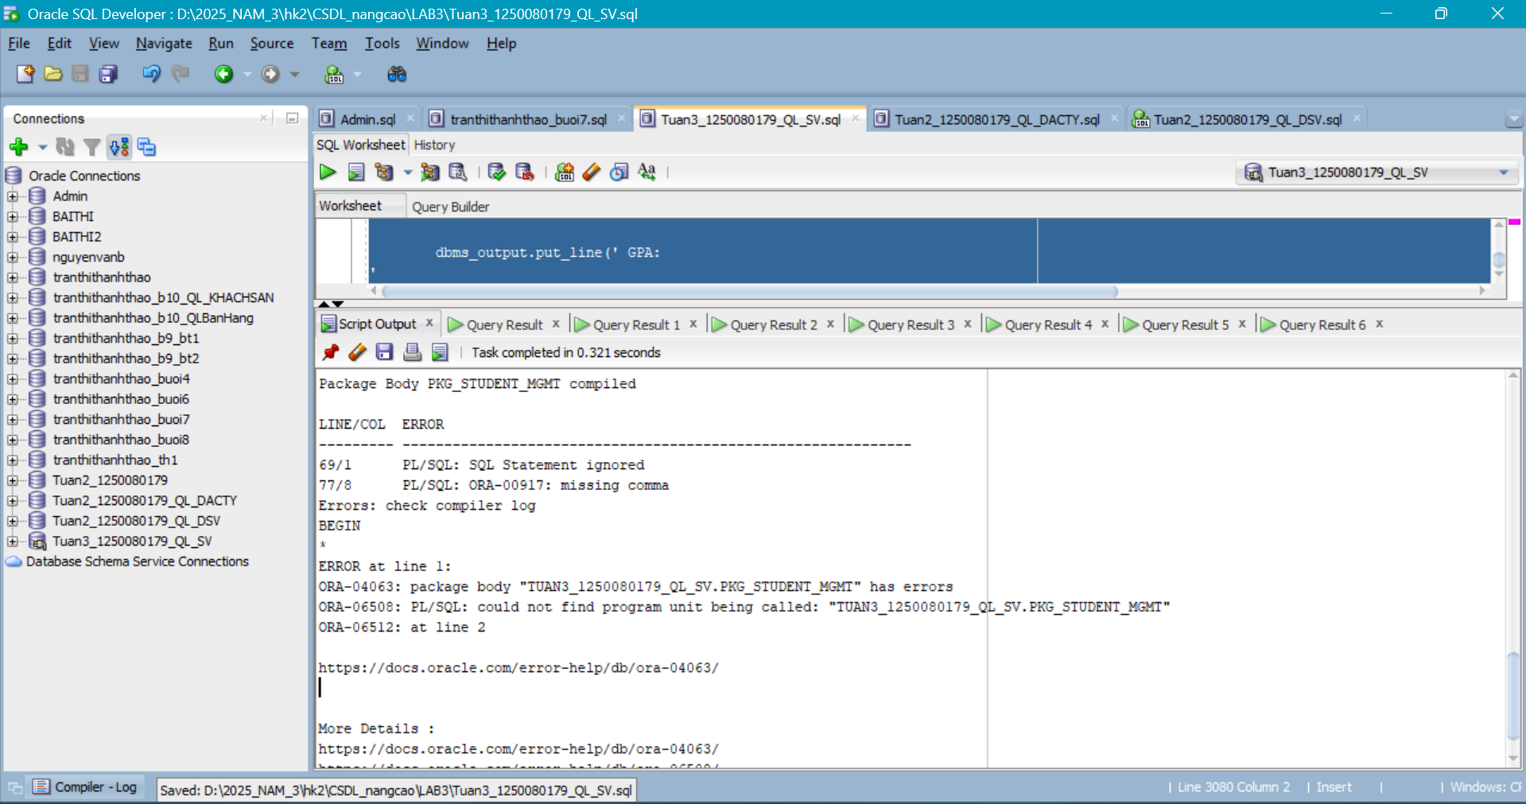
Câu 2.5: BULK COLLECT và FORALL xử lý hàng loạt
CREATE OR REPLACE PROCEDURE bulk_update_grades IS

TYPE t_num IS
TABLE OF NUMBER INDEX BY PLS_INTEGER;
v_sids t_num;
v_cids t_num;
v_grades t_num;
v_start NUMBER;
v_end NUMBER;
v_rows NUMBER := 0;
BEGIN
v_start := dbms_utility.get_time;
-- Doc du lieu vao mang nhanh
SELECT
studentid,
classid,
finalgrade
BULK COLLECT
INTO
v_sids,
v_cids,
v_grades
FROM
enrollment
WHERE
finalgrade IS NOT NULL;

dbms_output.put_line('Doc duoc '
|| v_sids.count
|| ' ban ghi...');
-- Cap nhat hang loat vao GRADE (MERGE thay the INSERT+UPDATE)
FORALL i IN 1..v_sids.count SAVE EXCEPTIONS
MERGE INTO grade g
USING (
SELECT
v_sids(i) AS sid,
v_cids(i) AS cid,
v_grades(i) AS gr
FROM
dual
) src ON ( g.studentid = src.sid
AND g.classid = src.cid )
WHEN MATCHED THEN UPDATE
SET g.grade = src.gr,
g.modifiedby = user,
g.modifieddate = sysdate
WHEN NOT MATCHED THEN
INSERT (
studentid,
classid,
grade,
createdby,
createddate,
modifiedby,
modifieddate )
VALUES
( src.sid,
src.cid,
src.gr,
user,
sysdate,
user,
sysdate );

v_rows := SQL%rowcount;
COMMIT;
v_end := dbms_utility.get_time;
dbms_output.put_line('Xu ly: '
|| v_rows
|| ' hang | Thoi gian: '
|| round((v_end - v_start) / 100, 2)
|| ' giay');

EXCEPTION
WHEN OTHERS THEN
FOR j IN 1..SQL%bulk_exceptions.count LOOP
dbms_output.put_line('Loi hang
'
|| SQL%bulk_exceptions(j).error_index
|| ': '
|| sqlerrm(-SQL%bulk_exceptions(j).error_code));
END LOOP;

ROLLBACK;
END bulk_update_grades;
/

BEGIN
bulk_update_grades;
END;
/
Kết quả:
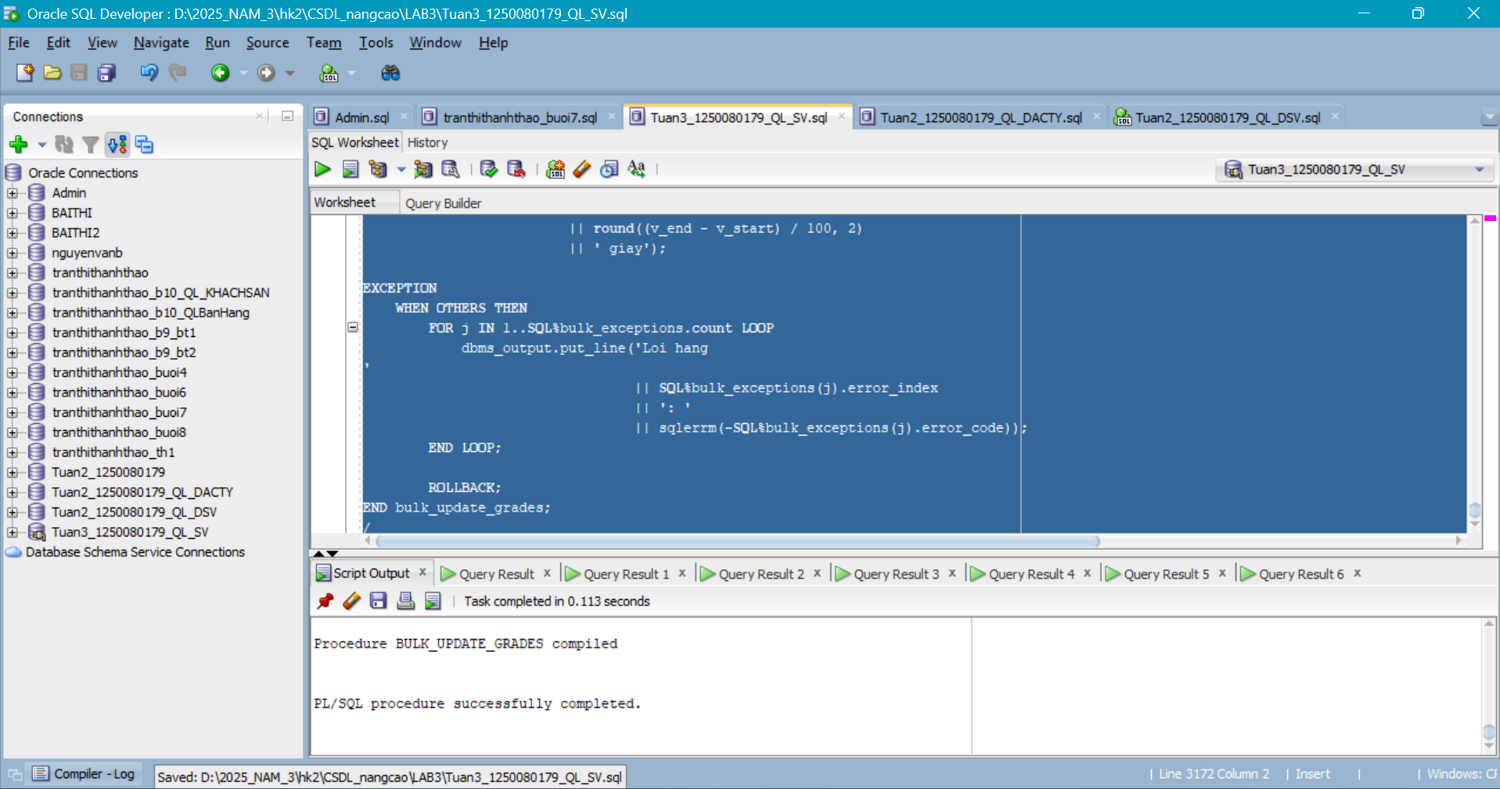
Câu 2.6: Thủ tục báo cáo môn học với định dạng bảng ASCII
CREATE OR REPLACE PROCEDURE generate_course_report (
p_courseno IN NUMBER
) IS

v_check NUMBER;
v_desc VARCHAR2(50);
v_cost NUMBER;
v_prereq NUMBER;
v_tong_sv NUMBER := 0;
v_sum_d NUMBER := 0;
v_co_d NUMBER := 0;
v_sep VARCHAR2(70) := rpad('=', 60, '=');
v_sep2 VARCHAR2(70) := rpad('-', 60, '-');
BEGIN
SELECT
COUNT(*)
INTO v_check
FROM
course
WHERE
courseno = p_courseno;

IF v_check = 0 THEN
dbms_output.put_line('Mon hoc '
|| p_courseno
|| ' khong ton tai!');
RETURN;
END IF;

SELECT
description,
cost,
prerequisite
INTO
v_desc,
v_cost,
v_prereq
FROM
course
WHERE
courseno = p_courseno;

dbms_output.put_line(v_sep);
dbms_output.put_line('BAO CAO MON HOC: ' || p_courseno);
dbms_output.put_line(v_sep2);
dbms_output.put_line('Ten mon : ' || v_desc);
dbms_output.put_line('Hoc phi :
'
|| to_char(
nvl(v_cost, 0),
'999,990.00'
)
|| ' VND');

dbms_output.put_line('Mon tien q: '
|| nvl(
to_char(v_prereq),
'Khong
co'
));
dbms_output.put_line(v_sep2);
dbms_output.put_line(rpad('Lop', 5)
|| rpad('Giao vien', 20)
|| lpad('SVDK', 6)
|| lpad('DTB', 7)
|| ' Trang thai');

dbms_output.put_line(v_sep2);
FOR rec IN (
SELECT
cl.classid,
cl.capacity,
i.firstname
|| ' '
|| i.lastname AS ten_gv,
COUNT(e.studentid) AS so_sv,
round(
avg(e.finalgrade),
1
) AS dtb
FROM
class cl
JOIN instructor i ON cl.instructorid = i.instructorid
LEFT JOIN enrollment e ON cl.classid = e.classid
WHERE
cl.courseno = p_courseno
GROUP BY
cl.classid,
cl.capacity,
i.firstname,
i.lastname
ORDER BY
cl.classid
) LOOP
v_tong_sv := v_tong_sv + rec.so_sv;
IF rec.dtb IS NOT NULL THEN
v_sum_d := v_sum_d + rec.dtb;
v_co_d := v_co_d + 1;
END IF;

dbms_output.put_line(lpad(rec.classid, 4)
|| ' '
|| rpad(rec.ten_gv, 20)
|| lpad(rec.so_sv, 5)
|| lpad(
nvl(
to_char(rec.dtb),
'--'
),
7
)
|| ' '
|| CASE
WHEN rec.capacity - rec.so_sv > 0 THEN
'Con '
||(rec.capacity - rec.so_sv)
|| ' cho'
ELSE 'Het cho'
END);

END LOOP;

dbms_output.put_line(v_sep2);
dbms_output.put_line('Tong SV dang ky : ' || v_tong_sv);
IF v_co_d > 0 THEN
dbms_output.put_line('Diem TB toan mon:
'
|| round(v_sum_d / v_co_d, 2));
END IF;

dbms_output.put_line(v_sep);
END generate_course_report;
/

BEGIN
generate_course_report(10);
END;
/
Kết quả:
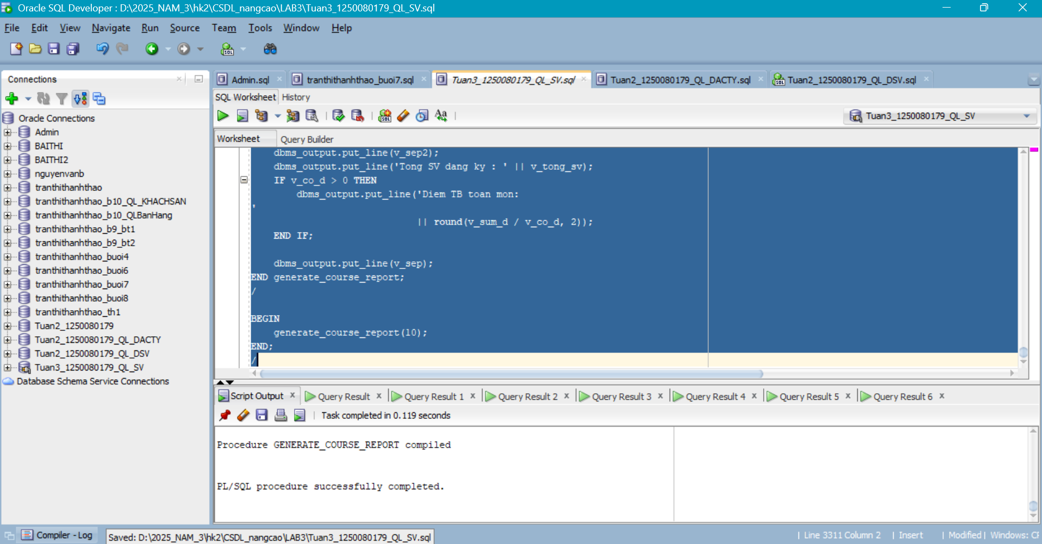
Câu 2.7: Hàm convert_to_gpa_40 và thủ tục print_gpa_report
CREATE OR REPLACE FUNCTION convert_to_gpa_40 (
p_studentid IN NUMBER
) RETURN NUMBER IS
v_check NUMBER;
v_gpa NUMBER;
BEGIN
SELECT
COUNT(*)
INTO v_check
FROM
student
WHERE
studentid = p_studentid;

IF v_check = 0 THEN
RETURN NULL;
END IF;
SELECT
round(sum(CASE
WHEN finalgrade >= 90 THEN
4.0
WHEN finalgrade >= 85 THEN
3.7
WHEN finalgrade >= 80 THEN
3.3
WHEN finalgrade >= 75 THEN
3.0
WHEN finalgrade >= 70 THEN
2.7
WHEN finalgrade >= 65 THEN
2.3
WHEN finalgrade >= 60 THEN
2.0
WHEN finalgrade >= 50 THEN
1.0
ELSE 0.0
END * 3) / -- So tin chi = 3
nullif(
sum(
CASE
WHEN finalgrade IS NOT NULL THEN
3
ELSE 0
END
),
0
),
2)
INTO v_gpa
FROM
enrollment
WHERE
studentid = p_studentid;

RETURN v_gpa;
END convert_to_gpa_40;
/

CREATE OR REPLACE PROCEDURE print_gpa_report IS
BEGIN
dbms_output.put_line(rpad('StudentID', 12)
|| rpad('Ho Ten', 25)
|| lpad('GPA
(4.0)', 10));

dbms_output.put_line(rpad('-', 48, '-'));
FOR rec IN (
SELECT
studentid,
firstname
|| ' '
|| lastname AS ho_ten
FROM
student
ORDER BY
studentid
) LOOP
DECLARE
v_gpa NUMBER;
BEGIN
v_gpa := convert_to_gpa_40(rec.studentid);
IF v_gpa IS NOT NULL THEN
dbms_output.put_line(lpad(rec.studentid, 10)
|| ' '
|| rpad(rec.ho_ten, 25)
|| lpad(v_gpa, 9));

END IF;

END;
END LOOP;

END print_gpa_report;
/

BEGIN
print_gpa_report;
END;
/
Kiểm tra:
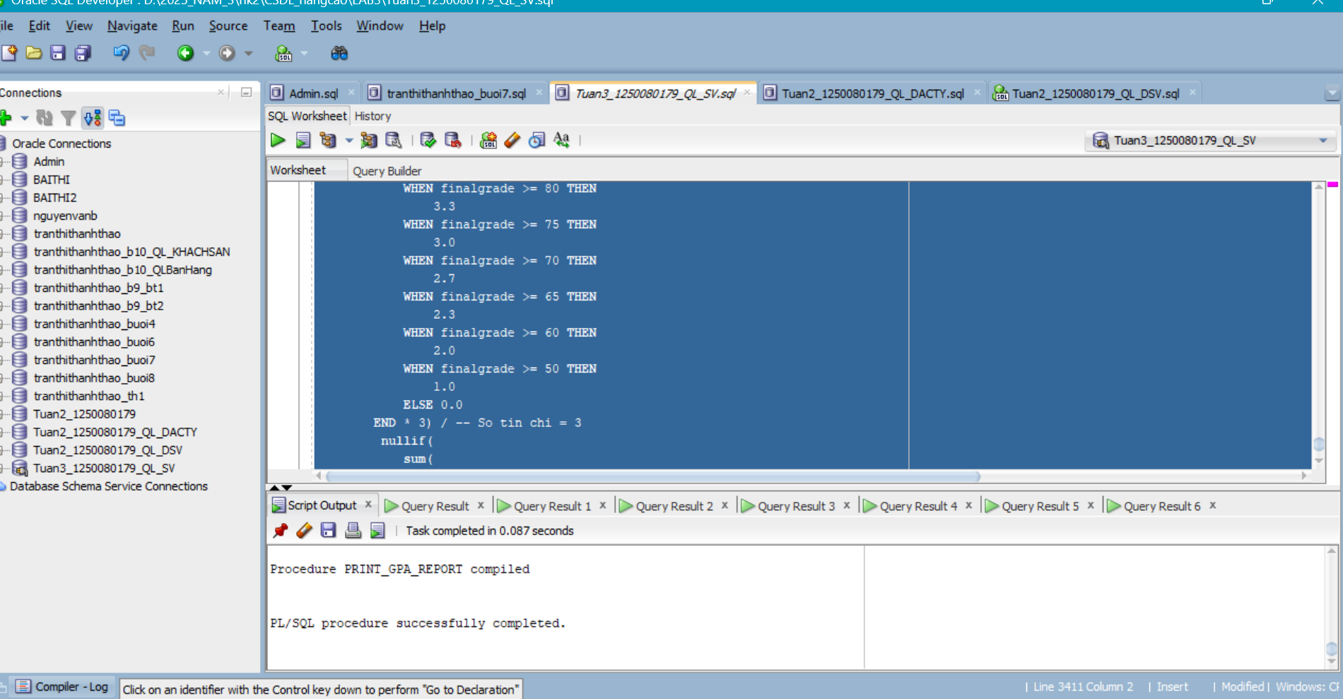
Câu 2.8: Thủ tục ghi log với PRAGMA AUTONOMOUS_TRANSACTION
CREATE TABLE notification_log (
log_id NUMBER
GENERATED ALWAYS AS IDENTITY
PRIMARY KEY,
nguoi_nhan VARCHAR2(50),
noi_dung VARCHAR2(500),
loai VARCHAR2(20),
thoi_gian DATE DEFAULT sysdate,
trang_thai VARCHAR2(10) DEFAULT 'SENT'
);
/

CREATE OR REPLACE PROCEDURE log_notification
(p_nguoi_nhan VARCHAR2,
p_noi_dung VARCHAR2,
p_loai VARCHAR2 DEFAULT 'INFO')
IS
PRAGMA AUTONOMOUS_TRANSACTION; -- Doc lap khoi transaction cha
BEGIN
INSERT INTO notification_log (nguoi_nhan, noi_dung, loai)
VALUES (p_nguoi_nhan, SUBSTR(p_noi_dung,1,500), p_loai);
COMMIT; -- Commit ngay, khong phu thuoc transaction cha
EXCEPTION
WHEN OTHERS THEN
ROLLBACK; -- Chi rollback autonomous transaction nay
END log_notification;
/

-- Kiem tra tinh doc lap:
BEGIN
INSERT INTO student (
studentid,
lastname,
registrationdate,
createdby,
createddate,
modifiedby,
modifieddate
) VALUES ( 9999,
'Test',
sysdate,
user,
sysdate,
user,
sysdate );

log_notification('Admin', 'Da them SV 9999', 'ENROLL');

ROLLBACK; -- Rollback INSERT student, nhung log van con!
end;
/

SELECT
*
FROM
notification_log; -- Ban ghi log van con du da ROLLBACK
Kết quả:
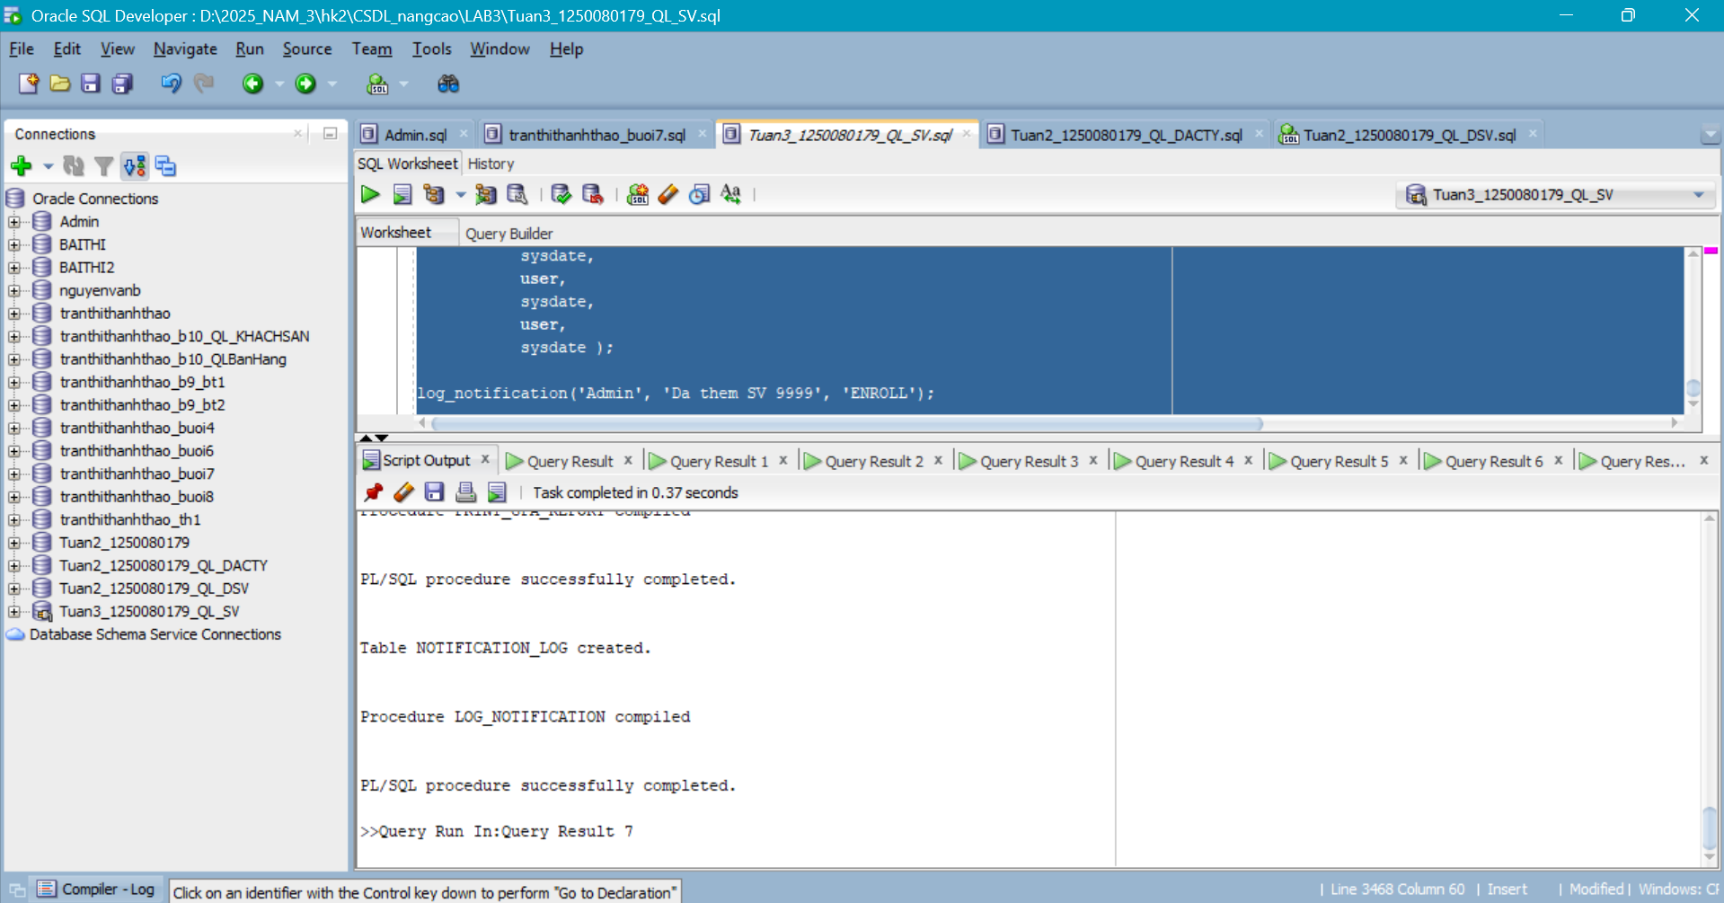

BÀI 3 – TRIGGER NÂNG CAO
Câu 3.1: Compound Trigger giải quyết Mutating Table
ALTER TABLE class ADD so_sv NUMBER DEFAULT 0;

CREATE OR REPLACE TRIGGER trg_update_class_count FOR
INSERT OR UPDATE OR DELETE ON enrollment
COMPOUND TRIGGER
TYPE t_ids IS
TABLE OF NUMBER INDEX BY PLS_INTEGER;
v_ids t_ids;
v_idx PLS_INTEGER := 0;
BEFORE STATEMENT IS BEGIN
v_idx := 0;
v_ids.DELETE;
END BEFORE STATEMENT;
AFTER EACH ROW IS BEGIN
v_idx := v_idx + 1;
v_ids(v_idx) :=
CASE
WHEN inserting
OR updating THEN
:new.classid
ELSE :old.classid
END;

END AFTER EACH ROW;
AFTER STATEMENT IS BEGIN
FOR i IN 1..v_idx LOOP
UPDATE class
SET
so_sv = (
SELECT
COUNT(*)
FROM
enrollment
WHERE
classid = v_ids(i)
)
WHERE
classid = v_ids(i);

END LOOP;
END AFTER STATEMENT;
END trg_update_class_count;
/

-- Kiem tra:
INSERT INTO enrollment (
studentid,
classid,
enrolldate,
createdby,
createddate,
modifiedby,
modifieddate
) VALUES ( 3020,
1006,
sysdate,
user,
sysdate,
user,
sysdate );

COMMIT;

SELECT
classid,
so_sv
FROM
class
WHERE
classid = 1006;
Kết quả:
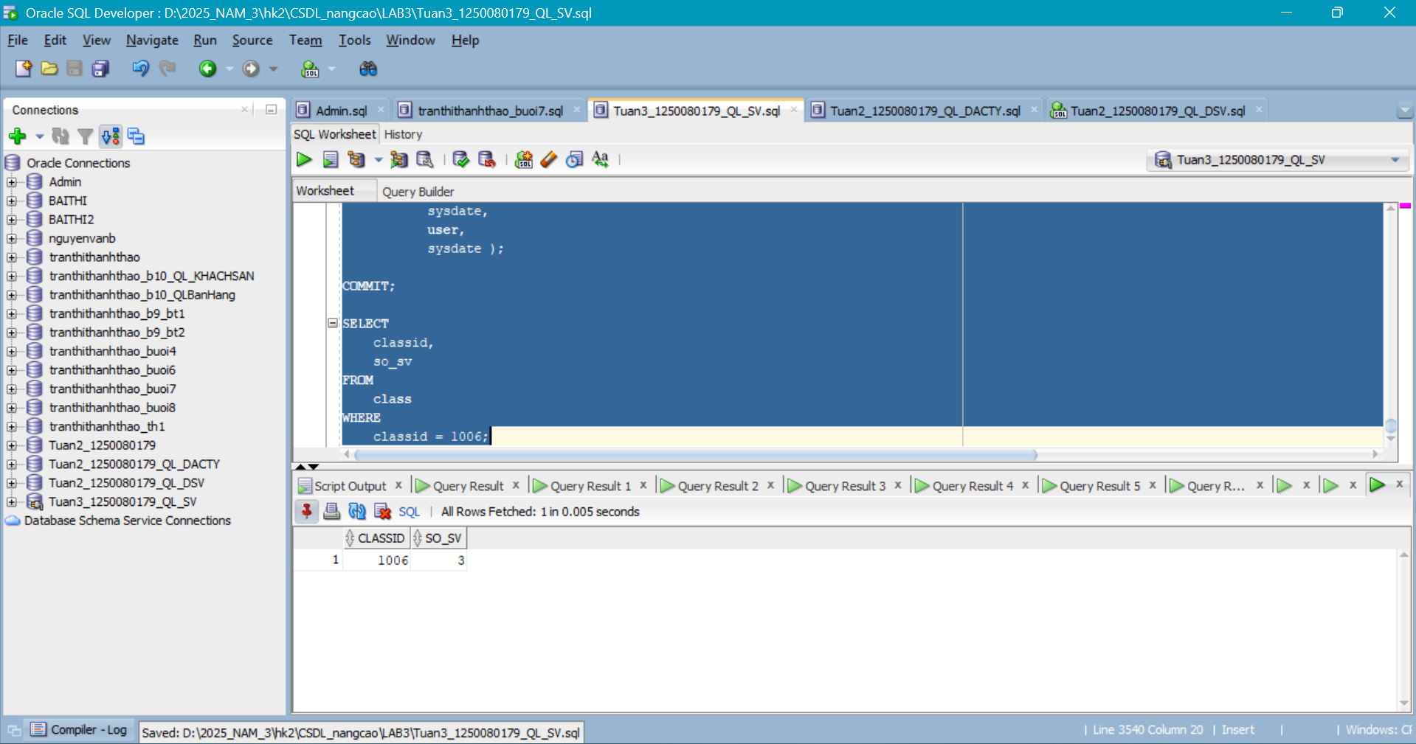
Câu 3.2: INSTEAD OF UPDATE Trigger trên view 4 bảng
CREATE OR REPLACE VIEW vw_class_enrollment_detail AS
SELECT
e.classid,
e.studentid,
s.firstname
|| ' '
|| s.lastname AS ten_sv,
co.description AS ten_mon,
e.finalgrade,
i.firstname
|| ' '
|| i.lastname AS ten_gv
FROM
enrollment e
JOIN student s ON e.studentid = s.studentid
JOIN class cl ON e.classid = cl.classid
JOIN course co ON cl.courseno = co.courseno
JOIN instructor i ON cl.instructorid = i.instructorid;

CREATE OR REPLACE TRIGGER trg_iot_update_grade INSTEAD OF
UPDATE ON vw_class_enrollment_detail
FOR EACH ROW
DECLARE
v_old_grade NUMBER;
BEGIN
IF
:new.finalgrade IS NOT NULL
AND ( :new.finalgrade < 0
OR :new.finalgrade > 100 )
THEN
raise_application_error(-20060, 'Diem khong hop le (0-100)!');
END IF;

SELECT
finalgrade
INTO v_old_grade
FROM
enrollment
WHERE
studentid = :old.studentid
AND classid = :old.classid;

UPDATE enrollment
SET
finalgrade = :new.finalgrade,
modifiedby = user,
modifieddate = sysdate
WHERE
studentid = :old.studentid
AND classid = :old.classid;

MERGE INTO grade g
USING (
SELECT
:old.studentid AS sid,
:old.classid AS cid
FROM
dual
) src ON ( g.studentid = src.sid
AND g.classid = src.cid )
WHEN MATCHED THEN UPDATE
SET g.grade = :new.finalgrade,
g.modifiedby = user,
g.modifieddate = sysdate
WHEN NOT MATCHED THEN
INSERT (
studentid,
classid,
grade,
createdby,
createddate,
modifiedby,
modifieddate )
VALUES
( :old.studentid,
:old.classid,
:new.finalgrade,
user,
sysdate,
user,
sysdate );

log_notification('System',
'Cap nhat diem SV '
|| :old.studentid
|| ' lop '
|| :old.classid
|| ': '
|| nvl(
to_char(v_old_grade),
'NULL'
)
|| '->'
|| :new.finalgrade,
'GRADE');

END trg_iot_update_grade;
/

-- Kiem tra:
UPDATE vw_class_enrollment_detail
SET
finalgrade = 88
WHERE
studentid = 3001
AND classid = 1001;

COMMIT;
Kết quả:
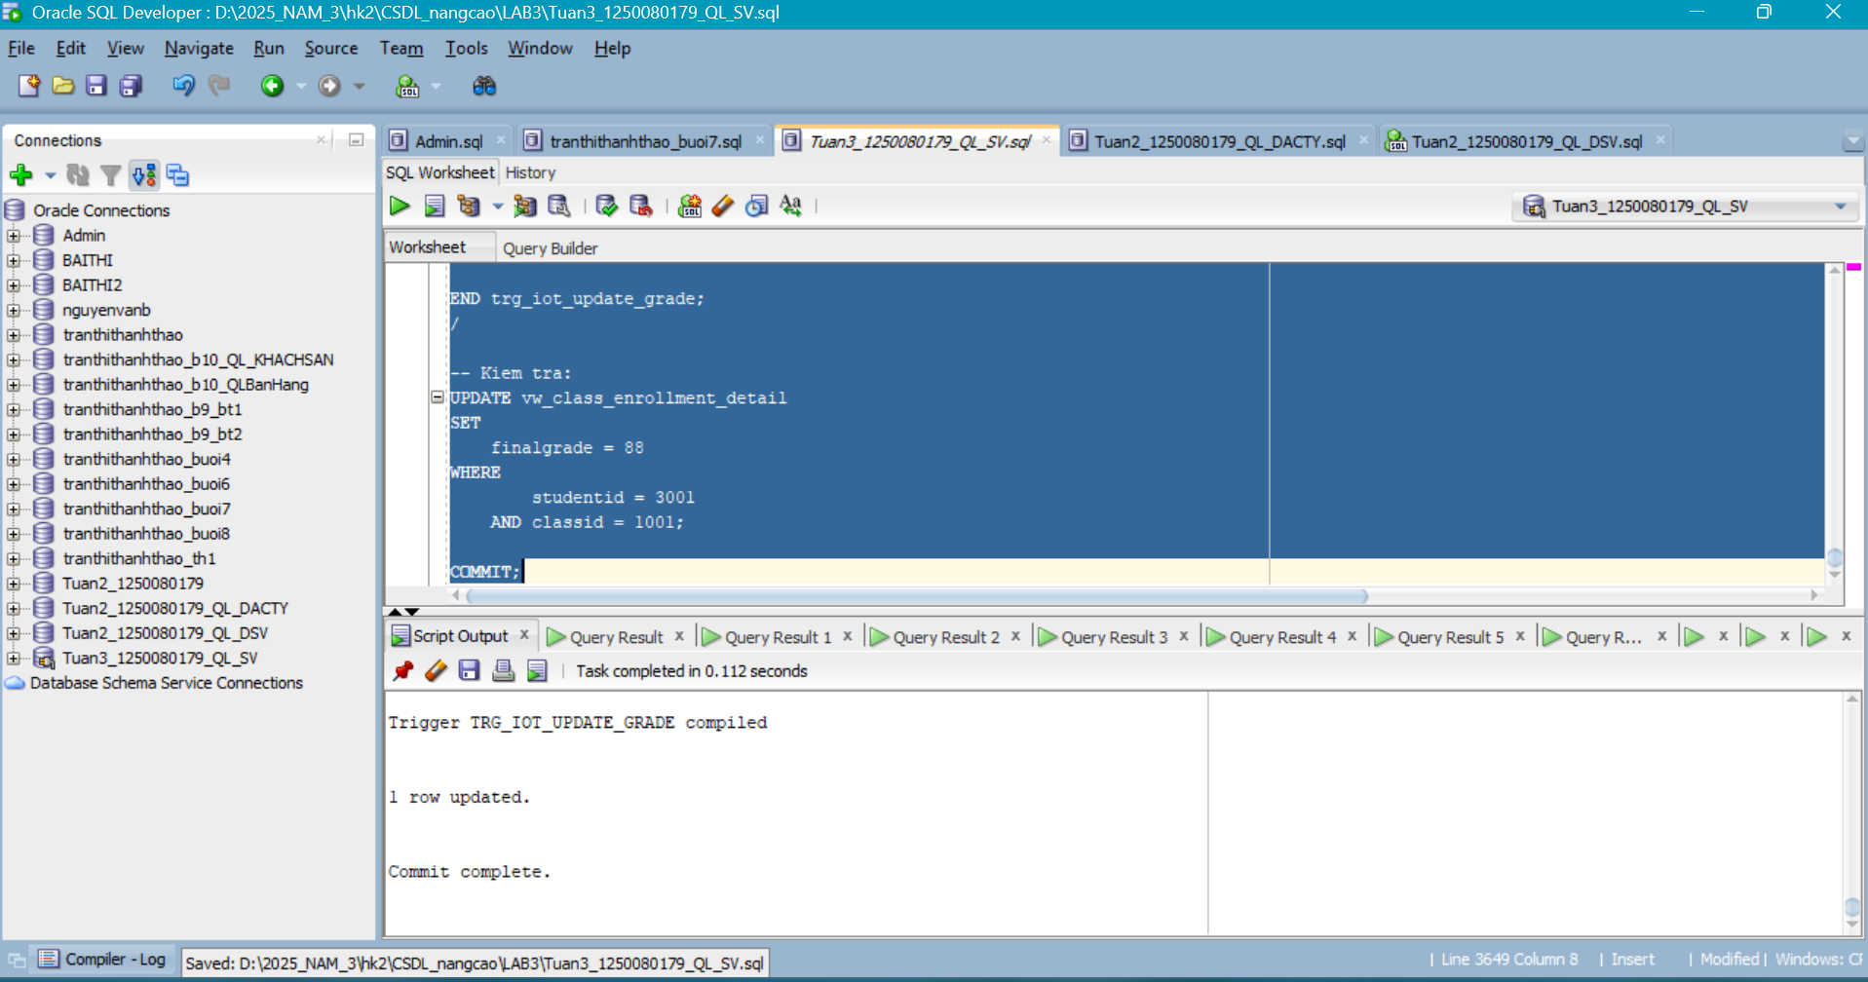
Câu 3.3: DDL Trigger ghi nhật ký mọi thay đổi cấu trúc
CREATE TABLE ddl_audit_log (
log_id NUMBER
GENERATED ALWAYS AS IDENTITY,
event_type VARCHAR2(30),
object_type VARCHAR2(30),
object_name VARCHAR2(128),
owner VARCHAR2(30),
event_time DATE,
current_usr VARCHAR2(30)
);
/

CREATE OR REPLACE TRIGGER trg_ddl_audit
AFTER DDL ON SCHEMA
DECLARE
PRAGMA
autonomous_transaction;

BEGIN
INSERT INTO ddl_audit_log (
event_type,
object_type,
object_name,
owner,
event_time,
current_usr
) VALUES ( ora_sysevent,
ora_dict_obj_type,
ora_dict_obj_name,
ora_dict_obj_owner,
sysdate,
ora_login_user );

COMMIT;
EXCEPTION
WHEN OTHERS THEN
ROLLBACK;
END trg_ddl_audit;
/

-- Kiem tra:
CREATE TABLE test_ddl_track (
id NUMBER
);

DROP TABLE test_ddl_track;

SELECT
*
FROM
ddl_audit_log
ORDER BY
log_id DESC;
Kết quả:
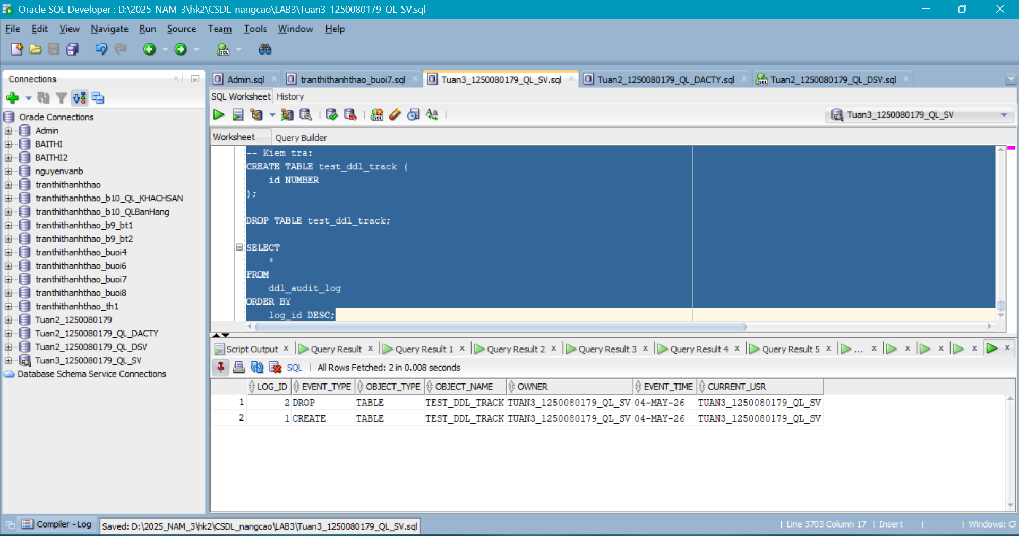
Câu 3.4: Trigger chuỗi - Cascade khi xóa sinh viên
CREATE TABLE ddl_audit_log (
log_id NUMBER
GENERATED ALWAYS AS IDENTITY,
event_type VARCHAR2(30),
object_type VARCHAR2(30),
object_name VARCHAR2(128),
owner VARCHAR2(30),
event_time DATE,
current_usr VARCHAR2(30)
);
/

CREATE OR REPLACE TRIGGER trg_ddl_audit
AFTER DDL ON SCHEMA
DECLARE
PRAGMA
autonomous_transaction;

BEGIN
INSERT INTO ddl_audit_log (
event_type,
object_type,
object_name,
owner,
event_time,
current_usr
) VALUES ( ora_sysevent,
ora_dict_obj_type,
ora_dict_obj_name,
ora_dict_obj_owner,
sysdate,
ora_login_user );

COMMIT;
EXCEPTION
WHEN OTHERS THEN
ROLLBACK;
END trg_ddl_audit;
/

-- Kiem tra:
CREATE TABLE test_ddl_track (
id NUMBER
);

DROP TABLE test_ddl_track;

SELECT
*
FROM
ddl_audit_log
ORDER BY
log_id DESC;
--Cau3.4
-- Trigger 1: BEFORE DELETE tren STUDENT - Kiem tra
CREATE OR REPLACE TRIGGER trg_prevent_student_delete BEFORE
DELETE ON student
FOR EACH ROW
DECLARE
v_count NUMBER;
BEGIN
SELECT
COUNT(*)
INTO v_count
FROM
enrollment
WHERE
studentid = :old.studentid;

IF v_count > 0 THEN
raise_application_error(-20030,
'Khong the xoa SV '
|| :old.studentid
|| ' dang co '
|| v_count
|| ' lop dang ky! Huy dang ky truoc.');

END IF;

END;
/
-- Trigger 2: AFTER DELETE tren STUDENT - Cascade xoa GRADE
CREATE OR REPLACE TRIGGER trg_cascade_delete_grade AFTER
DELETE ON student
FOR EACH ROW
BEGIN
DELETE FROM grade
WHERE
studentid = :old.studentid;

dbms_output.put_line('Da xoa '
|| SQL%rowcount
|| ' ban ghi GRADE cua SV
'
|| :old.studentid);

END;
/

-- Trigger 3: AFTER DELETE tren ENROLLMENT - Cap nhat so_sv trong CLASS
-- (Compound Trigger o cau 3.1 da xu ly dieu nay!)
-- Neu chua co compound trigger, viet them:
CREATE OR REPLACE TRIGGER trg_update_count_on_delete AFTER
DELETE ON enrollment
FOR EACH ROW
BEGIN
UPDATE class
SET
so_sv = so_sv - 1
WHERE
classid = :old.classid
AND so_sv > 0;

END;
/
-- Kiem tra chuoi trigger:
-- Thu xoa SV co enrollment (bi chan):
DELETE FROM student
WHERE
studentid = 3001;

-- Xoa enrollment truoc, sau do xoa SV (thanh cong):
DELETE FROM enrollment
WHERE
studentid = 3001;

DELETE FROM student
WHERE
studentid = 3001;

ROLLBACK;
Kết quả:
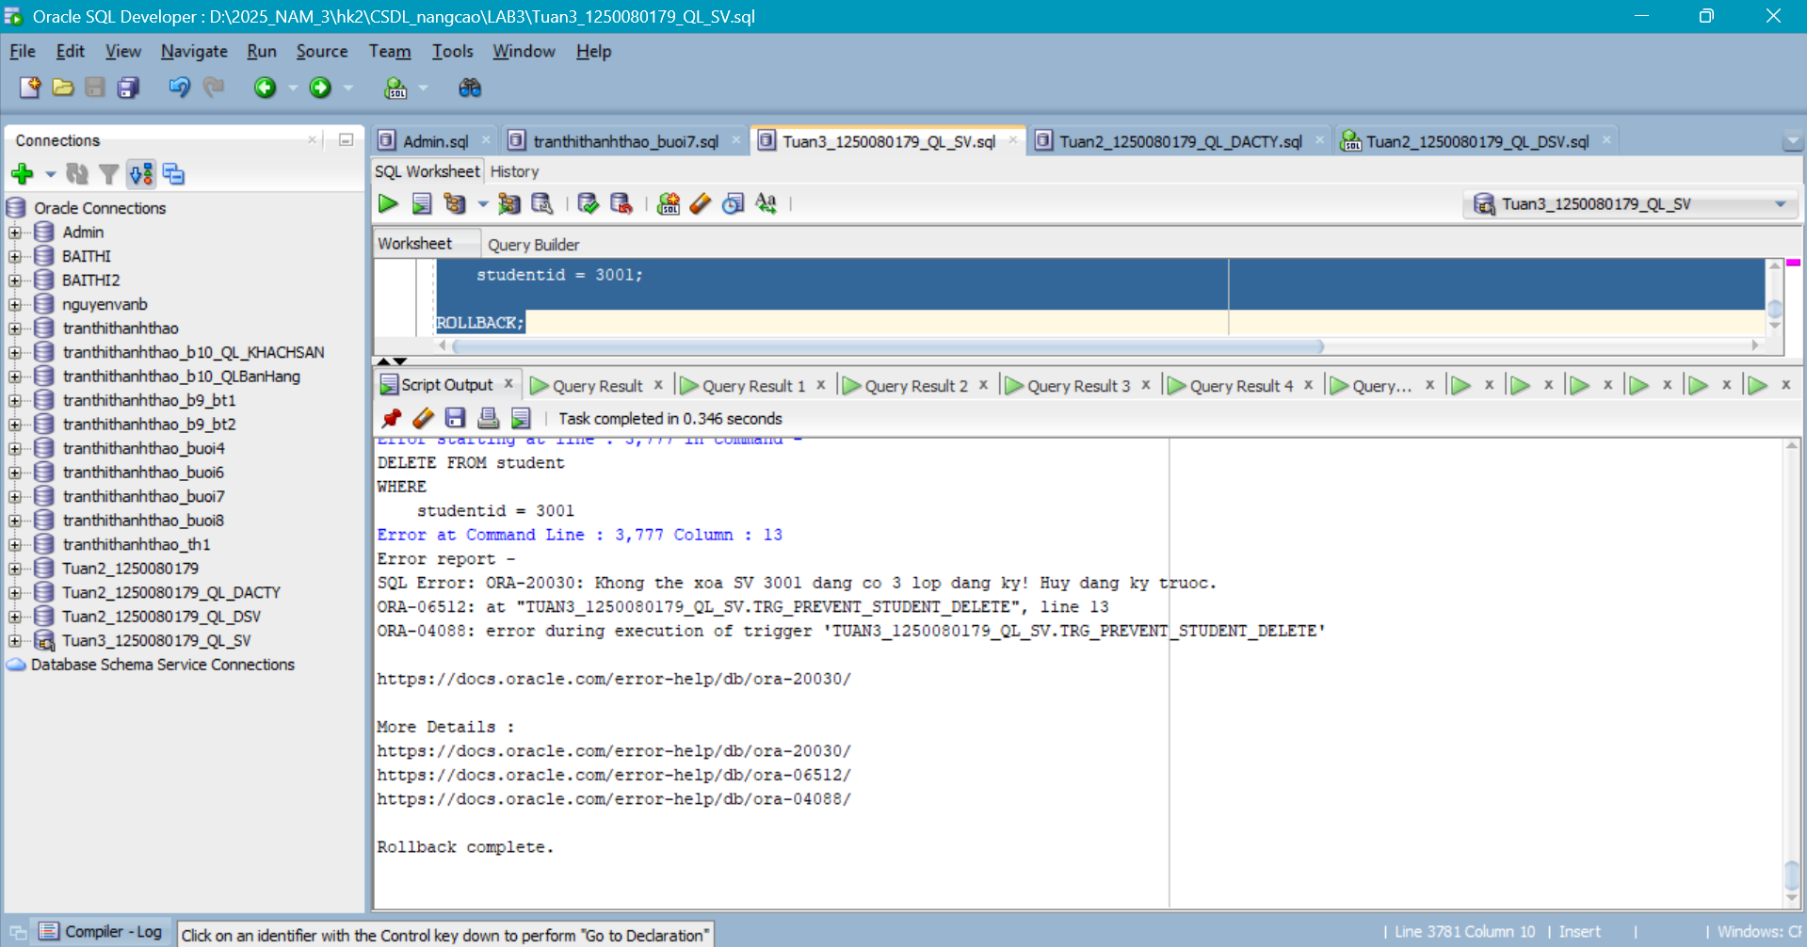
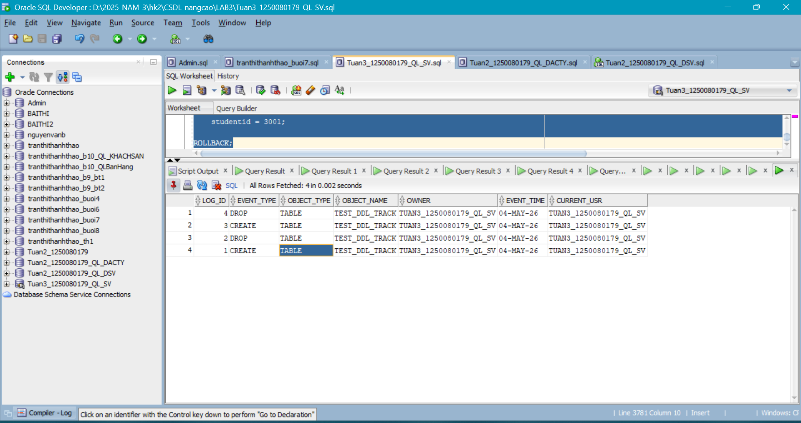
Câu 3.5: Trigger với WHEN - Tự động cấp chứng chỉ khi đạt điểm
CREATE TABLE certificate (
cert_id NUMBER
GENERATED ALWAYS AS IDENTITY,
studentid NUMBER(8),
courseno NUMBER(8),
cap_cc DATE,
loai VARCHAR2(20)
);
/
CREATE OR REPLACE TRIGGER trg_auto_certificate AFTER
UPDATE OF finalgrade ON enrollment
FOR EACH ROW
WHEN ( new.finalgrade >= 50 ) -- Chi chay khi diem >= 50
DECLARE
v_courseno NUMBER;
v_check NUMBER;
v_loai VARCHAR2(20);
v_ten_sv VARCHAR2(50);
v_ten_mon VARCHAR2(50);
BEGIN
-- Lay thong tin
SELECT
cl.courseno,
co.description,
s.firstname
|| ' '
|| s.lastname
INTO
v_courseno,
v_ten_mon,
v_ten_sv
FROM
class cl
JOIN course co ON cl.courseno = co.courseno
JOIN student s ON s.studentid = :new.studentid
WHERE
cl.classid = :new.classid;

-- Kiem tra da co chung chi chua
SELECT
COUNT(*)
INTO v_check
FROM
certificate
WHERE
studentid = :new.studentid
AND courseno = v_courseno;

IF v_check > 0 THEN
RETURN;
END IF; -- Da co roi, bo qua
-- Xac dinh loai chung chi
v_loai :=
CASE
WHEN :new.finalgrade >= 90 THEN
'HIGH_DISTINCTION'
WHEN :new.finalgrade >= 75 THEN
'DISTINCTION'
ELSE 'PASS'
END;

-- Cap chung chi
INSERT INTO certificate (
studentid,
courseno,
cap_cc,
loai
) VALUES ( :new.studentid,
v_courseno,
sysdate,
v_loai );

dbms_output.put_line('Chuc mung '
|| v_ten_sv
|| ' da hoan thanh mon '
|| v_ten_mon
|| ' voi '
|| v_loai
|| '!');

END trg_auto_certificate;
/

-- Kiem tra:
UPDATE enrollment
SET
finalgrade = 92
WHERE
studentid = 3001
AND classid = 1001;

COMMIT;

SELECT
*
FROM
certificate;
Kết quả:
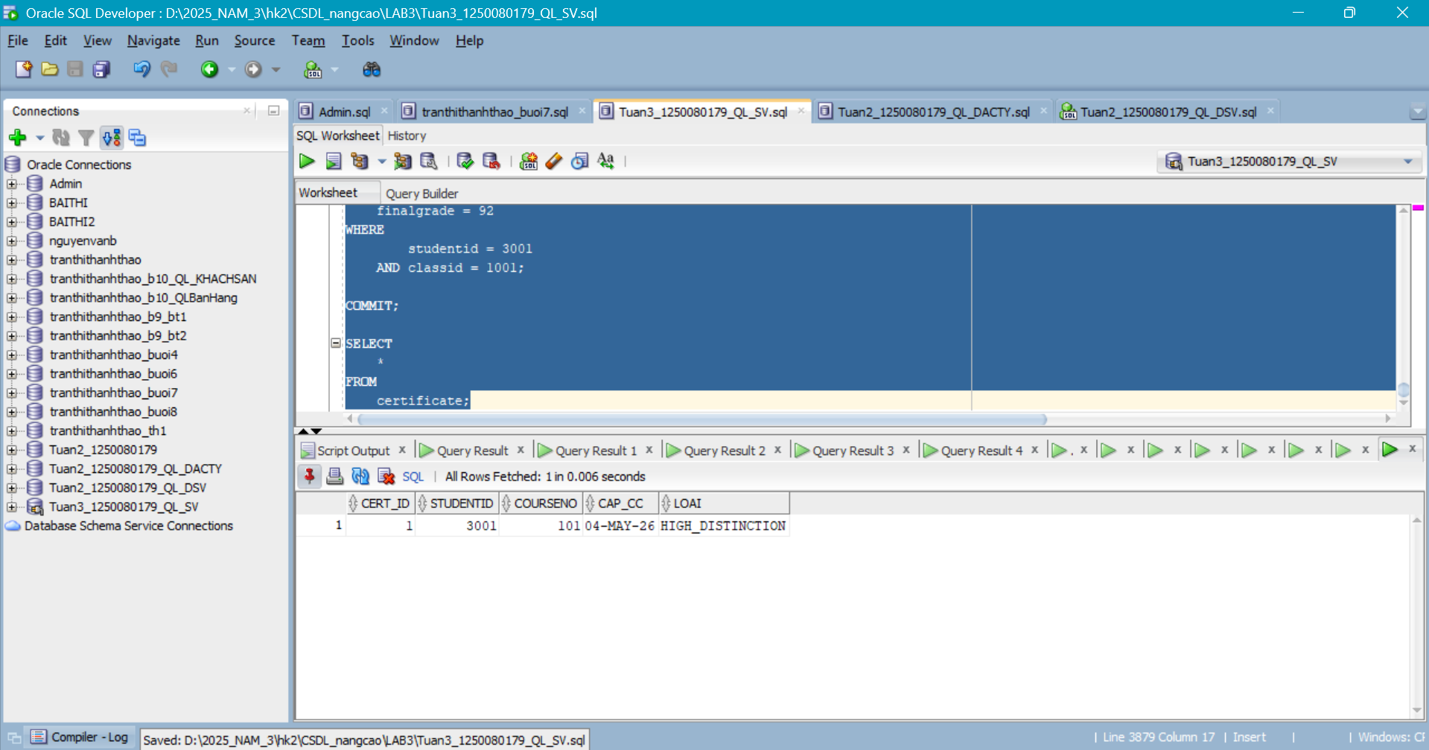

BÀI 4 - TỔNG HỢP
Câu 4.1: Hệ thống đăng ký học hoàn chỉnh - Package + View + Trigger
--View vw_enrollment_dashboard:
CREATE OR REPLACE VIEW vw_enrollment_dashboard AS
SELECT
(
SELECT
COUNT(*)
FROM
class
) AS so_lop_mo,
(
SELECT
SUM(cl.capacity - nvl(ec.sv, 0))
FROM
class cl
LEFT JOIN (
SELECT
classid,
COUNT(*) sv
FROM
enrollment
GROUP BY
classid
) ec ON cl.classid = ec.classid
) AS tong_cho_trong,
round((
SELECT
COUNT(*)
FROM
enrollment
) * 100.0 / nullif((
SELECT
SUM(capacity)
FROM
class
),
0),
1) AS ty_le_lap_day_pct,
(
SELECT
classid
|| ' ('
|| sv
|| ' SV)'
FROM
(
SELECT
classid,
COUNT(*) sv
FROM
enrollment
GROUP BY
classid
ORDER BY
sv DESC
FETCH FIRST 1 ROW ONLY
)
) AS lop_dong_nhat,
(
SELECT
classid
|| ' ('
|| sv
|| ' SV)'
FROM
(
SELECT
classid,
COUNT(*) sv
FROM
enrollment
GROUP BY
classid
ORDER BY
sv ASC
FETCH FIRST 1 ROW ONLY
)
) AS lop_it_nhat
FROM
dual;

SELECT
*
FROM
vw_enrollment_dashboard;
--Package pkg_enrollment_system (rút gọn phần chính):
CREATE OR REPLACE PACKAGE pkg_enrollment_system AS
FUNCTION is_eligible (
p_sid NUMBER,
p_cid NUMBER
) RETURN BOOLEAN;

PROCEDURE do_enroll (
p_sid NUMBER,
p_cid NUMBER
);

PROCEDURE do_withdraw (
p_sid NUMBER,
p_cid NUMBER
);

FUNCTION get_waitlist_position (
p_sid NUMBER,
p_cid NUMBER
) RETURN NUMBER;

END pkg_enrollment_system;
/

CREATE OR REPLACE PACKAGE BODY pkg_enrollment_system AS

FUNCTION is_eligible (
p_sid NUMBER,
p_cid NUMBER
) RETURN BOOLEAN IS
v_sv NUMBER;
v_cl NUMBER;
v_cap NUMBER;
v_enr NUMBER;
v_dup NUMBER;
BEGIN
SELECT
COUNT(*)
INTO v_sv
FROM
student
WHERE
studentid = p_sid;

IF v_sv = 0 THEN
RETURN FALSE;
END IF;
SELECT
COUNT(*)
INTO v_cl
FROM
class
WHERE
classid = p_cid;

IF v_cl = 0 THEN
RETURN FALSE;
END IF;
SELECT
capacity
INTO v_cap
FROM
class
WHERE
classid = p_cid;

SELECT
COUNT(*)
INTO v_enr
FROM
enrollment
WHERE
classid = p_cid;

IF v_enr >= v_cap THEN
RETURN FALSE;
END IF;
SELECT
COUNT(*)
INTO v_dup
FROM
enrollment
WHERE
studentid = p_sid
AND classid = p_cid;

IF v_dup > 0 THEN
RETURN FALSE;
END IF;
SELECT
COUNT(*)
INTO v_enr
FROM
enrollment
WHERE
studentid = p_sid;

IF v_enr >= 3 THEN
RETURN FALSE;
END IF;
RETURN TRUE;
END is_eligible;

PROCEDURE do_enroll (
p_sid NUMBER,
p_cid NUMBER
) IS
BEGIN
IF NOT is_eligible(p_sid, p_cid) THEN
dbms_output.put_line('[TU CHOI] Khong du dieu kien dang ky!');
RETURN;
END IF;

INSERT INTO enrollment (
studentid,
classid,
enrolldate,
createdby,
createddate,
modifiedby,
modifieddate
) VALUES ( p_sid,
p_cid,
sysdate,
user,
sysdate,
user,
sysdate );

COMMIT;
log_notification(user, 'Dang ky: SV '
|| p_sid
|| ' -> Lop
'
|| p_cid, 'ENROLL');
dbms_output.put_line('[OK] Dang ky thanh cong!');
END do_enroll;

PROCEDURE do_withdraw (
p_sid NUMBER,
p_cid NUMBER
) IS
v_check NUMBER;
BEGIN
SELECT
COUNT(*)
INTO v_check
FROM
enrollment
WHERE
studentid = p_sid
AND classid = p_cid;

IF v_check = 0 THEN
dbms_output.put_line('[LOI] SV chua dang ky lop nay!');
RETURN;
END IF;
DELETE FROM enrollment
WHERE
studentid = p_sid
AND classid = p_cid;

COMMIT;
log_notification(user, 'Huy dk: SV '
|| p_sid
|| ' khoi Lop
'
|| p_cid, 'WITHDRAW');
dbms_output.put_line('[OK] Huy dang ky thanh cong!');
END do_withdraw;

FUNCTION get_waitlist_position (
p_sid NUMBER,
p_cid NUMBER
) RETURN NUMBER IS
v_cap NUMBER;
v_enr NUMBER;
BEGIN
SELECT
capacity
INTO v_cap
FROM
class
WHERE
classid = p_cid;

SELECT
COUNT(*)
INTO v_enr
FROM
enrollment
WHERE
classid = p_cid;

IF v_enr < v_cap THEN
RETURN 0;
END IF;
RETURN v_enr - v_cap + 1;
END;

END pkg_enrollment_system;
/

-- Kiem tra:
BEGIN
pkg_enrollment_system.do_enroll(3020, 1006);
pkg_enrollment_system.do_enroll(999, 1001); -- SV khong ton tai
END;
/
Kết quả:
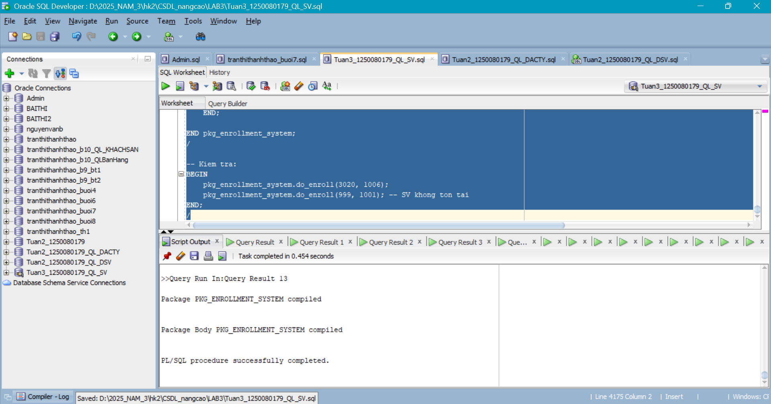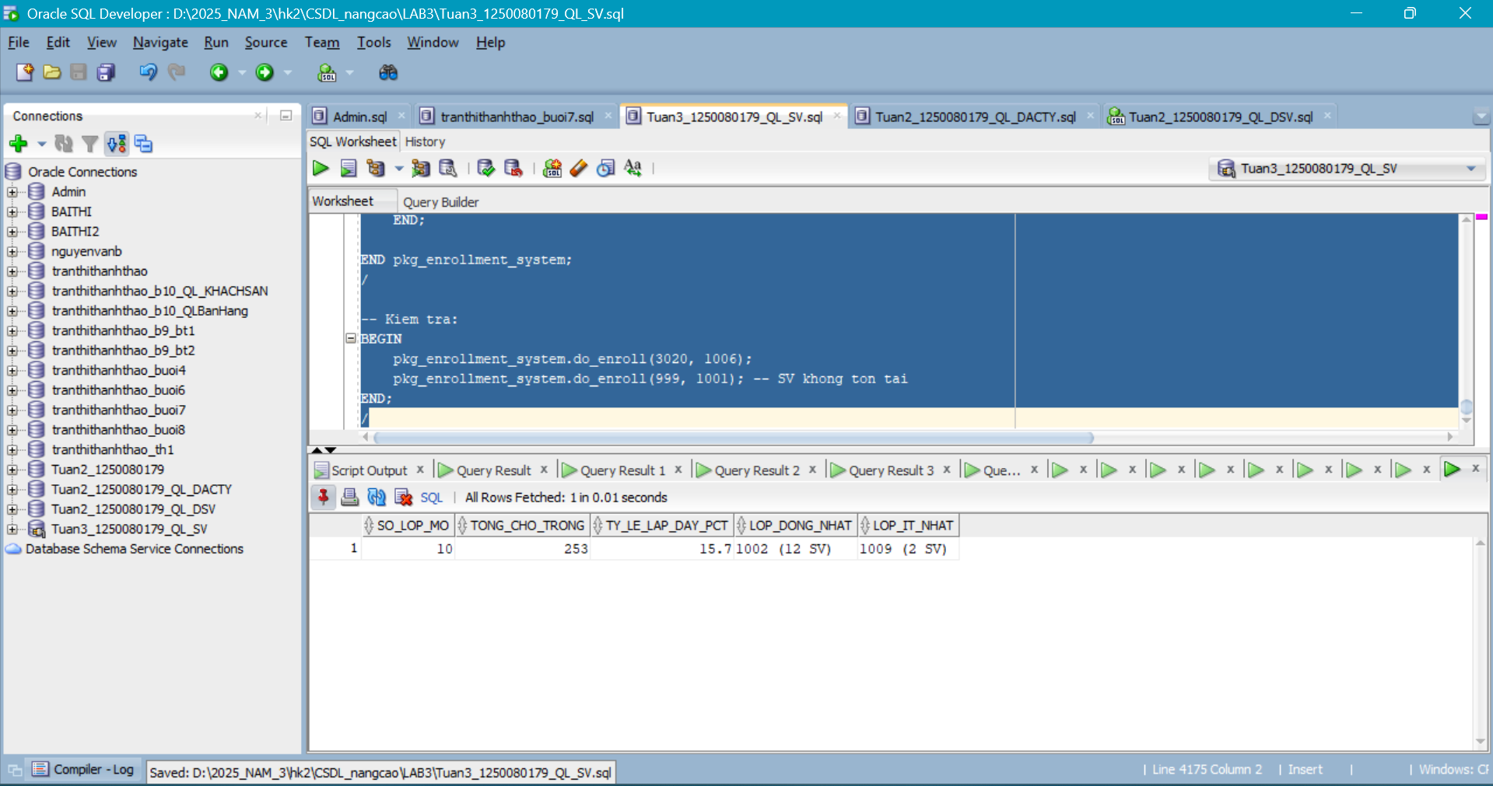
Câu 4.2: Tối ưu hóa: EXPLAIN PLAN và BULK COLLECT Refactor
--Phần A - Phân tích hiệu năng với EXPLAIN PLAN:
-- Xem execution plan cua view
EXPLAIN PLAN
FOR
SELECT
*
FROM
vw_course_summary;

SELECT
*
FROM
TABLE ( dbms_xplan.display );
-- Tim Full Table Scan (TABLE ACCESS FULL) trong output
-- Tao INDEX tren cac cot hay dung trong JOIN/WHERE:
CREATE INDEX idx_enrollment_classid ON
enrollment (
classid
);

CREATE INDEX idx_enrollment_studentid ON
enrollment (
studentid
);

CREATE INDEX idx_class_courseno ON
class (
courseno
);

CREATE INDEX idx_class_instructorid ON
class (
instructorid
);
-- Chay lai EXPLAIN PLAN sau khi tao INDEX de so sanh
EXPLAIN PLAN
FOR
SELECT
*
FROM
vw_course_summary;

SELECT
*
FROM
TABLE ( dbms_xplan.display );
-- Ket qua mong doi: thay 'TABLE ACCESS FULL' bang 'INDEX RANGE SCAN'
---Phần B - Refactor cursor bằng BULK COLLECT:
CREATE OR REPLACE PROCEDURE report_class_detail_v2 (
p_classid IN NUMBER
) IS

TYPE t_rec IS RECORD (
ho_ten VARCHAR2(50),
finalgrade NUMBER
);
TYPE t_recs IS
TABLE OF t_rec INDEX BY PLS_INTEGER;
v_data t_recs;
v_stt NUMBER := 0;
BEGIN
-- BULK COLLECT thay vi cursor tung hang
SELECT
s.firstname
|| ' '
|| s.lastname,
e.finalgrade
BULK COLLECT
INTO v_data
FROM
enrollment e
JOIN student s ON e.studentid = s.studentid
WHERE
e.classid = p_classid
ORDER BY
s.lastname;

dbms_output.put_line('So SV: ' || v_data.count);
FOR i IN 1..v_data.count LOOP
v_stt := v_stt + 1;
dbms_output.put_line(lpad(v_stt, 3)
|| ' '
|| rpad(v_data(i).ho_ten,
22)
|| lpad(
nvl(
to_char(v_data(i).finalgrade),
'--'
),
6
));

END LOOP;

END report_class_detail_v2;
/
--Phần C - Thủ tục chạy test tự động:
CREATE OR REPLACE PROCEDURE run_all_tests IS
v_pass NUMBER := 0;
v_fail NUMBER := 0;

PROCEDURE assert (
p_test VARCHAR2,
p_cond BOOLEAN
) IS
BEGIN
IF p_cond THEN
v_pass := v_pass + 1;
dbms_output.put_line('[PASS] ' || p_test);
ELSE
v_fail := v_fail + 1;
dbms_output.put_line('[FAIL] ' || p_test);
END IF;
END;

V_CNT NUMBER ; BEGIN DBMS_OUTPUT . PUT_LINE ( '=== BAT DAU TEST ===' ) ;
-- Test 1: enroll SV ton tai vao lop ton tai
BEGIN
pkg_enrollment_system.do_enroll(102, 2);
SELECT
COUNT(*)
INTO v_cnt
FROM
enrollment
WHERE
studentid = 3020
AND classid = 1006;

assert('Enroll hop le', v_cnt > 0);
ROLLBACK;
EXCEPTION
WHEN OTHERS THEN
assert('Enroll hop le', FALSE);
END;

-- Test 2: enroll SV khong ton tai -> phai that bai
BEGIN
pkg_enrollment_system.do_enroll(99999, 1001);
SELECT
COUNT(*)
INTO v_cnt
FROM
enrollment
WHERE
studentid = 99999;

assert('Chon SV khong ton tai', v_cnt = 0);
end;
dbms_output.put_line('=== KET QUA: PASS='
|| v_pass
|| ' FAIL='
|| v_fail
|| '
===');

END run_all_tests;
/

BEGIN
run_all_tests;
END;
/
Kết quả:
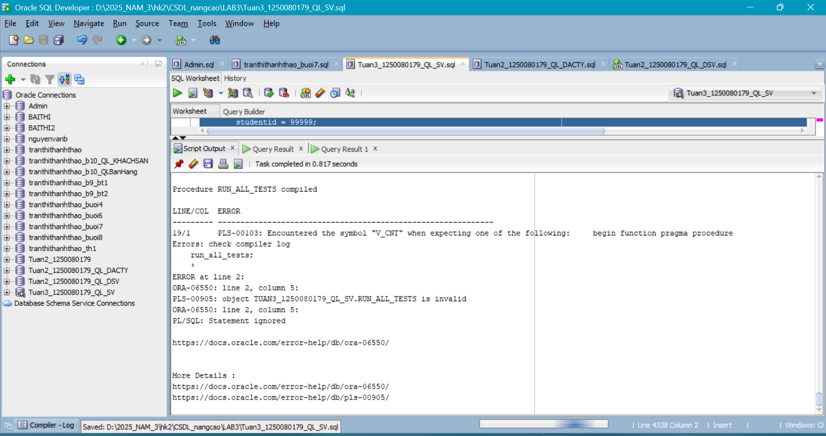
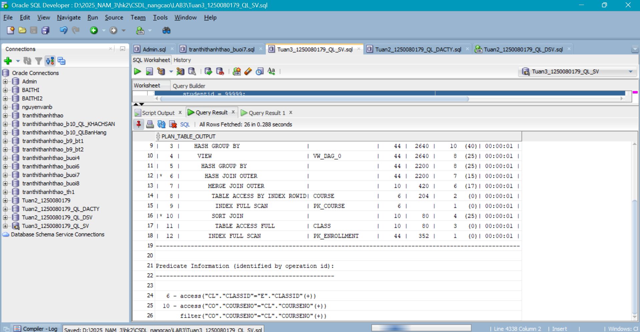
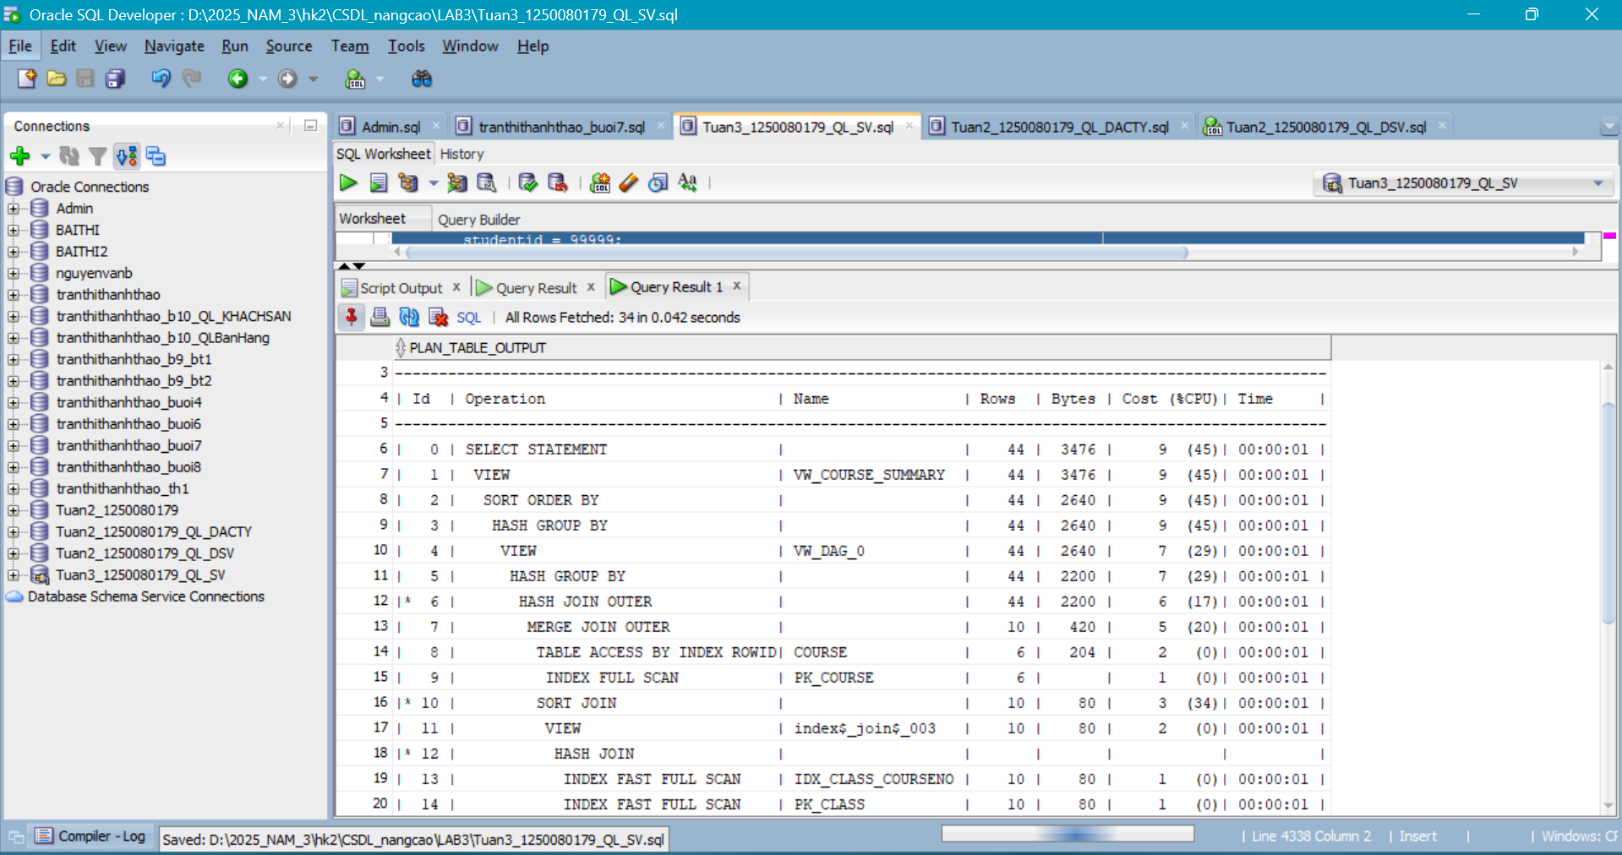
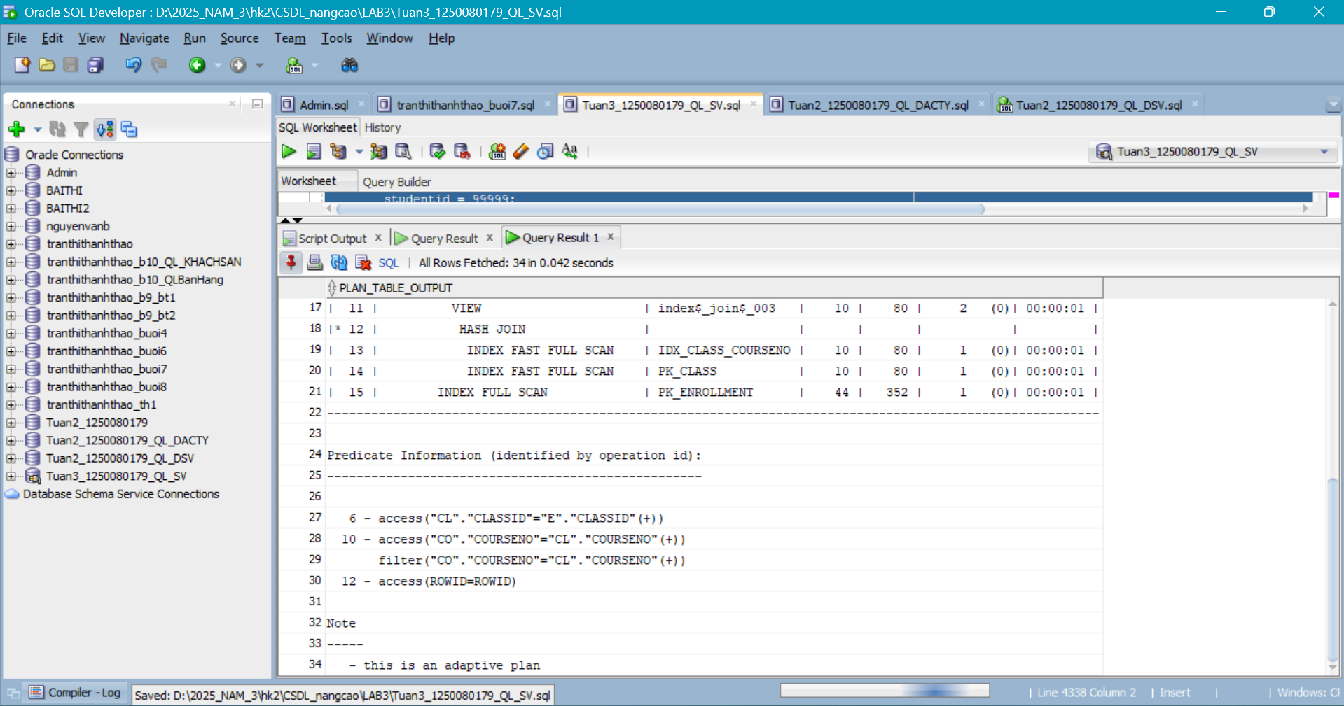

PHẦN 2: NHẬN XÉT
Nhìn chung bài lab bao quát khá đầy đủ các nội dung nâng cao của Oracle/PLSQL: xây dựng view nâng cao, stored procedure/package, trigger nâng cao. Qua đó giúp củng cố tư duy thiết kế CSDL, thao tác DML/DDL, quản lý transaction và kỹ năng debug lỗi thực tế. Tuy nhiên khi triển khai cần chú ý chuẩn hóa dữ liệu test, hạn chế hard-code ID, kiểm soát COMMIT/ROLLBACK trong procedure/package và kiểm tra ràng buộc để tránh lỗi constraint/mutaning.
Tổng kết: bài làm có tính thực tiễn tốt và giúp nắm vững quy trình xây dựng một hệ thống đăng ký học hoàn chỉnh trên Oracle.

