BÀI TẬP TUẦN 10
Bài tập: ngày 23/03/2026
Lớp: 12_ĐH_CNTT4
Tên sinh viên: Trần Thị Thanh Thảo
Mã số sinh viên: 1250080179
PHIẾU BÀI TẬP 1
Tạo bảng
-----Tạo bảng HangSX
CREATE TABLE HangSX (
MaHangSX VARCHAR2(10) CONSTRAINT pk_hangsx PRIMARY KEY,
TenHang VARCHAR2(100) NOT NULL,
DiaChi VARCHAR2(200),
SoDT VARCHAR2(15),
Email VARCHAR2(100)
);
/
-----Tạo bảng NhanVien
CREATE TABLE NhanVien (
MaNV VARCHAR2(10) CONSTRAINT pk_nhanvien PRIMARY KEY,
TenNV VARCHAR2(100) NOT NULL,
GioiTinh VARCHAR2(10),
DiaChi VARCHAR2(200),
SoDT VARCHAR2(15),
Email VARCHAR2(100),
TenPhong VARCHAR2(100)
);
/
-----Tạo bảng SanPham
CREATE TABLE SanPham (
MaSP VARCHAR2(10) CONSTRAINT pk_sanpham PRIMARY KEY,
MaHangSX VARCHAR2(10) NOT NULL,
TenSP VARCHAR2(100) NOT NULL,
SoLuong NUMBER(10) DEFAULT 0 NOT NULL,
MauSac VARCHAR2(30),
GiaBan NUMBER(15,2) NOT NULL,
DonViTinh VARCHAR2(20),
MoTa VARCHAR2(200),
CONSTRAINT fk_sanpham_hangsx FOREIGN KEY (MaHangSX) REFERENCES HangSX(MaHangSX)
);
/
-----Tạo bảng PNhap
CREATE TABLE PNhap (
SoHDN VARCHAR2(10) CONSTRAINT pk_pnhap PRIMARY KEY,
NgayNhap DATE NOT NULL,
MaNV VARCHAR2(10) NOT NULL,
CONSTRAINT fk_pnhap_nhanvien FOREIGN KEY (MaNV) REFERENCES NhanVien(MaNV)
);
/
-----Tạo bảng Nhap
CREATE TABLE Nhap (
SoHDN VARCHAR2(10) NOT NULL,
MaSP VARCHAR2(10) NOT NULL,
SoLuongN NUMBER(10) NOT NULL,
DonGiaN NUMBER(15,2) NOT NULL,
CONSTRAINT pk_nhap PRIMARY KEY (SoHDN, MaSP),
CONSTRAINT fk_nhap_pnhap FOREIGN KEY (SoHDN) REFERENCES PNhap(SoHDN),
CONSTRAINT fk_nhap_sanpham FOREIGN KEY (MaSP) REFERENCES SanPham(MaSP)
);
/
-----Tạo bảng PXuat
CREATE TABLE PXuat (
SoHDX VARCHAR2(10) CONSTRAINT pk_pxuat PRIMARY KEY,
NgayXuat DATE NOT NULL,
MaNV VARCHAR2(10) NOT NULL,
CONSTRAINT fk_pxuat_nhanvien FOREIGN KEY (MaNV) REFERENCES NhanVien(MaNV)
);
/
-----Tạo bảng Xuat
CREATE TABLE Xuat (
SoHDX VARCHAR2(10) NOT NULL,
MaSP VARCHAR2(10) NOT NULL,
SoLuongX NUMBER(10) NOT NULL,
CONSTRAINT pk_xuat PRIMARY KEY (SoHDX, MaSP),
CONSTRAINT fk_xuat_pxuat FOREIGN KEY (SoHDX) REFERENCES PXuat(SoHDX),
CONSTRAINT fk_xuat_sanpham FOREIGN KEY (MaSP) REFERENCES SanPham(MaSP)
);
/
Kết quả:
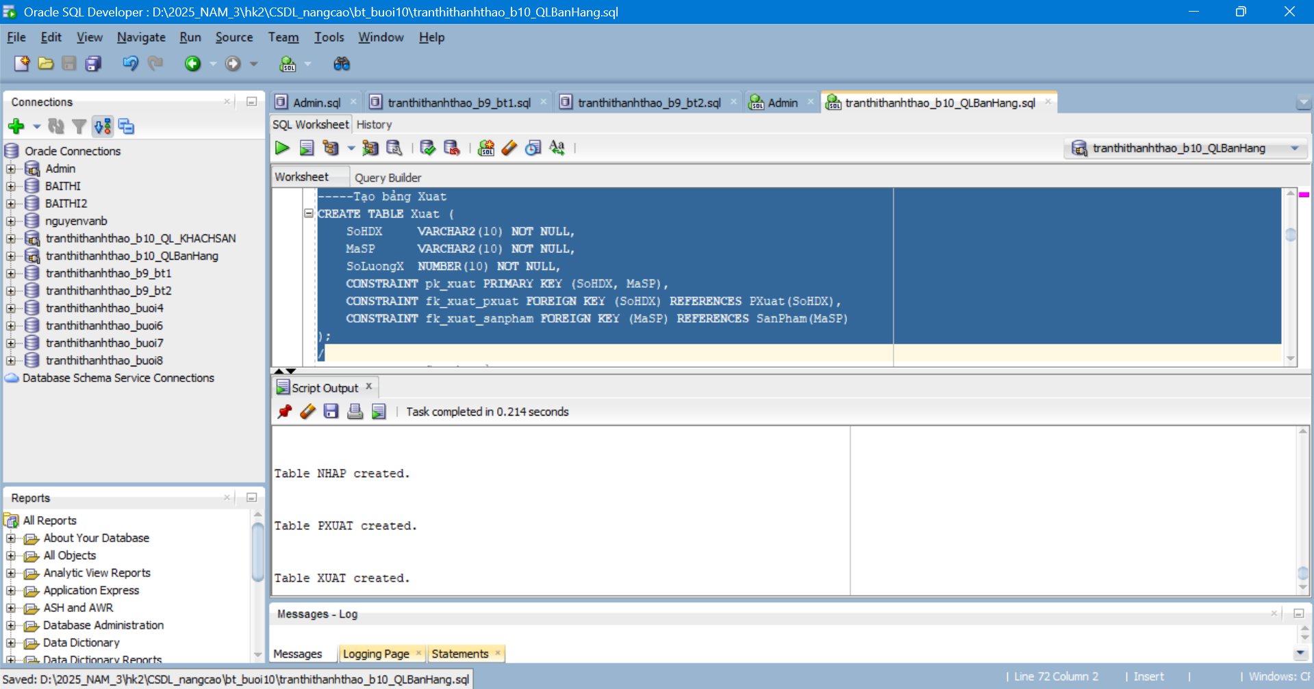Nhập dữ liệu mẫu
-----Insert 5 dữ liệu bảng HangSX
INSERT INTO HangSX VALUES ('HSX01', 'Samsung', 'Ha Noi', '0901000001', 'samsung@gmail.com');
INSERT INTO HangSX VALUES ('HSX02', 'Sony', 'TP.HCM', '0901000002', 'sony@gmail.com');
INSERT INTO HangSX VALUES ('HSX03', 'LG', 'Da Nang', '0901000003', 'lg@gmail.com');
INSERT INTO HangSX VALUES ('HSX04', 'Panasonic', 'Can Tho', '0901000004', 'panasonic@gmail.com');
INSERT INTO HangSX VALUES ('HSX05', 'Sharp', 'Hai Phong', '0901000005', 'sharp@gmail.com');
-----Insert 5 dữ liệu bảng NhanVien
INSERT INTO NhanVien VALUES ('NV01', 'Nguyen Van An', 'Nam', 'Quan 1', '0911000001', 'an@gmail.com', 'Kinh Doanh');
INSERT INTO NhanVien VALUES ('NV02', 'Tran Thi Binh', 'Nu', 'Quan 3', '0911000002', 'binh@gmail.com', 'Ke Toan');
INSERT INTO NhanVien VALUES ('NV03', 'Le Van Cuong', 'Nam', 'Thu Duc', '0911000003', 'cuong@gmail.com', 'Kho');
INSERT INTO NhanVien VALUES ('NV04', 'Pham Thi Dung', 'Nu', 'Go Vap', '0911000004', 'dung@gmail.com', 'Ban Hang');
INSERT INTO NhanVien VALUES ('NV05', 'Hoang Minh Duc', 'Nam', 'Binh Thanh', '0911000005', 'duc@gmail.com', 'Van Phong');
-----Insert 5 dữ liệu bảng SanPham
INSERT INTO SanPham VALUES ('SP01', 'HSX01', 'Tivi 43 inch', 50, 'Den', 8500000, 'Cai', 'Tivi thong minh');
INSERT INTO SanPham VALUES ('SP02', 'HSX02', 'Loa Bluetooth', 80, 'Xam', 1200000, 'Cai', 'Loa mini');
INSERT INTO SanPham VALUES ('SP03', 'HSX03', 'May giat', 30, 'Trang', 7200000, 'Cai', 'May giat cua ngang');
INSERT INTO SanPham VALUES ('SP04', 'HSX04', 'Dieu hoa', 25, 'Trang', 9800000, 'Cai', 'Dieu hoa inverter');
INSERT INTO SanPham VALUES ('SP05', 'HSX05', 'Lo vi song', 40, 'Bac', 2500000, 'Cai', 'Lo vi song gia dinh');
-----Insert 5 dữ liệu bảng PNhap
INSERT INTO PNhap VALUES ('N001', DATE '2026-03-01', 'NV01');
INSERT INTO PNhap VALUES ('N002', DATE '2026-03-02', 'NV02');
INSERT INTO PNhap VALUES ('N003', DATE '2026-03-03', 'NV03');
INSERT INTO PNhap VALUES ('N004', DATE '2026-03-04', 'NV04');
INSERT INTO PNhap VALUES ('N005', DATE '2026-03-05', 'NV05');
-----Insert 5 dữ liệu bảng Nhap
INSERT INTO Nhap VALUES ('N001', 'SP01', 10, 7000000);
INSERT INTO Nhap VALUES ('N002', 'SP02', 15, 900000);
INSERT INTO Nhap VALUES ('N003', 'SP03', 5, 6000000);
INSERT INTO Nhap VALUES ('N004', 'SP04', 7, 8200000);
INSERT INTO Nhap VALUES ('N005', 'SP05', 12, 1800000);
-----Insert 5 dữ liệu bảng PXuat
INSERT INTO PXuat VALUES ('X001', DATE '2026-03-10', 'NV01');
INSERT INTO PXuat VALUES ('X002', DATE '2026-03-11', 'NV02');
INSERT INTO PXuat VALUES ('X003', DATE '2026-03-12', 'NV03');
INSERT INTO PXuat VALUES ('X004', DATE '2026-03-13', 'NV04');
INSERT INTO PXuat VALUES ('X005', DATE '2026-03-14', 'NV05');
-----Insert 5 dữ liệu bảng Xuat
INSERT INTO Xuat VALUES ('X001', 'SP01', 5);
INSERT INTO Xuat VALUES ('X002', 'SP02', 8);
INSERT INTO Xuat VALUES ('X003', 'SP03', 3);
INSERT INTO Xuat VALUES ('X004', 'SP04', 2);
INSERT INTO Xuat VALUES ('X005', 'SP05', 4);
Kết quả:
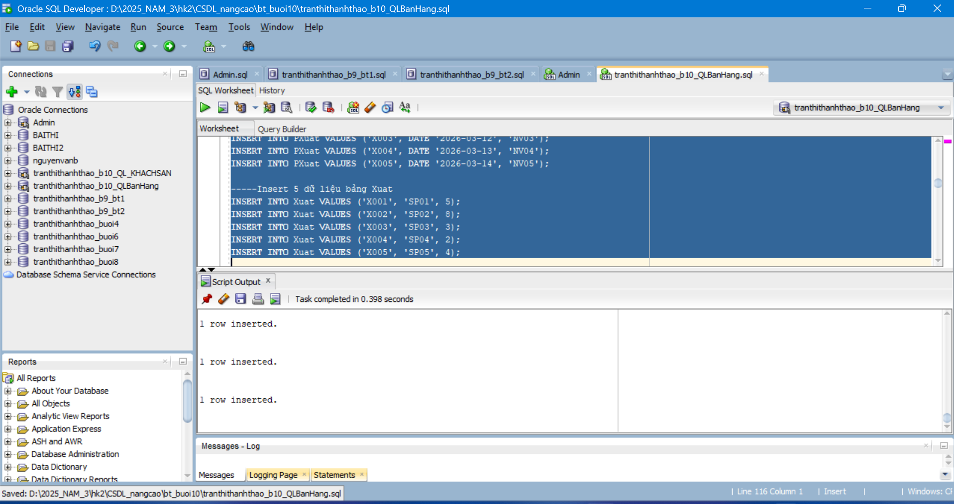
a. Trigger INSERT bảng NHAP – trg_Nhap
CREATE OR REPLACE TRIGGER trg_Nhap
BEFORE INSERT ON Nhap
FOR EACH ROW
DECLARE
v_dem NUMBER := 0;
v_so_luong NUMBER := 0;
BEGIN
SELECT COUNT(*)
INTO v_dem
FROM SanPham
WHERE MaSP = :NEW.MaSP;
IF v_dem = 0 THEN
RAISE_APPLICATION_ERROR(-20001, 'MaSP khong ton tai trong bang SanPham');
END IF;
IF NVL(:NEW.SoLuongN, 0) <= 0 OR NVL(:NEW.DonGiaN, 0) <= 0 THEN
RAISE_APPLICATION_ERROR(-20002, 'SoLuongN va DonGiaN phai lon hon 0');
END IF;
SELECT SoLuong
INTO v_so_luong
FROM SanPham
WHERE MaSP = :NEW.MaSP
FOR UPDATE;
UPDATE SanPham
SET SoLuong = v_so_luong + :NEW.SoLuongN
WHERE MaSP = :NEW.MaSP;
END trg_Nhap;
/
Kết quả:
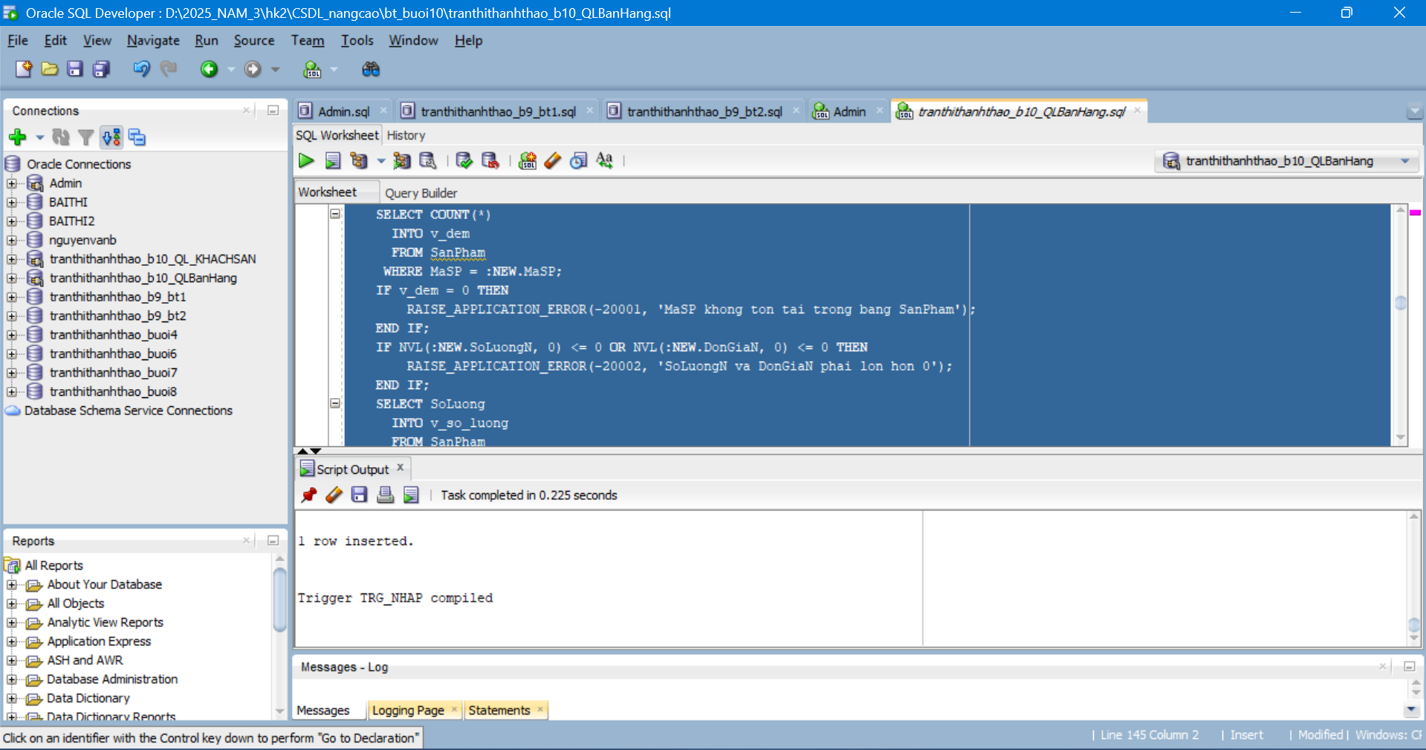
b. Trigger INSERT bảng XUAT – trg_Xuat
CREATE OR REPLACE TRIGGER trg_Xuat
BEFORE INSERT ON Xuat
FOR EACH ROW
DECLARE
v_dem NUMBER := 0;
v_so_luong NUMBER := 0;
BEGIN
SELECT COUNT(*)
INTO v_dem
FROM SanPham
WHERE MaSP = :NEW.MaSP;
IF v_dem = 0 THEN
RAISE_APPLICATION_ERROR(-20003, 'MaSP khong ton tai trong bang SanPham');
END IF;
IF NVL(:NEW.SoLuongX, 0) <= 0 THEN
RAISE_APPLICATION_ERROR(-20004, 'SoLuongX phai lon hon 0');
END IF;
SELECT SoLuong
INTO v_so_luong
FROM SanPham
WHERE MaSP = :NEW.MaSP
FOR UPDATE;
IF :NEW.SoLuongX > v_so_luong THEN
RAISE_APPLICATION_ERROR(-20005, 'SoLuongX vuot qua so luong ton trong SanPham');
END IF;
UPDATE SanPham
SET SoLuong = v_so_luong - :NEW.SoLuongX
WHERE MaSP = :NEW.MaSP;
END trg_Xuat;
/
Kết quả:
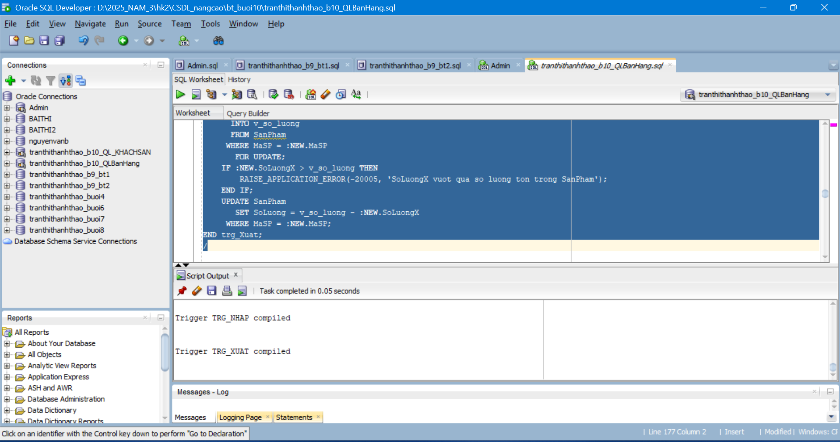
c. Trigger DELETE bảng XUAT – trg_XoaXuat
CREATE OR REPLACE TRIGGER trg_XoaXuat
AFTER DELETE ON Xuat
FOR EACH ROW
BEGIN
UPDATE SanPham
SET SoLuong = SoLuong + :OLD.SoLuongX
WHERE MaSP = :OLD.MaSP;
END trg_XoaXuat;
/
Kết quả:
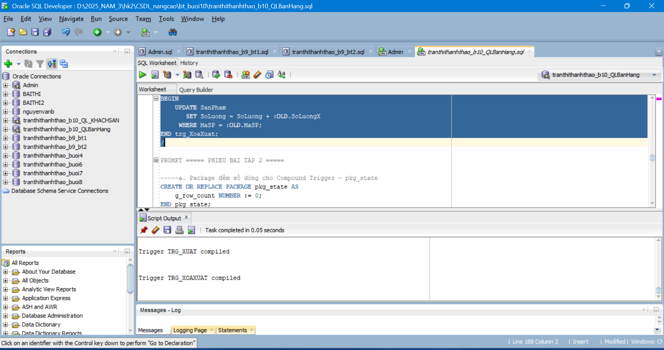
PHIẾU BÀI TẬP 2
a. Trigger UPDATE bảng XUAT – trg_CapNhatXuat
CREATE OR REPLACE TRIGGER trg_CapNhatXuat
FOR UPDATE ON Xuat
COMPOUND TRIGGER
BEFORE STATEMENT IS
BEGIN
pkg_state.g_row_count := 0;
END BEFORE STATEMENT;

BEFORE EACH ROW IS
v_ton_cu NUMBER := 0;
v_ton_moi NUMBER := 0;
BEGIN
pkg_state.g_row_count := pkg_state.g_row_count + 1;

IF pkg_state.g_row_count > 1 THEN
RAISE_APPLICATION_ERROR(-20011, 'Chi duoc UPDATE 1 ban ghi tren bang Xuat');
END IF;

IF NVL(:NEW.SoLuongX, 0) <= 0 THEN
RAISE_APPLICATION_ERROR(-20012, 'SoLuongX phai lon hon 0');
END IF;

IF :NEW.MaSP <> :OLD.MaSP THEN
SELECT SoLuong
INTO v_ton_moi
FROM SanPham
WHERE MaSP = :NEW.MaSP
FOR UPDATE;

IF :NEW.SoLuongX > v_ton_moi THEN
RAISE_APPLICATION_ERROR(-20013, 'SanPham moi khong du so luong de xuat');
END IF;
ELSE
SELECT SoLuong
INTO v_ton_cu
FROM SanPham
WHERE MaSP = :OLD.MaSP
FOR UPDATE;

IF (:NEW.SoLuongX - :OLD.SoLuongX) > v_ton_cu THEN
RAISE_APPLICATION_ERROR(-20014, 'Khong du so luong ton de cap nhat phieu xuat');
END IF;
END IF;
EXCEPTION
WHEN NO_DATA_FOUND THEN
RAISE_APPLICATION_ERROR(-20015, 'MaSP khong ton tai trong bang SanPham');
END BEFORE EACH ROW;

AFTER EACH ROW IS
BEGIN
IF :NEW.MaSP <> :OLD.MaSP THEN
UPDATE SanPham
SET SoLuong = SoLuong + :OLD.SoLuongX
WHERE MaSP = :OLD.MaSP;

UPDATE SanPham
SET SoLuong = SoLuong - :NEW.SoLuongX
WHERE MaSP = :NEW.MaSP;
ELSE
UPDATE SanPham
SET SoLuong = SoLuong - (:NEW.SoLuongX - :OLD.SoLuongX)
WHERE MaSP = :NEW.MaSP;
END IF;
END AFTER EACH ROW;
END trg_CapNhatXuat;
/
Kết quả:
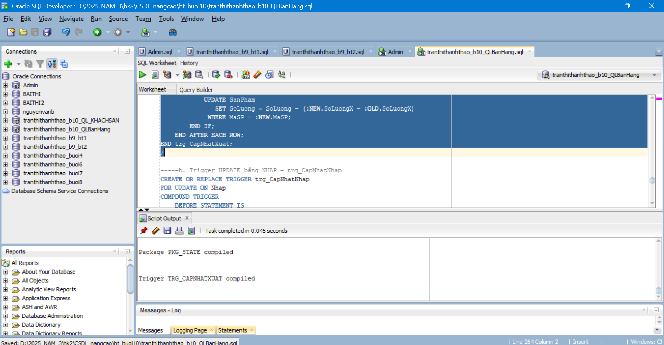
b. Trigger UPDATE bảng NHAP – trg_CapNhatNhap
CREATE OR REPLACE TRIGGER trg_CapNhatNhap
FOR UPDATE ON Nhap
COMPOUND TRIGGER
BEFORE STATEMENT IS
BEGIN
pkg_state.g_row_count := 0;
END BEFORE STATEMENT;

BEFORE EACH ROW IS
BEGIN
pkg_state.g_row_count := pkg_state.g_row_count + 1;

IF pkg_state.g_row_count > 1 THEN
RAISE_APPLICATION_ERROR(-20021, 'Chi duoc UPDATE 1 ban ghi tren bang Nhap');
END IF;

IF NVL(:NEW.SoLuongN, 0) <= 0 OR NVL(:NEW.DonGiaN, 0) <= 0 THEN
RAISE_APPLICATION_ERROR(-20022, 'SoLuongN va DonGiaN phai lon hon 0');
END IF;
END BEFORE EACH ROW;

AFTER EACH ROW IS
BEGIN
IF :NEW.MaSP <> :OLD.MaSP THEN
UPDATE SanPham
SET SoLuong = SoLuong - :OLD.SoLuongN
WHERE MaSP = :OLD.MaSP;

UPDATE SanPham
SET SoLuong = SoLuong + :NEW.SoLuongN
WHERE MaSP = :NEW.MaSP;
ELSE
UPDATE SanPham
SET SoLuong = SoLuong + (:NEW.SoLuongN - :OLD.SoLuongN)
WHERE MaSP = :NEW.MaSP;
END IF;
END AFTER EACH ROW;
END trg_CapNhatNhap;
/
kết quả:
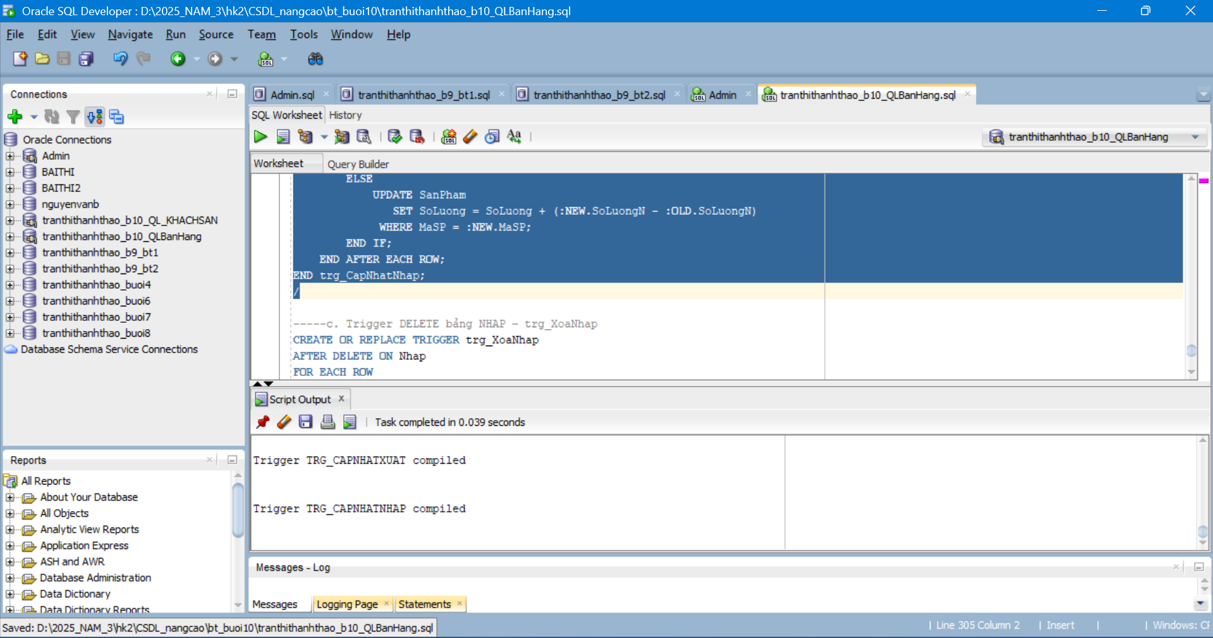
c. Trigger DELETE bảng NHAP – trg_XoaNhap
CREATE OR REPLACE TRIGGER trg_XoaNhap
AFTER DELETE ON Nhap
FOR EACH ROW
DECLARE
v_so_luong NUMBER := 0;
BEGIN
SELECT SoLuong
INTO v_so_luong
FROM SanPham
WHERE MaSP = :OLD.MaSP
FOR UPDATE;

IF :OLD.SoLuongN > v_so_luong THEN
RAISE_APPLICATION_ERROR(-20031, 'Khong the xoa phieu nhap vi so luong ton se bi am');
END IF;

UPDATE SanPham
SET SoLuong = v_so_luong - :OLD.SoLuongN
WHERE MaSP = :OLD.MaSP;
END trg_XoaNhap;
/
kết quả: 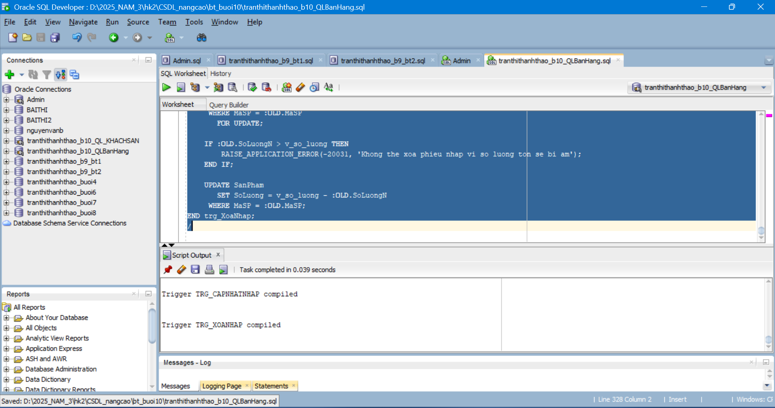
PHIẾU BÀI TẬP 3
Tạo bảng
-----Tạo bảng Phong
CREATE TABLE Phong (
MaPhong VARCHAR2(10) CONSTRAINT pk_phong PRIMARY KEY,
LoaiPhong VARCHAR2(50) NOT NULL,
TrangThai VARCHAR2(20) NOT NULL,
GiaTheoGio NUMBER(15,2) NOT NULL,
GiaTheoNgay NUMBER(15,2) NOT NULL,
SoNguoiToiDa NUMBER(3) NOT NULL,
CONSTRAINT ck_phong_trangthai CHECK (TrangThai IN ('TRONG', 'DA_THUE', 'BAO_TRI'))
);
/
-----Tạo bảng KhachHang
CREATE TABLE KhachHang (
MaKH VARCHAR2(10) CONSTRAINT pk_khachhang PRIMARY KEY,
HoTen VARCHAR2(100) NOT NULL,
CCCD VARCHAR2(20) NOT NULL,
SoDT VARCHAR2(15),
Email VARCHAR2(100),
QuocTich VARCHAR2(50)
);
/
-----Tạo bảng HoaDon
CREATE TABLE HoaDon (
MaHD VARCHAR2(10) CONSTRAINT pk_hoadon PRIMARY KEY,
MaKH VARCHAR2(10) NOT NULL,
MaPhong VARCHAR2(10) NOT NULL,
NgayNhan DATE NOT NULL,
NgayTra DATE NOT NULL,
SoNguoi NUMBER(3) NOT NULL,
TongTien NUMBER(15,2),
TrangThai VARCHAR2(20) NOT NULL,
CONSTRAINT fk_hd_kh FOREIGN KEY (MaKH) REFERENCES KhachHang(MaKH),
CONSTRAINT fk_hd_phong FOREIGN KEY (MaPhong) REFERENCES Phong(MaPhong),
CONSTRAINT ck_hd_trangthai CHECK (TrangThai IN ('CHO_NHAN', 'DANG_O', 'DA_TRA', 'HUY'))
);
/
-----Tạo bảng ChiPhiPhuThu
CREATE TABLE ChiPhiPhuThu (
MaCP VARCHAR2(10) CONSTRAINT pk_chiphiphuthu PRIMARY KEY,
MaHD VARCHAR2(10) NOT NULL,
MoTa VARCHAR2(200),
SoTien NUMBER(15,2) NOT NULL,
ThoiGian DATE DEFAULT SYSDATE,
CONSTRAINT fk_cp_hd FOREIGN KEY (MaHD) REFERENCES HoaDon(MaHD)
);
/
-----Tạo bảng LichSuPhong
CREATE TABLE LichSuPhong (
MaLS VARCHAR2(10) CONSTRAINT pk_lichsuphong PRIMARY KEY,
MaPhong VARCHAR2(10) NOT NULL,
MaHD VARCHAR2(10) NOT NULL,
NgayNhan DATE,
NgayTra DATE,
GhiChu VARCHAR2(200),
CONSTRAINT fk_ls_phong FOREIGN KEY (MaPhong) REFERENCES Phong(MaPhong),
CONSTRAINT fk_ls_hd FOREIGN KEY (MaHD) REFERENCES HoaDon(MaHD)
);
/
kết quả: 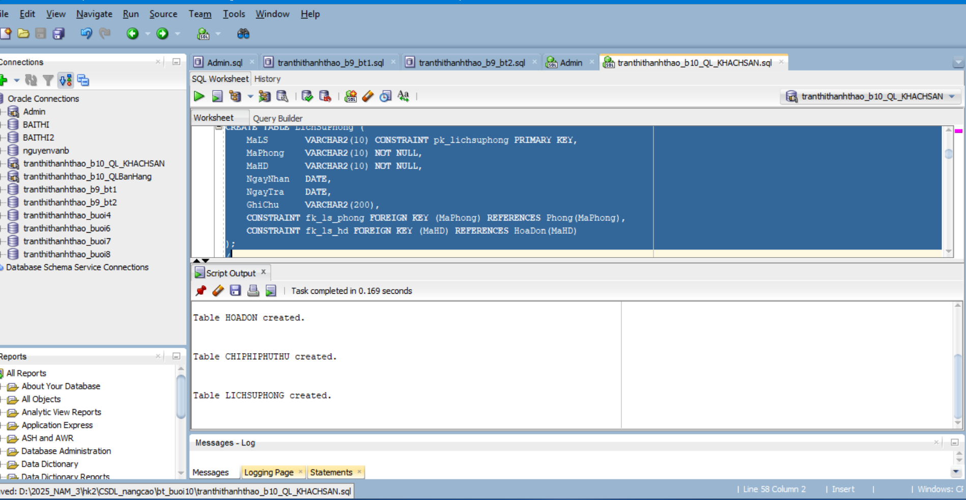
kiểm tra:
Insert dữ liệu
-----Insert 5 dữ liệu bảng Phong
INSERT INTO Phong VALUES ('P101', 'Don', 'TRONG', 80000, 450000, 2);
INSERT INTO Phong VALUES ('P102', 'Doi', 'TRONG', 120000, 650000, 4);
INSERT INTO Phong VALUES ('P103', 'VIP', 'TRONG', 200000, 1200000, 4);
INSERT INTO Phong VALUES ('P104', 'Gia dinh', 'BAO_TRI', 150000, 900000, 5);
INSERT INTO Phong VALUES ('P105', 'Don', 'TRONG', 90000, 500000, 2);
-----Insert 5 dữ liệu bảng KhachHang
INSERT INTO KhachHang VALUES ('KH01', 'Nguyen Thi Lan', '079123456789', '0902000001', 'lan@gmail.com', 'Viet Nam');
INSERT INTO KhachHang VALUES ('KH02', 'Tran Van Minh', '079123456780', '0902000002', 'minh@gmail.com', 'Viet Nam');
INSERT INTO KhachHang VALUES ('KH03', 'Le Hoang Nam', '079123456781', '0902000003', 'nam@gmail.com', 'Thai Lan');
INSERT INTO KhachHang VALUES ('KH04', 'Pham Thu Ha', '079123456782', '0902000004', 'ha@gmail.com', 'Han Quoc');
INSERT INTO KhachHang VALUES ('KH05', 'Do Quoc Bao', '079123456783', '0902000005', 'bao@gmail.com', 'Nhat Ban');
-----Insert 5 dữ liệu bảng HoaDon
INSERT INTO HoaDon VALUES ('HD0001', 'KH01', 'P101', DATE '2026-03-23', DATE '2026-03-24', 2, 450000, 'CHO_NHAN');
INSERT INTO HoaDon VALUES ('HD0002', 'KH02', 'P102', DATE '2026-03-23', DATE '2026-03-25', 3, 1300000, 'DANG_O');
INSERT INTO HoaDon VALUES ('HD0003', 'KH03', 'P103', DATE '2026-03-20', DATE '2026-03-22', 2, 2400000, 'DA_TRA');
INSERT INTO HoaDon VALUES ('HD0004', 'KH04', 'P105', DATE '2026-03-24', DATE '2026-03-26', 2, 1000000, 'HUY');
INSERT INTO HoaDon VALUES ('HD0005', 'KH05', 'P101', DATE '2026-03-27', DATE '2026-03-28', 1, 450000, 'CHO_NHAN');
-----Cập nhật trạng thái phòng tương ứng dữ liệu mẫu HoaDon
UPDATE Phong SET TrangThai = 'DA_THUE' WHERE MaPhong IN ('P101', 'P102');
-----Insert 5 dữ liệu bảng ChiPhiPhuThu
INSERT INTO ChiPhiPhuThu VALUES ('CP001', 'HD0001', 'Nuoc uong', 50000, DATE '2026-03-23');
INSERT INTO ChiPhiPhuThu VALUES ('CP002', 'HD0002', 'Giat ui', 70000, DATE '2026-03-24');
INSERT INTO ChiPhiPhuThu VALUES ('CP003', 'HD0002', 'An sang', 120000, DATE '2026-03-24');
INSERT INTO ChiPhiPhuThu VALUES ('CP004', 'HD0003', 'Hu hong vat dung', 300000, DATE '2026-03-21');
INSERT INTO ChiPhiPhuThu VALUES ('CP005', 'HD0004', 'Dat coc huy phong', 100000, DATE '2026-03-24');
-----Insert 5 dữ liệu bảng LichSuPhong
INSERT INTO LichSuPhong VALUES ('LS0001', 'P103', 'HD0003', DATE '2026-03-20', DATE '2026-03-22', 'Da tra phong dung han');
INSERT INTO LichSuPhong VALUES ('LS0002', 'P102', 'HD0002', DATE '2026-03-23', DATE '2026-03-25', 'Dang luu tru');
INSERT INTO LichSuPhong VALUES ('LS0003', 'P101', 'HD0001', DATE '2026-03-23', DATE '2026-03-24', 'Cho nhan phong');
INSERT INTO LichSuPhong VALUES ('LS0004', 'P105', 'HD0004', DATE '2026-03-24', DATE '2026-03-26', 'Hoa don huy');
INSERT INTO LichSuPhong VALUES ('LS0005', 'P101', 'HD0005', DATE '2026-03-27', DATE '2026-03-28', 'Dat truoc');
COMMIT;
Kết quả:
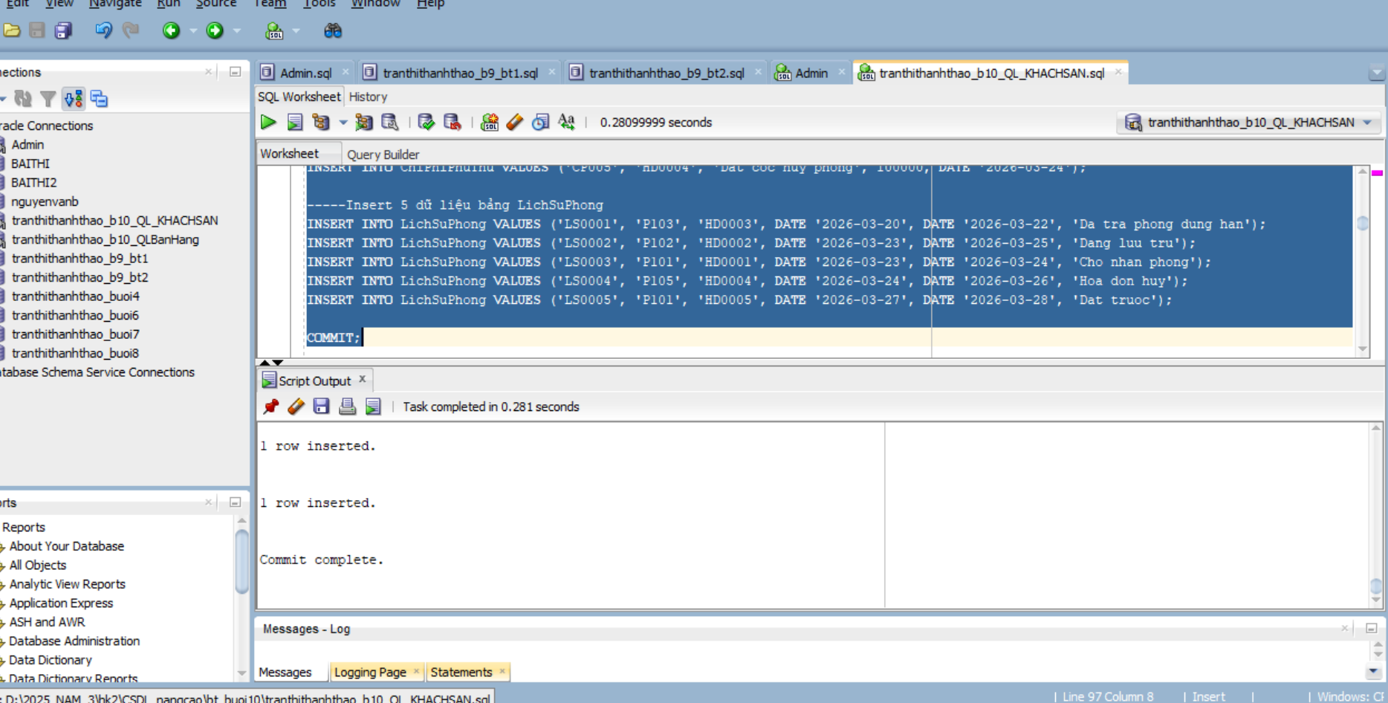
a. Trigger INSERT bảng HOADON – trg_DatPhong
CREATE OR REPLACE TRIGGER trg_DatPhong
BEFORE INSERT ON HoaDon
FOR EACH ROW
DECLARE
v_dem_kh NUMBER := 0;
v_dem_phong NUMBER := 0;
v_trang_thai Phong.TrangThai%TYPE;
v_gia_theo_ngay Phong.GiaTheoNgay%TYPE;
v_so_nguoi_max Phong.SoNguoiToiDa%TYPE;
v_so_ngay NUMBER := 0;
BEGIN
SELECT COUNT(*)
INTO v_dem_kh
FROM KhachHang
WHERE MaKH = :NEW.MaKH;
IF v_dem_kh = 0 THEN
RAISE_APPLICATION_ERROR(-20101, 'MaKH khong ton tai trong bang KhachHang');
END IF;
SELECT COUNT(*)
INTO v_dem_phong
FROM Phong
WHERE MaPhong = :NEW.MaPhong;
IF v_dem_phong = 0 THEN
RAISE_APPLICATION_ERROR(-20102, 'MaPhong khong ton tai trong bang Phong');
END IF;
SELECT TrangThai, GiaTheoNgay, SoNguoiToiDa
INTO v_trang_thai, v_gia_theo_ngay, v_so_nguoi_max
FROM Phong
WHERE MaPhong = :NEW.MaPhong
FOR UPDATE;
IF v_trang_thai <> 'TRONG' THEN
RAISE_APPLICATION_ERROR(-20103, 'Phong hien tai khong o trang thai TRONG');
END IF;
IF NVL(:NEW.SoNguoi, 0) <= 0 OR :NEW.SoNguoi > v_so_nguoi_max THEN
RAISE_APPLICATION_ERROR(-20104, 'SoNguoi khong hop le hoac vuot qua SoNguoiToiDa');
END IF;
IF :NEW.NgayNhan IS NULL OR :NEW.NgayTra IS NULL THEN
RAISE_APPLICATION_ERROR(-20105, 'NgayNhan va NgayTra khong duoc de trong');
END IF;
IF :NEW.NgayNhan < TRUNC(SYSDATE) OR :NEW.NgayNhan >= :NEW.NgayTra THEN
RAISE_APPLICATION_ERROR(-20106, 'NgayNhan phai >= ngay hien tai va nho hon NgayTra');
END IF;
v_so_ngay := :NEW.NgayTra - :NEW.NgayNhan;
:NEW.TongTien := v_so_ngay * v_gia_theo_ngay;
IF :NEW.TrangThai IS NULL THEN
:NEW.TrangThai := 'CHO_NHAN';
END IF;
UPDATE Phong
SET TrangThai = 'DA_THUE'
WHERE MaPhong = :NEW.MaPhong;
END trg_DatPhong;
/
kết quả: 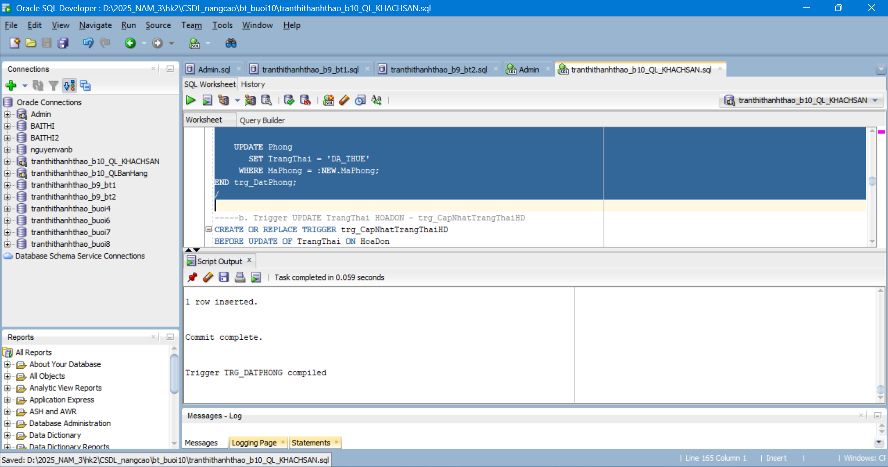
b. Trigger UPDATE TrangThai HOADON – trg_CapNhatTrangThaiHD
CREATE OR REPLACE TRIGGER trg_CapNhatTrangThaiHD
BEFORE UPDATE OF TrangThai ON HoaDon
FOR EACH ROW
BEGIN
IF :OLD.TrangThai = 'CHO_NHAN' THEN
IF :NEW.TrangThai NOT IN ('DANG_O', 'HUY') THEN
RAISE_APPLICATION_ERROR(-20111, 'CHO_NHAN chi duoc chuyen sang DANG_O hoac HUY');
END IF;
ELSIF :OLD.TrangThai = 'DANG_O' THEN
IF :NEW.TrangThai <> 'DA_TRA' THEN
RAISE_APPLICATION_ERROR(-20112, 'DANG_O chi duoc chuyen sang DA_TRA');
END IF;
ELSIF :OLD.TrangThai IN ('DA_TRA', 'HUY') THEN
RAISE_APPLICATION_ERROR(-20113, 'HoaDon da ket thuc khong duoc thay doi trang thai');
ELSE
RAISE_APPLICATION_ERROR(-20114, 'Trang thai cu khong hop le');
END IF;
END trg_CapNhatTrangThaiHD;
/
kết quả:
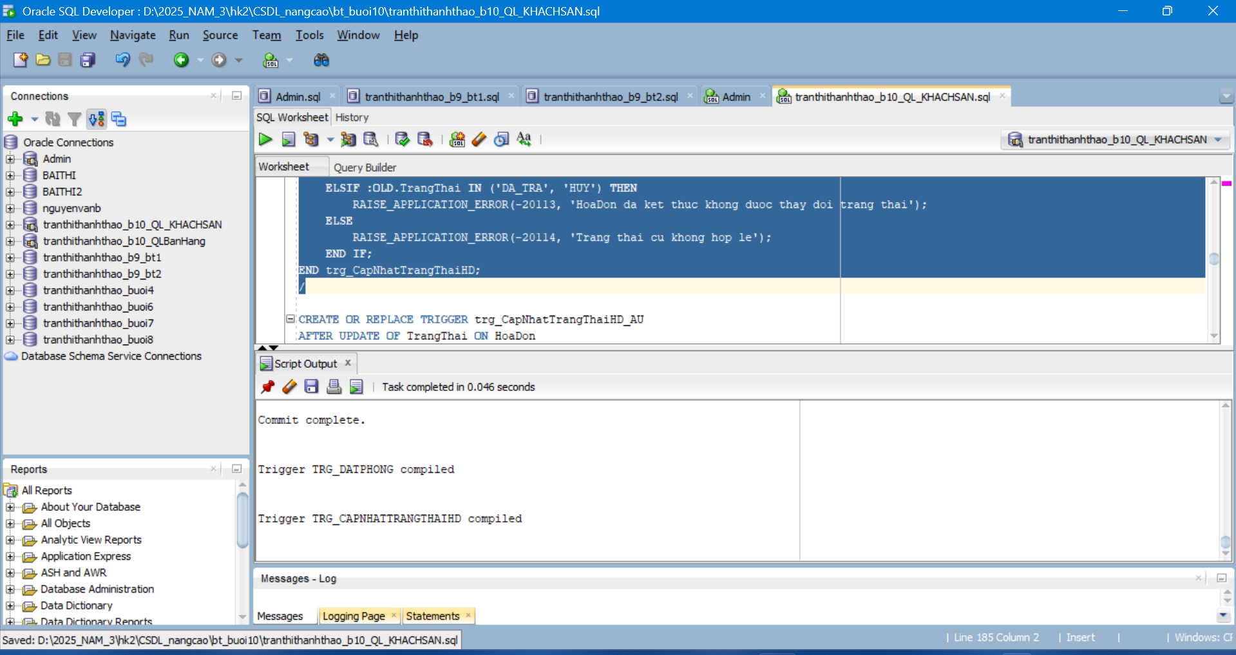
c. Compound Trigger UPDATE ChiPhiPhuThu – trg_SuaChiPhi
CREATE OR REPLACE TRIGGER trg_SuaChiPhi
FOR INSERT OR UPDATE ON ChiPhiPhuThu
COMPOUND TRIGGER
TYPE t_mahd_tab IS TABLE OF HoaDon.MaHD%TYPE INDEX BY PLS_INTEGER;
g_mahd_list t_mahd_tab;
g_row_count NUMBER := 0;
PROCEDURE add_mahd(p_mahd HoaDon.MaHD%TYPE) IS
v_found BOOLEAN := FALSE;
BEGIN
FOR i IN 1 .. g_mahd_list.COUNT LOOP
IF g_mahd_list(i) = p_mahd THEN
v_found := TRUE;
EXIT;
END IF;
END LOOP;
IF NOT v_found THEN
g_mahd_list(g_mahd_list.COUNT + 1) := p_mahd;
END IF;
END add_mahd;
BEFORE STATEMENT IS
BEGIN
g_row_count := 0;
g_mahd_list.DELETE;
END BEFORE STATEMENT;
BEFORE EACH ROW IS
BEGIN
g_row_count := g_row_count + 1;
IF g_row_count > 5 THEN
RAISE_APPLICATION_ERROR(-20121, 'Chi duoc INSERT/UPDATE toi da 5 chi phi trong 1 lenh');
END IF;
IF NVL(:NEW.SoTien, 0) <= 0 OR :NEW.SoTien >= 50000000 THEN
RAISE_APPLICATION_ERROR(-20122, 'SoTien phai > 0 va < 50000000');
END IF;
add_mahd(:NEW.MaHD);
IF UPDATING AND :OLD.MaHD <> :NEW.MaHD THEN
add_mahd(:OLD.MaHD);
END IF;
END BEFORE EACH ROW;
AFTER STATEMENT IS
v_tien_phong NUMBER := 0;
v_phu_thu NUMBER := 0;
BEGIN
FOR i IN 1 .. g_mahd_list.COUNT LOOP
SELECT (hd.NgayTra - hd.NgayNhan) * p.GiaTheoNgay,
NVL((SELECT SUM(cp.SoTien)
FROM ChiPhiPhuThu cp
WHERE cp.MaHD = hd.MaHD), 0)
INTO v_tien_phong, v_phu_thu
FROM HoaDon hd
JOIN Phong p ON p.MaPhong = hd.MaPhong
WHERE hd.MaHD = g_mahd_list(i);
UPDATE HoaDon
SET TongTien = v_tien_phong + v_phu_thu
WHERE MaHD = g_mahd_list(i);
END LOOP;
END AFTER STATEMENT;
END trg_SuaChiPhi;
Kết quả:
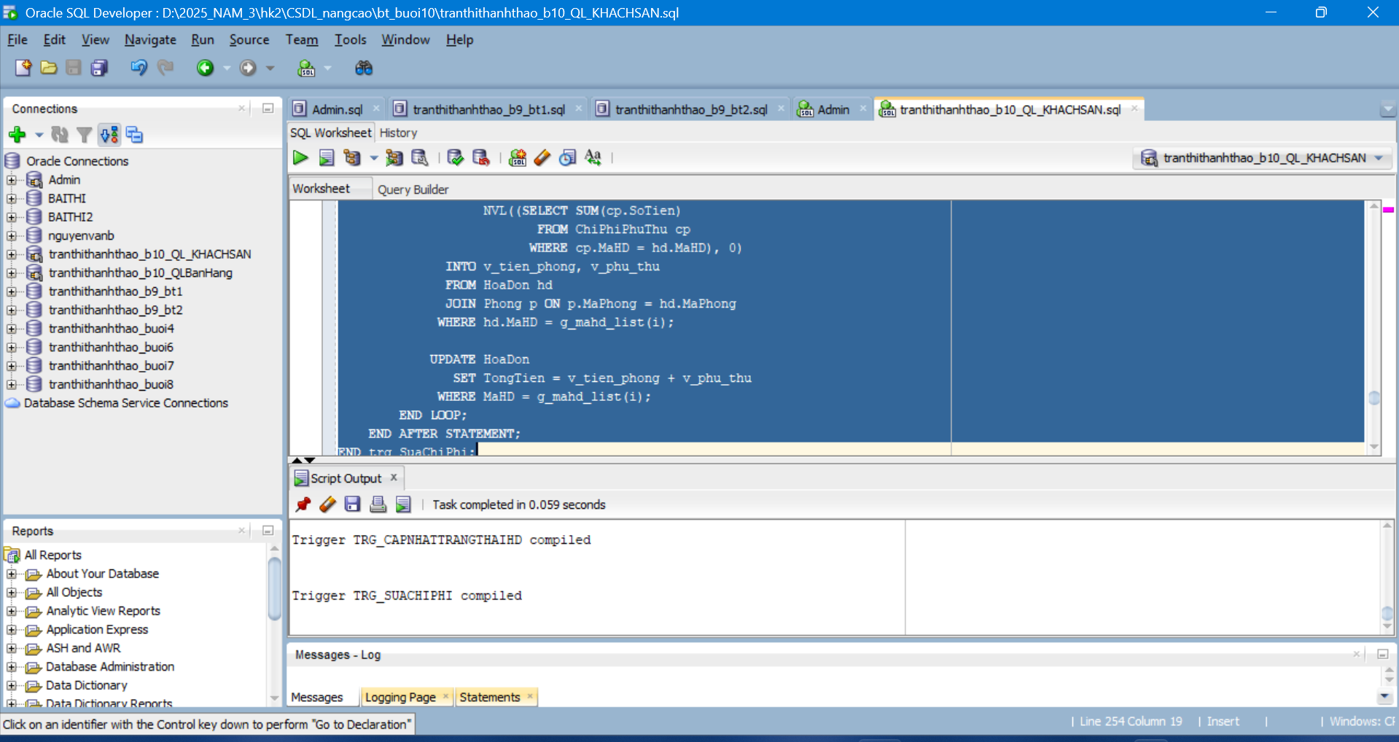
d. INSTEAD OF Trigger trên View – trg_vwPhongTrong_ins
Tạo View vw_PhongTrong
CREATE OR REPLACE VIEW vw_PhongTrong AS
SELECT MaPhong,
LoaiPhong,
TrangThai,
GiaTheoGio,
GiaTheoNgay,
SoNguoiToiDa
FROM Phong
WHERE TrangThai = 'TRONG';
/
Kết quả
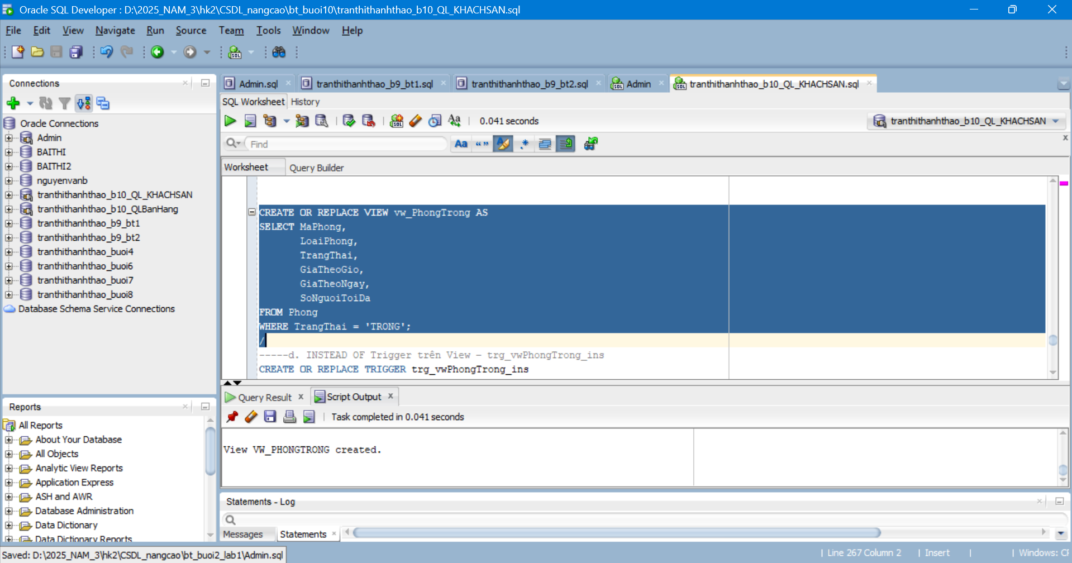
Tạo SEQUENCE SEQ_HD
CREATE SEQUENCE SEQ_HD
START WITH 1
INCREMENT BY 1
NOCACHE;
/
Kết quả:
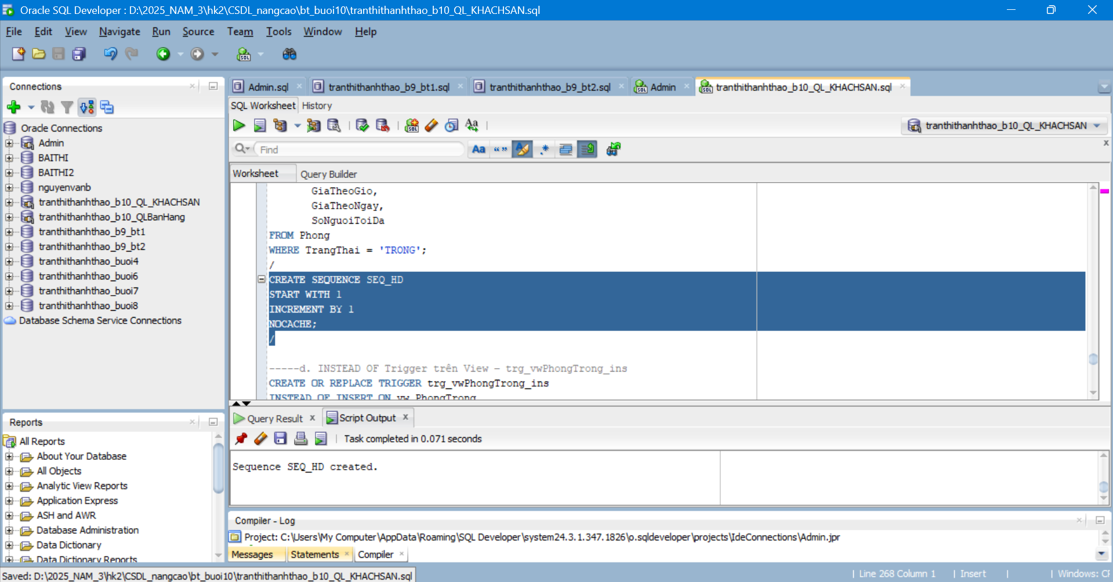
INSTEAD OF Trigger trên View – trg_vwPhongTrong_ins
CREATE OR REPLACE TRIGGER trg_vwPhongTrong_ins
INSTEAD OF INSERT ON vw_PhongTrong
FOR EACH ROW
DECLARE
v_ma_kh KhachHang.MaKH%TYPE;
v_ma_hd HoaDon.MaHD%TYPE;
BEGIN
SELECT MIN(MaKH)
INTO v_ma_kh
FROM KhachHang;

IF v_ma_kh IS NULL THEN
RAISE_APPLICATION_ERROR(-20131, 'Khong tim thay KhachHang de tao dat phong qua view');
END IF;

v_ma_hd := 'HD' || TO_CHAR(SEQ_HD.NEXTVAL, 'FM0000');

INSERT INTO HoaDon (
MaHD, MaKH, MaPhong, NgayNhan, NgayTra, SoNguoi, TongTien, TrangThai
)
VALUES (
v_ma_hd, v_ma_kh, :NEW.MaPhong, TRUNC(SYSDATE), TRUNC(SYSDATE) + 1, 1, NULL, 'CHO_NHAN'
);
END trg_vwPhongTrong_ins;
/
kết quả:
