DOCUMENT HISTORY AND INFORMATION

History of Amendments:
Date | Version | Modified Section | Summary of Change | Author
12/10/24 | 0.1 | ALL | Initial Draft | T.Linh

Distributed for Review
This document has been distributed for the following to review:
Name | Title & Company | Issue Date | Revision
Approvals
This document requires the following approvals:
Name | Signature | Title | Issue Date

Associated Documents
This document is associated with the following other documents:
Name | Title and Originator’s Reference | Source | Issue Date | Version

Table of contents

1 Introduction 3
2 Purpose 3
3 Scope 3
4 Definitions, Acronyms and Abbreviations 3
5 Overview 3
5.1 Use case diagram 3
5.2 Entity relationship diagram 4
6 Functionality Requirements 4
6.1 Choose Address 4
6.1.1 Select Existing Address 4
6.1.2 Add New Address 5
6.1.3 Edit Address 6
6.2 Choose Voucher 6
6.2.1 Select Shop Voucher 6
6.2.2 Select Shopee Voucher 7
6.3 Choose Shipping Method 8
6.4 Choose Payment Method 9
6.4.1 Cash on Delivery 9
6.4.2 Shopee Account Balance 9
6.4.3 ShopeePay Wallet 9
6.4.4 Credit/Debit Card 9
6.4.5 Google Pay 9
6.5 Review and Comfirm Order 10

Introduction
This feature allows users to purchase and pay for the products they have selected on the shopping cart page.

Purpose
This document details the functional (within Use Case documents) requirements and non-functional requirements related to the order placement proccess for users.

Scope
The scope of this document is for the Shopee Ecommecrce Site, this will include any interfaces that are required.

Definitions, Acronyms and Abbreviations
<TBD>

Overview

Use case diagram
The following use cases are required to be to be included in the Checkout

UC | Name | Description
UC001 | Checkout | Allowing users to confirm and complete their order

Entity relationship diagram
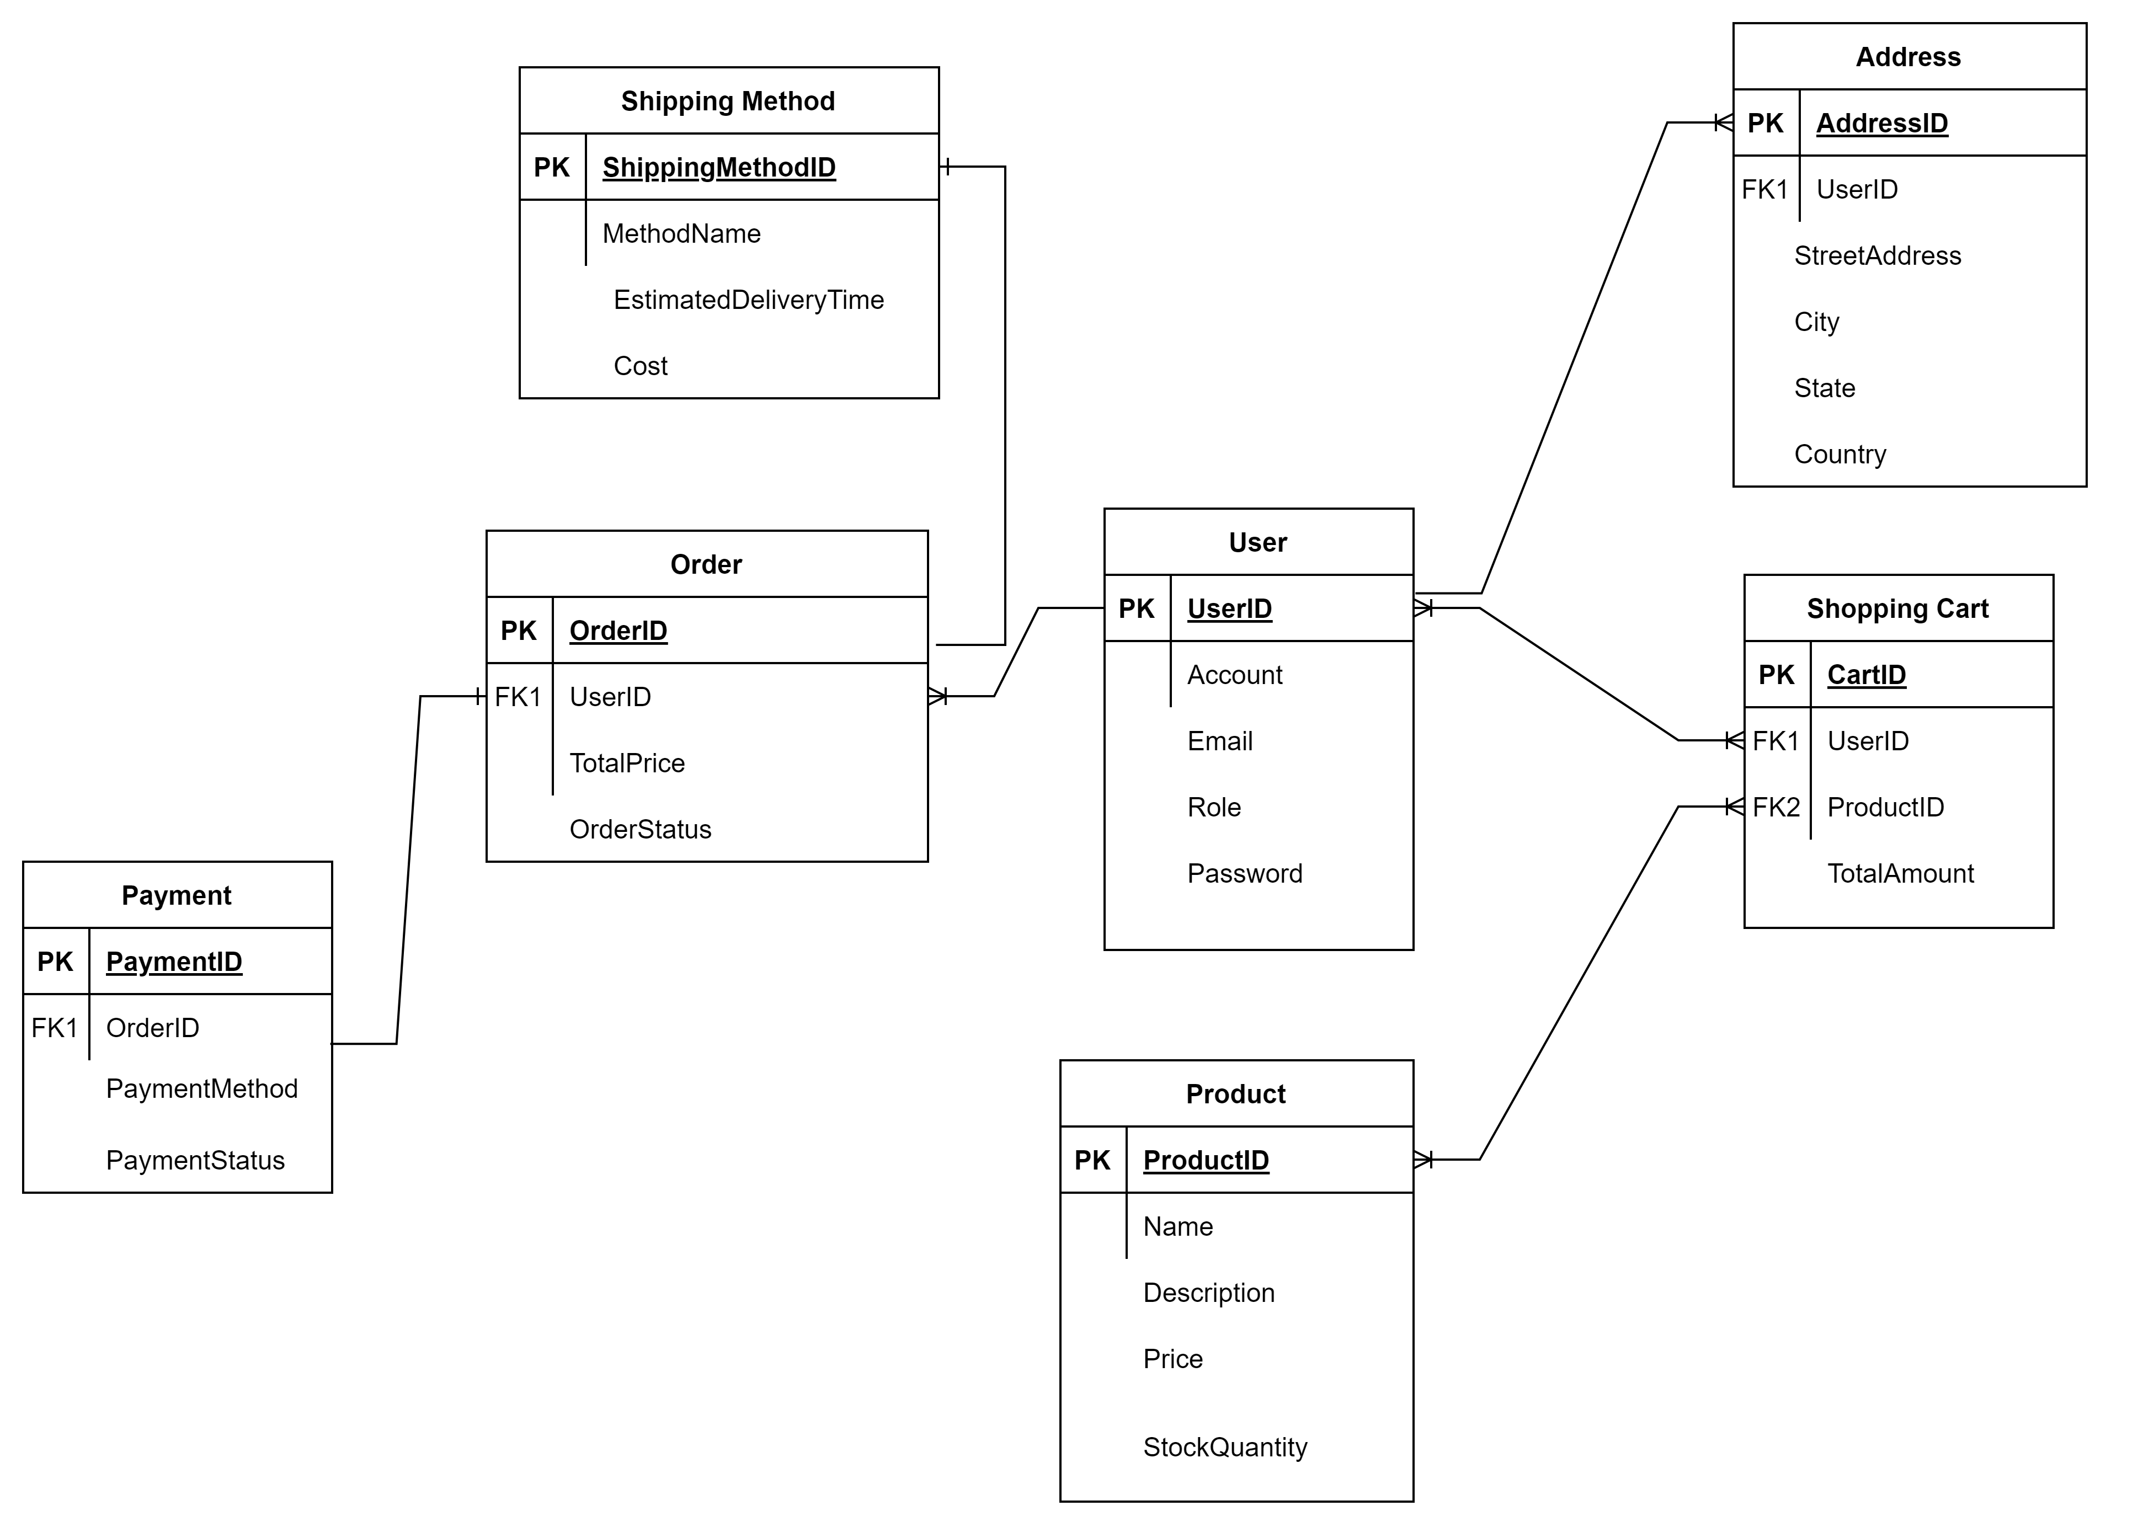

# | Entity | Description
1 | Product | List of all products available in the system
2 | Shopping Cart | List of products added to the shopping cart
3 | Order | Information about placed orders
4 | User | List of registered users in the system
5 | Address | Storing all contacts in the system
6 | Shipping Method | List of available shipping options
7 | Payment | Information related to payment transactions

Functionality Requirements

Choose Address
During the checkout process, users can select shipping address for their order. This feature allows for efficient order processing by ensuring accurate delivery information.

Select Existing Address
Users can choose from previously saved addresses.
- The system will display a list of saved addresses associated with the user’s account.
- Each address will include the recipient's name, street address, city/province.
- Users can select an address by clicking a radio button next to the desired address.

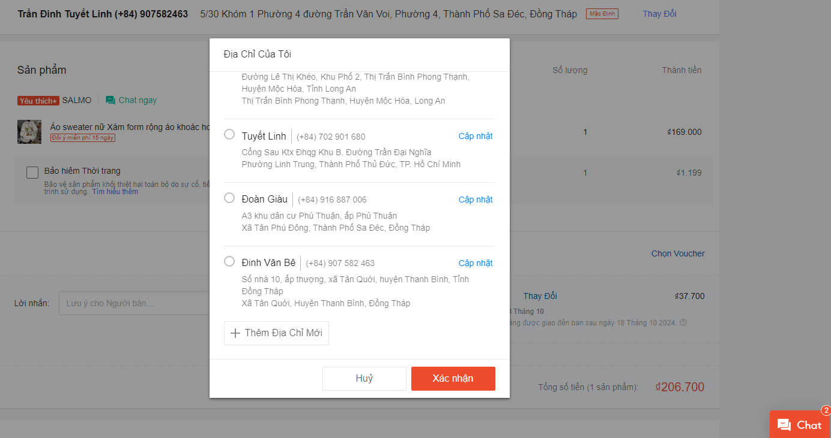

Add New Address
Users have the option to add a new shipping address if none of the existing addresses are suitable.
Users can click the "Add New Address" button, which will open a form with the following required fields:
- Full name (with constraint greater than 2 characters, maximum 64 characters)
- Phone number
- Provine/City
- Specific address (must select full province/city, district, ward before filling in address)
- Pin location
- Address type
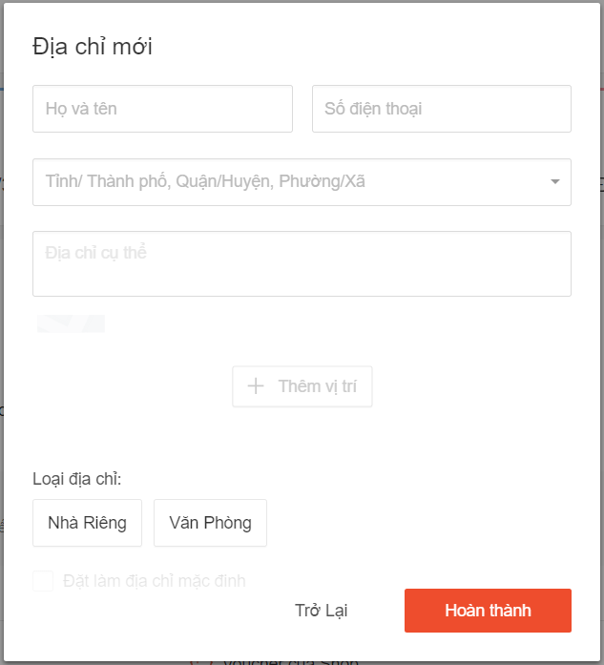

Edit Address
Users can click the “Update” button on the address they want to change. This will open a form pre-populated with the address information, allowing the user to update the fields.
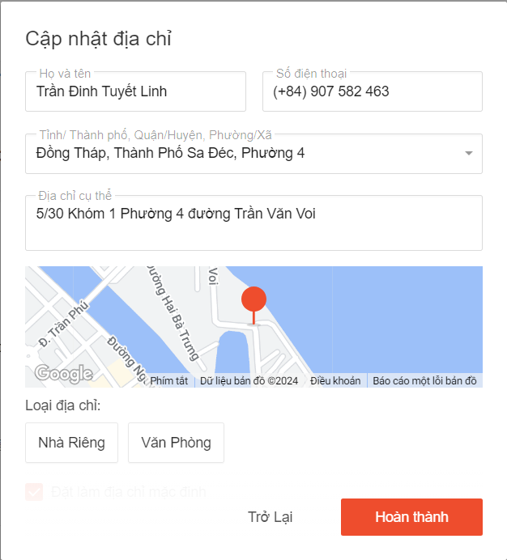

Choose Voucher

Select Shop Voucher
- Users can view and select available vouchers from the shop.
- The system will display a list of shop vouchers that the user is eligible to apply based on the items in their cart.
- Each voucher will display:
- Discount details (e.g., percentage off, fixed amount off)
- Minimum purchase requirement (if applicable)
- Expiry date
- Users can apply a voucher by clicking the "OK" button next to the desired voucher. The system will update the order total to reflect the applied discount.
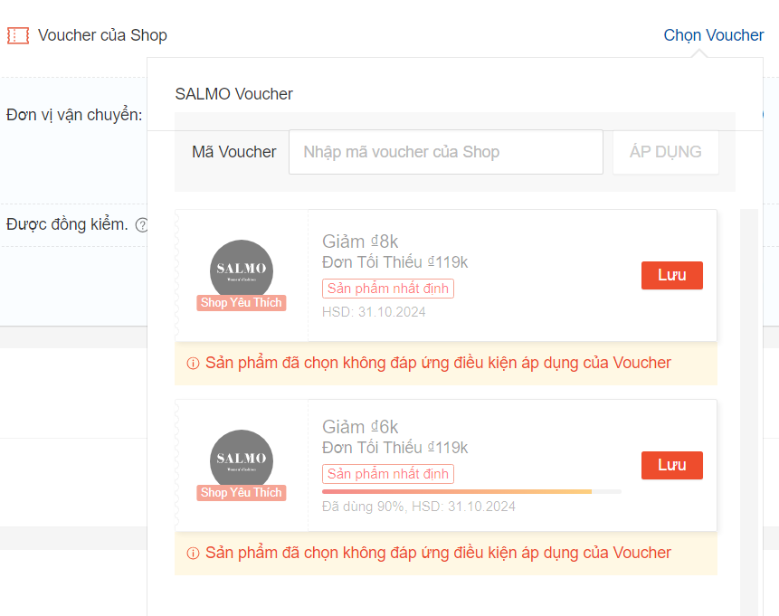

Select Shopee Voucher
- Users can also apply Shopee vouchers, which provide platform-wide discounts.
- The system will display a list of available Shopee vouchers based on the user's eligibility.
- Each Shopee voucher will display:
- Discount details (e.g., free shipping, percentage off, cashback)
- Minimum purchase requirement (if applicable)
- Expiry date
- Users can apply a Shopee voucher by clicking the "OK" button. The system will update the order total to reflect the applied discount.
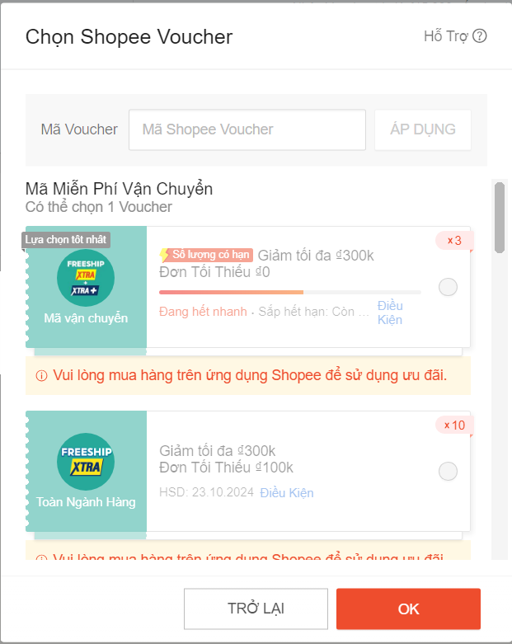

Choose Shipping Method
During checkout, users will be able to select a shipping method from the available options.
- The system will display a list of shipping methods based on the selected shipping address.
- Each shipping method will include the estimated delivery time and cost.
- Users can select a shipping method by clicking a radio button next to the desired option.
- The system will update the order total based on the selected shipping method.

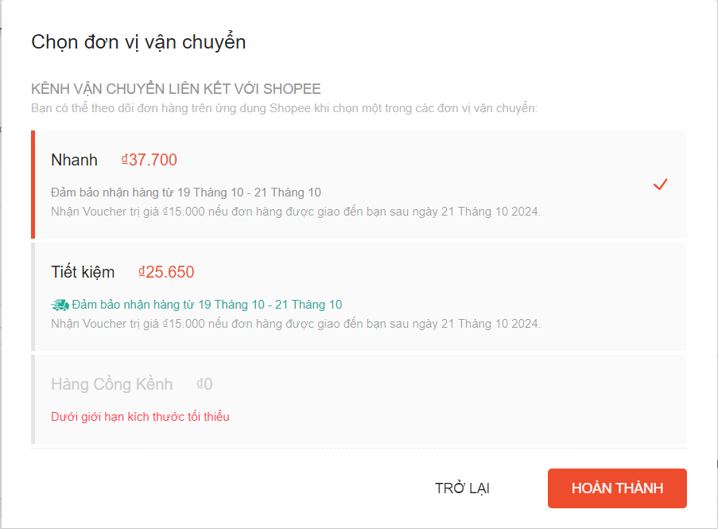

Choose Payment Method
Users will have multiple payment options available during the checkout process. The system will allow users to select one of the following payment methods:

Cash on Delivery
Users can pay for their order after receiving the item from the delivery personnel (shipper).

Shopee Account Balance
- Users can use their Shopee account balance to pay for the order.
- The system will verify if the account balance is sufficient to cover the total cost of the order.

ShopeePay Wallet
- Users can select ShopeePay to complete their payment using the ShopeePay digital wallet.
- If selected, the system will redirect users to the ShopeePay portal for authentication and payment.

Credit/Debit Card
- Users can pay using a credit or debit card.
- The following details are required for this payment method:
- Cardholder's name
- Card number
- Expiration date
- Security code
- The system will securely process the transaction through a payment gateway.

Google Pay
- Users can choose to pay via Google Pay, using their linked bank accounts or cards.
- The system will redirect users to the Google Pay interface for authentication and payment confirmation.
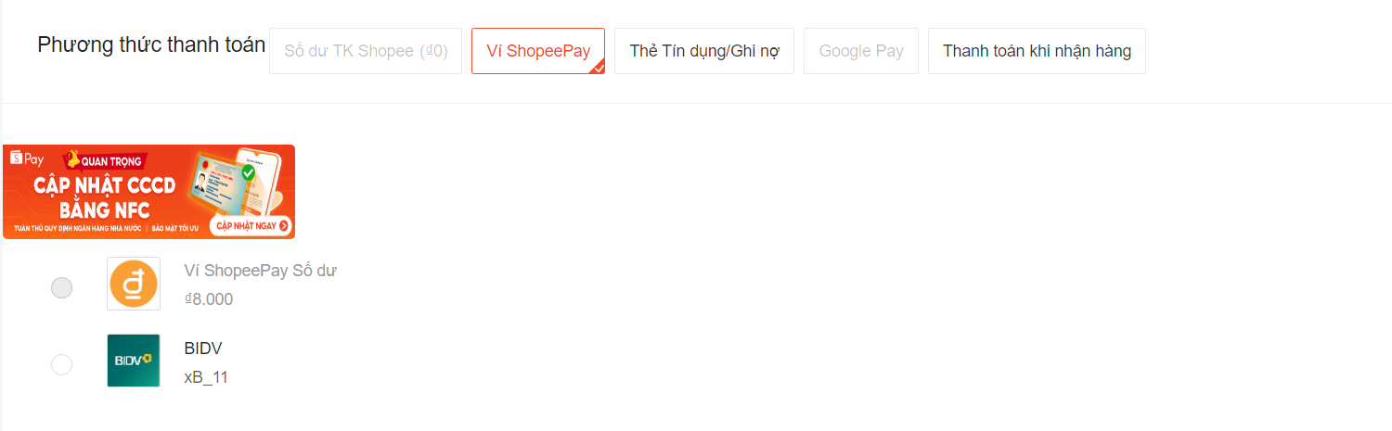

Review and Comfirm Order
After reviewing the shipping address, product details (name, type, and quantity), shipping method, payment method, and total price, users can proceed to complete their order.
- Order Review:
Before placing the order, users can verify:
  - Shipping address
  - Product details (name, type, and quantity)
  - Selected shipping method
  - Selected payment method
  - Total price (including shipping fees, taxes, and discounts)
- Place Order:
Once all details have been reviewed, users can click the "Place Order" button to finalize the purchase.
  - The system will process the payment and generate an order.
  - Users will receive a confirmation and can expect the order to be delivered based on the selected shipping method.
