DOCUMENT HISTORY AND INFORMATION

History of Amendments:
Date | Version | Modified Section | Summary of Change | Author
17/10/2024 | 0.1 | ALL | Initial | Ngoc Thao

Distributed for Review
This document has been distributed for the following to review:
Name | Title & Company | Issue Date | Revision
Approvals
This document requires the following approvals:
Name | Signature | Title | Issue Date

Associated Documents
This document is associated with the following other documents:
Name | Title and Originator’s Reference | Source | Issue Date | Version

Table of contents
1 Introduction 3
2 Purpose 3
3 Scope 3
4 Definitions, Acronyms and Abbreviations 3
5 Overview 3
5.1 Use case diagram 3
5.2 Entity relationship diagram 3
6 Functionality Requirements 3
6.1 User Order Management 3
7 Non-functional requirements 4
7.1 Performance 4
7.2 Scalability 4
7.3 Security 4
7.4 Portability 4
7.5 Audit 4
7.6 Error handling 5
7.7 Infrastructure 5
7.8 Look and feel 5
7.9 Legal 5
7.10 Training 5
7.11 User Documentation & Help Screen Requirements 5
7.12 Support & Supportability 5
7.13 Reliability 5
7.14 Design Constraints 5
7.15 Purchased Components 5
7.16 Interfaces 5
7.17 Test 5
7.18 Data 5

Introduction
We want to buy the product but don't have much time. So we need something that we can buy anything but without having to go too far. It's called an economic website called Shoppe

Purpose
This document details the functional (within Use Case documents) requirements and non-functional requirements for the Services Directory.

NB In early versions of this document many of the requirements are stated as <TBD>, this means To Be Detailed>. At the point of writing the version then this requirement needs further discussion /investigation or analysis before it can be documented.

Scope
The scope of this document is for the Shoppe website, this will include any interfaces that are required.

Definitions, Acronyms and Abbreviations
<TBD>

Overview

Use case diagram

Entity relationship diagram

Functionality Requirements

User Order Management
- The screen will display a list of all orders placed by the user, categorized by the order status
- To Pay: Displays orders that have been successfully placed but not yet prepaid. If the user makes a payment, the order will move directly to the To Ship status. Orders in this status are waiting for the seller's confirmation.
- To Ship: Displays orders that are being packed and prepared for shipment by the seller.
- To Receive: Displays orders that have been handed over to the delivery department and are in the process of being shipped to the user.
- Completed: Displays orders that the user has confirmed they have received successfully.
- Canceled: Displays orders that the user has canceled before moving to the To Receive status. If prepaid, the system will automatically refund the payment to the user's account.
- Returned/Refunded: Displays orders that encountered issues, such as being damaged or not meeting the order details. The user can request a return or refund.
- Processing flow
- When an order is successfully placed, the default status is To Pay
- After the payment is completed, the order will automatically move to the To Ship status.
- Once the order is handed over to the delivery service, the status changes to To Receive
- After the user confirms receipt of the order, the status updates to Completed
- If the user cancels the order before it is shipped, the status changes to Canceled
- In case of issues with the product, the user can request a return or refund, and the order status will change to Returned/Refunded
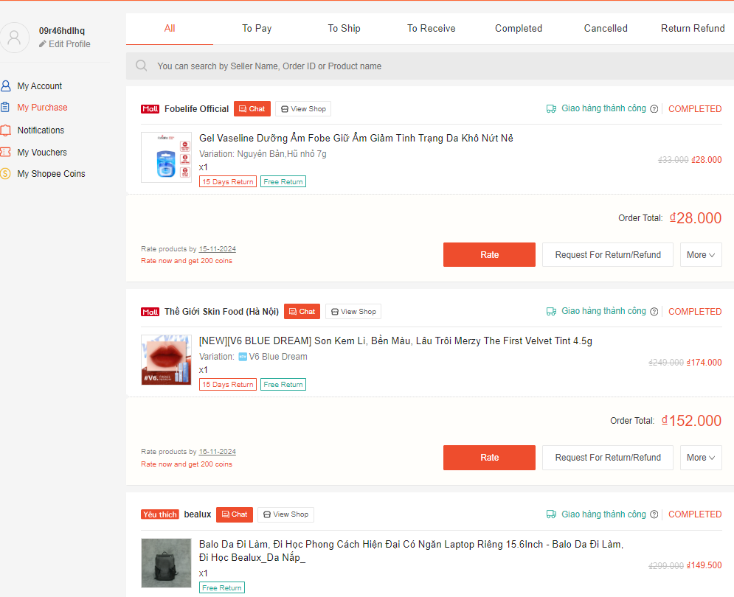

Non-functional requirements

Performance

Scalability

Security

Portability

Audit

Error handling

Infrastructure

Look and feel

Legal

Training

User Documentation & Help Screen Requirements

Support & Supportability

Reliability

Design Constraints

Purchased Components

Interfaces

Test

Data

