`PRACTICAL EXAMINATION 01
Subject code: FER202 – SU 2024
Duration: 85 minutes
You are required to create a patient management application that uses JSON Server, ReactJS, Hooks, and Bootstrap. Use the useReducer hook to manage the state instead of Redux. The application should include functionalities to add, edit, delete, and display a list of patients with routing using React Router, and implement lazy loading with suspense. Take these steps:
- Setup JSON Server (1 mark):
- Create a file named db.json to initialize a virtual server using JSON Server with the sample data below:
{
"patients": [
{
"id": "1",
"name": "Nguyễn Văn An",
"age": 30,
"gender": "Male",
"address": "Quảng Nam"
},
{
"id": "2",
"name": "Trần Thị Vân",
"age": 25,
"gender": "Female",
"address": "Thừa Thiên Huế"
},
{
"id": "3",
"name": "Hoàng Văn Thạch",
"age": 26,
"gender": "Male",
"address": "Thừa Thiên Huế"
},
{
"id": "c9ca",
"name": "Cao Thị Miên",
"age": "20",
"gender": "Female",
"address": "Đà Nẵng"
},
{
"id": "45df",
"name": "Nguyễn Thị Thập",
"age": "32",
"gender": "Female",
"address": "Quảng Nam"
}
]
}
- Create ReactJS Application. (1 mark)
- Initialize a new ReactJS project.
- Use functional components and React hooks (useState, useEffect, useReducer).
- Create Login Form. (1 mark)
- Create a login form with two input fields: Username and Password.
- Check login information: If the Username is "admin" and the Password is "admin", allow the user to log in successfully and continue to the Patient management form. Otherwise, show the message "Login failed".
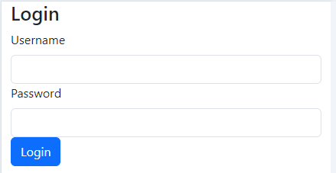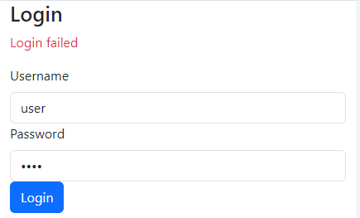
- Create Patient Management Form (4 marks):
- Show Patient List:
  - Retrieve the patient list from JSON Server and display the patient's name, age, gender, and address.
  - Show "Edit" and "Delete" buttons for each patient.
- Add New Patient:
  - Allow users to enter new patient details into the form.
  - When the user presses the "Add" button, add the new patient to the list and update JSON Server.
- Edit Patient:
  - When the user presses the "Edit" button on a patient, allow the user to edit the patient details in the form.
  - When the user presses the "Save" button, update the patient information and update JSON Server.
- Delete Patient:
  - When the user presses the "Delete" button on a patient, show a confirmation modal.
  - If the user confirms, remove the patient from the list and update JSON Server.
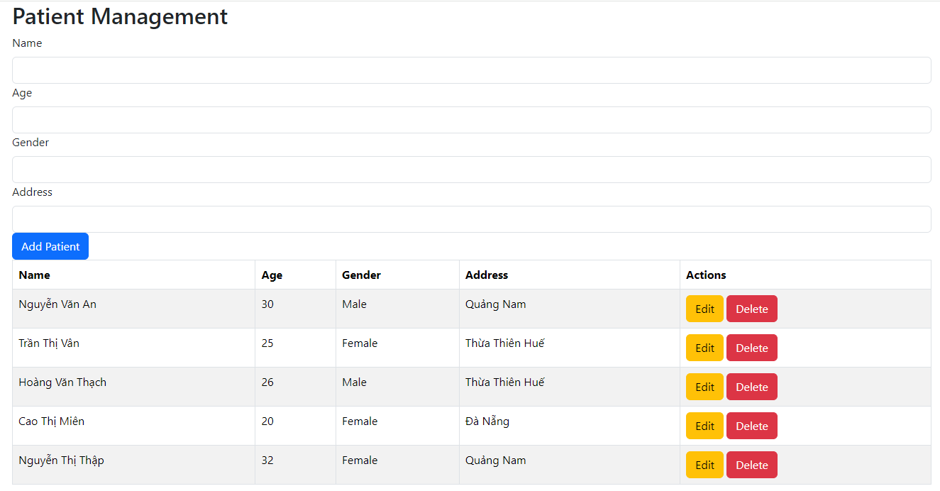
- Use Reducer Hook (1.5 mark):
- Use the useReducer hook to manage the state of the patient list instead of using Redux.
- User Interface (0.5 mark)
- Use Bootstrap to style the interface and make it responsive on mobile devices.
- Build a user-friendly and easy-to-use user interface.
- Routing (0.5 mark):
- Use React Router to navigate between the login form and the patient management form.
- Lazy Loading and Suspense (0.5 mark):
- Implement lazy loading for the components with a simulated delay using React.lazy and React.Suspense.
Note:
- You need to install and configure JSON Server correctly to fulfill the API requirements.
- If identical assignments are detected, the student's work will receive a score of zero.
- If the exercise is incorrect or doesn't produce the correct result, the student's work will receive a score of zero.
- Students are allowed to use resources on their computer, but only use the Internet to download the exam questions, submit their exams, and install via the Terminal.
- Supported URLs refer to the CSS Framework library:
  - https://getbootstrap.com/xxx
  - https://react-bootstrap.netlify.app/xxx
- During the file compression for submission, please exclude the node_modules folder.
The materials that the student must submit to the lsmdn system for marking include:
- FPTUniversity_FER202.zip

