HANOI UNIVERSITY OF SCIENCE AND TECHNOLOGY
SCHOOL OF ELECTRICAL AND ELECTRONIC ENGINEERING


ET3291E - Design project I
Building a Snake Game with Java Swing

Student: Bùi Thanh Thảo
Student ID: 20233876
Instructor: PhD. Vương Hoàng Nam

Hanoi, 06/2026.
Table of Contents

LIST OF FIGURES 4
INTRODUCTION 5
CHAPTER 1. PROJECT OVERVIEW 6
1.1 Problem Statement 6
1.2 Objectives and Scope 6
1.3 Technology Overview 6
CHAPTER 2. THEORETICAL BACKGROUND 6
2.1 Java Programming Language 6
2.2 Object-Oriented Programming (OOP) 6
a) Encapsulation 6
b) Inheritance 7
c) Interface and Polymorphism 7
d) Single Responsibility Principle 7
2.3 Java Swing Library 7
CHAPTER 3. REQUIREMENTS ANALYSIS 8
3.1 Problem Description 8
3.2 Functional Requirements 8
3.3 Non-Functional Requirements 9
CHAPTER 4. SYSTEM DESIGN 11
4.1 Overall Architecture 11
4.2 OOP Design 12
4.2.1 Encapsulation in ScoreManager 12
4.2.2 Interface Callback Pattern 13
4.2.3 CardLayout Navigation Pattern 13
4.3 System Activity Flow 13
CHAPTER 5. IMPLEMENTATION 14
5.1 Development Environment 14
5.2 GameMode Enum 14
5.3 ScoreManager Class 14
5.4 StartPanel Class 15
5.5 GameFrame Class 16
5.6 GamePanel Class 17
5.6.1 Snake Data Structure 17
5.6.2 Game Loop 17
5.6.3 Collision Detection by Mode 18
5.6.4 Random Wall Generation (WALL mode) 19
CHAPTER 6. TESTING AND RESULTS 21
6.1 Functional Testing 21
6.2 Result Evaluation 22
Strengths 22
Limitations 23
CHAPTER 7. CONCLUSION 24
7.1 Summary 24
7.2 Limitations 24
7.3 Future Development 25
REFERENCES 26

LIST OF FIGURES
Figure 4.1 System architecture of the Snake Game 13
Figure 5.1 Start Screen interface showing three game modes 17
Figure 5.2 Game board in CLASSIC mode during gameplay 19
Figure 5.3 WALL mode with randomly generated obstacles 20
Figure 5.4 Game Over screen displaying NEW RECORD badge 21
Figure 5.5 PAUSED overlay screen 21

INTRODUCTION
In the process of studying programming, building real applications plays an important role in reinforcing theoretical knowledge and developing problem-solving skills. Simple games provide an ideal environment for applying learned concepts in practice, especially in the areas of object-oriented programming and graphical user interface design.
The Snake game is one of the most well-known classic games, with simple rules that require quick reflexes and strategic thinking. Its use of array-based data structures, game loops, keyboard event handling, collision detection, and graphical rendering makes it a suitable topic to implement using Java and the Swing GUI library.
This project, "Building a Snake Game with Java Swing," aims to create a fully functional game application with a clean user interface and stable behavior. Beyond the core mechanics, the project extends to include three distinct game modes, a Start screen, pause functionality, dynamic speed scaling, and persistent high score storage.
Through this project, the author aims to strengthen skills in object-oriented design, Swing-based GUI development, and software architecture, while producing a complete and presentable deliverable for academic evaluation.

CHAPTER 1. PROJECT OVERVIEW

1.1 Problem Statement
Object-oriented programming (OOP) is the foundation of most modern software systems. However, mastering OOP through theory alone is often insufficient for students to deeply understand concepts such as encapsulation, inheritance, polymorphism, and system design. Building a complete application from scratch gives students a direct experience of the full software development cycle: analysis, design, implementation, and testing.
The Snake game was selected as the project topic because of its universal familiarity, straightforward rules, and sufficient technical complexity to demonstrate core programming concepts including data structures, game loops, event handling, collision detection, state management, and graphical rendering.

1.2 Objectives and Scope
The objectives of this project are to build a Snake game application running on the Java Desktop platform with the following requirements:
- Build a Snake game with a graphical user interface (GUI) using Java Swing.
- Allow the player to control the snake using arrow keys or WASD.
- Generate food randomly; increase snake length and score when food is eaten.
- Detect collisions with walls and the snake's own body.
- Display score and a Game Over screen with restart functionality.
- Extend with three game modes, pause support, speed scaling, and persistent high score storage.

The scope of implementation includes:
- A Snake game running on Windows with JDK 11 or later.
- Interface built exclusively with Java Swing; no external graphics libraries.
- Three game modes: CLASSIC (border kills), ENDLESS (wrap-around), and WALL (random obstacles).
- High score stored per game mode in a local file named highscore.txt.

1.3 Technology Overview
- Java SE (JDK 25): Primary programming language with full OOP support.
- Java Swing (javax.swing): Java's built-in GUI library for building desktop interfaces.
- java.awt: 2D graphics support (Graphics, Color, Font, FontMetrics).
- javax.swing.Timer: Thread-safe timer for driving the game loop at fixed intervals.
- java.io (BufferedReader, BufferedWriter): File I/O for reading and writing highscore.txt.
- java.util.Random: Generates random positions for food and wall segments.
- java.util.ArrayList: Stores wall tile coordinates in WALL mode.

CHAPTER 2. THEORETICAL BACKGROUND

2.1 Java Programming Language
Java is an object-oriented programming language developed by Sun Microsystems in 1995 and currently maintained by Oracle. Java achieves platform independence through the Java Virtual Machine (JVM): source code is compiled into bytecode (.class files), which the JVM then executes on any supported operating system.
Key Java features applied in this project include:
- Strong typing: Explicit type declarations reduce runtime errors.
- Garbage collection: Automatic memory management eliminates manual deallocation.
- Exception handling: try-catch blocks in ScoreManager handle file I/O errors gracefully.
- Enum types: The GameMode enum enforces type safety for the three game modes.
- Switch expressions: Used in Java 14+ for concise mode-based branching.

2.2 Object-Oriented Programming (OOP)
Object-oriented programming organizes code around objects rather than functions and logic alone. The four core principles of OOP are applied throughout the project as follows.

a) Encapsulation
Each class hides its internal data and exposes only a well-defined public interface. For example, ScoreManager fully encapsulates file I/O logic. GamePanel calls only getHighScore(mode) and saveIfBetter(mode, score) without knowing how data is stored on disk. Similarly, GamePanel encapsulates all game state (snake coordinates, food position, walls, flags) and exposes no direct field access to outside classes.

b) Inheritance
GamePanel extends JPanel to gain the ability to override paintComponent() for custom rendering. GameFrame extends JFrame to become the main application window. StartPanel also extends JPanel for the Start screen UI. This demonstrates how Java inheritance enables code reuse while allowing specialized behavior.

c) Interface and Polymorphism
GamePanel implements ActionListener so it can receive events from javax.swing.Timer directly. The inner interface GameStartListener, defined in StartPanel, declares a single method onGameStart(GameMode). GameFrame implements this interface, allowing StartPanel to notify the frame when the player clicks Play without creating a direct dependency between the two classes. This is a classic example of the callback pattern and loose coupling in OOP.

d) Single Responsibility Principle
Each class is responsible for exactly one concern: GamePanel handles game logic and rendering; ScoreManager handles persistent storage; StartPanel handles the mode selection UI; GameFrame handles screen navigation. This separation makes the codebase easier to read, test, and extend.

2.3 Java Swing Library
Swing is Java's built-in GUI toolkit, part of the Java Foundation Classes (JFC). It provides a rich set of components and allows full graphical customization by overriding paintComponent(Graphics g).
Swing components used in this project:
- JFrame: Top-level application window (GameFrame).
- JPanel: Drawable container with custom painting (GamePanel, StartPanel).
- JButton: Clickable buttons in the Start screen.
- JLabel: Text labels for mode descriptions and hints.
- GridBagLayout: Flexible layout manager used in StartPanel for centered vertical alignment.
- CardLayout: Container layout in GameFrame that switches between StartPanel and GamePanel.
- javax.swing.Timer: Fires ActionEvents on the EDT at fixed intervals, serving as the game loop.

A critical note: Swing is single-threaded. All UI operations must run on the Event Dispatch Thread (EDT). Using javax.swing.Timer instead of a raw Thread ensures that actionPerformed() is always called on the EDT, making it safe to update the game state and repaint the panel without synchronization overhead.

CHAPTER 3. REQUIREMENTS ANALYSIS

3.1 Problem Description
The Snake game is played on a 600 x 600 pixel board divided into a 24 x 24 grid of 25 x 25 pixel tiles. The player controls a snake that moves continuously in one direction. The snake grows longer each time it eats a food item (a red dot), and the score increases by 10 points per food eaten. The game ends when the snake collides with a wall (in CLASSIC mode) or with its own body.
This project extends the basic Snake game with three distinct game modes that alter collision behavior at the board boundary, a dynamic speed system that increases difficulty as the score rises, and a persistent high score system that records the best result per mode across sessions.

3.2 Functional Requirements
The functional requirements of the system are summarized in the table below.

No. | Feature | Description
1 | Start Screen | Displays game title, three mode buttons, Play button, and control hints
2 | Mode Selection | Three modes: CLASSIC (border kills), ENDLESS (wrap-around), WALL (obstacles)
3 | Snake Movement | Controlled via arrow keys or WASD; 180-degree reversal is blocked
4 | Game Loop | Timer fires every 150 ms; each tick moves the snake and redraws the board
5 | Food Generation | Random tile not overlapping the snake body or wall segments
6 | Eating Food | Snake grows by one tile, score increases by 10, speed adjusts
7 | Collision Detection | Wall collision (CLASSIC), self-collision (all modes), random wall (WALL)
8 | Score Display | Shows current Score, Best Score, and Level during gameplay
9 | Speed Scaling | Delay decreases by 10 ms every 50 points; minimum delay is 40 ms
10 | Pause | P or ESC toggles pause; semi-transparent overlay keeps board visible
11 | Game Over Screen | Shows score, record, level reached, and restart instructions
12 | High Score Storage | ScoreManager writes highscore.txt per mode; NEW RECORD badge on beat
13 | Restart | R key resets all state for a new game without reopening the window
14 | Return to Menu | M key stops the timer and returns to StartPanel at any time

3.3 Non-Functional Requirements
- Performance: Game loop runs stably at 150 ms per tick with no visible lag or stuttering.
- Usability: The interface is self-explanatory; no manual is needed to understand the controls.
- Extensibility: Clear class separation allows new features to be added without modifying existing logic.
- Reliability: ScoreManager handles file errors gracefully; no crash occurs on corrupt or missing files.
- Compatibility: Runs on Windows with JDK 11 or later using only the Java Standard Library.

CHAPTER 4. SYSTEM DESIGN

4.1 Overall Architecture
The system is designed using an object-oriented approach and divided into six classes, each with a clearly defined responsibility.

Class | Responsibility | Extends / Implements
Main | Entry point; starts the application on the EDT | N/A
GameFrame | Main window; manages screen navigation | JFrame, GameStartListener
GameMode | Defines the three game modes as constants | Enum
StartPanel | Start screen UI; mode selection and Play button | JPanel
ScoreManager | Reads and writes high scores to highscore.txt | N/A
GamePanel | Game logic, rendering, input handling, and state | JPanel, ActionListener

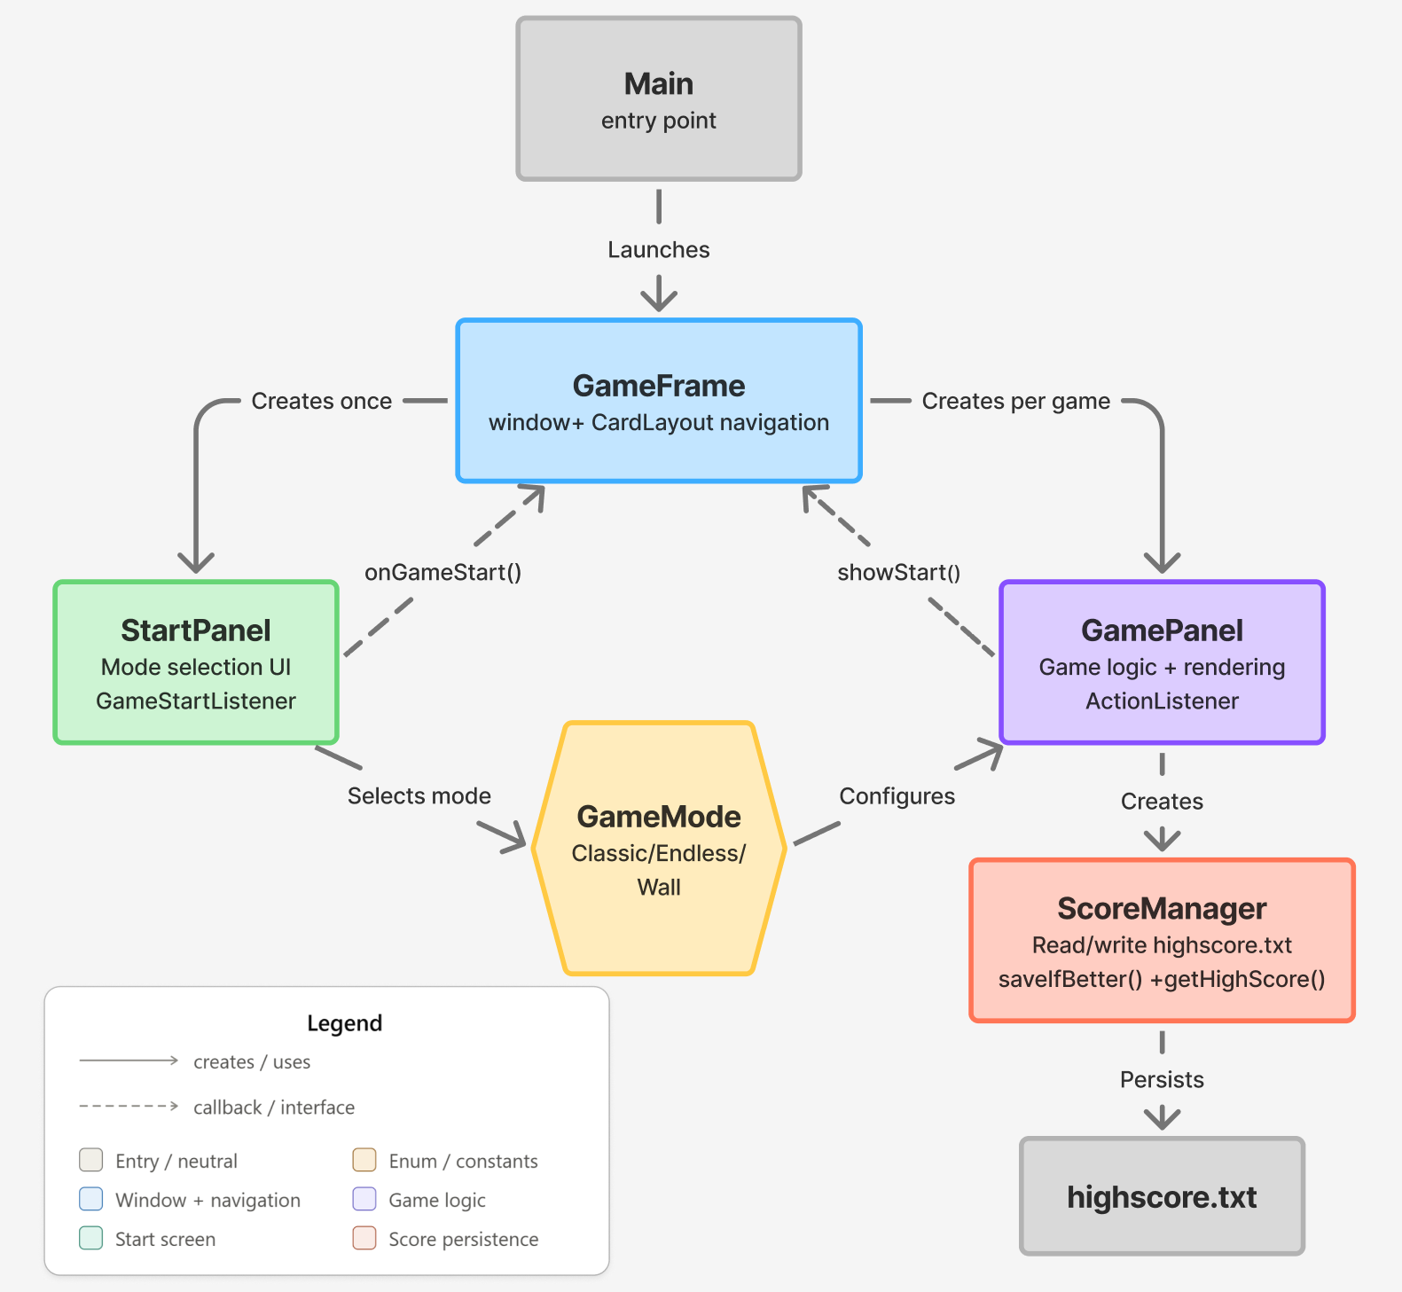
Figure 4.1 System architecture of the Snake Game
The dependency flow between classes is as follows: Main creates GameFrame. GameFrame holds StartPanel and GamePanel through a CardLayout container. StartPanel notifies GameFrame via the GameStartListener interface. GamePanel uses ScoreManager to persist scores and holds a reference to GameFrame for screen navigation.

4.2 OOP Design

4.2.1 Encapsulation in ScoreManager
ScoreManager stores high scores in a HashMap with GameMode as the key and Integer as the value. It exposes three public methods: getHighScore(GameMode), saveIfBetter(GameMode, int), and the constructor which loads the file. GamePanel interacts only through these methods and is completely unaware of the file path, format, or parsing logic.

4.2.2 Interface Callback Pattern
StartPanel declares a nested interface GameStartListener with one method: onGameStart(GameMode mode). GameFrame implements this interface. When the player clicks Play, StartPanel calls listener.onGameStart(selectedMode). StartPanel does not hold any reference to GameFrame directly; it only knows the listener interface. This achieves loose coupling between the two screens.

4.2.3 CardLayout Navigation Pattern
GameFrame wraps both screens inside a single JPanel using CardLayout. Each time the player starts a new game, a fresh GamePanel instance is created with the selected mode and added to the container. This guarantees complete state reset and avoids bugs from leftover state carried between game sessions.

4.3 System Activity Flow
The complete activity flow of the application proceeds as follows:
- Main.main() calls SwingUtilities.invokeLater() to create GameFrame on the EDT.
- GameFrame displays StartPanel (card "start") by default.
- The player selects a mode and clicks PLAY; StartPanel fires listener.onGameStart(mode).
- GameFrame creates a new GamePanel with the selected mode and switches to card "game".
- GamePanel.startGame() calls initSnake(), then generateWalls() if mode is WALL, then spawnFood(), then Timer.start().
- Every 150 ms, the Timer fires actionPerformed(). If isRunning and not isPaused, move() is called followed by repaint().
- move() shifts body segments, updates the head, calls checkFood(), then calls checkCollision().
- On game over, triggerGameOver() calls ScoreManager.saveIfBetter() and repaints the Game Over overlay.
- Pressing R calls startGame() for a new round. Pressing M stops the timer and calls GameFrame.showStart().

CHAPTER 5. IMPLEMENTATION

5.1 Development Environment
- Language: Java SE (JDK 25.0.2)
- IDE: VS Code with Extension Pack for Java / IntelliJ IDEA Community Edition
- Operating System: Windows 10 / Windows 11
- Libraries: Java Standard Library only (no external dependencies)
- Build: Direct javac compilation from the command line; no build tool required

Compile and run commands:
javac Main.java GameFrame.java GameMode.java StartPanel.java ScoreManager.java GamePanel.java
java Main

5.2 GameMode Enum
GameMode is an enum that defines the three game modes as named constants. Using an enum instead of integer or string constants provides compiler-checked exhaustiveness in switch expressions: if a new mode is added but a switch block does not handle it, the compiler raises an error. This prevents silent bugs from missing cases.
public enum GameMode {
CLASSIC, // Border is active; hitting the wall ends the game
ENDLESS, // No border; the snake wraps to the opposite side
WALL // No border; random wall segments kill on contact
}

5.3 ScoreManager Class
ScoreManager manages high scores keyed by GameMode and persists them in a plain-text file named highscore.txt located in the working directory. The file uses a simple key-value format:
CLASSIC=120
ENDLESS=200
WALL=80

The constructor calls load() immediately to populate the internal HashMap. load() opens the file with BufferedReader, splits each line on the "=" character, converts the mode string using GameMode.valueOf(), and parses the score with Integer.parseInt(). If the file does not exist (first run) or any line is malformed, the exception is caught silently and the default value of 0 is kept. This ensures the application never crashes due to a missing or corrupt file.
saveIfBetter(GameMode, int) compares the new score against the stored value before writing. If the new score is higher, the map is updated and saveToFile() overwrites the entire file using BufferedWriter. The method returns a boolean indicating whether a new record was set, which GamePanel uses to display the NEW RECORD badge.

5.4 StartPanel Class
StartPanel extends JPanel and uses GridBagLayout to vertically center all UI components. The layout contains: a large green "SNAKE" title label, a subtitle, three mode selection buttons, a dynamic description label, a Play button, and a control hint at the bottom.
A key technical detail is the prevention of button size changes when the border color is swapped on selection. The solution requires calling setPreferredSize(), setMinimumSize(), and setMaximumSize() with the same Dimension object (440 x 54 pixels) on every button, and setting GridBagConstraints.fill to NONE so GridBagLayout does not stretch the component. Additionally, RoundedBorder overrides getBorderInsets() to always return a fixed Insets value regardless of the border color, preventing any layout recalculation when selection state changes.
RoundedBorder is an inner class that extends AbstractBorder. Its paintBorder() method draws a rounded rectangle using Graphics2D.drawRoundRect() with antialiasing enabled for smooth edges. When a mode is selected, the button's background changes to dark green and the border color changes to bright green; all other buttons revert to the default gray style.
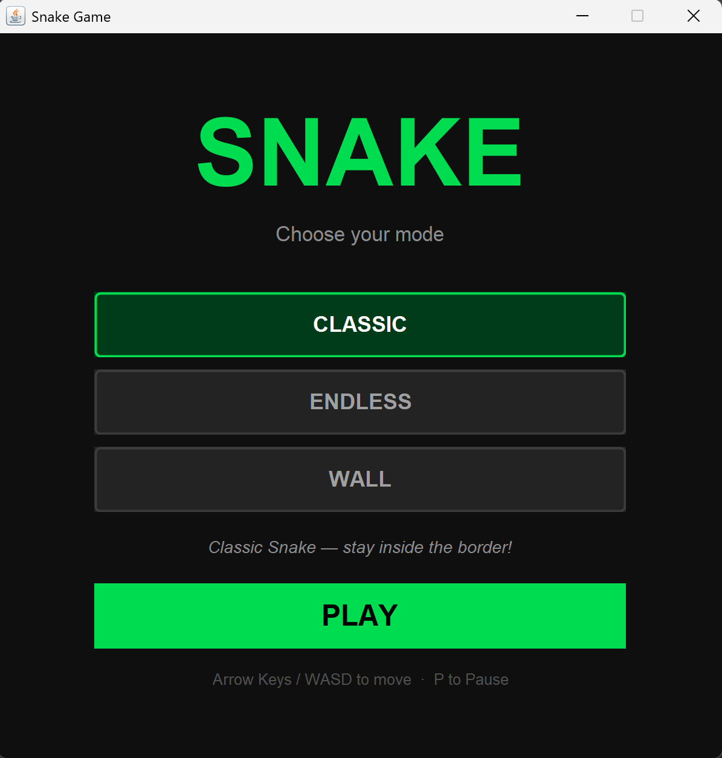
Figure 5.1 Start Screen interface showing three game modes

5.5 GameFrame Class
GameFrame extends JFrame and implements GameStartListener. The constructor creates a CardLayout container, adds StartPanel as card "start", and calls showStart() to display the Start screen. GamePanel is not created in the constructor; it is instantiated only when the player clicks Play, ensuring the mode is known before construction.
showGame(GameMode) removes any existing GamePanel from the container (to free resources and avoid duplicate Timer instances), creates a new GamePanel with the chosen mode, adds it as card "game", and switches the CardLayout. showStart() reverses this by switching back to card "start" and returning focus to StartPanel for keyboard input.

5.6 GamePanel Class
GamePanel is the central class of the application. It extends JPanel, implements ActionListener, and contains all game state, rendering logic, and input handling. The key constants that define the game board are:
TILE_SIZE = 25 px GRID_WIDTH = 24 GRID_HEIGHT = 24
INITIAL_DELAY = 150 ms MIN_DELAY = 40 ms SPEED_STEP = 10 ms SCORE_PER_LEVEL = 50
WALL_COUNT = 8 WALL_MIN_LEN = 3 WALL_MAX_LEN = 5 SAFE_ZONE: tiles (8,8) to (16,16)

5.6.1 Snake Data Structure
The snake is represented by two parallel integer arrays, snakeX[] and snakeY[], each of size MAX_TILES = 576 (24 x 24). Index 0 is always the head. An integer snakeLength tracks how many tiles are currently alive. This approach avoids object creation per frame (unlike ArrayList<Point>) and enables O(1) access to any tile by index.
The movement algorithm per tick proceeds in two steps: first, shift all body segments backward from the tail toward index 1 (for i = snakeLength - 1 down to 1: pos[i] = pos[i-1]); second, update pos[0] according to the current direction. The backward iteration is essential to avoid overwriting a position before it has been copied to the next index. When food is eaten, snakeLength is simply incremented: the tile previously at index snakeLength becomes active without any new allocation.

5.6.2 Game Loop
The game loop is implemented with javax.swing.Timer. The constructor creates a Timer with INITIAL_DELAY as the interval and "this" (GamePanel) as the ActionListener. Every tick, actionPerformed() checks isRunning && !isPaused before calling move() and repaint(). This means the Timer continues to run even during pause or Game Over, but has no effect until the flags are cleared. This avoids the complexity of stopping and restarting the Timer for every state transition.
Dynamic speed is computed as: newDelay = max(INITIAL_DELAY - (score / SCORE_PER_LEVEL) * SPEED_STEP, MIN_DELAY). adjustSpeed() calls gameTimer.getDelay() and only applies setDelay() and restart() when the value actually changes, avoiding unnecessary Timer resets on every food pick-up.
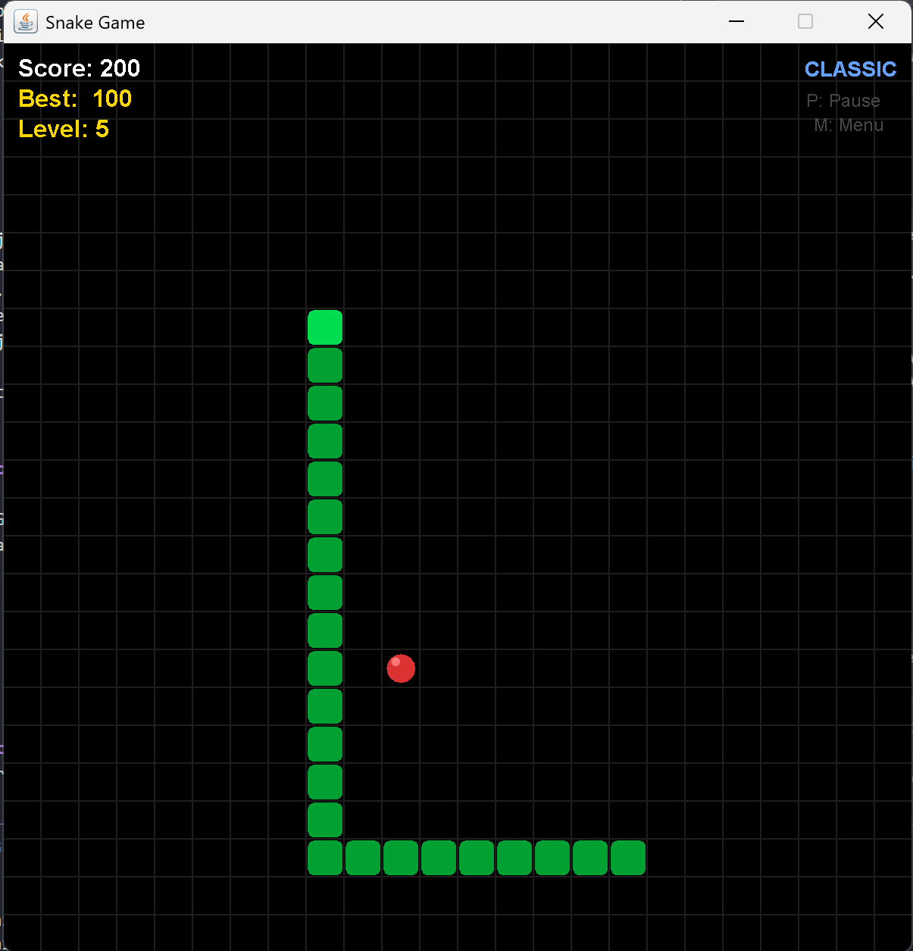
Figure 5.2 Game board in CLASSIC mode during gameplay

5.6.3 Collision Detection by Mode
checkCollision() branches on the current GameMode after each move:
  - CLASSIC: hitBorder() checks whether snakeX[0] or snakeY[0] is out of the [0, GRID_WIDTH) or [0, GRID_HEIGHT) range. If true, triggerGameOver() is called.
  - ENDLESS: wrapAround() maps out-of-bound coordinates back to the opposite side: x = -1 becomes x = GRID_WIDTH - 1; x = GRID_WIDTH becomes x = 0; and similarly for Y. The snake never dies from the border.
  - WALL: wrapAround() handles the border first, then hitWall() iterates the walls ArrayList to check whether snakeX[0] and snakeY[0] match any wall tile. If true, triggerGameOver() is called.
Self-collision is checked last and applies to all three modes: a loop from i = 1 to snakeLength - 1 compares each body tile to the head position. Starting at index 1 is critical; checking index 0 would always match the head against itself.

5.6.4 Random Wall Generation (WALL mode)
generateWalls() creates WALL_COUNT = 8 wall segments. For each segment, a random direction (horizontal or vertical), a random length between WALL_MIN_LEN and WALL_MAX_LEN, and a random origin point are chosen. The origin is clamped so the entire segment stays within the board. Each tile of the proposed segment is then checked against two conditions: it must not fall inside the safe zone (tiles 8 to 16 in both X and Y) and it must not overlap any already-placed wall tile. If a conflict is found, the entire attempt is discarded and a new one is tried. A maximum of 200 total attempts prevents an infinite loop if the board becomes too crowded.
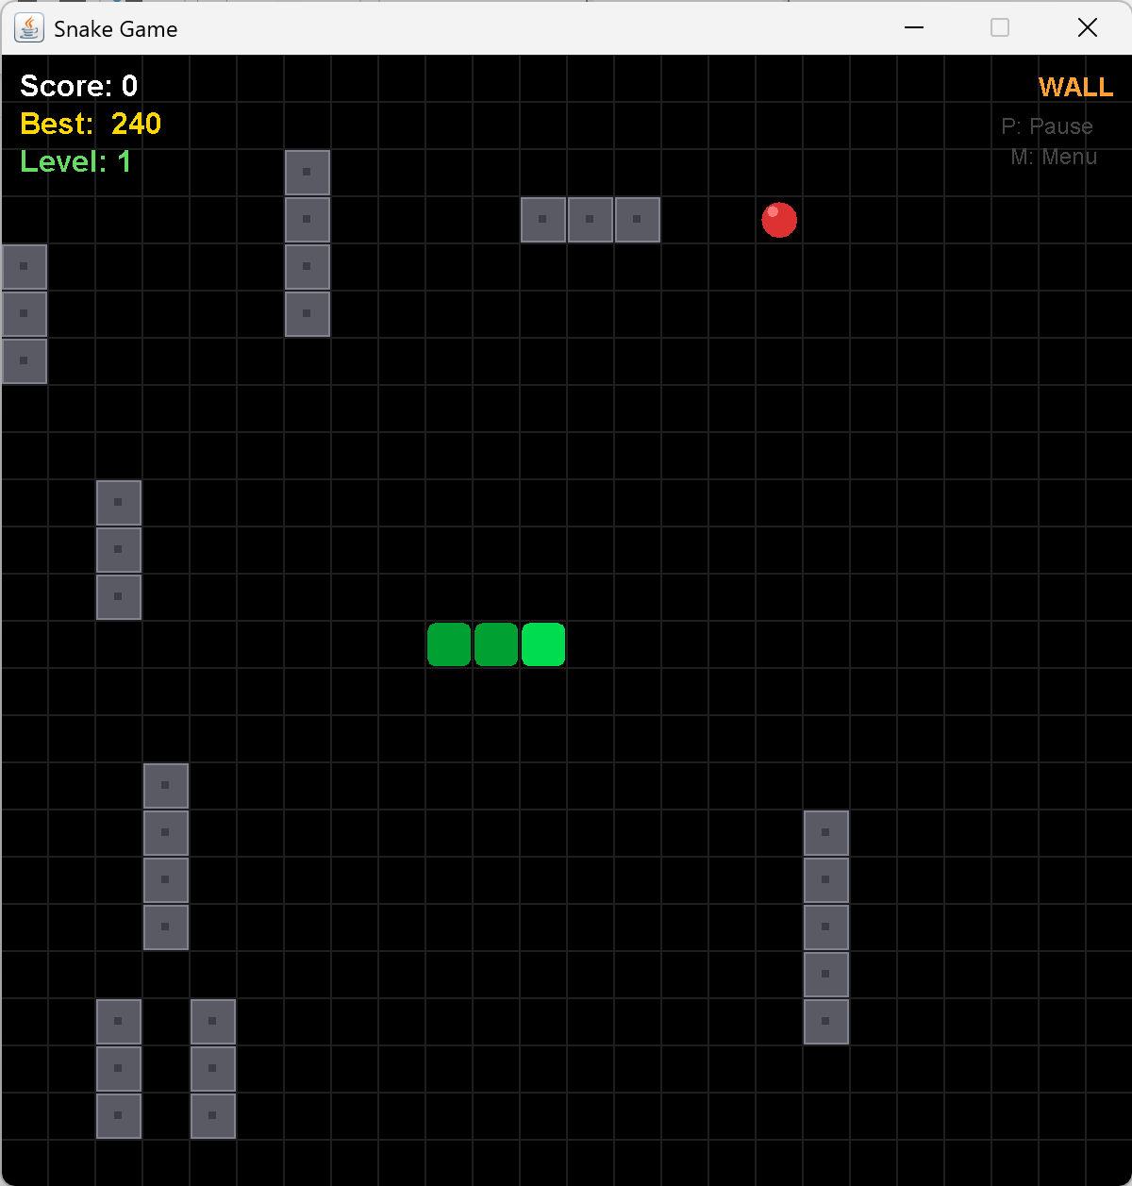
Figure 5.3 WALL mode with randomly generated obstacles
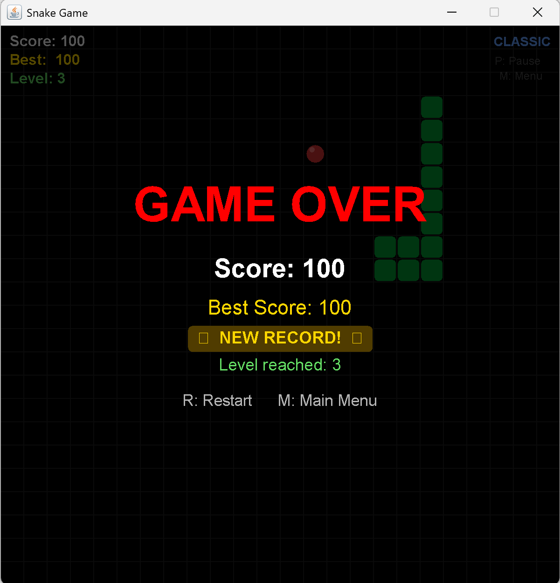
Figure 5.4 Game Over screen displaying NEW RECORD badge
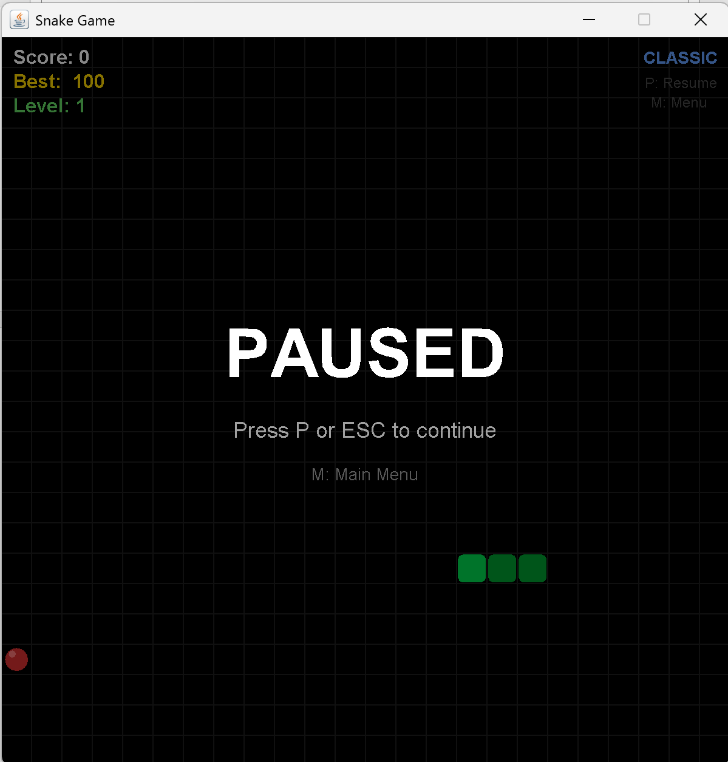
Figure 5.5 PAUSED overlay screen

CHAPTER 6. TESTING AND RESULTS

6.1 Functional Testing
All functional requirements were tested manually against defined test cases. The purpose of testing was to confirm that each feature behaves as specified, identify and resolve defects during development, and validate the stability of the game under continuous play.

No. | Feature Under Test | Test Scenario | Expected Result | Outcome
1 | Start Screen | Launch application | Three mode buttons visible; CLASSIC highlighted by default | PASS
2 | Mode selection | Click each button | Selected button highlights; description label updates | PASS
3 | Game loop start | Click PLAY | Snake moves right automatically every 150 ms | PASS
4 | Direction control | Press arrow keys and WASD | Snake changes direction; 180-degree reversal blocked | PASS
5 | Food consumption | Steer snake onto food tile | Snake grows by one, score increases by 10, new food appears | PASS
6 | Speed scaling | Reach 50, 100, 150 points | Delay decreases 10 ms per 50 pts; Level indicator updates | PASS
7 | Wall collision CLASSIC | Steer snake into border | Game Over triggered immediately | PASS
8 | Wrap-around ENDLESS | Steer snake past any edge | Snake reappears on the opposite side | PASS
9 | WALL obstacle hit | Steer snake into a gray wall tile | Game Over triggered | PASS
10 | Self-collision | Steer snake into its own body | Game Over triggered | PASS
11 | Pause | Press P or ESC during play | Snake stops; PAUSED overlay appears; board still visible | PASS
12 | Resume from pause | Press P or ESC while paused | Game resumes at the same speed and position | PASS
13 | High score persistence | Beat record, close, reopen | highscore.txt updated; record visible on next session | PASS
14 | NEW RECORD badge | Achieve a new best score | Golden badge appears on Game Over screen | PASS
15 | Restart | Press R after Game Over | All state resets; WALL mode regenerates new wall layout | PASS
16 | Return to menu | Press M at any time | Timer stops; Start Screen displayed with mode selection intact | PASS

6.2 Result Evaluation

Strengths
- All 16 test cases pass with consistent behavior across multiple play sessions.
- The three game modes are clearly differentiated in both mechanics and visual style.
- Dynamic speed scaling creates a natural difficulty curve that increases player engagement.
- ScoreManager persists records reliably; no data loss occurs on application close or file corruption.
- The codebase follows a clear separation of concerns: six classes with distinct, independent roles.
- The application is stable: no crashes observed under any tested input sequence.

Limitations
- The best score (bestScore) shown during gameplay resets when the player returns to the menu, because GamePanel is recreated on each new game. The persistent record in highscore.txt is correctly maintained, but the in-session best is lost.
- There are no sound effects: no audio feedback on eating food, Game Over, or record-breaking.
- Snake movement is tile-by-tick with no interpolation, which appears as discrete jumps rather than smooth sliding at high speeds.
- WALL mode does not increase obstacle count with level; difficulty comes only from speed, not new walls.

CHAPTER 7. CONCLUSION

7.1 Summary
After the full design and implementation cycle, the Snake Game project has been completed and meets all stated objectives. The application delivers a fully functional desktop game with three distinct modes, a polished Start screen, dynamic speed progression, pause support, a detailed Game Over screen, and file-based high score persistence.
From a technical perspective, the project successfully demonstrates the following programming concepts: object-oriented design with six well-separated classes, inheritance (JPanel, JFrame), the interface callback pattern (GameStartListener), event-driven programming (KeyAdapter, ActionListener), array-based data structures for the snake, collision detection algorithms, file I/O, and GUI construction with Java Swing including custom painting, CardLayout navigation, and custom border rendering.
Through this project, the author has strengthened practical skills in:
- Object-oriented design: defining class responsibilities, interfaces, and enums.
- Java Swing GUI development: custom painting, layout managers, and component styling.
- System thinking: decomposing a problem into independent modules and designing their interactions.
- Debugging and testing: identifying and resolving layout bugs, timer issues, and collision edge cases.

7.2 Limitations
- The in-session best score is lost when the player returns to the menu, because GamePanel is newly instantiated each game. The file-persisted record is correct, but the displayed best during gameplay does not carry over.
- No sound effects are present. Java's javax.sound.sampled API introduces platform-specific compatibility concerns on Windows, so audio was excluded from scope.
- The board size and window dimensions are fixed at 600 x 600 pixels. The UI does not adapt to different screen resolutions.
- WALL mode obstacle density is static. At very high levels (delay below 60 ms), certain random wall configurations may create unavoidable dead ends.

7.3 Future Development
Based on the identified limitations and potential improvements, the following directions are proposed for future development:
- Pass bestScore from the previous GamePanel to the new instance via GameFrame so the in-session best is preserved across restarts.
- Add short audio clips (food pickup, Game Over, new record) using javax.sound.sampled.Clip loaded from bundled .wav resources.
- Implement a top-5 leaderboard per mode in highscore.txt, replacing the single-record system.
- Scale WALL mode obstacle count with level: add one extra wall segment every 100 points to increase spatial difficulty independently of speed.
- Add a two-player mode on the same keyboard: one player uses WASD, the other uses arrow keys.
- Introduce special food items that appear for a limited time and award bonus points when eaten.

REFERENCES
[1] K. Sierra and B. Bates, Head First Java, 2nd ed. Sebastopol, CA, USA: O'Reilly Media, 2005.
[2] H. Schildt, Java: The Complete Reference, 12th ed. New York, NY, USA: McGraw-Hill Education, 2021.
[3] Oracle Corporation, "Java Platform, Standard Edition Documentation," 2025. [Online]. Available: https://docs.oracle.com/javase/. [Accessed: Jul. 2026].
[4] Oracle Corporation, "The Swing Tutorial," 2025. [Online]. Available: https://docs.oracle.com/javase/tutorial/uiswing/. [Accessed: Jul. 2026].
[5] GeeksforGeeks, "Java Swing Tutorial," 2025. [Online]. Available: https://www.geeksforgeeks.org/java-swing/. [Accessed: Jul. 2026].
[6] Stack Overflow, "Java Swing and Event Handling Discussions," 2025. [Online]. Available: https://stackoverflow.com/. [Accessed: Jul. 2026].
[7] Hanoi University of Science and Technology, "Lecture Notes: Object-Oriented Programming," Hanoi, Vietnam.

