  - MSS301 – MICROSERVICES ARCHITECTURE

ASSIGNMENT 01 REPORT
FUCinemaBookingSystem
Cinema Ticket Booking System using API Gateway

Student Information
Information | Content
Student ID | DE190669
Full Name | Trần Hồ Thảo Nguyên
Email | thtn.0507@gmail.com
GitHub Repository | https://github.com/Thaonguyen0507/MSS301

Project at a Glance
Category | Specification
Architecture | 3 microservices + 1 API Gateway; backend-oriented assignment
Core technologies | Java 21; Spring Boot 4.1.0; Spring Cloud 2025.1.3; Spring Cloud Gateway Server Web MVC
Databases | SQL Server 2022 / MongoDB 7.0.5 / MySQL 8.3.0 (Docker Compose)
Security & integration | JWT HS256, role-based authorization, BCrypt, OpenFeign
Testing | Postman Desktop; collection and environment

Prepared from Assignment1.md and Assignment1_Guide.md. Screenshot evidence and actual test results are intentionally left for the student to insert and verify.

Nội dung
Student Information 1
Project at a Glance 1
Report Contents 2
1. Introduction 3
1.1 Project Overview 3
1.2 Project Objectives 3
1.3 Technologies and Runtime 3
1.4 Scope of the Assignment 3
2. System Architecture 3
2.1 Overall Architecture 3
2.2 Microservice Responsibilities 4
Customer Service 4
Movie Service 4
Booking Service 4
2.3 JWT Authentication and Authorization Flow 4
2.4 Inter-service Communication 4
3. Database Design 5
3.1 Database per Service and Polyglot Persistence 5
3.2 Customer Database – SQL Server 5
3.3 Movie Database – MongoDB 5
3.4 Booking Database – MySQL 6
3.5 Entity Relationships and Status Values 6
4. Backend Development 6
4.1 Infrastructure and Project Setup (F0) 6
4.2 Authentication Module (F1) 7
4.3 Customer Registration, Profile and Admin CRUD (F2–F3) 7
4.4 Genre and Cinema Room Management (F4) 7
4.5 Movie Catalog Management (F5) 7
4.6 Showtime Management (F6) 8
4.7 Ticket Booking and Seat Map (F7) 8
4.8 Booking History and Cancellation (F8) 8
4.9 Revenue Report (F9) 8
4.10 API Gateway Security and Routing (F10) 9
5. API Specification 9
5.1 Customer Service Endpoints 9
5.2 Movie Service Endpoints 9
5.3 Booking Service Endpoints 10
6. Business Rules and Validation 10
6.1 Standardized Error Responses 11
7. Postman Testing and Evidence 11
7.1 Environment and Collection Structure 11
7.2 Core Test Scenarios 11
7.3 Example Report Assertions 12
7.4 Collection Runner and Database Verification 12
8. Challenges and Solutions 13
8.1 Polyglot Persistence and Identifier Types 13
8.2 Scheduling and Seat Consistency 13
8.3 Authentication and Trust Boundaries 13
8.4 Database Initialization and Compatibility 13
8.5 Handling Service Failure and Error Codes 13
9. Deployment and Submission Checklist 13
9.1 Local Startup Sequence 13
9.2 Required Deliverables 14
9.3 Screenshot Checklist for the Student 14
10. Conclusion and References 14
10.1 Conclusion 14
10.2 Source Documents 14

1. Introduction

1.1 Project Overview
FUCinemaBookingSystem is a backend-oriented cinema ticket booking platform designed around a microservices architecture. The system supports customer accounts, movie and showtime management, cinema rooms, seat availability, ticket bookings, cancellation, booking history and period-based revenue reporting. Requests from Postman or other clients enter through a single API Gateway.
The solution consists of Customer Service, Movie Service and Booking Service. Each service independently owns data in a different database engine, demonstrating polyglot persistence. Customer accounts are stored in SQL Server; movie catalog documents in MongoDB; and transactional booking information in MySQL.

1.2 Project Objectives
- Design three domain-specific RESTful microservices and route their APIs through Spring Cloud Gateway Server Web MVC.
- Implement registration, login, profile management and role-based access for ADMIN and CUSTOMER using JWT (HS256).
- Create and manage genres, cinema rooms, movies and showtimes while enforcing scheduling constraints.
- Allow customers to select available seats, create bookings, view history and cancel eligible bookings.
- Generate administrative reports of confirmed bookings and revenue within a date range.
- Configure three databases with Docker Compose and validate the system through a structured Postman collection.

1.3 Technologies and Runtime
Layer | Technology / configuration
Language and framework | Java 21; Spring Boot 4.1.0
Microservices integration | Spring Cloud 2025.1.3; OpenFeign for booking → movie calls
Client-facing entry | Spring Cloud Gateway Server Web MVC, port 9000
Persistence and migrations | Spring Data JPA, Spring Data MongoDB, Flyway for SQL Server and MySQL
Authentication | BCrypt passwords; HS256 JWT issued by Customer Service and verified at Gateway
Execution / verification | Docker Compose, Maven, IntelliJ IDEA, Postman

1.4 Scope of the Assignment
The supplied assignment specifies three backend services, one gateway and Postman as the test client. It does not require a React frontend or a Eureka Discovery Server. The focus of this report is therefore service boundaries, APIs, data ownership, business rules and verification evidence.

2. System Architecture

2.1 Overall Architecture
All external traffic reaches API Gateway at http://localhost:9000. It validates JWT tokens, checks the access role, cleans and adds user-context headers and forwards requests to the responsible service. Booking Service retrieves showtime information from Movie Service through a direct internal OpenFeign call.
Component | Port | Responsibility / storage
API Gateway | 9000 | Client entry point; security, request routing and user headers; no database.
Customer Service | 8081 | Authentication, customer registration/profile, Admin CRUD; SQL Server cinema_customer.
Movie Service | 8082 | Genres, rooms, movies, showtimes and scheduling; MongoDB cinema_movie.
Booking Service | 8083 | Seat availability, booking lifecycle and revenue report; MySQL cinema_booking.

[ INSERT YOUR SCREENSHOT HERE ]
Draw or capture the overall architecture: Postman → Gateway (:9000) → three services; Booking → Movie via OpenFeign; one database per service.
Figure 2.1. Overall system architecture (student evidence).

2.2 Microservice Responsibilities

Customer Service
Provides public customer registration and authentication. It performs BCrypt password verification, issues HS256 access tokens with sub, uid, role, iat and exp claims, and blocks INACTIVE accounts. Authenticated customers can view/update their own profile and change passwords. ADMIN can search, create, update and soft-delete customer records.

Movie Service
Manages Genre, CinemaRoom, Movie and Showtime as MongoDB documents. It supports catalog searching, valid entity references, room state checks, showtime conflict detection and soft cancellation of showtimes. Showtime responses include seatRows, seatsPerRow and ticketPrice for the Booking Service.

Booking Service
Stores Booking and BookingDetail in MySQL, with ACID persistence of a booking and its tickets. It uses OpenFeign to validate each showtime, checks seat layout and conflicts, computes prices on the server and stores movie/title/room/start-time snapshots. The service also handles customer history, cancellations and reports.

2.3 JWT Authentication and Authorization Flow
1. A client submits POST /api/auth/login through the Gateway. Customer Service checks either the configured Admin account or a Customer record and returns a signed HS256 token.
2. The client includes Authorization: Bearer <token> on protected requests. The Gateway verifies signature and expiration using the matching secret.
3. Gateway authorization checks role permissions and removes any client-supplied X-User-* headers.
4. Gateway injects trusted X-User-Id, X-User-Email and X-User-Role headers before forwarding. Downstream services use these headers to identify the authenticated user.
[ INSERT YOUR SCREENSHOT HERE ]
Postman login response with JWT and an authorized /api/customers/me request.
Figure 2.2. JWT issuance and authenticated routing (student screenshot).

2.4 Inter-service Communication
Booking Service communicates directly with Movie Service by calling GET /api/showtimes/{id} through MovieClient (OpenFeign). This call checks the selected showtime and obtains ticket price and room dimensions. Business services do not communicate through the external Gateway. If Movie Service is unavailable, the booking operation is expected to return HTTP 503 (BR14).

3. Database Design

3.1 Database per Service and Polyglot Persistence
Each microservice has a separate database. Service-to-service references are stored only as identifiers, not as cross-database foreign keys. MySQL and SQL Server use numeric BIGINT primary keys; MongoDB uses ObjectId, represented by 24-character strings in API payloads.
Service | Database | Schema/collections | Data lifecycle
customer-service | SQL Server 2022 | cinema_customer / customer | Flyway T-SQL V1__init.sql + V2__seed.sql
movie-service | MongoDB 7.0.5 | cinema_movie / genres, cinema_rooms, movies, showtimes | DataSeeder on empty collections; Mongo indexes
booking-service | MySQL 8.3.0 | cinema_booking / booking, booking_detail | Flyway MySQL; transaction-oriented persistence

3.2 Customer Database – SQL Server
The customer table contains customer_id (BIGINT IDENTITY primary key), customer_name (NVARCHAR(100)), telephone, unique email, customer_birthday, customer_status and a BCrypt password hash. NVARCHAR and N-prefixed Unicode string literals are required for Vietnamese customer names. The configured Admin account is stored in application properties rather than the customer table.

Figure 3.1. SQL Server customer database (student screenshot).

3.3 Movie Database – MongoDB
Collection | Important fields | Index / rule
genres | _id, genreName, description | Unique genreName
cinema_rooms | _id, roomName, roomType, seatRows, seatsPerRow, roomStatus | Unique roomName
movies | _id, title, description, director, durationMinutes, language, ageRating, releaseDate, genreId, movieStatus | genreId lookup; genre must exist
showtimes | _id, movieId, roomId, startTime, endTime, ticketPrice, showtimeStatus | movieId; compound index (roomId, startTime)

Movie Service must validate document references in application logic because MongoDB does not enforce foreign keys. The movie search supports keyword, genreId and movie status filters through MongoTemplate and Criteria. Showtime ticketPrice is stored as Decimal128 to avoid floating-point or string representation for monetary values.

Figure 3.2. MongoDB document collections (student screenshot).

3.4 Booking Database – MySQL
The booking table contains booking_id (BIGINT AUTO_INCREMENT), customer_id (logical reference to Customer Service), booking_date, total_price and booking_status. Each booking has one or more booking_detail rows connected by a local foreign key booking_id. A booking_detail stores showtime_id and movie_id as VARCHAR(24), seat_code, price and movie/title/room/start-time snapshot fields.
One confirmed ticket occupies a seat for its showtime. Cancelling the corresponding booking removes it from the set of seats considered occupied. A report uses stored booking details and snapshot fields without needing to query Movie Service for historical data.
Figure 3.3. MySQL booking database (student screenshot).

3.5 Entity Relationships and Status Values
Within Movie Service, Genre has many Movies; Movie and CinemaRoom each have many Showtimes. Across boundaries, one Customer can have many Bookings (logical customer ID), and each Showtime can appear in multiple BookingDetails (logical ObjectId). Within MySQL, one Booking has one or many BookingDetails.
Field | Accepted values
customerStatus | ACTIVE, INACTIVE
roomType | STANDARD, THREE_D, IMAX
roomStatus | ACTIVE, MAINTENANCE
ageRating | P, T13, T16, T18
movieStatus | COMING_SOON, NOW_SHOWING, ENDED
showtimeStatus | SCHEDULED, CANCELLED
bookingStatus | CONFIRMED, CANCELLED

4. Backend Development
The subsections describe implementation requirements and supporting evidence to be collected from the student’s project. The supplied Markdown files are specifications and guides; no runtime result is assumed without verification.

4.1 Infrastructure and Project Setup (F0)
The fu-cinema project contains four Spring Boot modules and a Docker Compose configuration. Containers cinema-sqlserver, cinema-mongo and cinema-mysql provide database services. The additional one-shot cinema-sqlserver-init container creates cinema_customer after SQL Server becomes healthy. MySQL creates cinema_booking using mysql/init.sql; MongoDB creates its database and collections when documents are first written.
fu-cinema/
docker-compose.yml | sqlserver/init.sql | mysql/init.sql
customer-service/ | movie-service/ | booking-service/ | api-gateway/
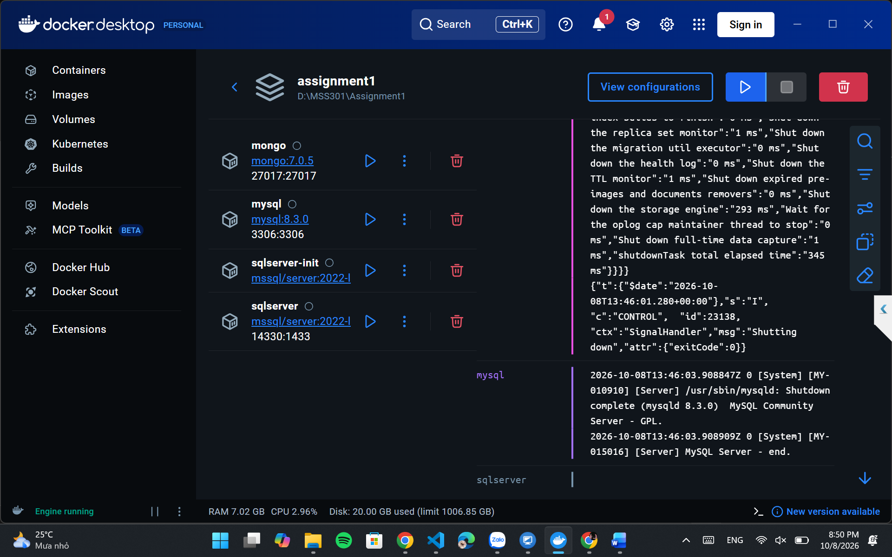

Figure 4.1. Infrastructure startup evidence.

4.2 Authentication Module (F1)
Customer Service configures Admin credentials, JwtService and BCryptPasswordEncoder. A successful login returns an access token and role. Wrong credentials return 401, inactive customers receive 403 and invalid login data is rejected with 400. The JWT claim role differentiates ADMIN and CUSTOMER permissions enforced at the Gateway.
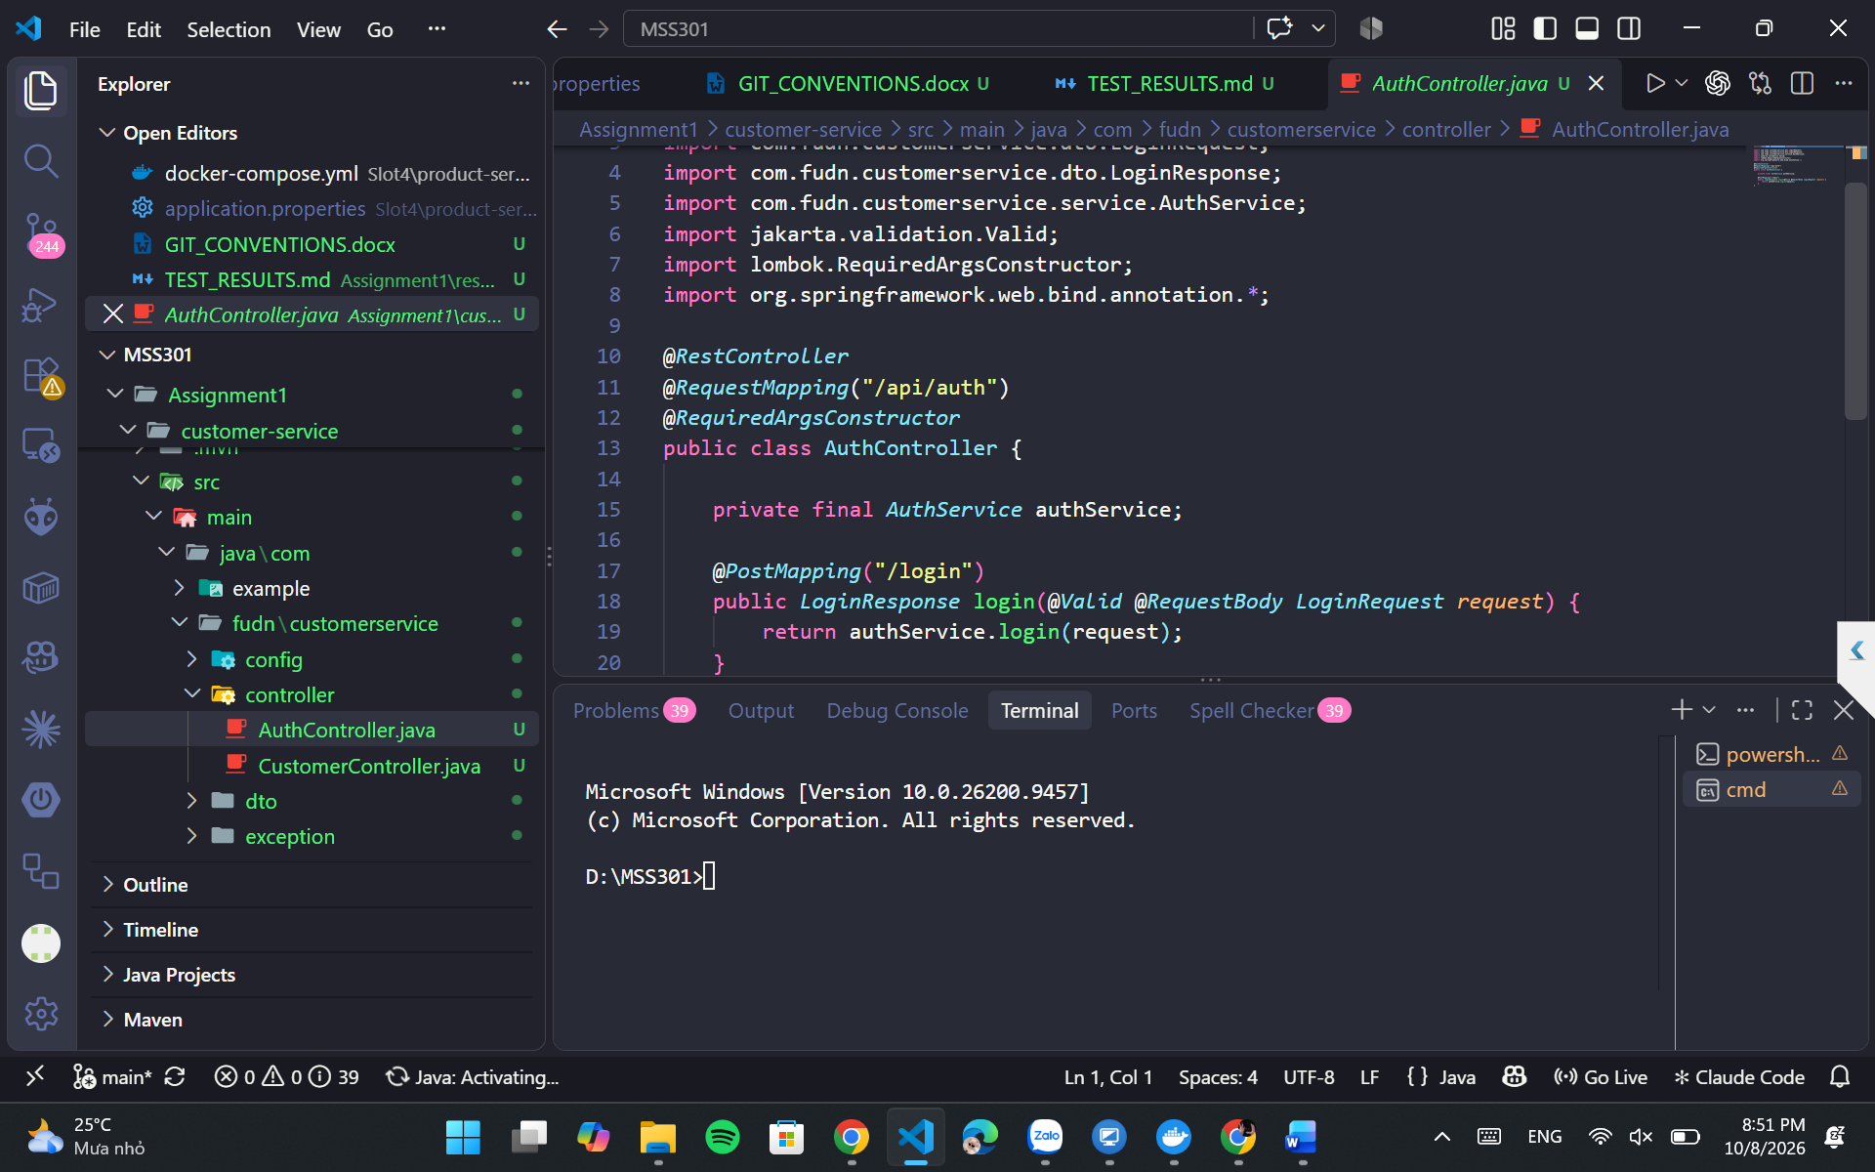
Figure 4.2. Authentication API evidence.

4.3 Customer Registration, Profile and Admin CRUD (F2–F3)
Customer registration validates required fields, enforces a unique email address (including the Admin email), hashes the password and creates an ACTIVE account. GET/PUT /api/customers/me and password change operations use the trusted user ID. Admin can list/search, view, create, update and soft-delete customers; soft delete changes status to INACTIVE instead of physically removing the row.
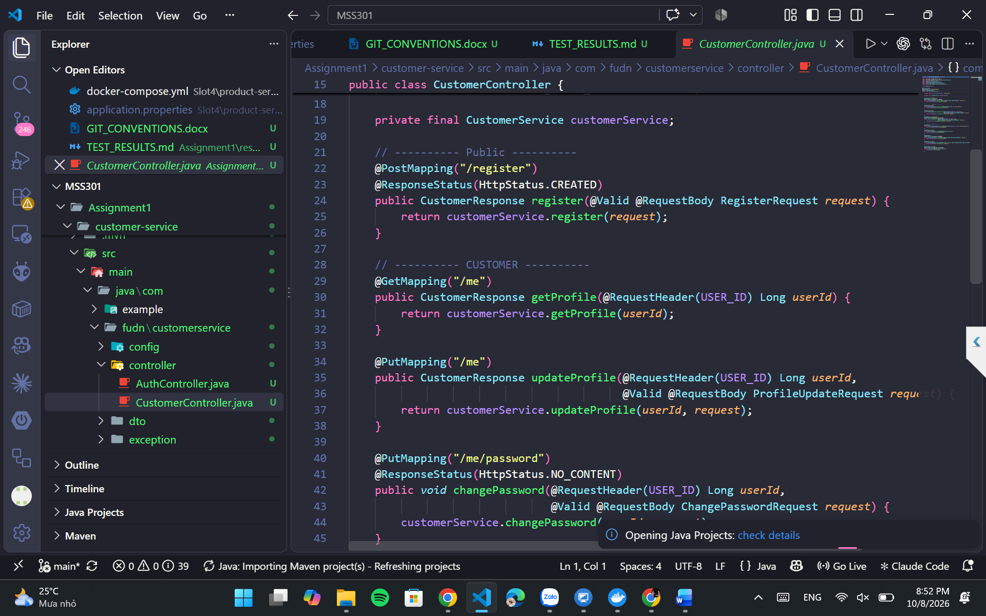
Figure 4.3. Customer management evidence.

4.4 Genre and Cinema Room Management (F4)
Movie Service uses Spring Data MongoDB documents and repositories for genres and rooms, with unique indexes on names. Room data includes type, status and grid dimensions (seatRows × seatsPerRow). Deleting a genre linked to movies or a room linked to showtimes must be rejected with 409. DataSeeder loads reference data only when collections are empty.
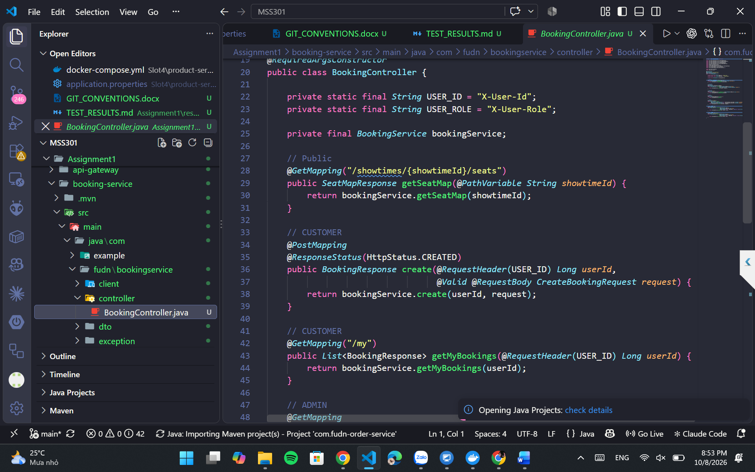
Figure 4.4. Genre and room management evidence.

4.5 Movie Catalog Management (F5)
Movie documents reference genreId and include title, director, duration, language, age rating, release date and status. Public endpoints provide movie lists/details. Admin endpoints create, update and delete movies. Search uses MongoTemplate Criteria for optional keyword (case-insensitive), genre and status. Unknown genre references are rejected with 404.
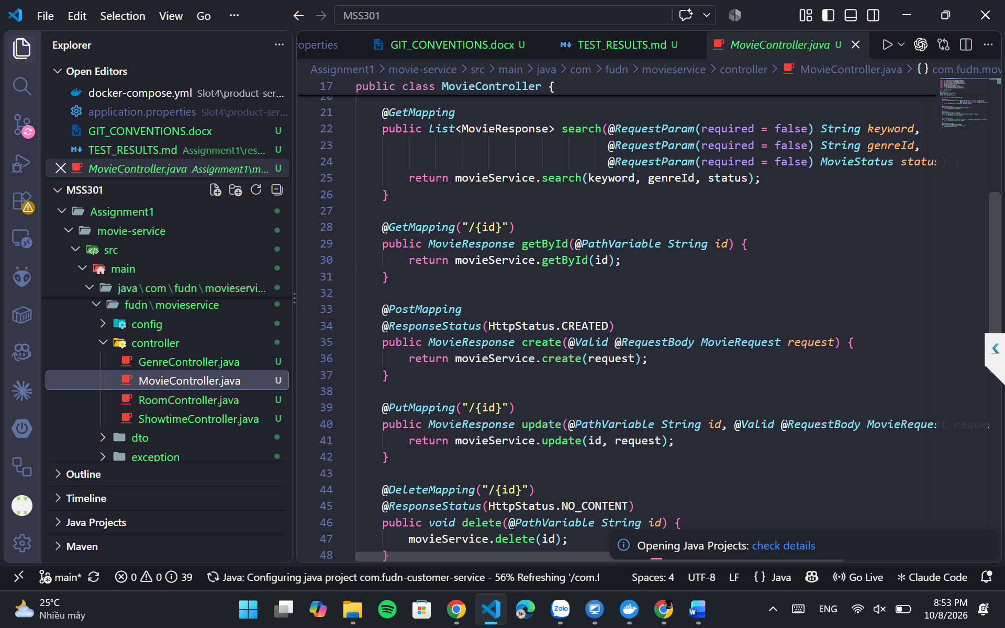
Figure 4.5. Movie catalog evidence.

4.6 Showtime Management (F6)
A showtime references a movie and a room, uses a Decimal128 ticket price and calculates its end time from startTime plus the movie duration. The selected movie must not be ENDED, the room must be ACTIVE and the start time must be in the future. SCHEDULED showtimes in the same room cannot overlap. Deletion is implemented as status transition to CANCELLED.
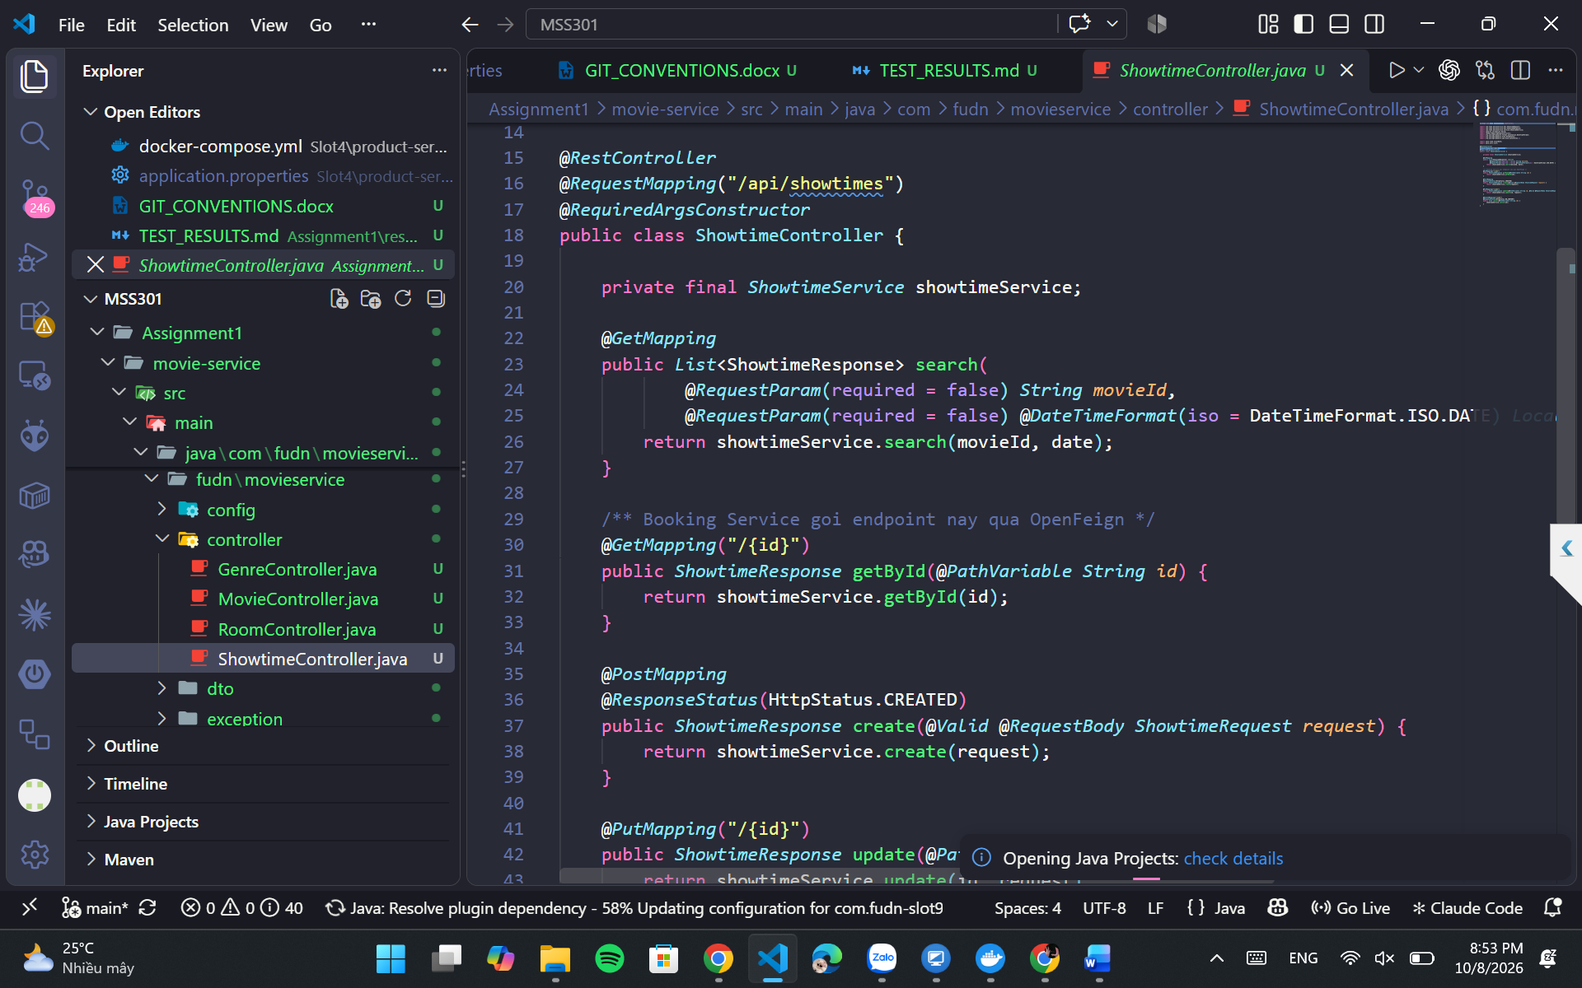
Figure 4.6. Showtime scheduling evidence.

4.7 Ticket Booking and Seat Map (F7)
When creating a booking, the service accepts 1–8 tickets, validates their showtime IDs and unique seat codes, rejects seats outside the room grid, and checks occupancy from confirmed bookings. Prices are read from Movie Service rather than sent by clients. A booking and its details are stored in a MySQL transaction and totalPrice is computed as the sum of ticket prices. The public seat map reports total, booked and available seats.
POST /api/bookings
{ “items”: [
{ “showtimeId”: “66f300000000000000000001”, “seatCode”: “E5” },
{ “showtimeId”: “66f300000000000000000001”, “seatCode”: “E6” }
] }

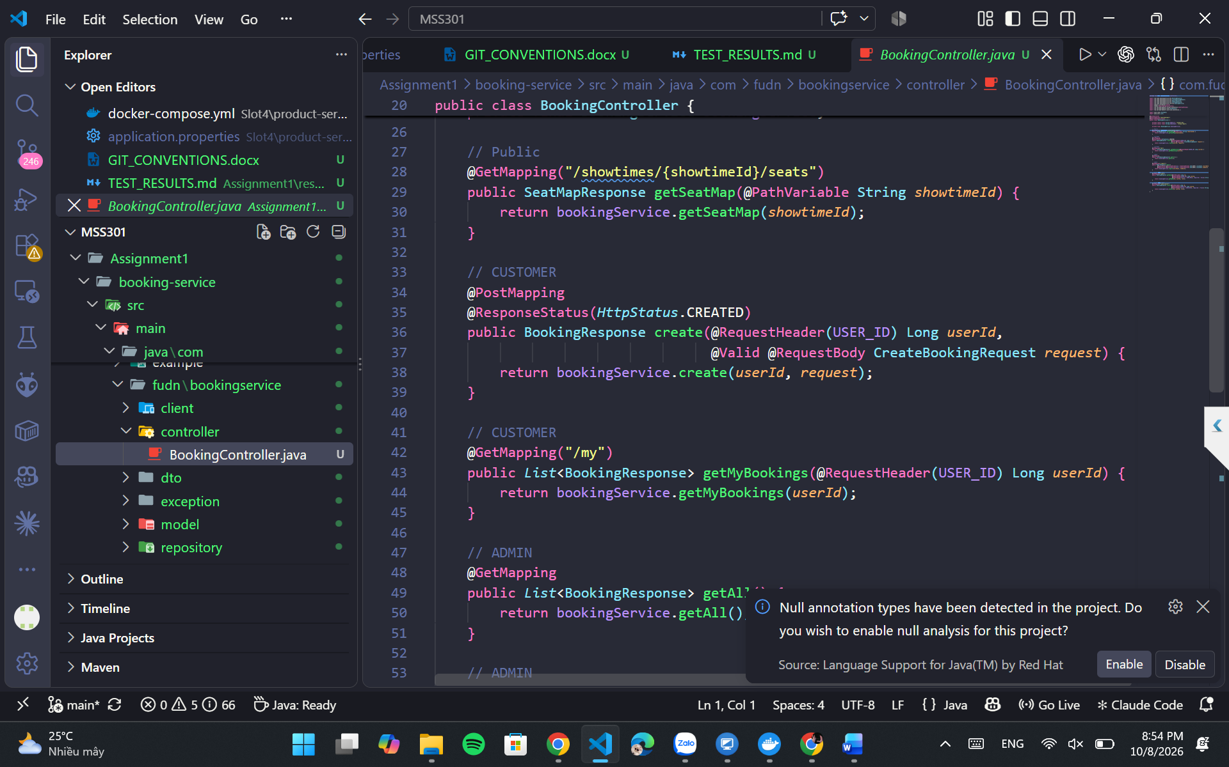
Figure 4.7. Booking creation and seat occupancy evidence.

4.8 Booking History and Cancellation (F8)
GET /api/bookings/my returns the logged-in customer’s bookings ordered by bookingDate descending. Booking detail and cancel operations verify ownership unless the user is ADMIN. Only CONFIRMED bookings can be cancelled; customers must cancel at least two hours before a showtime, whereas Admin can cancel at any time under the specification. Once cancelled, its seats are made available again.
Figure 4.8. Booking history and cancellation evidence.

4.9 Revenue Report (F9)
The report endpoint accepts startDate and endDate, rejects an inverted date range, and counts only CONFIRMED bookings. It returns totalBookings, totalTickets, totalRevenue, bookings ordered newest first and revenueByMovie ordered by revenue descending. Historical movie information is taken from booking_detail snapshots.
GET /api/bookings/report?startDate=2026-10-01&endDate=2026-10-31
Response fields: totalBookings, totalTickets, totalRevenue,
revenueByMovie, bookings

Figure 4.9. Revenue reporting evidence.

4.10 API Gateway Security and Routing (F10)
The Spring Cloud Gateway Server Web MVC module exposes routes for auth/customers, genres/rooms/movies/showtimes, and bookings. Its OAuth2 Resource Server configuration verifies HS256 signatures using the same secret as Customer Service, maps JWT role claims to Spring Security authorities, and enforces per-endpoint permissions. UserHeaderFilter removes spoofed client headers and injects validated identity context.
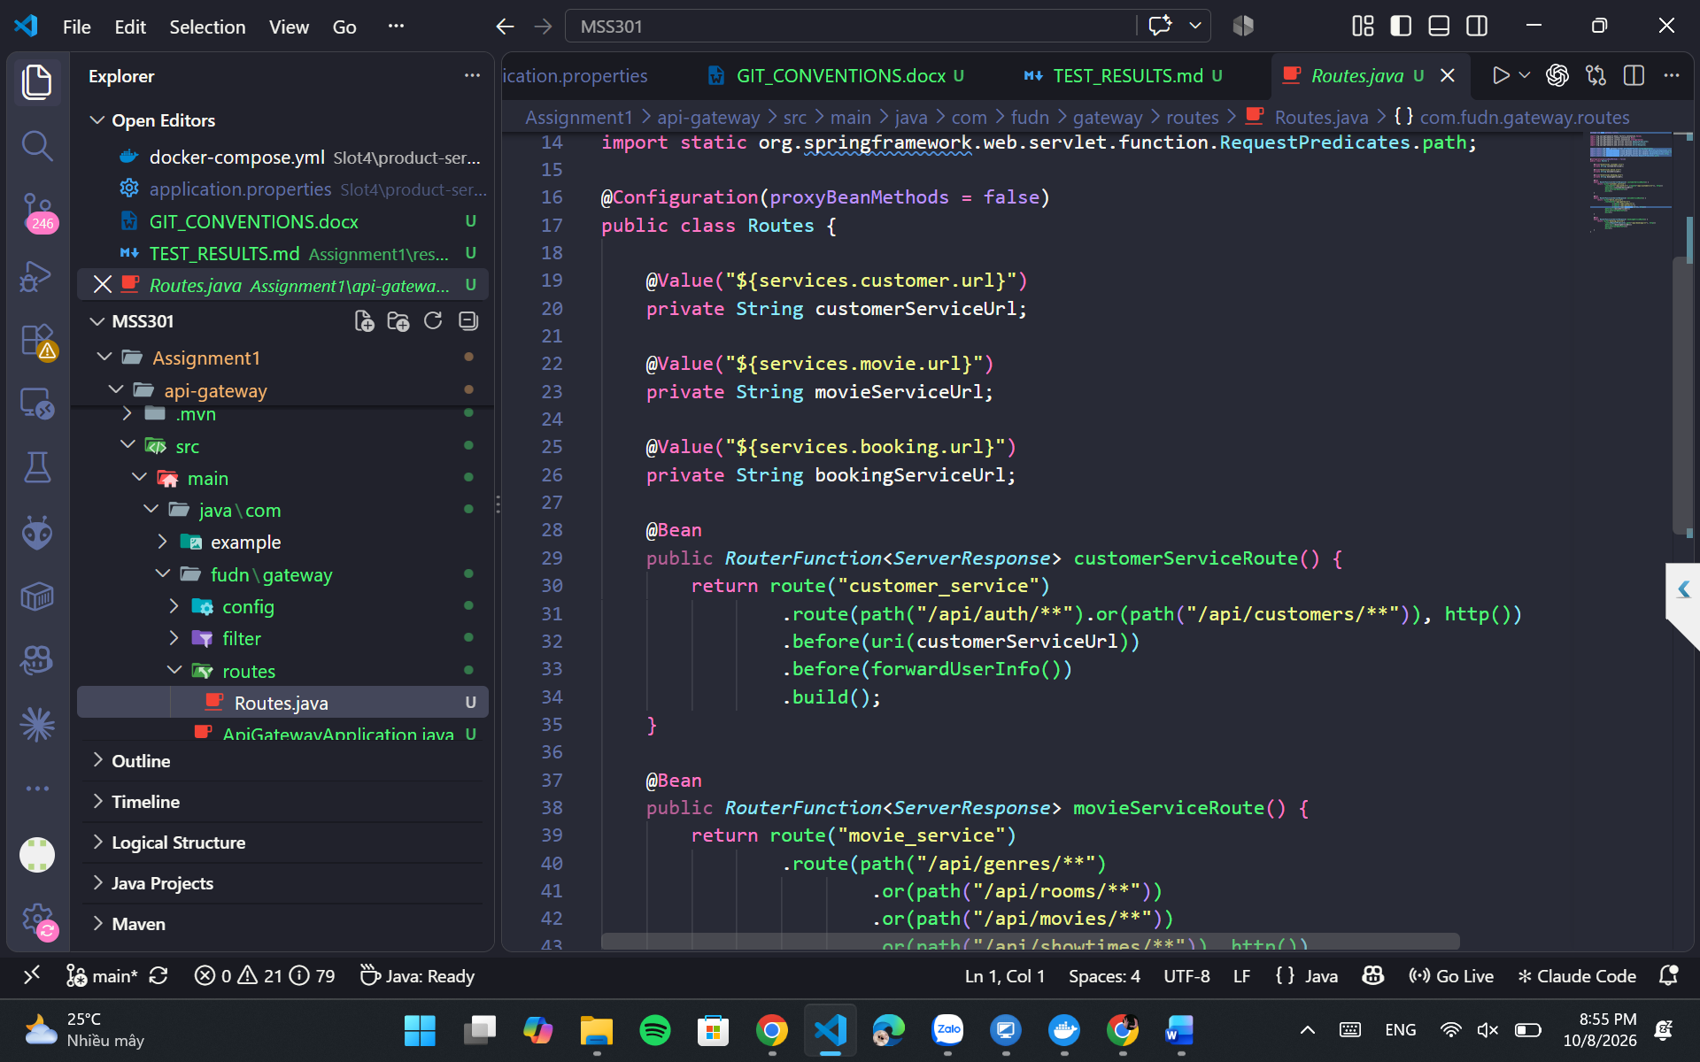Figure 4.10. Gateway access control evidence.

5. API Specification
All routes below are called through http://localhost:9000. Permissions: Public = no token, CUS = CUSTOMER, ADM = ADMIN, Auth = signed-in customer or admin with ownership checks where relevant. MongoDB resources use string ObjectId values; Customer and Booking IDs are numeric.

5.1 Customer Service Endpoints
Method | Endpoint | Access | Purpose
POST | /api/auth/login | Public | Login and issue JWT
POST | /api/customers/register | Public | Register customer
GET | /api/customers/me | CUS | Own profile
PUT | /api/customers/me | CUS | Update profile
PUT | /api/customers/me/password | CUS | Change password (204)
GET | /api/customers?keyword= | ADM | Search customers
GET | /api/customers/{id} | ADM | Get customer
POST | /api/customers | ADM | Create customer (201)
PUT | /api/customers/{id} | ADM | Update customer
DELETE | /api/customers/{id} | ADM | Soft-delete (204)

5.2 Movie Service Endpoints
Method | Endpoint | Access | Purpose
GET | /api/genres, /api/genres/{id} | Public | List/detail genres
POST / PUT / DELETE | /api/genres, /api/genres/{id} | ADM | Maintain genres
GET / POST / PUT / DELETE | /api/rooms, /api/rooms/{id} | ADM | Maintain rooms
GET | /api/movies?keyword=&genreId=&status= | Public | Search movies
GET | /api/movies/{id} | Public | Movie detail
POST / PUT / DELETE | /api/movies, /api/movies/{id} | ADM | Maintain movies
GET | /api/showtimes?movieId=&date= | Public | Search showtimes
GET | /api/showtimes/{id} | Public | Showtime detail for booking
POST / PUT | /api/showtimes, /api/showtimes/{id} | ADM | Create/update showtime
DELETE | /api/showtimes/{id} | ADM | Cancel showtime (204)

5.3 Booking Service Endpoints
Method | Endpoint | Access | Purpose
GET | /api/bookings/showtimes/{showtimeId}/seats | Public | Seat map and availability
POST | /api/bookings | CUS | Create booking (201)
GET | /api/bookings/my | CUS | Own booking history
GET | /api/bookings/{id} | Auth | Get booking; owner or Admin
PUT | /api/bookings/{id}/cancel | Auth | Cancel booking
GET | /api/bookings | ADM | All bookings
GET | /api/bookings/report?startDate=&endDate= | ADM | Revenue report

6. Business Rules and Validation
The following required rules come from the assignment specification. Failure conditions are summarized by expected HTTP responses and must be validated in Postman.
Rule | Required behavior | On failure
BR01 | Customer email is unique and cannot equal configured Admin email. | 409
BR02 | Invalid credentials (401); INACTIVE customer cannot log in (403). | 401 / 403
BR03 | Prevent deleting a genre with movies or room/movie with showtimes. | 409
BR04 | Valid future showtime, non-ENDED movie, ACTIVE room; endTime computed. | 400
BR05 | SCHEDULED showtimes cannot overlap in the same room. | 409
BR06 | Delete showtime by setting status to CANCELLED. | —
BR07 | Booking has 1–8 distinct seat requests. | 400
BR08 | Showtime exists, is SCHEDULED, not started; seat exists in room. | 400 / 404
BR09 | Seat is not already taken by a CONFIRMED booking for that showtime. | 409
BR10 | Server computes ticket prices and totalPrice. | —
BR11 | Customers may view/cancel only their own booking. | 403
BR12 | Cancel only CONFIRMED; customer must cancel ≥ 2 h before showtime. | 400
BR13 | startDate ≤ endDate; report includes only CONFIRMED bookings. | 400
BR14 | Movie Service unavailable during booking. | 503
BR15 | Movie genreId and showtime movieId/roomId must exist in MongoDB. | 404
BR16 | Vietnamese customerName must be stored/read with correct Unicode. | —

6.1 Standardized Error Responses
Each service uses DTO validation and @RestControllerAdvice with a consistent JSON body containing timestamp, status, error, message and path. This makes business errors distinguishable from authentication or infrastructure failures.
{ "timestamp": "2026-10-02T15:30:00", "status": 409, "error": "Conflict",
"message": "Seat E5 is already booked", "path": "/api/bookings" }

7. Postman Testing and Evidence

7.1 Environment and Collection Structure
The provided guide specifies a Postman environment named FUCinema-Local with gateway=http://localhost:9000 and dynamically saved access tokens and entity IDs. The FUCinemaBookingSystem collection has eight folders, ordered to preserve dependencies between requests.
Folder | Coverage | Representative expected outcomes
01-Auth | JWT generation; invalid login; missing/malformed token | 200 / 400 / 401 / 403
02-Customer | Register, profile/password, Admin CRUD, spoofed header | 201 / 200 / 204 / 403 / 409
03-Genre-Room | CRUD; uniqueness; deletion guards; invalid room data | 200 / 201 / 400 / 403 / 409
04-Movie | CRUD, keyword/genre/status search, invalid reference | 200 / 201 / 400 / 404 / 409
05-Showtime | Duration, conflicts, room state, cancel, references | 200 / 201 / 204 / 400 / 409
06-Booking | Seat map, create, reserved/invalid seats, 1–8 tickets | 200 / 201 / 400 / 401 / 403 / 409
07-History-Cancel | Ownership, history ordering, cancel/rebook | 200 / 201 / 400 / 403
08-Report | Totals, sorting, date validation and ADM access | 200 / 400 / 403

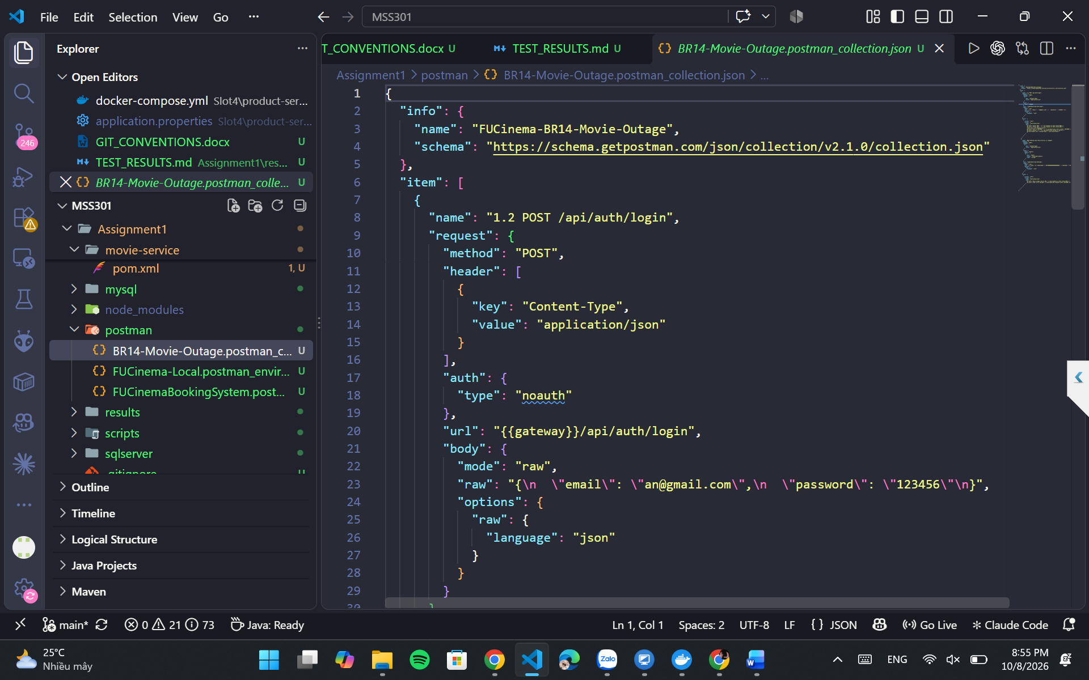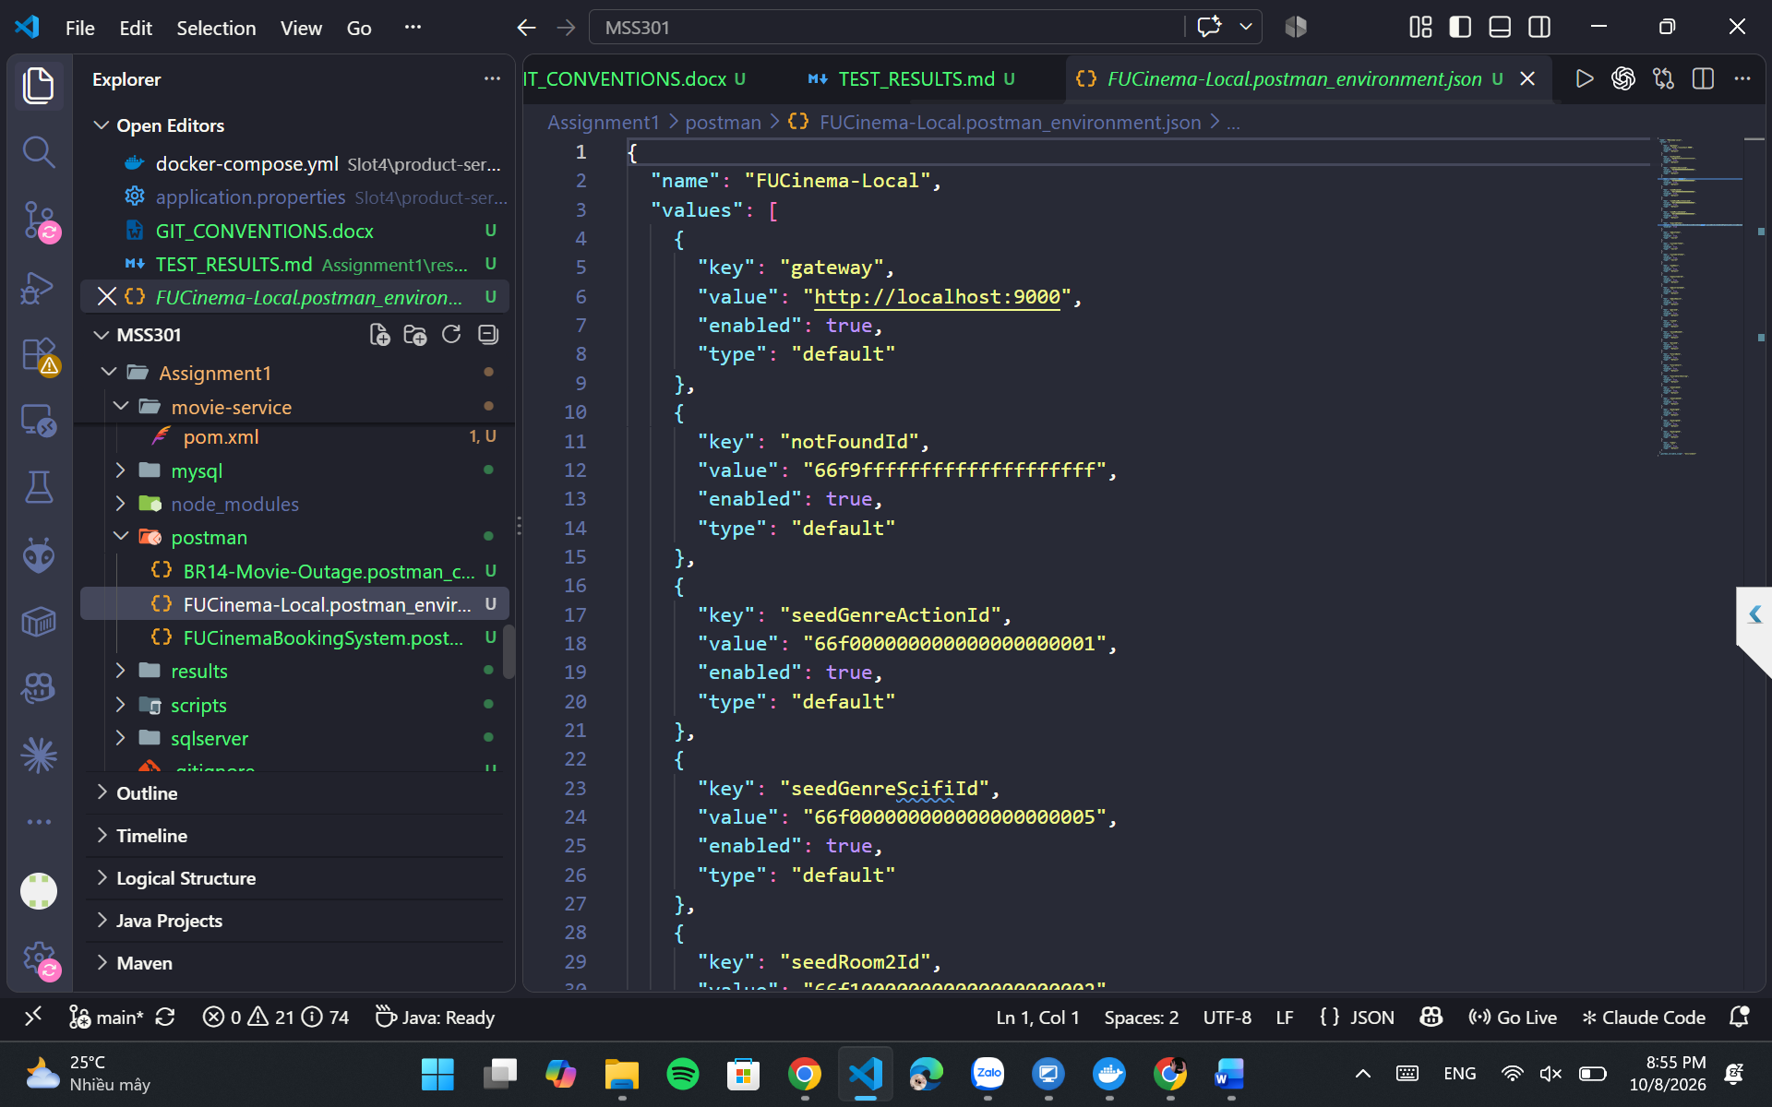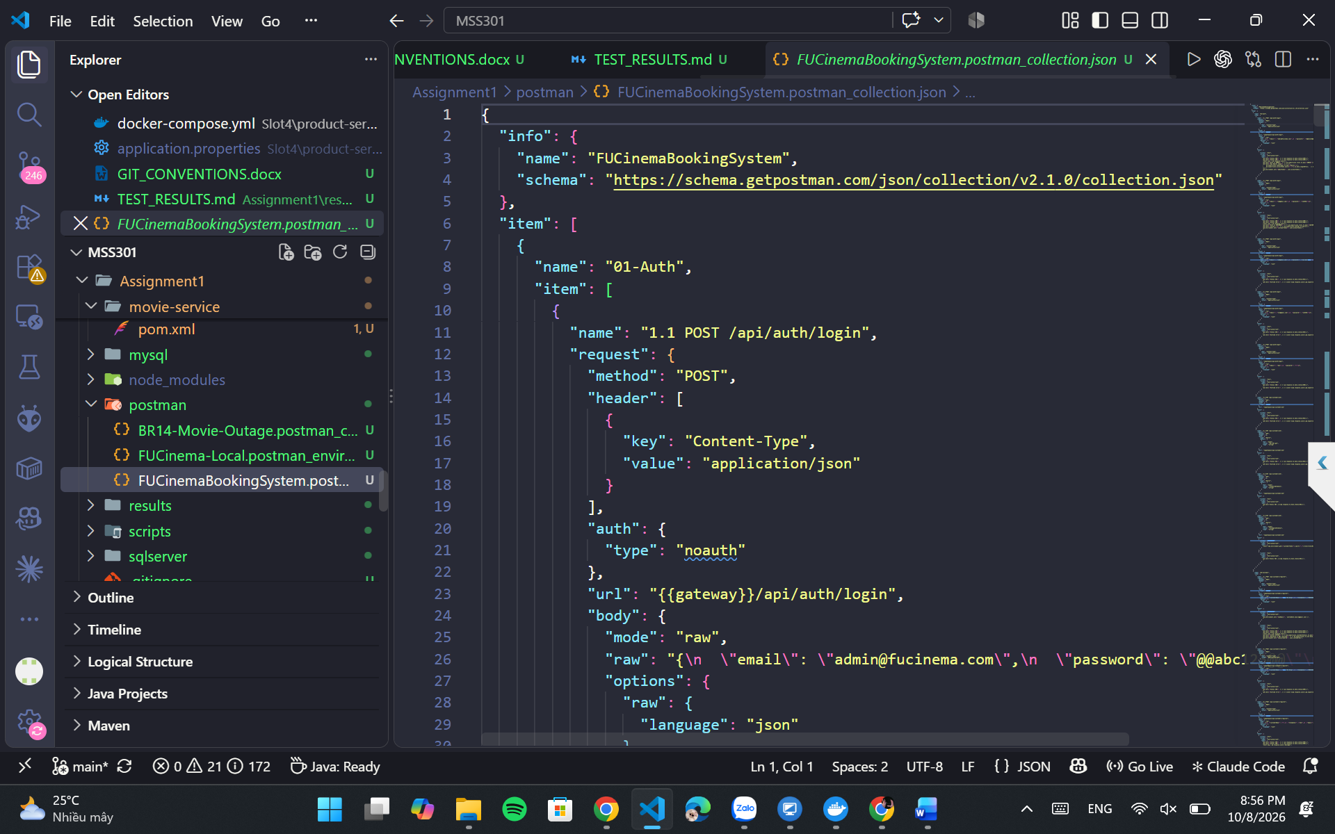Figure 7.1. Postman configuration (student screenshot).

8. Challenges and Solutions

8.1 Polyglot Persistence and Identifier Types
SQL Server and MySQL use numeric BIGINT identifiers, whereas MongoDB stores ObjectIds. The provided design resolves this by representing Mongo IDs as strings across HTTP and in booking_detail VARCHAR(24) columns. Cross-service relationships use logical ID references, while local MySQL booking-to-detail relationships use database constraints.

8.2 Scheduling and Seat Consistency
Two SCHEDULED showtimes in the same room must not overlap; the validation uses time interval intersection checks and excludes the current record when updating. Ticket booking requires seat-code validation against seatRows and seatsPerRow and must exclude cancelled bookings when determining availability. The guide recommends an additional concurrency safeguard as optional work; it is not a mandatory feature proved by the supplied documents.

8.3 Authentication and Trust Boundaries
A naive design might trust a client-supplied X-User-Id, allowing access to another customer’s resources. The Gateway removes incoming identity headers and replaces them with token-derived values, while customer/booking services enforce ownership. JWT secrets must match between issuer and verifier; invalid or expired tokens return 401.

9. Conclusion and References

9.1 Conclusion
FUCinemaBookingSystem illustrates separation of responsibilities across three microservices and a secure API Gateway. The solution specification combines SQL Server for identity data, MongoDB for a flexible cinema catalog and MySQL for transactional ticket booking. OpenFeign, JWT HS256, Flyway, validation rules and structured Postman testing form the core of the required backend design.
The remaining report action is evidence collection: execute the system, replace each screenshot placeholder with a capture from the actual application, check the output against expected statuses and values, and attach the exported Postman assets. This report intentionally does not claim runtime verification without those results.

9.2 Source Documents
- Assignment1.md — Assignment 01 for MSS301: Cinema Ticket Booking System using API Gateway; requirements, architecture, entities, business rules and API specification.
- Assignment1_Guide.md — Step-by-step implementation guidance; Docker configuration, service construction, Postman scenarios, troubleshooting and commit recommendations.
- ASSIGNMENT 01 REPORT_DE190669.docx — Original report used for student information and report-style structure; obsolete car-rental content and screenshots replaced.

