SLOT4 REPORT

Product Service

Student Information
Information | Content
Student ID | DE190669
Full Name | Trần Hồ Thảo Nguyên
Email | thtn.0507@gmail.com
GitHub Repository | https://github.com/Thaonguyen0507/MSS301

1. Introduction

1.1 Project Overview
Product Service is a Spring Boot microservice used to manage product information. The service provides RESTful APIs for creating, viewing, updating, and deleting products. Product data is stored in MongoDB and can be tested through Postman.

1.2 Objectives
The objectives of this project are:
● Apply Microservices Architecture with Spring Boot.
● Develop RESTful APIs for product management.
● Implement CRUD operations: create, get, update, and delete products.
● Connect Spring Boot with MongoDB.
● Test API functions using Postman.

2. Test

2.1 POST /api/products
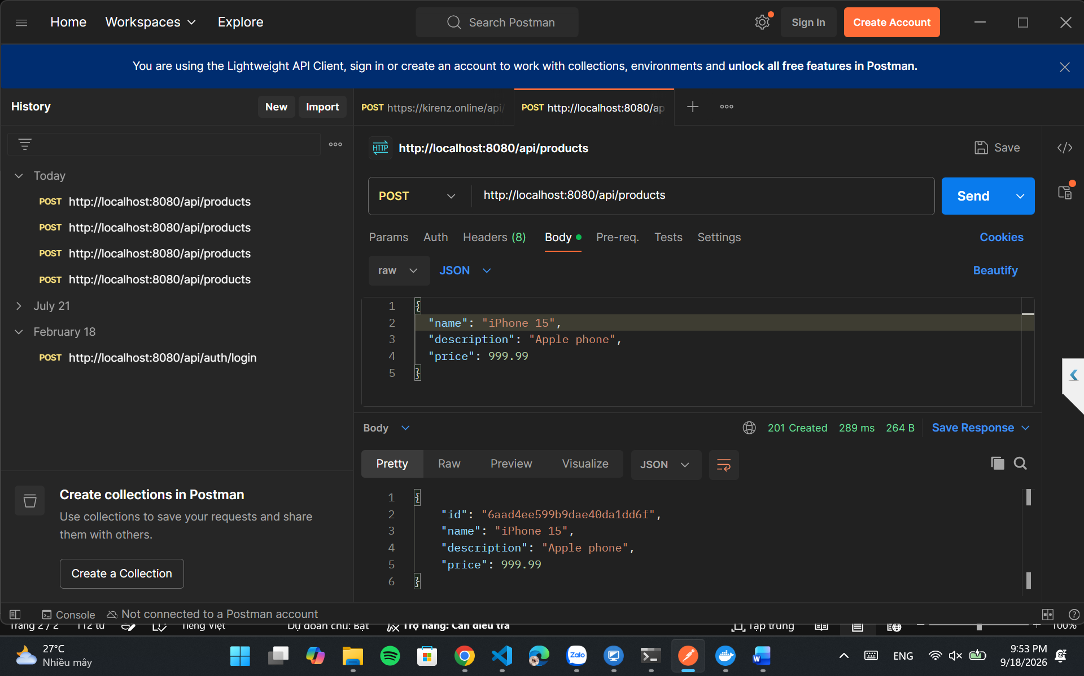

2.2 GET /api/products
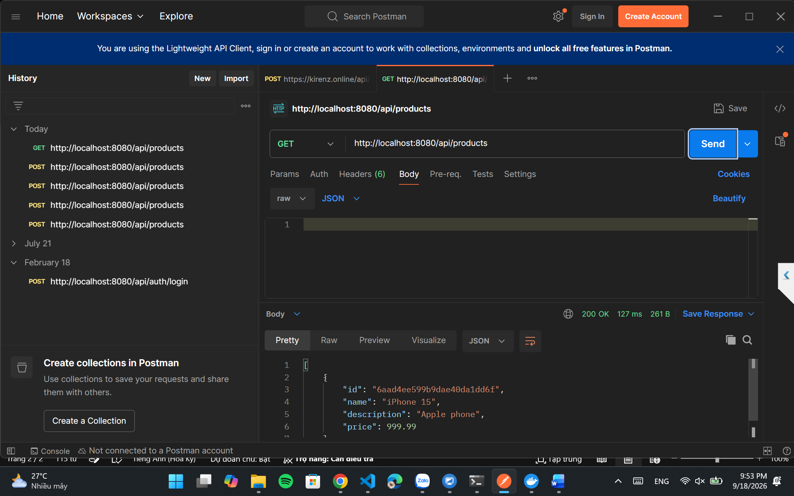

2.3. PUT /api/products/{id}
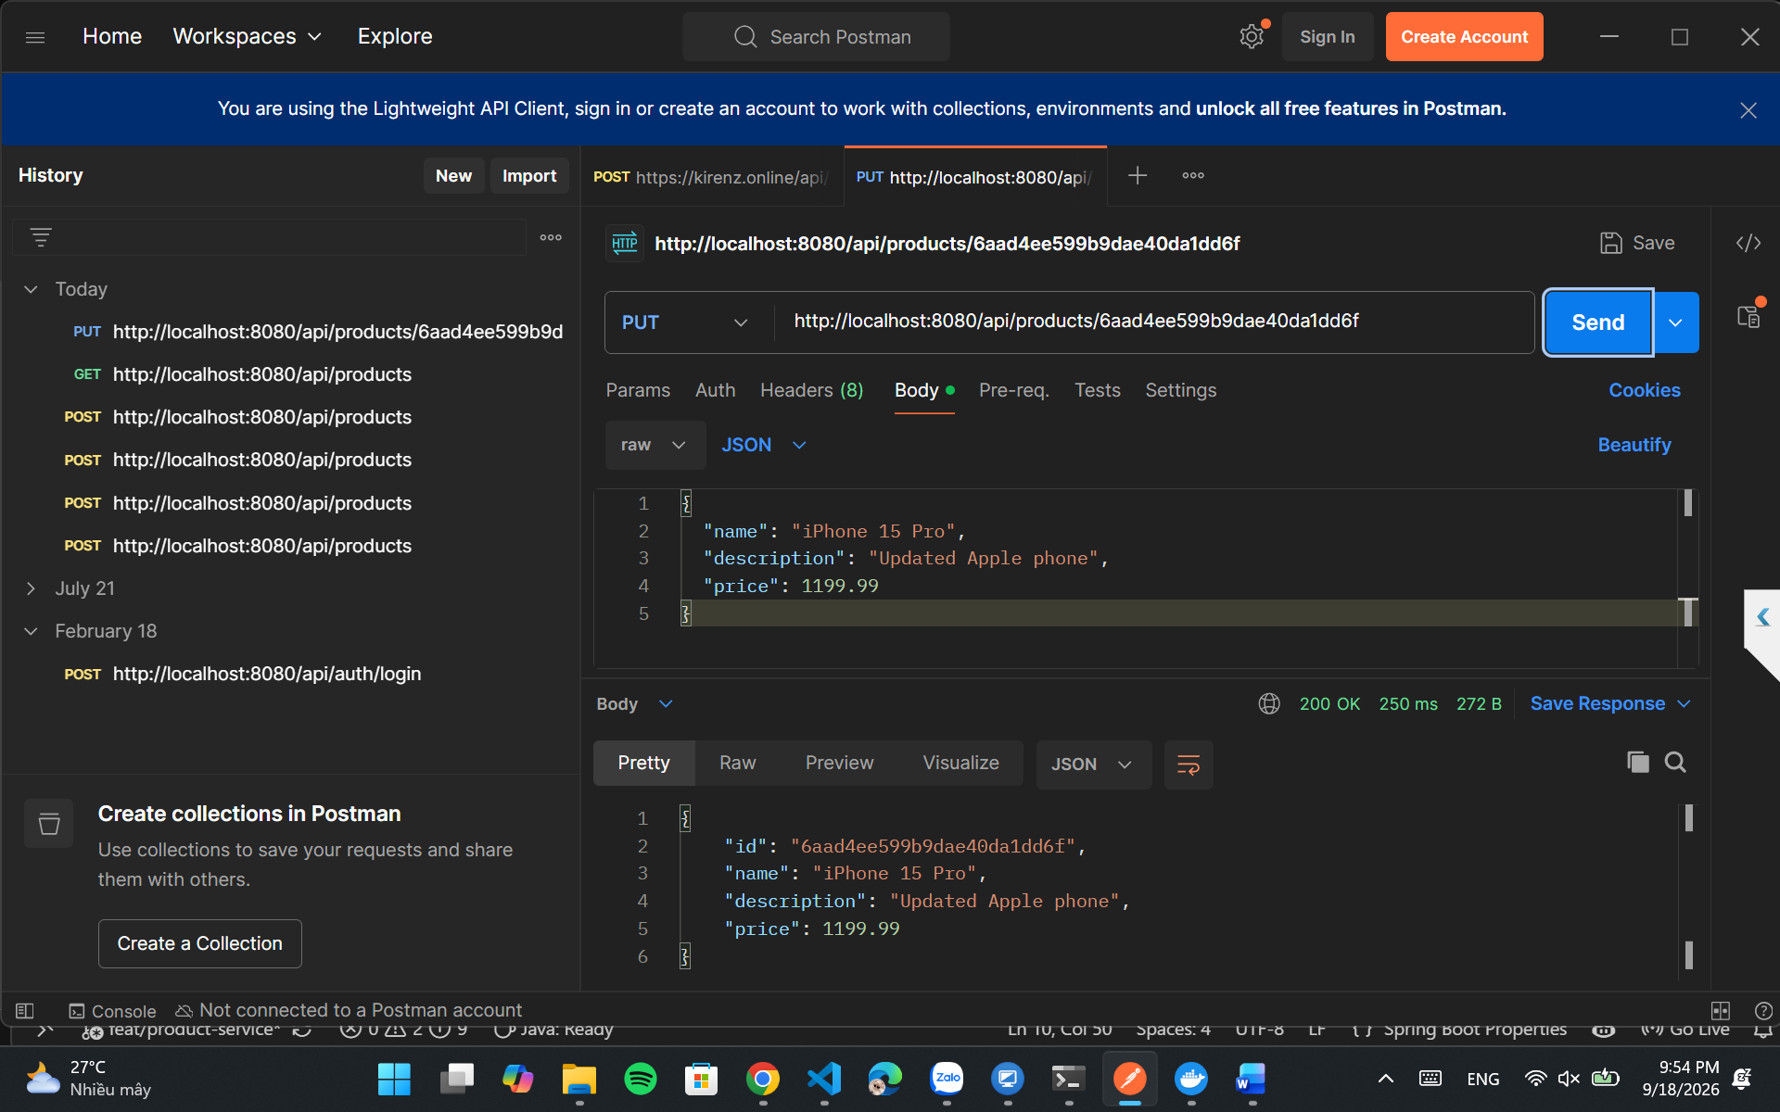

2.4. DELETE /api/products/{id}
