Pawnshop Management System

**Software Requirements Specification**

Version 1.0

Danang, Sep 2016

**TABLE OF CONTENTS**

**TABLE OF CONTENTS** 2

1. DOCUMENT HISTORY 3

2. REFERENCE DOCUMENTS 3

3. DISTRIBUTION LIST AND APPROVALS 3

4. INTRODUCTION 3

4.1 Purpose 3

4.2 In Scope 3

5. OVERVIEW 4

5.1 Actors 4

5.2 System Use Case Diagram 4

5.3 System Pages Flow 8

6. Functional Description 9

6.1 Login: 9

6.2 Airlines Information Maintenance 9

6.3 Project/Contract Information Maintenance 15

7. NON-FUNCTIONAL REQUIREMENTS AND OTHERS 31

Performance 31

Scalability 31

Security 32

Infrastructure 32

Browser 32

Reliability 32

Purchased Components 32

Interfaces 32

Extensibility 32

Assumptions 32

8. APPENDIX 33

# DOCUMENT HISTORY

|  |  |  |
| --- | --- | --- |
| **Date** | **Summary of Changes** | **Version** |
| 23/09/2016 | Tạo tài liệu SRS | 1.0 |
|  |  |  |
|  |  |  |

# REFERENCE DOCUMENTS

|  |  |
| --- | --- |
| **Document Name** | **Description** |
| SRS template | https://www.google.com/search?q=SRS+template&ie=utf-8&oe=utf-8&client=firefox-b-ab&gfe_rd=cr&ei=RJ_sV7WUF4KS2ATI9LjwCA |
| Modeling with UseCase Diagram | http://staruml.sourceforge.net/docs/user-guide(en)/ch05_1.html |
|  |  |
|  |  |
|  |  |
|  |  |
|  |  |

# DISTRIBUTION LIST AND APPROVALS

This document is distributed to the following stakeholders to get their valuable comments and corrections.

|  |  |
| --- | --- |
| **Name** | **Title** |
|  |  |
|  |  |
|  |  |
|  |  |
|  |  |
|  |  |
|  |  |
|  |  |
|  |  |

# INTRODUCTION

## Purpose

* *Mục đích của hệ thống trên để quản lý quán cà phê được dễ dàng hơn.*

## In Scope

* *Phạm vi dự án*

# OVERVIEW

## Actors

The below diagram describes all actors of the JAVA01Resource Management System. An actor represents a User Role; currently we have Administrator and Normal User Account. Each user has his own actions when accessing into the system, base on his rights. Administrator and Normal User Account have the rights to add new, update and delete records in all features; except User Accounts Maintenance and Housekeeping Modules, only Administrator can access.

|  |  |
| --- | --- |
| **Actor** | **Description** |
| Administrator | Has the right to View, Add new, Update and Delete data in all modules. |
| Normal User Account | Has the right to View, Add new, Update and Delete data in all modules, except User Accounts Maintenance and Housekeeping Modules. |

## System Use Case Diagram

Sơ đồ dưới đây cung cấp một bức trang tổng thể về các nhóm chức năng, Actors của dự án. Những chức năng của dự án sẽ được chia dựa vào sơ đồ “Use case” bên dưới:

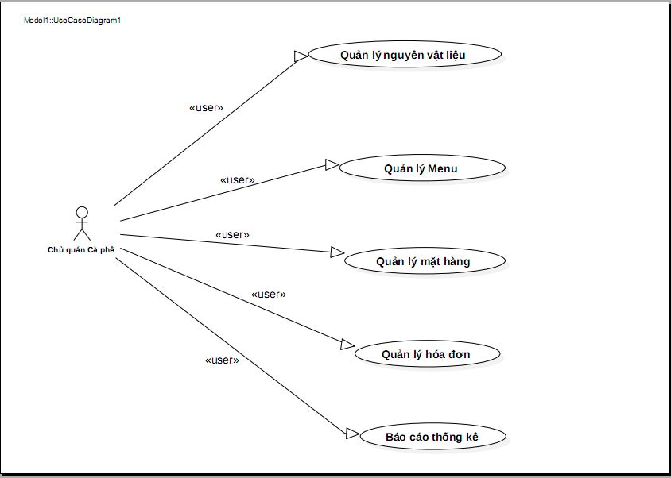

### Quản lý nguyên vật liệu - Use Case Diagram

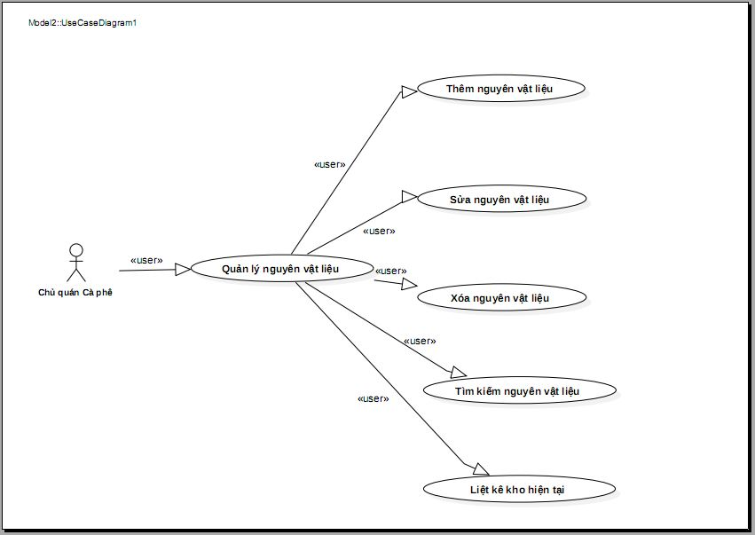

### Quản lý Menu - Use Case Diagram

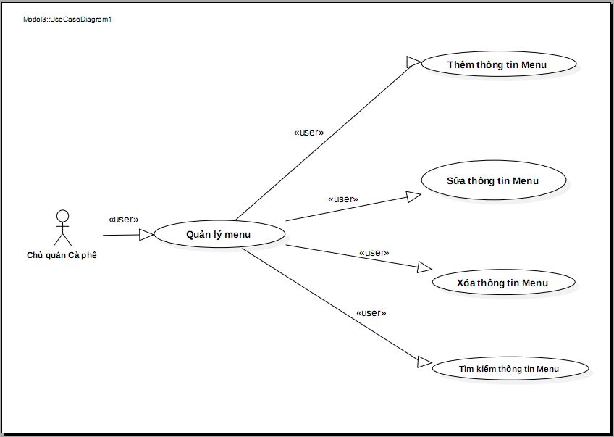

### Quản lý mặt hàng - Use Case Diagram

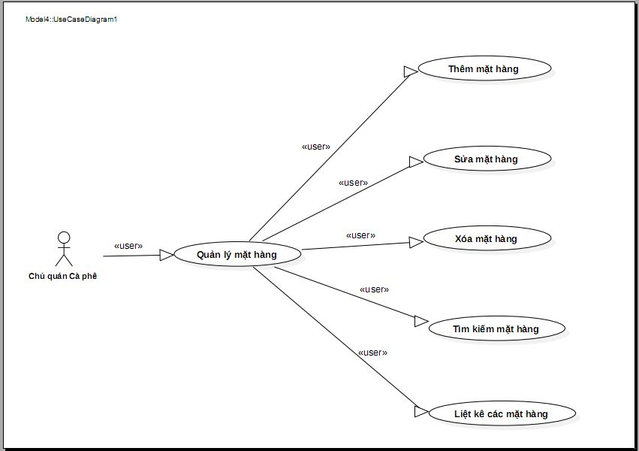

### Quản lý hóa đơn - Use Case Diagram

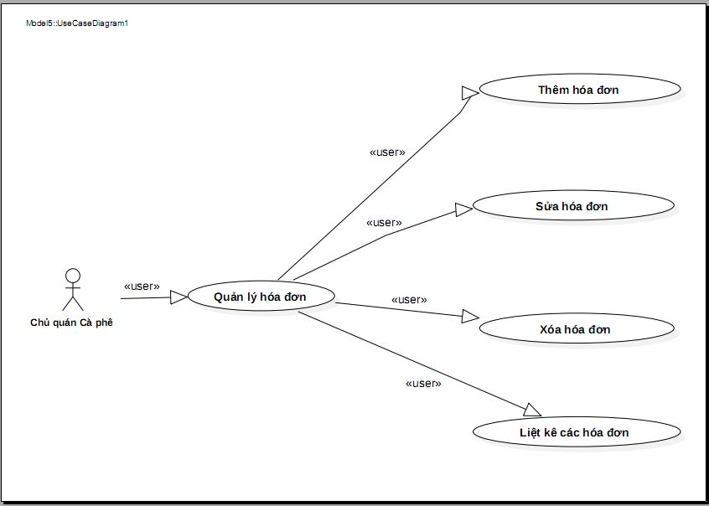

### Báo cáo thống kê - Use Case Diagram

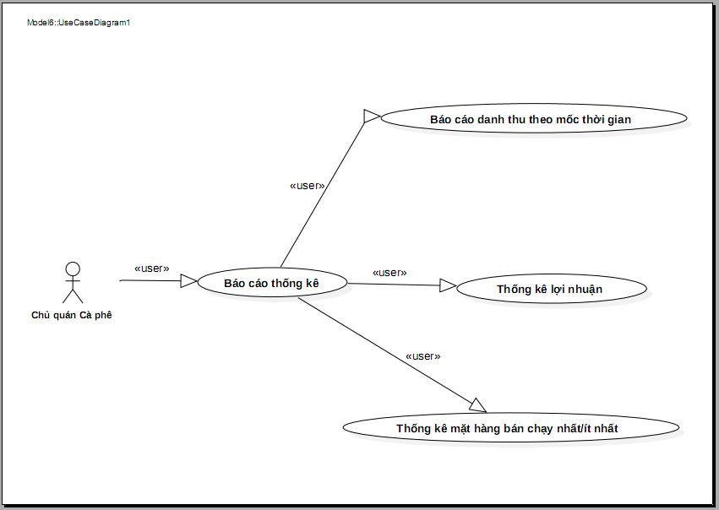

## System Pages Flow

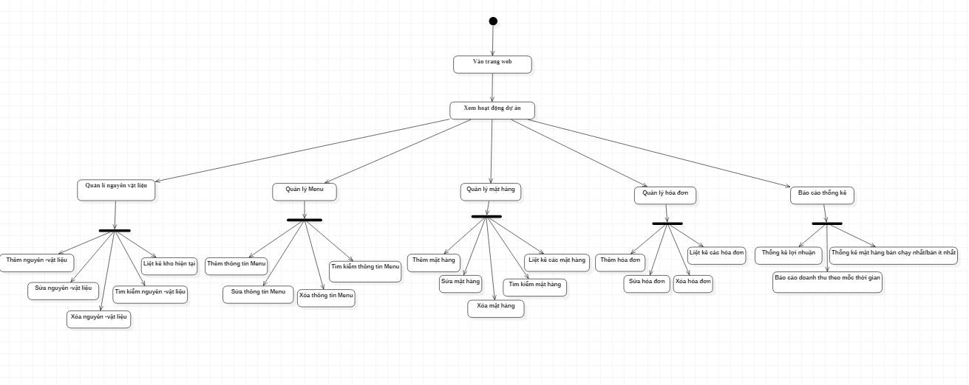

# NON-FUNCTIONAL REQUIREMENTS AND OTHERS

Performance

|  |  |
| --- | --- |
| No. | Requirement |
| 1. | Allow at least 5 users to access into the system at the same time. |

Scalability

|  |  |
| --- | --- |
| No. |  |
| 1. |  |
| 2. |  |

Security

|  |  |
| --- | --- |
| No. | Requirement |
| 1. | Web Server => Redhat 4, running apache 2.2  Appl Server => Solaris 10, running weblogic 10 MP1 |
| 2. |  |

Infrastructure

|  |  |
| --- | --- |
| No. | Requirement |
| 1. |  |

Browser

|  |  |
| --- | --- |
| No. | Requirement |
| 1. | IE6 and above (IE8 is not recommended).  FireFox is not mandatory. |

Reliability

|  |  |
| --- | --- |
| No. | Requirement |
| 1. |  |

Purchased Components

|  |  |
| --- | --- |
| No. | Requirement |
| 1. |  |
| 2. |  |

Interfaces

|  |  |
| --- | --- |
| No. | Requirement |
| 1. | Font style is the same with [http://www.customer.com.sg/default.aspx](http://www.abacus.com.sg/default.aspx) |

Extensibility

|  |  |
| --- | --- |
| No. | Requirement |
| 1. |  |

Assumptions

|  |  |
| --- | --- |
| No. | Requirement |
| 1. |  |

# APPENDIX