**LAB 1**

**LAB 1.a: Create a simple page to demonstrate the usage of necessary html tags. The page should contains and their description (image and description). You can show your own creativity which will be evaluated accordingly.​**

**Background:**

HTML, which stands for Hyper Text Markup Language, is the backbone of the World Wide Web. It's a standardized markup language used for creating web pages and structuring the content within them. HTML documents consist of a series of elements or "tags" that define the structure and presentation of web content.

HTML tags are enclosed in angle brackets (< >) and are used to define various elements on a web page, such as headings, paragraphs, links, images, and more. These tags provide instructions to web browsers on how to render and display the content to users. Each HTML tag serves a specific purpose and can have attributes that modify its behavior or appearance.

For example, the <h1> tag is used to create a top-level heading, while the <p> tag is used for paragraphs of text. Attributes like "src" in an <img> tag specify the image source, and "href" in an <a> tag defines the hyperlink destination.

**Source Code:**

<!DOCTYPE html>

<html lang="en">

<head>

<meta charset="UTF-8">

<meta name="viewport" content="width=device-width, initial-scale=1.0">

<title>Popular Places</title>

<style>

/* Basic CSS for styling */

body {

font-family: Arial, sans-serif;

margin: 0;

padding: 0;

background-color: #f0f0f0;

}

header {

background-color: #333;

color: #fff;

text-align: center;

padding: 10px;

}

main {

max-width: 800px;

margin: 20px auto;

padding: 20px;

background-color: #fff;

box-shadow: 0 0 5px rgba(0, 0, 0, 0.2);

}

.mountain{

margin-bottom: 20px;

}

.mountain img {

max-width: 100%;

height: auto;

}

</style>

</head>

<body>

<header>

<h1>Mountains</h1>

</header>

<main>

<div class="mountain">

<img src="annapurna.jpeg" alt="annapurna">

<h2>MT. Annapurna</h2>

<p>Annapurna is a mountain situated in the Annapurna mountain range of Gandaki province north-central Nepal. It is the tenth highest mountain in the world at 8,091 metres (26,545 ft) above sea level and is well known for the difficulty and danger involved in its ascent.</p>

</div>

<div class="mountain">

<img src="dhaulagiri.jpeg" alt="dhaulagiri">

<h2>MT. Dhaulagiri</h2>

<p>Dhaulagiri is the seventh highest mountain in the world at 8,167 metres (26,795 ft) above sea level, and the highest mountain within the borders of a single country (Nepal).</p>

</div>

</main>

</body>

</html>

**Output:**

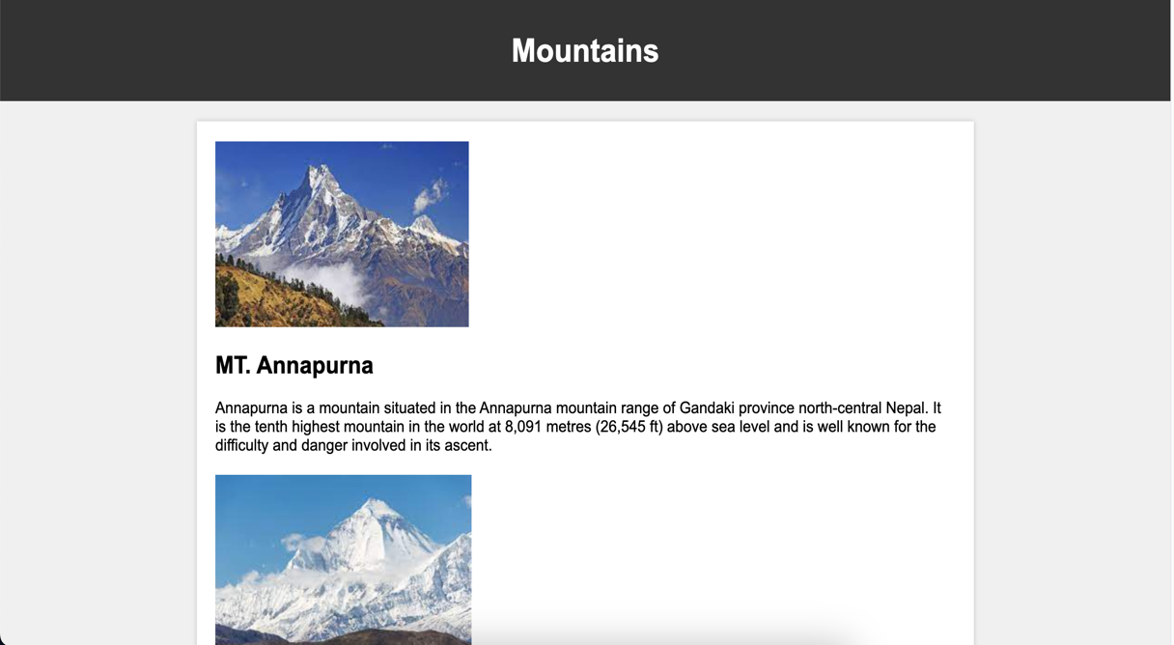

**LAB 1.b: Create a page that shows the course structure of B.Sc.CSIT using list. Also create organizational structure of College of Applied Business.**

**Background:**

A list is a fundamental structural element used to organize and display related pieces of content in a structured manner. Lists are essential for improving the readability and organization of web documents. There are three list types in HTML:

* Unordered list - used to group a set of related items in no particular order
* Ordered list - used to group a set of related items in a specific order
* Description list - used to display name/value pairs such as terms and definitions

**Source Code:**

<!DOCTYPE html>

<html lang="en">

<head>

<meta charset="UTF-8">

<meta name="viewport" content="width=device-width, initial-scale=1.0">

<title>B.Sc.CSIT Course Structure & College Organization</title>

<style>

/* Basic CSS for styling */

body {

font-family: Arial, sans-serif;

margin: 0;

padding: 0;

background-color: #f0f0f0;

}

header {

background-color: #333;

color: #fff;

text-align: center;

padding: 10px;

}

main {

max-width: 800px;

margin: 20px auto;

padding: 20px;

background-color: #fff;

box-shadow: 0 0 5px rgba(0, 0, 0, 0.2);

}

h2 {

color: #333;

}

</style>

</head>

<body>

<header>

<h1>B.Sc.CSIT Course Structure & College Organization</h1>

</header>

<main>

<section>

<h2>B.Sc.CSIT Course Structure</h2>

<ul>

<li>Semester 1:

<ul>

<li>Introduction to Information Technology</li>

<li>Mathematics-I</li>

<li>Programming in C</li>

<!-- Add more courses for Semester 1 -->

</ul>

</li>

<li>Semester 2:

<ul>

<li>D</li>

<li>Computer Organization and Architecture</li>

<li>Object-Oriented Programming in C++</li>

<!-- Add more courses for Semester 2 -->

</ul>

</li>

<li>Semester 3:

<ul>

<li>Data Structures and Algorithms</li>

<li>Computer Organization and Architecture</li>

<li>Object-Oriented Programming in C++</li>

<!-- Add more courses for Semester 2 -->

</ul>

</li>

<li>Semester 4:

<ul>

<li>Data Structures and Algorithms</li>

<li>Computer Organization and Architecture</li>

<li>Object-Oriented Programming in C++</li>

<!-- Add more courses for Semester 2 -->

</ul>

</li>

<!-- Add more semesters and courses as needed -->

</ul>

</section>

<section>

<h2>Organizational Structure of College of Applied Business</h2>

<p>The College of Applied Business has a hierarchical organizational structure with various departments and administrative units.<br> The top-level management includes:</p>

<ul>

<li>Principal</li>

<li>Vice Principal</li>

<li>Department Heads</li>

</ul>

<p>Departments within the college may include:</p>

<ul>

<li>Department of Business Administration</li>

<li>Department of Information Technology</li>

<!-- Add more departments as needed -->

</ul>

<p>Each department further consists of faculty, staff, and students pursuing various academic programs.</p>

</section>

</main>

</body>

</html>

**Output:**

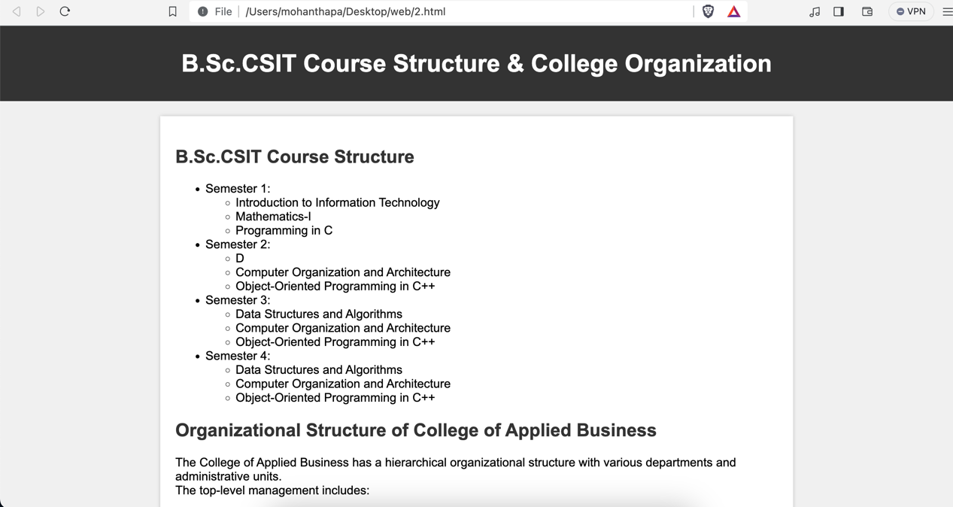

**LAB 1.c: Create a user registration form with necessary fields.**

**Background:**

A HTML form is a crucial element used to collect and submit user input or data on a web page. It provides a structured way for website visitors to interact with the site by entering information, making selections, and submitting data for further processing, such as searching, logging in, or submitting contact information.

**Source Code:**

<!DOCTYPE html>

<html lang="en">

<head>

<meta charset="UTF-8">

<meta name="viewport" content="width=device-width, initial-scale=1.0">

<title>User Registration</title>

<style>

/* Basic CSS for styling */

body {

font-family: Arial, sans-serif;

margin: 0;

padding: 0;

background-color: #f0f0f0;

}

header {

background-color: #333;

color: #fff;

text-align: center;

padding: 10px;

}

main {

max-width: 600px;

margin: 20px auto;

padding: 20px;

background-color: #fff;

box-shadow: 0 0 5px rgba(0, 0, 0, 0.2);

}

label {

font-weight: bold;

}

input[type="text"],

input[type="email"],

input[type="password"] {

width: 100%;

padding: 10px;

margin-bottom: 15px;

border: 1px solid #ccc;

border-radius: 4px;

}

button {

background-color: #333;

color: #fff;

padding: 10px 20px;

border: none;

border-radius: 4px;

cursor: pointer;

}

button:hover {

background-color: #555;

}

</style>

</head>

<body>

<header>

<h1>User Registration</h1>

</header>

<main>

<form action="registration_handler.php" method="post">

<label for="firstname">First Name:</label>

<input type="text" id="firstname" name="firstname" required>

<label for="lastname">Last Name:</label>

<input type="text" id="lastname" name="lastname" required>

<label for="email">Email:</label>

<input type="email" id="email" name="email" required>

<label for="password">Password:</label>

<input type="password" id="password" name="password" required>

<button type="submit">Register</button>

</form>

</main>

</body>

</html>

**Output:**

