- Is used if there is two recursive calls made

- If optimality is asked

- Recursion=>Memoization = DP

- Then buttonUp approach

1. 0-1 knapsack(6)

2. Unbounded knapsack(5)

3. Fibonacci(7)

4. LCS(15)

5. LIS(10)

6. Kodane's Algorithms(6)

7. Matrix Chain Multiplication(7)

8. DP on trees(4)

9. DP on Grid(14)

10. Others (5)

Identification - if we have choice

- if asked for optimal

Solution : Recursive ---> Memoization ---> BottomUp/TopDown

Choice Diagram: 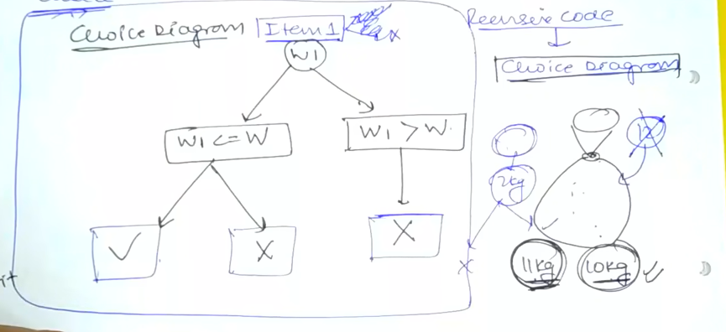

Look at return type, inputs :

Base Condition=> smallest valid input

Choice diagram

Now initialize matrix or dictionary. Size of matrix is size of changing variable.

Dictionary keys = changing variable

For Knapsack top-down:

1. Initialize =>base condition of base condition changes to initialization