Thapanachart Thumpreecha 61070503408

Operating System Lab 7 Concurrency and Thread

The code is task with subtraction 1 thousand million with 5 time the input from user. This is the example of thread so I have created 2 threads and the input should be in even number to equally divided the work for them. The code also has task with no thread in order to check the correctness of the given task to thread compare to original method.

Output with low input :

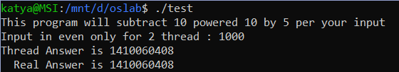

Discussion (with myself): It work the task done correctly so far

Output with higher input :

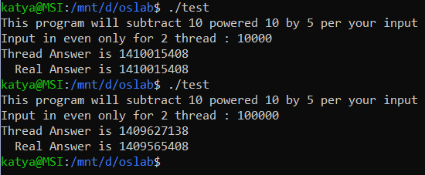

Discussion (with myself again) : It still working fine on 10000 but in the other hand 100000 thread begin to give us a wrong answer, So we can conclude that the performance of the thread work is inversely proportional to number of task that given the thread (Higher task , less accurate)

Output with even higher number of tasks to be confirm:

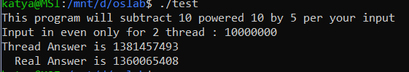

Problem that found : The accuracy is even worse than before with more task assign

Possible Solution : Create more thread to withstand more tasks