**OR GATES**

**2 INPUTS**

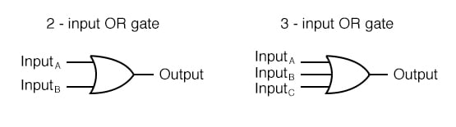(EETech Group, LLC, 2016)

|  |  |  |
| --- | --- | --- |
| **A** | **B** | **OUTPUT** |
| **0** | **0** | **0** |
| **0** | **1** | **1** |
| **1** | **0** | **1** |
| **1** | **1** | **1** |

**3 INPUTS**

(EETech Group, LLC, 2016)

$$OUTPUT=A+B+C$$

|  |  |  |  |
| --- | --- | --- | --- |
| **A** | **B** | **C** | **OUTPUT** |
| **0** | **0** | **0** | **0** |
| **0** | **0** | **1** | **1** |
| **0** | **1** | **0** | **1** |
| **0** | **1** | **1** | **1** |
| **1** | **0** | **0** | **1** |
| **1** | **0** | **1** | **1** |
| **1** | **1** | **0** | **1** |
| **1** | **1** | **1** | **1** |

**4 INPUTS**

$$OUTPUT=A+B+C+D$$

|  |  |  |  |  |
| --- | --- | --- | --- | --- |
| **A** | **B** | **C** | **D** | **OUTPUT** |
| **0** | **0** | **0** | **0** | **0** |
| **0** | **0** | **0** | **1** | **1** |
| **0** | **0** | **1** | **0** | **1** |
| **0** | **0** | **1** | **1** | **1** |
| **0** | **1** | **0** | **0** | **1** |
| **0** | **1** | **0** | **1** | **1** |
| **0** | **1** | **1** | **0** | **1** |
| **0** | **1** | **1** | **1** | **1** |
| **1** | **0** | **0** | **0** | **1** |
| **1** | **0** | **0** | **1** | **1** |
| **1** | **0** | **1** | **0** | **1** |
| **1** | **0** | **1** | **1** | **1** |
| **1** | **1** | **0** | **0** | **1** |
| **1** | **1** | **0** | **1** | **1** |
| **1** | **1** | **1** | **0** | **1** |
| **1** | **1** | **1** | **1** | **1** |