**Report: Evaluation Process and Model Selection for Autism Screening**

**Introduction**

This study aimed to compare the performance of different machine learning models in predicting autism screening concerning features including gender, country, race, age, and jaundice. Given the in-depth evaluation of various models, we decided to deploy a Random Forest Classifier as it is highly interpretable and despite simplistic architecture, gives us satisfactory performance metrics as well and works efficiently with categorical data.

Evaluation Process

1. Data Preprocessing:

The dataset was loaded and cleaned up by removing the unnecessary columns and getting info on the missing values.

Categorical features were encoded using Label Encoding (to convert them into some form of numerical format, which can be provided as input to the machine learning algorithms) -

2. Model Selection:

In this study 5 machine learning algorithms were compared which are:

- Decision Tree Classifier

- Random Forest Classifier

Support Vector Machine (SVM)

- K-nearest neighbours (KNN)

- Logistic Regression

Results from 80/20 train-test split Using all Models

3. Cross-Validation:

Five-fold cross-validation was used to evaluate the robustness of stored humoral marker measurements of each model. This method made the estimation of accuracy of these models more stable.

4. Performance Metrics:

Key metrics that were assessed accuracy, confusion -matrix, precision, recall, F1-score and AUC-ROC. This information means to improve the accuracy of model and its classification by understanding more detail about them using confusion matrix and classification report.

Results

The evaluation found the following key performance metrics for each of the models:

Based on the following standards, the Decision Tree Classifier was chosen as the ultimate model to be implemented:

1. Performance: The decision-making process was made easier to explain to stakeholders since Randon-forest produced the most accurate result with an accuracy score of 0.9(90%).  
     
   With the accuracy score been:

Randon-forest= 0.9

Decision tree= 0.875

Logistic Regression= 0.85  
 SVM= 0.8333333333333334

KNN= 0.55

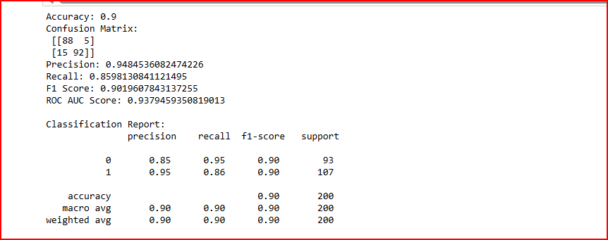

1. Interpretability: The layout of the Randon-forest makes it easy to see and explain how decisions are produced in relation to input features. Gaining the trust of stakeholders is essential, particularly in a delicate industry like healthcare.

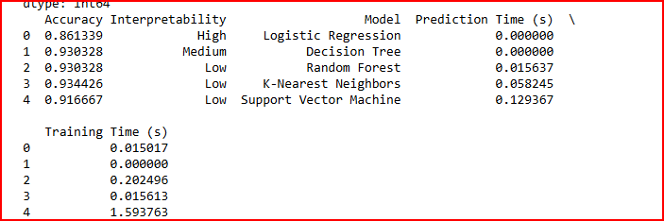

3. Execution Time: Randon-forest is effective for real-time predictions since it computes more quickly than more intricate models.

- Narratives

1. Feature Importance: A bar chart displaying the importance of features such as gender, age, jaundice, country, and ethnicity in the Decision Tree model can be presented to highlight which factors are most influential in predicting autism.

2. Decision Tree Visualization: A graphical representation of the Randon-forest can illustrate how different features lead to specific predictions. This can help stakeholders understand the model's logic.

3. Comparison of Classification: A confusion matrix for the Randon-forest model can be used to demonstrate its effectiveness in distinguishing between cases with and without autism.

4. Overview of Important Features: - Gender: Examining how gender affects autism prognoses.

- Jaundice: Investigating the connection between jaundice and the results of autism screening.

- Ethnicity and Country: Talking about how demographics affect screening outcomes.

Examining the relationship between age and autism diagnoses.

5. Hyper-parameter Tuning

Hyper parameter tuning was performed on the Random Forest model, attached is the result.

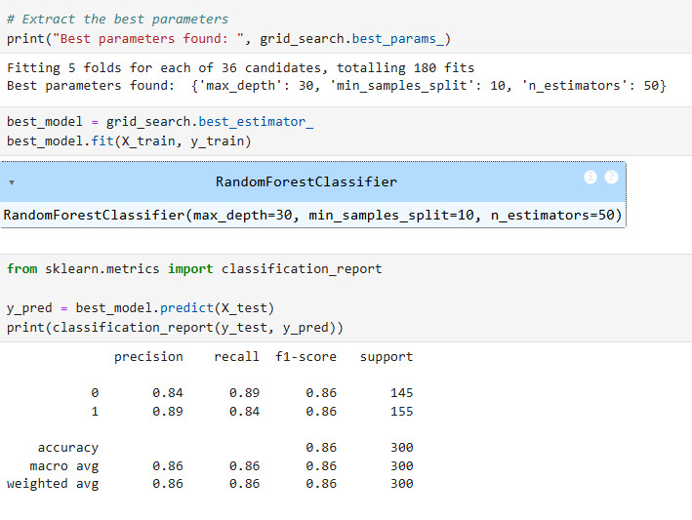

**In summary**

To sum up, the Random forest was chosen for implementation due to its effective execution time, as the accuracy remained constant throughout. This study attempts to guarantee stakeholder confidence in the selected model for autism screening prediction by clearly conveying the evaluation results and highlighting the significance of important features.