# CHAPTER 1 – TABLE OF CONTENT

Table of Contents

CHAPTER 1 – TABLE OF CONTENT 1

CHAPTER 2 - INTRODUCTION 1

2.1 Introduction 2

2.2. Business Background 2

2.3. Current Problems 2

2.4. Aims and Objectives 3

CHAPTER 3 – LITERATURE REVIEW 5

3.1. System Introduction 5

3.2. Methodology 5

3.3. Web Frameworks 6

3.4 Database System 6

5. CHAPTER 5 – SIMILAR SYSTEM ANALYSIS 7

5.1. User Interface Design 8

6. CHAPTER 6 – Legal, Social, Ethical and Professional Issues 13

5.1 Legal Issues 13

5.2 Social Issues 13

5.3 Ethical Issues 14

5.4 Professional Issues 14

7. CHAPTER 7 – REQUIREMENT ANALYSIS 14

7.1. Functional Requirements 14

7.2. Non-Functional Requirements 15

7.3. Prioritizations of Requirements 16

7.4. TimeBox Plan 17

8. CHAPTER 8 – ENGINEERING AND EXPLORATION 18

7.1. TimeBox – 1 Registration 18

# CHAPTER 2 - INTRODUCTION

## 2.1 Introduction

As the part-time jobs become popular in Myanmar even more than full time jobs due to the improvement of the country and neighbor-countries’ investment of industries, hotels, restaurant and others, the labors are in high demand. The job agencies are booming and they perform services to find the labors for the employers. By engaging the job seekers to the employer, the services are paid and gain profit in that way. One of the popular agencies in Myanmar is the Labor Power.

Labor Power is the part-time job agency service in Yangon which hold a large community of labor who want to work part time and engage them with numbers of part-time jobs. The organization has a lot of branch offices in Yangon to provide the job seeking services. They usually provide the ground services manually but it is a very slow service and need a lot of man-power. Nowadays, as the smart-phones are booming and internet is improving in Myanmar, the agency want to have an online-website which is accessible with both mobile and computers by their customers. They want to have a computer system for the agency service as they believe it would take much less time and energy than manual system and it would be more efficient. The agency would still provide the ground service even they have a computer system to keep their service versatile for their customers.

The manual services provided by the agency are-

1. Receiving the details of Employers
2. Receiving the jobs details or description
3. Receiving the personal detail and RESUME of the job seekers
4. Engages the suitable job for the job-seeker
5. Notifying the job-seekers for the available jobs
6. Collecting the feedbacks of a certain worker from employers

## 2.2. Business Background

**History**

Founded in 2009 in Myanmar, started with a small business of part-time job agency service. As the part-time jobs become popular, the agency spread branches across Yangon to improve their business. As the community of employers and employee get larger, due to the efficient service and favoring customers’ satisfaction, their reputation is continuously growing and they are planning to spread their business to Nay Pi Taw and Mandalay which are the modern cities in Myanmar.

## 2.3. Current Problems

Labor Power part-time job agency is a popular and deal with a lot of customers thus their agency is always busy with the employers and the job-seekers. There are direct-discussions with employer about the job details that they want the agency to find the part-time workers and the job seekers fill and submit the paper form and their personal details so the agency can engage them. However, it sometimes takes too long to complete engagement of job seekers and employers as the manual system of the agency inform the successful engagement workers and employers with phone or letters. There are always problems like the workers accept or confirm the job and they fail to work for various reasons so it impacts the reputations of the agency. Sometimes there are various problems between the employers and the workers and they usually complain to the agency even it is not the responsibility of the agency. Sometimes the agency confirms the workers to work but the job is cancelled for various reasons thus it is unsatisfactory for the workers.

## 2.4. Aims and Objectives

**Aims**

The system aims to provide an online process of engaging the workers and the job owners. By using the system, the workers would be able to submit their job resume and job description, apply job and the job owners make confirmation or declination through the system in order to have benefit for both labors and organizations as well as the job owners where they can use the system to improve the job seeking process. The new computer system should be able to facilitate the process of the organization and take a less time than the normal manual process.

**Objectives**

The timeframe is in format of [Weeks. Days]. The developer team work 7 hours a day excluding lunch time. Saturday and Sunday are off days.

Research [4.3]

**Conduct a Feasibility Study [0.3]**

-Research the current need for data analysis in the industry [0.3]

**Research about the Labour Power Agency [1.0]**

-Prepare the require devices, tools and technique to research the system.[0.2]

-Research the current system of the agency.[0.3]

-Research the issues of the agency.[0.2]

**Research Business intelligence and visualisation [2.0]**

-Research the business of the agency, business type and how to help it to improve with the system.[0.4]

-Research the advantages and disadvantages of the business intelligence and visualisation.[0.3]

-Research the advantages and disadvantages of the business intelligence and visualisation.[0.3]

-Research the type of visualisation.[0.1]

-Transform the information to represent in the visual form.[0.3]

**Research the relevant topic areas[1.0]**

-Research the Jackob Nielsen heuristics.[0.1]

-Research Data Mining and Big Data.[0.2]

-Research ETL Processes.[0.2]

-Research tools, technique and process to create ERD.[0.1]

-Research Legal, Social, Ethical and Professional issues for the project.[0,1]

3.2 Analysis[2.1]

**Analysis of Business and Product Requirements[1.1]**

-Produce the business requirements.[0.3]

-The functional requirements are documented using MoSCoW.[0.3]

-Non-functional requirements are also produced.[0.2].

**Prepare required things for the development[1.0]**

-Built up ER diagrams.[0.3]

-Draw a data flow diagram.[0.2]

-Built up Use-Case diagram.[0.1]

-Draw the rich picture for the project.[0.1]

3.3 Design and Implementation[7.0]

**Setting Up Data Warehouse[0.4]**

-Create a ETL based data warehouse using MySQL.[0.2]

-Data warehouse is then tested with SQL queries.[0.2]

**Prototype and Visualisation[2.0]**

-Insert data from the data warehouse to the excel spreadsheet.[0.5]

-Represent the data using pivot tables and chart from the excel spreadsheet.[0.5]

-Produce visualisation in form of dashboard with Tableau and test the dashboard.[0.4]

**Implement the System[4.3]**

-Prepare a suitable programming language, IDE, frameworks ,hardware and software.[0.3]

-Program the system base on the results and suggestions of the previous stages.[4.0]

3.4 Testing[1.4]

-Test the MySQL data warehouse. [0.2]

-Test whether the program work as the requirement of the system.[0.2]

-Find the bugs and errors in the program.[0.2]

-Fix the bugs and errors.[0.5]

3.5 Evaluation and Conclusion[1.2]

-Summarise the key findings from the project.[0.3]

-Document the recommendation base on the information from the visualisation.[0.2]

-Perform the software quality and quantity measurement.[0.2]

-Documents the future plan to maintain and improve the system.[0.3]

# CHAPTER 3 – LITERATURE REVIEW

## 3.1. System Introduction

Database driven websites become popular in recent years that can be developed with various evolving technologies. To start a project, it is essential to choose a suitable project development methodology for the project base on factors such as budget, project-time and adhere to its rules and guidelines. Nowadays, the developers usually use web frameworks which are the ready-made packages or libraries of different programming languages to develop a website of client side(front-end) and server side(back-end). By using frameworks, the implementation become faster and easier. Databases and a lot of DBMS and technologies are also evolving. There are a lot of technologies to build a website in which each of them have certain advantages and disadvantages so only picking up a suitable technology for the system will have a good outcome. Thus, right things to choose to develop Labour Power agency service is discussed as following.

## 3.2. Methodology

**DSDM Methodology**

DSDM methodology is an Agile approach of the project which is can be used in moderately large and complex corporate projects. Unlike other agile methods, the foundation of the project is agreed early then the projects is divided into multiple stages and it allows iterative development at all stages in DSDM. This methodology allows to collaborate with the customers and concerns on how the customers or end users would use the product and what problem it will solve. DSDM do not complete each stages of software development and complete about 80% or just sufficient completion to move on to next stage so it would be less time consuming and easier to maintain and iterate if any changes occur against the initial plan. As it is a vendor-independent approach, it makes the developers to collaborate together effectively to achieve business-goals. Timeboxing, prototyping, surveys and interviews are widely used in this methodology.

(Anon., 2019)

**SSADM Methodology**

SSADM also known as Waterfall Methodology is widely used in long-term and large scope projects. It is gradually functioning rather than iterative approach. In SSADM, each stages of project life-cycle is completed and move on to next phase. In this methodology, the plans are stable or cannot change after the project is started. There is no user participation while developing the project and there is no turn back to previous stage or no iteration even if the previous stages have flaws and mistakes. Thus, this methodology is pretty straight forward with no flexibility. Techniques such as Logical Data Modeling, Data Flow Modeling and Entity Behavior Modeling are widely used in this methodology.

(Anon., 2011)

**Suggested Methodology**

In this project, DSDM is best suited as the system has moderately large scope and fair amount of time to develop is given. By using DSDM, customer satisfaction can be more likely to achieved as it focuses on rapid prototyping and quick feedbacks of the customers. The developer can also iterate over the phases thus can make updates and changes to the system.

## 3.3. Web Frameworks

**Spring Boot**

Spring is an open-source, high-level backend web framework which uses Java. It is a powerful framework that is mostly used in large and complex applications. It is very flexible as it can be compiled with many database technologies and third-party tools. Spring provide a wide range of security features as well. Spring is hard to learn, need to configure a lot and written in complex coding syntax but it has a great documentation resource to learn.

(Anon., 2020)

**Django**

Django is also an open-source, high-level server-side framework written in Python. It focuses on rapid development of the system and the coding has clean syntax. By using Django, developers only need to make a few configurations and it contains a plenty of libraries and third-party packages that can be used readily or extend to meet the requirements of the system. So, Django is easy to develop and less time consuming.

(Anon., 2020)

**Laravel**

Laravel is an open-source PHP web framework. It is most-used web framework to implement server-side codes and it has a large community. Laravel is famous for elegant syntax, fast implementation, easy to learn and moderately strong security features.

(Anon., 2020)

**Suggested Web Framework**

The Labor Power agency system got a fair amount of time and budget to develop. Since it is moderately large and require modern security features to protect the system, Spring Boot is well-suited for the implementation.

## 3.4 Database System

**MySQL**

MySQL is an open-source relational database management system(RDBMS) that is owned and maintained by Oracle Corporation. As it is released since 1995, it is most widely used in the community and possess a lot of third-party tools. Since it is RDBMS, it uses the tables as core components and works primarily on relational database models so its database administration is easier and more flexible. MySQL adhere to SQL standards, provide ACID behaviour and it is famous for fast and efficient database transaction, easy to install, cheap and contain a lot of features.

(Harris, 2018)

**PostgreSQL**

PostgreSQL is also an open-source DBMS and known as most modern and advanced DBMS system which uses object relational mapping(ORM) technology so it is called ORDBMS. It is an advanced database system and due to ORM technology it maps the model objects of the system into the database tables structures so the database is automatically created with that technology. PostgreSQL adhere to SQL standards and ACID properties and famous for easy installation easy usage and contains advanced features and tools but it is not a good choice to works with heavy database models as it has a moderately slow in transaction.

(Hristozov, 2019)

**Oracle**

Oracle is an open-source and largest RDBMS developed and maintained by Oracle Corporation. It is known as the best and most expensive DBMS in IT market. It has a high performance in transaction, very strong security features and own a lot of third-party tools. Oracle can handle very heavy data transaction and strong security and scalability so it is used to store the confidential data or large and complex data models.

(Byrd, 2019)

**DBMS Suggestion**

For DBMS of Labour Power job agency, it would always be a good choice to choose Oracle for the fast database transaction and the best security but it is very expensive and may not worth to spent a lot of budget for DBMS. As the agency do not make the very heavy transactions of data and the data are also enough to protect with moderately strong security, PostgreSQL or MySQL would be enough. However, PostgreSQL contains a lot of modern features than MySQL and ORM technology makes the database structures easy to set up and takes less time, PostgreSQL is recommended to use for the agency system.

# 5. CHAPTER 5 – SIMILAR SYSTEM ANALYSIS

A similar system called JobNet (<https://www.jobnet.com.mm>) will be analysed its UI, system functionality and design.

## 5.1. User Interface Design

UI of the similar system is analyzed of how it is designed to adhere Jakob Nielsen's principles to find how easy is it to understand and convenient to use for the customers.

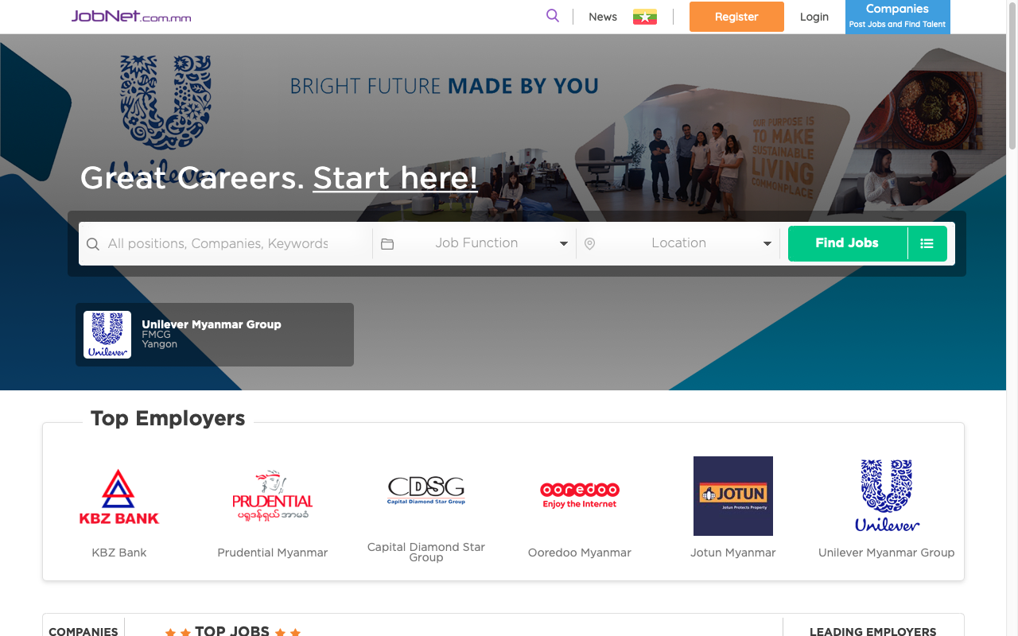

logos



Fig(1.1)

Figure(1.1) is the very first page of the system before login. In that page it shows the search-engine of the jobs and with top employers list so it is very prominent even at a first glance that the system is about finding jobs. It labelled the search box informing the job seekers where to start finding the jobs above the search box and it also clearly labelled the options of the search box and other functions as well. Thus the system has a good visibility of system status.

The system uses the symbols of search box with the commonly used and familiar icons so the customers may easily understand even without reading the labels. The employers are also expressed with both name and their currently using logo so the system is matched with the outside world.

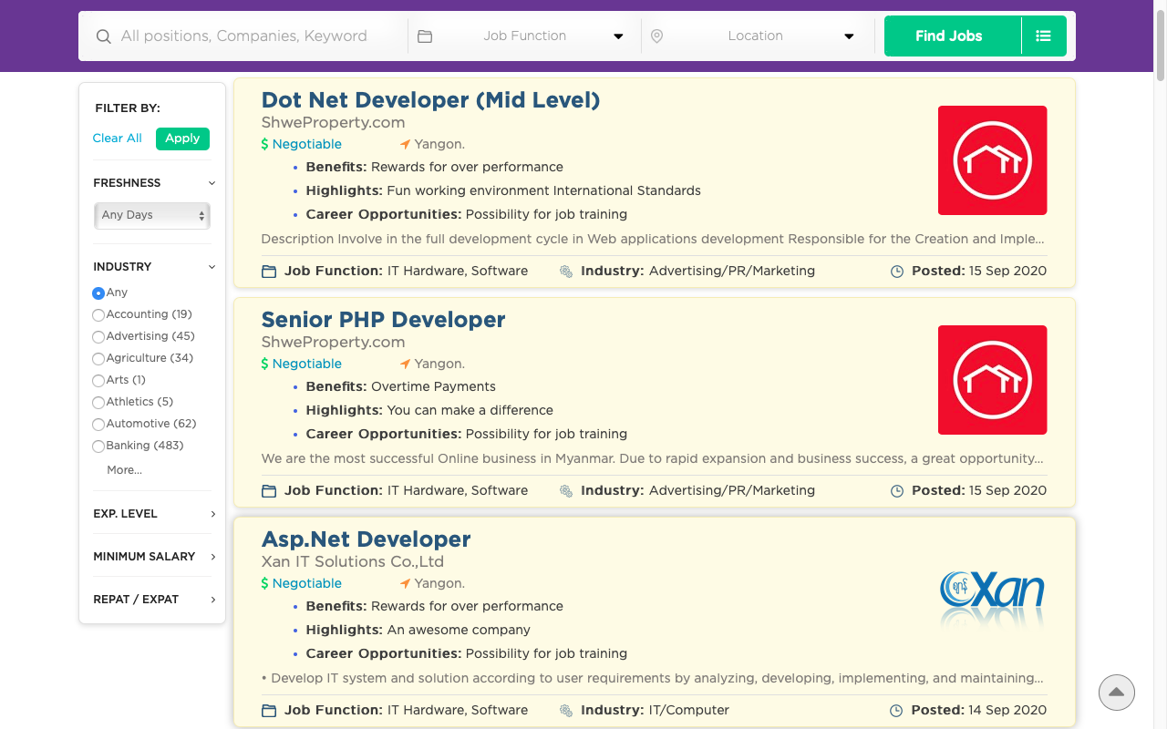

search engine

Fig(1.2)

If the users search for the jobs, the system would lead to the page that show the search results of the users as in Fig(1.2). But the search box also come along to the page which is flexible for the users as they can easily make a search again if the result doesn’t meet their desire jobs so they don’t need to go back to the previous page. The users can click on the list to view the detail of the job and apply the job by clicking the “Apply Now” button as shown below in Fig(1.3).

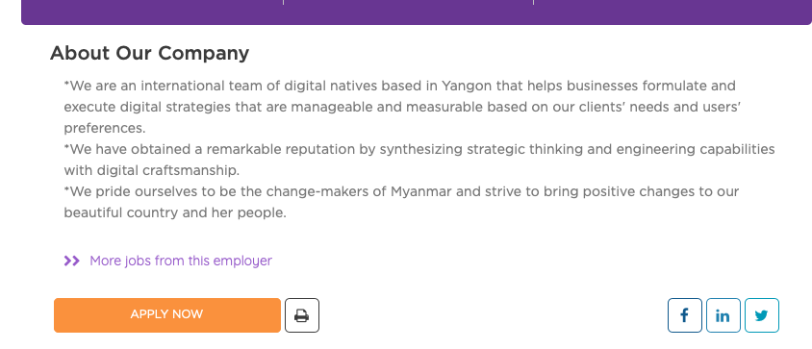

Fig(1.3)

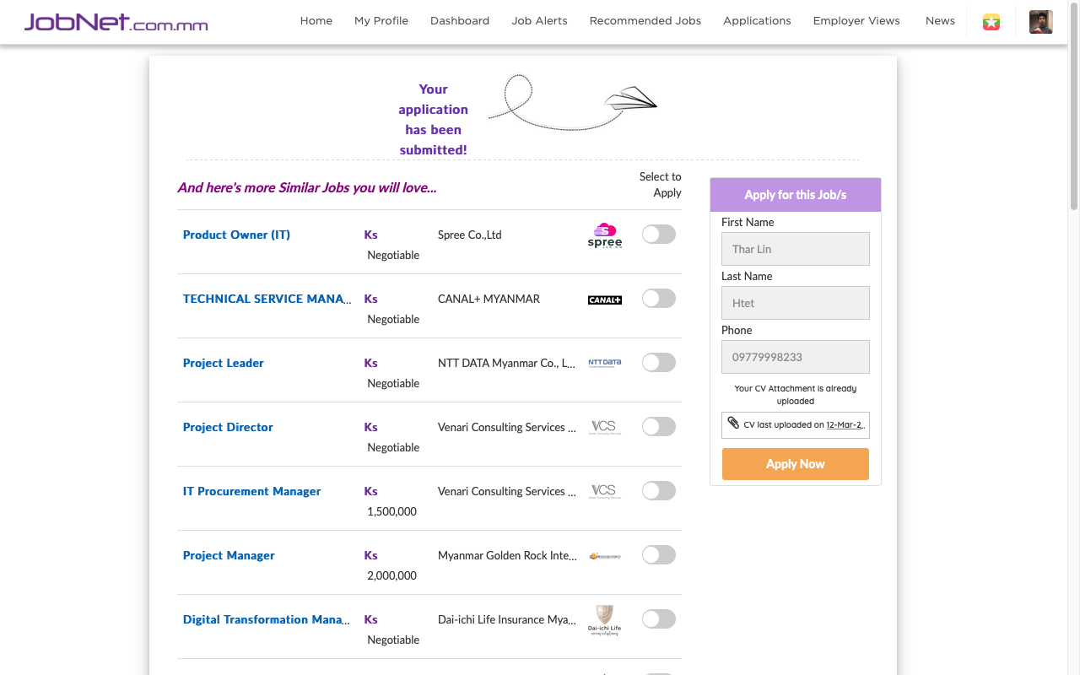

Fig(1.4)

If the user apply the jobs and if it is successful, the system respond with the successful message as shown in Fig(1.4) which is a good visibility of status.

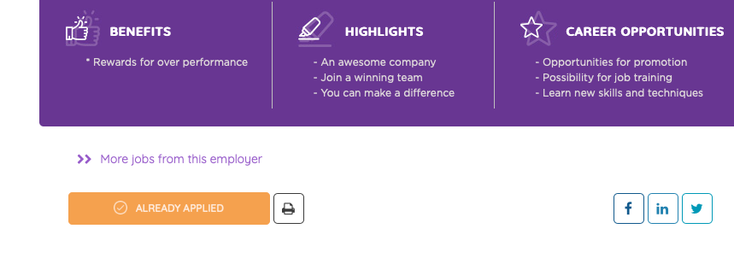

Fig(1.5)

If the job application is successful, the button of the job changes from “Apply Now” to “Already Applied” so the users can easily distinguish which job is already applied so they can recognise rather than recall. This is also a way of error prevention caused by applying multiple times.

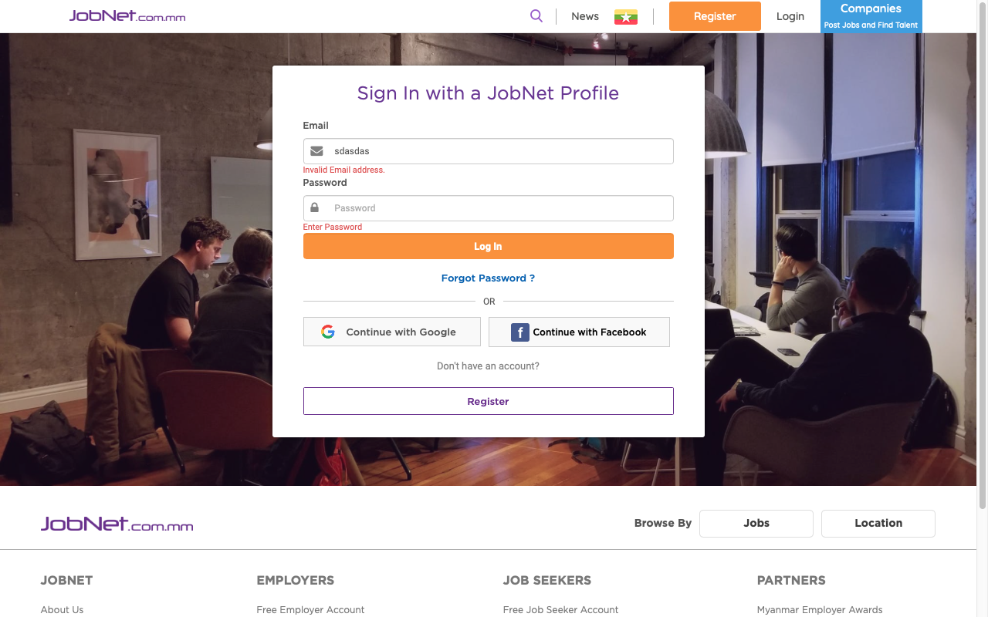

error messages



Fig(1.6)

But if the users haven’t login and click the “Apply Now” button in Figure(1.3) the system lead them to the login page without informing anything to the users. In this way, the experienced users may understand that the system want them to login which is a good aesthetic and minimalist design as it doesn’t show the unnecessary messages for them but for the unexperienced users, the system doesn’t have a good visibility. The login form simply ask for the email and the password from the users. If the user doesn’t have the account yet, there is also a register button around, so the users can easily go to register page which is flexible and efficient for the users.

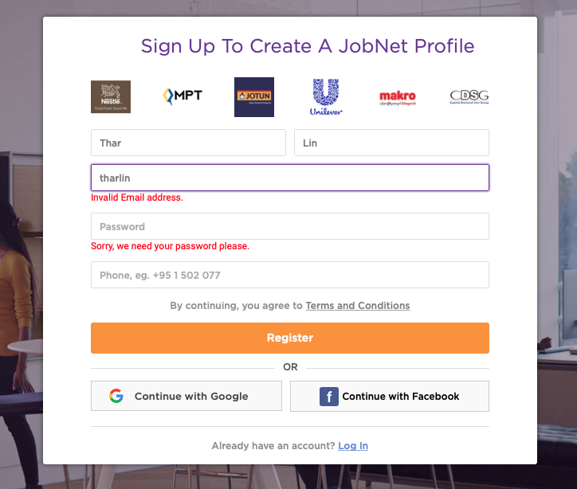

Fig(1.7)

If the users click the register buttons from Fig(1.6), the registration page of Fig(1.7) will be shown up. Both the registration form and login forms simply ask for the input from the users and if the users leave the blank or the information inputted by the user is invalid, the system shows up the error messages as shown in figure(circled in redline). The information is very useful for the users as it clearly expressed whether the information is wrong or the information is required to fill. Thus the system can help users to recognise, diagnose and recover form errors.

Image of user

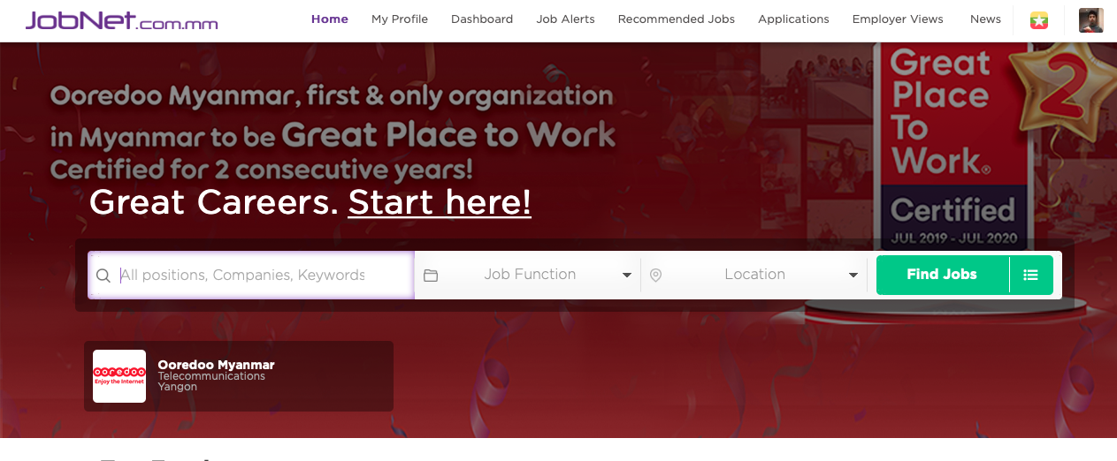

Fig(1.8)

After login the system shows the user image as shown in Fig(1.8) so the users can easily know whether they are already logged into the system or not so it is a good way to satisfy the recognition rather than recall.

The system keep their logo and mostly use white background blue for some text but other colour for the buttons. The system is enough to say it has consistency and standards. Thus, the system adhere with a lot of Jakob Nielsen’s principles.

(Nielsen, 1994)

## 

## 5.2. System Functionality

# 6. CHAPTER 6 – Legal, Social, Ethical and Professional Issues

## 5.1 Legal Issues

* The system should behave according to the job and worker law of Myanmar.
* The data collected for the system should only be accessed by the authorized users according to the data-protection rule.
* The project team should make the contract with the agency and follow the rule and regulation like cost, duration and how the system would behave.
* The cyber-crimes like the hacking, spamming and other cyber-bullying must adhere to the Myanmar’s cyber law and policy.
* The system should be developed with respect to the copyright rule.

## 5.2 Social Issues

* Culture related issues of Myanmar must be considered while developing the system.
* The social views and feedback of the people should also be considered.
* The system should consider the users of the system such as their age, gender, education, etc.
* The system should be socially acceptable and representable.

## 5.3 Ethical Issues

* It is ethically necessary to keep the confidential information, idea and creation of the project safe.
* It is always good to reference to the data owners.
* The developer team should keep in touch with the agency to report the situations in developing the system.

## 5.4 Professional Issues

* Each member of the project team should be qualified to work as a profession.
* There should be a contract that keep the professionalism and make agreements to follow the rules and regulations, salaries , working hours ,etc.
* Professional IT standards and issues should be set up base on the professional body(British Computer Society).
* The project team should stick with local professional policies and rules of Myanmar.

# 7. CHAPTER 7 – REQUIREMENT ANALYSIS

## 7.1. Functional Requirements

After requirement analysis and similar system research, some essential requirements are detected. The system is supposed to contain the following functions to satisfy to requirements of the agency.

1. Registration and Login

* Job-seeker Registration
* Employer Registration
* Login
* Update Registration Details

1. Job Post and Application

* Display available Jobs
* Apply jobs by job-seekers
* Accept or decline application by employers

1. Search Functions

* Search desire job

1. Making Schedules

* Make job schedules for employees

1. Report and Banning

* Report complaints of employees
* Report complaints of jobs
* Ban reported employees

## 7.2. Non-Functional Requirements

The system targets some non-functional requirements which are necessary. They are-

**Reliability**

This is the quality of how the system can work without any failures or error. It is usually measured in Probability Percentage which is the traditional way. The system target to achieve Probability Percentage of 80% for a month under normal usage which mean there’s 80% chance that the system won’t experience critical failure. If there are failures, the number of critical failures and time gap between each failure will also be measured and maintained.

**Maintainability**

Maintainability defines how easily and how fast the system can be fixed from error and failures. It also measures how a system can adapt the changing environment and changes its performance base on that environment. The maintainability is targeted 75% for 24 hours which means that the system has 75% chance to recover from errors and failures within 24 hours.

**Availability**

Availability describes how likely the system is accessible by the clients. The agency system should have at least 98% availability for a month which means the system is available 98% of a month. Availability is a business requirement so the system should have high availability percent.

**Security**

The system must be accessible by authorized users and the confidential data must be protected from the malicious attacks such as malware and cross-site-scripting, etc. The security is very important as the system works on open network thus it can cause trouble from cyber-attacks so security features such as encryption, two-factor authentications and hashing must be performed.

**Usability**

Usability defines how the system could be used easily and efficiently by the users. There should be some test to measure how hard to learn the system, how the much the users satisfy the system and whether it is efficient or not. The results should be fair and reasonable.

(Anon., 2019)

## 7.3. Prioritizations of Requirements

The requirements of the system are identified briefly and they are prioritized using MoSCoW prioritization. By prioritizing, it would be clear to see the main requirements of the system thus the most important ones can be developed first so the main functions can be delivered on time.

**Must Have**

The system clearly needs the basic information of the users and the jobs thus Registration is inevitable. Moreover, the aim of the system is to successfully engage the jobs of the employers to the employees so the Job Application function is also essential. Thus, must-have functions are-

* Registration
* Job Posting
* Job Application

**Should Have**

The system has to deal with many different kinds of jobs and the job seekers should be able to find their desire jobs types or other options. It would be very convenient for them to have a search function. Moreover, the agency faces a lot of complaints if there are problems between employers and employees so the system should be able handle the complaints to its best as possible. So, should-have functions are-

* Search Function
* Report and Banning

**Could Have**

The system still could able to implement some useful functions even if that can make the users more convenient. The schedule function is not essential but it could make the job seekers clearly see the upcoming jobs that are confirmed in an efficient way. Thus could-have function is-

* Making Schedule

**Would Have**

The system would insert more features to attract more users and to make the current users more convenient and easier. As the job seekers can search their desire jobs, the job owners would be able to mark their favourite employees in the system could make them offer to their jobs. The system should able suggest jobs to the job seekers that are supposed to be admired by the job seekers. To make the system more efficient, there should also be the mail-notification system to notify the important messages. Thus would-have functions are-

* Job Suggestions
* Mail Notification
* Mark Favourite Employees

## 7.4. TimeBox Plan

|  |  |  |  |
| --- | --- | --- | --- |
| No | Time Box Name | Date | Deliverables |
| 1 | Registration and login | 06-04-2020 to 09-5-2020 | User registration forms, profiles views |
| 2 | Job Posting and Applications | 10-05-2020 to 26-5-2020 | Job Post form, job list views, job application forms |
| 3 | Report and banning | 27-5-2020 to 11-6-2020 | Report form, banned list view |

# 8. CHAPTER 8 – ENGINEERING AND EXPLORATION

## 8.1. Timebox-1 (Registration and Login)

### 8.1.1 Detail Timebox Plan

|  |  |  |
| --- | --- | --- |
| TimeBox-1 Registration and Login | | |
| Start Date: 06-04-2020 | | End Date: 09-5-2020 |
| **Task** | **Task Name** | **Description of Task** |
| 1 | System Design | * Make prototypes of registration forms and login form * Build up suitable UML diagrams |
| 2 | Database Design | * Create the database users with suitable roles and level * Create suitable database tables and design * Create the database with suitable table structure for employer, job-seeker and agency staff. |
| 3 | System Development | * Develop the system functional requirements. * Develop the system client-side base on the prototypes. |
| 4 | Testing | * Test the registration of each users. * Test whether the profiles can update. * Test the login and logout functions. |

### 8.1.2 Functional Requirement

* Employer Register
* Job Seeker Register
* Agency Staff Register
* Update Profiles
* Login
* Logout

### 8.1.3 Use Case Diagram

### 8.1.4 Use Case Description

Use Case Name: Registration and Login

Actor: Agency Staff, Job Seeker, Employer

Flow of Event: Use Case start when the users of system register

1. User Register the relevant forms.
2. User manage the relevant register information.

This end the Use Case.

Other use case description will show in appendix.

### 8.1.5 Class Diagram

### 8.1.6 Low Level Prototype

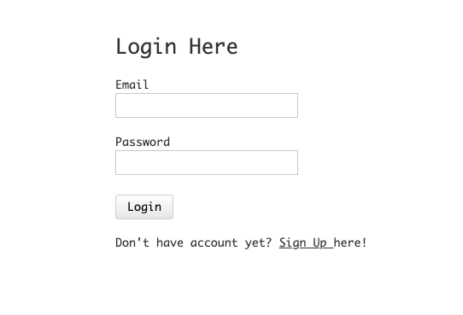

Fig-8.1 (Login Form)

See more prototypes at the appendix

**8.1.7 Database Design**

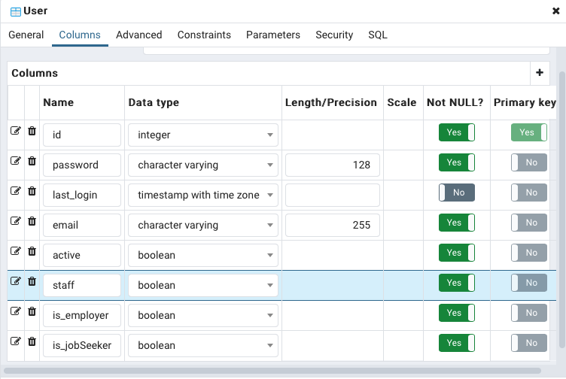

Fig-8.2(User model’s database design)

Other database design will show in appendix.

**8.1.8 Testing Plan**

|  |  |  |  |
| --- | --- | --- | --- |
| No | Function Name | Date | Testing Detail |
| 1 | Job Seeker Register | 11-6-2020  to  14-6-2020 | 1. Check whether register forms validate data. 2. Check whether login form authenticate correctly. 3. Check the profile of each users can successfully update. 4. Check above functions effect the database. 5. Check whether the logout function is working well. |
| 2 | Employer Register |
| 3 | Profile Updates |
| 4 | Login/Logout |

**8.1.9 Test Case**

Tester = Thar Lin Htet

Type of testing = Unit Testing

Testing Date = 11 June 2020

|  |  |  |  |  |
| --- | --- | --- | --- | --- |
| Test Case | T001 | Test Description | Form Initialization Stage | |
| Test Procedure | Test Data | Expected Result | Actual Result | Result |
| Click the “Register” button of Employer Registration form without filling any data. | No input required. | Expect a warning to input form fields. | As expected. | Pass |

Test Evidence (Actual Result)

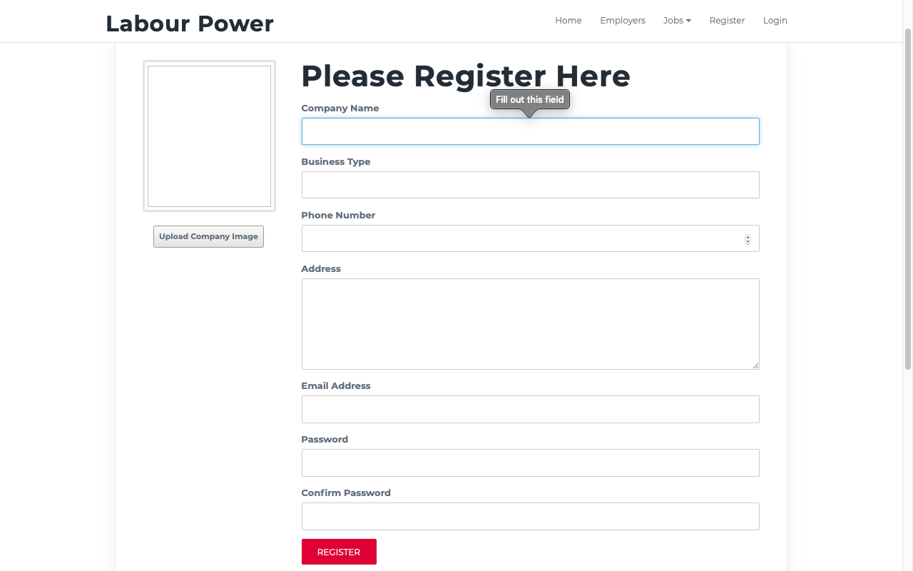

Fig-8.3(Test evidence of T001)

Other test script will show in appendix.

## 8.2. Timebox-2 (Job Application)

### 8.2.1 Detail Timebox Plan

|  |  |  |
| --- | --- | --- |
| TimeBox-2 Job Post and Application | | |
| Start Date: 10-05-2020 | | End Date: 26-05-2020 |
| **Task** | **Task Name** | **Description of Task** |
| 1 | System Design | * Make prototypes of job post form job application and job display views. * Build up suitable UML diagrams. |
| 2 | Database Design | * Create the database with suitable table structure for job and job-applications. * Connect the program to the database with suitable database adapter. |
| 3 | System Development | * Develop the system functional requirements. * Develop the system client-side base on the prototypes. |
| 4 | Testing | * Test the job posting, updating and deleting functions. * Test the job application functions. * Test the job search functions. |

**8.2.2 Functional Requirements**

* Post Job
* Apply Job
* Search Job
* View job list
* View application list
* Schedules

### 8.2.3 Use Case Diagram

### 8.2.4 Use Case Description

Use Case Name: Job Application

Actor: Agency Staff, Job Seeker, Employer

Flow of Event: Use Case start when employer post the job

1. Employer post and manage the job.
2. Job seekers can apply the job.
3. Job seekers could manage the job applications.
4. Employer accept or decline the application.

This end the Use Case.

Other use case description will show in appendix.

### 8.2.5 Class Diagram

### 8.2.6 Database Design

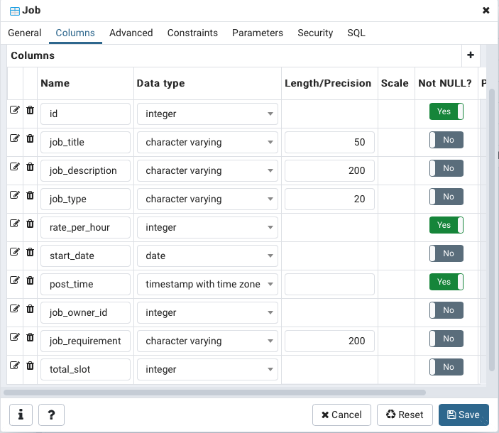

Fig-8.4 (Database design of Job model)

More database design will be shown in appendix

### 8.2.7 Low Level Prototype

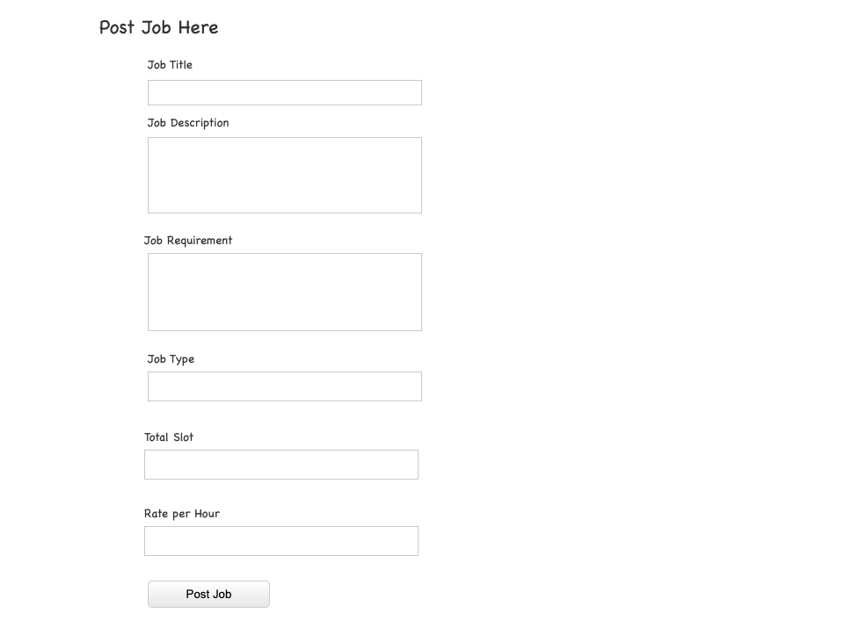

Fig-8.5(Job posting form)

see more prototypes at appendix

**8.2.8 Testing Plan**

|  |  |  |  |
| --- | --- | --- | --- |
| No | Function Name | Date | Testing Detail |
| 1 | Post/Update/Delete Job | 15-6-2020  to  19-6-2020 | 1. Check whether the jobs can post through the form. 2. Check the update and delete functions of posted jobs. 3. Check the job application function works well and the employer can accept or decline. 4. Check above functions effect the database. 5. Check the search functions show the correct search result. |
| 2 | Apply/Cancel Job |
| 3 | Search Job |

**8.2.9 Test Case**

Tester = Thar Lin Htet

Type of testing = Unit Testing

Testing Date = 15 June 2020

|  |  |  |  |  |
| --- | --- | --- | --- | --- |
| Test Case | T005 | Test Description | Form Initialization Stage | |
| Test Procedure | Test Data | Expected Result | Actual Result | Result |
| Click the “Post Job” button of Job posting form without filling any data. | No input required. | Expect a warning to input form fields. | As expected | Pass |

Test Evidence(Actual Result)

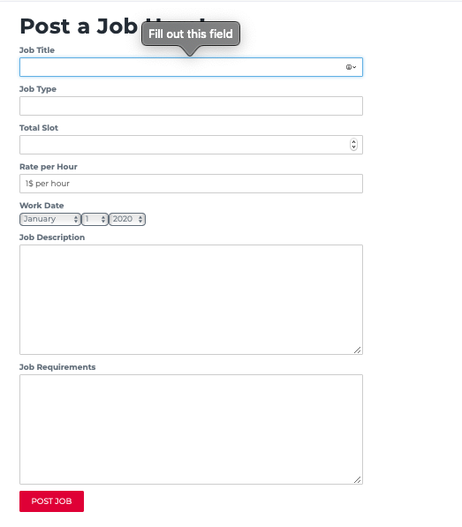

Other test cases will be shown in appendix

## 8.3. Timebox-3 (Report and Banning)

### 8.3.1 Detail Timebox Plan

|  |  |  |
| --- | --- | --- |
| TimeBox-3 Report and Banning | | |
| Start Date: 27-5-2020 | | End Date: 11-6-2020 |
| **Task** | **Task Name** | **Description of Task** |
| 1 | System Design | * Make prototypes of report form and banned list view. * Build up suitable UML diagrams. |
| 2 | Database Design | * Create the database with suitable table structure for job and job-applications. * Connect the program to the database with suitable database adapter. |
| 3 | System Development | * Develop the system functional requirements. * Develop the system client-side base on the prototypes. |
| 4 | Testing | * Test the job posting, updating and deleting functions. * Test the job application functions. * Test the job search functions. |

**8.3.2 Functional Requirements**

* Report workers by employers
* Ban workers by agency staff
* Banned-list view

### 8.3.3 Use Case Diagram

### 8.3.4 Use Case Description

Use Case Name: Report and Banning

Actor: Agency Staff, Employer

Flow of Event: Use Case start when employer post the job

1. Employer can report the unsatisfactory workers.
2. The agency staffs can ban the certain worker from using the system.
3. The staff can also unban them.

This end the Use Case.

Other use case description will show in appendix.

### 8.3.5 Class Diagram

### 8.3.6 Low Level Prototype

**8.3.8 Testing Plan**

|  |  |  |  |
| --- | --- | --- | --- |
| No | Function Name | Date | Testing Detail |
| 1 | Make Report | 20-6-2020  to  25-6-2020 | 1. Check whether report forms validate data. 2. Check the reports can be submitted successfully. 3. Check whether ban and unban functions work well. |
| 2 | Ban Workers |
| 3 | Banned List View |
| 4 | Unban Workers |

**8.3.9 Test Case**

Tester = Thar Lin Htet

Type of testing = Unit Testing

Testing Date = 15 June 2020

|  |  |  |  |  |
| --- | --- | --- | --- | --- |
| Test Case | T005 | Test Description | Form Initialization Stage | |
| Test Procedure | Test Data | Expected Result | Actual Result | Result |
| Click the “Report” button of Job Post form without filling any data. | No input required. | Expect a warning to input form fields. | As expected | Pass |

# 9. CHAPTER 9 – Critical Evaluation

9.1. Evaluation of User Interface