Chapter (Similar System)

Bro thar

## Visibility of system status

 This system has some features that match the visibility status. I will also write in my system design. I also wrote the code carefully and systematically for the layout. It’s very focused on coding, so it fits in well with the visibility system of the status.

## Match between system and the real world

The live icon looks like companies, top jobs and jobs types of the jobnet.com. No suitable icons in horizontal navigation bar. There must be icons for companies and top jobs.

## User control and freedom



Long operation should be YES or NO. All dialogs should have a YES button. And, then to sure answer questions, user will be click to an ‘apply now’ button.

## Consistency and standards



This form of consistency in layout helps users feel less dis-oriented when they browse a new and unfamiliar site. This is an assuming every professional—and probably non-professional-working in fields such as UX design or interaction design.

## Aesthetic and minimalist design

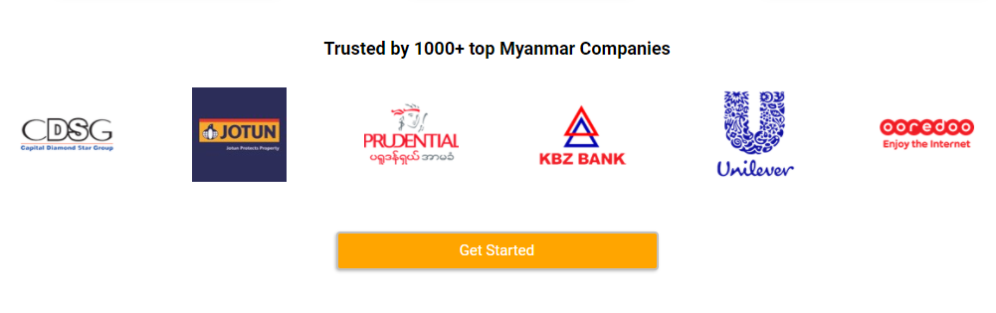

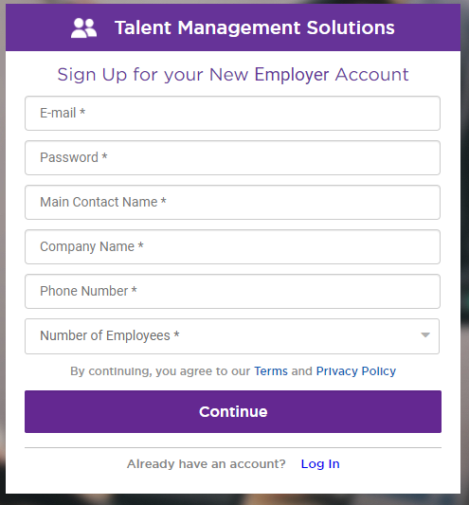

The aesthetic and minimalist design is important to deal with this limitation. And, then we system design has this UI design in our website template. These enable quicker actions and increases the efficiency of the users.

## Help and documentation



In the project system, I have written a documentation to make it easy for users to understand. And users can be helped by one side of the system.