# When the days are cold.



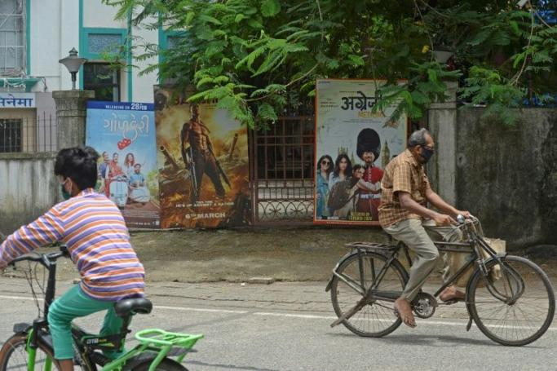

When the days are cold and cards are folded. When the days are cold and cards are folded.  
  
When the days are cold and cards are folded. When the days are cold and cards are folded. When the days are cold and cards are folded.  
  
When the days are cold and cards are folded. When the days are cold and cards are folded. When the days are cold and cards are folded.  
  
  
  
  
  
  
  
   
  
This is a new paragraph