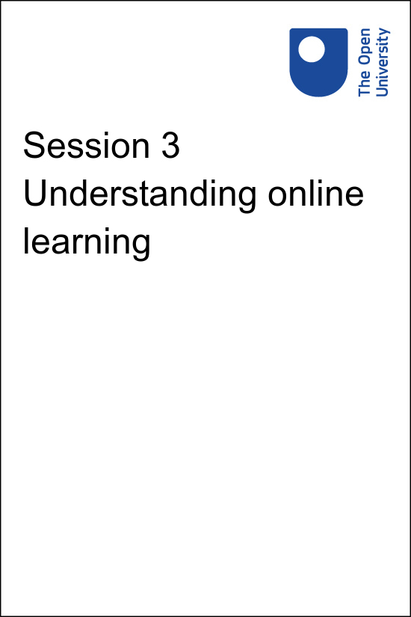

**PUB\_4769\_1.0   Skills for Prosperity: Online Education**

**Session 3 Understanding online learning**

Copyright © 2021 The Open University

All Rights reserved.

# Contents

* [Introduction](#Session1)
* [1 Principles of effective online teaching](#Session2)
  + [1.1 Create a schedule](#Session2_Section1)
  + [1.2 Know the students](#Session2_Section2)
  + [1.3 Foster a sense of community](#Session2_Section3)
* [2 Educational theories that can help take teaching online](#Session3)
  + [2.1 Behaviourism](#Session3_Section1)
  + [2.2 Cognitivism](#Session3_Section2)
  + [2.3 Constructivism](#Session3_Section3)
* [3 Digital technologies for online teaching](#Session4)
  + [3.1 Learning management systems](#Session4_Section1)
  + [3.2 Content creation tools](#Session4_Section2)
  + [3.3 Networking and collaboration tools](#Session4_Section3)
  + [3.4 Enhancing existing tools and materials](#Session4_Section4)
* [4 This session’s quiz](#Session5)
* [Summary](#Session6)
* [References](#References1)
* [Solutions](#Solutions1)

## Introduction

How do universities get started with online education? In this session, you will look at some of the principles that underpin effective online teaching, and how learning theories can inform approaches to online provision. Following this, you will be introduced to a categorisation of the technologies used in online teaching and learning. Pulling all of this together should enable you to plan for learning and teaching facilitated by technology.

## Practitioner reflections

This session begins with a clip from Leanne, who talks about some of the tools and concepts she has found useful in her teaching. In it, she refers to ‘learning objects’, by which she means the different elements of her online teaching. As you watch the video, or read the transcript, make a note of the different types of work Leanne has to do in order to take her teaching online, and consider in each case how other professionals could help her to complete these tasks.

Start of Media Content

Watch the video at [YouTube.com](https://www.youtube.com/watch?v=E1XF4XNGxS4&hl=en&fs=1&rel=0).

[View transcript - Uncaptioned interactive content](" \l "Session1_Transcript1)

End of Media Content

## Learning outcomes

By the end of this session, you should be able to:

* find, evaluate, manage, curate, organise and share digital content for learning, teaching and assessment;
* share learning and teaching materials and resources on appropriate digital sites and networks;
* understand some of the key principles of online teaching;
* relate theories of learning to strategies that can be used to enhance learning online.

## 1 Principles of effective online teaching

Session 2 introduced some of the ways in which online and blended learning can create new opportunities and benefits for educators and learners. In order to realise those benefits, certain principles need to be followed to optimise the experience for learners.

Start of Activity

**Activity 3.1 Challenging preconceptions about online teaching**

Allow about 15 minutes

Start of Question

Watch the video [‘What are some benefits of teaching online?’](https://vimeo.com/420250) and make a note of any concerns expressed that you had not already thought of regarding the teaching context at your university.

Start of Media Content

End of Media Content

End of Question

*Provide your answer…*

[View comment - Activity 3.1 Challenging preconceptions about online teaching](" \l "Session2_Discussion1)

End of Activity

## 1.1 Create a schedule

In a face-to-face teaching environment, educators are not available to learners at all times of the day and night, every day of the week. When moving to an asynchronous online learning environment it is tempting for learners to expect that educators should always be available. Therefore, educators should be supported to establish a set schedule of when they are, and are not, available to learners.

If students need synchronous support, you can schedule drop-in tutorials. Otherwise, educators, managers and collaborators/support staff need to establish expectations across the department (or across the university) that messages and emails will be responded to within a specific time period. For example, if students contact an educator after a certain hour, they should be aware they will not receive a response until the following morning.

Similarly, educators should provide students with a schedule of expectations – giving them dates for each milestone in the course and following up when students miss core deadlines. Developing this schedule and issuing reminders is work that can be done together with collaborators/support staff, including those who are advising on learning design. Establishing expectations in this way will help to keep on track students who are less able to motivate themselves so they can progress through the course.

Information about core deadlines should be repeated often. Educators can do this, but the information can also be built into the learning environment. If there are to be synchronous learning events where participants are required to engage at the same time (such as webinars and group tutorials), students should be reminded of the event several times in the weeks and days leading up to each event. If there is to be a change to planned activities, for example if an educator will be away and unable to respond to messages for a few days, students should be informed well in advance, and an alternative person should be identified for them to contact if they need assistance urgently.

Educators will need to check at regular intervals how students are doing, evaluate their progression through the course materials, and ensure they are being supported. Collaborators/support staff can help with these checks, using data generated by the learning management system (LMS) or virtual learning environment (VLE) (see Section 3.1 later in this session). Students who respond negatively, and those who do not respond at all, will need an educator’s attention to help them develop study strategies to get them back on track.

## 1.2 Know the students

One of the first principles when developing any teaching or training course, whether for online or face-to-face delivery, is to understand the audience. Understanding who the learners are is always key to delivering a good online learning experience.

Through your experience, you probably know quite a lot about the students who enrol for your courses. For example, for each student, you may know:

* their age, gender, ethnicity, and any disabilities;
* their professional or working backgrounds;
* the life experiences they are likely to have had;
* their motivation for attending the course.

Start of Figure

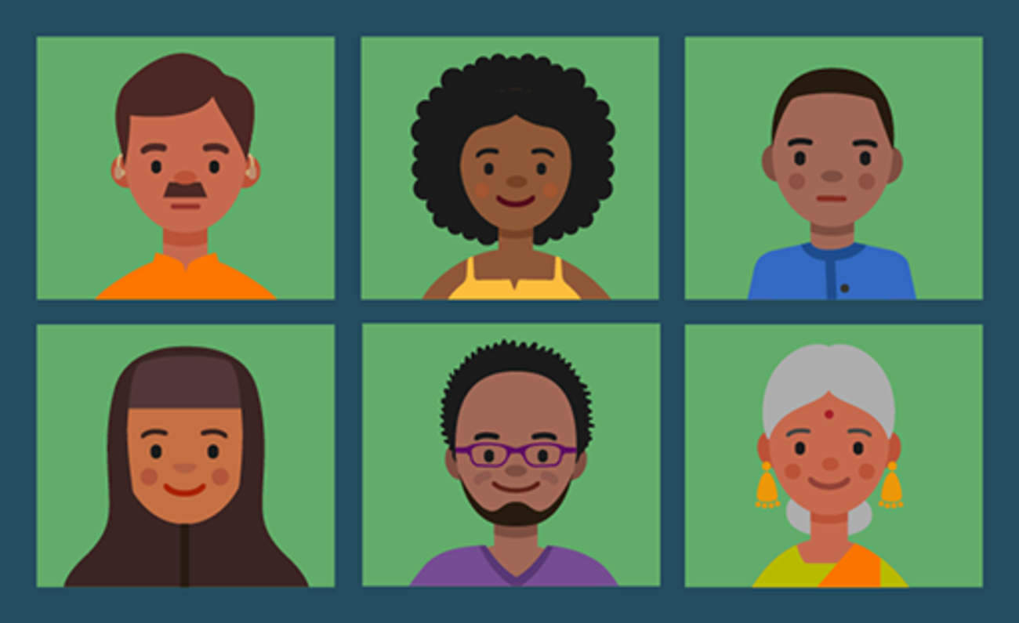

**Figure 3.1** A cohort often includes diverse students.

[View description - Figure 3.1 A cohort often includes diverse students.](" \l "Session2_Description1)

End of Figure

It is important to keep collecting this kind of information so that educators and collaborators/support staff can continue to use it to improve courses and managers can plan for the future.

When moving to online education, teachers, course designers and collaborators/support staff require a range of different information about students. For instance, it is helpful to know:

* how confident and familiar they are working online;
* which technologies and online tools they are already familiar with (for example, video conferences, webinars, social media);
* how easy it is for them to get internet access and whether access is difficult at certain times;
* which devices they use to get online (for example, phone, tablet or computer);
* whether they need any extra resources to make online material accessible to them, (for example, screen readers or writing tools).

In the following video, Charlotte talks about what happened when she moved her training online as a result of COVID-19. She thought carefully about students’ access to technologies and tools. However, when the time came to run the sessions, she realised that some participants were using older models of phones than she had expected, and also that the structure of sessions needed to be planned very differently to work online.

Start of Activity

**Activity 3.2 Learning from experience**

Allow about 30 minutes

Start of Question

Watch the video below, or read the transcript, and make a list of changes that could be made by staff at Charlotte’s institution to improve the online training experience for their learners. Note whether the changes would be initiated and made by (a) managers (b) educators and/or (c) collaborators/support staff.

Start of Media Content

Watch the video at [YouTube.com](https://www.youtube.com/watch?v=pUkPCt9H_g0&hl=en&fs=1&rel=0).

[View transcript - Uncaptioned interactive content](" \l "Session2_Transcript1)

End of Media Content

End of Question

*Provide your answer…*

[View comment - Activity 3.2 Learning from experience](" \l "Session2_Discussion2)

End of Activity

Reflecting on this new knowledge about the students meant the course could be redesigned so that it worked much better.

One way of thinking about different types of learner and how to design an online course to meet their diverse needs is by creating profiles that identify a range of key characteristics. This kind of activity is often referred to as ‘generating personas’, meaning creating descriptions of the sorts of learners you expect to be teaching or supporting. To do this, you can use persona forms such as [this one](http://www.open.ac.uk/blogs/learning-design/wp-content/uploads/2020/07/Student-Profile-form-v2-updated-June-2018-1.pdf), used by The Open University.

Ensuring an online course is accessible to students with disabilities and those with additional needs is particularly important. In fact, online education has the potential to be much more accessible than face-to-face learning. This is partly because participants do not need to travel, and partly because – with asynchronous training – they can study at their own pace and at a time that suits them.

You will find out more about making online education accessible for students with disabilities in Session 7.

Start of Figure

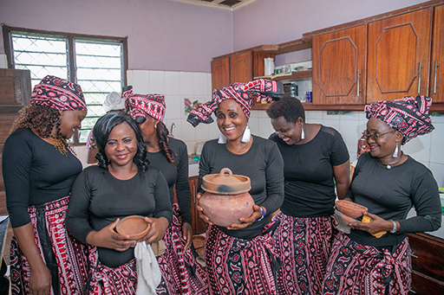

**Figure 3.2** Personas help you to consider in what ways your learners are similar and how their learning needs differ.

[View description - Figure 3.2 Personas help you to consider in what ways your learners are similar and ...](" \l "Session2_Description2)

End of Figure

## 1.3 Foster a sense of community

Learning online is not an individual process – there are many ways of bringing learners together in order to support their studies. Wenger’s (1998) concept of ‘communities of practice’ has become popular in education over the past two decades. Wenger suggests that people who share a common goal or purpose can form a community of practice through which they share insights and experiences. Members of one of these communities are practitioners in a particular area. For example, they might be learning technologists who discuss their ideas and experiences in a shared online space. Participating in a community of practice is a social activity that provides opportunities for learning and strengthens the connections between members.

Building a sense of community is important for online learning, as learners can readily drift away or feel isolated due to the nature of online engagement. It is therefore important that you take steps to keep students together and engaged. This might involve reminding them of what they are supposed to be working on at any given time. Drawing on the concept of communities of practice, the university can emphasise that connecting and sharing with like-minded others can be very beneficial.

Educators may find that they spend less time engaging with students through lectures or traditional sessions because the material is presented in a form that students can access independently at any time. In an online environment, the role of the educator can become more supportive and collegiate, making students aware that their teacher’s primary role is to help them to succeed on the course. To this end, it can be useful for educators to construct an individual relationship with each student rather than always relying on mass or automated emails.

Start of Activity

**Activity 3.3 Benefitting from a community of practice**

Allow about 20 minutes

Start of Question

From the beginning of this course, you have had the opportunity to join the course community of practice via the course Facebook group. Take a few minutes to think about the ways you have used this group. Have your activities been mainly social and to develop your network? Or have you also had some academic or practice-related activities, for example discussing ideas about your projects, practices and research? If you have not engaged with your community of practice, think about the reasons for this.

End of Question

*Provide your answer…*

Start of Question

Now that you have reflected on your engagement (or lack of engagement) with the course community of practice, decide how you would like to engage with it from this session onwards.

End of Question

[View comment - Part](" \l "Session2_Discussion3)

End of Activity

If you have time, and this is a subject that interests you, follow this link to learn more about [communities of practice](https://wenger-trayner.com/introduction-to-communities-of-practice/).

## 2 Educational theories that can help take teaching online

Start of Figure



**Figure 3.3** Theories help us to understand best approaches to online education.

[View description - Figure 3.3 Theories help us to understand best approaches to online education.](" \l "Session3_Description1)

End of Figure

When referring to online education and its advantages for learners, three theories are often discussed. These are behaviourism, cognitivism and constructivism. You do not need to delve deeply into any of these theories, but it is useful to bear in mind the general ideas behind them when considering a move to an online or blended teaching environment.

## 2.1 Behaviourism

Skinner (1968) and Thorndike (1928) were two of the main proponents of behaviourism. Their work examined how behaviour is linked to experience and reward. In the online education context, educators should be aware of the benefits of ‘rewarding’ their students for positive behaviour. One way of doing this is via the assessed elements of the course. Grades, digital badges, records of progress, certificates and qualifications can all be used to mark achievement. Another approach is to offer encouragement and positive feedback for activities such as engaging in discussion or reaching certain milestones.

## 2.2 Cognitivism

Cognitivism largely replaced behaviourism as a theory of education and concentrated on the organisation of knowledge, information processing and decision making. Bruner (1966) suggested that learners should be given opportunities to discover for themselves relationships that are inherent in the learning material, a teaching technique he named ‘scaffolding’. In an online learning environment, this could mean, for example, educators providing regular and focused support to students in the early stages of a course but making less frequent supporting interventions as the students begin to act successfully by themselves.

Ausubel’s work (1960) indicated that it is better to provide some materials in advance, enabling learners to organise their learning approach, so that once the course begins they have already developed much of the skillset they will need to undertake it successfully.

## 2.3 Constructivism

Constructivism is concerned with how knowledge is constructed. The main proponents of constructivism were Piaget (1957) and Vygotsky (1986). Piaget was interested in how knowledge is constructed by the individual, and in particular, how children move through several different stages of development in terms of constructing knowledge.

Vygotsky, who wrote in the 1920s and 1930s and was translated into English several decades later, was more concerned with the important role that the social construction of knowledge has to play in this process. With respect to online education, one of the important notions to take from Vygotsky’s work is the ‘zone of proximal development’, or ZPD. In short, this suggests that learners progress best if they are continually presented with tasks that are just beyond (i.e. proximal to) their current zone of ability or development. If tasks are too simple, boredom ensues, and, for example, a student may drop out of a course. If tasks are too advanced, enthusiasm can be lost, frustration builds and again, the student may lose interest.

Vygotsky suggested that the tasks in that zone of proximal development are ones that most learners can achieve with just a little help – which is where the role of the online educator is vital. Some of the ways in which an educator can offer support and challenge are different from those used in face-to-face settings, as this course will explain.

Start of Activity

**Activity 3.4 How do educational theories match with your practice?**

Allow about 25 minutes

Start of Question

Make brief notes on the differences between behaviourism, cognitivism and constructivism. Are there ideas that are present in your current practice? How do they appear? Do these theories fit with your experiences of learning in general and your learning on this course?

End of Question

*Provide your answer…*

[View comment - Activity 3.4 How do educational theories match with your practice?](" \l "Session3_Discussion1)

End of Activity

In this section you have explored some of the theories that inform the underpinning principles of effective online teaching. However, online education cannot take place without the application of technology, and this is what you will focus on next.

## 3 Digital technologies for online teaching

Start of Figure

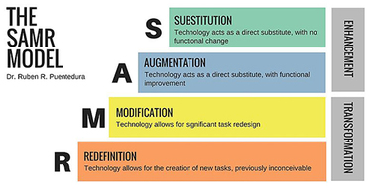

**Figure 3.4** The SAMR model

[View description - Figure 3.4 The SAMR model](" \l "Session4_Description1)

End of Figure

This section of Session 3 gives an overview of the possible technologies available in an online education setting and the ways in which they can support and influence teaching and learning.

The SAMR model categorises four ways in which the introduction of technology changes teaching activity (Puentedura, 2017):

* **Substitution:** Technology is used as a direct substitute for what was done in the past, with no functional change.
* **Augmentation:** Technology is a direct substitute, but there is functional improvement over what was done without the technology.
* **Modification:** Technology makes it possible to redesign the task significantly.
* **Redefinition:** Technology makes it possible to do things that were previously not possible.

As Figure 3.4 shows, the first two ways of using technology for online education lead to an **enhancement** of the teaching practice and potentially the learning experience, while the other two ways (modification and redefinition) lead to the **transformation** of the teaching practice.

There has been substantial debate about the value of, and evidence for, the SAMR model (for example Love, 2015). However, the model has achieved some popularity among researchers and practitioners. Here, it is used as a way to categorise four ways in which technology can be introduced into online education. If you have time, you may wish to explore some of the discussions about the value of this model, starting by following the references in brackets above (full versions of references are provided at the end of each session).

The following sections describe different groups of tools that are commonly used in online education.

## 3.1 Learning management systems

Online courses and courses with any online component are usually delivered using a host platform, commonly referred to as a learning management system (LMS) or virtual learning environment (VLE). These systems (Moodle and Blackboard are popular examples) support the delivery of materials to students, keep track of registered students, and support other tasks such as assessment and communications.

Educators based in traditional universities and colleges will not normally have much input into the selection process when their institution is investing in one of these systems (even ‘free’ LMS systems such as Moodle require investment in terms of adapting and running the product). Usually the role of educators and collaborators/support staff is to find out what possibilities exist for teaching online using the product, and to use the elements that seem most productive in their individual context.

A variety of tools can typically be included, such as e-books, blogs and wikis, quizzes and automated assessment processes, spaces for synchronous and asynchronous learning activities, and repositories for learning objects. The ways in which LMS tools can be used in teaching are covered in more detail in the next session.

## 3.2 Content creation tools

With online learning comes the potential to use a variety of media and to use content creation tools to package them all together to form a coherent learning experience. As well as providing interesting ways to use audio and video in teaching, leading and/or supporting learning, there are online tools available that support the production of graphs and infographics, animations, storyboards and more.

Whatever your role, it is useful to browse and trial a range of software (with a variety of media and presentation formats) to discover which kinds would help bring online education at the university alive. Session 4 of the course provides some guidance on this process. When you have an idea of what you want to create, or want others to create, you will need to identify how the outputs that can be created with these tools can be integrated with the learning management system to create a dynamic and engaging online learning experience.

In addition, you may enable students to use these tools in their online work. Beetham (2007) points out that:

Start of Quote

‘Applications can even be shared to enable collaborative representations to be built, as happens face to face with electronic whiteboards, and with wikis online. Learners’ representations can of course be used for assessment but they can also be re-integrated into the learning situation for reflection and peer review, or even as learning materials for future cohorts.’

(Beetham, 2007, p. 35)

End of Quote

## 3.3 Networking and collaboration tools

Google Docs and other elements of the Google Workspace (as well as similar tools such as Padlet) allow educators to share materials with their students and work on them together in real time, or asynchronously. This can strengthen the teacher-student online relationship, which is particularly valuable in the early stages of a course. In addition, a range of collaborative networking tools can be used to foster group working and a sense of community between students on an online course.

Instant messaging apps can be used to support backchannels (Session 2 of this course introduced backchannels). Activities using Twitter or Pinterest to search for information, or Diigo to gather together relevant internet bookmarks, can help bring an online group together with a shared objective, as well as exposing that group to a wider community in a relevant subject area.

## 3.4 Enhancing existing tools and materials

You may already be used to creating Word documents and PowerPoint presentations, or be familiar with similar word processing and presentation software. Materials in both formats can be repurposed for the online environment. They are a classic example of the ‘substitution category’ of the SAMR model (Puentedura, 2017) where methods used in a face-to-face environment are moved directly online.

With a little more work, static documents featuring text and images can be turned into online exploration tools, linking to websites, animations, videos, blogs and so on to enrich the learning experience. These improved files can then be integrated with other materials using content creation tools, or mounted within an LMS, for example. The next session will cover the practicalities of doing this.

## 4 This session’s quiz

Check what you have learned this session by taking the end-of-session quiz.

[Session 3 practice quiz](http://www.open.edu/openlearn/ocw/mod/oucontent/olinkremote.php?website=PUB_4769_1.0&targetdoc=Session%203%20practice%20quiz)

Open the quiz in a new window or tab, then return to this session when you’re done.

## Summary

In this session you have looked at the core theories and principles that underpin effective online teaching and started to look at the digital technologies involved. In Session 4 you will look in more detail at the technologies that can be used to deliver online education.

Finally, this week, let’s see how Rita’s getting along.

Start of Activity

**Activity 3.5 Reflecting on progress**

Allow about 40 minutes

Start of Question

Watch the video or read the transcript. In it, Rita reflects on Session 3 from her perspective as an educator. Take some time to make notes on the following questions:

1. How does what you have learned in this session relate to your own role?
2. What changes, if any, could you make to your practice or to the wider practice at your university as a result of what you have learned?

Start of Media Content

Watch the video at [YouTube.com](https://www.youtube.com/watch?v=mcbuYGCgb6o&hl=en&fs=1&rel=0).

[View transcript - Uncaptioned interactive content](" \l "Session6_Transcript1)

End of Media Content

End of Question

*Provide your answer…*

End of Activity

You can now go to [Session 4](http://www.open.edu/openlearn/ocw/mod/oucontent/olinkremote.php?website=PUB_4769_1.0&targetdoc=Session%204%20Selecting%20technologies).

## References

Ausubel, D.P. (1960) ‘Use of advance organisers in the learning and retention of meaningful material’, Journal of Educational Psychology, vol. 51, no. 5, pp. 267–72.

Beetham, H. (2007) ‘An approach to learning activity design’, in Beetham, H. and Sharpe, R. (eds) Rethinking Pedagogy for a Digital Age, Oxford, Routledge, pp. 26–40.

Bruner, J.S. (1966) Toward a Theory of Instruction, Cambridge, MA, Harvard University Press.

Cooper, S. (2016) 10 Best Practices To Be An Effective Online Teacher [Online]. Available at <https://elearningindustry.com/10-best-practices-effective-online-teacher> (Accessed 17 June 2021).

Hill, C. (ed.) (2015) 10 Principles of Effective Online Teaching: Best Practices in Distance Education [Online]. Available at <https://www.facultyfocus.com/wp-content/uploads/2015/02/10-Principles-of-Effective-Online-Teaching.pdf> (Accessed 17 June 2021).

Love, C. (2015) SAMR: A model without evidence [Online]. Available at <https://charlielove.org/?p=10025> (Accessed 15 June 2021).

Piaget, J. (1957) ‘The Child and Modern Physics’, Scientific American, vol. 196, no. 3, pp. 46–51.

Puentedura, R.R. (2017) A SAMR Ladder for Teacher Professional Development [Online]. Available at <http://hippasus.com/blog/wp-content/uploads/2017/09/SAMRLadderForTeacherPD.pdf> (Accessed 15 June 2021).

Skinner, B.F. (1968) The Technology of Teaching, New York, NY, Appleton-Century-Crofts.

Thorndike, E.L., Bregman, E.O., Tilton, J.W. and Woodyard, E. (1928) Adult Learning, New York, NY, Macmillan.

Vygotsky, L.S. (1986) Thought and Language (trans. from Russian and revised and edited by A. Kozulin), Cambridge, MA, MIT Press.

Wenger, E. (1998) Communities of Practice: learning, meaning and identity, Cambridge, Cambridge University Press.

## Solutions

## Activity 3.1 Challenging preconceptions about online teaching

#### Comment

Often educators have preconceptions about teaching online and what they or their learners may ‘lose’ if they take their teaching online. This session’s material and activities are designed to help you to separate perceived advantages and disadvantages of teaching online from the real ones, as applied to you in your own context.

Rather than being a simple binary choice, there are many options and ways of tailoring online learning to any context. It is important to be aware of key concepts and types of tools, consider what is known about these, and to have an approach that allows you to trial ways of facilitating online learning and to understand the results. The course will help you to develop in each of these areas.

Searching the web for ‘principles of effective online teaching’ brings up many different takes on the topic, each slightly different. The text includes a summary of some of the key principles that almost always feature in these lists. They have been gathered from a range of sources, but have been inspired in particular by Cooper (2016) and Hill (2015).

[Back to - Activity 3.1 Challenging preconceptions about online teaching](" \l "Session2_Activity1)

## Activity 3.2 Learning from experience

#### Comment

You may have come up with a number of possible changes. Here are some examples:

* Consider learners’ access to technology before planning the training. Depending on the structure of an organisation, this change could be initiated by an educator/trainer or collaborator/support staff (administrator, support tutor etc.).
* Choose an appropriate tool or application for running the training. This change can be initiated by the trainer/educator; however it will require IT and technical staff support to choose the most appropriate and secure tool/app and managers’ support to pay for the licence or other fees (if needed).
* Consider activity types and delivery arrangements. These can be initiated by the educator or trainer when planning a session.

[Back to - Activity 3.2 Learning from experience](" \l "Session2_Activity2)

## Activity 3.3 Benefitting from a community of practice

### Part

#### Comment

Members of a community of practice often engage with the community for a variety of purposes. Sometimes their activities are purely social or purely academic, and sometimes they include a mixture of different activities. Research has shown that when the community is engaged with a balance of different activities, the members benefit the most. Therefore, try to engage with both social and academic/practice-related activities of your course community of practice.

[Back to - Part](" \l "Session2_Part2)

## Activity 3.4 How do educational theories match with your practice?

#### Comment

If you are an educator you are probably familiar with these theories already, but it can be helpful to take a step back and look at your practice with a critical eye. This activity should help you to identify where you draw on the theories. As you move through the course, this should also help you to decide where the theories will play a role in your online practice.

[Back to - Activity 3.4 How do educational theories match with your practice?](" \l "Session3_Activity1)

# Figure 3.1 A cohort often includes diverse students.

## Description

An illustration showing a grid with six people of different ages, genders and races.

[Back to - Figure 3.1 A cohort often includes diverse students.](" \l "Session2_Figure1)

# Figure 3.2 Personas help you to consider in what ways your learners are similar and how their learning needs differ.

## Description

A photograph of six Duruma women who are wearing identical kishutu. Three are holding an object, for example a bowl, in their hands, and three do not hold anything.

[Back to - Figure 3.2 Personas help you to consider in what ways your learners are similar and how their learning needs differ.](" \l "Session2_Figure2)

# Figure 3.3 Theories help us to understand best approaches to online education.

## Description

A photograph of a person sitting on a bed with an open laptop in front of them. They are surrounded by books and a diary.

[Back to - Figure 3.3 Theories help us to understand best approaches to online education.](" \l "Session3_Figure1)

# Figure 3.4 The SAMR model

## Description

A diagram showing the SAMR model. The descriptions of the four components are as given in the body text. Substitution and Augmentation are linked under the heading ‘Enhancement’ and Modification and Redefinition under ‘Transformation’.

[Back to - Figure 3.4 The SAMR model](" \l "Session4_Figure1)

# Uncaptioned interactive content

## Transcript

LEANNE:

Hello! When I first started creating online learning objects, I was surprised at the amount of time that it took. Compared to my previous face-to-face teaching experiences, I had to dramatically change the way in which I planned for learning opportunities when taking them online. I quickly realised that the ability that you have in class to change the direction and adapt to the needs of learners quickly didn’t exist, so much more thought about the different routes that students could take needed to be considered in advance.

Although this felt a little daunting at first, the benefits for students soon became apparent. They could access the learning at a time, location and pace appropriate to them as individuals. The creation of digital badges is something that has had a particular impact on my teaching practice. After being really motivated when I was awarded some digital badges myself on an online course that I was completing, I decided to use them with my students.

In the past, I found it difficult to acknowledge and track the progress made by students online when it comes to the acquisition of skills. This was particularly important in my context, as students were studying a practical biology course. By introducing a range of digital badges to represent the various skills developed on the course, students had a way of demonstrating the progress they made.

Creating learning objects can be time-consuming initially, but will save you time in the long run. I would recommend for anyone to take their teaching online in this way.

[Back to - Uncaptioned interactive content](" \l "Session1_MediaContent1)

# Uncaptioned interactive content

## Transcript

CHARLOTTE:

So, what I’m going to share with you is an experience that we as a programme are going through, as a way to adapt the way that we do capacity development for our volunteers during this COVID era. We were one of the organisations that used to do face-to-face trainings, because we totally believed that children interaction plays a key role in building skills, knowledge and attitudes that are essential in implementing a programme. But, unfortunately, due to COVID, we couldn’t meet, so we had to adapt the way that we interact with our volunteers fast.

One of the things that we ended up settling for, as a programme, is the use of WhatsApp. Why the use of WhatsApp is because we thought every volunteer had a phone, every volunteer could type, and every volunteer could buy, you know, bundles. They are really cheap, and it would enable them to then just give an interaction within the platforms.

But I must say things are not always as we expect them to be. Yes, people had phones. Yes, they had experience in typing, but the experience we later learned during our trainings is that we would, for example, ask our volunteers to use emojis just to show their presence in a workshop. For some, with big phones, it was easy. They would quickly look for a smiley and then press on it. And voila – it comes.

But for some with small phones that need extra buttons they had to work extra hard to get to that image, and sometimes it would take a lot of time than anticipated, meaning by the time they get to see the image and send it, we would be doing question number one, question number two. So that was the biggest problem that we noticed.

The second thing that we noticed is that not everyone was quick in typing and reading. So, in a group WhatsApp platform where you have about 40 participants, everyone is busy typing an answer in response to what the facilitators asked. One wants to read and check whether what they want to write has not already been mentioned. One wants to also learn what others are saying. At the same time, they also want to concentrate with putting their response to the question. By the time they actually press ‘Enter’, what will happen is we are on question number three. So, we realised that pace, typing skills, general knowledge, and appreciation of WhatsApp functions were crucial, and were things that we had taken for granted, mainly because we just thought everyone works with WhatsApp.

How we have managed to work around this problem is that we have introduced another module where we still use WhatsApp platforms, but what we now do is we send information in advance to different groups, so they’re working groups of about five volunteers at a time. They read through the materials. They discuss in their free time before the actual training date.

When they come for the actual training date, what they then do is they are simply giving feedback to what they’ve discussed as a group. The good part about this is that it enables different groups to share experience that they actually do within their school hubs. It enables participants to ask each other questions, comments, clarifications on why they’ve done things in a certain way. And it enables, for example, the facilitator to give the leading role to the participants, because they then determine what is crucial to understand within the training itself, and what new ideas they are then – what they're picking, unlike our old model, where everything used to be sent out to the group, then the facilitator, then they would get to summarise it for everyone for them to be on the same level.

[Back to - Uncaptioned interactive content](" \l "Session2_MediaContent2)

# Uncaptioned interactive content

## Transcript

RITA:

This was interesting. I can see now how my existing knowledge of teaching theories fits into what I want to do online, and I can also understand which technologies I will need to use.

My institution has a learning management system, so I can use that to host the resources I want to use in my teaching online.

I already use PowerPoint presentations and web-based resources to teach this subject in the classroom, so I should be able to reuse some of those in the online setting. But I will need to turn around some of my lessons if I want to use the ‘flipped classroom’ technique.

I can already see that some of my lessons can become good learning objects, and this would allow the learners to interact with them on their own or in groups. I think the more I can develop the teaching resources to stand alone, with good quality instructions, the more successful this is likely to be. Of course, there are differences when I’m not available to offer help immediately as I am in the classroom.

I will need to be prepared to also create some new learning objects, to fill the gaps where I currently use classroom-based activities.

I’ve had a quick look ahead, and in the next two weeks of this course we’ll learn more about choosing technologies, and think about online networks as a source of help and inspiration. So that will help guide me.

[Back to - Uncaptioned interactive content](" \l "Session6_MediaContent1)