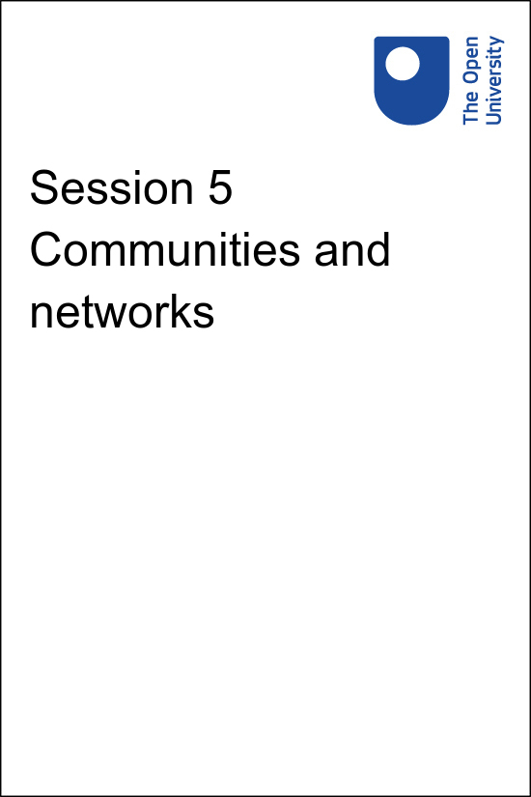

**PUB\_4769\_1.0   Skills for Prosperity: Online Education**

**Session 5 Communities and networks**

Copyright © 2021 The Open University

All Rights reserved.

# Contents

* [Introduction](#Session1)
* [1 Benefits of engaging with online networks](#Session2)
  + [1.1 Sharing ideas and resources](#Session2_Section1)
  + [1.2 Professional development](#Session2_Section2)
  + [1.3 Making contacts](#Session2_Section3)
* [2 Communities](#Session3)
  + [2.1 Communities of practice](#Session3_Section1)
* [3 Developing communities of practice](#Session4)
  + [3.1 Microblogging](#Session4_Section1)
* [4 This session’s quiz](#Session5)
* [Summary](#Session6)
* [Solutions](#Solutions1)

## Introduction

Start of Figure

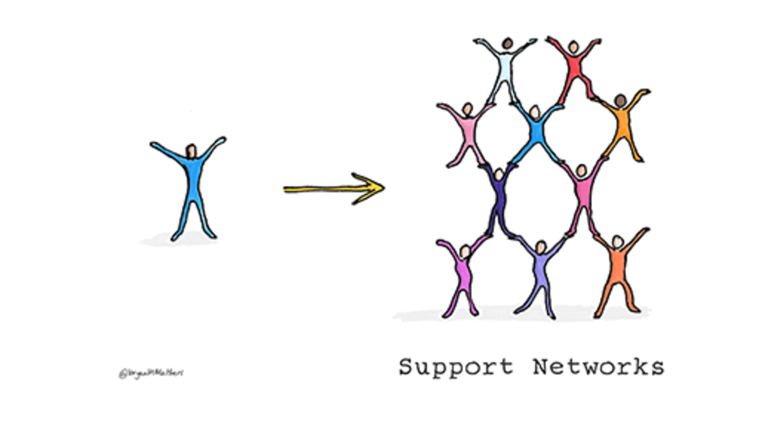

**Figure 5.1** Technology gives us the opportunity to connect widely.

[View description - Figure 5.1 Technology gives us the opportunity to connect widely.](" \l "Session1_Description1)

End of Figure

One of the most effective ways to build confidence and ability in teaching and supporting learners online is to connect and talk with others. This may involve forming a network of peers who are at a similar stage and can share experiences, test ideas and offer moral support. It may involve connecting to people who have already achieved the same objective and can provide useful advice.

A great advantage of using online tools, particularly social networking tools such as Telegram, WhatsApp or Facebook, is that individuals are not limited to one physical or online place. They can decide what to discuss, how, when and with whom. Participation in these networks is sometimes described as either active or passive.

Passive participation does not involve any online engagement that is visible to others. Simply reading the comments of others without initiating or responding to a post is a form of passive engagement (sometimes referred to as ‘lurking’). ‘Active’ online learners make contributions that are obvious to others, for example, sharing resources or discussing ideas.

However, these labels may be misleading because they are based on what can be seen of a learner’s activity online. From the perspective of those online, ‘passive’ learners appear not to be engaging because they make no obvious contribution. However, they may actually be very active – reading everything, making notes, bookmarking sites, and discussing ideas with friends and colleagues. On the other hand, ‘active’ learners may appear to be working hard because their activity is visible online, but – on closer inspection – their contributions may be low quality or off topic.

Understanding concepts such as synchronous and asynchronous communication will help with online teaching. These concepts apply to a variety of platforms and tools: for example, social networking tools include discussion or message boards. They also provide ways of sharing and curating information, for example through social bookmarking and micro-blogging. Individuals can share resources and findings of their work online and can also find information and resources shared by others with similar interests.

This session covers advantages that can be gained by expanding online networks, and provides guidelines and tips for developing professional networks.

## Practitioner reflections

The session starts with another video from educator Sarah. Here she reflects on her experiences with online networks. As you watch the video or read the transcript, make a note of the different ways in which Sarah uses Facebook and Twitter to support her teaching.

Start of Media Content

Watch the video at [YouTube.com](https://www.youtube.com/watch?v=sAkdqP_Igic&hl=en&fs=1&rel=0).

[View transcript - Uncaptioned interactive content](" \l "Session1_Transcript1)

End of Media Content

## Learning outcomes

By the end of this session, you should be able to:

* stay up to date with how digital tools are changing learning and teaching practices;
* participate in and facilitate digital teams, working groups and networks;
* collaborate effectively in digital spaces;
* participate actively in social media relevant to your professional role and interests;
* share learning and teaching materials, presentations, resources etc. on appropriate digital sites and networks;
* develop and project a positive digital identity (or identities) in your professional role and manage your digital reputation across a range of platforms.

## 1 Benefits of engaging with online networks

Start of Figure



**Figure 5.2** People come together for all sorts of reasons – social and professional – and networks can help with this.

[View description - Figure 5.2 People come together for all sorts of reasons – social and professional ...](" \l "Session2_Description1)

End of Figure

The term ‘network’ is often used in relation to computers and digital information. See, for example, this quote from an article about the value of connecting computers together to form networks:

Start of Quote

‘Most of the benefits of networking can be divided into two generic categories: connectivity and sharing. Networks allow computers, and hence their users, to be connected together. They also allow for the easy sharing of information and resources, and cooperation between the devices in other ways. Since modern business depends so much on the intelligent flow and management of information, this tells you a lot about why networking is so valuable.’

(Kozierok, 2005)

End of Quote

With just a few amendments, this quote can describe the benefits of social networking to any educator:

Start of Quote

Most of the benefits of networking can be divided into two generic categories: connectivity and sharing. Networks allow educators to be connected together. They also allow for the easy sharing of information and resources, and cooperation between the educators in other ways. Since online education depends so much on the intelligent flow and management of information, this tells you a lot about why networking is so valuable.

End of Quote

As described in previous sessions, online education requires thought and planning. There is also perhaps a little risk in trying new technologies and techniques. You and your colleagues may feel nervous about designing or delivering a course online, but remember that you are not alone. Reaching out to networks of people who are either in a similar position or have already done what you are starting to do can provide support and reassurance

People have different expectations about what networking is and what they are using it for. Networking can be largely invisible to others and only partly visible to the direct participants in any exchange. This is true whether networking occurs face to face or online. It is not always clear whether a person is actively networking or just having a chat. Often one becomes the other without anyone formally recognising it. Networking can be formal – introducing yourself to a group at a face-to-face conference or posting in an online discussion forum, for example. Networking can also occur much less formally, for example by following relevant Twitter accounts, or by chatting to colleagues or peers, whether face to face or via social media such as WhatsApp or Facebook.

There are several benefits to participating in networking activities and these will be discussed in the following section.

## 1.1 Sharing ideas and resources

Start of Figure



**Figure 5.3** Social-networking sites enable you to easily connect to and communicate with others in your field.

[View description - Figure 5.3 Social-networking sites enable you to easily connect to and communicate ...](" \l "Session2_Description2)

End of Figure

Educators and those supporting or leading learning can use social networks to share ideas, tips and tricks, or resources with others in a similar position. They can join an online network and simply observe without contributing, or they might comment on other people’s ideas, and use them for their own inspiration. They can also share their ideas with others and obtain valuable feedback that improves their work.

When considering partnerships, networks and communities, it is wise to be aware of potential ‘boundaries’. These may include perspectives and power relations between different types of people, different roles, even different pay grades (MacGillivray, 2017). These distinctions will not necessarily limit the types of contribution that any individual makes, however, it is often worth observing a network to understand how it works before participating actively.

When you have established a ‘presence’ in a network, you are likely to find your relationships with certain individuals are of particular value. You may start to ask specific people for advice or find you are commenting more freely on their materials. These interactions can be channelled into the formation of a community of practice (this will be explored further in Section 2 of this session).

You can also use social networks to make connections with peers who are more experienced. Do not be afraid to reach out to those who may have more experience to ask for advice on how best to approach an element of online education. If someone reaches out to you for guidance, return the favour.

## 1.2 Professional development

While social networking can be informal and outside the regular work environment, its value to staff professional development can be considerable (Davis, 2011). By sharing with peers and experts via networks, people can advance their online skillsets more rapidly than they would do alone. They can also solve problems or deal with issues by asking for assistance from their networks. In addition, beyond the subject matter of online education, simply developing the skill of effective networking is a part of professional development. Many educational institutions now actively support their staff to develop social networks and recognise the value of doing this.

Start of Activity

**Activity 5.1 Social networking tools**

Allow about 20 minutes

Start of Question

1. Make a list of what you think are the key benefits of and challenges to using social networks to support your professional development. While you are doing this, reflect on any previous experience you might have of using social networks and whether the challenges are different now to a year or two ago.
2. Select two benefits and two challenges and post them on your course community of practice Facebook group. When sharing your thoughts, you could explain why you consider these important benefits and challenges. If you have not joined the [community of practice Facebook group](https://www.facebook.com/groups/550668899635715), you could discuss these ideas with colleagues within your university.
3. Revisit the page later to view or comment on new posts. Are your views similar to or different from those of others?

End of Question

*Provide your answer...*

[View comment - Activity 5.1 Social networking tools](" \l "Session2_Discussion1)

End of Activity

## 1.3 Making contacts

Social networking can remove many of the barriers to engaging in dialogue with the leading people in a field. A couple of decades ago it would be difficult to interact with a particular expert unless you were attending the same event. Now social and professional networks such as Twitter, LinkedIn and ResearchGate can be used to ask an expert a question. Social networking has made the education world much more accessible to its members than it has ever been before (Davis, 2011).

Start of Activity

**Activity 5.2 Identifying your existing roles in networks**

Allow about 30 minutes

Start of Question

Complete the following table. Which of the following networks do you already participate in? In each case, consider the type of participation you have with each network. (Participation described as ‘informal’ can take place as needed, on any topic, sometimes unrelated to your own practice; participation described as ‘formal’ would be focused on improving your practice or sharing resources.)

Start of Table

Table 5.1 Types of involvement in online networks

|  |  |  |  |  |  |
| --- | --- | --- | --- | --- | --- |
| **Type of participation > Type of network** | **Observer (reading other people’s input but not contributing directly)** | **Responder (answering questions or commenting on discussions)** | **Text contributor (posting questions or starting discussions)** | **Information contributor (providing factual information that is not your own material)** | **Sharer (contributing your own material for discussion or reuse)** |
| Informal online contact with people in your organisation that you interact with mostly face to face. | *Provide your answer...* | *Provide your answer...* | *Provide your answer...* | *Provide your answer...* | *Provide your answer...* |
| Informal online contact with people in your organisation that you interact with mostly online. | *Provide your answer...* | *Provide your answer...* | *Provide your answer...* | *Provide your answer...* | *Provide your answer...* |
| Informal online contact with people in other organisations that you have met face to face at some time. | *Provide your answer...* | *Provide your answer...* | *Provide your answer...* | *Provide your answer...* | *Provide your answer...* |
| Informal online contact with people who have come together informally via social media. | *Provide your answer...* | *Provide your answer...* | *Provide your answer...* | *Provide your answer...* | *Provide your answer...* |
| Formal online contact with people of the same subject discipline or age group. | *Provide your answer...* | *Provide your answer...* | *Provide your answer...* | *Provide your answer...* | *Provide your answer...* |
| Formal online contact with people of many backgrounds focused on particular teaching topics (e.g. flipped classrooms, online teaching etc.) | *Provide your answer...* | *Provide your answer...* | *Provide your answer...* | *Provide your answer...* | *Provide your answer...* |
| Formal online contact with other members of educational or related organisations (e.g. members of professional bodies, unions etc.) | *Provide your answer...* | *Provide your answer...* | *Provide your answer...* | *Provide your answer...* | *Provide your answer...* |
| Formal or informal online contact with other members of this course | *Provide your answer...* | *Provide your answer...* | *Provide your answer...* | *Provide your answer...* | *Provide your answer...* |

End of Table

End of Question

[View comment - Activity 5.2 Identifying your existing roles in networks](" \l "Session2_Discussion2)

End of Activity

## 2 Communities

Start of Figure

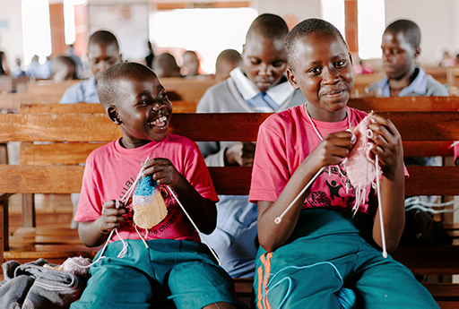

**Figure 5.4** Members of communities usually have stronger connections than people loosely connected in a network.

[View description - Figure 5.4 Members of communities usually have stronger connections than people loosely ...](" \l "Session3_Description1)

End of Figure

When groups of people come together online around a particular topic or job role, they are often referred to as communities. Communities are more bounded than networks. There is usually some restriction on membership and, as a result, a greater degree of trust between members. For example, to be part of a community of physics lecturers, you would need to be employed in that role or to have worked in that role. You would be more likely to trust the views of a member of that community on physics and related subjects than a member of the general public.

Communities can be central to helping to develop an approach to online education. For example, educators can seek guidance from their teaching community about how to design an online activity or find out who the experts are in a specific field of practice. Whatever your reason for seeking contact with others in the field, participating in a relevant community can be of great value, and it can lead to personal skills development, exchanging knowledge and developing practice.

## 2.1 Communities of practice

Communities come in many forms. When the concept of ‘communities of practice’ was discussed in Session 3, it was noted that communities can develop wherever a common interest exists between individuals, such as a shared profession:

Start of Quote

‘Communities of practice are groups of people who share a concern or a passion for something they do and learn how to do it better as they interact regularly. Note that this definition allows for, but does not assume, intentionality: learning can be the reason the community comes together or an incidental outcome of members’ interactions.’

(Wenger-Trayner and Wenger-Trayner, 2015)

End of Quote

The Wenger-Trayners, who are leaders in this area, suggest there are three key characteristics of a community of practice:

* **A shared domain of interest.** A community of practice is not just a group of friends; membership implies a commitment to the domain, and therefore a shared competence that distinguishes members from other people.
* **An active community**, sharing and exploring the domain. Members engage in joint activities and discussions, help each other and share information. They build relationships that enable them to learn from each other and they care about their standing with each other. However, they do not necessarily work together on a daily basis.
* **An impact on the practice of those involved.** Members of a community of practice are practitioners. They develop a shared set of resources: experiences, stories, tools, ways of addressing recurring problems – in short, a shared practice. This takes time and sustained interaction.

The Wenger-Trayners state that ‘it is the combination of these three elements that constitutes a community of practice, and it is by developing these three elements in parallel that one cultivates such a community’. Networks can develop into communities of practice but will usually require sustained effort and contributions to persist.

Start of Activity

**Activity 5.3 Your communities of practice**

Allow about 20 minutes

Start of Question

Think about the range of social and professional communities you belong to. Reflect on why they work so well (and if they do not work well, why not). Is there a difference between a ‘network’ and a ‘community’? Are these inclusive communities?

Share your reflections about the value you get from belonging to these communities with others in the course via the course community of practice Facebook group. Read the contributions of others and note any suggestions they have made that you could benefit from in the future. If you have not joined the [community of practice Facebook group](https://www.facebook.com/groups/550668899635715), you could discuss your reflections with colleagues at your university.

End of Question

*Provide your answer…*

[View comment - Activity 5.3 Your communities of practice](" \l "Session3_Discussion1)

End of Activity

## 3 Developing communities of practice

You may be looking for a wider community, wanting to find out about best practice, interested in the latest developments, or seeking to help others by sharing successful techniques and technologies. In all these cases you are likely to find it valuable to connect with like-minded people by expanding your networks and joining (or helping establish) one or more communities of practice.

Start of Figure



**Figure 5.5** Technology allows us to form networks globally, not just with those immediately around us.

[View description - Figure 5.5 Technology allows us to form networks globally, not just with those immediately ...](" \l "Session4_Description1)

End of Figure

One way of expanding work-related networks is to join an established community of practice (Krutka et al., 2014). This can be done by:

* searching the internet for communities related to your work;
* joining one or more of these communities, observing the discussions that take place, and deciding whether you would benefit from taking a more active role;
* choosing one or two of these communities for more active participation and using these to establish/develop your professional identity, skills and a sense of membership.

For those working in education, there are several services that offer ways to find and connect with others. One of the most widely used is the professional networking site [LinkedIn](https://gb.linkedin.com/), which provides for all kinds of professionals and claims to be ‘the world’s largest professional network on the Internet’ (LinkedIn, 2020). For those working in higher education, more specialised social-networking services are available, such as [Academia](https://www.academia.edu/) and [ResearchGate](https://www.researchgate.net/), which help academics and researchers engage with each other through sharing publications and facilitating communication.

## 3.1 Microblogging

A useful way to make contact with like-minded people is to use a microblogging site such as Twitter (Carpenter & Krutka, 2014) or Tumblr. However, millions of posts are made every day to microblogging sites, so it is important to think about how you want to engage and manage your interactions. You may find the following actions useful:

* **Gather information on a particular subject.** Make a list of keywords or hashtags to search for. Hashtags may be long or short. They start with the hash symbol (#) and can include phrases and acronyms, but without spaces, for example #DigitalUniversity or #OpenLearn.
* **Follow and learn from experts in a particular subject.** List the names of the experts to search for.
* **Look at the profiles of experts to see who they follow.** A lot of the people they follow are likely to be of interest to you.
* **Make connections with people in a similar position to yourself.** Think of ideas about how you might find those people – how will you search for them? You may need to combine some keywords or hashtags into a single search, enabling you to filter out information that is related, but not precisely what you are looking for.
* **Share your own work.** Identify precisely which items you would like to share, list some keywords and hashtags that might describe your work, and practise creating a short microblogging message that describes your work succinctly.

Services such as Twitter are relatively easy to use. The instructions below will help you to maximise the benefits of Twitter. If you use a different tool the same principles apply, but you will need to alter the method and tools to suit your platform.

* Create an account on [Twitter](https://twitter.com/).
* Use your Twitter account to register with [TweetDeck](https://tweetdeck.twitter.com/). TweetDeck is a very good way to make sense of the vast amount of information on Twitter and helps you to arrange the information you need in easily managed columns.
* Use the search function in TweetDeck to generate new columns relating to your keywords or hashtags of interest, or search for experts and follow them – all tweets from accounts that you follow will appear in your Home column in TweetDeck in chronological order.
* If you are looking for peers, first find and follow likely people – they may well follow you back (it is good Twitter etiquette to follow individuals who follow you). When you are familiar with each other’s tweets, you could suggest forming a List (a column in your TweetDeck that gathers tweets from selected individuals which others can subscribe to).
* If you want to share your own work, learn from how others do it. Observe how they use their tweets, how they ask for feedback or for others to retweet them. Aim to build a good number of followers before sharing your work so that their retweets will increase your reach.

Start of Activity

**Activity 5.4 Sharing information**

Allow about 40 minutes

Start of Question

Think again about the professional networks and communities you already belong to (formal and informal) and consider how these communities share information. What tools do they use? How do you decide which information can be trusted?

Pick one example. How could they use other channels or social media to improve the flow of information?

Now think about the community of practice that is forming around this course. What could you do to maximise the benefits for you and for other members?

End of Question

*Provide your answer...*

[View comment - Activity 5.4 Sharing information](" \l "Session4_Discussion1)

End of Activity

## 4 This session’s quiz

Check what you have learned this session by taking the end-of-session quiz.

[Session 5 practice quiz](http://www.open.edu/openlearn/ocw/mod/oucontent/olinkremote.php?website=PUB_4769_1.0&targetdoc=Session%205%20practice%20quiz)

Open the quiz in a new window or tab, then return to this session when you’re done.

## Summary

This session has presented a variety of possible paths to become a more networked professional. It has highlighted the benefits of being connected to others with similar interests or areas of practice. Hopefully you now have some ideas about where you want your networking to go next – Rita has certainly got a few ideas!

Start of Activity

**Activity 5.5 Reflecting on progress**

Allow about 20 minutes

Start of Question

Watch the video or read the transcript. In it, Rita reflects on Session 5 from her perspective as an educator. Take some time to make notes on the following questions:

1. How does what you have learned in this session relate to your own role?
2. What changes, if any, could you make to your practice or to the wider practice at your university as a result of what you have learned?

End of Question

Start of Media Content

Watch the video at [YouTube.com](https://www.youtube.com/watch?v=-rTbS40Ao_Q&hl=en&fs=1&rel=0).

[View transcript - Uncaptioned interactive content](" \l "Session6_Transcript1)

End of Media Content

*Provide your answer...*

End of Activity

You can now go to [Session 6](http://www.open.edu/openlearn/ocw/mod/oucontent/olinkremote.php?website=PUB_4769_1.0&targetdoc=Session%206%20OER%20and%20Creative%20Commons).

Carpenter, J.P. and Krutka, D.G. (2014) ‘How and Why Educators Use Twitter: A Survey of the Field’, Journal of Research on Technology in Education, vol. 46, no. 4, pp .414–34.

Davis, M.R. (2011) ‘Social Media Feeds Freewheeling Professional Development’, Education Week, vol. 31, no. 9 [Online]. Available at <https://www.edweek.org/ew/articles/2011/10/26/09edtech-social.h31.html> (Accessed 10 June 2021).

Kozierok, C. (2005) The TCP/IP Guide [Online]. Available at [www.tcpipguide.com/free/t\_TheAdvantagesBenefitsofNetworking.htm](http://www.tcpipguide.com/free/t_TheAdvantagesBenefitsofNetworking.htm) (Accessed 10 June 2021).

Krutka, D.G., Bergman, D.J., Flores, R., Mason, K. and Jack, A.R. (2014) ‘Microblogging about teaching: Nurturing participatory cultures through collaborative online reflection with pre-service teachers’, Teaching and Teacher Education, vol. 40, pp. 83–93.

LinkedIn (2017) About Us [Online]. Available at [https://www.linkedin.com/company/linkedin/](https://www.linkedin.com/) (Accessed 10 June 2021).

MacGillivray, A.E. (2017) ‘Social Learning in Higher Education: A Clash of Cultures?’, in McDonald, J. and Cater-Steel, A. (eds) Communities of Practice: Facilitating Social Learning in Higher Education, Springer, Singapore, pp.27–46.

Wenger-Trayner, E. and Wenger-Trayner, B. (2015) Introduction to communities of practice [Online]. Available at [www.wenger-trayner.com/introduction-to-communities-of-practice/](https://wenger-trayner.com/introduction-to-communities-of-practice//introduction-to-communities-of-practice/) (Accessed 10 June 2021).

## Solutions

## Activity 5.1 Social networking tools

#### Comment

This activity is designed to help you to think about the use of social networking tools in your context. There are many benefits, although – as you’ve probably identified yourself and discovered from your Facebook discussions – there are also challenges that need to be considered.

[Back to - Activity 5.1 Social networking tools](" \l "Session2_Activity1)

## Activity 5.2 Identifying your existing roles in networks

#### Comment

When planning for online education it is important to consider not only your learning materials, but also your own practice as a member of the wider education community. This activity should help you to identify where you could make the most of your existing connections and how you might make new ones online.

[Back to - Activity 5.2 Identifying your existing roles in networks](" \l "Session2_Activity2)

## Activity 5.3 Your communities of practice

#### Comment

This activity is intended to help you reflect on the way communities you belong to operate and how they support those who belong to them.

[Back to - Activity 5.3 Your communities of practice](" \l "Session3_Activity1)

## Activity 5.4 Sharing information

#### Comment

This activity helps you to develop as a networked individual. It should help you to identify how you could make use of the networks and communities available to you to inform and improve your online practice. When you have completed this course these connections will enable you to keep developing your practice.

[Back to - Activity 5.4 Sharing information](" \l "Session4_Activity1)

# Figure 5.1 Technology gives us the opportunity to connect widely.

## Description

A drawing of a person positioned left. To the right is a group of 10 people making a human pyramid. There is an arrow going from the solitary person towards the group. Under the group are the words ‘Support Networks’.

[Back to - Figure 5.1 Technology gives us the opportunity to connect widely.](" \l "Session1_Figure1)

# Figure 5.2 People come together for all sorts of reasons – social and professional – and networks can help with this.

## Description

An image of a finger pointing at a variety of icons on a screen. The icons show silhouettes of people engaged in a variety of social and professional activities, including relaxing, hiking, talking, and dancing.

[Back to - Figure 5.2 People come together for all sorts of reasons – social and professional – and networks can help with this.](" \l "Session2_Figure1)

# Figure 5.3 Social-networking sites enable you to easily connect to and communicate with others in your field.

## Description

An illustration showing two abstract black forearms and hands held in an upwards position, as if catching or holding a ball in the air. Resting on the hands is a ball of digital icons of various colours. The icons relate to communicating, and include the Windows icon and icons for Facebook, Google, Bing, Skype, Twitter, Yahoo and others. The whole image also represents a tree, with the arms representing the trunk and the ball of icons representing the shape of the tree crown.

[Back to - Figure 5.3 Social-networking sites enable you to easily connect to and communicate with others in your field.](" \l "Session2_Figure2)

# Figure 5.4 Members of communities usually have stronger connections than people loosely connected in a network.

## Description

A photograph of a group of boys in Uganda. In the foreground are two boys dressed alike and engaged in knitting. The older boy is smiling at the camera, while the younger boy turns, laughing, towards him.

[Back to - Figure 5.4 Members of communities usually have stronger connections than people loosely connected in a network.](" \l "Session3_Figure1)

# Figure 5.5 Technology allows us to form networks globally, not just with those immediately around us.

## Description

A cartoon showing the top half of the Earth, with a row of brightly coloured human silhouettes holding hands standing on the globe’s surface.

[Back to - Figure 5.5 Technology allows us to form networks globally, not just with those immediately around us.](" \l "Session4_Figure1)

# Uncaptioned interactive content

## Transcript

How have you developed your networks?

SARAH:

It’s fair to point out that prior to these studies, I had absolutely no digital presence whatsoever. So I've only really dipped my toe in the water. I’ve tried a couple of things, which has made a real difference and been incredibly beneficial in my teaching practice, and that’s what I’m sharing with you today.

I’m a music teacher, and I have a busy private practice. And I have set up a private group within Facebook for myself and for my pupils and for my pupils’ parents. I use it to deal with timetabling issues, with publicising when exams are going to be, term dates, all the nitty-gritty, that’s sort of practical stuff.

It’s been incredibly useful, because prior to this I’d have used the telephone or sent out letters, whereas now I know instantly who has read the information, and therefore I know if I need to prompt any further.

I have also been surprised to find that it has created this community within my group of students. They now are doing things like sharing resources. And also, they are offering each other support before exams, congratulating each other on their successes. And that’s a nice sort of side development from the whole thing.

The second part of my career is that I teach academic subjects online. And I have used for that a Twitter account to create this professional presence online. I have been astonished how useful I find that. I have discovered through having this Twitter presence, conferences which have been beneficial, I have found fellow professionals working geographically close to me.

I have a particular interest in teaching students with Asperger’s syndrome, or who are on the autistic spectrum, on the high-functioning end of the autistic spectrum. And I have discovered all sorts of resources and people who are able to help me in my endeavours. And I am really surprised at how this network has just developed and how I’m learning constantly. I’ve read articles that I wouldn’t have expected to have found, and therefore, my own teaching practice is much improved by this.

I admit I was sceptical, but it has been really beneficial. So just two small examples of how sort of spreading your digital presence can be really helpful. Thank you.

[Back to - Uncaptioned interactive content](" \l "Session1_MediaContent1)

# Uncaptioned interactive content

## Transcript

RITA:

I didn’t think that I was a part of any networks or communities, but I now realise that I am. Most of this isn’t online, but the more I think about it, the boundaries between the online world and the ‘real’ world are quite blurred!

I attend teaching conferences to make sure my skills are up to date, and to find out about the latest innovations in educational technology. I often meet new people at these events; people like me who are doing similar jobs and teaching in a similar way.

I keep in touch with these people and others by email, on mailing lists for teachers with particular interests, and in some cases we have become Facebook friends, too. We often share new ideas, or new technologies or techniques that we have discovered, but doing it by email is always a bit of a hassle, because you’re never quite sure if you’re annoying people by including them when it’s not really their thing.

I am going to ask all my teacher friends if we should set up a list on Twitter, which I admit I have not really used in the past. On Twitter, we could share things quickly and simply, and people could choose whether to engage or not. Plus, it would keep all of our discussions in one place, so we can refer back to things easily. It would be a great way for me to share my plans for moving my course online, and to find out if anyone has done anything similar already and can give me any advice.

Who knew I was part of a ‘community of practice’? But it seems that I am!

[Back to - Uncaptioned interactive content](" \l "Session6_MediaContent1)