

**THARAKA UNIVERSITY**

**COLLEGE**

(**A Constituent College of Chuka University)**

**FACULTY OF SCIENCE, ENGINEERING AND TECHNOLOGY DEPARTMENT OF COMPUTER SCIENCE AND ICT**

**PROJECT PROPOSAL**

**NAME: BENARD KIPKIRUI**

**REG NO: EDV2/04736/22**

**UNIT NAME: PROJECT 1**

**SERIES: MAY/AUGUST**

**AUTOMATED CLEARANCE GRADUATION SYSTEM**

**Supervisor: Mark Kamanja**

# **Declaration**

I hereby entitled that the work entitled automated clearance graduation management system submitted to the faculty management of Tharaka University College is an original place of work under the supervisor of the Mr. Mark Kamanja faculty member of computer science and submitted in partial fulfillment of the requirement of information communication (ICT)

Benard

Tharaka University

Date

# **Acknowledgement**

I would like to express my special thanks of gratitude to my teacher mike kamanja who gave me golden opportunity to do this wonderful project on topic of graduation clearance which help me to learn a lot in research and cause of completion of this project.

I’m also indebted to my family and parents for their valuable support, advice and love which help me to do this project with a given time frame.

Contents

**Declaration** 2

**Acknowledgement** 3

**Dedication** 6

**Abstract** 7

**1. 0:CHAPTER ONE** 8

**1.1: INTRODUCTION** 8

**1.1:Background information** 9

**1.2: Problem Statement** 9

**1.3: Objectives** 9

**1.3.1: General objective** 9

**1.3.2: Specific objectives** 9

1**.3 :Overview of proposed system** 10

**1.4: Advantages of proposed system** 10

**1.5: Disadvantages of proposed system** 10

**2.0:CHAPTER TWO** 11

**2.1:literature review** 11

2**.1:1: Scope of the project** 11

2**.2: Facts finding** 11

2.**1.0: Observation** 11

2.**1.1: interview** 11

**2.1.2: Questionnaires** 12

**2.1.3: Email** 12

**2.3: FEASBILITY** 12

**2.3.1: Operational feasibility** 12

**2.3.2: Schedule feasibility** 12

**2.3.3: Technical feasibility** 13

**2.3.4: Economic feasibility** 13

**2.4: Input specifications** 13

**2.5: Output specification** 14

3.**0: CHAPTER THREE** 15

**3.1: Research methodology** 15

3**.1: Overview** 15

**3.3: Methodology** 15

**3.3.1: Waterfall Methodology** 15

**3.3:1Approach to chosen methodology** 15

**3.4: Requirement analysis** 16

**3.5: Requirement specifications** 16

**3.6: System design** 17

**3.6: Summary** 19

**4.0: CHAPTER FOUR** 20

**4.0: Discussion Conclusion and Recommendation** 20

**4.1.1: Overview** 20

**4.2: Objective assessment** 20

4.**3: Summary** 20

**4.4: Recommendations** 20

**4.5: Conclusion** 20

**4.6: Approval** 21

# 

# **Dedication**

I dedicate this project to my lecture Mike Kamanja who acted as a consultant and he guided me successfully to complete this project work, I would like also to dedicate this project to my friends who have been wonderful supporters until my research was completed with the encouragement the gave me.

# **Abstract**

Clearance for graduating student is a continual process in every university as it is done every year once the student has finished his/her course of study at university. Early on there has been challenges in clearing the students and also students themselves faces these challenges thus need to find a long-lasting solution who are done with their level of studies at a university level and want to graduate for further studies or employments or any other necessary reasons. In this project an automated online student’s clearance graduating management system which is a web-based project work that will help build an effective information clearance graduating system for university to avoid the challenges being encountered. The proposed system of automated clearance graduating system has five chapters in which in those five chapters, every step taking place is dealt about in every chapter as seen in chapter one where introduction of an automated clearance graduating system such as introduction, background information problem statement, general objective and general objective and it continues the same way through out other chapter different documentation taking place in each and every chapter, The proposed system will serve as effective means of undertaking students clearance as it enables ones on how to do clearance online so that he/she may be seen whether he is eligible to graduate or not thus make it easier for a someone to see his status of graduating, it is also equip with ensuring that before someone graduate he/she must complete all steps necessary to graduate. The project work makes use of data collection from different universities and observation from several institution of learning where clearance for graduation is done, the use of questionnaires emails, interview was done to those who were then wanted to graduate and observation was used so as this project is developed to achieve its objective and when implemented it will function as indented.

# 

# **1. 0: CHAPTER ONE**

## **1.1: INTRODUCTION**

Clearance is a status granted to individual to a university graduate while graduation is system that allows graduating student receive a certificate whether diploma, degree after completing her education. Automated clearance graduating system is an online based system that allows graduating student does their final year clearance electronically. The automated clearance system is aimed at ensuring that student have to do clearance in such a way that the problem of the existing system that involving student moving from one department to another to know whether he or she is eligible to graduate, instead a student needs only to sign in into university portal input details in a university portal such as registration number, password then he or she sign in, so as one can access the her details and clearance from dean of students, exam office, registrar office and finally finance office so that one can be identified if he or she is able to graduate or not.

## **1.1: Background information**

Automated graduation clearance system is a proposed system. It is a system that is being used to clear a student before graduating and leave the campus. This proposed system is improved in such a way that student before graduation he or she must be cleared in the faculty that is associated with, dean of student, registrar office, and finally finance office of the university in an online way. Since the proposed system is a web-based clearance graduation management it is able to address the different problems mainly student accessing the information through his portal whether he or she is eligible to graduate after being cleared or not able to graduate.

## **1.2: Problem Statement**

This process of clearing graduating students after end of academic year requires that the student must be cleared in various department, faculty associated with the student and also registrar department. The proposed system is develop to solve the problem of student being unable to know whether he or she is eligible to graduate or not since ,since clearance must be done in each and every department This problem triggers student not preparing well to know whether he or he can graduate or not instead of student able to know it before so as to make arrangements .whether concerning to exams, Dean of student department registrar of academics, or finance office to compete clearance in time to enable her or him graduate.

## **1.3: Objectives**

The proposed system of graduation clearance system has objective being general and specific

### **1.3.1: General objective**

The general objective of the proposed system of clearance graduating system is to enable graduating student to be cleared by the university so that he or she may know whether he or she will not graduate after completion of graduation requirement he will proceed to graduate

### **1.3.2: Specific objectives**

The proposed system will have specific objectives such as

* To develop a reliable graduation clearance system.
* To enable friendly interface be design
* To serve as a reference material to other researchers
* Fast rate of operation and excellent response time
* To reduce the number of mal-activities from the end of graduating students

## 1**.3: Overview of proposed system**

The proposed system of online clearance graduating system thus this system provides centralized clearance system hence graduating student can get to be cleared by login in to the portal the proceed to check whether he or she is eligible to graduate because of him or her being cleared or not.

This proposed system also provide well-resourced control mechanism, the proposed system will minimize the current problem and weakness of the existing system office, as generally the proposed system will be able to minimize the existing problem and resource consumption.

## **1.4: Advantages of proposed system**

The proposed system has advantages that would enable graduating student not to have rough time, the following are the advantages thus include

* It will enable graduating student to adequately prepare and be able to finalize uncleared process.
* It saves times on part of student graduating
* The proposed system has an impact on university fraternity such that it enables clearing students complete what it takes to graduate, be it exam matters or financial arrears are being cleared.
* It guarantees a prompt clearance.

## **1.5: Disadvantages of proposed system**

It requires web browser thus require internet connection.

# **2.0: CHAPTER TWO**

## **2.1: literature review**

### 2**.1:1: Scope of the project**

This is a documentation in which project planning involve determining and documenting a list of specific project good deliverable task cost and deadlines thus this project is only used in university level of education since it has a clearance graduation system. The scope of this project includes

The automated clearance graduation system is used only by university

The system contains all recorded information that can be handled by different departments of university.

The automation of clearance graduation system manages students who are free from any university property or free from financial arrears before graduating. The scope thus has its task perform by the following parts

* Registrar
* Head of dean of students
* Head of faculty a student is associated with.
* Financial office

## 2**.2: Facts finding**

The way data will be collected is in different ways to identify the problem facing the existing system. The following are methods which were used

### 2.**1.0: Observation**

This method of data collection is obtained by what we are during clearance when one is about to graduate. This data will be collected from a section of some graduating students.

### 2.**1.1: interview**

It is a fact-finding technique whereby data collection is being collected from individual through face to face. Data will be collected from some of graduating students, as it will true since recognition of problem facing them while doing clearance. This method will be good in that the problem facing the system will be able to be identified from various students clearing so that she can graduate.

### **2.1.2: Questionnaires**

This another type of method of data gathering where data is obtained by distributing questionnaires or papers having same questions so that the responded can respond to it in a method of answering those questions in a questionnaire, it will be good method of information gathering since graduating students will educated hence there will be no illiteracy, it will be a best way of acquiring data since hand in hand information thus will be obtained

### **2.1.3: Email**

Email will be another fact fining technique of gathering information in that through email send to chancellor of the university such a problem of graduating student will be obtained making it another way of best of fact finding

## **2.3: FEASBILITY**

Feasibility study is intended to be preliminary function of the facts review to see it its worthy of proceeding to another phase.

Feasibility in this system of graduation management system is operational feasibility, schedule feasibility, and finally technical feasibility

### **2.3.1: Operational feasibility**

Operational feasibility deals with the proposed system. The proposed system should be very easy to end users to manage easy propose system will solve the problem for easy the campus administration and other users providing effective processing system which satisfies graduating students as it will

* Proposed system will offer greater level of user friendliness
* Proposed system will be easily implemented

### **2.3.2: Schedule feasibility**

Schedule feasibility deals with weather time allocated and completion data can be met or not. The project is being worked hard to ensure it is completed in time without any delay. The task is planned in order to ensure the entire task for project is planned.

### **2.3.3: Technical feasibility**

The evaluation determines whether the technology needed for proposed system is available or not, this involve, this is concerned with specifying equipment’s and software that will be usefully satisfy user usefully involves questions such as whether the most of technology needed has exist.

We have to find out whether the necessary technology and proposed system equipment’s have the capacity to hold the data used in the project. The technical feasibility issues usually raised during the stage of the fact finding include the following;

This software is running in windows and Linux operating system

The system can be expanded in any system platforms

### **2.3.4: Economic feasibility**

This type of feasibility is concerned with benefits is more than cost the cost of developing system is including software and hardware cost of class application being considered should be elevated, so the benefits obtain by proposed system, such benefits are

1. Using less man power.
2. Increase speed of activities and competence
3. Knowledge is required by project developer
4. Facilitating information processing

## **2.4: Input specifications**

After clearance graduation system is implemented to perform the process, it needs a login in and in order for one to sign he or she must have fields details like registration number, password and also input design form should contain registration task for button and forget password

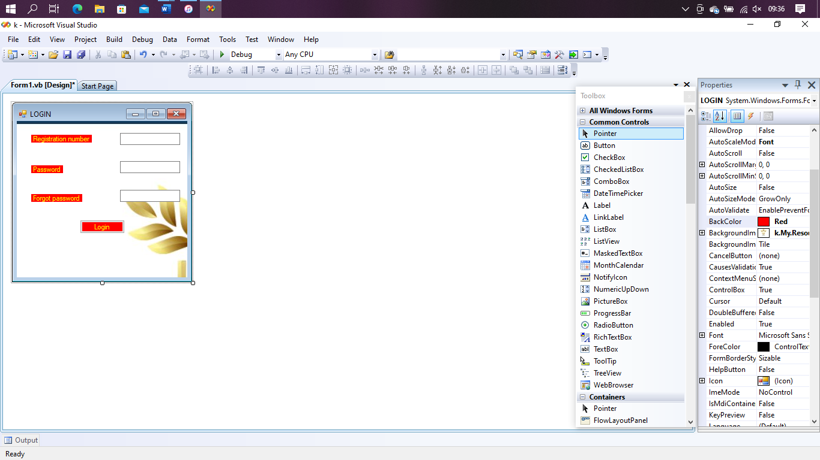

## **2.5: Output specification**

In output specification of the proposed system has to take input in order to perform a process, some function in order to produce an output based on a given input

# 3.**0: CHAPTER THREE**

# **3.1: Research methodology**

## 3**.1: Overview**

In this part the perquisites examination and configuration will talked about including all the information gathering apparatus utilized in planning the framework. The data has been purposefully inspected and requirement gathering technique used in building framework, the space for enhancement and updates has been perceived, arrange and data framework to complete them and besides develop thought for new framework. A structured data working frame work was actualized and advancement of a new prototype for a new network.

System design was started; system design is a special outline that either depicts the new system or portray the existing system will be modified. It at last answers the inquiry ‘in what manner will the system do what is must do to acquire an answer for an issue? It likewise subtitles system yields information sources, determine programming, information assumed transmission, staff and techniques and show this part are connected.

## **3.3: Methodology**

### **3.3.1: Waterfall Methodology**

The waterfall model is a model which will be for use in this project; additional alluded to as a direct successive life cycle model will be viewed as the most conventional way to deal with programming development. It will be a successive methodology in which each stage in the advancement cycle is done straightly. It is the earliest software development methanoyl ever used; the___14 waterfall methodology will pick because of restricted extend of this project. The feature and requirement

### **3.3:1Approach to chosen methodology**

In this section, the approach used for implementation waterfall methodology will be discussed. The waterfall methodology is broken down into multiple paces that include requirement, design, implementation, verification and maintenance

During the requirement phase, we will be able to access clearance graduation system, we will be able to interview the students of proposed system and thus observed that the students will like to feature where they can easily go through stages of clearance without issues and monitor their progress. All the recommendations will be then cross checked with university to verify requirements.

In design phase, with suggestion from management a comprehensive idea of system design and user interface will be derived in the form of derived template. This template use a basic design template for the system on which the changes will be made until a completed template derived. The derived template will be then used as basis for implementation phase.

Having assembled all the functional and nonfunctional requirements, the subsequent stage would be the implementation stages.

Then come to testing phase, after completion of implementation, the project will be properly with the help of stake holders to ensure that it satisfies all the requirements. During testing the errors encountered will then be isolated from complete system after what code for that particular section will revised and fixed.

Finally, during maintenance stage, blunders observed will then be fixed. There will be code enhancement modification extra time to guarantee that the system is working and its ideal level a measure of information and client increment.

## **3.4: Requirement analysis**

The requirement of graduation management system will be determined by analyzing information gathered from interviews from users at university. It will be derived that the graduating students when clearing complain about being only easy to do their clearance and keep truck record.

All of graduating students’ issues will be solved through this project by providing easy access to all departments required to be cleared first before graduating from comfort of their computers or phones.

## **3.5: Requirement specifications**

This section will provide a detailed description the system as well as functional and nonfunctional requirements. It will contain all necessary features required to ensure that the system is complete.

The software required for development of this is:

* Operating system
* Fronted language
* Database
* Environment

## **3.6: System design**

Below is an application architecture which shows graphical representation of the applications. It also shows the connections and steps that can carried out in a system.

Database accessory

Forgot password

Login

Eligible to graduate

Yes

Graduation status

No

Visit Faculty rep

Full Paid

Yes

Fee Status

No

Visit finance to finish payment

No

Visit registrar office

Fully Done

Yes

Examination

Checked

Visit Sport Department

Yes

Sports

No

Checked

Yes

Library

No

Visit library Department

Deactivated

Yes

University ID

No

Confirm Deactivate

Checked

Yes

Hostel

No

Visit finance office to finish payment

## **3.6: Summary**

In this chapter the system functional and nonfunctional requirements will be discuss along with some development of methodologies consider like waterfall methodology. The waterfall methodology will be chosen specifically as approach used for developing this software system as proven when the strengths and weakness of each methodology will be discussed.

The tools and techniques used in development of this system will also be discuss as well as showing the user interface design that will be created.

# **4.0: CHAPTER FOUR**

# **4.0: Discussion Conclusion and Recommendation**

### **4.1.1: Overview**

This project will achieve the goal that is mentioned earlier. It gives a student clearing it give a user step by step guidance on how to use this clearance graduating system and how to understand it quickly. Around the same, the clearance process of graduating student was ease and the new system effective transitioned to a computerized system

## **4.2: Objective assessment**

This project provides the end user with an optimized means of doing clearance before convocation and minimizing the end user manual transaction. By making great strides in education and training the government actively supports the worth of transaction. By launch of lower cost pc would potentially encourage more the value of IT, as clearance electronically or by smartphone instead of doing it manually, Since the framework is established within a narrow reach, multiple parties do really profit from it Some advantages area saving time, first data search and retrieval

## 4.**3: Summary**

As identified in the requirements review process, the online graduation clearance system is effectively configured and built to satisfy the required requirement such as system is very friendly and validation perform s very effectively. The architecture has been developed to make it easier to implement future changes and enhancement without losing its key functionalities

## **4.4: Recommendations**

We recommend the following;

* Mainly for the university, keeping the peace of campus is the main because without peace anything can’t be done
* Department to give students full information
* The university should use system developed after evaluation its functionality
* Advice students effectively

## **4.5: Conclusion**

It can be concluded that clearance graduation system works well; the success rate of proposed clearance graduating system is about 85%, However it is opened to be improved by paying attention for features. This improvement may help clearance graduating system become more robust.

# **4.6: Approval**

This project was submitted to the University Applied Science and technology for the online clearance graduating system with approval of Mark kamanja

Sign Date

Department of computer science

**Reference**

Peter rob &calos coronel, database system design implementation and management

use get, pavansonawane, Chetan B barhate.” COLLEGE ERP SYSTEM “International journal for research